Supplementary Information for:

National Forest Inventories capture the multifunctionality of managed forests in Germany
Authors: Nadja K. Simons*, María R. Felipe-Lucia, Peter Schall, Christian Ammer, Jürgen Bauhus, Nico Blüthgen, Steffen Boch, François Buscot, Markus Fischer, Kezia Goldmann, Martin M. Gossner, Falk Hänsel, Kirsten Jung, Peter Manning, Thomas Nauss, Yvonne Oelmann, Rodica Pena, Andrea Polle Swen C. Renner, Michael Schloter, Ingo Schöning, Ernst-Detlef Schulze, Emily F. Solly, Elisabeth Sorkau, Barbara Stempfhuber, Tesfaye Wubet, Jörg Müller, Sebastian Seibold and Wolfgang W. Weisser
* Corresponding author: Nadja K. Simons, nadja.simons@tu-darmstadt.de, ORDID: 0000-0002-2718-7050

Content:
Supplementary Figure 1: Ordinary least squares regression between forest structural parameters of 124 forest plots from the Biodiversity Exploratories (calibration sites).
Supplementary Figure 2: Comparison between observed and predicted data based on subsets of the Biodiversity Exploratories plots.
Supplementary Figure 3: Procedure of forest inventory plot selection for the extrapolation of ecosystem service indicators.
Supplementary Figure 4: Averages and 95% confidence intervals for the initial set of predictors (forest structural and abiotic parameters) calculated for the final set of 53 forest types.
Supplementary Figure 5: Principal components space based on the forest structural and compositional parameters and abiotic parameters.
Supplementary Figure 6: Predicted levels of ecosystem service indicators for the 53 most dominant forest types in Germany.

Supplementary Table 1: List of ecosystem service indicators with corresponding categories and unit of measurement.
Supplementary Table 2: Coefficients of ecosystem service models based on forest structural and compositional parameters and abiotic parameters.
Supplementary Table 3: Number of forest inventory plots used to predict potential ecosystem service supply across Germany.

Supplementary Figure 1
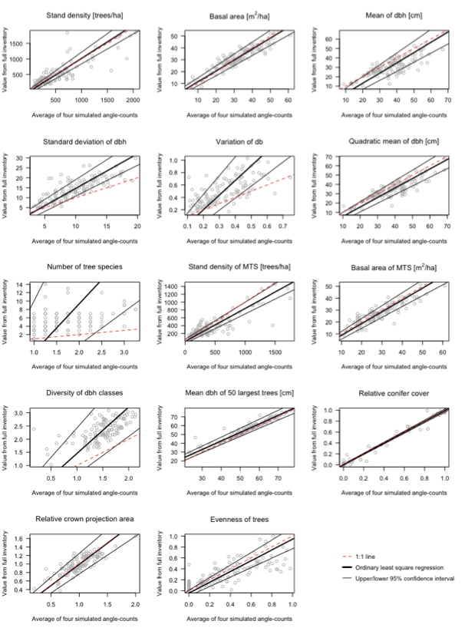
Ordinary least squares regression between forest structural parameters of 124 forest plots from the Biodiversity Exploratories (calibration sites). Parameters were calculated from all trees within 1 ha (full inventory, y-axis) and from trees assessed by four simulated angle-count measurements (x-axis). Black lines show the average and confidence intervals of the regression model, the red line indicates the 1:1 line of a perfect correlation. Parameters for which the 1:1 line falls within the confidence interval are not biased by the inventory method.

Supplementary Figure 2
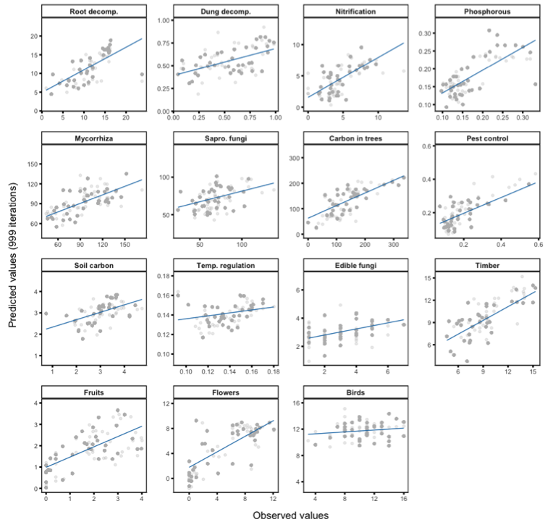
Comparison between observed and predicted data based on subsets of the Biodiversity Exploratories plots. 70% of the plots were used to develop predictive models and the remaining 30% of plots used to predict ecosystem services indicators. Random selection of the test subset was repeated 999 times. Blue lines indicate the average regression lines. For average R² values of 10-fold cross-validations see Table S3. Darker points indicate overlaying points.

Supplementary Figure 3
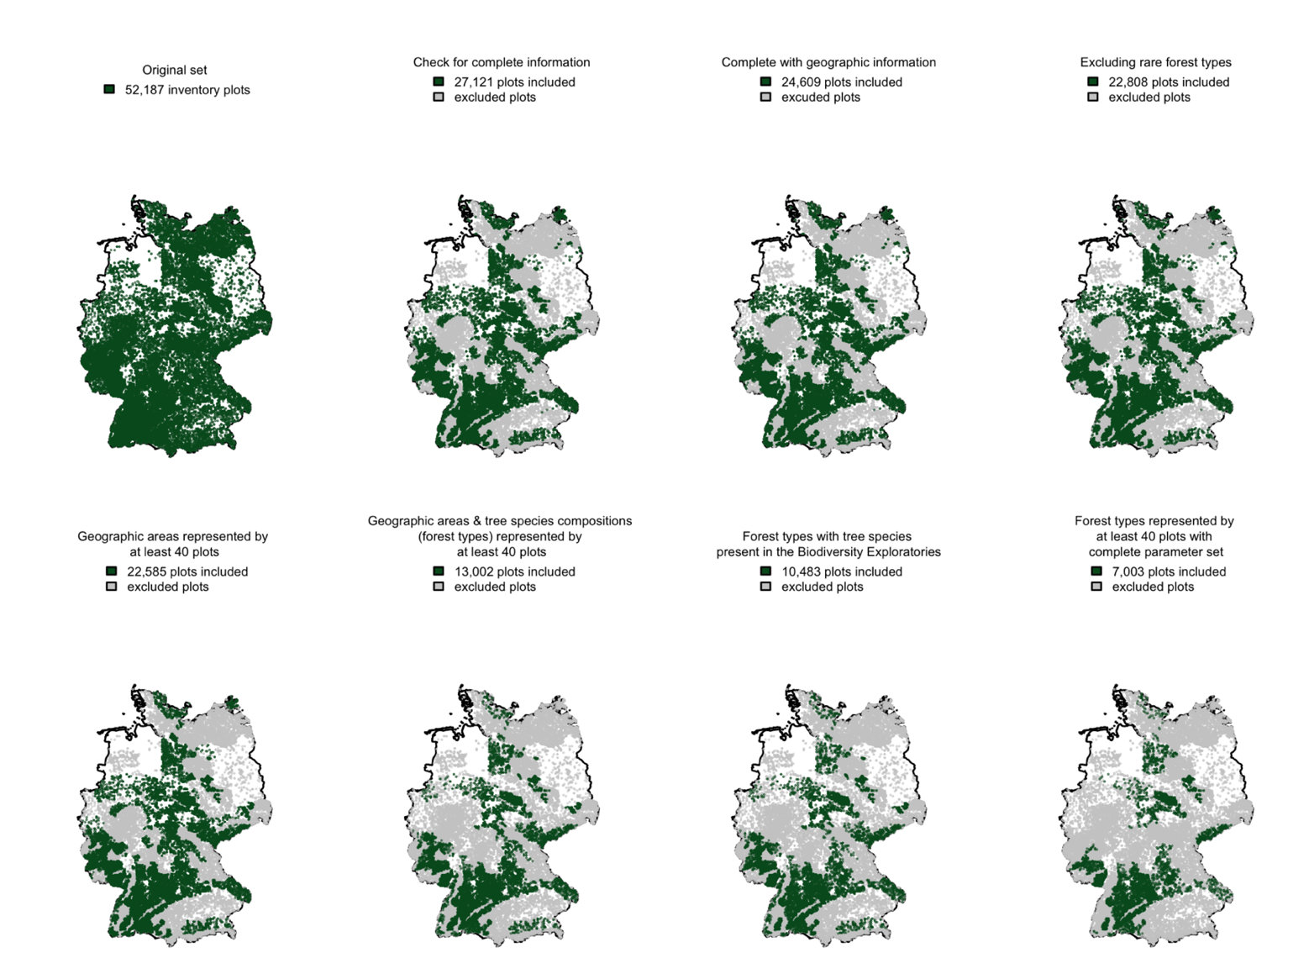
Procedure of forest inventory plot selection for the extrapolation of ecosystem service indicators. The forest inventory plots at each step are shown in dark green for the remaining plots and in grey for the excluded plots.

Supplementary Figure 4
Averages and 95% confidence intervals for the initial set of predictors (forest structural and abiotic parameters) calculated for the final set of 53 forest types. The final set of forest types includes those with the same tree species composition as the Biodiversity Exploratories (calibration sites) and are represented by at least 40 forest inventory plots with a complete set of predictors. The red lines indicate the minimum and maximum observed value within the Biodiversity Exploratories data. Forest types are ordered on the y-axis based on tree species composition (second number) within geographic areas (first numbers). Geographic areas are numbered from North to South (2: northernmost, 79 southernmost area). Tree species composition is a combination of main tree species (26: beech, 21: spruce, 22: pine, 27: oak, 31: other deciduous species) and admixed tree species (00: pure stand, 01: with coniferous species, 02: with deciduous species, 03: with coniferous and deciduous species).

Supplementary Figure 5
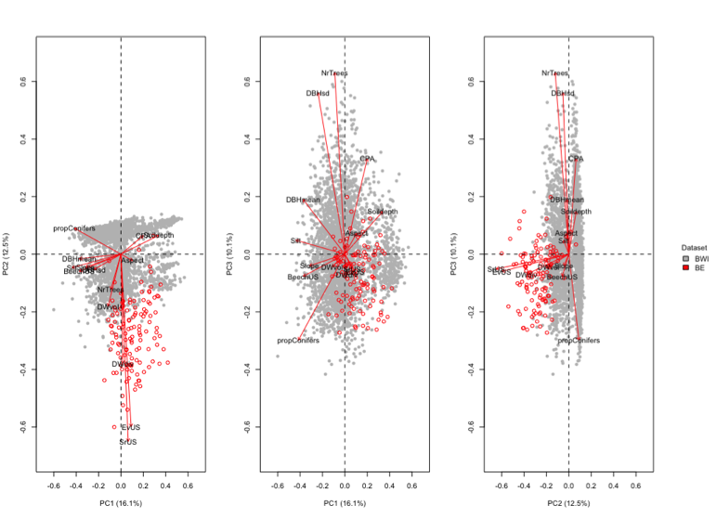
Principal components space based on the forest structural and compositional parameters and abiotic parameters. Grey dots represent 2900 plots of the German National Forest Inventory (BWI, predicted sites) for which complete information on all pre-selected predictors was available. Red circles represent 124 plots of the Biodiversity Exploratories (BE, calibration sites).

Supplementary Figure 6
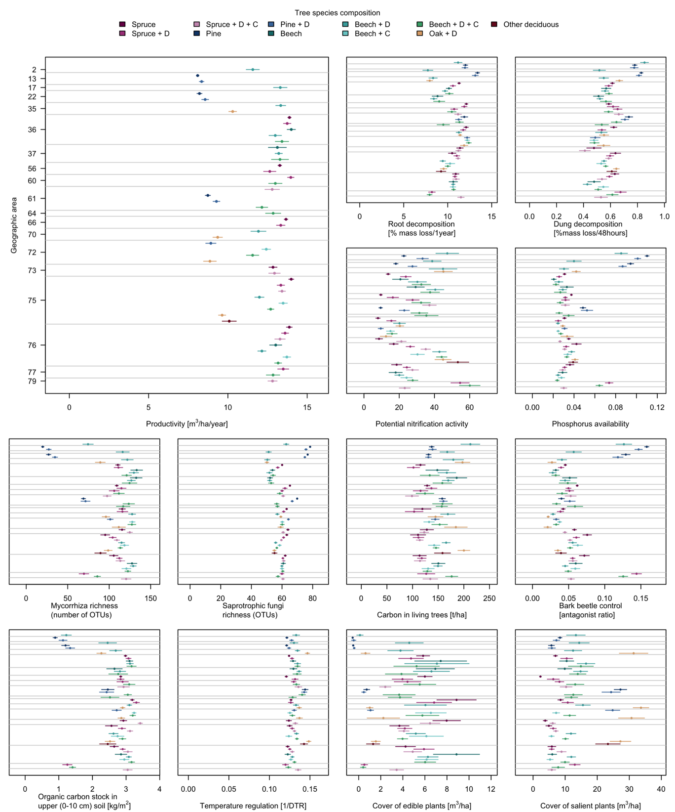

Predicted levels of ecosystem service indicators for the 53 most dominant forest types in Germany. Plots show averages and 95%-confidence intervals of the predicted ecosystem service indicator for each forest type. Confidence intervals are based on at least 40 plots per forest type, for exact sample size see Table S2. Horizontal grey lines separate geographic areas, points between grey lines indicate different tree species compositions within the same geographic area. Geographic areas are numbered from North to South. For a map of the geographic areas see Fig. 5 in the main text. Spruce = Picea abies ((L.) H. Karst), Pine = Pinus sylvestris (L.), Beech = Fagus sylvatica (L.), Oak = Quercus spp., D= deciduous tree species, C = coniferous tree species.

Supplementary Table 1 List of ecosystem service indicators with corresponding categories and unit of measurement.
IPBES Category | MEA Category | Ecosystem service indicator | Unit of measurement
Regulation of environmental processes | Supporting | Richness of saprotrophic fungi | Number of OTUs
Regulation | Supporting | Richness of mycorrhizal fungi | Number of OTUs
Regulation | Supporting | Root decomposition | percent mass loss of fine roots within the upper 10 cm of the mineral soil in 1 year
Regulation | Supporting | Dung decomposition | removal rate after 48 hours of exposure
Regulation | Supporting | Potential nitrification activity | ng NO₂/ g dry weight/ h
Regulation | Supporting | Phosphorus availability | mg extractable phosphorus per kg soil
Regulation | Regulating | Carbon in living trees | T/ha
Regulation | Regulating | Organic carbon in the soil | kg/m² of organic carbon in topsoil (up to 10 cm depth)
Regulation | Regulating | Bark beetle control | Ratio of bark beetle antagonists and bark beetles of the family Xyleborini
Regulation | Regulating | Temperature regulation | Inverse of diurnal temperature range variability (DTR)
Materials and assistance | Provisioning | Productivity | Increment of wood volume in m³/ha/year
Materials and assistance | Cultural | Edible fungi richness | Number of OTUs
Materials and assistance | Cultural | Cover of edible plants | Percent cover of plants with edible fruits or other plant parts
Non-material | Cultural | Cover of culturally interesting plants | Percent cover of plants which are of cultural interest
Non-material | Cultural | Bird watching potential | Nr. of observed bird species
IPBES: Intergovernmental Science-Policy Platform on Biodiversity and Ecosystem Services. MAE: Millennium Ecosystem Service Assessment.

Supplementary Table 2 Coefficients of ecosystem service models based on forest structural and compositional parameters and abiotic parameters
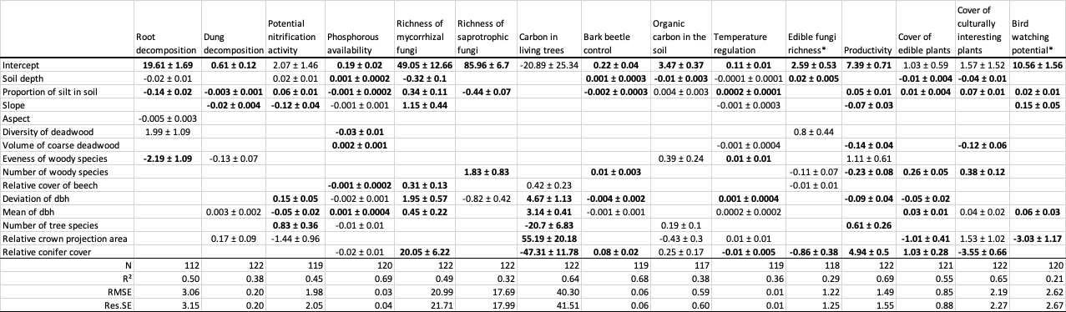
N: number of predictors (excluding the intercept) selected by model simplification. R²: adjusted R-squared of production functions. RMSE: root mean squared error. Res. SE: residual standard error. dF: degrees of freedom. The total number of calibration sites included in the study is 124.

Supplementary Table 3 Number of forest inventory plots used to predict potential ecosystem service supply across Germany
Geographic area |  | Spruce |  |  | Pine |  | Beech |  |  |  | Oak | Other deciduous
 |  | Pure | Conifers | Conifers & Deciduous | Pure | Conifers | Pure | Deciduous | Conifers | Conifers & Deciduous | Conifers | Conifers
2 | Jungmoränenlandschaft Schleswig‒Holstein Ost / Nordwest‒Mecklenburg | ‒ | ‒ | ‒ | ‒ | ‒ | ‒ | ‒ | 46 | ‒ | ‒ | ‒
13 | Ostniedersächsisches Tiefland | ‒ | ‒ | ‒ | 114 | 66 | ‒ | ‒ | ‒ | ‒ | ‒ | ‒
17 | Weserbergland | ‒ | ‒ | ‒ | ‒ | ‒ | ‒ | ‒ | 55 | ‒ | ‒ | ‒
22 | Mittleres nordostdeutsches Altmoränenland | ‒ | ‒ | ‒ | 130 | 75 | ‒ | ‒ | ‒ | ‒ | ‒ | ‒
35 | Nordthüringisches Trias‒Hügelland | ‒ | ‒ | ‒ | ‒ | ‒ | ‒ | ‒ | 52 | ‒ | 71 | ‒
36 | Harz | 126 | 63 | ‒ | ‒ | ‒ | 44 | ‒ | 70 | 40 | ‒ | ‒
37 | Mitteldeutsches Trias‒Berg‒ und Hügelland | ‒ | ‒ | ‒ | ‒ | ‒ | 53 | ‒ | 96 | 41 | ‒ | ‒
56 | Erzgebirge | 130 | 52 | ‒ | ‒ | ‒ | ‒ | ‒ | ‒ | ‒ | ‒ | ‒
60 | Frankenalb und Oberpfälzer Jura | ‒ | 54 | ‒ | ‒ | ‒ | ‒ | ‒ | ‒ | 48 | ‒ | ‒
61 | Fränkischer Keuper und Albvorland | ‒ | ‒ | 52 | 42 | 65 | ‒ | ‒ | ‒ | 40 | ‒ | ‒
64 | Odenwald | ‒ | ‒ | ‒ | ‒ | ‒ | ‒ | ‒ | ‒ | 41 | ‒ | ‒
66 | Hunsrück | 41 | 48 | ‒ | ‒ | ‒ | ‒ | ‒ | ‒ | ‒ | ‒ | ‒
70 | Saar‒Nahe Bergland | ‒ | ‒ | ‒ | ‒ | ‒ | ‒ | ‒ | 40 | ‒ | 58 | ‒
72 | Pfälzerwald | ‒ | ‒ | ‒ | ‒ | 83 | ‒ | 81 | ‒ | 60 | 41 | ‒
73 | Schwarzwald | 50 | ‒ | 75 | ‒ | ‒ | ‒ | ‒ | ‒ | ‒ | ‒ | ‒
75 | Neckarland | 51 | 97 | 128 | ‒ | ‒ | ‒ | 62 | 156 | 198 | 124 | 53
76 | Schwäbische Alb | 52 | 143 | 86 | ‒ | ‒ | 61 | 82 | 178 | 132 | ‒ | ‒
77 | Südwestdeutsches Alpenvorland | ‒ | 44 | ‒ | ‒ | ‒ | ‒ | ‒ | ‒ | 47 | ‒ | ‒
79 | Bayerischer Wald | ‒ | ‒ | 58 | ‒ | ‒ | ‒ | ‒ | ‒ | ‒ | ‒ | ‒
Forest types are defined as combinations of geographic areas and tree species composition represented by at least 40 inventory plots. First header line shows the main tree species, second header line the admixed tree species. Inventory plots were part of the 2012 German National Forest Inventory. Further information on geographic areas can be found at https://gdi.thuenen.de/wo/wgwb/ (Thünen-Institut, Wuchsgebiete). Spruce = Picea abies ((L.) H. Karst), Pine = Pinus sylvestris (L.), Beech = Fagus sylvatica (L.), Oak = Quercus spp.

