Supplementary Material

Exome-wide association study identifies FN3KRP and PGP as new candidate longevity genes

Guillermo G. Torres¹, PhD, Marianne Nygaard^{2,3}, PhD, Amke Caliebe⁴, PhD, Hélène Blanché⁵, PhD, Sophie Chantalat⁶, PhD, Pilar Galan⁷, MD, PhD, Wolfgang Lieb⁸, MD, MSc, Lene Christiansen^{2,9}, PhD, Jean-François Deleuze^{5,6}, PhD, Kaare Christensen^{2,3,10}, PhD, Konstantin Strauch^{11,12}, PhD, Martina Müller-Nurasyid^{11,12,13}, PhD, Annette Peters^{11,14}, PhD, Markus M. Nöthen¹⁵, MD, Per Hoffmann¹⁵, PhD, Friederike Flachsbart¹, PhD, Stefan Schreiber¹, MD, David Ellinghaus¹, PhD, Andre Franke¹, PhD, Janina Dose¹, PhD, Almut Nebel¹, PhD

¹ Institute of Clinical Molecular Biology, Kiel University, University Hospital Schleswig-Holstein, Campus Kiel, Rosalind-Franklin-Str. 12, 24105 Kiel, Germany; g.torres@ikmb.uni-kiel.de, j.dose@ikmb.uni-kiel.de, d.ellinghaus@ikmb.uni-kiel.de, f.flachsbart@mucosa.de, s.schreiber@mucosa.de, a.franke@mucosa.de, a.nebel@mucosa.de
² The Danish Twin Registry and The Danish Aging Research Center, Department of Public Health, University of Southern Denmark, J.B. Winsloews Vej 9B, 5000 Odense C, Denmark; mnygaard@health.sdu.dk
³ Department of Clinical Genetics, Odense University Hospital, J.B. Winsloews Vej 4, 5000 Odense C, Denmark
⁴ Institute of Medical Informatics and Statistics, Kiel University, University Hospital Schleswig-Holstein, Campus Kiel, Brunswiker Str. 10, 24105 Kiel, Germany; caliebe@medinfo.uni-kiel.de
⁵ Fondation Jean Dausset-Centre d’Etude du Polymorphisme Humain (CEPH), 27 Rue Juliette Dodu, 75010 Paris, France; helene.blanche@fjd-ceph.org
⁶ Centre National de Recherche en Génomique Humaine CNRGH-CEA, 91000 Evry, France; deleuze@cng.fr, chantalat@cng.fr
⁷ Université Sorbonne Paris Cité-UREN, Unité de Recherche en Epidémiologie Nutritionelle, U557 Inserm, U1125 Inra, Cnam, Université Paris 13, CRNH IdF, 93017 Bobigny, France; p.galan@uren.smbh.univ-paris13.fr
⁸ Institute of Epidemiology and Biobank Popgen, Kiel University, University Hospital Schleswig-Holstein, Campus Kiel, Niemannsweg 11, 24105 Kiel, Germany; Wolfgang.Lieb@epi.uni-kiel.de
⁹ Department of Clinical Immunology, Copenhagen University Hospital, Rigshospitalet, Blegdamsvei 9, 2100 Copenhagen OE, Denmark; lene.christiansen.02@regionh.dk
¹⁰ Department of Clinical Biochemistry and Pharmacology, Odense University Hospital, Kløvervænget 47, 5000 Odense C, Denmark; kchristensen@health.sdu.dk
¹¹ Institute of Genetic Epidemiology, Helmholtz Zentrum München - German Research Center for Environmental Health, Ingolstädter Landstraße 1, Neuherberg, Germany; strauch@helmholtz-muenchen.de; peters@helmholtz-muenchen.de
¹² Chair of Genetic Epidemiology, IBE, Faculty of Medicine, Ludwig-Maximilians-University (LMU) Munich, Bavarian 19, Munich, Germany; martina_mueller@ibe.med.uni-muenchen.de
¹³ Department of Internal Medicine I (Cardiology), Hospital of the LMU Munich, Marchioninistraße 15, Munich, Germany.
¹⁴ German Center for Diabetes Research (DZD), Ingolstädter Landstraße 1, Neuherberg, Germany.
¹⁵ Institute of Human Genetics, University of Bonn, Regina-Pacis-Weg 3, Bonn, Germany; markus.noethen@ukbonn.de, p.hoffmann@uni-bonn.de

Corresponding author:
Almut Nebel, PhD
Institute of Clinical Molecular Biology
Kiel University
Rosalind-Franklin-Str. 12
24105 Kiel, Germany
phone: +49 (0)431 500 15155, fax: +49 (0)431 500 15168
email: a.nebel@mucosa.de

German, Danish and French study populations
The German sample comprised 1,248 German LLI (male/female ratio: approximately 1/3; age range: 94 - 110 years; mean age: 99 years) as described previously (1, 2). The collection was recruited with the help of the biobank popgen; in detail, 2,905 adults from the KORA study (Collaborative Health Research in the Region of Augsburg) (3) 2,360 individuals from HCDEBONN, 998 Germans from the popgen biorepository (4), 473 participants from HCDEMICK, and 205 additional individuals from HCGCON. All study participants provided a written informed consent prior to enrolment in the study. Approval for the project was obtained from the Ethics Committee of the Medical Faculty of Kiel University.

For the Danish data set, the 1,002 cases (male/female ratio: 1/3; age range: 90.0 - 102.5 years; mean age: 97.4 years) consisted of participants drawn from seven nation-wide surveys collected at the University of Southern Denmark; the Study of Danish Old Sibs (DOS), the 1905 Birth Cohort Study, the 1910 Birth Cohort Study, the 1911-12 Birth Cohort Study, the 1915 Birth Cohort Study, the Longitudinal Study of Danish Centenarians (LSDC), and the Longitudinal Study of Ageing Danish Twins (LSADT). Briefly, DOS was initiated in 2004 and included families in which at least two siblings were ≥ 90 years of age at intake. The LSDC and 1905, 1910, and 1915 Birth Cohort Studies were prospective follow-up studies initiated in 1995, 1998, 2010, and 2010, when participants were 100, 92-93, 100, and 95 years of age, respectively (5). The 1911-1912 Birth Cohort Study consisted of individuals reaching the age of 100 years in the period from May 2011 to July 2012 (6) and LSADT was initiated in 1995 and includes Danish twins ≥ 70 years of age (7). From DOS and LSADT, one individual from each sib-ship or twin pair was randomly selected among participants that had reached an age of ≥ 91 years for DOS, and ≥ 90 years for LSADT. The 738 controls (mean age: 66.3 years) consisted of individuals recruited by the Danish Twin Registry (DTR) as part of the study of Middle-Aged Danish Twins (MADT) (8). Participants were revisited from 2008 to 2011 (9), where the blood samples used for DNA extraction were collected. Signed informed consents were obtained from all participants. Collection and use of biological material and survey information were approved by the Regional Committees on Health Research Ethics for Southern Denmark, and the study was approved by the Danish Data Protection Agency.

The French cases comprised 1,264 individuals (male/female ratio ~ 1/4.5, age range 91-115+ years; mean age 102.4 years;) (10). French siblings were recruited when at least two siblings fulfilled age criteria of 90 years or older; in such a case the oldest sibling was selected for the study. All subjects signed a written informed consent form in accordance with the local review board. The French controls consisted of 1,830 subjects (age < 62 years) selected in a population-based sample of French subjects that had participated in the Supplementation in Vitamins and Mineral Antioxidants (SU.VI.MAX) study (11).

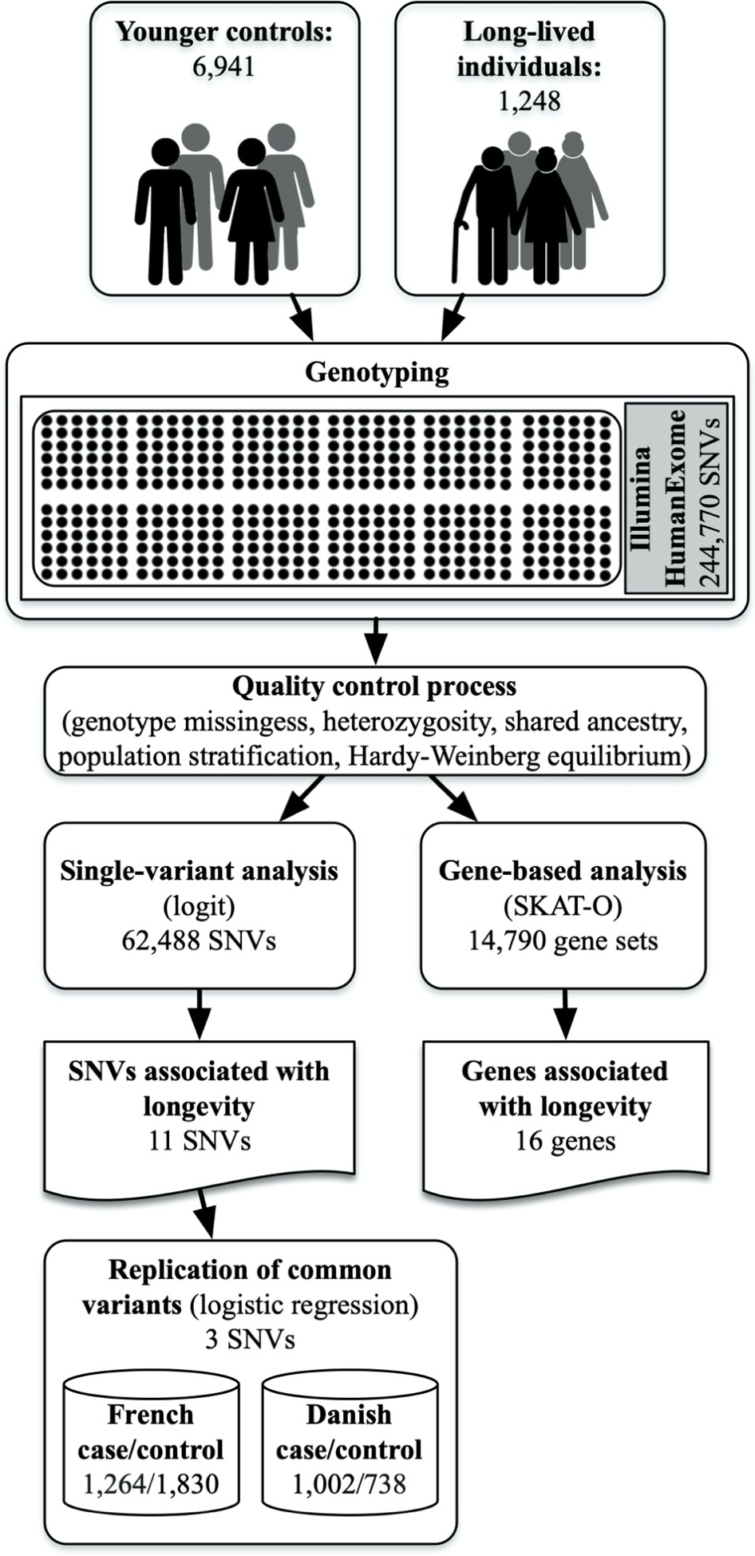
Supplementary figure 1. Workflow of the association analyses of the chip-based exome-wide case-control longevity study.

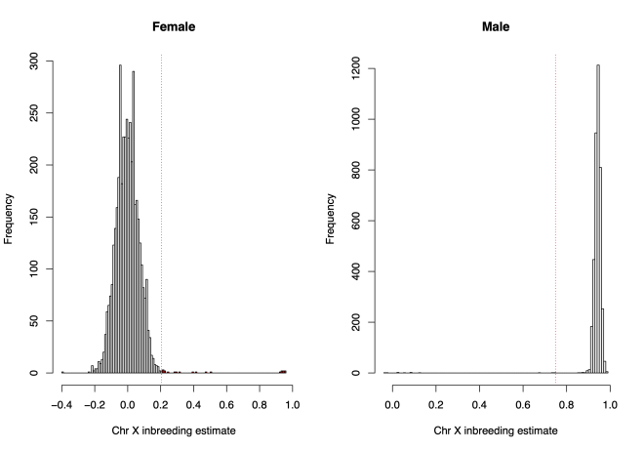  A. | B.  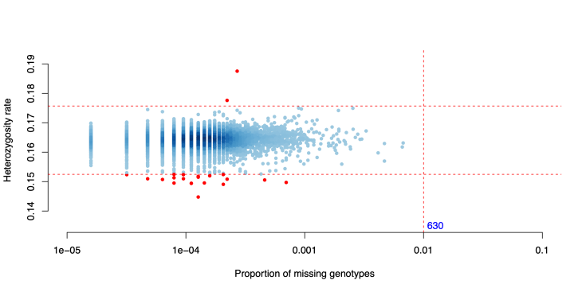
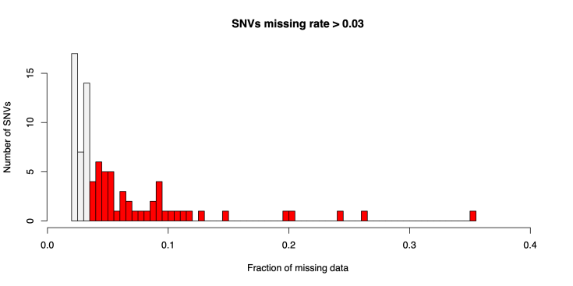  C. | 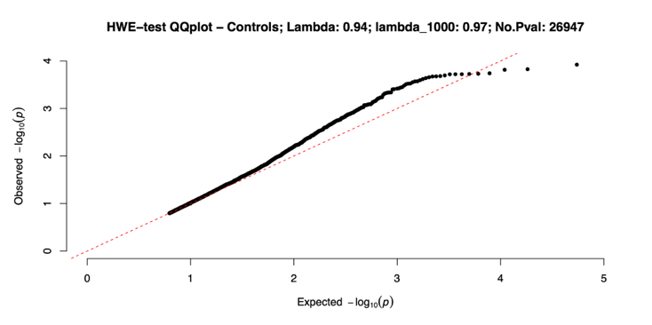  D.

Supplementary figure 2. Quality control results of the exome chip data. A. Sex discordant information. B. Genotype failure rate as a function of the heterozygosity across all individuals (red lines denote quality control thresholds). C. Missing data rate per variant across all individuals passing 'per-individual' quality control; variants with missing rate >0.03 are colored red. D. Hardy Weinberg equilibrium Q-Q plot for the common SNVs in the German control population. The genomic inflation lambda 100 (lambda) and lambda 1000 (lambda_1000) is also reported in the graph. The lambda was estimated based on the number of P-values of the association (No. Pval).

Supplementary figure 3. Population stratification based on ancestry-SNVs (N = 16,782 SNVs). A., B., and C. depict the ancestry clustering based on a principal component analysis (PCA) constructed with the HapMap3 reference samples and German case and control populations. A. Shows the PCA map using the genotypes form Utah residents with Northern and Western European ancestry from the CEPH collection (CEU), Han Chinese population in Beijing (CHB), Japanese population in Tokyo (JPT), Yoruba population in Ibadan, Nigeria (YRI) and the German individuals under study. B. PCA map from CEU and German case and control sub-populations. C. PCA map from German case and control populations. D. Local outlier factor score for each individual calculated based on the first five principal components (red dots indicate individuals out of quality control thresholds).

Supplementary figure 4. Epistatic interactions among SNV candidates. A. SNV-SNV interaction graph. It is reported for each SNV the value of information gain (IG) in percentage. The links indicate the entropy-based IG for the SNV pairs. Red and orange bar links indicate the high-level synergies on the phenotype, while brown indicate a medium-level interaction, green and blue with negative IG values represent redundancy or lack of synergistic interactions between the markers. B. Interaction dendrogram; color code as described before. C. Histograms of the distribution of LLI (left bars) and controls (right bars) for the three-locus and two-locus genotype combinations of SNVs. The effect of rs1046896 (FN3KRP gene) is showed alone due to its univariate effect. Dark-shaded cells are considered “high risk” for longevity, while light-shaded cells are considered “low risk”.

Supplementary table 1. Association statistics for the 11 longevity-associated SNVs identified by the single variant association approach in the German study population and in male and female subpopulations, respectively.
 |  |  | MAFª |  |  | Basic association test
SNV | Gene | Population | LLI | Controls |  | OR^{b} | P^{d}
 |  |  |  |  |  | [95% C.I.]^{c} | P^{d}
rs769449 | APOE | Total | 0.0558 | 0.1095 |  | 0.48 [0.40 - 0.58] | 7.77E-15
rs769449 | APOE | Female | 0.0521 | 0.1087 |  | 0.45 [0.36 - 0.57] | 6.02E-12
rs769449 | APOE | Male | 0.06383 | 0.1107 |  | 0.54 [0.38 - 0.79] | 2.57E-04
rs4420638 | APOC1 | Total | 0.1091 | 0.1693 |  | 0.60 [0.52 - 0.69] | 3.55E-13
rs4420638 | APOC1 | Female | 0.1019 | 0.1689 |  | 0.54 [0.46 - 0.64] | 2.537E-12
rs4420638 | APOC1 | Male | 0.1277 | 0.1277 |  | 0.72 [0.57 - 0.92] | 7.42E-03
rs2075650 | TOMM40 | Total | 0.1087 | 0.1466 |  | 0.70 [0.61 - 0.80] | 3.51E-07
rs2075650 | TOMM40 | Female | 0.1059 | 0.1448 |  | 0.68 [0.58 - 0.81] | 9.58E-06
rs2075650 | TOMM40 | Male | 0.1125 | 0.1484 |  | 0.72 [0.56 - 0.93] | 1.22E-02
rs1046896 | FN3KRP | Total | 0.2761 | 0.3244 |  | 0.78 [0.71 - 0.86] | 7.40E-07
rs1046896 | FN3KRP | Female | 0.2837 | 0.3352 |  | 0.79 [0.70 - 0.89] | 7.37E-05
rs1046896 | FN3KRP | Male | 0.2584 | 0.3141 |  | 0.77 [0.64 - 0.93] | 5.45E-03
rs55882518 | NOTCH3 | Total | 0.0129 | 0.0048 |  | 2.69 [1.73 - 4.18] | 1.07E-05
rs55882518 | NOTCH3 | Female | 0.01359 | 0.0049 |  | 2.74 [1.60 - 4.72] | 2.37E-04
rs55882518 | NOTCH3 | Male | 0.01216 | 0.0048 |  | 1.92 [0.67 - 5.52] | 2.26E-01
rs13119846 | TMEM131L | Total | 0.4858 | 0.4383 |  | 1.22 [1.11 - 1.33] | 1.73E-05
rs13119846 | TMEM131L | Female | 0.4955 | 0.4399 |  | 1.25 [1.12 - 1.29] | 3.80E-05
rs13119846 | TMEM131L | Male | 0.4666 | 0.4363 |  | 1.15 [0.98 - 1.35] | 9.26E-02
rs1063192 | CDKN2B | Total | 0.4822 | 0.4387 |  | 1.21 [1.11 - 1.32] | 2.99E-05
rs1063192 | CDKN2B | Female | 0.4892 | 0.4283 |  | 1.27 [1.14 - 1.41] | 1.33E-05
rs1063192 | CDKN2B | Male | 0.4696 | 0.4481 |  | 1.01 [0.93 - 1.29] | 2.58E-01
rs184214819 | SPZ1 | Total | 0.0089 | 0.0035 |  | 3.01 [1.77 - 5.11] | 4.72E-05
rs184214819 | SPZ1 | Female | 0.00906 | 0.0029 |  | 3.38 [1.70 - 6.70] | 4.91E-04
rs184214819 | SPZ1 | Male | 0.00912 | 0.004 |  | 2.54 [1.03 - 6.28] | 4.35E-02
rs200956599 | SKOR1 | Total | 0.0137 | 0.0063 |  | 2.34 [1.55 - 3.54] | 5.24E-05
rs200956599 | SKOR1 | Female | 0.0130 | 0.0059 |  | 2.16 [1.28 - 3.62] | 3.65E-03
rs200956599 | SKOR1 | Male | 0.01672 | 0.0064 |  | 2.73 [1.38 - 5.39] | 3.80E-03
rs63750412 | GRN | Total | 0.0077 | 0.0018 |  | 3.57 [1.93 - 6.61] | 5.18E-05
rs63750412 | GRN | Female | 0.00849 | 0.0026 |  | 3.18 [1.55 - 6.53] | 1.61E-03
rs63750412 | GRN | Male | 0.00608 | 0.0012 |  | 4.02 [0.90 - 17.9] | 6.82E-02
rs1790706 | DSC2 | Total | 0.1597 | 0.1897 |  | 0.79 [0.70 - 0.89] | 9.59E-05
rs1790706 | DSC2 | Female | 0.1665 | 0.1947 |  | 0.82 [0.71 - 0.94] | 5.40E-03
rs1790706 | DSC2 | Male | 0.1368 | 0.1863 |  | 0.69 [0.54 - 0.87] | 1.73E-03
APOC1, apolipoprotein C1; APOE, apolipoprotein E; CDKN2B, cyclin dependent kinase inhibitor 2B; DSC2, desmocollin 2; FN3KRP, fructosamine 3 kinase related protein; GRN, granulin precursor; NOTCH3, notch 3; SKOR1, SKI family transcriptional corepressor 1; SPZ1, spermatogenic leucine zipper 1; TMEM131L, transmembrane 131 like; TOMM40, translocase of outer mitochondrial membrane 40
Listed are rs-numbers, annotated gene name, chromosome, allele frequencies in cases and controls, the minor allele, odds ratios with 95% confidence intervals and allelic P-values for the German study population (1,248 LLI, 6,941 younger controls) before and after conditional analysis for the SNVs in the TOMM40/APOE/APOC1 locus. The statistics are listed for all individuals of the study populations as well as for males and females separately.
ªMinor allele frequency, MAF; the definition of the minor allele (MA) is based on controls; the MA for the SNVs are given in column
^{b}Odds ratio for longevity, OR; based on the minor allele in controls
^{c}95% confidence interval, 95% C.I.; C.I. for the odds ratio
^{d}Allelic P-values, calculated from logistic regression

Supplementary table 2. Association statistics for the 11 longevity-associated SNVs identified by the single variant association approach in the German centenarian subpopulation.
 |  |  | MAFª |  |  | Basic association test |  |  | Conditional analysis
SNV | Gene | Chr | LLI | Controls |  | OR^{b} | P^{d} |  | OR^{b} | P^{d}
 |  |  |  |  |  | [95% C.I.]^{c} | P^{d} |  | [95% C.I.]^{c} | P^{d}
rs769449 | APOE | 19 | 0.053 | 0.109 |  | 0.46 [0.36 - 0.60] | 6.69E-09 |  | - | -
rs4420638 | APOC1 | 19 | 0.111 | 0.169 |  | 0.61 [0.51 - 0.74] | 4.56E-07 |  | - | -
rs2075650 | TOMM40 | 19 | 0.112 | 0.147 |  | 0.73 [0.60 - 0.88] | 1.20E-03 |  | - | -
rs1046896 | FN3KRP | 17 | 0.258 | 0.324 |  | 0.71 [0.62 - 0.81] | 8.47E-07 |  | 0.70 [0.61-0.81] | 4.65E-07
rs55882518 | NOTCH3 | 19 | 0.014 | 0.005 |  | 2.87[1.64 - 5.02] | 2.27E-04 |  | 2.90 [1.65-5.08] | 2.04E-04
rs13119846 | TMEM131L | 4 | 0.485 | 0.438 |  | 1.20 [1.07 - 1.34] | 2.84E-03 |  | 1.20 [1.06-1.35] | 3.72E-03
rs1063192 | CDKN2B | 9 | 0.486 | 0.439 |  | 1.23 [1.09 - 1.39] | 7.24E-04 |  | 1.24 [1.10-1.40] | 4.60E-04
rs184214819 | SPZ1 | 5 | 0.011 | 0.003 |  | 3.65 [1.90 - 7.02] | 9.97E-05 |  | 3.51 [1.82-6.77] | 1.77E-04
rs200956599 | SKOR1 | 15 | 0.012 | 0.006 |  | 1.89 [1.06- 3.37] | 3.12E-02 |  | 1.85 [1.03-3.31] | 3.82E-02
rs63750412 | GRN | 17 | 0.005 | 0.002 |  | 2.14 [0.85 - 5.35] | 1.03E-01 |  | 2.05 [0.82-5.13] | 1.27E-01
rs1790706 | DSC2 | 18 | 0.164 | 0.190 |  | 0.82 [0.69 - 0.96] | 1.38E-02 |  | 0.81 [0.69-0.95] | 9.15E-03
APOC1, apolipoprotein C1; APOE, apolipoprotein E; CDKN2B, cyclin dependent kinase inhibitor 2B; DSC2, desmocollin 2; FN3KRP, fructosamine 3 kinase related protein; GRN, granulin precursor; NOTCH3, notch 3; SKOR1, SKI family transcriptional corepressor 1; SPZ1, spermatogenic leucine zipper 1; TMEM131L, transmembrane 131 like; TOMM40, translocase of outer mitochondrial membrane 40
Listed are rs-numbers, annotated gene name, chromosome, allele frequencies in cases and controls, the minor allele, odds ratios with 95% confidence intervals and allelic P-values for the German study population (1,248 LLI, 6,941 younger controls) before and after conditional analysis for the SNVs in the TOMM40/APOE/APOC1 locus.
ªMinor allele frequency, MAF; the definition of the minor allele (MA) is based on controls; the MA for the SNVs are given in column
^{b}Odds ratio for longevity, OR; based on the minor allele in controls
^{c}95% confidence interval, 95% C.I.; C.I. for the odds ratio
^{d}Allelic P-values, calculated from logistic regression

Supplementary table 3. Contextual annotation for rs1046896 (FN3KRP) and rs1063192 (CDK2NB) based on HaploReg¹.
SNV | chr | pos (hg38) | LD |  | Ref | Alt | Frequency |  |  |  |  | Histone marks |  | DNAse | Proteins  bound | Motifs  changed | NHGRI/EBI  GWAS hits | GRASP QTL  hits | Selected eQTL  hits | GENCODE  genes | dbSNP  func annot
SNV | chr | pos (hg38) | (r²) | (D') | Ref | Alt | AFR | AMR | ASN | EUR |  | Promoter | Enhancer
rs12449739 | 17 | 82725544 | 0.82 | 0.99 | G | A | 0.23 | 0.42 | 0.49 | 0.29 |  |  |  |  |  | 10 altered motifs |  |  | 39 hits | FN3KRP | intronic
rs9895455 | 17 | 82726104 | 0.87 | 0.97 | C | T | 0.27 | 0.46 | 0.5 | 0.3 |  |  |  |  |  | ERalpha-a,HNF4,SP1 |  |  | 29 hits | FN3KRP | intronic
rs1046875 | 17 | 82727550 | 1 | -1 | A | G | 0.71 | 0.53 | 0.48 | 0.68 |  |  |  | PLCNT |  | 4 altered motifs | 1 hit | 7 hits | 38 hits | FN3KRP | 3'-UTR
rs1046896 | 17 | 82727657 | 1 | 1 | C | T | 0.27 | 0.47 | 0.52 | 0.32 |  |  |  |  |  | Hoxd10,Mef2,Whn | 2 hits | 6 hits | 38 hits | FN3KRP | 3'-UTR
rs1046917 | 17 | 82727779 | 1 | -1 | A | G | 0.71 | 0.53 | 0.48 | 0.68 |  |  |  |  |  | AP-4,Sin3Ak-20 |  | 3 hits | 38 hits | FN3KRP | 3'-UTR
rs12947062 | 17 | 82728494 | 1 | -1 | A | G | 0.71 | 0.53 | 0.48 | 0.68 |  |  |  |  |  | Irf,NRSF,SETDB1 |  |  | 33 hits | FN3KRP
rs9909940 | 17 | 82731160 | 0.87 | 0.93 | C | T | 0.27 | 0.46 | 0.51 | 0.32 |  |  |  |  |  | 6 altered motifs |  |  | 30 hits | RP11-388C12.5
rs28485881 | 17 | 82732138 | 0.87 | 0.93 | G | A | 0.27 | 0.46 | 0.52 | 0.32 |  |  |  | LIV |  | 7 altered motifs |  |  | 34 hits | RP11-388C12.5
rs7208565 | 17 | 82738816 | 0.87 | 0.93 | C | T | 0.3 | 0.47 | 0.52 | 0.33 |  | LIV, BRN | 7 tissues | 6 tissues | GATA2,TAL1,GATA1 |  |  |  | 33 hits | FN3K | intronic
rs113373052 | 17 | 82739582 | 0.81 | 0.91 | C | T | 0.29 | 0.45 | 0.49 | 0.32 |  |  | LIV, BRN, GI |  |  | BDP1,GR |  |  | 31 hits | FN3K | intronic
rs2811713 | 9 | 21999329 | 0.84 | -0.99 | G | A | 0.01 | 0.19 | 0.18 | 0.39 |  |  | BLD |  |  | Nanog |  |  |  | RP11-145E5.5 | intronic
rs1063192 | 9 | 22003368 | 1 | 1 | G | A | 0.99 | 0.79 | 0.82 | 0.57 |  |  |  | SKIN |  | AIRE,GATA,Tgif1 | 2 hits | 3 hits |  | CDKN2B | 3'-UTR
rs3217977 | 9 | 22007358 | 0.86 | 0.96 | CA | C | 0.96 | 0.75 | 0.9 | 0.55 |  | 10 tissues | BRST, BLD | 6 tissues |  | 20 altered motifs |  |  |  | CDKN2B | intronic
rs2069418 | 9 | 22009699 | 0.87 | 0.96 | G | C | 0.98 | 0.77 | 0.9 | 0.55 |  | 19 tissues | 6 tissues | 33 tissues | CTCF,POL2 |  |  | 1 hit |  | RP11-145E5.5 | intronic
rs573687 | 9 | 22011643 | 0.8 | -1 | G | A | 0.01 | 0.19 | 0.1 | 0.38 |  |  | GI, MUS | BLD |  | Cdx,Sox |  | 1 hit |  | RP11-145E5.5 | intronic
rs1101330 | 9 | 22015466 | 0.84 | -1 | C | A | 0.02 | 0.19 | 0.1 | 0.39 |  |  |  |  |  | 7 altered motifs |  |  |  | RP11-145E5.5 | intronic
rs523096 | 9 | 22019130 | 0.83 | -0.91 | A | G | 0.01 | 0.23 | 0.1 | 0.43 |  |  |  |  | CFOS | 7 altered motifs | 1 hit | 2 hits |  | RP11-145E5.5 | intronic
rs518394 | 9 | 22019674 | 0.83 | -0.91 | G | C | 0.01 | 0.23 | 0.1 | 0.43 |  |  |  |  |  | GR,Pax-4,ZNF263 |  |  |  | RP11-145E5.5 | intronic
rs581876 | 9 | 22022377 | 0.83 | -1 | C | T | 0.01 | 0.19 | 0.32 | 0.39 |  |  |  |  | SETDB1 | AP-1,Foxp1 |  |  |  | RP11-145E5.5 | intronic
rs615552 | 9 | 22026078 | 0.81 | -0.9 | T | C | 0.01 | 0.22 | 0.1 | 0.43 |  |  |  |  |  | Pax-5 | 1 hit | 2 hits |  | RP11-145E5.5 | intronic
rs613312 | 9 | 22026595 | 0.91 | -1 | G | A | 0.01 | 0.2 | 0.1 | 0.41 |  |  |  |  |  | 4 altered motifs |  |  |  | RP11-145E5.5 | intronic
rs543830 | 9 | 22026640 | 0.91 | -1 | A | T | 0.01 | 0.2 | 0.1 | 0.41 |  |  | ESC, BLD, CRVX |  |  | LBP-1 |  | 3 hits |  | RP11-145E5.5 | intronic
rs599452 | 9 | 22027403 | 0.91 | -1 | G | A | 0.01 | 0.2 | 0.1 | 0.41 |  |  | BLD |  |  | GR,T3R |  |  |  | RP11-145E5.5 | intronic
rs142048183 | 9 | 22028213 | 0.9 | -1 | CAT | C | 0.01 | 0.2 | 0.1 | 0.41 |  |  | BLD |  |  | 10 altered motifs |  |  |  | RP11-145E5.5 | intronic
rs679038 | 9 | 22029081 | 0.91 | -1 | G | A | 0.02 | 0.2 | 0.1 | 0.41 |  |  | BLD |  |  | Irf,Znf143 |  | 3 hits |  | RP11-145E5.5 | intronic
rs564398 | 9 | 22029548 | 0.9 | -0.99 | T | C | 0.01 | 0.2 | 0.1 | 0.41 |  | BLD | 9 tissues | BRN,LNG |  |  | 1 hit | 3 hits |  | RP11-145E5.5 | intronic
rs7865618 | 9 | 22031006 | 0.94 | 0.99 | G | A | 0.99 | 0.8 | 0.9 | 0.58 |  |  | 4 tissues |  |  |  | 3 hits | 4 hits |  | RP11-145E5.5 | intronic
rs634537 | 9 | 22032153 | 0.91 | -1 | T | G | 0.02 | 0.21 | 0.1 | 0.41 |  |  | 4 tissues | 5 tissues |  | 6 altered motifs |  | 3 hits |  | RP11-145E5.5 | intronic
rs2157719 | 9 | 22033367 | 0.94 | 0.99 | C | T | 0.99 | 0.8 | 0.9 | 0.58 |  |  | ESC, BRST, SKIN | 6 tissues |  | Pou2f2,Zfp187 | 3 hits | 4 hits |  | CDKN2B-AS1 | intronic
rs1008878 | 9 | 22036113 | 0.93 | 0.99 | G | T | 0.97 | 0.79 | 0.9 | 0.58 |  |  |  |  |  | 4 altered motifs |  | 4 hits |  | CDKN2B-AS1 | intronic
rs1556515 | 9 | 22036368 | 0.93 | 0.99 | C | T | 0.97 | 0.79 | 0.9 | 0.58 |  |  | 4 tissues |  |  | Sox,TATA |  | 4 hits |  | CDKN2B-AS1 | intronic
rs1333037 | 9 | 22040766 | 0.92 | 0.99 | C | T | 0.99 | 0.79 | 0.9 | 0.58 |  | GI | 13 tissues | 5 tissues |  |  |  | 4 hits |  | CDKN2B-AS1 | intronic
rs1412829 | 9 | 22043927 | 0.9 | -0.99 | A | G | 0.01 | 0.21 | 0.1 | 0.41 |  |  | BRN |  |  | 5 altered motifs | 2 hits | 3 hits |  | CDKN2B-AS1 | intronic
rs1360589 | 9 | 22045318 | 0.9 | 0.98 | C | T | 0.99 | 0.79 | 0.9 | 0.58 |  |  | 7 tissues |  |  | 10 altered motifs |  | 5 hits |  | CDKN2B-AS1 | intronic
rs200059580 | 9 | 22049480 | 0.89 | 0.98 | A | ACT | 0.99 | 0.8 | 0.9 | 0.59 |  |  | 12 tissues | 5 tissues | TCF4 | Mtf1,PRDM1,Zbtb3 |  |  |  | CDKN2B-AS1 | intronic
rs944801 | 9 | 22051671 | 0.9 | 0.98 | G | C | 0.99 | 0.79 | 0.9 | 0.59 |  | BLD | 5 tissues |  |  |  |  | 5 hits |  | CDKN2B-AS1 | intronic
rs6475604 | 9 | 22052735 | 0.9 | 0.98 | T | C | 0.99 | 0.8 | 0.9 | 0.59 |  |  | 15 tissues | 19 tissues | 4 bound proteins | 5 altered motifs |  |  |  | CDKN2B-AS1 | intronic
rs7030641 | 9 | 22054041 | 0.9 | 0.98 | C | T | 0.99 | 0.79 | 0.9 | 0.59 |  |  | 5 tissues |  |  | GATA,Irf,Sp100 |  | 5 hits |  | CDKN2B-AS1 | intronic
rs7866783 | 9 | 22056360 | 0.85 | 0.96 | A | G | 0.98 | 0.79 | 0.9 | 0.59 |  |  | SKIN |  |  | CACD |  |  |  | CDKN2B-AS1 | intronic
SNVs with LD > 0.8 were included. LD information was calculated using the 1000 Genomes Phase 1(Abecasis et al., 2012) and the regulatory annotation was obtained from the ENCODE project (ENCODE, 2012). The SNVs are sorted according to their position in the genome and the color gradient is proportional to the LD (r²) value, with the darkest colored rows indicating the two SNV candidates rs1046896 (FN3KRP) and rs1063192 (CDK2NB), respectively. ¹ https://pubs.broadinstitute.org/mammals/haploreg/haploreg.php.
Supplementary table 4. Significant cis-eQTL associations from two databases¹ for rs1046896 and SNVs in high LD.
SNV | Position (hg18) | eQTL  P-value | Tissue | Alleles | MA | Effect diection of MA | eQTL gene | eQTL gene position (hg18) | Database
rs1046896 | 78278822 | 3.10E-20 | Muscle - Skeletal | T/C | T | - | FN3KRP | chr 17:80674559-80688204 | GTEx
 |  | 6.50E-20 | Colon - Transverse |  |  | -
 |  | 3.30E-19 | Skin - Sun Exposed (Lower leg) |  |  | -
 |  | 1.40E-18 | Adipose - Subcutaneous |  |  | -
 |  | 5.90E-18 | Lung |  |  | -
 |  | 3.20E-17 | Esophagus - Mucosa |  |  | -
 |  | 1.80E-15 | Esophagus - Muscularis |  |  | -
 |  | 9.70E-15 | Nerve - Tibial |  |  | -
 |  | 2.00E-14 | Thyroid |  |  | -
 |  | 3.70E-14 | Whole Blood |  |  | -
 |  | 4.40E-14 | Artery - Tibial |  |  | -
 |  | 2.70E-13 | Artery - Aorta |  |  | -
 |  | 9.10E-13 | Skin - Not Sun Exposed (Suprapubic) |  |  | -
 |  | 1.30E-12 | Esophagus - Gastroesophageal Junction |  |  | -
 |  | 1.70E-12 | Brain - Cerebellum |  |  | -
 |  | 5.20E-12 | Breast - Mammary Tissue |  |  | -
 |  | 5.20E-12 | Adrenal Gland |  |  | -
 |  | 1.30E-11 | Cells - Transformed fibroblasts |  |  | -
 |  | 3.70E-11 | Pancreas |  |  | -
 |  | 9.20E-11 | Testis |  |  | -
 |  | 6.20E-10 | Brain - Cortex |  |  | -
 |  | 6.90E-10 | Brain - Cerebellar Hemisphere |  |  | -
 |  | 6.20E-09 | Adipose - Visceral (Omentum) |  |  | -
 |  | 2.20E-08 | Colon - Sigmoid |  |  | -
 |  | 3.50E-08 | Liver |  |  | -
 |  | 8.60E-08 | Vagina |  |  | -
 |  | 1.00E-07 | Brain - Frontal Cortex (BA9) |  |  | -
 |  | 1.70E-07 | Spleen |  |  | -
 |  | 2.00E-07 | Stomach |  |  | -
 |  | 2.10E-07 | Artery - Coronary |  |  | -
 |  | 6.50E-07 | Uterus |  |  | -
 |  | 3.40E-06 | Brain - Putamen (basal ganglia) |  |  | -
 |  | 6.00E-06 | Brain - Caudate (basal ganglia) |  |  | -
 |  | 6.20E-06 | Small Intestine - Terminal Ileum |  |  | -
 |  | 1.00E-05 | Brain - Hippocampus |  |  | -

Supplementary table 4, continued
SNV | Position (hg18) | eQTL  P-value | Tissue | Alleles | MA | Effect diection of MA | eQTL gene | eQTL gene position (hg18) | Database
 |  | 1.00E-14 | Whole Blood |  |  | - | FN3K | chr 17:80693451-80709073
 |  | 7.60E-08 | Esophagus - Mucosa |  |  | -
 |  | 1.41E-05 |  |  |  |  | TBCD | chr 17:82752064-82945922 | Blood eQTL browser
 |  | 1.41E-05 |  |  |  |  | B3GNTL1 | chr 17:82943791-83051810 | Blood eQTL browser
rs1046917 |  | 3.34E-191 |  | A/G | A | - | FN3KRP | chr 17:80674559-80688204 | Blood eQTL browser
 |  | 1.41E-05 |  |  |  |  | TBCD | chr 17:82752064-82945922
 |  | 1.41E-05 |  |  |  |  | B3GNTL1 | chr 17:82943791-83051810
rs1046875 |  | 2.51E-190 |  | A/G | A | - | FN3KRP | chr 17:80674559-80688204 | Blood eQTL browser
 |  | 1.13E-05 |  |  |  |  | TBCD | chr 17:82752064-82945922
 |  | 1.13E-05 |  |  |  |  | B3GNTL1 | chr 17:82943791-83051810
SNV, single nucleotide variant; Chr, chromosome; MA, minor allele; eQTL, expression quantitative trait loci
eQTL P-value: nominal P-values were generated for each variant-gene pair by testing the hypothesis that the slope of a linear regression model between genotype and expression deviates from 0
¹GTEx (http://www.gtexportal.org/home/), Blood eQTL browser (http://genenetwork.nl/bloodeqtlbrowser/)

Supplementary table 5. Association statistics for the 8 longevity-associated genes identified by the gene-based approach in the German centenarian subpopulation.
 |  |  |  | SNVs
Gene | Chr | P_skato | P_burden | All | Rare | Common | No. rs
APOE | 19 | 9.07E-09 | 9.07E-09 | 2 | 1 | 1 | rs769449, rs769452
TMEM14A | 6 | 1.58E-08 | 1.58E-08 | 2 | 1 | 1 | rs35319285, rs11543266
IRAK1BP1 | 6 | 5.32E-07 | 3.72E-03 | 9 | 8 | 1 | rs201167163, rs41269339, rs79733388, rs148053167, rs187608910, rs200615035, rs142043201, rs146319639, rs139260647
HMHA1 | 19 | 2.25E-05 | 2.41E-07 | 8 | 5 | 3 | rs1801284, rs2074442, rs36084354, rs142614852, rs150294461, rs139988914, rs61734935, rs139251906
ACPP | 3 | 2.16E-06 | 4.70E-05 | 3 | 3 | 0 | rs141502063, rs200598576, rs148218296
PLXNB1 | 3 | 2.30E-06 | 1.03E-04 | 13 | 11 | 2 | rs140052429, rs149655601, rs146664022, rs34958067, rs146993823, rs138130529, rs139674900, rs144428611, rs114964512, rs142527941, rs112016313, rs146898727, rs146847340
FN3KRP | 17 | 3.08E-06 | 6.97E-02 | 5 | 3 | 2 | rs138953335, rs61743692, rs144986629, rs142718764, rs1046896
GAR1 | 4 | 8.49E-05 | 1.28E-06 | 2 | 2 | 0 | rs147082071, rs143266987
ACPP, acid phosphatase, prostate; APOE, apolipoprotein E; FN3KRP, fructosamine 3 kinase related protein;HMHA1, Rho GTPase activating protein 45; IRAK1BP1, interleukin 1 receptor associated kinase 1 binding protein 1; GAR1, GAR1 ribonucleoprotein; PLXNB1, plexin B.
P_skato and P_burden denote the P-value calculated using SKAT-CommonRare function or the SKAT-O method respectively from R-package SKAT.
All is the total number of SNVs genotyped for each gene set; Tested, Rare and Common indicate the number SNVs tested, and the number of rare or common SNVs tested.
TMEM14A, IRAK1BP1, ACPP, PLXNB1, and GAR1, all involved in cell proliferation and cell growth (12–16).

Supplementary references
1. Flachsbart F, Caliebe A, Kleindorp R et al. Association of FOXO3A variation with human longevity confirmed in German centenarians. Proc Natl Acad Sci U S A. 2009; 106: 2700-2705.
2. Nebel A, Kleindorp R, Caliebe A et al. A genome-wide association study confirms APOE as the major gene influencing survival in long-lived individuals. Mech Ageing Dev. 2011; 132: 324-330.
3. Holle R, Happich M, Löwel H, Wichmann HE, MONICA/KORA SG. KORA--a research platform for population based health research. Gesundheitswesen. 2005; 67: S19-S25.
4. Krawczak M, Nikolaus S, von Eberstein H, Croucher PJ, El Mokhtari NE, Schreiber S. PopGen: population-based recruitment of patients and controls for the analysis of complex genotype-phenotype relationships. Community Genet. 2006; 9: 55-61.
5. Rasmussen SH, Andersen-Ranberg K, Thinggaard M et al. Cohort Profile: The 1895, 1905, 1910 and 1915 Danish Birth Cohort Studies - secular trends in the health and functioning of the very old. Int J Epidemiol. 2017; 46: 1746-1746j.
6. Robine JM, Cheung SL, Saito Y, Jeune B, Parker MG, Herrmann FR. Centenarians Today: New Insights on Selection from the 5-COOP Study. Curr Gerontol Geriatr Res. 2010; 2010: 120354.
7. Skytthe A, Kyvik K, Holm NV, Vaupel JW, Christensen K. The Danish Twin Registry: 127 birth cohorts of twins. Twin Research and Human Genetics. 2002; 5: 352-357.
8. Gaist D, Bathum L, Skytthe A et al. Strength and anthropometric measures in identical and fraternal twins: no evidence of masculinization of females with male co-twins. Epidemiology. 2000; 11: 340-343.
9. Skytthe A, Christiansen L, Kyvik KO et al. The Danish twin registry: Linking surveys, national registers, and biological information. Twin Res Hum Genet. 2013; 16: 104-111.
10. Blanché H, Cabanne L, Sahbatou M, Thomas G. A study of French centenarians: are ACE and APOE associated with longevity. C R Acad Sci III. 2001; 324: 129-135.
11. Hercberg S, Galan P, Preziosi P et al. Background and rationale behind the SU.VI.MAX Study, a prevention trial using nutritional doses of a combination of antioxidant vitamins and minerals to reduce cardiovascular diseases and cancers. SUpplementation en VItamines et Minéraux AntioXydants Study. Int J Vitam Nutr Res. 1998; 68: 3-20.
12. Zhang Q, Chen X, Zhang X, Zhan J, Chen J. Knockdown of TMEM14A expression by RNAi inhibits the proliferation and invasion of human ovarian cancer cells. Biosci Rep. 2016; 36: e00298.
13. Conner JR, Smirnova II, Moseman AP, Poltorak A. IRAK1BP1 inhibits inflammation by promoting nuclear translocation of NF-kappaB p50. Proc Natl Acad Sci U S A. 2010; 107: 11477-11482.
14. Staley LA, Ebbert MT, Bunker D et al. Variants in ACPP are associated with cerebrospinal fluid prostatic acid phosphatase levels. BMC Genomics. 2016; 17 Suppl 3: 439.
15. Liu B, Gu X, Huang T, Luan Y, Ding X. Identification of TMPRSS2-ERG mechanisms in prostate cancer invasiveness: Involvement of MMP-9 and plexin B1. Oncol Rep. 2017; 37: 201-208.
16. Lin P, Mobasher ME, Hakakian Y et al. Differential requirements for H/ACA ribonucleoprotein components in cell proliferation and response to DNA damage. Histochem Cell Biol. 2015; 144: 543-558.

