Supporting Information
Croconaine-based nanoparticles enable efficient optoacoustic imaging of murine brain tumors
Nian Liu^{a,b}, Vipul Gujrati^{a,b,}*, Jaber Malekzadeh-Najafabadiª, Juan Pablo Fuenzalida Werner^{b}, Uwe Klemm^{b}, Longguang Tang^{c}, Zhenyue Chen^{d}, Jaya Prakash^{b,e}, Yuanhui Huang^{a,b}, Andre Stiel^{b}, Gabriele Mettenleiter^{f}, Michaela Aichler^{f}, Andreas Blutke^{f}, Axel Walch^{f}, Karin Kleigrewe^{g}, Daniel Razansky^{d}, Michael Sattler^{h,i}, Vasilis Ntziachristos^{a,b,}*

ª Chair of Biological Imaging, Center for Translational Cancer Research (TranslaTUM), School of Medicine, Technical University of Munich, Munich 81675, Germany.
^{b} Institute of Biological and Medical Imaging, Helmholtz Zentrum München (GmbH), Neuherberg 85764, Germany.
^{c} State Key Laboratory of Molecular Vaccinology and Molecular Diagnostics & Center for Molecular Imaging and Translational Medicine, School of Public Health, Xiamen University, Xiamen 361005, China.
^{d} Institute for Biomedical Engineering and Institute of Pharmacology and Toxicology, University of Zurich and ETH Zurich, Zurich 8093, Switzerland
^{e} Department of Instrumentation and Applied Physics, Indian Institute of Science, C. V. Raman Road, Bengaluru 560012, India.
^{f} Research Unit Analytical Pathology, Helmholtz Zentrum München (GmbH), Neuherberg 85764, Germany.
^{g} Bavarian Center for Biomolecular Mass Spectrometry (BayBioMS), Technical University of Munich, Freising 85354, Germany
^{h} Bavarian NMR Center and Center for Integrated Protein Science Munich, Department of Chemistry, Technical University of Munich, Garching 85747, Germany
^{i} Institute of Structural Biology, Helmholtz Zentrum München (GmbH), Neuherberg 85764, Germany

E-mail: vipul.gujrati@tum.de, v.ntziachristos@tum.de

Fig. S1 Schematic for synthesizing CR780.

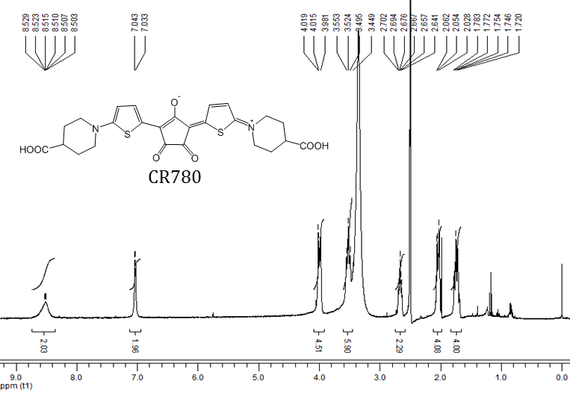
Fig. S2 ¹H NMR (500 MHz, DMSO-d₆) of CR780.
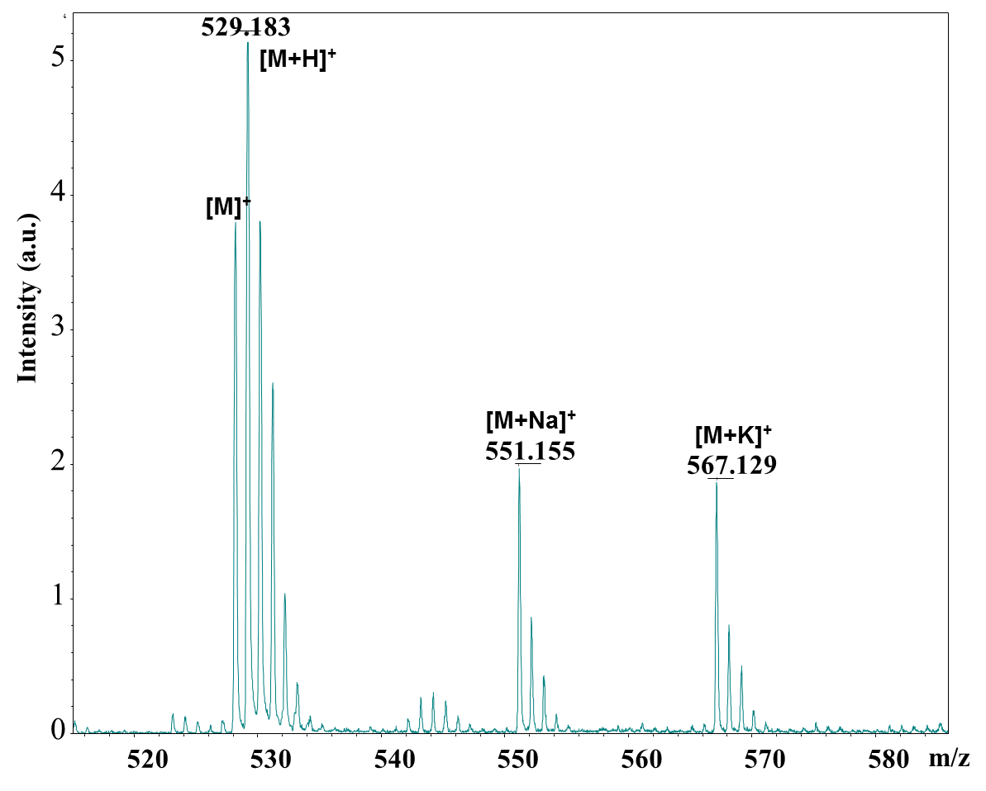
Fig. S3 MALDI-TOF mass spectrum of CR780.

Dye | Fluorescence Ex/Em (nm) | Molar absorption coefficient (M^{–1} cm^{–1}) in ethanol | Quantum yield in ethanol
CR780 | 780/800 | 3.4·10⁵ at 780 nm | 0.006
ICG | 780/810 | 2.1·10⁵ at 780 nm | 0.05
IRDye800CW | 780/800 | 2.54·10⁵ at 780 nm | 0.125
IR780 iodide | 780/800 | 2.8·10⁵ at 780 nm | 0.081
IR820 | 820/835 | 3.03·10⁵ at 820 nm | 0.024
Table S1 Photo-physical properties of CR780, ICG, IRDye800CW, IR780 iodide, and IR820, measured in ethanol.

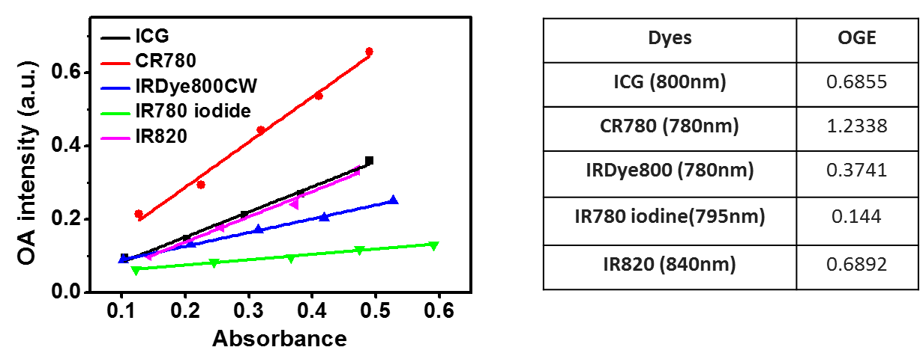
Fig. S4 OGE of ICG at 800 nm, CR780 at 780 nm, IRDye800CW at 780 nm, IR780 iodide at 795 nm, and IR820 at 840 nm. All the dyes were measured in 10% FBS.

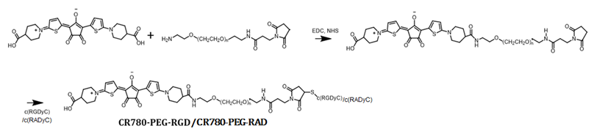
Fig. S5 Schematic for synthesizing CR780-PEG-RAD, and CR780-PEG-RGD.

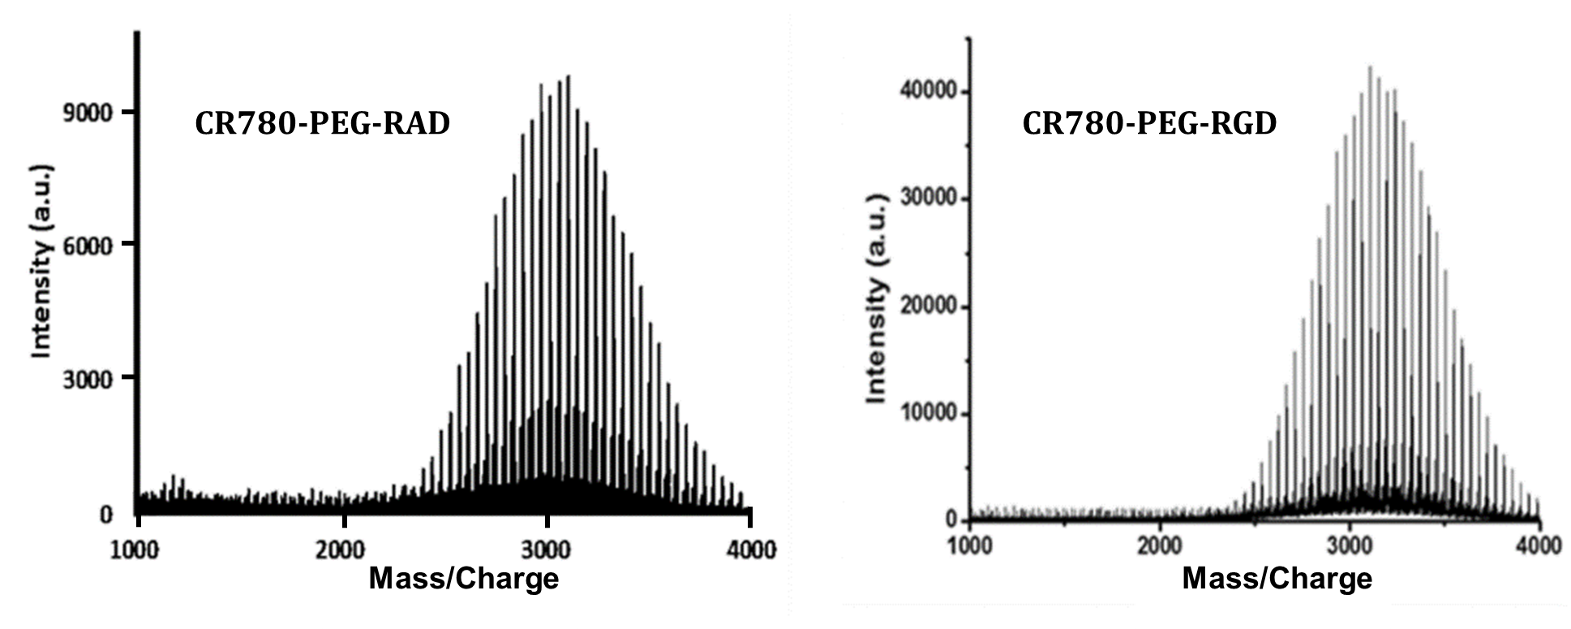
Fig. S6 MALDI-TOF analyses of CR780-PEG-RAD, and CR780-PEG-RGD.

Fig. S7 DLS analysis of CR780RGD-NPs.
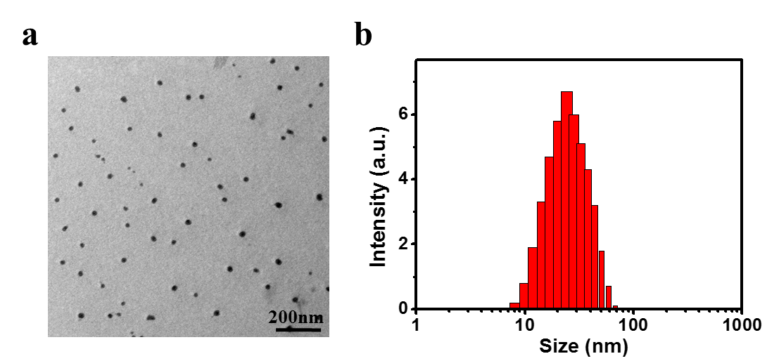
Fig. S8 (a) TEM images and (b) DLS analysis of CR780RAD-NPs.

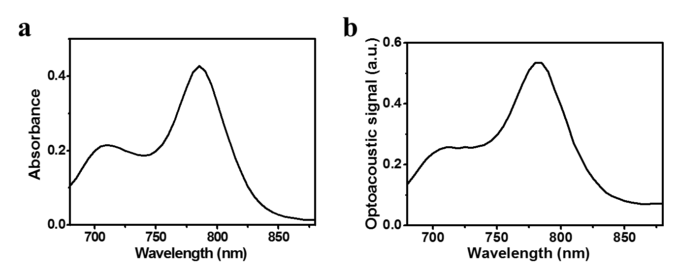
Fig. S9 (a) Optical spectrum and (b) optoacoustic spectrum of CR780RAD-NPs.
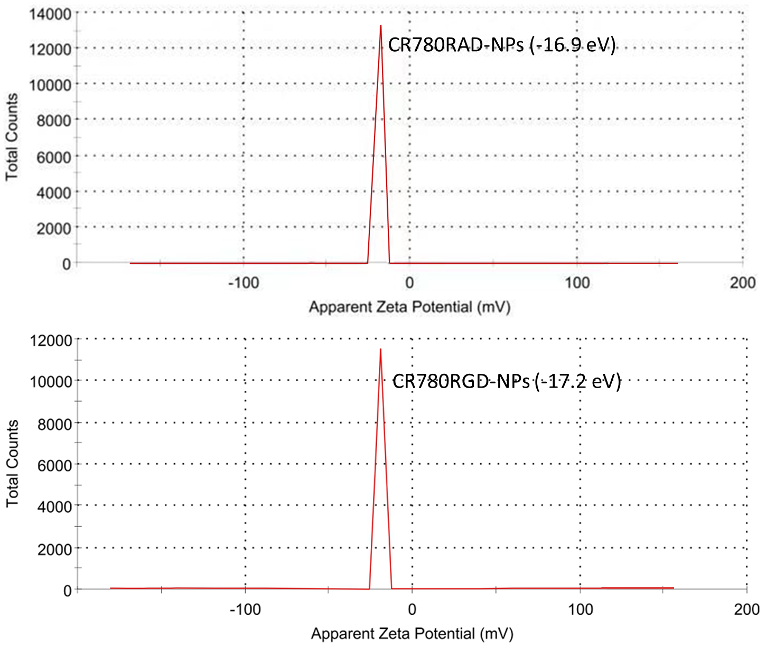
Fig. S10 Zeta potential of CR780RAD-NPs and CR780RGD-NPs.
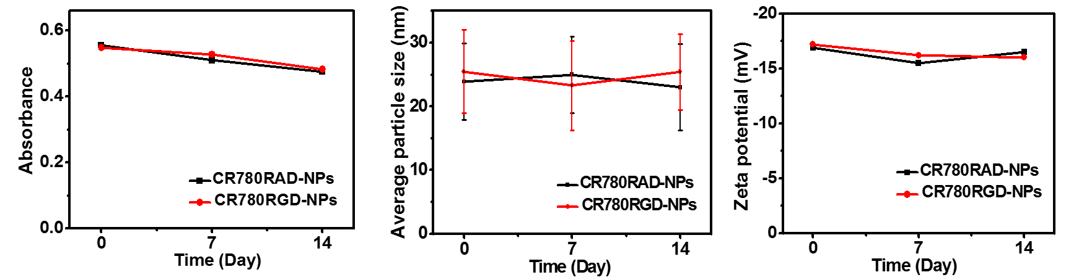
Fig. S11 Absorption intensity, average particle size, and zeta potential of CR780RAD-NPs and CR780RGD-NPs in water over 14 days.
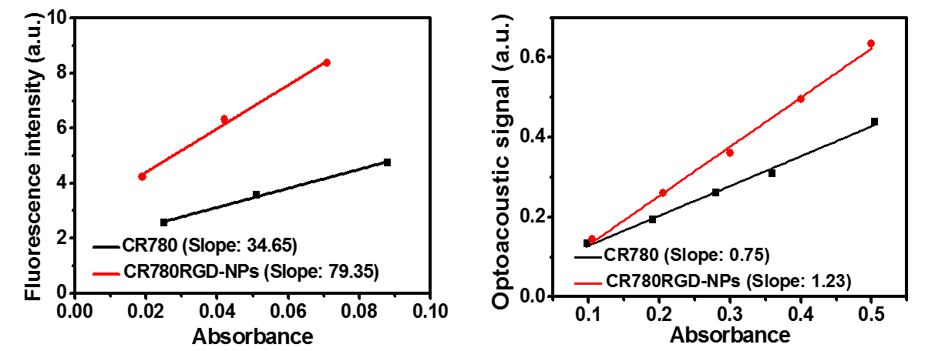
Fig. S12 Fluorescent and optoacoustic signal intensities of CR780 and CR780RGD-NPs at different concentration in the water phase.
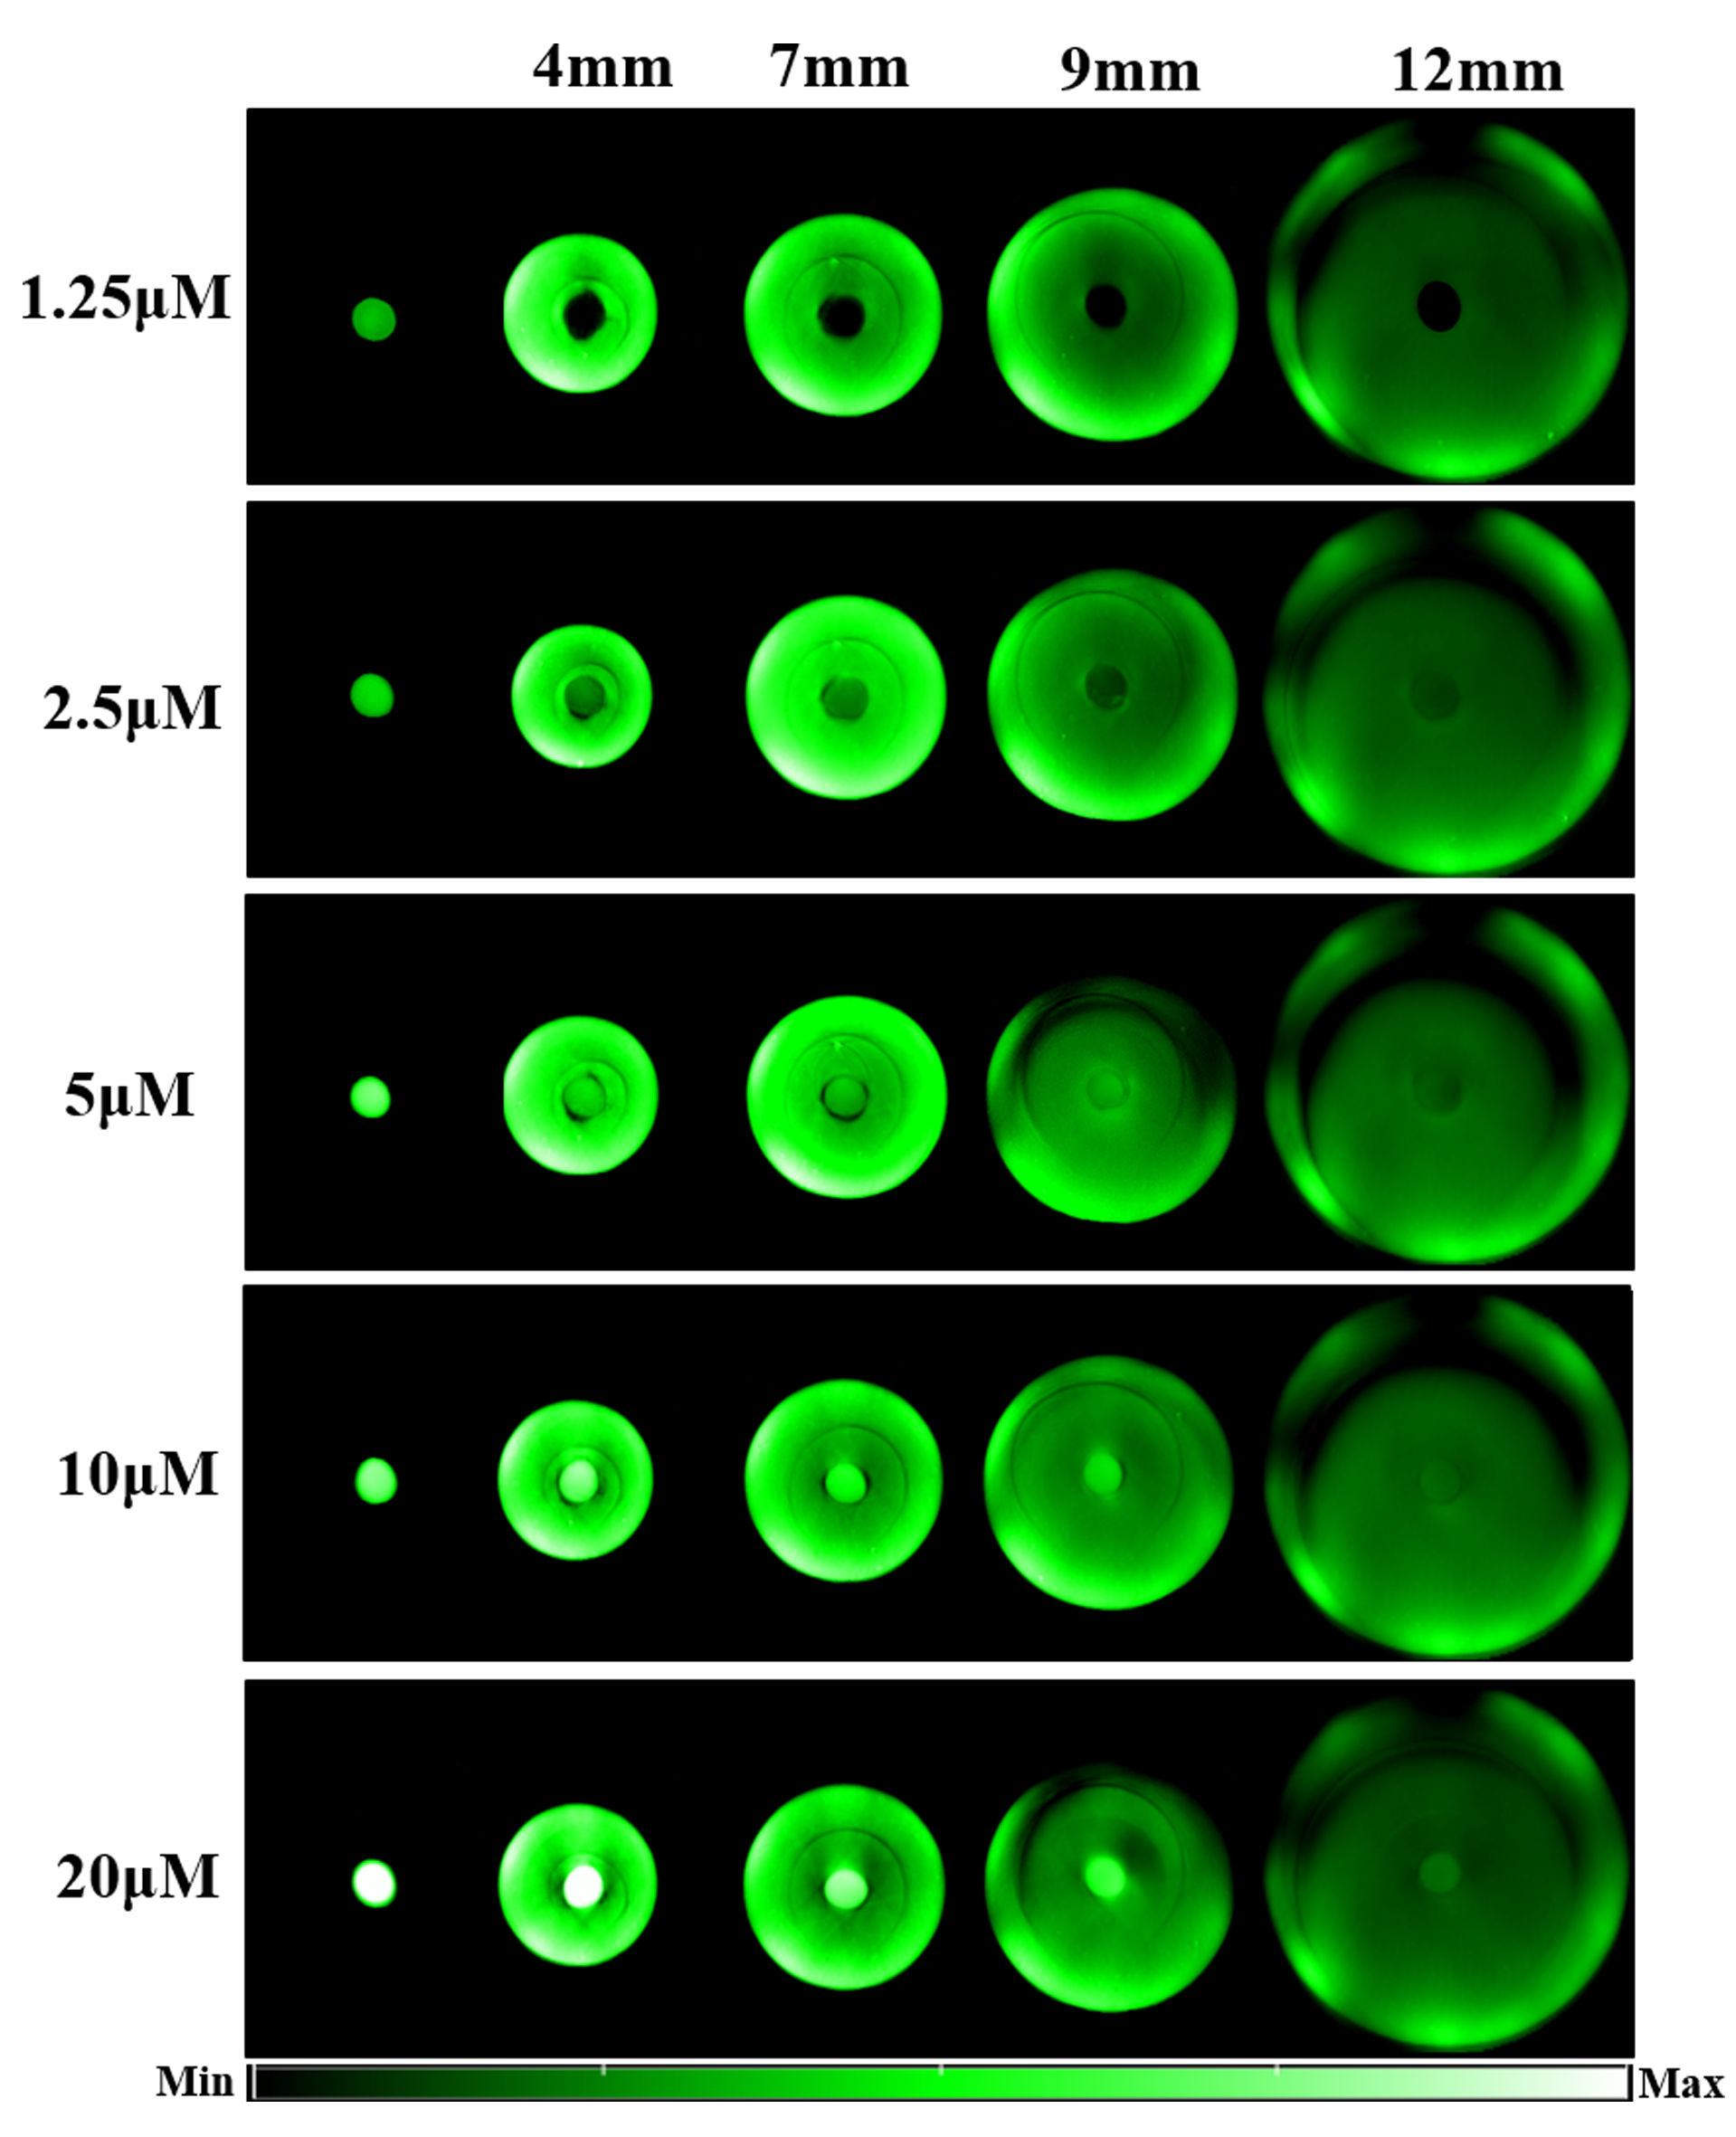
Fig. S13 Optoacoustic imaging of tissue-mimicking phantoms of increasing thickness containing different concentrations of CR780RGD-NPs at 780 nm.
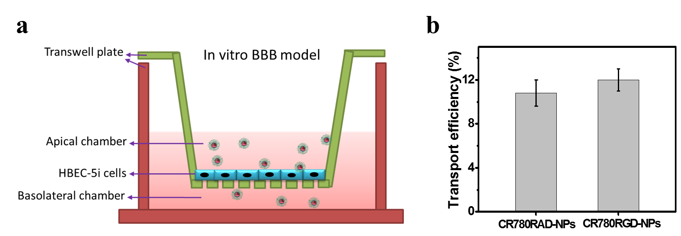
Fig. S14 (a) Schematic overview of the in vitro BBB model and BBB penetration capability of nanoparticles. (b) Transport efficiency of CR780-derived nanoparticles (50 μM) across the BBB model in vitro at the 4-hour time point.

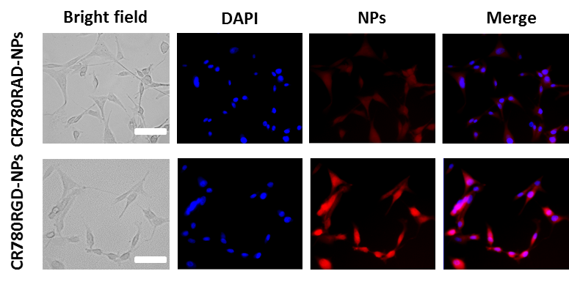
Fig. S15 Fluorescence images of U87MG cells after 4 h of treatment with CR780RAD-NPs, or CR780RGD-NPs. Blue color: DAPI staining, red color: nanoparticles fluorescence. Scale bar, 50 μm.
Fig. S16 Viability of U87MG cells incubated with different concentrations of croconaine-based nanoparticles for 24 h.

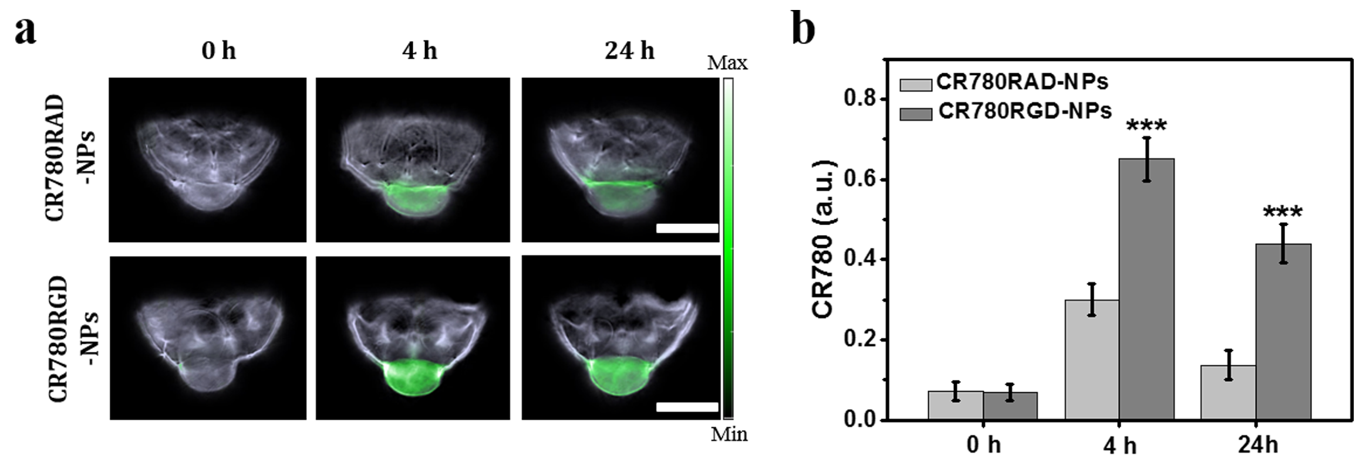
Fig. S17 (a) Unmixed MSOT imaging of mice bearing subcutaneous U87MG tumors after intravenous injection of non-targeting CR780RAD-NPs or tumor-targeting CR780RGD-NPs. Scale bar, 5 mm. (b) CR780 concentrations in the tumors were measured over time. ***p < 0.001.
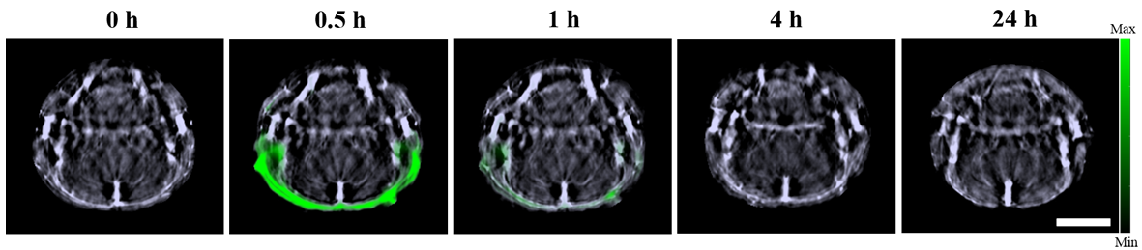
Fig. S18 In vivo optoacoustic imaging of a normal murine brain using 100 μL CR780RGD-NPs (1 mM). Scale bar, 5 mm.
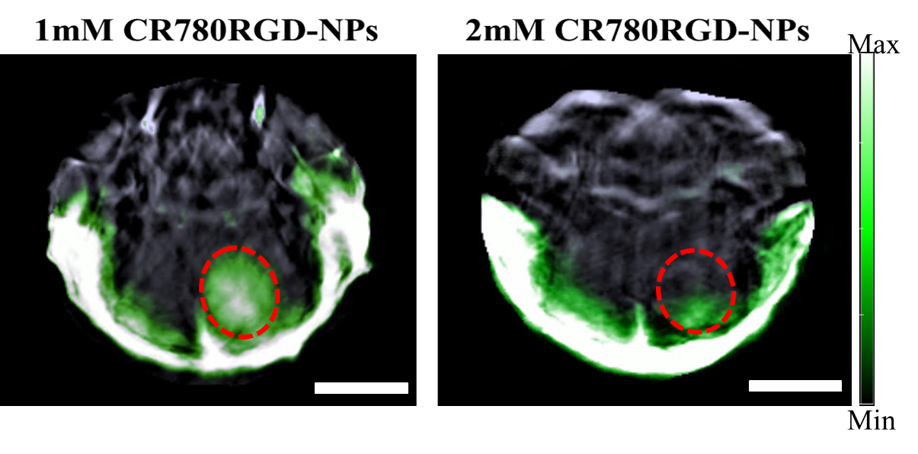
Fig. S19 Representative unmixed image of brain tumors 4 h post-injection of CR780RGD-NPs (1 mM or 2 mM). Signals are shown for the whole mouse head. Scale bar, 5 mm.
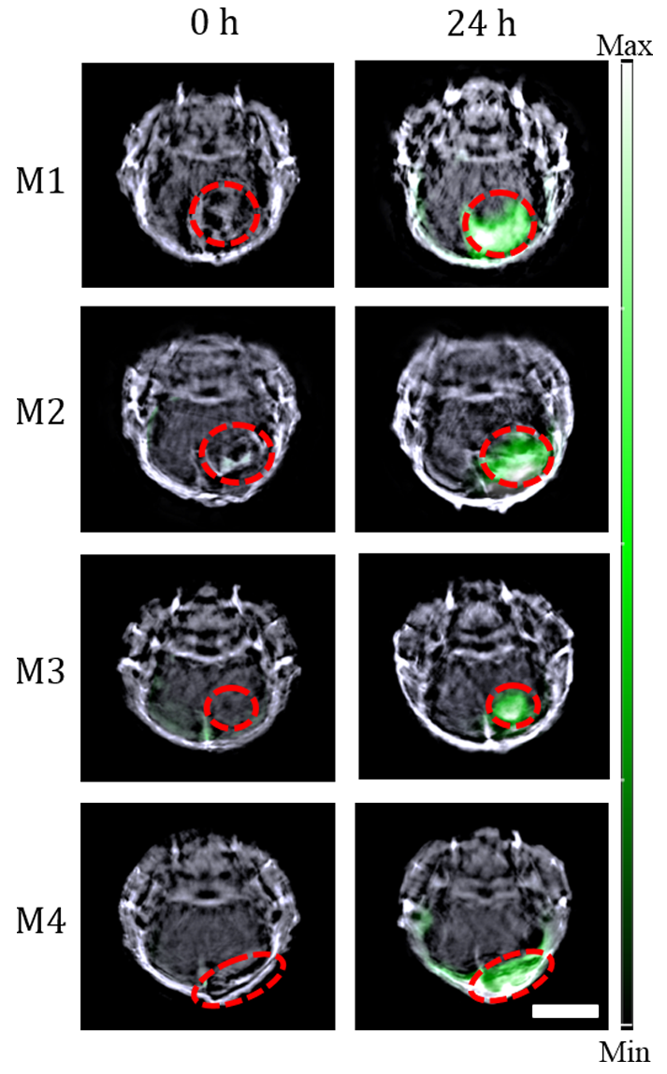
Fig. S20 Unmixed MSOT imaging of orthotopic brain tumors in mice after intravenous injection of CR780RGD-NPs (Scale bar, 5 mm). These mice (M1-M4) were different from the mice shown in Figure 3. Signals are shown only for the brain region.
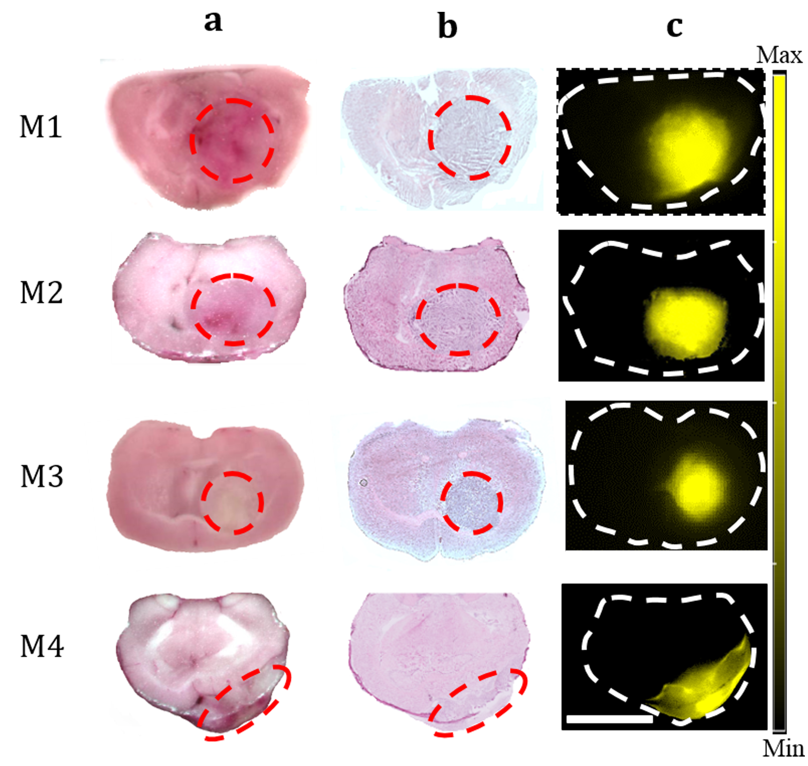
Fig. S21 (a, b) Bright field and H&E staining of brain slices. (c) Fluorescence imaging of isolated brain slices, showing the presence of CR780RGD-NPs. These results were obtained from four animals (M1-M4). Scale bar, 5 mm.
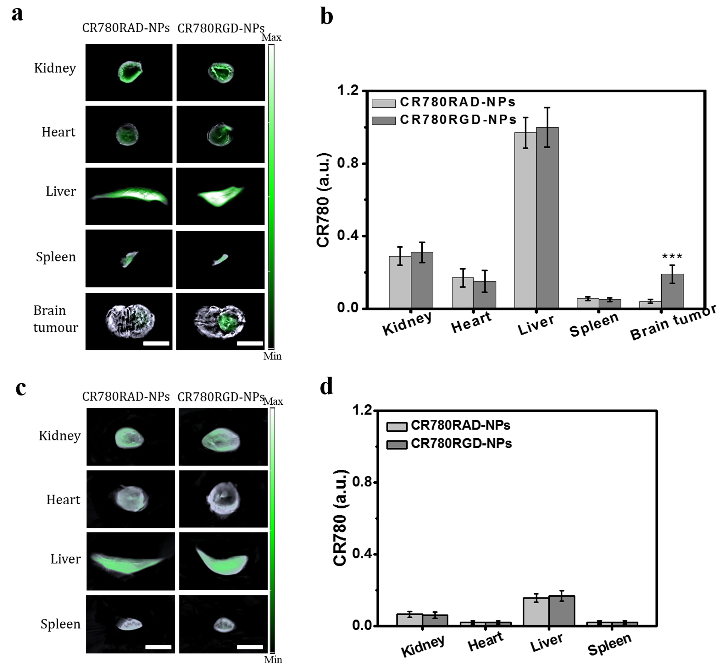
Fig. S22 Optoacoustic coronal plane images and optoacoustic signal intensity of major organs after treatment with 100 μL of CR780RAD-NPs (1 mM) or CR780RGD-NPs (1 mM) on day 1 (a, b) and day 7 post-injection (c, d). Scale bar, 5 mm. (***p < 0.001)
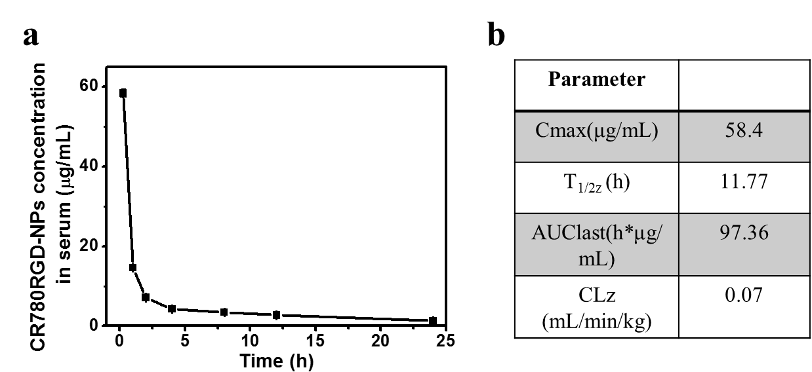
Fig. S23 (a) Blood CR780RGD-NPs concentration vs. time curve in healthy mice intravenously injected with 100 μL of CR780RGD-NPs (1 mM). (b) Pharmacokinetic parameters of CR780RGD-NPs intravenously administered to the healthy mice in (a). (C_{max}, peak concentration; T1/2z, elimination half life; AUC, area under the curve; Clz, clearance rate).

