Supplementary Information for

Non-enzymatic lipid peroxidation initiated by photodynamic therapy drives a distinct ferroptosis-like cell death pathway

Sufang Shui^{1,2}, Zenglu Zhao^{1,2}, Hao Wang^{1,2}, Marcus Conrad^{3,4}, Guoquan Liu^{1,2 *}

¹ State Key Laboratory of Natural and Biomimetic Drugs, School of Pharmaceutical Sciences, Peking University, Beijing, China
² Department of Chemical Biology, School of Pharmaceutical Sciences, Peking University, Beijing, China
² Institute of Metabolism and Cell Death, Helmholtz Zentrum München, Neuherberg, Germany
³ Pirogov Russian National Research Medical University, Moscow, Russia
* Corresponding author, email: guoquanliu@bjmu.edu.cn

a）
b)
c)

d)

e)

Supplementary Figure S1. a) Cleaved caspase-3 protein expressions in low- and medium-dose HYP after irradiation. STS (Staurosporine) is a typical apoptosis activator; b) DMSO or STS induced cell deaths in A549 cells revealed by ﬂow cytometry (50 nM, 16h); c) The dose-dependent effect of Fer-1 on cell death triggered under HYP-PDT conditions (2µM-2min) in A549 cells. d) Hochest 33342 staining for the nucleus in A549 cells treated with PDT in different conditions. e) TEM of A549 cells treated with DMSO (for 8 h), or RSL3 (10 µM, for 8 h), or PDT (2µM-2min, 8 h after), or PDT (10µM-2min, 0.5 h after). The double arrows represent the normal mitochondria, and the single arrow represents the compressed mitochondria. Cell viability was assessed 24 h after PDT. Data are plotted as the mean ± s.d., n= 3.

a)
b)
c)
d)
e)
Supplementary Figure S2. Cells in a)-e) were treated with 10 µM HYP-PDT and multi-concentrations of inhibitors (Fer-1, Lip-1, Nec-1, 3-MA, ZVF). Experiments were performed in triplicate with biologically independent samples. Data were plotted as the mean ± s.d., n=3 biologically independent samples. All P values were calculated using a two-way ANOVA.

e)
d)
c)

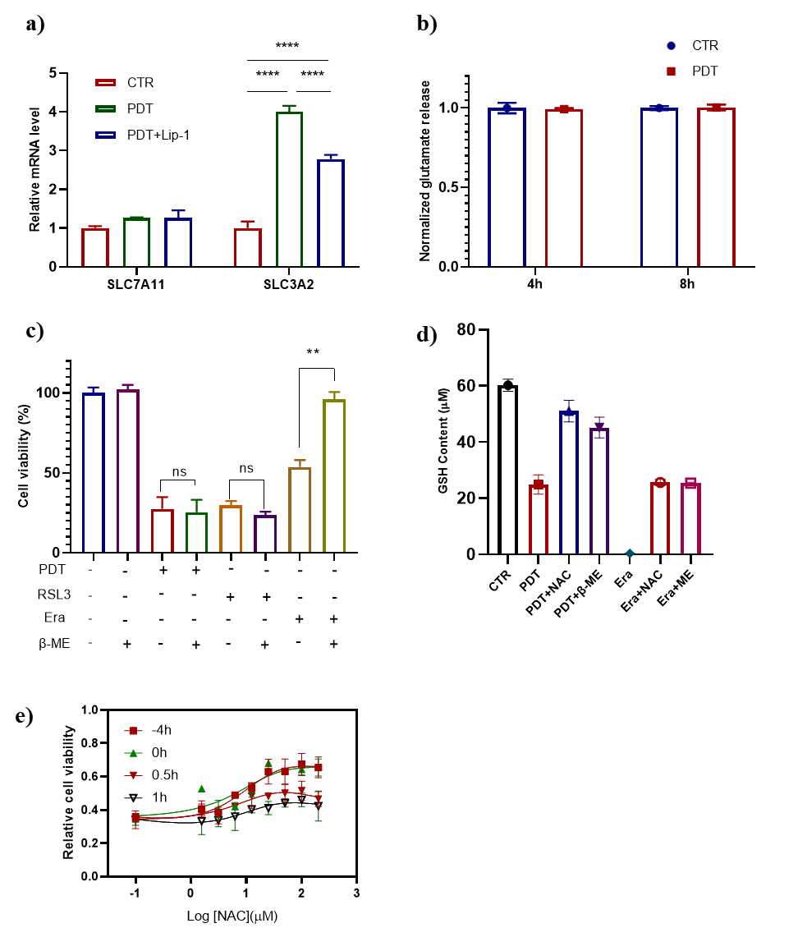
Supplementary Figure S3. a), mRNA levels of SLC3A2 and SLC7A11 in A549 cells 4 h after PDT treatment. Lip-1concentration is 8 μM. b), Normalized glutamate release in cells treated with PDT measured by LC/MS after irradiation for 4h or 8h. Data were processed according to the chromatographic peak area. c), Effect of β –ME (100 μM) on cell death triggered by PDT, or RSL3 (10 μM), or erastin (15 μM). d), Changes of GSH contents in cells treated with HYP-PDT or erastin (Era) and the related inhibitors (β-mercaptoethanol, β-Me; n-acetylcysteine, NAC). e), Effect of NAC on cell death trigger by PDT (“-4h” means pretreated with NAC 4h before irradiation; “0h” means NAC was added during irradiation; “0.5-1h” means NAC was added 0.5 or 1h after irradiation). Cell viability is assessed 24 h after treatment. Data are plotted as the mean ± s.d., n= 3 biologically independent samples and analyzed using a two-way ANOVA. *p < 0.05, **p < 0.01, ***p < 0.001 and ****p < 0.0001.

Supplementary Figure S4. Effect of PDT on H₂DCFDA-sensitive ROS production in A549 cells treated in different time.
b)
a)

Supplementary Figure S5. a) EPR spectrums for singlet oxygen (¹O₂) generated by PDT and declined to a lower level by co-incubated with GSH using 4-OH TEMP (200 mM), 2 μM HYP with/without 40 µM GSH; b) EPR intensity generated ¹O2 in vitro for PDT with prolonged irradiation and captured by 200 mM 4-OH-TEMP.

a)
c)
b)
Supplementary Figure S6. Gpx4 expressions in PDT (2 µM-2min, 8 hr), RSL3 (10 µM, 8 hr), and erastin (15 µM, 8 hr) treated cells. a) relative mRNA expression; b) Gpx4 protein expression measured by western blot; c) Time dependence of Gpx4 protein expression after PDT. Note: CTR means cells were treated with HYP but with no irradiation. CTR means cells were treated with DMSO.
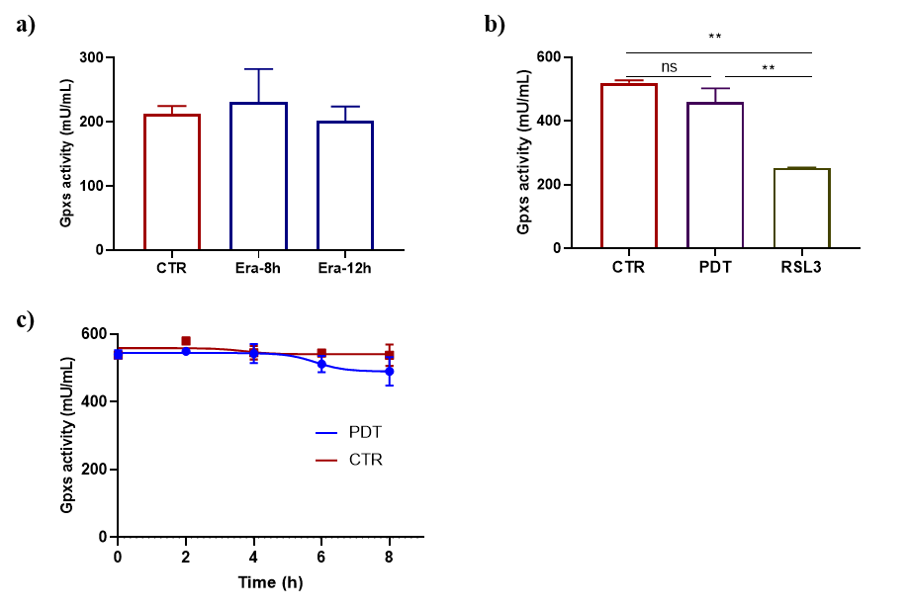

Supplementary Figure S7. a) Effect of erastin on the in vitro activity of GPX4 from treated A549 cells. Cells were treated with DMSO, erastin (15 μM) for 8 h or 12h. b) Effect of RSL3 (10 μM, for 8 h) or PDT (8 h after) on GPXs activity in the A549 cell lysates. c) Time dependent inhibition of GPX4 after irradiation in cells treated with 2 µM HYP. Cells were lysed and lysates were treated according to the Gpxs activity assay kit. Data were plotted as the mean ± s.d., n=3 biologically independent samples. All P values were calculated using a two-way ANOVA. *p < 0.05 , **p < 0.01, ***p < 0.001.

b)
a)
Supplementary Figure S8. a) Effects of different concentrations of RSL3 combined with 2 µM HYP on cell survival. b) Effects of cell viability by combination of PDT and erastin (3 µM, 5 µM, 10 µM). Viability was measured 24 h after compound addition using cck-8. Experiments were performed in biological triplicate. Data are plotted as the mean ± s.d..

Supplementary Figure S9. mRNA expression in HT1080 cells with or without siRNA alox15 intervening. Data were plotted as the mean ± s.d., n=3 biologically independent samples. All P values were calculated using a two-way ANOVA. *p < 0.05, **p < 0.01, ***p < 0.001.

Supplementary Figure S10. Dose-dependent cytotoxicity of erastin (Era) in WT (Acsl4^{+/+}) and Acsl4 KO (Acsl4^{−/−}) Pfa1 cells for 24 h. Data were plotted as the mean ± s.d., n=3 biologically independent samples. b, Improved cell viability when cotreated with RSL3 and Lip-1 or siRNA. All P values were calculated using a two-way ANOVA. *p < 0.05, **p < 0.01, ***p < 0.001.

Overlay
Tracker
HYP
Nucleus
Mitochondria
Endoplasmic
Reticulum
Membrane
Lysosome
Golgi apparatus

Manders' Colocalization Coefficients (MCC) of HYP and organelles

MCC | Membrane | Nuclear | Mitochondria | Endoplasmic Reticulum | Lysosome | Golgi Apparatus
M1 | 0.444 | 0.082 | 0.153 | 0.46 | 0.343 | 0.586
M2 | 0.314 | 0.113 | 0.239 | 0.798 | 0.921 | 0.88
Note: M1: Fraction of HYP overlapping with organelles; M2: Fraction of organelles overlapping with HYP.

Supplementary Figure S11. CLSM imaging of A549 cells stained with Hoechst 33324, mito-Tracker, Dio, ER-Tracker, lyso-Tracker, and golgi-Tracker, and the corresponding colocalization coefficients.

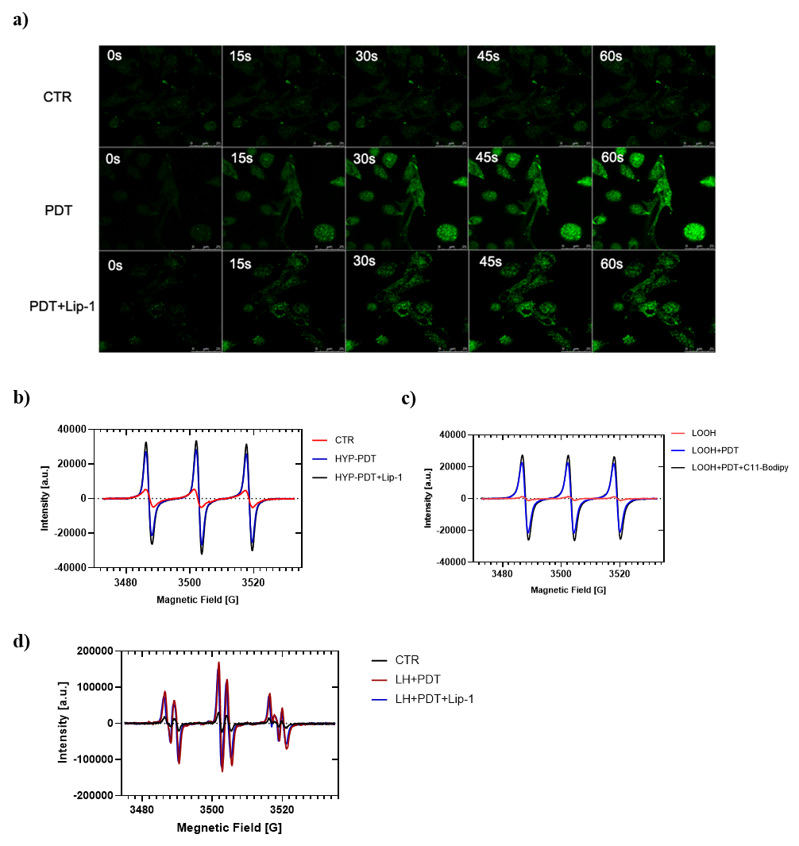

Supplementary Figure S12. a) lipid ROS were directly generated during photoexcitation measured by CLSM. Images show the changes in fluorescence intensity at different time; b) EPR spectrums for ¹O₂ generated by PDT and had no changes by co-incubated with 20 µM Lip-1 using 4-OH TEMP (200 mM), 2 μM HYP ; c) EPR spectrums for ¹O₂ in the mixture of 20 µM HYP and 6 mM oxidized linoleic acid (LOOH) with or without 10 µM C11-Bodipy were measured by using 200 mM 4-OH TEMPO after irradiation; d) Effects of Lip-1 (20 μM) on the lipid ROS detected by EPR spectra in the mixture of 20 µM HYP, 1 mM FeSO₄·7H₂O, 0.1 mM DTPA, 400 mM POBN and 6 mM linoleic acid (LH) after irradiation.

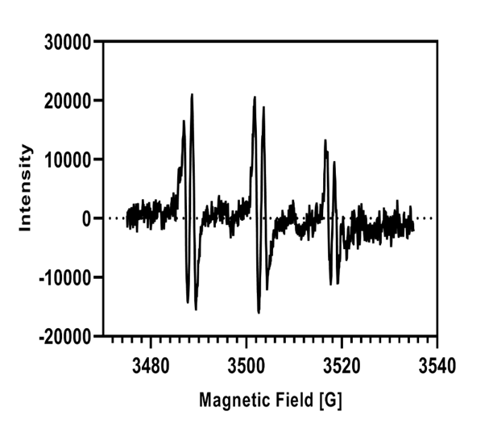
d)
c)
a)
b)

Supplementary Figure S13. a) Typical EPR spectrum of lipid radicals induced by PDT in extracted A549 cells membrane using POBN (40 mM), with 50 μM FeSO4 and 0.1 mM DTPA; b) Increase of EPR intensity of generated lipid radicals for PDT and linoleic acid (LH) mixture and captured by 40 mM POBN; c) Increase of EPR intensity of generated lipid radicals for PDT and A549 membrane (Mem.) mixture and captured by 40 mM POBN; d) Increase of EPR intensity of generated lipid radicals for PDT and erythrocyte membrane (RBCM) mixture and captured by 40 mM POBN.

PE O-18:0_22:6;4O
PE O-18:0_22:5;O
PE 18:1_20:3;O
PE O-18:0_20:5;3O
PE O-18:0_22:5;2O
PE O-18:1_22:5;O
Erastin induced lipid peroxides in ferroptosis;
a)
b)
PE O-16:0_22:6;O
PE O-16:0_22:6;4O
PE O-18:0_20:5;4O
PE O-16:0_20:5;3O
PE O-18:1_22:6;2O
PE O-16:0_20:5;4O
PE O-16:0_20:4;3O
PE O-18:1_20:6;O
PE O-16:0_20:6;O
PE O-16:0_22:6;O
PE O-18:0_22:6;4O
PE O-16:0_20:5;O
PE O-16:0_22:6;3O
PE O-18:0_20:5;3O
PE O-16:0_22:5;2O
PE O-18:0_22:5;2O
PE O-16:0_20:4;2O
PE O-16:0_18:1;3O
PE O-18:0_22:5;2O
PE O-18:1_18:1;3O
PE O-16:0_22:5;2O
PDT-induced lipid peroxides (21 PE)

c)
Supplementary Figure S14. a) Oxidized Lipids in A549 cells treated with Erastin (20 μM); b) Oxidized Lipids in A549 cells treated with 2 μM HYP-PDT; c) Upregulated oxidized Lipids in A549 cells treated with PDT or erastin.

b)
a)
Supplementary Figure S15. Cells were pretreated with different concentrations of TRO (a) or ROSI (b) in 2 µM HYP-PDT. Experiments were performed in triplicate with biologically independent samples. Data were plotted as the mean ± s.d., n=3 biologically independent samples. All P values were calculated using a two-way ANOVA.
a)
b)
Supplementary Figure S16. a) Cells were pretreated with multi-concentrations of DFO for 12 or 24h before 2 µM HYP-PDT. b) Effects of DFO on erastin-treated cells. Experiments were performed in triplicate with biologically independent samples. Data were plotted as the mean ± s.d., n=3 biologically independent samples.

b)
a)
c)

Before irradiation
After irradiation

Supplementary Figure S17. Mitochondrial membrane potential was measured by Rh123. a) A549 cells were treated with 2 µM HYP-PDT (with or without Lip-1, 8 µM) for 8h; b) A549 cells were treated with 125 nM HYP-PDT for 8, 12, 14h; and 500 nM Rh123 was added in a) and b) for 30 min before detecting, then live cells were measured by flow cytometry and mean fluorescence was calculated. c) MitoSOX (5 µM) and MitoTracker Green (0.2 µM) staining for measurement of mitochondrial ROS formation and subsequently observed by confocal laser scan microscope (CLSM) in A549 cells. Arrows point to the mitochondria where no fluorescence of ROS from MitoSOX is observed. HYP emits red fluorescence but it does not stain the mitochondria. Data in a-b were plotted as the mean ± s.d., n=3 biologically independent samples.

Supplementary Figure S18. Cells treated with 2 µM HYP-PDT and multi-concentrations Mito-tempol. Experiments were performed in triplicate with biologically independent samples. Data were plotted as the mean ± s.d., n=3 biologically independent samples.

c)

b)
a)
c)

Supplementary Figure S19. a) mRNA expression in A549 cells with or without siRNA MCU intervening for 24h. b) WB of FTMT after siRNA. No.3 was chosen for further experiments. c) FTMT siRNA partially rescued the cell death. Data were plotted as the mean ± s.d., n=3 biologically independent samples. All P values were calculated using a two-way ANOVA. *p < 0.05, **p < 0.01, ***p < 0.001.

Supplementary Figure S20. Effect ferroptosis-suppressing compounds (30 µM Fer-1, 8 µM Lip-1, 100 µM DFO, 100 µM TRO) on various cell lines treated with Rose Bengal (20 µM-15 min) for 24 h. The relative cell viability is represented by color. Data were plotted as the mean ± s.d., n=3 biologically independent samples. All P values were calculated using a two-way ANOVA. . *p < 0.05 , **p < 0.01, ***p < 0.001 and ****p < 0.0001.

a)
b)
Supplementary Figure S21. a) The protein expression for Acsl4 and Gpx4 in parental or erastin-resistant A549 cells (Era-A549). b) The dose-dependent cytotoxicity of RSL3 on parental or erastin-resistant A549 cells (Era-A549). Data were plotted as the mean ± s.d., n=3 biologically independent samples.

Supplementary Figure S22. The dark cytotoxicity of HYP or VPF. Data were plotted as the mean ± s.d., n=3 biologically independent samples.

Supplementary Figure S23. Effects of Verteporfin on ACSL4 expression in A549 cells (detected 12 h after PDT treatment).

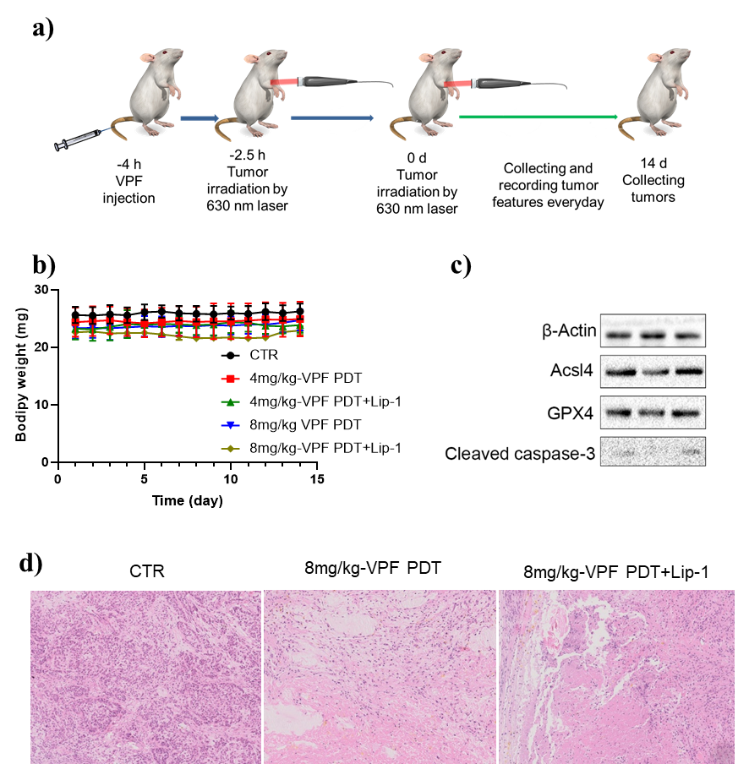

Supplementary Figure S24. VPF PDT treatment in A549 subcutaneous-xenografted mice. a) Mice with well-established A549 subcutaneous tumors were distributed into different groups and treated by a single intravenous injection of verteporfin or normal saline (control). Mice were then maintained in the dark or exposed to NIR laser (660 nm) irradiation for twice. b) Changes in body weight during the course of different treatments. c) Expression of ACSL4 and GPX4 by western blot analysis in tumors 14 d after PDT with 4 mg/kg veterporfin. d) Histological examination of tumors by H&E staining. Data were plotted as the mean ± s.d., n=3 biologically independent samples.

Table S1 Summary of the potential metabolite markers revealed in HYP-PDT vs. HYP-darkness.
Metabolite name | Average Rt (min) | Average Mz | Adduct type | Formula | Normalized to HYP-darkness | FC
Cer 18:0;2O/16:0 | 10.8 | 538.5208 | [M-H]- | C34H69NO3 | ↑ | 7.0
Cer 18:1;2O/16:0 | 10.521 | 536.5047 | [M-H]- | C34H67NO3 | ↑ | 2.2
Cer 18:0;2O/22:0 | 12.085 | 668.6223 | [M+HCOO]- | C40H81NO3 | ↑ | 5.3
Cer 18:0;2O/22:1 | 11.664 | 666.6038 | [M+HCOO]- | C40H79NO3 | ↑ | 6.6
Cer 18:1;2O/22:0 | 11.954 | 666.6039 | [M+HCOO]- | C40H79NO3 | ↑ | 1.7
Cer 18:2;2O/22:0 | 11.539 | 664.5899 | [M+HCOO]- | C40H77NO3 | ↑ | 2.4
Cer 18:0;2O/24:0 | 12.439 | 696.6505 | [M+HCOO]- | C42H85NO3 | ↑ | 1.8
Cer 18:0;2O/24:1 | 12.025 | 694.6362 | [M+HCOO]- | C42H83NO3 | ↑ | 3.9
Cer 18:1;2O/24:0 | 12.312 | 694.6366 | [M+HCOO]- | C42H83NO3 | ↓ | 0.6
Cer 18:1;2O/24:1 | 11.91 | 692.6212 | [M+HCOO]- | C42H81NO3 | ↑ | 1.3
Cer 18:2;2O/24:1 | 11.537 | 690.6055 | [M+HCOO]- | C42H79NO3 | ↑ | 1.6
Cer 18:0;2O/26:1 | 12.372 | 722.6683 | [M+HCOO]- | C44H87NO3 | ↑ | 5.4
FA 18:0 | 4.878 | 283.2637 | [M-H]- | C18H36O2 | ↓ | 0.6
FA 18:1 | 1.727 | 281.2479 | [M-H]- | C18H34O2 | ↓ | 0.2
FA 28:7 | 5.346 | 409.3106 | [M-H]- | C28H42O2 | ↑ | 3.1
FA 40:5 | 10.738 | 581.5265 | [M-H]- | C40H70O2 | ↓ | 0.6
FA 42:5 | 11.271 | 609.5573 | [M-H]- | C42H74O2 | ↓ | 0.5
FA 44:5 | 11.707 | 637.5904 | [M-H]- | C44H78O2 | ↓ | 0.5
HexCer 18:1;2O/16:0 | 9.482 | 744.5621 | [M+HCOO]- | C40H77NO8 | ↑ | 6.2
HexCer 18:0;2O/20:0 | 11.418 | 802.6439 | [M+HCOO]- | C44H87NO8 | ↑ | 50.6
HexCer 38:1;2O | 11.266 | 800.627 | [M+HCOO]- | C44H85NO8 | ↑ | 48.2
HexCer 18:0;2O/22:0 | 11.786 | 830.6742 | [M+HCOO]- | C46H91NO8 | ↑ | 13.2
HexCer 18:0;2O/22:1 | 11.374 | 828.6602 | [M+HCOO]- | C46H89NO8 | ↑ | 77.7
HexCer 18:1;2O/22:0 | 11.649 | 828.6597 | [M+HCOO]- | C46H89NO8 | ↑ | 5.0
HexCer 40:2;2O | 11.223 | 826.6401 | [M+HCOO]- | C46H87NO8 | ↑ | 34.5
HexCer 18:1;2O/23:0 | 11.834 | 842.6763 | [M+HCOO]- | C47H91NO8 | ↑ | 1.8
HexCer 41:2;2O | 11.408 | 840.6584 | [M+HCOO]- | C47H89NO8 | ↑ | 6.7
HexCer 18:0;2O/24:0 | 12.141 | 858.7039 | [M+HCOO]- | C48H95NO8 | ↑ | 5.1
HexCer 18:0;2O/24:1 | 11.736 | 856.6877 | [M+HCOO]- | C48H93NO8 | ↑ | 14.9
HexCer 18:1;2O/24:0 | 12.001 | 810.6863 | [M-H]- | C48H93NO8 | ↑ | 1.5
HexCer 18:1;2O/24:1 | 11.605 | 808.668 | [M-H]- | C48H91NO8 | ↑ | 4.2
HexCer 42:3;2O | 11.256 | 852.6574 | [M+HCOO]- | C48H89NO8 | ↑ | 11.6
HexCer 43:1;2O | 12.176 | 870.7075 | [M+HCOO]- | C49H95NO8 | ↑ | 1.9
HexCer 43:2;2O | 11.776 | 868.6905 | [M+HCOO]- | C49H93NO8 | ↑ | 3.9
HexCer 44:0;2O | 12.467 | 886.7365 | [M+HCOO]- | C50H99NO8 | ↑ | 17.4
HexCer 18:0;2O/26:1 | 12.076 | 884.7201 | [M+HCOO]- | C50H97NO8 | ↑ | 19.0
HexCer 18:1;2O/26:0 | 12.348 | 884.7197 | [M+HCOO]- | C50H97NO8 | ↑ | 3.3
HexCer 18:1;2O/26:1 | 11.954 | 882.7031 | [M+HCOO]- | C50H95NO8 | ↑ | 4.8
HexCer 44:3;2O | 11.614 | 880.6871 | [M+HCOO]- | C50H93NO8 | ↑ | 12.2
HexCer 44:4;2O | 11.331 | 878.6678 | [M+HCOO]- | C50H91NO8 | ↑ | 248.9
LPC 16:0 | 1.829 | 540.3311 | [M+HCOO]- | C24H50NO7P | ↓ | 0.5
LPC 16:1 | 1.428 | 538.3138 | [M+HCOO]- | C24H48NO7P | ↓ | 0.5
LPC 18:0 | 2.53 | 568.3638 | [M+HCOO]- | C26H54NO7P | ↓ | 0.7
LPC 18:1 | 1.871 | 566.3472 | [M+HCOO]- | C26H52NO7P | ↓ | 0.4
LPC 18:2 | 1.499 | 564.3303 | [M+HCOO]- | C26H50NO7P | ↓ | 0.5
LPC O-16:0 | 2.123 | 526.3532 | [M+HCOO]- | C24H52NO6P | ↓ | 0.7
LPE 16:0 | 1.912 | 452.2773 | [M-H]- | C21H44NO7P | ↓ | 0.5
LPE O-16:1 | 2.159 | 436.2836 | [M-H]- | C21H44NO6P | ↓ | 0.7
LPE O-18:1 | 3.034 | 464.3142 | [M-H]- | C23H48NO6P | ↓ | 0.8
LPE O-18:2 | 2.215 | 462.2994 | [M-H]- | C23H46NO6P | ↓ | 0.7
LPE O-19:0 | 2.519 | 480.3455 | [M-H]- | C24H52NO6P | ↓ | 0.6
LPG 22:6 | 1.297 | 555.2731 | [M-H]- | C28H45O9P | ↑ | 5.5
LPS 18:0 | 2.18 | 524.2978 | [M-H]- | C24H48NO9P | ↓ | 0.4
LPS 18:1 | 1.659 | 522.2832 | [M-H]- | C24H46NO9P | ↓ | 0.1
PA 14:0_16:0 | 8.771 | 619.4346 | [M-H]- | C33H65O8P | ↓ | 0.3
PA 16:0_16:0 | 10.37 | 647.4651 | [M-H]- | C35H69O8P | ↓ | 0.3
PA 16:0_16:1 | 8.867 | 645.4489 | [M-H]- | C35H67O8P | ↓ | 0.4
PA 16:0_18:1 | 10.399 | 673.4783 | [M-H]- | C37H71O8P | ↓ | 0.5
PC 14:0_14:0 | 7.266 | 722.4969 | [M+HCOO]- | C36H72NO8P | ↓ | 0.5
PC 14:0_16:0 | 8.94 | 750.5303 | [M+HCOO]- | C38H76NO8P | ↓ | 0.6
PC 14:0_16:1 | 7.373 | 748.5142 | [M+HCOO]- | C38H74NO8P | ↓ | 0.4
PC 16:0_16:0 | 10.524 | 778.562 | [M+HCOO]- | C40H80NO8P | ↓ | 0.5
PC 16:0_16:1 | 9.313 | 776.5434 | [M+HCOO]- | C40H78NO8P | ↓ | 0.8
PC 16:0_16:2 | 8.578 | 774.5265 | [M+HCOO]- | C40H76NO8P | ↓ | 0.5
PC 16:1_16:1 | 7.737 | 774.527 | [M+HCOO]- | C40H76NO8P | ↓ | 0.3
PC 16:0_17:1 | 9.844 | 790.5587 | [M+HCOO]- | C41H80NO8P | ↓ | 0.7
PC 17:0_16:1 | 11.252 | 790.5582 | [M+HCOO]- | C41H80NO8P | ↓ | 0.7
PC 16:1_17:1 | 8.325 | 788.5466 | [M+HCOO]- | C41H78NO8P | ↓ | 0.6
PC 16:0_18:0 | 11.11 | 806.5948 | [M+HCOO]- | C42H84NO8P | ↓ | 0.4
PC 16:0_18:1;O | 6.055 | 820.5718 | [M+HCOO]- | C42H82NO9P | ↓ | 0.4
PC 16:0_18:1 | 10.551 | 804.5757 | [M+HCOO]- | C42H82NO8P | ↓ | 0.9
PC 16:1_18:1 | 9.125 | 802.5585 | [M+HCOO]- | C42H80NO8P | ↓ | 0.8
PC 16:1_18:2 | 7.816 | 800.5435 | [M+HCOO]- | C42H78NO8P | ↓ | 0.5
PC 17:1_18:1 | 11.259 | 816.5785 | [M+HCOO]- | C43H82NO8P | ↓ | 0.7
PC 18:1_17:2 | 10.813 | 814.5531 | [M+HCOO]- | C43H80NO8P | ↓ | 0.8
PC 16:0_20:0 | 11.502 | 834.6268 | [M+HCOO]- | C44H88NO8P | ↓ | 0.4
PC 16:0_20:3 | 10.226 | 828.5772 | [M+HCOO]- | C44H82NO8P | ↓ | 0.4
PC 18:1_18:2 | 9.395 | 828.577 | [M+HCOO]- | C44H82NO8P | ↓ | 0.8
PC 16:0_20:4 | 9.051 | 826.5581 | [M+HCOO]- | C44H80NO8P | ↓ | 0.7
PC 16:1_20:3 | 8.23 | 826.559 | [M+HCOO]- | C44H80NO8P | ↓ | 0.4
PC 16:0_20:5 | 7.945 | 824.5466 | [M+HCOO]- | C44H78NO8P | ↓ | 0.4
PC 16:1_20:4 | 7.513 | 824.5468 | [M+HCOO]- | C44H78NO8P | ↓ | 0.5
PC 17:0_20:4 | 9.824 | 840.5703 | [M+HCOO]- | C45H82NO8P | ↓ | 0.6
PC 17:1_20:4 | 10.658 | 838.5605 | [M+HCOO]- | C45H80NO8P | ↓ | 0.7
PC 18:0_20:3 | 10.997 | 856.6068 | [M+HCOO]- | C46H86NO8P | ↓ | 0.7
PC 18:0_20:4 | 10.563 | 854.5911 | [M+HCOO]- | C46H84NO8P | ↓ | 0.8
PC 16:0_22:6 | 8.533 | 850.5638 | [M+HCOO]- | C46H80NO8P | ↓ | 0.3
PC 18:1_20:5 | 7.997 | 850.5574 | [M+HCOO]- | C46H80NO8P | ↓ | 0.5
PC 16:1_22:6 | 6.925 | 848.5443 | [M+HCOO]- | C46H78NO8P | ↓ | 0.5
PC 39:3 | 11.412 | 870.6287 | [M+HCOO]- | C47H88NO8P | ↓ | 204.8
PC 16:0_24:0 | 12.181 | 890.6831 | [M+HCOO]- | C48H96NO8P | ↓ | 0.4
PC 16:0_24:1 | 11.826 | 888.6674 | [M+HCOO]- | C48H94NO8P | ↓ | 0.5
PC 18:1_22:1 | 11.465 | 886.6519 | [M+HCOO]- | C48H92NO8P | ↓ | 0.8
PC 18:1_22:3 | 10.863 | 882.6255 | [M+HCOO]- | C48H88NO8P | ↑ | 1.4
PC 16:0_24:6 | 9.418 | 878.5938 | [M+HCOO]- | C48H84NO8P | ↓ | 0.7
PC 18:0_22:6 | 10.107 | 878.5932 | [M+HCOO]- | C48H84NO8P | ↓ | 0.6
PC 18:1_22:6 | 8.536 | 876.5779 | [M+HCOO]- | C48H82NO8P | ↓ | 0.6
PC 16:0_26:0 | 12.513 | 918.7157 | [M+HCOO]- | C50H100NO8P | ↓ | 0.4
PC 16:0_26:1 | 12.167 | 916.7011 | [M+HCOO]- | C50H98NO8P | ↓ | 0.5
PC 16:0_26:2 | 11.808 | 914.6865 | [M+HCOO]- | C50H96NO8P | ↓ | 0.6
PC 18:1_24:2 | 11.493 | 912.6688 | [M+HCOO]- | C50H94NO8P | ↓ | 0.8
PC 18:1_24:3 | 11.213 | 910.6511 | [M+HCOO]- | C50H92NO8P | ↓ | 0.8
PC 16:0_26:5 | 10.952 | 908.6438 | [M+HCOO]- | C50H90NO8P | ↓ | 0.8
PC 18:1_24:6 | 9.508 | 904.6068 | [M+HCOO]- | C50H86NO8P | ↓ | 0.8
PC 16:0_28:1 | 12.501 | 944.7321 | [M+HCOO]- | C52H102NO8P | ↓ | 0.5
PC 18:1_26:1 | 12.145 | 942.7185 | [M+HCOO]- | C52H100NO8P | ↓ | 0.6
PC 18:1_28:1 | 12.452 | 970.7501 | [M+HCOO]- | C54H104NO8P | ↓ | 0.6
PC O-16:0_14:0 | 9.907 | 736.5519 | [M+HCOO]- | C38H78NO7P | ↓ | 0.8
PC O-16:1_14:0 | 9.674 | 734.5328 | [M+HCOO]- | C38H76NO7P | ↓ | 0.9
PC O-16:0_16:0 | 10.931 | 764.5798 | [M+HCOO]- | C40H82NO7P | ↓ | 0.7
PC O-16:1_16:0 | 10.864 | 762.5641 | [M+HCOO]- | C40H80NO7P | ↓ | 0.7
PC O-18:0_16:0 | 11.369 | 792.614 | [M+HCOO]- | C42H86NO7P | ↓ | 0.8
PC O-18:1_16:0 | 11.311 | 790.5997 | [M+HCOO]- | C42H84NO7P | ↓ | 0.5
PC O-20:0_16:0 | 11.755 | 820.6457 | [M+HCOO]- | C44H90NO7P | ↓ | 0.8
PC O-18:1_18:0 | 11.662 | 818.6304 | [M+HCOO]- | C44H88NO7P | ↑ | 1.4
PC O-18:1_20:4 | 10.844 | 838.5941 | [M+HCOO]- | C46H84NO7P | ↓ | 0.9
PC O-16:0_22:6 | 9.462 | 836.5779 | [M+HCOO]- | C46H82NO7P | ↓ | 0.8
PC O-18:1_22:5 | 9.934 | 864.6095 | [M+HCOO]- | C48H86NO7P | ↑ | 1.7
PC O-18:1_22:6 | 10.632 | 862.5985 | [M+HCOO]- | C48H84NO7P | ↓ | 0.6
PC O-20:0_22:5 | 11.335 | 894.6624 | [M+HCOO]- | C50H92NO7P | ↓ | 0.7
PE 14:0_16:0 | 9.351 | 662.4753 | [M-H]- | C35H70NO8P | ↓ | 0.6
PE 14:0_16:1 | 7.791 | 660.4623 | [M-H]- | C35H68NO8P | ↓ | 0.5
PE 16:0_16:0 | 10.731 | 690.5079 | [M-H]- | C37H74NO8P | ↓ | 0.7
PE 16:0_16:1 | 9.46 | 688.4919 | [M-H]- | C37H72NO8P | ↓ | 0.7
PE 16:0_17:1 | 10.247 | 702.5104 | [M-H]- | C38H74NO8P | ↓ | 0.7
PE 16:0_18:0 | 11.222 | 718.5406 | [M-H]- | C39H78NO8P | ↓ | 0.7
PE 16:0_18:1 | 10.757 | 716.5237 | [M-H]- | C39H76NO8P | ↓ | 0.8
PE 16:1_18:1 | 9.506 | 714.5059 | [M-H]- | C39H74NO8P | ↓ | 0.7
PE 17:0_18:0 | 11.33 | 732.5543 | [M-H]- | C40H80NO8P | ↓ | 0.7
PE 17:0_18:1 | 11.01 | 730.5418 | [M-H]- | C40H78NO8P | ↓ | 0.8
PE 17:1_18:1 | 10.284 | 728.5226 | [M-H]- | C40H76NO8P | ↓ | 0.7
PE 18:0_18:1 | 11.227 | 744.556 | [M-H]- | C41H80NO8P | ↓ | 0.7
PE 18:1_18:1 | 10.761 | 742.5371 | [M-H]- | C41H78NO8P | ↓ | 0.9
PE 16:0_20:4 | 9.439 | 738.5083 | [M-H]- | C41H74NO8P | ↓ | 0.7
PE 16:1_20:4 | 8.921 | 736.4931 | [M-H]- | C41H72NO8P | ↑ | 2.0
PE 16:1_20:5 | 7.792 | 734.4752 | [M-H]- | C41H70NO8P | ↑ | 1.4
PE 18:1_19:1 | 10.991 | 756.558 | [M-H]- | C42H80NO8P | ↓ | 0.9
PE 17:0_20:4 | 10.226 | 752.5247 | [M-H]- | C42H76NO8P | ↓ | 0.7
PE 20:0_18:1 | 11.599 | 772.5858 | [M-H]- | C43H84NO8P | ↓ | 0.7
PE 18:0_20:3 | 11.124 | 768.5557 | [M-H]- | C43H80NO8P | ↓ | 0.9
PE 18:0_20:5 | 9.93 | 764.5232 | [M-H]- | C43H76NO8P | ↓ | 0.7
PE 18:1_20:4 | 10.481 | 764.5232 | [M-H]- | C43H76NO8P | ↑ | 1.4
PE 16:0_22:6 | 8.947 | 762.508 | [M-H]- | C43H74NO8P | ↓ | 0.6
PE 16:1_22:6 | 7.399 | 760.4927 | [M-H]- | C43H72NO8P | ↓ | 0.3
PE 19:1_20:1 | 11.387 | 784.5847 | [M-H]- | C44H84NO8P | ↓ | 0.8
PE 19:0_20:4 | 10.981 | 780.5527 | [M-H]- | C44H80NO8P | ↓ | 0.8
PE 22:0_18:1 | 11.965 | 800.6159 | [M-H]- | C45H88NO8P | ↓ | 0.6
PE 20:1_20:1 | 11.584 | 798.6016 | [M-H]- | C45H86NO8P | ↓ | 0.7
PE 18:0_22:6 | 10.5 | 790.5399 | [M-H]- | C45H78NO8P | ↓ | 0.5
PE 18:1_22:6 | 8.982 | 788.5212 | [M-H]- | C45H76NO8P | ↓ | 0.6
PE 23:0_18:1 | 12.129 | 814.6347 | [M-H]- | C46H90NO8P | ↓ | 0.5
PE 17:1_24:1 | 11.74 | 812.6163 | [M-H]- | C46H88NO8P | ↓ | 0.6
PE 24:0_18:1 | 12.286 | 828.6474 | [M-H]- | C47H92NO8P | ↓ | 0.5
PE 22:0_20:4 | 11.577 | 822.6036 | [M-H]- | C47H86NO8P | ↓ | 0.7
PE 26:0_18:1 | 12.605 | 856.682 | [M-H]- | C49H96NO8P | ↓ | 0.6
PE 18:1_26:1 | 12.227 | 854.6667 | [M-H]- | C49H94NO8P | ↓ | 0.6
PE O-16:0_16:0 | 11.066 | 676.5292 | [M-H]- | C37H76NO7P | ↓ | 0.6
PE O-16:1_16:0 | 11.01 | 674.5118 | [M-H]- | C37H74NO7P | ↓ | 0.4
PE O-16:1_17:1 | 10.751 | 686.5126 | [M-H]- | C38H74NO7P | ↓ | 0.8
PE O-18:1_16:0 | 11.438 | 702.5452 | [M-H]- | C39H78NO7P | ↓ | 0.5
PE O-16:1_18:1 | 11.009 | 700.5305 | [M-H]- | C39H76NO7P | ↓ | 0.9
PE O-16:1_18:2 | 10.498 | 698.5142 | [M-H]- | C39H74NO7P | ↓ | 0.8
PE O-17:1_18:1 | 11.217 | 714.546 | [M-H]- | C40H78NO7P | ↓ | 0.8
PE O-20:1_16:0 | 11.811 | 730.5747 | [M-H]- | C41H82NO7P | ↓ | 0.2
PE O-18:1_18:1 | 11.426 | 728.5588 | [M-H]- | C41H80NO7P | ↓ | 0.7
PEO-16:1_20:3 | 10.675 | 724.5276 | [M-H]- | C41H76NO7P | ↓ | 0.8
PE O-16:1_20:4 | 10.154 | 722.5115 | [M-H]- | C41H74NO7P | ↓ | 0.8
PE O-14:1_22:6 | 7.994 | 718.4843 | [M-H]- | C41H70NO7P | ↓ | 0.3
PE O-19:1_18:1 | 11.594 | 742.5755 | [M-H]- | C42H82NO7P | ↓ | 0.7
PE O-16:1_22:1 | 11.785 | 756.5919 | [M-H]- | C43H84NO7P | ↓ | 0.7
PE O-18:1_20:5 | 10.561 | 748.5299 | [M-H]- | C43H76NO7P | ↓ | 0.8
PE O-18:2_20:4 | 10.155 | 748.5297 | [M-H]- | C43H76NO7P | ↓ | 0.9
PEO-18:1_22:3 | 11.579 | 780.5898 | [M-H]- | C45H84NO7P | ↓ | 0.6
PE O-18:1_22:4 | 11.274 | 778.5734 | [M-H]- | C45H82NO7P | ↑ | 1.5
PE O-18:1_22:5 | 10.96 | 776.5607 | [M-H]- | C45H80NO7P | ↑ | 1.4
PE O-18:1_22:6 | 10.814 | 774.5433 | [M-H]- | C45H78NO7P | ↓ | 0.6
PE O-18:2_22:6 | 9.641 | 772.5281 | [M-H]- | C45H76NO7P | ↓ | 0.7
PE-Cer 42:2;2O | 11.567 | 769.6215 | [M-H]- | C44H87N2O6P | ↑ | 1.2
PG 14:0_16:0 | 8.271 | 693.4694 | [M-H]- | C36H71O10P | ↓ | 0.1
PG 16:0_16:0 | 9.845 | 721.502 | [M-H]- | C38H75O10P | ↓ | 0.2
PG 16:0_18:1 | 9.853 | 747.5202 | [M-H]- | C40H77O10P | ↓ | 0.3
PG 17:0_18:1 | 10.565 | 761.537 | [M-H]- | C41H79O10P | ↓ | 0.4
PG 18:0_18:1 | 10.86 | 775.551 | [M-H]- | C42H81O10P | ↓ | 0.6
PG 18:1_18:1 | 8.936 | 773.5331 | [M-H]- | C42H79O10P | ↓ | 0.8
PG 18:1_18:2 | 7.993 | 771.5163 | [M-H]- | C42H77O10P | ↓ | 0.4
PG 18:1_20:3 | 8.04 | 797.5366 | [M-H]- | C44H79O10P | ↓ | 0.5
PG 16:0_22:5 | 7.987 | 795.5161 | [M-H]- | C44H77O10P | ↓ | 0.4
PG 16:1_22:6 | 5.448 | 791.4841 | [M-H]- | C44H73O10P | ↓ | 0.5
PG 18:1_22:6 | 6.97 | 819.5181 | [M-H]- | C46H77O10P | ↓ | 0.7
PG 22:5_22:6 | 5.584 | 867.5172 | [M-H]- | C50H77O10P | ↓ | 0.6
PG 22:6_22:6 | 5.129 | 865.5048 | [M-H]- | C50H75O10P | ↓ | 0.7
PG O-16:1_16:0 | 10.535 | 705.508 | [M-H]- | C38H75O9P | ↓ | 0.1
PI 14:0_18:1 | 8.027 | 807.5058 | [M-H]- | C41H77O13P | ↓ | 0.4
PI 16:0_18:1 | 9.593 | 835.5331 | [M-H]- | C43H81O13P | ↓ | 0.7
PI 16:1_18:1 | 8.046 | 833.5158 | [M-H]- | C43H79O13P | ↓ | 0.6
PI 17:0_18:1 | 10.384 | 849.5528 | [M-H]- | C44H83O13P | ↓ | 0.7
PI 18:0_18:0 | 11.223 | 865.5791 | [M-H]- | C45H87O13P | ↓ | 0.6
PI 18:0_18:1 | 10.795 | 863.5657 | [M-H]- | C45H85O13P | ↓ | 0.6
PI 18:0_18:3 | 9.279 | 859.5352 | [M-H]- | C45H81O13P | ↓ | 0.8
PI 16:0_20:4 | 8.056 | 857.517 | [M-H]- | C45H79O13P | ↓ | 0.7
PI 19:0_18:1 | 11.006 | 877.5803 | [M-H]- | C46H87O13P | ↓ | 0.6
PI 18:0_19:2 | 10.709 | 875.5673 | [M-H]- | C46H85O13P | ↓ | 0.7
PI 17:0_20:3 | 10.058 | 873.5482 | [M-H]- | C46H83O13P | ↓ | 0.7
PI 18:0_20:1 | 11.193 | 891.5952 | [M-H]- | C47H89O13P | ↓ | 0.6
PI 16:0_22:6 | 7.606 | 881.5162 | [M-H]- | C47H79O13P | ↓ | 0.5
PI 19:1_20:4 | 8.867 | 897.5495 | [M-H]- | C48H83O13P | ↑ | 1.3
PI 18:0_22:3 | 11.009 | 915.5981 | [M-H]- | C49H89O13P | ↑ | 1.2
PI 18:0_22:4 | 10.62 | 913.5796 | [M-H]- | C49H87O13P | ↑ | 1.4
PI 18:0_22:5 | 9.619 | 911.5668 | [M-H]- | C49H85O13P | ↓ | 0.9
PI 18:0_22:6 | 9.19 | 909.5472 | [M-H]- | C49H83O13P | ↓ | 0.6
PI 42:3 | 11.335 | 943.6313 | [M-H]- | C51H93O13P | ↑ | 1.6
PI 42:6 | 10.101 | 937.5801 | [M-H]- | C51H87O13P | ↓ | 0.6
PMeOH 18:2_18:2 | 7.994 | 709.4834 | [M-H]- | C40H71O8P | ↓ | 0.3
PS 16:0_18:1 | 9.749 | 760.5162 | [M-H]- | C40H76NO10P | ↓ | 0.5
PS 16:1_18:1 | 8.225 | 758.4954 | [M-H]- | C40H74NO10P | ↓ | 0.3
PS 18:0_17:1 | 10.5 | 774.5306 | [M-H]- | C41H78NO10P | ↓ | 0.6
PS 18:0_18:1 | 10.84 | 788.5451 | [M-H]- | C42H80NO10P | ↓ | 0.7
PS 18:0_18:2 | 10.037 | 786.5289 | [M-H]- | C42H78NO10P | ↓ | 0.5
PS 18:1_18:1 | 9.772 | 786.5286 | [M-H]- | C42H78NO10P | ↓ | 0.5
PS 18:1_18:2 | 8.526 | 784.5145 | [M-H]- | C42H76NO10P | ↓ | 0.4
PS 18:0_20:3 | 10.397 | 812.5425 | [M-H]- | C44H80NO10P | ↓ | 0.6
PS 16:0_22:6 | 7.708 | 806.4979 | [M-H]- | C44H74NO10P | ↓ | 0.3
PS 22:0_18:1 | 11.625 | 844.6096 | [M-H]- | C46H88NO10P | ↓ | 0.4
PS 18:1_22:1 | 11.242 | 842.5905 | [M-H]- | C46H86NO10P | ↓ | 0.7
PS 18:0_22:3 | 11.054 | 840.5782 | [M-H]- | C46H84NO10P | ↓ | 0.8
PS 18:1_24:1 | 11.594 | 870.6244 | [M-H]- | C48H90NO10P | ↓ | 0.5
SHexCer 38:1;2O | 9.181 | 834.5689 | [M-H]- | C44H85NO11S | ↓ | 0.7
SHexCer 42:1;3O | 11.443 | 906.6309 | [M-H]- | C48H93NO12S | ↓ | 0.8
SM 34:1;2O | 8.985 | 747.5645 | [M+HCOO]- | C39H79N2O6P | ↓ | 0.8
Note: the up- (or down-) arrows represent the relatively increased (or decreased) levels of the potential metabolite markers compared to HYP-PDT, the content level was evaluated by the normalized area of biomarkers. FC means fold change, which represents the multiple for the metabolites in HYP-PDT than HYP-darkness.
(RB)

Table S2 Summary of the potential metabolite markers revealed in erastin vs. CTR.
Metabolite name | Average Rt(min) | Average Mz | Adduct type | Formula | Normalized to CTR | FC
Cer 18:0;2O/24:0 | 12.876 | 696.6533 | [M+HCOO]- | C42H85NO3 | ↓ | 0.2
FA 18:0 | 2.671 | 283.2656 | [M-H]- | C18H36O2 | ↓ | 0.5
FA 20:3 | 3.759 | 305.2504 | [M-H]- | C20H34O2 | ↓ | 0.1
FA 20:4 | 2.846 | 303.2337 | [M-H]- | C20H32O2 | ↓ | 0.2
FA 20:5 | 2.243 | 301.2215 | [M-H]- | C20H30O2 | ↓ | 0.1
FA 44:7 | 11.248 | 633.5632 | [M-H]- | C44H74O2 | ↓ | 0.6
HBMP 18:0_22:6_22:6 | 12.142 | 1131.766 | [M-H]- | C68H109O11P | ↓ | 0.5
HexCer 18:0;2O/22:0 | 12.207 | 830.6754 | [M+HCOO]- | C46H91NO8 | ↓ | 0.6
HexCer 18:0;2O/24:0 | 12.573 | 858.7055 | [M+HCOO]- | C48H95NO8 | ↓ | 0.5
LPC O-18:1 | 2.525 | 552.3703 | [M+HCOO]- | C26H54NO6P | ↓ | 0.4
LPE O-18:1 | 3.704 | 464.3177 | [M-H]- | C23H48NO6P | ↓ | 0.4
LPE O-22:1 | 7.086 | 520.3797 | [M-H]- | C27H56NO6P | ↓ | 0.4
PC 16:0_16:1 | 10.564 | 776.5504 | [M+HCOO]- | C40H78NO8P | ↓ | 0.5
PC 16:0_18:1 | 11.061 | 804.5823 | [M+HCOO]- | C42H82NO8P | ↓ | 0.8
PC 16:1_18:1 | 10.568 | 802.5657 | [M+HCOO]- | C42H80NO8P | ↓ | 0.5
PC 18:1_18:1 | 11.048 | 830.5973 | [M+HCOO]- | C44H84NO8P | ↓ | 0.7
PC 18:1_18:2 | 10.591 | 828.5772 | [M+HCOO]- | C44H82NO8P | ↓ | 0.5
PC 16:1_20:5 | 7.485 | 822.5312 | [M+HCOO]- | C44H76NO8P | ↓ | 0.4
PC 18:0_20:4 | 10.91 | 854.5926 | [M+HCOO]- | C46H84NO8P | ↓ | 0.6
PC 18:1_21:2 | 11.323 | 870.6246 | [M+HCOO]- | C47H88NO8P | ↓ | 0.7
PC 16:0_24:0 | 12.622 | 890.6902 | [M+HCOO]- | C48H96NO8P | ↓ | 0.6
PC 18:1_22:6 | 9.721 | 876.5781 | [M+HCOO]- | C48H82NO8P | ↓ | 0.4
PC O-16:0_14:0 | 10.856 | 736.5541 | [M+HCOO]- | C38H78NO7P | ↓ | 0.7
PC O-16:0_16:0 | 11.359 | 764.5873 | [M+HCOO]- | C40H82NO7P | ↓ | 0.6
PC O-16:1_16:2 | 10.53 | 758.5413 | [M+HCOO]- | C40H76NO7P | ↓ | 0.6
PC O-18:0_16:0 | 11.778 | 792.6155 | [M+HCOO]- | C42H86NO7P | ↓ | 0.6
PC O-20:0_16:0 | 12.17 | 820.6472 | [M+HCOO]- | C44H90NO7P | ↓ | 0.6
PC O-18:1_18:1 | 11.323 | 816.6168 | [M+HCOO]- | C44H86NO7P | ↓ | 0.6
PC O-18:2_18:1 | 11.257 | 814.6039 | [M+HCOO]- | C44H84NO7P | ↓ | 0.6
PC O-16:0_20:4 | 10.855 | 812.5864 | [M+HCOO]- | C44H82NO7P | ↓ | 0.6
PC O-18:2_20:5 | 9.815 | 834.5699 | [M+HCOO]- | C46H80NO7P | ↓ | 0.3
PC O-16:2_24:2 | 11.501 | 868.6478 | [M+HCOO]- | C48H90NO7P | ↓ | 0.6
PE 20:0_20:4 | 11.44 | 794.5768 | [M-H]- | C45H82NO8P | ↑ | 2.0
PE 26:0_18:1 | 13.036 | 856.6829 | [M-H]- | C49H96NO8P | ↓ | 0.5
PE O-16:1_14:0 | 10.946 | 646.4869 | [M-H]- | C35H70NO7P | ↓ | 0.6
PE O-16:1_20:3 | 11.283 | 724.5349 | [M-H]- | C41H76NO7P | ↓ | 0.5
PE O-16:1_20:5 | 10.342 | 720.5009 | [M-H]- | C41H72NO7P | ↓ | 0.4
PG 22:6_22:6 | 6.066 | 865.5043 | [M-H]- | C50H75O10P | ↓ | 0.4
PI 16:0_20:3 | 10.556 | 859.5349 | [M-H]- | C45H81O13P | ↓ | 0.3
PI 17:0_20:3 | 10.88 | 873.5543 | [M-H]- | C46H83O13P | ↓ | 0.4
PI 18:0_20:3 | 11.12 | 887.5658 | [M-H]- | C47H85O13P | ↓ | 0.4
PI 16:0_22:6 | 8.825 | 881.5226 | [M-H]- | C47H79O13P | ↓ | 0.4
PI 19:0_20:4 | 10.86 | 899.566 | [M-H]- | C48H85O13P | ↓ | 0.4
PI 19:1_20:3 | 10.7 | 899.5663 | [M-H]- | C48H85O13P | ↓ | 0.3
Note: the up- (or down-) arrows represent the relatively increased (or decreased) levels of the potential metabolite markers compared to HYP-PDT, the content level was evaluated by the normalized area of biomarkers. FC means fold change, which represents the multiple for the metabolites in HYP-PDT than HYP-dark.
(RB)

