Novel function of SART1 in HNF4α transcriptional regulation contributes to its antiviral role during HBV infection
Yan Teng, Zaichao Xu, Kaitao Zhao, Youquan Zhong, Jingjing Wang, Li Zhao, Zhixin Zheng, Wei Hou, Chengliang Zhu, Xinwen Chen, Ulrike Protzer, Yong Li, Yuchen Xia

Table of Contents
Supplementary Materials And Methods 2
Supplementary Fig 1 10
Supplementary Fig 2 11
Supplementary Fig 3 12
Supplementary Fig 4 14
Supplementary Fig 5 16
Supplementary Fig 6 18
Supplementary table 1 19
Supplementary table 2 20
Supplementary table 3 23
References 24

Supplementary Materials and methods

Cell cultures and transfection

The HepG2-NTCP [1], HepAD38 [2], Huh7, and HEK293T cells were maintained in DMEM with 10% FBS (Lonsera, Uruguay), 1% penicillin/streptomycin (Gibco, USA), and cultured at 37℃ with 5% CO₂. The AML12 cells were cultured in DMEM-F12 (Gibco, USA) with 10% FBS, 1% penicillin/streptomycin, and cultured at 37℃ with 5% CO₂. Lipofectamine RNAiMAX Transfection Reagent (Invitrogen, USA) and PEI MAX 40K (PolySciences, USA) were used for siRNA and DNA transfection respectively according to the manufacturer's instructions. The sequences of siRNAs were listed in Supplementary Table 1.

HBV infection and analysis

HBV stock was prepared from the HepAD38 cells culture supernatants [3]. Briefly, HBV stocks were concentrated from the supernatants of HepAD38 cells using a centrifugal filter (Millipore Corp., Bedford, MA) and titrated using Hepatitis B Viral DNA quantitative fluorescence diagnostic kit (Sansure Biotech, Changsha, China). Aliquoted HBV stocks were stored at -80℃.

For infection, HepG2-NTCP cells were pre-cultured with medium containing 2% DMSO (Sigma-Aldrich, St. Louis, MO, USA) for 48 h. The cells were infected with 100 HBV genomes per cell (multiplicity of infection, MOI 100) at the presence of 5% polyethylene glycol (PEG)-8000 (Sigma-Aldrich, St. Louis, MO, USA) for 24 h. On day 1 post infection, cells were washed three times with PBS and cultured further as indicated in each experiment.

HBeAg and HBsAg in the cell culture supernatants were determined by enzyme-linked immunosorbent assay (ELISA) (Kehua Bio-Engineering Co., Shanghai, China). Extracellular HBV DNA was quantified by qPCR using a Hepatitis B Viral DNA quantitative fluorescence diagnostic kit (Sansure Biotech, Changsha, China). Total DNA from infected cells was extracted using a TIANamp Genomic DNA Kit (TIANGEN Biotech Co., Beijing, China). Total RNA from infected cells was purified using RNApure Tissue & Cell Kit (Cowin Biotech, Beijing, China) and transcribed into cDNA by ReverTra Ace qPCR RT Master Mix (TOYOBO BIOTECH CO., Osaka, Japan). HBV pgRNA and cccDNA were detected using LightCycler 480 (Roche Diagnostics) [4]. Primers were listed in Supplementary Table 2.

Lentiviral and adeno-associated viral vectors production

Lentivirus plasmids containing short-hairpin RNA (shRNA) targeting SART1 or nontargeting control were purchased from GenePharma Biotech (Shanghai, China). The full-length of SART1 was constructed into lentivirus plasmid pWPI-puro. Recombinant AAV8-SART1 vectors carrying full-length of SART1 were constructed using the pAAV-CMV-EGFP vector. The lentiCRISPR v2 (Addgene #52961) vector was used and sgRNA target sites were designed by the CCTop [5]. The sequences of sgRNA were listed in Supplementary Table 1. The shRNAs targeting murine Sart1 were constructed using the AAV-U6sgRNA (SapI)-hSyn-GFP-KASH-bGH vector (Addgene #60958). The AAV-HBV1.3 mutation with two HNF4α binding sites mutated was constructed by PCR-based site-directed mutagenesis. The mutation converted the HBV sequence 5-GGACTCTTGGACT-3 to 5-CGCTAGCCTCGTA-3, and 5-AGGTTAAAGGTCT-3 to 5-GACCGCGGTACGT-3 as described previously [6].To produce lentivirus, HEK293T cells were seeded in a 150-mm plate and co-transfected with 12 μg lentivirus plasmid, 9 μg psPAX2, and 3 μg pMD2.G plasmids using PEI MAX 40K according to the manufacturer’s instructions. 72 h post transfection, the supernatants containing lentivirus were harvested, concentrated with Amicon Ultra-15 centrifugal filter unit (Millipore Corp., Bedford, MA), and stored at −80℃. For lentivirus transduction, 1×10⁶ HepG2-NTCP cells were seeded in collagen-coated 6-well plates, and inoculated with lentivirus or control lentivirus in the presence of 8 μg/ml polybrene (Sigma-Aldrich, St. Louis, MO, USA) for 24 h, and washed three times with PBS, then the fresh medium was added and grown in the presence of 2 μg/mL puromycin (Sigma-Aldrich, St. Louis, MO, USA) for a week. For the production of recombinant AAV [7], HEK293T cells were seeded in a 150-mm plate and co-transfected with pAAV-HBV1.3, pAAV-CMV-SART1 or pAAV-shSart1, pAAV2/8-RC, and pHelper in 1:1:1 molar ratio using PEI MAX 40K. 72 h post transfection, the supernatants were harvested and filtered with 0.22 µm filter, then concentrated with Amicon Ultra-15 centrifugal filter unit, the titer of virus stock were determined by qPCR. The sequences of shRNAs were listed in Supplementary Table 1.

Quantitative reverse transcription PCR (qRT-PCR)

Total cellular RNA was extracted by the RNApure Tissue & Cell Kit (Cowin Biotech, Beijing, China) followed by cDNA preparation using ReverTra Ace qPCR RT Master Mix (TOYOBO BIOTECH CO., Osaka, Japan) according to the manufacturer’s instructions. Gene expression was quantified by a LightCycler system (Roche Diagnostics) and analyzed using the second derivative maximum method that includes both normalizations to the reference gene (ACTB mRNA as the internal control) and primer efficiency. Primers were listed in Supplementary Table 2.

Immunofluorescence microscopy

Cells grown on coverslips were fixed with 4% paraformaldehyde (Invitrogen, USA) for 10 min at room temperature and permeabilized with 0.5% Triton X-100 (Sigma-Aldrich, St. Louis, MO, USA) for 5 min on ice. Fixed cells were blocked in PBS containing 1% normal goat serum for 1 h at room temperature. After blocking, primary antibodies diluted with 1% blocking serum were added overnight at 4℃. After PBS washing, cells were incubated with the secondary antibody for 1 h in the dark at room temperature. Cells were mounted with Hoechst (Invitrogen, USA) for 5 min at room temperature and images were captured with an Olympus CKX53 FL Microscope (Olympus, Japan). Image processing was conducted by Image J software. The antibodies were listed in Supplementary Table 3.

Western blot

Cell lysates were performed by lysing cells buffer (50 mM Tris-HCl, 150 mM NaCl, 1 mM EGTA, 1 mM EDTA, 1% Triton X-100, protease inhibitor) for 30 min on ice. Cell lysates were spun down at 12,000 g for 10 min at 4℃ and the supernatants was collected, the protein concentration was determined using a Bradford Assay Kit (Bio-Rad, USA). Total proteins (30 μg) were separated by SDS-PAGE using Mini-PROTEAN Tetra (Bio-Rad, USA) and transferred into a PVDF membrane (Millipore, USA) using a Mini Trans-Blot system (Bio-Rad, USA). The membrane was then blocked with 2.5% nonfat milk for 1 h at room temperature and incubated with the primary antibody overnight at 4℃. Protein bands were detected using Immobilon Western chemiluminescent HRP substrate (Millipore, USA) by a Luminescent Image Analyzer (Syngene, England) and analyzed using Image J software. The antibodies were listed in Supplementary Table 3.

Southern blot/Northern blot

The Random Primer DNA Labeling Kit Ver. 2 (Takara Bio, Janpan) and NorthernMax Kit (Invitrogen, USA) were used in the experiments. Briefly, For Southern blot, HBV cccDNA was extracted by a Hirt protein-free DNA extraction procedure and 20 ug DNA subjected to Southern blot assay as described previously [8]. For Northern blot, the cultured cells and liver tissues were performed according to the manufacturer’s instructions. The total cellular RNA was extracted by TRIzol reagent (Invitrogen, USA) according to the manufacturer’s instructions. Total RNA (20 µg) was used for the Northern blot assay according to the manufacturer’s protocols (Invitrogen, USA). For mouse liver tissues, 50 mg liver tissues were minced by Tissue Cell-Destroyer (DS1000, Novastar, China) and homogenized in TRIzol reagent, 30 µg RNA was used for the Northern blot assay according to the manufacturer’s protocols. The Hybridization signal was collected by Typhoon FLA 9500 imager (GE Healthcare Lifesciences).

Luciferase activity assay

HBV promoter luciferase reporter plasmids, pGL-S1P, pGL-S2P, pGL-core, pGL-XP, were constructed as described [9]. The Huh7 cells were transfected with SART1 siRNAs using RNAiMAX, 24 h post transfection, cells were transfected with the HBV promoter luciferase reporter plasmids or HNF4α promoter luciferase reporter plasmids by PEI MAX. For SART1 overexpression, Huh7 cells were co-transfected with SART1 plasmid and the HBV promoter luciferase reporter plasmids or HNF4α promoter luciferase reporter plasmids by PEI MAX. pRL-TK was transfected to normalize the efficiency of transfection. After promoter plasmids transfected for 48 h, the cells were lysed for luciferase using a Dual-Glo Luciferase Assay System (Promega, USA). The luciferase activity was determined by the GloMax 20/20 luminometer (Promega, USA).

Chromatin immunoprecipitation assay

ChIP assay was performed as described previously [10]. Briefly, 1×10⁷/ml cells were fixed in 1% formaldehyde (Invitrogen, USA) for 10 min at room temperature, and 1/20 volume of 2.5 M glycine (Sigma-Aldrich, St. Louis, MO, USA) was added to quit formaldehyde. Then incubated for 30 min in ChIP lysis buffer (50 mM Tris-HCl pH 8.0, 5 mM EDTA, 150 mM NaCl, 1% NP-40, 0.1% SDS, protease inhibitor) on ice, the lysates were sheared by sonication using a Bioruptor Plus (Diagenode, Belgium). Cross-linked chromatin samples were incubated with indicated antibody or normal rabbit IgG in a rotator overnight at 4℃. Subsequently, protein A/G-conjugated agarose beads (Smart-Lifesciences, Changzhou, China) were added and incubated overnight in the rotator at 4℃, then collecting the beads and washing three times. To elute DNA fragments, immunocomplexes were incubated with elution buffer（50 mM Tris-HCl, pH 8.0, 10 mM EDTA, 1.0% SDS）for 2 h at 65℃, one of the eluted immunocomplexes was saved as immunoprecipitation sample, the other was treated with proteinase K (Sigma-Aldrich, St. Louis, MO, USA) overnight at 55℃. Finally, the DNA was purified with a TIANamp Genomic DNA Kit (TIANGEN Biotech Co., Beijing, China). The purified DNA was detected by semi-quantitative PCR, and electrophoresed on 1% agarose gels, or qPCR. The antibodies used for ChIP and primers for PCR and qPCR were listed in Supplementary Table 2 and 3.

Mouse experiments

C57BL/6 mice were purchased from China Three Gorges University Laboratory Animal Center (Yichang, China). Six weeks old female mice were used in all experiments (9 mice per group). All mice were specific pathogen free and housed under controlled temperature and light conditions following the institutional animal care guidelines. C57BL/6 mice were injected with the recombinant AAV (2.5×10¹¹ viral genome AAV8-HBV1.3 and 2.5×10¹¹ viral genome AAV8-SART1 or AAV-shSart1 diluted in 200 µl PBS) through tail vein injection as described previously [11]. The blood sample was collected at the indicated time points, and serum samples were obtained after centrifugation at 1200 g for 15 min at 4℃ to examine HBeAg and HBsAg. The levels of mRNA and protein in the liver were determined. The protocol was approved by the ethic committee of animal facility, Wuhan University.

Supplementary Figures
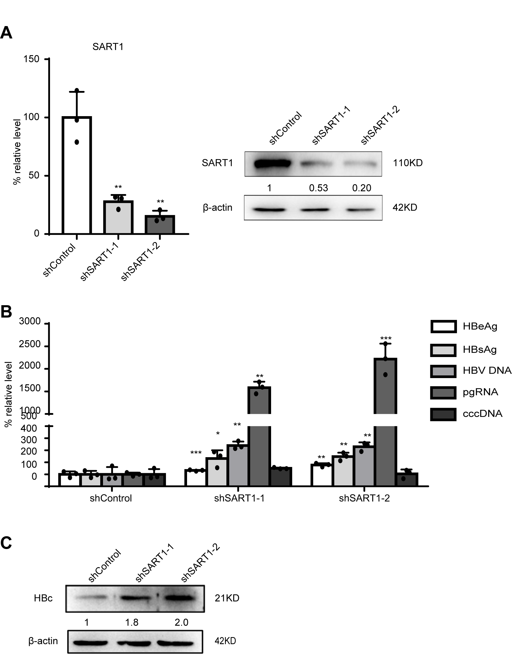
Fig. S1. Knockdown of SART1 promotes HBV transcription and replication.
HepG2-NTCP shRNA stable cells were established with lentiviruses expressing shRNA control or shRNAs targeting SART1. Cells were seed in 24-well plates and infected with HBV at MOI 100 then harvested at 7 days post infection. (A) The expression of SART1 was analyzed by qRT-PCR and Western blot. (B) HBeAg, HBsAg, and HBV DNA in culture supernatants were measured by ELISA and qPCR, and HBV pgRNA, HBV cccDNA were detected by qRT-PCR and qPCR. (C) HBc protein was tested by Western blot. The dots in all the graphs represented 3 biological replicates of 1 experiment. A representative result from three independent experiments was shown. The statistical analyses were carried out using Student's unpaired two-tailed t-test or the two-way ANOVA. * p < 0.05, ** p < 0.01 and *** p < 0.001.

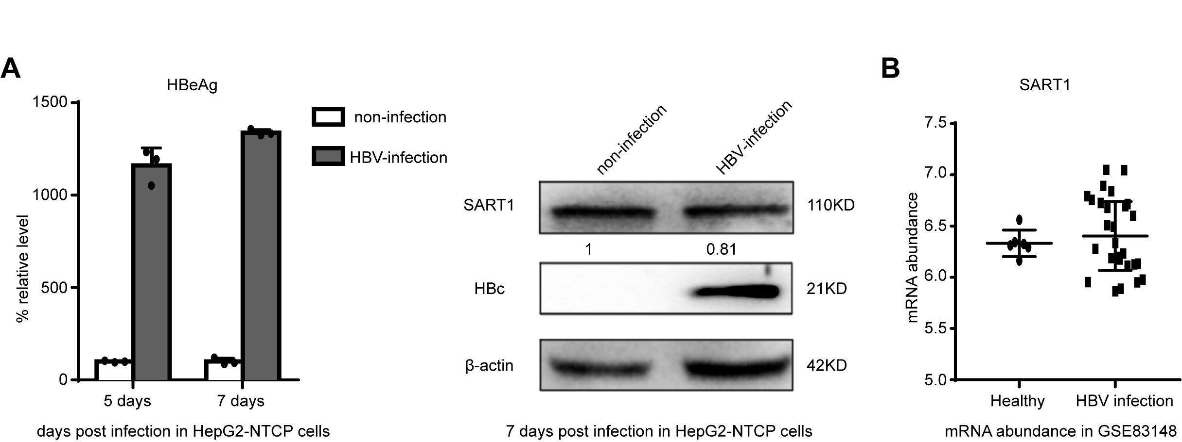

Fig. S2. The effect of HBV infection on SART1 expression.

HepG2-NTCP cells were infected with HBV at MOI 100, and the culture supernatants and cells were harvested at 7 days post infection. (A) The level of HBeAg in culture supernatants was examined by ELISA. And the expressions of SART1 and HBc were detected by Western blot. (B) The expression of SART1 between HBV infected and uninfected human liver tissue from a published dataset (GEO: GSE83148) was analysed. * p < 0.05, ** p < 0.01 and *** p < 0.001.
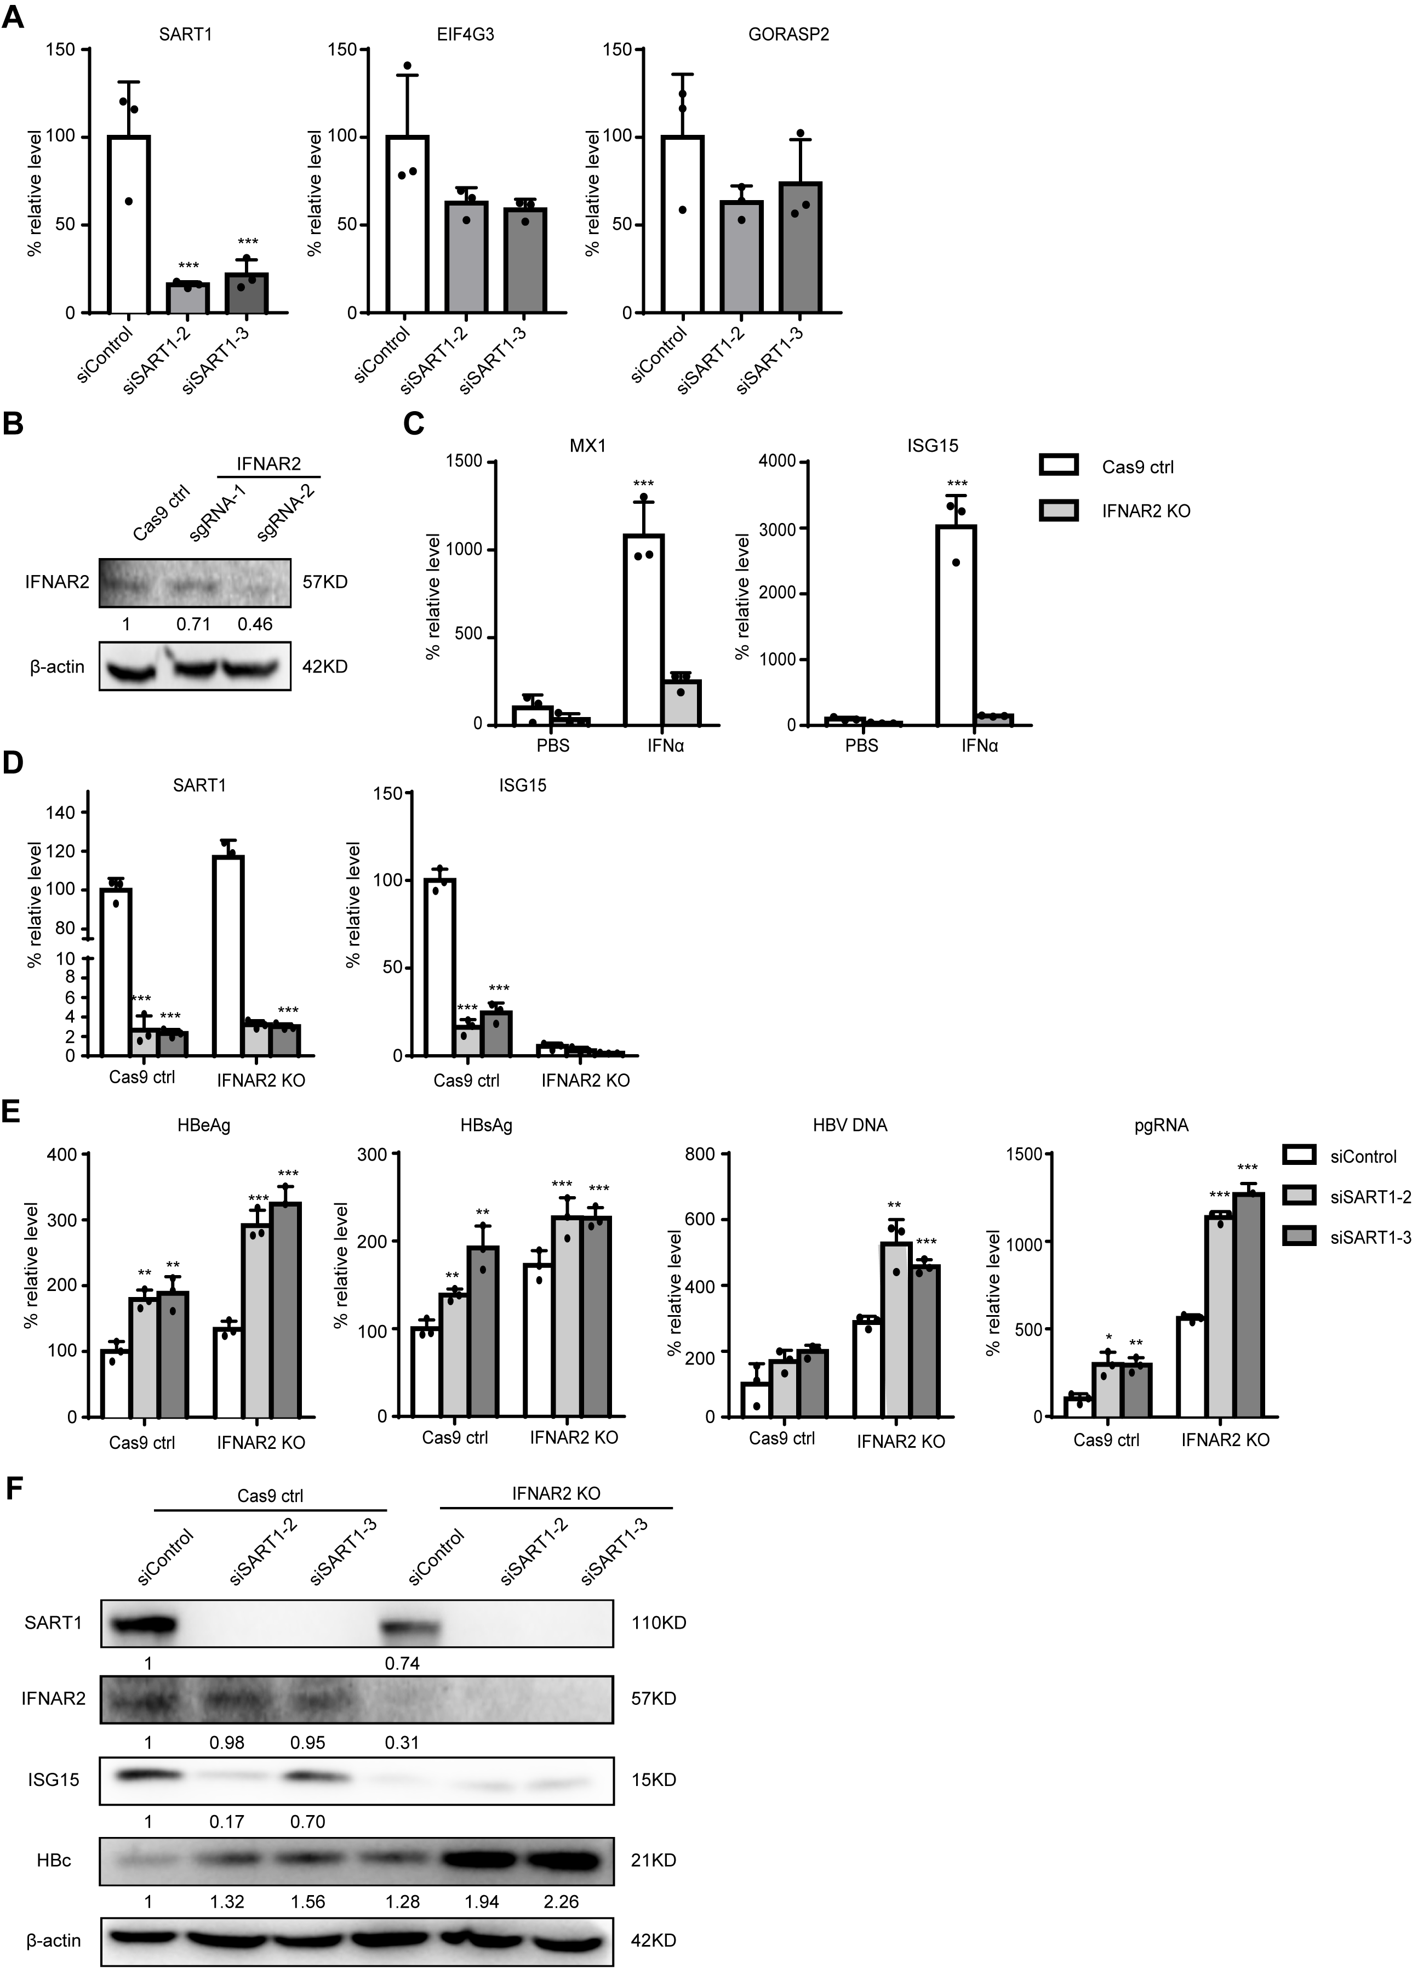

Fig. S3. The effect of SART1 on IFNAR2 knockout HepG2-NTCP cells.
(A) HepG2-NTCP cells were transfected with siRNAs targeting SART1, 48 h post transfection, cells were infected with HBV at MOI 100 then harvested at 7 days post infection. The expressions of SART1, EIF4G3, and GOPASP2 were analyzed by qRT-PCR. The IFNAR2 knockout HepG2-NTCP cells were established by the lentiCRISPR/Cas9 transduction, and cultured with puromycin (2μg/ml) for a week. (B) The expression of IFNAR2 was analyzed by Western blot. The IFNAR2 knockout HepG2-NTCP cells were treated with IFNα (1000 IU) for 6 h, and the cells were harvested. (C) The levels of MX1 and ISG15 were detected by qRT-PCR. The IFNAR2 knockout HepG2-NTCP cells were infected with HBV at MOI 100 then harvested at 7 days post infection. (D) The levels of SART1 and ISG15 were tested by qRT-PCR. (E) Secreted viral antigens, HBV DNA in the supernatants, and intracellular HBV RNA were analysed by ELISA, qPCR and qRT-PCR. (F) The expressions of SART1, IFNAR2, ISG15, and HBc were evaluated by Western blot. The dots in all the graphs represented 3 biological replicates of 1 experiment. A representative result from three independent experiments was shown. The statistical analyses were carried out using Student's unpaired two-tailed t-test or the two-way ANOVA. * p < 0.05, ** p < 0.01 and *** p < 0.001.

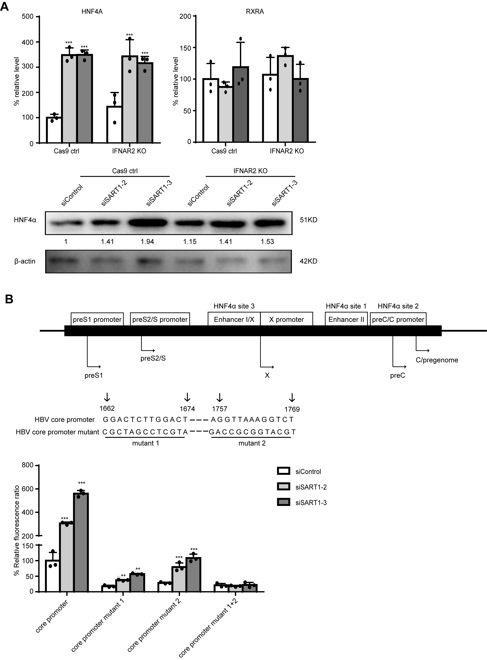
Fig. S4. The interaction between SART1 and HNF4α
The IFNAR2 knockout HepG2-NTCP cells were infected with HBV at MOI 100 then harvested at 7 days post infection. (A) The expressions of HNF4α and RXRα were analysed by qRT-PCR and Western blot. (B) The sequences of wide type and mutated HNF4α binding sites (1662 to 1674 and 1757 to 1769) in Enh II and core promoter region are shown. Huh7 cells were transfected with SART1 siRNAs, 24 h post transfection, cells were transfected with the wide type or mutated core promoter luciferase reporter plasmids, after promoter plasmids transfected for 48 h, the firefly luciferase activity was determined. The dots in all the graphs represented 3 biological replicates of 1 experiment. A representative result from three independent experiments was shown. The statistical analyses were carried out using Student's unpaired two-tailed t-test or the two-way ANOVA. * p < 0.05, ** p < 0.01 and *** p < 0.001.
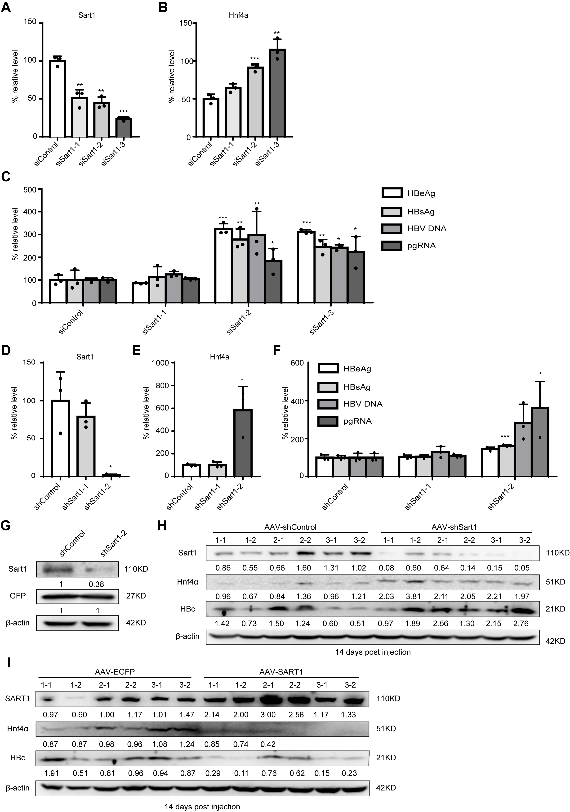
Fig. S5. Knockdown of Sart1 promotes HBV replication in mouse AML12 cells and AAV mouse model.
AML12 cells were transfected with siRNAs targeting Sart1, 48 h post transfection, cells were transduced with 2×10⁴ viral genome AAV-HBV then harvested at 5 days post transduction. (A) The mRNA levels of Sart1 and (B) Hnf4α were analyzed by qRT-PCR. (C) HBeAg, HBsAg and HBV DNA in culture supernatants were tested by ELISA and qPCR, HBV pgRNA were detected by qRT-PCR. AML12 cells were transduced with 2×10⁴ viral genome AAV-sh Sart1 and 2×10⁴ viral genome AAV-HBV then harvested at 5 days post transduction. (D) The levels of Sart1 and (E) Hnf4α were detected by qRT-PCR. (F) HBeAg, HBsAg, and HBV DNA in culture supernatants were measured by ELISA and qPCR, and HBV pgRNA were detected by qRT-PCR. AML12 cells were transduced with 2×10⁴ viral genome AAV-sh Sart1 and 2×10⁴ viral genome AAV-GFP then harvested at 5 days post transduction. (G) The expressions of Sart1 and GFP was detected by Western blot. C57BL/6 mice were injected with recombinant virus. The blood and liver were collected at indicated time points for analysis. (H) The expressions of Sart1, SART1, Hnf4α, HBc were monitored by Western blot at 14 days post injection, and each group of protein samples loaded twice as replicates. The dots in all the graphs represented 3 biological replicates of 1 experiment. A representative result from three independent experiments was shown. The statistical analyses were carried out using Student's unpaired two-tailed t-test or the two-way ANOVA. * p < 0.05, ** p < 0.01 and *** p < 0.001.

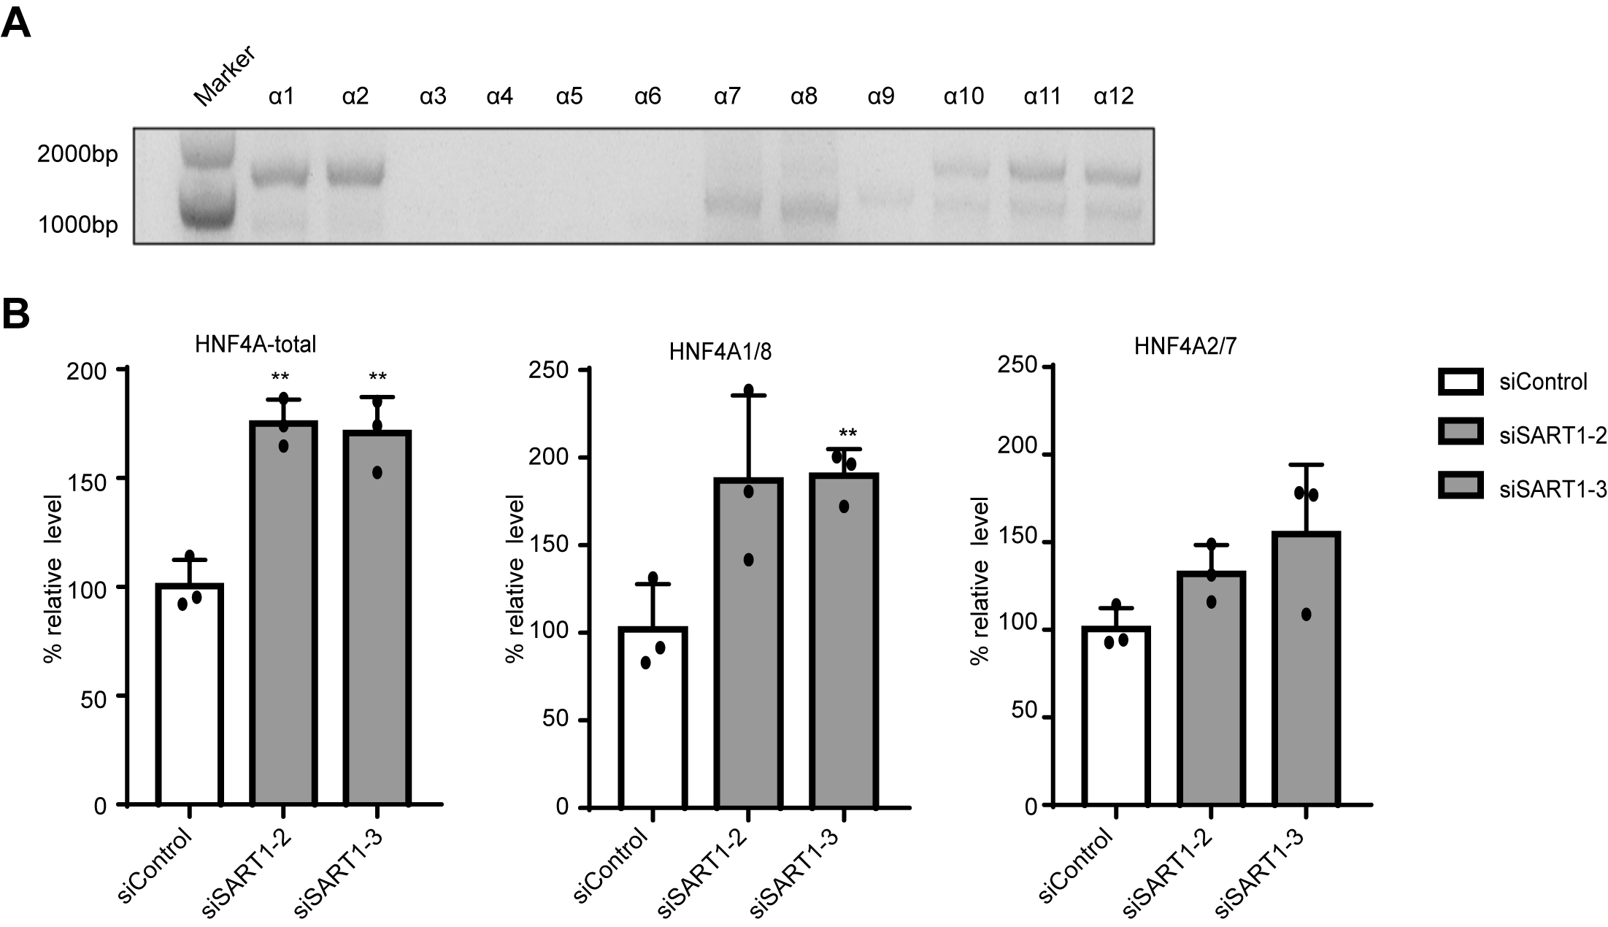
Fig. S6. Effect of SART1 on HNF4α alternative splicing.
(A) The cDNA was extracted from HepG2-NTCP cells as a template, the expressions of HNF4α isoforms were measured by PCR. (B) The expressions of HNF4α isoforms were detected by qRT-PCR. The dots in all the graphs represented 3 biological replicates of 1 experiment. A representative result from three independent experiments was shown. The statistical analyses were carried out using Student's unpaired two-tailed t-test or the two-way ANOVA. * p < 0.05, ** p < 0.01 and *** p < 0.001.

Supplementary table 1. Sequences for siRNA, shRNA and sgRNA
Name | Company | Sequence
siSART1-1 | RiboBio Company | CTCGCTCTATCCTGTCCAA
siSART1-2 | RiboBio Company | GCTACAAACCCGACGTTAA
siSART1-3 | RiboBio Company | GTATGACGAAGAGCTTGAA
ShSART1-1 | GenePharma Biotech | ACCGGCTACAAACCCGACGTTAATTCAAGAGATTAACGTCGGGTTTGTAGCTTTTTTG
ShSART1-2 | GenePharma Biotech | ACCGGTATGACGAAGAGCTTGAATTCAAGAGATTCAAGCTCTTCGTCATACTTTTTTG
siSart1-1 | RiboBio Company | AGACCAAACGGAGAGTGAA
siSart1-2 | RiboBio Company | CCCAGAAGACACCGTATAT
siSart1-3 | RiboBio Company | GCGAACACCATCACCAAAT
ShSart1-1 |  | ACCGCCCAGAAGACACCGTATATTTCAAGAGAATATACGGTGTCTTCTGGGTTTTTTG
ShSart1-2 |  | ACCGCGAACACCATCACCAAATTTCAAGAGAATTTGGTGATGGTGTTCGCTTTTTTG
IFNAR2 sgRNA-1 |  | GTGTATATCAGCCTCGTGTT
IFNAR2 sgRNA-2 |  | GCATATGAAATACCAAACACG
Supplementary table 2. Primer sequences for PCR and qRT-PCR
Oligoname | Sequence (5’-3’)
HBV pgRNA fwd | CTGGGTGGGTGTTAATTTGG
HBV pgRNA rev | TAAGCTGGAGGAGTGCGAAT
cccDNA 92 fwd | GCCTATTGATTGGAAAGTATGT
cccDNA 2251 rev | AGCTGAGGCGGTATCTA
SART1 fwd | TGGCCTCCGAATACCTCAC
SART1 rev | CCGCAGTCTGGAACCAAAG
ISG15 fwd | CGCAGATCACCCAGAAGATCG
ISG15 rev | TTCGTCGCATTTGTCCACCA
MX1 fwd | GGTGGTCCCCAGTAATGTGG
MX1 rev | CGTCAAGATTCCGATGGTCCT
EIF4G3 fwd | TGAATGTTGGGTCACGAAGA
EIF4G3 rev | TCCTGACACTTGCTTCATCAG
GORASP2 fwd | CAAGAAAATTCCCCAGGACA
GORASP2 rev | GCACATGCCAAACATTTTCA
HNF4A fwd | GATGTAGTCCTCCAAGCTCAC
HNF4A rev | GCCATCATCTTCTTTGACCCA
JUN fwd | ACCTCAGCAACTTCAACCCAG
JUN rev | TTCCTCATGCGCTTCCTCTCCG
NR2F1 fwd | ATCGTGCTGTTCACGTCAGAC
NR2F1 rev | TGGCTCCTCACGTACTCCTC
FXRA fwd | TGACGGAAATGGCAACCAATC
FXRA rev | CTTCAACCGCAGACCCTTTC
NR5A2 fwd | GCCACCCTCAACAACCTCATG
NR5A2 rev | TTCCTGGACACCTTCTACCAGC
PPARA fw | TTCTGTTCTTTTTCTGGATCTTGC
PPARA rev | CAGGCTATCATTACGGAGTCC
RXRA fwd | TGCTGCGGGCAGGCTGGAATG
RXRA rev | TGGAGTCAGGGTTAAAGAGGACG
NR0B2 fwd | GGAATATGCCTGCCTGAAAGG
NR0B2 rev | CTGGTCGGAATGGACTTGAGG
NR2C1 fwd | AAATCACGACGGCTCTAC
NR2C1 rev | TTGTCTCCACATACTACGC
NR2C2 fwd | TGGAGCAAGACAAACAGGTCTTC
NR2C2 rev | ACTTAGGTTGGCAAGGGAGGTCAC
Sart1 fwd | GAAGCGGGAGAAACGCGAT
Sart1 rev | ACTTTGCTCGGAGTTTATTGGTC
Isg15 fwd | GGTGTCCGTGACTAACTCCAT
Isg15 rev | TGGAAAGGGTAAGACCGTCCT
Mx1 fwd | CACTTGGGGCGTCTTATGGTT
Mx1 rev | CCAGTTCTCATCGGTGAGGAC
Hnf4a fwd | CACGCGGAGGTCAAGCTAC
Hnf4a rev | CCCAGAGATGGGAGAGGTGAT
HNF4α1 splicing fwd | gatgcaccccatgcccacca
HNF4α1 splicing rev | ctcaggggtggacatctg
HNF4α2 splicing fwd | CACCTGATGCAGGAACATATGG
HNF4α2 splicing rev | TCAGGGGTGGCTGCCTGT
HNF4α1 fwd | CAGCCTACACCACCCTGGAATTTG
HNF4α1 rev | GGGTCTCAGGGGTGGACATC
HNF4α2 fwd | CAGCCTACACCACCCTGGAATTTG
HNF4α2 rev | GTCGGGGCCACTCACACATC
HNF4α3 fwd | CAGCCTACACCACCCTGGAATTTG
HNF4α3 rev | CAGTGGGGAAGCCAAGGAGC
HNF4α4 fwd | CCGACATCACTGGAGCATATCTGGAG
HNF4α4 rev | GGGTCTCAGGGGTGGACATC
HNF4α5 fwd | CCGACATCACTGGAGCATATCTGGAG
HNF4α5 rev | GTCGGGGCCACTCACACATC
HNF4α6 fwd | CCGACATCACTGGAGCATATCTGGAG
HNF4α6 rev | CAGTGGGGAAGCCAAGGAGC
HNF4α7 fwd | GGGCTCCAGTGGAGAGTTCTTACG
HNF4α7 rev | GGGTCTCAGGGGTGGACATC
HNF4α8 fwd | GGGCTCCAGTGGAGAGTTCTTACG
HNF4α8 rev | GTCGGGGCCACTCACACATC
HNF4α9 fwd | GGGCTCCAGTGGAGAGTTCTTACG
HNF4α9 rev | CAGTGGGGAAGCCAAGGAGC
HNF4α10 fwd | ATGTCGGACTGGGGCCAG
HNF4α10 rev | GGGTCTCAGGGGTGGACATC
HNF4α11 fwd | ATGTCGGACTGGGGCCAG
HNF4α11 rev | GTCGGGGCCACTCACACATC
HNF4α12 fwd | ATGTCGGACTGGGGCCAG
HNF4α12 rev | CAGTGGGGAAGCCAAGGAGC
HNF4α-P1-2000-1500 fwd | CAGGATCATCTTTCTATTTTAC
HNF4α-P1-2000-1500 rev | AGACAGGGAGAATTAATGAGTG
HNF4α-P1-1500-1000 fwd | CTAATTCACTCACTCCTAATTC
HNF4α-P1-1500-1000 rev | CTTCAGAGTGGGCTTTGTGG
HNF4α-P1-1000-500 fwd | GTAGGAGACGGGTGGAGA
HNF4α-P1-1000-500 rev | TCCTTGTTCTGGGAGCTC
HNF4α-P1-500-0 fwd | TCCAGAAGATTGGCATCTGGG
HNF4α-P1-500-0 rev | AGTGCCCTCTCTGCCTTCC
HNF4α-P1-500-413 fwd | TCCAGAAGATTGGCATCTGG
HNF4α-P1-500-413 rev | CCCTCAATGCTTTTGCAGAG
HNF4α-P1-416-319 fwd | GGGTAGAAGTCAATGATTTGGGAAG
HNF4α-P1-416-319 rev | CCCCAAGTCAGGCATTCTAAC
HNF4α-P1-328-246 fwd | GACTTGGGGTGACAATGG
HNF4α-P1-328-246 rev | GTACAAGGCAGGCATCATGAC
HNF4α-P1-269-170 fwd | GAGTCATGATGCCTGCCTT
HNF4α-P1-269-170 rev | GTTGGTTTCTGGCTGACA
HNF4α-P1-175-103 fwd | CCAACAAACAGCCAAATCCC
HNF4α-P1-175-103 rev | GGGTTAATGGTTAATCGGTC
HNF4α-P1-123-38 fwd | GACCGATTAACCATTAACCC
HNF4α-P1-123-38 rev | AAGATCTGCTGGGAGT
HNF4α-P1-56-0 fwd | AGAGCCTCCACCCCTTCACA
HNF4α-P1-56-0 rev | AGTGCCCTCTCTGCCTT

Supplementary table 3. Antibodies used for Western blot and immunostaining
Antibody | Company | Cat# | Host | Dilution
SART1 | Proteintech | 22675-1-AP | Rabbit | 1:1000 (Western blot)  5 μg (ChIP assay)
HNF4α | Cell Signaling Technology | #3113 | Rabbit | 1:1000 (Western blot)
HNF4α | Santa Cruz Biotechnology | sc-374229 | Mouse | 1:100 (Western blot)  5 μg (ChIP assay)
ISG15 | Proteintech | 15981-1-AP | Rabbit | 1:1000 (Western blot)
MX1 | NOVUS | NBP1-47859 | Mouse | 1:2000 (Western blot)
HBc | Gene Technology | GB058629 | Rabbit | 1:500  (Western blot)  1:50 (immunostaining)
β-actin | Cell Signaling Technology | #4970 | Rabbit | 1:5000 (Western blot)
Histone H3 | Cell Signaling Technology | #4620 | Rabbit | 5 μg (ChIP assay)
Normal Rabbit IgG | Cell Signaling Technology | #2729 | Rabbit | 5 μg (ChIP assay)

References
[1] Ko C, Chakraborty A, Chou WM, Hasreiter J, Wettengel JM, Stadler D, et al. Hepatitis B virus genome recycling and de novo secondary infection events maintain stable cccDNA levels. J Hepatol 2018;69:1231-1241.
[2] Ladner SK, Otto MJ, Barker CS, Zaifert K, Wang GH, Guo JT, et al. Inducible expression of human hepatitis B virus (HBV) in stably transfected hepatoblastoma cells: a novel system for screening potential inhibitors of HBV replication. Antimicrob Agents Chemother 1997;41:1715-1720.
[3] Lucifora J, Xia Y, Reisinger F, Zhang K, Stadler D, Cheng X, et al. Specific and nonhepatotoxic degradation of nuclear hepatitis B virus cccDNA. Science 2014;343:1221-1228.
[4] Xia Y, Stadler D, Ko C, Protzer U. Analyses of HBV cccDNA Quantification and Modification. Methods in molecular biology (Clifton, NJ) 2017;1540:59-72.
[5] Stemmer M, Thumberger T, Del Sol Keyer M, Wittbrodt J, Mateo JL. CCTop: An Intuitive, Flexible and Reliable CRISPR/Cas9 Target Prediction Tool. PLoS One 2015;10:e0124633.
[6] Raney AK, Johnson JL, Palmer CN, McLachlan A. Members of the nuclear receptor superfamily regulate transcription from the hepatitis B virus nucleocapsid promoter. J Virol 1997;71:1058-1071.
[7] Burwitz BJ, Wettengel JM, Muck-Hausl MA, Ringelhan M, Ko C, Festag MM, et al. Hepatocytic expression of human sodium-taurocholate cotransporting polypeptide enables hepatitis B virus infection of macaques. Nat Commun 2017;8:2146.
[8] Cai D, Nie H, Yan R, Guo JT, Block TM, Guo H. A southern blot assay for detection of hepatitis B virus covalently closed circular DNA from cell cultures. Methods Mol Biol 2013;1030:151-161.
[9] Zhang X, Zhang E, Ma Z, Pei R, Jiang M, Schlaak JF, et al. Modulation of hepatitis B virus replication and hepatocyte differentiation by MicroRNA-1. Hepatology 2011;53:1476-1485.
[10] Lee TI, Johnstone SE, Young RA. Chromatin immunoprecipitation and microarray-based analysis of protein location. Nature protocols 2006;1:729-748.
[11] Javanbakht H, Mueller H, Walther J, Zhou X, Lopez A, Pattupara T, et al. Liver-Targeted Anti-HBV Single-Stranded Oligonucleotides with Locked Nucleic Acid Potently Reduce HBV Gene Expression In Vivo. Molecular therapy Nucleic acids 2018;11:441-454.

