Shrub expansion modulates belowground impacts of changing snow conditions in alpine grasslands
Supplementary Information. Broadbent et al.

METHODS
Snowmelt timing
Soil temperature sensors (iButtons [Maximum Integrated, San Jose, CA, USA] in all plots and Hobo loggers [Onset Computer Corporation, Bourne, MA, USA] in a subset of 27 plots) were installed at a depth of ca. 5 cm in August 2017. Soil temperature was measured continuously at 4 hour (h) or 15 minute intervals (iButtons/ Hobo loggers respectively) until sampling occurred in July 2019. The snowmelt dates estimated by iButtons and loggers installed in the same plots closely corresponded. The only discrepancy occurred in four plots where snowmelt dates estimated by loggers were one day earlier than iButtons (iButton dates on these plots were used for consistency). Snowmelt dates were standardised each year using the date that the first plot melted in that year, which was given the value 0. Snowmelt dates of other plots were allocated numbers relative to the date that the first plot melted, such that a plot which melted 10 days after the first plot received the number 10, and so forth. Snowmelt occurred about a month later, on average, in 2019 than 2018, but standardised snowmelt dates correlated closely between individual plots. During the 2018/19 winter, 28 iButtons and 10 loggers failed, which meant we only recorded snowmelt dates for 44 plots in 2019. However, we were able to accurately estimate 2019 snowmelt dates for an additional 24 plots using the 2018 snowmelt dates. To do this, we used a linear mixed effects model (LMM) that predicted the measured 2019 snowmelt dates, using the 2018 snowmelt dates and plot aspect (on an 8-point compass scale) as fixed effects, and block nested in site as random effects. We used Akaike information criterion (AIC) model selection to test whether vegetation treatment, elevation and slope improved our model, but including them increased the AIC and they were therefore not included. Our model predicted the actual 2019 snowmelt dates on the measured plots to high degree of accuracy (conditional r² = 0.94, fig. S5). We therefore used this model to predict the unmeasured 2019 snowmelt dates on plots for which we had 2018 snowmelt dates.

Molecular soil sub-sampling
Five soil subsamples were taken from each soil sample, pooled and added to sterile MP Bio lysing matrix E tubes containing DNA/RNA shield solutionTM (Zymo Research Corp, Irvine, CA, USA) to achieve 10 % w/v sample to preservation buffer. Lysis was immediately performed in the field using an MP Bio SuperFastPrep1 and Homogenizer (MP Biomedicals, Santa Ana, CA, USA) for 30 Secs at full speed. Lysed soil was immediately stored at -80 °C and shipped to the UK Centre for Ecology and Hydrology, Wallingford, UK for molecular analyses.

Vegetation surveys
Plant species relative cover (%) was visually estimated to the nearest 1% within a 60 x 60 cm subplot using a modified Daubenmire method (Daubenmire 1959). Plant community composition on shrub removal plots was more similar to grass control plots than shrub invaded plots (PERMANOVA, F = 26.7, p < 0.01; fig. S1).

Extractions for biogeochemical cycling and microbial biomass
To measure plant available inorganic N, and dissolved organic nitrogen (DON), 5 g (fresh weight) of soil was extracted with 25 ml of 1 M KCl, or 35 ml ultrapure (Milli-Q®) H₂O for DON, shaken for 1 h or 10 min for DON, and then extracts were analysed on a Seal AA3 Segmented Flow Multi-chemistry analyser (Mequon, WI, USA). To calculate DON we measured total dissolved N and total dissolved inorganic N (NH₄⁺-N and NO₃⁻-N) simultaneously in each extract, and then subtracted total dissolved inorganic N from total dissolved N (Jones & Willett 2006). Net NH₄⁺-N and NO₃⁻-N mineralisation rate was measured as the release of NH₄⁺-N and NO₃⁻-N after incubation of soil samples (5 g) for 14 days at 25 °C (Ross 1992). Dissolved (water-extractable) organic carbon was determined by extracting 5 g (fresh weight) of soil in 35 ml ultrapure (Milli-Q) water and analysed using a 5000A TOC analyser (Shimadzu, Japan). Microbial biomass C and N was determined by extracting a non-fumigated 5 g (fresh weight) subsample of soil with 25 mL of 0.5 M K₂SO₄ and another subsample fumigated with ethanol-free CHCl₃ for 24 h, and measuring microbial C and N in each extract. Fumigation versus non-fumigation allows for a comparison of the C and N contained in dead versus living pools (i.e., contained with microbial cells) within the soil (Brookes et al. 1985). To account for baseline C and N mineralization, all values for microbial C were multiplied by a K_{EC} factor of 0.45 and all values of microbial N were multiplied by a K_{EN} factor of 0.54 (Brookes et al. 1985). Total organic C in filtered extracts was determined using a using a 5000A TOC analyser (Shimadzu, Japan) and total N was determined using a Seal AA3 Segmented Flow Multi-chemistry analyser (Mequon, WI, USA). All extracts were filtered through ashless Whatman no. 42 filter papers.

Soil extracellular enzyme assays
We measured a suite of eight extracellular soil enzymes, specifically β-glucosidase (GLC), cellobiohydrolase (CBH), β-xylosidase (XYL), phenol oxidase (POX), peroxidase (PER), N-acetylglucosaminidase (NAG), phosphatase (PHO), and urease (URE). GLC and CBH contribute to the degradation of cellulose and other β-1,4 glucans (Sinsabaugh et al. 2008). XYL contributes to the breakdown of the complex plant cell wall polysaccharide xylan (Collins et al. 2005). NAG degrades chitin and other β-1,4-linked glucosamine polymers (Sinsabaugh et al. 2008). PHO hydrolyses phosphomonoesters, and in some cases phosphodiesters, releasing phosphate (Sinsabaugh et al. 2008), and URE hydrolyses urea to ammonia. POX and PER play a large role in the degradation of polyphenols (e.g. lignin, tannin and their degradation products) (Sinsabaugh et al. 2008).
GLC, CBH, XYL, NAG and PHO were measured photometrically according to Jackson et al. (2013), with modifications. Specifically, 4 g of sieved soil was suspended in 8 mL of sodium acetate buffer (50 mM, pH 5.0). Then 150 μl of this soil slurry was introduced into a 96-well deepwell block and mixed with 150 μl of a substrate solution: 30 mM pNP-β-glucopyranoside for GLC, 2 mM pNP-β-D-cellobioside for CBH, 30 mM pNP-β-xylopyranoside for XYL, 5 mM pNP-β-N-acetylglucosaminide for NAG and 40 mM pNP -phosphate disodium salt hexahydrate for PHO. Blocks were incubated at 18 °C for 20 min (PHO), 45 min (GLC), 1.5 h (XYL), 2 h (NAG) and 2.5 h (CBH) or under continuous shaking. Blocks were then centrifuged (2900 x g, 5 min), 100 µl of the supernatant pipetted into transparent 96-well plates and mixed with 200 µl of 50 mM NaOH solution. Absorbance was measured at 405 nm in a microplate reader (EZ400 Research, Biochrom, Germany) and corrected for soil and substrate colouration. pNP concentration was calculated from an absorbance calibration curve of pNP at concentrations up to 1 mM. Reported activity is the mean of four analytical replicates for each soil sample.
POX and PER activities were measured photometrically as described in De Long et al. (2019). Specifically, 0.25 g of soil was suspended in 25 ml of sodium acetate buffer (50 mM, pH 5.0). Then 0.4 ml of soil slurry was extracted under continuous shaking and mixed (1:1) with a 20 mM L-3,4-dihydroxyphenylalanin (L-DOPA) solution in a deep-well block. Blocks were shaken for 10 min and centrifuged (2900 x g, 5 min), and then 250 µl of the supernatant was pipetted into transparent 96-well plates. For peroxidase activity, wells additionally received 10 µl of a 0.3% H₂O₂ solution. Absorbance was measured at 450 nm in a plate reader microplate reader (EZ400 Research, Biochrom, Germany) at the starting time point (t0), after 1.5h (t1 for PER) and after 20h (t1 for POX) at 18 °C. Enzyme activity was calculated from the difference in absorption between the two time points, corrected for substrate colouration, and using a previously published value of the micromolar extinction coefficient of oxidized L-DOPA (7.9 µmol⁻¹) (DeForest 2009). For PER activity, POX activity was subtracted as both enzymes could be oxidizing DOPA in the presence of O₂ and H₂O₂. Reported activity is the mean of three analytical replicates for each soil sample.
For URE we followed the methods of Cordero et al. (2019). Specifically, 2 g of soil was suspended in 5 mL of sodium acetate buffer (50 mM, pH 5.0). Then 0.25 ml of soil slurry was extracted under continuous shaking and mixed with 0.1mL urea solution (80 mM) in a deep-well block. Blocks were centrifuged (2900 x g, 10 sec) and incubated under continuous shaking at 18 °C. Then 1 ml of 2 M KCl was added and incubated under continuous shaking for 30 min. Blocks were centrifuged (2900 x g, 5 min) and then 75 µl of the supernatant was pipetted into transparent 96-well plates that contained 75 µl of ultrapure water. Wells then received 75 µl of colour reagent (0.15 M NaOH mixed with 170 mg ml⁻¹ sodium salicylate and 1.278 mg ml⁻¹ sodium nitroprusside dehydrate just before use) and 30 µl of oxidation solution (1 mg ml⁻¹ dichloroisocyanuric acid sodium salt dehydrate), and after 30 min colour intensity was measured at 650 nm in a plate reader microplate reader (EZ400 Research, Biochrom, Germany).

Soil respiration
For soil respiration measurements, circular gas sampling collars were inserted into the soil (depth = 5 cm, diameter = 10 cm) and above-ground plant parts were removed from within the collars prior to sampling. During sampling, the SRC was sealed onto gas sampling collars and CO₂ flux was measured over 2 minutes.

PLFA analyses
PLFAs were extracted from freeze-dried soil (Frostegård et al. 1991), as modified by Buyer and Sasser (Buyer & Sasser 2012), and analysed on a gas chromatograph (Agilent 7890A Gas chromatograph, Santa Clara, CA, USA). Abundance of PLFAs was expressed in nmol PLFA g⁻¹ dry soil. PLFAs were assigned as indicators of fungal and bacterial abundance, with 18:2ω6,9 used for fungi; 16:1ω9, cy17:0, 18:1ω7 and cy19:0 used for Gram-negative bacteria; a15:0, i15:0, i16:0, a17:0 and i17:0 used for Gram-positive bacteria; 15:0 and 17:0 used for bacteria; and 18:1ω9, 16:0 and 18:0 considered as non-specific biomarkers (Zelles 1999; Frostegård et al. 2011; Willers et al. 2015). The marker 18:1ω9 is sometimes used as a fungal marker, however, this is only recommended if it correlates closely with the main fungal marker 18:2ω6,9, and when 18:2ω6,9 is abundant, otherwise 18:1ω9 can be an indicator of bacteria (Frostegård et al. 2011). Total PLFA abundance and the ratios of fungal to bacterial markers and Gram positive (GP) to Gram negative (GN) bacterial markers were also calculated. This PLFA data was used for the GP:GN ratio discussed in our manuscript.

DNA extraction
Prior to DNA extraction, samples were thawed at room temperature and treated to an additional lysis step on MP Bio FastPrep24 Homogenizer for 30 secs at 5 m s⁻¹. Samples were centrifuged at 14,000 x g for 10 min and 400 µl of supernatant transferred to Zymo-Spin™ IV Spin Filter and further centrifuged at 8,000 x g for 1 minute. Filtrate was combined with 1200 µl soil binding buffer and DNA extraction continued as per manufacturer’s protocol. Eluted DNA was stored at -20ºC prior to downstream analysis.

Amplicon sequencing
Amplicons were generated using a 2-step amplification approach, with Illumina TruSeq tagged primers based upon the primers 784F (Andersson et al. 2008), V6R (Arenz et al. 2015) for bacterial 16S and flTS7 (Ihrmark et al. 2012), ITS4R (White et al. 1990) for fungal ITS, with the addition of a unique custom barcode combinations corresponding to each sample (Kozich et al. 2013).

2-step Illumina Sequencing PCR protocol
Extracted DNA was quantified using the nanodrop 8000 UV-Vis spectrophotometer (ThermoFisher scientific, MA, USA). The first PCR step amplifies using gene specific primers (16S and ITS, described above) modified with the addition of an Illumina adapter. Each gene amplicon was generated separately using approximately 20 ng DNA template, combined with 1 µl dNTPs (10 mM), 0.5 µl of each modified amplicon primer (100 µM), 0.5 µl Q5 High fidelity DNA polymerase (New England Biolabs, MA, USA), 10 µl Q5 Reaction Buffer (5X), and molecular grade water to a total of 50 µl. PCR conditions consisted of an initial denaturation of 30 seconds at 98°C, followed by 20 cycles of 10 seconds at 98 °C, 10 seconds at 50 °C and 20 seconds at 72 °C. A final extension of 10 minutes at 72 °C was also included to complete the reaction. Once finished PCR products were purified using ZR-96 DNA clean up kit (Zymo research, CA, USA) according to manufacturer’s protocol. Final product was eluted in 40 µl molecular grade water.
2nd step primers are specific to the Illumina adapter, additionally they contain unique barcodes (Kozich et al. 2013) and the Illumina sequencing primer binding site. Illumina tag primer combinations for each sample are available upon request.
10 µl of step 1 product was combined with 1 µl dNTPs (10 mM), 5 µl Illumina tag primers mix (10 mM each), 0.5 µl Q5 High fidelity DNA polymerase (New England Biolabs), 10 µl Q5 Reaction Buffer (5X), and molecular grade water to a total of 50 µl. PCR consisted of Initial denaturation of 30 seconds at 98 °C, followed by 10 cycles of 10 seconds at 98 °C, 20 seconds at 62 °C and 30 seconds at 72 °C. A final extension of 2 minutes at 72 °C was also included to complete the reaction.
PCR Products were normalised using Sequalprep normalisation plates (Invitrogen, Carlsbad, CA, USA). Pooled amplicon libraries were vacuum concentrated and gel purified. Resultant libraries were quantified using a Qubit dsDNA HS Assay kit (Invitrogen) and the pool was sequenced at a concentration of 5.4 pM with a 0.6 pM addition of Illumina generated PhiX control library. Sequencing was performed on an Illumina MiSeq platform using V3 chemistry (Illumina Inc., San Diego, CA, USA).

DNA sequence processing
Sequences were processed using DADA2 (Callahan et al. 2016) pipeline in R V.3.0.17 (R Core Team 2021) to quality filter, merge, denoise and assign taxonomies. 16S amplicon reads were trimmed to 250 and 220 bases, forward and reverse respectively. ITS2 amplicons reads were trimmed to 270 and 220 bases, forward and reverse respectively. Filtering settings were maximum number of Ns (maxN) = 0, maximum number of expected errors (maxEE) = (1,1). The primer sequences were removed using trimLeft=c(20,20). Sequences were dereplicated and the DADA2 core sequence variant inference algorithm applied. mergePairs was used to merge sequences and ASV tables were constructed. Chimeric sequences were removed using removeBimeraDenovo default settings. ASVs were subject to taxonomic assignment using assignTaxonomy at default settings; training databases were GreenGenes v13.8 (DeSantis et al. 2006) and Unite v7.2 (Kõljalg et al. 2005) for 16S and ITS respectively.
After quality filtering a total of 1,937,193 bacterial (16S rRNA) and 1,083,809 fungal (ITS2) sequences were used in the analysis for the landscape-scale experiment, and 1,379,623 (16S rRNA) and 594,026 (ITS2) in the snow manipulation experiment. To account for the effect of sequencing depth bias, the resultant ASV tables were rarefied to an even depth of 12,630 (16S rRNA) and 2,358 (ITS2) in the landscape-scale experiment, and 11,776 (16S rRNA) and 6,646 (ITS2) in the manipulative experiment (fig. S4), based on the sample with the lowest number of reads in each experiment.

Real-time PCR
All reactions contained 1 × Power SYBR Green PCR Master Mix (Life Technologies LTD, UK), bovine serum albumin (BSA; 0.06 %; Sigma-Aldrich Chemie GmbH, Germany), PCR primers and 2 μl of DNA template to a final volume of 25 μl. 5 pmol of each primer were used for genes amoA of AOA, nirK and nirS, but 7.5 pmol for amoA of AOB. PCR reactions for denitrification genes additionally contained dimethyl sulfoxide (DMSO, 2.5 %; Sigma-Aldrich Chemie GmbH). The detailed PCR thermal profiles are described in table S6. Positive standards containing cloned plasmids with the genes of interest were prepared using the ZeroBlunt TOPO kit (Invitrogen AG, USA), following the manufacturer’s protocol, and were included in the analysis. The sources of the genes were Nitrosomonas sp., fosmid clone 54d9, Azospirillum irakense DMS 11586 and Pseudomonas stutzeri for amoA of AOB, amoA of AOA, nirK and nirS, respectively. The efficiency of qPCRs was calculated based on the linear curve of the positive standards according to the formula $E=10^(-1/slope)$ and was in the range of 75˗95 %. DNA samples were diluted 1:100 before quantification in order to minimize PCR inhibition based on a pre-experiment test. Zero values indicate that no amplification was observed.

Stable isotope labelling and measurements
Subplots that received stable isotope labelling were separated by impermeable plastic sheeting (ca. 20 cm depth to the mineral horizon) to prevent labels from different solutions being translocated. The three solutions contained the following compounds dissolved in DI water: solution 1) ¹⁵N-labelled inorganic N (126.00 mg l⁻¹ ¹⁵NH₄¹⁵NO₃, 98+% enriched; Cambridge Isotope Laboratories, Andover, MA, USA) with unlabelled organic N (247.09 mg l⁻¹ glycine); solution 2) unlabelled inorganic N (131.72 mg l⁻¹ ammonium nitrate) with dual ¹³C-¹⁵N labelled organic N (236.70 mg l⁻¹ glycine-2-¹³C-¹⁵N, 99% enriched, Cambridge Isotope Laboratories, Andover, MA, USA); and solution 3) the control of unlabelled inorganic and organic N (131.72 mg l⁻¹ ammonium nitrate with 247.09 mg l⁻¹ glycine) that was used for natural abundance measurements of ¹⁵N. Each solution contained 4.608 mg of N in total, which included 2.304 mg ¹⁵N in the labelled solutions.
Directly after sampling, soil was homogenised and the chloroform fumigation-extraction technique (Vance et al. 1987) was immediately carried out to determine total ¹⁵N content in the soil microbial biomass. K₂SO₄ extractions were carried out on fumigated and non-fumigated soil. A subsample was taken and analysed for microbial biomass N using a Seal AA3 Segmented Flow Multi-chemistry analyser (Mequon, WI, USA), as described above. K₂SO₄ extractions were then freeze-dried. Plant roots were washed in 0.5 M CaCl₂ solution to remove any of the isotope label attached externally (Wilkinson et al. 2015). Plant material was dried for 48 h at 65 °C before being weighed and ground. A subsample from each processed component of the core (i.e., freeze-dried K₂SO₄ extractions, plant roots and shoots) was subsequently analysed for % N and ¹⁵N content.
Stable isotope measurements of nitrogen (δ¹⁵N) were conducted at the NERC National Environmental Isotope Facility (NEIF) at UK Centre for Ecology and Hydrology in Lancaster, UK. Prior to analyses, samples were oven-dried for 1 hour to remove residual moisture. Plant tissue and microbial extract samples were weighed out in tin capsules and combusted in a Carlo Erba NA1500 elemental analyser (EA) coupled to a Dennis Leigh Technology Isotope Ratio Mass Spectrometer (IRMS). We used n-Carbobenzyloxy-L-aspartic acid as instrumental standard for δ¹⁵N. Calibrated in-house working standards of vegetation material (unlabelled and ¹⁵N-labelled) and were used as Quality Control (QC) materials. Isotopic results are expressed in delta notation, in parts per thousand (‰) deviations from the international standard (AIR). Analytical precision, measured as the within-run standard deviation from replicates of laboratory standards, was <0.4 ‰ (and within 5% for labelled QC materials) for δ¹⁵N.
The concentration of excess ¹⁵N above natural abundance values (µmol excess ¹⁵N g⁻¹) in each component was calculated using ¹⁵N atom percent excess (calculated from δ¹⁵N values as described in Wilkinson et al. (2015)) and N content (McKane et al. 2002; Bardgett et al. 2003). Concentrations of excess ¹⁵N (µmol excess ¹⁵N g⁻¹) and the mass of each component (g) were used to calculate total ¹⁵N recovered (as a percentage of total ¹⁵N added). Natural abundance values of δ¹⁵N were calculated separately for each snow cover and vegetation treatment combination from the corresponding subplots that received the unlabelled control solution. We also assessed how differences in isotope dilution within soil N pools affected ¹⁵N uptake by scaling ¹⁵N excess values recorded within plant and microbial biomass based on the size of the target N pool within the corresponding plot, as described in McKane et al. (2002).

Statistical analysis
To test the effects of snowmelt timing and shrub expansion in the landscape-scale experiment we used linear mixed effects models (LMMs) with snowmelt timing, vegetation treatments, and their interaction, as fixed effects, and block nested in site as random effects. To test the effects of reduced snow cover and shrub expansion in the snow manipulation experiment, we used LMMs with snow manipulation treatments, vegetation treatments, and their interaction, as fixed effects, and block as a random effect. To test the effects of reduced snow cover and shrub expansion on plant-microbial competition for different forms of N (i.e., inorganic-N or organic-N) following stable isotope labelling, we used LMMs with snow manipulation treatments, vegetation treatments, N-form treatments, and their interactions, as fixed effects, and plot nested in block as random effects. LMMs were modelled using the R package “nlme” (Pinheiro et al. 2020) and if required following model diagnostic checks, a constant variance structure was applied using the varIdent function, or data were log₁₀ transformed, to meet assumptions of normality and homoscedasticity of model residuals (Zuur et al. 2009; Harrison et al. 2018). To determine whether fixed effects were significant, p-values were calculated using analysis of deviance Wald χ² tests via the Anova function from the R package “car” (Fox & Weisberg 2019). P values were adjusted for multiple tests using the “Benjamini-Hochberg (BH)” adjustment (Benjamini & Hochberg 1995; Jafari & Ansari-Pour 2019) for microbial community composition (i.e., bacterial and fungal families, and PLFA analyses); absolute and specific enzymes activities; and biogeochemical and physical soil properties, due to multiple comparisons. If a fixed effect that had more than two levels (i.e., the vegetation treatment or any interaction) was significant (p < 0.05), then differences between estimated marginal means of the relevant treatments were tested for significance (p < 0.05) with a Tukey HSD post-hoc test, using the “emmeans” R package (Lenth et al. 2019).
Differences in plant and microbial community composition (based on plant species % cover, and individual ASV abundances, respectively) were tested using Permutational Multivariate Analysis of Variance (PERMANOVA) tests (Anderson 2001) via the adonis2 function in the R package “Vegan” (Oksanen et al. 2020). Fixed effects were the same as described for the LMMs for the landscape-scale and snow manipulation experiments. Permutations were stratified by site for the landscape-scale experiment, and by block for the snow manipulation experiment. To test that variance between groups was homogeneous and that any significant differences were therefore due to changes in centroids of groups, rather than their variance, we used the betadisper function of the R package “Vegan” coupled with the anova function (“stats” package) to test for betadispersion between groups (Anderson 2006; Oksanen et al. 2020). To visualise plant and microbial community profiles across experimental treatments, nonmetric multidimensional scaling (NMDS) was performed using the metaMDS function, based on dissimilarities calculated using the Bray–Curtis index. Stress on NMDS plots was checked and deemed to be acceptable (stress values were ≤ 0.2 for all NMDS plots). Plant species and microbial ASV abundance data were treated with Wisconsin double standardization and square-root transformation prior to NMDS analyses.

REFERENCES
Anderson, M.J. (2001). A new method for non parametric multivariate analysis of variance. Austral Ecol., 26, 32–46.
Anderson, M.J. (2006). Distance-based tests for homogeneity of multivariate dispersions. Biometrics, 62, 245–253.
Andersson, A.F., Lindberg, M., Jakobsson, H., Bäckhed, F., Nyrén, P. & Engstrand, L. (2008). Comparative Analysis of Human Gut Microbiota by Barcoded Pyrosequencing. PLoS One, 3, e2836.
Arenz, B.E., Schlatter, D.C., Bradeen, J.M. & Kinkel, L.L. (2015). Blocking primers reduce co-amplification of plant DNA when studying bacterial endophyte communities. J. Microbiol. Methods, 117, 1–3.
Bardgett, R., Treeter, T. & Roland, B. (2003). SOIL MICROBES COMPETE EFFECTIVELY WITH PLANTS FOR ORGANIC-NITROGEN INPUTS TO TEMPERATE GRASSLANDS. Ecology, 84, 1277–1287.
Benjamini, Y. & Hochberg, Y. (1995). Controlling the False Discovery Rate : A Practical and Powerful Approach to Multiple Testing. J. R. Stat. Soc., 57.
Braker, G., Fesefeldt, A. & Witzel, K.P. (1998). Development of PCR primer systems for amplification of nitrite reductase genes (nirK and nirS) to detect denitrifying bacteria in environmental samples. Appl. Environ. Microbiol., 64, 3769–3775.
Brookes, P.C., Landman, A., Pruden, G. & Jenkinson, D.S. (1985). Chloroform fumigation and the release of soil nitrogen: A rapid direct extraction method to measure microbial biomass nitrogen in soil. Soil Biol. Biochem., 17, 837–842.
Buyer, J.S. & Sasser, M. (2012). High throughput phospholipid fatty acid analysis of soils. Appl. Soil Ecol., 61, 127–130.
Callahan, B.J., McMurdie, P.J., Rosen, M.J., Han, A.W., Johnson, A.J.A. & Holmes, S.P. (2016). DADA2: High-resolution sample inference from Illumina amplicon data. Nat. Methods, 13, 581–583.
Collins, T., Gerday, C. & Feller, G. (2005). Xylanases, xylanase families and extremophilic xylanases. FEMS Microbiol. Rev., 29, 3–23.
Cordero, I., Snell, H. & Bardgett, R.D. (2019). High throughput method for measuring urease activity in soil. Soil Biol. Biochem., 134, 72–77.
Daubenmire, R.F. (1959). Canopy coverage method of vegetation analysis. Northwest Sci., 33, 43:64.
DeForest, J.L. (2009). The influence of time, storage temperature, and substrate age on potential soil enzyme activity in acidic forest soils using MUB-linked substrates and l-DOPA. Soil Biol. Biochem., 41, 1180–1186.
DeSantis, T.Z., Hugenholtz, P., Larsen, N., Rojas, M., Brodie, E.L., Keller, K., et al. (2006). Greengenes, a chimera-checked 16S rRNA gene database and workbench compatible with ARB. Appl. Environ. Microbiol., 72, 5069–5072.
Fox, J. & Weisberg, S. (2019). An R Companion to Applied Regression. Third edit. Sage publications, Inc., Thousand Oaks CA.
Frostegård, Å., Tunlid, A. & Bååth, E. (1991). Microbial biomass measured as total lipid phosphate in soils of different organic content. J. Microbiol. Methods, 14, 151–163.
Frostegård, Å., Tunlid, A. & Bååth, E. (2011). Use and misuse of PLFA measurements in soils. Soil Biol. Biochem., 43, 1621–1625.
Harrison, X.A., Donaldson, L., Correa-Cano, M.E., Evans, J., Fisher, D.N., Goodwin, C.E.D., et al. (2018). A brief introduction to mixed effects modelling and multi-model inference in ecology. PeerJ, 6, e4794.
Henry, S., Baudoin, E., López-Gutiérrez, J.C., Martin-Laurent, F., Brauman, A. & Philippot, L. (2004). Quantification of denitrifying bacteria in soils by nirK gene targeted real-time PCR. J. Microbiol. Methods, 59, 327–335.
Ihrmark, K., Bödeker, I.T.M., Cruz-Martinez, K., Friberg, H., Kubartova, A., Schenck, J., et al. (2012). New primers to amplify the fungal ITS2 region - evaluation by 454-sequencing of artificial and natural communities. FEMS Microbiol. Ecol., 82, 666–677.
Jackson, C.R., Tyler, H.L. & Millar, J.J. (2013). Determination of Microbial Extracellular Enzyme Activity in Waters, Soils, and Sediments using High Throughput Microplate Assays. J. Vis. Exp., (80), e50399.
Jafari, M. & Ansari-Pour, N. (2019). Why, when and how to adjust your P values? Cell J., 20, 604–607.
Jones, D.L. & Willett, V.B. (2006). Experimental evaluation of methods to quantify dissolved organic nitrogen (DON) and dissolved organic carbon (DOC) in soil. Soil Biol. Biochem., 38, 991–999.
Kõljalg, U., Larsson, K.H., Abarenkov, K., Nilsson, R.H., Alexander, I.J., Eberhardt, U., et al. (2005). UNITE: A database providing web-based methods for the molecular identification of ectomycorrhizal fungi. New Phytol., 166, 1063–1068.
Kozich, J.J., Westcott, S.L., Baxter, N.T., Highlander, S.K. & Schloss, P.D. (2013). Development of a dual-index sequencing strategy and curation pipeline for analyzing amplicon sequence data on the miseq illumina sequencing platform. Appl. Environ. Microbiol., 79, 5112–5120.
Leininger, S., Urich, T., Schloter, M., Schwark, L., Qi, J., Nicol, G.W., et al. (2006). Archaea predominate among ammonia-oxidizing prokaryotes in soils. Nature, 442, 806–809.
Lenth, R., Love, J. & Herve, M. (2019). emmeans: Estimated Marginal Means, aka Least-Squares Means.
De Long, J.R., Semchenko, M., Pritchard, W.J., Cordero, I., Fry, E.L., Jackson, B.G., et al. (2019). Drought soil legacy overrides maternal effects on plant growth. Funct. Ecol., 33, 1400–1410.
McKane, R.B., Johnson, L.C., Shaver, G.R., Nadelhoffer, K.J., Rastetter, E.B., Fry, B., et al. (2002). Resource-based niches provide a basis for plant species diversity and dominance in arctic tundra. Nature, 415, 68–71.
Michotey, V., Méjean, V. & Bonin, P. (2000). Comparison of methods for quantification of cytochrome cd1-denitrifying bacteria in environmental marine samples. Appl. Environ. Microbiol., 66, 1564–1571.
Oksanen, J., Blanchet, F.G., Friendly, M., Kindt, R., Legendre, P., McGlinn, D., et al. (2020). vegan: Community Ecology Package. R package version 2.5-7. https://CRAN.R-project.org/package=vegan.
Pinheiro, J., Bates, D., DebRoy, S., Sarkar, D. & Team, R.C. (2020). _nlme: Linear and Nonlinear Mixed Effects Models_. R package version 3.1-144, <URL: https://CRAN.R-project.org/package=nlme>.
R Core Team. (2021). R: A language and environment for statistical computing. R Foundation for Statistical Computing, Vienna, Austria. https://www.R-project.org/.
Ross, D.J. (1992). Influence of sieve mesh size on estimates of microbial carbon and nitrogen by fumigation-extraction procedures in soils under pasture. Soil Biol. Biochem., 24, 343–350.
Rotthauwe, J.H., Witzel, K.P. & Liesack, W. (1997). The ammonia monooxygenase structural gene amoa as a functional marker: Molecular fine-scale analysis of natural ammonia-oxidizing populations. Appl. Environ. Microbiol., 63, 4704–4712.
Sinsabaugh, R.L., Lauber, C.L., Weintraub, M.N., Ahmed, B., Allison, S.D., Crenshaw, C., et al. (2008). Stoichiometry of soil enzyme activity at global scale. Ecol. Lett., 11, 1252–1264.
Throbäck, I.N., Enwall, K., Jarvis, Å. & Hallin, S. (2004). Reassessing PCR primers targeting nirS, nirK and nosZ genes for community surveys of denitrifying bacteria with DGGE. FEMS Microbiol. Ecol., 49, 401–417.
Vance, E.D., Brookes, P.C. & Jenkinson, D.S. (1987). An extraction method for measuring soil microbial biomass C. Soil Biol. Biochem., 19, 703–707.
White, T.J., Bruns, T., Lee, S. & Taylor, J. (1990). PCR Protocols. Academic Press.
Wilkinson, A., Hill, P.W., Vaieretti, M. V., Farrar, J.F., Jones, D.L. & Bardgett, R.D. (2015). Challenging the paradigm of nitrogen cycling: No evidence of in situ resource partitioning by coexisting plant species in grasslands of contrasting fertility. Ecol. Evol., 5, 275–287.
Willers, C., Jansen van Rensburg, P.J. & Claassens, S. (2015). Phospholipid fatty acid profiling of microbial communities-a review of interpretations and recent applications. J. Appl. Microbiol., 119, 1207–1218.
Zelles, L. (1999). Fatty acid patterns of phospholipids and lipopolysaccharides in the characterisation of microbial communities in soil: A review. Biol. Fertil. Soils, 29, 111–129.
Zuur, A., Ieno, E.N., Walker, N., Saveliev, A.A. & Smith, G.M. (2009). Mixed Effects Models and Extensions in Ecology with R. Springer, New York.

SUPPLEMENTARY FIGURES AND TABLES
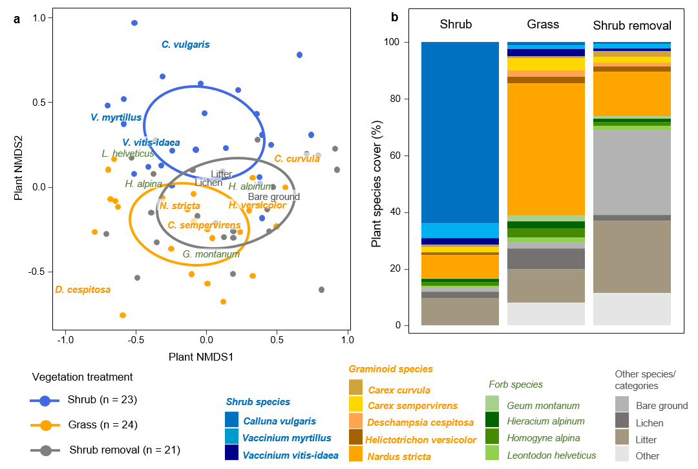
Figure S1 | Plant community composition across the vegetation treatments in the landscape-scale experiment. a) Non-metric multidimensional scaling (NMDS) plot of plant communities, showing significant effect of vegetation treatments (p < 0.01, F = 26.7 and r² = 0.43, PERMANOVA, ellipses show the 95% confidence regions for the centroids of vegetation treatments). b) Mean cover (%) of shrub, graminoid, forb, and other species and categories, across vegetation treatments. Only species with overall mean abundance > 1% are shown individually (with colours).

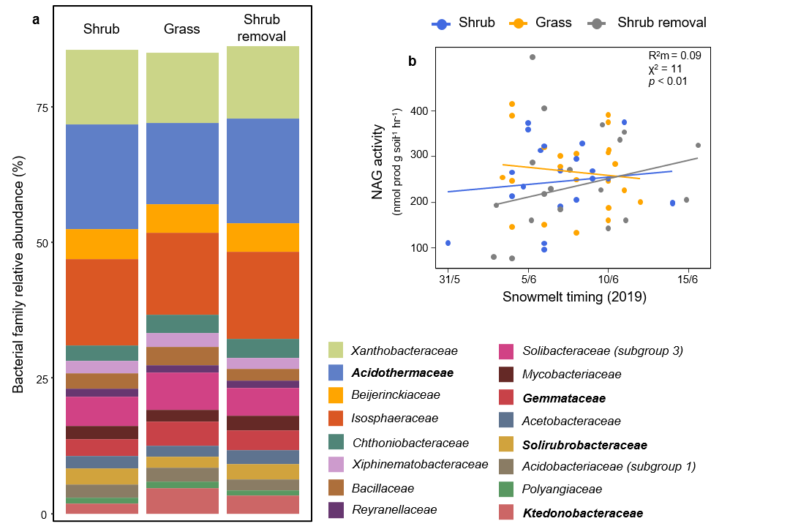
Figure S2 | Additional snowmelt timing and shrub expansion effects on summertime soil microbial community composition and functioning in the landscape-scale experiment. a) Bacterial family mean relative abundances (significant differences [p < 0.05] in bold; only families with overall mean abundance >1% are shown) and b) N-acetylglucosaminidase (NAG) potential activity, lines show model regression fits and points show individual plots (R²m = marginal R², χ² and p = χ² and p-values of snowmelt timing and vegetation treatment interaction). See tables S1 and S2 for details, including exact p and χ²-values.

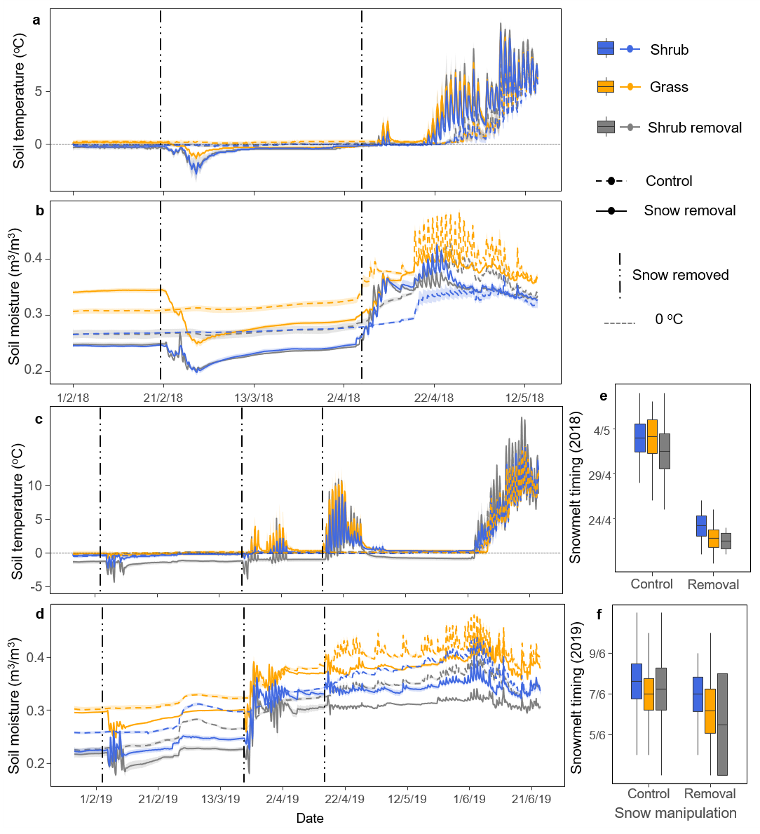
Figure S3 | Soil climate and snowmelt timing in the snow manipulation experiment. a-d) Mean soil temperature (n = 8) and moisture (n = 3) across all treatments in the manipulative experiment (± SE in shaded area), showing freeze-thaw cycles following snow removal in 2018 (a and b) and 2019 (c and d). Snowmelt timing across all treatments in 2018 (e) and 2019 (f). Boxplots show mean, SE and range. Dates in day/month/year format.

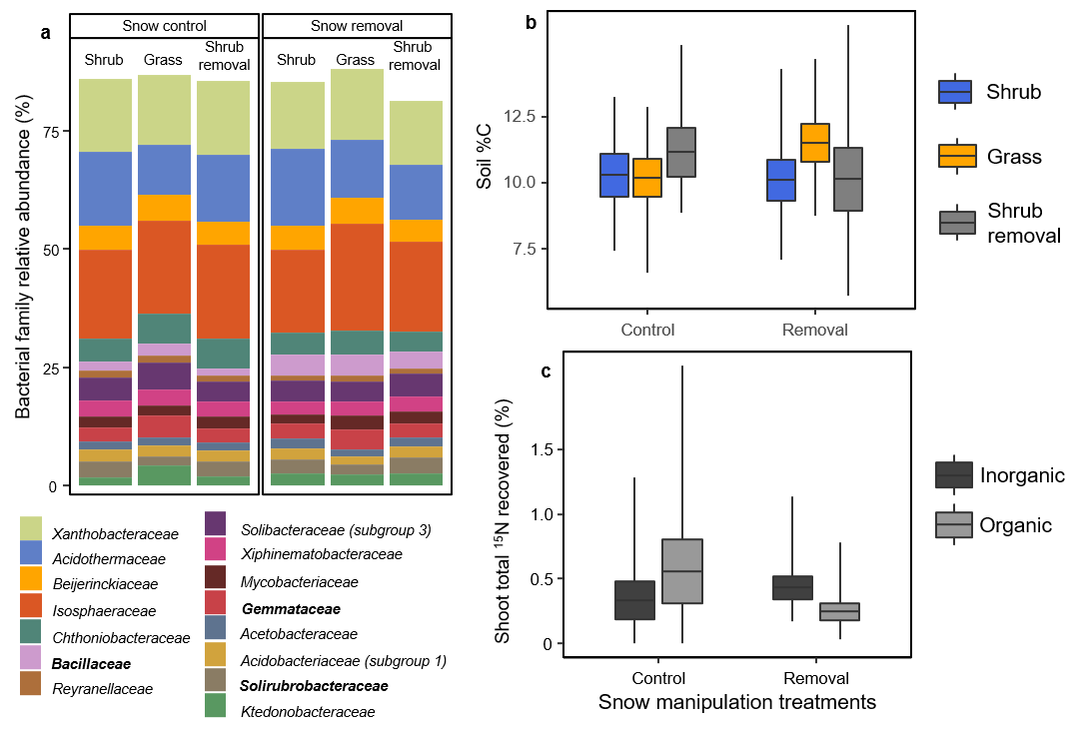
Figure S4 | Additional snow removal and shrub expansion effects on summertime soil microbial community composition, functioning, and ¹⁵N content in shoot biomass following ¹⁵N labelling, in the snow manipulation experiment. a) Relative abundances of bacterial families across the snow and vegetation manipulation treatments (significant differences [p < 0.05] in bold; only families with overall mean abundance >1% are shown), b) soil %C measured in 2018 (after the first year of snow removal treatments; p > 0.05 for snow and vegetation manipulation treatments), c) shoot total ¹⁵N recovered from inorganic and organic ¹⁵N addition across snow manipulation treatments. Boxplots show mean, SE and range. See tables S3-S5 for details, including exact p and χ²-values.

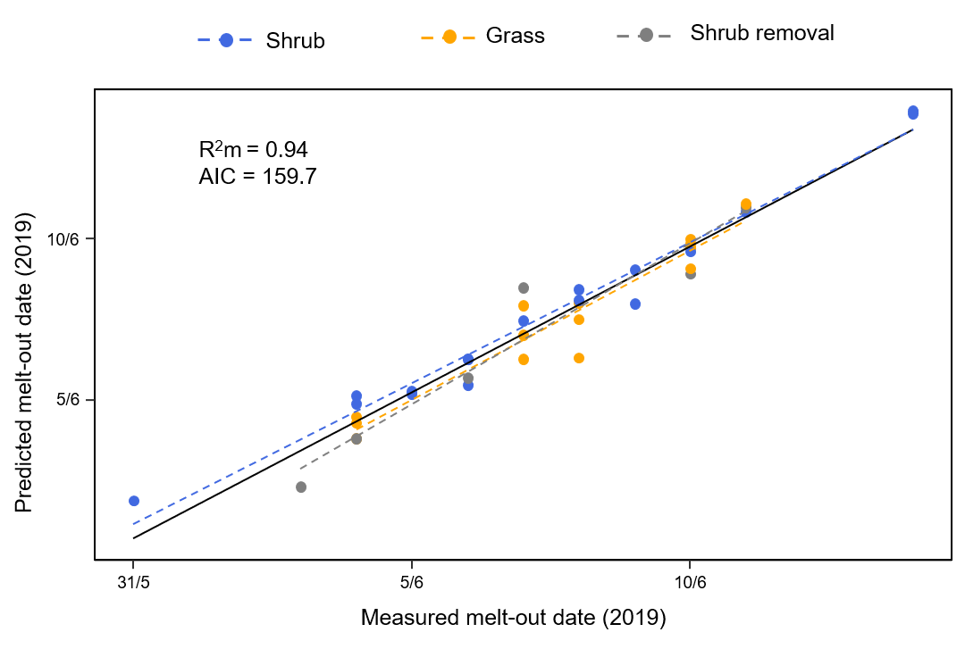
Figure S5 | Predicted vs. measured 2019 snowmelt dates. Predicted melt-out dates for 2019 generated by linear mixed effects model that had 2018 snowmelt dates and plot aspect as fixed effects, and block nested in site as random effects. Solid black line shows overall model regression fit, and dotted lines show regression fits for each vegetation treatment. R²m = marginal R², AIC = Akaike information criterion, n = 38.

Table S1 | Soil microbial community composition in the landscape-scale experiment. Means (± SE), % change (Δ) from the grass-control to the shrub-invaded treatment (as % of grass-control, based on unrounded means), p, and χ2 values for the vegetation treatment, snowmelt timing, and their interaction. All biomasses in phospholipid fatty acid (PLFA) analyses are in nmol PLFA g⁻¹ dry soil. Due to the large number of microbial families analysed, only those with significant effects are shown. Significant differences (p < 0.05) in bold, *log₁₀ transformed for analysis.

PLFA ANALYSIS | Mean ± SE Shrub-invaded  (n = 23) | Grass-control  (n = 24) |  | Shrub removal  (n = 21) |  | Δ grass  to shrub (%) | Veg  p (Χ²)  Df = 2 | Snowmelt timing  p (Χ²)  Df = 1 | Snowmelt  timing*Veg  p (Χ²)  Df = 2
Fungal: bacterial ratio | 0.46 ± 0.02 | 0.50 ± 0.02 |  | 0.48 ± 0.02 |  | -7 | 0.30 (2.5) | 0.68 (1.0) | 0.22 (3.4)
Gram positive:  gram negative ratio | 3.0 ± 0.1 | 2.7 ± 0.1 |  | 2.7 ± 0.1 |  | 10 | <0.01 (15.6) | 0.68 (1.1) | 0.93 (0.1)
Fungal biomass | 285.9 ± 27.6 | 397.2 ± 41.3 |  | 347.0 ± 39.3 |  | -28 | 0.21 (4.7) | 0.74 (0.1) | 0.22 (4.1)
Bacterial biomass | 617.7 ± 59.3 | 803.2 ± 72 |  | 711.5 ± 67.4 |  | -23 | 0.22 (3.9) | 0.68 (0.3) | 0.22 (3.7)
Actinomycete biomass | 374.6 ±36.7 | 458.3 ± 37.0 |  | 414.1 ± 42.2 |  | -18 | 0.3 (2.4) | 0.68 (0.3) | 0.22 (3.8)
Total biomass | 1293 ± 123 | 1738 ± 166 |  | 1517 ± 146 |  | -26 | 0.21 (4.5) | 0.68 (0.3) | 0.22 (3.8)
BACTERIAL FAMILY
RELATIVE ABUNDANCE (%)
Acidothermaceae | 19.3 ± 1.5 | 14.9 ± 1.3 |  | 19.2 ± 2.0 |  | 29 | 0.01 (14.2) | 0.94 (0.7) | 0.93 (0.4)
Gemmataceae | 3.1 ± 0.2 | 4.4 ± 0.4 |  | 3.7 ± 0.4 |  | -29 | 0.02 (10.8) | 0.95 (0.1) | 0.75 (3.2)
Ktedonobacteraceae* | 1.8 ± 0.2 | 4.7 ± 0.9 |  | 3.3 ± 0.8 |  | -61 | <0.01 (14.0) | 0.96 (0.6 | 0.91 (1.5)
Solirubrobacteraceae* | 3.0 ± 0.4 | 2.0 ± 0.2 |  | 2.7 ± 0.3 |  | 49 | 0.01 (13.2) | 0.96 (<0.1) | 0.91 (0.8)
FUNGAL FAMILY
RELATIVE ABUNDANCE (%)
Extremaceae* | 0.5 ± 0.2 | 1.8 ± 0.5 |  | 0.9 ± 0.2 |  | -69 | 0.03 (9.6) | 0.66 (0.9) | 0.14 (9.4)
Helotiales  (fam_Incertae_sedis)* | 7.2 ± 0.9 | 12.0 ± 1.5 |  | 6.1 ± 0.9 |  | -40 | <0.01 (19.4) | 0.67 (0.3) | 0.83 (2.6)
Herpotrichiellaceae | 23.3 ± 2.6 | 14.2 ± 2.6 |  | 25.4 ± 2.5 |  | 64 | <0.01 (19.4) | 0.64 (2.9) | 0.21 (5.7)
Hygrophoraceae* | 6.0 ± 2.1 | 22.8 ± 5.1 |  | 7.8 ± 3.1 |  | -74 | 0.01 (11.5) | 0.66 (1.2) | 0.87 (0.5)
Leotiaceae* | 6.8 ± 1.3 | 1.4 ± 0.4 |  | 7.6 ± 1.4 |  | 389 | <0.01 (53.4) | 0.73 (0.2) | 0.15 (6.8)
Venturiaceae* | 3.2 ± 1.0 | 0.2 ± 0.1 |  | 3.0 ± 1.0 |  | 1974 | <0.01 (23.1) | 0.67 (0.3) | 0.87 (0.3)

Table S2 | Soil functioning and biogeochemistry in the landscape-scale experiment. Means (± SE), % change (Δ) from the grass-control to the shrub-invaded treatment (as % of grass-control, based on unrounded means), p, and χ2 values for the vegetation treatment, snowmelt timing, and their interaction. Potential enzyme activities in nmol prod. g⁻¹ dry soil h⁻¹, except Urease (µg NH4⁺ g⁻¹ dry soil h⁻¹). Microbial biomass (MB)-specific enzyme activities in nmol prod µg⁻¹ MBC h⁻¹, except Urease (µg NH4⁺ µg⁻¹ MBC h⁻¹). Due to the large number of variables analysed, only those with significant effects are shown. Significant differences (p < 0.05) in bold, *log₁₀ transformed for analysis.

POTENTIAL ENZYME ACTIVITY | Mean ± SE Shrub-invaded  (n = 23) | Grass-control  (n = 24) | Shrub removal  (n = 21) | Δ grass  to shrub (%) | Veg  p (Χ²)  Df = 2 | Snowmelt timing  p (Χ²)  Df = 1 | Snowmelt  timing*Veg  p (Χ²)  Df = 2
β-glucosidase | 1368 ± 69 | 1109 ± 71 | 1383 ± 91 | 23 | <0.01 (14.6) | 0.56 (0.6) | 0.08 (6.9)
Cellobiohydrolase* | 220.4 ± 11.1 | 186.2 ± 10.1 | 236.5 ± 17.7 | 18 | 0.01 (11.8) | 0.95 (<0.1) | 0.85 (0.7)
N-acetylglucosaminidase* | 249.3 ± 18.0 | 267.6 ± 17.7 | 249.8 ± 26.1 | -7 | 0.10 (6.3) | 0.60 (1.0) | 0.02 (10.9)
Phosphatase | 16522 ± 1883 | 18645 ± 1793 | 14081 ± 1365 | -11 | <0.01 (14.7) | 0.34 (2.7) | 0.02 (11.5)
Urease* | 20.6 ± 4.2 | 19.3 ± 2.4 | 15.3 ± 1.5 | 7 | 0.38 (2.9) | 0.68 (0.5) | <0.01 (17.4)
MB-SPECIFIC ENZYME ACTIVITY
β-glucosidase* | 0.47 ± 0.06 | 0.31 ± 0.03 | 0.51 ± 0.07 | 53 | <0.01 (30.6) | 0.68 (0.5) | 0.25 (4.1)
Cellobiohydrolase* | 0.08 ± 0.01 | 0.05 ± 0.01 | 0.09 ± 0.01 | 50 | <0.01 (27.0) | 0.78 (0.2) | 1.0 (0.2)
β-xylosidase* | 0.43 ± 0.04 | 0.35 ± 0.03 | 0.41 ± 0.04 | 23 | 0.02 (10.3) | 0.70 (0.3) | 1.0 (<0.1)
Urease | 0.006 ± 0.001 | 0.005 ± 0.0003 | 0.005 ± 0.001 | 20 | 0.23 (4.1) | 0.56 (0.6) | <0.01 (24.1)
MICROBIAL BIOMASS
Carbon (C; µg C g soil⁻¹) * | 3550 ± 381 | 4372 ± 460 | 3359 ± 365 | -19 | <0.01 (11.5) | 0.97 (<0.1) | 0.79 (0.5)
Nitrogen (N; µg N g soil⁻¹) | 383.9 ± 39.7 | 546.5 ± 46.5 | 409.7 ± 34.5 | -30 | <0.01 (31.9) | 0.88 (<0.1) | 0.26 (2.7)
C: N ratio | 9.3 ± 0.3 | 7.8 ± 0.2 | 8 ± 0.3 | 18 | <0.01 (36.1) | 0.65 (0.2) | 0.15 (3.8)
BIOGEOCHEMICAL SOIL PROPERTIES
Available NH₄⁺  (µg N g⁻¹ dry soil) * | 1.6 ± 0.3 | 2.3 ± 0.2 | 2.7 ± 0.4 | -28 | 0.01 (11.6) | 0.60 (0.9) | 0.77 (1.2)
Soil C:N ratio | 18.3 ± 0.3 | 17.0 ± 0.4 | 17.8 ± 0.4 | 8 | <0.01 (25.1) | 0.49 (2.6) | 0.79 (1.0)

Table S3 | Soil microbial communities in the snow cover manipulation experiment. Means (± SE; n = 8), p, and χ2 values for the vegetation (Df = 2) and snow manipulation treatments (Df = 1), and their interaction (Df = 2). All biomasses in phospholipid fatty acid (PLFA) analyses are in nmol PLFA g⁻¹ dry soil. Due to the large number of microbial families analysed, only those with significant effects are shown. Significant differences (p < 0.05) in bold, *log₁₀ transformed for analysis.
 | Means (± SE)  Control |  |  | Snow removal |  |  | Veg  p  (Χ²) | Snow  p  (Χ²) | Int.  p  (Χ²)
 | Shrub-invaded | Grass-control | Shrub removal | Shrub-invaded | Grass-control | Shrub removal | Veg  p  (Χ²) | Snow  p  (Χ²) | Int.  p  (Χ²)
PHOSPHOLIPID FATTY ACID ANALYSIS
Fungal: bacterial ratio | 0.4 ± 0.02 | 0.4 ± 0.03 | 0.4 ± 0.03 | 0.5 ± 0.04 | 0.4 ± 0.02 | 0.4 ± 0.03 | 0.74 (0.6) | 0.83 (<0.01) | 0.43 (1.9)
Gram positive: gram negative bacterial ratio | 3.2 ± 0.2 | 3.0 ± 0.2 | 2.9 ± 0.1 | 3.0 ± 0.2 | 2.6 ± 0.1 | 2.9 ± 0.3 | 0.48 (5.1) | 0.01 (9.4) | 0.43 (1.7)
Fungal biomass | 229.4 ± 35.5 | 437.0 ± 120.1 | 303.1 ± 66.2 | 396.4 ± 188.1 | 255.3 ± 45.0 | 261.2 ± 50.7 | 0.74 (0.7) | 0.57 (0.5) | 0.42 (2.8)
Bacterial biomass | 511.5 ± 62.7 | 923.4 ± 193.5 | 706.5 ± 143.0 | 782.7 ± 332.1 | 614.7 ± 100.8 | 577.5 ± 90.7 | 0.74 (1.0) | 0.53 (0.9) | 0.42 (2.5)
Actinomycete biomass | 318.8 ± 42.6 | 527.3 ± 91.9 | 410.1 ± 85.8 | 457.9 ± 181.2 | 349.9 ± 62.9 | 340.6 ± 58.7 | 0.74 (0.8) | 0.53 (1.1) | 0.42 (2.6)
Total biomass | 1076.4 ± 136.2 | 2012.9 ± 461.2 | 1485.1 ± 294.8 | 1752.5 ± 785.8 | 1288.6 ± 210.3 | 1225.8 ± 195.6 | 0.74 (1.0) | 0.53 (0.9) | 0.42 (2.7)
BACTERIAL FAMILY RELATIVE ABUNDANCE (%)
Bacillaceae | 2.1 ± 0.4 | 2.7 ± 1.0 | 1.5 ± 0.3 | 4.4 ± 1.5 | 4.4 ± 1.4 | 3.7 ± 0.9 | 0.71 (1.4) | 0.02 (10.3) | 0.99 (0.1)
Gemmataceae | 3.0 ± 0.4 | 4.6 ± 0.7 | 2.9 ± 0.4 | 3.1 ± 0.4 | 4.1 ± 0.7 | 2.9 ± 0.4 | 0.01 (14.2) | 0.91 (0.2) | 0.93 (0.6)
Solirubrobacteraceae | 3.4 ± 0.8 | 2.0 ± 0.3 | 3.2 ± 0.4 | 3.0 ± 0.5 | 2.1 ± 0.3 | 3.4 ± 0.7 | <0.01 (16.2) | 0.83 (0.2) | 0.99 (0.5)
FUNGAL FAMILY RELATIVE ABUNDANCE (%)
Hygrophoraceae | 11.7 ± 5.2 | 42.9 ± 8.9 | 16.0 ± 7.6 | 9.7 ± 4.5 | 35.2 ± 8.0 | 4.8 ± 2.2 | <0.01 (25.7) | 0.76 (1.7) | 0.82 (0.5)
Herpotrichiellaceae* | 23.7 ± 4.3 | 5.6 ± 1.3 | 20.9 ± 2.9 | 20.7 ± 3.3 | 10.6 ± 4.2 | 24.1 ± 3.4 | <0.01 (54.4) | 0.77 (0.9) | 0.71 (2.1)
Leotiaceae* | 6.1 ± 2.8 | 0.4 ± 0.2 | 9.6 ± 3.1 | 4.7 ± 1.1 | 0.6 ± 0.3 | 4.9 ± 1.4 | <0.01 (70.6) | 0.77 (<0.01) | 0.71 (1.4)

Table S4 | Soil functioning and biogeochemistry in the snow cover manipulation experiment. Means (± SE; n = 8), p, and χ2 values for the vegetation (Df = 2) and snow manipulation treatments (Df = 1), and their interaction (Df = 2). Potential enzyme activities in nmol prod. g⁻¹ dry soil h⁻¹. Microbial biomass (MB)-specific enzyme activities in nmol prod µg⁻¹ MBC h⁻¹. Due to the large number of variables analysed, only those with significant effects are shown. Significant differences (p < 0.05) in bold.
 | Means (± SE)  Snow Control |  |  | Snow removal |  |  | Veg  p  (Χ²) | Snow  p  (Χ²) | Int.  p  (Χ²)
MICROBIAL BIOMASS | Shrub-invaded | Grass-control | Shrub removal | Shrub-invaded | Grass-control | Shrub removal | Veg  p  (Χ²) | Snow  p  (Χ²) | Int.  p  (Χ²)
Nitrogen (µg N g⁻¹ dry soil) | 246.0 ± 20.2 | 407.4 ± 54.8 | 280.5 ± 17.4 | 279.7 40.4 | 270.8 ± 23.1 | 245.8 ± 38.5 | 0.02 (8.0) | 0.07 (3.3) | 0.02 (7.7)
C:N ratio | 8.8 ± 0.5 | 7.3 ± 0.3 | 7.4 ± 0.5 | 8.0 ± 0.5 | 7.6 ± 0.3 | 7.9 ± 0.4 | <0.01 (10.2) | 0.98 (<0.01) | 0.10 (4.6)
POTENTIAL ENZYME ACTIVITY
β-glucosidase | 1518.0 ± 107.4 | 1202.1 ± 112.6 | NA | 1657.9 ± 108.9 | 1128.8 ± 74.3 | NA | <0.01 (17.2) | 0.90 (0.04) | 0.83 (1.1)
Cellobiohydrolase | 245.9 ± 18.7 | 198.0 ± 21.8 | NA | 302.1 ± 33.1 | 165.3 ± 18.0 | NA | <0.01 (15.2) | 0.96 (<0.01) | 0.83 (3.5)
N-acetylglucosaminidase | 268.4 ± 13.8 | 299.2 ± 28.9 | NA | 221.5 ± 18.7 | 267.6 ± 36.5 | NA | 0.27 (2.7) | 0.048 (8.3) | 0.83 (0.1)
Phosphatase | 10866 ± 422.2 | 13312 ± 965.3 | NA | 9711 ± 781.0 | 11563 ± 571.0 | NA | <0.01 (9.0) | 0.12 (4.0) | 0.83 (0.2)
MB-SPECIFIC ENZYME ACTIVITY
β-glucosidase | 0.7 ± 0.1 | 0.5 ± 0.04 | NA | 0.9 ± 0.1 | 0.6 ± 0.1 | NA | <0.01 (12.0) | 0.09 (5.2) | 0.96 (<0.01)
Cellobiohydrolase | 0.11 ± 0.1 | 0.08 ± 0.01 | NA | 0.16 ± 0.02 | 0.09 ± 0.01 | NA | <0.01 (14.5) | 0.15 (3.4) | 0.83 (1.5)
Peroxidase | 3.4 ± 0.3 | 2.8 ± 0.2 | NA | 4.2 ± 0.5 | 4.5 ± 0.6 | NA | 0.92 (0.1) | 0.048 (7.5) | 0.83 (1.3)
BIOGEOCHEMICAL SOIL PROPERTIES
Soil %C | 11.1 ± 0.9 | 9.6 ± 0.9 | 10.4 ± 0.8 | 10.0 ± 0.9 | 7.9 ± 0.5 | 9.1 ± 0.8 | 0.03 (9.7) | 0.047 (7.3) | 0.95 (0.3)
Soil C:N ratio | 17.9 ± 0.3 | 16.3 ± 0.5 | 17.1 ± 0.4 | 17.2 ± 0.4 | 16.4 ± 0.3 | 17.5 ± 0.2 | <0.01 (15.5) | 0.90 (0.2) | 0.94 (2.8)
Available NH₄  (µg N g⁻¹ dry soil) | 0.6 ± 0.3 | 1.6 ± 0.4 | 1.6 ± 0.9 | 0.2 ± 0.1 | 1.4 ± 0.6 | 1.1 ± 0.8 | 0.03 (8.6) | 0.42 (1.4) | 0.95 (0.1)
ADDITIONAL MEASURES
Soil respiration  (g CO₂ m⁻² h⁻¹) | 0.66 ± 0.07 | 0.87 ± 0.10 | NA | 0.45 ± 0.07 | 0.73 ± 0.08 | NA | <0.01 (9.4) | 0.03 (4.8) | 0.62 (0.2)

Table S5 | Soil microbial and plant ¹⁵N content after ¹⁵N labelling in the snow cover manipulation experiment. Means (± SE) for vegetation treatments and change (Δ) from grass to shrub (as % of grass, based on unrounded means). p and χ2 values from Wald tests for vegetation and snow manipulation treatments, N-form (i.e., inorganic and organic), and their interactions. Significant effects in bold, *log₁₀ transformed for analysis.
 | Means ± SE  Shrub  (n = 20) | Grass  (n = 20) | Δ grass to shrub (%) | Veg (V)  p (χ²) | Snow (S)  p (χ²) | N-form (N)  p (χ²) | V*S  p (χ²) | V*N  p (χ²) | S*N  p (χ²) | V*S*N  p (χ²)
TOTAL ¹⁵N RECOVERED (%)
Microbial biomass  (¹⁵N excess  g⁻¹ dry soil) | 27 ± 6 | 14 ± 3 | 106 | 0.02 (5.1) | 0.11 (2.5) | 0.33 (0.9) | 0.20 (1.6) | 0.67 (0.2) | 0.82 (<0.1) | 0.2 (1.6)
Shoot biomass  (¹⁵N excess  g⁻¹ biomass) | 0.23 ± 0.07 | 0.6 ± 0.1 | -59 | 0.04 (4.2) | 0.51 (0.4) | 0.84 (<0.1) | 0.41 (0.7) | 0.93 (<0.1) | 0.04 (4.1) | 0.77 (0.1)
Root biomass  (¹⁵N excess  g⁻¹ biomass) | 1.3 ± 0.3 | 2.2 ± 0.5 | -39 | 0.26 (1.2) | 0.62 (0.2) | 0.16 (1.9) | 0.81 (0.1) | 0.41 (0.7) | 0.05 (3.8) | 0.44 (0.6)
Ratio MB: plant biomass | 28.6 ± 9.6 | 8.9 ± 2.9 | 221 | 0.01 (6.3) | 0.39 (0.8) | 0.91 (<0.1) | 0.46 (0.5) | 0.87 (<0.1) | 0.88 (<0.1) | 0.74 (0.1)
¹⁵N EXCESS
Microbial biomass  (¹⁵N excess  g⁻¹ dry soil)* | 0.02 ± 0.01 | 0.01 ± 0.003 | 106 | 0.02 (5.5) | 0.21 (1.6) | 0.98 (<0.1) | 0.16 (1.9) | 0.73 (0.1) | 0.57 (0.3) | 0.37 (0.8)
Shoot biomass  (¹⁵N excess  g⁻¹ biomass)* | 0.007 ± 0.002 | 0.02 ± 0.005 | -66 | <0.01 (10.0) | 0.01 (6.3) | 0.27 (1.1) | 0.95 (<0.01) | 0.90 (<0.1) | 0.04 (4.1) | 0.76 (0.1)
Root biomass  (¹⁵N excess  g⁻¹ biomass) | 0.05 ± 0.01 | 0.12 ± 0.03 | -54 | 0.03 (5.0) | 0.60 (0.3) | 0.99 (<0.1) | 0.99 (<0.1) | 0.66 (0.2) | 0.89 (<0.1) | 0.32 (1.0)
N UPTAKE SCALED BY TARGET SOIL N POOL SIZE
Microbial biomass* | 0.16 ± 0.07 | 0.07 ± 0.02 | 126 | 0.23 (1.4) | 0.25 (1.3) | <0.01 (12.2) | 0.72 (0.1) | 0.14 (2.1) | 0.83 (<0.1) | 0.57 (0.3)
Shoot biomass* | 0.03 ± 0.01 | 0.15 ± 0.05 | -78 | <0.01 (9.8) | 0.22 (1.5) | 0.09 (2.8) | 0.34 (0.9) | 0.55 (0.4) | 0.70 (0.14) | 0.62 (0.2)
Root biomass | 0.32 ± 0.08 | 0.63 ± 0.16 | -49 | 0.02 (5.3) | 0.09 (2.7) | <0.01 (11.8) | 0.61 (0.26) | 0.99 (<0.1) | 0.94 (<0.1) | 0.53 (0.4)

Table S6 | Primer sets and thermal profiles used for the quantification of the selected genes. Asterisks (*) indicate data collection steps. † touchdown: -1ºC per cycle.
Target gene | Primer set | Fragment length (bp) | Initial denaturation | Thermal profile | Number of cycles | Reference
amoA  (Bacteria) | amoA 1F  amoA 2R | 491 | 95°C - 10 min | 94°C - 45 s  60°C - 45 s  72°C - 45 s* | 40 | (Rotthauwe et al. 1997)
amoA (Archaea) | 19F  CrenamoA616r48x | 624 | 95°C - 10 min | 94°C - 45 s  55°C - 45 s  72°C - 45 s* | 40 | (Leininger et al. 2006)
nirK | nirK 876  nirK 5R | 164 | 95°C - 10 min | 95°C - 15 s  63°C - 30 s†  72°C - 30 s | 5 | (Braker et al. 1998; Henry et al. 2004)
 |  |  |  | 95°C - 15 s  58°C - 30 s  72°C - 30 s* | 40 | (Braker et al. 1998; Henry et al. 2004)
nirS | nirS cd3af  nirS R3cd | 4413 | 95°C - 10 min | 94°C - 45 s  57°C - 45 s  72°C - 45 s* | 40 | (Michotey et al. 2000; Throbäck et al. 2004)

