Supplementary Online Data

Variants in mitochondrial ATP synthase cause variable neurologic phenotypes
Michael Zech, Robert Kopajtich, Katja Steinbrücker, Céline Bris, Naig Gueguen, René G. Feichtinger, Melanie T. Achleitner, Neslihan Duzkale, Maximilien Périvier, Johannes Koch, Harald Engelhardt, Peter Freisinger, Matias Wagner, Theresa Brunet, Riccardo Berutti, Dmitrii Smirnov, Tharsini Navaratnarajah, Richard J.T. Rodenburg, Lynn S Pais, Christina Austin-Tse, Melanie O’Leary, Sylvia Boesch, Robert Jech, Somayeh Bakhtiari, Sheng Chih Jin, Friederike Wilbert, Michael C Kruer, Saskia B. Wortmann, Matthias Eckenweiler, Johannes A. Mayr, Felix Distelmaier, Robert Steinfeld, Juliane Winkelmann, Holger Prokisch

Table of contents

Supplementary Online Tables

Supplementary Online Table 1 Summary of clinical features by gene and variant
Supplementary Online Table 2 Detailed results of enzymatic analysis in muscle tissue of patient 5 (ATP5F1A mutation)
Supplementary Online Table 3 Detailed results of enzymatic analysis in fibroblasts of patients 8 and 10 (ATP5MC3 mutations)

Supplementary Online Figures

Supplementary Figure 1 Measurement of oxygen consumption rate (OCR) in patient 8 (ATP5MC3 mutation)
Supplementary Figure 2 BN-PAGE analysis for patient 10 (ATP5MC3 mutation)

Supplementary Online Tables

Supplementary Online Table 1 Summary of clinical features by gene and variant
Patient |  | 1 | 2 | 3 | 4 | 5 | 6 | 7 | 8 | 9 | 10
Gene |  | ATP5F1E | ATP5F1E | ATP5F1E | ATP5PO | ATP5F1A | ATP5F1A | ATP5F1A | ATP5MC3 | ATP5MC3 | ATP5MC3
Variant(s) |  | c.35A>G (p.Tyr12Cys) | c.35A>G (p.Tyr12Cys) | c.35A>G (p.Tyr12Cys) | c.34C>T (p.Gln12*); c.329-20A>G | c.620G>A (p.Arg207His) | c.545G>A (p.Arg182Gln) | c.1037C>T (p.Ser346Phe) | c.318C>G (p.Asn106Lys) | c.319C>G (p.Pro107Ala) | c.236G>T (p.Gly79Val)
Background
Gender |  | female | female | female | female | female | male | female | male | female | male
Ancestry |  | European | European | Turkish | European | European | European | European | European | European | European
Age at last examination |  | 33 years | 16 months | 13 years | 6 years | 14 years | 17 years | 12 years | 12 years | 15 years | 6 years
Clinical features
Developmental delay |  | yes | yes | yes | yes | yes | yes | yes | no | yes | yes | 9/10
Muscular hypotonia/ history of hypotonia |  | yes | yes | yes | yes | yes | yes | yes | no | yes | no | 8/10
Intellectual disability |  | yes | N/A | yes | yes | no | yes | yes | no | no | yes | 6/10
Movement disorder(s) |  |  |  |  |  |  |  |  |  |  |  | 8/10
 | Dystonia | yes | yes | no | yes | no | yes | yes (diagnosis of dystonic cerebral palsy) | yes (isolated limb dystonia) | yes | no | 7/10
 | Ataxia | yes | no | yes | no | no | yes | no | no | no | no | 3/10
Spasticity/ pyramidal signs |  | no | no | no | no | no | yes | yes | no | yes | yes | 4/10
Seizures |  | no | yes | yes | yes | no | no | no | no | no | no | 3/10
Seizure quality |  | - | GTCS | GTCS | FS, GTCS | - | - | - | - | - | -
Peripheral neuropathy |  | yes | no | yes | no | no | no | no | no | no | no | 2/10
Non-ambulatory |  | no | N/A | no | yes | no | no | yes | no | no | no | 2/10
Speech abnormality |  | yes | N/A | no | yes | no | yes | yes | no | no | no | 4/10
Neurologic regression |  | no | no | no | yes | no | no | no | no | no | no | 1/10
Spontaneous symptom resolution |  | no | no | no | no | yes | no | no | no | no | no | 1/10
Current status |  | alive, persistent neurologic dysfunction | alive, persistent neurologic dysfunction | alive, persistent neurologic dysfunction | died (age 6 years) | alive, no clinical symptoms | alive, persistent neurologic dysfunction | alive, persistent neurologic dysfunction | alive, persistent neurologic dysfunction | alive, persistent neurologic dysfunction | alive, persistent neurologic dysfunction
Lactate elevation |  | yes | yes | yes | yes | yes | no | yes | no | no | yes | 7/10
Other metabolic abnormalities |  | hyperammonaemia; hyper-Ckaemia; 3-methylglutatonic aciduria; increased isoleucin, leucin, and ornithine | hyperammonaemia; hyper-Ckaemia; increased alanine, lysine, tyrosine, and glutamine; increased carnitine, acyle carnitine, and benzoyl carnitine | 3-methylglutatonic aciduria; elevated 4-OH phenylpyruvic acid | no | no | no | no | no | no | no | 3/10
Additional features |  | mild hypertrophy of left ventricle; renal tubular acidosis | congenital bilateral cataracta nuclearis, bilateral persistent A. hyaloidea; congenital hearing loss, abnormal BERA | hepatomegaly; hyposomia; dystrophia | microcephaly; restlessness; sleep disturbances | failure-to-thrive | hearing impairment | swallowing problems; strabismus; 21-hydroxylase deficiency | no | no | no | 7/10
Brain MRI abnormality |  | increased signal intensities in Ncl. caudati (14 years) | haemosiderin staining in left side ventricle | N/A | reduced brain volume; delayed myelination and hypoplasia of the lower part of the cerebellar vermis (15 months); severe progressive global atrophy (5 years) | no | no | signal abnormality in the bilateral ventrolateral thalami | signal abnormality in the bilateral frontoparietal white matter | no | no | 5/10

FS, focal seizures; GTCS, generalized tonic-clonic seizures

Supplementary Online Table 2 Detailed results of enzymatic analysis in muscle tissue of patient 5 (ATP5F1A mutation)
I. Enzyme investigations | mUnit/mg protein | normal range | mUnit/mUnit CS | normal range | protein [mg/ml]
Citrate synthase (CS) | 236 | 150 - 338 |  |  | 2.38
Complex I | 63 | 28 - 76 | 0.26 | 0.14 – 0.35
Complex II | 58 | 33 - 102 | 0.24 | 0.18 – 0.41
Complex II+III | 128 | 65 - 180 | 0.54 | 0.3 – 0.67
Complex III | 527 | 304 - 896 | 2.23 | 1.45 – 3.76
Cytochrome c oxidase | 511 | 181 - 593 | 2.16 | 0.91 – 2.24
Complex V | 52 | 86 - 257 | 0.22 | 0.42 – 1.26
Pyruvate dehydrogenase | 16 | 5.3 – 19.8 | 0.068 | 0.026 – 0.08
II. Substrate oxidation | nmol/h/mg protein | normal range | nmol/h/mUnit CS | normal range
[1-14C]Pyruvate+malate+ADP | 380 | 263 - 900 | 1.61 | 1.54 – 3.55
[1-14C]Pyruvate+carnitine | 566 | 302 - 856 | 2.40 | 1.65 – 3.66
[1-14C]Pyruvate+malate (no ADP) | 58 | 32 - 102 | 0.25 | 0.21 – 0.41
[1-14C]Pyruvate+malate+CCCP | 495 | 304 - 889 | 2.10 | 1.31 – 3.11
[1-14C]Pyruvate+malate+atractyloside | 77 | 19 - 90 | 0.33 | 0.16 – 0.55
[U-14C]Malate+pyruvate+malonate | 330 | 282 - 874 | 1.40 | 1.56 – 3.87
[U-14C]Malate+acetylcarn.+malonate | 430 | 273 - 678 | 1.82 | 1.16 – 2.82
[U-14C]Malate+acetylcarn.+arsenite | 214 | 156 - 378 | 0.91 | 0.57 – 1.52
[U-14C]Glutamate+acetylcarnitine | 94 | 86 - 209 | 0.40 | 0.35 – 1.06

The normal range was defined by using assay results of 37 independent muscle control samples as a reference (Salzburg, Austria). Measurements were performed in duplicate on one patient-derived muscle biopsy sample (no availability of independent additional biopsies from the patient). Under I (enzyme investigations), complex V (ATP synthase) was reduced when normalized to protein and marker enzyme (CS). Under II (substrate oxidation), the ratio of CCCP-activated respiration (“pyruvate+malate+CCCP”) versus ADP-activated respiration (“pyruvate+malate+ADP”) was abnormal (compared to internal reference ranges; 0.73-1.23, muscle controls N=929; Salzburg, Austria), indicating a defect of ATP synthesis.

Supplementary Online Table 3 Detailed results of enzymatic analysis in fibroblasts of patients 8 and 10 (ATP5MC3 mutations)
 |  | nmol/min/mg protein |  |  |  |  |  | Ratios (OXPHOS enzyme activities normalized to CS)
 |  | Complex I | Complex II | Complex III | Complex IV | Complex V (ATP synthase) | Citrate synthase (CS) | I/CS | II/CS | III/CS | IV/CS | V/CS
Controls (n=100) | mean | 245 | 93 | 706 | 626 | 191 | 496 | 0.50 | 0.17 | 1.15 | 1.09 | 0.40
 | SD | 27 | 16 | 109 | 89 | 34 | 112 | 0.07 | 0.03 | 0.28 | 0.19 | 0.09
Normal ranges |  | 191 | 61 | 489 | 448 | 123 | 271 | 0.35 | 0.10 | 0.56 | 0.70 | 0.22
 |  | 299 | 125 | 924 | 804 | 271 | 720 | 0.66 | 0.25 | 1.73 | 1.52 | 0.60
Patient 8 (N106K) | P5 | 297 | 45 | 499 | 524 | 96 | 561 | 0.53 | 0.08 | 0.89 | 0.93 | 0.17
 | P6 | 230 | 78 | 515 | 571 | 140 | 560 | 0.41 | 0.14 | 0.92 | 1.02 | 0.25
 | P7 | - | 85 | - | - | 121 | 574 | - | 0.15 | - | - | 0.21
 | mean | 264 | 69 | 507 | 548 | 119 | 565 | 0.47 | 0.12 | 0.91 | 0.98 | 0.21
Patient 10 (G79V) | P8 | 271 | 90 | 382 | 724 | 11 | 603 | 0.45 | 0.15 | 0.63 | 1.20 | 0.02
 | P10 | 330 | 102 | 450 | 819 | 76 | 704 | 0.47 | 0.14 | 0.64 | 1.16 | 0.11
 | P11 | - | - | - | - | 38 | 626 | - | - | - | - | 0.06
 | mean | 301 | 96 | 416 | 772 | 42 | 644 | 0.46 | 0.15 | 0.64 | 1.18 | 0.06

The normal range was defined by using assay results of 100 independent fibroblast control samples as a reference (Angers, France). Measurements were performed in duplicate and repeated with different passages of patient-derived fibroblasts. In case of discrepant values, an additional measurement was performed. Complex V (ATP synthase) activities were significantly reduced in both patient 8 (c.318C>G, p.Asn106Lys) and patient 10 (c.236G>T, p.Gly79Val), although ATP synthase impairment was much more pronounced in patient 10. The mild ATP synthase activity reduction in patient 8 was consistent with results from Neilson et al. (Neilson et al., Mov Disord 2021, PMID: 34636445), where an affected father-son pair with the same mutation has been studied enzymatically.

Supplementary Figure 1 Measurement of oxygen consumption rate (OCR) in patient 8 (ATP5MC3 mutation)
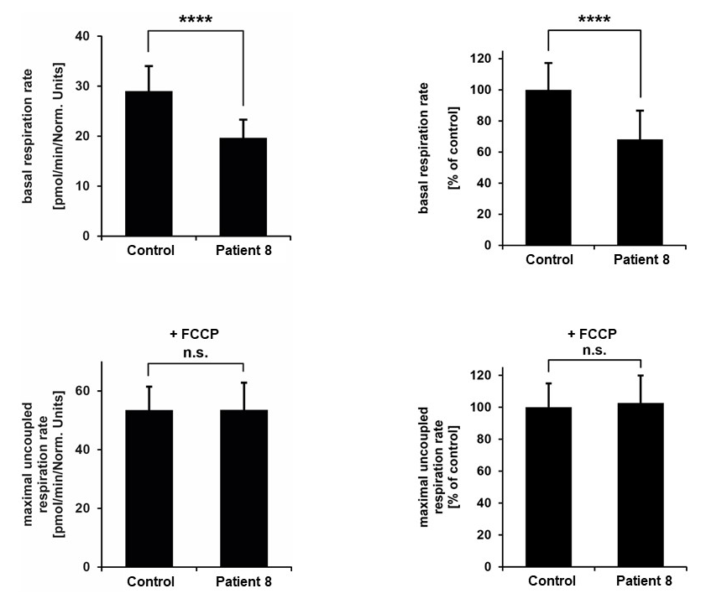

OCR was determined in patient 8`s fibroblasts and a control line. Data show the mean values ± SEM of basal respiration (upper graphs; left graph: absolute values; right graph: relative values) and of maximal respiration after addition of FCCP (bottom graphs; left graph: absolute values; right graph: relative values); number of replicates: patient=28 control=25; ****p<0.0001. Normalization of oxygen consumption after the addition of FCCP is consistent with a defect of complex V (ATP synthase).

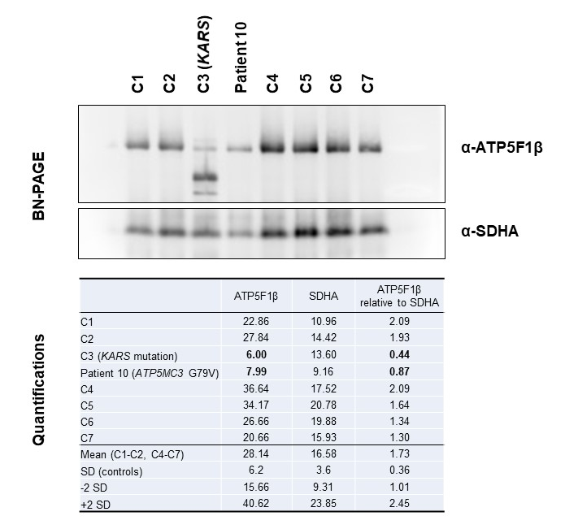
Supplementary Figure 2 BN-PAGE analysis for patient 10 (ATP5MC3 mutation)
BN-PAGE indicating reduced levels of ATP synthase in patient 10 relative to six different healthy control subjects (C1-C2; C4-C7); a positive control line (C3) with pathogenic KARS mutations (OMIM:601421) resulting in profoundly aberrant ATP synthase assembly was also included. A cropped version of the membrane (not showing controls C4-C7) is depicted in Figure 5f of the main manuscript. Normalization of ATP synthase holoenzyme expression to the expression of complex II (SDHA) showed a significant decrease in ATP synthase protein amounts in patient 10 (< 2 SD from mean control value); quantifications of immunoblot band intensities are provided in the bottom panel.

