Supplementary figures:

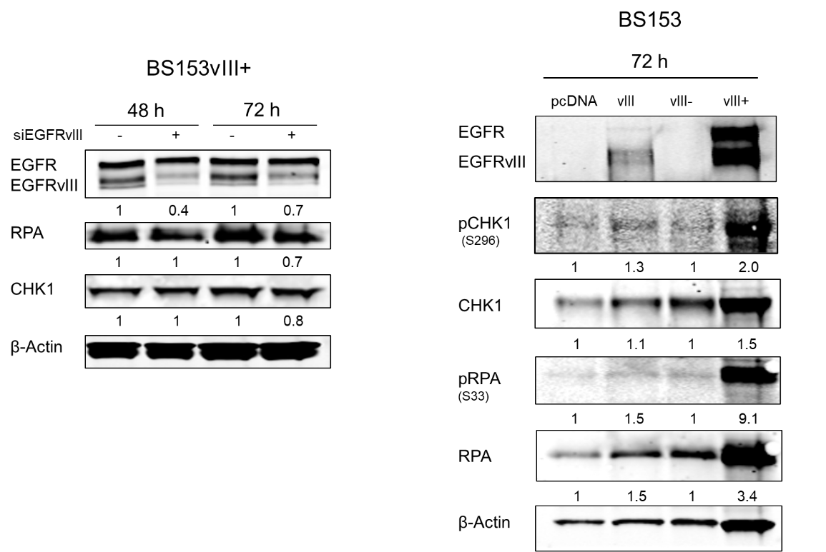
A B

Fig. S1. Impact of siRNA-mediated EGFRvIII knockdown and EGFRvIII overexpression on RPA and CHK1 expression/phosphorylation. A) Knockdown of EGFRvIII in BS153vIII+ cells via siRNA after 48 h and 72 h. An siRNA against cyclophilin B served as a control. For Western blot analysis β-actin served as loading control. For quantification of relative RPA and CHK1 expression protein levels were normalized to β-actin and to RPA and CHK1 levels in the cyclophilin B control. B) Overexpression of EGFRvIII in BS153vIII- cells after 72 h using an pcDNA-EGFRvIII plasmid. Empty pcDNA vector was used as a control. For quantification of relative RPA/pRPA and CHK1/pCHK1 expression and phosphorylation levels were normalized to β-actin and to RPA/pRPA and CHK1/pCHK1 levels in the pcDNA or BS153vIII- control.

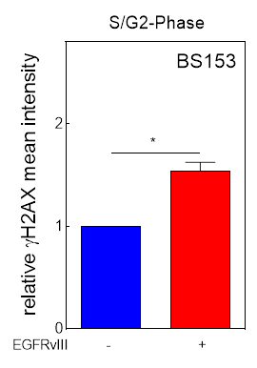

Fig. S2. EGFRvIII expression causes replication stress. Quantification of H2AX intensity in S/G2-phase of BS153vIII-/+ cells using flow cytometry (mean with S.E.M, n = 4; P-values are obtained by two-tailed Mann Whitney test, *p <0.05).

Fig. S3. EGFRvIII expression is associated with increased single stranded DNA. Quantification of RPA intensity in S/G2-phase of DKMGvIII-/+ and BS153vIII-/+ cells using flow cytometry (mean with S.E.M, n = 4; P-values are obtained by two-tailed Mann Whitney test, *p <0.05).

A B
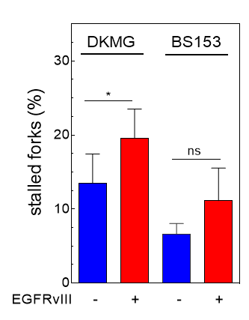

Fig. S4. EGFRvIII expression causes replication stress. Bar charts summarize quantification of A) stalled and B) first and second pulse origins (as a percentage of total number of replication structures identified) in DKMGvIII-/+ and BS153vIII-/+ cells (mean with S.E.M, n = 4; P-values are obtained by two-tailed Mann Whitney test, *p <0.05, ns: not significant).

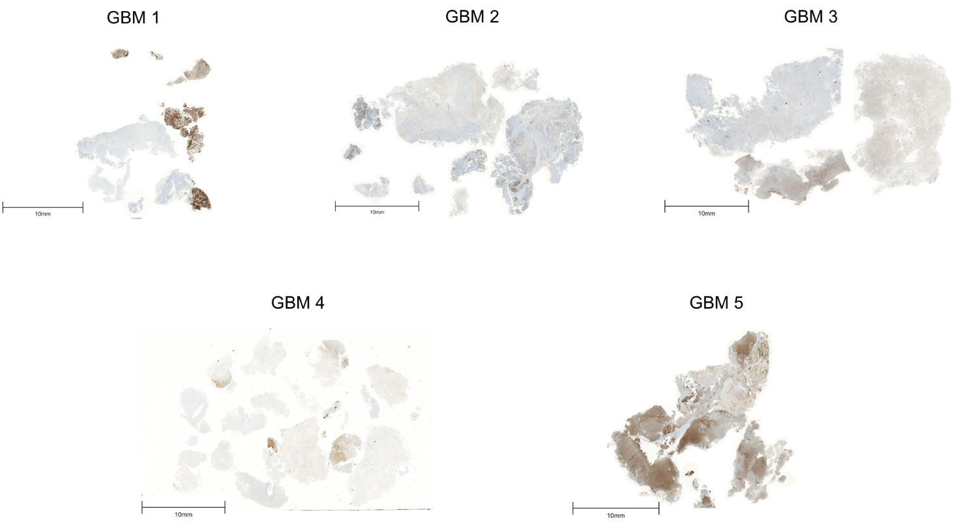

Fig. S5: Heterogenous EGFRvIII expression in human GBM samples. Immunohistochemical detection of EGFRvIII in the five GBM samples patient samples used for the analysis of RS markers. Scale bars represent 10 mm.

Fig. S6. Activated DNA damage response in EGFRvIII expressing GBM cells. Western blot analysis of DNA damage response markers in DKMGvIII-/+ and BS153vIII-/+ cells. Samples were normalized to cell number. β-Actin served as loading control.

A
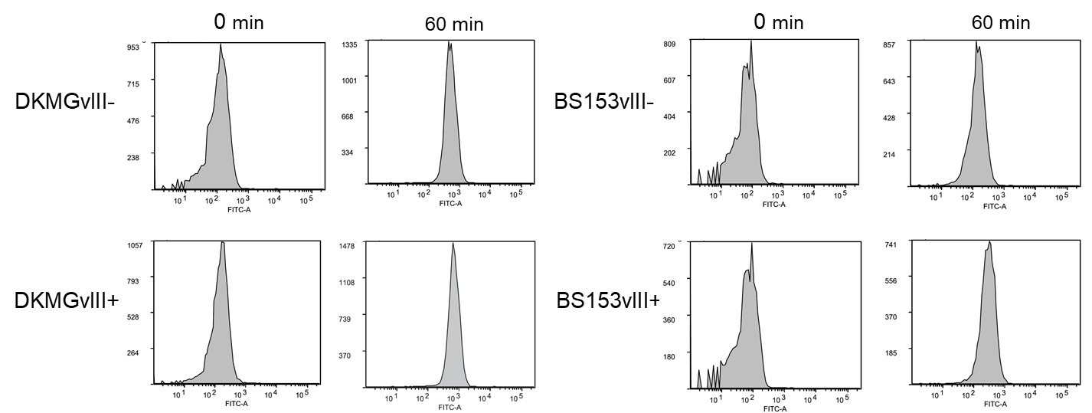

B

Fig. S7: EGFRvIII expression increases transcription activity. A) Transcriptional activity of DKMGvIII-/+ and BS153vIII-/+ cells was measured by EU incorporation via flow cytometry. Representative histograms showing kinetics over 60 minutes of EU treatment are depicted. B) Quantification of EU incorporation rate for the times indicated (mean with S.E.M, n = 3; P-values are obtained by two-tailed student’s t test, *p <0.05).

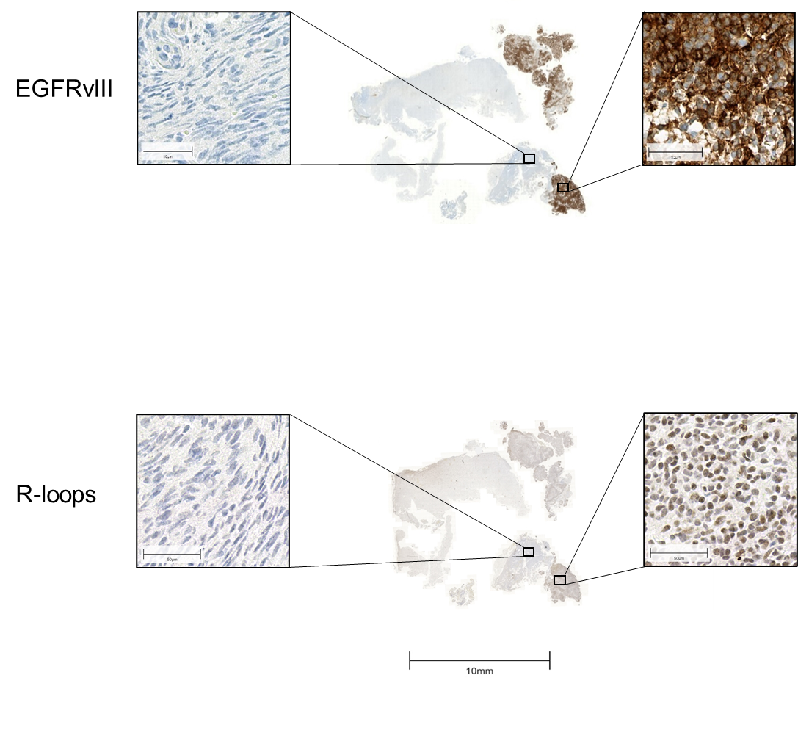
Fig. S8: Detection of R-loops in EGFRvIII+ GBM. Immunohistochemical detection of R-loops in one representative GBM patient sample (GBM1) displaying heterogeneous EGFRvIII expression. Scale bar represents 10 mm. Scale bars of the enlarged specimens represent 50 µm.

