SUPPLEMENTARY INFORMATION

Acidic Wood Extractives Accelerate the Curing Process of Emulsion Polymer Isocyanate (EPI) Adhesives
Merve Özparpucu^{1,}*, Antoni Sánchez-Ferrer^{1,*}, Mathias Schuh¹, Bianca Wilhelm¹, Riddhiman Sarkar^{2,3}, Bernd Reif^{2,3}, Elisabeth Windeisen-Holzhauser¹, Klaus Richter¹

¹ Technical University of Munich, School of Life Sciences Weihenstephan, Chair of Wood Science, Winzererstr. 45, 80797 Munich, Germany.
² Helmholtz-Zentrum München (HMGU), Deutsches Forschungszentrum für Gesundheit und Umwelt, Ingolstädter Landstr. 1, 85764 Neuherberg, Germany
³ Technical University of Munich, Bayerisches NMR Zentrum (BNMRZ), Department of Chemistry, Lichtenbergstr. 4, 85748 Garching, Germany
* Corresponding authors: e-mail: oezparpucu@hfm.tum.de and sanchez@hfm.tum.de

Supplementary Tables

Table SI-1 Spectral changes related to EPI-curing
FTIR band (cm⁻¹) | Assignment | The relative changes
FTIR band (cm⁻¹) | Assignment | EPI-Ref | EPI-Ch | EPI-Oa
3100-3500 | N-H str.  Due to the formation of the amine (N-H), urea (NHCON-H), and urethane (OCON-H) moieties, but partly overlaps with OH str. | +28% | +48% | -12%
2270 | NCO str.  Isocyanate stretching from the hardener | -31% | -47% | -37%
1730 | CO str.  free urethane moiety together with the acetyl moiety | -21% | -5% | -15%
1645 | CO str.  carbonyl stretching of H-bonded urea motifs (NHCONH) and partly overlapped with scissoring band of water | +44% | +70% | -2%

Table SI-2. pK_{a} values for the compounds used in the mixtures with EPI-adhesive.

Acidic Compounds |  | pK_{a}*
Gallic acid |  | 3.94
Benzoic acid |  | 4.08
Malonic acid |  | 2.43
Maleic acid |  | 1.83
Succinic acid |  | 3.55
Ellagic acid |  | 5.54
Caffeic acid |  | 3.14
m-Coumaric acid |  | 4
Phenolic compounds
Phloroglucinol |  | 9.13
Hydroquinone |  | 9.68
Sugar alcohol
Xylitol |  | 12.76
* Based on the values in ChemAxon.

Table SI-3. Storage shear modulus (G’), segmental molecular weight (M_{c}) and crosslinking density (ν_{c}) for the samples EPI-Ref, EPI-Ch and EPI-Oa after 36 h of curing.
Sample | G' (MPa) | M_{c} (g/mol) | v_{c} (mol/m³)*
EPI-Ref | 6.26 | 466 | 2568
EPI-Ch | 7.23 | 403 | 2966
EPI-Oa | 5.61 | 520 | 2302
*The density for the cured EPI-adhesive was estimated to be 1.20 g/cm³ at 20 °C.
Supplementary Figures

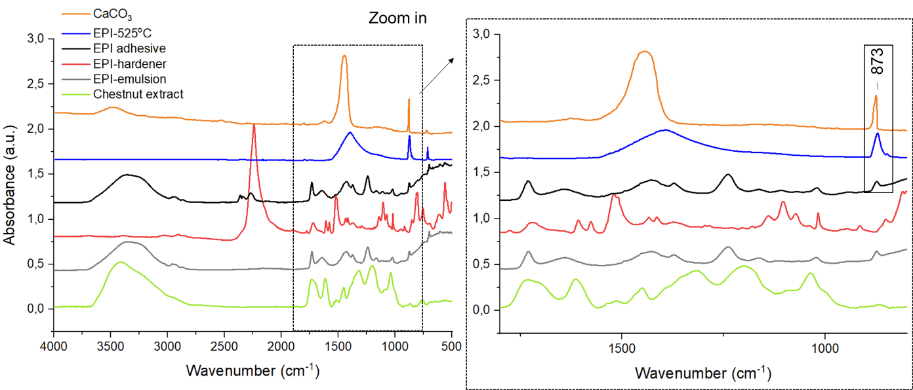
FIGURE SI-1 FTIR spectra comparison: water-based EPI-adhesive components: chestnut extract (green), EPI-emulsion part (grey), EPI-isocyanate based hardener (red), EPI-adhesive (emulsion+hardener at the beginning of rheology measurements, t=0 min) (black), cured EPI-adhesive after ashing at 525 °C for 90 min (blue), and precipitated CaCO₃ (orange, NIST database).

a)
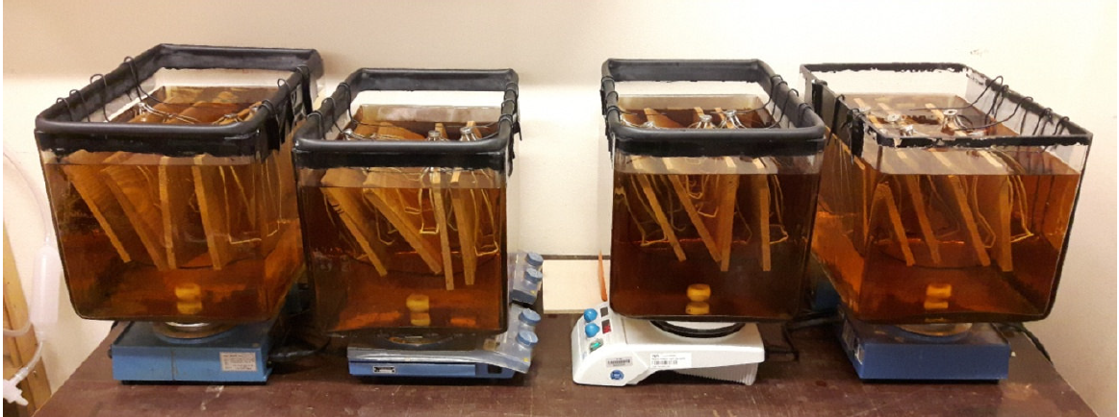
b)
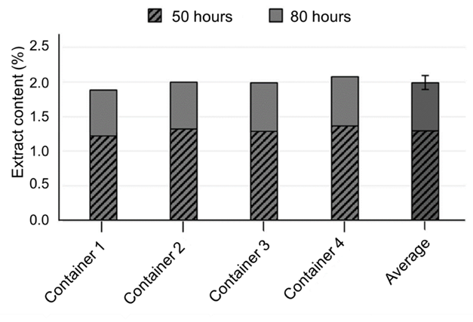
FIGURE SI-2 a) The water extraction set-up at room temperature. b) The extracted content after 50 and 80 h of extraction on the chestnut wood panels from which the tensile shear test specimens were prepared.

FIGURE SI-3 Liquid ¹³C NMR spectra of the polymer EPI-emulsion component (PVA-PVAC, black), the EPI-hardener (pMDI, blue), and the chestnut extract (gallic acid and sugar molecules, red).

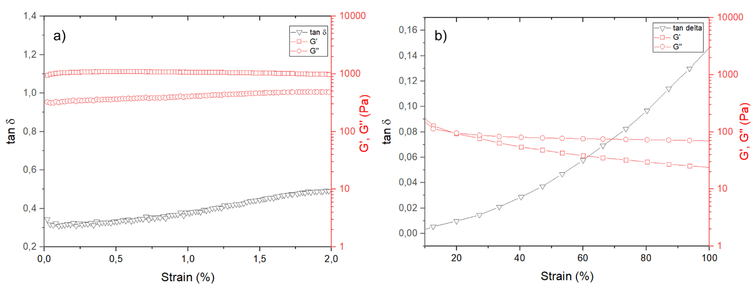
FIGURE SI-4 Strain-sweep tests at 1 Hz frequency and 20 °C on the EPI-Ref sample a) at lower strain % values (for the determination of the LVR Region), and b) at higher strain % values (indicating a shear thinning behavior).

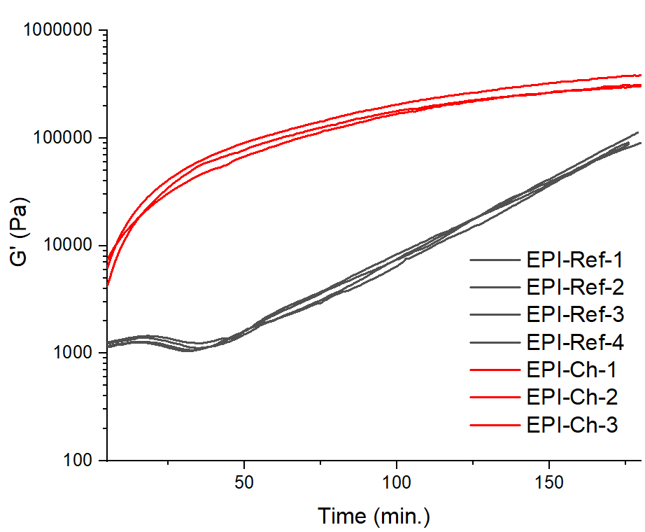
FIGURE SI-5 Example of technical variabilities in G‘ curves within the sample groups.

FIGURE SI-6 Derivative curves, dG‘/dt, as a function of time for the samples EPI-Ref (black), EPI-Ch (red) and EPI-Oa (blue) showing the different reaction kinetics for 3 h of measurement.

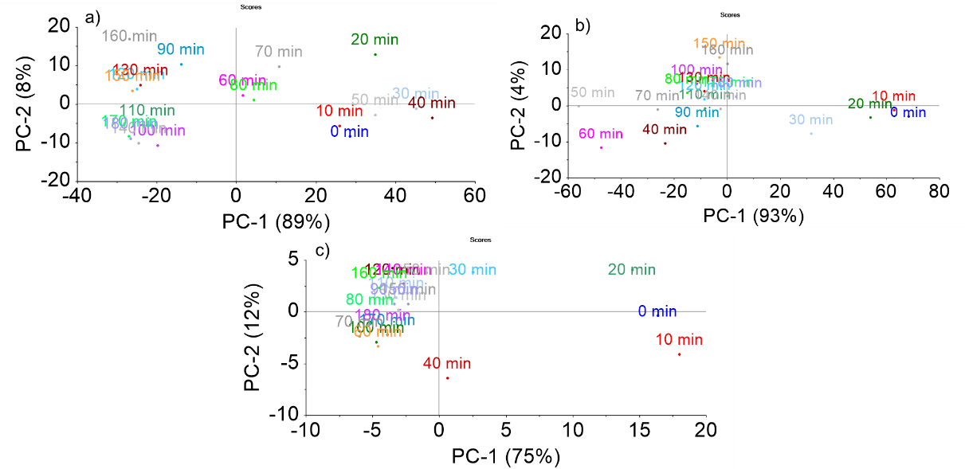
FIGURE SI-7 PCA scores from the FTIR spectra for the a) EPI-Ref, b) EPI-Ch and EPI-Oa samples

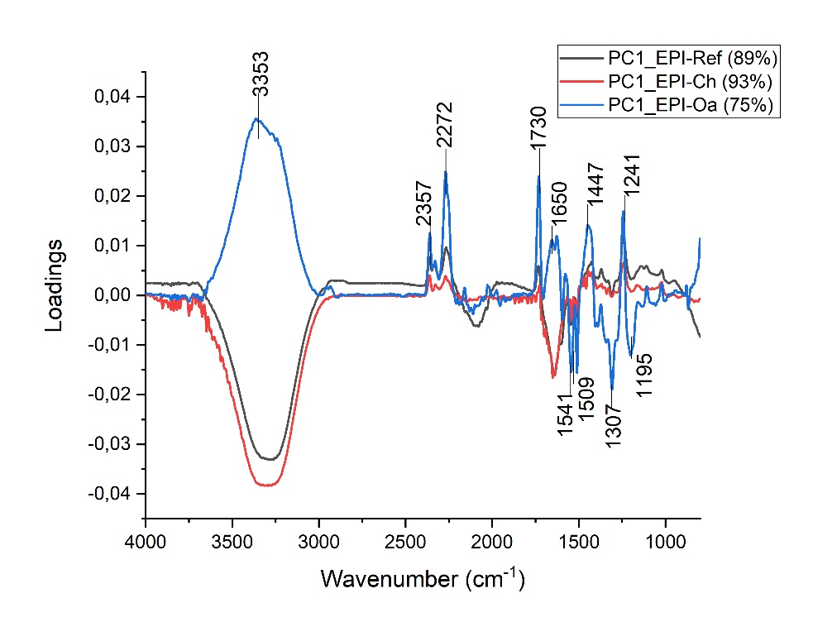
FIGURE SI-8 Loading PC1 comparison for the EPI-Ref, EPI-Ch and EPI-Oa

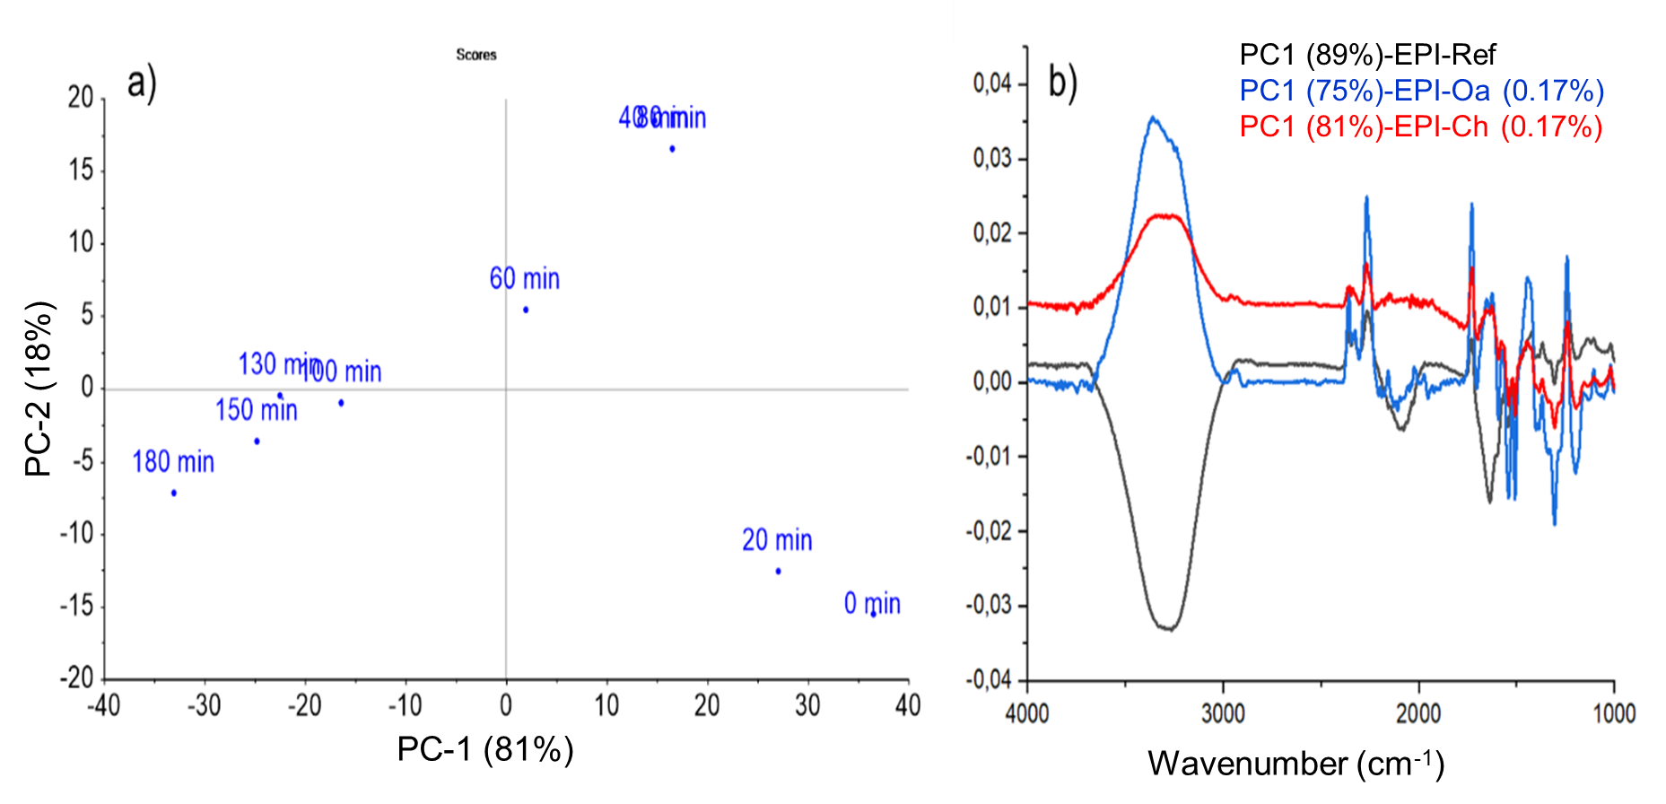
FIGURE SI-9 PCA Results from the FTIR spectra: a) PC scores of EPI-Ch with 0.17 % extract addition, b) the comparison of the loadings PC1 between the samples.

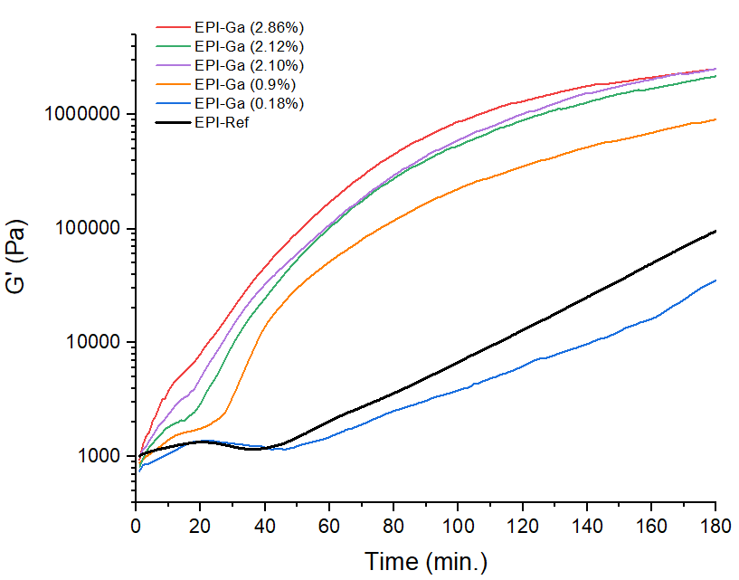
FIGURE SI-10 Storage shear modulus G’ as a function of time and for different amounts of gallic acid.

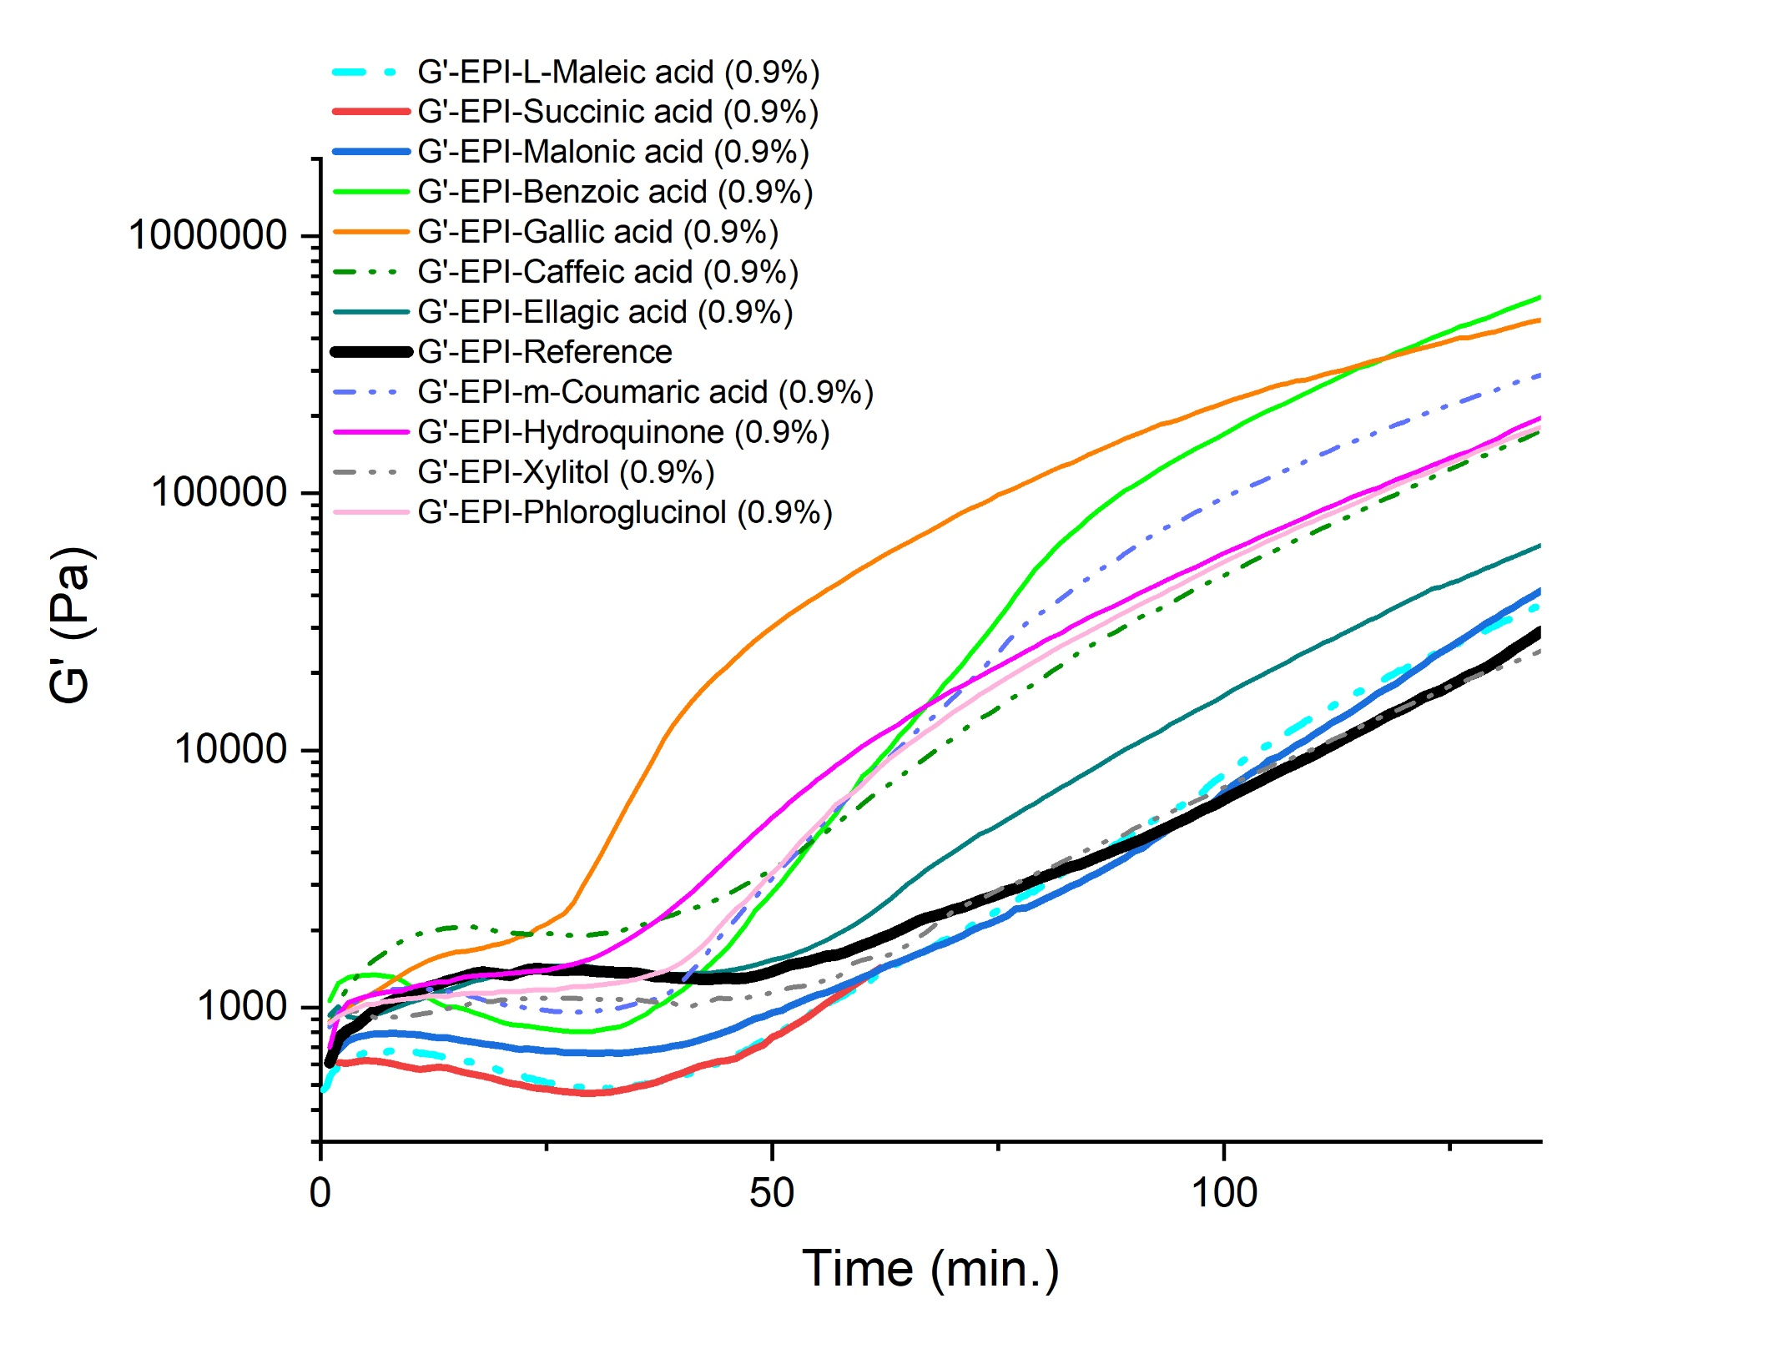
FIGURE SI-11 Storage shear modulus G’ as a function of time for some EPI-mixtures with different organic compounds.

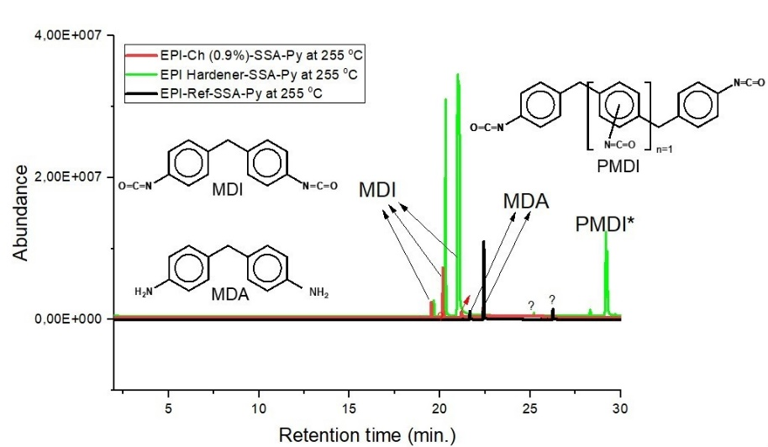
FIGURE SI-12 Single Shot Analysis (SSA)-pyrolysis products of the EPI-Ref, EPI-Ch samples and the hardener (at 255 °C).

a) | b)
c)
FIGURE SI-13 Storage shear modulus, G’, loss shear modulus, G”, and loss factor, tan δ, evolution for 6 h for the samples a) EPI-Ref, b) EPI-Ch and c) Derivative curves, dG‘/dt, as a function of time for 6 h of measurement.

a) | b)
c) | d)
FIGURE SI-14 Storage shear modulus, G’, loss shear modulus, G”, and loss factor, tan δ, evolution for 35 h for the samples a) EPI-Ref, b) EPI-Ch and c) EPI-Oa, and d) Derivative curves, dG‘/dt, as a function of time for 35 h of measurement.
.
FIGURE SI-15 Solid-state ¹³C NMR of the EPI-Ref sample (black), and the simulated peaks of the urethane (red), urea (green) and free amine (orange) formed during the curing process, and the PVA-PVAc polymer in the EPI-emulsion (blue).
FIGURE SI-16 Solid-state ¹³C NMR of the chestnut extract (black), and the simulated peaks of gallic acid (red), inositol (green), and sugars (C₆ and C₅, blue).

FIGURE SI-17 Solid-state ¹³C NMR spectra for the a) EPI-Ch (0.93%) and b) EPI-Oa (0.17%). The fitting curves (red) and the corresponding extract (blue) are evaluated from the deconvolution process. The results indicate 0.98% and 0.35% of extractives for the EPI-Ch and EPI-Oa samples, respectively.

