Short-term effects of cold spells on plasma viscosity: results from the KORA cohort study in Augsburg, Germany

Authors: Wenli Ni^{1,2}, Alexandra Schneider¹, Kathrin Wolf¹, Siqi Zhang¹, Kai Chen^{3,4}, Wolfgang Koenig^{5,6,7}, Annette Peters^{1,2,7}, Susanne Breitner^{1,2}

¹ Institute of Epidemiology, Helmholtz Zentrum München - German Research Center for Environmental Health (GmbH), Ingolstädter Landstraße 1, Neuherberg, Germany.
² Institute for Medical Information Processing, Biometry, and Epidemiology, Pettenkofer School of Public Health, LMU Munich, Munich, Germany
³ Department of Environmental Health Sciences, Yale School of Public Health, New Haven, CT 06520, USA.
⁴ Yale Center on Climate Change and Health, Yale School of Public Health, New Haven, CT, USA
⁵ Institute of Epidemiology and Medical Biometry, University of Ulm, Ulm, Germany
⁶ Deutsches Herzzentrum München, Technische Universität München, Munich, Germany.
⁷ German Centre for Cardiovascular Research (DZHK), Partner Site Munich Heart Alliance, Munich, Germany.

Corresponding author:
Wenli Ni
Institute of Epidemiology, Helmholtz Zentrum München - German Research Center for Environmental Health (GmbH), Ingolstädter Landstr. 1, D-85764 Neuherberg, Germany.
Institute for Medical Information Processing, Biometry, and Epidemiology, Pettenkofer School of Public Health, LMU Munich, Munich, Germany.
E-mail: wenli.ni@helmholtz-muenchen.de

Abstract
Background: As the underlying mechanisms of adverse health effects of air temperature are not well understood, we explored the effects of cold spells on plasma viscosity, a blood parameter linked to cardiovascular disease.
Methods: This cross-sectional study involved 3,622 participants from the KORA S1 Study (1984-1985), performed in Augsburg, Germany. Exposure data was obtained from the Bavarian State Office for the Environment. Cold spells were defined as two or more consecutive days with daily mean temperatures below the 3rd, 5th, or 10th percentile of the distribution. The effects of cold spells on plasma viscosity were explored by generalized additive models with distributed lag nonlinear models (DLNM). We estimated cumulative effects at lags 0-1, 0-6, 0-13, 0-20, and 0-27 days separately.
Results: Cold spells (mean temperature <3rd, <5th or <10th percentile) were significantly associated with an increase in plasma viscosity with a lag of 0-1 days [%change of geometric mean (95% confidence interval): 1.35 (0.06-2.68), 1.35 (0.06-2.68), and 2.49 (0.34-4.69), respectively], and a lag of 0-27 [18.81 (8.97-29.54), 17.85 (8.29-28.25), and 7.41 (3.35-11.0), respectively]. For the analysis with mean temperature <3rd or 10th percentile, we also observed significant associations at lag 0-20 days [8.34 (0.43-16.88), and 4.96 (1.68, 8.35), respectively].
Conclusion: We found that cold spells had significant immediate and longer lagged effects on plasma viscosity. This finding supports the complex interplay of multiple mechanisms of cold on adverse cardiac events and enriches the knowledge about how cold exposure acts on the human body.
Keywords: cold spell, plasma viscosity

Introduction
Numerous scientific reports have so far shown significant associations between extreme air temperature and increased mortality and morbidity^{1, 2}. With climate change, populations will experience extreme events even more frequently – with often severe health consequences³. Previous studies have shown that the amount of excess morbidity and mortality caused by cold spells may even exceed that caused by heat waves⁴⁻⁷. Cold spells appear to show several adverse health effects, particularly for cardiovascular diseases, such as ischemic stroke and myocardial infarction^{4, 8-11}. Also, a systematic review and meta-analysis study found that cold spells were associated with increased mortality from cardiovascular diseases⁴.
However, the underlying biological mechanisms of the association between air temperature and health are not well understood. Several potential mechanisms have been proposed, including blood pressure variability and changes in lipid levels, blood markers of coagulation and inflammation, such as fibrinogen¹²⁻¹⁶. Previous studies about seasonal variations have shown that fibrinogen levels increased in winter^{17, 18}.
Plasma viscosity is an important determinant of blood flow rheology. It is influenced by various macromolecules, e.g. fibrinogen, lipoproteins, and certain immunoglobulins¹⁹. In addition, plasma viscosity has been shown to play a role in the progression or onset of ischemic heart disease, myocardial infarction, and atherosclerosis¹⁹⁻²⁵. Increased plasma and blood viscosity were associated with an increased risk of mortality and morbidity of cardiovascular diseases^{23, 25-27}. A previous study from our group found that plasma viscosity was high during a severe air pollution episode²⁸. However, the relationship between air temperature and plasma viscosity is incompletely understood until now. Though several previous studies reported that changes in air temperature or seasonal variations were associated with changes in plasma viscosity levels²⁹⁻³⁶, these were either experimental with a small number of tested individuals or animal studies or focused on subgroups (e.g. men in the only epidemiological study). Thus overall, the findings remained inconsistent.
We therefore conducted this population-based epidemiological study to explore the effects of cold spells on plasma viscosity, using data collected between October 1984 and May 1985 in Augsburg, Germany²⁸.

Materials and Methods

Study population
This cross-sectional study was based on the Cooperative Health Research in the Region of Augsburg (KORA) S1 study, which was performed in the city of Augsburg and the two adjacent counties Augsburg and Aichach-Friedberg, Germany, during October 1984 and May 1985. The total number of KORA S1 participants was 4,022, with an age range of 25 to 64 years. Four hundred subjects without plasma viscosity measurements were excluded. Thus, in total, plasma viscosity measurements were available for 3,622 participants. More details of the study design have been described elsewhere³⁷. All study participants have given written informed consent. The Ethics Committees of the Bavarian Medical Association approved the study in adherence to the Declaration of Helsinki.

Laboratory procedures
The laboratory procedures have been described in detail previously^{28, 38, 39}. In brief, blood samples were taken with short-term venous occlusion and minimal aspiration. EDTA-blood was then centrifuged at 3000 g for 15 minutes and finally stored at 4℃ for up to four days. Plasma viscosity was measured at 37°C by a Coulter-Harkness capillary viscometer (Coulter Electronics, Luton, UK). The plasma viscosity test was repeated three times. In terms of quality control, a continuous comparison was made with water control. The coefficient of variation was 1.0%. There was no baseline shift during the data collection period. At irregular times, repetition was measured in a single-blind method. Its coefficient of variation was 2.0%, and 93% of the duplicates agreed within 5%. High-density lipoprotein (HDL) cholesterol and total cholesterol were measured by enzymatic methods⁴⁰. Lipid analyses were standardized on the World Health Organization lipid quality control reference laboratory in Prague.

Exposure assessment
Exposure data was obtained from the Bayerisches Landesamt für Umwelt (Bavarian State Office for the Environment). Daily 24-h averages of air temperature, relative humidity, and barometric pressure were measured at an urban background monitoring station located 7 km south of the city center⁴¹. Sulfur dioxide (SO₂), carbon monoxide (CO), and total suspended particulate (TSP) concentrations were measured at an urban background site located in the center of Augsburg²⁸. Air temperature, relative humidity, and barometric pressure measurements were available on 100% of the days. TSP, SO₂, and CO measurements were available on more than 85% of days during the study period (October 8, 1984, to May 24, 1985).
Definition of cold spell
There is no standard definition of a cold spell. The multiple of methods has been used to define a cold spell across different studies. Previous studies suggest that the definitions of cold spells with two or more consecutive days provide more precise statistical estimates than definitions based on single days^{42, 43}. Therefore, we defined cold spells as daily mean temperature (Tmean) below the 3rd (cold spell < 3%), 5th (cold spell < 5%), and 10th (cold spell < 10%) percentiles of the temperature distribution for two or more consecutive days during the study period.
Covariates
Participants completed a standardized interview including demographic characteristics (including age, education, sex, and occupational status), medical history, lifestyle characteristics (including smoking status, alcohol consumption, and physical activity), and medication intake. Besides, body height and weight were obtained via physical examinations, and body mass index (BMI) was calculated as weight in kilograms divided by the square of height in meters.

Statistical analysis
Our analysis explored the effects of cold spells on plasma viscosity using generalized additive models with distributed lag nonlinear models (DLNM). Specifically, cold spells were defined as a binary variable with a value of 1 during the cold spell period and 0 for the non-cold spell days. To estimate the cumulative and lagged effects of the cold spells, we used a “cross-basis” function with a linear function for the relationship between cold spells and plasma viscosity and a natural cubic spline function for the lag-response dimension with two internal knots at equally spaced log values of lag days. We estimated cumulative effects at lags 0-1, 0-6, 0-13, 0-20, and 0-27 days separately. A long lag structure of up to 27 days was intended to capture the cold spell exposure’s cumulative effects completely^{42, 44}. Plasma viscosity levels (0.99 mPa·s-1.76 mPa·s) were natural log-transformed to increase the conformity to normal distributions of the residuals. We controlled for sex (male, female), age (years), BMI (kg/m²), education (<10 years of education, ≥10 years of education but not a university degree, university degree), smoking status (never, former, current), alcohol consumption (g/day), physical activity (low: almost no exercise; medium: regularly or irregularly approx. 1 hour per week; high: regularly more than 2 hours per week), day of the week, season (warm: April - May; cold: October - March), SO₂ (μg/m³), CO (mg/m³), TSP (μg/m³, as the three pollutants were not highly correlated) at lag 0, time trend (natural cubic spline with three degrees of freedom - df), relative humidity at lag 0 (natural cubic spline with three df), and barometric pressure at lag 0 (natural cubic spline with three df).
Also, we conducted stratification analyses for cold spell effects on plasma viscosity to examine effect modification by 1) sex (male vs. female), 2) age (< 50 years vs. ≥ 50 years), 3) physical activity (low vs. medium or high), 4) overweight (< 25 kg/m² vs. ≥ 25 kg/m²), 5) hypertension (yes vs. no), and 6) cardiovascular disease [defined as a history of hypertension, myocardial infarction, or stroke (yes vs. no)].
In order to assess the robustness of the results, we performed several sensitivity analyses. First, we alternatively defined cold spells as the daily mean temperature below the 3rd, 5th, and 10th percentiles of the temperature distribution with three or more consecutive days during the study period, and then explored the association between cold spells and plasma viscosity. Second, instead of Tmean, we used daily minimum temperature (Tmin), daily maximum temperature (Tmax), mean apparent temperature (Tappmean), and mean dew point temperature (Tdewpmean) as exposure metrics to identify the effects of cold spells on plasma viscosity, respectively. Third, we applied three further adjustment sets to test the robustness of our results: the minimum model was only adjusted for age, sex, BMI, day of the week, season, SO₂, CO, TSP, relative humidity, and barometric pressure. In contrast, based on the main model, the maximum model additionally adjusted for medication intake (antihypertensive, lipid-lowering, or antidiabetic medication, platelet inhibitors), total cholesterol, and HDL. Further, we assessed a model without air pollution where we did not adjust for the three pollutants (TSP, SO₂, and CO) in the model. Fourth, we excluded plasma viscosity measurements below the 1st or above the 99th percentile to avoid overestimating effects induced by extreme blood marker values. Fifth, from 956 male participants, we had additional C-reactive protein (CRP) data. We excluded individuals with high CRP values (> 10 mg/L), which may indicate ongoing infection. Sixth, the influenza virus was detected in human serum samples from people in Munich (50 km southeast of Augsburg) in February and March 1985²⁸, indicating a potentially ongoing influenza wave at this time. We, therefore, included an indicator for February and March to control for this confounding factor. Finally, we adjusted for relative humidity, barometric pressure, and the three pollutants (SO₂, CO, and TSP) with the same lag period as the cold spells for lag 0-1 and lag 0-6 days in the model (relative humidity and barometric pressure with “cross-basis” of distributed lag nonlinear model structure, and three pollutants with “cross-basis” of distributed lag linear model structure). We could not perform this sensitivity analysis for longer cumulative averages due to a large number of missing values in the three pollutants.
Effect estimates are presented as cumulative percent changes of the geometric outcome mean during cold-spell days comparing to non-cold spell days together with 95% confidence intervals (CIs). P < 0.05 was considered to be statistically significant for all statistical tests. We used R software version 4.0.3 to conduct all the analyses.

Results

Cold spells day
Cold spell episodes (defined as two or more consecutive days during the study period) were identified, and led to four days (<3rd), five days (<5th), and ten days (<10th) of cold spell days. Table 1 presents detailed information on cold spell days during our study period. Figure S1 (supplementary materials) shows the time series of the daily mean temperature of the study period.

Study population and exposure data
Table 2 presents the individual characteristics of the study participants and the plasma viscosity levels. The overall geometric mean level of plasma viscosity was 1.25 mPa·s. The mean age and BMI were 45.3 years and 26.4 kg/m², respectively. Over half of the participants were overweight, 51.0% were male, 30.1% were current smokers, and 43.5% had low physical activity. Of the participants, 33.6% had hypertension and 34.3% had cardiovascular disease. Plasma viscosity and total cholesterol levels were significantly higher in participants in the different cold spell definition groups (Tmean <3rd, <5th, or <10th percentile) compared to non-cold spells groups. Participants in the different cold spell definition groups were significantly less educated than individuals in non-cold spells groups (supplementary materials, Table S1).
The distributions of meteorological variables and air pollutants are presented in Table 3. During the study period, the median of the daily mean temperature was 2.4°C. Figure S2 (supplementary materials) shows the Spearman correlation coefficients (r) between meteorological variables and air pollutants. The correlation between the different temperature variables was high (r>0.8). The correlation between temperature variables and air pollutants as well as among the three air pollutants was weak to moderate.

Cold spells and plasma viscosity
Figure 1 presents the cumulative effects [percent change (95% CI) of geometric mean] of cold spells (using different definitions) on plasma viscosity at lag 0-1, lag 0-6, lag 0-13, lag 0-20, and lag 0–27 days. Cumulative effects of cold spells (Tmean <3rd, <5th or <10th percentile) were significantly associated with plasma viscosity with a lag of 0-1 days [%change: 1.35 (0.06-2.68), 1.35 (0.06-2.68), and 2.49 (0.34-4.69), respectively], and a lag of 0-27 days [%change: 18.81 (8.97-29.54), 17.85 (8.29-28.25), and 7.41 (3.35-11.0), respectively]. For the analysis with Tmean <3rd or 10th percentile, we also observed significant associations with lags 0-20 days [%change: 8.34 (0.43-16.88), and 4.96 (1.68, 8.35), respectively], which was similar in size for Tmean <5th percentile, but only borderline significant.
Figure 2 presents the single-lag effects of the different cold spell definitions (Tmean<3rd, <5th or <10th percentile) on plasma viscosity: cold spells were significantly associated with increased levels of plasma viscosity at lag0 or lag1, and longer lag days (> 14 days /16 days). We expanded the lag days up to 41 days in order to check when the effects go down. We found that the effects decreased after lag19/20 and became non-significant after lag27 for Tmean<5th or <10th percentile, and became non-significant after lag34 for Tmean<3rd (supplementary materials, Figure S3). The number of participants for each lag day (0-27) during cold spells and non-cold spells (Tmean <10th percentile) are shown in Table S2 (supplementary materials).

Effect modification
Figure 3 shows the estimated cumulative effects of the cold spell defined as Tmean<10th percentile on plasma viscosity at lag 0-1, lag 0-6, lag 0-13, lag 0-20, and lag 0–27 days modified by sex, age, overweight, cardiovascular disease, hypertension, and physical activity. Overall, we did not find significant effect modification by these participant characteristics (all P > 0.05 for the interaction term). The analysis of cold spells defined as Tmean <3rd and <5th percentiles gave similar results (not shown).

Sensitivity analysis
In general, the associations between cold spells and plasma viscosity remained almost similar in the sensitivity analyses (supplementary materials, Figure S4). Defining cold spells as the daily mean temperature below the 3rd, 5th, and 10th percentile of the temperature distribution with three or more consecutive days during the study period, resulted in similar effects compared to the main results. Alternative exposure metrics Tmin, Tmax, Tappmean, and Tdewmean showed similar effect estimates as Tmean, except for Tmin at lag 0-1 days which was slightly decreased. We also observed similar estimates when alternatively adjusting for the minimum or maximum set of covariates, but effects estimates were considerably decreased when not adjusting for air pollutants. Moreover, the exclusion of extreme plasma viscosity values (1% and 99%) showed robust results. Exclusion of participants with elevated CRP value (>10 mg/L, n=47) mainly confirmed our main results. Additional adjustment for potential influenza effects also resulted in similar estimates of the cold spells on plasma viscosity. Finally, the adjustment for relative humidity, barometric pressure, and the three pollutants using the same lag period as the cold spells in the model resulted in similar effects for lag 0-6 days compared to our main results, but non-significant effects for lag 0-1 days.

Discussion
To our knowledge, this is the most extensive population-based study to explore the effect of cold spells on plasma viscosity in the general population. In this epidemiological study, we found significant associations between cold spells and increased plasma viscosity.
An epidemiological study based on the MONICA project in Augsburg, Germany¹⁹, showed that plasma viscosity was associated with an increased risk of coronary heart disease. Viscosity was also a risk factor for subsequent cardiovascular events in stroke survivors in a further population-based study⁴⁵. Moreover, plasma viscosity, blood viscosity and fibrinogen were significantly associated with cardiovascular events in the Edinburgh Artery Study, based on a population aged 55–74 years²⁷. Additional two studies also found that plasma viscosity and fibrinogen were significantly associated with ischemic heart disease^{46, 47}.
Our findings are generally consistent with reported observations from some of the previous experimental studies. Keatinge et al., for example, reported that healthy male (n=4) and female (n=4) subjects exposed to cold for six hours showed significant increases in plasma and whole blood viscosity³². Rostomily et al. found an increase in the mean blood viscosity by 19% for ten healthy volunteers immersed in mid-sternum in 10°C water for 90 minutes³³. Seasonal analyses also showed plasma viscosity variability with peak values during winter months in sixteen healthy volunteers³⁶. A further study in fourteen healthy middle-aged individuals reported blood viscosity levels of 5.73 mPa·s in February, 5,60 mPa·s in May, and 5.51 mPa·s in August (P < 0.05), but there was no seasonal alteration in plasma viscosity level²⁹. However, results were not consistent across all studies. An epidemiological study focusing only on a male population (50-65 years) found that plasma viscosity levels did not differ between the coldest and the warmest month⁴⁸. Three animal studies across rats also reported that blood viscosity significantly increased as temperature decreased^{30, 31, 35}. However, one further animal study showed plasma viscosity was significantly lower in hamsters exposed to relatively low temperatures for four weeks³⁴.
To our knowledge, this is the first research that explores the effects of different definitions of cold spells on plasma viscosity at different lag periods. Our results showed larger effect estimates for plasma viscosity during cold spells that were more intense (Tmean <3rd: 18.81, Tmean <5th: 17.85, Tmean <10th: 7.41). We found that cold spells had both immediate (lag 0-1 days) but also longer lagged (up to 27 days) effects on plasma viscosity. This finding supports the complex interplay of multiple mechanisms of cold on adverse health. Previous studies have showed that cold temperatures had relatively longer lagged effects on health⁴⁹⁻⁵¹. Our findings suggest that the delayed effects of cold spells on health are also significant and should be considered - the adhibition of shorter lag periods may undervalue the health effects of cold spells.
Previous work of our group studying associations between a severe air pollution episode and plasma viscosity showed an increased risk for extreme values of plasma viscosity after adjustment for meteorological variables and cardiovascular risk factors during the episode (characterized by elevated TSP, SO₂, and CO)²⁸. This study adjusted for air pollution (TSP, SO₂, and CO) and found an increased plasma viscosity during cold spells. Moreover, we did not find significantly differing effects in any investigated subgroup (sex, age, overweight, physical activity, cardiovascular disease, and hypertension). This can be interpreted as robust effects of cold spells on plasma viscosity across the population, implying a high potential for generalizability of the findings of this study. Moreover, we found similar results for different temperature metrics (Tmean, Tmin, Tmax, Tappmean, and Tdewpmean) in our study, again speaking for the stability of our results.
The mechanisms of how cold spells could lead to increases in plasma viscosity remain inconclusive. Plasma viscosity is determined basically by water content and macromolecular components of blood⁵². One mechanism may be that exposure to cold causes vasoconstriction and increases respiratory water loss and diuresis, which induce a reversible plasma water shift from vascular to interstitial spaces, increasing the plasma viscosity levels⁵³⁻⁵⁵. On the other hand, fibrinogen is one of the most important proteins in the process of blood coagulation, which is a major determinant of plasma viscosity⁵⁶⁻⁵⁸. Previous studies have found that fibrinogen levels were elevated in winter^{17, 18}. Increases in fibrinogen may therefore explain increased plasma viscosity during cold spells.
This study has several strengths. Firstly, to our knowledge, this is the most extensive population-based study to analyze the effect of cold spells on plasma viscosity. Secondly, the KORA cohort provided a wide range of information on patient characteristics allowing us to adjust comprehensively for confounders and investigate potential effect modifying factors. Thirdly, we carried out many sensitivity analyses to show that the results were reasonably robust.
A major limitation of this study is that the temperature data was derived from a fixed monitoring site rather than measuring individual exposure, which may induce exposure measurement error (Berkson type) and lead to underestimated and less precise cold spell effects. Secondly, this is only a single-center study in Augsburg, Germany, and the results may be limited concerning the generalizability to other regions and other ethnic groups. Finally, as with other observational studies, we made the best efforts to control for the main confounders; however, there may remain some residual confounding because of unknown or unmeasured confounders in this study.

Conclusion
In conclusion, we found that cold spells had significant immediate and longer lagged effects on plasma viscosity. This finding supports the complex interplay of multiple mechanisms of cold on adverse cardiac events and enriches the knowledge about how cold exposure acts on the human body.

Credit author statement
Wenli Ni, Methodology, Formal analysis, Visualization, Writing - original draft, Writing - review & editing. Alexandra Schneider, Methodology, Writing - review & editing, Supervision. Kathrin Wolf, Methodology, Writing - review & editing. Siqi Zhang, Methodology, Writing - review & editing. Kai Chen, Writing - review & editing. Wolfgang Koenig, Methodology, Writing - review & editing. Annette Peters, Writing review & editing, Supervision. Susanne Breitner, Conceptualization, Methodology, Writing - review & editing, Supervision.

Declaration of competing interest
The authors declare that they have no known competing financial interests or personal relationships that could have appeared to influence the work reported in this paper.

Acknowledgments
This work was supported by a scholarship under the State Scholarship Fund by the China Scholarship Council (File No. 201906010316). The KORA Study was initiated and ﬁnanced by the Helmholtz Zentrum München – German Research Center for Environmental Health, which is funded by the German Federal Ministry of Education and Research and by the State of Bavaria. Furthermore, KORA research was supported within the Munich Center of Health Sciences (MC-Health), Ludwig-Maximilians-Universität, as part of LMUinnovativ.

References
1. Ye X, Wolff R, Yu W, Vaneckova P, Pan X, Tong S. Ambient temperature and morbidity: a review of epidemiological evidence. Environmental health perspectives. Jan 2012;120(1):19-28. doi:10.1289/ehp.1003198
2. Bunker A, Wildenhain J, Vandenbergh A, et al. Effects of Air Temperature on Climate-Sensitive Mortality and Morbidity Outcomes in the Elderly; a Systematic Review and Meta-analysis of Epidemiological Evidence. EBioMedicine. Apr 2016;6:258-268. doi:10.1016/j.ebiom.2016.02.034
3. Luber G, McGeehin M. Climate change and extreme heat events. American journal of preventive medicine. Nov 2008;35(5):429-35. doi:10.1016/j.amepre.2008.08.021
4. Ryti NR, Guo Y, Jaakkola JJ. Global Association of Cold Spells and Adverse Health Effects: A Systematic Review and Meta-Analysis. Environmental health perspectives. Jan 2016;124(1):12-22. doi:10.1289/ehp.1408104
5. Lin YK, Ho TJ, Wang YC. Mortality risk associated with temperature and prolonged temperature extremes in elderly populations in Taiwan. Environmental research. Nov 2011;111(8):1156-63. doi:10.1016/j.envres.2011.06.008
6. Huynen MM, Martens P, Schram D, Weijenberg MP, Kunst AE. The impact of heat waves and cold spells on mortality rates in the Dutch population. Environ Health Perspect. 2001;109(5):463-470.
7. Ballester F, Michelozzi P, Iñiguez C. Weather, climate, and public health. Journal of epidemiology and community health. Oct 2003;57(10):759-60. doi:10.1136/jech.57.10.759
8. Bhaskaran K, Hajat S, Haines A, Herrett E, Wilkinson P, Smeeth L. Short term effects of temperature on risk of myocardial infarction in England and Wales: time series regression analysis of the Myocardial Ischaemia National Audit Project (MINAP) registry. Bmj. Aug 10 2010;341:c3823. doi:10.1136/bmj.c3823
9. Gao J, Yu F, Xu Z, et al. The association between cold spells and admissions of ischemic stroke in Hefei, China: Modified by gender and age. The Science of the total environment. Jun 15 2019;669:140-147. doi:10.1016/j.scitotenv.2019.02.452
10. Kysely J, Pokorna L, Kyncl J, Kriz B. Excess cardiovascular mortality associated with cold spells in the Czech Republic. BMC public health. Jan 15 2009;9:19. doi:10.1186/1471-2458-9-19
11. Wolf K, Schneider A, Breitner S, et al. Air temperature and the occurrence of myocardial infarction in Augsburg, Germany. Circulation. Sep 1 2009;120(9):735-42. doi:10.1161/circulationaha.108.815860
12. Wu S, Yang D, Pan L, et al. Ambient temperature and cardiovascular biomarkers in a repeated-measure study in healthy adults: A novel biomarker index approach. Environmental research. Jul 2017;156:231-238. doi:10.1016/j.envres.2017.02.036
13. Schauble CL, Hampel R, Breitner S, et al. Short-term effects of air temperature on blood markers of coagulation and inflammation in potentially susceptible individuals. Occupational and environmental medicine. Sep 2012;69(9):670-8. doi:10.1136/oemed-2011-100469
14. Zhou X, Lin H, Zhang S, et al. Effects of climatic factors on plasma lipid levels: A 5-year longitudinal study in a large Chinese population. Journal of clinical lipidology. Sep-Oct 2016;10(5):1119-28. doi:10.1016/j.jacl.2016.06.009
15. Wang S, Li M, Hua Z, et al. Outdoor temperature and temperature maintenance associated with blood pressure in 438,811 Chinese adults. Blood pressure. Aug 2017;26(4):246-254. doi:10.1080/08037051.2017.1297676
16. Schneider A, Panagiotakos D, Picciotto S, et al. Air temperature and inflammatory responses in myocardial infarction survivors. Epidemiology (Cambridge, Mass). May 2008;19(3):391-400. doi:10.1097/EDE.0b013e31816a4325
17. Woodhouse PR, Khaw KT, Plummer M, Foley A, Meade TW. Seasonal variations of plasma fibrinogen and factor VII activity in the elderly: winter infections and death from cardiovascular disease. Lancet (London, England). Feb 19 1994;343(8895):435-9. doi:10.1016/s0140-6736(94)92689-1
18. van der Bom JG, de Maat MP, Bots ML, Hofman A, Kluft C, Grobbee DE. Seasonal variation in fibrinogen in the Rotterdam Study. Thrombosis and haemostasis. Sep 1997;78(3):1059-62.
19. Koenig W, Sund M, Filipiak B, Döring A, Löwel H, Ernst E. Plasma viscosity and the risk of coronary heart disease: results from the MONICA-Augsburg Cohort Study, 1984 to 1992. Arteriosclerosis, thrombosis, and vascular biology. May 1998;18(5):768-72. doi:10.1161/01.atv.18.5.768
20. Lowe GD. Blood rheology in vitro and in vivo. Bailliere's clinical haematology. Sep 1987;1(3):597-636. doi:10.1016/s0950-3536(87)80018-5
21. Lowe GD. Blood rheology in general medicine and surgery. Bailliere's clinical haematology. Sep 1987;1(3):827-61. doi:10.1016/s0950-3536(87)80026-4
22. Lowe G, Rumley A, Norrie J, et al. Blood rheology, cardiovascular risk factors, and cardiovascular disease: the West of Scotland Coronary Prevention Study. Thrombosis and haemostasis. Oct 2000;84(4):553-8.
23. Peters SA, Woodward M, Rumley A, Tunstall-Pedoe HD, Lowe GD. Plasma and blood viscosity in the prediction of cardiovascular disease and mortality in the Scottish Heart Health Extended Cohort Study. European journal of preventive cardiology. Jan 2017;24(2):161-167. doi:10.1177/2047487316672004
24. Fuchs J, Weinberger I, Teboul A, Rotenberg Z, Joshua H, Agmon J. Plasma viscosity and haematocrit in the course of acute myocardial infarction. European heart journal. Nov 1987;8(11):1195-200. doi:10.1093/oxfordjournals.eurheartj.a062192
25. Koenig W, Hombach V, Ernst E, Sund M, Mraz W, Keil U. Plasma viscosity as a cardiovascular risk factor. Circulation. Sep 1992;86(3):1045. doi:10.1161/01.cir.86.3.1045
26. Skretteberg PT, Bodegård J, Kjeldsen SE, et al. Interaction between inflammation and blood viscosity predicts cardiovascular mortality. Scandinavian cardiovascular journal : SCJ. Apr 2010;44(2):107-12. doi:10.1080/14017430903171248
27. Lowe GD, Lee AJ, Rumley A, Price JF, Fowkes FG. Blood viscosity and risk of cardiovascular events: the Edinburgh Artery Study. British journal of haematology. Jan 1997;96(1):168-73. doi:10.1046/j.1365-2141.1997.8532481.x
28. Peters A, Doring A, Wichmann HE, Koenig W. Increased plasma viscosity during an air pollution episode: a link to mortality? Lancet. May 31 1997;349(9065):1582-7. doi:10.1016/s0140-6736(97)01211-7
29. Otto C, Donner MG, Schwandt P, Richter WO. Seasonal variations of hemorheological and lipid parameters in middle-aged healthy subjects. Clinica chimica acta; international journal of clinical chemistry. Dec 9 1996;256(1):87-94. doi:10.1016/s0009-8981(96)06414-5
30. Luo B, Zhang S, Ma S, Zhou J, Wang B. Effects of different cold-air exposure intensities on the risk of cardiovascular disease in healthy and hypertensive rats. International journal of biometeorology. Mar 2014;58(2):185-94. doi:10.1007/s00484-013-0641-3
31. Luo B, Zhang S, Ma S, Zhou J, Wang B. Effects of cold air on cardiovascular disease risk factors in rat. International journal of environmental research and public health. Jul 2012;9(7):2312-25. doi:10.3390/ijerph9072312
32. Keatinge WR, Coleshaw SR, Cotter F, Mattock M, Murphy M, Chelliah R. Increases in platelet and red cell counts, blood viscosity, and arterial pressure during mild surface cooling: factors in mortality from coronary and cerebral thrombosis in winter. British medical journal (Clinical research ed). Nov 24 1984;289(6456):1405-8. doi:10.1136/bmj.289.6456.1405
33. KA R, DM J, CM P, DW I, Diving BMJ, medicine h. Haemoconcentration, not decreased blood temperature, increases blood viscosity during cold water immersion. 2020;50(1):24-27. doi:10.28920/dhm50.1.24-27
34. Deveci D, Stone PC, Egginton S. Differential effect of cold acclimation on blood composition in rats and hamsters. Journal of comparative physiology B, Biochemical, systemic, and environmental physiology. Mar 2001;171(2):135-43. doi:10.1007/s003600000156
35. Blumberg MS, Sokoloff G, Kent KJ. Cardiovascular concomitants of ultrasound production during cold exposure in infant rats. Behavioral neuroscience. Dec 1999;113(6):1274-82. doi:10.1037//0735-7044.113.6.1274
36. Frohlich M, Sund M, Russ S, et al. Seasonal variations of rheological and hemostatic parameters and acute-phase reactants in young, healthy subjects. Arteriosclerosis, thrombosis, and vascular biology. Nov 1997;17(11):2692-7. doi:10.1161/01.atv.17.11.2692
37. Löwel H, Döring A, Schneider A, Heier M, Thorand B, Meisinger C. The MONICA Augsburg surveys--basis for prospective cohort studies. Gesundheitswesen (Bundesverband der Arzte des Offentlichen Gesundheitsdienstes (Germany)). Aug 2005;67 Suppl 1:S13-8. doi:10.1055/s-2005-858234
38. Koenig W, Sund M, Lowe GD, et al. Geographical variations in plasma viscosity and relation to coronary event rates. Lancet (London, England). Sep 10 1994;344(8924):711-4. doi:10.1016/s0140-6736(94)92207-1
39. Koenig W, Sund M, Ernst E, Keil U, Rosenthal J, Hombach V. Association between plasma viscosity and blood pressure. Results from the MONICA-project Augsburg. American journal of hypertension. Jun 1991;4(6):529-36. doi:10.1093/ajh/4.6.529
40. Keil U, Stieber J, Döring A, et al. The cardiovascular risk factor profile in the study area Augsburg. Results from the first MONICA survey 1984/85. Acta medica Scandinavica Supplementum. 1988;728:119-28. doi:10.1111/j.0954-6820.1988.tb05563.x
41. Chen K, Breitner S, Wolf K, et al. Temporal variations in the triggering of myocardial infarction by air temperature in Augsburg, Germany, 1987-2014. European heart journal. May 21 2019;40(20):1600-1608. doi:10.1093/eurheartj/ehz116
42. Chen J, Yang J, Zhou M, et al. Cold spell and mortality in 31 Chinese capital cities: Definitions, vulnerability and implications. Environment international. Jul 2019;128:271-278. doi:10.1016/j.envint.2019.04.049
43. Ma C, Yang J, Nakayama SF, et al. Cold Spells and Cause-Specific Mortality in 47 Japanese Prefectures: A Systematic Evaluation. Environmental health perspectives. Jun 2021;129(6):67001. doi:10.1289/ehp7109
44. Xie H, Yao Z, Zhang Y, et al. Short-term effects of the 2008 cold spell on mortality in three subtropical cities in Guangdong Province, China. Environmental health perspectives. Feb 2013;121(2):210-6. doi:10.1289/ehp.1104541
45. Resch KL, Ernst E, Matrai A, Paulsen HF. Fibrinogen and viscosity as risk factors for subsequent cardiovascular events in stroke survivors. Annals of internal medicine. Sep 1 1992;117(5):371-5. doi:10.7326/0003-4819-117-5-371
46. Yarnell JW, Baker IA, Sweetnam PM, et al. Fibrinogen, viscosity, and white blood cell count are major risk factors for ischemic heart disease. The Caerphilly and Speedwell collaborative heart disease studies. Circulation. Mar 1991;83(3):836-44. doi:10.1161/01.cir.83.3.836
47. Sweetnam PM, Thomas HF, Yarnell JW, Beswick AD, Baker IA, Elwood PC. Fibrinogen, viscosity and the 10-year incidence of ischaemic heart disease. European heart journal. Dec 1996;17(12):1814-20. doi:10.1093/oxfordjournals.eurheartj.a014797
48. Elwood PC, Beswick A, O'Brien JR, et al. Temperature and risk factors for ischaemic heart disease in the Caerphilly prospective study. British heart journal. Dec 1993;70(6):520-3. doi:10.1136/hrt.70.6.520
49. Guo Y, Jiang F, Peng L, et al. The association between cold spells and pediatric outpatient visits for asthma in Shanghai, China. PloS one. 2012;7(7):e42232. doi:10.1371/journal.pone.0042232
50. Goodman PG, Dockery DW, Clancy L. Cause-specific mortality and the extended effects of particulate pollution and temperature exposure. Environmental health perspectives. Feb 2004;112(2):179-85. doi:10.1289/ehp.6451
51. Wang L, Liu T, Hu M, et al. The impact of cold spells on mortality and effect modification by cold spell characteristics. Scientific reports. Dec 6 2016;6:38380. doi:10.1038/srep38380
52. Késmárky G, Kenyeres P, Rábai M, Tóth K. Plasma viscosity: A forgotten variable. Clinical hemorheology and microcirculation. 2008;39(1–4):243-246. doi:10.3233/ch-2008-1088
53. Young AJ, Muza SR, Sawka MN, Pandolf KB. Human vascular fluid responses to cold stress are not altered by cold acclimation. Undersea biomedical research. May 1987;14(3):215-28.
54. Vogelaere P, Pereira C. Thermoregulation and aging. Rev Port Cardiol. May 2005;24(5):747-61.
55. Freund BJ, Sawka MNJNNiC, Operations H-AEAfMPiF. Influence of cold stress on human fluid balance. 1996:161-180.
56. Jensen T, Halvorsen S, Godal HC, Sandset PM, Skjønsberg OH. The viscosity of fibrinogen subfractions and of EDTA denatured fibrinogen do not differ from that of native fibrinogen. Thrombosis research. 2004;113(1):51-6. doi:10.1016/j.thromres.2004.01.010
57. Letcher RL, Chien S, Pickering TG, Sealey JE, Laragh JH. Direct relationship between blood pressure and blood viscosity in normal and hypertensive subjects. Role of fibrinogen and concentration. The American journal of medicine. Jun 1981;70(6):1195-1202. doi:10.1016/0002-9343(81)90827-5
58. Matsuda T, Murakami M. Relationship between fibrinogen and blood viscosity. Thrombosis research. May 1976;8(2 suppl):25-33. doi:10.1016/0049-3848(76)90044-x

Tables

Table 1. Cold spell days identified based on different intensities
Threshold | Threshold temperature | Cold spell days | Non-cold spell days | Sample size of study participants in cold spells | Number of cold episodes
<3rd | -18.2°C | 4 | 147 | 143 | 1
<5th | -17.8°C | 5 | 146 | 168 | 2
<10th | -11.5°C | 10 | 141 | 343 | 3

Table 2. Individual characteristics of the study participants and levels of plasma viscosity (N=3,622)
 | Mean ± SD (Geometric mean*) / N (%)
Plasma viscosity (mPa·s) | 1.26 ± 0.07 (1.25)
Age (years) | 45.3 ± 11.3
Sex (male) | 1849 (51.0)
Body mass index (kg/m²) | 26.4 ± 4.03
Overweight (yes: BMI≥25kg/m²) | 2165 (59.8)
Smoking status
Current smoker | 1089 (30.1)
Former smoker | 935 (25.8)
Never smoker | 1597 (44.1)
Physical activity
Low (no or <1h per week) | 1576 (43.5)
Medium (~1h per week) | 1459 (40.3)
High (~2h per week or more) | 580 (16.0)
Alcohol consumption (g/day) | 23.5 ± 29.6
Education
<10 years of education | 617 (17.0)
≥ 10 years of education but not a university degree | 2690 (74.3)
University degree | 314 (8.7)
Total cholesterol (mmol/L) | 6.02 ± 1.22
High-density-lipoprotein (HDL; mmol/L) | 1.48 ± 0.46
Hypertension (yes) | 1217 (33.6)
Cardiovascular disease (yes) | 1242 (34.3)
Medication intake
Antihypertensive medication (yes) | 305 (8.4)
Lipid-lowering medication (yes) | 41 (1.1)
Antidiabetic medication (yes) | 53 (1.5)
Platelet inhibitors (yes) | 19 (0.5)
* Geometric mean, additionally shown for plasma viscosity

Table 3. Descriptive statistics of meteorological variables and air pollutants
 | Mean ± SD | Min | 25% | Median | 75% | Max
Tmean (°C) | 1.4 ± 8.2 | -24.8 | -1.6 | 2.4 | 6.4 | 14.7
Tmin (°C) | -2.4 ± 7.9 | -28.7 | -4.3 | -0.8 | 2.0 | 10.0
Tmax (°C) | 5.7 ± 9.2 | -20.9 | 1.1 | 5.7 | 12.7 | 25.7
Tappmean (°C) | -1.3 ± 8.2 | -27.7 | -4.2 | -0.3 | 3.8 | 12.0
Tdewpmean (°C) | -1.6 ± 7.5 | -26.9 | -3.5 | 0.2 | 2.8 | 10.6
Relative humidity (%) | 82.2 ± 9 | 56.6 | 76.6 | 83.4 | 89.7 | 97.0
Barometric pressure (hPa) | 1015.5 ± 8.4 | 997.4 | 1009.5 | 1015.6 | 1022.5 | 1031.1
CO (mg/m³) | 4.4 ± 1.7 | 0.9 | 3.1 | 4.3 | 5.5 | 10.7
SO₂ (μg/m³) | 60.1 ± 46.9 | 12.1 | 31.3 | 51.8 | 68.9 | 223.1
TSP (μg/m³) | 54.2 ± 31.8 | 7.0 | 31.0 | 44.0 | 72.0 | 176.0
Tmean: daily mean temperature; Tmin: daily minimum temperature; Tmax: daily maximum temperature; Tappmean: mean apparent temperature; Tdewpmean: mean dew point temperature; CO: carbon monoxide; SO_{2:} sulfur dioxide; TSP: total suspended particulate

Figures
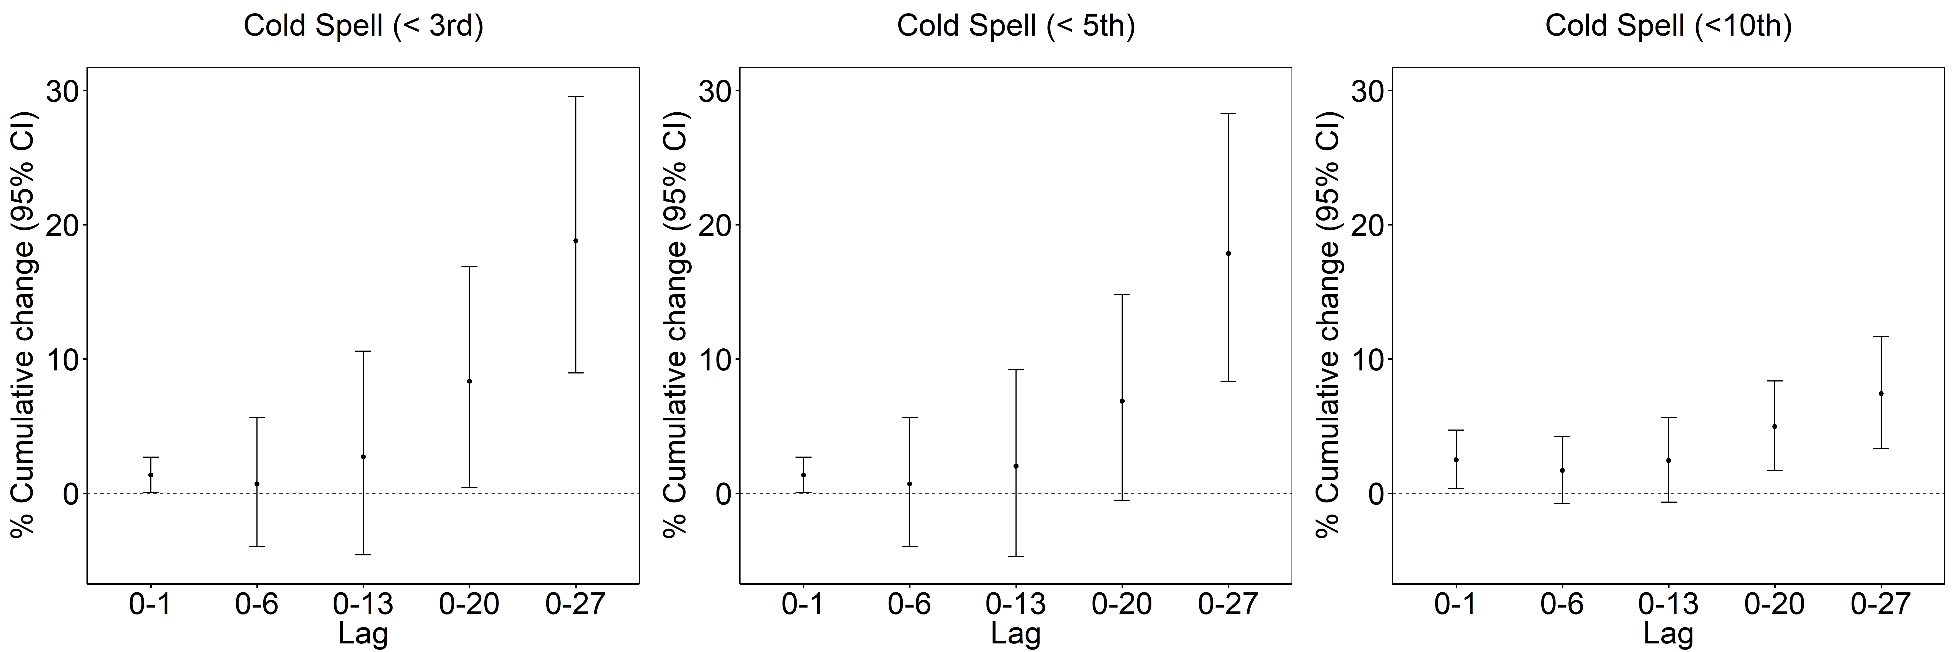

Figure 1. Estimated cumulative effects [percent change (95% CI) of geometric mean] for the different cold spell definitions (Tmean<3rd, <5th or <10th percentile) on plasma viscosity at lags 0-1, lags 0-6, lags 0-13, lags 0-20, and lags 0–27.
Generalized additive models with distributed lag nonlinear models were adjusted for age, sex, BMI, education, smoking status, alcohol consumption, physical activity, day of the week, season, SO₂ at lag 0 , CO at lag 0, TSP at lag 0, time trend (natural cubic spline with three degrees of freedom - df), relative humidity at lag 0 (natural cubic spline with three df), and barometric pressure at lag 0 (natural cubic spline with three df). Cold spells were defined as a binary variable with a value of 1 during the cold spell period and 0 for the non-cold spell days. Plasma viscosity levels were natural log-transformed in analyses, and the effect estimates are shown as the percent changes of geometric outcome mean.
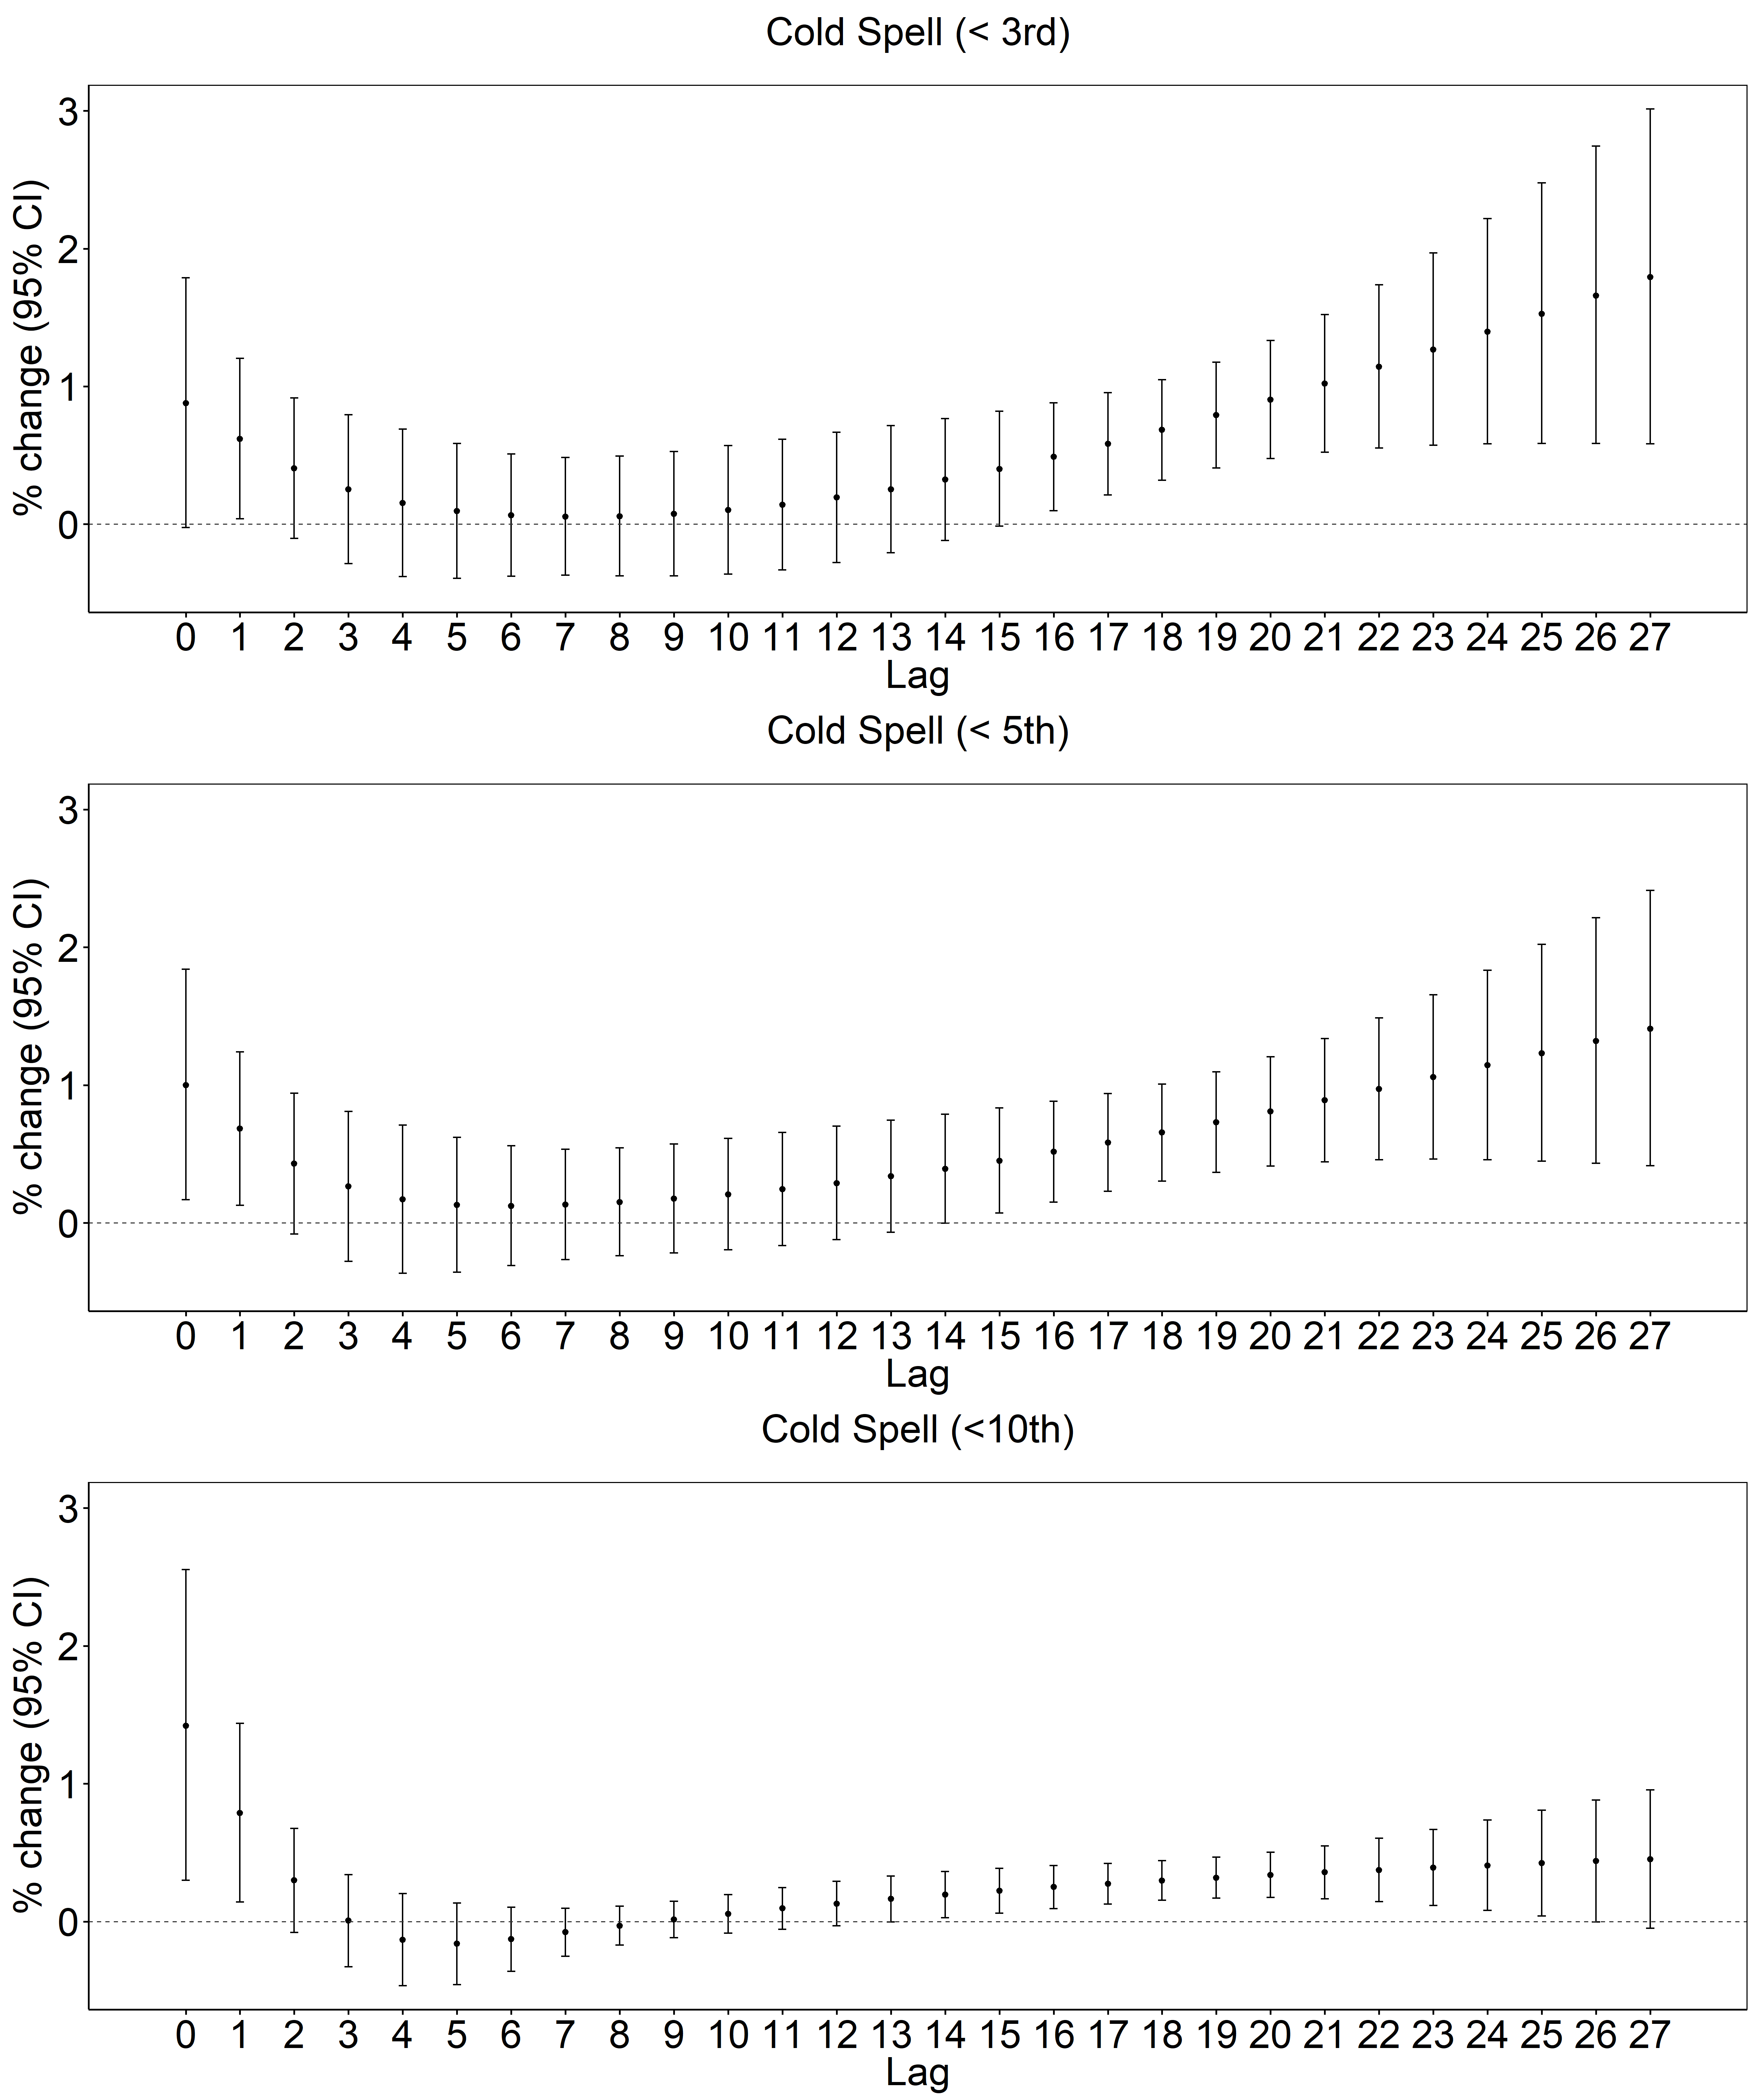

Figure 2. Single-day lag structures (0–27 days) for eﬀects of the three cold spell definitions on plasma viscosity
Generalized additive models with distributed lag nonlinear models were adjusted for age, sex, BMI, education, smoking status, alcohol consumption, physical activity, day of the week, season, SO₂ at lag 0 , CO at lag 0, TSP at lag 0, time trend (natural cubic spline with three degrees of freedom - df), relative humidity at lag 0 (natural cubic spline with three df), and barometric pressure at lag 0 (natural cubic spline with three df). Cold spells were defined as a binary variable with a value of 1 during the cold spell period and 0 for the non-cold spell days. Plasma viscosity levels were natural log-transformed in analyses, and the effect estimates are showed as the percent changes of geometric outcome mean.
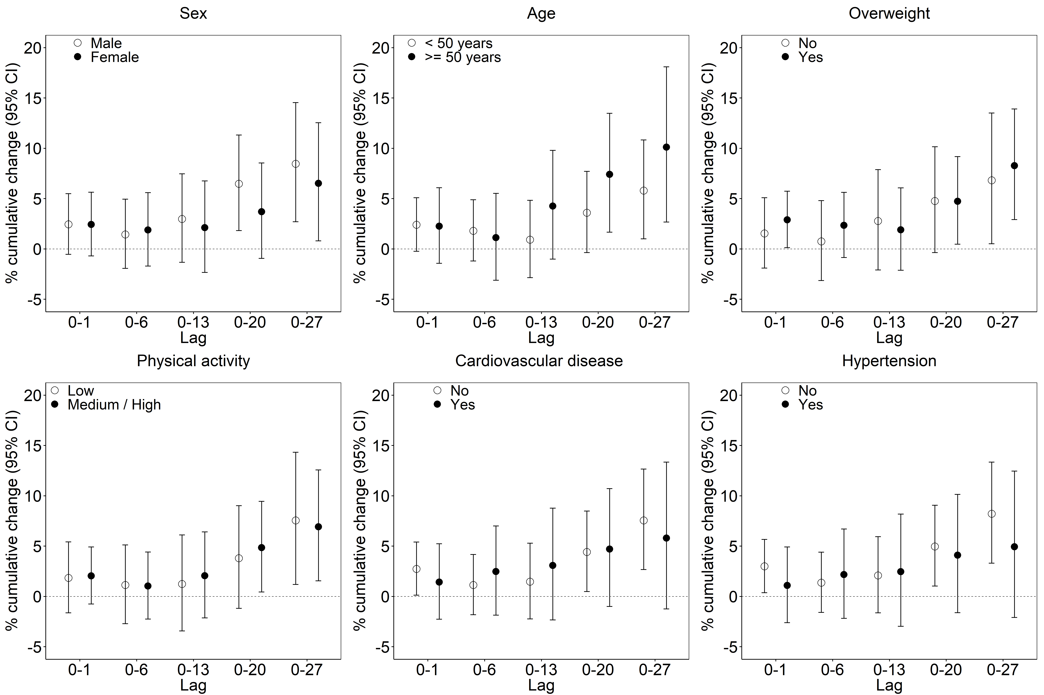
Figure 3. Estimated cumulative effects [percent change (95% CI) of geometric mean] of the cold spell defined as Tmean <10th percentile on plasma viscosity at lags 0-1, lags 0-6, lags 0-13, lags 0-20, and lags 0–27 modified by sex, age, overweight, cardiovascular disease, hypertension and physical activity.
Cold spells were defined as a binary variable with a value of 1 during the cold spell period and 0 for the non-cold spell days. Plasma viscosity levels were natural log-transformed in analyses, and the effect estimates are showed as the percent changes of geometric outcome mean.

