Supplementary material:

The German version of the Pulmonary Embolism - Quality of Life (PEmb-QoL) questionnaire: reliability, responsiveness and structural validity.

Simone Fischer^{1,3}, Christine Meisinger^{1,2}, Jakob Linseisen^{1,2,3}, Wolfgang von Scheidt⁴, Thomas M. Berghaus⁴, Inge Kirchberger^{1,2,3}

Affiliations:
1 Chair of Epidemiology, University of Augsburg, at University Hospital Augsburg, Augsburg, Germany
2 Clinical Epidemiology (KEPI), Helmholtz Zentrum München, Neuherberg, Germany
3 IBE, LMU München, Munich, Germany
4 Department of Cardiology, Respiratory Medicine and Intensive Care, University Hospital Augsburg, Augsburg, Germany

Corresponding Author:
Simone Fischer
IBE, LMU München
(c/o) Chair of Epidemiology, University of Augsburg
at University Hospital Augsburg
Stenglinstr. 2
86156 Augsburg, Germany
simone.fischer@med.uni-augsburg.de

Distribution characteristics of single items of PEmb-QoL
Table 1: Distribution of single Items (3 months after PE)
Item | Min | Q25 | Median | Q75 | Max | Missings
1a | 1 | 1 | 1 | 2 | 5 | 18
1b | 1 | 1 | 1 | 2 | 5 | 19
1c | 1 | 1 | 1 | 3 | 5 | 23
1d | 1 | 1 | 1 | 2 | 5 | 19
1e | 1 | 1 | 1 | 2 | 5 | 19
1f | 1 | 1 | 1 | 1 | 5 | 20
1g | 1 | 1 | 1 | 1 | 5 | 24
1h | 1 | 1 | 2 | 4 | 5 | 7
4a | 0 | 0 | 0 | 1 | 3 | 16
4b | 1 | 1 | 2 | 2 | 3 | 36
4c | 1 | 1 | 1 | 2 | 3 | 44
4d | 1 | 1 | 2 | 3 | 3 | 36
4e | 1 | 1 | 2 | 2 | 3 | 32
4f | 1 | 1 | 2 | 2 | 3 | 28
4g | 1 | 1 | 2 | 3 | 3 | 22
4h | 1 | 1 | 1 | 2 | 3 | 28
4i | 1 | 1 | 2 | 2 | 3 | 28
4j | 1 | 1 | 1 | 2 | 3 | 39
4k | 1 | 1 | 1 | 2 | 3 | 37
4l | 1 | 1 | 1 | 2 | 3 | 31
4m | 1 | 1 | 1 | 2 | 3 | 24
5a | 0 | 0 | 0 | 1 | 1 | 22
5b | 0 | 0 | 0 | 1 | 1 | 23
5c | 0 | 0 | 0 | 1 | 1 | 20
5d | 0 | 0 | 0 | 1 | 1 | 17
6 | 1 | 1 | 1 | 2 | 5 | 14
7 | 1 | 1 | 2 | 3 | 6 | 4
8 | 1 | 1 | 2 | 3 | 6 | 5
9a | 1 | 1 | 2 | 3 | 6 | 7
9b | 1 | 1 | 2 | 3 | 6 | 11
9c | 1 | 2 | 3 | 4 | 6 | 18
9d | 1 | 1 | 2 | 3 | 6 | 15
9e | 1 | 1 | 1 | 3 | 6 | 25
9f | 1 | 1 | 2 | 3 | 6 | 11
9g | 1 | 1 | 1 | 2 | 6 | 9
9h | 1 | 1 | 2 | 3 | 6 | 8
9i | 1 | 1 | 2 | 3 | 6 | 9
9j | 1 | 1 | 1 | 2 | 6 | 9

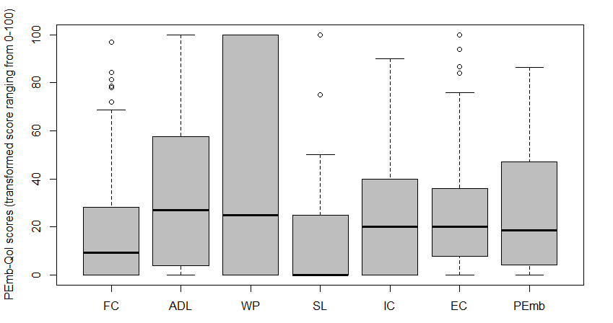
Distribution of PEmb-QoL dimensions at 3, 6 and 12 months after PE
Fig. 1: Boxplots of PEmb-QoL dimensions and summary score (3 months after PE)
Higher scores indicate worse quality of life
FC: Frequency of complaints
ADL: Activities of daily living limitations
WP: Work-related problems
SL: Social limitations
IC: Intensity of complaints
EC: Emotional complaints
PEmb: PEmb-QoL summary score

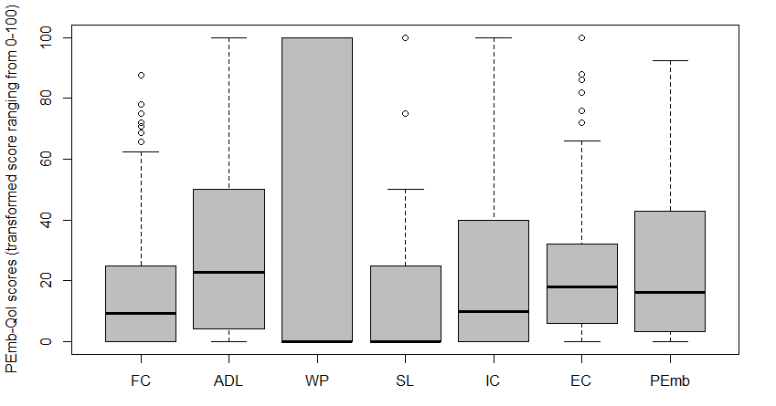
Fig.2: Boxplots of PEmb-QoL dimensions and summary score (6 months after PE)
Higher scores indicate worse quality of life
FC: Frequency of complaints
ADL: Activities of daily living limitations
WP: Work-related problems
SL: Social limitations
IC: Intensity of complaints
EC: Emotional complaints
PEmb: PEmb-QoL summary score

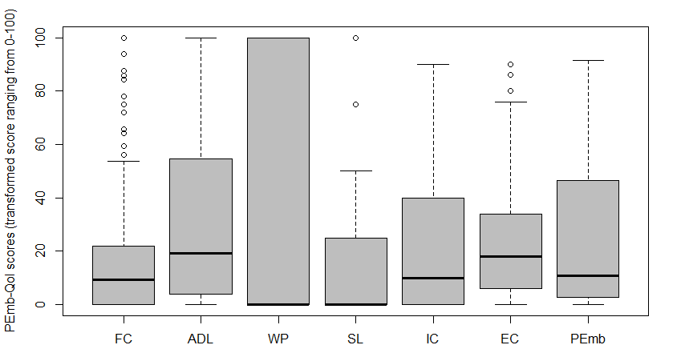
Fig.3: Boxplots of PEmb-QoL dimensions and summary score (12 months after PE)
Higher scores indicate worse quality of life
FC: Frequency of complaints
ADL: Activities of daily living limitations
WP: Work-related problems
SL: Social limitations
IC: Intensity of complaints
EC: Emotional complaints
PEmb: PEmb-QoL summary score

Table 2: Missings, floor and ceiling effects of the PEmb-Qol (6 months after PE); n=257
Dimension | Missingsª  % (n) | Floor effects  % | Ceiling effects  %
Frequency of complaints (Q1) | 7.0 (18) | 32.0 | 0
ADL limitations (Q4) | 6.2 (16) | 19.1 | 3.1
Work-related problems (Q5) | 5.1 (13) | 49.0 | 28.0
Social limitations (Q6) | 3.5 (9) | 57.6 | 2.3
Intensity of complaints (Q7, Q8) | 1.2 (3) | 31.5 | 0.8
Emotional complaints (Q9) | 1.2 (3) | 11.3 | 0.4
Pemb-QoL summary score | 13.6 (35) | 4.7 | 0
ADL: Activities of daily living
ª dimension was considered as missing if >50% of the items had missing values, otherwise missing values were replaced with means

Table 3: Missings, floor and ceiling effects of the PEmb-Qol (12 months after PE), n=196
Dimension | Missingsª  % (n) | Floor effects  % | Ceiling effects  %
Frequency of complaints (Q1) | 5.1(10) | 30.6 | 0.5
ADL limitations (Q4) | 7.7 (15) | 23.0 | 2.0
Work-related problems (Q5) | 4.1 (8) | 55.1 | 26.0
Social limitations (Q6) | 3.6 (7) | 62.8 | 3.1
Intensity of complaints (Q7, Q8) | 3.1 (6) | 36.7 | 0
Emotional complaints (Q9) | 1.5 (3) | 11.7 | 0
Pemb-QoL summary score | 12.8 (25) | 5.1 | 0
ADL: Activities of daily living
ª dimension was considered as missing if >50% of the items had missing values, otherwise missing values were replaced with means

G-study according to the approach of generalizability theory with a single-facet design

Table 4: Variance component results of the G-study
Source | df | SS | MS | Variance component | Percent  variance
Frequency of complaints
person | 41.00 | 43553.08 | 1062.27 | 481.08 | 82.66
method | 1.00 | 132.52 | 132.52 | 0.77 | 0.13
error | 41.00 | 4104.91 | 100.12 | 100.12 | 17.20
total | 48.76 |  |  | 581.97 | 100.00
ADL
limitations
person | 42.00 | 64393.96 | 1533.19 | 720.48 | 85.44
method | 1.00 | 1407.41 | 1407.41 | 30.59 | 3.63
error | 42.00 | 3873.66 | 92.23 | 92.23 | 10.94
total | 47.07 |  |  | 843.30 | 100.00
Work-related problems
person | 45.00 | 151793.48 | 3373.19 | 1450.79 | 75.47
method | 1.00 | 27.17 | 27.17 | 0.00 | 0.00
error | 45.00 | 21222.83 | 471.62 | 471.62 | 24.53
total | 57.34 |  |  | 1922.40 | 100.00
Social limitations
person | 45.00 | 49565.22 | 1101.45 | 381.94 | 52.93
method | 1.00 | 434.78 | 434.78 | 2.11 | 0.29
error | 45.00 | 15190.22 | 337.56 | 337.56 | 46.78
total | 70.29 |  |  | 721.62 | 100.00
Intensity of complaints
person | 45.00 | 52530.43 | 1167.34 | 549.28 | 88.87
method | 1.00 | 4.35 | 4.35 | 0.00 | 0.00
error | 45.00 | 3095.65 | 68.79 | 68.79 | 11.13
total | 50.29 |  |  | 618.07 | 100.00
Emotional complaints
person | 46.00 | 36423.18 | 791.81 | 373.10 | 86.49
method | 1.00 | 642.04 | 642.04 | 12.69 | 2.94
error | 46.00 | 2098.14 | 45.61 | 45.61 | 10.57
total | 51.63 |  |  | 431.40 | 100.00
PEmb-QoL summary score
person | 38.00 | 38145.89 | 1003.84 | 475.93 | 89.97
method | 1.00 | 93.15 | 93.15 | 1.06 | 0.20
error | 38.00 | 1975.36 | 51.98 | 51.98 | 9.83
total | 42.07 |  |  | 528.97 | 100.00
ADL: Activities of daily living
df: degrees of freedom
SS: sum squares
MS: mean squares

Interpretation of results of the G-study:
We conducted a G-study according to the approach of generalizability theory with a single-facet design to examine the possible effect of the different data collection methods (paper and pencil at home vs. phone) on estimating reliability. The focus of generalizability theory is to identify multiple sources of measurement errors. Table 4 shows the measurement variance sources and the percentage of variance for every dimension. Data collection method shows low percentage of variance (0 - 3.6 %) and a large proportion of the variance is attributed to differences among persons in every dimension. Notable, the proportion of variance due to error is relatively high for dimensions work-related problems and social limitations (24.5 and 46.8 %). This may suggest problems with psychometric properties, which is in line with for example the lower ICCs that were calculated for these dimensions. However, variance explained by persons is higher than the error variance proportions for all dimensions. Results indicate that our different data collection methods seem to have only a small effect on estimating reliability.

Selection of models for CFA:
We conducted CFA with robust maximum likelihood estimation for five different models. Since 54.4 % of the participants indicated that they did not work, item 4a was excluded for the CFA. For the first model that represents the original six dimensions, the covariance matrix of latent variables was not positive definite and the model could not be analysed. Inspection of the correlation matrix led to model 2, in which the items of the two factors intensity and frequency of complaints were combined into one factor due to very high correlation. Model 2 showed poor model fit. Model 3 represents a model with four factors as proposed for the German version. The results of Frey et al. revealed a structure with four factors and some items that did not load well on any factor. They proposed to either delete the items or assign them to the dimensions they loaded the most. We examined both versions of the model (with and without the items in question), and the model without items 1h, 6, 8, 9h, and 9i showed better fit indices, which is why we decided for this model for further analyses. All of the error terms were uncorrelated and the latent factors were free to co-vary. Inspection of modification indices of model 3 revealed some local misspecifications, which we examined by analysing the wording of the questions. Items 4j, 4k and 4l do have the same wording except from different numbers of meters one can walk. Item 9d asks if the respondent felt more emotional and item 9e if it bothered the respondent that he or she felt more emotional, which makes the two items interdependent. As a result, we co-varied error terms on items 4j and 4k, 4k and 4l, 4j and 4l and 9d and 9e, which ended in model 4. To account for the high factor correlation between the four factors (0.54 to 0.84), we added a general factor in model 5. We assessed a bifactor model and a hierarchical (second order) model. The bifactor model also showed good fit indices (χ²/df = 1.76, p < 0.001, TLI = 0.936, CFI = 0.945, RMSEA = 0.056 (0.049; 0.063) and SRMR = 0.058). However, the bifactor model is less restricted than the hierarchical model 5 and therefore, is more likely to yield better fit statistics. After accounting for the general factor in the bifactor model some loadings on the domain specific factors were very low and not significant, which let us assume the hierarchical model 5 to be better in explaining the data.

