
Journal of Advances in Modeling Earth Systems
Supporting Information for
Modelling intra- and interannual variability of BVOC emissions from maize, oil-seed rape and ryegrass
Felix Havermann^{1,a}, Andrea Ghirardo², Jörg-Peter Schnitzler², Claas Nendel³, Mathias Hoffmann³, David Kraus¹, Rüdiger Grote¹
¹Karlsruhe Institute of Technology, Institute of Meteorology and Climate Research–Atmospheric Environmental Research, Garmisch-Partenkirchen, Germany
²Helmholtz Zentrum München, Institute of Biochemical Plant Pathology, Research Unit Environmental Simulation (EUS), Neuherberg, Germany
³Leibniz Centre for Agricultural Landscape Research (ZALF), Müncheberg, Germany
ªpresent address: Ludwig-Maximilians-Universität München, Department of Geography, Munich, Germany

Contents of this file

Figures S1 to S12

Introduction
The supplementary figures provide a more detailed look into information not directly investigated in the framework of the presented manuscript. These are in particular weather conditions during the time the field experiments had been carried out (Fig. S1-3), and the development of gross primary production and biomass (Fig. S4-6). In addition, some more detailed information is given for issues that are presented only in an exemplarily or lumped way in the main document. These are the development of measured emissions during the experiments are shown for compounds that are not explicitly presented in the main document (Fig. S7-9), as well as the average emission rate for all compounds from the three species simulated throughout three consecutive years (Fig. S10-12).

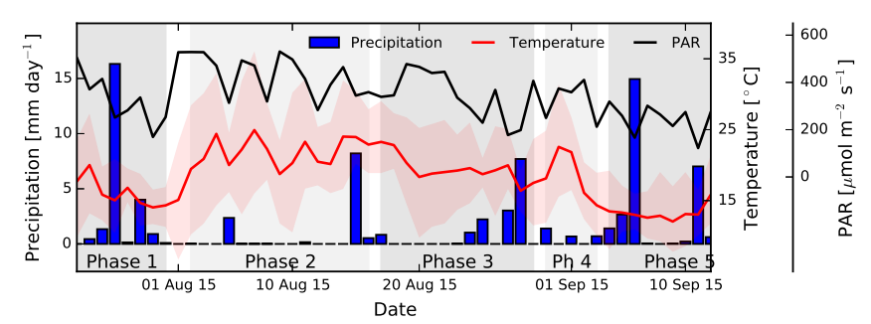

Figure S1. Environmental conditions at the CarboZALF ﬁeld site in Dedelow during the maize ﬁeld experiment 2015. Precipitation is given as daily sums, air temperature at 2 m aboveground as daily means and daily range, and PAR as daily means. Diﬀerent meteorological phases as indicated in the main text are highlighted in gray. The Figure is reproduced and slightly reformatted from Wiss et al. 2017 (Figure 3c), published under Creative Commons Attribution by John Wiley & Sons Ltd.

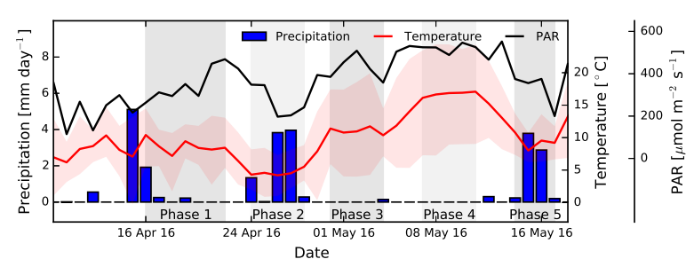

Figure S2. Temperature, PAR, and precipitation during the oil-seed rape ﬁeld experiment 2016. Diﬀerent meteorological phases are highlighted in gray. See Figure S1 for more details.

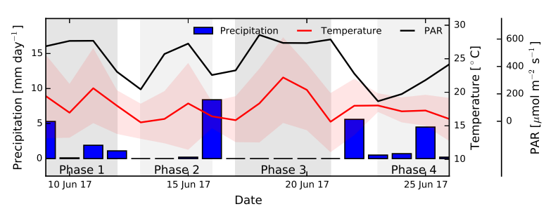

Figure S3. Temperature, PAR, and precipitation during the ryegrass ﬁeld experiment 2017. Diﬀerent meteorological phases are highlighted in gray. See Figure S1 for more details.

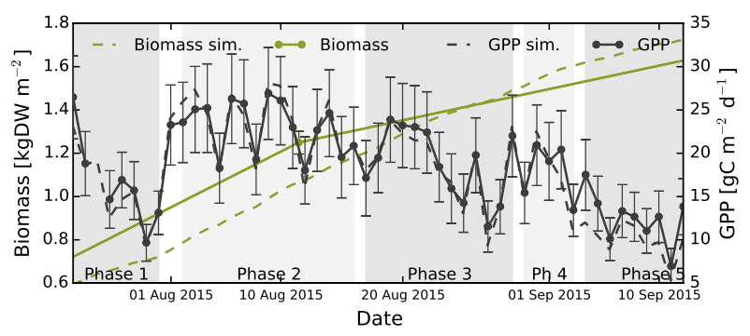

Figure S4. Observed and simulated biomass and daily sums of GPP (calculated from observed CO₂ measurements) from maize ecosystem ﬁeld experiment 2015. The green line links two biomass observation points linearly. Error bars are given as ± the standard error of the sum. The meteorological phases depicted in gray are described in the text.

Figure S5. Observed biomass and daily sums of GPP from oil-seed rape ecosystem ﬁeld experiment 2016. See Figure S4 for more details.

Figure S6. Observed biomass and daily sums of GPP from ryegrass ecosystem ﬁeld experiment 2017. See Figure S4 for more details.

Figure S7. Daily sums of diﬀerent observed and simulated BVOC emissions (see y-axis description) from maize ecosystem. Error bars indicate ± the standard error of the sum.

Figure S7. Continued.

Figure S8. Daily sums of diﬀerent observed and simulated BVOC emissions (see y-axis description) from oil-seed ecosystem. Error bars indicate ± the standard error of the sum.

Figure S8. Continued.

Figure S9. Daily sums of diﬀerent observed and simulated BVOC emissions (see y-axis description) from ryegrass ecosystem. Error bars indicate ± the standard error of the sum.

Figure S9. Continued.

Figure S10. Simulated annual BVOC ﬂuxes from the maize ecosystem for three consecutive years (2015–2017). The error bars indicate ± the standard deviation of three yearly sums.

Figure S11. Simulated annual BVOC ﬂuxes from the oil-seed rape ecosystem for three consecutive years (2015–2017). The error bars indicate ± the standard deviation of three yearly sums.

Figure S12. Simulated annual average BVOC ﬂuxes from the ryegrass ecosystem for three consecutive years (2015–2017). The error bars indicate ± the standard deviation of three yearly sums.

References
Wiß, F., A. Ghirardo, J.-P. Schnitzler, C. Nendel, J. Augustin, M. Hoffmann, and R. Grote (2017), Net ecosystem fluxes and composition of BVOCs over a maize field - Interaction of meteorology and phenological stages, GCB Bioenergy, 9(11), 1627–1643, doi:10.1111/gcbb.12454.

