Supplementary Figure 1

Supplementary Figure 1: Representative illustration of serum EV purification by size exclusion chromatography using the qEVoriginal column. Particle concentration (black line) and protein concentration (grey dashed line) were determined in each SEC fraction. The three fractions containing the highest amounts of EVs (#7-9) were pooled and further used as purified serum EVs.

Supplementary Figure 2

Supplementary Figure 2: Isolation of serum EVs was performed by SEC with mini spin columns packed with Sepharose CL-4B. 100 µl serum were loaded on top of the column and after centrifugation the flow-through (= fraction 1) was collected. 150 µl of PBS were added repeatedly to collect fractions 2-4. EV and protein concentration in each fraction were measured by NTA (black line) and BCA protein assay (grey line); n=4.

Supplementary Figure 3

Supplementary Figure 3: Evaluation of optimal hemin concentration for HEK293-HRP⁺ suspension cells. A: The cell culture medium was supplemented with different concentrations of hemin and cell numbers and cell vitality were determined at the indicated time points. B: In parallel, the EV numbers in the cell supernatant were measured and the HRP activity was determined. Based on these measurements, a hemin concentration of 1 µM was used for further experiments.

Supplementary Figure 4

Supplementary Figure 4: Transmission electron microscopy of HRP⁺ extracellular vesicles purified from conditioned cell culture supernatant by serial centrifugation. (A) Low magnification TEM micrograph; (B) Higher magnification view. EVs were negatively stained with 1% uranyl acetate. Scale bars: 2 µm (A) and 500 nm (B).

Supplementary Figure 5

Supplementary Figure 5: Size of EVs isolated from different sources was determined by NTA. Mean with SD is shown (n≥10). SKOV-3: ovarian cancer cell line; HepG2: hepatocellular carcinoma cell line; U-373: glioblastoma cell line; PCI-01: head and neck cancer cell line. (B) The zetapotential of HRP⁺ EVs and HEK293-wt EVs was measured using the ZetaView instrument. For this, the EVs were diluted in Milli-Q water. (n=4; p=0.8857, Mann-Whitney test).

Supplementary Figure 6

Supplementary Figure 6: Characterization of HRP⁺ EVs purified by density gradient centrifugation. Particle concentration (black line) and protein concentration (grey dashed line) in Optiprep gradient fractions from cell culture supernatant of HEK293-HRP⁺ cells are shown.
Supplementary Figure 7

Supplementary Figure 7: Characterization of HEK293-derived EVs by high-sensitivity flow cytometry. A: Representative image of the background noise when running PBS in the V-SSC-H channel. B: EVs derived from HEK293-HRP⁺ or wildtype HEK293 cells were stained with cell-trace yellow and an HRP-specific antibody. The percentage of CTY⁺/HRP⁺ EVs from three independent experiments is shown.
Supplementary Figure 8

Supplementary Figure 8: Treatment of purified HRP⁺ EVs with Proteinase K (PK) confirms surface association of the enzyme. (A) Size and particle concentration were measured three times in HRP⁺ EVs treated with or without PK. The size distribution of one measurement is shown. (B) Subsequently, the EVs were serially diluted in PBS and HRP activity was measured directly (left) or after EV immobilization with an HRP-specific antibody (right) by adding TMB substrate. The reaction was stopped after 15 min with 0.5 M H₂SO₄.

Supplementary Figure 9

Supplementary Figure 9: Measurement of EV-associated and free HRP activity using the fluorogenic substrate Amplex Red. A: HRP⁺ EVs were diluted in PBS as indicated. HRP activity was measured by adding Amplex Red substrate. The fluorescence was measured after 10 minutes. B: Purified HRP enzyme from a commercial vendor with known concentration of HRP activity was diluted in PBS and mixed with Amplex Red substrate. Fluorescence was measured after 10 minutes. R² = 0.9837.

Supplementary Figure 10

Supplementary Figure 10: Purified HRP⁺ EVs were loaded onto an Izon qEV70 SEC column and fractions of 500 µL were collected. HRP activity was measured by adding TMB substrate to the EV- containing fractions (left diagram). The same amount of EVs used for the SEC was then frozen and stored at -80°C for four months. After thawing, the EVs were again separated by SEC (right diagram).

Supplementary Figure 11

Supplementary Figure 11: Analysis of HRP and GAPDH RNA in EVs. A: RNA was isolated from HEK293-wt and HEK-HRP EVs and transcribed into cDNA. Template cDNA was diluted as indicated and amplified by RT-qPCR using primers specific for HRP and the housekeeping gene GAPDH. Mean Cq values of three technical replicates are shown. B: Representative qPCR amplification curves for detection of HRP-specific cDNA. The lower panel shows the background noise generated from HEK293-wt EVs.

Supplementary Figure 12

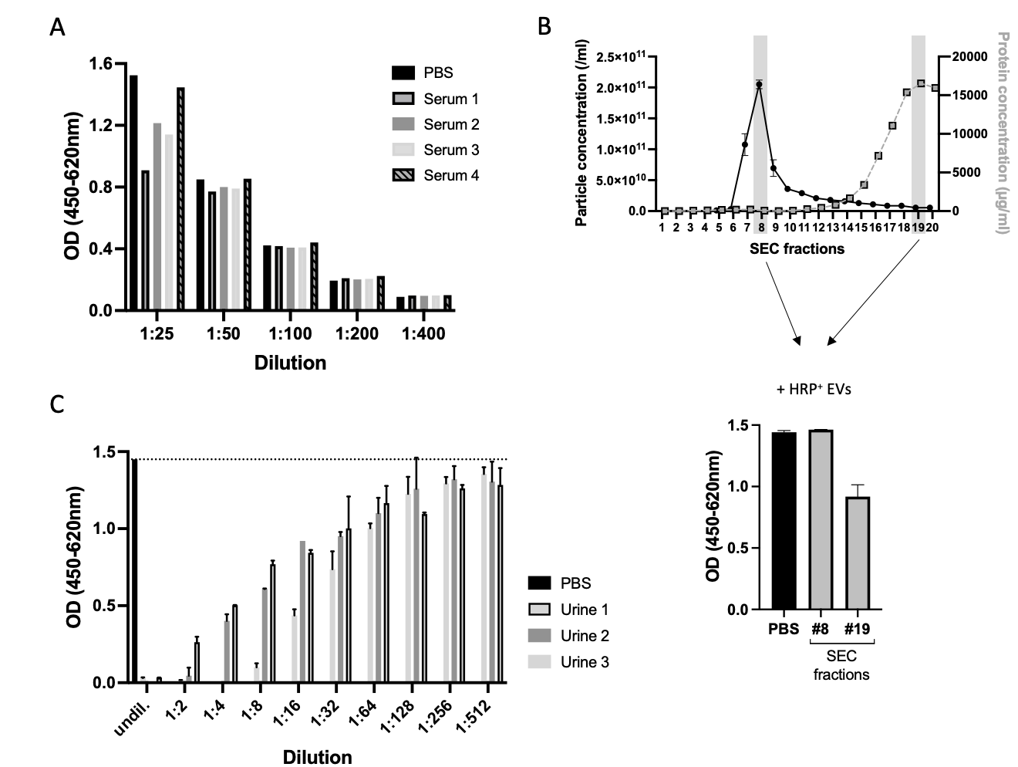

Supplementary Figure 12: High concentrations of protein components in pure serum and urine samples can inhibit the activity of EV-associated HRP. A: Sera from four donors were spiked with HRP⁺ EVs (5000 µU/mL) and then diluted in PBS from 1:25 to 1:400. The OD was measured after addition of TMB substrate. A serum dilution of 1:50 or higher fully restored the HRP signal. B: We loaded 500 µl of serum onto an Izon qEVoriginal column to separate EV and protein components by SEC. 20 fractions were collected and the particle and protein concentrations in each fraction were determined. PBS, the EV-containing fraction #8 and the high-protein fraction #19 were spiked with HRP⁺ EVs and HRP activity was measured after addition of TMB. The serum protein components reduced the HRP signal significantly. C: Urine from three donors was serially diluted in PBS, as indicated. Each dilution was then spiked with 100 µU of HRP⁺ EVs and the HRP activity was measured in triplicates. The dotted line represents the baseline of 100 µU HRP⁺ EVs measured in PBS.
Supplementary Figure 13

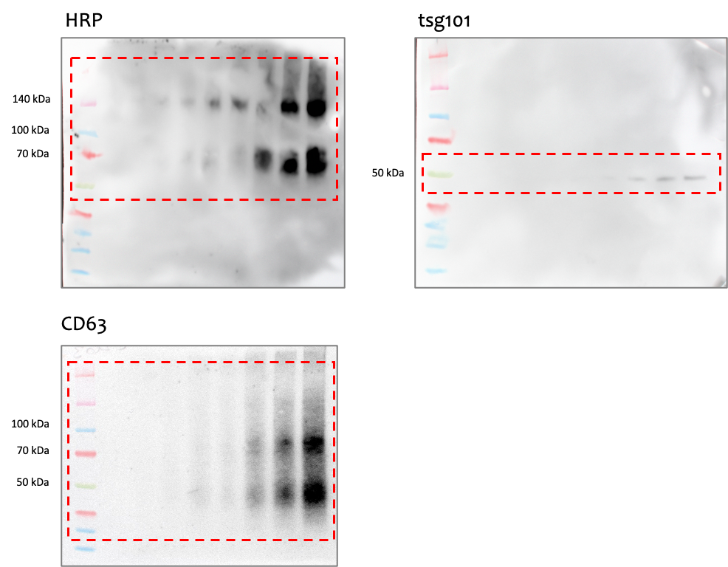

Supplementary Figure 13: Uncropped images corresponding to the Western blots shown in Figures 1D and 3D.

Supplementary Table 1

Method: ExoQuick

Replicate | Particle conc. (/ml) | Calculated  recovery (%) | Normalized conc. (/ml) | CV (absolute) | CV (normalized)
#1 | 1.50E+10 | 49.69 | 3.02E+10 | 22% | 16.1%
#2 | 1.30E+10 | 47.37 | 2.74E+10 | 22% | 16.1%
#3 | 1.65E+10 | 48.60 | 3.40E+10 | 22% | 16.1%
#4 | 1.05E+10 | 42.69 | 2.46E+10 | 22% | 16.1%
#5 | 1.90E+10 | 51.51 | 3.69E+10 | 22% | 16.1%

Method: Mini-SEC

Replicate | Particle conc. (/ml) | Calculated  recovery (%) | Normalized conc. (/ml) | CV (absolute) | CV (normalized)
#1 | 3.50E+10 | 53.36 | 6.56E+10 | 16% | 3.3%
#2 | 3.00E+10 | 46.83 | 6.41E+10 | 16% | 3.3%
#3 | 4.10E+10 | 63.62 | 6.44E+10 | 16% | 3.3%
#4 | 4.30E+10 | 62.45 | 6.89E+10 | 16% | 3.3%

Method: Density gradient

Replicate | Particle conc. (/ml) | Calc. recovery (%) | Normalized conc. (/ml) | CV (absolute) | CV (normalized)
#1 | 1.53E+11 | 53.00 | 2.89E+11 | 18.4% | 4.4%
#2 | 1.855E+11 | 60.40 | 3.07E+11 | 18.4% | 4.4%
#3 | 2.21E+11 | 80.00 | 2.76E+11 | 18.4% | 4.4%
#4 | 2.34E+11 | 80.30 | 2.91E+11 | 18.4% | 4.4%

Supplementary Table 1: HRP⁺ reference EVs were spiked into serum and EV purification was performed in technical replicates with the indicated methods. Recovery was calculated by comparing the output and input HRP-specific signals. The concentration of isolated EVs was measured by NTA and normalized against the recovery rate. The coefficient of variation (CV) was calculated by dividing the dataset’s standard deviation by the mean. The shown data is representative for Figure 6E.

