Short-term effects of ultrafine particles on stroke events: an assessment using four different exposure metrics

(Supplementary materials)

Contents
I) Description of pollution measurement devices: 5
II) Definitions of Extreme temperature events (ETEs): 6
III) Tables 7
sTable 1. The definitions of different ETEs in Augsburg, Germany, from 2006 to 2020. 7
sTable 2. Summary of 1-neighboring week values imputed daily levels of four ultrafine particle metrics in five size ranges in Augsburg, Germany, from 2006 to 2020. 8
sTable 3. Mean levels of four ultrafine particle metrics (10-100 nm) by different definitions of ETEs in Augsburg, Germany, from 2006 to 2020. 9
sTable 4. Spearman correlation coefficients between daily levels of four ultrafine particle metrics in five size ranges and meteorological indicators in Augsburg, Germany, from 2006 to 2020. 10
sTable 5. Spearman correlation coefficients between daily levels of four UFP metrics (10-100 nm) and routinely measured air pollutants in Augsburg, Germany, from 2006 to 2020. 11
sTable 6. Percent changes and 95% CIs in the odds of overall stroke events associated with per IQR increase in the single-lagged day of four ultrafine particle metrics in five size ranges over lag 0 to lag 6 days. 12
sTable 7. Percent changes and 95% CIs in the odds of overall stroke events associated with per IQR increase in the lagged moving average four ultrafine particle metrics in five size ranges over lag 0 to lag 6 days. 13
sTable 8. Subgroup percent changes and 95% CIs in the odds of stroke events associated with per IQR increase in the single lag 3 day and lagged moving average 0-6 days of four ultrafine particle metrics in five size ranges by subtypes of strokes. 14
sTable 9. Percent changes and 95% CIs in the odds of overall strokes associated with per IQR increase in the single lag 3 day and lagged moving average 0-6 days of four ultrafine particle metrics in five size ranges stratified by stroke-induced disability levels. 15
sTable 10. Percent changes and 95% CIs in the odds of overall strokes associated with per IQR increase in the single lag 3 day and lagged moving average 0-6 days of four ultrafine particle metrics in five size ranges stratified by stroke severity levels. 16
sTable 11. The modification effects on the association of overall stroke events with per IQR increase in the single lag 3 day and lagged moving average 0-6 days of ultrafine particle metrics (10-100 nm). 17
sTable 12. The modification effects of 6 definitions of cold spells during the cold seasons on the association of overall stroke events with per IQR increase in the single lag 3 day and lagged moving average 0-6 days of ultrafine particle metrics (10-100 nm). 18
sTable 13. The modification effects of 6 definitions of heat waves during the warm seasons on the percent changes and 95% CIs in the odds of overall stroke events associated with per IQR increase in the single lag 3 day and lagged moving average 0-6 days of ultrafine particle metrics (10-100 nm). 20
sTable 14. Percent changes and 95% CIs in the odds of overall stroke events associated with per IQR increase in the single lag 3 day and lagged moving average 0-6 days of four ultrafine particle metrics (10-100 nm) in the two-pollutant model. 22
sTable 15. Percent changes and 95% CIs in the odds of overall stroke events associated with per IQR increase in the single lag 3 day and lagged moving average 0-6 days of ultrafine particle metrics over (10-100 nm) in specific sensitivity models. 23
IV) Figures 24
sFig 1. Percent change (95%CI) in the odds of overall stroke events per interquartile range (IQR) increase in the a) single-day and b) lagged moving average UFP metrics (10-30 nm). Note: * P<0.10; ** P<0.05. 25
sFig 2. Percent change (95%CI) in the odds of overall stroke events per interquartile range (IQR) increase in the a) single-day and b) lagged moving average UFP metrics (30-100 nm). Note: ** P<0.05. 26
sFig 3. Percent change (95%CI) in the odds of overall stroke events per interquartile range (IQR) increase in the a) single-day and b) lagged moving average UFP metrics (100-500 nm). Note: * P<0.10; ** P<0.05. 27
sFig 4. Percent change (95%CI) in the odds of overall stroke events per interquartile range (IQR) increase in the a) single-day and b) lagged moving average UFP metrics (10-500 nm). Note: * P<0.10; ** P<0.05. 28
sFig 5. Percent change (95%CI) in the odds of three stroke subtypes per interquartile range (IQR) increase in single 3 day and moving average 0-6 days of UFP metrics (10-30 nm). Note: * P<0.10. 29
sFig 6. Percent change (95%CI) in the odds of three stroke subtypes per interquartile range (IQR) increase in single 3 day and moving average 0-6 days of UFP metrics (30-100 nm). Note: * P<0.10; ** P<0.05. 30
sFig 7. Percent change (95%CI) in the odds of three stroke subtypes per interquartile range (IQR) increase in single 3 day and moving average 0-6 days of UFP metrics (100-500 nm). Note: * P<0.10. 31
sFig 8. Percent change (95%CI) in the odds of three stroke subtypes per interquartile range (IQR) increase in single 3 day and moving average 0-6 days of UFP metrics (10-500 nm). Note: * P<0.10. 32
sFig 9. Stratified percent change (95%CI) in the odds of overall stroke events by two stroke-related disability levels per IQR increase in single 3 day and moving average 0-6 days of UFP metrics (10-100 nm). Note: * P<0.10; ** P<0.05. 33
sFig 10. Stratified percent change (95%CI) in the odds of overall stroke events by two stroke severity levels per IQR increase in single 3 day and moving average 0-6 days of UFP metrics (10-100 nm). Note: * P<0.10; ** P<0.05. 34
sFig 11. Effect modification by the consecutive a) 2 days, b) 4 days and c) 6 days of P5.0th thresholds of cold spells on the association between lag 0-6 days of UFP metrics (10-100 nm) and the percent changes in the odds of overall stroke events. 35
sFig 12. Effect modification by the consecutive a) 2 days, b) 4 days and c) 6 days of P95.0th thresholds of heat waves on the association between lag 3 days of UFP metrics (10-100 nm) and the percent changes in the odds of overall stroke events. 36
sFig 13. Effect modification by the consecutive a) 2 days, b) 4 days and c) 6 days of P95.0th thresholds of heat waves on the association between lag 0-6 days of UFP metrics (10-100 nm) and the percent changes in the odds of overall stroke events. 37
sFig 14. Percent change (95%CI) in the odds of overall stroke events per IQR increase in lag 3 day of four UFP metrics (10-100 nm). Note: the x-axis shows the results of the main model and the two-pollutants model: adjusted for ambient pollutants with a Spearman correlation coefficient less than 0.7. * P<0.10; ** P<0.05. 38
sFig 15. Percent change (95%CI) in the odds of overall stroke events per IQR increase in lag 0-6 days of four UFP metrics (10-100 nm). Note: the x-axis shows the results of the main model and the two-pollutants model: adjusted for ambient pollutants with a Spearman correlation coefficient less than 0.7. * P<0.10; ** P<0.05 39
sFig 16. Percent change (95%CI) in the odds of overall stroke events per IQR increase in lag 3 day of four UFP metrics (10-100 nm) in three models. Note: the x-axis shows the results of the main model and different sensitivity analyses: Model 1 represents results estimated using 1-neighbouring week values imputed data; Model 2 represents results specifically excluded patients after the beginning of the COVID-19 pandemic; Model 3 represents results specially adjusted for the warm and cold temperatures calculated based on the annual levels of ambient air temperature. * P<0.10; ** P<0.05. 40
sFig 17. Percent change (95%CI) in the odds of overall stroke events per IQR increase in lag 0-6 day of four UFP metrics (10-100 nm) in three models. Note: the x-axis shows the results of the main model and different sensitivity analyses: Model 1 represents results estimated using 1-neighbouring week values imputed data; Model 2 represents results specifically excluded patients after the begin of COVID-19 pandemic; Model 3 represents results specially adjusted for the warm and cold temperatures calculated based on the annual levels of ambient air temperature. * P<0.10; ** P<0.05. 41
sFig 18. The exposure-response relationship between lag 3 days of four UFP metrics (10-100 nm) and the odds ratios (95%CI) of overall stroke events using the restricted curved spline. Note: the likelihood test was used, with a P value < 0.05 indicating potential non-linearity. 42
sFig 19. The exposure-response relationship between lag 0-6 days of four UFP metrics (10-100 nm) and the odds ratios (95%CI) of overall stroke events using the restricted curved spline. Note: the likelihood test was used, with a P value < 0.05 indicating potential non-linearity. 43
References: 44

I) Description of pollution measurement devices:
A Twin Differential Mobility Particle Sizer (TDMPS) system was used in conjunction with an aerodynamic particle sizer (APS, Model 3321, TSI Inc., U.S., size range 0.8 to 10 µm) to continuously measure particle size distribution (PSD) ranging from 3 nm to 10 µm ¹⁻³.
The condensation particle counter (CPC) was used to measure total particle particulate number concentration (PNC) with sizes ranging from 3 nm to 3µm ³. An electrical aerosol detector (EAD, model 3070A; TSI Inc., U.S.) was used to measure the length of particles (PLC) in sizes 10 nm-1000 µm in aerodynamic diameter (or 10 nm to 800 nm in mobility equivalent diameter, Dp), and the response of the EAD is almost proportional to the diameter, Dp ³. A Diffusion Charging Particle Sensor (DCPS, model LQ1; Matter Aerosol AG, Switzerland) was utilized to obtain the total active (or Fuchs) surface of particles (PSC) in the size range <1 µm ³⁻⁵. Measurement of particle mass concentration (PMC) was performed using two independent Tapered Element Oscillating Microbalances (TEOM, model 1400ab, Thermo Fisher Scientific Inc., U.S.) equipped with a Filter Dynamics Measurement System (FDMS model 8500b, Thermo Fisher Scientific Inc., U.S.) to correct the loss of volatile fractions from particulate mass ³⁻⁵.
To determine the physical properties of particles within the ultrafine range, total PLC in a given air volume is obtained by summing the particle diameters in a certain amount of time, and PSC equals the particle number concentration times the squared diameter of the particle within a certain size range⁴. (1)-(4) showed the calculation methods for PNC, PLC, PSC, and PMC based on the PSD data measured above ³.
$NC\left(d_{1}-d_{2}\right)= \sum_{d_{1}}^{d_{2}}{{NC}_{i}}$ (1)
$LC\left(d_{1}-d_{2}\right)= \sum_{d_{1}}^{d_{2}}{{NC}_{i}}×d_{i}$ (2)
$SC\left(d_{1}-d_{2}\right)= π\sum_{d_{1}}^{d_{2}}{{NC}_{i}}×{d_{i}}^{2}$ (3)
$MC\left(d_{1}-d_{2}\right)=\frac{1}{6} ρπ\sum_{d_{1}}^{d_{2}}{{NC}_{i}}×{d_{i}}^{3}$ (4)

where $d_{1}$ and $d_{2}$ are the lower and upper edges of the size range, respectively. $d_{i}$ is one of the size bins within the size range $d_{1}-d_{2}$ and $ρ$ is the particle density ³.

II) Definitions of Extreme temperature events (ETEs):
- We calculated the cutoffs for heat waves, including the 95.0th and 97.5th percentiles of daily air temperature, then we defined the heat waves as the days with air temperature equaling or exceeding any of these thresholds for at least 2, 4, 6 consecutive days ^{6,7}.
- The cutoff values for cold spells were the 2.5th and 5.0th percentiles of daily air temperature, and the cold spells were defined as air temperature equal to or lower than any of these thresholds for at least 2, 4, 6 consecutive days ^{6,7}.
- As an example, “P97.5_4d” suggests a heat wave event that occurs at or above the 97.5th percentile of AT for at least 4 consecutive days, whereas “P2.5_4d” indicates a cold spell event that occurs at or below the 2.5th percentile of AT for at least 4 consecutive days.
- These methods built 6 definitions for the heat waves or cold spells, respectively.

III) Tables

sTable 1. The definitions of different ETEs in Augsburg, Germany, from 2006 to 2020.
Model name | ETEs definition ª
Model name | Percentile | Duration day | Threshold, ℃ | No. of ETEs ^{b}
Heat waves ^{c}
P95.0_2d | ≥95.0th percentile of  apparent temperature | ≥2 days | 22.36 | 274
P95.0_4d | ≥95.0th percentile of  apparent temperature | ≥4 days | 22.36 | 272
P95.0_6d | ≥95.0th percentile of  apparent temperature | ≥6 days | 22.36 | 269
P97.5_2d | ≥97.5th percentile of  apparent temperature | ≥2 days | 23.79 | 137
P97.5_4d | ≥97.5th percentile of  apparent temperature | ≥4 days | 23.79 | 136
P97.5_6d | ≥97.5th percentile of  apparent temperature | ≥6 days | 23.79 | 135
Cold spells ^{d}
P5.0_2d | ≤5.0th percentile of  apparent temperature | ≥2 days | -2.37 | 274
P5.0_4d | ≤5.0th percentile of  apparent temperature | ≥4 days | -2.37 | 265
P5.0_6d | ≤5.0th percentile of  apparent temperature | ≥6 days | -2.37 | 251
P2.5_2d | ≤2.5th percentile of  apparent temperature | ≥2 days | -4.28 | 137
P2.5_4d | ≤2.5th percentile of  apparent temperature | ≥4 days | -4.28 | 134
P2.5_6d | ≤2.5th percentile of  apparent temperature | ≥6 days | -4.28 | 130
Note:
ª The ETEs were defined by the threshold of ambient air temperature (℃);
^{b} The total number of ETE days in each definition during 2006-2020;
^{c} Heat waves are defined as the days with apparent temperature equaling or exceeding the 95.0th or 97.5th percentiles for consecutive 2, 4, 6 days;
^{d} Cold spells are defined as the days with apparent temperature equaling or lower than the 2.5th or 5.0th percentiles for consecutive 2, 4, 6 days.
Abbreviations: ETEs, extreme temperature events.

sTable 2. Summary of 1-neighboring week values imputed daily levels of four ultrafine particle metrics in five size ranges in Augsburg, Germany, from 2006 to 2020.
 | Mean ± SD | Min | P25 | Median | P75 | Max | IQR
PNC (particles/cm³)
PNC ₁₀₋₁₀₀ | 7374.1±4250.8 | 504.4 | 4541.2 | 6401.7 | 8922.1 | 48386.9 | 4380.9
PNC ₁₀₋₃₀ | 3413.5±2027.3 | 279.8 | 2129.8 | 2947.5 | 4199.7 | 42526.3 | 2069.9
PNC ₃₀₋₁₀₀ | 3960.6±2551.1 | 224.7 | 2351.5 | 3401.1 | 4792.9 | 26932.0 | 2441.4
PNC ₁₀₀₋₅₀₀ | 1481.2±959.2 | 0.0 | 871.9 | 1283.8 | 1819.8 | 10562.8 | 947.9
PNC ₁₀₋₅₀₀ | 8855.3±4975.9 | 735.9 | 5567.4 | 7731.4 | 10662.4 | 49795.9 | 5095.0
PMC (μg/m³)
PMC ₁₀₋₁₀₀ | 0.7±0.5 | 0.1 | 0.4 | 0.6 | 0.9 | 5.1 | 0.5
PMC ₁₀₋₃₀ | 0.0±0.0 | 0.0 | 0.0 | 0.0 | 0.0 | 0.4 | 0.0
PMC ₃₀₋₁₀₀ | 0.7±0.5 | 0.0 | 0.4 | 0.6 | 0.9 | 5.0 | 0.5
PMC ₁₀₀₋₅₀₀ | 10.0±7.6 | 0.0 | 5.2 | 8.3 | 12.6 | 98.8 | 7.4
PMC ₁₀₋₅₀₀ | 10.7±8.0 | 0.1 | 5.7 | 9.0 | 13.4 | 103.0 | 7.7
PLC (mm/cm³)
PLC ₁₀₋₁₀₀ | 282087.0±170409.7 | 19149.8 | 171480.3 | 245973.6 | 341368.0 | 1710893.0 | 169887.7
PLC ₁₀₋₃₀ | 65565.9±39247.4 | 5122.0 | 40629.3 | 56588.3 | 80542.5 | 961207.8 | 39913.2
PLC ₃₀₋₁₀₀ | 216521.1±139882.5 | 13461.7 | 128165.9 | 187196.6 | 262250.0 | 1528987.0 | 134084.1
PLC ₁₀₀₋₅₀₀ | 257158.3±169953.1 | 0.0 | 150770.6 | 222959.8 | 315283.0 | 1990223.0 | 164512.4
PLC ₁₀₋₅₀₀ | 539245.3±318746.7 | 46278.4 | 338815.8 | 477695.1 | 645929.5 | 3389249.0 | 307113.7
PSC (μm²/cm³)
PSC ₁₀₋₁₀₀ | 45.9±28.9 | 3.3 | 27.6 | 39.9 | 55.7 | 311.9 | 28.1
PSC ₁₀₋₃₀ | 4.3±2.6 | 0.3 | 2.7 | 3.7 | 5.3 | 71.1 | 2.6
PSC ₃₀₋₁₀₀ | 41.6±27.0 | 2.7 | 24.6 | 36.0 | 50.5 | 299.1 | 25.9
PSC ₁₀₀₋₅₀₀ | 164.7±114.9 | 0.0 | 92.7 | 141.7 | 203.6 | 1430.6 | 110.9
PSC ₁₀₋₅₀₀ | 210.6±137.5 | 7.5 | 124.7 | 182.6 | 256.2 | 1685.5 | 131.5
Note: All air pollutants and meteorology were consecutively measured between 2006 and 2020.
Abbreviations: CIs, confidence intervals; IQR, interquartile range; PNC, particle number concentration; PMC, particle mass concentration; PLC, particle length concentration; PSC, particle surface concentration; 10-100, from 10 to 100 nm mobility diameter; 10-30, from 10 to 30 nm mobility diameter; 30-100, from 30 to 100 nm mobility diameter; 100-500, from 100 to 500 nm mobility diameter; 10-500, from 10 to 500 nm mobility diameter.

sTable 3. Mean levels of four ultrafine particle metrics (10-100 nm) by different definitions of ETEs in Augsburg, Germany, from 2006 to 2020.
ETEs | The current day of four ultrafine particle metrics (10-100 nm) ª
ETEs | PNC  (particles/cm³) | PMC  (μg/m³) | PLC  (mm/cm³) | PSC  (μm²/cm³)
Heat waves ^{b}
P95.0_2d | 7490.1±2805.9 | 0.9±0.3 | 308628.7±121696.6 | 52.7±21.0
P95.0_4d | 7502.3±2813.8 | 0.9±0.3 | 309037.9±122104.6 | 52.8±21.0
P95.0_6d | 7507.0±2828.9 | 0.9±0.3 | 309399.7±122767.1 | 52.9±21.1
P97.5_2d | 7054.3±2133.7 | 0.8±0.2 | 292801.8±85007.3 | 50.5±14.8
P97.5_4d | 7059.1±2141.8 | 0.8±0.2 | 293127.2±85277.4 | 50.6±14.9
P97.5_6d | 7059.8±2150.6 | 0.8±0.3 | 293203.7±85624.8 | 50.6±14.9
Cold spells ^{c}
P5.0_2d | 10150.5±5862.4 | 1.1±0.7 | 412372.1±245270.1 | 70.0±42.3
P5.0_4d | 9957.2±5590.1 | 1.1±0.7 | 402750.1±231707.5 | 68.2±39.8
P5.0_6d | 9565.1±5280.6 | 1.1±0.6 | 384046.5±212588.2 | 64.8±35.8
P2.5_2d | 11575.7±5987.3 | 1.3±0.7 | 472883.4±244759.9 | 80.6±41.7
P2.5_4d | 11502.5±5922.5 | 1.3±0.7 | 468813.3±240700.5 | 79.7±40.8
P2.5_6d | 11379.5±5796.8 | 1.3±0.6 | 462071.8±233344.1 | 78.4±39.3
Note:
ª Data were presented as mean ± standard deviation;
^{b} Heat waves are defined as the days with ambient air temperature equaling or exceeding the 95.0th or 97.5th percentiles for consecutive 2, 4, 6 days;
^{c} Cold spells are defined as the days with ambient air temperature equaling or lowering than the 2.5th or 5.0th percentiles for consecutive 2, 4, 6 days.
Abbreviations: ETEs, extreme temperature events; PNC, particle number concentration; PMC, particle mass concentration; PLC, particle length concentration; PSC, particle surface concentration; 10-100, from 10 to 100 nm mobility diameter; P, percentile.

sTable 4. Spearman correlation coefficients between daily levels of four ultrafine particle metrics in five size ranges and meteorological indicators in Augsburg, Germany, from 2006 to 2020.
 | PNC  ₁₀₋₃₀ | PNC  ₁₀₋₁₀₀ | PNC  ₃₀₋₁₀₀ | PNC  ₁₀₀₋₅₀₀ | PNC₁₀₋₅₀₀ | PLC  ₁₀₋₃₀ | PLC  ₁₀₋₁₀₀ | PLC  ₃₀₋₁₀₀ | PLC  ₁₀₀₋₅₀₀ | PLC  ₁₀₋₅₀₀ | PSC  ₁₀₋₃₀ | PSC  ₁₀₋₁₀₀ | PSC  ₃₀₋₁₀₀ | PSC  ₁₀₀₋₅₀₀ | PSC  ₁₀₋₅₀₀ | PMC  ₁₀₋₃₀ | PMC  ₁₀₋₁₀₀ | PMC  ₃₀₋₁₀₀ | PMC  ₁₀₀₋₅₀₀ | PMC  ₁₀₀₋₅₀₀ | T (°C) | RH (%)
PNC₁₀₋₃₀ | 1.00
PNC₁₀₋₁₀₀ | 0.94 | 1.00
PNC₃₀₋₁₀₀ | 0.80 | 0.96 | 1.00
PNC₁₀₀₋₅₀₀ | 0.48 | 0.68 | 0.78 | 1.00
PNC₁₀₋₅₀₀ | 0.89 | 0.99 | 0.97 | 0.77 | 1.00
PLC₁₀₋₃₀ | 1.00 | 0.95 | 0.82 | 0.50 | 0.91 | 1.00
PLC₁₀₋₁₀₀ | 0.84 | 0.98 | 0.99 | 0.78 | 0.99 | 0.87 | 1.00
PLC₃₀₋₁₀₀ | 0.76 | 0.93 | 1.00 | 0.82 | 0.96 | 0.79 | 0.99 | 1.00
PLC₁₀₀₋₅₀₀ | 0.45 | 0.63 | 0.73 | 0.99 | 0.73 | 0.46 | 0.72 | 0.77 | 1.00
PLC₁₀₋₅₀₀ | 0.69 | 0.86 | 0.92 | 0.95 | 0.92 | 0.71 | 0.92 | 0.94 | 0.93 | 1.00
PSC₁₀₋₃₀ | 0.99 | 0.96 | 0.84 | 0.52 | 0.92 | 1.00 | 0.88 | 0.81 | 0.48 | 0.72 | 1.00
PSC₁₀₋₁₀₀ | 0.76 | 0.93 | 0.99 | 0.84 | 0.96 | 0.78 | 0.99 | 1.00 | 0.78 | 0.95 | 0.80 | 1.00
PSC₃₀₋₁₀₀ | 0.72 | 0.91 | 0.98 | 0.85 | 0.95 | 0.75 | 0.98 | 1.00 | 0.80 | 0.95 | 0.77 | 1.00 | 1.00
PSC₁₀₀₋₅₀₀ | 0.39 | 0.56 | 0.65 | 0.96 | 0.66 | 0.41 | 0.65 | 0.69 | 0.99 | 0.88 | 0.42 | 0.71 | 0.72 | 1.00
PSC₁₀₋₅₀₀ | 0.49 | 0.66 | 0.75 | 0.98 | 0.76 | 0.51 | 0.75 | 0.79 | 0.99 | 0.94 | 0.52 | 0.80 | 0.81 | 0.99 | 1.00
PMC₁₀₋₃₀ | 0.99 | 0.97 | 0.86 | 0.53 | 0.93 | 1.00 | 0.89 | 0.82 | 0.49 | 0.74 | 1.00 | 0.82 | 0.78 | 0.43 | 0.53 | 1.00
PMC₁₀₋₁₀₀ | 0.70 | 0.89 | 0.97 | 0.87 | 0.94 | 0.73 | 0.97 | 0.99 | 0.82 | 0.96 | 0.75 | 0.99 | 1.00 | 0.74 | 0.83 | 0.76 | 1.00
PMC₃₀₋₁₀₀ | 0.69 | 0.88 | 0.97 | 0.88 | 0.93 | 0.71 | 0.96 | 0.99 | 0.83 | 0.96 | 0.73 | 0.99 | 1.00 | 0.75 | 0.84 | 0.75 | 1.00 | 1.00
PMC₁₀₀₋₅₀₀ | 0.34 | 0.49 | 0.57 | 0.90 | 0.59 | 0.36 | 0.57 | 0.61 | 0.95 | 0.82 | 0.37 | 0.63 | 0.64 | 0.99 | 0.96 | 0.37 | 0.66 | 0.67 | 1.00
PMC₁₀₋₅₀₀ | 0.37 | 0.52 | 0.61 | 0.92 | 0.63 | 0.38 | 0.61 | 0.64 | 0.96 | 0.84 | 0.40 | 0.66 | 0.68 | 0.99 | 0.97 | 0.40 | 0.70 | 0.70 | 1.00 | 1.00
T (°C) | -0.02 | 0.04 | 0.07 | -0.07 | 0.02 | 0.00 | 0.06 | 0.07 | -0.12 | -0.04 | 0.01 | 0.06 | 0.06 | -0.18 | -0.14 | 0.02 | 0.06 | 0.06 | -0.24 | -0.23 | 1.00
RH (%) | -0.18 | -0.21 | -0.21 | -0.08 | -0.19 | -0.18 | -0.21 | -0.20 | -0.04 | -0.13 | -0.19 | -0.20 | -0.19 | 0.03 | -0.02 | -0.19 | -0.18 | -0.18 | 0.09 | 0.07 | -0.56 | 1.00
Note: All ultrafine particle metrics and meteorological indicators were consecutively measured between 2006 and 2020.
Abbreviations: PNC, particle number concentration; PLC, particle length concentration; PSC, particle surface concentration; PMC, particle mass concentration; 10-100, from 10 to 100 nm mobility diameter; 10-30, from 10 to 30 nm mobility diameter; 30-100, from 30 to 100 nm mobility diameter; 100-500, from 100 to 500 nm mobility diameter; 10-500, from 10 to 500 nm mobility diameter; T, air temperature; RH, relative humidity.

sTable 5. Spearman correlation coefficients between daily levels of four UFP metrics (10-100 nm) and routinely measured air pollutants in Augsburg, Germany, from 2006 to 2020.
 | PNC₁₀₋₁₀₀ | PLC₁₀₋₁₀₀ | PSC₁₀₋₁₀₀ | PMC₁₀₋₁₀₀ | PM₁₀ | PM_{2.5} | NO | NO₂
PNC₁₀₋₁₀₀ | 1.00
PLC₁₀₋₁₀₀ | 0.98 | 1.00
PSC₁₀₋₁₀₀ | 0.94 | 0.99 | 1.00
PMC₁₀₋₁₀₀ | 0.90 | 0.97 | 1.00 | 1.00
PM₁₀ | 0.04 | 0.04 | 0.04 | 0.03 | 1.00
PM_{2.5} | 0.07 | 0.07 | 0.06 | 0.05 | 0.94 | 1.00
NO | 0.06 | 0.05 | 0.05 | 0.04 | 0.54 | 0.56 | 1.00
NO₂ | 0.11 | 0.10 | 0.09 | 0.08 | 0.65 | 0.65 | 0.81 | 1.00
Note: All ultrafine particle metrics and meteorological indicators were consecutively measured between 2006 and 2020.
Abbreviations: 10-100, from 10 to 100 nm mobility diameter; PNC, particle number concentration; PMC, particle mass concentration; PLC, particle length concentration; PSC, particle surface concentration; PM_{2.5}, particulate matter with aerodynamic diameter below 2.5 μm; PM₁₀, particulate matter with aerodynamic diameter below 10 μm; NO, Nitric oxide; NO₂, nitrogen dioxide.

sTable 6. Percent changes and 95% CIs in the odds of overall stroke events associated with per IQR increase in the single-lagged day of four ultrafine particle metrics in five size ranges over lag 0 to lag 6 days.
 | Percent changes (95% CIs)
 | Lag 0 | Lag 1 | Lag 2 | Lag 3 | Lag 4 | Lag 5 | Lag 6
PNC (particles/cm³)
PNC₁₀₋₁₀₀ | 1.56 (-0.79; 3.98) | 0.82 (-1.49; 3.19) | 0.66 (-1.66; 3.03) | 2.45 (0.14; 4.81)** | 2.09 (-0.21; 4.44)* | 1.49 (-0.79; 3.83) | 1.80 (-0.49; 4.14)
PNC₁₀₋₃₀ | 1.48 (-0.71; 3.72) | 0.35 (-1.73; 2.48) | -0.02 (-2.09; 2.11) | 1.61 (-0.48; 3.74) | 1.91 (-0.19; 4.06)* | 0.79 (-1.31; 2.93) | 1.69 (-0.39; 3.82)
PNC₃₀₋₁₀₀ | 1.22 (-1.01; 3.51) | 1.04 (-1.21; 3.34) | 1.12 (-1.14; 3.43) | 2.53 (0.30; 4.81)** | 1.67 (-0.52; 3.92) | 1.74 (-0.46; 4.00) | 1.39 (-0.81; 3.64)
PNC₁₀₀₋₅₀₀ | -0.02 (-2.16; 2.16) | 0.13 (-2.04; 2.35) | 1.70 (-0.53; 3.98) | 2.52 (0.30; 4.79)** | 1.82 (-0.37; 4.06) | 1.10 (-1.08; 3.34) | 1.00 (-1.18; 3.23)
PNC₁₀₋₅₀₀ | 1.34 (-1.02; 3.76) | 0.74 (-1.59; 3.14) | 0.94 (-1.41; 3.34) | 2.68 (0.33; 5.09)** | 2.19 (-0.12; 4.56) | 1.53 (-0.78; 3.90) | 1.80 (-0.54; 4.18)
PMC (μg/m³)
PMC₁₀₋₁₀₀ | 1.22 (-1.05; 3.53) | 1.26 (-1.01; 3.59) | 1.55 (-0.76; 3.91) | 2.54 (0.26; 4.87)** | 1.63 (-0.61; 3.93) | 1.71 (-0.54; 4.02) | 1.39 (-0.86; 3.69)
PMC₁₀₋₃₀ | 1.65 (-0.52; 3.87) | 0.29 (-1.79; 2.42) | 0.40 (-1.68; 2.51) | 1.45 (-0.59; 3.55) | 2.21 (0.20; 4.25)** | 0.98 (-1.12; 3.12) | 1.51 (-0.53; 3.60)
PMC₃₀₋₁₀₀ | 1.18 (-1.07; 3.48) | 1.27 (-0.99; 3.59) | 1.56 (-0.74; 3.91) | 2.51 (0.25; 4.81)** | 1.56 (-0.66; 3.83) | 1.70 (-0.54; 3.98) | 1.35 (-0.88; 3.63)
PMC₁₀₀₋₅₀₀ | -1.23 (-3.29; 0.88) | -0.45 (-2.57; 1.73) | 0.80 (-1.35; 3.00) | 1.86 (-0.31; 4.07)* | 1.26 (-0.88; 3.44) | 0.86 (-1.29; 3.05) | 0.84 (-1.28; 3.01)
PMC₁₀₋₅₀₀ | -1.12 (-3.18; 0.98) | -0.36 (-2.49; 1.81) | 0.86 (-1.31; 3.07) | 1.94 (-0.24; 4.16)* | 1.30 (-0.84; 3.49)* | 0.92 (-1.23; 3.13) | 0.89 (-1.25; 3.07)
PLC (mm/cm³)
PLC₁₀₋₁₀₀ | 1.42 (-0.89; 3.79) | 1.06 (-1.26; 3.43) | 1.12 (-1.20; 3.49) | 2.57 (0.27; 4.92)** | 1.92 (-0.34; 4.24)* | 1.70 (-0.58; 4.03) | 1.60 (-0.67; 3.93)
PLC₁₀₋₃₀ | 1.60 (-0.60; 3.84) | 0.34 (-1.74; 2.47) | 0.17 (-1.90; 2.28) | 1.56 (-0.50; 3.66) | 2.12 (0.01; 4.27)** | 0.87 (-1.23; 3.01) | 1.65 (-0.44; 3.77)
PLC₃₀₋₁₀₀ | 1.20 (-1.05; 3.51) | 1.15 (-1.11; 3.46) | 1.28 (-0.99; 3.60) | 2.55 (0.30; 4.84)** | 1.63 (-0.59; 3.90) | 1.75 (-0.47; 4.03) | 1.37 (-0.85; 3.64)
PLC₁₀₀₋₅₀₀ | -0.42 (-2.52; 1.73) | -0.06 (-2.20; 2.13) | 1.50 (-0.70; 3.74) | 2.39 (0.19; 4.63)** | 1.75 (-0.43; 3.96) | 1.04 (-1.11; 3.23) | 0.99 (-1.18; 3.20)
PLC₁₀₋₅₀₀ | 0.48 (-1.74; 2.74) | 0.51 (-1.72; 2.78) | 1.44 (-0.83; 3.77) | 2.72 (0.46; 5.04)** | 2.00 (-0.23; 4.27)* | 1.47 (-0.74; 3.73) | 1.41 (-0.83; 3.70)
PSC (μm²/cm³)
PSC₁₀₋₁₀₀ | 1.28 (-0.99; 3.59) | 1.19 (-1.09; 3.52) | 1.38 (-0.92; 3.74) | 2.57 (0.29; 4.90)** | 1.73 (-0.51; 4.03) | 1.73 (-0.52; 4.04) | 1.45 (-0.80; 3.75)
PSC₁₀₋₃₀ | 1.64 (-0.54; 3.87) | 0.32 (-1.75; 2.43) | 0.30 (-1.73; 2.36) | 1.47 (-0.54; 3.51) | 2.22 (0.14; 4.34)** | 0.91 (-1.15; 3.02) | 1.57 (-0.49; 3.68)
PSC₃₀₋₁₀₀ | 1.18 (-1.07; 3.48) | 1.23 (-1.04; 3.54) | 1.43 (-0.85; 3.76) | 2.52 (0.28; 4.81)** | 1.59 (-0.63; 3.86) | 1.73 (-0.50; 4.02) | 1.36 (-0.87; 3.64)
PSC₁₀₀₋₅₀₀ | -0.86 (-2.95; 1.27) | -0.26 (-2.39; 1.91) | 1.19 (-0.99; 3.40) | 2.16 (-0.02; 4.39)* | 1.56 (-0.60; 3.77) | 0.96 (-1.19; 3.16) | 0.94 (-1.21; 3.13)
PSC₁₀₋₅₀₀ | -0.50 (-2.62; 1.67) | 0.01 (-2.16; 2.23) | 1.30 (-0.91; 3.56) | 2.37 (0.17; 4.63)** | 1.69 (-0.49; 3.91) | 1.17 (-1.00; 3.40) | 1.11 (-1.09; 3.36)
Note: *, P<0.10; **, P<0.05.
The model was adjusted for the corresponding lagged days of air temperature and relative humidity.
Abbreviations: CIs, confidence intervals; IQR, interquartile range; PNC, particle number concentration; PMC, particle mass concentration; PLC, particle length concentration; PSC, particle surface concentration; 10-100, from 10 to 100 nm mobility diameter; 10-30, from 10 to 30 nm mobility diameter; 30-100, from 30 to 100 nm mobility diameter; 100-500, from 100 to 500 nm mobility diameter; 10-500, from 10 to 500 nm mobility diameter.

sTable 7. Percent changes and 95% CIs in the odds of overall stroke events associated with per IQR increase in the lagged moving average four ultrafine particle metrics in five size ranges over lag 0 to lag 6 days.
 | Percent changes (95% CIs)
 | Lag 0-1 | Lag 2-4 | Lag 5-6 | Lag 0-6
PNC (particles/cm³)
PNC₁₀₋₁₀₀ | 1.59 (-1.02; 4.28) | 2.85 (0.03; 5.75)** | 2.24 (-0.34; 4.88)* | 4.76 (1.06; 8.60)**
PNC₁₀₋₃₀ | 1.29 (-1.15; 3.79) | 2.15 (-0.55; 4.91) | 1.84 (-0.56; 4.30) | 3.85 (0.32; 7.49)**
PNC₃₀₋₁₀₀ | 1.45 (-1.01; 3.97) | 2.74 (0.13; 5.43)** | 2.01 (-0.41; 4.49) | 4.23 (0.94; 7.64)**
PNC₁₀₀₋₅₀₀ | 0.03 (-2.17; 2.28) | 2.64 (0.27; 5.07)** | 1.14 (-1.08; 3.41) | 2.51 (-0.31; 5.42)*
PNC₁₀₋₅₀₀ | 1.35 (-1.26; 4.03) | 2.92 (0.24; 5.67)** | 2.17 (-0.40; 4.81)* | 4.62 (1.00; 8.38)**
PMC (μg/m³)
PMC₁₀₋₁₀₀ | 1.51 (-0.90; 3.99) | 2.68 (0.20; 5.22)** | 1.88 (-0.51; 4.31) | 3.99 (0.93; 7.13)**
PMC₁₀₋₃₀ | 1.42 (-1.10; 4.01) | 2.61 (-0.11; 5.40)* | 1.78 (-0.52; 4.14) | 4.36 (0.75; 8.10)**
PMC₃₀₋₁₀₀ | 1.49 (-0.90; 3.94) | 2.66 (0.18; 5.19)** | 1.85 (-0.52; 4.27) | 3.92 (0.90; 7.03)**
PMC₁₀₀₋₅₀₀ | -0.99 (-3.14; 1.21) | 1.64 (-0.66; 4.01) | 0.90 (-1.30; 3.15) | 1.03 (-1.66; 3.78)
PMC₁₀₋₅₀₀ | -0.89 (-3.05; 1.33) | 1.74 (-0.59; 4.12) | 0.98 (-1.25; 3.26) | 1.17 (-1.51; 3.92)
PLC (mm/cm³)
PLC₁₀₋₁₀₀ | 1.61 (-0.96; 4.24) | 2.88 (0.20; 5.63)** | 2.16 (-0.37; 4.76)* | 4.52 (1.11; 8.05)**
PLC₁₀₋₃₀ | 1.36 (-1.09; 3.88) | 2.39 (-0.33; 5.17)* | 1.86 (-0.55; 4.33) | 4.20 (0.56; 7.96)**
PLC₃₀₋₁₀₀ | 1.47 (-0.96; 3.95) | 2.69 (0.15; 5.30)** | 1.95 (-0.44; 4.40) | 4.13 (0.94; 7.42)**
PLC₁₀₀₋₅₀₀ | -0.31 (-2.52; 1.95) | 2.44 (0.08; 4.86)** | 1.10 (-1.13; 3.39) | 2.15 (-0.69; 5.08)
PLC₁₀₋₅₀₀ | 0.56 (-1.77; 2.95) | 2.87 (0.35; 5.46)** | 1.68 (-0.66; 4.08) | 3.45 (0.32; 6.66)**
PSC (μm²/cm³)
PSC₁₀₋₁₀₀ | 1.53 (-0.91; 4.04) | 2.77 (0.21; 5.40)** | 1.98 (-0.44; 4.45) | 4.14 (1.00; 7.38)**
PSC₁₀₋₃₀ | 1.38 (-1.06; 3.87) | 2.52 (-0.18; 5.29)* | 1.84 (-0.54; 4.28) | 4.36 (0.70; 8.16)**
PSC₃₀₋₁₀₀ | 1.49 (-0.93; 3.97) | 2.66 (0.17; 5.22)** | 1.91 (-0.48; 4.35) | 4.00 (0.92; 7.18)**
PSC₁₀₀₋₅₀₀ | -0.70 (-2.93; 1.59) | 2.12 (-0.25; 4.54)* | 1.04 (-1.22; 3.36) | 1.61 (-1.18; 4.49)
PSC₁₀₋₅₀₀ | -0.32 (-2.56; 1.98) | 2.37 (-0.06; 4.85)* | 1.28 (-1.02; 3.63) | 2.14 (-0.73; 5.09)
Note: *, P<0.10; **, P<0.05.
The model was adjusted for the corresponding lagged moving average of air temperature and relative humidity.
Abbreviations: CIs, confidence intervals; IQR, interquartile range; PNC, particle number concentration; PMC, particle mass concentration; PLC, particle length concentration; PSC, particle surface concentration; 10-100, from 10 to 100 nm mobility diameter; 10-30, from 10 to 30 nm mobility diameter; 30-100, from 30 to 100 nm mobility diameter; 100-500, from 100 to 500 nm mobility diameter; 10-500, from 10 to 500 nm mobility diameter.

sTable 8. Subgroup percent changes and 95% CIs in the odds of stroke events associated with per IQR increase in the single lag 3 day and lagged moving average 0-6 days of four ultrafine particle metrics in five size ranges by subtypes of strokes.
 | Percent changes (95% CIs)
 | Lag 3 days |  |  | Lag 0-6 days
 | Transient ischemic attacks | Hemorrhagic strokes | Ischemic strokes | Transient ischemic attacks | Hemorrhagic strokes | Ischemic strokes
PNC (particles/cm³)
PNC₁₀₋₁₀₀ | 1.50 (-2.94; 6.13) | 4.38 (-4.84; 14.50) | 2.67 (-0.15; 5.57)* | 5.80 (-1.54; 13.68) | 6.01 (-8.98; 23.46) | 4.25 (-0.16; 8.85)*
PNC₁₀₋₃₀ | 0.83 (-3.04; 4.86) | 3.20 (-5.38; 12.55) | 1.90 (-0.70; 4.58) | 4.91 (-2.18; 12.52) | 6.98 (-7.53; 23.77) | 3.23 (-0.96; 7.59)
PNC₃₀₋₁₀₀ | 1.70 (-2.69; 6.29) | 4.19 (-4.57; 13.76) | 2.64 (-0.05; 5.41)* | 5.02 (-1.44; 11.90) | 3.69 (-9.16; 18.35) | 3.93 (-0.01; 8.03)*
PNC₁₀₀₋₅₀₀ | 2.66 (-1.69; 7.20) | 2.66 (-5.57; 11.61) | 2.45 (-0.26; 5.23)* | 3.98 (-1.58; 9.85) | 2.63 (-8.45; 15.05) | 1.92 (-1.49; 5.45)
PNC₁₀₋₅₀₀ | 1.87 (-2.67; 6.63) | 4.41 (-4.90; 14.64) | 2.85 (-0.01; 5.79)* | 5.87 (-1.31; 13.58) | 5.64 (-8.90; 22.51) | 4.04 (-0.28; 8.54)*
PMC (μg/m³)
PMC₁₀₋₁₀₀ | 1.84 (-2.61; 6.49) | 3.57 (-5.10; 13.03) | 2.67 (-0.09; 5.50)* | 4.73 (-1.26; 11.07) | 2.26 (-9.30; 15.29) | 3.83 (0.15; 7.64)**
PMC₁₀₋₃₀ | 0.30 (-3.25; 3.98) | 4.12 (-3.31; 12.12) | 1.80 (-0.75; 4.41) | 4.96 (-2.05; 12.48) | 8.30 (-6.34; 25.22) | 3.76 (-0.63; 8.34)*
PMC₃₀₋₁₀₀ | 1.86 (-2.57; 6.49) | 3.44 (-5.17; 12.84) | 2.65 (-0.09; 5.46)* | 4.67 (-1.27; 10.98) | 2.09 (-9.41; 15.06) | 3.79 (0.14; 7.57)**
PMC₁₀₀₋₅₀₀ | 2.67 (-1.63; 7.15) | 0.95 (-7.32; 9.95) | 1.69 (-0.93; 4.38) | 3.00 (-2.39; 8.69) | 3.84 (-6.99; 15.93) | 0.03 (-3.15; 3.32)
PMC₁₀₋₅₀₀ | 2.67 (-1.62; 7.15) | 1.11 (-7.17; 10.14) | 1.78 (-0.85; 4.49) | 3.13 (-2.29; 8.85) | 3.86 (-7.07; 16.09) | 0.20 (-2.99; 3.50)
PLC (mm/cm³)
PLC₁₀₋₁₀₀ | 1.65 (-2.81; 6.32) | 4.37 (-4.56; 14.15) | 2.75 (-0.04; 5.63)* | 5.45 (-1.33; 12.69) | 4.35 (-9.00; 19.65) | 4.16 (0.08; 8.42)**
PLC₁₀₋₃₀ | 0.58 (-3.12; 4.43) | 3.81 (-4.42; 12.75) | 1.94 (-0.71; 4.65) | 5.11 (-2.13; 12.87) | 7.52 (-7.11; 24.46) | 3.57 (-0.77; 8.10)
PLC₃₀₋₁₀₀ | 1.79 (-2.65; 6.43) | 3.95 (-4.78; 13.48) | 2.66 (-0.05; 5.45)* | 4.89 (-1.34; 11.50) | 3.08 (-9.06; 16.84) | 3.88 (0.05; 7.85)**
PLC₁₀₀₋₅₀₀ | 2.70 (-1.59; 7.18) | 2.32 (-5.93; 11.30) | 2.27 (-0.40; 5.02)* | 3.76 (-1.85; 9.70) | 3.22 (-7.98; 15.77) | 1.42 (-2.01; 4.97)
PLC₁₀₋₅₀₀ | 2.42 (-2.01; 7.05) | 3.68 (-5.16; 13.35) | 2.74 (-0.00; 5.56)* | 4.81 (-1.30; 11.28) | 3.99 (-8.17; 17.76) | 2.85 (-0.93; 6.77)
PSC (μm²/cm³)
PSC₁₀₋₁₀₀ | 1.79 (-2.69; 6.47) | 4.01 (-4.88; 13.73) | 2.70 (-0.05; 5.53)* | 4.94 (-1.25; 11.53) | 3.06 (-9.14; 16.90) | 3.91 (0.13; 7.83)**
PSC₁₀₋₃₀ | 0.40 (-3.14; 4.07) | 4.07 (-3.74; 12.52) | 1.87 (-0.72; 4.53) | 5.18 (-2.12; 13.04) | 8.05 (-6.76; 25.20) | 3.74 (-0.67; 8.33)*
PSC₃₀₋₁₀₀ | 1.83 (-2.59; 6.45) | 3.67 (-4.97; 13.11) | 2.64 (-0.06; 5.41)* | 4.80 (-1.29; 11.28) | 2.57 (-9.25; 15.93) | 3.80 (0.10; 7.63)**
PSC₁₀₀₋₅₀₀ | 2.72 (-1.57; 7.19) | 1.70 (-6.54; 10.66) | 2.01 (-0.64; 4.74) | 3.40 (-2.17; 9.29) | 3.71 (-7.50; 16.28) | 0.73 (-2.61; 4.19)
PSC₁₀₋₅₀₀ | 2.72 (-1.66; 7.31) | 2.27 (-6.18; 11.49) | 2.28 (-0.40; 5.03)* | 3.86 (-1.86; 9.92) | 3.80 (-7.66; 16.69) | 1.32 (-2.11; 4.86)
Note: *, P<0.10; **, P<0.05.
The model was adjusted for the corresponding lagged moving average of air temperature and relative humidity.
Abbreviations: CIs, confidence intervals; IQR, interquartile range; PNC, particle number concentration; PMC, particle mass concentration; PLC, particle length concentration; PSC, particle surface concentration; 10-100, from 10 to 100 nm mobility diameter; 10-30, from 10 to 30 nm mobility diameter; 30-100, from 30 to 100 nm mobility diameter; 100-500, from 100 to 500 nm mobility diameter; 10-500, from 10 to 500 nm mobility diameter.

sTable 9. Percent changes and 95% CIs in the odds of overall strokes associated with per IQR increase in the single lag 3 day and lagged moving average 0-6 days of four ultrafine particle metrics in five size ranges stratified by stroke-induced disability levels.
 | Percent changes (95% CIs)
 | Lag 3 day |  | Lag 0-6 days
 | No symptoms to slight disability ª | Moderate disability to death ª | No symptoms to slight disability ª | Moderate disability to death ª
PNC (particles/cm³)
PNC₁₀₋₁₀₀ | 1.75 (-2.25; 5.92) | 2.24 (-1.83; 6.49) | 7.04 (0.36; 14.17)** | 2.61 (-3.52; 9.12)
PNC₁₀₋₃₀ | 1.53 (-1.82; 5.00) | 0.56 (-3.16; 4.43) | 7.70 (1.25; 14.55)** | -0.55 (-6.43; 5.70)
PNC₃₀₋₁₀₀ | 1.34 (-2.76; 5.62) | 3.34 (-0.78; 7.63) | 4.71 (-1.24; 11.02) | 4.52 (-1.20; 10.56)
PNC₁₀₀₋₅₀₀ | 3.09 (-0.96; 7.31) | 1.62 (-2.28; 5.69) | 1.86 (-3.02; 7.00) | 3.90 (-1.09; 9.13)
PNC₁₀₋₅₀₀ | 2.19 (-1.92; 6.47) | 2.31 (-1.83; 6.62) | 6.32 (-0.20; 13.26)* | 3.23 (-2.89; 9.74)
PMC (μg/m³)
PMC₁₀₋₁₀₀ | 1.90 (-2.25; 6.22) | 2.76 (-1.36; 7.06) | 4.28 (-1.15; 10.01) | 4.77 (-0.50; 10.33)*
PMC₁₀₋₃₀ | 0.25 (-2.75; 3.34) | 1.62 (-2.10; 5.49) | 7.41 (1.06; 14.16)** | 0.03 (-5.85; 6.27)
PMC₃₀₋₁₀₀ | 1.91 (-2.20; 6.21) | 2.75 (-1.36; 7.02) | 4.14 (-1.25; 9.83) | 4.86 (-0.40; 10.39)*
PMC₁₀₀₋₅₀₀ | 2.96 (-0.92; 6.99) | -0.48 (-4.33; 3.53) | -0.33 (-5.07; 4.64) | 1.53 (-3.33; 6.63)
PMC₁₀₋₅₀₀ | 2.98 (-0.93; 7.04) | -0.31 (-4.16; 3.70) | -0.13 (-4.89; 4.87) | 1.70 (-3.14; 6.79)
PLC (mm/cm³)
PLC₁₀₋₁₀₀ | 1.60 (-2.56; 5.94) | 2.93 (-1.23; 7.26) | 5.66 (-0.51; 12.22)* | 4.06 (-1.81; 10.28)
PLC₁₀₋₃₀ | 0.96 (-2.30; 4.33) | 1.04 (-2.68; 4.90) | 7.86 (1.30; 14.84)** | -0.31 (-6.28; 6.05)
PLC₃₀₋₁₀₀ | 1.54 (-2.58; 5.83) | 3.16 (-0.91; 7.40) | 4.39 (-1.28; 10.39) | 4.72 (-0.79; 10.53)*
PLC₁₀₀₋₅₀₀ | 3.07 (-0.92; 7.22) | 1.17 (-2.70; 5.19) | 1.14 (-3.76; 6.28) | 3.49 (-1.57; 8.82)
PLC₁₀₋₅₀₀ | 2.57 (-1.47; 6.78) | 2.16 (-1.83; 6.32) | 3.27 (-2.23; 9.09) | 4.06 (-1.40; 9.82)
PSC (μm²/cm³)
PSC₁₀₋₁₀₀ | 1.73 (-2.47; 6.12) | 2.98 (-1.19; 7.32) | 4.68 (-1.00; 10.69) | 4.65 (-0.88; 10.48)
PSC₁₀₋₃₀ | 0.53 (-2.59; 3.74) | 1.37 (-2.31; 5.20) | 7.69 (1.20; 14.59)** | -0.11 (-6.06; 6.22)
PSC₃₀₋₁₀₀ | 1.73 (-2.39; 6.03) | 2.98 (-1.12; 7.24) | 4.21 (-1.28; 10.00) | 4.85 (-0.54; 10.53)*
PSC₁₀₀₋₅₀₀ | 3.03 (-0.92; 7.12) | 0.43 (-3.43; 4.44) | 0.33 (-4.58; 5.50) | 2.67 (-2.40; 8.00)
PSC₁₀₋₅₀₀ | 2.96 (-1.05; 7.13) | 0.95 (-2.95; 5.00) | 1.05 (-3.90; 6.26) | 3.13 (-2.00; 8.52)
Note: *, P<0.10; **, P<0.05.
The model was adjusted for the corresponding lagged moving average of air temperature and relative humidity.
ª Disability due to stroke: No symptoms to slight disability (mRS=0-2), moderate disability to death (mRS=3-6).
Abbreviations: CIs, confidence intervals; IQR, interquartile range; PNC, particle number concentration; PMC, particle mass concentration; PLC, particle length concentration; PSC, particle surface concentration; 10-100, from 10 to 100 nm mobility diameter; 10-30, from 10 to 30 nm mobility diameter; 30-100, from 30 to 100 nm mobility diameter; 100-500, from 100 to 500 nm mobility diameter; 10-500, from 10 to 500 nm mobility diameter.

sTable 10. Percent changes and 95% CIs in the odds of overall strokes associated with per IQR increase in the single lag 3 day and lagged moving average 0-6 days of four ultrafine particle metrics in five size ranges stratified by stroke severity levels.
 | Percent changes (95% CIs)
 | Lag 3 day |  | Lag 0-6 days
 | No symptoms to minor stroke ª | Moderate to severe stroke ª | No symptoms to minor stroke ª | Moderate to severe stroke ª
PNC (particles/cm³)
PNC₁₀₋₁₀₀ | 2.18 (-1.24; 5.72) | 0.39 (-3.88; 4.85) | 6.35 (0.74; 12.28)** | 0.17 (-6.31; 7.11)
PNC₁₀₋₃₀ | 1.72 (-1.33; 4.88) | -1.02 (-5.00; 3.13) | 6.81 (1.33; 12.60)** | -2.45 (-8.67; 4.19)
PNC₃₀₋₁₀₀ | 2.00 (-1.42; 5.53) | 1.62 (-2.69; 6.11) | 4.45 (-0.50; 9.64)* | 2.16 (-3.83; 8.53)
PNC₁₀₀₋₅₀₀ | 1.61 (-1.77; 5.10) | 1.78 (-2.34; 6.07) | 2.34 (-1.90; 6.76) | 1.73 (-3.50; 7.24)
PNC₁₀₋₅₀₀ | 2.27 (-1.24; 5.92) | 0.73 (-3.65; 5.30) | 5.88 (0.40; 11.66)** | 0.61 (-5.79; 7.43)
PMC (μg/m³)
PMC₁₀₋₁₀₀ | 1.96 (-1.48; 5.51) | 1.40 (-2.88; 5.87) | 4.46 (-0.18; 9.31)* | 2.62 (-3.00; 8.56)
PMC₁₀₋₃₀ | 0.72 (-1.97; 3.49) | 0.16 (-3.70; 4.18) | 6.19 (0.92; 11.74)** | -2.12 (-8.61; 4.83)
PMC₃₀₋₁₀₀ | 1.96 (-1.47; 5.51) | 1.43 (-2.86; 5.90) | 4.36 (-0.25; 9.18)* | 2.70 (-2.87; 8.59)
PMC₁₀₀₋₅₀₀ | 1.47 (-1.82; 4.87) | -0.15 (-4.19; 4.06) | 0.48 (-3.59; 4.72) | -0.98 (-5.91; 4.20)
PMC₁₀₋₅₀₀ | 1.54 (-1.77; 4.96) | -0.07 (-4.12; 4.15) | 0.67 (-3.41; 4.91) | -0.84 (-5.78; 4.37)
PLC (mm/cm³)
PLC₁₀₋₁₀₀ | 2.07 (-1.41; 5.68) | 1.18 (-3.15; 5.70) | 5.29 (0.16; 10.69)** | 1.59 (-4.54; 8.12)
PLC₁₀₋₃₀ | 1.30 (-1.66; 4.35) | -0.49 (-4.44; 3.62) | 6.84 (1.27; 12.72)** | -2.31 (-8.60; 4.42)
PLC₃₀₋₁₀₀ | 1.99 (-1.40; 5.51) | 1.57 (-2.69; 6.03) | 4.35 (-0.42; 9.34)* | 2.40 (-3.37; 8.52)
PLC₁₀₀₋₅₀₀ | 1.50 (-1.82; 4.93) | 1.51 (-2.61; 5.80) | 1.70 (-2.53; 6.11) | 1.12 (-4.15; 6.68)
PLC₁₀₋₅₀₀ | 1.96 (-1.46; 5.50) | 1.46 (-2.74; 5.84) | 3.60 (-1.17; 8.61) | 1.45 (-4.28; 7.52)
PSC (μm²/cm³)
PSC₁₀₋₁₀₀ | 2.01 (-1.46; 5.60) | 1.42 (-2.91; 5.94) | 4.66 (-0.12; 9.68)* | 2.33 (-3.50; 8.50)
PSC₁₀₋₃₀ | 0.97 (-1.89; 3.90) | -0.10 (-3.98; 3.94) | 6.64 (1.12; 12.47)** | -2.16 (-8.45; 4.56)
PSC₃₀₋₁₀₀ | 1.97 (-1.42; 5.48) | 1.51 (-2.76; 5.97) | 4.34 (-0.34; 9.24)* | 2.62 (-3.08; 8.65)
PSC₁₀₀₋₅₀₀ | 1.45 (-1.87; 4.89) | 0.83 (-3.25; 5.09) | 1.02 (-3.20; 5.43) | 0.13 (-5.06; 5.60)
PSC₁₀₋₅₀₀ | 1.66 (-1.70; 5.12) | 0.99 (-3.12; 5.29) | 1.68 (-2.59; 6.15) | 0.51 (-4.80; 6.12)
Note: *, P<0.10; **, P<0.05.
The model was adjusted for the corresponding lagged moving average of air temperature and relative humidity.
ª Stroke severity: No symptoms to minor stroke (NIHSS=0-3), Moderate to severe stroke (NIHSS=4-42).
Abbreviations: CIs, confidence intervals; IQR, interquartile range; PNC, particle number concentration; PMC, particle mass concentration; PLC, particle length concentration; PSC, particle surface concentration; 10-100, from 10 to 100 nm mobility diameter; 10-30, from 10 to 30 nm mobility diameter; 30-100, from 30 to 100 nm mobility diameter; 100-500, from 100 to 500 nm mobility diameter; 10-500, from 10 to 500 nm mobility diameter.

sTable 11. The modification effects on the association of overall stroke events with per IQR increase in the single lag 3 day and lagged moving average 0-6 days of ultrafine particle metrics (10-100 nm).
 | Lag 3 day |  | Lag 0-6 days
 | Percent changes (95%CIs) ª | P ^{b} | Percent changes (95%CIs) ª | P ^{b}
Sex
PNC, particles/cm³
Men | 2.94 (-0.84; 6.86) | Ref | 6.53 (0.53; 12.88) | Ref
Women | 3.28 (-0.16; 6.85) | 0.89 | 3.27 (-2.04; 8.88) | 0.42
PMC, μg/m³
Men | 3.10 (-0.60; 6.93) | Ref | 4.57 (-0.25; 9.63) | Ref
Women | 2.34 (-0.97; 5.76) | 0.76 | 3.42 (-0.89; 7.92) | 0.72
PLC, mm/cm³
Men | 2.87 (-0.87; 6.75) | Ref | 5.60 (0.11; 11.39) | Ref
Women | 3.08 (-0.31; 6.58) | 0.93 | 3.50 (-1.39; 8.63) | 0.57
PSC, μm²/cm³
Men | 2.93 (-0.77; 6.77) | Ref | 4.86 (-0.17; 10.14) | Ref
Women | 2.68 (-0.66; 6.13) | 0.92 | 3.45 (-1.04; 8.15) | 0.67
Age, years
PNC, particles/cm³
<65.0 | 3.19 (-0.94; 7.49) | Ref | 8.71 (1.99; 15.88) | Ref
≥65.0 | 2.16 (-0.51; 4.90) | 0.68 | 3.27 (-0.93; 7.64) | 0.17
PMC, μg/m³
<65.0 | 3.66 (-0.43; 7.92) | Ref | 5.87 (0.60; 11.41) | Ref
≥65.0 | 2.10 (-0.51; 4.77) | 0.52 | 3.19 (-0.24; 6.73) | 0.39
PLC, mm/cm³
<65.0 | 3.49 (-0.63; 7.78) | Ref | 7.47 (1.39; 13.92) | Ref
≥65.0 | 2.22 (-0.43; 4.93) | 0.61 | 3.38 (-0.49; 7.41) | 0.26
PSC, μm²/cm³
<65.0 | 3.62 (-0.48; 7.89) | Ref | 6.40 (0.87; 12.23) | Ref
≥65.0 | 2.17 (-0.45; 4.85) | 0.55 | 3.26 (-0.31; 6.96) | 0.34
Seasons ^{c}
PNC, particles/cm³
Warm seasons | 0.82 (-3.24; 5.06) | Ref | 5.75 (-0.87; 12.81) | Ref
Cold seasons | 3.10 (0.40; 5.87) | 0.36 | 4.38 (0.10; 8.84) | 0.73
PMC, μg/m³
Warm seasons | 1.08 (-2.95; 5.27) | Ref | 3.96 (-1.46; 9.69) | Ref
Cold seasons | 3.13 (0.45; 5.87) | 0.41 | 3.93 (0.41; 7.57) | 0.99
PLC, mm/cm³
Warm seasons | 1.24 (-2.85; 5.49) | Ref | 5.30 (-0.91; 11.90) | Ref
Cold seasons | 3.11 (0.42; 5.87) | 0.45 | 4.23 (0.29; 8.32) | 0.78
PSC, μm²/cm³
Warm seasons | 1.26 (-2.78; 5.47) | Ref | 4.46 (-1.22; 10.46) | Ref
Cold seasons | 3.10 (0.42; 5.85) | 0.46 | 4.02 (0.37; 7.80) | 0.90
Five-year periods
PNC, particles/cm³
2006-2010 | 2.10 (-0.91; 5.21) | Ref | 3.25 (-1.39; 8.10) | Ref
2011-2015 | 3.41 (-0.44; 7.41) | 0.60 | 7.02 (0.66; 13.79) | 0.34
2016-2020 | 1.46 (-4.47; 7.76) | 0.85 | 6.46 (-3.07; 16.94) | 0.56
PMC, μg/m³
2006-2010 | 1.72 (-1.09; 4.62) | Ref | 2.21 (-1.48; 6.05) | Ref
2011-2015 | 4.49 (0.12; 9.06) | 0.29 | 5.84 (0.42; 11.55) | 0.26
2016-2020 | 2.70 (-2.52; 8.20) | 0.75 | 7.43 (0.40; 14.94) | 0.20
PLC, mm/cm³
2006-2010 | 1.83 (-1.03; 4.78) | Ref | 2.68 (-1.47; 7.01) | Ref
2011-2015 | 4.35 (0.09; 8.78) | 0.33 | 7.25 (1.05; 13.83) | 0.22
2016-2020 | 2.47 (-3.11; 8.37) | 0.84 | 7.61 (-0.86; 16.81) | 0.31
PSC, μm²/cm³
2006-2010 | 1.73 (-1.08; 4.63) | Ref | 2.35 (-1.48; 6.32) | Ref
2011-2015 | 4.60 (0.21; 9.18) | 0.27 | 6.46 (0.74; 12.50) | 0.23
2016-2020 | 2.76 (-2.58; 8.39) | 0.74 | 7.57 (0.06; 15.64) | 0.22
Note:
ª Estimates for interaction model;
^{b} P for interaction;
^{c} Seasons: warm seasons: May to October; cold seasons: November to April.
The model was adjusted for the corresponding lagged moving average of air temperature and relative humidity.
Abbreviations: CIs, confidence intervals; PNC, particle number concentration; PMC, particle mass concentration; PLC, particle length concentration; PSC, particle surface concentration; 10-100, from 10 to 100 nm mobility diameter.

sTable 12. The modification effects of 6 definitions of cold spells during the cold seasons on the association of overall stroke events with per IQR increase in the single lag 3 day and lagged moving average 0-6 days of ultrafine particle metrics (10-100 nm).
ETE definitions | Lag 3 day ª |  | Lag 0-6 days ª
ETE definitions | Percent changes (95%CIs) ^{b} | P ^{c} | Percent changes (95%CIs) ^{b} | P ^{c}
PNC, particles/cm³
P5.0_2d
Normal temperature days | 2.80 (-0.53; 6.24) | Ref | 3.43 (-2.01; 9.17) | Ref
Cold spells | 9.37 (1.40; 17.97) | 0.13 | 11.54 (0.80; 23.42) | 0.16
P5.0_4d
Normal temperature days | 2.95 (-0.36; 6.37) | Ref | 3.93 (-1.50; 9.66) | Ref
Cold spells | 8.97 (0.87; 17.72) | 0.17 | 9.77 (-0.88; 21.56) | 0.31
P5.0_6d
Normal temperature days | 3.26 (-0.06; 6.68) | Ref | 4.31 (-1.13; 10.05) | Ref
Cold spells | 6.97 (-1.20; 15.81) | 0.41 | 7.99 (-2.94; 20.15) | 0.54
P2.5_2d
Normal temperature days | 3.22 (-0.03; 6.58) | Ref | 4.02 (-1.30; 9.63) | Ref
Cold spells | 8.27 (-2.13; 19.79) | 0.37 | 10.09 (-3.74; 25.92) | 0.42
P2.5_4d
Normal temperature days | 3.32 (0.07; 6.68) | Ref | 4.58 (-0.75; 10.19) | Ref
Cold spells | 7.76 (-2.73; 19.38) | 0.44 | 6.37 (-7.28; 22.03) | 0.81
P2.5_6d
Normal temperature days | 3.40 (0.15; 6.74) | Ref | 4.71 (-0.63; 10.33) | Ref
Cold spells | 7.34 (-3.47; 19.37) | 0.50 | 5.65 (-7.95; 21.25) | 0.90
PMC, μg/m³
P5.0_2d
Normal temperature days | 2.27 (-1.00; 5.65) | Ref | 2.95 (-1.67; 7.78) | Ref
Cold spells | 9.84 (2.73; 17.45) | 0.05 | 9.31 (1.27; 18.00) | 0.16
P5.0_4d
Normal temperature days | 2.50 (-0.74; 5.84) | Ref | 3.56 (-1.03; 8.37) | Ref
Cold spells | 9.49 (2.23; 17.27) | 0.08 | 7.81 (-0.19; 16.45) | 0.34
P5.0_6d
Normal temperature days | 2.90 (-0.34; 6.26) | Ref | 3.97 (-0.62; 8.77) | Ref
Cold spells | 7.49 (0.04; 15.49) | 0.27 | 6.35 (-2.12; 15.54) | 0.62
P2.5_2d
Normal temperature days | 2.92 (-0.24; 6.18) | Ref | 3.63 (-0.80; 8.26) | Ref
Cold spells | 8.42 (-0.95; 18.68) | 0.28 | 7.38 (-2.87; 18.70) | 0.51
P2.5_4d
Normal temperature days | 3.09 (-0.07; 6.35) | Ref | 4.28 (-0.15; 8.90) | Ref
Cold spells | 7.55 (-1.89; 17.90) | 0.39 | 4.15 (-6.09; 15.51) | 0.98
P2.5_6d
Normal temperature days | 3.18 (0.03; 6.42) | Ref | 4.43 (-0.01; 9.07) | Ref
Cold spells | 7.32 (-2.54; 18.18) | 0.44 | 3.53 (-6.68; 14.86) | 0.88
PLC (mm/cm³)
P5.0_2d
Normal temperature days | 2.49 (-0.78; 5.86) | Ref | 3.22 (-1.84; 8.54) | Ref
Cold spells | 9.44 (2.11; 17.30) | 0.08 | 10.27 (1.05; 20.34) | 0.16
P5.0_4d
Normal temperature days | 2.68 (-0.57; 6.02) | Ref | 3.79 (-1.25; 9.09) | Ref
Cold spells | 9.09 (1.61; 17.11) | 0.12 | 8.65 (-0.52; 18.66) | 0.34
P5.0_6d
Normal temperature days | 3.04 (-0.21; 6.39) | Ref | 4.20 (-0.85; 9.50) | Ref
Cold spells | 7.10 (-0.51; 15.28) | 0.33 | 7.03 (-2.52; 17.52) | 0.60
P2.5_2d
Normal temperature days | 3.02 (-0.16; 6.30) | Ref | 3.87 (-1.04; 9.02) | Ref
Cold spells | 8.18 (-1.41; 18.70) | 0.32 | 8.51 (-3.30; 21.76) | 0.48
P2.5_4d
Normal temperature days | 3.16 (-0.02; 6.44) | Ref | 4.49 (-0.42; 9.64) | Ref
Cold spells | 7.50 (-2.17; 18.12) | 0.41 | 5.02 (-6.71; 18.23) | 0.94
P2.5_6d
Normal temperature days | 3.24 (0.07; 6.50) | Ref | 4.64 (-0.28; 9.80) | Ref
Cold spells | 7.18 (-2.87; 18.27) | 0.47 | 4.34 (-7.35; 17.51) | 0.96
PSC, μm²/cm³
P5.0_2d
Normal temperature days | 2.36 (-0.96; 5.80) | Ref | 3.05 (-1.73; 8.06) | Ref
Cold spells | 9.85 (2.55; 17.67) | 0.06 | 9.60 (1.18; 18.72) | 0.16
P5.0_4d
Normal temperature days | 2.58 (-0.72; 5.99) | Ref | 3.65 (-1.11; 8.63) | Ref
Cold spells | 9.50 (2.05; 17.49) | 0.09 | 8.06 (-0.31; 17.13) | 0.34
P5.0_6d
Normal temperature days | 2.98 (-0.32; 6.40) | Ref | 4.05 (-0.70; 9.04) | Ref
Cold spells | 7.46 (-0.16; 15.65) | 0.29 | 6.54 (-2.26; 16.14) | 0.62
P2.5_2d
Normal temperature days | 2.99 (-0.24; 6.32) | Ref | 3.71 (-0.89; 8.53) | Ref
Cold spells | 8.47 (-1.12; 18.97) | 0.29 | 7.73 (-3.01; 19.66) | 0.50
P2.5_4d
Normal temperature days | 3.15 (-0.08; 6.48) | Ref | 4.35 (-0.25; 9.17) | Ref
Cold spells | 7.65 (-2.00; 18.26) | 0.39 | 4.41 (-6.30; 16.35) | 0.99
P2.5_6d
Normal temperature days | 3.23 (0.02; 6.54) | Ref | 4.51 (-0.11; 9.34) | Ref
Cold spells | 7.39 (-2.69; 18.50) | 0.45 | 3.76 (-6.92; 15.67) | 0.90
Note:
ª The modification effect by cold spells was explored,, restricted within the cold seasons (from November to April);
^{b} Estimates for interaction models;
^{c} P for interaction.
Abbreviations: ETEs, extreme temperature events; CIs, confidence intervals; PNC, particle number concentration; PMC, particle mass concentration; PLC, particle length concentration; PSC, particle surface concentration; 10-100, from 10 to 100 nm mobility diameter.

sTable 13. The modification effects of 6 definitions of heat waves during the warm seasons on the percent changes and 95% CIs in the odds of overall stroke events associated with per IQR increase in the single lag 3 day and lagged moving average 0-6 days of ultrafine particle metrics (10-100 nm).
ETE definitions | Lag 3 day ª |  | Lag 0-6 days ª
ETE definitions | Percent changes (95%CIs) ^{b} | P ^{c} | Percent changes (95%CIs) ^{b} | P ^{c}
PNC, particles/cm³
P95.0_2d
Normal temperature days | 0.27 (-3.06; 3.71) | Ref | 4.32 (-0.59; 9.48) | Ref
Heat waves | 3.89 (-8.42; 17.85) | 0.59 | 4.35 (-8.95; 19.59) | 1.00
P95.0_4d
Normal temperature days | 0.27 (-3.06; 3.71) | Ref | 4.36 (-0.55; 9.52) | Ref
Heat waves | 4.05 (-8.29; 18.04) | 0.57 | 4.20 (-9.07; 19.42) | 0.98
P95.0_6d
Normal temperature days | 0.26 (-3.06; 3.70) | Ref | 4.39 (-0.53; 9.55) | Ref
Heat waves | 4.29 (-8.08; 18.31) | 0.55 | 4.22 (-9.06; 19.45) | 0.98
P97.5_2d
Normal temperature days | 0.54 (-2.75; 3.93) | Ref | 4.55 (-0.34; 9.67) | Ref
Heat waves | -0.59 (-20.47; 24.26) | 0.92 | -0.89 (-20.13; 22.98) | 0.63
P97.5_4d
Normal temperature days | 0.54 (-2.74; 3.93) | Ref | 4.57 (-0.32; 9.69) | Ref
Heat waves | -0.22 (-20.17; 24.73) | 0.95 | -0.81 (-20.06; 23.06) | 0.63
P97.5_6d
Normal temperature days | 0.57 (-2.71; 3.96) | Ref | 4.56 (-0.32; 9.69) | Ref
Heat waves | -1.69 (-21.43; 22.99) | 0.84 | 0.00 (-19.30; 23.93) | 0.68
PMC, μg/m³
P95.0_2d
Normal temperature days | 0.78 (-2.45; 4.11) | Ref | 3.21 (-0.72; 7.30) | Ref
Heat waves | -0.68 (-11.61; 11.60) | 0.81 | 3.47 (-7.12; 15.27) | 0.97
P95.0_4d
Normal temperature days | 0.77 (-2.45; 4.10) | Ref | 3.21 (-0.71; 7.30) | Ref
Heat waves | -0.49 (-11.44; 11.80) | 0.84 | 3.48 (-7.10; 15.27) | 0.96
P95.0_6d
Normal temperature days | 0.76 (-2.46; 4.09) | Ref | 3.23 (-0.70; 7.31) | Ref
Heat waves | -0.29 (-11.25; 12.03) | 0.86 | 3.47 (-7.11; 15.27) | 0.97
P97.5_2d
Normal temperature days | 0.86 (-2.30; 4.13) | Ref | 3.26 (-0.60; 7.28) | Ref
Heat waves | -5.69 (-23.23; 15.86) | 0.53 | -1.05 (-18.16; 19.64) | 0.66
P97.5_4d
Normal temperature days | 0.87 (-2.29; 4.14) | Ref | 3.27 (-0.60; 7.29) | Ref
Heat waves | -5.60 (-23.14; 15.95) | 0.53 | -1.01 (-18.12; 19.66) | 0.66
P97.5_6d
Normal temperature days | 0.90 (-2.26; 4.17) | Ref | 3.26 (-0.61; 7.28) | Ref
Heat waves | -6.52 (-23.92; 14.86) | 0.47 | -0.37 (-17.51; 20.33) | 0.71
PLC (mm/cm³)
P95.0_2d
Normal temperature days | 0.71 (-2.60; 4.12) | Ref | 4.17 (-0.45; 9.01) | Ref
Heat waves | 1.61 (-10.17; 14.92) | 0.89 | 4.26 (-7.93; 18.06) | 0.99
P95.0_4d
Normal temperature days | 0.70 (-2.60; 4.12) | Ref | 4.20 (-0.43; 9.04) | Ref
Heat waves | 1.79 (-10.01; 15.12) | 0.87 | 4.19 (-7.98; 17.97) | 1.00
P95.0_6d
Normal temperature days | 0.70 (-2.61; 4.12) | Ref | 4.22 (-0.41; 9.06) | Ref
Heat waves | 2.00 (-9.82; 15.37) | 0.84 | 4.21 (-7.97; 17.99) | 1.00
P97.5_2d
Normal temperature days | 0.89 (-2.37; 4.25) | Ref | 4.31 (-0.26; 9.10) | Ref
Heat waves | -3.16 (-22.18; 20.50) | 0.72 | -1.11 (-19.97; 22.20) | 0.62
P97.5_4d
Normal temperature days | 0.89 (-2.36; 4.26) | Ref | 4.33 (-0.25; 9.11) | Ref
Heat waves | -2.90 (-21.97; 20.83) | 0.73 | -1.01 (-19.88; 22.30) | 0.63
P97.5_6d
Normal temperature days | 0.93 (-2.33; 4.29) | Ref | 4.32 (-0.26; 9.10) | Ref
Heat waves | -4.12 (-23.00; 19.39) | 0.65 | -0.12 (-19.06; 23.25) | 0.69
PSC, μm²/cm³
P95.0_2d
Normal temperature days | 0.84 (-2.43; 4.23) | Ref | 3.58 (-0.59; 7.93) | Ref
Heat waves | 0.15 (-11.19; 12.94) | 0.91 | 3.74 (-7.34; 16.15) | 0.98
P95.0_4d
Normal temperature days | 0.84 (-2.44; 4.23) | Ref | 3.59 (-0.58; 7.94) | Ref
Heat waves | 0.33 (-11.02; 13.14) | 0.94 | 3.72 (-7.35; 16.12) | 0.98
P95.0_6d
Normal temperature days | 0.83 (-2.44; 4.22) | Ref | 3.61 (-0.56; 7.96) | Ref
Heat waves | 0.54 (-10.84; 13.37) | 0.96 | 3.73 (-7.35; 16.13) | 0.99
P97.5_2d
Normal temperature days | 0.97 (-2.25; 4.29) | Ref | 3.66 (-0.45; 7.94) | Ref
Heat waves | -4.92 (-23.23; 17.76) | 0.59 | -1.13 (-18.90; 20.54) | 0.64
P97.5_4d
Normal temperature days | 0.97 (-2.24; 4.30) | Ref | 3.67 (-0.44; 7.95) | Ref
Heat waves | -4.75 (-23.09; 17.95) | 0.60 | -1.06 (-18.84; 20.61) | 0.65
P97.5_6d
Normal temperature days | 1.01 (-2.21; 4.33) | Ref | 3.66 (-0.45; 7.94) | Ref
Heat waves | -5.80 (-23.97; 16.72) | 0.53 | -0.29 (-18.12; 21.42) | 0.70
Note:
ª The modification effect by Heat waves was explored restricted within the warm seasons (from May to October);
^{b} Estimates for interaction models;
^{c} P for interaction.
Abbreviations: ETEs, extreme temperature events; CIs, confidence intervals; PNC, particle number concentration; PMC, particle mass concentration; PLC, particle length concentration; PSC, particle surface concentration; 10-100, from 10 to 100 nm mobility diameter.

sTable 14. Percent changes and 95% CIs in the odds of overall stroke events associated with per IQR increase in the single lag 3 day and lagged moving average 0-6 days of four ultrafine particle metrics (10-100 nm) in the two-pollutant model.
 | Percent changes (95% CIs)
 | Lag 3 day | Lag 0-6 days
PNC (particles/cm³)
+PM_{2.5} | 2.05 (-0.33; 4.49)* | 4.28 (0.41; 8.30)**
+PM₁₀ | 2.11 (-0.31; 4.59)* | 4.38 (0.43; 8.49)**
+NO | 2.11 (-0.61; 4.91) | 2.52 (-2.14; 7.41)
+NO₂ | 1.72 (-1.15; 4.67) | 4.24 (-0.28; 8.96)*
PMC (μg/m³)
+PM_{2.5} | 2.05 (-0.43; 4.59) | 3.68 (0.25; 7.22)**
+PM₁₀ | 2.21 (-0.33; 4.82)* | 3.89 (0.36; 7.54)**
+NO | 2.46 (-0.55; 5.55) | 1.97 (-2.29; 6.41)
+NO₂ | 1.92 (-1.17; 5.11) | 3.95 (-0.24; 8.32)*
PLC (mm/cm³)
+PM_{2.5} | 2.13 (-0.29; 4.61)* | 4.11 (0.43; 7.92)**
+PM₁₀ | 2.24 (-0.24; 4.77)* | 4.27 (0.50; 8.18)**
+NO | 2.39 (-0.48; 5.35) | 2.43 (-2.12; 7.18)
+NO₂ | 1.94 (-1.06; 5.03) | 4.30 (-0.12; 8.92)*
PSC (μm²/cm³)
+PM_{2.5} | 2.10 (-0.35; 4.60)* | 3.79 (0.33; 7.38)**
+PM₁₀ | 2.24 (-0.27; 4.81)* | 3.98 (0.42; 7.67)**
+NO | 2.47 (-0.48; 5.50) | 2.14 (-2.17; 6.64)
+NO₂ | 1.97 (-1.08; 5.11) | 4.05 (-0.17; 8.45)*
Note: *, P<0.10; **, P<0.05.
The model was adjusted for the corresponding lagged days of air temperature and relative humidity.
Abbreviations: CIs, confidence intervals; IQR, interquartile range; PNC, particle number concentration; PMC, particle mass concentration; PLC, particle length concentration; PSC, particle surface concentration; 10-100, from 10 to 100 nm mobility diameter.

sTable 15. Percent changes and 95% CIs in the odds of overall stroke events associated with per IQR increase in the single lag 3 day and lagged moving average 0-6 days of ultrafine particle metrics over (10-100 nm) in specific sensitivity models.
 | Percent changes (95% CIs)
 | Lag 3 day | Lag 0-6 days
PNC (particles/cm³)
Model 1 ª | 2.75 (0.55; 4.99)** | 5.10 (1.64; 8.68)**
Model 2 ^{b} | 2.51 (0.14; 4.94)** | 4.55 (0.77; 8.46)**
Model 3 ^{c} | 2.41 (0.11; 4.76)** | 4.26 (0.69; 7.95)**
PMC (μg/m³)
Model 1 ª | 2.59 (0.49; 4.73)** | 4.04 (1.22; 6.93)**
Model 2 ^{b} | 2.66 (0.34; 5.04)** | 3.98 (0.83; 7.24)**
Model 3 ^{c} | 2.45 (0.21; 4.74)** | 3.52 (0.59; 6.53)**
PLC (mm/cm³)
Model 1 ª | 2.78 (0.62; 4.98)** | 4.72 (1.55; 7.99)**
Model 2 ^{b} | 2.67 (0.32; 5.07)** | 4.45 (0.92; 8.12)**
Model 3 ^{c} | 2.52 (0.25; 4.85)** | 4.04 (0.75; 7.44)**
PSC (μm²/cm³)
Model 1 ª | 2.67 (0.56; 4.83)** | 4.20 (1.32; 7.16)**
Model 2 ^{b} | 2.67 (0.35; 5.05)** | 4.11 (0.86; 7.46)**
Model 3 ^{c} | 2.49 (0.25; 4.79)** | 3.68 (0.66; 6.79)**
Note: *, P<0.10; **, P<0.05.
ª Model 1 was conducted using the imputed data using 1-neighboring week values;
^{b} Model 2 was conducted after excluding patients who were diagnosed after the beginning of the COVID-19 pandemic;
^{c} Model 3 was adjusted for cold and warm air temperatures.
Abbreviations: CIs, confidence intervals; IQR, interquartile range; PNC, particle number concentration; PMC, particle mass concentration; PLC, particle length concentration; PSC, particle surface concentration; 10-100, from 10 to 100 nm mobility diameter.

IV) Figures
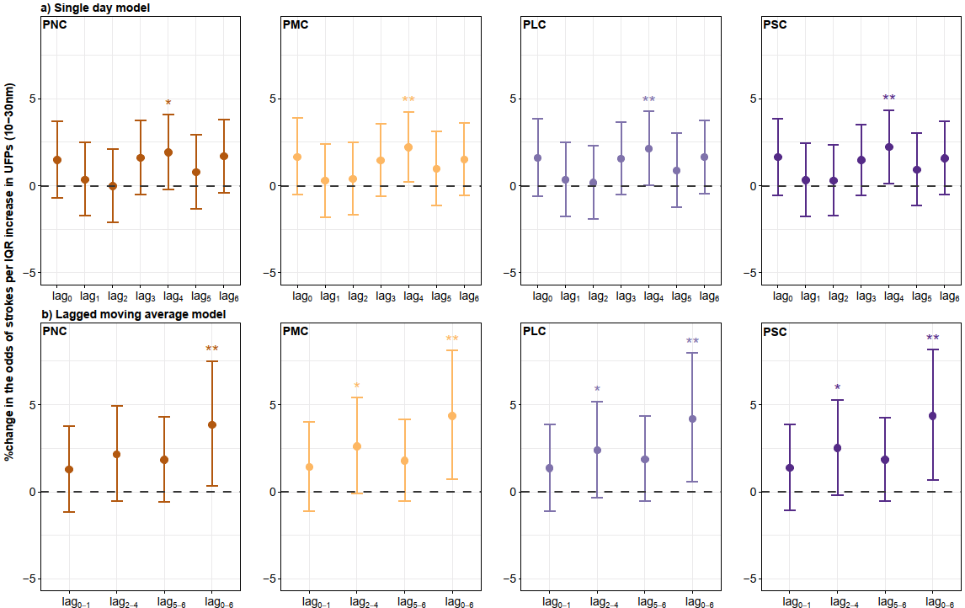

sFig 1. Percent change (95%CI) in the odds of overall stroke events per interquartile range (IQR) increase in the a) single-day and b) lagged moving average UFP metrics (10-30 nm). Note: * P<0.10; ** P<0.05.
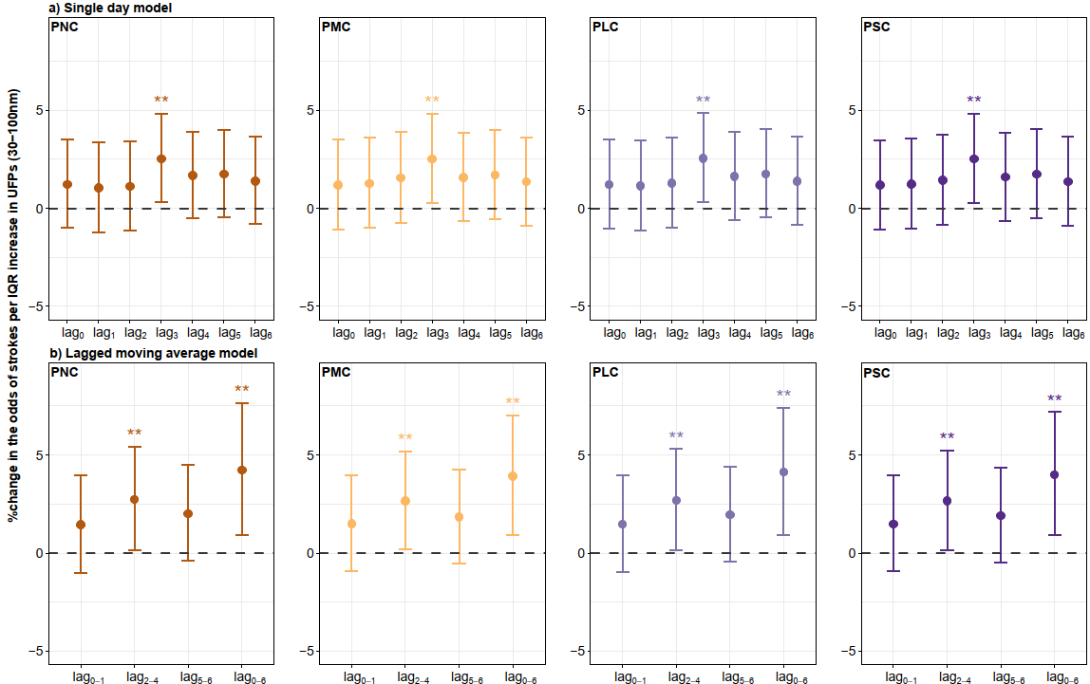

sFig 2. Percent change (95%CI) in the odds of overall stroke events per interquartile range (IQR) increase in the a) single-day and b) lagged moving average UFP metrics (30-100 nm). Note: ** P<0.05.
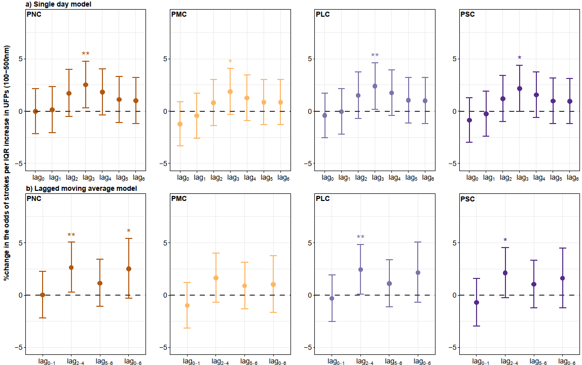

sFig 3. Percent change (95%CI) in the odds of overall stroke events per interquartile range (IQR) increase in the a) single-day and b) lagged moving average UFP metrics (100-500 nm). Note: * P<0.10; ** P<0.05.
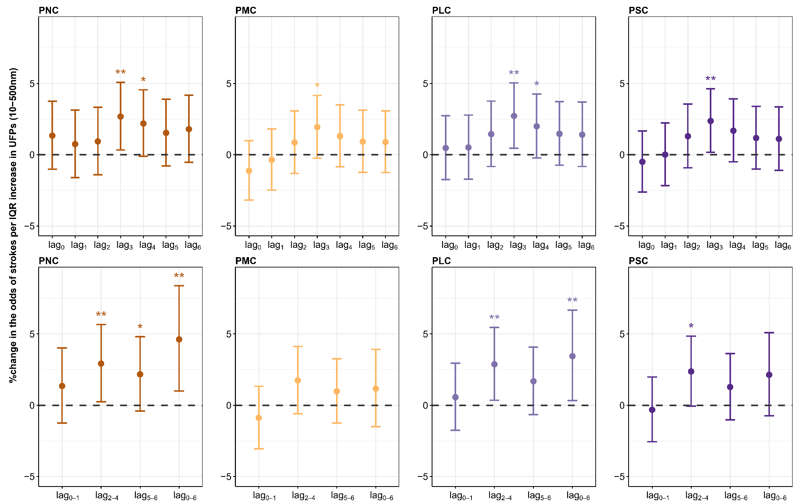

sFig 4. Percent change (95%CI) in the odds of overall stroke events per interquartile range (IQR) increase in the a) single-day and b) lagged moving average UFP metrics (10-500 nm). Note: * P<0.10; ** P<0.05.

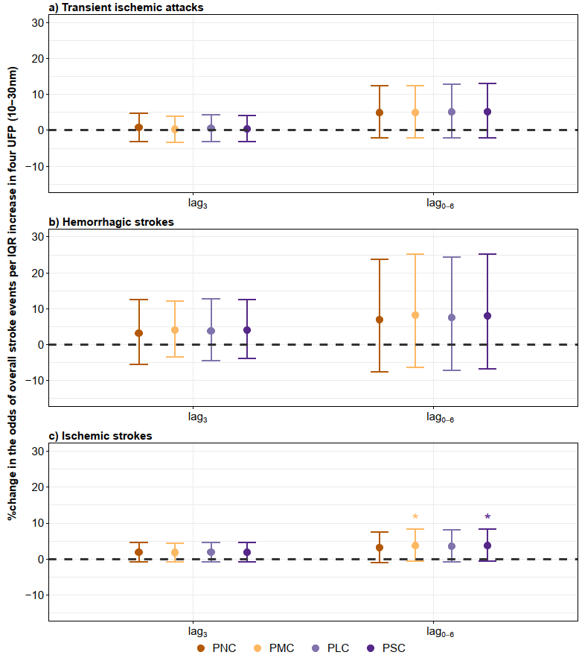

sFig 5. Percent change (95%CI) in the odds of three stroke subtypes per interquartile range (IQR) increase in single 3 day and moving average 0-6 days of UFP metrics (10-30 nm). Note: * P<0.10.

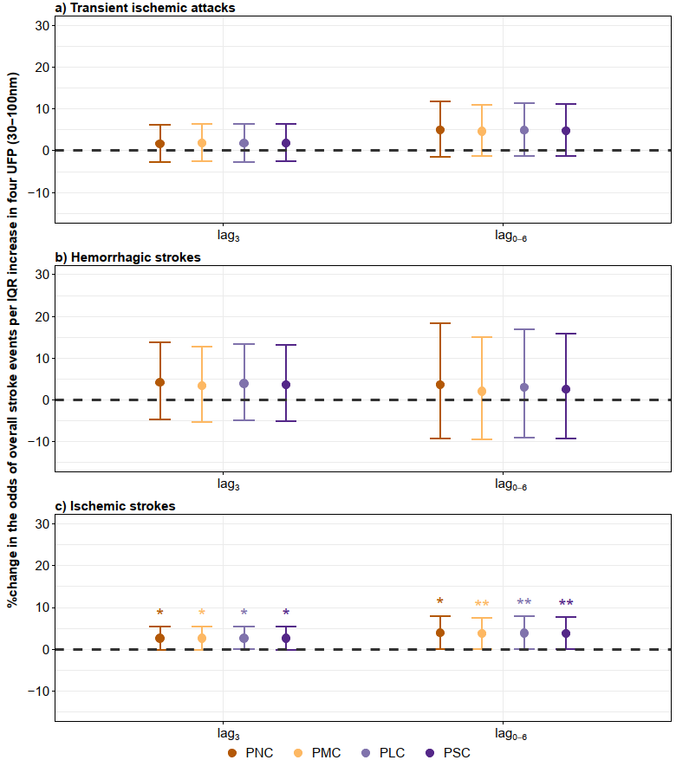

sFig 6. Percent change (95%CI) in the odds of three stroke subtypes per interquartile range (IQR) increase in single 3 day and moving average 0-6 days of UFP metrics (30-100 nm). Note: * P<0.10; ** P<0.05.

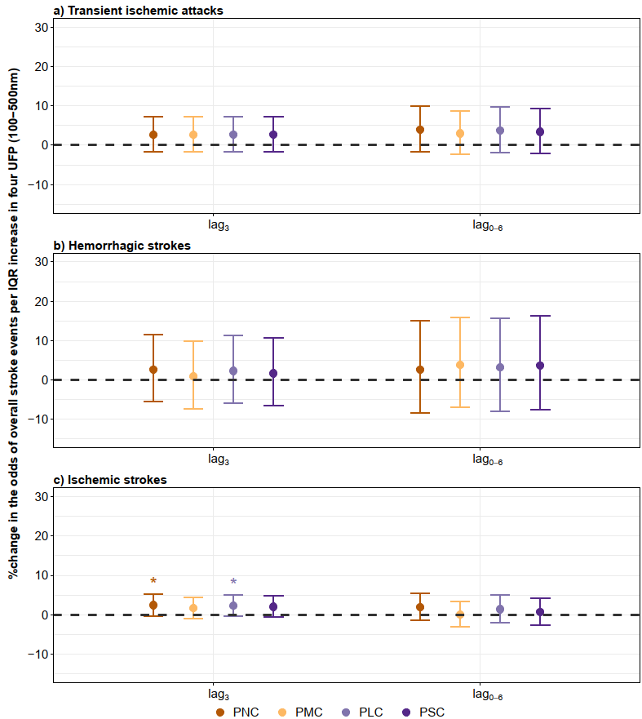

sFig 7. Percent change (95%CI) in the odds of three stroke subtypes per interquartile range (IQR) increase in single 3 day and moving average 0-6 days of UFP metrics (100-500 nm). Note: * P<0.10.
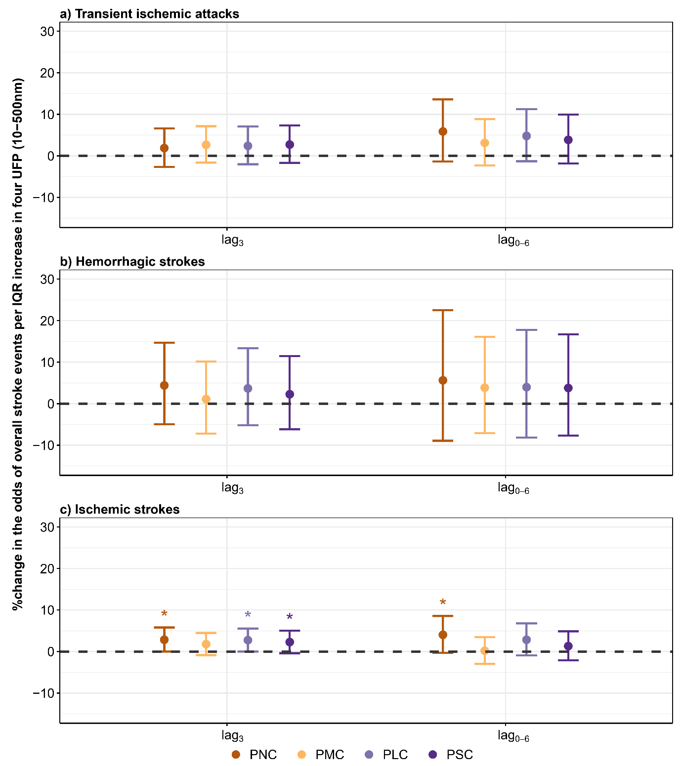

sFig 8. Percent change (95%CI) in the odds of three stroke subtypes per interquartile range (IQR) increase in single 3 day and moving average 0-6 days of UFP metrics (10-500 nm). Note: * P<0.10.

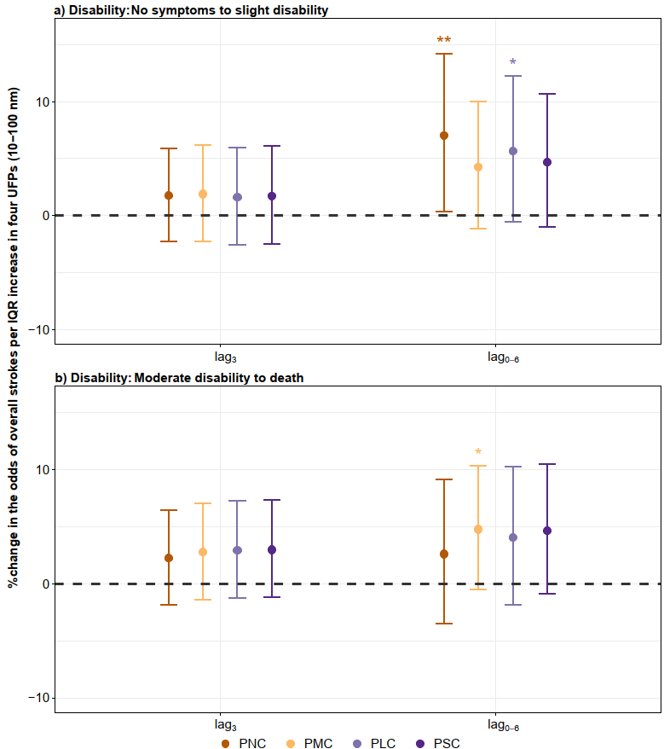

sFig 9. Stratified percent change (95%CI) in the odds of overall stroke events by two stroke-related disability levels per IQR increase in single 3 day and moving average 0-6 days of UFP metrics (10-100 nm). Note: * P<0.10; ** P<0.05.

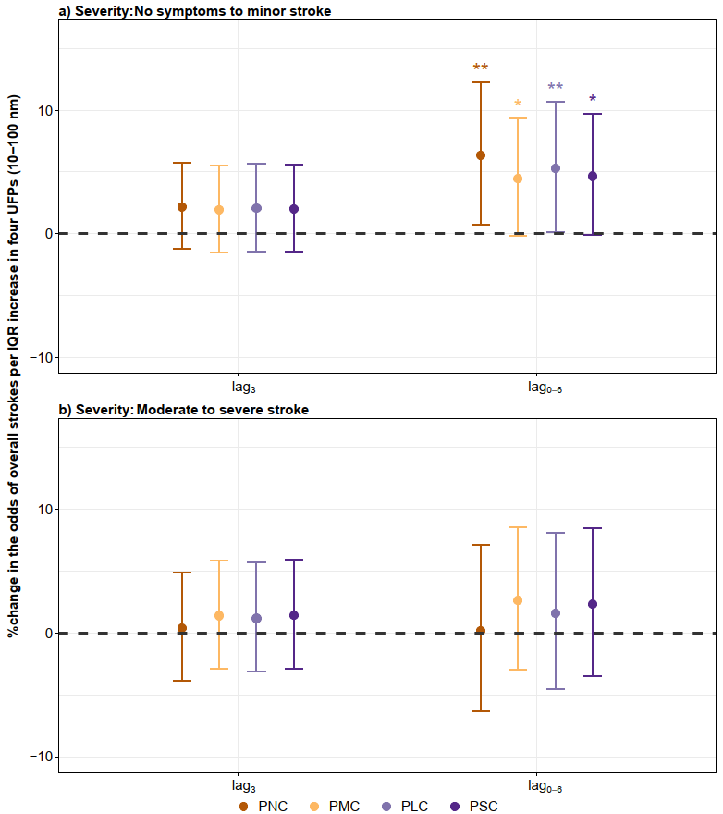

sFig 10. Stratified percent change (95%CI) in the odds of overall stroke events by two stroke severity levels per IQR increase in single 3 day and moving average 0-6 days of UFP metrics (10-100 nm). Note: * P<0.10; ** P<0.05.

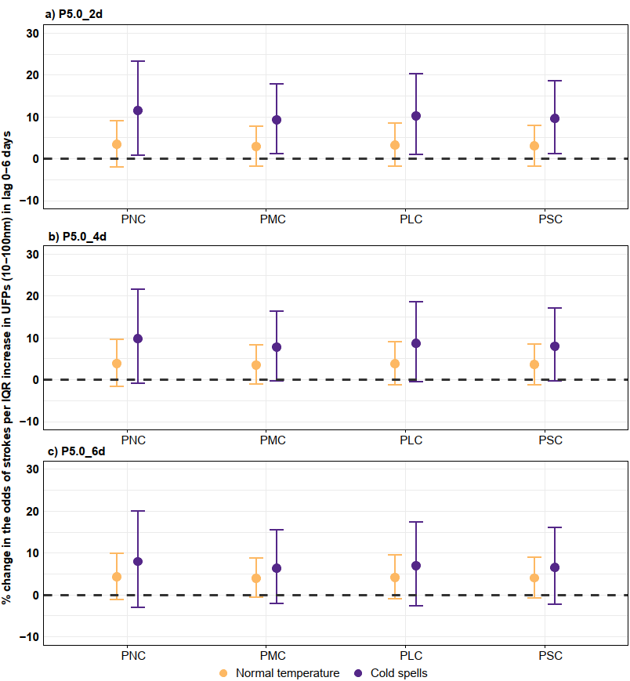

sFig 11. Effect modification by the consecutive a) 2 days, b) 4 days and c) 6 days of P5.0th thresholds of cold spells on the association between lag 0-6 days of UFP metrics (10-100 nm) and the percent changes in the odds of overall stroke events.
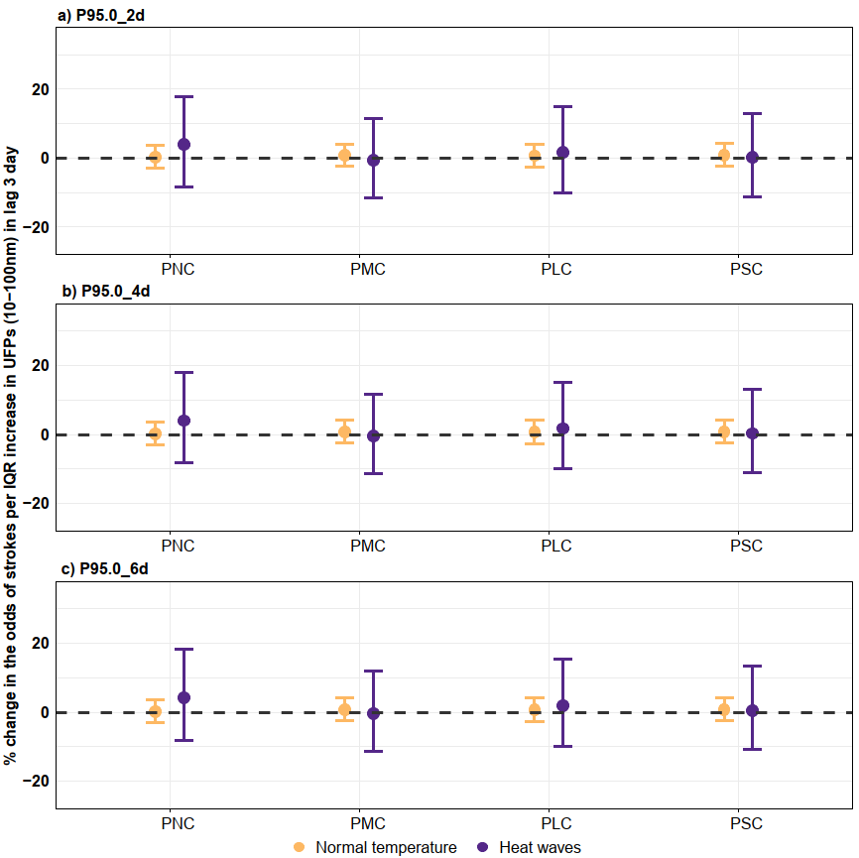

sFig 12. Effect modification by the consecutive a) 2 days, b) 4 days and c) 6 days of P95.0th thresholds of heat waves on the association between lag 3 days of UFP metrics (10-100 nm) and the percent changes in the odds of overall stroke events.

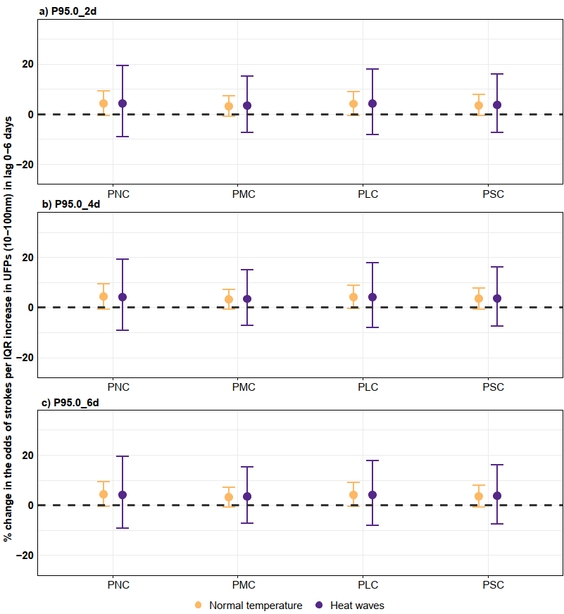

sFig 13. Effect modification by the consecutive a) 2 days, b) 4 days and c) 6 days of P95.0th thresholds of heat waves on the association between lag 0-6 days of UFP metrics (10-100 nm) and the percent changes in the odds of overall stroke events.
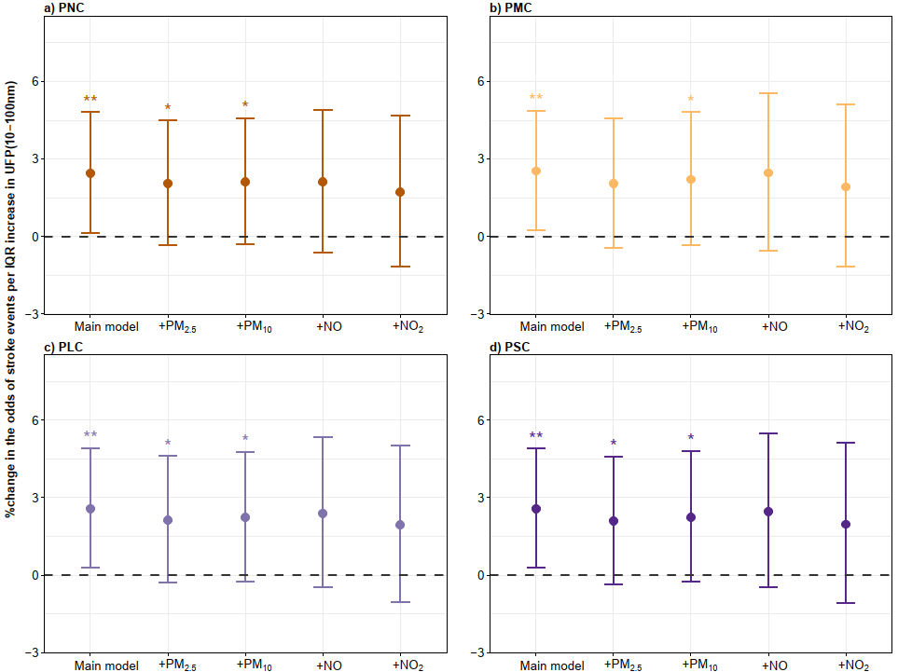

sFig 14. Percent change (95%CI) in the odds of overall stroke events per IQR increase in lag 3 day of four UFP metrics (10-100 nm). Note: the x-axis shows the results of the main model and the two-pollutants model: adjusted for ambient pollutants with a Spearman correlation coefficient less than 0.7. * P<0.10; ** P<0.05.
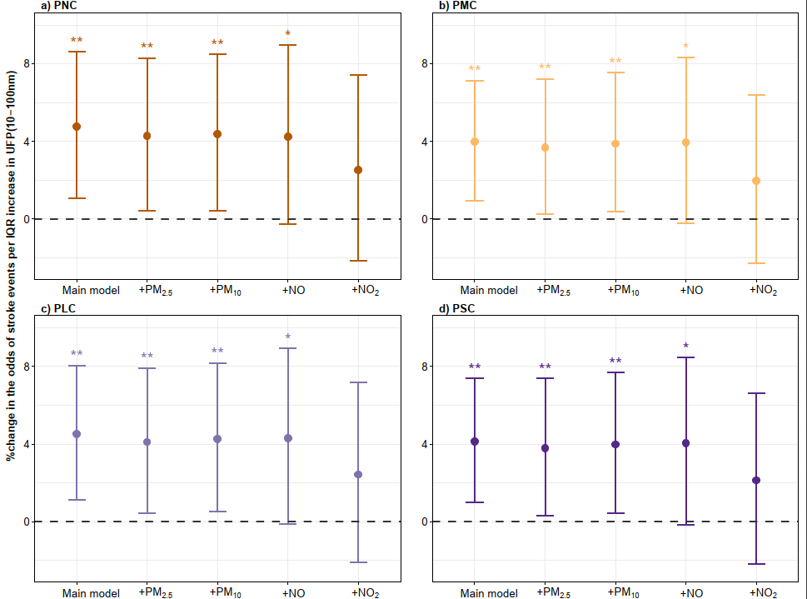

sFig 15. Percent change (95%CI) in the odds of overall stroke events per IQR increase in lag 0-6 days of four UFP metrics (10-100 nm). Note: the x-axis shows the results of the main model and the two-pollutants model: adjusted for ambient pollutants with a Spearman correlation coefficient less than 0.7. * P<0.10; ** P<0.05

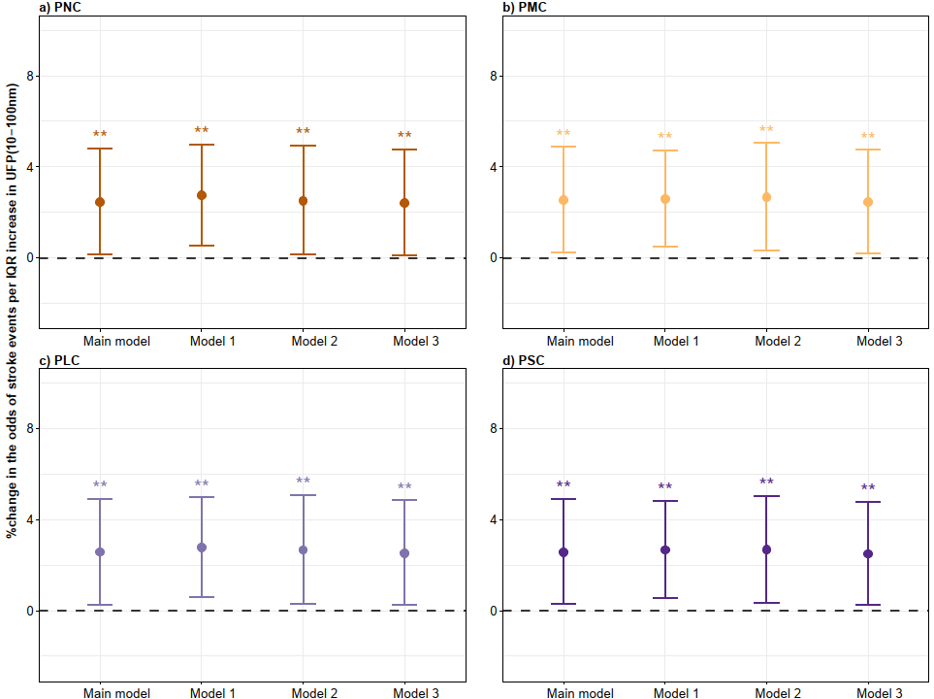

sFig 16. Percent change (95%CI) in the odds of overall stroke events per IQR increase in lag 3 day of four UFP metrics (10-100 nm) in three models. Note: the x-axis shows the results of the main model and different sensitivity analyses: Model 1 represents results estimated using 1-neighbouring week values imputed data; Model 2 represents results specifically excluded patients after the beginning of the COVID-19 pandemic; Model 3 represents results specially adjusted for the warm and cold temperatures calculated based on the annual levels of ambient air temperature. * P<0.10; ** P<0.05.

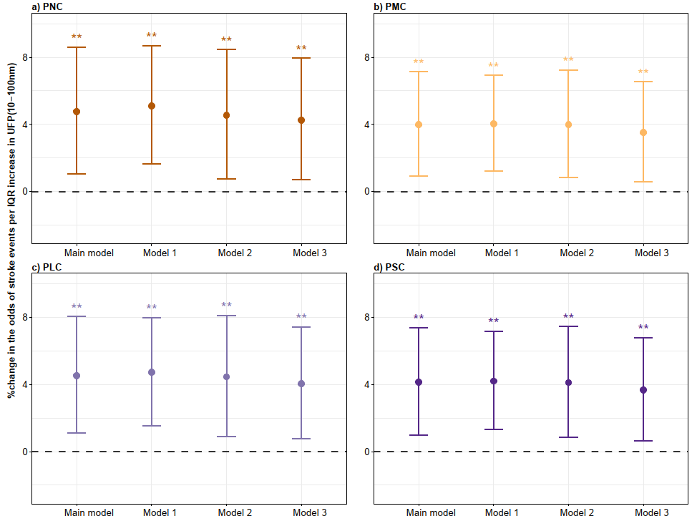

sFig 17. Percent change (95%CI) in the odds of overall stroke events per IQR increase in lag 0-6 day of four UFP metrics (10-100 nm) in three models. Note: the x-axis shows the results of the main model and different sensitivity analyses: Model 1 represents results estimated using 1-neighbouring week values imputed data; Model 2 represents results specifically excluded patients after the begin of COVID-19 pandemic; Model 3 represents results specially adjusted for the warm and cold temperatures calculated based on the annual levels of ambient air temperature. * P<0.10; ** P<0.05.
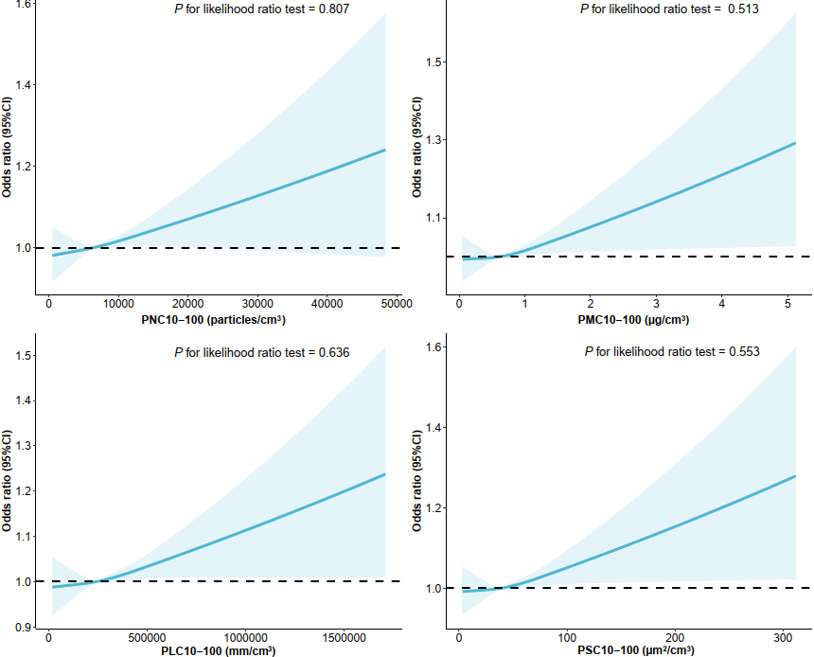

sFig 18. The exposure-response relationship between lag 3 days of four UFP metrics (10-100 nm) and the odds ratios (95%CI) of overall stroke events using the restricted curved spline. Note: the likelihood test was used, with a P value < 0.05 indicating potential non-linearity.
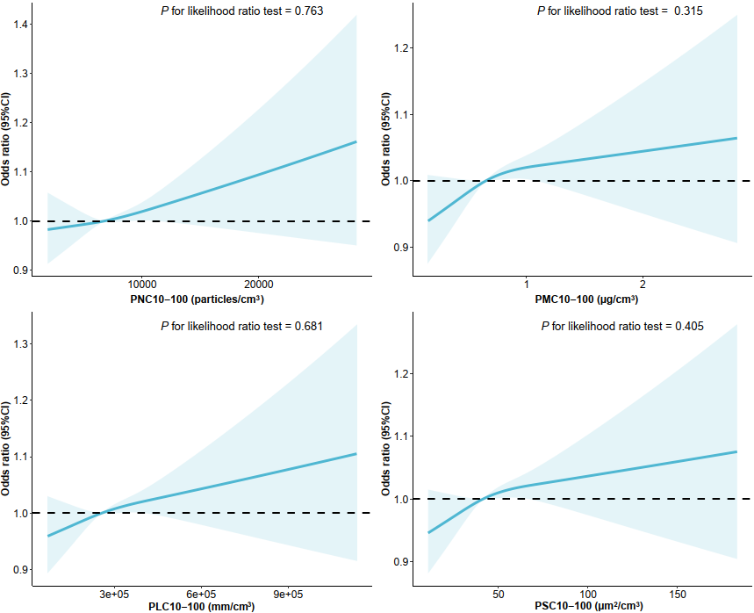

sFig 19. The exposure-response relationship between lag 0-6 days of four UFP metrics (10-100 nm) and the odds ratios (95%CI) of overall stroke events using the restricted curved spline. Note: the likelihood test was used, with a P value < 0.05 indicating potential non-linearity.

References:
1. Birmili W, Heinke K, Pitz M, et al. Particle number size distributions in urban air before and after volatilisation. Atmospheric Chemistry and Physics. 10(10):4643-4660,
2. Birmili W, Stratmann F, Wiedensohler A. Design of a DMA-based size spectrometer for a large particle size range and stable operation. Journal of Aerosol Science. 30(4):549-553,
3. Gu J, Pitz M, Breitner S, et al. Selection of key ambient particulate variables for epidemiological studies - applying cluster and heatmap analyses as tools for data reduction. Sci Total Environ. 435-436:541-550, doi:10.1016/j.scitotenv.2012.07.040
4. Rückerl R, Schneider A, Hampel R, et al. Association of novel metrics of particulate matter with vascular markers of inflammation and coagulation in susceptible populations -results from a panel study. Environ Res. 150:337-347, doi:10.1016/j.envres.2016.05.037
5. Pitz M, Birmili W, Schmid O, Peters A, Wichmann HE, Cyrys J. Quality control and quality assurance for particle size distribution measurements at an urban monitoring station in Augsburg, Germany. J Environ Monit. 10(9):1017-1024, doi:10.1039/b807264g
6. Xu R, Huang S, Shi C, et al. Extreme Temperature Events, Fine Particulate Matter, and Myocardial Infarction Mortality. Circulation. 148(4):312-323, doi:10.1161/circulationaha.122.063504
7. Deng B, Zhu L, Zhang Y, et al. Short-term exposure to PM(2.5) constituents, extreme temperature events and stroke mortality. Sci Total Environ. 954:176506, doi:10.1016/j.scitotenv.2024.176506

