Table S1. Associations between long-term exposure to particle number concentration (PNC) and cardiovascular, metabolic, and respiratory diseases as well as cardiometabolic risk markers. Results are presented odds ratios for diseases or as percentage changes in geometric mean of risk markers per 1000 particles/cm³ increase in PNC.
Outcome | Odds ratio (95% CI)
Hypertension | 1.031 (1.007, 1.054)
MI | 1.095 (1.021, 1.174)
Stroke | 1.040 (0.964, 1.122)
Diabetes | 1.020 (0.979, 1.062)
COPD | 1.041 (0.995, 1.088)
 | % change (95% CI)
Glucose | 0.260 (0.090, 0.430)
HbA1c | 0.069 (-0.065, 0.202)
Leukocytes | 0.247 (0.005, 0.489)
MI = myocardial infarction; COPD = chronic obstructive pulmonary disease; HbA1c = hemoglobin A1c; 95% CI = 95% confidence interval
Adjustments were made for the study region (Augsburg or Regensburg), age, sex, level of education, and the annual average of the monthly household income at the administrative district level. In addition, we added BMI, smoking status, physical activity, and alcohol consumption, which explained some heterogeneity of our participants.
Table S2: Associations between long-term exposure to air pollutants and cardiovascular, metabolic, and respiratory diseases. Results are presented as odds ratios for diseases per interquartile (IQR) increase in air pollutant.
Air pollutant | IQR | Hypertension | MI | Stroke | Diabetes | COPD
PNC | 1.78 10³/cm³ | 1.055 (1.013, 1.099) | 1.176 (1.038, 1.331) | 1.072 (0.936, 1.227) | 1.035 (0.963, 1.112) | 1.073 (0.992, 1.161)
PM_{2.5} | 1.18 µg/m³ | 1.031 (0.999, 1.065) | 1.127 (1.016, 1.250) | 0.943 (0.849, 1.047) | 1.059 (1.001, 1.121) | 1.061 (0.993, 1.133)
BC | 0.36 10⁻⁵/m | 1.025 (0.978, 1.076) | 1.132 (0.976, 1.313) | 1.005 (0.854, 1.183) | 1.026 (0.943, 1.116) | 1.069 (0.977, 1.169)
NO₂ | 6.59 µg/m³ | 1.033 (0.987, 1.081) | 1.157 (1.003, 1.333) | 1.012 (0.867, 1.182) | 1.036 (0.955, 1.123) | 1.102 (1.011, 1.202)
PNC = particle number concentration; PM_{2.5} = particulate matter with a diameter ≤ 2.5 µm; BC = black carbon; NO₂ = nitrogen dioxide; MI = myocardial infarction; COPD = chronic obstructive pulmonary disease
Adjustments were made for the study region (Augsburg or Regensburg), age, sex, level of education, and the annual average of the monthly household income at the administrative district level. In addition, we added BMI, smoking status, physical activity, and alcohol consumption, which explained some heterogeneity of our participants.
Table S3: Associations between long-term exposure to air pollutants and cardiometabolic risk markers. Results are presented as geometric mean of risk markers per interquartile (IQR) increase in air pollutants.
Adjustment | IQR | Glucose | HbA1c | Leukocytes
PNC | 1.78 10³/cm³ | 0.463 (0.160, 0.766) | 0.122 (-0.115, 0.361) | 0.440 (0.010, 0.873)
PM_{2.5} | 1.18 µg/m³ | 0.305 (0.063, 0.547) | -0.021 (-0.211, 0.170) | 0.213 (-0.132, 0.560)
BC | 0.36 10⁻⁵/m | 0.489 (0.140, 0.839) | -0.082 (-0.356, 0.192) | 0.137 (-0.359, 0.634)
NO₂ | 6.59 µg/m³ | 0.440 (0.103, 0.777) | -0.043 (-0.307, 0.221) | 0.140 (-0.338, 0.620)
PNC = particle number concentration; PM_{2.5} = particulate matter with a diameter ≤ 2.5 µm; BC = black carbon; NO₂ = nitrogen dioxide; HbA1c = hemoglobin A1c
Adjustments were made for the study region (Augsburg or Regensburg), age, sex, level of education, and the annual average of the monthly household income at the administrative district level. In addition, we added BMI, smoking status, physical activity, and alcohol consumption, which explained some heterogeneity of our participants.
Table S4: Associations between long-term exposure to particle number concentration (PNC) and cardiovascular diseases, diabetes, and chronic obstructive pulmonary disease (COPD) – sensitivity analyses. Results are presented as odds ratios for diseases per 1000 particles/cm³ increase in PNC.
 | Adjustment | Hypertension | MI | Stroke | Diabetes | COPD
 | Main | 1.031 (1.007, 1.054) | 1.095 (1.021, 1.174) | 1.040 (0.964, 1.122) | 1.020 (0.979, 1.062) | 1.041 (0.995, 1.088)
(1) | Crude model | 1.033 (1.003, 1.063) | 1.121 (1.051, 1.195) | 1.057 (0.986, 1.134) | 1.042 (1.004, 1.082) | 1.103 (1.060, 1.148)
(2) | Only adjustment for confounders* | 1.034 (1.010, 1.057) | 1.120 (1.045, 1.200) | 1.050 (0.974, 1.133) | 1.027 (0.987, 1.069) | 1.059 (1.014, 1.107)
(3) | Additional adjustment for marital status | 1.028 (1.005, 1.052) | 1.093 (1.019, 1.172) | 1.036 (0.960, 1.118) | 1.017 (0.976, 1.059) | 1.034 (0.989, 1.081)
(4) | Additional adjustment for unemployment rate | 1.047 (1.022, 1.073) | 1.100 (1.022, 1.184) | 1.057 (0.975, 1.145) | 1.033 (0.990, 1.078) | 1.040 (0.992, 1.090)
(5) | Additional adjustment for BMI
(6) | Mixed regression models | 1.031 (1.007, 1.054) | 1.095 (1.021, 1.174) | 1.040 (0.964, 1.122) | 1.020 (0.979, 1.062) | 1.041 (0.995, 1.088)
(7) | Only participants who had lived at their residence for at least 5 years before examination | 1.034 (1.006, 1.063) | 1.094 (1.005, 1.192) | 0.989 (0.898, 1.089) | 1.010 (0.959, 1.062) | 1.025 (0.968, 1.084)
(8) | Analyses for Augsburg | 1.040 (1.011, 1.070) | 1.070 (0.981, 1.167) | 1.050 (0.956, 1.154) | 1.056 (1.004, 1.110) | 1.053 (0.997, 1.113)
 | Analyses for Regensburg | 1.066 (1.018, 1.115) | 1.184 (1.034, 1.354) | 1.077 (0.929, 1.249) | 0.976 (0.901, 1.056) | 0.998 (0.914, 1.090)
(9) | Two pollutant model – adj. for PM_{2.5} (UBA) | 1.052 (1.023, 1.082) | 1.110 (1.021, 1.207) | 1.067 (0.974, 1.170) | 1.028 (0.979, 1.080) | 1.022 (0.968, 1.079)
 | Two pollutant model – adj. for NO₂ (UBA) | 1.054 (1.026, 1.082) | 1.099 (1.014, 1.191) | 1.081 (0.991, 1.179) | 1.026 (0.979, 1.076) | 1.022 (0.971, 1.076)
*Adjustment for study region, age, sex, level of education, and the annual average of the monthly household income at the administrative district level.
Table S5: Associations between long-term exposure to particle number concentration (PNC) and cardiometabolic risk markers – sensitivity analyses. Results are presented as percentage changes in risk marker per 1000 particles/cm³ increase in PNC.
 | Adjustment | Glucose | HbA1c | Leukocytes
 | Main | 0.260 (0.090, 0.430) | 0.069 (-0.065, 0.202) | 0.247 (0.005, 0.489)
(1) | Crude model | 0.298 (0.142, 0.453) | 0.150 (0.026, 0.273) | 0.487 (0.256, 0.718)
(2) | Only adjustment for confounders* | 0.286 (0.116, 0.456) | 0.129 (-0.005, 0.264) | 0.535 (0.284, 0.786)
(3) | Additional adjustment for marital status | 0.239 (0.069, 0.410) | 0.051 (-0.083, 0.185) | 0.198 (-0.044, 0.441)
(4) | Additional adjustment for unemployment rate | 0.253 (0.072, 0.434) | 0.233 (0.091, 0.376) | 0.285 (0.027, 0.544)
(5) | Additional adjustment for BMI | 0.219 (0.052, 0.386) | 0.038 (-0.093, 0.169) | 0.182 (-0.054, 0.419)
(6) | Mixed regression models | 0.260 (0.091, 0.430) | 0.100 (-0.033, 0.234) | 0.240 (0.001, 0.482)
(7) | Only participants who had lived at their residence for at least 5 years before examination | 0.229 (0.017, 0.441) | 0.077 (-0.091, 0.244) | 0.275 (-0.030, 0.581)
(8) | Analyses for Augsburg | 0.308 (0.100, 0.516) | 0.238 (0.064, 0.413) | 0.450 (0.147, 0.755)
 | Analyses for Regensburg | 0.144 (-0.204, 0.492) | 0.185 (-0.054, 0.424) | -0.104 (-0.577, 0.370)
(9) | Two pollutant model – adj. for PM_{2.5} (UBA) | 0.274 (0.066, 0.483) | 0.305 (0.141, 0.470) | 0.362 (0.065, 0.659)
 | Two pollutant model – adj. for NO₂ (UBA) | 0.294 (0.096, 0.493) | 0.304 (0.147, 0.461) | 0.351 (0.068, 0.634)

*Adjustment for study region, age, sex, level of education, and the annual average of the monthly household income at the administrative district level.

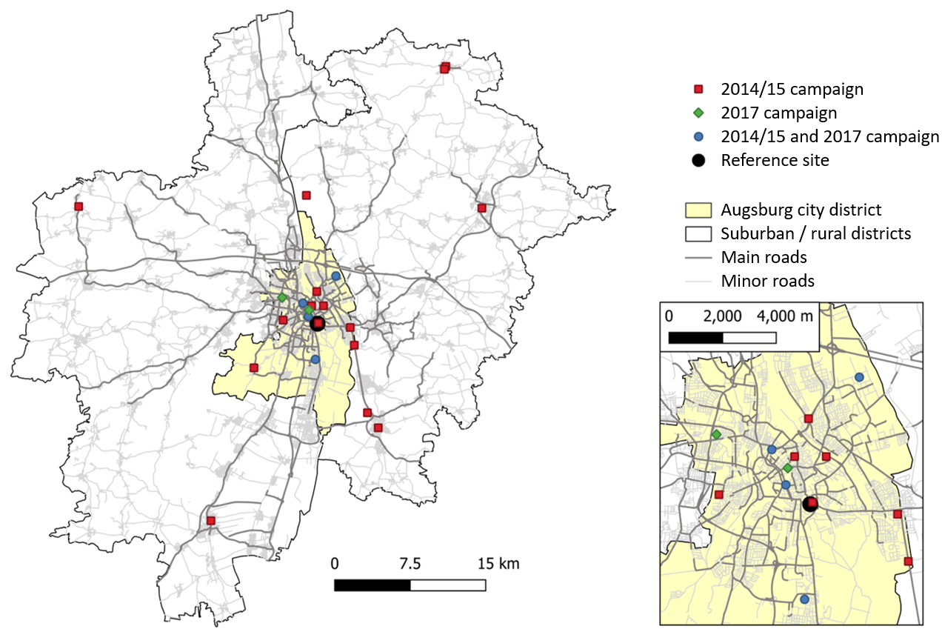

Figure S1. Map of the monitoring sites and road network in the Augsburg area.

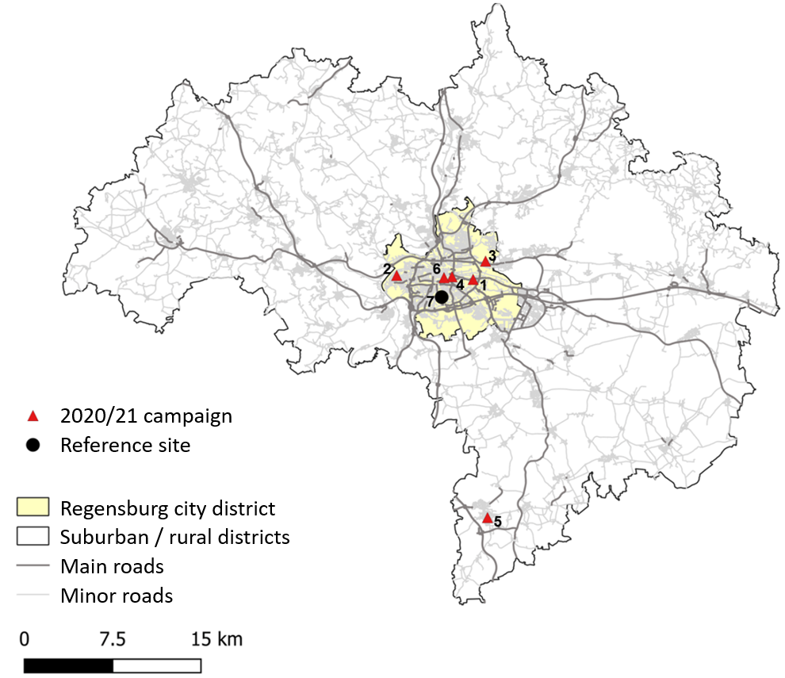

Figure S2. Map of the monitoring sites and road network in the Regensburg area.

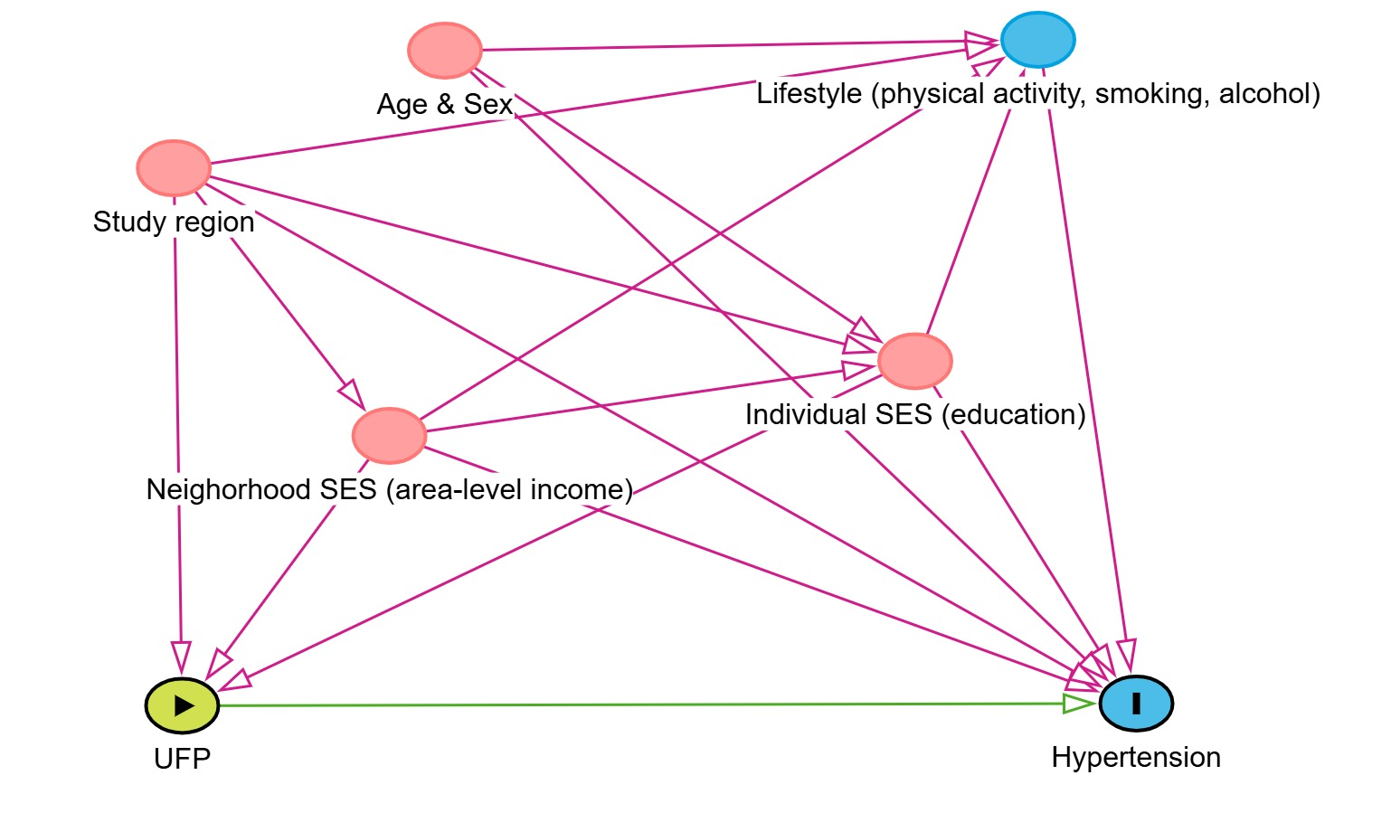
Supplemental Figure 3: Proposed directed acyclic graph (DAG) demonstrating the assumed causal relationships between the exposure (green circle), outcome (blue circle with black border), and other variables of interest. DAG was built at www.dagitty.net.

Myocardial infarction

Stroke

Diabetes

Chronic obstructive pulmonary disease (COPD)
Figure S4: Associations between long-term exposure to particle number concentrations (PNC) and Associations between long-term exposure to air pollutants and cardiovascular, metabolic, and respiratory diseases – effect modifications. Results are presented as odds ratios for diseases per 1000 particles/cm³ increase in PNC.
*p-value of interaction < 0.05.

Hypertension
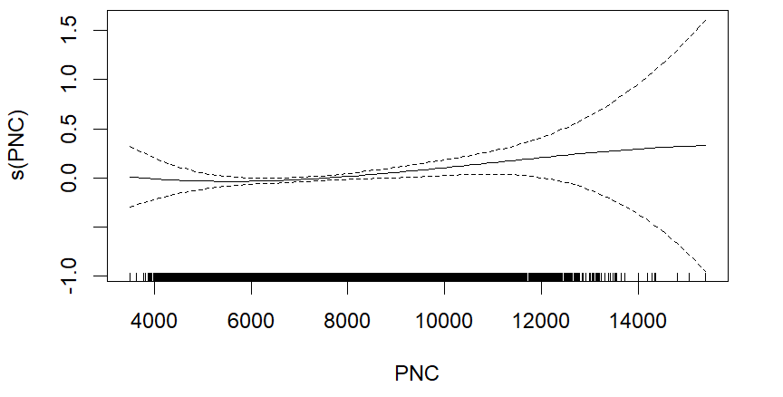
Myocardial infarction
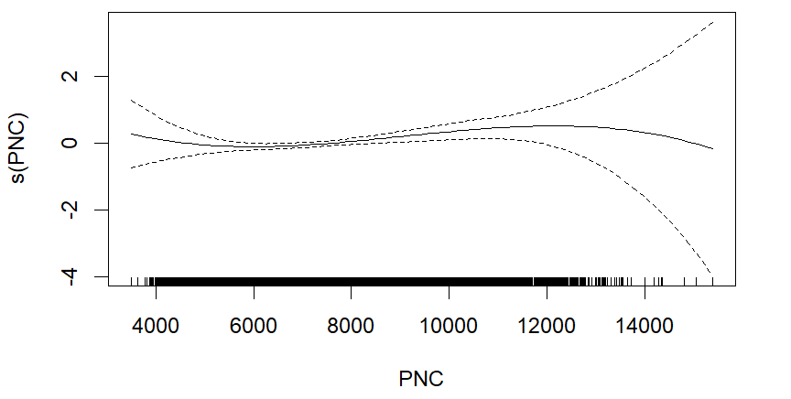
Stroke
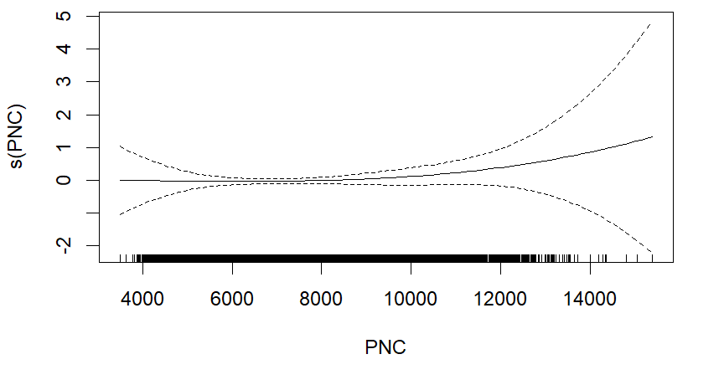
Diabetes
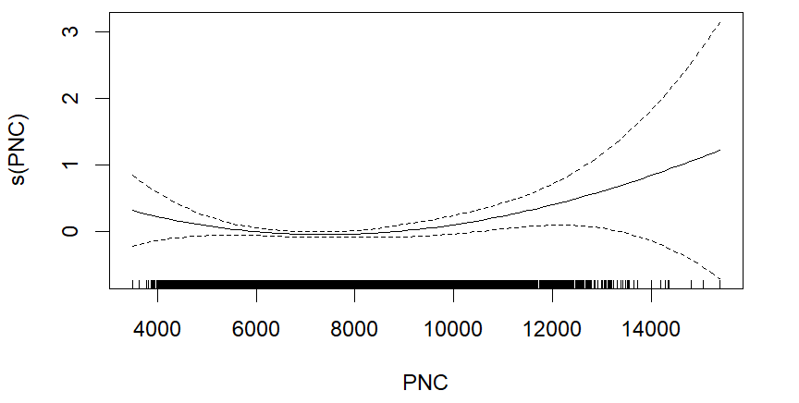
COPD
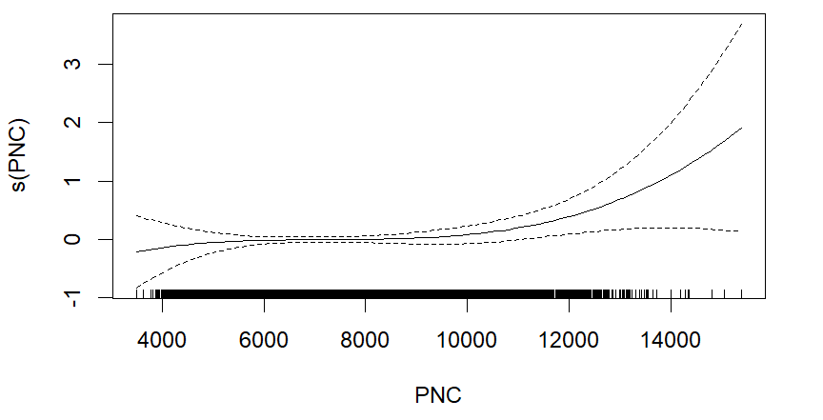
Figure S5. Exposure-response functions for long-term exposure to particle number concentration (PNC) and cardiovascular, metabolic, and respiratory diseases.

Glucose
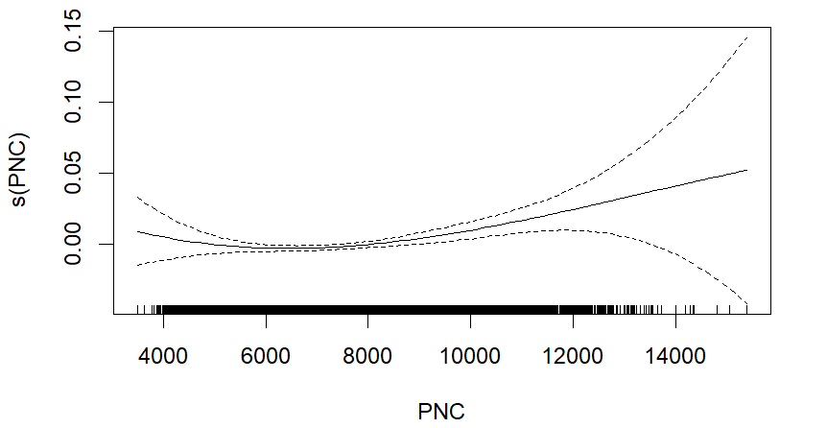
HbA1c
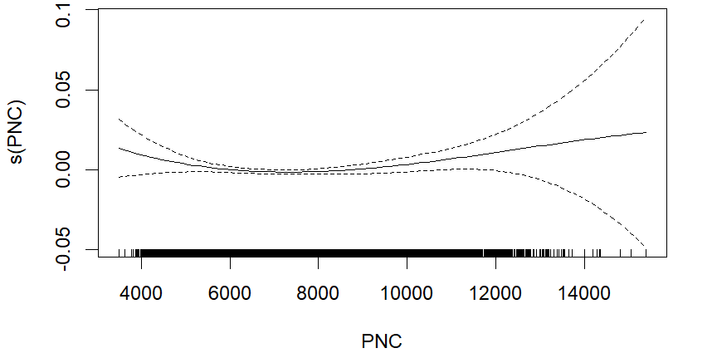
Leucocytes
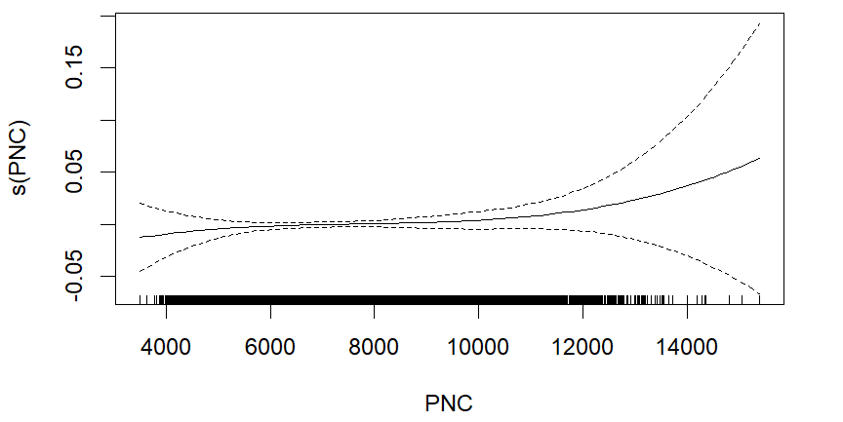

Figure S6. Exposure-response function for long-term exposure to particle number concentration (PNC) and cardiometabolic marker levels.

