Supplementary Material

Figure S1
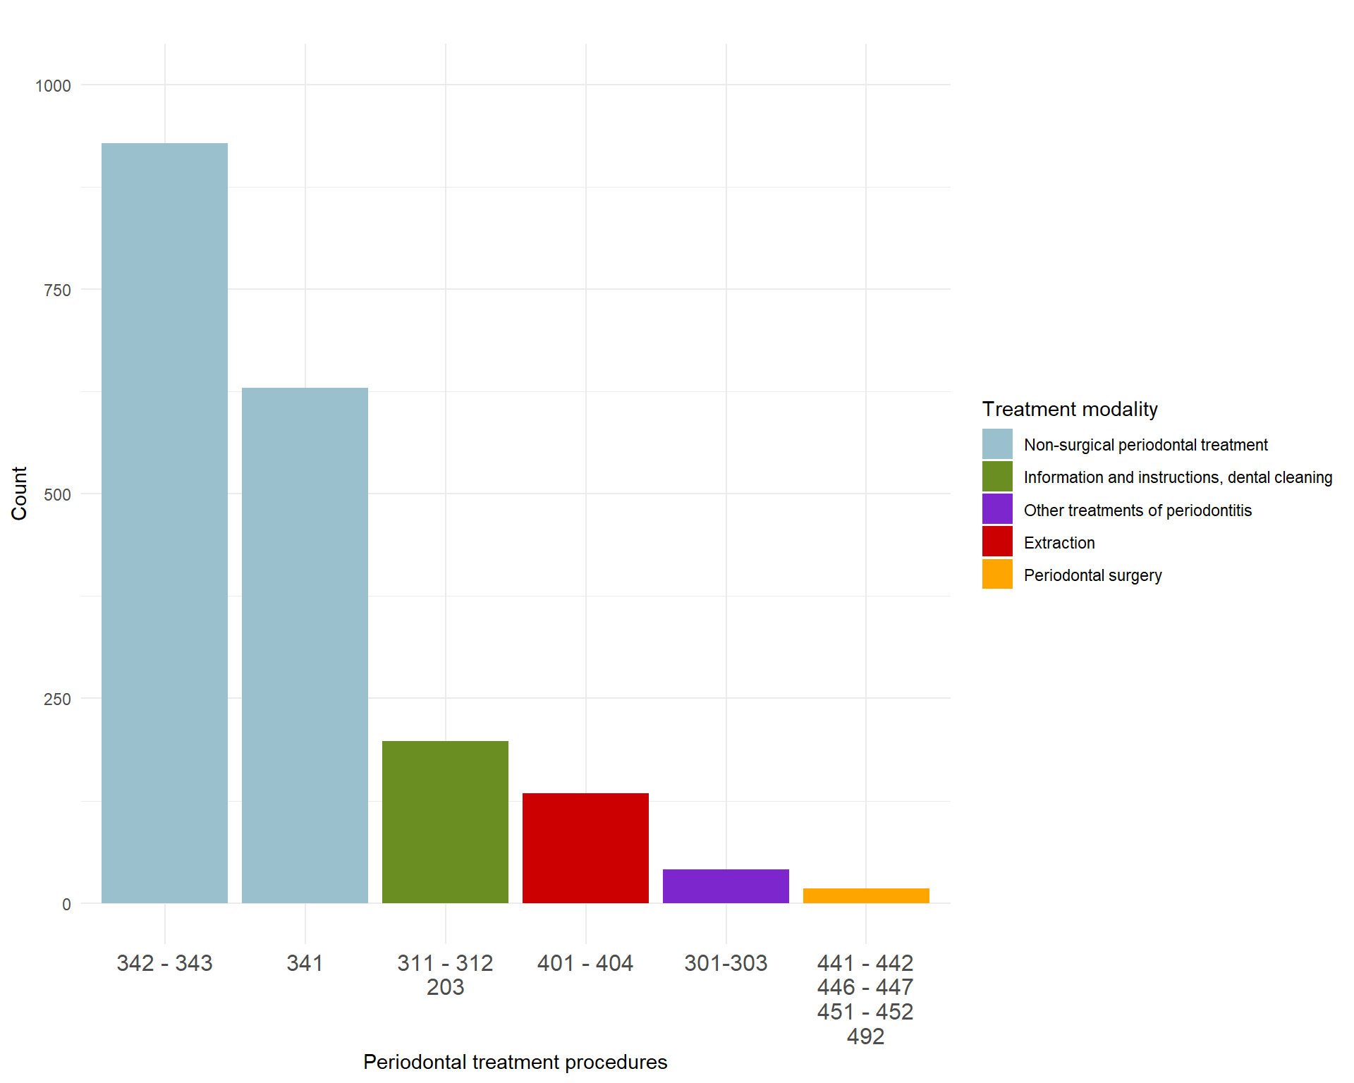
FIGURE S1 | Number of procedures (count) with condition code 3043 for periodontitis. Procedures are grouped based on similarity, and the specific procedural codes are presented in Table S1. Colour coding is based on treatment modality.

TABLE S1 | (A) Description of dental procedure codes included in the Swedish dental care subsidy, which can be combined with the periodontitis condition 3043 in the 2020 edition. (B) Description of all condition codes that can be combined with the procedures presented in Table S1A.

S1A. Procedural codes that can be combined with the condition code for periodontitis

Dental procedure code | Description | Comment | Condition
203 | Professional tooth cleaning, fluoride treatment, and dietary advice | Preventive measure, revoked in 2012 | 2041, 2051, 3041, 3042, 3043
301 | Disease or pain treatment, non-extensive |  | 3043, 3044, 3045, 3046, 3071, 3072
302 | Disease or pain treatment |  | 3042, 3043, 3044, 3045, 3046, 3071, 3072, 3111
303 | Disease or pain treatment, extensive |  | 3042, 3043, 3044, 3046, 3072, 3111
311 | Information or instructions for oral health-related diseases or conditions |  | 3041, 3042, 3043, 3044
312 | Follow-up information or instructions for oral health-related diseases or conditions |  | 3041, 3042, 3043, 3044
341 | Non-extensive non-surgical periodontal treatment |  | 3041, 3042, 3043, 3044
342 | Extensive non-surgical periodontal treatment | Several deep pockets or furcation involvements must be present | 3043, 3044
343 | Very extensive non-surgical periodontal treatment | Session must be at least 90 minutes long in addition to requirements of 342 | 3043, 3044
401 | Tooth extraction |  | 3043, 3045, 3046, 3071
402 | Tooth extraction where sectioning of roots or prosthodontics is required |  | 3043, 3045, 3046, 3071
403 | Tooth extraction, simple | Tooth or residual root with minimal or no periodontal attachment | 3043, 3045, 3046, 3071
404 | Tooth extraction, flap surgery | One or several teeth | 3043, 3045, 3046, 3071
441 | Simple surgical treatment of periodontitis (one or two teeth) or peri-implantitis (single implant) | Legacy procedure for 451 Revoked in 2019 | 3043, 3044, 3046, 3111
442 | Surgical treatment of periodontitis | Legacy procedure for 451, 452  Revoked in 2019 | 3043, 3046
446 | Reconstructive periodontal surgery (GTR or EMD) | Adjunct procedure to 451, 452 | 3043, 3046
447 | Reconstructive periodontal surgery with bone graft | Adjunct procedure to 451, 452 | 3043
451 | Periodontal surgery, one quadrant | Implemented in 2019 | 3043, 3046
452 | Extensive periodontal surgery in one quadrant or periodontal surgery in two quadrants | Implemented in 2019 | 3043
492 | Adjunct procedure for specialist dentists in periodontology | Revoked in 2012

S1B. Condition codes that can be combined with the procedures in A

Condition code | Description
2031 | Tartar on teeth or dental implants
2041 | Increased risk of periodontitis
2051 | Increased risk of peri-implantitis
3041 | Gingivitis
3042 | Peri-implant mucositis
3043 | Periodontitis
3044 | Peri-implantitis
3045 | Pericoronitis
3046 | Other diseases and conditions affecting the gingiva and surrounding tissues of the teeth or dental implants
3071 | Aphthous stomatitis or traumatic ulcers
3072 | Denture stomatitis
3073 | Denture chafing
3111 | Inflammation and other symptoms in salivary glands, oral mucosa, lips, tongue, and surrounding tissues
5061 | Dentition with severe attachment loss due to periodontitis in need of prosthodontic stabilization, unstable periodontitis
5062 | Dentition with severe attachment loss due to periodontitis in need of prosthodontic stabilization, stable periodontitis

TABLE S2 | Outcomes of the questionnaire, stratified by clinical periodontitis stage.
Question | Overall  N = 607 | Healthy/Stage I  N = 349 | Stage II  N = 158 | Stage III-IV  N = 100
Do you usually have tartar on your teeth? n (%)
Yes | 475 (86.4) | 253 (83.8) | 134 (86.5) | 88 (94.6)
No | 75 (13.6) | 49 (16.2) | 21 (13.5) | 5 (5.4)
Don’t know | 57 | 47 | 3 | 7
Are your gums sore or do they bleed? n (%)
Yes | 36 (6.0) | 20 (5.8) | 6 (3.8) | 10 (10.1)
Only when I brush | 163 (27.1) | 93 (27.0) | 34 (21.5) | 36 (36.4)
No | 403 (66.9) | 232 (67.2) | 118 (74.7) | 53 (53.5)
Don’t know | 5 | 4 | 0 | 1
Has anyone told you that you have deep periodontal pockets? n (%)
Yes | 190 (32.3) | 73 (21.5) | 63 (40.9) | 54 (56.8)
No | 398 (67.7) | 266 (78.5) | 91 (59.1) | 41 (43.2)
Don’t know | 19 | 10 | 4 | 5
Do your teeth feel loose? n (%)
Yes | 9 (1.5) | 3 (0.9) | 0 (0.0) | 6 (6.1)
A bit | 38 (6.3) | 23 (6.6) | 6 (3.8) | 9 (9.2)
No | 558 (92.2) | 323 (92.6) | 152 (96.2) | 83 (84.7)
Don’t know | 2 | 0 | 0 | 2

A total of 607 participants responded. Answers are stratified by clinical classification of periodontitis. Percentages are based on the total number of responses in the overall population and by periodontitis stage.

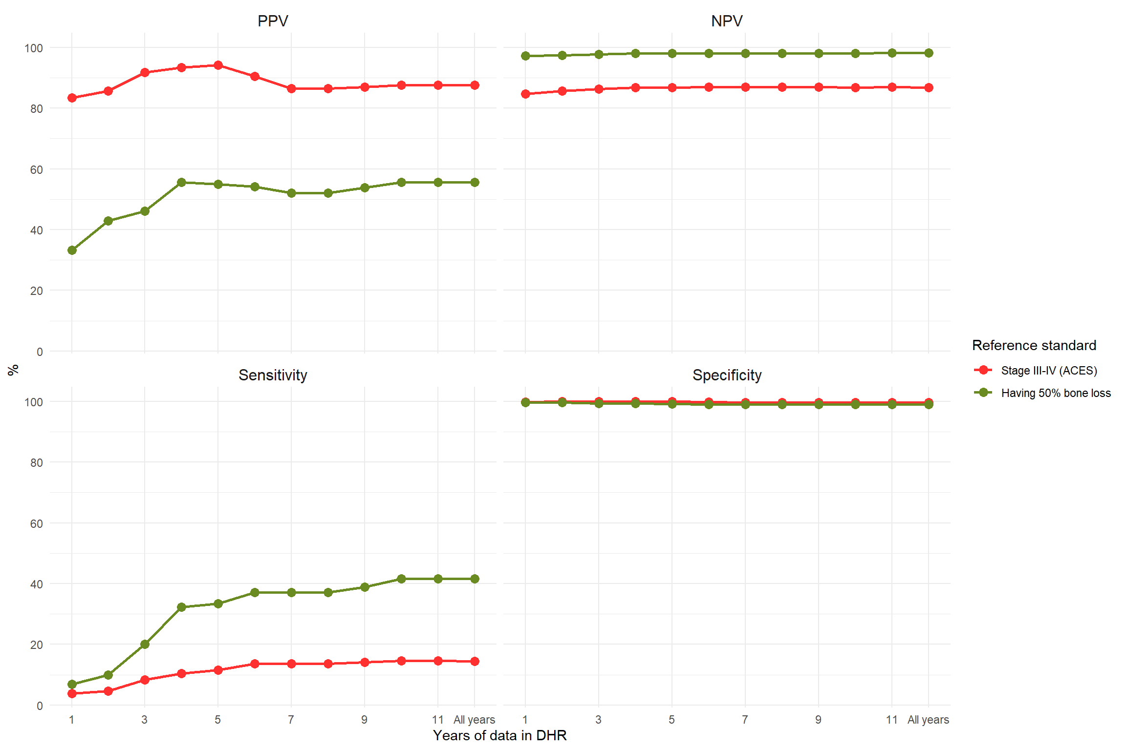
FIGURE S2 | Positive predictive value (PPV), negative predictive value (NPV), sensitivity, and specificity of the Dental Health Register (DHR)-based severe periodontitis variable per full year in the DHR. Both PPV and sensitivity plateaus after about 6-7 years.

TABLE S3 | Positive predictive value (PPV), negative predictive value (NPV), sensitivity, specificity, and number of Malmö Offspring Dental Study participants that answered the questions, for the questions included in the questionnaire.
Reference standard | Question | PPV | NPV | Sensitivity | Specificity | N
Stage III-IV (ACES) | Bleeding gums | 23.12 | 86.85 | 46.46 | 69.58 | 603
Stage III-IV (ACES) | Deep pockets | 28.42 | 89.70 | 56.84 | 72.41 | 589
Stage III-IV (ACES) | Loose teeth | 31.91 | 85.13 | 15.31 | 93.69 | 606
Stage III-IV (ACES) | Tartar on teeth | 18.53 | 93.33 | 94.62 | 15.32 | 551
Having 50% bone loss | Bleeding gums | 3.02 | 97.52 | 37.50 | 67.06 | 602
Having 50% bone loss | Deep pockets | 5.26 | 98.49 | 62.50 | 68.53 | 588
Having 50% bone loss | Loose teeth | 14.89 | 98.39 | 43.75 | 93.21 | 605
Having 50% bone loss | Tartar on teeth | 3.37 | 100.00 | 100.00 | 14.04 | 550

Notes: The response to the questions about bleeding gums, “yes” and “only when I brush my teeth” were merged. The response to the questions about loose teeth, the options “a bit” and “yes” were merged. The full questions were as follows: “Are your gums sore or do they bleed?”; “Has anyone told you that you have deep periodontal pockets?”; “Do your teeth feel loose?”; and “Do you usually have tartar on your teeth?”

