Appendix A. Supplementary material
Table of contents
Methods E1. Data sources p. 2
Methods E2. Study design and statistical analysis p. 7
Random forest classification p. 7
Difference-in-differences (DID) parallel trend assumption p. 8
Formular DID main model p. 11
Metavariables p. 12
Results E3. Descriptive statistics p. 15
Results E4. Main analyses p. 23
Results E5. Sensitivity analyses p. 24

Methods E1. Data sources
City | Dates | DWD weather station(s) | Code(s) | File(s)
Berlin | 1993-01-01 to 2020-12-31 | Berlin-Tempelhof | 433 | produkt_klima_tag_19480101_20211231_00433.txt
Bremen | 1993-01-01 to 2020-12-31 | Bremen | 691 | produkt_klima_tag_18900101_20211231_00691.txt
Cologne | 1993-01-01 to 2020-12-31 | Koeln-Bonn | 2667 | produkt_klima_tag_19570701_20211231_02667.txt
Dortmund | 1993-01-01 to 2007-12-31  2008-01-01 to 2018-10-31  2018-11-01 to 2020-12-31 | Hagen-Fley  Bochum  Gevelsberg-Oberbroeking | 1920  555  13700 | produkt_klima_tag_19780601_20071231_01920.txt  produkt_klima_tag_19400101_20181031_00555.txt  produkt_klima_tag_20080501_20211231_13700.txt
Dresden | 1993-01-01 to 2020-12-31 | Dresden-Klotzsche | 1048 | produkt_klima_tag_19340101_20211231_01048.txt
Duisburg | 1993-01-01 to 1993-12-31  1994-05-01 to 2007-05-31  2007-06-01 to 2020-12-31 | Duisburg-Laar  Duisburg-Friemersheim  Duisburg-Baerl | 1087  1084  13670 | produkt_klima_tag_19510101_19931231_01087.txt  produkt_klima_tag_19940501_20070531_01084.txt  produkt_klima_tag_20070601_20211231_13670.txt
Dusseldorf | 1993-01-01 to 2020-12-31 | Duesseldorf | 1078 | produkt_klima_tag_19520101_20211231_01078.txt
Essen | 1993-01-01 to 2020-12-31 | Essen | 1303 | produkt_klima_tag_19350101_20211231_01303.txt
Frankfurt am Main | 1993-01-01 to 2020-12-31 | Frankfurt-Main | 1420 | produkt_klima_tag_19490101_20211231_01420.txt
Hamburg | 1993-01-01 to 2020-12-31 | Hamburg-Fuhlsbuettel | 1975 | produkt_klima_tag_19360101_20211231_01975.txt
Hannover | 1993-01-01 to 2020-12-31 | Hannover | 2014 | produkt_klima_tag_19360101_20211231_02014.txt
Leipzig | 1993-01-01 to 2020-12-31 | Leipzig-Holzhausen | 2928 | produkt_klima_tag_18631201_20211231_02928.txt
Munich | 1993-01-01 to 2020-12-31 | Muenchen-Stadt | 3379 | produkt_klima_tag_19540601_20211231_03379.txt
Nuremberg | 1993-01-01 to 2020-12-31 | Nuernberg | 3668 | produkt_klima_tag_18790101_20211231_03668.txt
Stuttgart | 1993-01-01 to 2020-12-31 | Stuttgart-Schnarrenberg | 4928 | produkt_klima_tag_19580101_20211231_04928.txt
Table A.1. Name and code of the referring DWD weather station(s) per city.

Variable | Description | Format/ Value | Missing Values (n)*
date | Date | Date (1993-05-01 to 2020-09-30) | ---
cityname | Names of 15 German cities | Categorical, character | ---
death | Daily total mortality per city (all-cause deaths) | Integer | ---
tmean | Daily (24 h) mean air temperature (°C) | Numeric | 0.00% | (3)
tmax | Daily maximum air temperature (°C) | Numeric | 0.01% | (6)
tmin | Daily minimum air temperature (°C) | Numeric | 0.01% | (7)
rel.hum | Daily (24h) mean relative humidity (%) | Numeric | 0.19% | (121)
sp.hum | Daily (24 h) mean specific humidity (g of water vapor/ kg of humid air) | Numeric | 15.39% | (9,890)
precip | Daily (24 h) cumulative precipitation amount (mm) | Numeric | 0.02% | (18)
ws | Wind speed (m/s), 24 h mean | Numeric | 11.45% | (7,355)
sunh | Daily sunshine duration in hours | Numeric | 9.37% | (6,018)
year | Year | Integer | ---
month | Month of the year | Categorical (5 to 9) | ---
day | Day number within a month | Categorical (1 to 31) | ---
yday | Day number within a year | Categorical (121 to 274) | ---
yday.sm | Day number within warm-season months (May-September) | Categorical (1 to 153) | ---
obs.nr | Observation number (starting 1993-05-01, ending 2020-09-30, per city) | Integer (1 to 4284) | ---
dow | Weekday name | Categorical, character | ---
AT | Apparent temperature based on maximum air temperature and relative humidity | Numerical | - 0% | (126)
AT_tmean | Apparent temperature based on mean air temperature and relative humidity | Numerical | 0.19% | (121)
D3tmean | Running mean of the mean daily air temperature (°C) of the respective last three days | Numerical | 0.01% | (9)
D3tmax | Running mean of the maximum daily air temperature (°C) of the respective last three days | Numerical | 0.03% | (18)
D3tmin | Running mean of the minimum daily air temperature (°C) of the respective last three days | Numerical | 0.03% | (21)
hw.level | Days with heat alert from 2005 to 2020 | Categorical (no = day without heat alert, yes =day with heat alert) | 42.86% | (27,540)
hw.predict | Probable days with heat alert based on random forest classification from 1993 to 2020 | Categorical (no = day without heat alert, yes = day with heat alert) | 0.35% | (222)
population.total | Yearly census-corrected number of total inhabitants. Population with 1987 and 2011 census correction. Extrapolated values for 1993 and 1994. | Integer | ---
residents.65 | Proportion of inhabitants 65 years and older in %. Based on the continuation of the population figures of the Federation and Länder as of the 31.12 reference date of the respective year. Extrapolated values for 1993 and 1994. | Numerical | ---
life.expectancy | Mean life expectancy of a newborn (under one year old) in years. The indicator is calculated as the average of the respective last three years. Based on the continuation of the population figures of the Federation and Länder as of the 31.12 reference date of the respective year. Extrapolated values for 1993 and 1994. | Numerical | ---
mortality.rate | Number of all-cause deaths per 100,000 inhabitants (daily deaths/ yearly population.total *100,000) | Numerical | ---
implementation | Implementation of the German heat health warning system (HHWS) | Categorical (0 = pre-HHWS period, 1 = post-HHWS period) | ---
eligible | Eligible and non-eligible days (1993-2004 based on random forest classification, 2005-2020 based on DWD heat alerts) | Categorical (0 = days without heat alert, 1 = days with heat alert) | 0.08% | (49)
*Percentages related to all observations in all 15 German cities in the whole study period (N = 6420).
Table A.2. Variables of the first-stage dataset.

Variable | Description | Format | Years | Missing values/years (%)*
cityname | Names of 15 German cities | Character | --- | ---
admin_name | Name of the federal states (Bundesländer) where the cities are located. | Character | --- | ---
admin | Abbreviation of the federal states | Character | --- | ---
region | Regions in Germany where the cities are located (North, South, East, West). | Character | --- | ---
population | Census-corrected number of total inhabitants. Population with 1987 and 2011 census correction. | Integer | 1995-2020 | 1993-1994 | (7.14)
women | Proportion of women in the population in %**. | Numeric | 1995-2020 | 1993-1994 | (7.14)
res_65 | Proportion of inhabitants 65 years and older in %**. | Numeric | 1995-2020 | 1993-1994 | (7.14)
av.age | Average age of the population in years**. | Numeric | 1995-2020 | 1993-1994 | (7.14)
life.expect | Mean life expectancy of a newborn (under one year old) in years. The indicator is calculated as the average of the respective last three years**. | Numeric | 1995-2020 | 1993-1994 | (7.14)
rest.life.expect | Remaining life expectancy of 60-year-old persons in years. The indicator is calculated as the average of the respective last three years**. | Numeric | 1995-2020 | 1993-1994 | (7.14)
foreign | Proportion of foreign inhabitants (including stateless persons and persons with unclear citizenship) in the population in %**. | Numeric | 1995-2020 | 1993-1994 | (7.14)
unemployed | Annual average number of unemployed persons (all persons who are temporarily not in employment, living in Germany, are not younger than 15 years of age or have not reached retirement age and have personally registered as unemployed with an employment agency or job center). | Integer | 1995-2020 | 1993-1994 | (7.14)
income | Average disposable income of private households in € per inhabitant. Disposable income is the amount available to private households for consumption purposes or for savings***. | Numeric | 2000-2019 | 1993-1999, 2020 | (28.57)
pop.density | Inhabitants per km²***. | Numeric | 1996,2000,2004, 2008-2020 | 1995,1997-1999,  2001-2003,  2005-2007 | (35.71)
GISD | German Index of Socioeconomic Deprivation (GISD): Data on Education, employment and income situation at district level from the INKAR database are weighted via principal component analyses (39). | Numeric | 1998-2019 | 1993-1997,2020 | (16.80)
recreational.area | Recreation area per inhabitant in m² (predominantly green, sparsely sealed areas that take on important functions for the local microclimate and groundwater recharge)***. | Numeric | 2016-2020 | 1993-2015 | (82.14)
open.space | Open space per inhabitant in m². In addition to agricultural, forest and water areas, open space also includes unbuilt settlement areas, namely quarrying land, recreational and cemetery areas***. | Numeric | 2016-2020 | 1993-2015 | (82.14)
natural.area | Near-natural area per inhabitant in m² (Water area without harbor basin and vegetation area without agriculture and forest)***. | Numeric | 2016-2020 | 1993-2015 | (82.14)
forest.area | Proportion of forest area in % of total area. Based on the Amtlichen Liegenschaftskataster-Informationssystem (ALKIS). | Numeric | 2016-2020 | 1993-2015 | (82.14)
water.area | Proportion of water area in % of area. Water-covered areas include flowing waters, standing waters, harbor basins and, on coasts, the part of the sea that has been incommunalized. Based on the Amtlichen Liegenschaftskataster-Informationssystem (ALKIS). | Numeric | 2016-2020 | 1993-2015 | (82.14)
* Percentage of missing years = Amount missing years / Study period (1993-2020 = 28 years).
** Based on the continuation of the population figures of the Federation and Länder as of the 31.12 reference date of the respective year.
*** The reference figure of inhabitants is based on the continuation of the population figures of the Federation and Länder.
Table A.3. Metavariables of the second-stage analyses. Socioeconomic variables without extrapolation.

Methods E2. Study design and statistical analysis

Random forest classification
For the DID approach it is necessary to have a classification of expectable days with heat alerts and without heat alerts prior to HHWS implementation (1993-2004). To perform this classification, we used machine learning techniques. Given that the HHWS in Germany utilizes complex simulations rather than a heat index or temperature threshold, we employed a random forest classification algorithm with the following input variables: month, daily mean, minimum and maximum air temperature, perceived temperature, the running mean of these temperature variables and indices for the previous two and three days, as well as relative air humidity. Other meteorological variables were excluded due to a high proportion of missing values. As there were more days without heat alert than with (2.61% days with heat alert), oversampling was used to create a balanced dataset. Seventy percent of the days from the balanced dataset were randomly assigned to the training dataset, with the binary outcome variable heat alert, and 30 percent to the test dataset. The test dataset model accuracy was 0.9967 (95% CI: 0.9961 to 0.9971), the model sensitivity was 0.9933, and the model specifity was 1.00. Further information on the variable importance is presented in Figure A.1.
[AT = apparent temperature, tmean = mean daily temperature, tmax = daily maximum temperature, D2 = running mean of previous two days, D3 = running mean of previous three days].
Figure A.1. Top ten variables with the highest variable importance in the random forest model based on mean decrease in Gini.

Difference-in-differences (DID) parallel trend assumption
Figure A.2. Scatterplot and linear trendline with 95% confidence interval bands of daily mortality per city before and after Implementation of the heat health warning system (HHWS) in 2005 for eligible and non-eligible days.

Formular DID main model
(1) $DID main model=glm(death \sim eligible+implementation+\left(eligible×implementation\right)+ns\left(yday.sm, df=4\right):factor\left(year\right)+ns(date, df=round\left(number of years \text{/ 1 / 10}\right)+as.factor\left(dow\right)+tmean+rel.hum, family=quasipoisson\left(link=log\right), offset=ln⁡(population.total)$
Explanations for the variables given in the quasi-Poisson main model can be found in Table A.2.
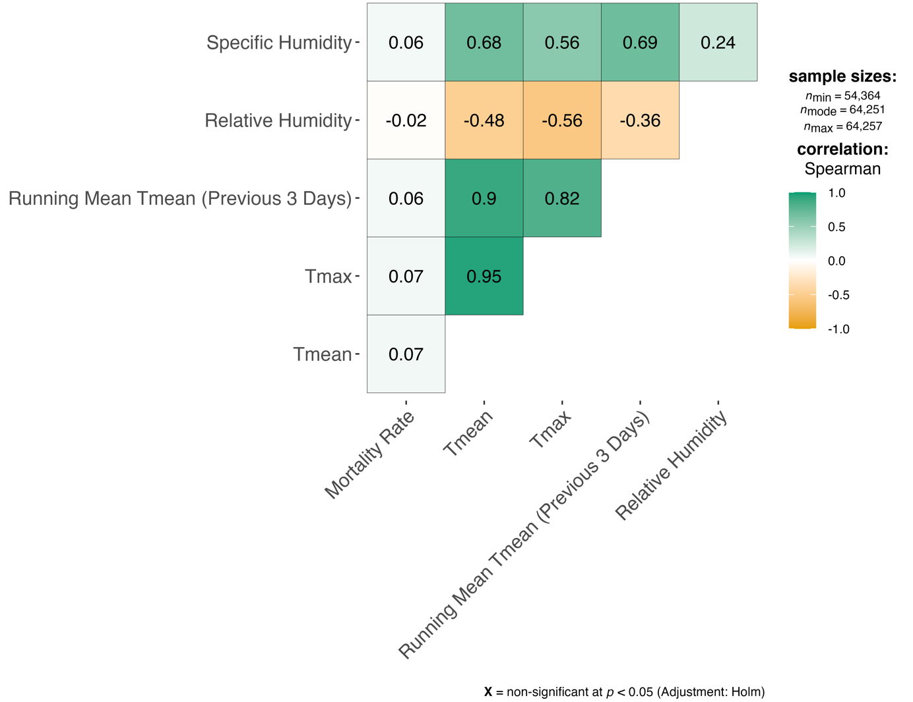
Figure A.3. Correlogram of selected first-stage variables and mortality rate (per 100,000 inhabitants).

Metavariables
City | Population | Proportion of women (%) | Residents ≤ 65* | Average age* | Mean life expectancy* | Rest life expectancy* | Proportion of foreign inhabitants (%) | Unemployed persons
Berlin | 3,391,702.15 | 51.19 | 17.29 | 41.56 | 78.98 | 22.09 | 14.27 | 237,455.27
Bremen | 548,897.04 | 51.44 | 20.01 | 42.78 | 78.90 | 22.36 | 14.13 | 31,130.81
Cologne | 1,007,010.96 | 51.51 | 17.11 | 41.12 | 79.24 | 22.23 | 18.14 | 54,811.58
Dortmund | 582,948.04 | 51.17 | 19.71 | 42.49 | 78.20 | 21.70 | 15.73 | 38,610.81
Dresden | 507,696.38 | 51.11 | 20.18 | 42.30 | 80.60 | 23.31 | 4.90 | 28,916.81
Duisburg | 503,200.15 | 51.09 | 20.11 | 42.53 | 77.90 | 21.46 | 17.50 | 33,011.92
Dusseldorf | 587,086.65 | 52.31 | 18.98 | 42.53 | 78.97 | 22.08 | 18.03 | 29,238.19
Essen | 583,432.96 | 51.98 | 21.11 | 43.43 | 78.26 | 21.58 | 12.35 | 34,654.23
Frankfurt a. M. | 675,492.88 | 51.03 | 16.33 | 41.06 | 79.89 | 22.72 | 24.70 | 27,272.69
Hamburg | 1,727,124.31 | 51.34 | 18.04 | 41.61 | 79.37 | 22.34 | 14.71 | 78,478.38
Hannover | 1,117,460.96 | 51.53 | 19.57 | 42.53 | 79.63 | 22.57 | 11.17 | 53,686.15
Leipzig | 517,519.23 | 51.51 | 20.15 | 42.72 | 79.11 | 22.37 | 6.36 | 34,962.15
Munich | 1,322,035.69 | 51.63 | 17.08 | 41.36 | 80.72 | 23.40 | 23.98 | 40,954.77
Nuremberg | 492,298.19 | 51.75 | 19.70 | 42.64 | 79.06 | 22.23 | 18.59 | 23,554.88
Stuttgart | 593,217.85 | 50.66 | 17.67 | 41.47 | 80.84 | 23.46 | 23.75 | 19,421.12
* in years

City | Disposable income per household | Population density | GISD | Recreational area per inhabitant (m²) | Open space per inhabitant (m²) | Natural area per inhabitant (m²) |  | Proportion of forest area (%) | Proportion of water area (%)
Berlin | 1,432.05 | 3,915.00 | 0.72 | 32.99 | 108.38 | 18.78 | 18.50 |  | 6.58
Bremen | 1,593.83 | 1,699.45 | 0.56 | 57.01 | 296.19 | 47.10 | 1.91 |  | 7.22
Cologne | 1,620.37 | 2,544.29 | 0.46 | 40.51 | 191.77 | 31.61 | 17.05 |  | 4.77
Dortmund | 1,384.13 | 2,080.91 | 0.68 | 33.19 | 232.67 | 29.18 | 14.51 |  | 0.93
Dresden | 1,410.30 | 1,604.92 | 0.51 | 31.67 | 376.76 | 21.65 | 22.55 |  | 2.11
Duisburg | 1,264.18 | 2,136.01 | 0.83 | 41.22 | 228.86 | 64.52 | 10.58 |  | 8.49
Dusseldorf | 1,868.06 | 2,750.68 | 0.34 | 33.51 | 174.63 | 29.53 | 12.67 |  | 5.99
Essen | 1,514.50 | 2,763.31 | 0.59 | 42.93 | 168.04 | 19.82 | 14.33 |  | 2.55
Frankfurt a. M. | 1,663.82 | 2,828.30 | 0.32 | 24.95 | 165.32 | 8.75 | 15.13 |  | 2.13
Hamburg | 1,782.17 | 2,352.14 | 0.39 | 35.04 | 208.53 | 47.78 | 8.01 |  | 8.15
Hannover | 1,545.92 | 494.35 | 0.50 | 56.45 | 1,607.69 | 121.05 | 20.14 |  | 2.98
Leipzig | 1,332.25 | 1,818.40 | 0.72 | 58.32 | 294.31 | 28.86 | 7.50 |  | 3.93
Munich | 2,158.36 | 4,446.66 | 0.12 | 26.02 | 82.29 | 11.19 | 6.89 |  | 1.36
Nuremberg | 1,655.09 | 2,703.67 | 0.52 | 29.65 | 170.37 | 19.50 | 16.73 |  | 1.85
Stuttgart | 1,876.22 | 2,941.85 | 0.24 | 20.17 | 181.87 | 6.43 | 23.98 |  | 1.32
Table A.4. Arithmetic means of 16 metavariables per city included as predictors in meta-regression.

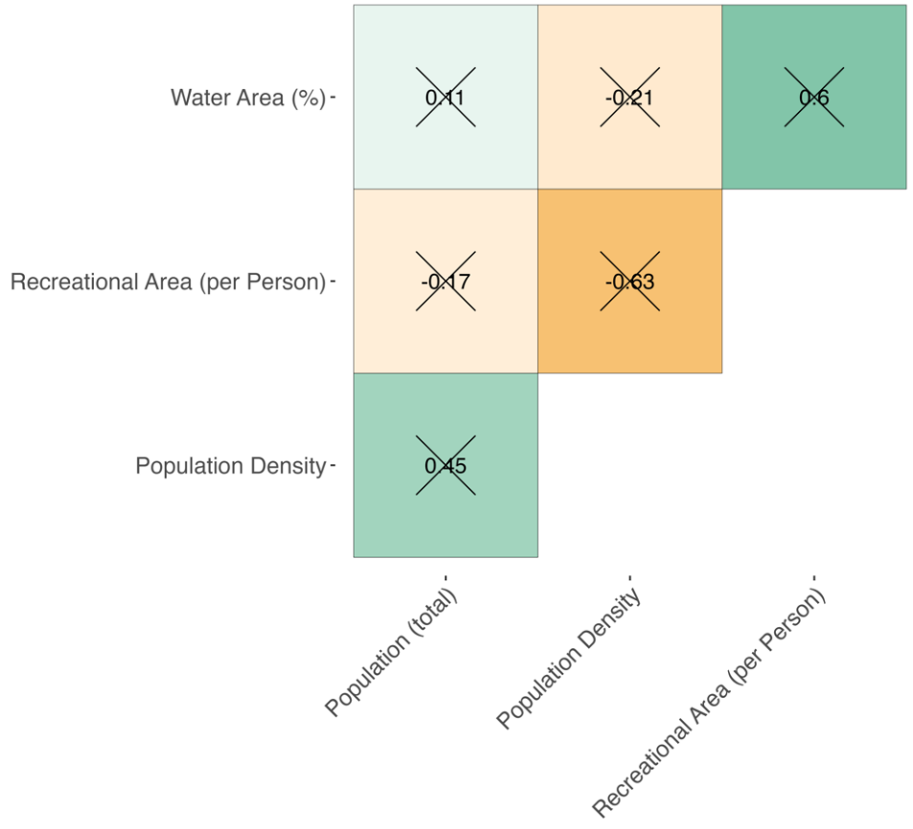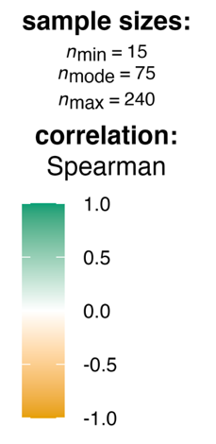
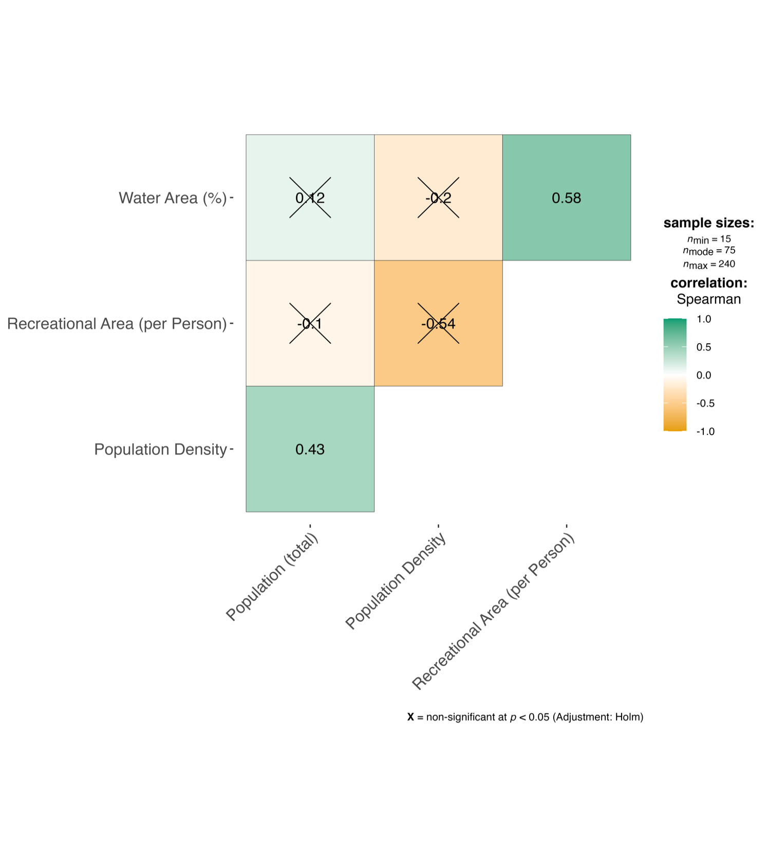
Figure A.4. Correlogram of the means per city of the metavariables included in the final second-stage meta-regression models.
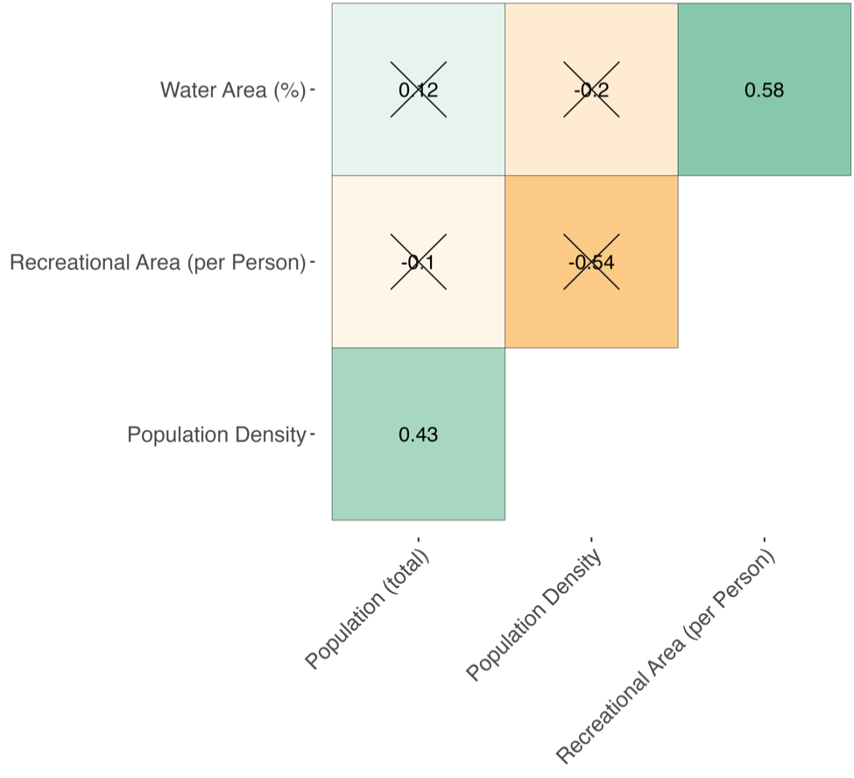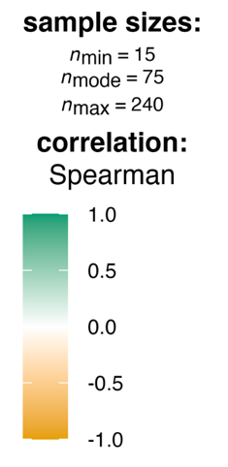
Limited validity of the correlogram, since normal distribution assumption is not given for all variables.
Figure A.5. Correlogram of the metavariables (with all given values from 1993 to 2020) included in the final second-stage meta-regression models.

Results E3. Descriptive statistics
Variables *, **, *** | Pre-HHWS period  (1993-2004) |  |  |  |  | Post-HHWS period  (2005-2020)
Variables *, **, *** | Non-eligible days  (n = 1,733) |  | Eligible days  (n = 103) |  |  | Non-eligible days  (n = 2,270) |  | Eligible days  (n = 178)
Number of days per year | 144.4 |  | 8.6 |  |  | 141.9 |  | 11.1
Daily number of all-cause deaths (IQR) | 94.4 | (85.0 – 104.0) | 112.0 | (93.5 – 120.5) |  | 87.3 | (80.0 – 94.0) | 100.3 | (89.2 – 109.0)
Mean temperature [°C (IQR)] | 16.6 | (14.1 – 19.4) | 25.0 | (24.1 – 26.5) |  | 17.4 | (14.8 – 20.0) | 25.3 | (24.0 – 26.6)
Maximum temperature [°C (IQR)] | 21.4 | (18.1 – 24.7) | 31.7 | (30.4 – 33.0) |  | 22.5 | (19.2 – 25.5) | 32.0 | (30.2 – 33.9)
Minimum temperature [°C (IQR)] | 12.2 | (9.9 – 14.4) | 18.4 | (17.4 – 19.6) |  | 12.5 | (10.0 – 14.8) | 18.6 | (17.3 – 19.7)
Relative humidity [% (IQR)] | 69.0 | (60.0 – 79.0) | 55.0 | (49.0 – 63.0) |  | 66.4 | (58.0 – 75.0) | 54.0 | (47.0 – 61.0)
Apparent temperature [°C (IQR)] | 22.2 | (18.0 – 26.6) | 35.5 | (34.1 – 37.5) |  | 23.6 | (19.3 – 27.6) | 36.1 | (34.2 – 38.5)
Table A.5. Descriptive statistics for Berlin pre- and post-heat health warning system (HHWS) period for eligible and non-eligible days.
Variables *, **, *** | Pre-HHWS period  (1993-2004) |  |  |  |  | Post-HHWS period  (2005-2020)
Variables *, **, *** | Non-eligible days  (n = 1,768) |  | Eligible days  (n = 68) |  |  | Non-eligible days  (n = 2,338) |  | Eligible days  (n = 110)
Number of days per year | 147.3 |  | 5.7 |  |  | 146.1 |  | 6.9
Daily number of all-cause deaths (IQR) | 16.4 | (13.0 – 19.0) | 18.1 | (15.0 – 21.0) |  | 17.8 | (15.0 – 21.0) | 20.1 | (17.0 – 23.0)
Mean temperature [°C (IQR)] | 15.2 | (13.0 – 17.8) | 24.5 | (23.1 – 25.2) |  | 15.9 | (13.6 – 18.3) | 24.0 | (22.4 – 25.7)
Maximum temperature [°C (IQR)] | 20.0 | (17.4 – 23.1) | 31.0 | (29.5 – 32.3) |  | 21.0 | (18.1 – 24.1) | 31.4 | (28.9 – 33.1)
Minimum temperature [°C (IQR)] | 10.5 | (8.0 – 12.8) | 17.3 | (16.4 – 18.2) |  | 10.6 | (8.0 – 13.0) | 16.6 | (14.9 – 18.1)
Relative humidity [% (IQR)] | 77.0 | (70.0 – 84.0) | 62.5 | (54.8 – 69.2) |  | 76.0 | (69.0 – 82.0) | 61.5 | (54.0 – 69.0)
Apparent temperature [°C (IQR)] | 21.2 | (17.5 – 25.4) | 36.0 | (33.8 – 37.7) |  | 22.5 | (18.4 – 26.6) | 36.2 | (33.6 – 38.7)
* Median values, followed by the interquartile range (IQR), are provided for each continuous variable except the daily number of all-cause deaths.
** For daily number of all-cause deaths, mean values are provided, followed by the interquartile range (IQR).
*** For number of days per year, mean values are provided.
Table A.6. Descriptive statistics for Bremen pre- and post-heat health warning system (HHWS) period for eligible and non-eligible days.
Variables *, **, *** | Pre-HHWS period  (1993-2004) |  |  |  |  | Post-HHWS period  (2005-2020)
Variables *, **, *** | Non-eligible days  (n = 1,746) |  | Eligible days  (n = 90) |  |  | Non-eligible days  (n = 2,319) |  | Eligible days  (n = 129)
Number of days per year | 145.5 |  | 7.5 |  |  | 144.9 |  | 8.1
Daily number of all-cause deaths (IQR) | 25.3 | (22.0 – 29.0) | 29.6 | (24.0 – 33.0) |  | 26.0 | (22.0 – 29.0) | 31.8 | (27.0 – 36.0)
Mean temperature [°C (IQR)] | 16.0 | (13.5 – 18.6) | 24.4 | (23.3 – 25.8) |  | 16.6 | (14.2 – 19.1) | 24.8 | (23.3 –26.1)
Maximum temperature [°C (IQR)] | 21.6 | (18.5 – 24.7) | 32.2 | (30.7 – 33.3) |  | 22.2 | (19.0 – 25.3) | 33.0 | (30.6 – 34.4)
Minimum temperature [°C (IQR)] | 11.0 | (8.7 – 13.3) | 16.4 | (15.6 – 17.9) |  | 11.0 | (8.1 – 13.4) | 16.9 | (15.5 – 18.3)
Relative humidity [% (IQR)] | 74.0 | (66.0 – 81.0) | 60.5 | (53.2 – 67.0) |  | 73.0 | (65.0 – 81.0) | 62.0 | (52.0 – 71.0)
Apparent temperature [°C (IQR)] | 23.0 | (18.8 – 27.4) | 37.4 | (35.5 – 39.5) |  | 23.8 | (19.6 – 28.1) | 38.6 | (36.1 – 41.1)
Table A.7. Descriptive statistics for Cologne pre- and post-heat health warning system (HHWS) period for eligible and non-eligible days.
Variables *, **, *** | Pre-HHWS period  (1993-2004) |  |  |  |  | Post-HHWS period  (2005-2020)
Variables *, **, *** | Non-eligible days  (n = 1,765) |  | Eligible days  (n = 71) |  |  | Non-eligible days  (n = 2,320) |  | Eligible days  (n = 128)
Number of days per year | 147.1 |  | 5.9 |  |  | 145.0 |  | 8.0
Daily number of all-cause deaths (IQR) | 17.2 | (14.0 – 20.0) | 20.2 | (16.0 – 23.0) |  | 17.5 | (15.0 – 20.0) | 21.2 | (17.0 – 24.0)
Mean temperature [°C (IQR)] | 15.9 | (13.5 – 18.6) | 24.1 | (23.2 – 25.2) |  | 16.2 | (13.8 – 18.6) | 24.2 | (22.5 – 25.5)
Maximum temperature [°C (IQR)] | 20.8 | (17.7 – 24.1) | 31.7 | (30.6 – 33.0) |  | 21.3 | (18.2 – 24.5) | 32.0 | (29.7 – 33.4)
Minimum temperature [°C (IQR)] | 11.4 | (9.0 – 13.8) | 16.4 | (15.0 – 17.5) |  | 11.0 | (8.3 – 13.4) | 16.6 | (14.9 – 18.0)
Relative humidity [% (IQR)] | 73.0 | (65.0 – 81.0) | 62.0 | (55.5 – 67.0) |  | 74.0 | (67.0 – 81.0) | 62.5 | (54.0 – 73.0)
Apparent temperature [°C (IQR)] | 21.9 | (17.7 – 26.4) | 37.3 | (35.4 – 39.2) |  | 22.6 | (18.6 – 27.0) | 37.4 | (35.2 – 39.5)
* Median values, followed by the interquartile range (IQR), are provided for each continuous variable except the daily number of all-cause deaths.
** For daily number of all-cause deaths, mean values are provided, followed by the interquartile range (IQR).
*** For number of days per year, mean values are provided.
Table A.8. Descriptive statistics for Dortmund pre- and post-heat health warning system (HHWS) period for eligible and non-eligible days.
Variables *, **, *** | Pre-HHWS period  (1993-2004) |  |  |  |  | Post-HHWS period  (2005-2020)
Variables *, **, *** | Non-eligible days  (n = 1,761) |  | Eligible days  (n = 75) |  |  | Non-eligible days  (n = 2,277) |  | Eligible days  (n = 171)
Number of days per year | 146.8 |  | 6.2 |  |  | 142.3 |  | 10.7
Daily number of all-cause deaths (IQR) | 13.7 | (11.0 – 16.0) | 15.9 | (12.5 – 19.0) |  | 14.8 | (12.0 – 17.0) | 16.9 | (14.0 – 20.0)
Mean temperature [°C (IQR)] | 16.2 | (13.4 – 19.2) | 24.8 | (23.7 – 26.3) |  | 16.7 | (13.9 – 19.4) | 24.5 | (23.0 – 26.3)
Maximum temperature [°C (IQR)] | 20.9 | (17.3 – 24.5) | 31.6 | (30.3 – 32.8) |  | 21.6 | (18.0 – 24.8) | 31.1 | (29.1 – 33.2)
Minimum temperature [°C (IQR)] | 11.8 | (9.3 – 14.1) | 18.4 | (17.1 – 19.4) |  | 11.9 | (9.4 – 14.3) | 17.9 | (16.6 – 19.0)
Relative humidity [% (IQR)] | 71.0 | (62.0 – 80.0) | 57.0 | (48.5 – 62.5) |  | 69.8 | (61.0 – 78.0) | 57.7 | (49.8 – 66.5)
Apparent temperature [°C (IQR)] | 21.6 | (17.2 – 26.3) | 36.2 | (34.3 – 37.5) |  | 22.6 | (18.1 – 27.1) | 35.4 | (33.5 – 37.8)
Table A.9. Descriptive statistics for Dresden pre- and post-heat health warning system (HHWS) period for eligible and non-eligible days.
Variables *, **, *** | Pre-HHWS period  (1993-2004) |  |  |  |  | Post-HHWS period  (2005-2020)
Variables *, **, *** | Non-eligible days  (n = 1,765) |  | Eligible days  (n = 71) |  |  | Non-eligible days  (n = 2,319) |  | Eligible days  (n = 129)
Number of days per year | 147.1 |  | 5.9 |  |  | 144.9 |  | 8.1
Daily number of all-cause deaths (IQR) | 15.6 | (13.0 – 18.0) | 18.7 | (16.0 – 21.0) |  | 15.4 | (13.0 – 18.0) | 20.2 | (17.0 – 24.0)
Mean temperature [°C (IQR)] | 15.9 | (13.5 – 18.6) | 24.1 | (23.2 – 25.2) |  | 16.2 | (13.8 – 18.6) | 24.3 | (22.5 – 25.5)
Maximum temperature [°C (IQR)] | 20.8 | (17.7 – 24.1) | 31.7 | (30.6 – 33.0) |  | 21.3 | (18.2 – 24.5) | 31.9 | (29.7 – 33.4)
Minimum temperature [°C (IQR)] | 11.4 | (9.0 – 13.8) | 16.4 | (15.0 – 17.5) |  | 11.0 | (8.3 – 13.4) | 16.6 | (14.9 – 18.1)
Relative humidity [% (IQR)] | 73.0 | (65 – 81.0) | 62.0 | (55.5 – 67.0) |  | 74.0 | (67.0 – 81.0) | 62.3 | (54.0 – 73.0)
Apparent temperature [°C (IQR)] | 21.9 | (17.7 – 26.4) | 37.3 | (35.4 – 39.2) |  | 22.6 | (18.5 – 27.0) | 37.3 | (34.9 –39.5)
* Median values, followed by the interquartile range (IQR), are provided for each continuous variable except the daily number of all-cause deaths.
** For daily number of all-cause deaths, mean values are provided, followed by the interquartile range (IQR).
*** For number of days per year, mean values are provided.
Table A.10. Descriptive statistics for Duisburg pre- and post-heat health warning system (HHWS) period for eligible and non-eligible days.

Variables *, **, *** | Pre-HHWS period  (1993-2004) |  |  |  |  | Post-HHWS period  (2005-2020)
Variables *, **, *** | Non-eligible days  (n = 1,735) |  | Eligible days  (n = 101) |  |  | Non-eligible days  (n = 2,317) |  | Eligible days  (n = 131)
Number of days per year | 144.6 |  | 8.4 |  |  | 144.8 |  | 8.2
Daily number of all-cause deaths (IQR) | 18.4 | (16.0 – 21.0) | 21.8 | (18.0 – 25.0) |  | 17.2 | (14.0 – 20.0) | 20.6 | (17.0 – 23.0)
Mean temperature [°C (IQR)] | 16.1 | (13.8 – 18.8) | 24.7 | (23.8 – 26.1) |  | 16.8 | (14.4 – 19.2) | 25.2 | (23.5 – 26.6)
Maximum temperature [°C (IQR)] | 21.2 | (18.4 – 24.4) | 32.0 | (30.5 – 33.2) |  | 21.8 | (18.8 – 24.8) | 32.5 | (30.0 – 34.0)
Minimum temperature [°C (IQR)] | 11.7 | (9.3 – 13.9) | 17.2 | (16.1 – 18.8) |  | 11.6 | (9.0 – 14.0) | 18.0 | (16.1 – 19.4)
Relative humidity [% (IQR)] | 73.0 | (65.0 – 81.0) | 58.0 | (52.0 – 63.0) |  | 72.0 | (64.0 – 79.0) | 59.6 | (50.0 – 69.0)
Apparent temperature [°C (IQR)] | 22.6 | (18.8 – 26.6) | 36.2 | (34.6 – 38.4) |  | 23.2 | (19.3 – 27.2) | 37.0 | (34.9 – 39.9)
Table A.11. Descriptive statistics for Dusseldorf pre- and post-heat health warning system (HHWS) period for eligible and non-eligible days.
Variables *, **, *** | Pre-HHWS period  (1993-2004) |  |  |  |  | Post-HHWS period  (2005-2020)
Variables *, **, *** | Non-eligible days  (n = 1,740) |  | Eligible days  (n = 71) |  |  | Non-eligible days  (n = 2,319) |  | Eligible days  (n = 129)
Number of days per year | 145.0 |  | 5.9 |  |  | 144.9 |  | 8.1
Daily number of all-cause deaths (IQR) | 21.4 | (18.0 – 25.0) | 25.4 | (22.0 – 29.0) |  | 21.1 | (18.0 – 24.0) | 25.4 | (21.0 – 29.0)
Mean temperature [°C (IQR)] | 15.7 | (13.2 – 18.5) | 25.4 | (24.0 – 26.2) |  | 16.2 | (13.9 – 18.8) | 24.8 | (23.1 – 26.3)
Maximum temperature [°C (IQR)] | 20.0 | (17.1 – 23.2) | 31.3 | (30.2 – 32.4) |  | 20.6 | (17.7 – 23.8) | 31.1 | (29.1 – 32.8)
Minimum temperature [°C (IQR)] | 11.8 | (9.6 – 14.2) | 18.8 | (17.9 – 20.0) |  | 12.2 | (9.8 – 14.4) | 18.8 | (17.3 – 19.6)
Relative humidity [% (IQR)] | 74.0 | (65.0 – 83.0) | 56.0 | (49.5 – 62.5) |  | 73.0 | (64.0 – 82.0) | 58.6 | (48.0 – 70.0)
Apparent temperature [°C (IQR)] | 20.9 | (17.1 – 24.9) | 35.3 | (33.8 – 37.7) |  | 21.6 | (17.9 – 25.6) | 35.4 | (33.2 – 37.6)
* Median values, followed by the interquartile range (IQR), are provided for each continuous variable except the daily number of all-cause deaths.
** For daily number of all-cause deaths, mean values are provided, followed by the interquartile range (IQR).
*** For number of days per year, mean values are provided.
Table A.12. Descriptive statistics for Essen pre- and post-heat health warning system (HHWS) period for eligible and non-eligible days.

Variables *, **, *** | Pre-HHWS period  (1993-2004) |  |  |  |  | Post-HHWS period  (2005-2020)
Variables *, **, *** | Non-eligible days  (n = 1,691) |  | Eligible days  (n = 145) |  |  | Non-eligible days  (n = 2,259) |  | Eligible days  (n = 189)
Number of days per year | 140.9 |  | 12.1 |  |  | 141.2 |  | 11.8
Daily number of all-cause deaths (IQR) | 19.0 | (16.0 – 22.0) | 22.8 | (18.0 – 26.0) |  | 18.4 | (15.0 – 21.0) | 20.6 | (17.0 – 24.0)
Mean temperature [°C (IQR)] | 17.1 | (14.6 – 19.8) | 24.9 | (23.7 – 26.1) |  | 17.6 | (15.0 – 20.2) | 25.4 | (23.9 – 26.6)
Maximum temperature [°C (IQR)] | 22.3 | (19.1 – 25.6) | 31.7 | (30.3 – 33.6) |  | 23.1 | (19.8 – 26.2) | 32.8 | (30.9 – 34.8)
Minimum temperature [°C (IQR)] | 12.1 | (9.7 – 14.4) | 17.8 | (16.4 – 18.8) |  | 12.3 | (9.6 – 14.6) | 18.2 | (16.8 – 19.6)
Relative humidity [% (IQR)] | 68.0 | (60.0 – 78.0) | 57.0 | (49.0 – 66.0) |  | 67.0 | (59.0 – 76.0) | 57.0 | (51.0 – 65.1)
Apparent temperature [°C (IQR)] | 23.6 | (19.3 – 28.0) | 36.3 | (34.5 – 39.1) |  | 24.5 | (20.1 – 28.9) | 38.2 | (35.7 – 40.4)
Table A.13. Descriptive statistics for Frankfurt pre- and post-heat health warning system (HHWS) period for eligible and non-eligible days.
Variables *, **, *** | Pre-HHWS period  (1993-2004) |  |  |  |  | Post-HHWS period  (2005-2020)
Variables *, **, *** | Non-eligible days  (n = 1,776) |  | Eligible days  (n = 60) |  |  | Non-eligible days  (n = 2,344) |  | Eligible days  (n = 104)
Number of days per year | 148.0 |  | 5.0 |  |  | 146.5 |  | 6.5
Daily number of all-cause deaths (IQR) | 51.1 | (45.0 – 57.0) | 58.6 | (50.0 – 66.0) |  | 49.0 | (44.0 – 54.0) | 53.7 | (47.0 – 61.0)
Mean temperature [°C (IQR)] | 15.3 | (13.0 – 17.8) | 24.4 | (23.6 – 25.6) |  | 15.9 | (13.5 – 18.1) | 23.4 | (22.5 – 25.1)
Maximum temperature [°C (IQR)] | 19.7 | (17.0 – 22.9) | 31.1 | (30.1 – 32.8) |  | 20.5 | (17.7 – 23.5) | 30.6 | (29.0 – 32.7)
Minimum temperature [°C (IQR)] | 11.0 | (8.7 – 13.1) | 18.0 | (16.6 – 18.7) |  | 11.1 | (8.6 – 13.2) | 16.7 | (15.2 – 18.2)
Relative humidity [% (IQR)] | 76.0 | (68.0 – 82.0) | 60.5 | (51.8 – 66.2) |  | 76.0 | (68.0 – 82.0) | 62.4 | (56.0 – 71.0)
Apparent temperature [°C (IQR)] | 20.5 | (16.9 – 25.0) | 35.8 | (34.2 – 37.8) |  | 21.8 | (17.8 – 25.8) | 35.9 | (33.2 – 38.4)
* Median values, followed by the interquartile range (IQR), are provided for each continuous variable except the daily number of all-cause deaths.
** For daily number of all-cause deaths, mean values are provided, followed by the interquartile range (IQR).
*** For number of days per year, mean values are provided.
Table A.14. Descriptive statistics for Hamburg pre- and post-heat health warning system (HHWS) period for eligible and non-eligible days.

Variables *, **, *** | Pre-HHWS period  (1993-2004) |  |  |  |  | Post-HHWS period  (2005-2020)
Variables *, **, *** | Non-eligible days  (n = 1,773) |  | Eligible days  (n = 63) |  |  | Non-eligible days  (n = 2,326) |  | Eligible days  (n = 122)
Number of days per year | 147.8 |  | 5.2 |  |  | 145.4 |  | 7.6
Daily number of all-cause deaths (IQR) | 31.3 | (27.0 – 35.0) | 35.7 | (32.0 – 39.5) |  | 31.6 | (28.0 – 35.0) | 36.4 | (32.0 – 41.0)
Mean temperature [°C (IQR)] | 15.6 | (13.2 – 18.2) | 24.3 | (23.6 – 25.5) |  | 16.3 | (13.8 – 18.7) | 24.4 | (22.8 – 26.0)
Maximum temperature [°C (IQR)] | 20.4 | (17.3 – 23.7) | 31.4 | (30.2 – 32.8) |  | 21.2 | (18.1 – 24.3) | 31.4 | (29.6 – 33.3)
Minimum temperature [°C (IQR)] | 11.1 | (8.6 – 13.4) | 17.2 | (16.0 – 18.2) |  | 11.1 | (8.6 – 13.4) | 16.9 | (15.5 – 18.3)
Relative humidity [% (IQR)] | 74.0 | (67.0 – 81.0) | 60.0 | (53.0 – 66.0) |  | 73.0 | (66.0 – 81.0) | 60.0 | (52.2 – 69.0)
Apparent temperature [°C (IQR)] | 21.4 | (17.4 – 25.8) | 36.3 | (34.7 – 37.7) |  | 22.6 | (18.5 – 26.7) | 36.6 | (34.6 – 38.8)
Table A.15. Descriptive statistics for Hannover pre- and post-heat health warning system (HHWS) period for eligible and non-eligible days.
Variables *, **, *** | Pre-HHWS period  (1993-2004) |  |  |  |  | Post-HHWS period  (2005-2020)
Variables *, **, *** | Non-eligible days  (n = 1,722) |  | Eligible days  (n = 102) |  |  | Non-eligible days  (n = 2,271) |  | Eligible days  (n = 177)
Number of days per year | 143.5 |  | 8.5 |  |  | 141.9 |  | 11.1
Daily number of all-cause deaths (IQR) | 16.3 | (13.0 – 19.0) | 18.9 | (16.0 – 23.0) |  | 18.4 | (15.0 – 21.0) | 21.8 | (18.0 – 25.0)
Mean temperature [°C (IQR)] | 16.7 | (13.8 – 19.4) | 24.6 | (23.6 – 25.9) |  | 16.8 | (14.1 – 19.4) | 24.2 | (22.7 – 25.6)
Maximum temperature [°C (IQR)] | 21.5 | (18.1 – 25.0) | 31.8 | (30.2 – 33.4) |  | 22.3 | (18.8 – 25.4) | 31.8 | (29.8 – 33.5)
Minimum temperature [°C (IQR)] | 12.3 | (10.1 – 14.4) | 18.3 | (17.5 – 19.4) |  | 11.3 | (8.7 – 13.6) | 16.7 | (15.3 – 18.0)
Relative humidity [% (IQR)] | 70.0 | (62.0 – 79.0) | 59.5 | (53.0 – 66.0) |  | 69.0 | (62.0 – 77.0) | 61.0 | (54.0 – 69.0)
Apparent temperature [°C (IQR)] | 22.5 | (18.1 – 27.1) | 36.4 | (34.6 – 38.5) |  | 23.5 | (19.1 – 28.1) | 37.0 | (34.6 – 39.0)
* Median values, followed by the interquartile range (IQR), are provided for each continuous variable except the daily number of all-cause deaths.
** For daily number of all-cause deaths, mean values are provided, followed by the interquartile range (IQR).
*** For number of days per year, mean values are provided.
Table A.16. Descriptive statistics for Leipzig pre- and post-heat health warning system (HHWS) period for eligible and non-eligible days.

Variables *, **, *** | Pre-HHWS period  (1993-2004) |  |  |  |  | Post-HHWS period  (2005-2020)
Variables *, **, *** | Non-eligible days  (n = 1,747) |  | Eligible days  (n = 89) |  |  | Non-eligible days  (n = 2,264) |  | Eligible days  (n = 184)
Number of days per year | 145.6 |  | 7.4 |  |  | 141.5 |  | 11.5
Daily number of all-cause deaths (IQR) | 32.1 | (28.0 – 36.0) | 35.5 | (31.0 – 39.0) |  | 33.1 | (29.0 – 37.0) | 36.0 | (31.0 – 40.2)
Mean temperature [°C (IQR)] | 16.7 | (13.7 – 19.7) | 24.9 | (24.0 – 26.6) |  | 16.8 | (14.0 – 19.7) | 24.5 | (23.4 – 26.0)
Maximum temperature [°C (IQR)] | 21.6 | (17.9 – 25.4) | 31.7 | (30.2 – 33.5) |  | 22.2 | (18.4 – 25.8) | 31.9 | (30.0 – 33.5)
Minimum temperature [°C (IQR)] | 12.2 | (9.8 – 14.6) | 18.4 | (17.3 – 19.4) |  | 12.2 | (9.7 – 14.4) | 17.9 | (16.4 – 18.9)
Relative humidity [% (IQR)] | 69.0 | (60.0 – 79.0) | 54.0 | (47.0 – 62.0) |  | 70.0 | (62.0 – 78.0) | 58.0 | (51.0 – 64.0)
Apparent temperature [°C (IQR)] | 22.5 | (17.8 – 27.6) | 36.0 | (34.3 – 37.5) |  | 23.3 | (18.5 – 28.5) | 36.6 | (34.1 – 38.6)
Table A.17. Descriptive statistics for Munich pre- and post-heat health warning system (HHWS) period for eligible and non-eligible days.
Variables *, **, *** | Pre-HHWS period  (1993-2004) |  |  |  |  | Post-HHWS period  (2005-2020)
Variables *, **, *** | Non-eligible days  (n = 1,741) |  | Eligible days  (n = 95) |  |  | Non-eligible days  (n = 2,253) |  | Eligible days  (n = 195)
Number of days per year | 145.1 |  | 7.9 |  |  | 140.8 |  | 12.2
Daily number of all-cause deaths (IQR) | 15.3 | (12.0 – 18.0) | 18.3 | (14.0 – 21.5) |  | 15.9 | (13.0 – 19.0) | 17.8 | (15.0 – 21.0)
Mean temperature [°C (IQR)] | 16.2 | (13.4 – 19.0) | 24.6 | (23.4 – 26.0) |  | 16.5 | (13.8 – 19.2) | 24.3 | (22.5 – 25.6)
Maximum temperature [°C (IQR)] | 21.7 | (18.1 – 25.4) | 31.9 | (30.5 – 33.8) |  | 22.3 | (18.6 – 25.7) | 32.0 | (29.6 – 34.0)
Minimum temperature [°C (IQR)] | 10.7 | (8.3 – 13.1) | 16.5 | (15.4 – 18.1) |  | 10.7 | (8.0 – 13.0) | 16.4 | (14.9 – 17.4)
Relative humidity [% (IQR)] | 71.0 | (61.0 – 79.0) | 57.0 | (51.0 – 64.5) |  | 71.0 | (63.0 – 79.0) | 59.0 | (52.9 – 68.0)
Apparent temperature [°C (IQR)] | 22.7 | (18.1 – 27.7) | 36.5 | (35.2 – 39.0) |  | 23.6 | (18.9 – 28.6) | 37.4 | (34.3 – 40.0)
* Median values, followed by the interquartile range (IQR), are provided for each continuous variable except the daily number of all-cause deaths.
** For daily number of all-cause deaths, mean values are provided, followed by the interquartile range (IQR).
*** For number of days per year, mean values are provided.
Table A.18. Descriptive statistics for Nuremberg pre- and post-heat health warning system (HHWS) period for eligible and non-eligible days.

Variables *, **, *** | Pre-HHWS period  (1993-2004) |  |  |  |  | Post-HHWS period  (2005-2020)
Variables *, **, *** | Non-eligible days  (n = 1,689) |  | Eligible days  (n = 135) |  |  | Non-eligible days  (n = 2,228) |  | Eligible days  (n = 220)
Number of days per year | 140.8 |  | 11.2 |  |  | 139.2 |  | 13.8
Daily number of all-cause deaths (IQR) | 15.1 | (12.0 – 18.0) | 17.7 | (14.0 – 20.0) |  | 15.3 | (13.0 – 18.0) | 17.7 | (14.0 – 20.2)
Mean temperature [°C (IQR)] | 16.9 | (14.1 – 19.7) | 24.5 | (23.6 – 25.9) |  | 17.2 | (14.6 – 19.8) | 24.7 | (23.4 – 26.2)
Maximum temperature [°C (IQR)] | 21.8 | (18.2 – 25.1) | 31.0 | (29.6 – 32.8) |  | 22.2 | (19.0 – 25.5) | 31.7 | (29.4 – 33.8)
Minimum temperature [°C (IQR)] | 12.4 | (9.9 – 14.5) | 18.1 | (17.1 – 19.0) |  | 12.6 | (10.2 – 14.7) | 18.3 | (17.0 – 19.3)
Relative humidity [% (IQR)] | 69.0 | (60.0 – 78.0) | 59.0 | (51.0 – 65.0) |  | 69.0 | (60.3 – 77.0) | 58.0 | (51.0 – 66.1)
Apparent temperature [°C (IQR)] | 22.8 | (18.3 – 27.5) | 35.4 | (33.8 – 37.9) |  | 23.4 | (19.0 – 28.0) | 36.4 | (34.2 – 38.7)
* Median values, followed by the interquartile range (IQR), are provided for each continuous variable except the daily number of all-cause deaths.
** For daily number of all-cause deaths, mean values are provided, followed by the interquartile range (IQR).
*** For number of days per year, mean values are provided.
Table A.19. Descriptive statistics for Stuttgart pre- and post-heat health warning system (HHWS) period for eligible and non-eligible days.

Results E4. Main analyses
Name (of the population) |  | RR | 95% CI* |  |  |  |  | p-Value
Berlin |  | 0.95 | [ | 0.91 | , | 0.99 | ] | < 0.01
Bremen** |  | 1.04 | [ | 0.96 | , | 1.13 | ] | 0.37
Cologne |  | 1.02 | [ | 0.96 | , | 1.09 | ] | 0.45
Dortmund |  | 1.02 | [ | 0.93 | , | 1.10 | ] | 0.62
Dresden |  | 0.97 | [ | 0.90 | , | 1.05 | ] | 0.42
Duisburg** |  | 1.09 | [ | 1.01 | , | 1.18 | ] | < 0.05
Dusseldorf |  | 1.00 | [ | 0.94 | , | 1.07 | ] | 0.92
Essen** |  | 1.01 | [ | 0.95 | , | 1.08 | ] | 0.73
Frankfurt am Main** |  | 0.94 | [ | 0.88 | , | 1.00 | ] | < 0.05
Hamburg |  | 0.95 | [ | 0.90 | , | 1.00 | ] | < 0.05
Hannover** |  | 1.01 | [ | 0.96 | , | 1.07 | ] | 0.66
Leipzig |  | 1.04 | [ | 0.97 | , | 1.12 | ] | 0.21
Munich** |  | 1.01 | [ | 0.96 | , | 1.05 | ] | 0.83
Nuremberg** |  | 0.96 | [ | 0.89 | , | 1.03 | ] | 0.19
Stuttgart |  | 0.97 | [ | 0.91 | , | 1.03 | ] | 0.30
Pooled all cities effect | (Intercept) | 0.85 | [ | 0.75 | , | 0.97 | ] | < 0.05
Pooled all cities effect | (Predicted) | 1.00 | [ | 0.98 | , | 1.01 | ]
Pooled selected cities effect** | (Intercept) | 0.90 | [ | 0.81 | , | 0.99 | ] | < 0.05
Pooled selected cities effect** | (Predicted) | 1.01 | [ | 0.98 | , | 1.03 | ]
* With 1,000 samples bootstrapped non-parametric 95% confidence intervals for the city-specific first-stage effects. Parametric 95% confidence intervals for pooled second-stage effects.
** DID parallel trend assumption appears to be fulfilled based on graphical assessment.
Table A.20. Main results of the first-stage difference-in-differences (DID) quasi-Poisson models for each German city and second-stage meta-regression models. Relative risks (RR) less than one suggest that the implementation of the heat health warning system (HHWS) reduced all-cause mortality during heat episodes. RR greater than or equal to one suggest no protective effect of the HHWS. In comparison to the city-specific RR, the pooled RR provide the effect among all cities and the cities fulfilling the DID parallel trend assumption (selected cities) of HHWS heat alerts on mortality. The predicted pooled RR is based on the average of the meta-variables across all or the selected cities. The pooled RR (intercept of the meta-regression) for all and selected cities is based on the city-specific meta-variables.

Results E5. Sensitivity analyses
Name (of the population) |  | RR | 95% CI* |  |  |  |  | p-Value
Berlin |  | 0.95 | [ | 0.91 | , | 0.99 | ] | < 0.01
Bremen** |  | 1.04 | [ | 0.97 | , | 1.13 | ] | 0.32
Cologne |  | 1.02 | [ | 0.97 | , | 1.09 | ] | 0.41
Dortmund |  | 1.02 | [ | 0.93 | , | 1.11 | ] | 0.62
Dresden |  | 0.97 | [ | 0.90 | , | 1.05 | ] | 0.50
Duisburg** |  | 1.09 | [ | 1.00 | , | 1.18 | ] | < 0.05
Dusseldorf |  | 1.01 | [ | 0.94 | , | 1.08 | ] | 0.86
Essen** |  | 1.00 | [ | 0.94 | , | 1.07 | ] | 0.95
Frankfurt am Main** |  | 0.95 | [ | 0.89 | , | 1.00 | ] | < 0.05
Hamburg |  | 0.95 | [ | 0.90 | , | 1.00 | ] | < 0.05
Hannover** |  | 1.01 | [ | 0.96 | , | 1.07 | ] | 0.72
Leipzig |  | 1.04 | [ | 0.97 | , | 1.12 | ] | 0.21
Munich** |  | 1.00 | [ | 0.96 | , | 1.05 | ] | 0.87
Nuremberg** |  | 0.95 | [ | 0.89 | , | 1.03 | ] | 0.16
Stuttgart |  | 0.96 | [ | 0.91 | , | 1.02 | ] | 0.18
Pooled all cities effect | (Intercept) | 0.85 | [ | 0.75 | , | 0.97 | ] | < 0.05
Pooled all cities effect | (Predicted) | 0.99 | [ | 0.98 | , | 1.01 | ]
Pooled selected cities effect** | (Intercept) | 0.89 | [ | 0.81 | , | 0.98 | ] | < 0.05
Pooled selected cities effect** | (Predicted) | 1.00 | [ | 0.98 | , | 1.03 | ]
* With 1,000 samples bootstrapped non-parametric 95% confidence intervals for the city-specific first-stage effects. Parametric 95% confidence intervals for pooled second-stage effects.
** DID parallel trend assumption appears to be fulfilled based on graphical assessment.
Table A.21. Results of the first-stage difference-in-differences (DID) quasi-Poisson models for each German city and second-stage meta-regression models (based on random forest classification of eligible and non-eligible days). Relative risks (RR) less than one suggest that the implementation of the heat health warning system (HHWS) reduced all-cause mortality during heat episodes. RR greater than or equal to one suggest no protective effect of the HHWS. In comparison to the city-specific RR, the pooled RR provide the effect among all cities and the cities fulfilling the DID parallel trend assumption (selected cities) of HHWS heat alerts on mortality. The predicted pooled RR is based on the average of the meta-variables across all or the selected cities. The pooled RR (intercept of the meta-regression) for all and selected cities is based on the city-specific meta-variables.

Name (of the population) |  | RR | 95% CI* |  |  |  |  | p-Value
Berlin |  | 0.96 | [ | 0.92 | , | 0.99 | ] | < 0.01
Bremen** |  | 1.02 | [ | 0.94 | , | 1.10 | ] | 0.65
Cologne |  | 1.02 | [ | 0.95 | , | 1.09 | ] | 0.55
Dortmund |  | 1.02 | [ | 0.94 | , | 1.11 | ] | 0.57
Dresden |  | 0.97 | [ | 0.90 | , | 1.06 | ] | 0.41
Duisburg** |  | 1.09 | [ | 1.00 | , | 1.19 | ] | < 0.05
Dusseldorf |  | 0.99 | [ | 0.92 | , | 1.07 | ] | 0.83
Essen** |  | 1.00 | [ | 0.94 | , | 1.08 | ] | 0.91
Frankfurt am Main** |  | 0.94 | [ | 0.89 | , | 1.00 | ] | < 0.05
Hamburg |  | 0.95 | [ | 0.90 | , | 1.01 | ] | 0.07
Hannover** |  | 1.00 | [ | 0.95 | , | 1.07 | ] | 0.89
Leipzig |  | 1.05 | [ | 0.98 | , | 1.13 | ] | 0.13
Munich** |  | 0.99 | [ | 0.95 | , | 1.04 | ] | 0.83
Nuremberg** |  | 0.98 | [ | 0.91 | , | 1.06 | ] | 0.53
Stuttgart |  | 0.97 | [ | 0.91 | , | 1.04 | ] | 0.39
Pooled all cities effect | (Intercept) | 0.87 | [ | 0.77 | , | 0.99 | ] | < 0.05
Pooled all cities effect | (Predicted) | 0.99 | [ | 0.98 | , | 1.01 | ]
Pooled selected cities effect** | (Intercept) | 0.92 | [ | 0.83 | , | 1.02 | ] | 0.10
Pooled selected cities effect** | (Predicted) | 1.00 | [ | 0.98 | , | 1.03 | ]
* With 1,000 samples bootstrapped non-parametric 95% confidence intervals for the city-specific first-stage effects. Parametric 95% confidence intervals for pooled second-stage effects.
** DID parallel trend assumption appears to be fulfilled based on graphical assessment.
Table A.22. Results of the first-stage difference-in-differences (DID) quasi-Poisson models for each German city and second-stage meta-regression models (with restriction to non-eligible days above specific temperature and relative humidity thresholds). Relative risks (RR) less than one suggest that the implementation of the heat health warning system (HHWS) reduced all-cause mortality during heat episodes. RR greater than or equal to one suggest no protective effect of the HHWS. In comparison to the city-specific RR, the pooled RR provide the effect among all cities and the cities fulfilling the DID parallel trend assumption (selected cities) of HHWS heat alerts on mortality. The predicted pooled RR is based on the average of the meta-variables across all or the selected cities. The pooled RR (intercept of the meta-regression) for all and selected cities is based on the city-specific meta-variables.

Name (of the population) |  | RR | 95% CI* |  |  |  |  | p-Value
Berlin |  | 1.03 | [ | 0.97 | , | 1.10 | ] | 0.31
Bremen** |  | 1.10 | [ | 0.92 | , | 1.32 | ] | 0.19
Cologne |  | 0.96 | [ | 0.83 | , | 1.10 | ] | 0.51
Dortmund |  | 1.02 | [ | 0.85 | , | 1.21 | ] | 0.77
Dresden |  | 1.09 | [ | 0.94 | , | 1.27 | ] | 0.25
Duisburg** |  | 1.14 | [ | 0.96 | , | 1.38 | ] | 0.08
Dusseldorf |  | 0.99 | [ | 0.87 | , | 1.15 | ] | 0.91
Essen** |  | 1.18 | [ | 1.03 | , | 1.36 | ] | < 0.05
Frankfurt am Main** |  | 0.85 | [ | 0.74 | , | 0.97 | ] | < 0.05
Hamburg |  | 1.06 | [ | 0.97 | , | 1.16 | ] | 0.16
Hannover** |  | 0.96 | [ | 0.87 | , | 1.08 | ] | 0.51
Leipzig |  | 1.14 | [ | 0.98 | , | 1.32 | ] | 0.06
Munich** |  | 1.00 | [ | 0.92 | , | 1.08 | ] | 0.94
Nuremberg** |  | 0.92 | [ | 0.81 | , | 1.05 | ] | 0.21
Stuttgart |  | 0.87 | [ | 0.77 | , | 0.99 | ] | < 0.05
Pooled all cities effect | (Intercept) | 0.72 | [ | 0.55 | , | 0.93 | ] | < 0.05
Pooled all cities effect | (Predicted) | 1.01 | [ | 0.97 | , | 1.04 | ]
Pooled selected cities effect** | (Intercept) | 0.90 | [ | 0.70 | , | 1.17 | ] | 0.44
Pooled selected cities effect** | (Predicted) | 1,02 | [ | 0.95 | , | 1.09 | ]
* With 1,000 samples bootstrapped non-parametric 95% confidence intervals for the city-specific first-stage effects. Parametric 95% confidence intervals for pooled second-stage effects.
** DID parallel trend assumption appears to be fulfilled based on graphical assessment.
Table A.23. Results of the first-stage difference-in-differences (DID) quasi-Poisson models for each German city and second-stage meta-regression models (for the period 2002 to 2007). Relative risks (RR) less than one suggest that the implementation of the heat health warning system (HHWS) reduced all-cause mortality during heat episodes. RR greater than or equal to one suggest no protective effect of the HHWS. In comparison to the city-specific RR, the pooled RR provide the effect among all cities and the cities fulfilling the DID parallel trend assumption (selected cities) of HHWS heat alerts on mortality. The predicted pooled RR is based on the average of the meta-variables across all or the selected cities. The pooled RR (intercept of the meta-regression) for all and selected cities is based on the city-specific meta-variables.

Name (of the population) |  | RR | 95% CI* |  |  |  |  | p-Value
Berlin |  | 1.00 | [ | 0.95 | , | 1.06 | ] | 0.97
Bremen** |  | 1.02 | [ | 0.90 | , | 1.18 | ] | 0.71
Cologne |  | 0.95 | [ | 0.86 | , | 1.06 | ] | 0.30
Dortmund |  | 1.02 | [ | 0.89 | , | 1.18 | ] | 0.77
Dresden |  | 1.04 | [ | 0.91 | , | 1.19 | ] | 0.58
Duisburg** |  | 1.10 | [ | 0.97 | , | 1.24 | ] | 0.11
Dusseldorf |  | 0.98 | [ | 0.88 | , | 1.09 | ] | 0.68
Essen** |  | 1.06 | [ | 0.95 | , | 1.19 | ] | 0.27
Frankfurt am Main** |  | 0.91 | [ | 0.82 | , | 1.02 | ] | 0.07
Hamburg |  | 0.99 | [ | 0.92 | , | 1.06 | ] | 0.75
Hannover** |  | 0.95 | [ | 0.87 | , | 1.04 | ] | 0.26
Leipzig |  | 1.12 | [ | 1.00 | , | 1.26 | ] | < 0.05
Munich** |  | 1.00 | [ | 0.93 | , | 1.08 | ] | 0.93
Nuremberg** |  | 0.91 | [ | 0.82 | , | 1.00 | ] | 0.06
Stuttgart |  | 0.90 | [ | 0.82 | , | 1.00 | ] | < 0.05
Pooled all cities effect | (Intercept) | 0.75 | [ | 0.61 | , | 0.92 | ] | < 0.01
Pooled all cities effect | (Predicted) | 0.99 | [ | 0.96 | , | 1.02 | ]
Pooled selected cities effect** | (Intercept) | 0.88 | [ | 0.75 | , | 1.02 | ] | 0.10
Pooled selected cities effect** | (Predicted) | 0.99 | [ | 0.95 | , | 1.03 | ]
* With 1,000 samples bootstrapped non-parametric 95% confidence intervals for the city-specific first-stage effects. Parametric 95% confidence intervals for pooled second-stage effects.
** DID parallel trend assumption appears to be fulfilled based on graphical assessment.
Table A.24. Results of the first-stage difference-in-differences (DID) quasi-Poisson models for each German city and second-stage meta-regression models (for the period 2000 to 2009). Relative risks (RR) less than one suggest that the implementation of the heat health warning system (HHWS) reduced all-cause mortality during heat episodes. RR greater than or equal to one suggest no protective effect of the HHWS. In comparison to the city-specific RR, the pooled RR provide the effect among all cities and the cities fulfilling the DID parallel trend assumption (selected cities) of HHWS heat alerts on mortality. The predicted pooled RR is based on the average of the meta-variables across all or the selected cities. The pooled RR (intercept of the meta-regression) for all and selected cities is based on the city-specific meta-variables.

Name (of the population) |  | RR | 95% CI* |  |  |  |  | p-Value
Berlin |  | 0.98 | [ | 0.95 | , | 1.02 | ] | 0.31
Bremen** |  | 1.02 | [ | 0.92 | , | 1.13 | ] | 0.65
Cologne |  | 0.99 | [ | 0.92 | , | 1.07 | ] | 0.86
Dortmund |  | 1.01 | [ | 0.93 | , | 1.11 | ] | 0.77
Dresden |  | 1.00 | [ | 0.91 | , | 1.10 | ] | 0.95
Duisburg** |  | 1.08 | [ | 0.97 | , | 1.19 | ] | 0.08
Dusseldorf |  | 1.01 | [ | 0.93 | , | 1.09 | ] | 0.89
Essen** |  | 1.01 | [ | 0.93 | , | 1.09 | ] | 0.89
Frankfurt am Main** |  | 0.89 | [ | 0.83 | , | 0.97 | ] | < 0.01
Hamburg |  | 0.96 | [ | 0.90 | , | 1.02 | ] | 0.16
Hannover** |  | 1.01 | [ | 0.94 | , | 1.09 | ] | 0.78
Leipzig |  | 1.04 | [ | 0.96 | , | 1.13 | ] | 0.30
Munich** |  | 1.02 | [ | 0.97 | , | 1.07 | ] | 0.51
Nuremberg** |  | 0.95 | [ | 0.87 | , | 1.03 | ] | 0.18
Stuttgart |  | 0.96 | [ | 0.89 | , | 1.03 | ] | 0.27
Pooled all cities effect | (Intercept) | 0.83 | [ | 0.72 | , | 0.97 | ] | < 0.05
Pooled all cities effect | (Predicted) | 0.99 | [ | 0.97 | , | 1.01 | ]
Pooled selected cities effect** | (Intercept) | 0.85 | [ | 0.76 | , | 0.96 | ] | < 0.01
Pooled selected cities effect** | (Predicted) | 1.00 | [ | 0.97 | , | 1.03 | ]
* With 1,000 samples bootstrapped non-parametric 95% confidence intervals for the city-specific first-stage effects. Parametric 95% confidence intervals for pooled second-stage effects.
** DID parallel trend assumption appears to be fulfilled based on graphical assessment.
Table A.25. Results of the first-stage difference-in-differences (DID) quasi-Poisson models for each German city and second-stage meta-regression models (for the period 1995 to 2014). Relative risks (RR) less than one suggest that the implementation of the heat health warning system (HHWS) reduced all-cause mortality during heat episodes. RR greater than or equal to one suggest no protective effect of the HHWS. In comparison to the city-specific RR, the pooled RR provide the effect among all cities and the cities fulfilling the DID parallel trend assumption (selected cities) of HHWS heat alerts on mortality. The predicted pooled RR is based on the average of the meta-variables across all or the selected cities. The pooled RR (intercept of the meta-regression) for all and selected cities is based on the city-specific meta-variables.

Name (of the population) |  | RR | 95% CI* |  |  |  |  | p-Value
Berlin |  | 0.97 | [ | 0.93 | , | 1.01 | ] | 0.07
Bremen** |  | 1.03 | [ | 0.93 | , | 1.14 | ] | 0.60
Cologne |  | 1.07 | [ | 1.00 | , | 1.15 | ] | 0.05
Dortmund |  | 1.02 | [ | 0.93 | , | 1.13 | ] | 0.62
Dresden |  | 0.94 | [ | 0.86 | , | 1.04 | ] | 0.22
Duisburg** |  | 1.08 | [ | 0.99 | , | 1.20 | ] | 0.11
Dusseldorf |  | 1.02 | [ | 0.94 | , | 1.11 | ] | 0.57
Essen** |  | 0.97 | [ | 0.89 | , | 1.06 | ] | 0.53
Frankfurt am Main** |  | 0.94 | [ | 0.87 | , | 1.01 | ] | 0.07
Hamburg |  | 0.94 | [ | 0.88 | , | 1.00 | ] | < 0.05
Hannover** |  | 1.00 | [ | 0.92 | , | 1.08 | ] | 0.97
Leipzig |  | 0.99 | [ | 0.91 | , | 1.08 | ] | 0.85
Munich** |  | 1.02 | [ | 0.96 | , | 1.08 | ] | 0.46
Nuremberg** |  | 0.96 | [ | 0.88 | , | 1.06 | ] | 0.40
Stuttgart |  | 0.99 | [ | 0.91 | , | 1.07 | ] | 0.85
Pooled all cities effect | (Intercept) | 0.86 | [ | 0.74 | , | 1.01 | ] | 0.07
Pooled all cities effect | (Predicted) | 1.00 | [ | 0.98 | , | 1.02 | ]
Pooled selected cities effect** | (Intercept) | 0.87 | [ | 0.77 | , | 0.99 | ] | < 0.05
Pooled selected cities effect** | (Predicted) | 1.00 | [ | 0.97 | , | 1.03 | ]
* With 1,000 samples bootstrapped non-parametric 95% confidence intervals for the city-specific first-stage effects. Parametric 95% confidence intervals for pooled second-stage effects.
** DID parallel trend assumption appears to be fulfilled based on graphical assessment.
Table A.26. Results of the first-stage difference-in-differences (DID) quasi-Poisson models for each German city and second-stage meta-regression models (with exclusion of the years 1994, 2003, 2006, 2015, 2018, 2019, with the highest amount of heat related deaths in the study period).Relative risks (RR) less than one suggest that the implementation of the heat health warning system (HHWS) reduced all-cause mortality during heat episodes. RR greater than or equal to one suggest no protective effect of the HHWS. In comparison to the city-specific RR, the pooled RR provide the effect among all cities and the cities fulfilling the DID parallel trend assumption (selected cities) of HHWS heat alerts on mortality. The predicted pooled RR is based on the average of the meta-variables across all or the selected cities. The pooled RR (intercept of the meta-regression) for all and selected cities is based on the city-specific meta-variables.
Name (of the population) |  | RR | 95% CI* |  |  |  |  | p-Value
Berlin |  | 0.99 | [ | 0.96 | , | 1.02 | ] | 0.38
Bremen** |  | 1.05 | [ | 0.97 | , | 1.15 | ] | 0.21
Cologne |  | 1.02 | [ | 0.94 | , | 1.10 | ] | 0.53
Dortmund |  | 1.00 | [ | 0.91 | , | 1.10 | ] | 0.97
Dresden |  | 0.99 | [ | 0.92 | , | 1.08 | ] | 0.89
Duisburg** |  | 1.10 | [ | 1.01 | , | 1.20 | ] | < 0.05
Dusseldorf |  | 1.00 | [ | 0.93 | , | 1.08 | ] | 0.95
Essen** |  | 1.01 | [ | 0.95 | , | 1.10 | ] | 0.70
Frankfurt am Main** |  | 0.93 | [ | 0.88 | , | 1.00 | ] | < 0.05
Hamburg |  | 0.97 | [ | 0.92 | , | 1.02 | ] | 0.24
Hannover** |  | 1.01 | [ | 0.95 | , | 1.08 | ] | 0.74
Leipzig |  | 1.03 | [ | 0.96 | , | 1.11 | ] | 0.33
Munich** |  | 1.02 | [ | 0.97 | , | 1.07 | ] | 0.54
Nuremberg** |  | 0.97 | [ | 0.90 | , | 1.05 | ] | 0.39
Stuttgart |  | 0.96 | [ | 0.90 | , | 1.03 | ] | 0.26
Pooled all cities effect | (Intercept) | 0.84 | [ | 0.74 | , | 0.97 | ] | < 0.05
Pooled all cities effect | (Predicted) | 1.00 | [ | 0.98 | , | 1.02 | ]
Pooled selected cities effect** | (Intercept) | 0.89 | [ | 0.80 | , | 0.99 | ] | < 0,05
Pooled selected cities effect** | (Predicted) | 1.01 | [ | 0.98 | , | 1.04 | ]
* With 1,000 samples bootstrapped non-parametric 95% confidence intervals for the city-specific first-stage effects. Parametric 95% confidence intervals for pooled second-stage effects.
** DID parallel trend assumption appears to be fulfilled based on graphical assessment.
Table A.27. Results of the first-stage difference-in-differences (DID) quasi-Poisson models for each German city and second-stage meta-regression models (with exclusion of the year 1994).Relative risks (RR) less than one suggest that the implementation of the heat health warning system (HHWS) reduced all-cause mortality during heat episodes. RR greater than or equal to one suggest no protective effect of the HHWS. In comparison to the city-specific RR, the pooled RR provide the effect among all cities and the cities fulfilling the DID parallel trend assumption (selected cities) of HHWS heat alerts on mortality. The predicted pooled RR is based on the average of the meta-variables across all or the selected cities. The pooled RR (intercept of the meta-regression) for all and selected cities is based on the city-specific meta-variables.
Name (of the population) |  | RR | 95% CI* |  |  |  |  | p-Value
Berlin |  | 0.95 | [ | 0.90 | , | 0.99 | ] | < 0.01
Bremen** |  | 1.04 | [ | 0.96 | , | 1.14 | ] | 0.34
Cologne |  | 1.08 | [ | 1.01 | , | 1.15 | ] | < 0.05
Dortmund |  | 1.06 | [ | 0.97 | , | 1.16 | ] | 0.13
Dresden |  | 0.94 | [ | 0.86 | , | 1.01 | ] | 0.11
Duisburg** |  | 1.10 | [ | 1.01 | , | 1.19 | ] | < 0.05
Dusseldorf |  | 1.04 | [ | 0.97 | , | 1.12 | ] | 0.24
Essen** |  | 1.02 | [ | 0.95 | , | 1.10 | ] | 0.54
Frankfurt am Main** |  | 0.98 | [ | 0.92 | , | 1.04 | ] | 0.44
Hamburg |  | 0.93 | [ | 0.88 | , | 0.99 | ] | < 0.01
Hannover** |  | 1.02 | [ | 0.96 | , | 1.09 | ] | 0.55
Leipzig |  | 1.02 | [ | 0.95 | , | 1.10 | ] | 0.58
Munich** |  | 1.00 | [ | 0.95 | , | 1.06 | ] | 0.91
Nuremberg** |  | 0.95 | [ | 0.87 | , | 1.03 | ] | 0.15
Stuttgart |  | 1.00 | [ | 0.93 | , | 1.08 | ] | 0.95
Pooled all cities effect | (Intercept) | 0.88 | [ | 0.77 | , | 1.01 | ] | 0.08
Pooled all cities effect | (Predicted) | 1.01 | [ | 0.99 | , | 1.02 | ]
Pooled selected cities effect** | (Intercept) | 0.92 | [ | 0.82 | , | 1.02 | ] | 0.12
Pooled selected cities effect** | (Predicted) | 1.01 | [ | 0.99 | , | 1.04 | ]
* With 1,000 samples bootstrapped non-parametric 95% confidence intervals for the city-specific first-stage effects. Parametric 95% confidence intervals for pooled second-stage effects.
** DID parallel trend assumption appears to be fulfilled based on graphical assessment.
Table A.28. Results of the first-stage difference-in-differences (DID) quasi-Poisson models for each German city and second-stage meta-regression models (with exclusion of the year 2003). Relative risks (RR) less than one suggest that the implementation of the heat health warning system (HHWS) reduced all-cause mortality during heat episodes. RR greater than or equal to one suggest no protective effect of the HHWS. In comparison to the city-specific RR, the pooled RR provide the effect among all cities and the cities fulfilling the DID parallel trend assumption (selected cities) of HHWS heat alerts on mortality. The predicted pooled RR is based on the average of the meta-variables across all or the selected cities. The pooled RR (intercept of the meta-regression) for all and selected cities is based on the city-specific meta-variables.
Name (of the population) |  | RR | 95% CI* |  |  |  |  | p-Value
Berlin |  | 0.95 | [ | 0.91 | , | 0.98 | ] | < 0.01
Bremen** |  | 1.03 | [ | 0.95 | , | 1.12 | ] | 0.51
Cologne |  | 1.02 | [ | 0.96 | , | 1.10 | ] | 0.45
Dortmund |  | 1.00 | [ | 0.92 | , | 1.09 | ] | 0.96
Dresden |  | 0.97 | [ | 0.89 | , | 1.04 | ] | 0.37
Duisburg** |  | 1.08 | [ | 0.99 | , | 1.17 | ] | 0.06
Dusseldorf |  | 0.99 | [ | 0.92 | , | 1.07 | ] | 0.75
Essen** |  | 0.99 | [ | 0.92 | , | 1.06 | ] | 0.74
Frankfurt am Main** |  | 0.94 | [ | 0.88 | , | 1.01 | ] | < 0.05
Hamburg |  | 0.94 | [ | 0.89 | , | 0.99 | ] | < 0.05
Hannover** |  | 1.00 | [ | 0.95 | , | 1.07 | ] | 0.87
Leipzig |  | 1.03 | [ | 0.96 | , | 1.10 | ] | 0.40
Munich** |  | 1.01 | [ | 0.96 | , | 1.06 | ] | 0.80
Nuremberg** |  | 0.96 | [ | 0.90 | , | 1.04 | ] | 0.29
Stuttgart |  | 0.97 | [ | 0.91 | , | 1.03 | ] | 0.30
Pooled all cities effect | (Intercept) | 0.86 | [ | 0.75 | , | 0.98 | ] | < 0.05
Pooled all cities effect | (Predicted) | 0.99 | [ | 0.97 | , | 1.01 | ]
Pooled selected cities effect** | (Intercept) | 0.89 | [ | 0.81 | , | 0.99 | ] | < 0.05
Pooled selected cities effect** | (Predicted) | 1.00 | [ | 0.97 | , | 1.03 | ]
* With 1,000 samples bootstrapped non-parametric 95% confidence intervals for the city-specific first-stage effects. Parametric 95% confidence intervals for pooled second-stage effects.
** DID parallel trend assumption appears to be fulfilled based on graphical assessment.
Table A.29. Results of the first-stage difference-in-differences (DID) quasi-Poisson models for each German city and second-stage meta-regression models (with exclusion of the year 2006). Relative risks (RR) less than one suggest that the implementation of the heat health warning system (HHWS) reduced all-cause mortality during heat episodes. RR greater than or equal to one suggest no protective effect of the HHWS. In comparison to the city-specific RR, the pooled RR provide the effect among all cities and the cities fulfilling the DID parallel trend assumption (selected cities) of HHWS heat alerts on mortality. The predicted pooled RR is based on the average of the meta-variables across all or the selected cities. The pooled RR (intercept of the meta-regression) for all and selected cities is based on the city-specific meta-variables.
Name (of the population) |  | RR | 95% CI* |  |  |  |  | p-Value
Berlin |  | 0.95 | [ | 0.92 | , | 0.99 | ] | < 0.01
Bremen** |  | 1.03 | [ | 0.95 | , | 1.11 | ] | 0.53
Cologne |  | 1.02 | [ | 0.95 | , | 1.09 | ] | 0.53
Dortmund |  | 1.02 | [ | 0.94 | , | 1.12 | ] | 0.59
Dresden |  | 0.97 | [ | 0.90 | , | 1.05 | ] | 0.40
Duisburg** |  | 1.09 | [ | 1.00 | , | 1.19 | ] | < 0.05
Dusseldorf |  | 0.99 | [ | 0.93 | , | 1.07 | ] | 0.85
Essen** |  | 1.01 | [ | 0.94 | , | 1.08 | ] | 0.87
Frankfurt am Main** |  | 0.93 | [ | 0.87 | , | 0.99 | ] | < 0.01
Hamburg |  | 0.95 | [ | 0.90 | , | 1.00 | ] | < 0.05
Hannover** |  | 1.01 | [ | 0.96 | , | 1.07 | ] | 0.66
Leipzig |  | 1.04 | [ | 0.97 | , | 1.12 | ] | 0.24
Munich** |  | 1.01 | [ | 0.96 | , | 1.06 | ] | 0.70
Nuremberg** |  | 0.96 | [ | 0.89 | , | 1.04 | ] | 0.31
Stuttgart |  | 0.96 | [ | 0.90 | , | 1.03 | ] | 0.24
Pooled all cities effect | (Intercept) | 0.85 | [ | 0.74 | , | 0.96 | ] | < 0.05
Pooled all cities effect | (Predicted) | 0.99 | [ | 0.98 | , | 1.01 | ]
Pooled selected cities effect** | (Intercept) | 0.89 | [ | 0.80 | , | 0.98 | ] | < 0.05
Pooled selected cities effect** | (Predicted) | 1.00 | [ | 0.98 | , | 1.03 | ]
* With 1,000 samples bootstrapped non-parametric 95% confidence intervals for the city-specific first-stage effects. Parametric 95% confidence intervals for pooled second-stage effects.
** DID parallel trend assumption appears to be fulfilled based on graphical assessment.
Table A.30. Results of the first-stage difference-in-differences (DID) quasi-Poisson models for each German city and second-stage meta-regression models (with exclusion of the year 2015). Relative risks (RR) less than one suggest that the implementation of the heat health warning system (HHWS) reduced all-cause mortality during heat episodes. RR greater than or equal to one suggest no protective effect of the HHWS. In comparison to the city-specific RR, the pooled RR provide the effect among all cities and the cities fulfilling the DID parallel trend assumption (selected cities) of HHWS heat alerts on mortality. The predicted pooled RR is based on the average of the meta-variables across all or the selected cities. The pooled RR (intercept of the meta-regression) for all and selected cities is based on the city-specific meta-variables.
Name (of the population) |  | RR | 95% CI* |  |  |  |  | p-Value
Berlin |  | 0.95 | [ | 0.91 | , | 0.99 | ] | < 0.01
Bremen** |  | 1.04 | [ | 0.96 | , | 1.13 | ] | 0.32
Cologne |  | 1.02 | [ | 0.96 | , | 1.09 | ] | 0.52
Dortmund |  | 1.02 | [ | 0.93 | , | 1.11 | ] | 0.63
Dresden |  | 0.96 | [ | 0.89 | , | 1.05 | ] | 0.37
Duisburg** |  | 1.09 | [ | 1.00 | , | 1.20 | ] | < 0.05
Dusseldorf |  | 1.01 | [ | 0.94 | , | 1.08 | ] | 0.78
Essen** |  | 1.00 | [ | 0.94 | , | 1.08 | ] | 0.89
Frankfurt am Main** |  | 0.94 | [ | 0.88 | , | 1.00 | ] | < 0.05
Hamburg |  | 0.95 | [ | 0.90 | , | 1.00 | ] | < 0.05
Hannover** |  | 1.01 | [ | 0.95 | , | 1.07 | ] | 0.86
Leipzig |  | 1.04 | [ | 0.97 | , | 1.12 | ] | 0.26
Munich** |  | 1.00 | [ | 0.96 | , | 1.05 | ] | 0.95
Nuremberg** |  | 0.95 | [ | 0.88 | , | 1.03 | ] | 0.15
Stuttgart |  | 0.97 | [ | 0.91 | , | 1.03 | ] | 0.37
Pooled all cities effect | (Intercept) | 0.85 | [ | 0.75 | , | 0.97 | ] | < 0.05
Pooled all cities effect | (Predicted) | 0.99 | [ | 0.98 | , | 1.01 | ]
Pooled selected cities effect** | (Intercept) | 0.89 | [ | 0.80 | , | 0.98 | ] | < 0,05
Pooled selected cities effect** | (Predicted) | 1.00 | [ | 0.98 | , | 1.03 | ]
* With 1,000 samples bootstrapped non-parametric 95% confidence intervals for the city-specific first-stage effects. Parametric 95% confidence intervals for pooled second-stage effects.
** DID parallel trend assumption appears to be fulfilled based on graphical assessment.
Table A.31. Results of the first-stage difference-in-differences (DID) quasi-Poisson models for each German city and second-stage meta-regression models (with exclusion of the year 2018). Relative risks (RR) less than one suggest that the implementation of the heat health warning system (HHWS) reduced all-cause mortality during heat episodes. RR greater than or equal to one suggest no protective effect of the HHWS. In comparison to the city-specific RR, the pooled RR provide the effect among all cities and the cities fulfilling the DID parallel trend assumption (selected cities) of HHWS heat alerts on mortality. The predicted pooled RR is based on the average of the meta-variables across all or the selected cities. The pooled RR (intercept of the meta-regression) for all and selected cities is based on the city-specific meta-variables.
Name (of the population) |  | RR | 95% CI* |  |  |  |  | p-Value
Berlin |  | 0.96 | [ | 0.92 | , | 0.99 | ] | < 0.01
Bremen** |  | 1.02 | [ | 0.95 | , | 1.11 | ] | 0.57
Cologne |  | 1.02 | [ | 0.95 | , | 1.08 | ] | 0.58
Dortmund |  | 1.02 | [ | 0.94 | , | 1.11 | ] | 0.65
Dresden |  | 0.97 | [ | 0.89 | , | 1.05 | ] | 0.42
Duisburg** |  | 1.08 | [ | 0.99 | , | 1.18 | ] | < 0.05
Dusseldorf |  | 1.01 | [ | 0.94 | , | 1.08 | ] | 0.88
Essen** |  | 1.01 | [ | 0.94 | , | 1.08 | ] | 0.73
Frankfurt am Main** |  | 0.94 | [ | 0.88 | , | 1.00 | ] | < 0.05
Hamburg |  | 0.95 | [ | 0.90 | , | 0.99 | ] | < 0.05
Hannover** |  | 1.02 | [ | 0.96 | , | 1.08 | ] | 0.60
Leipzig |  | 1.05 | [ | 0.98 | , | 1.13 | ] | 0.12
Munich** |  | 1.01 | [ | 0.96 | , | 1.05 | ] | 0.81
Nuremberg** |  | 0.95 | [ | 0.88 | , | 1.02 | ] | 0.12
Stuttgart |  | 0.96 | [ | 0.90 | , | 1.03 | ] | 0.24
Pooled all cities effect | (Intercept) | 0.84 | [ | 0.74 | , | 0.96 | ] | < 0.01
Pooled all cities effect | (Predicted) | 0.99 | [ | 0.98 | , | 1.01 | ]
Pooled selected cities effect** | (Intercept) | 0.89 | [ | 0.80 | , | 0.98 | ] | < 0.05
Pooled selected cities effect** | (Predicted) | 1.00 | [ | 0.98 | , | 1.03 | ]
* With 1,000 samples bootstrapped non-parametric 95% confidence intervals for the city-specific first-stage effects. Parametric 95% confidence intervals for pooled second-stage effects.
** DID parallel trend assumption appears to be fulfilled based on graphical assessment.
Table A.32. Results of the first-stage difference-in-differences (DID) quasi-Poisson models for each German city and second-stage meta-regression models (with exclusion of the year 2019). Relative risks (RR) less than one suggest that the implementation of the heat health warning system (HHWS) reduced all-cause mortality during heat episodes. RR greater than or equal to one suggest no protective effect of the HHWS. In comparison to the city-specific RR, the pooled RR provide the effect among all cities and the cities fulfilling the DID parallel trend assumption (selected cities) of HHWS heat alerts on mortality. The predicted pooled RR is based on the average of the meta-variables across all or the selected cities. The pooled RR (intercept of the meta-regression) for all and selected cities is based on the city-specific meta-variables.
Name (of the population) |  | RR | 95% CI* |  |  |  |  | p-Value
Berlin |  | 0.96 | [ | 0.91 | , | 1.02 | ] | < 0.05
Bremen** |  | 1.03 | [ | 0.96 | , | 1.11 | ] | 0.40
Cologne |  | 1.04 | [ | 0.98 | , | 1.11 | ] | 0.11
Dortmund |  | 1.03 | [ | 0.95 | , | 1.12 | ] | 0.41
Dresden |  | 0.98 | [ | 0.91 | , | 1.06 | ] | 0.67
Duisburg** |  | 1.09 | [ | 1.02 | , | 1.18 | ] | < 0.05
Dusseldorf |  | 1.01 | [ | 0.94 | , | 1.08 | ] | 0.82
Essen** |  | 1.02 | [ | 0.95 | , | 1.08 | ] | 0.61
Frankfurt am Main** |  | 0.92 | [ | 0.86 | , | 0.98 | ] | < 0.01
Hamburg |  | 0.96 | [ | 0.90 | , | 1.01 | ] | 0.07
Hannover** |  | 1.01 | [ | 0.96 | , | 1.06 | ] | 0.75
Leipzig |  | 1.03 | [ | 0.96 | , | 1.10 | ] | 0.41
Munich** |  | 1.00 | [ | 0.95 | , | 1.05 | ] | 0.93
Nuremberg** |  | 0.95 | [ | 0.88 | , | 1.01 | ] | 0.08
Stuttgart |  | 0.98 | [ | 0.92 | , | 1.04 | ] | 0.52
Pooled all cities effect | (Intercept) | 0.88 | [ | 0.78 | , | 0.99 | ] | < 0.05
Pooled all cities effect | (Predicted) | 1.00 | [ | 0.98 | , | 1.01 | ]
Pooled selected cities effect** | (Intercept) | 0.88 | [ | 0.80 | , | 0.97 | ] | < 0.01
Pooled selected cities effect** | (Predicted) | 1.00 | [ | 0.98 | , | 1.03 | ]
* With 1,000 samples bootstrapped non-parametric 95% confidence intervals for the city-specific first-stage effects. Parametric 95% confidence intervals for pooled second-stage effects.
** DID parallel trend assumption appears to be fulfilled based on graphical assessment.
Table A.33. Results of the first-stage difference-in-differences (DID) quasi-Poisson models without any adjustments (basic DID model) for each German city and results of second-stage meta-regression models. Relative risks (RR) less than one suggest that the implementation of the heat health warning system (HHWS) reduced all-cause mortality during heat episodes. RR greater than or equal to one suggest no protective effect of the HHWS. In comparison to the city-specific RR, the pooled RR provide the effect among all cities and the cities fulfilling the DID parallel trend assumption (selected cities) of HHWS heat alerts on mortality. The predicted pooled RR is based on the average of the meta-variables across all or the selected cities. The pooled RR (intercept of the meta-regression) for all and selected cities is based on the city-specific meta-variables.

Name (of the population) |  | RR | 95% CI* |  |  |  |  | p-Value
Berlin |  | 0.96 | [ | 0.92 | , | 1.00 | ] | < 0.01
Bremen** |  | 1.04 | [ | 0.96 | , | 1.13 | ] | 0.32
Cologne |  | 1.03 | [ | 0.97 | , | 1.09 | ] | 0.39
Dortmund |  | 1.02 | [ | 0.94 | , | 1.11 | ] | 0.52
Dresden |  | 0.97 | [ | 0.90 | , | 1.05 | ] | 0.47
Duisburg** |  | 1.10 | [ | 1.01 | , | 1.19 | ] | < 0.05
Dusseldorf |  | 1.01 | [ | 0.94 | , | 1.08 | ] | 0.78
Essen** |  | 1.02 | [ | 0.96 | , | 1.09 | ] | 0.51
Frankfurt am Main** |  | 0.95 | [ | 0.89 | , | 1.00 | ] | 0.05
Hamburg |  | 0.95 | [ | 0.90 | , | 1.00 | ] | < 0.05
Hannover** |  | 1.02 | [ | 0.96 | , | 1.08 | ] | 0.54
Leipzig |  | 1.04 | [ | 0.97 | , | 1.12 | ] | 0.20
Munich** |  | 1.01 | [ | 0.96 | , | 1.05 | ] | 0.78
Nuremberg** |  | 0.96 | [ | 0.89 | , | 1.03 | ] | 0.20
Stuttgart |  | 0.98 | [ | 0.92 | , | 1.04 | ] | 0.42
Pooled all cities effect | (Intercept) | 0.86 | [ | 0.75 | , | 0.97 | ] | < 0.05
Pooled all cities effect | (Predicted) | 1.00 | [ | 0.98 | , | 1.02 | ]
Pooled selected cities effect** | (Intercept) | 0.90 | [ | 0.82 | , | 1.00 | ] | < 0.05
Pooled selected cities effect** | (Predicted) | 1.01 | [ | 0.99 | , | 1.04 | ]
* With 1,000 samples bootstrapped non-parametric 95% confidence intervals for the city-specific first-stage effects. Parametric 95% confidence intervals for pooled second-stage effects.
** DID parallel trend assumption appears to be fulfilled based on graphical assessment.
Table A.34. Results of the first-stage difference-in-differences (DID) quasi-Poisson models, only adjusting for temporal patterns, for each German city and results of second-stage meta-regression models. Relative risks (RR) less than one suggest that the implementation of the heat health warning system (HHWS) reduced all-cause mortality during heat episodes. RR greater than or equal to one suggest no protective effect of the HHWS. In comparison to the city-specific RR, the pooled RR provide the effect among all cities and the cities fulfilling the DID parallel trend assumption (selected cities) of HHWS heat alerts on mortality. The predicted pooled RR is based on the average of the meta-variables across all or the selected cities. The pooled RR (intercept of the meta-regression) for all and selected cities is based on the city-specific meta-variables.

Name (of the population) |  | RR | 95% CI* |  |  |  |  | p-Value
Berlin |  | 0.95 | [ | 0.92 | , | 0.99 | ] | < 0.01
Bremen** |  | 1.04 | [ | 0.96 | , | 1.13 | ] | 0.36
Cologne |  | 1.02 | [ | 0.96 | , | 1.09 | ] | 0.45
Dortmund |  | 1.02 | [ | 0.94 | , | 1.11 | ] | 0.54
Dresden |  | 0.97 | [ | 0.90 | , | 1.05 | ] | 0.45
Duisburg** |  | 1.10 | [ | 1.01 | , | 1.19 | ] | < 0.05
Dusseldorf |  | 1.00 | [ | 0.94 | , | 1.07 | ] | 0.90
Essen** |  | 1.01 | [ | 0.95 | , | 1.09 | ] | 0.67
Frankfurt am Main** |  | 0.94 | [ | 0.88 | , | 1.00 | ] | < 0.05
Hamburg |  | 0.95 | [ | 0.90 | , | 1.00 | ] | < 0.05
Hannover** |  | 1.01 | [ | 0.96 | , | 1.07 | ] | 0.63
Leipzig |  | 1.04 | [ | 0.97 | , | 1.12 | ] | 0.18
Munich** |  | 1.00 | [ | 0.96 | , | 1.05 | ] | 0.90
Nuremberg** |  | 0.96 | [ | 0.89 | , | 1.03 | ] | 0.19
Stuttgart |  | 0.97 | [ | 0.91 | , | 1.03 | ] | 0.29
Pooled all cities effect | (Intercept) | 0.85 | [ | 0.75 | , | 0.96 | ] | < 0.05
Pooled all cities effect | (Predicted) | 1.00 | [ | 0.98 | , | 1.01 | ]
Pooled selected cities effect** | (Intercept) | 0.90 | [ | 0.81 | , | 0.99 | ] | < 0.05
Pooled selected cities effect** | (Predicted) | 1.01 | [ | 0.98 | , | 1.03 | ]
* With 1,000 samples bootstrapped non-parametric 95% confidence intervals for the city-specific first-stage effects. Parametric 95% confidence intervals for pooled second-stage effects.
** DID parallel trend assumption appears to be fulfilled based on graphical assessment.
Table A.35. Results of the first-stage difference-in-differences (DID) quasi-Poisson models, adjusting for temporal patterns, relative humidity, and daily maximum air temperature, for each German city and results of second-stage meta-regression models. Relative risks (RR) less than one suggest that the implementation of the heat health warning system (HHWS) reduced all-cause mortality during heat episodes. RR greater than or equal to one suggest no protective effect of the HHWS. In comparison to the city-specific RR, the pooled RR provide the effect among all cities and the cities fulfilling the DID parallel trend assumption (selected cities) of HHWS heat alerts on mortality. The predicted pooled RR is based on the average of the meta-variables across all or the selected cities. The pooled RR (intercept of the meta-regression) for all and selected cities is based on the city-specific meta-variables.

Name (of the population) |  | RR | 95% CI* |  |  |  |  | p-Value
Berlin |  | 0.96 | [ | 0.92 | , | 0.99 | ] | < 0.01
Bremen** |  | 1.04 | [ | 0.96 | , | 1.13 | ] | 0.35
Cologne |  | 1.02 | [ | 0.96 | , | 1.09 | ] | 0.46
Dortmund |  | 1.01 | [ | 0.93 | , | 1.10 | ] | 0.71
Dresden |  | 0.97 | [ | 0.90 | , | 1.05 | ] | 0.43
Duisburg** |  | 1.09 | [ | 1.00 | , | 1.18 | ] | < 0.05
Dusseldorf |  | 1.00 | [ | 0.94 | , | 1.07 | ] | 0.95
Essen** |  | 1.01 | [ | 0.95 | , | 1.08 | ] | 0.73
Frankfurt am Main** |  | 0.94 | [ | 0.89 | , | 1.00 | ] | < 0.05
Hamburg |  | 0.95 | [ | 0.90 | , | 1.00 | ] | < 0.05
Hannover** |  | 1.01 | [ | 0.96 | , | 1.07 | ] | 0.63
Leipzig |  | 1.04 | [ | 0.97 | , | 1.12 | ] | 0.22
Munich** |  | 1.00 | [ | 0.96 | , | 1.05 | ] | 0.88
Nuremberg** |  | 0.96 | [ | 0.89 | , | 1.03 | ] | 0.20
Stuttgart |  | 0.97 | [ | 0.92 | , | 1.03 | ] | 0.32
Pooled all cities effect | (Intercept) | 0.85 | [ | 0.75 | , | 0.97 | ] | < 0.05
Pooled all cities effect | (Predicted) | 1.00 | [ | 0.98 | , | 1.01 | ]
Pooled selected cities effect** | (Intercept) | 0.90 | [ | 0.82 | , | 0.99 | ] | < 0.05
Pooled selected cities effect** | (Predicted) | 1.01 | [ | 0.98 | , | 1.03 | ]
* With 1,000 samples bootstrapped non-parametric 95% confidence intervals for the city-specific first-stage effects. Parametric 95% confidence intervals for pooled second-stage effects.
** DID parallel trend assumption appears to be fulfilled based on graphical assessment.
Table A.36. Results of the first-stage difference-in-differences (DID) quasi-Poisson models, adjusting for temporal patterns, relative humidity, and the running mean air temperature over the previous three days, for each German city and results of second-stage meta-regression models. Relative risks (RR) less than one suggest that the implementation of the heat health warning system (HHWS) reduced all-cause mortality during heat episodes. RR greater than or equal to one suggest no protective effect of the HHWS. In comparison to the city-specific RR, the pooled RR provide the effect among all cities and the cities fulfilling the DID parallel trend assumption (selected cities) of HHWS heat alerts on mortality. The predicted pooled RR is based on the average of the meta-variables across all or the selected cities. The pooled RR (intercept of the meta-regression) for all and selected cities is based on the city-specific meta-variables.

Name (of the population) |  | RR | 95% CI* |  |  |  |  | p-Value
Berlin |  | 0.95 | [ | 0.91 | , | 0.99 | ] | < 0.01
Bremen** |  | 1.04 | [ | 0.96 | , | 1.13 | ] | 0.37
Cologne |  | 1.02 | [ | 0.96 | , | 1.09 | ] | 0.45
Dortmund |  | 1.02 | [ | 0.93 | , | 1.10 | ] | 0.62
Dresden |  | 0.97 | [ | 0.90 | , | 1.05 | ] | 0.42
Duisburg** |  | 1.09 | [ | 1.01 | , | 1.18 | ] | < 0.05
Dusseldorf |  | 1.00 | [ | 0.94 | , | 1.07 | ] | 0.92
Essen** |  | 1.01 | [ | 0.95 | , | 1.08 | ] | 0.74
Frankfurt am Main** |  | 0.94 | [ | 0.88 | , | 1.00 | ] | < 0.05
Hamburg |  | 0.95 | [ | 0.90 | , | 1.00 | ] | < 0.05
Hannover** |  | 1.01 | [ | 0.96 | , | 1.07 | ] | 0.66
Leipzig |  | 1.04 | [ | 0.97 | , | 1.12 | ] | 0.21
Munich** |  | 1.01 | [ | 0.96 | , | 1.05 | ] | 0.83
Nuremberg** |  | 0.96 | [ | 0.89 | , | 1.03 | ] | 0.19
Stuttgart |  | 0.97 | [ | 0.91 | , | 1.03 | ] | 0.30
Pooled all cities effect | (Intercept) | 0.85 | [ | 0.75 | , | 0.97 | ] | < 0.05
Pooled all cities effect | (Predicted) | 1.00 | [ | 0.98 | , | 1.01 | ]
Pooled selected cities effect** | (Intercept) | 0.90 | [ | 0.81 | , | 0.99 | ] | < 0.05
Pooled selected cities effect** | (Predicted) | 1.01 | [ | 0.98 | , | 1.03 | ]
* With 1,000 samples bootstrapped non-parametric 95% confidence intervals for the city-specific first-stage effects. Parametric 95% confidence intervals for pooled second-stage effects.
** DID parallel trend assumption appears to be fulfilled based on graphical assessment.
Table A.37. Results of the first-stage difference-in-differences (DID) quasi-Poisson models without offset, for each German city and results of second-stage meta-regression models. Relative risks (RR) less than one suggest that the implementation of the heat health warning system (HHWS) reduced all-cause mortality during heat episodes. RR greater than or equal to one suggest no protective effect of the HHWS. In comparison to the city-specific RR, the pooled RR provide the effect among all cities and the cities fulfilling the DID parallel trend assumption (selected cities) of HHWS heat alerts on mortality. The predicted pooled RR is based on the average of the meta-variables across all or the selected cities. The pooled RR (intercept of the meta-regression) for all and selected cities is based on the city-specific meta-variables.

Name (of the population) |  | RR | 95% CI* |  |  |  |  | p-Value
Berlin |  | 0.95 | [ | 0.91 | , | 0.99 | ] | < 0.01
Bremen** |  | 1.04 | [ | 0.96 | , | 1.13 | ] | 0.39
Cologne |  | 1.02 | [ | 0.96 | , | 1.09 | ] | 0.44
Dortmund |  | 1.02 | [ | 0.93 | , | 1.10 | ] | 0.61
Dresden |  | 0.97 | [ | 0.90 | , | 1.05 | ] | 0.44
Duisburg** |  | 1.09 | [ | 1.01 | , | 1.18 | ] | < 0.05
Dusseldorf |  | 1.00 | [ | 0.94 | , | 1.07 | ] | 0.91
Essen** |  | 1.01 | [ | 0.95 | , | 1.08 | ] | 0.73
Frankfurt am Main** |  | 0.94 | [ | 0.88 | , | 1.00 | ] | < 0.05
Hamburg |  | 0.95 | [ | 0.90 | , | 1.00 | ] | < 0.05
Hannover** |  | 1.01 | [ | 0.96 | , | 1.07 | ] | 0.67
Leipzig |  | 1.04 | [ | 0.97 | , | 1.12 | ] | 0.21
Munich** |  | 1.00 | [ | 0.96 | , | 1.05 | ] | 0.85
Nuremberg** |  | 0.96 | [ | 0.89 | , | 1.03 | ] | 0.21
Stuttgart |  | 0.97 | [ | 0.91 | , | 1.03 | ] | 0.30
Pooled all cities effect | (Intercept) | 0.85 | [ | 0.75 | , | 0.97 | ] | < 0.05
Pooled all cities effect | (Predicted) | 1.00 | [ | 0.98 | , | 1.01 | ]
Pooled selected cities effect** | (Intercept) | 0.90 | [ | 0.81 | , | 0.99 | ] | < 0.05
Pooled selected cities effect** | (Predicted) | 1.01 | [ | 0.98 | , | 1.03 | ]
* With 1,000 samples bootstrapped non-parametric 95% confidence intervals for the city-specific first-stage effects. Parametric 95% confidence intervals for pooled second-stage effects.
** DID parallel trend assumption appears to be fulfilled based on graphical assessment.
Table A.38. Results of the first-stage difference-in-differences (DID) quasi-Poisson models with additional adjustments for the proportion of people aged 65 and above and life expectancy, for each German city and results of second-stage meta-regression models. Relative risks (RR) less than one suggest that the implementation of the heat health warning system (HHWS) reduced all-cause mortality during heat episodes. RR greater than or equal to one suggest no protective effect of the HHWS. In comparison to the city-specific RR, the pooled RR provide the effect among all cities and the cities fulfilling the DID parallel trend assumption (selected cities) of HHWS heat alerts on mortality. The predicted pooled RR is based on the average of the meta-variables across all or the selected cities. The pooled RR (intercept of the meta-regression) for all and selected cities is based on the city-specific meta-variables.

Name of the city | DID Estimate | 95% CI* |  |  |  |  | p-Value
Berlin | - 0.15 | [ | - 0.33 | , | 0.02 | ] | < 0.01
Bremen** | 0.13 | [ | - 0.13 | , | 0.40 | ] | 0.29
Cologne | 0.11 | [ | - 0.10 | , | 0.30 | ] | 0.15
Dortmund | 0.12 | [ | - 0.16 | , | 0.40 | ] | 0.29
Dresden | - 0.05 | [ | - 0.29 | , | 0.19 | ] | 0.67
Duisburg** | 0.38 | [ | 0.10 | , | 0.67 | ] | < 0.01
Dusseldorf | - 0.04 | [ | - 0.29 | , | 0.20 | ] | 0.70
Essen** | 0.08 | [ | - 0.19 | , | 0.35 | ] | 0.49
Frankfurt am Main** | - 0.33 | [ | - 0.55 | , | - 0.13 | ] | < 0.01
Hamburg | - 0.18 | [ | - 0.36 | , | 0.01 | ] | < 0.05
Hannover** | 0.02 | [ | - 0.13 | , | 0.19 | ] | 0.78
Leipzig | 0.13 | [ | - 0.13 | , | 0.40 | ] | 0.23
Munich** | - 0.03 | [ | - 0.15 | , | 0.11 | ] | 0.64
Nuremberg** | - 0.21 | [ | - 0.47 | , | 0.02 | ] | 0.05
Stuttgart | - 0.07 | [ | - 0.25 | , | 0.11 | ] | 0.38
* With 1,000 samples bootstrapped non-parametric 95% confidence intervals for the city-specific first-stage DID estimates.
** DID parallel trend assumption appears to be fulfilled based on graphical assessment.
Table A.39. Results of the difference-in-differences (DID) linear regression models (without any adjustments) for each German city. DID estimates provide the city-specific effect of heat health warning system (HHWS) heat alerts on all-cause mortality.

Name of the city | DID Estimate | 95% CI* |  |  |  |  | p-Value
Berlin | - 0.18 | [ | - 0.32 | , | - 0.06 | ] | < 0.01
Bremen** | 0.14 | [ | - 0.11 | , | 0.43 | ] | 0.28
Cologne | 0.05 | [ | - 0.13 | , | 0.24 | ] | 0.49
Dortmund | 0.09 | [ | - 0.20 | , | 0.38 | ] | 0.47
Dresden | - 0.09 | [ | - 0.35 | , | 0.16 | ] | 0.42
Duisburg** | 0.37 | [ | 0.08 | , | 0.69 | ] | < 0.01
Dusseldorf | - 0.05 | [ | - 0.28 | , | 0.21 | ] | 0.66
Essen** | 0.06 | [ | - 0.21 | , | 0.35 | ] | 0.62
Frankfurt am Main** | - 0.25 | [ | - 0.44 | , | - 0.05 | ] | < 0.01
Hamburg | - 0.20 | [ | - 0.37 | , | - 0.05 | ] | < 0.01
Hannover** | 0.04 | [ | - 0.14 | , | 0.22 | ] | 0.67
Leipzig | 0.18 | [ | - 0.08 | , | 0.45 | ] | 0.11
Munich** | - 0.01 | [ | - 0.13 | , | 0.12 | ] | 0.91
Nuremberg** | - 0.17 | [ | - 0.45 | , | 0.09 | ] | 0.14
Stuttgart | - 0.10 | [ | - 0.29 | , | 0.08 | ] | 0.23
* With 1,000 samples bootstrapped non-parametric 95% confidence intervals for the city-specific first-stage DID estimates.
** DID parallel trend assumption appears to be fulfilled based on graphical assessment.
Table A.40. Results of the difference-in-differences (DID) linear regression models (with the same adjustments as in the quasi-Poisson main model) for each German city. DID estimates provide the city-specific effect of heat health warning system (HHWS) heat alerts on all-cause mortality.

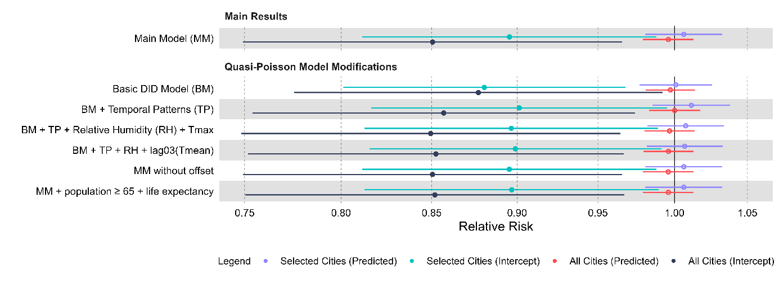
Figure A.6. Pooled relative risks (RR) of the sensitivity analyses on model modifications for all cities (intercepts of the meta regression: black, predicted RR based on the average of the meta variables across all cities: red) and the seven cities fulfilling the difference-in-differences parallel trends assumption (intercepts: turquoise, predicted RR: purple), with 95% confidence intervals. Filled symbols show significant estimates (p < 0.05), open symbols non-significant results.

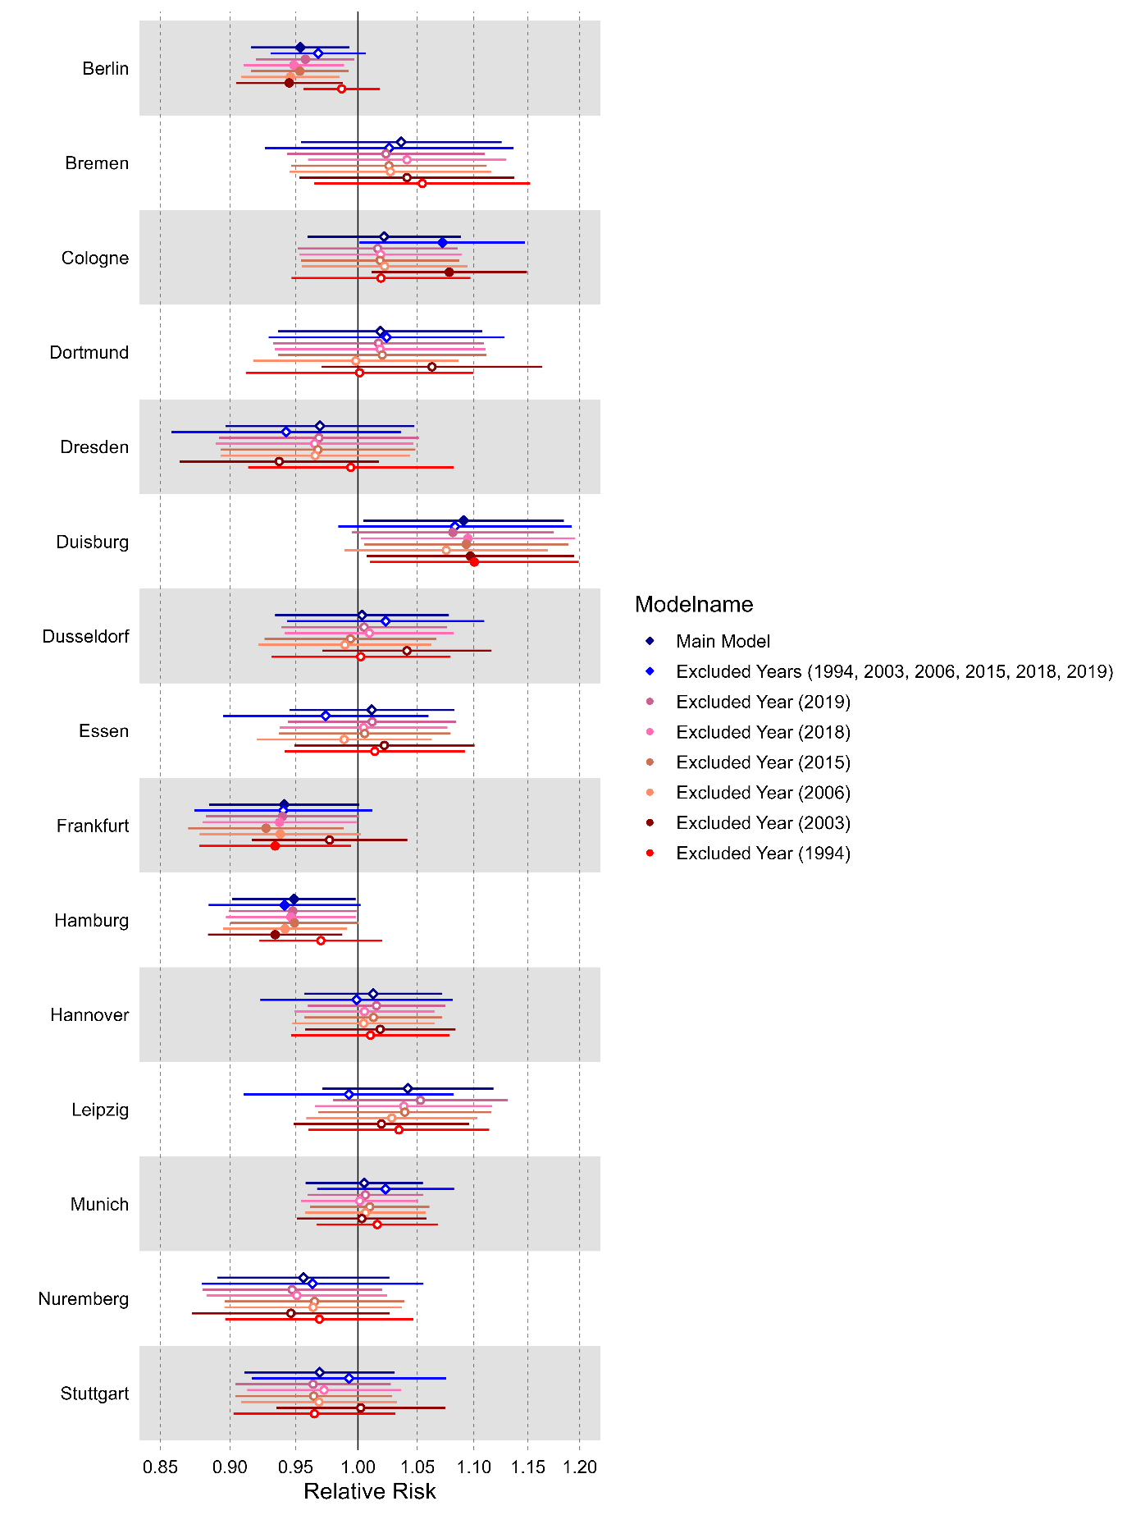 | 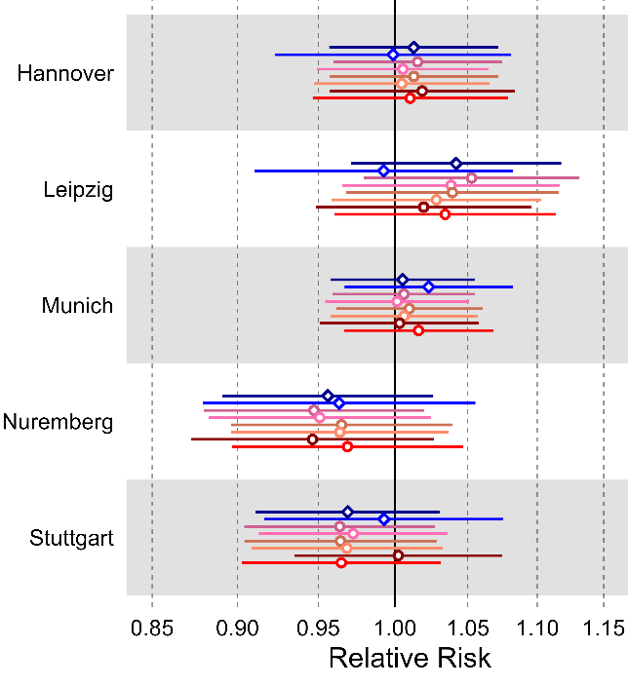  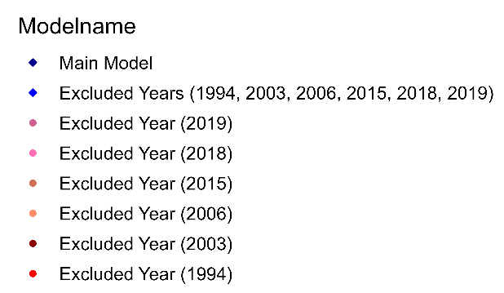
Figure A.7. City-specific relative risks of the sensitivity analyses to test the potential impact of years with extreme heat exposure, with 95% confidence intervals. Filled symbols show significant estimates (p < 0.05), open symbols non-significant results.

