Development and validation of advanced land use regression models for ultrafine particles in Augsburg and Regensburg, Germany.

Marco Dallavalle, Josef Cyrys, Susanne Sues, Simonas Kecorius, Susanne Breitner-Busch, Regina Pickford, Alexandra Schneider, Annette Peters, Kathrin Wolf

SUPPLEMENTARY MATERIAL
Supplemental Table S1: Description of potential predictor variables, available years, selected buffer size, and expected direction of effects. 2
Supplemental Figure S1. Map of the monitoring sites and road network in the Augsburg area. 4
Supplemental Figure S2. Map of the monitoring sites and road network in the Regensburg area. 5
Supplemental Figure S3. Annual total particle number concentration (PNC) at a 50-meter resolution predicted with a generalized additive model (GAM, left) and a mixed model (MM, right) for the Augsburg (top) and Regensburg (bottom) area in 2014/15. 6
Supplemental Figure S4. Distribution of the modeled particle number concentrations (annual means for 2014/15 and 2017) at the grid centroids of the study regions Augsburg and Regensburg. 7
Supplemental Figure S5. Modelled particle number concentrations (GAM and MM), street network and spatial predictors within 500 m at Regensburg sites. 8

Supplemental Table S1: Description of potential predictor variables, available years, selected buffer size, and expected direction of effects.
GIS dataset | Source | Year | Predictor variable | Unit | Buffer size (radius of buffer in meter) | Direction of effect
Land use | BKG Basis-DLM; LBM-DE | 2015, 2018 | Residential land, industry, artificial surfaces | % area in buffer | 25, 50, 100, 300, 500, 1000, 5000 | +
Land use | BKG Basis-DLM; LBM-DE | 2015, 2018 | Urban green, forest and seminatural areas, water bodies | % area in buffer | 25, 50, 100, 300, 500, 1000, 5000 | -
Roads | BKG Basis-DLM  OSM | 2015, 2020  2017 | Road length of all (major*) roads in buffer | m | 25, 50, 100, 300, 500, 1000 | +
Roads | BKG Basis-DLM  OSM | 2015, 2020  2017 | Inverse distance to nearest (major*) road | m⁻¹ | NA | +
Roads | OSM | 2017 | Inverse distance / inverse logarithm of distance to nearest bus stop | m⁻¹, NA | NA | +
Roads | OSM | 2017 | Number of bus stops | N | 25, 50, 100, 300, 500, 1000, 5000 | +
Roads | OSM | 2017 | Inverse distance / inverse logarithm of distance to nearest traffic light | m⁻¹, NA | NA | +
Roads | OSM | 2017 | Number of traffic lights | N | 25, 50, 100, 300, 500, 1000, 5000 | +
Building density | BKG LoD1 | 2015, 2019 | Area/number/height of buildings | m², N, m | 25, 50, 100, 300, 500, 1000, 5000 | +
Population density | WiGeoGIS Basis | 2014, 2018 | Number of inhabitants | N | 100, 300, 500, 1000, 5000 | +
Household density | WiGeoGIS Basis | 2014, 2018 | Number of households | N | 100, 300, 500, 1000, 5000 | +
Topography | BKG DGM10 | 2016 | Altitude, square root of altitude and adjusted altitude | m, m^{-1/2}, m | NA | +/-
Topography | BKG DGM10 | 2016 | Slope gradient | ° | NA | +/-
Wind | DWD |  | Average wind speed | km.h⁻¹ | NA
Precipitation | DWD | 2014, 2017 | Yearly sum of precipitation height | mm | Raster 1000*1000 | -
Imperviousness | EEA | 2015, 2018 | Average imperviousness | % | 25, 50, 100, 300, 500, 1000, 5000 | +
Forests | EEA | 2015, 2018 | Forest density derived with focal sum | % | 25, 50, 100, 300, 500, 1000, 5000 | -
NDVI | Landsat8 | 2014, 2017 | Yearly average NDVI (2014, 2015,2017,2018) | NA | 25, 50, 100, 300, 500, 1000, 5000 | -
Tropospheric NO₂ | Copernicus Sentinel | 2018 | Yearly average 2018 (Jan, Feb, Mar, Apr missing) | molec./cm² | NA | +
Tropospheric NO₂ | DLR | 2018 | Yearly average 2018 | molec./cm² | NA | +
Near surface NO₂ | DLR | 2018 | Yearly average 2018 | molec./cm² | NA | +
Coordinates | NA | NA | Original coordinates, truncated coordinates | m | NA | +/-
*Major roads are classified based on two criteria: the lane width exceeds 6.5 meters, and the road is not designated for pedestrians.
Basis-DLM: Digital Basic-Landscapemodel; BKG: Federal Agency for Cartography and Geodesy; DGM: Digital Terrain Model; DLR: German Aerospace Center; WiGeoGIS: Geomarketing company WiGeoGIS; DWD: German Weather Service; EEA: European Environmental Agency; ESA: European Space Agency; LBM-DE: Digital Land Cover Model; LoD1: 3D building model, level of detail 1; NA: Not applicable; NDVI: Normalized difference vegetation index; NO₂: nitrogen dioxide; OSM: Open Street Map.

Supplemental Figure S1. Map of the monitoring sites and road network in the Augsburg area.

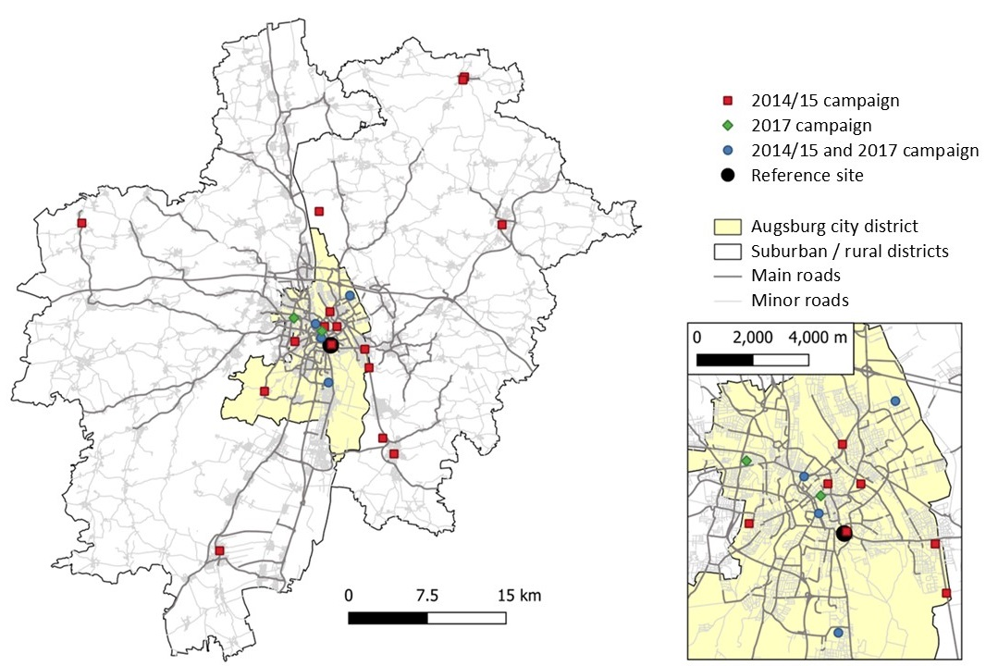

Supplemental Figure S2. Map of the monitoring sites and road network in the Regensburg area.

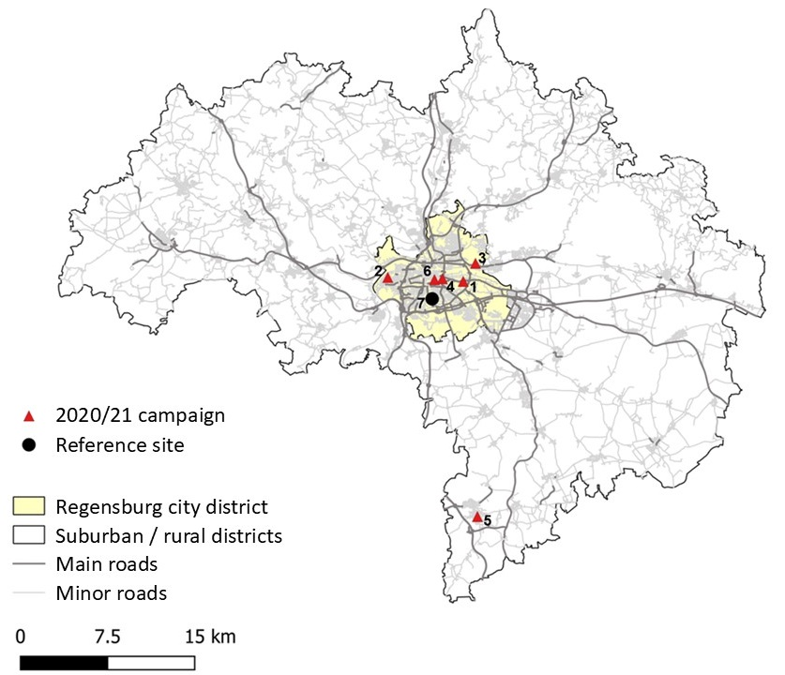

Supplemental Figure S3. Annual total particle number concentration (PNC) at a 50-meter resolution predicted with a generalized additive model (GAM, left) and a mixed model (MM, right) for the Augsburg (top) and Regensburg (bottom) area in 2014/15.

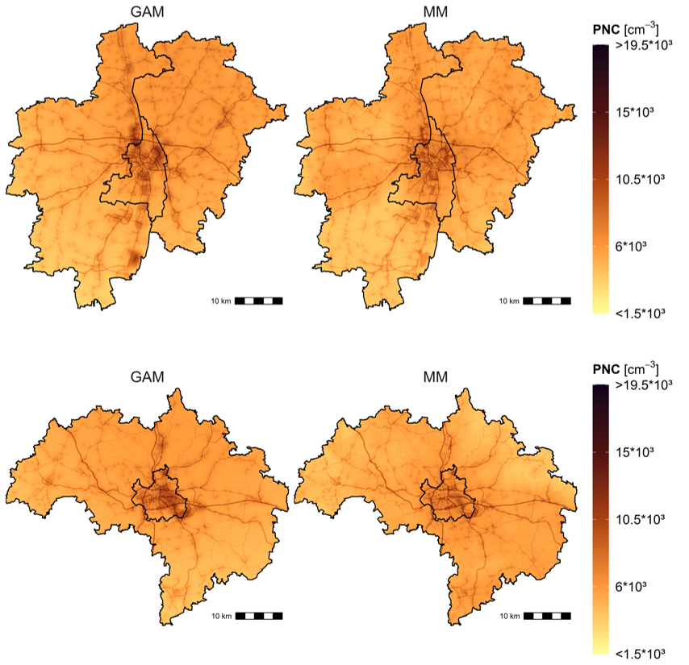

Supplemental Figure S4. Distribution of the modeled particle number concentrations (annual means for 2014/15 and 2017) at the grid centroids of the study regions Augsburg and Regensburg. Bold lines in the middle of the boxes indicate median values (50th percentiles); lower and upper hinges correspond to 25th and 75th percentiles; lower and upper whiskers to 5th and 95th percentiles.

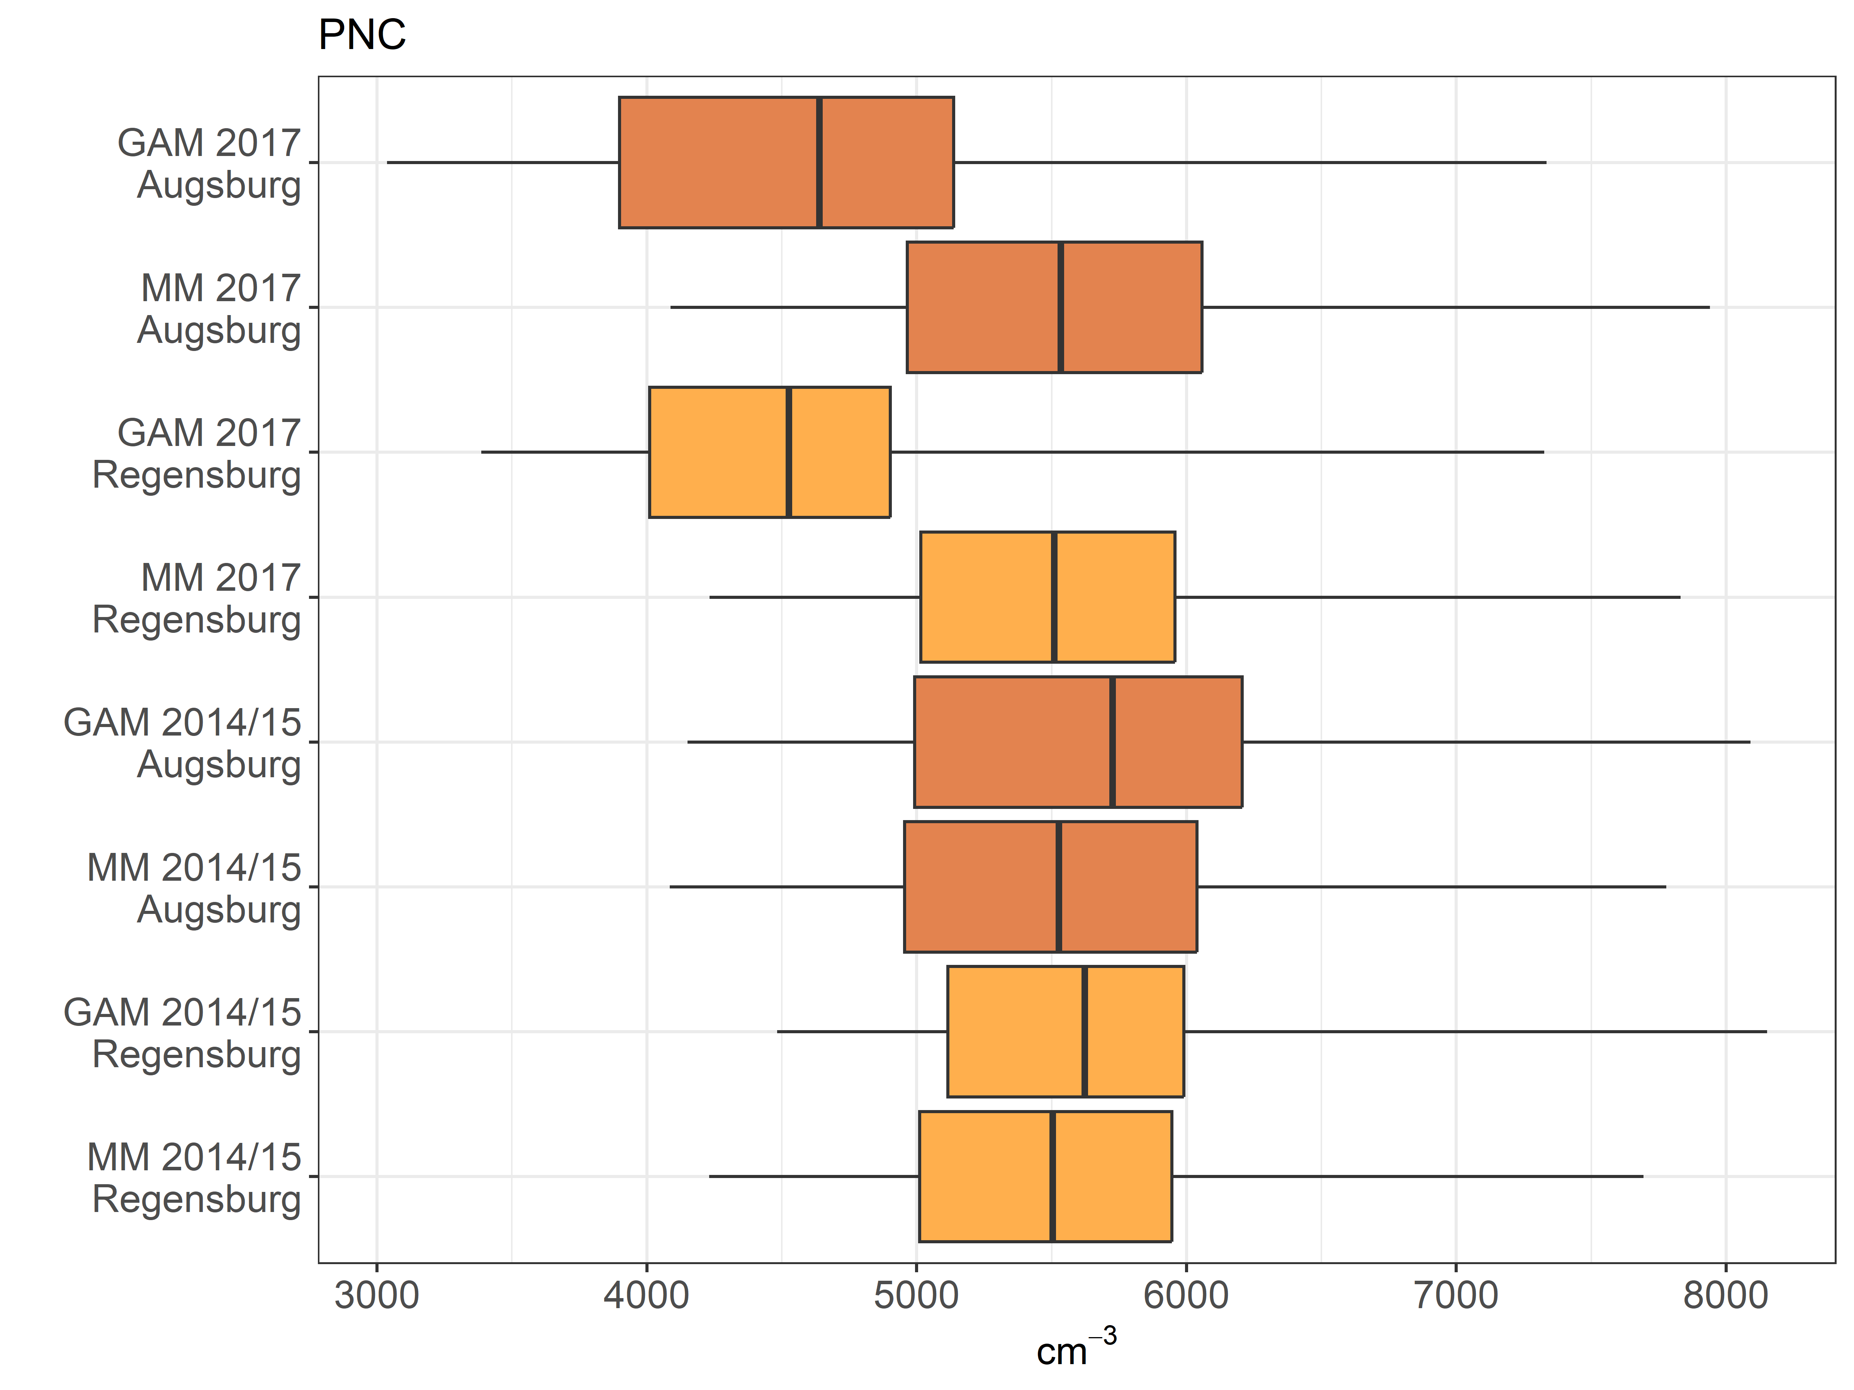

Supplemental Figure S5. Modelled particle number concentrations (GAM and MM), street network and spatial predictors within 500 m at Regensburg sites (site numbers refer to locations in Supplemental Figure S2; ub: urban background; ut: urban traffic – red shading; rb: regional background – blue shading).
