Short-term exposure to low and high temperatures and mortality in heart failure patients in Sweden
Subtitle: A Nationwide Case-Crossover study
Wenli Ni, PhD ^{1,2}; Lina Benson, MSc ³; Petter Ljungman, MD, PhD ^{4,5}; Federica Nobile, MSc ^{4,6}; Susanne Breitner, PhD ^{7,8}; Siqi Zhang, PhD ^{9,10}; Jeroen de Bont, PhD ⁴; Lars H. Lund, MD, PhD ¹¹; Gianluigi Savarese, MD, PhD ^{3*}; Alexandra Schneider, PhD ^{7*}; Stefan Agewall, MD, PhD ^{12,13*}
- Center for Climate, Health, and the Global Environment, Department of Environmental Health, Harvard T.H. Chan School of Public Health, Boston, MA, USA
- Division of Pulmonary and Critical Care Medicine, Department of Medicine, Beth Israel Deaconess Medical Center, Harvard Medical School, Boston, MA, USA
- Department of Clinical Science and Education, Södersjukhuset; Karolinska Institutet, Stockholm, Sweden
- Institute of Environmental Medicine, Karolinska Institutet, Stockholm, Sweden
- Department of Cardiology and Clinical Physiology, Danderyd Hospital, Stockholm, Sweden.
- Department of Epidemiology, Lazio Regional Health Service, ASL Roma 1, Rome, Italy
- Institute of Epidemiology, Helmholtz Zentrum München - German Research Center for Environmental Health (GmbH), Neuherberg, Germany.
- Institute for Medical Information Processing, Biometry, and Epidemiology, Faculty of Medicine, LMU Munich, Munich, Germany.
- Department of Environmental Health Sciences, Yale School of Public Health, New Haven, CT, USA.
- Yale Center on Climate Change and Health, Yale School of Public Health, New Haven, CT, USA
- Division of Cardiology, Department of Medicine, Karolinska Institutet, Stockholm, Sweden.
- Department of Clinical Sciences, Danderyd Hospital, Karolinska Institutet, Stockholm, Sweden
- Institute of Clinical Medicine, University of Oslo, Oslo, Norway

* Gianluigi Savarese, Alexandra Schneider, and Stefan Agewall contributed equally and share last authorship.

Corresponding author:
Wenli Ni
Center for Climate, Health, and the Global Environment, Department of Environmental Health, Harvard T.H. Chan School of Public Health, Boston, MA, USA
Division of Pulmonary and Critical Care Medicine, Department of Medicine, Beth Israel Deaconess Medical Center, Harvard Medical School, Boston, MA, USA

E-Mail: wni@hsph.harvard.edu
Telephone numbers: 617222409
Harvard T.H. Chan School of Public Health, 665 Huntington Ave, Boston, MA 02115, United States

Date of the revision: August 18, 2025
word count: 3400

Key Points
Question: What are the associations between short-term low and high ambient temperature exposures and mortality among heart failure patients in Sweden?
Findings: In this nationwide, time-stratified case-crossover study involving over 250,000 heart failure patients, short-term exposure to both low and high ambient temperatures was associated with increased risk of all-cause and cardiovascular mortality. The mortality risk associated with high temperatures intensified over time.
Meaning: Both low and high temperature exposures are linked to higher mortality in heart failure patients, with high temperature-related mortality increasing over time, even in this high-latitude country not traditionally considered heat-vulnerable.

Abstract
Importance: Heart failure patients may be particularly susceptible to non-optimal temperature exposures, but the associations between short-term low and high temperature exposure and mortality in this population remain unclear, especially in Sweden - a high-latitude country where no nationwide study has been conducted.
Objective: To investigate the associations between short-term exposure to low and high ambient temperatures and all-cause and cardiovascular mortality among Swedish patients with heart failure.
Design: Nationwide time-stratified case-crossover study.
Setting: Sweden, 2006-2021
Participants: 250,640 patients with heart failure who died from any cause, identified from the Swedish National Patient Register and the Cause of Death Register.
Exposure: Daily mean ambient temperature was assessed at 1 × 1 km spatial resolution. To account for regional adaptation, temperature exposures were defined using municipality-specific percentiles, with low and high temperatures corresponding to the 2.5th and 97.5th percentiles, respectively.
Main Outcome(s) and Measure(s): All-cause and cardiovascular mortality among patients with heart failure.
Results: The average age at death among heart failure patients was 84.3 years, with 48.3% female. Short-term exposure to ambient temperature demonstrated a U-shaped association with both all-cause and cardiovascular mortality. For all-cause mortality, odds ratios (ORs) were 1.130 (95% CI: 1.074-1.189) for low temperatures and 1.054 (95% CI: 1.017-1.093) for high temperatures over the entire study period. For cardiovascular mortality, low temperatures were associated with an OR of 1.160 (95% CI: 1.083-1.242) during 2006-2021, and high temperatures with an OR of 1.084 (95% CI: 1.014-1.159) during 2014-2021. The mortality risk associated with high temperatures was more pronounced during 2014-2021 compared to 2006-2013. Male patients, those with comorbid diabetes, and diuretic users were more susceptible to low temperatures, whereas high temperature was more strongly associated with mortality in patients with comorbid atrial fibrillation/flutter and those exposed to elevated ozone levels.
Conclusions and Relevance: This nationwide Swedish study indicates that short-term exposure to both low and high temperatures is associated with increased risk of all-cause and cardiovascular mortality in heart failure patients. The mortality risk associated with high temperatures appears to be increasing over time, emphasizing the need for adaptation even in high-latitude regions.

Keywords: Low and high temperature, mortality, heart failure, short-term associations

Introduction
Climate change has increased the frequency and intensity of extreme weather events, with significant implications for human health and mortality¹. Non-optimal temperature exposures have been identified as a key contributor to global mortality². Low and high temperatures have been associated with increased mortality rates from cardiovascular diseases (CVD)^{3,4}. According to a recent global study, non-optimal temperatures were responsible for ~9% of total CVD mortality, with cold-related fatalities accounting for ~8%, and heat-related deaths for ~0.7%⁵. A Swedish study projected rising heat- and cold-related deaths in Stockholm, despite declining attributable fractions for cold⁶.
Heart failure represents a prevalent, debilitating, and potentially fatal cardiovascular condition ^{7,8}. Individuals with heart failure may be particularly vulnerable to extreme temperatures due to the underlying neurohumoral, cardiovascular and cardio-kidney dysfunction that can impair thermoregulatory and volume responses, potentially increasing the risk of mortality⁹. Despite this concern, research on the association between low and high temperature exposures and mortality in heart failure patients remains limited^{3,10–13}. To date, no nationwide studies have specifically examined the impact of low and high temperatures on mortality among heart failure patients in Sweden - a Nordic country. Furthermore, there is a paucity of research exploring how the presence of comorbidities or the use of specific medications might modulate the vulnerability of heart failure patients to temperature-related mortality.Therefore, this nationwide study investigated the association between short-term exposure to low and high temperatures and the subsequent risk of mortality in heart failure patients in Sweden.

2. Methods

2.1 Study population
This study was conducted in Sweden, a Nordic country situated between approximately 55°N to 69°N latitude and 11°E to 24°E longitude. All analyses utilized data from the Swedish National Patient Register, which was linked to the Cause of Death Register and the Dispensed Drug Register through unique personal identification numbers assigned to all permanent residents of Sweden¹⁴. This nationwide study included all heart failure patients who died from any cause between January 1, 2006, and December 31, 2021, as identified using predefined ICD-10 codes. Details regarding climate zones, spatial temperature variation, registries, ICD-10 codes, and definitions of pre-existing conditions and medication use are provided in the Supplement (eText 1 and 2, eTable 1, and eFigure 1).
The study was conducted in compliance with the Declaration of Helsinki's ethical principles and was approved by the Swedish Ethical Review Authority under protocol number 2021-04326. Informed consent is waived for the use of registry data for quality improvement and health research, as is permitted under Swedish law.

2.2 Exposure assessment
Daily mean ambient temperature, particulate matter with a diameter less than 2.5μm (PM_{2.5}), nitrogen dioxide (NO₂), and ozone (O₃) were data obtained at high spatial resolution (1 × 1 km) across Sweden using a machine learning-based spatiotemporal modeling approach¹⁵, as detailed in the Supplement (eText 3).
Due to adaptations to local climatic conditions, populations may experience varying health impacts from an identical absolute temperature, especially when it signifies a local extreme rather than a typical temperature in the region^{16,17}. Therefore, to address these differences, we derived individual exposure indicators based on the percentiles of daily temperatures experienced by residents of each Swedish municipality during the study period (2006-2021) instead of using absolute temperature readings.

2.3 Study design
We employed a time-stratified case-crossover design, which is a well-established method for assessing the link between short-term environmental exposures and mortality^{3,18}. This self-matched approach, compare exposure levels on the day of the death event (termed the 'case' day) with those on equivalent weekdays in the same calendar month and year (referred to as 'control' days). To avoid overlap bias between case and control periods, we focused on exposures within a lag period of 0-6 days. Further study design details are provided in the Supplement (eText 4). This study followed the Strengthening the Reporting of Observational Studies in Epidemiology (STROBE) reporting guidelines.

2.4 Statistical analysis
We examined the associations between short-term exposure to low and high temperatures within a lag period of 0-6 days and all-cause and CVD mortality in heart failure patients using a conditional logistic regression model with distributed lag non-linear model (DLNM)¹⁹. High and low temperature exposures were defined as the 97.5th and 2.5th percentiles of the temperature distribution, respectively, representing temperature extremes within the Swedish context. The Minimum Mortality Temperature (MMT)²⁰, which corresponds to the temperature at which the lowest mortality rate is observed, was selected as the reference value. All results are reported as cumulative associations across lag 0-6 days, reflecting the overall association of temperature with mortality over the seven-day window by summing estimated effects for each lag day from day 0 (the day of the event) to day 6 prior²¹. Furthermore, we estimated the attributable fraction of mortality due to low and high temperatures²². Detailed model specifications and descriptive analyses are provided in the Supplementary eText 5.
To elucidate potential temporal variations in the association between low and high temperatures and mortality within heart failure patients, we conducted separate analyses for 2006-2013 and 2014-2021 (each with approximately equal duration and case count). We further examined whether temporal variations differed according to region, duration of heart failure and key patient characteristics (sex, age, medication use, and comorbidities) by comparing the associations between 2006-2013 and 2014-2021 within each subgroup. To assess the statistical significance of the difference in effect sizes between these two periods, we employed a z-test.
To identify potentially susceptible subgroups, we conducted a series of stratified analyses. Regional variations were evaluated by stratifying analyses for southern, central, and northern Sweden. As standard clinical metrics such as ejection fraction were unavailable, we used heart failure duration (measured in days) as a surrogate for disease progression and categorized it into tertiles (short, intermediate, long) for subgroup analysis. Additional stratified analyses were performed by age (<65 years vs. ≥65 years), sex (male vs. female), the presence or absence of various pre-existing conditions: diabetes, stroke/TIA, ischemic heart disease, atrial fibrillation/flutter, hypertension, obesity, chronic obstructive pulmonary disease (COPD), malignant cancer within 3 years, peripheral artery disease, and renal failure, medication history: diuretics, anticoagulants, antiplatelets, beta-blockers, calcium channel blockers, digoxin, lipid-lowering agents, mineralocorticoid receptor antagonists, antiarrhythmics, nitrates, renin-angiotensin system inhibitors/angiotensin receptor blockers (RASi / ARNi) and SGLT2 Inhibitors, and air pollution (O₃, PM₂.₅, NO₂; low: < median, high: ≥ median) .
Sensitivity analyses were conducted to assess the robustness of our findings. First, for temporal variation, we included the time period (2006-2013 vs. 2014-2021) as an interaction term in the model, enabling simultaneous estimation of temperature-mortality associations for both intervals within a unified analytical framework. Second, the study period was restricted to 2006–2019 to exclude potential COVID-19 effects. Third, absolute temperature was used as the exposure variable instead of temperature percentiles. Fourth, alternative definitions for low and high temperature were applied, using the 5th and 95th percentiles, respectively. Fifth, ambient pollutants (O_{3,} PM_{2.5,} and NO₂) were adjusted in separate models. Finally, analyses were restricted to heart failure cases with an ICD-10 code of I50.
The effect of high temperatures was estimated as the odds ratio (OR) with 95% confidence intervals (CI) for an increase in daily air temperature from the MMT to the 97.5th percentile of the temperature percentile distribution, while the effect of low temperatures was estimated for a decrease from the MMT to the 2.5th percentile of the distribution.
All analyses were conducted using R software, version 4.3.0. Statistical significance was assessed using a two-sided p-value of less than 0.05.

3. Result

3.1 Study population and exposure data
This nationwide study included 250,640 heart failure patients who died from any cause between 2006 and 2021, of whom at least 144,729 (57.8%) deaths were attributed to CVD. The average age at all-cause death was 84.3 ± 9.4 years, with 48.3% female (Table 1). Characteristics of CVD deaths among heart failure patients are presented in eTable 2 (Supplement).

Table 1. Descriptive statistics of characteristics of death cases in the heart failure patients during 2006-2021, 2006-2013 and 2014-2021
 | Mean ± SD / n (%)
 | Overall period: 2006-2021  (N=250,640) | 2006-2013  (N=114,912) | 2014-2021  (N=135,728)
Age (years) | 84.3 ± 9.4 | 84.1 ± 9.3 | 84.4 ± 9.4
Sex (female) | 121061 (48.3%) | 56563 (49.2%) | 64498 (47.5%)
Region
North | 31988 (12.8%) | 14953 (13.0%) | 17035 (12.6%)
Central | 95930 (38.3%) | 43453 (37.8%) | 52477 (38.7%)
South | 122722 (49.0%) | 56506 (49.2%) | 66216 (48.8%)
Duration of heart failure (days) | 1670 ± 1570 | 1360 ± 1210 | 1920 ± 1780
Comorbidities (yes)
Hypertension | 160968 (64.2%) | 62201 (54.1%) | 98767 (72.8%)
Diabetes | 74585 (29.8%) | 31974 (27.8%) | 42611 (31.4%)
Ischemic heart disease | 143741 (57.3%) | 68425 (59.5%) | 75316 (55.5%)
Atrial fibrillation/flutter | 149343 (59.6%) | 63309 (55.1%) | 86034 (63.4%)
Stroke / TIA | 84813 (33.8%) | 38890 (33.8%) | 45923 (33.8%)
Peripheral artery disease | 37440 (14.9%) | 16877 (14.7%) | 20563 (15.2%)
Renal Disease | 83883 (33.5%) | 30261 (26.3%) | 53622 (39.5%)
COPD | 50700 (20.2%) | 22038 (19.2%) | 28662 (21.1%)
Malignant cancer within 3 years | 53913 (21.5%) | 23346 (20.3%) | 30567 (22.5%)
Obesity | 10572 (4.2%) | 3145 (2.7%) | 7427 (5.5%)
History of medication use (yes)
Diuretics | 193859 (77.3%) | 91726 (79.8%) | 102133 (75.2%)
RASi / ARNi | 129754 (51.8%) | 58121 (50.6%) | 71633 (52.8%)
Beta-Blockers | 165250 (65.9%) | 70365 (61.2%) | 94885 (69.9%)
Antiplatelet | 104352 (41.6%) | 61412 (53.4%) | 42940 (31.6%)
Mineralocorticoid Receptor Antagonists | 63686 (25.4%) | 29719 (25.9%) | 33967 (25.0%)
SGLT2 | 1206 (0.5%) | - | 1206 (0.9%)
Calcium Channel Blockers | 36344 (14.5%) | 15591 (13.6%) | 20753 (15.3%)
Anticoagulant | 80313 (32.0%) | 22202 (19.3%) | 58111 (42.8%)
Lipid-Lowering | 67415 (26.9%) | 25825 (22.5%) | 41590 (30.6%)
Digoxin | 30957 (12.4%) | 17954 (15.6%) | 13003 (9.6%)
Nitrate | 60582 (24.2%) | 32708 (28.5%) | 27874 (20.5%)
Antiarrhythmic | 3718 (1.5%) | 1479 (1.3%) | 2239 (1.6%)
Note: COPD, chronic obstructive pulmonary disease. RASi / ARNi, renin-angiotensin inhibitors/angiotensin receptor blockers

3.2 Exposure data
The mean of daily mean air temperatures over the period 2006-2021 was 6.63°C (SD: 7.91°C, range: -34.5°C to 26.3°C) (Table 2). For 2006–2013, the mean was 6.14°C (SD: 8.23°C; range: -34.5°C to 25.5°C), and for 2014–2021, it was 7.05°C (SD: 7.61°C; range: -32.6°C to 26.3°C) (Table 2). Spearmen correlations between ambient temperature and ambient pollutants were generally weak to moderate (-0.29 to 0.37) (Supplement, eFigure 2).

Table 2. Descriptive statistics of the levels of ambient temperatures and ambient pollutants
 | Mean | SD | 2.5% | 5% | 25% | Median | 75% | 95% | 97.5%
Air temperature (°C)
2006-2021 | 6.63 | 7.91 | -8.99 | -6.21 | 1.09 | 6.13 | 13.23 | 18.75 | 20.26
2006-2013 | 6.14 | 8.23 | -10.18 | -7.47 | 0.25 | 5.99 | 13.04 | 18.49 | 19.81
2014-2021 | 7.05 | 7.61 | -7.64 | -4.79 | 1.68 | 6.26 | 13.38 | 19.01 | 20.69
PM_{2.5} (μg/m³) | 7.78 | 3.57 | 2.61 | 3.16 | 5.42 | 7.24 | 9.51 | 13.90 | 16.08
NO₂ (μg/m³) | 11.66 | 7.85 | 1.96 | 2.50 | 5.87 | 10.10 | 15.37 | 26.78 | 31.70
O₃ (μg/m³) | 54.50 | 13.69 | 28.83 | 32.28 | 44.54 | 54.58 | 64.44 | 76.30 | 79.97
Note: Values in Table 2 summarize the distribution of individual-level daily exposures, which were assigned to each study subject according to their area (RegSO) of residence and date of death, using high-resolution gridded exposure models. All descriptive statistics are calculated by pooling these individual-level exposures across all deaths during the analysis period.

3.3 Short-term exposure to low and high temperatures and all-cause and CVD mortality in heart failure patients
The relationship between short-term exposure to daily air temperatures and all-cause and CVD mortality in heart failure patients consistently exhibited a U-shaped pattern throughout the study period (2006-2021; Figures A1 and B1). Mortality risk was elevated at both low and high temperatures, with a more pronounced association at low temperatures. Temporal variation in the exposure-response curves showed that associations with both low and high temperatures were stronger in 2014-2021 than in 2006-2013 (Figure A1 and B1). The U-shaped association for all-cause mortality was evident in both sub-periods. In contrast, CVD mortality in the earlier period was predominantly associated with low temperatures, following a near-linear pattern; but shifted to a U-shaped pattern in more recent years, indicating increased mortality risk at high temperatures. Notably, the slope of the risk curve for high temperatures became steeper for both all-cause and CVD mortality in the more recent period, indicating a more rapid rise in mortality risk at high temperature.
For all-cause mortality over the 2006-2021 period (Figure A2, Supplementary eTable 3), the ORs were 1.130 (95% CI: 1.074-1.189) for low temperatures at the 2.5th percentile compared to the MMT - corresponding to a temperature percentile of 0.841, and 1.054 (95% CI: 1.017-1.093) for high temperatures at the 97.5th percentile. By period, the ORs for low temperature were 1.108 (95% CI: 1.027-1.195) in 2006-2013 and 1.149 (95% CI: 1.074-1.229) in 2014-2021, and associations at high temperatures were slightly stronger in 2014-2021 (OR=1.082, 95% CI: 1.029-1.138) than in 2006-2013 (OR=1.024, 95% CI: 0.973-1.077), though this difference was not statistically significant (Figure A2). For CVD mortality (Figure B2, Supplementary eTable 3), low temperatures consistently showed elevated risk overall (OR=1.160, 95% CI: 1.083-1.242) and both sub-periods (2006-2013: OR=1.132, 95% CI: 1.025-1.251; 2014-2021: OR=1.192, 95% CI: 1.086-1.307). High temperatures were not associated with increased CVD mortality overall or during 2006-2013, but a significant association emerged in 2014-2021 (OR=1.084, 95% CI: 1.014-1.159) that was significantly higher than in 2006-2013 (OR=1.001, 95% CI: 0.973-1.029).
The attributable fractions of all-cause mortality due to low and high temperatures were 0.30% (95% empirical confidence interval [eCI]: 0.17%-0.42%) and 0.15% (0.05%-0.26%), respectively; for CVD mortality, 0.36% (0.20%-0.52%) and 0.12% (-0.01%-0.24%) (Supplement, eTable 4). Attributable fractions for both low and high temperatures in all-cause and CVD mortality were higher in 2014-2021 compared to 2006-2013, with the increase particularly pronounced for high temperature.

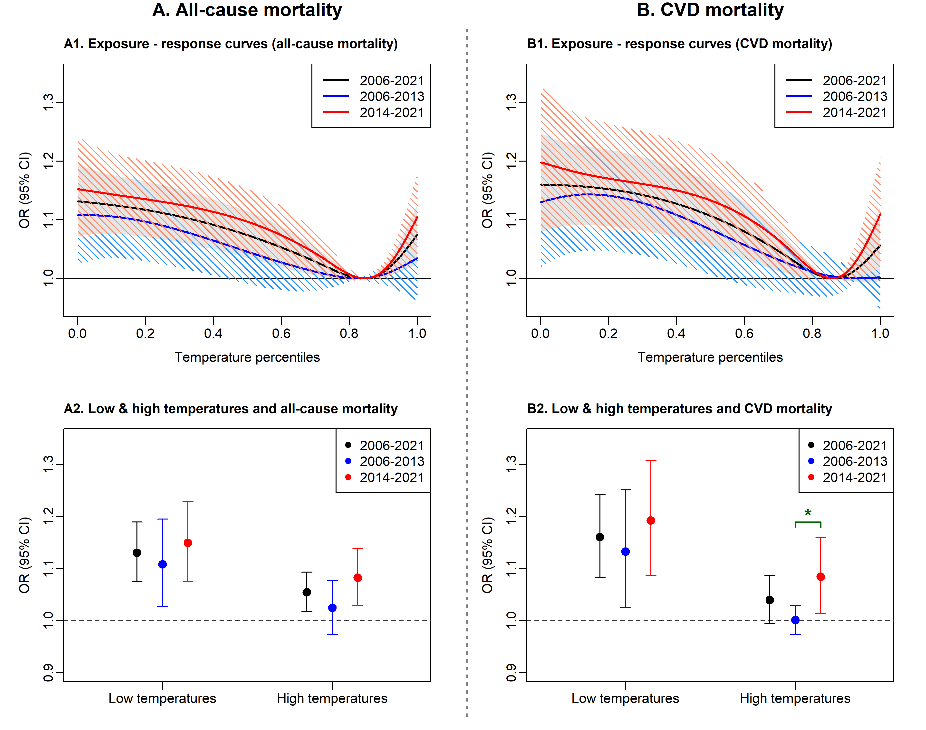
Figure 1. Association of short-term air temperature exposure with all-cause and CVD mortality in heart failure patients
Note: Association between short-term air temperature exposure (lag 0-6 days) and all-cause and cardiovascular mortality among Swedish heart failure patients from 2006 to 2021, including sub-periods 2006-2013 and 2014-2021. Panels A1 and B1, exposure-response curves of association between air temperature exposure with all-cause mortality (A1) and CVD mortality (B1) in the heart failure patients. The x-axis represents the temperature percentiles. The solid black, blue, and red lines with shaded regions represent the ORs (95% CI) of all-cause mortality and CVD mortality associated with air temperature exposure during 2006-2021, 2006-2013, and 2014-2021, respectively. A2 and B2, OR (95% CI) of all-cause mortality (A2) and CVD mortality (B2) in the heart failure patients associated with low temperature (2.5th percentile) and high temperature (97.5th percentile) vs MMT. For all-cause mortality, the MMT corresponded to temperature percentiles of 0.841 (2006-2021), 0.827 (2006-2013), and 0.846 (2014-2021); for CVD mortality, 0.863, 0.931, and 0.859, respectively. A green star indicates a significant difference between OR estimates for the periods 2006-2013 and 2014-2021. All associations represent cumulative effects across lag 0-6 days, calculated by summing the estimated effects from the day of the event (lag 0) to six days prior (lag 6), reflecting the overall short-term impact of temperature exposure on mortality. The horizontal black line represents the OR of 1.

3.4 Stratified analyses
Regional analyses (Supplement, eFigure 3 and 4) demonstrated that high temperatures were more strongly associated with increased CVD mortality risk among heart failure patients in northern Sweden compared to those in the southern and central regions during 2006-2021, while in southern Sweden, the association between high temperatures and all-cause mortality became notably stronger in recent years. Longer heart failure duration was linked to greater high temperature-related CVD mortality risk during overall period, with no temporal variation across duration subgroups (Supplement, eFigure 5 and 6).
We also observed that males exhibited a stronger association between low temperatures exposures and CVD mortality compared to females, with a similar but non-significant trend for all-cause mortality during 2006-2021 (Figure 2). Low temperatures were more strongly associated with both all-cause and CVD mortality in patients with comorbid diabetes, and with all-cause mortality in those using diuretics during 2006-2021. High temperatures were more strongly associated with CVD mortality in patients with comorbid atrial fibrillation/flutter, and with all-cause mortality in those with higher O₃ exposure (Figure 2). No effect modification was observed for other pre-existing conditions, medication history, or air pollutants during 2006–2021 (Figure 2 and Supplement, eFigure 7, 8, and 9).
Temporal analyses (Supplement, eFigure 10, 11, and 12) indicated that among heart failure patients with comorbid cancer, the association between low temperature exposure and CVD mortality was stronger in 2014-2021 compared to the earlier period. Similarly, in older patients (≥65 years) and in those with comorbid atrial fibrillation/flutter, high temperatures were more strongly associated with increased CVD mortality in the more recent period. No temporal differences in temperature-related CVD mortality were observed among females, males, younger patients (<65 years), or those with other comorbidities or medication use. Likewise, no temporal differences in temperature-related all-cause mortality risk were found across age, sex, comorbidities, or medication use (Supplement, eFigure 10, 11, and 12).
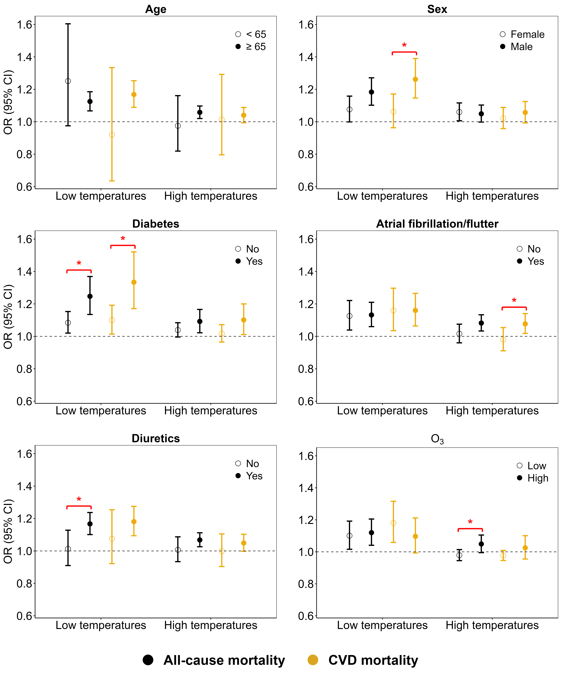
Figure 2. Effect modifications of low and high temperatures on all-cause and CVD mortality in heart failure patients
Note: Effect modifications of low and high temperatures on all-cause and CVD mortality in heart failure by age, sex, diabetes, atrial fibrillation/flutter, diuretics and O₃ during 2006-2021. Red stars indicate statistically significant differences (p-value < 0.05) between groups. O₃: ozone
3.5 Sensitivity analysis
Results remained robust across a series of sensitivity analyses (Supplement, eFigure 13, 14 and 15), including incorporating time period as an interaction term, restricting the study period to pre-COVID-19 years (2006-2019), using absolute temperature instead of percentiles, applying alternative percentile thresholds (95th and 5th), adjusting for ambient pollutants (O₃, PM_{2.5}, NO₂), and limiting cases to ICD-10 code I50.

4. Discussion
In this nationwide Swedish heart failure study, we found that both low and high temperatures exposures are associated with an increased all-cause and CVD mortality risk among patients with heart failure, with risks elevated by approximately 10-20% for low temperatures and 2-8% for high temperatures. Notably, the slopes of the all-cause and CVD mortality risk curves for high temperatures have accelerated sharply in recent years, indicating an intensifying impact of heat exposure in Sweden, even in this high-latitude region not traditionally considered heat-vulnerable.
Few studies have examined the effects of temperature extremes on all-cause or CVD mortality in heart failure patients, especially in Nordic regions. This is the first nationwide Swedish investigation of temperature and mortality in heart failure, including effect modification by comorbidities and medication use. While conducted in Sweden, our findings are likely relevant for other Nordic countries due to similar climates, demographics, and healthcare systems. One prior ecological study across multiple regions, using aggregated data (daily death counts) rather individual-level information, reported that high and low temperature exposure was associated with increased heart failure mortality³. However, their analysis excluded Sweden and most Nordic countries, grouping the UK, Estonia, and only Helsinki as Northern Europe. This atypical classification may limit the generalizability of their findings to the Nordics, which have distinct climate or healthcare characteristics compared to the UK and Estonia. Studies from Spain and Germany also found that low and high temperatures were both associated with increased heart failure mortality¹¹¹⁰. Regional studies in Hong Kong and Quebec reported that lower temperatures were associated with increased heart failure mortality^{12,13}. However, these studies did not examine how individual comorbidities or medication use might modify the effect of non-optimal temperatures on mortality risk in heart failure patients.
The temporal variation in temperature-mortality curves among heart failure patients highlights an emerging concern for high temperature exposure in Sweden, a country typically considered less vulnerable to heat due to its northern, colder climate. The slope of the mortality risk curve for high temperatures was steeper and exhibited a more rapid increase over time from 2014-2021 compared to 2006-2013, especially in the southern region where about half the population resides. The exposure-response relationship indicates that the association between low temperatures and mortality was also stronger in the later period. These patterns align with projections that Sweden’s increasing temperature-related mortality among older adults is driven by population aging, rather than climate change alone⁶. Our findings support these projections, with more pronounced temperature-mortality associations in recent years, especially among older patients and those with comorbid atrial fibrillation/flutter or cancer. This is accompanied by noticeable differences in health status between 2014-2021 and 2006-2013, with patients in more recent years had longer heart failure duration, more comorbidities (such as hypertension), and greater polypharmacy. Such escalation in clinical susceptibility may explain the rise in temperature-related mortality in recent years. In an aging world, the number of susceptible individuals is likely to rise, potentially leading to an increase in both heat-related and cold-related deaths²³. While we did not directly analyze temperature trends, we observed a rise in mean daily air temperature from 6.1°C (2006-2013) to 7.1°C (2014-2021) , consistent with climate change¹. If extreme temperatures occur more frequently and are associated with increased mortality, patients with heart failure will likely face more high-risk days than in the past. Therefore, the intensification of the temperature-mortality relationship, regardless of its underlying cause - be it climate or demographic changes²³ - highlights the potential for rapidly escalating risk of heat-related mortality among individuals with heart failure.
The risks of both all-cause and CVD mortality among heart failure patients demonstrated a more pronounced association with low temperatures compared to high temperatures, consistent with previous findings that excess deaths attributable to cold exceed those attributable to heat^{24,25}. This disparity may, in part, be explained by the greater frequency of cold days compared to hot days in Sweden^{24,26}. In addition, the predominance of cold-related deaths can be understood mathematically: the area under the exposure-response curve for heat is substantially smaller than that for cold²⁴, with the MMT located at a temperature percentile of approximately 0.85 in our study. This mathematical difference further accounts for the greater burden of cold-related deaths observed in our study.
Low temperatures showed a significantly stronger association with mortality among heart failure in males than females, consistent with previous studies reporting higher cold-related cardiovascular mortality in men^{27,28}. These sex-specific differences may reflect both behavioral factors, greater occupational or behavioral exposure to cold as well as risk-taking behaviors like higher rates of alcohol consumption during cold periods among men; and physiological differences, larger decreases in core body temperature in response to cold^{29,30}. Similarly, the association between low temperatures and mortality was stronger in heart failure patients with diabetes, possibly due to impaired vascular responsiveness thorough dysregulated sympathetic function in this group³¹. Although previous studies suggested diabetes may also increase heat susceptibility, we observed only a slightly stronger, non-significant effect of high temperatures in these patients. Diuretic users also exhibited a stronger association between low temperatures and mortality. Diuretics may influence thermoregulation by inhibiting the resorption of sodium and potassium in the distal tubules of the kidneys, resulting in decreased plasma volume^{9,32}, which can diminish vasomotor tone and the body’s ability to maintain temperature homeostasis during cold exposure³³. Diuretic use may also be a marker of more severe heart failure, further explaining this heightened risk. Although diuretics may theoretically increase susceptibility to heat due to impaired fluid and electrolyte regulation, this was not observed in our study. High temperature exposure was more strongly associated with mortality in heart failure patients with comorbid atrial fibrillation/flutter and those with longer heart failure duration. These frail individuals may experience impaired cardiovascular function³⁴, potentially exacerbating their susceptibility. High temperature- mortality relationship was also amplified for those exposed to higher O₃ levels. As temperature correlates positively with ground-level O₃ formation³⁵, this synergistic interaction highlights the health risks posed by concurrent heat and O₃. In contrast, no effect modification by PM_{2.5} was detected, indicating that its levels did not appear to influence the short-term association between temperature and mortality in this population.
While the precise mechanisms linking low and high temperatures to mortality in heart failure patients require further elucidation, several plausible pathways have been proposed. Alterations in autonomic and cardiovascular function, commonly observed in heart failure, may impair thermoregulatory responses^{9,36,37}. Both cold and heat exposures elicit coordinated autonomic-cardiovascular responses to maintain core body temperature. High temperature exposure could cause vasodilation, sweating, dehydration and electrolyte imbalances, aggravating sympathoadrenal activation, tachycardia, and risks of ischemia/plaque rupture^{4,38,39}. Additionally, exposure to high temperatures may also promote a prothrombotic state and endothelial injury via proinflammatory cytokines^{4,38–40}. Previous studies have also reported impaired skin blood flow responses to environmental heating in individuals with chronic heart failure⁴¹. Conversely, low-temperature exposures could trigger vasoconstriction, increased vascular resistance and blood pressure, exacerbating plaque vulnerability^{38,39,42}. Moreover, exposure to low temperatures may deposit cholesterol crystals and activate platelets/inflammatory markers^{4,38,39,43}.
Our study has several limitations. First, using outdoor ambient temperatures as proxies for personal exposures may lead to exposure misclassification, particularly for elderly patients who may spend more time indoors, although daily variations are likely well represented. However, individualized exposure data were not feasible at a national scale. Second, the observational design precludes causal inference. Third, the absence of ejection fraction data limits our ability to assess susceptibility differences across heart failure phenotypes. The case-crossover approach is optimized for short-term effects and may not capture impacts beyond the 6-day window. We were also unable to adjust for humidity due to a lack of data, potentially resulting in residual confounding. Finally, as the study was conducted in Sweden, generalizability to other regions and populations may be limited.

5. Conclusions
Short-term exposure to both low and high temperatures is associated with increased all-cause and CVD mortality risk among heart failure patients in Sweden. The observed rise in mortality risk associated with high temperatures over time underscores the importance of timely adaptation measures, even in high-latitude regions not traditionally considered heat-vulnerable.

Author contributions
Wenli Ni contributed to conceptualization, methodology, formal analysis, visualization, and writing - original draft, writing - review and editing. Wenli Ni had full access to all of the data in the study and takes responsibility for the integrity of the data and the accuracy of the data analysis. Lina Benson contributed to data analysis, methodology, and writing - review and editing. Petter Ljungman contributed to exposure data, methodology, writing - review and editing. Federica Nobile contributed to exposure modeling, writing - review and editing. Susanne Breitner contributed to methodology, writing - review and editing. Siqi Zhang contributed to methodology, writing - review and editing. Jeroen de Bont contributed to methodology, writing - review and editing. Lars H. Lund contributed to methodology, writing - review and editing. Gianluigi Savarese contributed to collecting resources, conceptualization, methodology, and writing - review and editing. Alexandra Schneider contributed to conceptualization, methodology, writing - review and editing, and supervision. Stefan Agewall contributed to conceptualization, methodology, writing - review and editing, and supervision.
Funding
This study has received funding from the European Union’s Horizon 2020 research and innovation program under grant agreement No 820655 (EXHAUSTION).
Declaration of competing interest
The authors declare that they have no known competing financial interests or personal relationships that could have appeared to influence the work reported in this paper.

Role of the Funder/Sponsor
The funder had no role in the design and conduct of the study; collection, management, analysis, and interpretation of the data; preparation, review, or approval of the manuscript; and decision to submit the manuscript for publication.
Data availability statement

The authors do not have permission to share the data used in this study. Individual patient data cannot be shared due to ethical restrictions.

References
1. Change (IPCC) IP on C. Weather and Climate Extreme Events in a Changing Climate. In: Climate Change 2021 – The Physical Science Basis: Working Group I Contribution to the Sixth Assessment Report of the Intergovernmental Panel on Climate Change. Cambridge University Press; 2023:1513-1766.
2. Collaborators GBD, Ärnlöv J. Global burden of 87 risk factors in 204 countries and territories, 1990–2019: a systematic analysis for the Global Burden of Disease Study 2019. The Lancet. 2020;396(10258):1223-1249.
3. Alahmad B, Khraishah H, Royé D, et al. Associations Between Extreme Temperatures and Cardiovascular Cause-Specific Mortality: Results From 27 Countries. Circulation. 2023;147(1):35-46. doi:10.1161/CIRCULATIONAHA.122.061832
4. Khraishah H, Alahmad B, Ostergard RLJ, et al. Climate change and cardiovascular disease: implications for global health. Nat Rev Cardiol. 2022;19(12):798-812. doi:10.1038/s41569-022-00720-x
5. Hundessa S, Huang W, Zhao Q, et al. Global and Regional Cardiovascular Mortality Attributable to Nonoptimal Temperatures Over Time. J Am Coll Cardiol. 2024;83(23):2276-2287. doi:10.1016/j.jacc.2024.03.425
6. Fonseca-Rodríguez O, Adams RE, Sheridan SC, Schumann B. Projection of extreme heat- and cold-related mortality in Sweden based on the spatial synoptic classification. Environ Res. 2023;239(Pt 2):117359. doi:10.1016/j.envres.2023.117359
7. Roger VL. Epidemiology of Heart Failure. Circulation Research. 2021;128(10):1421-1434. doi:10.1161/CIRCRESAHA.121.318172
8. McMurray JJV, Pfeffer MA. Heart failure. Lancet. 2005;365(9474):1877-1889. doi:10.1016/S0140-6736(05)66621-4
9. Balmain BN, Sabapathy S, Jay O, et al. Heart Failure and Thermoregulatory Control: Can Patients With Heart Failure Handle the Heat? J Card Fail. 2017;23(8):621-627. doi:10.1016/j.cardfail.2017.04.003
10. Rai M, Breitner S, Huber V, Zhang S, Peters A, Schneider A. Temporal variation in the association between temperature and cause-specific mortality in 15 German cities. Environ Res. 2023;229:115668. doi:10.1016/j.envres.2023.115668
11. Achebak H, Rey G, Lloyd SJ, Quijal-Zamorano M, Méndez-Turrubiates RF, Ballester J. Ambient temperature and risk of cardiovascular and respiratory adverse health outcomes: a nationwide cross-sectional study from Spain. Eur J Prev Cardiol. 2024;31(9):1080-1089. doi:10.1093/eurjpc/zwae021
12. Goggins WB, Chan EY. A study of the short-term associations between hospital admissions and mortality from heart failure and meteorological variables in Hong Kong: Weather and heart failure in Hong Kong. Int J Cardiol. 2017;228:537-542. doi:10.1016/j.ijcard.2016.11.106
13. Vanasse A, Talbot D, Chebana F, et al. Effects of climate and fine particulate matter on hospitalizations and deaths for heart failure in elderly: A population-based cohort study. Environ Int. 2017;106:257-266. doi:10.1016/j.envint.2017.06.001
14. Savarese G, Benson L, Sundström J, Lund LH. Association between renin-angiotensin-aldosterone system inhibitor use and COVID-19 hospitalization and death: a 1.4 million patient nationwide registry analysis. Eur J Heart Fail. 2021;23(3):476-485. doi:10.1002/ejhf.2060
15. de Bont J, Stafoggia M, Nakstad B, et al. Associations between ambient temperature and risk of preterm birth in Sweden: A comparison of analytical approaches. Environ Res. 2022;213:113586. doi:10.1016/j.envres.2022.113586
16. Basagaña X, Michael Y, Lensky IM, et al. Low and High Ambient Temperatures during Pregnancy and Birth Weight among 624,940 Singleton Term Births in Israel (2010-2014): An Investigation of Potential Windows of Susceptibility. Environ Health Perspect. 2021;129(10):107001. doi:10.1289/EHP8117
17. Ni W, Stafoggia M, Zhang S, et al. Short-Term Effects of Lower Air Temperature and Cold Spells on Myocardial Infarction Hospitalizations in Sweden. J Am Coll Cardiol. 2024;84(13):1149-1159. doi:10.1016/j.jacc.2024.07.006
18. Hanson C, de Bont J, Annerstedt KS, et al. A time-stratified, case-crossover study of heat exposure and perinatal mortality from 16 hospitals in sub-Saharan Africa. Nat Med. Published online September 3, 2024. doi:10.1038/s41591-024-03245-7
19. Gasparrini A, Armstrong B, Kenward MG. Distributed lag non-linear models. Stat Med. 2010;29(21):2224-2234. doi:10.1002/sim.3940
20. Gasparrini A, Guo Y, Hashizume M, et al. Mortality risk attributable to high and low ambient temperature: a multicountry observational study. Lancet. 2015;386(9991):369-375. doi:10.1016/S0140-6736(14)62114-0
21. Gasparrini A. Distributed Lag Linear and Non-Linear Models in R: The Package dlnm. J Stat Softw. 2011;43(8):1-20.
22. Gasparrini A, Leone M. Attributable risk from distributed lag models. BMC Med Res Methodol. 2014;14:55. doi:10.1186/1471-2288-14-55
23. García-León D, Masselot P, Mistry MN, et al. Temperature-related mortality burden and projected change in 1368 European regions: a modelling study. Lancet Public Health. 2024;9(9):e644-e653. doi:10.1016/S2468-2667(24)00179-8
24. Alahmad B, Tobias A, Masselot P, Gasparrini A. Are there more cold deaths than heat deaths? Lancet Planet Health. 2025;9(3):e170-e171. doi:10.1016/S2542-5196(25)00054-3
25. Gasparrini A, Guo Y, Hashizume M, et al. Mortality risk attributable to high and low ambient temperature: a multicountry observational study. Lancet. 2015;386(9991):369-375. doi:10.1016/S0140-6736(14)62114-0
26. Masselot P, Mistry MN, Rao S, et al. Estimating future heat-related and cold-related mortality under climate change, demographic and adaptation scenarios in 854 European cities. Nat Med. 2025;31(4):1294-1302. doi:10.1038/s41591-024-03452-2
27. Achebak H, Devolder D, Ballester J. Trends in temperature-related age-specific and sex-specific mortality from cardiovascular diseases in Spain: a national time-series analysis. Lancet Planet Health. 2019;3(7):e297-e306. doi:10.1016/S2542-5196(19)30090-7
28. Zhang W, Du G, Xiong L, et al. Extreme temperatures and cardiovascular mortality: assessing effect modification by subgroups in Ganzhou, China. Glob Health Action. 2021;14(1):1965305. doi:10.1080/16549716.2021.1965305
29. Wagner JA, Horvath SM. Cardiovascular reactions to cold exposures differ with age and gender. J Appl Physiol (1985). 1985;58(1):187-192. doi:10.1152/jappl.1985.58.1.187
30. Graham TE. Thermal, metabolic, and cardiovascular changes in men and women during cold stress. Med Sci Sports Exerc. 1988;20(5 Suppl):S185-192. doi:10.1249/00005768-198810001-00017
31. Kenny GP, Sigal RJ, McGinn R. Body temperature regulation in diabetes. Temperature (Austin). 2016;3(1):119-145. doi:10.1080/23328940.2015.1131506
32. Felker GM, O’Connor CM, Braunwald E. Loop diuretics in acute decompensated heart failure: necessary? Evil? A necessary evil? Circ Heart Fail. 2009;2(1):56-62. doi:10.1161/CIRCHEARTFAILURE.108.821785
33. O’Brien C, Young AJ, Sawka MN. Hypohydration and thermoregulation in cold air. J Appl Physiol (1985). 1998;84(1):185-189. doi:10.1152/jappl.1998.84.1.185
34. Joglar JA, Chung MK, Armbruster AL, et al. 2023 ACC/AHA/ACCP/HRS Guideline for the Diagnosis and Management of Atrial Fibrillation: A Report of the American College of Cardiology/American Heart Association Joint Committee on Clinical Practice Guidelines. Circulation. 2024;149(1):e1-e156. doi:10.1161/CIR.0000000000001193
35. Pusede SE, Steiner AL, Cohen RC. Temperature and recent trends in the chemistry of continental surface ozone. Chemical reviews. 2015;115(10):3898-3918.
36. Mancia G. Sympathetic activation in congestive heart failure. European Heart Journal. 1990;11(suppl_A):3-11.
37. Watson AMD, Hood SG, May CN. Mechanisms of sympathetic activation in heart failure. Clinical and experimental pharmacology and physiology. 2006;33(12):1269-1274.
38. Stewart S, Keates AK, Redfern A, McMurray JJV. Seasonal variations in cardiovascular disease. Nat Rev Cardiol. 2017;14(11):654-664. doi:10.1038/nrcardio.2017.76
39. Schneider A, Rückerl R, Breitner S, Wolf K, Peters A. Thermal Control, Weather, and Aging. Curr Environ Health Rep. 2017;4(1):21-29. doi:10.1007/s40572-017-0129-0
40. Wilker EH, Yeh G, Wellenius GA, Davis RB, Phillips RS, Mittleman MA. Ambient temperature and biomarkers of heart failure: a repeated measures analysis. Environmental health perspectives. 2012;120(8):1083-1087.
41. Green DJ, Maiorana AJ, Siong JHJ, et al. Impaired skin blood flow response to environmental heating in chronic heart failure. European heart journal. 2006;27(3):338-343.
42. Khraishah H, Alahmad B, Ostergard RLJ, et al. Climate change and cardiovascular disease: implications for global health. Nat Rev Cardiol. 2022;19(12):798-812. doi:10.1038/s41569-022-00720-x
43. Ni W, Breitner S, Nikolaou N, et al. Effects of Short- And Medium-Term Exposures to Lower Air Temperature on 71 Novel Biomarkers of Subclinical Inflammation: Results from the KORA F4 Study. Environ Sci Technol. 2023;57(33):12210-12221. doi:10.1021/acs.est.3c00302

