De novo variants in PPFIA2 in Individuals with Neurodevelopmental Disorders
Supplementary Methods
Individual 1: DNA from individual 1 and her parents was prepared for sequencing using the Illumina DNA PCR-Free Library preparation kit and subsequently sequenced on the NovaSeq6000 (Illumina) to an average of greater than 40-fold coverage as 150 base pair paired-end reads. >98% of target sequences including mitochondrial DNA (mtDNA) are covered at least 20-fold. Alignment of reads is to the Human Genome Assembly GRCh37 (hg19). The average sequencing coverage across PPFIA2 was 36x.
Individual 2: Exonic DNA fragments of individual 2 were enriched using the SureSelect Human All Exon Kit (Agilent, 60Mb V6). The prepared libraries were subsequently sequenced as 100 base pair paired-end reads on a NovaSeq machine (Illumina) to an average 122-fold coverage with >97% of target sequences being covered >20-fold. Alignment of reads is to the Human Genome Assembly GRCh37 (hg19). mtDNA was covered using “off-target reads”, alignment was performed using the revised Cambridge Reference Sequence¹.
Variant calling was performed using different software tools: for single-nucleotide variants (SNVs) the Genome Analysis Toolkit 4 (GATK 4.2.3.0) was used, for Indels up to 20 bp Pindel and for copy number variations (CNVs) ExomeDepth. For genomes, structural variants were called by a combination of different software tools and compiled by an in-house algorithm (github.com/mri-ihg/ngs_pipeline). The filtering and prioritization of variants was done using the in-house software EVAdb (github.com/mri-ihg/EVAdb). Assuming a recessive mode of inheritance, only variants with an allele frequency below 1% at the time of evaluation were assessed. For a dominant model, variants with an allele frequency below 0.1% were considered. Allele frequency was estimated using the in-house database currently comprising 27,500 exomes and 2,700 genomes as well as the Genome Aggregation Database (gnomAD)².
Supplementary Results
Case descriptions
Individual 1 is an 11-year-old girl born after an uneventful pregnancy at term to healthy German parents. Birth weight was 5070 g (>99th percentile), length 54 cm (91st percentile), and head circumference 41.5 cm (>99th percentile). At the age of 3 months, nystagmus was first noted and she was found to have spikes in her sleep EEG, without diagnosis of epilepsy. Motor milestones were achieved with delay (sitting at 13 months, walking at 3 years). Brain MRI at the age of 3 years showed coarsened gyration, immature opercularization and coarse corpus callosum. Additional features included macrocephaly, muscular hypotonia and gait ataxia. Ophthalmologic abnormalities included hyperopia, intermittent horizontal nystagmus and strabismus which was surgically treated at the age of 9 years. SON-IQ (Snijders-Oomen non-verbal intelligence test) at the age of seven years was 47 corresponding to an age of 2 years and moderate ID. At the age of 11 years, she is able to speak single words. Dysmorphic facial features were also present and fingers were strong with thumbs set proximally.
Individual 2 is a 7-year-old boy born as the first child of healthy parents from the Czech Republic. Pregnancy was without complications and delivery was spontaneous at term (birth weight of 3500 g). Early motor development was reported as normal (standing with support at 10 months, independent walking and first words at 12 months). He was diagnosed with hyperactivity disorder. At the age of 4 year 3 months he was able to speak in sentences. At the age of 4 years 6 months, he developed severe torticollis with retroflection and slurred speech during a febrile viral infection. Palpable repetitive dystonic contracting of the trapezius muscle/deep cervical muscles and dystonic-choreatic movement of the left hand and foot were observed unresponsive to levodopa. Baclofen was started with some improvement of torticollis and full restoration of vitality and speech. Currently, he still has mild cervical dystonia and some dystonic posturing of the left hand and mild scoliosis. Psychological testing at the age of 4 years 9 months showed mild ID with an actual intellectual capacity corresponding to an age of 3 years 2 months. MRIs of the brain were repeatedly normal. Metabolic screening and repeated evaluation of blood lactate was negative. Furthermore, ophthalmologic examinations and facial features were unremarkable.

Supplementary Figures
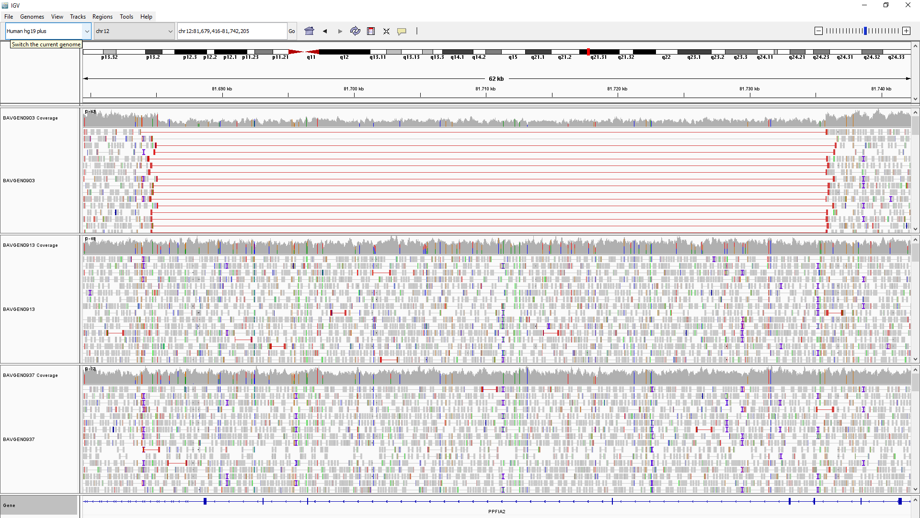Supplementary Figure 1. Visualization of the de novo variant in PPFIA2 found in patient 1. Presentation of the genome data in the Integrative Genomics Viewer (IGV). Top panel is patient 1, followed by the panels of mother and father. The PPFIA2 gene is shown at the bottom. The blue boxes represent the exons. The red lines in the top panel (patient 1) represent the detected heterozygous deletion which includes exons 20-24. As the deletion is not present in the parents, it occurred de novo.

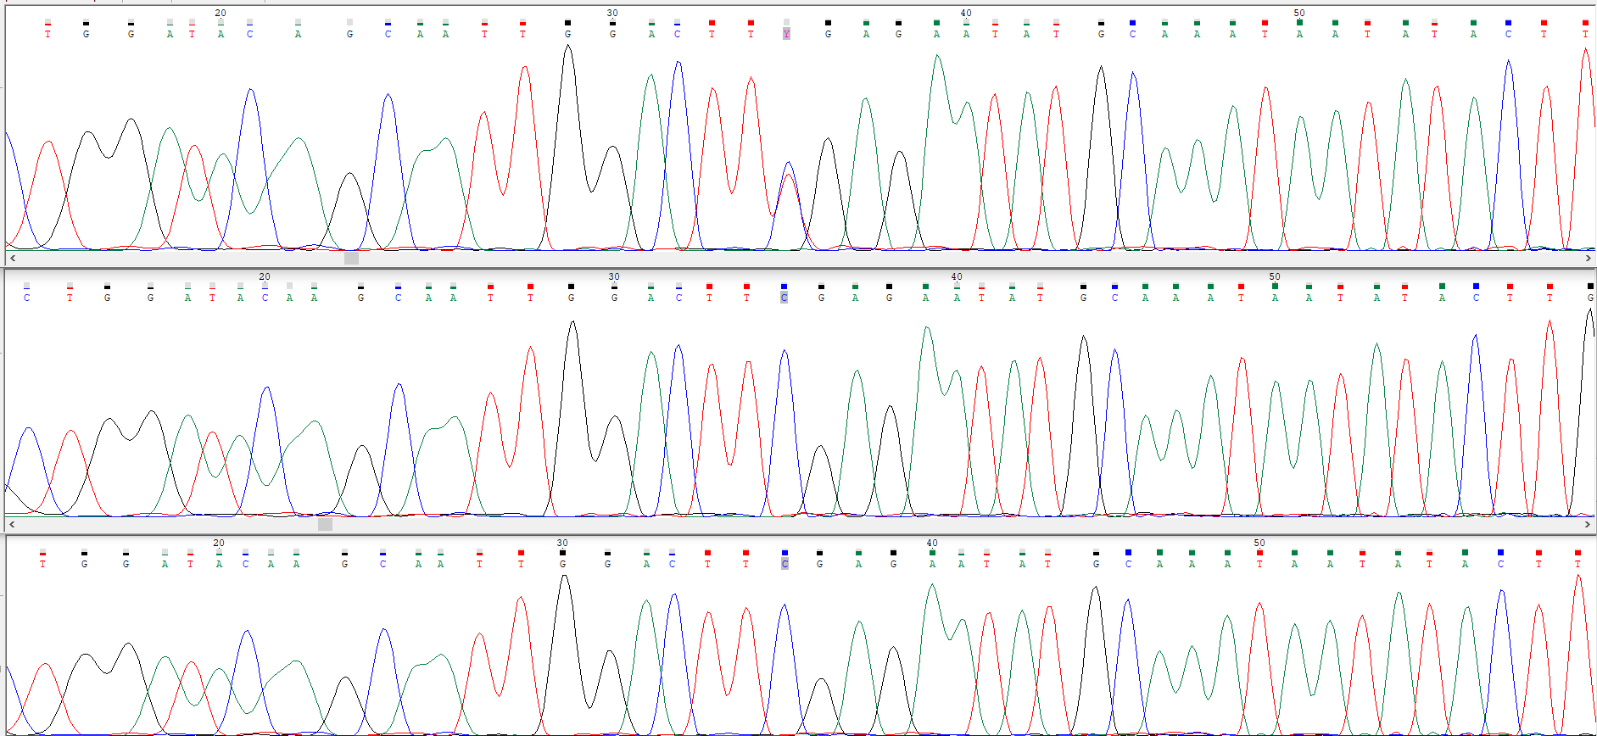
Supplementary Figure 2. Visualization of the de novo variant in PPFIA2 found in patient 2. Presentation of the sanger sequences from patient 2 (top panel) and the parents (following panels). The red arrow points to the heterozygous variant NM_003625.5: c.3367C>T in PPFIA2 showing its presence in patient 2 and its absence in the parents.

Supplementary Tables
Supplementary Table 1: List of rare coding variants found in the autosomal recessive filter. Only variants with an allele frequency below 1% in the in-house database (27,500 exomes, 2,700 genomes) and absent in homozygous state in gnomAD were considered.
n | Chromosome | Gene | Omim | Omim disease | Function | Variant alleles | gnomAD pLI | missense Z-score | ClinVar | gnomAD | CADD | SNV Qual | Geno- type Qual | Map Qual | Depth | %Var | Transcripts | ACMG classification
Individual 1
1 | chr12:9009835-9009835 | A2ML1 | 610627 | ad {Otitis media, susceptibility to} | missense | 1 | 0 | 0,32706 | Benign/Likely_benign | 140296--156--0 | 24,7 | 19 | 99 | 60 | 66 | 65 | uc001quz.5,A2ML1,+,2924T->C,1,non-syn,Met975Thr uc001qva.1,A2ML1,+,1664T->C,1,non-syn,Met555Thr | likely benign
2 | chr12:9020954-9020954 | A2ML1 | 610627 | ad {Otitis media, susceptibility to} | splice | 1 | 0 | 0,32706 | Uncertain_significance(2)|  Benign(1)|Likely_benign(1) | 138271--314--0 | 23,8 | 20 | 99 | 60 | 45 | 60 | uc001quz.5,A2ML1,+,GT->AT,direct splicesite | uncertain significance
3 | chr16:29825240-29825240 | BOLA2 | - | - | missense intronic | 1 |  |  | Uncertain_significance | 116519--6--0 | 18,95 | 8 | 99 | 60 | 30 | 30 | uc002due.4,PRRT2,+,865G->A,0,non-syn,Ala289Thr | NA
4 | chr16:29829813-29829815 | BOLA2 | - | - | indel intronic | 1 |  |  |  | 15655--51--0 |  | 22 | 99 | 60 | 36 | 56 | uc002duh.2,BC029255,-,181_183delGTA,2,indel,29829812,-GTA,del | NA
5 | chr19:8175953-8175953 | FBN3 | - | - | missense | 1 | 0 | 0,9584 | Likely_benign | 140077--457--0 | 19,48 | 18 | 99 | 60 | 50 | 54 | uc002mjf.3,FBN3,-,4199C->T,1,non-syn,Arg1400Gln | NA
6 | chr19:8188682-8188682 | FBN3 | - | - | missense | 1 | 0 | 0,9584 | Likely_benign | 138673--433--0 | 13,72 | 18 | 99 | 60 | 31 | 52 | uc002mjf.3,FBN3,-,2942C->T,1,non-syn,Arg981Gln | NA
Individual 2
1 | chr15:74315485-74315485 | PML | 102578 | Leukemia, acute promyelocytic, PML/RARA type | missense intronic | 1 | 0,21 | 1,7395 |  | 132203--248--0 | 23 | 225 | 99 | 60 | 111 | 51 | uc002awm.3,PML,+,919C->T,0,non-syn,Arg307Cys | uncertain significance
2 | chr15:74336872-74336872 | PML | 102578 | Leukemia, acute promyelocytic, PML/RARA type | missense | 1 | 0,21 | 1,7395 |  | 125235--3--0 | 24,4 | 225 | 99 | 60 | 247 | 45 | uc002awu.3,PML,+,2028C->G,2,non-syn,Phe676Leu | uncertain significance
3 | chr5:140615627-140615627 | PCDHB18 | - | - | missense | 1 |  |  |  | 140618--489--0 | 0,082 | 225 | 99 | 55 | 341 | 43 | uc003ljc.1,PCDHB18,+,1342A->G,0,non-syn,Thr448Ala | NA
4 | chr5:140615637-140615637 | PCDHB18 | - | - | missense | 1 |  |  |  | 140514--731--0 | 1,039 | 225 | 99 | 56 | 364 | 47 | uc003ljc.1,PCDHB18,+,1352T->C,1,non-syn,Val451Ala | NA
5 | chr9:104335472-104335472 | GRIN3A | - | - | missense | 1 | 0,45 | 0,7429 |  | 140182--571--0 | 33 | 225 | 99 | 60 | 92 | 51 | uc004bbo.2,GRIN3A,-,557C->T,1,non-syn,Arg186Gln | NA
6 | chr9:104449175-104449175 | GRIN3A | - | - | missense | 1 | 0,45 | 0,7429 |  | 125714--18--0 | 26,2 | 225 | 99 | 60 | 98 | 39 | uc004bbp.2,GRIN3A,-,1007C->T,1,non-syn,Arg336Gln uc004bbq.1,GRIN3A,-,1007C->T,1,non-syn,Arg336Gln | NA

Supplementary Table 2: List of rare coding variants found in the autosomal dominant/X-linked filter besides the reported PPFIA2 variants. Only variants with an allele frequency below 0,1% in the in-house database (27,500 exomes, 2,700 genomes) and absent in heterozygous and homozygous state in gnomAD were considered.
n | Chromosome | Gene | Omim | Omim disease | Function | Variant alleles | gnomAD pLI | missense Z-score | ClinVar | gnomAD | CADD | SNV Qual | Geno- type Qual | Map Qual | Depth | %Var | Transcripts | ACMG classification
Individual 1
1 | chr12:129299345-129299345 | SLC15A4 |  |  | nonsense noncoding regulation | 1 | 0,00 | 1,00720 |  |  | 35,0 | 18 | 99 | 60 | 44 | 57 | uc001uhu.2,SLC15A4,-,817G->A,0,non-syn,Arg273Stop | NA
2 | chr17:73725483-73725483 | ITGB4 | 147557 | ad Epidermolysis bullosa of hands and feet  ar Epidermolysis bullosa, junctional, non-Herlitz typear Epidermolysis bullosa, junctional, with pyloric atresia | missense | 1 | 0,00 | 0,37378 |  | 125565--0--0 | 31,0 | 13 | 99 | 60 | 47 | 45 | uc010dgo.3,ITGB4,+,704G->A,1,non-syn,Gly235Asp | uncertain significance
3 | chr11:65349012-65349012 | EHBP1L1 |  |  | missense | 1 | 0,00 | 0,84576 |  |  | 28,1 | 13 | 99 | 60 | 53 | 42 | uc001oeo.4,EHBP1L1,+,869C->T,1,non-syn,Ser290Phe | NA
4 | chr2:98375467-98375467 | TMEM131 |  |  | missense | 1 | 1,00 | 2,08120 |  |  | 26,3 | 22 | 99 | 60 | 49 | 67 | uc002syg.3,TMEM131,-,396C->A,2,non-syn,Gln132His | NA
5 | chr17:65688847-65688847 | PITPNC1 |  |  | missense 3utr | 1 | 0,99 | 2,36370 |  |  | 24,9 | 16 | 99 | 60 | 40 | 45 | uc002jgc.4,PITPNC1,+,842C->T,1,non-syn,Ser281Phe | NA
6 | chr11:108811087-108811087 | DDX10 |  |  | missense | 1 | 0,00 | 0,30359 |  |  | 24,5 | 17 | 99 | 60 | 45 | 49 | uc001pkm.3,DDX10,+,2565T->A,2,non-syn,Asp855Glu | NA
7 | chr14:95599758-95599758 | DICER1 | 606241 | GLOW syndrome, somatic mosaic Rhabdomyosarcoma, embryonal, 2  ad Goiter, multinodular 1, with or without Sertoli-Leydig cell tumors  ad Pleuropulmonary blastoma | missense noncoding | 1 | 1,00 | 4,22610 | Uncertain_significance |  | 24,0 | 12 | 99 | 60 | 50 | 38 | uc021sbc.1,DICER1,-,38C->A,1,non-syn,Gly13Val | uncertain significance
8 | chr10:119134459-119134459 | PDZD8 |  |  | missense regulation | 1 | 1,00 | 1,57300 |  |  | 23,1 | 20 | 99 | 60 | 32 | 56 | uc001lde.1,PDZD8,-,280T->C,0,non-syn,Thr94Ala | NA
10 | chr19:9006690-9006690 | MUC16 |  |  | missense noncoding intronic | 1 | 0,00 | -8,06420 |  |  | 13,4 | 18 | 99 | 60 | 47 | 55 | uc010dwj.3,MUC16,-,9G->T,2,non-syn,His3Gln | NA
11 | chr1:167088592-167088592 | DUSP27 |  |  | missense | 1 | 0,00 | -0,06036 |  |  | 12,7 | 20 | 99 | 60 | 51 | 63 | uc001geb.1,DUSP27,+,544C->A,0,non-syn,Leu182Met | NA
12 | chr9:114195617-114195617 | KIAA0368 |  |  | missense | 1 | 1,00 | 1,76590 |  |  | 11,8 | 12 | 99 | 60 | 43 | 44 | uc010muc.1,KIAA0368,-,744T->A,2,non-syn,Glu248Asp | NA
13 | chr11:67206336-67206336 | CORO1B |  |  | missense noncoding regulation | 1 | 0,00 | 1,03240 |  |  | 11,4 | 14 | 99 | 60 | 58 | 47 | uc001olk.1,CORO1B,-,1150C->T,0,non-syn,Asp384Asn | NA
14 | chr9:21385085-21385085 | IFNA2 |  |  | missense | 1 | 0,00 | -0,99474 |  |  | 6,2 | 14 | 99 | 60 | 33 | 52 | uc003zpb.3,IFNA2,-,244T->G,0,non-syn,Met82Leu | NA
15 | chr19:10265114-10265114 | DNMT1 | 126375 | ad Cerebellar ataxia, deafness, and narcolepsy,  autosomal dominantad Neuropathy, hereditary sensory, type IE | missense | 1 | 1,00 | 4,99030 |  |  | 3,1 | 17 | 99 | 60 | 52 | 50 | uc010xlc.2,DNMT1,-,1874C->T,1,non-syn,Arg625Lys | uncertain significance
16 | chr20:35526871-35526871 | SAMHD1 | 606754 | ad ?Chilblain lupus 2ar Aicardi-Goutieres syndrome 5 | missense intronic | 1 | 0,00 | 1,54740 | Uncertain_significance |  | 1,0 | 12 | 99 | 60 | 35 | 37 | uc002xgh.2,SAMHD1,-,1580T->C,1,non-syn,Asn527Ser | uncertain significance
17 | chr10:115612497-115612497 | DCLRE1A |  |  | missense regulation | 1 | 0,00 | 0,57924 |  |  | 0,1 | 20 | 99 | 60 | 41 | 59 | uc001law.3,DCLRE1A,-,445G->A,0,non-syn,Pro149Ser | NA
18 | chr1:13910458-13910458 | PDPN |  |  | missense regulation | 1 | 0,00 | -0,51965 |  |  | 0,0 | 14 | 99 | 60 | 43 | 51 | uc001avc.3,PDPN,+,158G->A,1,non-syn,Cys53Tyr | NA
19 | chr17:28405364-28405364 | EFCAB5 |  |  | missense intronic | 1 | 0,00 | 0,89029 |  |  | 0,0 | 12 | 99 | 60 | 40 | 48 | uc002het.3,EFCAB5,+,2869G->A,0,non-syn,Val957Ile | NA
20 | chr12:3040258-3040259 | TULP3 |  |  | frameshift 5utr noncoding | 1 | 0,00 | 0,25717 |  |  |  | 22 | 99 | 60 | 49 | 57 | uc001qlj.2,TULP3,+,548_549delGA,1,frame-shift,3040257,-GA,del | NA
Individual 2
1 | chr15:75122474-75122474 | CPLX3 |  |  | nonsense | 1 | 0,24 | 0,51328 |  |  | 43,0 | 225 | 99 | 59 | 57 | 53 | uc002ayu.1,CPLX3,+,256G->T,0,non-syn,Glu86Stop | NA
2 | chr5:79439552-79439552 | SERINC5 |  |  | nonsense intronic regulation | 1 | 0,00 | 0,96943 |  |  | 36,0 | 223 | 99 | 60 | 76 | 64 | uc011ctj.2,SERINC5,-,1320G->T,2,non-syn,Cys440Stop | NA
3 | chr3:38663939-38663939 | SCN5A | 600163 | Ventricular fibrillation, familial, 1 ad | missense | 1 | 0,91 | 2,75040 |  |  | 33,0 | 225 | 99 | 60 | 162 | 47 | uc021wvi.1,SCN5A,-,32C->A,1,non-syn,Cys11Phe | uncertain significance
4 | chr6:112457446-112457446 | LAMA4 | 600133 | ad Cardiomyopathy, dilated, 1JJ | missense | 1 | 0,00 | 0,14790 |  |  | 33,0 | 225 | 99 | 60 | 117 | 51 | uc003pvv.3,LAMA4,-,3272A->G,1,non-syn,Phe1091Ser | uncertain significance
5 | chr11:118828376-118828376 | UPK2 |  |  | missense nearsplice | 1 | 0,00 | -0,23739 |  |  | 32,0 | 225 | 99 | 60 | 104 | 43 | uc001puh.3,UPK2,+,416C->T,1,non-syn,Pro139Leu | NA
6 | chr7:4917475-4917475 | RADIL |  |  | missense noncoding | 1 | 0,00 | -0,96625 |  |  | 32,0 | 225 | 99 | 60 | 298 | 47 | uc003snj.1,RADIL,-,296C->G,1,non-syn,Arg99Pro | NA
7 | chr7:6544433-6544433 | GRID2IP |  |  | missense | 1 | 0,12 | 1,06550 |  |  | 29,3 | 225 | 99 | 59 | 101 | 48 | uc011jwx.2,GRID2IP,-,2701A->T,0,non-syn,Tyr901Asn | NA
8 | chr2:203977757-203977757 | NBEAL1 |  |  | missense | 1 | 0,00 | 1,87670 |  |  | 27,1 | 225 | 99 | 60 | 70 | 37 | uc002uzt.3,NBEAL1,+,2135T->C,1,non-syn,Ile712Thr | NA
9 | chr2:73339697-73339697 | RAB11FIP5 |  |  | missense regulation | 1 | 0,00 | 0,70195 |  | 105863--0--0 | 26,8 | 225 | 99 | 60 | 428 | 50 | uc002siu.4,RAB11FIP5,-,209C->A,1,non-syn,Arg70Leu | NA
10 | chr19:47156254-47156254 | DACT3 |  |  | missense | 1 | 0,51 | 2,01370 |  |  | 26,3 | 225 | 99 | 60 | 92 | 50 | uc010ekq.3,DACT3,-,328C->T,0,non-syn,Glu110Lys | NA
11 | chr19:9965233-9965233 | OLFM2 |  |  | missense | 1 | 0,08 | 2,34010 |  |  | 26,1 | 225 | 99 | 60 | 255 | 39 | uc002mmp.3,OLFM2,-,994G->A,0,non-syn,Leu332Phe | NA
12 | chr4:115586901-115586901 | UGT8 |  |  | missense noncoding | 1 | 0,03 | 1,66060 |  |  | 25,9 | 225 | 99 | 60 | 99 | 46 | uc003ibs.2,UGT8,+,1031A->G,1,non-syn,Asn344Ser | NA
13 | chr1:12172030-12172030 | TNFRSF8 |  |  | missense | 1 | 0,86 | 0,94113 |  |  | 25,7 | 225 | 99 | 60 | 371 | 52 | uc001atq.3,TNFRSF8,+,752A->G,1,non-syn,Asp251Gly uc010obc.2,TNFRSF8,+,419A->G,1,non-syn,Asp140Gly | NA
14 | chr1:162551250-162551250 | UAP1 |  |  | splice | 1 | 0,02 | 1,02450 |  |  | 25,7 | 127 | 99 | 60 | 17 | 59 | uc001gce.4,UAP1,+,GT->TT,direct splicesite | NA
15 | chr11:4843406-4843406 | OR51F2 |  |  | missense | 1 | 0,00 | -0,73590 |  |  | 25,5 | 225 | 99 | 60 | 116 | 54 | uc010qyn.2,OR51F2,+,791T->C,1,non-syn,Ile264Thr | NA
16 | chr7:1786481-1786481 | ELFN1 |  |  | missense | 1 | 1,00 | 2,43860 |  |  | 24,9 | 225 | 99 | 60 | 382 | 50 | uc010ksg.2,ELFN1,+,2249A->G,1,non-syn,Tyr750Cys | NA
17 | chr11:59622160-59622160 | TCN1 |  |  | missense | 1 | 0,00 | -1,08250 |  |  | 24,8 | 190 | 99 | 60 | 48 | 40 | uc001noj.2,TCN1,-,1086C->T,2,non-syn,Met362Ile | NA
18 | chr19:59028568-59028568 | ZBTB45 |  |  | missense | 1 | 0,00 | 1,36250 |  |  | 24,2 | 225 | 99 | 60 | 107 | 57 | uc002qtd.3,ZBTB45,-,473G->A,1,non-syn,Ala158Val uc002qtf.3,ZBTB45,-,473G->A,1,non-syn,Ala158Val | NA
19 | chr4:955527-955527 | DGKQ |  |  | missense | 1 | 0,00 | 0,10407 |  |  | 24,0 | 225 | 99 | 60 | 248 | 49 | uc003gbw.4,DGKQ,-,2411T->G,1,non-syn,Gln804Pro | NA
20 | chr1:164815866-164815866 | PBX1 | 176310 | ad Congenital anomalies of kidney and urinary tract syndrome with or without hearing loss, abnormal ears, or developmental delay | missense 3utr intronic | 1 | 1,00 | 3,82660 | Uncertain_significance |  | 23,4 | 225 | 99 | 60 | 102 | 53 | uc001gct.3,PBX1,+,1246T->A,0,non-syn,Ser416Thr | uncertain significance
21 | chr16:75276937-75276937 | BCAR1 |  |  | missense regulation | 1 | 1,00 | -0,59449 |  |  | 23,3 | 225 | 99 | 59 | 118 | 46 | uc010vna.2,BCAR1,-,58G->C,0,non-syn,Leu20Val | NA
22 | chr14:75322005-75322005 | PROX2 |  |  | missense nearsplice | 1 | 0,00 | 0,51942 |  |  | 23,1 | 162 | 99 | 60 | 28 | 61 | uc031qpi.1,PROX2,-,1609C->T,0,non-syn,Val537Ile | NA
23 | chr13:77672376-77672376 | MYCBP2 |  |  | missense | 1 | 1,00 | 6,04510 |  |  | 22,0 | 225 | 99 | 60 | 85 | 47 | uc010aew.3,DKFZp586G0322,-,957A->C,2,non-syn,Ile319Met uc001vkg.1,MYCBP2,-,1368A->C,2,non-syn,Ile456Met | NA
24 | chr19:43233493-43233493 | PSG3 |  |  | missense intronic | 1 | 0,00 | -5,17550 |  |  | 20,3 | 225 | 99 | 58 | 158 | 53 | uc002oue.3,PSG3,-,1025G->A,1,non-syn,Thr342Ile | NA
25 | chr11:102818758-102818758 | MMP13 | 600108 | ad ?Spondyloepimetaphyseal dysplasia, Missouri typead Metaphyseal anadysplasia 1ar Metaphyseal dysplasia, Spahr type | missense | 1 | 0,00 | -0,20977 |  |  | 19,9 | 177 | 99 | 60 | 49 | 45 | uc001phl.3,MMP13,-,1073T->G,1,non-syn,Asn358Thr | uncertain significance
26 | chr5:139267051-139267051 | NRG2 |  |  | missense | 1 | 1,00 | 2,27340 |  |  | 18,8 | 225 | 99 | 60 | 152 | 39 | uc003lev.2,NRG2,-,746A->G,1,non-syn,Val249Ala | NA
27 | chr12:56965593-56965593 | RBMS2 |  |  | missense 5utr intronic | 1 | 0,00 | 0,83531 |  |  | 18,6 | 225 | 99 | 47 | 135 | 51 | uc001sln.2,RBMS2,+,496A->G,0,non-syn,Ile166Val | NA
28 | chr1:210971031-210971031 | KCNH1 | 603305 | ad Temple-Baraitser syndromead Zimmermann-Laband syndrome 1 | missense | 1 | 0,55 | 3,81560 |  |  | 18,5 | 225 | 99 | 60 | 153 | 54 | uc001hib.2,KCNH1,-,1734C->A,2,non-syn,Glu578Asp | NA
29 | chr8:70744820-70744820 | SLCO5A1 |  |  | missense noncoding regulation | 1 | 0,00 | 0,90253 |  |  | 10,3 | 225 | 99 | 60 | 225 | 45 | uc010lzb.3,SLCO5A1,-,89G->A,1,non-syn,Pro30Leu | NA
30 | chr6:35762928-35762928 | CLPS |  |  | missense | 1 | 1,00 | 0,38490 |  |  | 8,0 | 225 | 99 | 60 | 55 | 53 | uc021yyz.1,CLPS,-,292G->T,0,non-syn,Gln98Lys | NA
31 | chr8:13424717-13424717 | C8orf48 |  |  | missense | 1 | 0,00 | -1,23380 |  |  | 7,8 | 225 | 99 | 60 | 91 | 46 | uc003wwp.3,C8orf48,+,217C->A,0,non-syn,Leu73Ile | NA
32 | chr18:30803113-30803113 | CCDC178 |  |  | missense intronic | 1 | 0,00 | -0,54693 |  |  | 5,8 | 225 | 99 | 60 | 37 | 41 | uc010dme.1,CCDC178,-,431C->A,1,non-syn,Arg144Leu | NA
33 | chr17:18647601-18647601 | FBXW10 |  |  | missense 5utr | 1 | 0,00 | 1,00480 |  |  | 4,5 | 225 | 99 | 43 | 252 | 54 | uc002guk.3,FBXW10,+,44G->A,1,non-syn,Arg15His | NA
34 | chr7:100839298-100839298 | MOGAT3 |  |  | syn missense | 1 | 0,00 | 0,31432 |  |  | 2,6 | 225 | 99 | 59 | 100 | 47 | uc003uyc.3,MOGAT3,-,955G->A,0,syn,Leu319Leu | NA
35 | chr19:39008130-39008130 | RYR1 | 180901 | ad King-Denborough syndrome  ad {Malignant hyperthermia susceptibility 1}  ar Minicore myopathy with external ophthalmoplegiaad,ar Central core diseasead,  ar Neuromuscular disease, congenital, with uniform type 1 fiber | missense noncoding | 1 | 0,00 | 1,91800 |  |  | 1,1 | 225 | 99 | 59 | 191 | 54 | uc010xuf.1,RYR1,+,577A->G,0,non-syn,Thr193Ala | uncertain significance
36 | chr8:55539588-55539588 | RP1 | 603937 | ad,ar Retinitis pigmentosa 1 | missense intronic | 1 | 0,00 | -0,89414 |  |  | 0,1 | 225 | 99 | 59 | 63 | 51 | uc003xsd.1,RP1,+,3146A->C,1,non-syn,Lys1049Thr | uncertain significance
37 | chr2:37873450-37873450 | CDC42EP3 |  |  | missense | 1 | 0,19 | -0,05577 |  |  | 0,0 | 225 | 99 | 60 | 142 | 45 | uc002rqi.2,CDC42EP3,-,281A->G,1,non-syn,Val94Ala | NA
38 | chr21:40549396-40549396 | PSMG1 |  |  | missense | 1 | 0,00 | 0,50118 |  |  | 0,0 | 225 | 99 | 60 | 95 | 48 | uc002yxi.4,PSMG1,-,757T->C,0,non-syn,Ile253Val | NA
39 | chr5:140625421-140625421 | PCDHB15 |  |  | frameshift | 1 | 0,00 | -0,61114 |  |  |  | 217 | 99 | 60 | 88 | 42 | uc003lje.3,PCDHB15,+,275_275delG,1,frame-shift,140625420,-G,del | NA

References:
1. Wagner M, Berutti R, Lorenz-Depiereux B, et al. Mitochondrial DNA mutation analysis from exome sequencing-A more holistic approach in diagnostics of suspected mitochondrial disease. J Inherit Metab Dis. 2019;42(5):909-917. doi:10.1002/jimd.12109
2. Chen S, Francioli LC, Goodrich JK, et al. A Genome-Wide Mutational Constraint Map Quantified from Variation in 76,156 Human Genomes. Genetics; 2022. doi:10.1101/2022.03.20.485034

