Supplementary material 1: Details of the methods of maternal lifestyle markers development
Physical activity: Physical activity during pregnancy was estimated by a questionnaire from the Swedish National Board of Health and Welfare (NBHW) based on validated categorical questions. For this purpose, the NBHW questionnaire was included as a part of the NorthPop questionnaire and sent out at gestational age 34 weeks. A total physical activity score was calculated by multiplying exercise time (scores for vigorous physical activity) by two and adding the product to the score for daily (moderate) physical activity, producing an index ranging from 3 to 19. The NBHW recommends a total score ≥ 11 to demarcate optimal physical activity and a score < 11 as inadequate.
Stress: The General Health Questionnaire – 12 items (GHQ-12) was administered at gestational age 26 weeks to pregnant women participating in the NorthPop study to measure their self-reported stress/psychological well-being. The GHQ-12 is a self-reported questionnaire used to examine the degree of general mental health/mental well-being in recent weeks. It comprises 12 statements half of which have been designed negative and the other half positive, in order to minimize response fix. The 12 items are rated on a 4-point scale and scored in several ways. Of these, the bimodal GHQ scoring method (0-0-1-1) and the Likert scoring method (0-1-2-3) are widely used. In this study, we used the bimodal GHQ scoring method (range: 0 – 12). As recommended, participants with a GHQ-12 score ≥ 3 were demarcated as of “reduced psychological well-being” while those with a score < 3 were assumed to be of “sufficient psychological well-being”. Regardless of the estimation method, the GHQ-12 has demonstrated high validity and internal reliability in various settings including in Sweden. The instrument has also been used in previous research to investigate the psychological well-being of pregnant women.
Diet inflammatory index: The literature-derived dietary inflammatory index (Shivappa et al., 2014) has been designed to assess the inflammatory effect of diet in any population and independent of specific dietary assessment method. Dietary assessment in pregnant women participating in the NorthPop study was made via food frequency questionnaire (FFQ)s. The original DII has been derived from 45 food parameters associated with inflammatory markers (IL-1β, IL-4, IL-6, IL-10, TNF-α and C-reactive protein) based on contemporary scientific literature. These 45 parameters have been assigned an overall inflammatory score based on the strength of the association and the quality of the studies. For each parameter, food consumption data from eleven populations in different regions of the world have been used to calculate global mean intakes and standard deviations. An individual’s exposure is calculated by subtracting the global mean intake from the reported intake of each food parameter, dividing by the global standard deviation and converting to a percentile score. The sum of these food-parameter-specific contributions yields the final DII score. The DII score could range from −8.87 (maximally anti-inflammatory to +7.98 (maximally pro-inflammatory). Intakes of 30 of the 45 food parameters assessed by the original study could be retrieved from the FFQs administered in the NorthPop study. These included total energy, total fat, saturated fat, trans fatty acids, cholesterol, monounsaturated fat, polyunsaturated fat, omega-6 fatty acids, omega-3 fatty acids, carbohydrates, protein, fiber, alcohol, caffeine, tea, folic acid, selenium, niacin, iron, zinc, thiamin, vitamin B2, vitamin B6, vitamin B12, vitamin A, vitamin E, vitamin C, vitamin D, magnesium, and β-carotene. Eugenol, garlic, ginger, onion, saffron, turmeric, flanan-3-ol, flavones, flavonols, flavonones, anthocyanidins, isoflavones, pepper, thyme/oregano and rosemary were the 15 omitted parameters. The DII of the present study was calculated as per the method described in the original study but based on the 30 aforementioned parameters (instead of 45).
Diet diversity score: Dietary data from the pregnant women collected through a self-reported FFQ in pregnancy was used to calculate the diet diversity (DD) score. A total of 40 food items were included to calculate a DD score based on the present dietary guidelines for pregnant women in Sweden (Norman et al., 2019). The DD score could potentially range from 0 to 40 points for an individual and was adjusted for total energy intake in kcal per day during pregnancy using the residual method. Detailed information about the development of DD score applied in this study has been published elsewhere (Bodén et al., 2023).
Mediterranean diet score: High intake of vegetables, legumes, fruits, nuts, seeds, cereals, and olive oil, moderately high intake of fish, low to moderate intake of dairy products, moderate intake of alcohol, and low intake of saturated fat, meat and meat products are the cornerstones of Mediterranean diet (Trichopoulou & Critselis, 2004). An adapted version of the Mediterranean diet score (MDS) previously applied to Swedish populations (Bodén et al., 2019) was used in the present study. The adapted MDS comprised three unfavorable food groups and five favorable food groups. The unfavorable food groups included dairy products, meat and meat products, and alcohol (>50 g/day). The favorable food groups included vegetables and potatoes, fruits and nuts, fish and fish products, MUFA+PUFA/SFA-ratio, and whole grain and cereals. The intake of all parameters except MUFA+PUFA/SFA-ratio and alcohol were adjusted to daily energy intakes of 2000 kcal using the nutrient density method. Participants with missing FFQ data and energy intakes below the 1st percentile or >5000 kcal/day were excluded. For favorable parameters, a value of 1 was assigned to subjects whose consumption was higher than the study population-specific median and 0 for intakes below the median. For unfavorable parameters a value of 0 was assigned to subjects whose consumption was higher than the study population-specific median and 1 for intakes below the median, except for alcohol where participants with intakes > 50g/day were assigned 0, and 1 if ≤ 50g/day. The 8 parameter scores were summed for a MDS ranging from 0 (lowest adherence) to 8 (highest adherence).
Healthy Nordic food index: The healthy Nordic food index (HNFI) based on Olsen et al. (Olsen et al., 2011), considers dietary items likely to have beneficial health effects when the consumption is high and is based on six typical food groups consumed in the Nordic countries (fish, cabbages, whole grain rye, whole grain oats, apples and pears, and root vegetables). Based on the FFQ administered during pregnancy in the NorthPop cohort, a score of 0 or 1 was assigned each food group depending on whether the participant's intake was below or above the study population-specific median for that particular food group. The 6 food group scores were summed for a HNFI ranging from 0 (lowest adherence) to 6 (highest adherence).
Total energy intake: Dietary data collected from the pregnant women through a self-reported FFQ at gestational week 34 was linked to the Swedish food composition database administered by the Swedish National Food Agency, to obtain the nutrient contribution of each food item including energy content. By summing up the energy content of all food items reported in the FFQ, the total daily energy intake for each participant was calculated.
Dietary CO2 emission/dietary carbon footprint: Life cycle assessment (LCA) data from the Food Climate Database administered by Research Institutes of Sweden (RISE, 2019) were used to estimate greenhouse gas emissions (GHGE) associated with the diet of the pregnant women. GHGEs from the complete diet assessed using the NorthPop FFQ at gestational week 34 were calculated for all study participants and expressed in kg carbon dioxide equivalents (CO2e) per year.
Gestational weight gain: Gestational weight gain (GWG) data self-reported by NorthPop participants and collected at 4 months postpartum were used in the present study.
BMI at the beginning of pregnancy: Pregnant women’s BMI measured at the beginning of pregnancy during their earliest visit at a maternity care centre was obtained from The Swedish Pregnancy Register .
References
Shivappa N, Steck SE, Hurley TG, Hussey JR, Hébert JR. Designing and developing a literature-derived, population-based dietary inflammatory index. Public Health Nutr. 2014 Aug;17(8):1689-96. DOI: 10.1017/S1368980013002115. Epub 2013 Aug 14. PMID: 23941862; PMCID: PMC3925198.
Norman M, Källén K, Wahlström E, Håkansson S; SNQ Collaboration. The Swedish Neonatal Quality Register - contents, completeness and validity. Acta Paediatr. 2019 Aug;108(8):1411-1418. DOI: 10.1111/apa.14823. Epub 2019 May 20. PMID: 31006126.
Bodén S, Lindam A, Domellöf M, Venter C, West CE. Diet diversity in pregnancy and early allergic manifestations in the offspring. Clin Exp Allergy. 2023 Sep;53(9):963-968. DOI: 10.1111/cea.14346. Epub 2023 Jun 4. PMID: 37271985.
Trichopoulou A, Critselis E. Mediterranean diet and longevity. Eur J Cancer Prev. 2004 Oct;13(5):453-6. doi: 10.1097/00008469-200410000-00014. PMID: 15452459.
Bodén S, Myte R, Wennberg M, Harlid S, Johansson I, Shivappa N, Hébert JR, Van Guelpen B, Nilsson LM. The inflammatory potential of diet in determining cancer risk; A prospective investigation of two dietary pattern scores. PLoS One. 2019 Apr 12;14(4):e0214551. DOI: 10.1371/journal.pone.0214551. PMID: 30978193; PMCID: PMC6461253.
Olsen A, Egeberg R, Halkjær J, Christensen J, Overvad K, Tjønneland A. Healthy aspects of the Nordic diet are related to lower total mortality. J Nutr. 2011 Apr 1;141(4):639-44. DOI: 10.3945/jn.110.131375. Epub 2011 Feb 23. PMID: 21346102.
Food Climate Database 1.6; RISE Research Institutes of Sweden (2019) Gothenburg, Sweden URL: https://www.ri.se/en/what-we-do/expertises/rise-food-climate-database
Supplementary material 2: DNA methylation data quality control and preprocessing pipeline
DNA methylation data pre-processing: Raw DNA methylation data were pre-processed primarily using the ENmix R package (Xu et al, 2016; Xu et al, 2022) version 1.38.01 on Bioconductor version 3.18 via R version 4.3.2. The raw DNA methylation data in IDAT format files were parsed to create an ‘rgDataSet’ with probe annotation, in which array intensities are organized by probe at red and green channels, using the ‘readidat’ function of the ENmix R package (Xu et al, 2016; Xu et al, 2022). Using the ‘Getmeth’ function of the ENmix R package (Xu et al, 2016; Xu et al, 2022), ‘rgDataSet’ was converted to ‘methDataset’ format. The ‘methDataset’ contains intensity values organized according to CpG probes, along with annotation and sample information. In order to produce methylation beta value matrix, ‘getB’ function of ENmix (Xu et al, 2016; Xu et al, 2022) was next applied. Prior to pre-processing, probes were excluded if they were either SNP related, had a call-rate of P < 0.01, were outliers (defined by default as less than Q1 - 3*IQR or greater than Q3 + 3*IQR), or were missing in more than 20% of the samples. The threshold to identify samples with low data quality (the percentage of low-quality methylation data points across probes for each sample) was set at 5% while the threshold to identify probes with low data quality (percentage of low-quality methylation data points across samples for each probe) was specified as 20%. Further low-quality probes were filtered out, using the qcfilter() function of ENmix (Xu et al, 2016; Xu et al, 2022). Non-CpG probes were removed. Methylation signal intensities were background corrected using out-of-band Infinium I intensities. Quantile normalization was applied for methylation intensity values of Infinium I and Infinium II probes separately. Data were corrected for probe type bias using the regression on correlated probes (RCP) method (Niu et al, 2016), via ‘rcp’ function of ENmix (Xu et al, 2016; Xu et al, 2022). Methylation data were estimated as beta values at each CpG site, ranging from 0 (unmethylated) to 1 (fully methylated). Probes with a signal detection p-value > 0.01 were removed. As suggested by Pidsley et al. (2016), cross-reactive probes were removed. As methylation patterns can vary across cord blood cell types, we estimated cord blood cell distributions to be included as covariates. The ‘minfi’ R package (Aryee et al, 2014) version 1.48.0 on Bioconductor version 3.18 via R version 4.3.2 was used for this purpose. The ‘estimateCellCounts’ function of ‘minfi’ was used with ‘compositeCellType’ specified as ‘CordBlood’ and ‘referencePlatform’ specified as ‘IlluminaHumanMethylationEPIC’, to obtain a matrix of composition estimates across all samples and cell types (Aryee et al, 2014; Bakulski et al, 2016). The estimates of seven cell types ("Bcell", "CD4T", "CD8T", "Gran", "Mono", "Neu", and "nRBC") produced by this step were included as covariates in analyses. Control samples (n = 8) were excluded. Known batch effects were removed using the ‘ComBat’ function of the ‘sva’ R package (Leek et al, 2025). We also estimated surrogate variables to account for residual confounding. This was done using intensity data for non-negative internal control probes and setting minimum percentage of variation explained by surrogate variables to 95%, via ‘ctrlsva’ function of ENmix (Xu et al, 2016; Xu et al, 2022). A total of eight surrogate variables produced by this step were included in analyses.
References
Xu Z, Niu L, Li L, Taylor J (2016). “ENmix: a novel background correction method for Illumina HumanMethylation450 BeadChip.” Nucleic Acids Research.
Xu Z, Niu L, Taylor J (2022). “The ENmix DNA methylation analysis pipeline for Illumina BeadChip and comparisons to 7 other preprocessing pipelines.” Clinical Epigenetics.
Pidsley R, Zotenko E, Peters TJ, Lawrence MG, Risbridger GP, Molloy P, Van Djik S, Muhlhausler B, Stirzaker C, Clark SJ. Critical evaluation of the Illumina MethylationEPIC BeadChip microarray for whole-genome DNA methylation profiling. Genome Biol. 2016 Oct 7;17(1):208. doi: 10.1186/s13059-016-1066-1. PMID: 27717381; PMCID: PMC5055731.
Niu L, Xu Z, Taylor J (2016). “RCP: a novel probe design bias correction method for Illumina Methylation BeadChip.” Bioinformatics.
Aryee MJ, Jaffe AE, Corrada-Bravo H, Ladd-Acosta C, Feinberg AP, Hansen KD, Irizarry RA (2014). “Minfi: A flexible and comprehensive Bioconductor package for the analysis of Infinium DNA Methylation microarrays.” Bioinformatics, 30(10), 1363–1369. doi:10.1093/bioinformatics/btu049.
KM Bakulski, JI Feinberg, SV Andrews, J Yang, S Brown, S McKenney, F Witter, J Walston, AP Feinberg, and MD Fallin. DNA methylation of cord blood cell types: Applications for mixed cell birth studies. Epigenetics (2016)

Leek JT, Johnson WE, Parker HS, Fertig EJ, Jaffe AE, Zhang Y, Storey JD, Torres LC (2025). sva: Surrogate Variable Analysis. doi:10.18129/B9.bioc.sva.

Supplementary material 3: Details of high dimensional mediation algorithms
Figure 1: Conceptual framework of the high dimensional mediation model applicable to HDMA, HIMA, and HIMA2
Cord blood methylation/CpG sites

Penalized regression
Linear regression
Mediators
M

Outcome
Y
Exposure(s)
X

Maternal lifestyle
-GWG
-BMI
Offspring’s z-birth weight

Consider the following: a sample of $N$ individuals, an exposure of interest $X_{a}$, a continuous outcome $Y_{a}$, and continuous mediators $M_{a}$of the a^{th} person (range of a: 1 to N). $M_{a}$ is a vector representing a set of R mediators $M_{a}^{(b)}$, whereby b ranges from 1 to R.${ C}_{a}$ is a vector of K covariates. R > 1 > N.
Outcome model:
1
$E[Y_{a}|X_{a}, M_{a}, C_{a}$] = $β_{a}X_{a}$ + $β_{m}^{T}M_{a}$ + $β_{c}^{T}C_{a}$
Where,
- $β_{m}$ is a vector of R length in which the b^{th} component, ($β_{m}$)_{b}, is the linear association of the b^{th} mediator with $Y_{a}$adjusting for the other variables
- $β_{a}$is the association between $X_{a}$and $Y_{a}$adjusting for mediators and covariates
Mediator model:
2
$E\left[M_{a} | X_{a}, C_{a}\right]= α_{a}X_{a}+ α_{c}C_{a}$
Where,
- $α_{a}$is an R vector of the associations between X and each mediator, ($α_{a}$)_{b}
- $α_{c}$ is a matrix of mediator-covariate associations
The mediation contribution of an individual mediator $b$ is equivalent to $\left(α_{a}\right)b{(β}_{m})b$ (as $\sum_{b=1}^{R}{{(α}_{a})b{(β}_{m})b= α_{a}^{T}}β_{m}$)
With respect to the equations 1 and 2, assuming no residual confounding of the X-M association, no residual confounding of the X-Y association, no residual confounding of the M-Y association, that confounders of the M-Y association are not influenced by X, and no X-M interactions influencing Y:
(ii)
(i)
- $β_{a}$is the direct effect estimate of $X_{a}$ on $Y_{a}$
- $α_{a}^{T}β_{m}$ is the total indirect effect/mediatory effect of $X_{a}$ on $Y_{a}$ via $M_{a}$
- And the sum of (i) and (ii) is the total effect of $X_{a}$ on $Y_{a}$
In case of the present study, outcome models and mediator models can be specified as follows:
Outcome models:
- $E\left[{offspring^{'}s z-birth weight}_{a} | …\right]= β_{a}GWG+ β_{m}^{T}{DNAm}_{a}+ β_{c}^{T}{covariates}_{a}$
- $E\left[{offspring^{'}s z-birth weight}_{a} | …\right]= β_{a}BMI+ β_{m}^{T}{DNAm}_{a}$ + $β_{c}^{T}{covariates}_{a}$
Mediator models:
- $E\left[{DNAm}_{a} | …\right]= α_{a}GWG+ α_{c}{covariates}_{a}$
- $E\left[{DNAm}_{a} | …\right]= α_{a}BMI+ α_{c}{covariates}_{a}$
(Where a ranges from 1 to N)
The total indirect (mediatory) effect $α_{a}^{T}β_{m}$ and individual mediation contributions of a given $b$mediator ${(α}_{a})b\left(β_{m}\right)b$ are estimated through a two-step process by the HDMA, HIMA, and HIMA2 methods, as stated below.
Algorithm | R package | Description
HDMA | HDMED  (Clark-Boucher et al, 2023) | Fits a high-dimensional mediation model with the de-biased LASSO approach as proposed by Guo et al. (2022), estimating the mediation contributions of potential mediators. The first step in HDMA is to perform sure independence screening (SIS) (Fan & Ly, 2008) to choose the “n_include” mediators that are most associated with the outcome (when Y is continuous) or the exposure (when Y is binary), based on p-values from linear regression. The second step is to fit the outcome model for the remaining mediators using de-sparsified (a.k.a. de-biased) LASSO, which as asymptotic properties allowing for computation of p-values by the “hdi” package. HDMA then fits the mediator models using linear regression among those mediators that have both survived SIS (in step 1) and been identified by the LASSO (in step 2), obtaining p-values for the mediation contributions by taking the maximum of the  α_{a} and  β_{m} p-values. The global indirect effect is estimated by summing the mediation contributions, and the direct effect is estimated by subtracting the global indirect effect from an estimate of the total effect (Gao et al, 2019).
HIMA | HDMED  (Clark-Boucher et al, 2023) | Fits a high-dimensional mediation model with the minimax concave penalty (MCP) as proposed by Zhang et al. (2016), estimating the mediation contributions of potential mediators. The first step in HIMA is to perform sure independence screening (SIS) to choose the “n_include” mediators that are most associated with the outcome (when Y is continuous) or the exposure (when Y is binary), based on p-values from linear regression. The second step is to apply the MCP to this subset of CpG sites for further dimension reduction. HIMA then fits the mediator models using linear regression among those mediators that have both survived SIS (in step 1) and been selected by the MCP (in step 2), which enables estimation of the mediation contributions. The global indirect effect is estimated by summing these contributions, and the direct effect is estimated by subtracting the global indirect effect from an estimate of the total effect. And p-values for the mediation contributions are computed by taking the maximum of the  α_{a} and  β_{m}  p-values, where the beta p-values are obtained via a second, unpenalized generalized linear model containing only the mediators selected by the MCP.
HIMA2 | HIMA  (Zhang et al, 2016) | An upgraded version of HIMA for estimating and testing high-dimensional mediation effects. First, HIMA2 reduces the dimension of mediators to a manageable level based on the sure independence screening (SIS) method. Second, a de-biased Lasso procedure is implemented for further reducing dimensions and estimating regression parameters on the mediators that have survived both SIS (step 1) and de-biased LASSO (step 2). Third, a multiple-testing procedure is used to accurately control the false discovery rate (FDR) when testing high-dimensional mediation hypotheses (Perera et al, 2022)

References

Clark-Boucher D, Zhou X, Du J, et al. Methods for mediation analysis with high-dimensional DNA methylation data: Possible choices and comparisons. PLoS Genet. 2023 Nov 7;19(11):e1011022. doi: 10.1371/journal.pgen.1011022. PMID: 37934796; PMCID: PMC10655967.

Fan, J. & Lv, J. Sure independence screening for ultrahigh dimensional feature space. J. R. Stat. Soc. 2008 Oct 70;5: 849-911. DOI: https://doi.org/10.1111/j.1467-9868.2008.00674.x

Gao Y, Yang H, Fang R, Zhang Y, Goode EL, Cui Y. Testing Mediation Effects in High-Dimensional Epigenetic Studies. Front Genet. 2019 Nov 22;10:1195. DOI: 10.3389/fgene.2019.01195. PMID: 31824577; PMCID: PMC6883258.

Guo Z, Ćevid D, Bühlmann P. Doubly debiased Lasso: High-dimensional inference under hidden confounding. Ann Stat. 2022 Jun;50(3):1320-1347. DOI: 10.1214/21-aos2152. Epub 2022 Jun 16. PMID: 35958884; PMCID: PMC9365063.

Perera C, Zhang H, Zheng Y, et al. HIMA2: high-dimensional mediation analysis and its application in epigenome-wide DNA methylation data. BMC Bioinformatics. 2022. DOI: 10.1186/s12859-022-04748-1. PMID: 35879655. PMCID: PMC9310002

Zhang H, Zheng Y, Zhang Z, et al. Estimating and testing high-dimensional mediation effects in epigenetic studies. Bioinformatics. 2016 Oct 15;32(20):3150-3154. doi: 10.1093/bioinformatics/btw351. Epub 2016 Jun 29. PMID: 27357171; PMCID: PMC5048064.

Supplementary material 4: Directed acyclic graphs
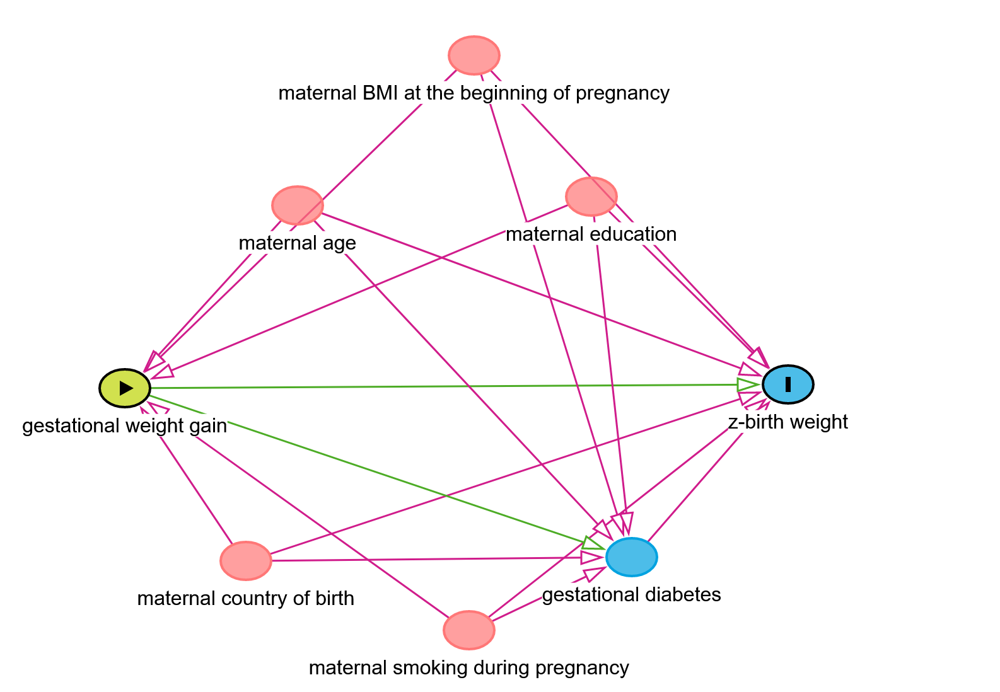
Figure 1: Directed acyclic graph for the association between gestational weight gain and offspring’s z-birth weight
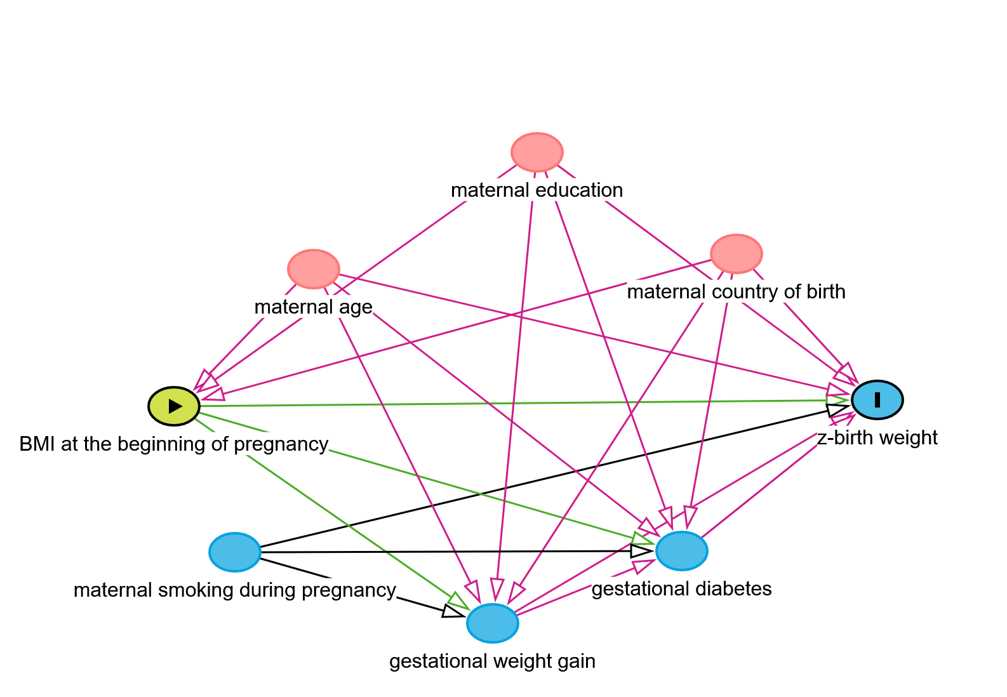
Figure 2: Directed acyclic graph for the association of BMI at the beginning of pregnancy with offspring’s z-birth weight
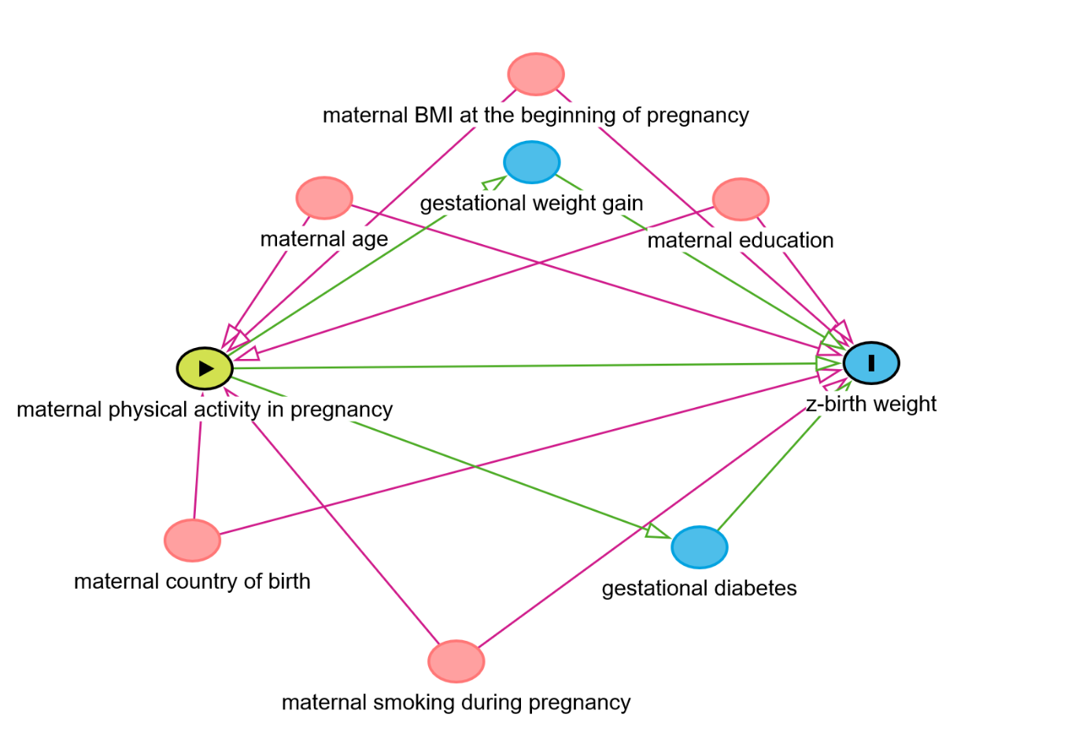
Figure 3: Directed acyclic graph for the association between physical activity in pregnancy and offspring’s z-birth weight
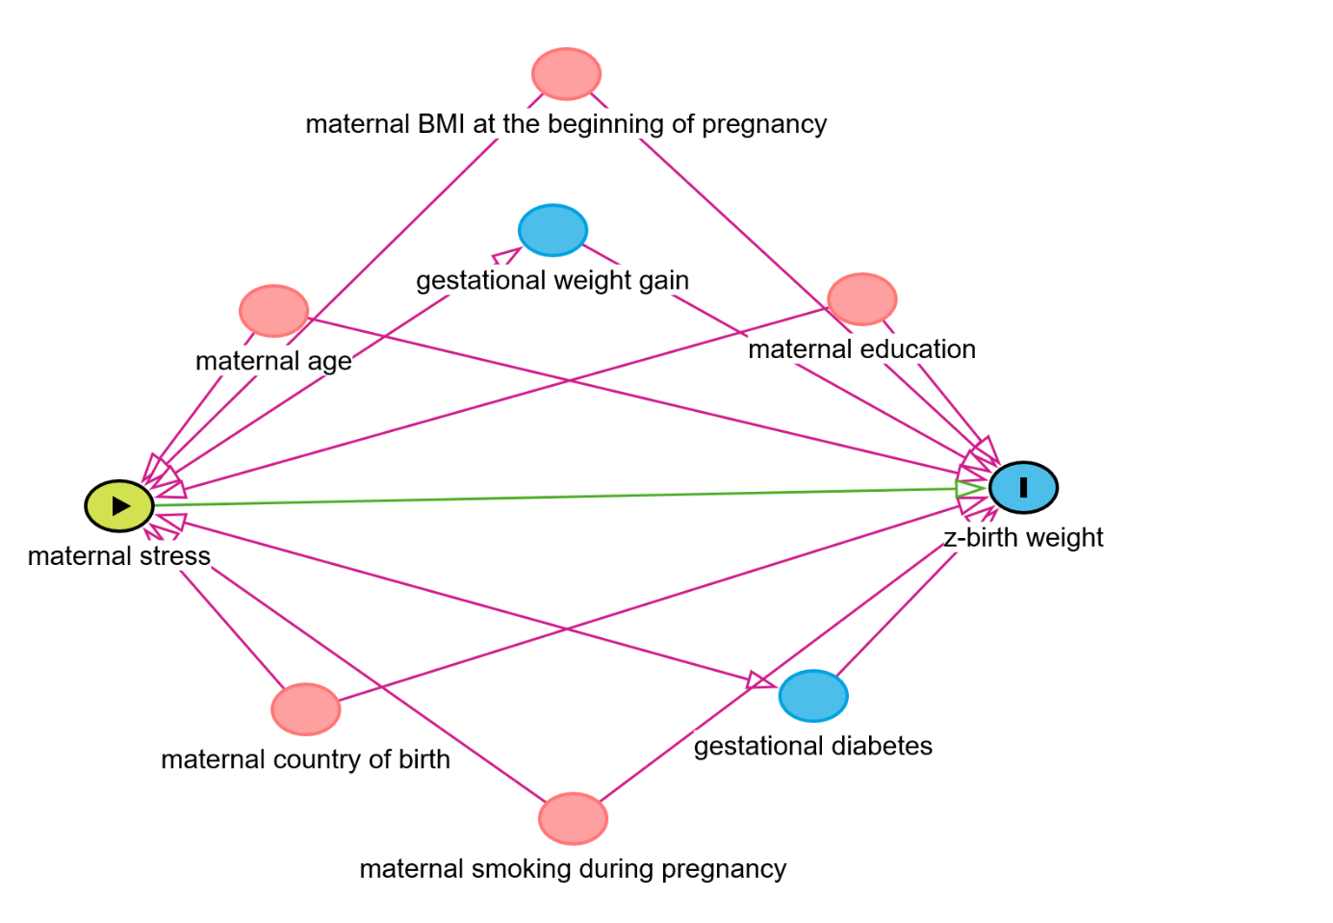
Figure 4: Directed acyclic graph for the association between stress in pregnancy and offspring’s z-birth weight
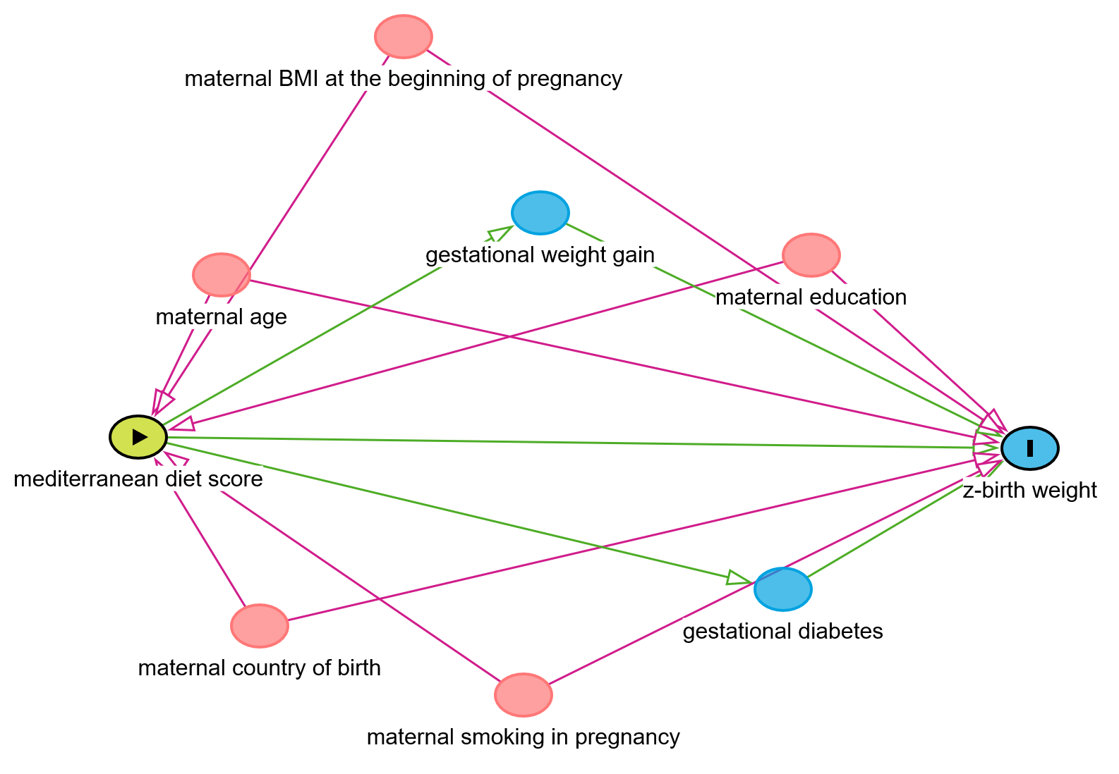
Figure 5: Directed acyclic graph of the association between maternal mediterranean diet score and offspring’s z-birth weight
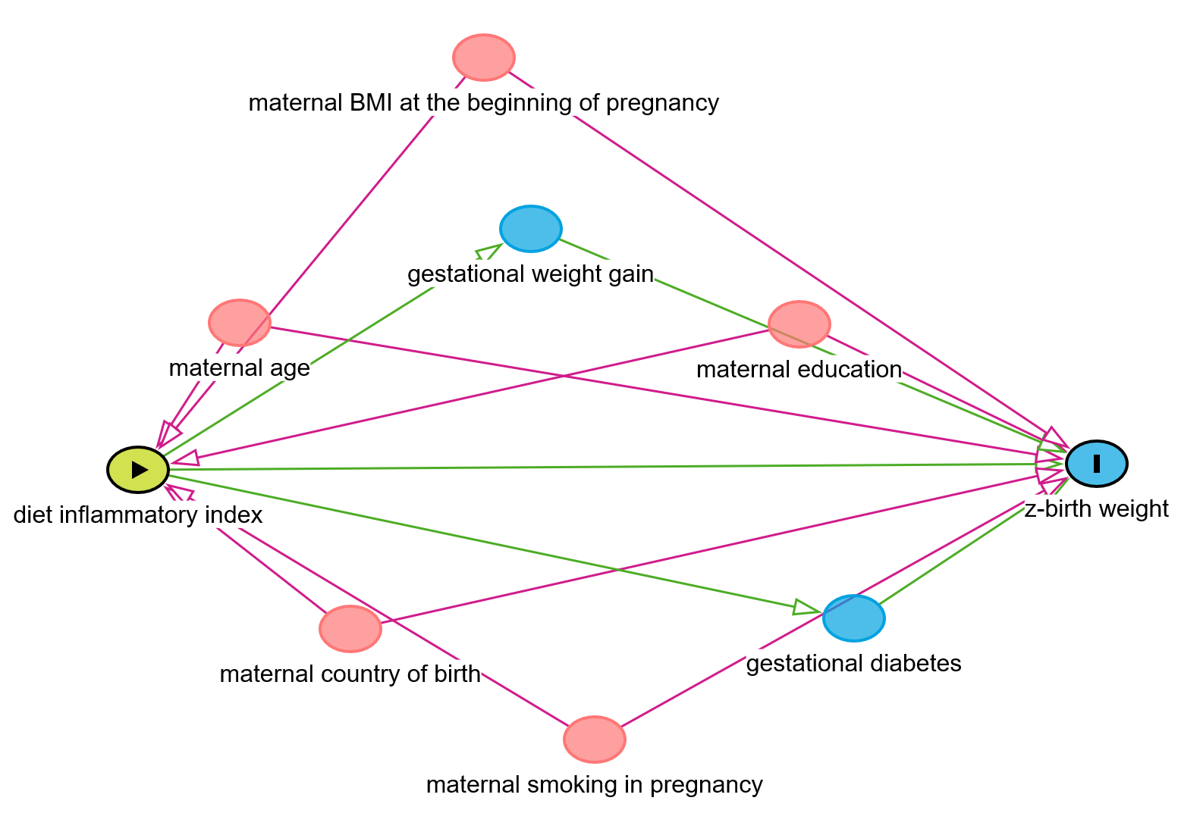
Figure 6: Directed acyclic graph of the association between maternal diet inflammatory index and offspring’s z-birth weight
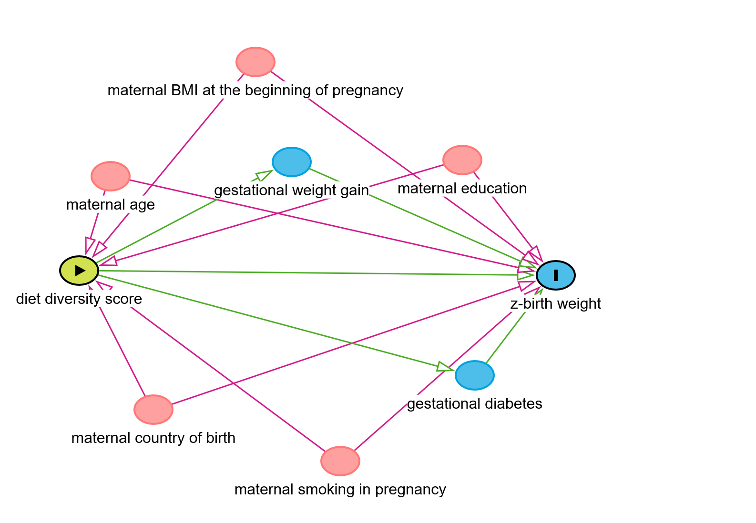
Figure 7: Directed acyclic graph for the association between maternal diet diversity score and offspring’s z-birth weight
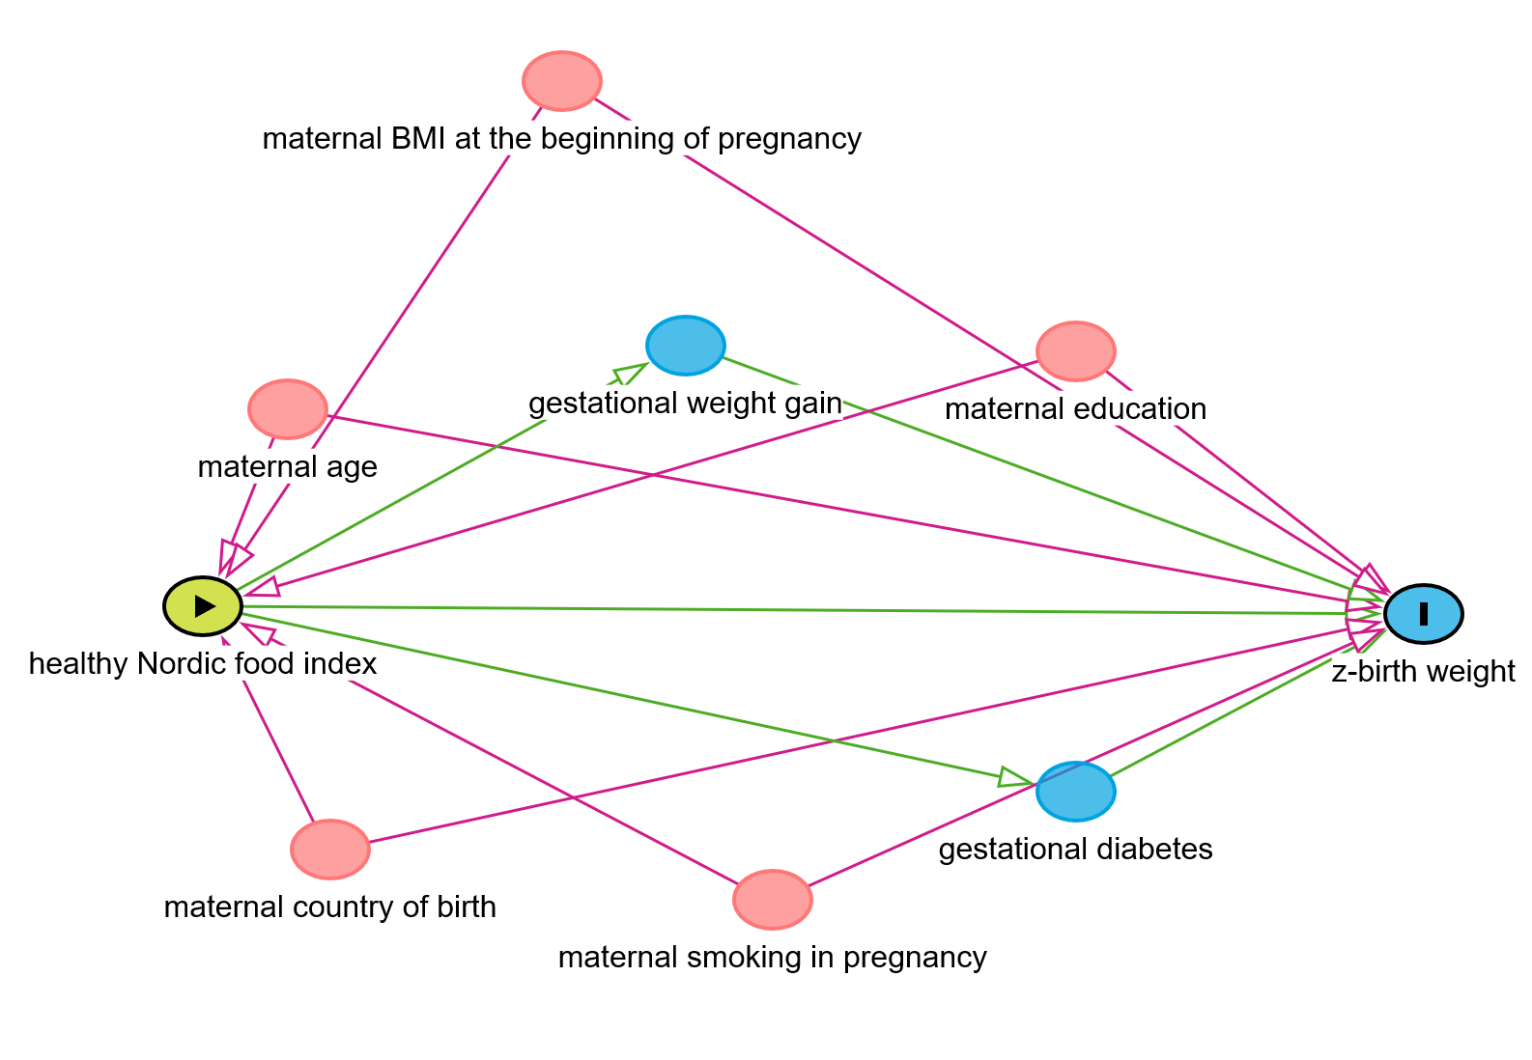
Figure 8: Directed acyclic graph of the association between maternal healthy Nordic food index and offspring’s z-birth weight
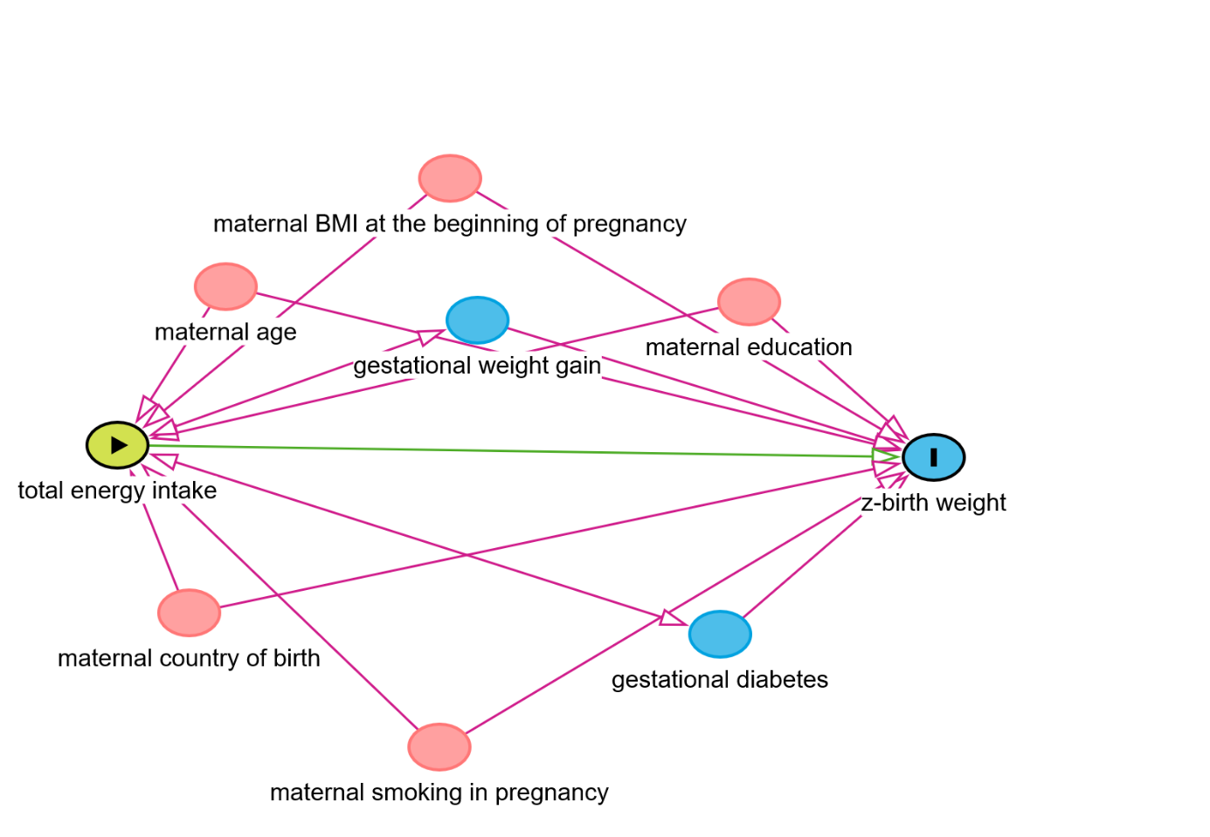
Figure 9: Directed acyclic graph for the association between maternal total energy intake and offspring’s z-birth weight
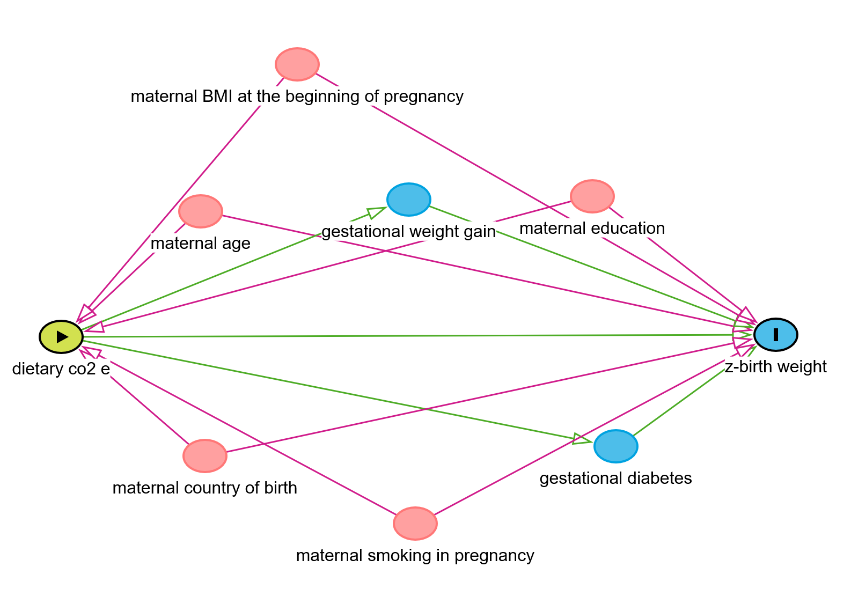
Figure 10: Directed acyclic graph for the association between maternal dietary CO2 emissions/dietary carbon footprint and offspring’s z-birth weight
Supplementary material 5: Correlations and associations between gestational weight gain, maternal BMI at the beginning of pregnancy, and z-birthweight of children in the entire cohort and sub-cohorts
Association of GWG and maternal BMI with z-birthweight (formula = z_birthweight ~ gwg + bmi)
All samples (n = 682) | β (SE) | p-value
GWG | 0.034 (0.007) | 8.9e-07
Maternal BMI | 0.034 (0.009) | 0.0004
Normal weight (N = 439)
GWG | 0.028 (0.009) | 0.002
Maternal BMI | 0.075 (0.027) | 0.005
Overweight (N = 148)
GWG | 0.039 (0.013) | 0.005
Maternal BMI | 0.220 (0.067) | 0.001
Obese (N = 90)
GWG | 0.043 (0.017) | 0.013
Maternal BMI | 0.072 (0.045) | 0.113
Overweight + Obese (N =238)
GWG | 0.038 (0.011) | 0.0004
Maternal BMI | 0.058 (0.021) | 0.008
Association of GWG and maternal BMI with z-birthweight (formula = z_birthweight ~ gwg + bmi + maternal education + maternal age + maternal country of birth + maternal smoking during pregnancy)
All samples (n = 682) | β (SE) | p-value
GWG | 0.031 (0.007) | 2.1e-05
Maternal BMI | 0.036 (0.009) | 0.0002
Normal weight (N = 439)
GWG | 0.026 (0.009) | 0.009
Maternal BMI | 0.059 (0.029) | 0.04
Overweight (N = 148)
GWG | 0.032 (0.014) | 0.02
Maternal BMI | 0.221 (0.065) | 0.0009
Obese (N = 90)
GWG | 0.043 (0.019) | 0.02
Maternal BMI | 0.089 (0.047) | 0.063
Overweight + Obese (N =238)
GWG | 0.034 (0.011) | 0.002
Maternal BMI | 0.049 (0.021) | 0.02

Correlation between maternal BMI at the beginning of pregnancy and gestational weight gain in the entire cohort and sub-cohorts
Cohort | correlation
All samples | 0.04
Normal weight | 0.06
Overweight | -0.08
Obese | -0.08
Overweight + Obese | -0.04

Supplementary material 6: Details of the results of high dimensional mediation analysis

Table 1: Details of the CpG sites selected as candidate mediators (n = 21) of the association between gestational weight gain and offspring’s standardized birth weight by the HDMA approach
mediator | alpha | alpha_pv | beta | beta_pv | alpha*beta | ab_pv
cg04968127 | 1.2592562393181e-05 | 0.943482912347783 | 6.48304957559463 | 0.000472136630128327 | 8.16382062787609e-05 | 0.943482912347783
cg14798382 | 0.000179842458782697 | 0.00634143074595538 | 8.99872499684574 | 0.0492221696292345 | 0.00161835282934206 | 0.0492221696292345
cg21516291 | 0.000382824953097754 | 0.0583456464895654 | 3.05673551872342 | 0.0171201955417699 | 0.00117019463158753 | 0.0493456464895654
cg27053299 | -9.51380933867518e-05 | 0.819666864942751 | -1.34195705859435 | 0.0366016746042471 | 0.00012767123596156 | 0.819666864942751
cg10660916 | -0.000205810561889876 | 0.315750857812919 | 3.2975632784644 | 0.0127387091087569 | -0.000678673351208179 | 0.315750857812919
cg14556683 | 3.12283125351938e-05 | 0.554971262719947 | 9.78276959624868 | 0.0311871443338365 | 0.000305499386411446 | 0.554971262719947
cg10178960 | -1.94479367272413e-05 | 0.82559454162065 | -11.2477692170418 | 0.00598641837578967 | 0.000218745904055641 | 0.82559454162065
cg16752400 | 0.000400552446129279 | 0.160401470771189 | 2.37681014163734 | 0.0159362145400034 | 0.000952037116217713 | 0.160401470771189
cg09247736 | -2.28279102459041e-05 | 0.632406806124404 | 14.9861465912769 | 0.00252788271436388 | -0.000342102409317631 | 0.632406806124404
cg18137450 | 8.61002142411789e-06 | 0.966710683317889 | 3.45867502348622 | 0.0130602143058213 | 2.97792660512778e-05 | 0.966710683317889
cg07002832 | 0.000122424251695494 | 0.472365290755901 | -4.37769511791223 | 0.0145368026395345 | -0.000535936048961421 | 0.472365290755901
cg02832224 | 0.000192465251885373 | 0.336575557147282 | 4.77028530035463 | 0.000838173914696004 | 0.000918114161897846 | 0.336575557147282
cg05779272 | -8.55784564816783e-05 | 0.612011956298708 | 4.28096332247215 | 0.00899726103408218 | -0.000366358233391844 | 0.612011956298708
cg19242268 | 0.000760024753338449 | 0.00334890784466188 | 2.33829417241514 | 0.0167099222305364 | 0.00177716145162255 | 0.0167099222305364
cg16402875 | 0.000116966565807042 | 0.438570007278646 | 4.33269171415938 | 0.0357029301538901 | 0.000506780070505849 | 0.438570007278646
cg15672022 | 0.000155037752532813 | 0.714240985681105 | -1.98704121726876 | 0.0193976826517957 | -0.000308066404515413 | 0.714240985681105
cg13131501 | 0.000318220164252777 | 0.130662136758009 | 3.43822256635646 | 0.012128154820652 | 0.00109411174980356 | 0.130662136758009
cg04457572 | -0.00030989435514351 | 0.2017398152483 | -3.96635481787463 | 0.000496260108866941 | 0.00122915096855561 | 0.2017398152483
cg01940139 | -2.51115958467901e-06 | 0.973494301559011 | 10.6946429024611 | 0.0171917815999335 | -2.68559550292346e-05 | 0.973494301559011
cg08461903 | -0.000655509718183357 | 0.00811177347398761 | -2.15793857112449 | 0.0372974015326812 | 0.00141454970461481 | 0.0372974015326812
cg00154986 | -0.000238410807150942 | 0.329974294873344 | -3.39742352539049 | 0.00254938830678076 | 0.000809982484921947 | 0.329974294873344
alpha = coefficient estimate of the exposure (X) –> mediator (M) association; alpha_pv = p-value for the exposure (X) –> mediator (M) association; beta = coefficient estimate of the mediator (M) –> outcome (Y) association, adjusted for exposure; beta_pv = p-value for the mediator (M) –> outcome (Y) association, adjusted for exposure; alpha*beta = mediation effect; ab_pv = multiple-testing corrected p-value for statistical significance of the mediator
Table 2: Details of the CpG sites selected as candidate mediators (n = 24) of the association between gestational weight gain and offspring’s standardized birth weight by the HIMA approach
mediator | alpha | alpha_pv | beta | beta_pv | alpha_beta | ab_pv
cg04968127 | 1.2592562393181e-05 | 0.943482912347783 | 6.75958264553157 | 3.70754449405406e-05 | 8.51204662157196e-05 | 0.943482912347783
cg05349624 | -4.35252966672858e-05 | 0.904077970813796 | 0.840322689378256 | 0.0578467395585855 | -3.657529435144e-05 | 0.904077970813796
cg21516291 | 0.000382824953097754 | 0.0583456464895654 | 1.69249274542587 | 0.0457505605120574 | 0.000647928455885948 | 0.0483456464895654
cg27053299 | -9.51380933867518e-05 | 0.819666864942751 | -1.21501286390417 | 0.0418674077628547 | 0.000115594007312219 | 0.819666864942751
cg10660916 | -0.000205810561889876 | 0.315750857812919 | 1.30803701933125 | 0.014709737663736 | -0.000269207833921323 | 0.315750857812919
cg14556683 | 3.12283125351938e-05 | 0.554971262719947 | 3.85469332501059 | 0.0671005407551571 | 0.000120375567880756 | 0.554971262719947
cg10178960 | -1.94479367272413e-05 | 0.82559454162065 | -9.80206704315084 | 5.62343191014168e-07 | 0.000190629979651374 | 0.82559454162065
cg16752400 | 0.000400552446129279 | 0.160401470771189 | 0.928010378751901 | 0.0389988398009207 | 0.000371716827242432 | 0.160401470771189
cg05304729 | 0.000478483687967837 | 0.156837160881313 | 1.20103752165605 | 0.0836401668609472 | 0.000574676862749736 | 0.156837160881313
cg04751761 | -5.67505287452858e-05 | 0.807817547708683 | 0.814647372936708 | 0.143972412378901 | -4.62316691551162e-05 | 0.807817547708683
cg09247736 | -2.28279102459041e-05 | 0.632406806124404 | 13.2141401690776 | 0.00184877684309049 | -0.000301651205756499 | 0.632406806124404
cg18137450 | 8.61002142411789e-06 | 0.966710683317889 | 3.11429286252577 | 0.0173384770991019 | 2.68141282673243e-05 | 0.966710683317889
cg02832224 | 0.000192465251885373 | 0.336575557147282 | 4.30528808756109 | 0.00114327472651364 | 0.000828618356211542 | 0.336575557147282
cg05779272 | -8.55784564816783e-05 | 0.612011956298708 | 2.92931280928598 | 0.00379852288395121 | -0.000250686068770703 | 0.612011956298708
cg19242268 | 0.000760024753338449 | 0.00334890784466188 | 1.3527834007674 | 0.0425573491051202 | 0.0010281488704886 | 0.0425573491051202
cg05560494 | -0.000308318008237926 | 0.0449686663943078 | 1.07431757013899 | 0.111659504860774 | -0.000331231453440261 | 0.111659504860774
cg16402875 | 0.000116966565807042 | 0.438570007278646 | 1.64915983572727 | 0.160556634901143 | 0.000192896562451925 | 0.438570007278646
cg13131501 | 0.000318220164252777 | 0.130662136758009 | 3.05258313184316 | 0.00765833296821208 | 0.000971393505610388 | 0.130662136758009
cg12804755 | -0.000991844089265759 | 0.0235692311108214 | -0.115673811519423 | 0.15428781303189 | 0.000114730386238381 | 0.15428781303189
cg04457572 | -0.00030989435514351 | 0.2017398152483 | -4.40682206507038 | 0.000761053860591922 | 0.00136564928208718 | 0.2017398152483
cg22247250 | -2.89695543774692e-05 | 0.904668336162854 | -0.207715197120164 | 0.261250052093978 | 6.01741669799932e-06 | 0.904668336162854
cg08461903 | -0.000655509718183357 | 0.00811177347398761 | -1.37189363084973 | 0.0577926151259687 | 0.000899289607335848 | 0.0477926151259687
cg00154986 | -0.000238410807150942 | 0.329974294873344 | -3.19555112675531 | 0.00533293062193004 | 0.000761853923421836 | 0.329974294873344
cg12145085 | 2.25872069728283e-05 | 0.803337553572515 | 3.78374200737788 | 0.0517847807552656 | 8.54641638524291e-05 | 0.803337553572515
alpha = coefficient estimate of the exposure (X) –> mediator (M) association; alpha_pv = p-value for the exposure (X) –> mediator (M) association; beta = coefficient estimate of the mediator (M) –> outcome (Y) association, adjusted for exposure; beta_pv = p-value for the mediator (M) –> outcome (Y) association, adjusted for exposure; alpha*beta = mediation effect; ab_pv = multiple-testing corrected p-value for statistical significance of the mediator
Table 3: Details of the CpG sites selected as candidate mediators (n = 24) of the association between gestational weight gain and offspring’s standardized birth weight by the HIMA2 approach
probe | alpha | beta | alpha*beta | BH.FDR
cg04968127 | 1.2592562393181e-05 | 6.75958264553157 | 8.51204662157196e-05 | 0.966710683317889
cg05349624 | -4.35252966672858e-05 | 0.840322689378256 | -3.657529435144e-05 | 0.966710683317889
cg21516291 | 0.000382824953097754 | 1.69249274542587 | 0.000647928455885948 | 0.280059103149914
cg27053299 | -9.51380933867518e-05 | -1.21501286390417 | 0.000115594007312219 | 0.966710683317889
cg10660916 | -0.000205810561889876 | 1.30803701933125 | -0.000269207833921323 | 0.673151114294564
cg14556683 | 3.12283125351938e-05 | 3.85469332501059 | 0.000120375567880756 | 0.948610209186606
cg10178960 | -1.94479367272413e-05 | -9.80206704315084 | 0.000190629979651374 | 0.966710683317889
cg16752400 | 0.000400552446129279 | 0.928010378751901 | 0.000371716827242432 | 0.481204412313568
cg05304729 | 0.000478483687967837 | 1.20103752165605 | 0.000574676862749736 | 0.481204412313568
cg04751761 | -5.67505287452858e-05 | 0.814647372936708 | -4.62316691551162e-05 | 0.966710683317889
cg09247736 | -2.28279102459041e-05 | 13.2141401690776 | -0.000301651205756499 | 0.948610209186606
cg18137450 | 8.61002142411789e-06 | 3.11429286252577 | 2.68141282673243e-05 | 0.966710683317889
cg02832224 | 0.000192465251885373 | 4.30528808756109 | 0.000828618356211542 | 0.673151114294564
cg05779272 | -8.55784564816783e-05 | 2.92931280928598 | -0.000250686068770703 | 0.948610209186606
cg19242268 | 0.000760024753338449 | 1.3527834007674 | 0.0010281488704886 | 0.049037378827188
cg05560494 | -0.000308318008237926 | 1.07431757013899 | -0.000331231453440261 | 0.269811998365847
cg16402875 | 0.000116966565807042 | 1.64915983572727 | 0.000192896562451925 | 0.809667705745192
cg13131501 | 0.000318220164252777 | 3.05258313184316 | 0.000971393505610388 | 0.481204412313568
cg12804755 | -0.000991844089265759 | -0.115673811519423 | 0.000114730386238381 | 0.188553848886571
cg04457572 | -0.00030989435514351 | -4.40682206507038 | 0.00136564928208718 | 0.537972840662133
cg22247250 | -2.89695543774692e-05 | -0.207715197120164 | 6.01741669799932e-06 | 0.966710683317889
cg08461903 | -0.000655509718183357 | -1.37189363084973 | 0.000899289607335848 | 0.049734128168785
cg00154986 | -0.000238410807150942 | -3.19555112675531 | 0.000761853923421836 | 0.673151114294564
cg12145085 | 2.25872069728283e-05 | 3.78374200737788 | 8.54641638524291e-05 | 0.966710683317889
alpha = coefficient estimates of exposure (X) –> mediators (M) associations; beta = coefficient estimates of mediators (M) –> outcome (Y) associations, adjusted for exposure; alpha*beta = mediation effects; BH.FDR = Benjamini-Hochberg FDR adjusted p-value for statistical significance of the mediator

Table 4: Details of the CpG sites selected as candidate mediators (n = 25) of the association between maternal BMI at the beginning of pregnancy and offspring’s standardized birth weight by the HDMA approach
mediator | alpha | alpha_pv | beta | beta_pv | alpha*beta | ab_pv
cg04968127 | -0.000117134888335002 | 0.618917142513759 | 5.27195794579884 | 0.00413647459914182 | -0.000617530205287973 | 0.618917142513759
cg21516291 | 0.00033374992013122 | 0.21164768787333 | 2.59878056884976 | 0.0358030566475134 | 0.000867342807292175 | 0.21164768787333
cg23260105 | 2.90524138089407e-05 | 0.51073316100907 | -22.7082985275131 | 0.00388630875461215 | -0.000659730885718269 | 0.51073316100907
cg00376553 | -0.000320823988220308 | 0.489055912097046 | 1.57548277360594 | 0.0480063334806574 | -0.000505452666800651 | 0.489055912097046
cg17040807 | -0.000704476905025845 | 0.0159508530025362 | -3.07893622985714 | 0.0111265033324041 | 0.0021690394659817 | 0.0159508530025362
cg21649604 | -2.17818339879823e-05 | 0.939581490118541 | 2.80143500194308 | 0.0481309517778563 | -6.10203921404471e-05 | 0.939581490118541
cg16752400 | 0.000656226879343457 | 0.080350059076816 | 3.71635251500328 | 0.000128013654566387 | 0.00243877041346081 | 0.080350059076816
cg25494075 | -3.91488935606756e-05 | 0.825774942846241 | 4.90109031266213 | 0.0409676393419151 | -0.000191872262981668 | 0.825774942846241
cg08289567 | 0.000275383318912381 | 0.0981604838802426 | -4.71732003165868 | 0.027716787783651 | -0.00129907124669003 | 0.0981604838802426
cg18137450 | 6.37984648871824e-05 | 0.813541141875918 | 5.25562586924733 | 0.000130841314467748 | 0.000335300862479344 | 0.813541141875918
cg02832224 | 0.000204165898093526 | 0.439698016260347 | 5.05210158320132 | 0.00027709340581825 | 0.00103146685699402 | 0.439698016260347
cg05779272 | -1.89362646499239e-05 | 0.932030953822198 | 3.25181215955961 | 0.0383588085887173 | -6.15771756452615e-05 | 0.932030953822198
cg19242268 | 0.000908375085696785 | 0.00839714356148382 | 2.58860418310286 | 0.00588795295016003 | 0.00235142354666111 | 0.00839714356148382
cg26552621 | 0.000850935104261077 | 0.0139543437332839 | -2.94899820527688 | 0.0173224491001761 | -0.00250940609527301 | 0.0173224491001761
cg18034719 | 2.94817270353869e-05 | 0.883337290484565 | 6.58689405871855 | 0.000137747152649459 | 0.000194193012650152 | 0.883337290484565
cg09171931 | 0.000195477624652817 | 0.231865982738286 | 4.51454056547862 | 0.0488914826091835 | 0.000882491666138544 | 0.231865982738286
cg13131501 | -4.76366283295481e-05 | 0.863672121362842 | 3.52422373071971 | 0.00970500342750538 | -0.000167882136010468 | 0.863672121362842
cg03688987 | -0.000302895818199109 | 0.329872638719241 | -2.57539772364163 | 0.0199558712340388 | 0.000780077200690554 | 0.329872638719241
cg04457572 | -0.000694880116204726 | 0.031228407402061 | -2.95153383564912 | 0.00837106340936899 | 0.00205096217469804 | 0.031228407402061
cg06457011 | 0.00177574711976154 | 0.00846277004263347 | 1.10692179627811 | 0.0475767762890234 | 0.00196561319154213 | 0.0475767762890234
cg14787880 | -1.59799882978612e-05 | 0.82367882718336 | 12.4236595667117 | 0.00412635467076922 | -0.000198529934492664 | 0.82367882718336
cg01940139 | 2.37574795826187e-05 | 0.812076779671485 | 10.6467896073137 | 0.0137169578521857 | 0.000252940886716191 | 0.812076779671485
cg08461903 | -0.000265659351759233 | 0.41928543011665 | -2.04957775316619 | 0.0418100945645003 | 0.000544489497286276 | 0.41928543011665
cg00154986 | -0.000431642782876597 | 0.183246804486515 | -2.42207986145519 | 0.0250716193415645 | 0.00104547329174788 | 0.183246804486515
cg12145085 | 0.000114330079463317 | 0.341439491945482 | 7.07713886503554 | 0.0311642639360312 | 0.000809129848812443 | 0.341439491945482
alpha = coefficient estimate of the exposure (X) –> mediator (M) association; alpha_pv = p-value for the exposure (X) –> mediator (M) association; beta = coefficient estimate of the mediator (M) –> outcome (Y) association, adjusted for exposure; beta_pv = p-value for the mediator (M) –> outcome (Y) association, adjusted for exposure; alpha*beta = mediation effect; ab_pv = multiple-testing corrected p-value for statistical significance of the mediator
Table 5: Details of the CpG sites selected as candidate mediators (n = 24) of the association between maternal BMI at the beginning of pregnancy and offspring’s standardized birth weight by the HIMA approach
mediator | alpha | alpha_pv | beta | beta_pv | alpha*beta | ab_pv
cg04968127 | -0.000117134888335002 | 0.618917142513759 | 5.37173490299259 | 0.000290892720913403 | -0.000629217568027269 | 0.618917142513759
cg14798382 | 0.000162532316756727 | 0.0591352611892092 | 3.90604522473127 | 0.0696595668639727 | 0.000634858579732123 | 0.0696595668639727
cg21516291 | 0.00033374992013122 | 0.21164768787333 | 1.26334937860766 | 0.0177476188496189 | 0.000421642754208133 | 0.21164768787333
cg23260105 | 2.90524138089407e-05 | 0.51073316100907 | -21.342802189629 | 0.00193441981218922 | -0.000620059921055468 | 0.51073316100907
cg00376553 | -0.000320823988220308 | 0.489055912097046 | 2.04225736532118 | 0.00268698953410555 | -0.000655205152914639 | 0.489055912097046
cg17040807 | -0.000704476905025845 | 0.0159508530025362 | -1.53143545695465 | 0.00660634221675107 | 0.00107886091096226 | 0.0159508530025362
cg16752400 | 0.000656226879343457 | 0.080350059076816 | 2.68237575728844 | 0.000417339650600328 | 0.00176024707243193 | 0.080350059076816
cg05304729 | 0.000734327829433121 | 0.0967000500853513 | 1.37499408005475 | 0.0185295353501625 | 0.00100969641828999 | 0.0967000500853513
cg15482893 | 0.000823698172114162 | 0.0788628214820748 | -0.0941678797143056 | 0.00685939995463376 | -7.75659103925398e-05 | 0.0788628214820748
cg18137450 | 6.37984648871824e-05 | 0.813541141875918 | 4.66617476087281 | 3.43971182027634e-05 | 0.000297694786639001 | 0.813541141875918
cg02832224 | 0.000204165898093526 | 0.439698016260347 | 4.71846067911673 | 3.31097297124896e-05 | 0.000963348762170857 | 0.439698016260347
cg05779272 | -1.89362646499239e-05 | 0.932030953822198 | 0.729871283409996 | 0.0409377826375437 | -1.38210357830313e-05 | 0.932030953822198
cg19242268 | 0.000908375085696785 | 0.00839714356148382 | 2.65827072473442 | 0.0026266133470941 | 0.00241470689738589 | 0.00839714356148382
cg26552621 | 0.000850935104261077 | 0.0139543437332839 | -3.62251245003404 | 5.0292368803488e-05 | -0.00308252300935677 | 0.0139543437332839
cg18034719 | 2.94817270353869e-05 | 0.883337290484565 | 7.11023506285039 | 1.22203072819428e-05 | 0.000209622009280392 | 0.883337290484565
cg13131501 | -4.76366283295481e-05 | 0.863672121362842 | 2.4167626589876 | 0.00145077902020376 | -0.000115126424546923 | 0.863672121362842
cg03688987 | -0.000302895818199109 | 0.329872638719241 | -3.20384719678319 | 0.00292620695547031 | 0.000970431918054567 | 0.329872638719241
cg04457572 | -0.000694880116204726 | 0.031228407402061 | -1.87910302900048 | 0.0115078360745678 | 0.00130575133115251 | 0.031228407402061
cg06457011 | 0.00177574711976154 | 0.00846277004263347 | 0.278375863358203 | 0.0321060839835381 | 0.000494325137569461 | 0.0321060839835381
cg14787880 | -1.59799882978612e-05 | 0.82367882718336 | 13.5024815599172 | 0.00108207855642818 | -0.000215769497319563 | 0.82367882718336
cg01940139 | 2.37574795826187e-05 | 0.812076779671485 | 7.9930068442057 | 0.00268393072307276 | 0.000189893696904948 | 0.812076779671485
cg08461903 | -0.000265659351759233 | 0.41928543011665 | -2.26673374873755 | 0.0111202593175418 | 0.000602179018300393 | 0.41928543011665
cg00154986 | -0.000431642782876597 | 0.183246804486515 | -0.321149817365529 | 0.0802809621460652 | 0.000138622000887968 | 0.183246804486515
cg05632420 | 0.000366182079550837 | 0.313439226072183 | -1.54941738008431 | 0.00164985898614122 | -0.000567368878331482 | 0.313439226072183
alpha = coefficient estimate of the exposure (X) –> mediator (M) association; alpha_pv = p-value for the exposure (X) –> mediator (M) association; beta = coefficient estimate of the mediator (M) –> outcome (Y) association, adjusted for exposure; beta_pv = p-value for the mediator (M) –> outcome (Y) association, adjusted for exposure; alpha*beta = mediation effect; ab_pv = multiple-testing corrected p-value for statistical significance of the mediator
Table 6: Details of the CpG sites selected as candidate mediators (n = 24) of the association between maternal BMI at the beginning of pregnancy and offspring’s standardized birth weight by the HIMA2 approach
mediator | alpha | beta | alpha*beta | BH.FDR
cg04968127 | -0.000117134888335002 | 5.37173490299259 | -0.000629217568027269 | 0.825222856685011
cg14798382 | 0.000162532316756727 | 3.90604522473127 | 0.000634858579732123 | 0.236541044756837
cg21516291 | 0.00033374992013122 | 1.26334937860766 | 0.000421642754208133 | 0.461776773541811
cg23260105 | 2.90524138089407e-05 | -21.342802189629 | -0.000620059921055468 | 0.721035050836334
cg00376553 | -0.000320823988220308 | 2.04225736532118 | -0.000655205152914639 | 0.721035050836334
cg17040807 | -0.000704476905025845 | -1.53143545695465 | 0.00107886091096226 | 0.0957051180152175
cg16752400 | 0.000656226879343457 | 2.68237575728844 | 0.00176024707243193 | 0.241050177230448
cg05304729 | 0.000734327829433121 | 1.37499408005475 | 0.00100969641828999 | 0.257866800227604
cg15482893 | 0.000823698172114162 | -0.0941678797143056 | -7.75659103925398e-05 | 0.241050177230448
cg18137450 | 6.37984648871824e-05 | 4.66617476087281 | 0.000297694786639001 | 0.921743259636068
cg02832224 | 0.000204165898093526 | 4.71846067911673 | 0.000963348762170857 | 0.703516826016555
cg05779272 | -1.89362646499239e-05 | 0.729871283409996 | -1.38210357830313e-05 | 0.932030953822198
cg19242268 | 0.000908375085696785 | 2.65827072473442 | 0.00241470689738589 | 0.0957051180152175
cg26552621 | 0.000850935104261077 | -3.62251245003404 | -0.00308252300935677 | 0.0957051180152175
cg18034719 | 2.94817270353869e-05 | 7.11023506285039 | 0.000209622009280392 | 0.921743259636068
cg13131501 | -4.76366283295481e-05 | 2.4167626589876 | -0.000115126424546923 | 0.921743259636068
cg03688987 | -0.000302895818199109 | -3.20384719678319 | 0.000970431918054567 | 0.608995640712446
cg04457572 | -0.000694880116204726 | -1.87910302900048 | 0.00130575133115251 | 0.149896355529893
cg06457011 | 0.00177574711976154 | 0.278375863358203 | 0.000494325137569461 | 0.0957051180152175
cg14787880 | -1.59799882978612e-05 | 13.5024815599172 | -0.000215769497319563 | 0.921743259636068
cg01940139 | 2.37574795826187e-05 | 7.9930068442057 | 0.000189893696904948 | 0.921743259636068
cg08461903 | -0.000265659351759233 | -2.26673374873755 | 0.000602179018300393 | 0.703516826016555
cg00154986 | -0.000431642782876597 | -0.321149817365529 | 0.000138622000887968 | 0.439792330767635
cg05632420 | 0.000366182079550837 | -1.54941738008431 | -0.000567368878331482 | 0.608995640712446
alpha = coefficient estimates of exposure (X) –> mediators (M) associations; beta = coefficient estimates of mediators (M) –> outcome (Y) associations, adjusted for exposure; alpha*beta = mediation effects; BH.FDR = Benjamini-Hochberg FDR adjusted p-value for statistical significance of the mediator

Supplementary material 7: Summary of results from ordinary least squares bootstrap mediation analysis with candidate CpG sites selected by high dimensional mediation analysis
Epigenetic mediation of the association between gestational weight gain and offspring’s standardized birth weight
Single mediator models – OLS bootstrap approach
CpG | Indirect effect |  | Direct effect |  |  | Total effect
 | Estimate | 95% CI | Estimate | SE | p-value | Estimate | SE | p-value
cg19242268 | 0.0035 | 0.0011, 0.0077 | 0.0269 | 0.007 | 0.0001 | 0.0304 | 0.007 | 0.00002
cg08461903 | 0.0030 | 0.0006, 0.0063 | 0.0274 | 0.007 | 0.0001 | 0.0304 | 0.007 | 0.00002
cg14798382 | 0.0042 | 0.0014, 0.0081 | 0.0262 | 0.007 | 0.0001 | 0.0304 | 0.007 | 0.00002
cg21516291 | 0.0028 | -0.0001, 0.0065 | 0.0276 | 0.007 | 0.00005 | 0.0304 | 0.007 | 0.00002
Serial multiple mediator model – OLS bootstrap approach
Indirect effects |  |  | Direct effect |  |  | Total effect
Pathway | Estimate | 95% CI | Estimate | SE | p-value | Estimate | SE | p-value
Total indirect | 0.009345 | 0.005113, 0.0148 | 0.021091 | 0.007 | 0.002 | 0.030436 | 0.007 | 0.00002
Indirect1 | 0.003237 | 0.000947, 0.007157 | (Indirect1: GWG -> cg19242268 -> z-birth weight)
Indirect2 | 0.002556 | 0.000487, 0.005649 | (Indirect2: GWG -> cg08461903 -> z-birth weight)
Indirect3 | 0.002875 | 0.000567, 0.006130 | (Indirect3: GWG -> cg14798382 -> z-birth weight)
Indirect4 | 0.000033 | -0.000203, 0.000295 | (Indirect4: GWG -> cg19242268 -> cg08461903 -> z-birth weight)
Indirect5 | 0.000269 | 0.000028, 0.000840 | (Indirect5: GWG -> cg19242268 -> cg14798382 -> z-birth weight)
Indirect6 | 0.000370 | 0.000068, 0.000986 | (Indirect6: GWG -> cg08461903 -> cg14798382 -> z-birth weight)
Indirect7 | 0.000005 | -0.000026, 0.000055 | (Indirect7: GWG -> cg19242268 -> cg08461903 -> cg14798382 -> z-birth weight)
Parallel multiple mediator model – OLS bootstrap approach
Indirect effects |  |  | Direct effect |  |  | Total effect
Pathway | Estimate | 95% CI | Estimate | SE | p-value | Estimate | SE | p-value
Total indirect | 0.0093 | 0.0051, 0.0148 | 0.0211 | 0.007 | 0.002 | 0.0304 | 0.007 | 0.00002
cg19242268 | 0.0032 | 0.0009, 0.0071
cg08461903 | 0.0026 | 0.0005, 0.0057
cg14798382 | 0.0035 | 0.0012, 0.0070
Epigenetic mediation of the association between BMI at the beginning of pregnancy and offspring’s standardized birth weight
Single mediator models – OLS bootstrap approach
CpG | Indirect effect |  | Direct effect |  |  | Total effect
 | Estimate | 95% CI | Estimate | SE | p-value | Estimate | SE | p-value
cg17040807 | 0.0040 | 0.0010, 0.0087 | 0.0324 | 0.009 | 0.0006 | 0.0364 | 0.009 | 0.0001
cg19242268 | 0.0054 | 0.0017, 0.0109 | 0.0310 | 0.009 | 0.0008 | 0.0364 | 0.009 | 0.0001
cg26552621 | 0.0051 | 0.0011, 0.0105 | 0.0313 | 0.009 | 0.001 | 0.0364 | 0.009 | 0.0001
cg04457572 | 0.0052 | 0.0015, 0.0106 | 0.0312 | 0.009 | 0.0009 | 0.0364 | 0.009 | 0.0001
cg06457011 | 0.0041 | 0.0006, 0.0097 | 0.0323 | 0.009 | 0.0006 | 0.0364 | 0.009 | 0.0001
Serial multiple mediator model – OLS bootstrap approach
Indirect effects |  |  | Direct effect |  |  | Total effect
Pathway | Estimate | 95% CI | Estimate | SE | p-value | Estimate | SE | p-value
Total indirect | 0.01170 | 0.00567, 0.02007 | 0.02465 | 0.009 | 0.008 | 0.03635 | 0.009 | 0.0001
Indirect1 | 0.00455 | 0.00146, 0.00959 | (Indirect1: BMI -> cg19242268 -> z-birth weight)
Indirect2 | 0.00222 | 0.00021, 0.00605 | (Indirect2: BMI -> cg26552621 -> z-birth weight)
Indirect3 | 0.00308 | 0.00020, 0.00695 | (Indirect3: BMI -> cg04457572 -> z-birth weight)
Indirect4 | 0.00058 | 0.00013, 0.00161 | (Indirect4: BMI -> cg19242268 -> cg26552621 -> z-birth weight)
Indirect5 | -0.00004 | -0.00051, 0.00031 | (Indirect5: BMI -> cg19242268 -> cg04457572 -> z-birth weight)
Indirect6 | 0.00104 | 0.00013, 0.00244 | (Indirect6: BMI -> cg26552621 -> cg04457572 -> z-birth weight)
Indirect7 | 0.00027 | 0.00008, 0.00067 | (Indirect7: BMI -> cg19242268 -> cg26552621 -> cg04457572 -> z-birth weight)
Parallel multiple mediator model – OLS bootstrap approach
Indirect effects |  |  | Direct effect |  |  | Total effect
Pathway | Estimate | 95% CI | Estimate | SE | p-value | Estimate | SE | p-value
Total indirect | 0.0136 | 0.0069, 0.0224 | 0.0228 | 0.009 | 0.01 | 0.0364 | 0.009 | 0.0001
cg17040807 | 0.0017 | -0.00001, 0.0050
cg19242268 | 0.0045 | 0.0014, 0.0093
cg26552621 | 0.0016 | -0.0002, 0.0052
cg04457572 | 0.0036 | 0.0009, 0.0081
cg06457011 | 0.0022 | 0.0002, 0.0064

Supplementary material 8: Single- and multiple- mediator models (graphical presentations)
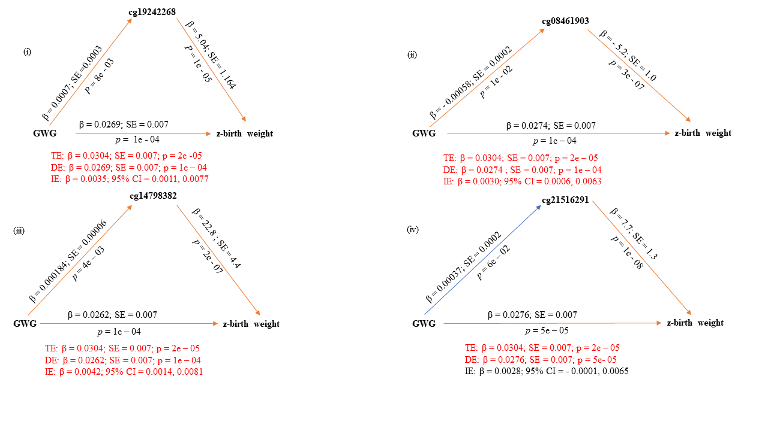
Figure 1: Single mediator models as per the OLS bootstrap approach with candidate CpG sites as mediators of the association between GWG and offspring’s z-birth weight. Significant pathways are drawn in orange while non-significant pathways are drawn in blue. Red text indicates coefficients of significant pathways, their standard errors, p-values, and 95% confidence intervals. Black text indicates those values in non-significant pathways.
DE = direct effects; IE = indirect effects; TE = total effects

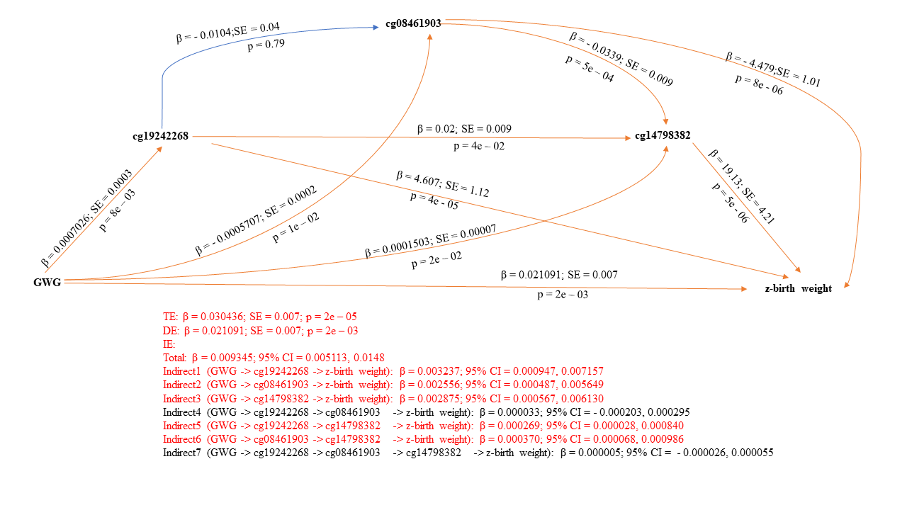
Figure 2: Serial multiple mediator model as per the OLS bootstrap approach with candidate CpG sites as mediators of the association between GWG and offspring’s z-birth weight. Significant pathways are drawn in orange while non-significant pathways are drawn in blue. Red text indicates coefficients of significant pathways, their standard errors, p-values, and 95% confidence intervals. Black text indicates those values in non-significant pathways.
DE = direct effects; IE = indirect effects; TE = total effects

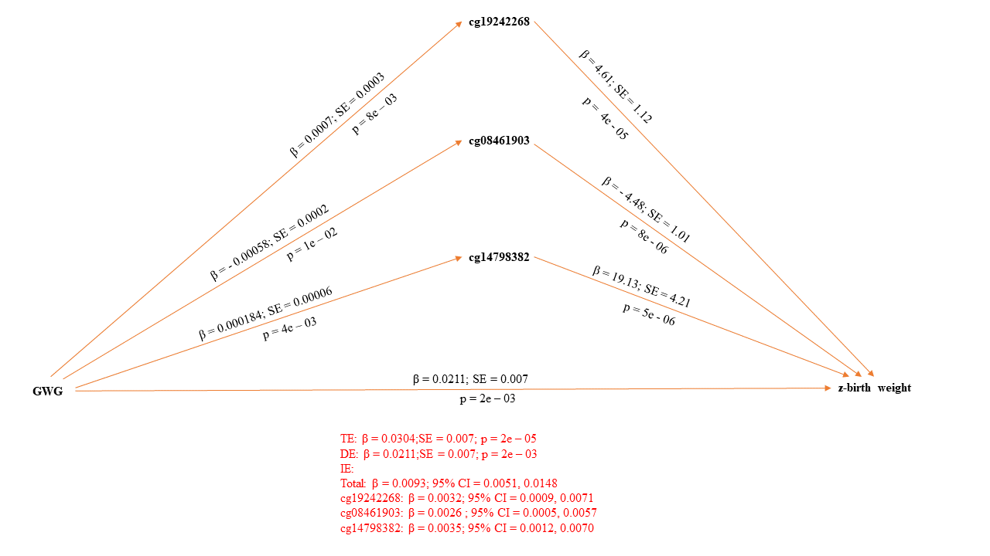
Figure 3: Parallel multiple mediator model as per the OLS bootstrap approach with candidate CpG sites as mediators of the association between GWG and offspring’s z-birth weight. Significant pathways are drawn in orange while non-significant pathways are drawn in blue. Red text indicates coefficients of significant pathways, their standard errors, p-values, and 95% confidence intervals. Black text indicates those values in non-significant pathways.
DE = direct effects; IE = indirect effects; TE = total effects

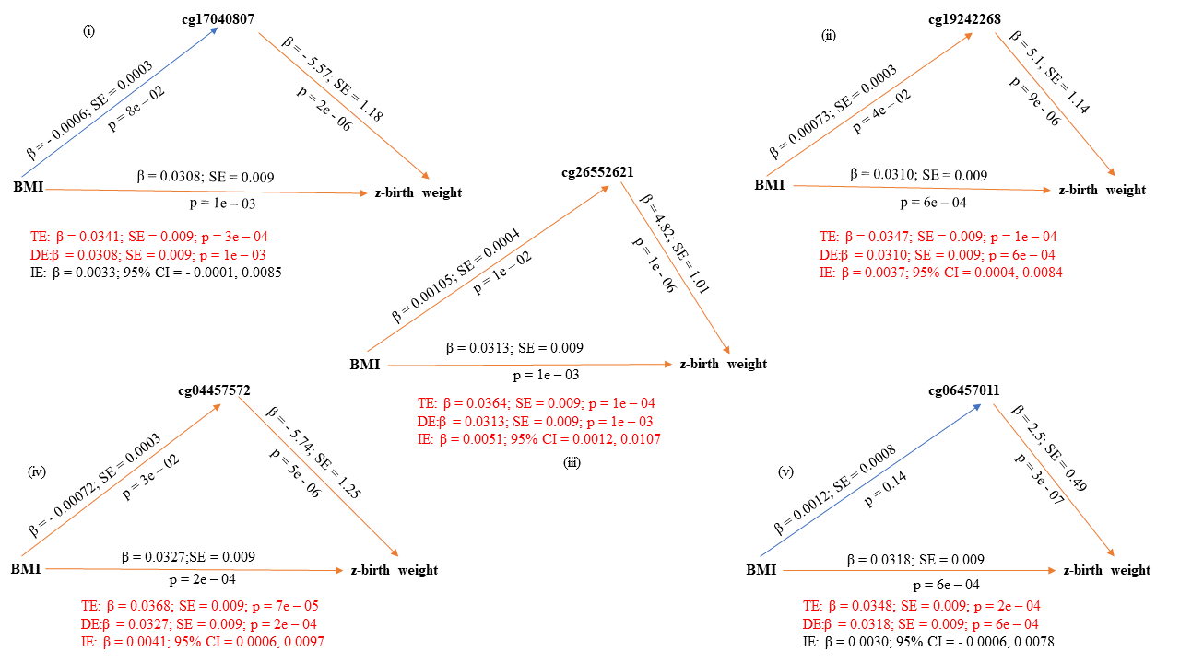
Figure 4: Single mediator models as per the robust bootstrapped approach with candidate CpG sites as mediators of the association between maternal BMI at the beginning of pregnancy and z-birth weight. Significant pathways are drawn in orange while non-significant pathways are drawn in blue. Red text indicates coefficients of significant pathways, their standard errors, p-values, and 95% confidence intervals. Black text indicates those values in non-significant pathways.
DE = direct effects; IE = indirect effects; TE = total effects

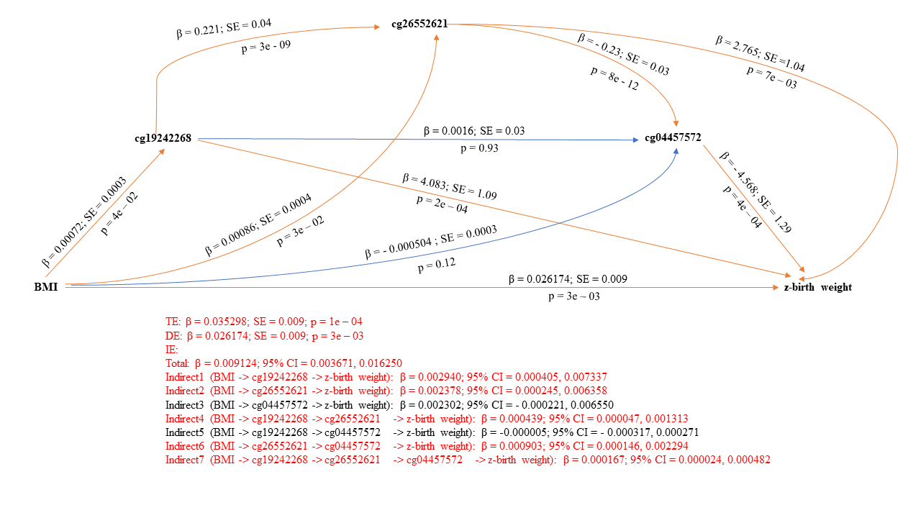
Figure 5: Serial multiple mediator model as per the robust bootstrapped approach with candidate CpG sites as mediators of the association between maternal BMI at the beginning of pregnancy and z-birth weight. Significant pathways are drawn in orange while non-significant pathways are drawn in blue. Red text indicates coefficients of significant pathways, their standard errors, p-values, and 95% confidence intervals. Black text indicates those values in non-significant pathways.
DE = direct effects; IE = indirect effects; TE = total effects
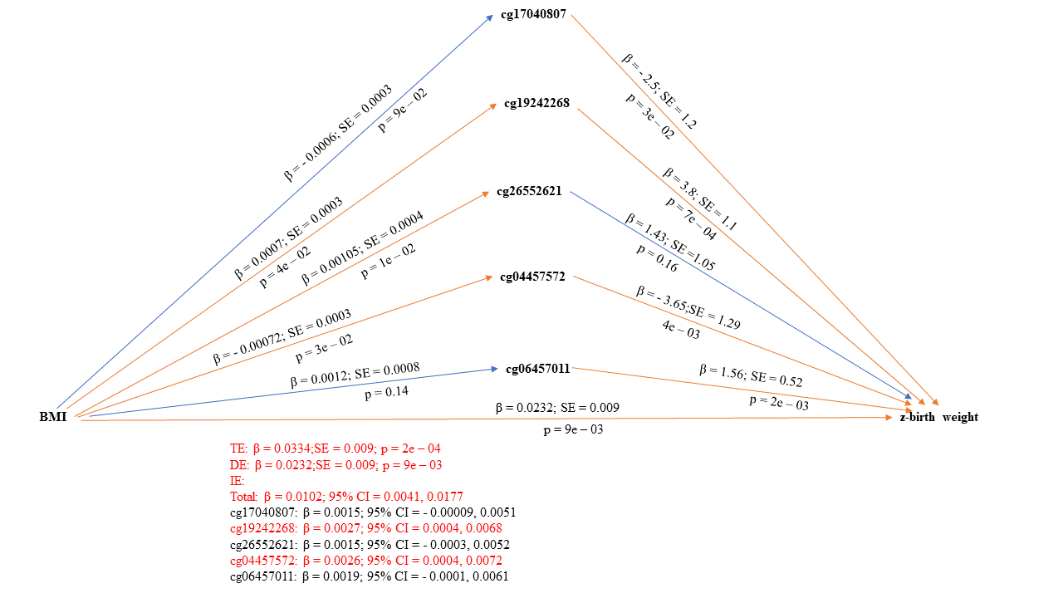
Figure 6: Parallel multiple mediator model as per the robust bootstrapped approach with candidate CpG sites as mediators of the association between maternal BMI at the beginning of pregnancy and z-birth weight. Significant pathways are drawn in orange while non-significant pathways are drawn in blue. Red text indicates coefficients of significant pathways, their standard errors, p-values, and 95% confidence intervals. Black text indicates those values in non-significant pathways.
DE = direct effects; IE = indirect effects; TE = total effects

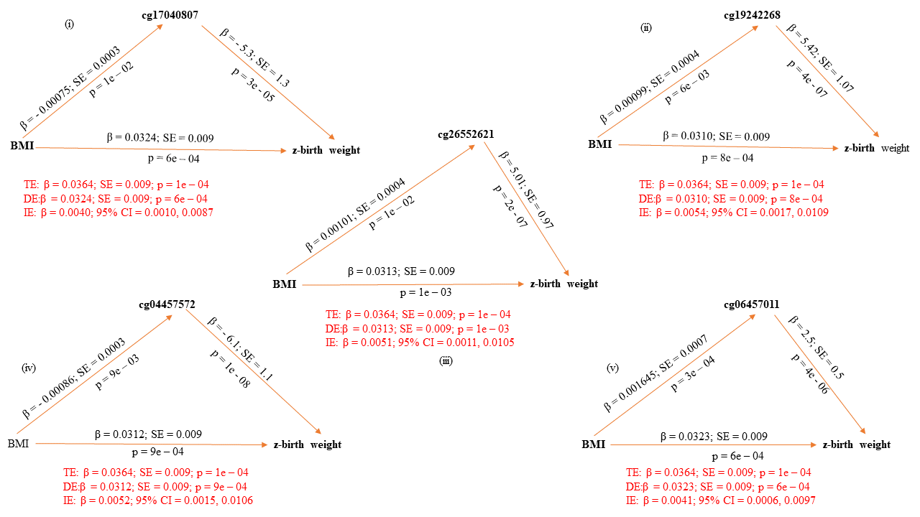
Figure 7: Single mediator models as per the OLS bootstrap approach with candidate CpG sites as mediators of the association between maternal BMI at the beginning of pregnancy and z-birth weight. Significant pathways are drawn in orange while non-significant pathways are drawn in blue. Red text indicates coefficients of significant pathways, their standard errors, p-values, and 95% confidence intervals. Black text indicates those values in non-significant pathways.
DE = direct effects; IE = indirect effects; TE = total effects
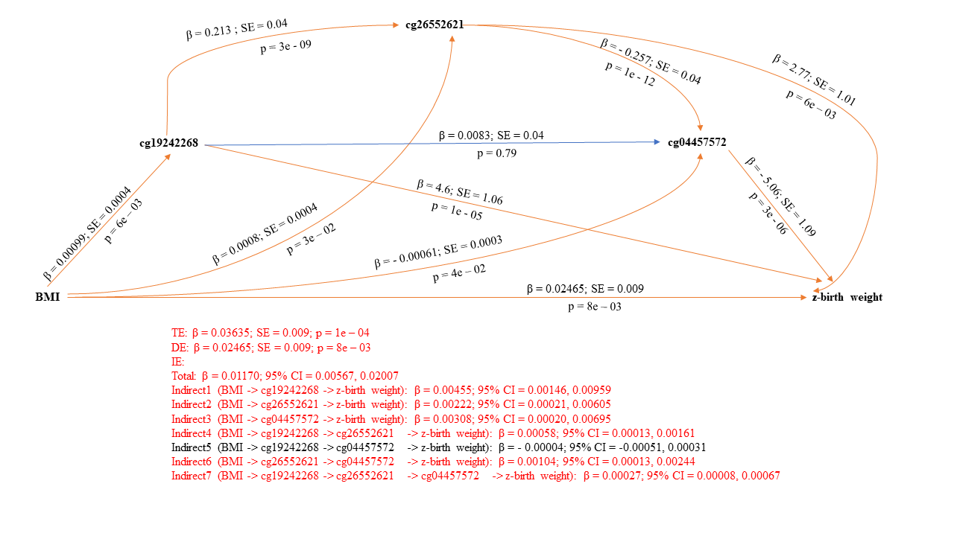
Figure 8: Serial multiple mediator model as per the OLS bootstrap approach with candidate CpG sites as mediators of the association between maternal BMI at the beginning of pregnancy and z-birth weight. Significant pathways are drawn in orange while non-significant pathways are drawn in blue. Red text indicates coefficients of significant pathways, their standard errors, p-values, and 95% confidence intervals. Black text indicates those values in non-significant pathways.
DE = direct effects; IE = indirect effects; TE = total effects
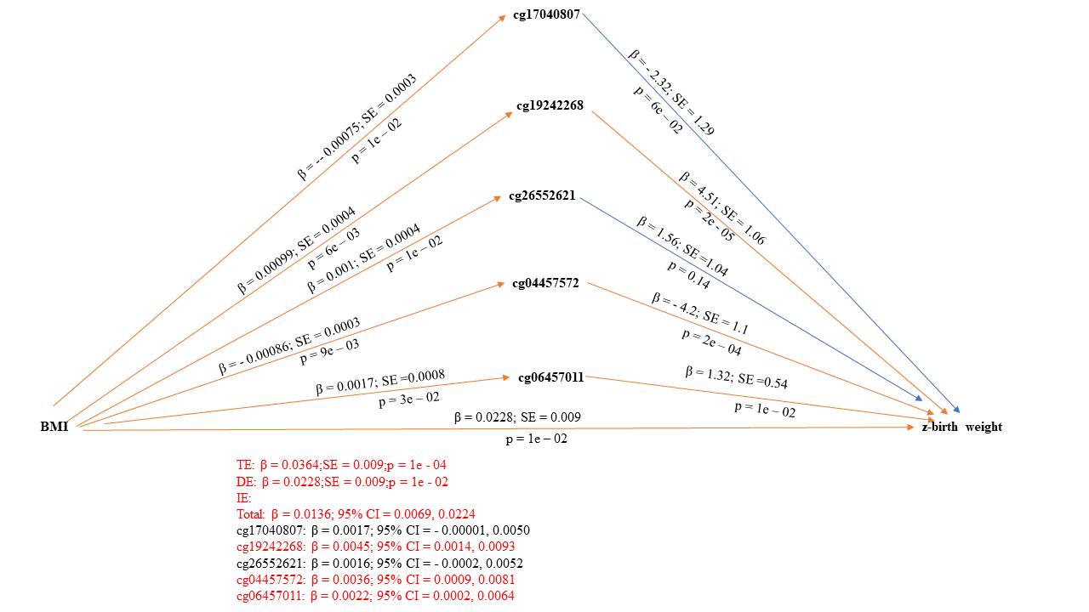
Figure 9: Parallel multiple mediator model as per the OLS bootstrap approach with candidate CpG sites as mediators of the association between maternal BMI at the beginning of pregnancy and z-birth weight. Significant pathways are drawn in orange while non-significant pathways are drawn in blue. Red text indicates coefficients of significant pathways, their standard errors, p-values, and 95% confidence intervals. Black text indicates those values in non-significant pathways.
DE = direct effects; IE = indirect effects; TE = total effects

Supplementary material 9: Findings from previous studies on the association of candidate CpG sites with markers of obesity published on the EWAS Catalog (Last accessed on 2025/06/22)
CpG mediator | Previous findings (EWAS Catalog*)
cg19242268 | (1) Birth weight EWAS meta-analysis of all ancestries: Küpers et al, 2019; PMID: 31015461  (2) Birth weight EWAS meta-analysis of European ancestry only: Küpers et al, 2019; PMID: 31015461  (3) Childhood growth trajectories from birth to late adolescence: Mulder et al, 2021; PMID: 33450751
cg21516291 | (1) Birth weight EWAS meta-analysis of all ancestries: Kupers et al, 2019; PMID: 31015461  (2) Birth weight EWAS meta-analysis of European ancestry only: Kupers et al, 2019; PMID: 31015461  (3) Incident type 2 diabetes: Hillary et al, 2023; PMID: 37410739  (4) Childhood growth trajectories from birth to late adolescence: Mulder et al, 2021; PMID: 33450751
cg17040807 | (1) Birth weight EWAS meta-analysis of all ancestries: Kupers et al, 2019; PMID: 31015461
cg26552621 | (1) NOG protein levels (obesogenic): Gadd et al 2022; PMID: 35945220  (2) Omega 6 fatty acids: Battram et al; PMID: NA  (3) Childhood growth trajectories from birth to late adolescence: Mulder et al, 2021; PMID: 33450751
cg04457572 | (1) Incident type 2 diabetes: Hillary et al, 2023; PMID: 37410739  (2) ADIPOQ protein/adiponectin levels (regulate fat metabolism and insulin sensitivity): Gadd et al, 2022; PMID: 35945220  (3) Growth trajectories from birth to early childhood: Xu et al, 2017; PMID: 28056824  (4) Childhood growth trajectories from birth to late adolescence: Mulder et al, 2021; PMID: 33450751
cg06457011 | (1) Fasting insulin: Liu et al, 2019; PMID: 31197173  (2) Estimated degree of fatty acid saturation levels: Battram et al; PMID: NA  (3) Childhood growth trajectories from birth to late adolescence: Mulder et al, 2021; PMID: 33450751
cg14798382 | (1) Childhood growth trajectories from birth to late adolescence: Mulder et al, 2021; PMID: 33450751
cg08461903 | (1) Childhood growth trajectories from birth to late adolescence: Mulder et al, 2021; PMID: 33450751
* https://www.ewascatalog.org/

Supplementary material 10: Details of findings on the EWAS Catalog, EWAS Atlas, EPIGEN MeQTL database, and eForge TF database (Last accessed on 2025/06/22)
Findings on EWAS Catalog in relation to CpG mediators revealed in the present study and their reported associations with examined/associated traits
CpG  (Gene) | Author (PMID) | Exposure-Outcome | N (# of studies) | Tissue | Age | β(SE) | p-value | Details
cg19242268  (TCEA2) | Kupers L  (31015461) | DNA methylation - birthweight | 8825  (24) | Cord blood | Infants | 95.8 (13.5) | 1.2e-12 | EWAS meta-analysis of all ancestries
cg19242268  (TCEA2) | Kupers L  (31015461) | DNA methylation - birthweight | 6023  (17) | Cord blood | Infants | 98 (16) | 9.7e-10 | EWAS meta-analysis of European ancestry only
cg19242268  (TCEA2) | Kashima K  (33564054) | Gestational age – DNA methylation | 110  (1) | Cord blood | Infants | 0.0048 (0.00078) | 1.1e-08 | -
cg19242268  (TCEA2) | Hillary RF  (38692281) | DNA methylation – CRP levels | 17936 (1) | Whole blood | Adults | 1.4 (0.288) | 5.8e-7 | -
cg21516291 (SLC35C2) | Kupers L (31015461) | DNA methylation-birthweight | 8825  (24) | Cord blood | Infants | 96.6 (13) | 9.1e-14 | EWAS meta-analysis of all ancestries
cg21516291 (SLC35C2) | Kupers L (31015461) | DNA methylation-birthweight | 6023  (17) | Cord blood | Infants | 101 (14.9) | 9.2e-12 | EWAS meta-analysis of European ancestry only
cg21516291 (SLC35C2) | Spiers H  (25650246) | Gestational age – DNA methylation | 179  (1) | Fetal brain | NA | 0.12436 (0.0197) | 2.6e-10 | -
cg21516291 (SLC35C2) | Hillary RF  (37410739) | Incident T2D – DNA methylation | 17749 (1) | Whole blood | Adults | 0.052 (0.00937) | 3.1e-08 | -
cg21516291 (SLC35C2) | Bohlin J  (27717397) | Gestational age – DNA methylation | 1068  (1) | Cord blood | Infants | -0.00038 (7.6e-05) | 5.8e-07 | -
cg21516291 (SLC35C2) | Hillary RF  (38692281) | DNA methylation – CRP levels | 17936 (1) | Whole blood | Adults | 1.3 (0.295) | 1.1e-05
cg21516291 (SLC35C2) | Hillary RF  (37410739) | Incident T2D – DNA methylation | 13971 (1) | Whole blood | Adults | 0.042 (0.00996) | 3e-05 | -
cg17040807  (CYGB) | Kupers L (31015461) | DNA methylation - birthweight | 8825 (24) | Cord blood | Infants | -61 (15.4) | 7.4e-05 | EWAS meta-analysis of all ancestries
cg17040807  (CYGB) | Kashima K  (33564054) | Gestational age – DNA methylation | 110  (1) | Cord blood | Infants | 0.0027 (0.00066) | 8.9e-05 | -
cg26552621  (C19orf23; CIRBP) | Spiers H  (25650246) | Gestational age – DNA methylation | 179  (1) | Fetal brain | NA | -0.1339 (0.019) | 1.6e-12 | -
cg26552621  (C19orf23; CIRBP) | Kashima K  (33564054) | Gestational age – DNA methylation | 110  (1) | Cord blood | Infants | -0.004 (0.00078) | 1e-06 | -
cg26552621  (C19orf23; CIRBP) | Gadd DA  (35945220) | DNA methylation - RRM1 protein levels | 774  (1) | Whole blood | Adults | -0.96 (0.234) | 4.3e-05 | -
cg26552621  (C19orf23; CIRBP) | Gadd DA  (35945220) | DNA methylation - PRG3 protein levels | 774  (1) | Whole blood | Adults | -0.95 (0.233) | 4.4e-05 | -
cg26552621  (C19orf23; CIRBP) | Gadd DA  (35945220) | DNA methylation – NOG protein levels | 774  (1) | Whole blood | Adults | -0.937 (0.233) | 6e-05
cg26552621  (C19orf23; CIRBP) | Battram T  (NA) | Omega 6 fatty acids – DNA methylation | 672  (1) | Whole blood | Adults | -0.219 (0.055) | 7.2e-05 | -
cg26552621  (C19orf23; CIRBP) | Gadd DA  (35945220) | DNA methylation – QPCT protein levels | 774  (1) | Whole blood | Adults | -0.9 (0.23) | 9.6e-05 | -
cg04457572 (CDH23) | Hillary RF  (38692281) | DNA methylation – CRP levels | 17936  (1) | Whole blood | Adults | 1.4 (0.305) | 5.2e-06 | -
cg04457572 (CDH23) | Gadd DA  (35945220) | DNA methylation - ADIPOQ protein levels | 774  (1) | Whole blood | Adults | -0.89 (0.218) | 4.5e-05 | -
cg04457572 (CDH23) | Gadd DA  (35945220) | DNA methylation - MXRA8 protein levels | 774  (1) | Whole blood | Adults | -0.86 (0.218) | 7.2e-05 | -
cg04457572 (CDH23) | Hillary RF (37410739) | Incident T2D – DNA methylation | 17749 (1) | Whole blood | Adults | 0.038 (0.00971) | 9.3e-05 | -
cg04457572 (CDH23) | Gadd DA  (35945220) | DNA methylation - CNTFR protein levels | 774  (1) | Whole blood | Adults | -0.85 (0.218) | 9.7e-05 | -
cg06457011  (PLCG1) | Bohlin J  (27717397) | Gestational age – DNA methylation | 1068  (1) | Cord blood | Infants | -0.00124 (0.000168) | 3.5e-13 | -
cg06457011  (PLCG1) | Kashima K  (33564054) | Gestational age – DNA methylation | 110  (1) | Cord blood | Infants | -0.01 (0.0013) | 9.1e-13 | -
cg06457011  (PLCG1) | Hannon E  (30966880) | DNA methylation – Gestational age | 1316  (1) | Whole blood | Infants | -0.00692 (NA) | 5.7e-12 | -
cg06457011  (PLCG1) | Bohlin J  (27717397) | Gestational age – DNA methylation | 1068  (1) | Cord blood | Infants | -0.0008 (0.000157) | 3.4e-07 | -
cg06457011  (PLCG1) | Hillary RF  (38692281) | DNA methylation – CRP levels | 17936  (1) | Whole blood | Adults | 0.76 (0.186) | 4.1e-05 | -
cg06457011  (PLCG1) | Liu J  (31197173) | Fasting insulin – DNA methylation | 4808  (4) | Whole blood | Adults | 0.7 (0.17) | 4.2e-05 | -
cg06457011  (PLCG1) | Battram T  (NA) | Estimated degree of fatty acid saturation – DNA methylation | 672  (1) | Whole blood | Adults | -2.12 (0.53) | 7.3e-05 | -

Findings on EWAS Atlas in relation to CpG mediators revealed in the present study and their reported associations with examined/associated traits
Probe ID | Studies | Correlation | Location | Related genes | CpG islands | Related traits
cg19242268 | 1 | Hyper: 100%; Hypo: 0%; NR: 0% | chr20: 62688573 | TCEA2 | Island | birth weight
cg21516291 | 1 | Hyper: 100%; Hypo: 0%; NR: 0% | chr20: 44979100 | SLC35C2 | Other | birth weight
cg06457011 | 8 | Hyper: 88%;Hypo: 13%;NR: 0% | chr20: 39767490 | PLCG1 | Shore | Preterm birth
cg06457011 | 8 | Hyper: 88%;Hypo: 13%;NR: 0% | chr20: 39767490 | PLCG1 | Shore | Gestational age

Findings on the EPIGEN MeQTL Database in relation to CpG mediators revealed in the present study and their reported associations with genetic variants
CpG | SNP | CpG_chr | CpG_pos | Beta | SE | p-value | FDR | Cis/Trans
cg19242268 | 20:62695878_C_A | 20 | 62688573 | -0.1923 | 0.0358 | 8.20e-8 | 9.29e-5 | cis
cg08461903 | 21:45838632_C_T | 21 | 45884825 | 0.5138 | 0.0468 | 4.97e-28 | 0 | cis
cg06457011 | 20:39906988_G_A | 20 | 39767490 | -0.4722 | 0.0368 | 1.26e-37 | 0 | cis
cg06457011 | 10:38015028_C_T | 20 | 39767490 | 0.4924 | 0.0400 | 1.01e-34 | 0 | trans

Findings on the eFORGE TF Database in relation to CpG mediators revealed in the present study and their reported associations with transcription factors
Probe | TF | Database | p-value | Q-value
cg06457011 | V_MYCMAX_B | TRANSFAC | 0 | 4.0793E-308
 | V_ZF5_B | TRANSFAC | 0 | 4.0793E-308
 | V_AHRARNT_02 | TRANSFAC | 0 | 4.0793E-308
cg08461903 | MA0066.1-PPARG | JASPAR | 0 | 3.33761E-308
 | MA0258.1-ESR2 | JASPAR | 0 | 3.33761E-308
cg14798382 | AR_nuclearreceptor_2 | Taipale/SELEX | 0 | 4.0793E-308
 | AR_nuclearreceptor_1 | Taipale/SELEX | 0 | 4.0793E-308
 | V_IK1_01 | TRANSFAC | 0 | 4.0793E-308

