Supplementary Material to
Association of habitual diet with skeletal muscle composition in a cross-sectional, population-based imaging study
Susanne Rospleszcz^{1,2,3}, Theresa Burger^{3,4}, Nuha Shugaa Addin^{2,3,5}, Lena S. Kiefer^{6,7}, Thierno D. Diallo¹, Nina Wawro^{3,10}, Christopher L. Schlett¹, Fabian Bamberg¹, Annette Peters^{2,3,8,9}, Kurt Gedrich⁴, Jakob Linseisen¹⁰
¹Department of Diagnostic and Interventional Radiology, University Medical Center Freiburg, Faculty of Medicine, University of Freiburg, Freiburg, Germany
²Chair of Epidemiology, Institute for Medical Information Processing, Biometry, and Epidemiology (IBE), Medical Faculty, Ludwig-Maximilians-Universität (LMU), München, Germany.
³Institute of Epidemiology, Helmholtz Zentrum München, German Research Center for Environmental Health, Neuherberg, Germany
⁴Technical University of Munich, ZIEL - Institute for Food & Health, Research Group Public Health Nutrition, Freising, Germany
⁵Pettenkofer School of Public Health, Munich
⁶Department of Diagnostic and Interventional Radiology, Eberhard Karls University of Tuebingen, Tuebingen, Germany
⁷Department of Nuclear Medicine and Clinical Molecular Imaging, Eberhard Karls University of Tuebingen, Tuebingen, Germany
⁸German Center for Diabetes Research (DZD), 85764 Neuherberg, Germany.
⁹German Centre for Cardiovascular Research (DZHK e.V.), Partner Site Munich Heart Alliance, 80802 München, Germany
¹⁰Epidemiology, University of Augsburg, University Hospital Augsburg, Augsburg, Germany

Supplementary Texts
Supplementary Text 1: Details of the assessment of dietary intake.
Participants filled out the Food Frequency Questionnaire (FFQ) electronically at home, within a week after the visit at the study center. They were given a phone call reminder if they did not return the questionnaire within a week, and a second reminder after two weeks. The FFQ covered the time frame of the past year (12 months). Participants reported usual consumption frequency and usual portion size. Frequency was assessed categorically as “never”, “ ≤1x per month”, “2-3x per month”, “1-2x per week”, “3-4x per week” “5-6x per week”, ”1x per day”, ”2x per day”, ”3x per day”, “>3x per day”. Portion size was assessed using pictograms.
The first 24-h recall list was filled out electronically at the study center visit. Participants were asked to complete two additional 24-h recall lists (one on a weekday, and one on a weekend) at home within three months after their visit at the study center.

Supplementary Tables
Supplementary Table 1: Difference in baseline characteristics between individuals excluded from the final sample and those included in the final sample.
 | Excluded | Included | p-value
 | N = 105 | N = 294
Demographics
Age, years | 56.0 ± 9.7 | 56.5 ± 9.0 | 0.651
Male sex | 68 (64.8%) | 162 (55.1%) | 0.109
Anthropometrics
Height, cm | 172.7 ± 9.6 | 171.2 ± 9.8 | 0.183
Weight, kg | 86.9 ± 17.7 | 81.6 ± 15.9 | 0.005
BMI, kg/m² | 29.1 ± 5.1 | 27.8 ± 4.8 | 0.024
Waist circumference, cm | 101.8 ± 14.8 | 97.5 ± 14.0 | 0.008
Hip circumference, cm | 108.5 ± 9.7 | 106.5 ± 8.9 | 0.046
Waist-to-Hip Ratio | 0.936 ± 0.088 | 0.914 ± 0.0.89 | 0.027
Lifestyle factors
Smoking behaviour
Neversmoker | 36 (34.3%) | 109 (37.1%) | 0.814
ex-smoker | 46 (43.8%) | 128 (43.5%)
regular smoker | 23 (21.9%) | 57 (19.4%)
Physical activity |  |  | 0.644
regularly 2h/w or more | 27 (25.7%) | 87 (29.6%)
regularly 1h/w | 30 (28.6%) | 93 (31.6%)
sporadically | 16 (15.2%) | 41 (13.9%)
inactive | 32 (30.5%) | 73 (24.8%)
Blood pressure
Systolic Blood Pressure, mmHg | 122.0 ± 17.7 | 120.2 ± 16.4 | 0.357
Diastolic Blood Pressure, mmHg | 76.2 ± 10.1 | 75.0 ± 10.0 | 0.273
Hypertension | 32 (30.5%) | 104 (35.4%) | 0.430
Antihypertensive medication | 22 (21.0%) | 80 (27.2%) | 0.258
Diabetes-related
Glycemia
Normogylcemia | 57 (54.3%) | 185 (62.9%) | 0.254
Prediabetes | 30 (28.6%) | 73 (24.8%)
Diabetes | 18 (17.1%) | 36 (12.2%)
HbA1c, % | 5.7 ± 1.0 | 5.5 ± 0.6 | 0.050
Fasting glucose, mg/dL | 107.5 ± 32.8 | 103.1 ± 17.6 | 0.089
2-h glucose, mg/dL# | 117.4 ± 39.8 | 111.9 ± 41.2 | 0.264
Fasting insulin, μU/mL | 12.1 ± 8.3 | 11.1 ± 7.2 | 0.246
2-h insulin, μU/mL# | 73.1 ± 66.5 | 64.3 ± 66.4 | 0.272
Glucose-lowering medication | 9 (8.6%) | 23 (7.8%) | 0.974
Lipid profile
Total Cholesterol, mg/dL | 218.4 ± 35.6 | 217.7 ± 36.6 | 0.877
HDL Cholesterol, mg/dL | 59.0 ± 16.8 | 62.9 ± 17.9 | 0.051
LDL Cholesterol, mg/dL | 140.0 ± 31.0 | 139.4 ± 33.6 | 0.876
Triglycerides, mg/dL | 147.0 ± 97.2 | 126.2 ± 79.5 | 0.031
Lipid-lowering medication | 10 (9.5%) | 33 (11.2%) | 0.765
Inflammation
Uric Acid, mg/dL | 5.7 ± 1.5 | 5.6 ± 1.5 | 0.556
hsCRP, mg/L | 2.3 ± 2.7 | 2.4 ± 3.5 | 0.895
Data are means and standard deviation for continuous variables, and counts and percentages for categorical values. P-values from t-test and Χ² test, respectively. #based on n=363 with Oral Glucose Tolerance Test data.

Supplementary Table 2: Habitual intake of selected foods and nutrients.
Food/Nutrient | unit | Whole sample | Women | Men
 |  | N = 294 | N = 132 | N = 162
Vegetables | g/d | 166.5 ± 60.8 | 191.8 ± 68.3 | 145.9 ± 44.4
Fruits and Nuts | g/d | 146.1 ± 74.1 | 160.0 ± 72.3 | 134.8 ± 73.9
Monosaccharides | g/d | 320.0 ± 138.5 | 287.9 ± 852.8 | 346.1 ± 165.7
Disaccharides | g/d | 623.0 ± 224.4 | 574.4 ± 206.0 | 662.7 ± 231.6
Saturated Fatty Acids | g/d | 34.7 ± 7.7 | 30.3 ± 6.2 | 38.4 ± 6.8
Monounsaturated Fatty Acids | g/d | 27.3 ± 6.3 | 23.2 ± 4.9 | 30.5 ± 5.3
Polyunsaturated Fatty Acids | g/d | 9.9 ± 2.6 | 8.7 ± 2.0 | 10.9 ± 2.6
Butter | g/d | 13.3 ± 6.5 | 10.6 ± 4.9 | 15.4 ± 6.9
Oils, plant-based | g/d | 5.8 ± 3.2 | 6.0 ± 3.0 | 5.7 ± 3.3
Beef | g/d | 8.7 ± 5.1 | 6.3 ± 4.1 | 10.7 ± 5.0
Pork | g/d | 20.8 ± 10.4 | 15.2 ± 5.7 | 25.3 ± 11.2
Poultry | g/d | 15.5 ± 7.6 | 14.3 ± 8.0 | 16.4 ± 7.2
Fish, Shellfish | g/d | 22.3 ± 14.8 | 18.5 ± 9.8 | 25.3 ± 17.3
Wine | g/d | 41.5 ± 52.3 | 33.9 ± 43.6 | 47.7 ± 57.8
Beer | g/d | 173.1 ± 228.6 | 19.2 ± 42.2 | 298.6 ± 241.7
Spirits | g/d | 0.6 ± 1.1 | 0.3 ± 0.3 | 0.9 ± 1.4
Cocktails, punch | g/d | 20.6 ± 38.3 | 15.3 ± 26.2 | 25.0 ± 45.5
Fiber | g/d | 16.5 ± 4.4 | 16.3 ± 4.3 | 16.6 ± 4.6
Sodium | mg/d | 2114.5 ± 563.1 | 1776.9 ± 424.7 | 2389.5 ± 510.7
Data are presented as means and standard deviation.
Supplementary Table 3: Association of habitual energy-providing nutrient intake with MRI-derived muscle fat and area – effect estimates for all variables in the model.
 | Outcome Muscle Fat, % |  |  | Outcome Muscle Area, cm²
 | β | 95%-CI | p-value | β | 95%-CI | p-value
Carbohydrates, per 1% of total energy intake
All
Carbohydrates | -0.06 | [-0.20, 0.07] | 0.356 | -0.11 | [-0.47, 0.24] | 0.520
Age, years | 0.34 | [0.28, 0.41] | 0.000 | -0.49 | [-0.66, -0.33] | 0.000
BMI, kg/m² | 0.34 | [0.22, 0.46] | 0.000 | 1.24 | [0.93, 1.54] | 0.000
Male sex | -4.34 | [-5.43, -3.25] | 0.000 | 27.73 | [24.95, 30.51] | 0.000
Physical Activity: regularly 1h/w | -0.04 | [-1.41, 1.33] | 0.956 | -1.88 | [-5.39, 1.63] | 0.292
Physical Activity: sporadically | 0.41 | [-1.38, 2.21] | 0.651 | -5.04 | [-9.62, -0.45] | 0.031
Physical Activity: inactive | 0.98 | [-0.55, 2.51] | 0.207 | -2.21 | [-6.12, 1.71] | 0.268
Glycemia: Prediabetes | -0.33 | [-1.71, 1.04] | 0.633 | 1.79 | [-1.72, 5.30] | 0.316
Glycemia: Diabetes | 1.41 | [-0.43, 3.26] | 0.133 | -0.20 | [-4.91, 4.51] | 0.933
Women
Carbohydrates | -0.01 | [-0.26, 0.23] | 0.911 | -0.05 | [-0.56, 0.47] | 0.859
Age, years | 0.44 | [0.33, 0.55] | 0.000 | -0.37 | [-0.59, -0.15] | 0.001
BMI, kg/m² | 0.31 | [0.12, 0.49] | 0.001 | 1.02 | [0.64, 1.39] | 0.000
Physical Activity: regularly 1h/w | -0.25 | [-2.38, 1.87] | 0.814 | -1.96 | [-6.36, 2.44] | 0.380
Physical Activity: sporadically | 1.44 | [-1.39, 4.27] | 0.317 | -2.56 | [-8.43, 3.31] | 0.389
Physical Activity: inactive | 1.60 | [-1.16, 4.36] | 0.252 | -0.64 | [-6.36, 5.07] | 0.824
Glycemia: Prediabetes | -1.35 | [-3.85, 1.16] | 0.289 | 5.90 | [0.71, 11.09] | 0.026
Glycemia: Diabetes | 3.71 | [0.49, 6.93] | 0.024 | 3.15 | [-3.52, 9.81] | 0.352
Men
Carbohydrates | -0.11 | [-0.27, 0.05] | 0.161 | -0.18 | [-0.67, 0.31] | 0.465
Age, years | 0.29 | [0.21, 0.37] | 0.000 | -0.57 | [-0.81, -0.33] | 0.000
BMI, kg/m² | 0.37 | [0.20, 0.53] | 0.000 | 1.33 | [0.82, 1.84] | 0.000
Physical Activity: regularly 1h/w | 0.07 | [-1.70, 1.83] | 0.941 | -1.47 | [-6.91, 3.98] | 0.595
Physical Activity: sporadically | -0.37 | [-2.64, 1.90] | 0.746 | -7.69 | [-14.69, -0.69] | 0.032
Physical Activity: inactive | 0.53 | [-1.24, 2.29] | 0.555 | -3.61 | [-9.05, 1.83] | 0.192
Glycemia: Prediabetes | 0.05 | [-1.52, 1.62] | 0.952 | -0.90 | [-5.74, 3.94] | 0.715
Glycemia: Diabetes | 0.35 | [-1.82, 2.52] | 0.751 | -1.78 | [-8.48, 4.92] | 0.601
Fat, per 1% of total energy intake
All
Fat | -0.1 | [-0.27, 0.06] | 0.209 | 0.11 | [-0.30, 0.53] | 0.589
Age, years | 0.35 | [0.29, 0.41] | 0.000 | -0.49 | [-0.66, -0.33] | 0.000
BMI, kg/m² | 0.34 | [0.22, 0.46] | 0.000 | 1.24 | [0.93, 1.54] | 0.000
Male sex | -4.43 | [-5.54, -3.33] | 0.000 | 28.03 | [25.20, 30.85] | 0.000
Physical Activity: regularly 1h/w | 0.04 | [-1.33, 1.41] | 0.958 | -1.86 | [-5.37, 1.65] | 0.297
Physical Activity: sporadically | 0.7 | [-1.11, 2.52] | 0.446 | -5.12 | [-9.76, -0.48] | 0.031
Physical Activity: inactive | 1.28 | [-0.25, 2.82] | 0.101 | -2.20 | [-6.13, 1.73] | 0.272
Glycemia: Prediabetes | -0.19 | [-1.56, 1.17] | 0.780 | 1.86 | [-1.63, 5.36] | 0.294
Glycemia: Diabetes | 1.64 | [-0.21, 3.48] | 0.082 | -0.22 | [-4.95, 4.51] | 0.927
Women
Fat | -0.13 | [-0.41, 0.14] | 0.335 | -0.4 | [-0.96, 0.17] | 0.167
Age, years | 0.45 | [0.34, 0.55] | 0.000 | -0.35 | [-0.57, -0.12] | 0.003
BMI, kg/m² | 0.31 | [0.13, 0.49] | 0.001 | 1.03 | [0.65, 1.41] | 0.000
Physical Activity: regularly 1h/w | -0.29 | [-2.41, 1.82] | 0.784 | -2.08 | [-6.44, 2.28] | 0.347
Physical Activity: sporadically | 1.65 | [-1.21, 4.50] | 0.256 | -1.95 | [-7.84, 3.94] | 0.514
Physical Activity: inactive | 1.93 | [-0.83, 4.69] | 0.168 | 0.34 | [-5.36, 6.04] | 0.906
Glycemia: Prediabetes | -1.21 | [-3.70, 1.28] | 0.338 | 6.32 | [1.18, 11.45] | 0.016
Glycemia: Diabetes | 3.72 | [0.51, 6.93] | 0.023 | 3.18 | [-3.44, 9.80] | 0.344
Men
Fat | -0.09 | [-0.28, 0.11] | 0.380 | 0.44 | [-0.16, 1.04] | 0.153
Age, years | 0.29 | [0.22, 0.37] | 0.000 | -0.56 | [-0.80, -0.33] | 0.000
BMI, kg/m² | 0.37 | [0.21, 0.54] | 0.000 | 1.32 | [0.81, 1.82] | 0.000
Physical Activity: regularly 1h/w | 0.34 | [-1.43, 2.10] | 0.706 | -1.66 | [-7.06, 3.74] | 0.545
Physical Activity: sporadically | 0.13 | [-2.15, 2.41] | 0.910 | -8.22 | [-15.20, -1.24] | 0.021
Physical Activity: inactive | 0.88 | [-0.90, 2.65] | 0.330 | -3.97 | [-9.39, 1.45] | 0.150
Glycemia: Prediabetes | 0.22 | [-1.35, 1.78] | 0.782 | -0.86 | [-5.65, 3.92] | 0.722
Glycemia: Diabetes | 0.76 | [-1.45, 2.97] | 0.496 | -2.47 | [-9.22, 4.28] | 0.471
Protein, per 1% of total energy intake
All
Protein | -0.34 | [-0.69, 0.00] | 0.052 | -0.11 | [-1.00, 0.77] | 0.801
Age, years | 0.34 | [0.28, 0.40] | 0.000 | -0.49 | [-0.66, -0.33] | 0.000
BMI, kg/m² | 0.38 | [0.25, 0.50] | 0.000 | 1.25 | [0.93, 1.57] | 0.000
Male sex | -4.59 | [-5.71, -3.47] | 0.000 | 27.74 | [24.87, 30.62] | 0.000
Physical Activity: regularly 1h/w | 0.03 | [-1.33, 1.39] | 0.966 | -1.81 | [-5.31, 1.70] | 0.312
Physical Activity: sporadically | 0.32 | [-1.46, 2.11] | 0.724 | -4.95 | [-9.54, -0.36] | 0.035
Physical Activity: inactive | 1.03 | [-0.48, 2.53] | 0.180 | -2.02 | [-5.89, 1.84] | 0.304
Glycemia: Prediabetes | -0.27 | [-1.63, 1.09] | 0.696 | 1.93 | [-1.56, 5.41] | 0.278
Glycemia: Diabetes | 1.48 | [-0.34, 3.31] | 0.111 | -0.06 | [-4.76, 4.63] | 0.979
Women
Protein | -0.23 | [-0.78, 0.31] | 0.403 | -0.21 | [-1.35, 0.92] | 0.710
Age, years | 0.43 | [0.32, 0.54] | 0.000 | -0.37 | [-0.60, -0.15] | 0.001
BMI, kg/m² | 0.33 | [0.14, 0.53] | 0.001 | 1.04 | [0.64, 1.45] | 0.000
Physical Activity: regularly 1h/w | -0.22 | [-2.34, 1.90] | 0.836 | -1.94 | [-6.34, 2.45] | 0.383
Physical Activity: sporadically | 1.26 | [-1.60, 4.11] | 0.384 | -2.74 | [-8.66, 3.19] | 0.362
Physical Activity: inactive | 1.64 | [-1.05, 4.34] | 0.230 | -0.53 | [-6.13, 5.06] | 0.851
Glycemia: Prediabetes | -1.34 | [-3.82, 1.14] | 0.286 | 5.95 | [0.80, 11.09] | 0.024
Glycemia: Diabetes | 3.50 | [0.26, 6.75] | 0.035 | 2.96 | [-3.78, 9.70] | 0.386
Men
Protein | -0.31 | [-0.76, 0.13] | 0.169 | 0.16 | [-1.22, 1.53] | 0.823
Age, years | 0.28 | [0.21, 0.36] | 0.000 | -0.56 | [-0.80, -0.32] | 0.000
BMI, kg/m² | 0.40 | [0.23, 0.57] | 0.000 | 1.32 | [0.80, 1.84] | 0.000
Physical Activity: regularly 1h/w | 0.25 | [-1.49, 2.00] | 0.775 | -1.19 | [-6.59, 4.21] | 0.664
Physical Activity: sporadically | -0.17 | [-2.41, 2.06] | 0.878 | -7.16 | [-14.06, -0.25] | 0.042
Physical Activity: inactive | 0.64 | [-1.11, 2.38] | 0.472 | -3.22 | [-8.61, 2.17] | 0.239
Glycemia: Prediabetes | 0.18 | [-1.37, 1.74] | 0.816 | -0.68 | [-5.49, 4.13] | 0.780
Glycemia: Diabetes | 0.72 | [-1.45, 2.88] | 0.514 | -1.52 | [-8.21, 5.16] | 0.653
Alcohol, per 1% of total energy intake
All
Alcohol | 0.31 | [0.14, 0.48] | <0.001 | 0.08 | [-0.37, 0.53] | 0.721
Age | 0.34 | [0.27, 0.40] | 0.000 | -0.49 | [-0.66, -0.33] | 0.000
BMI, kg/m² | 0.38 | [0.26, 0.50] | 0.000 | 1.25 | [0.94, 1.56] | 0.000
Male sex | -5.45 | [-6.69, -4.22] | 0.000 | 27.55 | [24.32, 30.77] | 0.000
Physical Activity: regularly 1h/w | -0.05 | [-1.39, 1.30] | 0.947 | -1.83 | [-5.33, 1.68] | 0.306
Physical Activity: sporadically | 0.51 | [-1.24, 2.26] | 0.567 | -4.89 | [-9.45, -0.32] | 0.036
Physical Activity: inactive | 0.98 | [-0.50, 2.46] | 0.193 | -2.03 | [-5.89, 1.84] | 0.303
Glycemia: Prediabetes | -0.49 | [-1.83, 0.85] | 0.474 | 1.87 | [-1.63, 5.37] | 0.294
Glycemia: Diabetes | 1.53 | [-0.27, 3.33] | 0.096 | -0.05 | [-4.74, 4.64] | 0.983
Women#
Alcohol | -0.01 | [-0.49, 0.47] | 0.971 | 0.61 | [-0.41, 1.63] | 0.240
Age, years | 0.44 | [0.34, 0.54] | 0.000 | -0.37 | [-0.58, -0.15] | 0.001
BMI, kg/m² | 0.30 | [0.11, 0.48] | 0.002 | 1.09 | [0.70, 1.47] | 0.000
Physical Activity: regularly 1h/w | -0.20 | [-2.21, 1.82] | 0.847 | -1.71 | [-5.96, 2.53] | 0.426
Physical Activity: sporadically | 1.63 | [-1.08, 4.34] | 0.237 | -1.78 | [-7.50, 3.94] | 0.539
Physical Activity: inactive | 1.08 | [-1.50, 3.66] | 0.410 | -1.24 | [-6.68, 4.20] | 0.652
Glycemia: Prediabetes | -1.23 | [-3.60, 1.14] | 0.305 | 5.77 | [0.77, 10.77] | 0.024
Glycemia: Diabetes | 2.25 | [-0.88, 5.39] | 0.158 | 0.97 | [-5.65, 7.59] | 0.772
Men
Alcohol | 0.28 | [0.10, 0.45] | 0.002 | -0.17 | [-0.73, 0.39] | 0.545
Age, years | 0.27 | [0.20, 0.35] | 0.000 | -0.55 | [-0.79, -0.31] | 0.000
BMI, kg/m² | 0.40 | [0.24, 0.56] | 0.000 | 1.31 | [0.80, 1.83] | 0.000
Physical Activity: regularly 1h/w | 0.10 | [-1.60, 1.81] | 0.904 | -1.10 | [-6.50, 4.30] | 0.689
Physical Activity: sporadically | -0.30 | [-2.48, 1.88] | 0.785 | -7.07 | [-13.96, -0.17] | 0.045
Physical Activity: inactive | 0.55 | [-1.15, 2.25] | 0.521 | -3.16 | [-8.53, 2.22] | 0.248
Glycemia: Prediabetes | -0.05 | [-1.58, 1.48] | 0.948 | -0.54 | [-5.37, 4.29] | 0.826
Glycemia: Diabetes | 0.82 | [-1.28, 2.93] | 0.442 | -1.61 | [-8.27, 5.05] | 0.634
Data for the energy-providing nutrients are repeated from main Table 3. # based on N=131 after excluding one outlier.

Supplementary Table 4: Association of habitual energy-providing nutrient intake with MRI-derived muscle fat and area in sensitivity analyses.
 | Outcome Muscle Fat, % |  |  | Outcome Muscle Area, cm²
 | β | 95%-CI | p-value | β | 95%-CI | p-value
Carbohydrates, per 1% of total energy intake
All
main | -0.06 | [-0.20, 0.07] | 0.356 | -0.11 | [-0.47, 0.24] | 0.520
+ Smoking | -0.06 | [-0.20, 0.08] | 0.382 | -0.10 | [-0.45, 0.25] | 0.578
WC instead of BMI | -0.05 | [-0.18, 0.08] | 0.439 | -0.09 | [-0.45, 0.26] | 0.598
Women
main | -0.01 | [-0.26, 0.23] | 0.911 | -0.05 | [-0.56, 0.47] | 0.859
+ Smoking | 0.01 | [-0.25, 0.26] | 0.955 | -0.04 | [-0.57, 0.48] | 0.875
WC instead of BMI | 0.03 | [-0.21, 0.26] | 0.825 | 0.01 | [-0.50, 0.53] | 0.959
Men
main | -0.11 | [-0.27, 0.05] | 0.161 | -0.18 | [-0.67, 0.31] | 0.465
+ Smoking | -0.12 | [-0.28, 0.04] | 0.156 | -0.19 | [-0.67, 0.30] | 0.448
WC instead of BMI | -0.11 | [-0.27, 0.04] | 0.148 | -0.19 | [-0.68, 0.30] | 0.449
Fat, per 1% of total energy intake
All
main | -0.1 | [-0.27, 0.06] | 0.209 | 0.11 | [-0.30, 0.53] | 0.589
+ Smoking | -0.1 | [-0.27, 0.06] | 0.207 | 0.08 | [-0.32, 0.49] | 0.684
WC instead of BMI | -0.1 | [-0.25, 0.06] | 0.223 | 0.16 | [-0.25, 0.58] | 0.437
Women
main | -0.13 | [-0.41, 0.14] | 0.335 | -0.40 | [-0.96, 0.17] | 0.167
+ Smoking | -0.14 | [-0.41, 0.14] | 0.332 | -0.40 | [-0.97, 0.17] | 0.163
WC instead of BMI | -0.16 | [-0.42, 0.09] | 0.207 | -0.43 | [-1.00, 0.13] | 0.134
Men
main | -0.09 | [-0.28, 0.11] | 0.380 | 0.44 | [-0.16, 1.04] | 0.153
+ Smoking | -0.09 | [-0.28, 0.11] | 0.389 | 0.43 | [-0.16, 1.02] | 0.156
WC instead of BMI | -0.06 | [-0.25, 0.13] | 0.548 | 0.53 | [-0.07, 1.13] | 0.085
Protein, per 1% of total energy intake
All
main | -0.34 | [-0.69, 0.00] | 0.052 | -0.11 | [-1.00, 0.77] | 0.801
+ Smoking | -0.35 | [-0.69, 0.00] | 0.051 | -0.14 | [-1.02, 0.73] | 0.748
WC instead of BMI | -0.36 | [-0.68, -0.04] | 0.029 | 0.14 | [-0.74, 1.02] | 0.759
Women
main | -0.23 | [-0.78, 0.31] | 0.403 | -0.21 | [-1.35, 0.92] | 0.710
+ Smoking | -0.23 | [-0.78, 0.32] | 0.413 | -0.25 | [-1.40, 0.90] | 0.671
WC instead of BMI | -0.34 | [-0.83, 0.16] | 0.181 | -0.04 | [-1.16, 1.07] | 0.942
Men
main | -0.31 | [-0.76, 0.13] | 0.169 | 0.16 | [-1.22, 1.53] | 0.823
+ Smoking | -0.31 | [-0.76, 0.13] | 0.168 | 0.17 | [-1.18, 1.53] | 0.799
WC instead of BMI | -0.29 | [-0.72, 0.14] | 0.187 | 0.33 | [-1.04, 1.71] | 0.631
Alcohol, per 1% of total energy intake
All
main | 0.31 | [0.14, 0.48] | <0.001 | 0.08 | [-0.37, 0.53] | 0.721
+ Smoking | 0.32 | [0.14, 0.49] | <0.001 | 0.10 | [-0.35, 0.54] | 0.669
WC instead of BMI | 0.28 | [0.12, 0.44] | <0.001 | -0.08 | [-0.52, 0.37] | 0.726
Women#
main | -0.01 | [-0.49, 0.47] | 0.971 | 0.61 | [-0.41, 1.63] | 0.240
+ Smoking | -0.08 | [-0.58, 0.42] | 0.760 | 0.66 | [-0.39, 1.71] | 0.217
WC instead of BMI | 0.07 | [-0.37, 0.51] | 0.746 | 0.39 | [-0.62, 1.40] | 0.442
Men
main | 0.28 | [0.10, 0.45] | 0.002 | -0.17 | [-0.73, 0.39] | 0.545
+ Smoking | 0.28 | [0.10, 0.46] | 0.002 | -0.16 | [-0.71, 0.39] | 0.566
WC instead of BMI | 0.25 | [0.08, 0.42] | 0.005 | -0.27 | [-0.83, 0.29] | 0.338
Data for the main model are repeated from Table 3 in the manuscript. The main model was adjusted for variables age, sex (for the whole sample), BMI, physical activity (4 categories), and glycemia (normoglycemia/ prediabetes/ diabetes). WC: waist circumference. # based on N=131 after excluding one outlier.

Supplementary Table 5: WHO recommended daily allowance (RDA) of essential amino acids, and percentage of this recommendation attained in the sample.
 | WHO RDA mg per kg body mass |  | Whole sample | Women | Men | p-value women vs men
 | WHO RDA mg per kg body mass |  | N = 294 | N = 132 | N = 162
 | WHO RDA mg per kg body mass | % of RDA
Phenylalanine and Tyrosine | 25 | mean ± sd | 278.5 ± 72.1 | 280.2 ± 81.5 | 277.1 ± 63.7 | 0.709
Phenylalanine and Tyrosine | 25 | [min, max] | [143.7, 647.6] | [143.7, 647.6] | [168.9, 523.7]
Valine | 26 | mean ± sd | 186.6 ± 46.8 | 185.8 ± 52.5 | 187.2 ± 41.9 | 0.804
Valine | 26 | [min, max] | [95.0, 415.5] | [95.0, 415.5] | [114.3, 344.1]
Tryptophan | 4 | mean ± sd | 255.1 ± 63.9 | 251.4 ± 71.6 | 258.1 ± 57.0 | 0.371
Tryptophan | 4 | [min, max] | [128.2, 554.6] | [128.2, 554.6] | [155.3, 471.4]
Threonine | 15 | mean ± sd | 237.8 ± 58.6 | 234.7 ± 64.9 | 240.2 ± 53.0 | 0.424
Threonine | 15 | [min, max] | [121.4, 513.8] | [121.4, 513.8] | [147.6, 422.7]
Isoleucine | 20 | mean ± sd | 206.7 ± 51.1 | 205.9 ± 57.0 | 207.4 ± 46.0 | 0.797
Isoleucine | 20 | [min, max] | [105.3, 445.9] | [105.3, 445.9] | [129.5, 370.5]
Methionine and Cysteine | 14.5 | mean ± sd | 214.5 ± 52.7 | 211.7 ± 58.4 | 216.8 ± 47.5 | 0.414
Methionine and Cysteine | 14.5 | [min, max] | [111.0, 479.3] | [111.0, 479.3] | [133.9, 384.3]
Histidine | 10 | mean ± sd | 248.8 ± 58.1 | 241.1 ± 62.3 | 255.1 ± 53.9 | 0.040
Histidine | 10 | [min, max] | [124.1, 504.4] | [124.1, 504.4] | [161.1, 451.5]
Leucine | 39 | mean ± sd | 176.3 ± 45.2 | 177.1 ± 51.2 | 175.6 ± 39.9 | 0.784
Leucine | 39 | [min, max] | [91.8, 405.9] | [91.8, 405.9] | [107.4, 320.3]
Lysine | 30 | mean ± sd | 198.2 ± 48.8 | 196.6 ± 54.4 | 199.5 ± 43.9 | 0.603
Lysine | 30 | [min, max] | [103.8, 404.3] | [103.8, 404.3] | [122.8, 340.3]

Supplementary Figures
Supplementary Figure 1: Correlation of habitual macronutrient intake with muscle area
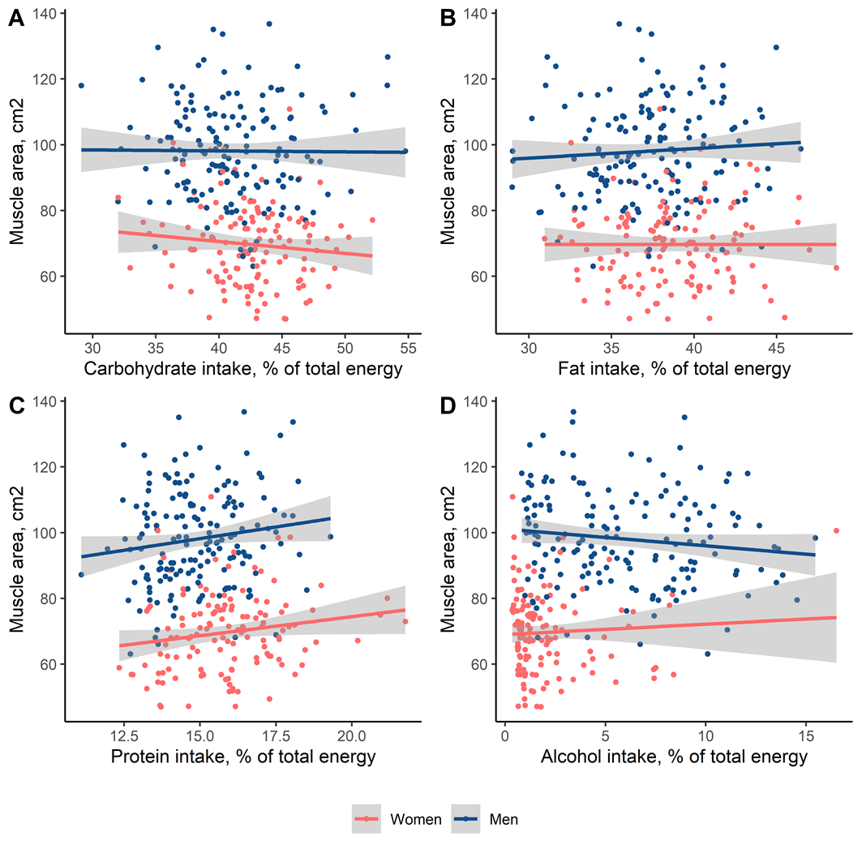

Supplementary Figure 2: Correlation of habitual dietary intake of essential amino acids with muscle area
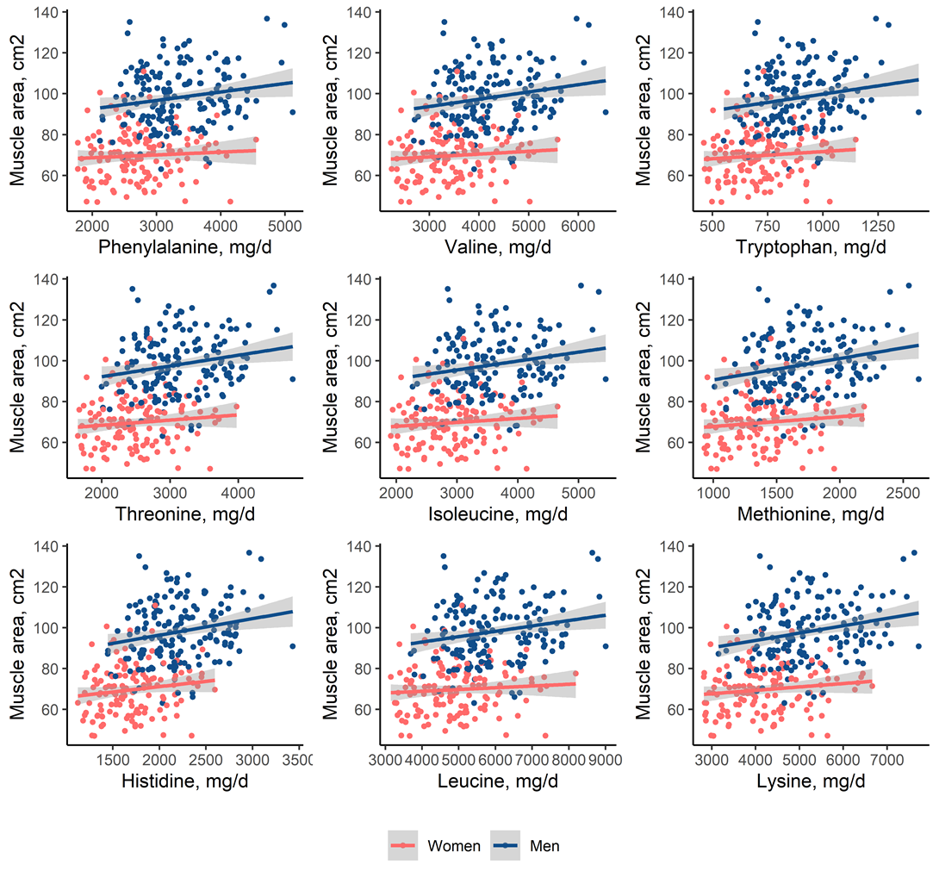

Supplementary Figure 3: Percentage of recommended intake of essential amino acids attained.
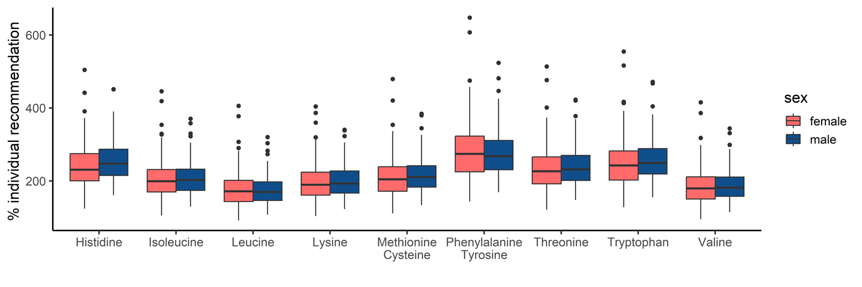
For each amino acid and each participant, individual recommended intake was calculated based on WHO RDA (Supplementary Table 2) and individual body weight. Actual intake was then divided by individual recommended intake to calculate percentage of recommended intake attained.

