Supplementary Information for
Elevated in-stream CO₂ concentration stimulates net-N₂O production from global fluvial ecosystems
Authors: R.M. Mwanake¹, G.M. Gettel^{2, 4}, E.G Wangari¹, G.W Macharia⁵, R. Martínez-Cuesta^{6,7}, S. Schulz⁶, M. Schloter^{6,7}, K. Butterbach-Bahl^{1, 3}, *R. Kiese ¹
Content:
Figs. S1 to S8
Tables S1 to S3

Fig. S1: Boxplots indicating the relationship of upstream land use with CO₂, N₂O and DOC:NO₃ ratios in the global data (4158 observations at 549 sites). The land use classifications are from the global land use map for 2019 from the HILDA+ database (Winkler et al., 2021;https://doi.org/10.1594/PANGAEA.921846). The class pasture also includes sites dominated by unmanaged grasslands. The letters on top represent significant differences (p<0.05) from pairwise mean comparisons using the Wilcoxon test.

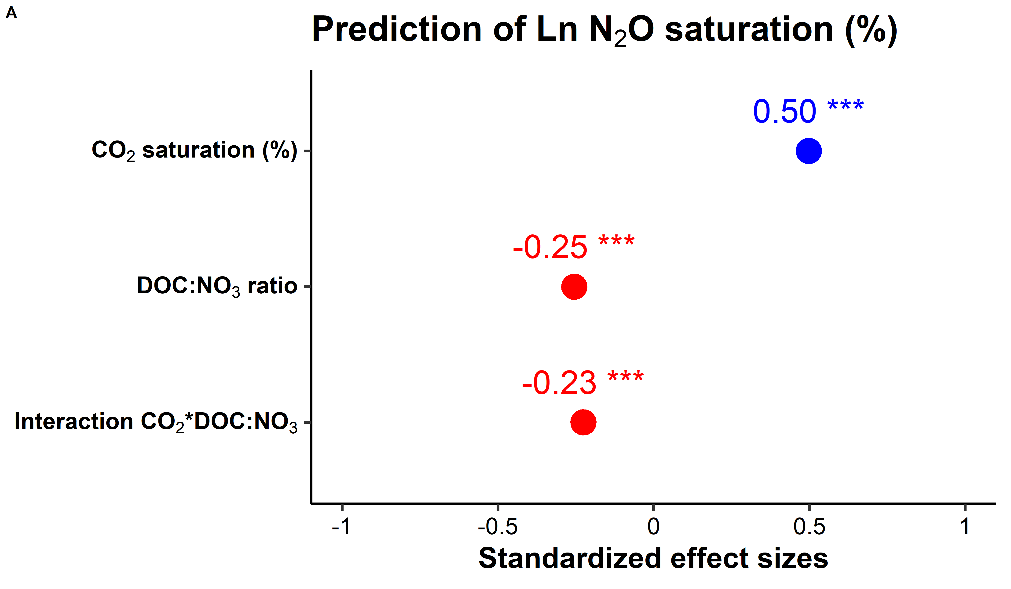
Fig. S2: A) Forest plot from the linear mixed effects model showing effect sizes of CO₂, the DOC:NO₃ ratio, and their interactions (CO₂*DOC:NO₃) on N₂O saturation levels in the global dataset. Numbers denote standardized slopes from the mixed-effects models (N=4158), with the significance level denoted by the number of asterisks *p<0.05, **p<0.01, and ***p<0.001. Blue symbols represent a positive effect, and red symbols represent a negative effect.

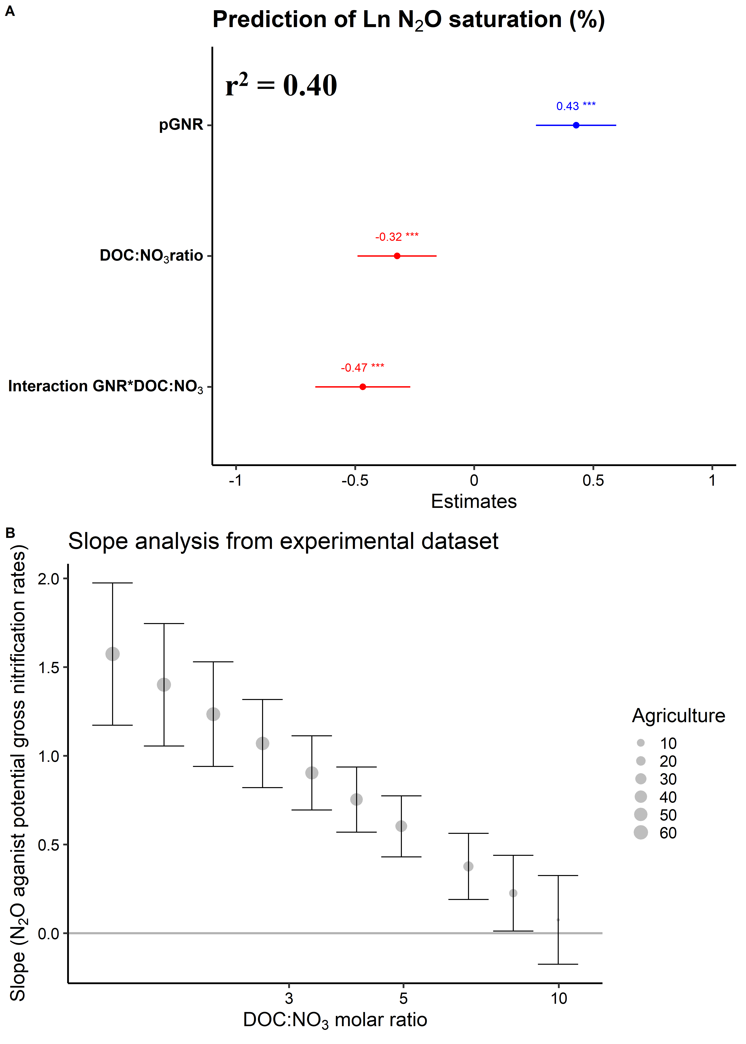
Fig. S3: A) Forest plot showing the effect sizes of potential gross nitrification rates (pGNR), DOC: NO₃ ratios, and their interaction on N₂O concentrations based on significant (*p<0.05, **p<0.01, ***p<0.001) standardized slope values from linear regression models. Blue dots represent a positive effect, red dots represent a negative effect, and the horizontal lines on the dots represent the confidence interval of the effect sizes (CI=95%). B) Scatterplot indicating the modeled GNR*DOC: NO₃ interactive effect on N₂O concentrations (µmol L⁻¹) outlined by changes in their N₂O-GNR slope ± SE values along increasing DOC: NO₃ ratios. The size of the dots indicates increasing upstream agricultural areas.

Fig. S4: Forest plot showing the effect sizes of O₂, pH, DOC: NO₃ ratios, and their interactions on sediment-slurry net N₂O production rates, gross nitrification rates, and the gene abundance of ammonium oxidizers (amoA AOA; amoB AOB) and denitrifiers (nirS, nirK, and clade I nosZ) based on significant (*p<0.05, **p<0.01, ***p<0.001) standardized slope values from linear regression models. Blue dots represent a positive effect, red dots represent a negative effect, and the horizontal lines on the dots represent the confidence interval of the effect sizes (CI=95%).

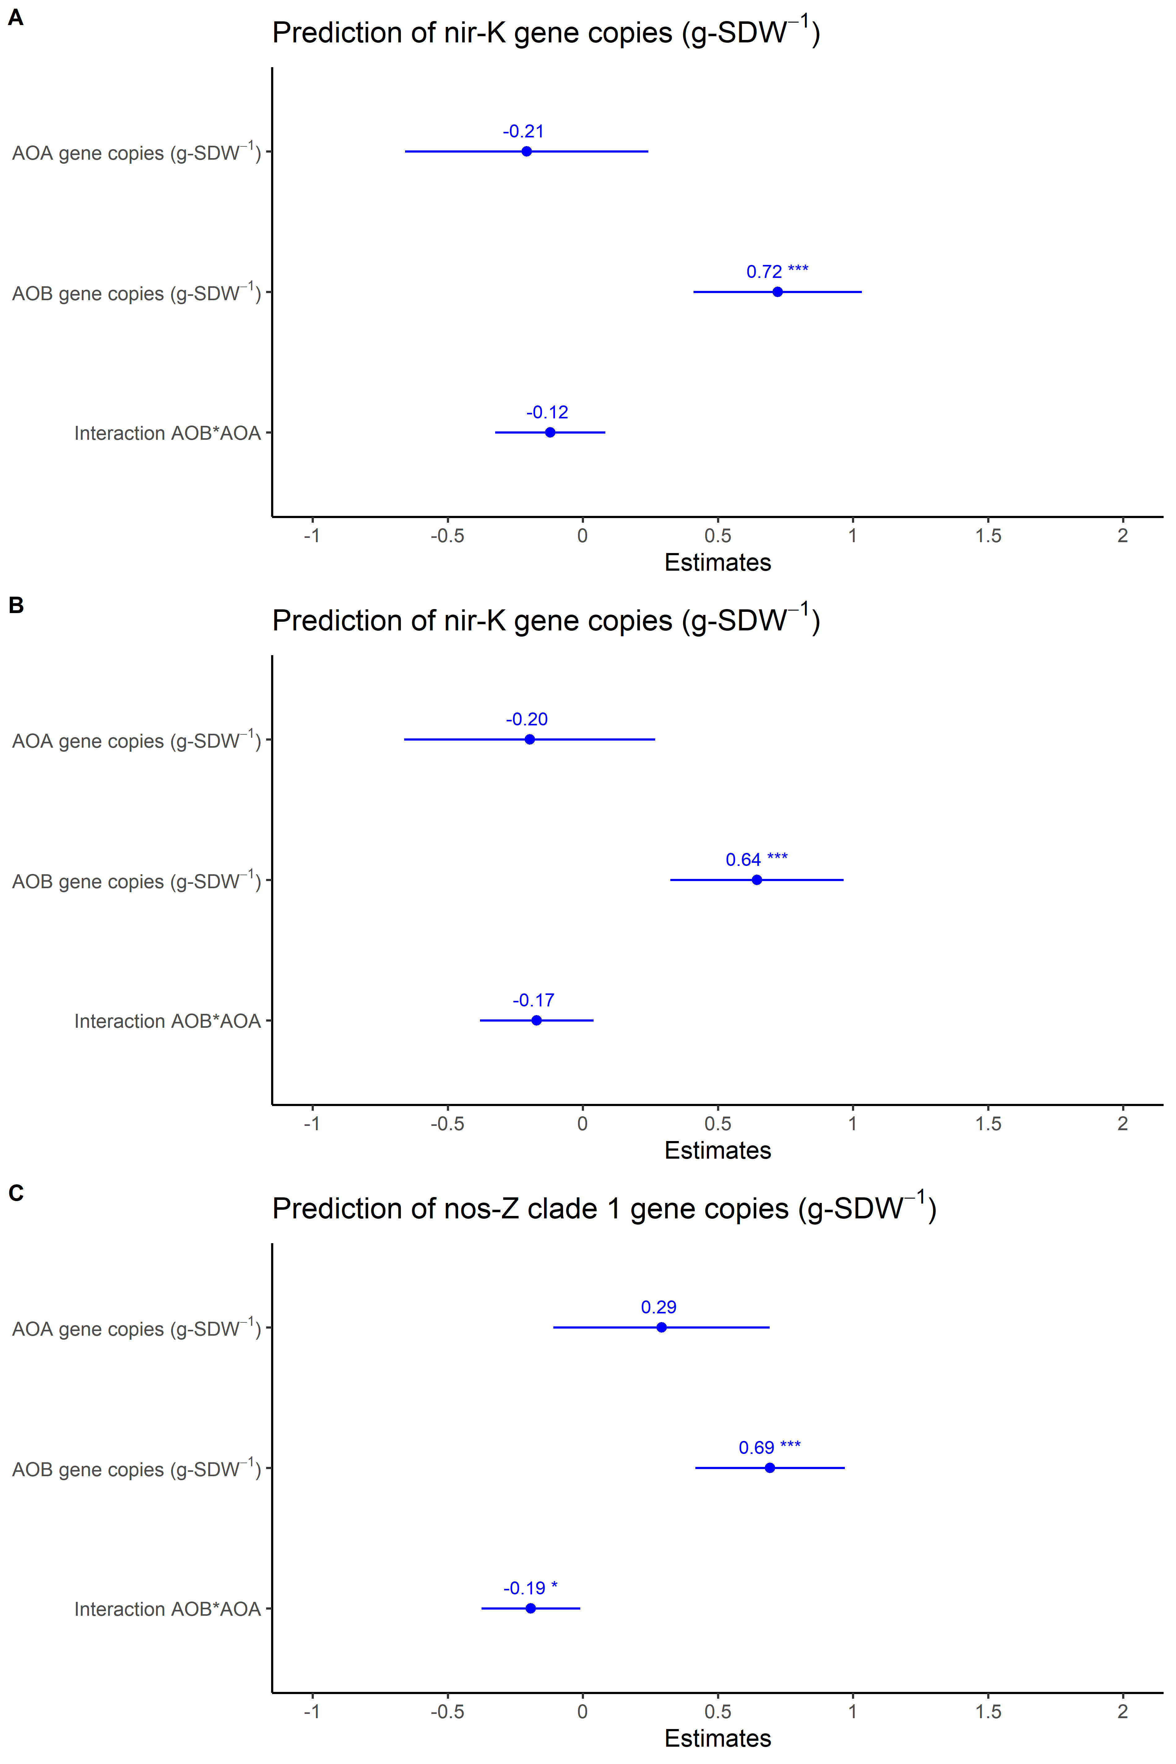
Fig. S5: Forest plot showing the effect sizes of AOA, AOB, and their interactions on denitrifiers gene abundances (nirS, nirK, and clade I nosZ) based on significant (*p<0.05, **p<0.01, ***p<0.001) standardized slope values from linear regression models. Blue dots represent a positive effect, red dots represent a negative effect, and the horizontal lines on the dots represent the confidence interval of the effect sizes (CI=95%).

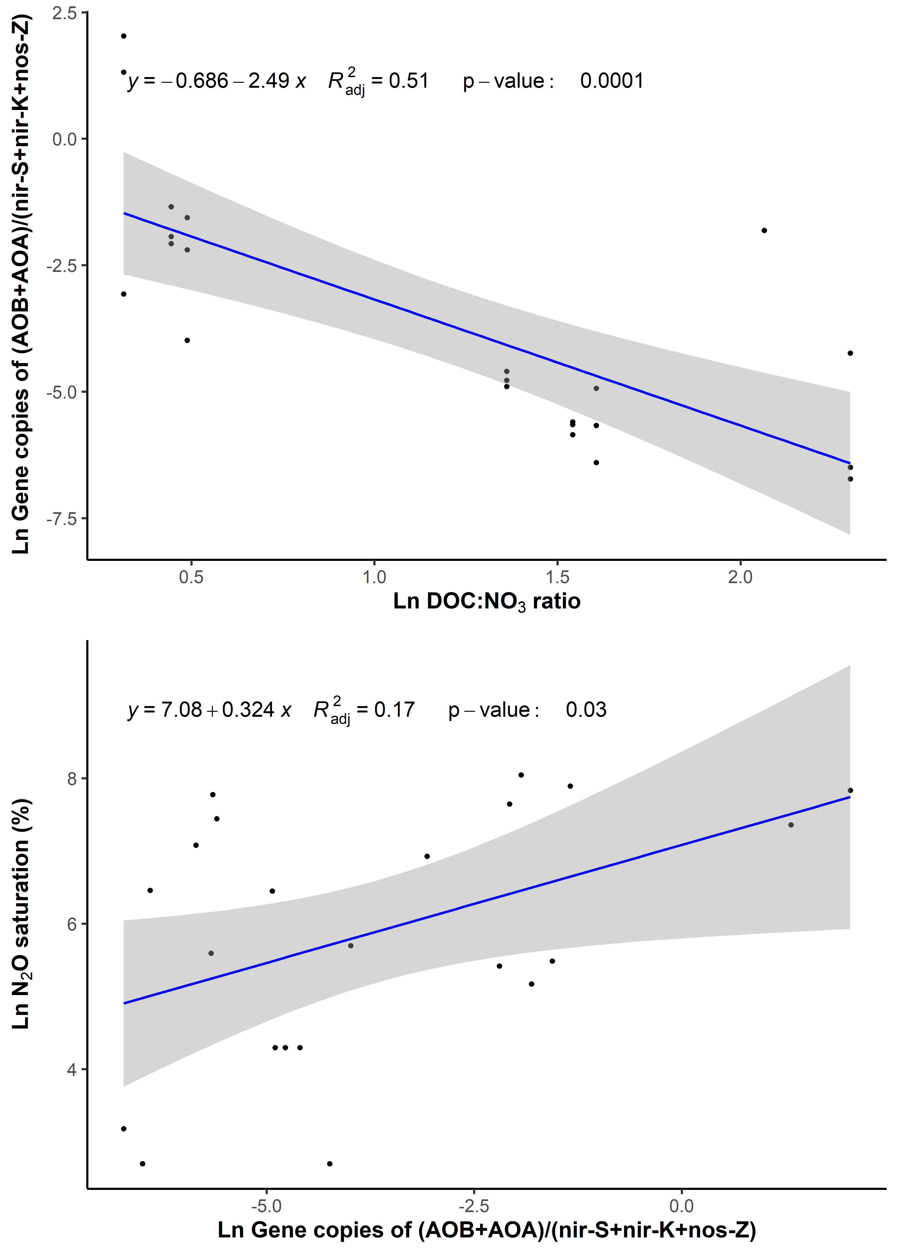
Fig. S6: Bivariate relationships between the ratio of the gene abundances of ammonium oxidizers (amoA AOA; amoB AOB) to denitrifiers (nirS, nirK, and clade I nosZ) against the DOC:NO₃ ratio from the 8 experimental sites used in the enrichment experiment. The second plot shows the relationship of the ratio with N₂O saturation.
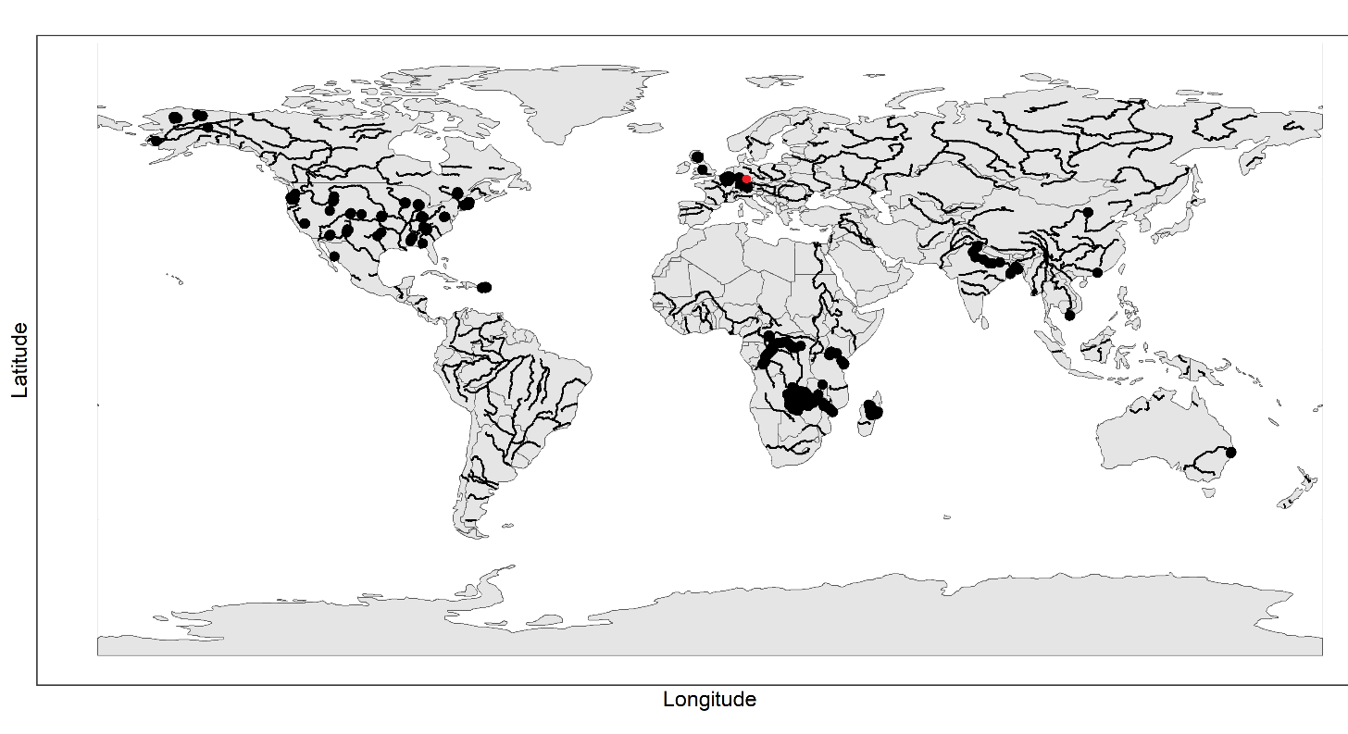
Fig. S7: Global distribution of sampling locations (number of observations = ~4158) from the meta-analysis in this study. The data comprises measured N₂O, CO₂, DOC, and river DIN concentrations. The red dot represents the location of the 8 subset sites in Germany where sediments and stream water for microcosm incubations experiments were collected. Background map represents country boundaries and black lines represents major global rivers.

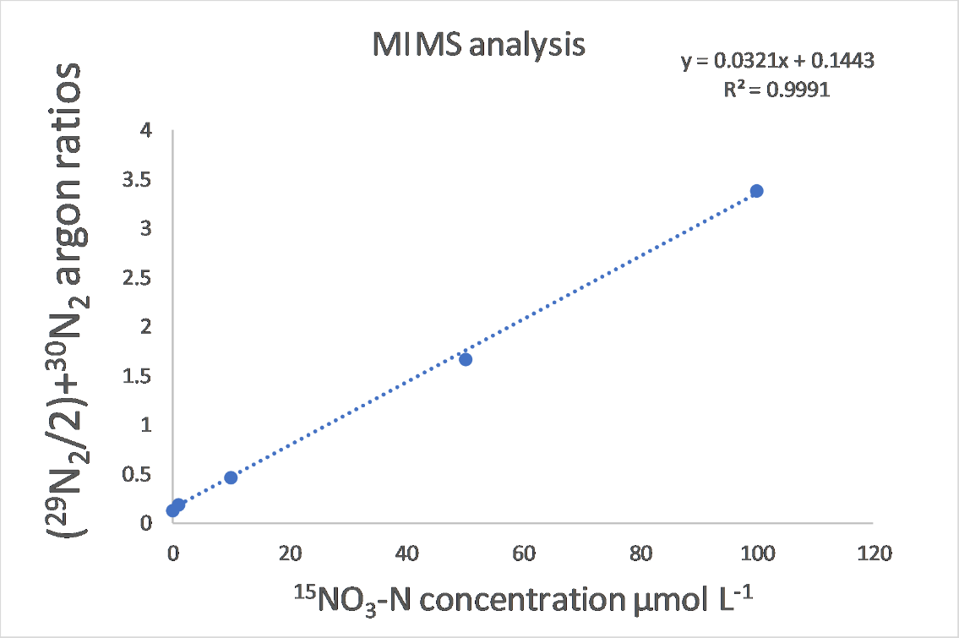
Fig. S8: Sample calibration curve of ¹⁵NO₃ concentrations in 1 M KCL against N₂/AR current ratios quantified on the membrane inlet mass spectrometer.

Table S1: Statistical summary of the water physico-chemical variables, N₂O concentrations, and CO₂ concentrations in the global data.

 | Global dataset
 | n | Range | Median
Water temperature (° C) | 4158 | 0.02 - 35.4 | 15.44
DO saturation (%) | 3720 | 1.3 - 301.4 | 92.00
NH₄ (µmol L⁻¹) | 4158 | 0.02 - 1538.5 | 3.57
NO₃ (µmol L⁻¹) | 4158 | 0.01 - 2520.9 | 28.60
DOC (µmol L⁻¹) | 4158 | 0.7 - 4496.3 | 243.33
DOC: NO₃ molar ratio | 4158 | 0.06 -16985.9 | 8.73
N₂O saturation (%) | 4158 | 1 ̶ 54452 | 162.00
CO₂ saturation (%) | 4158 | 3 ̶ 23495 | 407.00

Table: S2: Indices highlighting the performance of the best-fit SEM, which indicate significant interaction pathways of the direct drivers of in-stream N₂O concentrations in global rivers. The goodness of fit index (GFI), comparative fit index (CF1), Tucker Lewis index, root mean square error of approximation (RMSEA), standardized root mean square residual (SRMR), and r² are measures of the model's goodness of fit. The parsimony fit index (PNFI) was used to compare the Theoretical SEM with the best-fit SEM, where a higher PNFI represents a better model. ~ sign represents linear relationships between the dependent (left) and the independent variables, while ~~ indicates covariant variables.

 | Performance indices for the best-fit SEM |  |  |  |  |  | Model comparison
 |  |  |  |  |  |  | PNFI
Greenhouse gas (GHG) | GFI | CFI | TLI | RMSEA | SRMR | r² | Theoretical SEM | Best-fit SEM
Global meta-data | 1.00 | 1.00 | 0.99 | 0.02 | 0.01 | 0.24 | 0.08 | 0.13
Best model structure
1. Ln N₂O saturation~ DO saturation + Ln DOC + Ln NO₃ + Ln NH₄ + Ln CO₂ saturation
2. Ln NH₄ ~ Ln DOC + Ln CO₂ saturation
3. Ln NO₃ ~ DO saturation + Ln NH₄ + Ln CO₂ saturation
4. Ln DO saturation ~ Ln DOC
4. Ln DO saturation ~~ Ln CO₂ saturation
5. Ln DOC~~Ln CO₂ saturation
Goodness of fit assesment:- |  | GFI, CFI and TLI: 0.90 - 0.95; Good fit and >0.95 Excellent fit
 |  | SRMR and RMSEA: 0.05 - 0.10; Good fit and <0.05 Excellent fit

Table: S3: Standards, primers and cycling parameters for the qPCR reactions.
Primer | Standard | Primer | Reference | Cycles | No of cycles
amoA  AOA | Fosmid clone 54d9 | amo19F  CrenamoA16r48x | (Leininger et al., 2006; Schauss et al., 2009) | 94°C, 45 s / 55°C, 45 s / 72°C, 45 s | 40
amoA AOB | Nitrosomonas sp. | amoA1F  amoA2R | (Rotthauwe et al., 1997) | 94°C, 60 s / 58°C, 60 s / 72°C, 60 s | 40
nirK | Azospirillum irakense DSM 11586 | nirK876f  nirK5r | (Braker et al., 1998; Henry et al., 2004) | 95°C / 15 s, 62° C / 30 s, 72°C / 30 s, 5 cycles touchdown; 95°C / 15 s, 58° C / 30 s, 72°C / 30 s, 80°C / 30s | 45
nirS | Pseudomonas stutzeri | nirScd3af  nirSr3cd | (Michotey et al., 2000; ThrobÃ¤ck et al., 2004) | 95°C / 45 s, 57°C / 45 s, 72°C / 45 s | 40
clade I nosZ | Pseudomonas fluorescens C7R12 | nosZ2f  nosZ2r | (Henry et al., 2006) | 95°C /15 s, 65°C / 30 s, 72°C / 30 s, 5 cycles touchdown; 95°C / 15 s, 60°C / 30 s,  72°C / 30 s | 45

References
Braker, G., Fesefeldt, A., & Witzel, K.-P. (1998). Development of PCR Primer Systems for Amplification of Nitrite Reductase Genes ( nirK and nirS ) To Detect Denitrifying Bacteria in Environmental Samples. Applied and Environmental Microbiology, 64(10), 3769–3775. https://doi.org/10.1128/AEM.64.10.3769-3775.1998
Henry, S., Baudoin, E., López-Gutiérrez, J. C., Martin-Laurent, F., Brauman, A., & Philippot, L. (2004). Quantification of denitrifying bacteria in soils by nirK gene targeted real-time PCR. Journal of Microbiological Methods, 59(3), 327–335. https://doi.org/10.1016/j.mimet.2004.07.002
Henry, S., Bru, D., Stres, B., Hallet, S., & Philippot, L. (2006). Quantitative Detection of the nosZ Gene, Encoding Nitrous Oxide Reductase, and Comparison of the Abundances of 16S rRNA, narG , nirK , and nosZ Genes in Soils. Applied and Environmental Microbiology, 72(8), 5181–5189. https://doi.org/10.1128/AEM.00231-06
Leininger, S., Urich, T., Schloter, M., Schwark, L., Qi, J., Nicol, G. W., Prosser, J. I., Schuster, S. C., & Schleper, C. (2006). Archaea predominate among ammonia-oxidizing prokaryotes in soils. Nature, 442(7104), 806–809. https://doi.org/10.1038/nature04983
Michotey, V., Méjean, V., & Bonin, P. (2000). Comparison of Methods for Quantification of Cytochrome cd ₁ -Denitrifying Bacteria in Environmental Marine Samples. Applied and Environmental Microbiology, 66(4), 1564–1571. https://doi.org/10.1128/AEM.66.4.1564-1571.2000
Rotthauwe, J. H., Witzel, K. P., & Liesack, W. (1997). The ammonia monooxygenase structural gene amoA as a functional marker: molecular fine-scale analysis of natural ammonia-oxidizing populations. Applied and Environmental Microbiology, 63(12), 4704–4712. https://doi.org/10.1128/aem.63.12.4704-4712.1997
Schauss, K., Focks, A., Leininger, S., Kotzerke, A., Heuer, H., Thiele‐Bruhn, S., Sharma, S., Wilke, B., Matthies, M., Smalla, K., Munch, J. C., Amelung, W., Kaupenjohann, M., Schloter, M., & Schleper, C. (2009). Dynamics and functional relevance of ammonia‐oxidizing archaea in two agricultural soils. Environmental Microbiology, 11(2), 446–456. https://doi.org/10.1111/j.1462-2920.2008.01783.x
ThrobÃ¤ck, I. N., Enwall, K., Jarvis, Ã., & Hallin, S. (2004). Reassessing PCR primers targeting nirS, nirK and nosZ genes for community surveys of denitrifying bacteria with DGGE. FEMS Microbiology Ecology, 49(3), 401–417. https://doi.org/10.1016/j.femsec.2004.04.011

