The World Health Organisation (WHO) tool for Behavioural Insights on COVID-19.

WHO tool - Behavioural insights on COVID-19
- Personal experience  - To your knowledge, are you, or have you been, infected with COVID-19?  - If “yes”: Was it:  - Was it:  - Do you know people in your immediate social environment who are or have been infected with COVID-19 (suspected or confirmed)?  - If “yes”: Do you know someone who died from COVID-19? |  |  | 1 = Yes 2 = No  1 = Mild 2 = Severe  1 = Confirmed by a test  2 = Not confirmed by a test  1 = Yes 2 = No  1 = Yes 2 = No
- Variability and probability  - What do you consider to be your own probability of getting infected with COVID-19?  - How susceptible do you consider yourself to an infection with COVID-19?  - How severe would contracting COVID-19 be for you (how seriously ill do you think you will be)? |  | 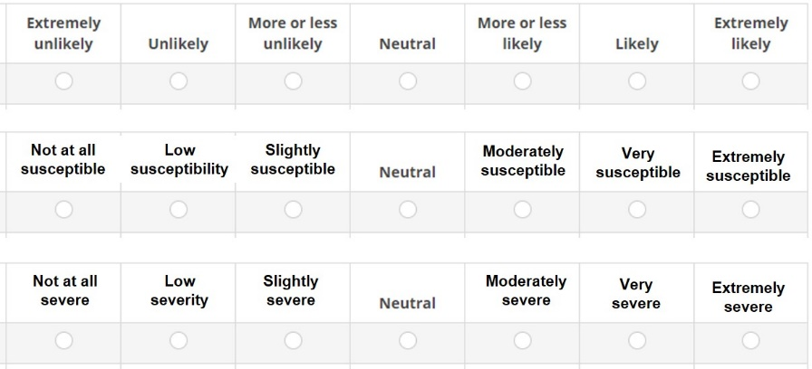
- Preparedness and Perceived self-efficacy  Next, we would like to know about you own practices related to COVID-19.  - I know how to protect myself from coronavirus  - For me avoiding an infection with COVID-19 in the current situation is… |  | 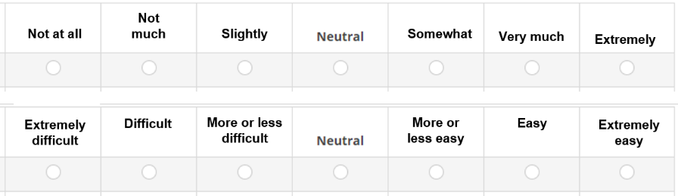
- Prevention – own behaviours  - Frequently washed my hands with soap and water for at least 20 seconds  - Avoided touching my eyes, nose and mouth with unwashed hands  - Used disinfectants to clean hands when soap and water were not available  - Avoided a social event I wanted to attend  - Stayed at home from work/school  - Used antibiotics to prevent or treat COVID-19  - Wore a mask in public  - Ensured physical distancing in public  - Disinfected surfaces |  | 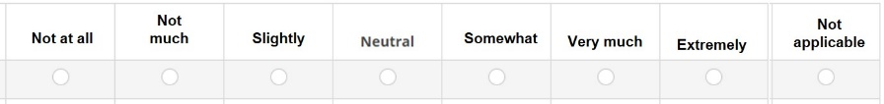
- Affect  COVID-19 to me feels ... | 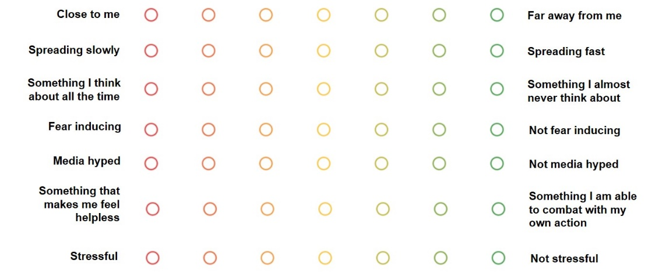
- Resilience  Please consider your experience during COVID-19 pandemic:  - I have a hard time making it through stressful events  - It does not take me long to recover from a stressful event  - It is hard for me to snap back when something bad happens |  | 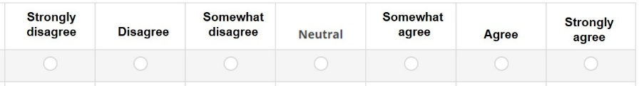
- Unwanted behaviour  Within the last 2 weeks, have you done the following…?  - Avoided people that I thought might infect me, based on their ethnicity  - Exercised less than I did before the pandemic  - Drank more alcohol than I did before the pandemic  - Ate more unhealthy food than I did before the pandemic  - Smoked more than I did before the pandemic  - Postponed vaccination for myself or my child  - Avoided going to the doctor for a non-COVID-19-related problem  - Bought drugs that I heard are good for treating COVID-19 |  |  | 1 = Yes 2 = No 3 = N/A  1 = Yes 2 = No 3 = N/A  1 = Yes 2 = No 3 = N/A  1 = Yes 2 = No 3 = N/A  1 = Yes 2 = No 3 = N/A  1 = Yes 2 = No 3 = N/A  1 = Yes 2 = No 3 = N/A  1 = Yes 2 = No 3 = N/A

