Long-term exposure to air pollution is associated with DNA methylation-based
estimators of age acceleration
Yueli Yao ^{a,b}, Kathrin Wolf ª, Susanne Breitner ^{a,b}, Siqi Zhang ^{a,c}, Melanie Waldenberger ^{a,d}, Juliane Winkelmann ^{e,f}, Alexandra Schneider ª*, Annette Peters ^{a,b,g,h}*

ª Institute of Epidemiology, Helmholtz Zentrum München GmbH, German Research Center for Environmental Health, Neuherberg, Germany
^{b} Institute for Medical Information Processing, Biometry, and Epidemiology (IBE), Faculty of Medicine, LMU Munich, Pettenkofer School of Public Health, Munich, Germany
^{c} Department of Environmental Health Sciences, Yale School of Public Health, New Haven, United States
^{d} Research Unit Molecular Epidemiology, Helmholtz Zentrum München GmbH, German Research Center for Environmental Health, Neuherberg, Germany
^{e} Institute of Neurogenomics, Helmholtz Zentrum München, German Research Center for Environmental Health, Neuherberg, Germany
^{f} Institute of Human Genetics, Technical University of Munich, Munich, Germany
^{g} German Center for Diabetes Research (DZD), Munich-Neuherberg, Germany
^{h} German Centre for Cardiovascular Research (DZHK), Partner Site Munich, Munich, Germany

*Authors share last authorship

Correspondence to:
Yueli Yao, Institute of Epidemiology, Helmholtz Zentrum München GmbH, German Research Center for Environmental Health, Ingolstädter Landstr. 1, 85764 Neuherberg, Germany; Email: yueli.yao@helmholtz-munich.de.

Appendix
Contents
Figure S1. Flow chart of participant exclusion process in this study.
Figure S2. Air pollution exposure maps in the KORA cohort area.
Figure S3. Directed Acyclic Graph (DAG) for air pollution, confounding, and epigenetic aging.
Figure S4. Pearson correlations between Age, DNAmHorvathAge, DNAmHannumAge, DNAmPhenoAge, DNAmGrimAge, DNAmSkinBloodAge, and DNAmTL.
Figure S5. Pearson correlation between houseman estimated cells.
Figure S6. Pearson correlations between chronological age, PM_{2.5}, PM₁₀, PM_{coarse}, PM_{2.5abs}, PNC, NO₂, NO_{x} and O₃.
Figure S7. Results of analysis on DNAmGrimAge with an inclusion of confounders step by step.
Figure S8. Absolute changes (95% CI, years) in DNAmHorvathAge acceleration per IQR increase in air pollutant concentrations stratified by categorized age group (≤ 65 vs > 65), sex, categorized BMI group, categorized group of alcohol consumption, educational attainment, physical activity, and history of diseases (hypertension, diabetes).
Figure S9. Absolute changes (95% CI, years) in DNAmHannumAge acceleration per IQR increase in air pollutant concentrations stratified by categorized age group (≤ 65 vs > 65), sex, categorized BMI group, categorized group of alcohol consumption, educational attainment, physical activity, and history of diseases (hypertension, diabetes).
Figure S10. Absolute changes (95% CI, years) in DNAmPhenoAge acceleration per IQR increase in air pollutant concentrations stratified by categorized age group (≤ 65 vs > 65), sex, categorized BMI group, categorized group of alcohol consumption, educational attainment, physical activity, and history of diseases (hypertension, diabetes).
Figure S11. Absolute changes (95% CI, years) in DNAmGrimAge acceleration per IQR increase in air pollutant concentrations stratified by categorized age group (≤ 65 vs > 65), sex, categorized BMI group, categorized group of alcohol consumption, educational attainment, physical activity, and history of diseases (hypertension, diabetes).
Figure S12. Absolute changes (95% CI, years) in DNAmSkinBloodAge acceleration per IQR increase in air pollutant concentrations stratified by categorized age group (≤ 65 vs > 65), sex, categorized BMI group, categorized group of alcohol consumption, educational attainment, physical activity, and history of diseases (hypertension, diabetes).
Figure S13. Associations between air pollution and the six epigenetic clocks under various sensitivity analyses.
Figure S14. Absolute change (95% CI, years) / percent change (95%CI) of epigenetic age acceleration per IQR increase in air pollutant concentrations stratified by categorized physical activity (percent change only for DNAmTL).
Figure S15. Sensitivity to Back-Extrapolated Exposures: Epigenetic age (years) and DNAmTL (%) change per IQR pollutant increase—Main vs Back-Extrapolation (95% CI).
Figure S16. Comparison between single and two-pollutant models after additional inclusion of PM_{2.5}.
Figure S17. Comparison between single and two-pollutant models after additional inclusion of O₃.
Table S1 Absolute/percent changes (95% CI) in epigenetic aging biomarkers per IQR increase in air pollutants.
Table S2 Effect estimates (95% CI) of the confounders used in the full models for each epigenetic aging biomarker.
Table S3 Descriptive statistics of participant characteristics by study wave in never smokers (N=1726).
Table S4 Absolute/percent changes (95% CI) in epigenetic aging biomarkers per IQR increase in air pollutants in never smokers.
Table S5 Descriptive statistics of participant characteristics by study wave in current and former smokers (N=2378).
Table S6 Absolute/percent changes (95% CI) in epigenetic aging biomarkers per IQR increase in air pollutants current and former smokers.
Table S7 Correlation and mean differences between default and overlap-only clocks by study wave. Table S8 Sensitivity analysis comparing original calculator-derived clocks and overlap-only CpG clocks across study waves
Table S9 Pathways identified by exposure-related CpG sites via Ingenuity Pathway Analysis (IPA).
Text S1 Back-extrapolated air pollutant concentrations.

1535
KORA S4
4261
KORA F4
3080
KORA FF4
2279
1725
1877
1516
1712
1869
5097
4105
KORA S4
1481
KORA F4
1599
KORA FF4
1025
Exclude participants without epigenetics/exposure data
Exclude participants with missing information of confounders used in
the full models
Exclude participants attending only one visit
across the entire study (S4-F4-FF4)
Participants included in this analysis

Figure S1. Flow chart of participants exclusion process in this study

Figure S2. Air pollution exposure maps in the KORA cohort area.
Those maps showed annual average air pollution exposures including PM_{2.5,} PM_{10,} PM_{coarse,} PM_{2.5abs,} PNC, NO_{2,} NO_{x,} and O_{3,} in the KORA study region, Germany. Source: ULTRA3 land used regression model; Spatial resolution: 50m × 50m; Exposure year: 2014. PM_{2.5} = particulate matter with an aerodynamic diameter less than or equal to 2.5 μm; PM₁₀ = particulate matter with an aerodynamic diameter less than or equal to 10 μm; PM_{coarse} = particulate matter with an aerodynamic diameter of 2.5-10 μm; PM_{2.5abs} = PM_{2.5} absorbance; PNC = particle number concentration; NO₂ = nitrogen dioxide; NO_{x} = nitrogen oxide; O₃ = ozone.

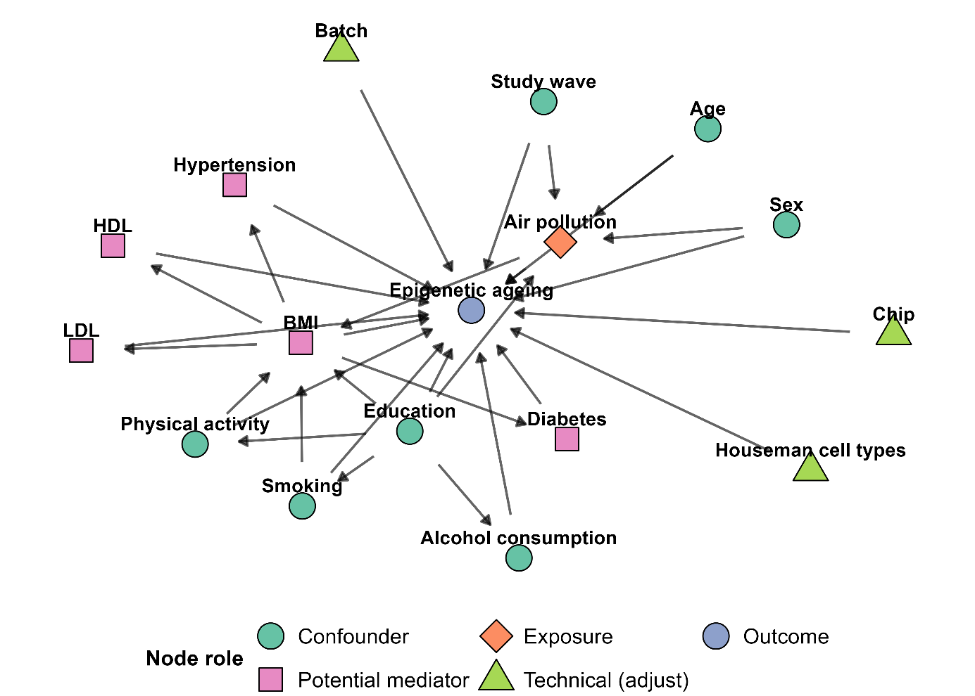
Figure S3. Directed Acyclic Graph (DAG) for air pollution, confounding, and epigenetic aging.

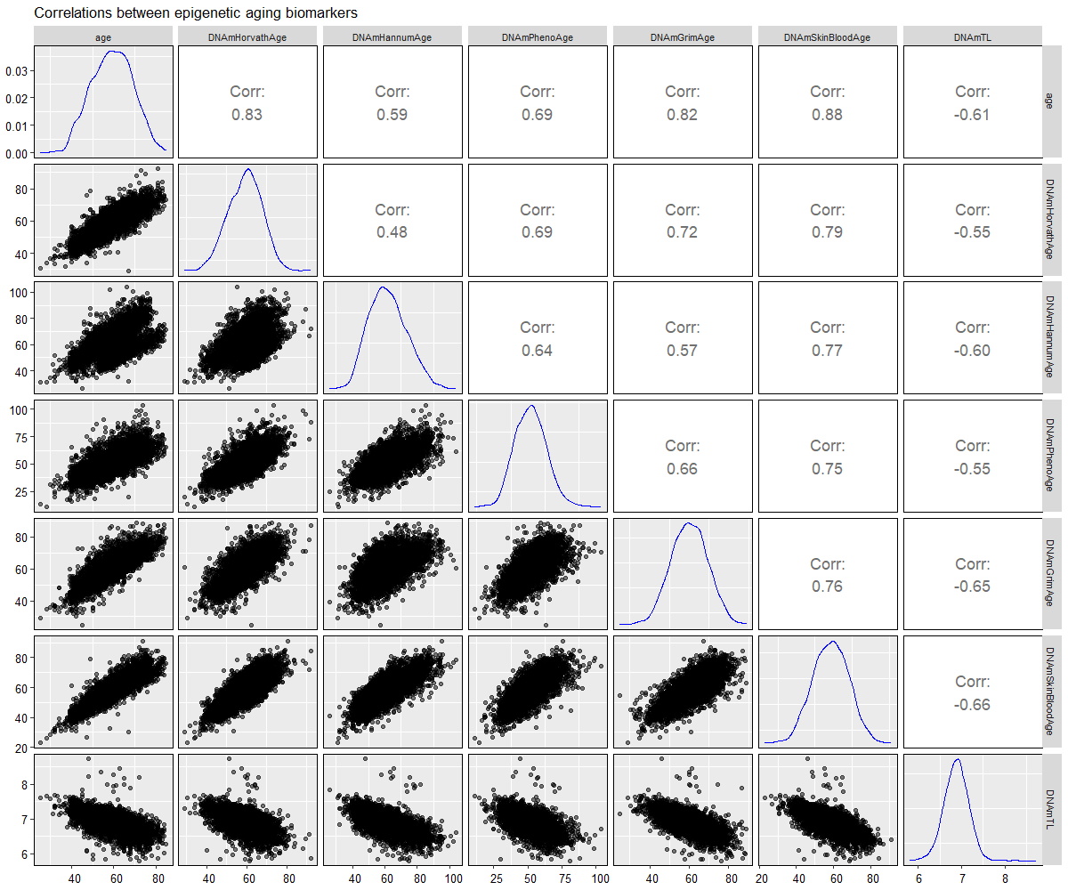
Figure S4. Pearson correlations between Age, DNAmHorvathAge, DNAmHannumAge, DNAmPhenoAge, DNAmGrimAge, DNAmSkinBloodAge, and DNAmTL. Pearson’s correlation coefficients were calculated to determine the correlations between chronological age and epigenetic aging biomarkers.

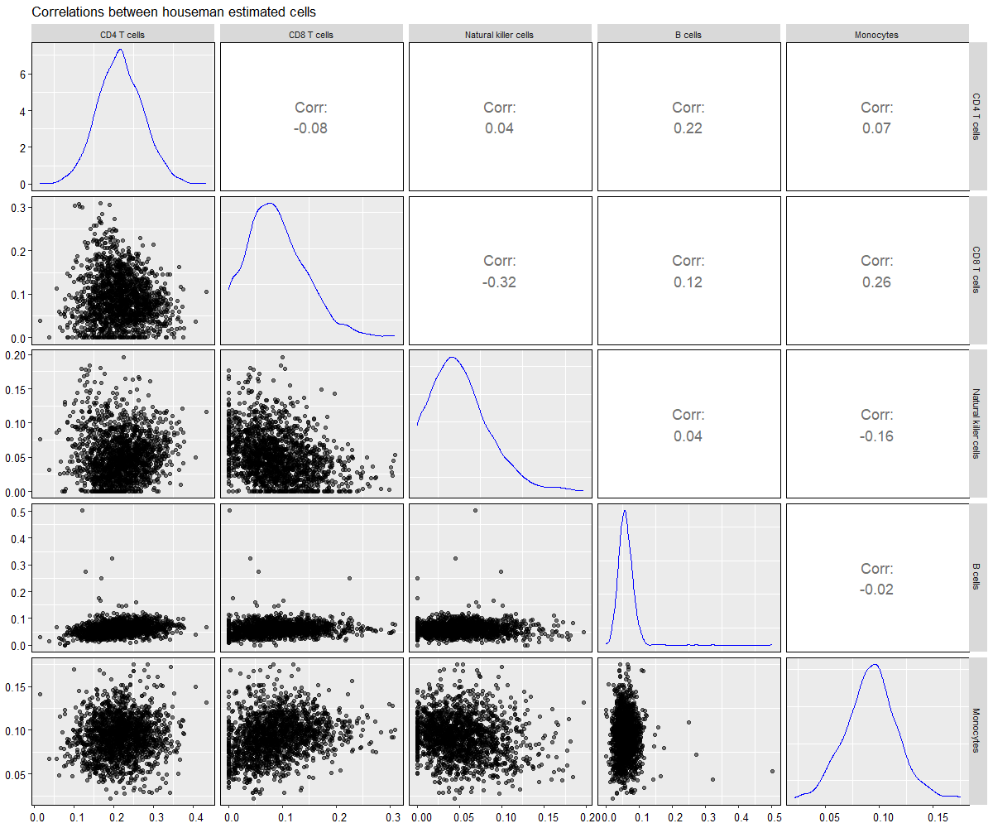

Figure S5. Pearson correlation between houseman estimated cells.

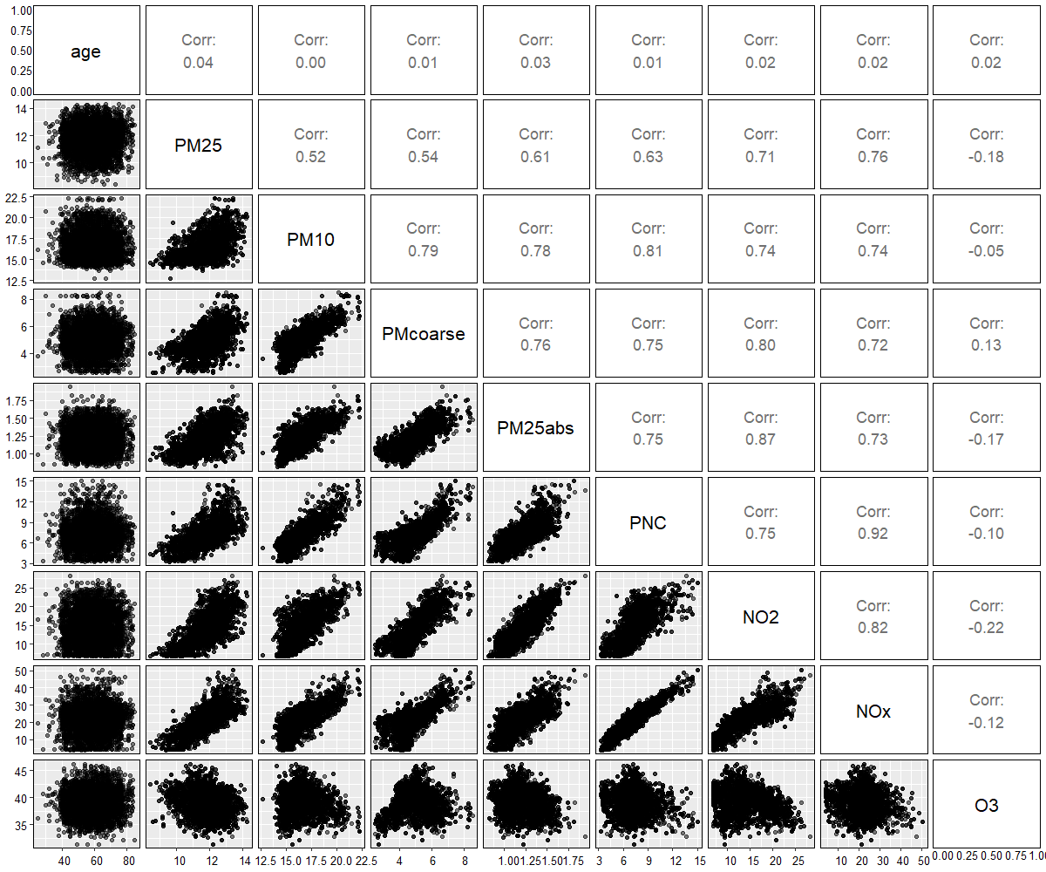
Figure S6. Pearson correlations between chronological age, PM_{2.5}, PM₁₀, PM_{coarse}, PM_{2.5abs}, PNC, NO₂, NO_{x} and O₃. PM_{2.5} = particulate matter with an aerodynamic diameter less than or equal to 2.5 μm; PM₁₀ = particulate matter with an aerodynamic diameter less than or equal to 10 μm; PM_{coarse} = particulate matter with an aerodynamic diameter of 2.5-10 μm; PM_{2.5abs} = PM_{2.5} absorbance; PNC = particle number concentration; NO₂ = nitrogen dioxide; NO_{x} = nitrogen oxide; O₃ = ozone.

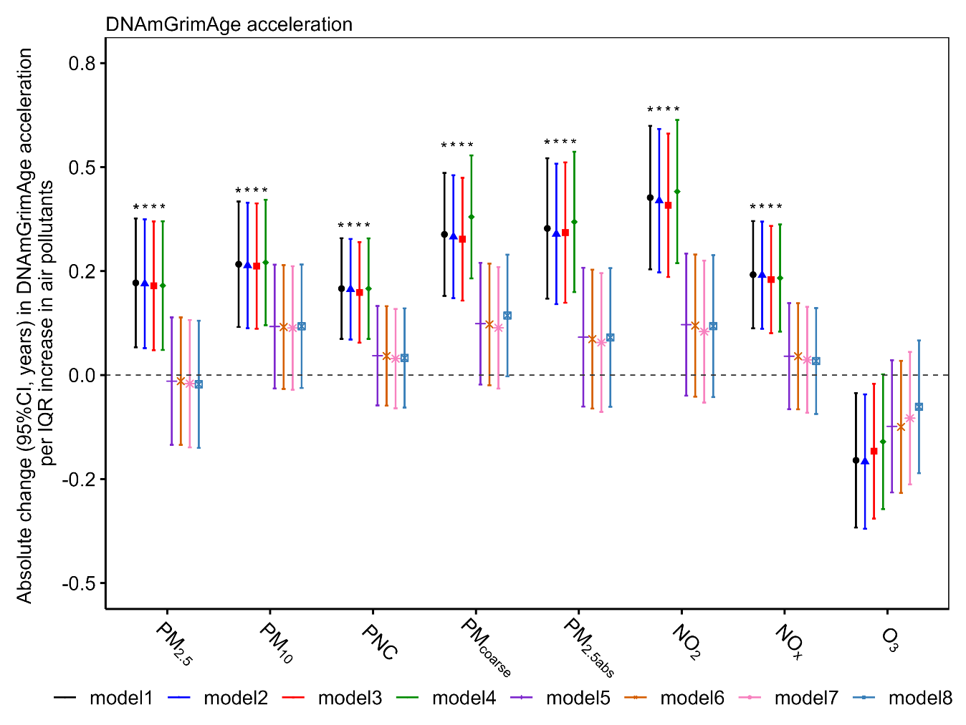
Figure S7. Results of analysis on DNAmGrimAge with an inclusion of confounders step by step.
Covariate-adjusted linear mixed-effect regression models were used.
Random effect: participant ID, batch, chip
model1: age + sex + houseman cells + indicator of study + BMI + hypertension + diabetes + HDL + LDL
model2: model1 + alcohol consumption
model3: model1 + physical activity
model4: model1 + education
model5: model1 + smoking
model6: model1 + smoking + alcohol consumption
model7: model1 + smoking + alcohol consumption + physical activity
model8: model1 + smoking + alcohol consumption + physical activity + education
PM_{2.5} = particulate matter with an aerodynamic diameter less than or equal to 2.5 μm; PM₁₀ = particulate matter with an aerodynamic diameter less than or equal to 10 μm; PNC = particle number concentration; PM_{coarse} = particulate matter with an aerodynamic diameter of 2.5-10 μm; PM_{2.5abs} = PM_{2.5} absorbance; NO₂ = nitrogen dioxide; NO_{x} = nitrogen oxide; O₃ = ozone.
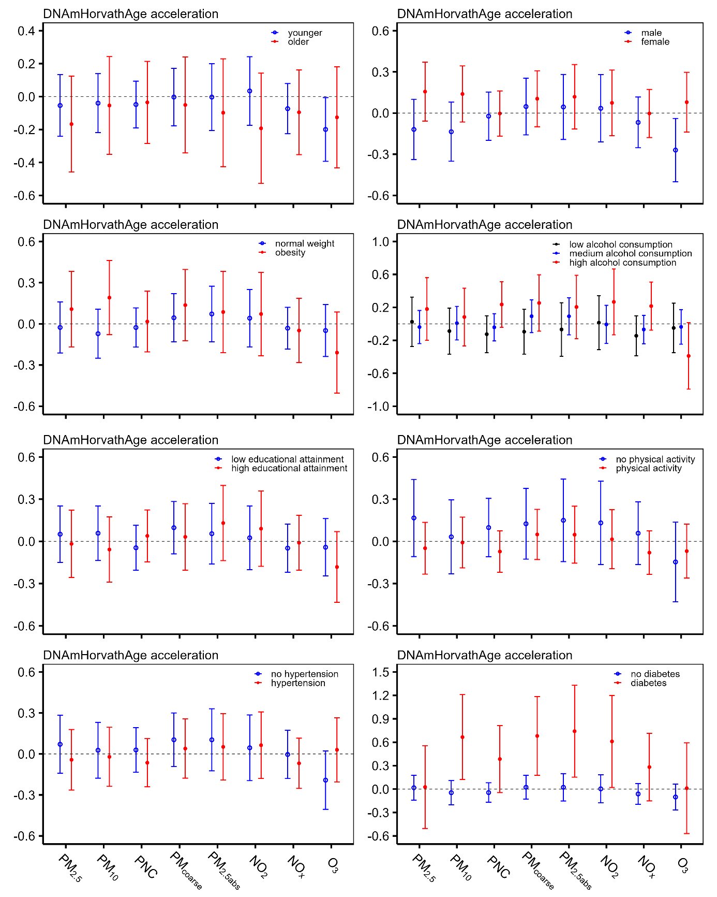
Figure S8. Absolute changes (95% CI, years) in DNAmHorvathAge acceleration per IQR increase in air pollutant concentrations stratified by categorized age group (≤ 65 vs > 65), sex, categorized BMI group, categorized group of alcohol consumption, educational attainment, physical activity, and history of diseases (hypertension, diabetes).
Covariate-adjusted linear mixed-effect regression models were used. Results were from our full model adjusted by age, sex, an indicator of each study waves visit (KORA S4, KORA F4, or KORA FF4), houseman estimated cells, batch, chip, educational attainment, smoking status, alcohol consumption, physical activity (yes/no), BMI, hypertension, diabetes, HDL, and LDL.
PM_{2.5} = particulate matter with an aerodynamic diameter less than or equal to 2.5 μm; PM₁₀ = particulate matter with an aerodynamic diameter less than or equal to 10 μm; PNC = particle number concentration; PM_{coarse} = particulate matter with an aerodynamic diameter of 2.5-10 μm; PM_{2.5abs} = PM_{2.5} absorbance; NO₂ = nitrogen dioxide; NO_{x} = nitrogen oxide; O₃ = ozone. An IQR increase was 1.4 μg/m³ for PM_{2.5}, 2.1 μg/m³ for PM₁₀, 2.0×10³/cm³ for PNC, 1.4 μg/m³ for PM_{coarse}, 0.3×10⁻⁵/m for PM_{2.5abs}, 7.2 μg/m³ for NO₂, 8.8 μg/m³ for NO_{x}, and 3.4 μg/m³ for O₃.

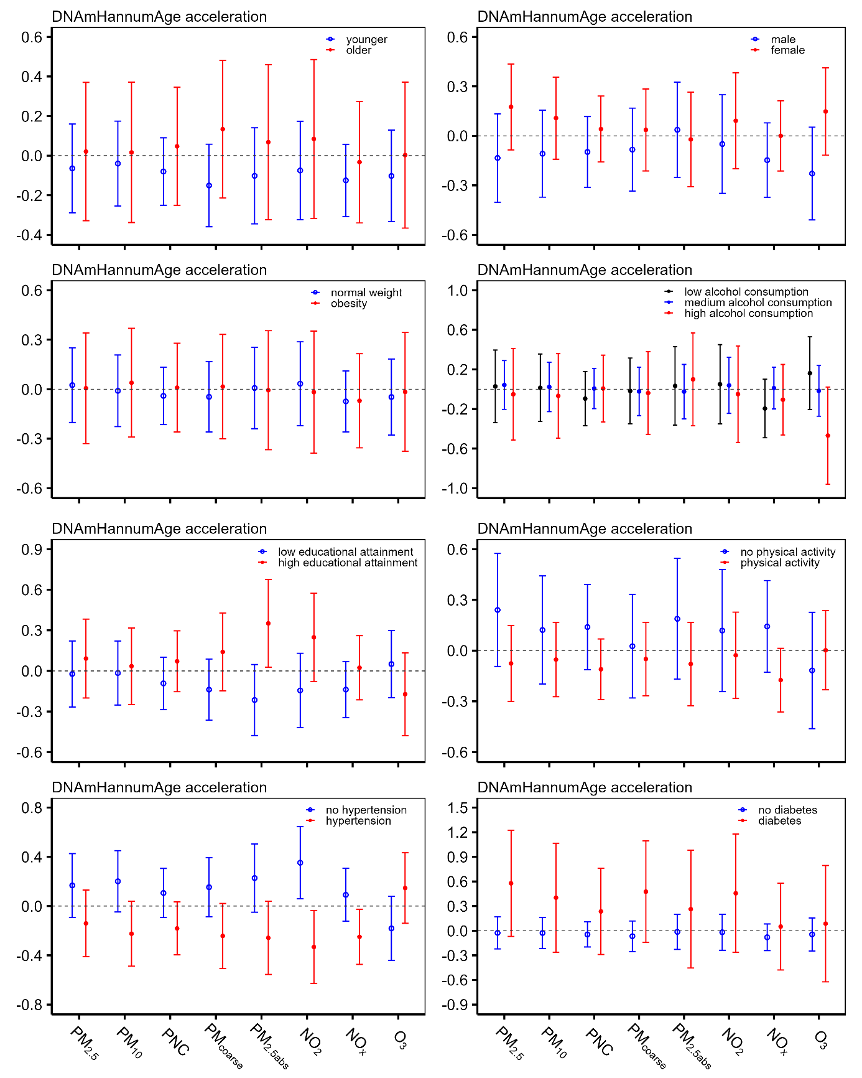
Figure S9. Absolute changes (95% CI, years) in DNAmHannumAge acceleration per IQR increase in air pollutant concentrations stratified by categorized age group (≤ 65 vs > 65), sex, categorized BMI group, categorized group of alcohol consumption, educational attainment, physical activity, and history of diseases (hypertension, diabetes).
Covariate-adjusted linear mixed-effect regression models were used. Results were from our full model adjusted by age, sex, an indicator of each study waves visit (KORA S4, KORA F4, or KORA FF4), houseman estimated cells, batch, chip, educational attainment, smoking status, alcohol consumption, physical activity (yes/no), BMI, hypertension, diabetes, HDL, and LDL.
PM_{2.5} = particulate matter with an aerodynamic diameter less than or equal to 2.5 μm; PM₁₀ = particulate matter with an aerodynamic diameter less than or equal to 10 μm; PNC = particle number concentration; PM_{coarse} = particulate matter with an aerodynamic diameter of 2.5-10 μm; PM_{2.5abs} = PM_{2.5} absorbance; NO₂ = nitrogen dioxide; NO_{x} = nitrogen oxide; O₃ = ozone. An IQR increase was 1.4 μg/m³ for PM_{2.5}, 2.1 μg/m³ for PM₁₀, 2.0×10³/cm³ for PNC, 1.4 μg/m³ for PM_{coarse}, 0.3×10⁻⁵/m for PM_{2.5abs}, 7.2 μg/m³ for NO₂, 8.8 μg/m³ for NO_{x}, and 3.4 μg/m³ for O₃.

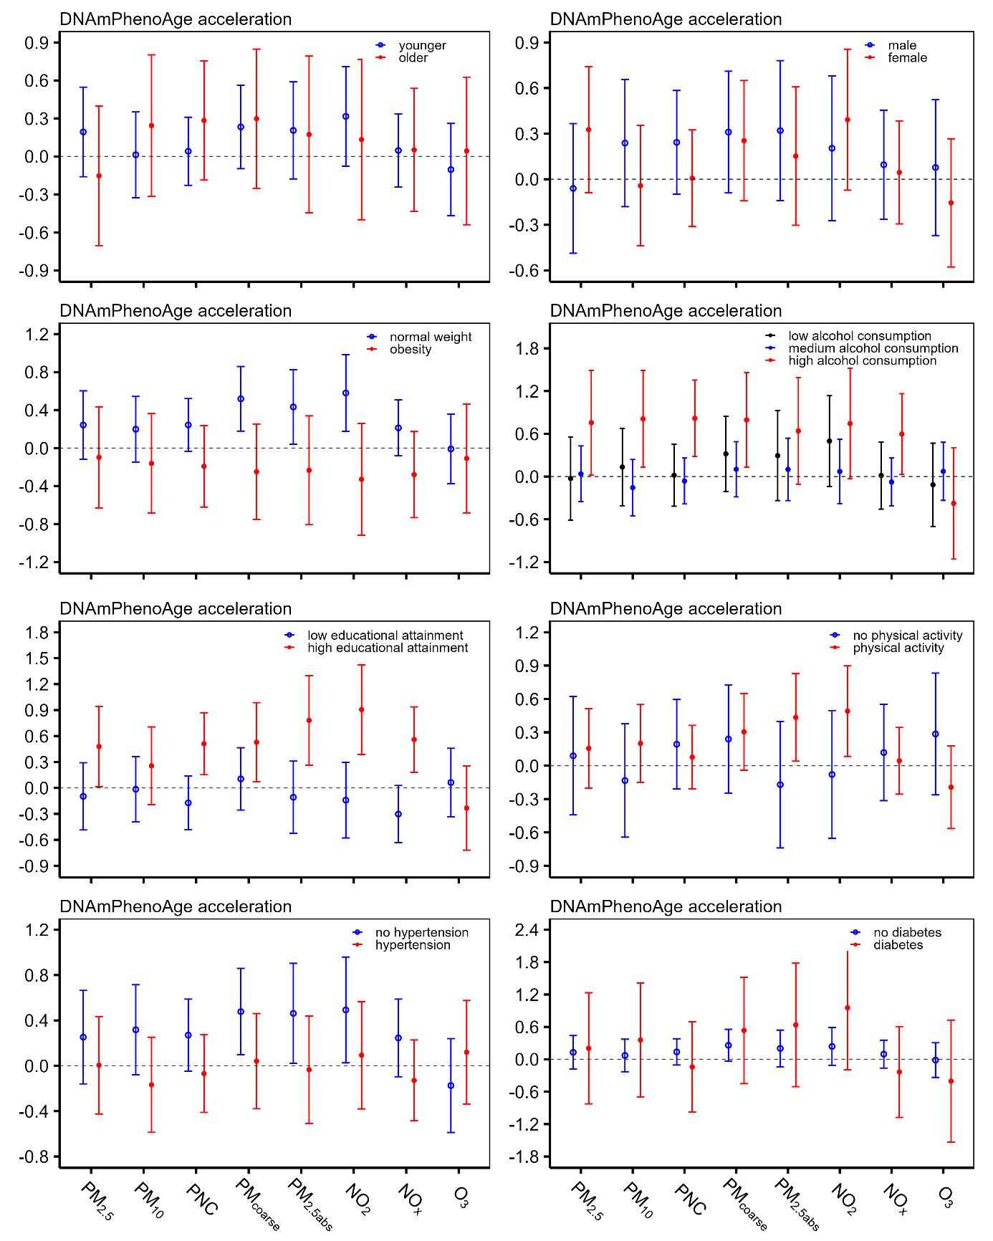
Figure S10. Absolute changes (95% CI, years) in DNAmPhenoAge acceleration per IQR increase in air pollutant concentrations stratified by categorized age group (≤ 65 vs > 65), sex, categorized BMI group, categorized group of alcohol consumption, educational attainment, physical activity, and history of diseases (hypertension, diabetes).
Covariate-adjusted linear mixed-effect regression models were used. Results were from our full model adjusted by age, sex, an indicator of each study waves visit (KORA S4, KORA F4, or KORA FF4), houseman estimated cells, batch, chip, educational attainment, smoking status, alcohol consumption, physical activity (yes/no), BMI, hypertension, diabetes, HDL, and LDL.
PM_{2.5} = particulate matter with an aerodynamic diameter less than or equal to 2.5 μm; PM₁₀ = particulate matter with an aerodynamic diameter less than or equal to 10 μm; PNC = particle number concentration; PM_{coarse} = particulate matter with an aerodynamic diameter of 2.5-10 μm; PM_{2.5abs} = PM_{2.5} absorbance; NO₂ = nitrogen dioxide; NO_{x} = nitrogen oxide; O₃ = ozone. An IQR increase was 1.4 μg/m³ for PM_{2.5}, 2.1 μg/m³ for PM₁₀, 2.0×10³/cm³ for PNC, 1.4 μg/m³ for PM_{coarse}, 0.3×10⁻⁵/m for PM_{2.5abs}, 7.2 μg/m³ for NO₂, 8.8 μg/m³ for NO_{x}, and 3.4 μg/m³ for O₃.

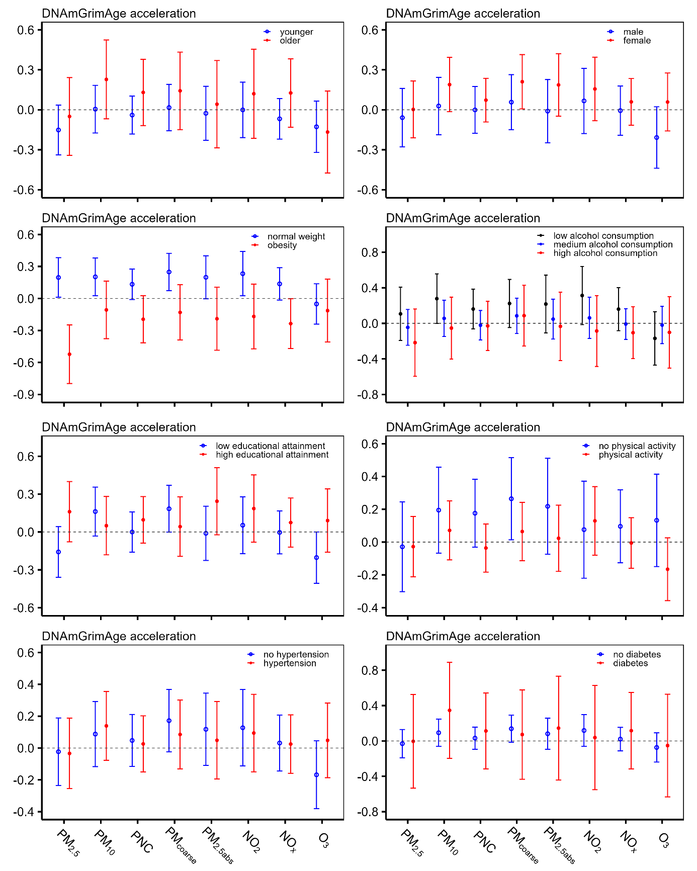
Figure S11. Absolute changes (95% CI, years) in DNAmGrimAge acceleration per IQR increase in air pollutant concentrations stratified by categorized age group (≤ 65 vs > 65), sex, categorized BMI group, categorized group of alcohol consumption, educational attainment, physical activity, and history of diseases (hypertension, diabetes).
Covariate-adjusted linear mixed-effect regression models were used. Results were from our full model adjusted by age, sex, an indicator of each study waves visit (KORA S4, KORA F4, or KORA FF4), houseman estimated cells, batch, chip, educational attainment, smoking status, alcohol consumption, physical activity (yes/no), BMI, hypertension, diabetes, HDL, and LDL.
PM_{2.5} = particulate matter with an aerodynamic diameter less than or equal to 2.5 μm; PM₁₀ = particulate matter with an aerodynamic diameter less than or equal to 10 μm; PNC = particle number concentration; PM_{coarse} = particulate matter with an aerodynamic diameter of 2.5-10 μm; PM_{2.5abs} = PM_{2.5} absorbance; NO₂ = nitrogen dioxide; NO_{x} = nitrogen oxide; O₃ = ozone. An IQR increase was 1.4 μg/m³ for PM_{2.5}, 2.1 μg/m³ for PM₁₀, 2.0×10³/cm³ for PNC, 1.4 μg/m³ for PM_{coarse}, 0.3×10⁻⁵/m for PM_{2.5abs}, 7.2 μg/m³ for NO₂, 8.8 μg/m³ for NO_{x}, and 3.4 μg/m³ for O₃.

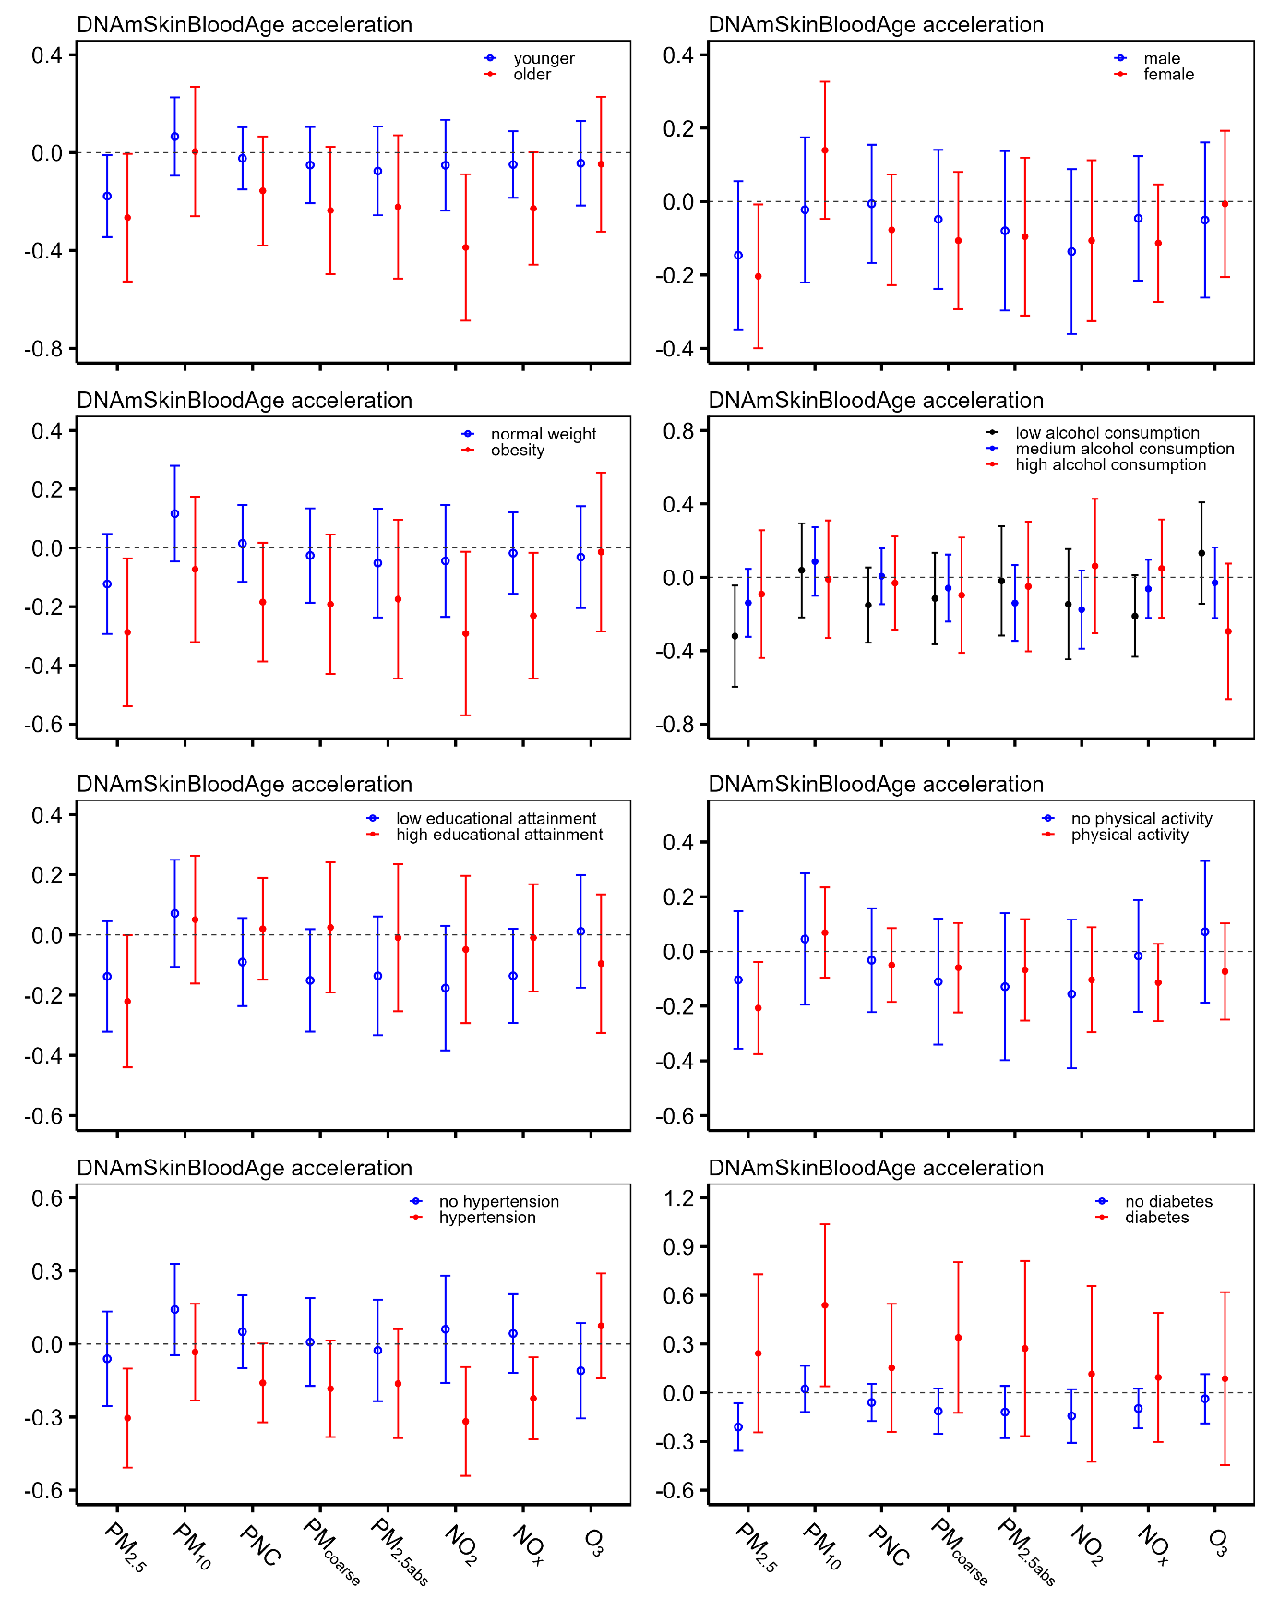
Figure S12. Absolute changes (95% CI, years) in DNAmSkinBloodAge acceleration per IQR increase in air pollutant concentrations stratified by categorized age group (≤ 65 vs > 65), sex, categorized BMI group, categorized group of alcohol consumption, educational attainment, physical activity, and history of diseases (hypertension, diabetes).
Covariate-adjusted linear mixed-effect regression models were used. Results were from our full model adjusted by age, sex, an indicator of each study waves visit (KORA S4, KORA F4, or KORA FF4), houseman estimated cells, batch, chip, educational attainment, smoking status, alcohol consumption, physical activity (yes/no), BMI, hypertension, diabetes, HDL, and LDL.
PM_{2.5} = particulate matter with an aerodynamic diameter less than or equal to 2.5 μm; PM₁₀ = particulate matter with an aerodynamic diameter less than or equal to 10 μm; PNC = particle number concentration; PM_{coarse} = particulate matter with an aerodynamic diameter of 2.5-10 μm; PM_{2.5abs} = PM_{2.5} absorbance; NO₂ = nitrogen dioxide; NO_{x} = nitrogen oxide; O₃ = ozone. An IQR increase was 1.4 μg/m³ for PM_{2.5}, 2.1 μg/m³ for PM₁₀, 2.0×10³/cm³ for PNC, 1.4 μg/m³ for PM_{coarse}, 0.3×10⁻⁵/m for PM_{2.5abs}, 7.2 μg/m³ for NO₂, 8.8 μg/m³ for NO_{x}, and 3.4 μg/m³ for O₃.
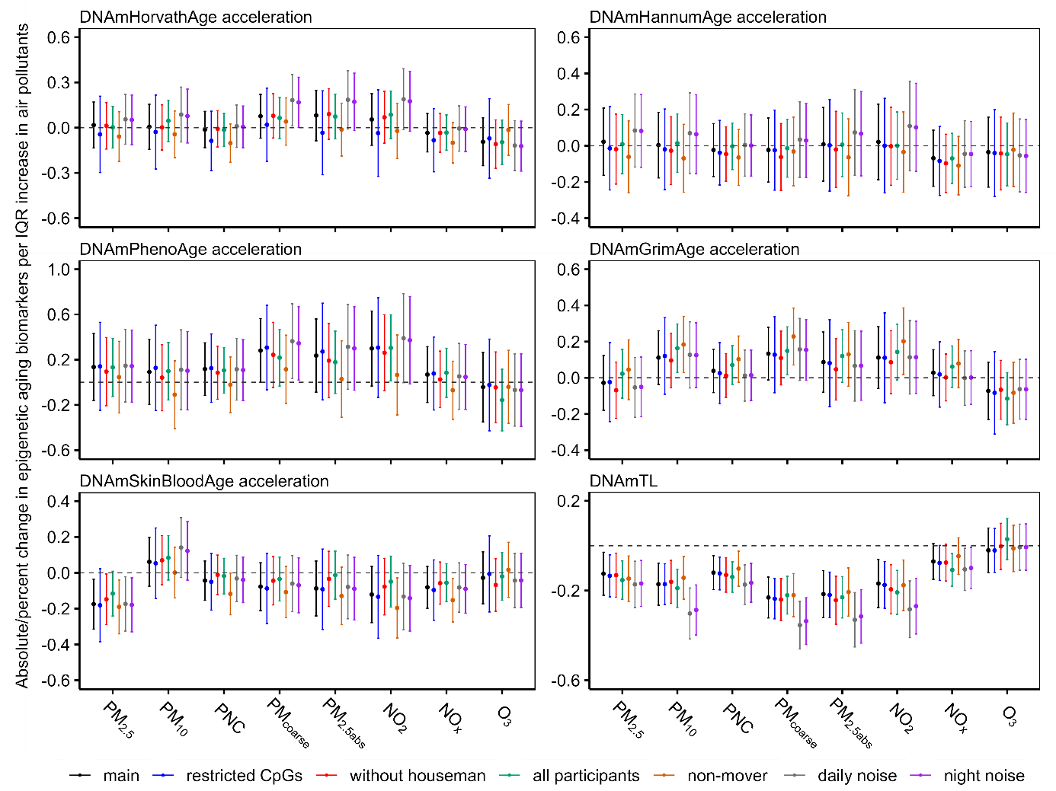
Figure S13. Associations between air pollution and the six epigenetic clocks under various sensitivity analyses.
Covariate-adjusted linear mixed-effect regression models were used. The percent change was only for DNAmTL. The confounders used in different sensitivity analyses were the same as used in our full model including by age, sex, an indicator of each study waves visit (KORA S4, KORA F4, or KORA FF4), houseman estimated cells, batch, chip, educational attainment, smoking status (current/former/never), alcohol consumption, physical activity (low/medium/high), BMI, hypertension, diabetes, HDL, and LDL.
Main: results from our full model; Restricted_CpG: Epigenetic clocks calculation after exclusion of missing CpG sites in MethylationEPIC (KORA FF4) from KORA S4 and F4 methylation dataset; Without houseman: an exclusion of houseman estimated cells from the confounders; All participants: An inclusion of all participants whoever attended KORA S4, F4 or FF4 once or more times and meet the data recruitments. Non-mover: participants without changing their residential address throughout the entire study period; Daily/night noise: an inclusion of daily or night noise correspondingly as the second environmental exposure.
PM_{2.5} = particulate matter with an aerodynamic diameter less than or equal to 2.5 μm; PM₁₀ = particulate matter with an aerodynamic diameter less than or equal to 10 μm; PNC = particle number concentration; PM_{coarse} = particulate matter with an aerodynamic diameter of 2.5-10 μm; PM_{2.5abs} = PM_{2.5} absorbance; NO₂ = nitrogen dioxide; NO_{x} = nitrogen oxide; O₃ = ozone. An IQR increase was 1.4 μg/m³ for PM_{2.5}, 2.1 μg/m³ for PM₁₀, 2.0×10³/cm³ for PNC, 1.4 μg/m³ for PM_{coarse}, 0.3×10⁻⁵/m for PM_{2.5abs}, 7.2 μg/m³ for NO₂, 8.8 μg/m³ for NO_{x}, and 3.4 μg/m³ for O₃.

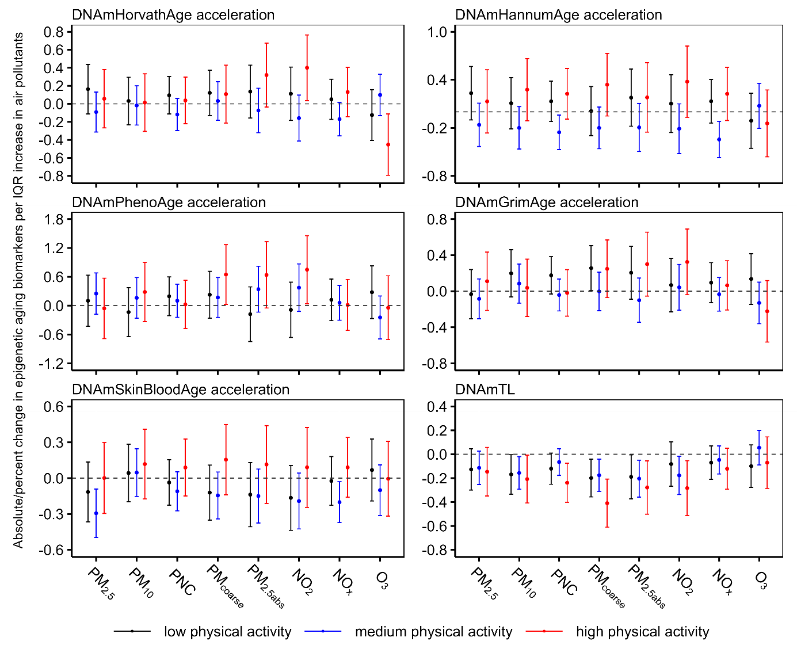
Figure S14. Absolute change (95% CI, years) / percent change (95%CI) of epigenetic age acceleration per IQR increase in air pollutant concentrations stratified by categorized physical activity (percent change only for DNAmTL).
Covariate-adjusted linear mixed-effect regression models were used. Results were from our full model adjusted by age, sex, an indicator of each study waves visit (KORA S4, KORA F4, or KORA FF4), houseman estimated cells, batch, chip, educational attainment, smoking status (current/former/never), alcohol consumption, BMI, hypertension, diabetes, HDL, and LDL.
PM_{2.5} = particulate matter with an aerodynamic diameter less than or equal to 2.5 μm; PM₁₀ = particulate matter with an aerodynamic diameter less than or equal to 10 μm; PNC = particle number concentration; PM_{coarse} = particulate matter with an aerodynamic diameter of 2.5-10 μm; PM_{2.5abs} = PM_{2.5} absorbance; NO₂ = nitrogen dioxide; NO_{x} = nitrogen oxide; O₃ = ozone. An IQR increase was 1.4 μg/m³ for PM_{2.5}, 2.1 μg/m³ for PM₁₀, 2.0×10³/cm³ for PNC, 1.4 μg/m³ for PM_{coarse}, 0.3×10⁻⁵/m for PM_{2.5abs}, 7.2 μg/m³ for NO₂, 8.8 μg/m³ for NO_{x}, and 3.4 μg/m³ for O₃.
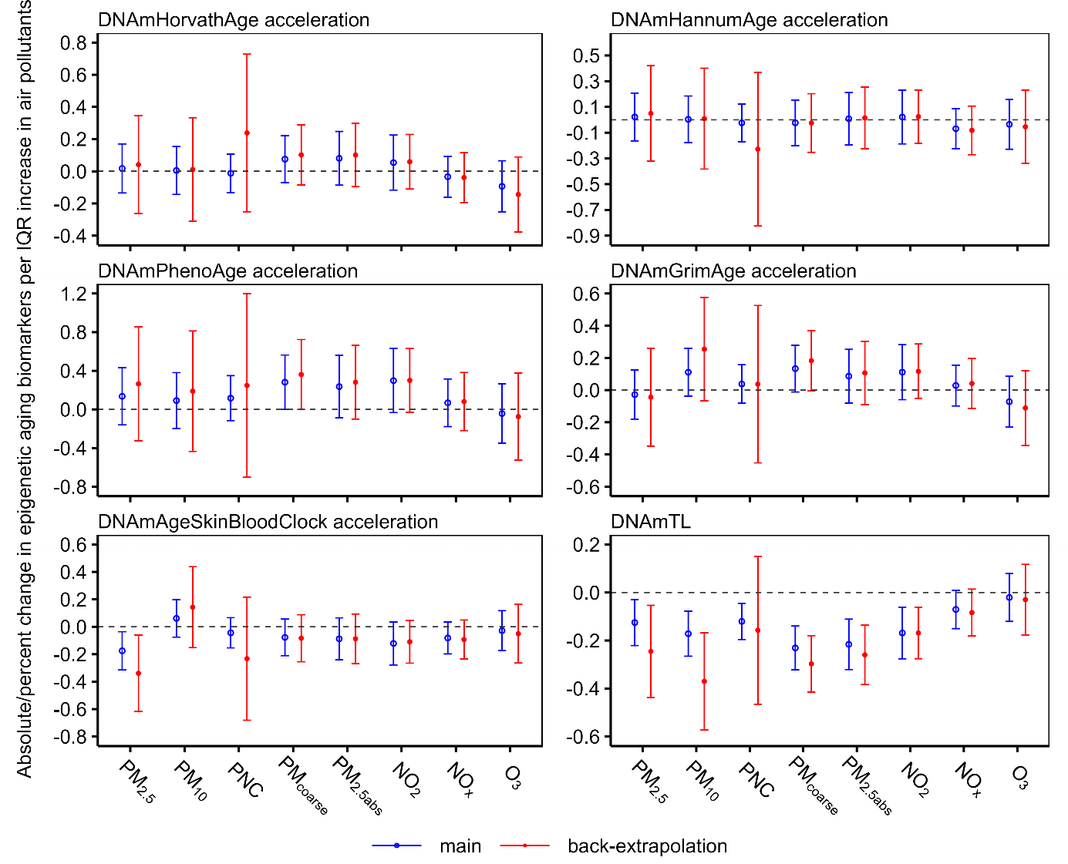
Figure S15. Sensitivity to Back-Extrapolated Exposures: Epigenetic age (years) and DNAmTL (%) change per IQR pollutant increase—Main vs Back-Extrapolation (95% CI).
Covariate-adjusted linear mixed-effect regression models were used. Results were from our full model adjusted by age, sex, an indicator of each study waves visit (KORA S4, KORA F4, or KORA FF4), houseman estimated cells, batch, chip, educational attainment, smoking status (current/former/never), alcohol consumption, physical activity (low/medium/high), BMI, hypertension, diabetes, HDL, and LDL.
PM_{2.5} = particulate matter with an aerodynamic diameter less than or equal to 2.5 μm; PM₁₀ = particulate matter with an aerodynamic diameter less than or equal to 10 μm; PNC = particle number concentration; PM_{coarse} = particulate matter with an aerodynamic diameter of 2.5-10 μm; PM_{2.5abs} = PM_{2.5} absorbance; NO₂ = nitrogen dioxide; NO_{x} = nitrogen oxide; O₃ = ozone.

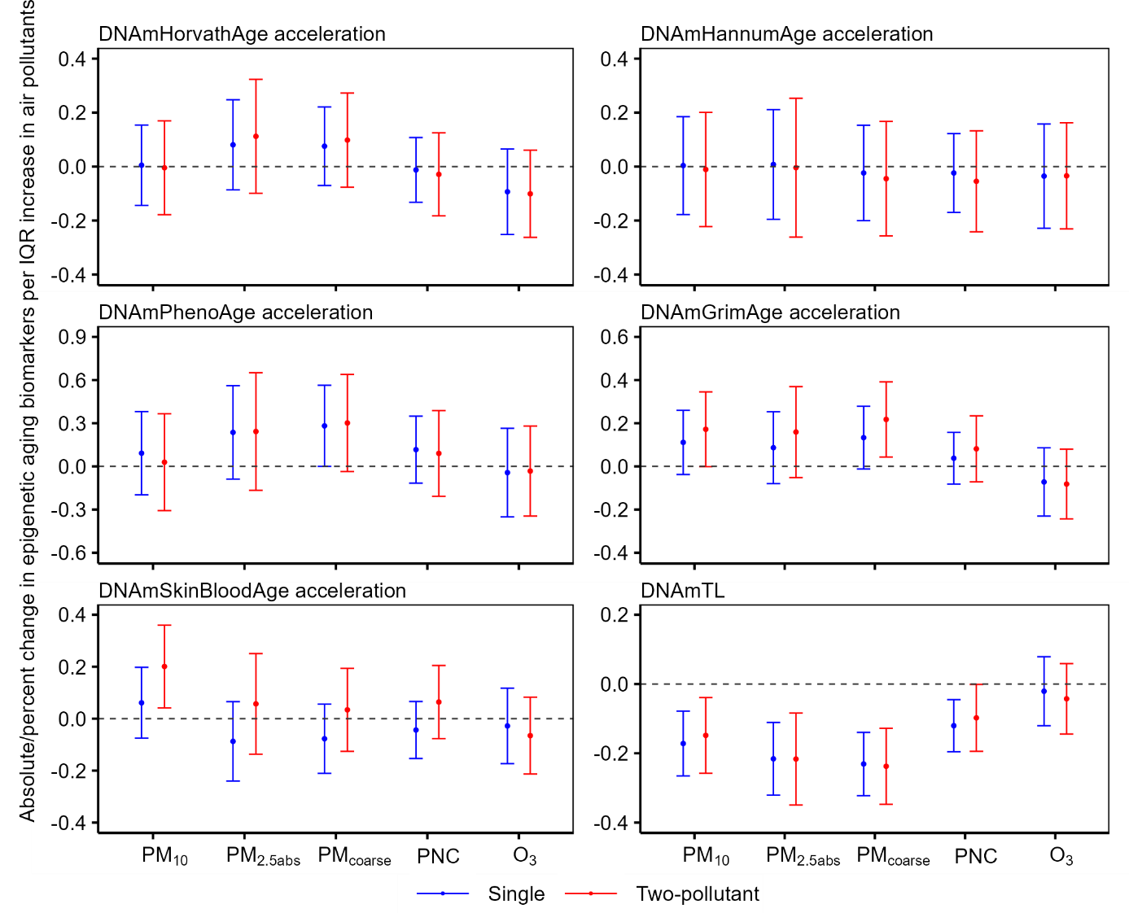
Figure S16. Comparison between single and two-pollutant models after additional inclusion of PM_{2.5} (percent change only for DNAmTL).
Covariate-adjusted linear mixed-effect regression models were used. Results were from our full model adjusted by age, sex, an indicator of each study waves visit (KORA S4, KORA F4, or KORA FF4), houseman estimated cells, batch, chip, educational attainment, smoking status (current/former/never), alcohol consumption, physical activity (low/medium/high), BMI, hypertension, diabetes, HDL, and LDL.
PM_{2.5} = particulate matter with an aerodynamic diameter less than or equal to 2.5 μm; PM₁₀ = particulate matter with an aerodynamic diameter less than or equal to 10 μm; PNC = particle number concentration; PM_{coarse} = particulate matter with an aerodynamic diameter of 2.5-10 μm; PM_{2.5abs} = PM_{2.5} absorbance; NO₂ = nitrogen dioxide; NO_{x} = nitrogen oxide; O₃ = ozone. An IQR increase was 1.4 μg/m³ for PM_{2.5}, 2.1 μg/m³ for PM₁₀, 1.4 μg/m³ for PM_{coarse}, 2.0×10³/cm³ for PNC, 0.3×10⁻⁵/m for PM_{2.5abs}, 7.2 μg/m³ for NO₂, 8.8 μg/m³ for NO_{x}, and 3.4 μg/m³ for O₃.

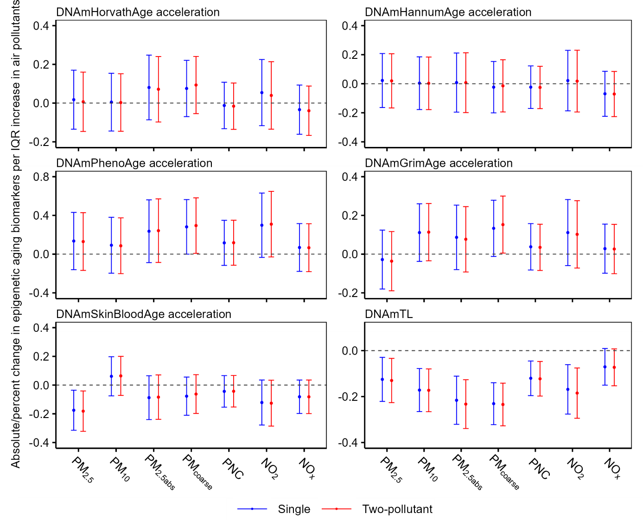
Figure S17. Comparison between single and two-pollutant models after additional inclusion of O₃ (percent change only for DNAmTL).
Covariate-adjusted linear mixed-effect regression models were used. Results were from our full model adjusted by age, sex, an indicator of each study waves visit (KORA S4, KORA F4, or KORA FF4), houseman estimated cells, batch, chip, educational attainment, smoking status (current/former/never), alcohol consumption, physical activity (low/medium/high), BMI, hypertension, diabetes, HDL, and LDL.
PM2.5 = particulate matter with an aerodynamic diameter less than or equal to 2.5 μm; PM10 = particulate matter with an aerodynamic diameter less than or equal to 10 μm; PNC = particle number concentration; PMcoarse = particulate matter with an aerodynamic diameter of 2.5-10 μm; PM2.5abs = PM2.5 absorbance; NO2 = nitrogen dioxide; NOx = nitrogen oxide; O3 = ozone. An IQR increase was 1.4 μg/m3 for PM2.5, 2.1 μg/m3 for PM10, 1.4 μg/m3 for PMcoarse, 2.0×103/cm3 for PNC, 0.3×10-5/m for PM2.5abs, 7.2 μg/m3 for NO2, 8.8 μg/m3 for NOx, and 3.4 μg/m3 for O3.
Table S1 Absolute/percent changes (95% CI) in epigenetic aging biomarkers per IQR increase in air pollutants.
Epigenetic aging biomarkers | Exposure | Basic | Behavioral | Clinical | Full
Acceleration of DNAmGrimAge | PM_{2.5} | 0.23 (0.08, 0.38);  p = 0.003 | --- | 0.22 (0.07, 0.38);  p = 0.005 | ---
Acceleration of DNAmGrimAge | PM₁₀ | 0.27 (0.12, 0.42);  p < 0.001 | --- | 0.27 (0.12, 0.42);  p < 0.001 | ---
Acceleration of DNAmGrimAge | PNC | 0.22 (0.1, 0.34);  p < 0.001 | --- | 0.21 (0.09, 0.33);  p < 0.001 | ---
Acceleration of DNAmGrimAge | PM_{coarse} | 0.34 (0.19, 0.49);  p < 0.001 | --- | 0.34 (0.19, 0.49);  p < 0.001 | ---
Acceleration of DNAmGrimAge | PM_{2.5abs} | 0.37 (0.2, 0.54);  p < 0.001 | --- | 0.35 (0.18, 0.52);  p < 0.001 | ---
Acceleration of DNAmGrimAge | NO₂ | 0.45 (0.27, 0.62);  p < 0.001 | --- | 0.43 (0.25, 0.6);  p < 0.001 | ---
Acceleration of DNAmGrimAge | NO_{x} | 0.25 (0.13, 0.38);  p < 0.001 | --- | 0.24 (0.11, 0.37);  p < 0.001 | ---
DNAmTL | PM_{2.5} | -0.2 (-0.3, -0.1);  p < 0.001 | -0.1 (-0.2, 0);  p = 0.013 | -0.2 (-0.3, -0.1);  p < 0.001 | -0.1 (-0.2, 0);  p < 0.001
DNAmTL | PM₁₀ | -0.2 (-0.3, -0.1);  p < 0.001 | -0.2 (-0.3, -0.1);  p < 0.001 | -0.2 (-0.3, -0.1);  p < 0.001 | -0.2 (-0.3, 0);  p < 0.001
DNAmTL | PNC | -0.1 (-0.2, -0.1);  p < 0.001 | -0.1 (-0.2, 0);  p = 0.003 | -0.1 (-0.2, -0.1);  p < 0.001 | -0.1 (-0.2, 0);  p = 0.002
DNAmTL | PM_{coarse} | -0.3 (-0.4, -0.2);  p < 0.001 | -0.2 (-0.3, -0.1);  p < 0.001 | -0.3 (-0.4, -0.2);  p < 0.001 | -0.2 (-0.3, -0.1);  p < 0.001
DNAmTL | PM_{2.5abs} | -0.3 (-0.4, -0.2);  p < 0.001 | -0.2 (-0.3, -0.1);  p < 0.001 | -0.3 (-0.4, -0.2);  p < 0.001 | -0.2 (-0.3, -0.1);  p < 0.001
DNAmTL | NO₂ | -0.2 (-0.3, -0.1);  p < 0.001 | -0.2 (-0.3, -0.1);  p = 0.002 | -0.2 (-0.3, -0.1);  p < 0.001 | -0.2 (-0.3, -0.1);  p = 0.002
DNAmTL | NO_{x} | -0.1 (-0.2, 0);  p = 0.009 | --- | -0.1 (-0.2, 0);  p = 0.008 | ---
Covariate-adjusted linear mixed-effect regression models were used. The effect estimates of acceleration of DNAmGrimAge and DNAmTL were presented as absolute change (together 95% CI) and percent change, respectively. Basic model: adjusted for age, sex, an indicator of each study wave (KORA S4, KORA F4, or KORA FF4), houseman estimated cells, batch, and chip; Behavioral model: further adjusted for educational attainment, smoking status (current/former/never), alcohol consumption, physical activity (low/medium/high) into basic model; Clinical model: additionally included BMI, hypertension, diabetes, HDL, and LDL into the basic models. Full model: all confounders used in the other three models. PM_{2.5} = particulate matter with an aerodynamic diameter less than or equal to 2.5 μm; PM₁₀ = particulate matter with an aerodynamic diameter less than or equal to 10 μm; PNC = particle number concentration; PM_{coarse} = particulate matter with an aerodynamic diameter of 2.5-10 μm; PM_{2.5abs} = PM_{2.5} absorbance; NO₂ = nitrogen dioxide; NO_{x} = nitrogen oxide. An IQR increase was 1.4 μg/m³ for PM_{2.5}, 2.1 μg/m³ for PM₁₀, 2.0×10³/cm³ for PNC, 1.4 μg/m³ for PM_{coarse}, 0.3×10⁻⁵/m for PM_{2.5abs}, 7.2 μg/m³ for NO₂, and 8.8 μg/m³ for NO_{x}.

Table S2 Effect estimates (95% CI) of the confounders used in the full models for each epigenetic aging biomarker.
 | Air pollution | age | sex | Smoking |  | alcohol | Physical activity | Education level |  | BMI | Hypertension | diabetes | HDL | LDL
 |  |  |  | Former smoker | Current smoker |  |  | High school | College
Acceleration of DNAmHorvathAge | PM_{2.5} | -0.32  (-0.34, -0.31) | -0.85  (-1.13, -0.57) | -0.3  (-0.55, -0.06) | -0.25  (-0.6, 0.09) | 0  (0, 0.01) | -0.12  (-0.37, 0.13) | 0.4  (0.13, 0.67) | -0.13  (-0.43, 0.18) | 0.05  (0.02, 0.07) | 0.12  (-0.12, 0.36) | -0.22  (-0.65, 0.22) | -0.34  (-0.65, -0.04) | 0.14  (0.03, 0.26)
 | PM₁₀ | -0.32  (-0.34, -0.31) | -0.85  (-1.13, -0.57) | -0.3  (-0.54, -0.05) | -0.25  (-0.59, 0.09) | 0  (0, 0.01) | -0.12  (-0.37, 0.13) | 0.4  (0.13, 0.67) | -0.13  (-0.43, 0.18) | 0.05  (0.02, 0.07) | 0.12  (-0.12, 0.36) | -0.22  (-0.65, 0.22) | -0.34  (-0.65, -0.04) | 0.14  (0.03, 0.26)
 | PNC | -0.32  (-0.34, -0.31) | -0.85  (-1.13, -0.57) | -0.3  (-0.54, -0.05) | -0.25  (-0.59, 0.09) | 0  (0, 0.01) | -0.12  (-0.37, 0.13) | 0.4  (0.13, 0.67) | -0.13  (-0.43, 0.18) | 0.05  (0.02, 0.07) | 0.12  (-0.12, 0.36) | -0.22  (-0.65, 0.22) | -0.35  (-0.65, -0.04) | 0.14  (0.03, 0.26)
 | PM_{coarse} | -0.33  (-0.34, -0.31) | -0.86  (-1.14, -0.58) | -0.31  (-0.55, -0.06) | -0.27  (-0.61, 0.07) | 0  (0, 0.01) | -0.12  (-0.37, 0.13) | 0.39  (0.12, 0.67) | -0.14  (-0.44, 0.17) | 0.05  (0.02, 0.07) | 0.12  (-0.12, 0.36) | -0.22  (-0.65, 0.21) | -0.34  (-0.65, -0.04) | 0.14  (0.03, 0.26)
 | PM_{2.5abs} | -0.33  (-0.34, -0.31) | -0.86  (-1.14, -0.58) | -0.31  (-0.55, -0.06) | -0.26  (-0.61, 0.08) | 0  (0, 0.01) | -0.12  (-0.37, 0.13) | 0.39  (0.12, 0.67) | -0.13  (-0.43, 0.17) | 0.05  (0.02, 0.07) | 0.12  (-0.12, 0.36) | -0.22  (-0.65, 0.21) | -0.34  (-0.65, -0.03) | 0.14  (0.03, 0.26)
 | NO₂ | -0.32  (-0.34, -0.31) | -0.86  (-1.14, -0.57) | -0.3  (-0.55, -0.06) | -0.26  (-0.6, 0.08) | 0  (0, 0.01) | -0.12 (-0.37, 0.13) | 0.4  (0.12, 0.67) | -0.13  (-0.43, 0.18) | 0.05  (0.02, 0.07) | 0.12  (-0.12, 0.36) | -0.22  (-0.65, 0.22) | -0.34  (-0.65, -0.03) | 0.14  (0.03, 0.26)
 | NO_{x} | -0.32  (-0.34, -0.31) | -0.85  (-1.13, -0.57) | -0.29  (-0.54, -0.05) | -0.24  (-0.59, 0.1) | 0  (0, 0.01) | -0.12  (-0.37, 0.13) | 0.4  (0.13, 0.67) | -0.13  (-0.43, 0.18) | 0.05  (0.02, 0.07) | 0.12  (-0.12, 0.36) | -0.22  (-0.65, 0.22) | -0.35  (-0.66, -0.04) | 0.14  (0.03, 0.26)
 | O₃ | -0.32 (-0.34, -0.31) | -0.85  (-1.13, -0.57) | -0.29  (-0.54, -0.05) | -0.25  (-0.59, 0.09) | 0  (0, 0.01) | -0.12  (-0.37, 0.13) | 0.4  (0.13, 0.68) | -0.12  (-0.42, 0.19) | 0.05  (0.02, 0.07) | 0.12  (-0.12, 0.36) | -0.22  (-0.65, 0.22) | -0.34  (-0.64, -0.03) | 0.14  (0.03, 0.26)
Acceleration of DNAmHannumAge | PM_{2.5} | -0.16  (-0.18, -0.15) | -1.73  (-2.07, -1.39) | 0.09  (-0.21, 0.39) | 0.47  (0.06, 0.89) | 0.01  (0.01, 0.02) | -0.11  (-0.41, 0.19) | 0.05  (-0.28, 0.39) | -0.32  (-0.69, 0.05) | 0.05  (0.02, 0.09) | -0.04  (-0.34, 0.25) | -0.58  (-1.11, -0.05) | -0.21  (-0.59, 0.16) | -0.18  (-0.32, -0.03)
 | PM₁₀ | -0.16  (-0.18, -0.15) | -1.73  (-2.07, -1.39) | 0.09  (-0.2, 0.39) | 0.48  (0.06, 0.89) | 0.01  (0.01, 0.02) | -0.11  (-0.41, 0.19) | 0.05  (-0.28, 0.39) | -0.32  (-0.69, 0.05) | 0.05  (0.02, 0.09) | -0.04  (-0.34, 0.25) | -0.58  (-1.11, -0.05) | -0.21  (-0.59, 0.16) | -0.18  (-0.32, -0.03)
 | PNC | -0.16  (-0.18, -0.15) | -1.73  (-2.07, -1.38) | 0.1  (-0.2, 0.39) | 0.48  (0.07, 0.9) | 0.01  (0.01, 0.02) | -0.11  (-0.41, 0.19) | 0.06  (-0.28, 0.39) | -0.32  (-0.69, 0.05) | 0.05  (0.02, 0.09) | -0.04  (-0.34, 0.25) | -0.58  (-1.1, -0.05) | -0.22  (-0.59, 0.16) | -0.18  (-0.32, -0.03)
 | PM_{coarse} | -0.16  (-0.18, -0.15) | -1.73  (-2.07, -1.38) | 0.1  (-0.2, 0.39) | 0.48  (0.07, 0.9) | 0.01  (0.01, 0.02) | -0.11  (-0.41, 0.19) | 0.06  (-0.28, 0.39) | -0.32  (-0.69, 0.06) | 0.05  (0.02, 0.09) | -0.04  (-0.34, 0.25) | -0.58  (-1.1, -0.05) | -0.22  (-0.59, 0.16) | -0.18  (-0.32, -0.03)
 | PM_{2.5abs} | -0.16  (-0.18, -0.15) | -1.73  (-2.07, -1.39) | 0.09  (-0.2, 0.39) | 0.48  (0.06, 0.89) | 0.01  (0.01, 0.02) | -0.11  (-0.41, 0.19) | 0.05  (-0.28, 0.39) | -0.32  (-0.69, 0.05) | 0.05  (0.02, 0.09) | -0.04  (-0.34, 0.25) | -0.58  (-1.11, -0.05) | -0.21  (-0.59, 0.16) | -0.18  (-0.32, -0.03)
 | NO₂ | -0.16  (-0.18, -0.15) | -1.73  (-2.07, -1.39) | 0.09  (-0.21, 0.39) | 0.47  (0.06, 0.89) | 0.01  (0.01, 0.02) | -0.11  (-0.41, 0.19) | 0.05  (-0.28, 0.39) | -0.32  (-0.69, 0.05) | 0.05  (0.02, 0.09) | -0.04  (-0.33, 0.25) | -0.58  (-1.1, -0.05) | -0.21  (-0.59, 0.16) | -0.18  (-0.32, -0.03)
 | NO_{x} | -0.16  (-0.18, -0.15) | -1.72  (-2.06, -1.38) | 0.1  (-0.2, 0.4) | 0.49  (0.08, 0.91) | 0.01  (0.01, 0.02) | -0.11  (-0.41, 0.19) | 0.06  (-0.28, 0.39) | -0.32  (-0.69, 0.05) | 0.05  (0.02, 0.08) | -0.05  (-0.34, 0.25) | -0.58  (-1.1, -0.05) | -0.22  (-0.6, 0.15) | -0.17  (-0.32, -0.03)
 | O₃ | -0.16  (-0.18, -0.15) | -1.73  (-2.07, -1.39) | 0.1  (-0.2, 0.39) | 0.48  (0.06, 0.89) | 0.01  (0.01, 0.02) | -0.11  (-0.41, 0.2) | 0.06 (-0.28, 0.39) | -0.32  (-0.69, 0.06) | 0.05  (0.02, 0.09) | -0.04  (-0.34, 0.25) | -0.58  (-1.11, -0.05) | -0.21  (-0.59, 0.16) | -0.18  (-0.32, -0.03)
Acceleration of DNAmPhneoAge | PM_{2.5} | -0.11  (-0.14, -0.08) | -0.75  (-1.29, -0.2) | 0.22  (-0.26, 0.69) | 1.37  (0.71, 2.04) | 0.03  (0.01, 0.04) | -0.46  (-0.94, 0.02) | 0.27  (-0.26, 0.8) | -0.7  (-1.28, -0.11) | 0.1  (0.05, 0.15) | 0.52  (0.05, 0.98) | 0.37  (-0.46, 1.21) | -0.2  (-0.79, 0.4) | 0  (-0.23, 0.22)
 | PM₁₀ | -0.11  (-0.14, -0.08) | -0.74  (-1.28, -0.2) | 0.23  (-0.25, 0.7) | 1.39  (0.73, 2.05) | 0.03  (0.01, 0.04) | -0.46  (-0.95, 0.02) | 0.27  (-0.26, 0.8) | -0.7  (-1.29, -0.11) | 0.1  (0.05, 0.15) | 0.51  (0.05, 0.98) | 0.37  (-0.47, 1.21) | -0.2  (-0.8, 0.39) | 0  (-0.23, 0.22)
 | PNC | -0.11  (-0.14, -0.08) | -0.74 (-1.29, -0.2) | 0.22  (-0.25, 0.7) | 1.37  (0.71, 2.04) | 0.03  (0.01, 0.04) | -0.46  (-0.94, 0.02) | 0.27  (-0.27, 0.8) | -0.7  (-1.29, -0.11) | 0.1  (0.05, 0.15) | 0.51  (0.05, 0.98) | 0.37  (-0.47, 1.2) | -0.2  (-0.79, 0.4) | 0  (-0.23, 0.22)
 | PM_{coarse} | -0.11  (-0.14, -0.08) | -0.76  (-1.3, -0.22) | 0.21  (-0.27, 0.68) | 1.34  (0.67, 2) | 0.03  (0.01, 0.04) | -0.46 (-0.94, 0.02) | 0.25  (-0.29, 0.78) | -0.74  (-1.33, -0.15) | 0.1 (0.05, 0.15) | 0.51  (0.04, 0.98) | 0.36  (-0.48, 1.2) | -0.2  (-0.8, 0.39) | 0  (-0.23, 0.22)
 | PM_{2.5abs} | -0.11  (-0.14, -0.08) | -0.75  (-1.29, -0.21) | 0.21  (-0.26, 0.69) | 1.36  (0.7, 2.02) | 0.03  (0.01, 0.04) | -0.46 (-0.94, 0.02) | 0.25  (-0.28, 0.79) | -0.71  (-1.3, -0.12) | 0.1 (0.05, 0.15) | 0.51  (0.05, 0.98) | 0.36  (-0.47, 1.2) | -0.19  (-0.78, 0.41) | 0  (-0.23, 0.22)
 | NO₂ | -0.11  (-0.14, -0.08) | -0.76  (-1.3, -0.21) | 0.2  (-0.27, 0.68) | 1.34  (0.68, 2.01) | 0.03  (0.01, 0.04) | -0.46 (-0.94, 0.3) | 0.26  (-0.27, 0.8) | -0.71  (-1.3, -0.12) | 0.1 (0.05, 0.15) | 0.52  (0.05, 0.98) | 0.37  (-0.46, 1.21) | -0.2  (-0.8, 0.4) | 0  (-0.23, 0.22)
 | NO_{x} | -0.11  (-0.14, -0.08) | -0.74  (-1.28, -0.2) | 0.23  (-0.25, 0.7) | 1.39  (0.72, 2.05) | 0.03  (0.01, 0.04) | -0.46 (-0.95, 0.02) | 0.27  (-0.26, 0.81) | -0.69  (-1.28, -0.11) | 0.1  (0.05, 0.15) | 0.51  (0.05, 0.98) | 0.37  (-0.47, 1.21) | -0.2  (-0.8, 0.4) | 0  (-0.23, 0.22)
 | O₃ | -0.11  (-0.14, -0.08) | -0.73  (-1.28, -0.19) | 0.24  (-0.24, 0.71) | 1.4  (0.74, 2.06) | 0.03  (0.01, 0.04) | -0.46 (-0.94, 0.02) | 0.28  (-0.26, 0.81) | -0.69  (-1.28, -0.1) | 0.1  (0.05, 0.15) | 0.51  (0.05, 0.98) | 0.37  (-0.46, 1.21) | -0.18  (-0.78, 0.41) | 0  (-0.23, 0.23)
Aacceleration of DNAmGrimAge | PM_{2.5} | -0.23  (-0.24, -0.22) | -2.36  (-2.64, -2.08) | 2.01  (1.77, 2.25) | 5.91  (5.57, 6.25) | 0.01  (0, 0.01) | -0.52  (-0.77, -0.27) | -0.27  (-0.55, 0) | -0.86  (-1.16, -0.56) | 0.07  (0.05, 0.1) | -0.03  (-0.27, 0.21) | 0.27  (-0.16, 0.7) | -0.46  (-0.77, -0.15) | -0.1  (-0.22, 0.02)
 | PM₁₀ | -0.23  (-0.24, -0.22) | -2.37  (-2.65, -2.09) | 2  (1.75, 2.24) | 5.88  (5.54, 6.22) | 0.01  (0, 0.01) | -0.52  (-0.77, -0.27) | -0.28  (-0.55, -0.01) | -0.86  (-1.17, -0.56) | 0.07  (0.05, 0.1) | -0.02  (-0.26, 0.22) | 0.27  (-0.16, 0.7) | -0.46  (-0.76, -0.15) | -0.1  (-0.22, 0.02)
 | PNC | -0.23  (-0.24, -0.22) | -2.37  (-2.65, -2.09) | 2  (1.76, 2.25) | 5.89  (5.55, 6.23) | 0.01  (0, 0.01) | -0.52  (-0.77, -0.27) | -0.28  (-0.55, 0) | -0.86  (-1.16, -0.56) | 0.07  (0.05, 0.1) | -0.03  (-0.26, 0.21) | 0.27  (-0.16, 0.7) | -0.46  (-0.76, -0.15) | -0.1  (-0.22, 0.02)
 | PM_{coarse} | -0.23  (-0.24, -0.22) | -2.38 (-2.66, -2.1) | 1.99  (1.75, 2.24) | 5.87  (5.53, 6.21) | 0.01  (0, 0.01) | -0.52  (-0.76, -0.27) | -0.29  (-0.56, -0.01) | -0.88  (-1.19, -0.58) | 0.07  (0.05, 0.1) | -0.03  (-0.27, 0.21) | 0.26  (-0.17, 0.69) | -0.46  (-0.76, -0.15) | -0.1  (-0.22, 0.02)
 | PM_{2.5abs} | -0.23  (-0.24, -0.22) | -2.37  (-2.65, -2.09) | 2  (1.76, 2.24) | 5.89  (5.55, 6.23) | 0.01  (0, 0.01) | -0.52  (-0.77, -0.27) | -0.28  (-0.55, -0.01) | -0.87  (-1.17, -0.56) | 0.07  (0.05, 0.1) | -0.02  (-0.26, 0.21) | 0.26  (-0.17, 0.7) | -0.45  (-0.76, -0.14) | -0.1  (-0.22, 0.02)
 | NO₂ | -0.23  (-0.24, -0.22) | -2.37  (-2.65, -2.09) | 2  (1.75, 2.24) | 5.88  (5.54, 6.22) | 0.01 (0, 0.01) | -0.52  (-0.76, -0.27) | -0.28  (-0.55, 0) | -0.87  (-1.17, -0.56) | 0.07  (0.05, 0.1) | -0.02  (-0.26, 0.22) | 0.27  (-0.16, 0.7) | -0.45  (-0.76, -0.14) | -0.1  (-0.22, 0.02)
 | NO_{x} | -0.23  (-0.24, -0.22) | -2.37  (-2.65, -2.09) | 2  (1.76, 2.25) | 5.89  (5.55, 6.23) | 0.01  (0, 0.01) | -0.52  (-0.77, -0.27) | -0.27  (-0.55, 0) | -0.86  (-1.16, -0.56) | 0.07  (0.05, 0.1) | -0.02  (-0.26, 0.21) | 0.27  (-0.16, 0.7) | -0.46  (-0.76, -0.15) | -0.1  (-0.22, 0.02)
 | O₃ | -0.23  (-0.24, -0.22) | -2.37  (-2.65, -2.09) | 2.01  (1.77, 2.25) | 5.9  (5.56, 6.24) | 0.01  (0, 0.01) | -0.52  (-0.76, -0.27) | -0.27  (-0.54, 0) | -0.85  (-1.16, -0.55) | 0.07  (0.05, 0.1) | -0.02  (-0.26, 0.22) | 0.27 (  -0.16, 0.7) | -0.45  (-0.76, -0.14) | -0.1  (-0.22, 0.02)
Acceleration of DNAmSkinBloodAge | PM_{2.5} | -0.09  (-0.1, -0.08) | -0.49  (-0.75, -0.23) | 0.15  (-0.08, 0.37) | -0.02  (-0.33, 0.29) | 0 (0, 0.01) | -0.16  (-0.39, 0.07) | 0.1  (-0.15, 0.35) | -0.21  (-0.49, 0.06) | 0.01  (-0.01, 0.04) | -0.09  (-0.31, 0.13) | -0.36  (-0.75, 0.04) | 0.05  (-0.24, 0.33) | 0.08  (-0.03, 0.18)
 | PM₁₀ | -0.09  (-0.1, -0.08) | -0.51  (-0.76, -0.25) | 0.12 (  -0.1, 0.34) | -0.06  (-0.38, 0.25) | 0 (0, 0.01) | -0.16  (-0.39, 0.07) | 0.09  (-0.16, 0.34) | -0.21  (-0.49, 0.06) | 0.01  (-0.01, 0.04) | -0.08  (-0.3, 0.13) | -0.36  (-0.75, 0.04) | 0.06  (-0.22, 0.34) | 0.07  (-0.03, 0.18)
 | PNC | -0.09  (-0.1, -0.08) | -0.5  (-0.76, -0.24) | 0.13  (-0.09, 0.35) | -0.04  (-0.36, 0.27) | 0 (0, 0.01) | -0.16  (-0.39, 0.07) | 0.09  (-0.16, 0.35) | -0.21  (-0.49, 0.07) | 0.01  (-0.01, 0.04) | -0.09  (-0.31, 0.13) | -0.35  (-0.75, 0.04) | 0.05  (-0.23, 0.33) | 0.07  (-0.03, 0.18)
 | PM_{coarse} | -0.09  (-0.1, -0.08) | -0.5  (-0.75, -0.24) | 0.13  (-0.09, 0.36) | -0.04  (-0.35, 0.28) | 0 (0, 0.01) | -0.16  (-0.39, 0.07) | 0.1  (-0.15, 0.35) | -0.2  (-0.48, 0.08) | 0.01  (-0.01, 0.04) | -0.09  (-0.31, 0.13) | -0.35  (-0.75, 0.04) | 0.05  (-0.23, 0.34) | 0.07  (-0.03, 0.18)
 | PM_{2.5abs} | -0.09  (-0.1, -0.08) | -0.5  (-0.75, -0.24) | 0.13  (-0.09, 0.36) | -0.04  (-0.35, 0.27) | 0 (0, 0.01) | -0.16  (-0.39, 0.07) | 0.1  (-0.15, 0.35) | -0.21  (-0.49, 0.07) | 0.01  (-0.01, 0.04) | -0.09  (-0.31, 0.13) | -0.35  (-0.75, 0.04) | 0.05  (-0.23, 0.33) | 0.07  (-0.03, 0.18)
 | NO₂ | -0.09  (-0.1, -0.08) | -0.49  (-0.75, -0.24) | 0.14  (-0.09, 0.36) | -0.03  (-0.34, 0.28) | 0 (0, 0.01) | -0.16  (-0.39, 0.07) | 0.1  (-0.16, 0.35) | -0.21  (-0.49, 0.07) | 0.01 (  -0.01, 0.04) | -0.08  (-0.3, 0.14) | -0.36  (-0.75, 0.04) | 0.06  (-0.22, 0.34) | 0.07  (-0.03, 0.18)
 | NO_{x} | -0.09  (-0.1, -0.08) | -0.5  (-0.76, -0.25) | 0.13  (-0.09, 0.36) | -0.04  (-0.35, 0.28) | 0 (0, 0.01) | -0.16  (-0.39, 0.07) | 0.09  (-0.16, 0.34) | -0.22  (-0.49, 0.06) | 0.01  (-0.01, 0.04) | -0.09  (-0.31, 0.13) | -0.35  (-0.75, 0.04) | 0.05  (-0.23, 0.33) | 0.08  (-0.03, 0.18)
 | O₃ | -0.09  (-0.1, -0.08) | -0.5  (-0.75, -0.24) | 0.13  (-0.1, 0.35) | -0.05  (-0.37, 0.26) | 0 (0, 0.01) | -0.16  (-0.38, 0.07) | 0.09  (-0.16, 0.34) | -0.21  (-0.49, 0.07) | 0.01  (-0.01, 0.04) | -0.09  (-0.31, 0.13) | -0.36  (-0.75, 0.04) | 0.05  (-0.24, 0.33) | 0.07  (-0.03, 0.18)
DNAmTL | PM_{2.5} | -0.21  (-0.22, -0.21) | 1.27  (1.1, 1.45) | -0.4  (-0.56, -0.25) | -0.98  (-1.19, -0.76) | 0  (-0.01, 0) | 0.21  (0.05, 0.36) | 0.2  (0.03, 0.37) | 0.4  (0.21, 0.59) | -0.02  (-0.03, 0) | -0.06  (-0.22, 0.09) | -0.18  (-0.45, 0.09) | 0.1  (-0.1, 0.29) | 0.07  (0, 0.14)
 | PM₁₀ | -0.21  (-0.22, -0.21) | 1.27  (1.1, 1.45) | -0.4  (-0.56, -0.25) | -0.98  (-1.19, -0.76) | 0  (-0.01, 0) | 0.21  (0.05, 0.36) | 0.21  (0.03, 0.38) | 0.4  (0.21, 0.59) | -0.02  (-0.03, 0) | -0.06  (-0.21, 0.09) | -0.18  (-0.45, 0.09) | 0.1  (-0.1, 0.29) | 0.07  (0, 0.14)
 | PNC | -0.21  (-0.22, -0.21) | 1.27  (1.09, 1.45) | -0.4  (-0.56, -0.25) | -0.98  (-1.19, -0.76) | 0  (-0.01, 0) | 0.21  (0.05, 0.36) | 0.21  (0.03, 0.38) | 0.4  (0.21, 0.59) | -0.02  (-0.03, 0) | -0.06  (-0.22, 0.09) | -0.18  (-0.45, 0.09) | 0.09  (-0.1, 0.29) | 0.07  (0, 0.14)
 | PM_{coarse} | -0.21  (-0.22, -0.21) | 1.28  (1.11, 1.46) | -0.39  (-0.55, -0.24) | -0.96  (-1.17, -0.74) | 0  (-0.01, 0) | 0.2  (0.05, 0.36) | 0.22  (0.04, 0.39) | 0.43  (0.24, 0.62) | -0.02  (-0.03, 0) | -0.06  (-0.21, 0.09) | -0.17  (-0.44, 0.1) | 0.1  (-0.09, 0.29) | 0.07  (0, 0.14)
 | PM_{2.5abs} | -0.21  (-0.22, -0.21) | 1.28  (1.1, 1.45) | -0.4  (-0.55, -0.25) | -0.97  (-1.18, -0.75) | 0  (-0.01, 0) | 0.21  (0.05, 0.36) | 0.21  (0.04, 0.39) | 0.41  (0.22, 0.6) | -0.02  (-0.03, 0) | -0.06  (-0.21, 0.09) | -0.17  (-0.44, 0.1) | 0.09  (-0.11, 0.28) | 0.07  (0, 0.14)
 | NO₂ | -0.21  (-0.22, -0.21) | 1.26  (1.09, 1.44) | -0.4  (-0.55, -0.25) | -0.97  (-1.19, -0.76) | 0  (-0.01, 0) | 0.2  (0.05, 0.36) | 0.2  (0.03, 0.37) | 0.41  (0.21, 0.6) | -0.02  (-0.03, 0) | -0.06  (-0.21, 0.09) | -0.18  (-0.45, 0.09) | 0.1  (-0.09, 0.3) | 0.07  (0, 0.14)
 | NO_{x} | -0.21  (-0.22, -0.21) | 1.27  (1.09, 1.45) | -0.41  (-0.56, -0.26) | -0.99  (-1.2, -0.77) | 0 (-0.01, 0) | 0.21  (0.05, 0.36) | 0.2  (0.02, 0.37) | 0.4  (0.21, 0.59) | -0.02  (-0.03, 0) | -0.06  (-0.21, 0.09) | -0.18  (-0.45, 0.09) | 0.1  (-0.1, 0.29) | 0.07  (0, 0.14)
 | O₃ | -0.21  (-0.22, -0.21) | 1.28  (1.1, 1.45) | -0.42  (-0.57, -0.26) | -1  (-1.22, -0.79) | 0 (-0.01, 0) | 0.21  (0.05, 0.37) | 0.2  (0.02, 0.37) | 0.4  (0.21, 0.59) | -0.02  (-0.03, 0) | -0.06  (-0.21, 0.09) | -0.18  (-0.45, 0.09) | 0.09  (-0.1, 0.28) | 0.07  (0, 0.14)
Covariate-adjusted linear mixed-effect regression models were used. Results were from our full model adjusted by age, sex, an indicator of each study waves visit (KORA S4, KORA F4, or KORA FF4), houseman estimated cells, batch, chip, educational attainment, smoking status (current/former/never), alcohol consumption, physical activity (low/medium/high), BMI, hypertension, diabetes, HDL, and LDL.

Table S3. Descriptive statistics of participant characteristics by study wave in never smokers (N=1726).
 | S4 (N=632) | F4 (N=673) | FF4 (N=421)
Variable | Mean ± SD / N (%) | Mean ± SD / N (%) | Mean ± SD / N (%) |  | p–value
Age (years) | 55.0 ± 9.0 | 61.9 ± 9.0 | 65.7 ± 8.3 |  | < 0.001
Sex (male) | 220 (34.8) | 232 (34.5) | 146 (34.7) |  | 0.993
Education |  |  |  |  | 0.464
Primary school | 373 (59.0) | 392 (58.2) | 228 (54.2)
High school | 145 (23.0) | 150 (22.3) | 100 (23.8)
College | 114 (18.0) | 131 (19.5) | 93 (22.1)
BMI (kg/m²) | 27.7 ± 4.4 | 28.0 ± 4.5 | 28.0 ± 4.7 |  | 0.509
Alcohol consumption (g/day) | 12.9 ± 18.0 | 12.0 ± 17.2 | 13.2 ± 17.7 |  | 0.092
Physical activity |  |  |  |  | 0.001
Low | 208 (32.9) | 207 (30.8) | 110 (26.1)
Medium | 311 (49.2) | 294 (43.7) | 199 (47.3)
High | 113 (17.9) | 172 (25.5) | 112 (26.6)
Hypertension (yes) | 262 (41.5) | 306 (45.5) | 203 (48.2) |  | 0.028
Diabetes (yes) | 17 (2.7) | 49 (7.3) | 47 (11.2) |  | < 0.001
HDL cholesterol (mmol/l) | 1.6 ± 0.4 | 1.5 ± 0.4 | 1.8 ± 0.5 |  | < 0.001
LDL cholesterol (mmol/l) | 3.7 ± 1.1 | 3.6 ± 0.9 | 3.6 ± 0.9 |  | 0.249
DNAmHorvathAge* | 56.1 ± 8.3 (58.1) | 60.0 ± 7.5 (38.2) | 65.3 ± 6.2 (48.9) |  | < 0.001
DNAmHannumAge* | 58.9 ± 9.1 (80.1) | 71.0 ± 9.6 (96.1) | 54.2 ± 7.6 (1.7) |  | < 0.001
DNAmPhenoAge* | 49.8 ± 10.9 (22.6) | 54.6 ± 12.4 (19.0) | 52.9 ± 9.8 (2.1) |  | < 0.001
DNAmGrimAge* | 53.8 ± 8.1 (39.7) | 60.6 ± 8.2 (35.4) | 62.7 ± 7.5 (14.7) |  | < 0.001
DNAmSkinBloodAge* | 55.2 ± 9.2 (52.9) | 62.8 ± 9.2 (58.1) | 60.2 ± 7.7 (6.9) |  | < 0.001
DNAmTL | 7.1 ± 0.3 | 6.8 ± 0.3 | 6.9 ± 0.22 |  | < 0.001
CD8 T cells | 0.11 ± 0.05 | 0.1 ± 0.06 | 0.05 ± 0.04 |  | < 0.001
CD4 T cells | 0.22 ± 0.05 | 0.23 ± 0.05 | 0.18 ± 0.06 |  | < 0.001
Natural killer cells | 0.03 ± 0.03 | 0.06 ± 0.03 | 0.07 ± 0.04 |  | < 0.001
B cells | 0.06 ± 0.02 | 0.07 ± 0.02 | 0.06 ± 0.04 |  | < 0.001
Monocytes | 0.1 ± 0.02 | 0.1 ± 0.02 | 0.07 ± 0.02 |  | < 0.001
KORA = Cooperative Health Research in the Region of Augsburg, S4 = fourth cross-sectional health survey of the KORA cohort, F4 = first follow-up examination of KORA S4, FF4 = second follow-up examination of KORA S4. BMI = body mass index, HDL = high density lipoprotein, LDL= low density lipoprotein. Physical activity was defined according to the exercise time per week: Low = almost or no sporting activity, Medium = regular/ irregular approx. 1 hour per week, High = regularly more than 2 hours in the week. 347 participants attended two examinations, and 344 attended three examinations (Only one participant attended one visit). * Represents the mean ± SD and the percent of participants with positive age acceleration. p-value was based on the Kruskal-Wallis test for continuous variables, and Pearson’s Chi-squared test for categorical variables.

Table S4. Absolute changes (95% CI) in epigenetic aging biomarkers per IQR increase in air pollutants in never smokers.
Epigenetic aging biomarkers | Exposure | Basic | Behavioral | Clinical | Full
Acceleration of DNAmHorvathAge | PM₁₀ | -0.35 (-0.58, -0.11);  p = 0.039 | -0.36(-0.6, -0.12);  p = 0.032 | -0.36 (-0.6, -0.12);  p = 0.029 | -0.36 (-0.6, -0.12);  p = 0.035
Acceleration of DNAmHorvathAge | PNC | -0.33 (-0.52, -0.14); p = 0.012 | -0.34 (-0.53, -0.15);  p = 0.007 | -0.35 (-0.54, -0.16);  p = 0.007 | -0.35 (-0.54, -0.16);  p = 0.007
Acceleration of DNAmHorvathAge | NO_{x} | -0.33 (-0.53, -0.14); p = 0.012 | -0.34 (-0.54, -0.14);  p = 0.009 | -0.35 (-0.55, -0.16);  p = 0.009 | -0.35 (-0.55, -0.16);  p = 0.008
Acceleration of DNAmSkinBloodAge | PM_{2.5} | -0.42 (-0.63, -0.21); p = 0.004 | -0.42 (-0.63, -0.21);  p = 0.004 | -0.43 (-0.64, -0.22);  p = 0.002 | -0.43 (-0.63, -0.22);  p = 0.003
All reported p-values are FDR-adjusted to account for multiple testing across exposures and outcomes.
Covariate-adjusted linear mixed-effect regression models were used. The effect estimates of acceleration of DNAmGrimAge and DNAmTL were presented as absolute change (together 95% CI) and percent change, respectively. Basic model: adjusted for age, sex, an indicator of each study wave (KORA S4, KORA F4, or KORA FF4), houseman estimated cells, batch, and chip; Behavioral model: further adjusted for educational attainment, alcohol consumption, physical activity (low/medium/high), into basic model; Clinical model: additionally included BMI, hypertension, diabetes, HDL, and LDL into the basic models. Full model: all confounders used in other three models. PM_{2.5} = particulate matter with an aerodynamic diameter less than or equal to 2.5 μm; PNC = particle number concentration; NO_{x} = nitrogen oxide. An IQR increase was 1.5 μg/m³ for PM_{2.5}, 2.1μg/m³ for PM_{10,} 2.0×10³/cm³ for PNC, and 8.8 μg/m³ for NO_{x}.

Table S5. Descriptive statistics of participant characteristics by study wave in current and former smokers (N=2378).
 | S4 (N=848) |  | F4 (N=926) |  | FF4 (N=604)
Variable | Mean ± SD / N (%) |  | Mean ± SD / N (%) |  | Mean ± SD / N (%) |  | p–value
Age (years) | 53.1 ± 8.7 |  | 59.9 ± 8.7 |  | 64.0 ± 7.8 |  | < 0.001
Sex (male) | 516 (60.9) |  | 551 (59.5) |  | 349 (57.8) |  | 0.518
Education |  |  |  |  |  |  | 0.793
Primary school | 500 (59.0) |  | 527 (56.9) |  | 339 (56.1)
High school | 192 (22.6) |  | 218 (23.5) |  | 140 (23.2)
College | 156 (18.4) |  | 181 (19.6) |  | 125 (20.7)
BMI (kg/m²) | 27.8 ± 4.6 |  | 28.3 ± 5.0 |  | 28.4 ± 5.2 |  | 0.098
Alcohol consumption (g/day) | 20.2 ± 24.2 |  | 18.5 ± 22.5 |  | 17.3 ± 22.2 |  | 0.020
Physical activity |  |  |  |  |  |  | 0.003
Low | 275 (32.4) |  | 285 (30.8) |  | 169 (28.0)
Medium | 396 (46.7) |  | 403 (43.5) |  | 254 (42.0)
High | 177 (20.9) |  | 238 (25.7) |  | 181 (30.0)
Hypertension (yes) | 358 (42.2) |  | 413 (44.6) |  | 280 (46.4) |  | 0.265
Diabetes (yes) | 34 (4.0) |  | 93 (10.0) |  | 83 (13.7) |  | < 0.001
HDL cholesterol (mmol/l) | 1.4 ± 0.4 |  | 1.4 ± 0.4 |  | 1.7 ± 0.5 |  | < 0.001
LDL cholesterol (mmol/l) | 3.7 ± 1.0 |  | 3.6 ± 0.9 |  | 3.5 ± 0.9 |  | 0.030
DNAmHorvathAge* | 54.6 ± 8.3 (62.7) |  | 58.4 ± 7.5 (38.0) |  | 64.8 ± 6.0 (57.5) |  | < 0.001
DNAmAgeHannum* | 58.1 ± 9.4 (86.2) |  | 69.9 ± 10.2 (96.8) |  | 53.5 ± 7.7 (0.8) |  | < 0.001
DNAmPhenoAge* | 49.2 ± 11.0 (26.8) |  | 53.6 ± 12.5 (22.7) |  | 52.4 ± 9.6 (4.0) |  | < 0.001
DNAmGrimAge* | 56.5 ± 8.7 (69.8) |  | 62.9 ± 9.1 (65.4) |  | 64.9 ± 8.0 (52.2) |  | < 0.001
DNAmSkinBloodAge* | 53.5 ± 9.3 (53.8) |  | 61.1 ± 9.2 (61.8) |  | 58.9 ± 7.7 (7.8) |  | < 0.001
DNAmTL | 7.0 ± 0.3 |  | 6.7 ± 0.3 |  | 6.8 ± 0.2 |  | < 0.001
CD8 T cells | 0.11 ± 0.05 |  | 0.1 ± 0.05 |  | 0.05 ± 0.04 |  | < 0.001
CD4 T cells | 0.22 ± 0.05 |  | 0.24 ± 0.05 |  | 0.19 ± 0.06 |  | < 0.001
Natural killer cells | 0.03 ± 0.02 |  | 0.06 ± 0.02 |  | 0.07 ± 0.04 |  | < 0.001
B cells | 0.06 ± 0.02 |  | 0.07 ± 0.02 |  | 0.05 ± 0.03 |  | < 0.001
Monocytes | 0.11 ± 0.02 |  | 0.1 ± 0.02 |  | 0.07 ± 0.02 |  | < 0.001
KORA = Cooperative Health Research in the Region of Augsburg; S4 = fourth cross-sectional health survey of the KORA cohort; F4 = first follow-up examination of KORA S4; FF4 = second follow-up examination of KORA S4. BMI = body mass index, HDL = high density lipoprotein, LDL= low density lipoprotein. Physical activity was defined according to the exercise time per week: Low = almost or no sporting activity, Medium = regular/ irregular approx. 1 hour per week, High = regularly more than 2 hours in the week. 487 participants attended two examinations, and 468 attended three examinations. * Represents the mean ± SD and the percent of participants with positive age acceleration. p-value was based on the Kruskal-Wallis test for continuous variables, and Pearson’s Chi-squared test for categorical variables.
Table S6. Absolute/percent changes (95% CIs) in epigenetic aging biomarkers per IQR increase in air pollutants in current and former smokers.
Epigenetic aging biomarkers | Exposure | Basic | Behavioral | Clinical | Full
Acceleration of DNAmHorvathAge | PM_{2.5} | 0.33 (0.13, 0.52);  p = 0.013 | 0.31 (0.12,0.51);  p = 0.026 | 0.32 (0.12,0.51);  p = 0.023 | 0.32 (0.12,0.51);  p = 0.010
Acceleration of DNAmHorvathAge | PM₁₀ | 0.29 (0.09, 0.49);  p = 0.015 | 0.28 (0.08,0.48);  p = 0.026 | 0.33 (0.04,0.61);  p = 0.041 | 0.26 (0.06,0.46);  p = 0.034
Acceleration of DNAmHorvathAge | PNC | 0.24 (0.09, 0.4);  p = 0.013 | 0.23 (0.08,0.39);  p = 0.026 | 0.23 (0.07,0.39);  p = 0.034 | 0.23 (0.07,0.39);  p = 0.020
Acceleration of DNAmHorvathAge | PM_{coarse} | 0.31 (0.12, 0.51);  p = 0.013 | 0.31 (0.11,0.5);  p = 0.026 | 0.32 (0.09,0.52);  p = 0.023 | 0.31 (0.12,0.51);  p = 0.010
Acceleration of DNAmHorvathAge | PM_{2.5abs} | 0.34 (0.12, 0.55);  p = 0.013 | 0.31 (0.1,0.52);  p = 0.026 | 0.33 (0.09,0.52);  p = 0.034 | 0.31 (0.09,0.52);  p = 0.022
Acceleration of DNAmHorvathAge | NO₂ | 0.36 (0.14, 0.59);  p = 0.013 | 0.35 (0.13,0.58);  p = 0.026 | 0.37 (0.14,0.59);  p = 0.023 | 0.36 (0.14,0.59);  p = 0.010
Acceleration of DNAmHorvathAge | NO_{x} | 0.23 (0.06, 0.39);  p = 0.024 | 0.22 (0.05,0.39);  p = 0.035 | 0.22 (0.05,0.39);  p = 0.041 | 0.22 (0.05,0.39);  p = 0.034
Acceleration of DNAmPhneoAge | PM_{2.5} | 0.51 (0.13, 0.89);  p = 0.015 | 0.5 (0.12, 0.88);  p = 0.032 | 0.51 (0.13, 0.89);  p = 0.041 | ---
Acceleration of DNAmPhneoAge | PM_{coarse} | 0.55 (0.17, 0.94);  p = 0.015 | 0.55 (0.17, 0.96);  p = 0.025 | 0.55 (0.17, 0.94);  p = 0.033 | 0.58 (0.19, 0.96);  p = 0.046
Acceleration of DNAmPhneoAge | PM_{2.5abs} | 0.56 (0.13, 0.96);  p = 0.015 | 0.55 (0.14, 0.97);  p = 0.032 | --- | ---
Acceleration of DNAmPhneoAge | NO₂ | 0.65 (0.21, 1.09);  p = 0.015 | 0.64 (0.19, 1.08);  p = 0.025 | 0.65 (0.21, 1.09);  p = 0.039 | 0.61 (0.17, 1.06);  p = 0.034
DNAmTL | PM_{2.5} | -0.3 (-0.4, -0.2);  p < 0.001 | -0.3 (-0.4, -0.2);  p < 0.001 | -0.3 (-0.4, -0.2);  p < 0.001 | -0.3 (-0.4, -0.2);  p < 0.001
DNAmTL | PM₁₀ | -0.2 (-0.3, -0.1);  p < 0.001 | -0.2 (-0.3, -0.1);  p < 0.001 | -0.2 (-0.3, -0.1);  p < 0.001 | -0.2 (-0.3, -0.1);  p = 0.005
DNAmTL | PNC | -0.1 (-0.2, 0);  p = 0.023 | -0.1 (-0.2, 0);  p = 0.041 | -0.1 (-0.2, 0);  p = 0.023 | ---
DNAmTL | PM_{coarse} | -0.3 (-0.4, -0.1);  p < 0.001 | -0.3 (-0.4, -0.2);  p < 0.001 | -0.3 (-0.4, -0.1);  p < 0.001 | -0.3 (-0.4, -0.1);  p < 0.001
DNAmTL | PM_{2.5abs} | -0.3 (-0.4, -0.2);  p < 0.001 | -0.3 (-0.4, -0.2);  p < 0.001 | -0.3 (-0.4, -0.2);  p < 0.001 | -0.3 (-0.4, -0.2);  p < 0.001
DNAmTL | NO₂ | -0.3 (-0.4, -0.2);  p < 0.001 | -0.3 (-0.4, -0.1);  p < 0.001 | -0.3 (-0.4, -0.2);  p < 0.001 | -0.3 (-0.4, -0.1);  p < 0.001
All reported p-values are FDR-adjusted to account for multiple testing across exposures and outcomes.
Covariate-adjusted linear mixed-effect regression models were used. The effect estimates of acceleration of DNAmGrimAge and DNAmTL were presented as absolute change (together 95% CI) and percent change, respectively. Basic model: adjusted for age, sex, an indicator of each study wave (KORA S4, KORA F4, or KORA FF4), houseman estimated cells, batch, and chip; Behavioral model: further adjusted for educational attainment, alcohol consumption, physical activity (low/medium/high), into basic model; Clinical model: additionally included BMI, hypertension, diabetes, HDL, and LDL into the basic models. Full model: all confounders used in other three models. PM_{2.5} = particulate matter with an aerodynamic diameter less than or equal to 2.5 μm; PM₁₀ = particulate matter with an aerodynamic diameter less than or equal to 10 μm; PNC = particle number concentration; PM_{coarse} = particulate matter with an aerodynamic diameter of 2.5-10 μm; PM_{2.5abs} = PM_{2.5} absorbance; NO₂ = nitrogen dioxide. An IQR increase was 1.3 μg/m³ for PM_{2.5}, 2.1 μg/m³ for PM₁₀, 2.0×10³/cm³ for PNC, 1.3 μg/m³ for PM_{coarse}, 0.3×10⁻⁵/m for PM_{2.5abs}, and 6.9 μg/m³ for NO₂.

Table S7 Correlation and mean differences between default and overlap-only clocks by study wave.
Study wave | Epigenetic aging biomarker | n | Pearson r | Mean difference | SD difference
S4 | DNAmHorvathAge | 1,488 | 0.882 | 1.09 | 3.96
F4 | DNAmHorvathAge | 1,604 | 0.936 | 0.23 | 2.72
FF4 | DNAmHorvathAge | 1,025 | 0.996 | 0.002 | 0.54
S4 | DNAmHannumAge | 1,488 | 0.980 | -12.76 | 2.04
F4 | DNAmHannumAge | 1,604 | 0.968 | -14.24 | 2.63
FF4 | DNAmHannumAge | 1,025 | 1 | 0 | 0
S4 | DNAmPhenoAge | 1,488 | 0.993 | -0.052 | 1.34
F4 | DNAmPhenoAge | 1,604 | 0.989 | -0.15 | 1.86
FF4 | DNAmPhenoAge | 1,025 | 1 | 0.002 | 0.062
S4 | DNAmGrimAge | 1,488 | 0.999 | 0.38 | 0.96
F4 | DNAmGrimAge | 1,604 | 0.993 | 0.36 | 1.06
FF4 | DNAmGrimAge | 1,025 | 0.999 | -0.010 | 0.31
S4 | DNAmSkinBloodClockAge | 1,488 | 0.999 | -0.0007 | 0.49
F4 | DNAmSkinBloodClockAge | 1,604 | 0.997 | 0.040 | 0.74
FF4 | DNAmSkinBloodClockAge | 1,025 | 1 | 0.004 | 0.093
S4 | DNAmTL | 1,488 | 0.988 | -0.0002 | 0.040
F4 | DNAmTL | 1,604 | 0.988 | 0.002 | 0.041
FF4 | DNAmTL | 1,025 | 1 | -2.0*10⁻⁵ | 0.0007

Table S8 Sensitivity analysis comparing original calculator-derived clocks and overlap-only CpG clocks across study waves
pollutant | outcome | beta_original | beta_overlap | direction_same | abs_diff
NO₂ | DNAmHorvathAge | 0.0077 | -0.0051 | FALSE | 0.013
PM₁₀ | DNAmHorvathAge | 0.0024 | -0.0140 | FALSE | 0.016
PM₁₀ | DNAmHannumAge | 0.0018 | -0.0096 | FALSE | 0.011
PM_{2.5} | DNAmHorvathAge | 0.0125 | -0.0315 | FALSE | 0.044
PM_{2.5} | DNAmHannumAge | 0.0158 | -0.0100 | FALSE | 0.026
PM_{2.5abs} | DNAmHorvathAge | 0.2877 | -0.1212 | FALSE | 0.409
NO₂ | DNAmHannumAge | 0.0031 | 0.0001 | TRUE | 0.003
NO₂ | DNAmSkinBloodAge | -0.0173 | -0.0191 | TRUE | 0.002
NO₂ | DNAmGrimAge | 0.0159 | 0.0158 | TRUE | 0.0001
NO₂ | DNAmPhenoAge | 0.0426 | 0.0438 | TRUE | 0.001
NO₂ | DNAmTL | -0.0017 | -0.0017 | TRUE | 0.00006
NO_{x} | DNAmHorvathAge | -0.0039 | -0.0096 | TRUE | 0.006
NO_{x} | DNAmHannumAge | -0.0080 | -0.0097 | TRUE | 0.002
NO_{x} | DNAmSkinBloodAge | -0.0094 | -0.0111 | TRUE | 0.002
NO_{x} | DNAmGrimAge | 0.0033 | 0.0021 | TRUE | 0.001
NO_{x} | DNAmPhenoAge | 0.0079 | 0.0090 | TRUE | 0.001
NO_{x} | DNAmTL | -0.0006 | -0.0006 | TRUE | 0.00005
O₃ | DNAmHorvathAge | -0.0274 | -0.0210 | TRUE | 0.006
O₃ | DNAmHannumAge | -0.0104 | -0.0118 | TRUE | 0.001
O₃ | DNAmSkinBloodAge | -0.0083 | -0.0018 | TRUE | 0.006
O₃ | DNAmGrimAge | -0.0212 | -0.0245 | TRUE | 0.003
O₃ | DNAmPhenoAge | -0.0126 | -0.0068 | TRUE | 0.006
O₃ | DNAmTL | -0.0004 | -0.0004 | TRUE | 0.00001
PM₁₀ | DNAmSkinBloodAge | 0.0295 | 0.0257 | TRUE | 0.00377
PM₁₀ | DNAmGrimAge | 0.0538 | 0.0582 | TRUE | 0.00444
PM₁₀ | DNAmPhenoAge | 0.0444 | 0.0615 | TRUE | 0.01708
PM₁₀ | DNAmTL | -0.0057 | -0.0057 | TRUE | 0.00000
PM_{2.5} | DNAmSkinBloodAge | -0.1242 | -0.1282 | TRUE | 0.00394
PM_{2.5} | DNAmGrimAge | -0.0199 | -0.0167 | TRUE | 0.00324
PM_{2.5} | DNAmPhenoAge | 0.0959 | 0.1000 | TRUE | 0.00418
PM_{2.5} | DNAmTL | -0.0061 | -0.0066 | TRUE | 0.00045
PM_{2.5abs} | DNAmHannumAge | 0.0283 | 0.0084 | TRUE | 0.01993
PM_{2.5abs} | DNAmSkinBloodAge | -0.3125 | -0.3277 | TRUE | 0.01519
PM_{2.5abs} | DNAmGrimAge | 0.3091 | 0.2890 | TRUE | 0.02014
PM_{2.5abs} | DNAmPhenoAge | 0.8439 | 0.9713 | TRUE | 0.12735
PM_{2.5abs} | DNAmTL | -0.0530 | -0.0540 | TRUE | 0.00092
PM_{coarse} | DNAmHorvathAge | 0.0567 | 0.0145 | TRUE | 0.04221
PM_{coarse} | DNAmHannumAge | -0.0178 | -0.0183 | TRUE | 0.00048
PM_{coarse} | DNAmSkinBloodAge | -0.0581 | -0.0655 | TRUE | 0.00746
PM_{coarse} | DNAmGrimAge | 0.1002 | 0.0958 | TRUE | 0.00444
PM_{coarse} | DNAmPhenoAge | 0.2119 | 0.2309 | TRUE | 0.01908
PM_{coarse} | DNAmTL | -0.0119 | -0.0121 | TRUE | 0.00020
PNC | DNAmHorvathAge | -0.0061 | -0.0432 | TRUE | 0.03714
PNC | DNAmHannumAge | -0.0117 | -0.0190 | TRUE | 0.00727
PNC | DNAmSkinBloodAge | -0.0216 | -0.0251 | TRUE | 0.00341
PNC | DNAmGrimAge | 0.0187 | 0.0125 | TRUE | 0.00623
PNC | DNAmPhenoAge | 0.0577 | 0.0620 | TRUE | 0.00434
PNC | DNAmTL | -0.0041 | -0.0042 | TRUE | 0.00014
Note: pollutant = air pollutant; outcome = DNA methylation clock outcome; beta_original = regression coefficient from original calculator derived clocks; beta_overlap = regression coefficient from overlap-only clocks; direction_same = indicator of whether the two estimates had the same sign (TRUE/FALSE); abs_diff = absolute difference between estimates.

Table S9. Pathways identified by exposure-related CpG sites via Ingenuity Pathway Analysis (IPA).
Canonical pathways |  |  | Top diseases |  | Top bio functions
Name |  | p-value | Name | p-value range | Name | p-value range
Triacylglycerol biosynthesis |  | 0.012 | Cardiovascular Disease | 0.02 - 2×10⁻⁴ | Lipid Metabolism | 0.048 - 9×10⁻⁶
Stearate biosynthesis I |  | 0.012 | Hematological Disease | 0.002 - 2×10⁻⁴ | Small Molecule Biochemistry | 0.048 - 9×10⁻⁶
D-myo-inositol (1,4,5,6)-tetrakisphosphate biosynthesis |  | 0.036 | Hereditary Disorder | 0.002 - 2×10⁻⁴ | Molecular Transport | 0.035 - 4×10⁻⁴
D-myo-inositol (3,4,5,6)-tetrakisphosphate biosynthesis |  | 0.036 | Metabolic Disease | 0.002 - 2×10⁻⁴ | Cell-To-Cell Signaling and Interaction | 0.020 - 6×10⁻⁴
3-phosphoinositide degradation |  | 0.038 | Ophthalmic Disease | 0.001 - 2×10⁻⁴ | Energy Production | 0.012 - 6×10⁻⁴

Text S1. Back-extrapolated air pollutant concentrations.
We calculated back-extrapolated air pollutant concentrations to account for both temporal and spatial variations. Briefly, we generated the time series of daily pollutant concentrations covering the study period of KORA S4–FF4. Using routine monitoring data, we calculated the absolute differences in annual average concentrations between each study wave (01.01.2000–31.12.2000 for S4, 01.01.2007–31.12.2007 for F4, and 01.07.2013–30.06.2014 for FF4) and the period of ULTRA III measurements (01.03.2014–15.04.2015). To account for differences in monitoring devices, we derived the ratio of average concentrations from routine monitor sites (ULTRA III period) to those from the 20 ULTRA III measurement sites, and applied this ratio to calibrate the absolute differences. For each participant and study visit, we then obtained the back-extrapolated concentration by adding the calibrated absolute difference to the LUR-model-estimated ULTRA III annual average concentration. This approach reflects both spatial and temporal variation in exposures (Zhang et al. 2021).

Reference:
Zhang S, Mwiberi S, Pickford R, Breitner S, Huth C, et al. 2021. Longitudinal associations between ambient air pollution and insulin sensitivity: results from the KORA cohort study. The Lancet Planetary Health 5(1): e39-e49. https://doi.org/10.1016/s2542-5196(20)30275-8.

