Supplements
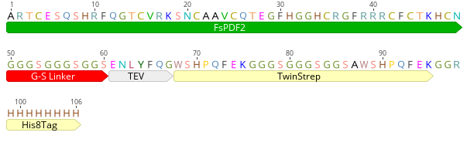
Supplementary Figure S1: Amino acid sequence of recombinant FsPDF2. The recombinant construct contains the plant defensin FsPDF2 connected with a linear glycine-serine linker and a cleavage site for TEV protease to a TwinStrep tag. There is an additional His8 tag for purification.

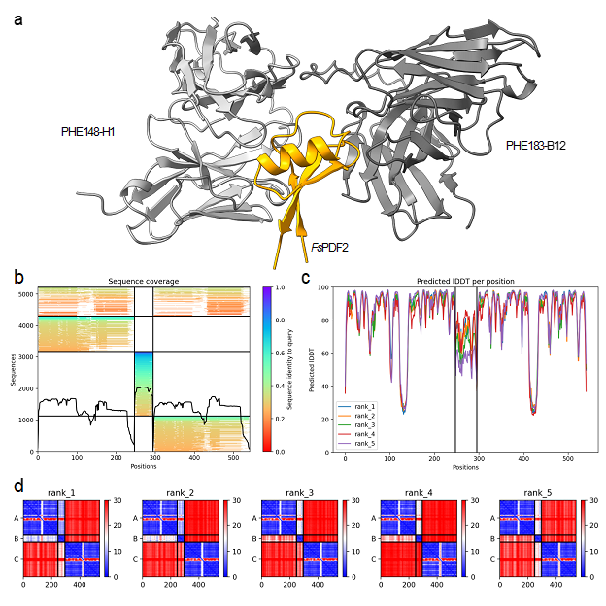
Supplementary Figure S2: Initial ColabFold model of FsPDF2 in complex with PHE148-H1 and PHE183-B12. a Protein structure of the antibody antigen complex. FsPDF2 is colored orange. PHE148-H1 is colored in light gray, and PHE183-B12 in dark gray. b multiple sequence alignment results for all 3 proteins. c Local Distance Difference test (lDDT) for 5 iterations of Alphafold2. d predicted alignment error (PAE) for 5 iterations of Alphafold2.
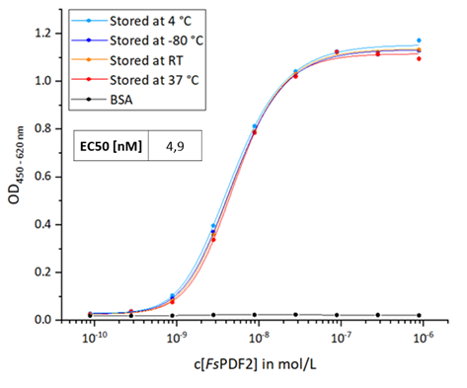
Supplementary Figure S3: Results of Titration ELISA revealing the stability of recombinant FsPDF2 from High Five insect cells at varied temperatures.
Titration curves and EC50 value in nM of purified FsPDF2 from High Five insect cells stored for 4 weeks at -80 °C (Dark blue), 4 °C (Light blue), RT (Orange), and 37 °C (Red). BSA (Black) was used as a negative control. The experiment is based on the assumption that denatured FsPDF2 can no longer be bound by the antibodies. See Figure 4a for the Titration ELISA setup. The consistent titration curves and identical EC50 values confirm the stability of FsPDF2 over 4 weeks at all temperatures tested and indicate a correct protein folding.

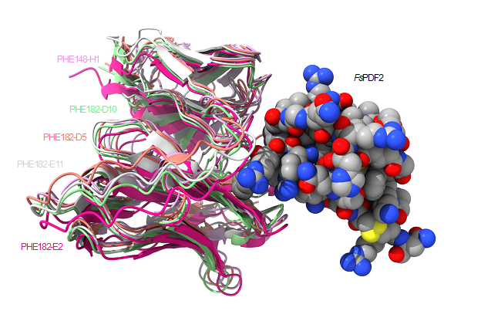
Supplementary Figure S4: Binding of the HAL10 scFv to FsPSF2. Structures were predicted with Alphafold multimer. The highest ranked models of each scFv in complex with FsPDF2 were superimposed and visualized. scFv structures were colored according to their name. FsPDF2 structure was displayed as spheres and colored by heteroatom.

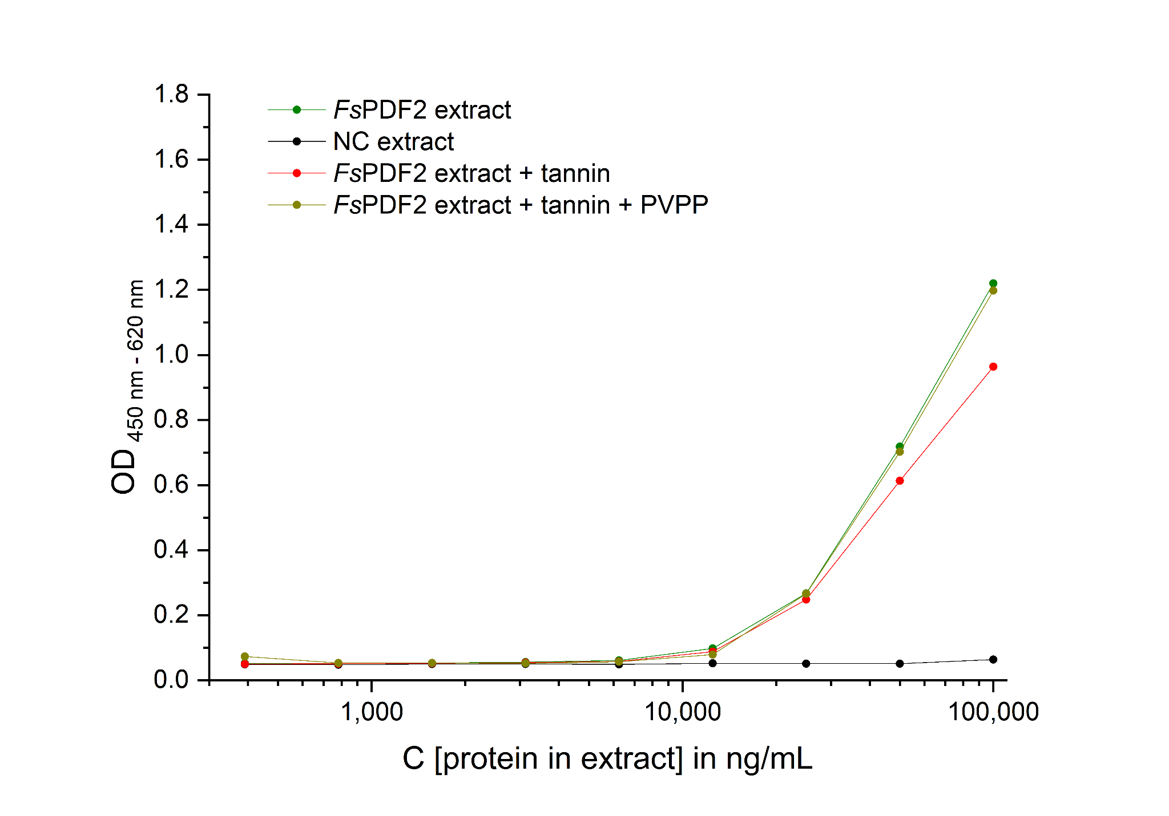
Supplementary Figure S5 Influence of tannins in the ELISA. The figure shows the titration curve of FsPDF2 with PHE148-H1 as capture antibody and PHE183-B12 for detection. The tannin containing FsPDF2 extract gives a lower signal than the extract without tannins. The extract treated with PVPP to adsorb tannins gives the same signals as the extract without tannins.

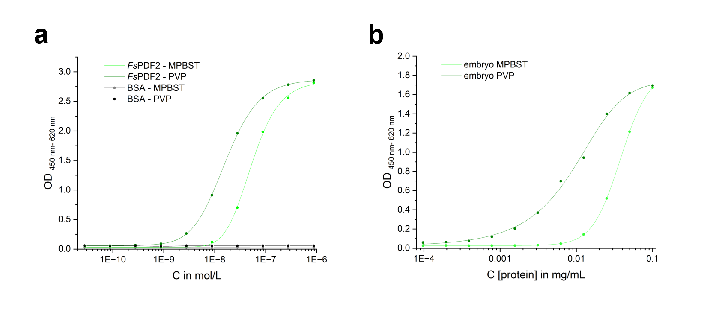
Supplementary Figure S6 ELISA with different blocking agents. Polystyrene MTP wells blocked with PVP show a higher sensitivity as MTP wells blocked with milk powder.
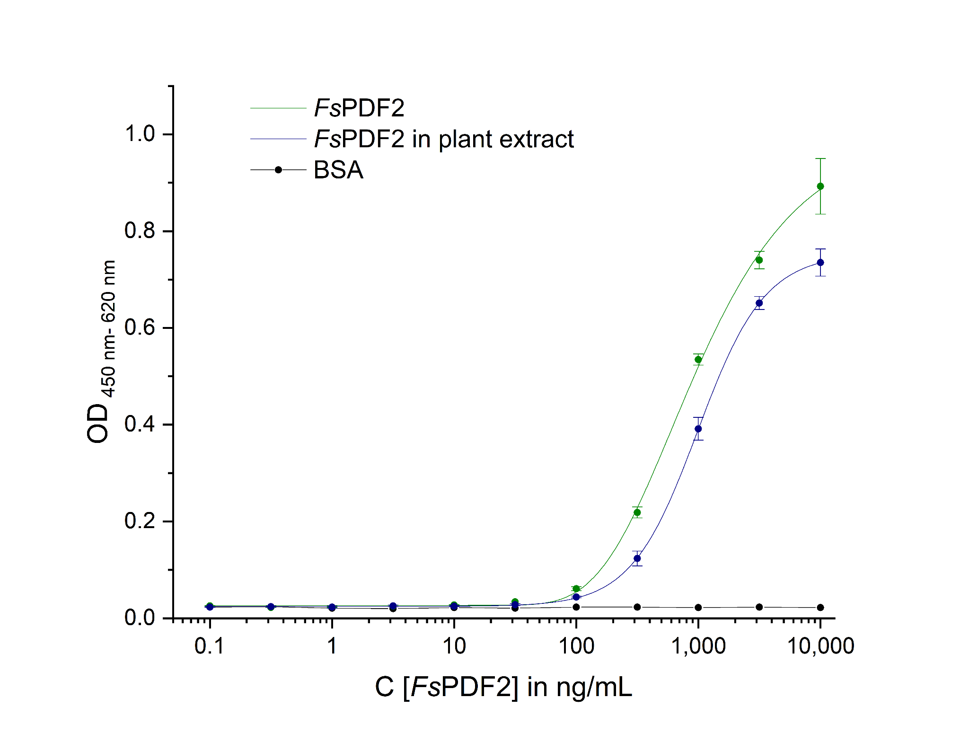
Supplementary Figure S7: Detection of recombinant FsPDF2 in crude plant extract. Signals of recombinant FsPDF2 mixed with 1:1 crude plant extract is slightly decreased, but in the same range like FsPDF2 in normal M-PBST buffer (EC₅₀ of 970 ng/mL and 993 ng/mL respectively).

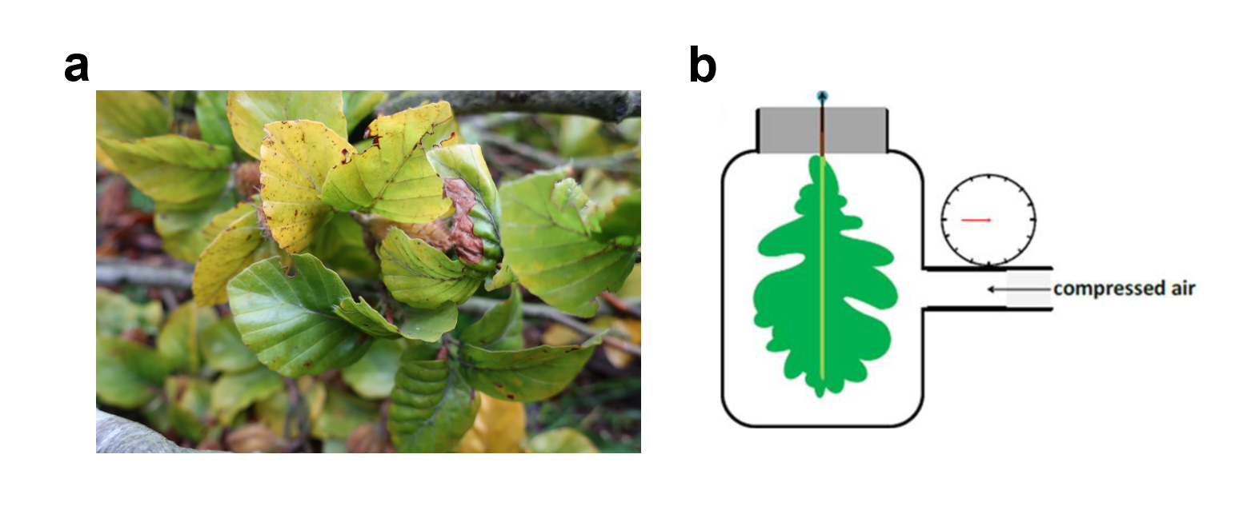
Supplementary Figure S8: a Doubt stressed leaves from Beerenbusch. b Scheme of Scholander Bomb measurement.
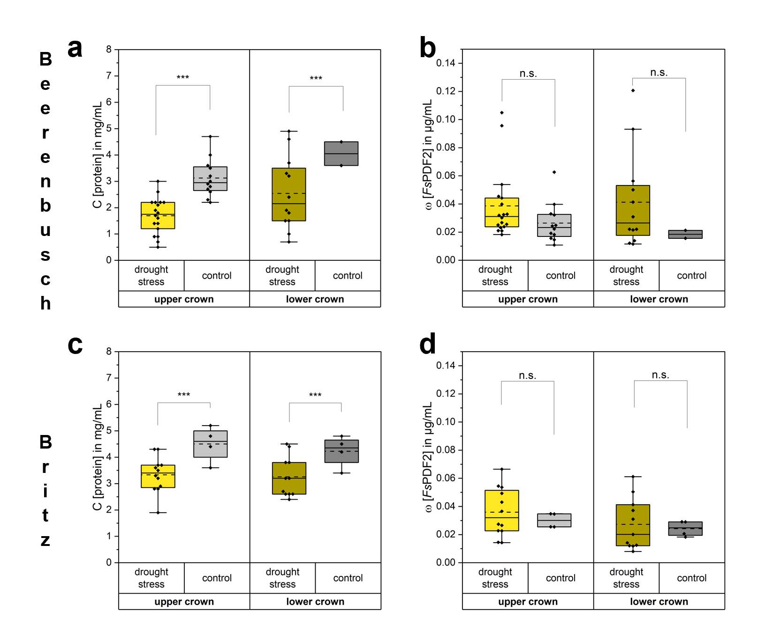
Supplementary Figure S9: a-d FsPDF2 quantification in beech leaves exposed to drought. Comparison of upper and lower crown leaves from F. sylvatica grown on sandy soil near (a/b) Beerenbusch (number of replicates: upper crown, drought stress n=18, control n=12; lower crown drought stress n=12, control n=2) and (c/d) Britz (number of replicates: upper crown, drought stress n=12, control n=4; lower crown drought stress n=11, control n=4) (Brandenburg), harvested after several months of drought in September 2019. Stressed trees grew in a dry forest area, control trees at a lake nearby.

Supplementary Table S1: Overview of Fagus sylvatica leaf samples. The Fagus sylvatica samples were collected in Raststatt, Germany.
RNA sample ID | Phytophthora infection | Tissue sample ID | leaf number | insect damage | collection date | collection place
fp1 | intermediate | 13 | 10 | yes | 17.05.2017 | Raststatt, Germany
fp2 | strong | 19 | 10 | yes | 17.05.2017 | Raststatt, Germany
fp3 | slight | 25 | 10 | yes | 17.05.2017 | Raststatt, Germany
fh1 | none | 31 | 10 | yes | 17.05.2017 | Raststatt, Germany

Table S2: List of synthesized gene sequences and used primers.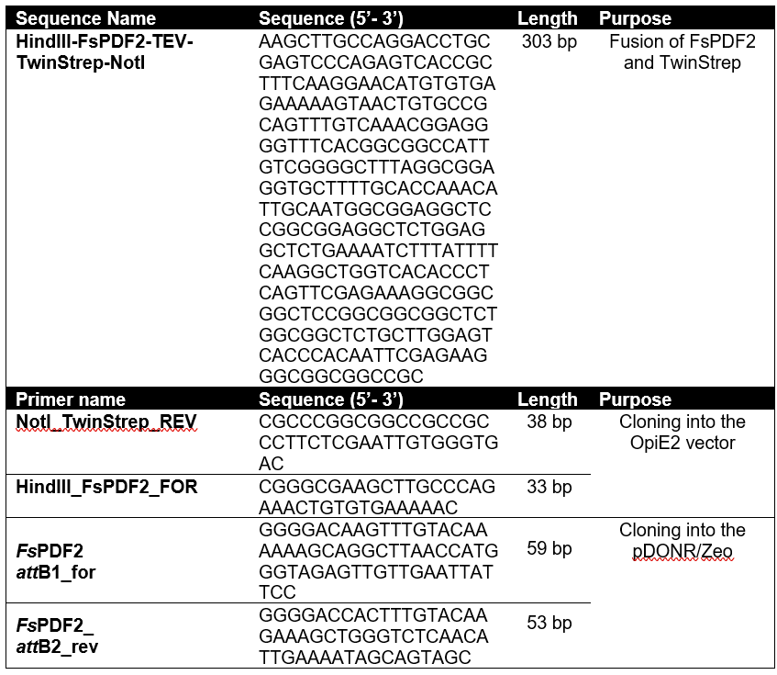

Table S3: Co-immunoprecipitation (CoIP) and LC-MS/MS to evaluate the specificity of PHE148-H1 and PHE183-B12⁽¹⁾.
Both antibodies, PHE148-H1 and PHE183-B12, bound recombinant FsPDF2 in co-immunoprecipitation (CoIP), whereas only PHE148-H1 was able to capture detectable levels of defensin out of crude plant extract as the antibody did in ELISA.
⁽¹⁾Either antibodies (PHE148-H1,PHE183-B12, or SH1956-D6) or unloaded Pierce Protein A/G magnetic beads (Thermo Scientific) were treated with proteins isolated from gall midge extracts. In addition, PHE148-H1 and PHE183-B12 coated beads were used for treatment with recombinant FsPDF2. FsPDF2 was only detectable when PHE148-H1 or PH183-B12 coated beads were used: for PHE148-H1 when using gall midge extracts or recombinant FsPDF2, for PHE183-B12 only when using recombinant FsPDF2. The lack of detection of FsPDF2 with the PHE183-B12 coated beads and using the gall midge tumour extracts is probably due to the fact that this antibody binds the protein much less well and the enriched concentrations with the gall midge tumour extracts remain below the detection limit.
⁽²⁾This protein was only found with PHE183-B12 and the levels detected were independent of whether recombinant FsPDF2 or gall midge tumour extracts were used. Furthermore, the protein was identified with only one unique peptide. It is therefore highly likely that the corresponding MS/MS spectrum is due to a contamination associated with the antibody used. Furthermore, the contamination is not observed in the samples with PHE183-B12, so even if in a hypothetical case there would be a cross reactivity between PHE148-H1 and a phosphoesterase, it would be irrelevant for the sandwich ELISA assay that requires binding to both antibodies.
⁽³⁾human contamination

