Table S1. Number of SNPs in 8 clusters used in present study and reported by Suzuki et al.

Cluster | Suzuki et al.’s data* | TPMI
Residual glycaemic | 389 | 339
Obesity | 233 | 212
Beta cell +PI | 91 | 71
Beta cell -PI | 89 | 76
Metabolic syndrome | 166 | 143
Liver/lipid metabolism | 3 | 3
Lipodystrophy | 45 | 38
Body fat | 273 | 227
Total | 1289 | 1109
*Suzuki, K., Hatzikotoulas, K., Southam, L. et al. Genetic drivers of heterogeneity in type 2 diabetes pathophysiology. Nature 2024:627, 347–357.
Abbreviations: Beta cell +PI or Beta cell -PI, beta-cell dysfunction with a positive or
negative association with proinsulin, respectively.

Table S2. Baseline characteristics of subjects with type 2 diabetes with dataset of multiple values of fasting glucose and HbA1c levels

Characteristics | Subjects with multiple  fasting glucose values  (N=2,090) | Subjects with multiple  HbA1c values  (N=2,507) | p-value
Age (years) | 59.1 ± 11.6 | 59.1 ± 11.7 | 0.907
Female, n (%) | 912 (43.6) | 1120 (44.7) | 0.480
BMI (kg/m²) | 26.7 ± 4.0 | 26.6 ± 3.9 | 0.364
Baseline Fasting Glucose (mg/dl) | 138.1 ± 26.5 | 137.8 ± 26.1 | 0.852
Change in Fasting Glucose on metformin treatment | -12.5 ± 27.2 | -13.0 ± 26.8 | 0.655
Baseline HbA1c (%) | 7.8 ± 1.7 | 7.9 ± 1.8 | 0.307
Change in HbA1c on metformin treatment | -1.1 ± 1.6 | -1.1 ± 1.7 | 0.831
Metformin use (mg/day) | 556 ± 226 | 554 ± 221 | 0.995
Duration of metformin use (month) | 4.7 ± 1.4 | 4.9 ± 1.3 | 0.037*
Data are presented as either the number (percentage) or as the mean ± standard deviation. The Kruskal-Wallis test ortest was conducted to evaluate the differences between two groups.
* denotes nominal significance (p<0.05); ** denotes Bonferroni-corrected significance (p<0.006 (0.05/9)).
Abbreviations: HbA1c, glycated hemoglobin

Table S3. Changes of FBG Responses in Q5 versus Q1 during metformin monotherapy by one or two clusters of risk alleles using East Asian specific- effect sizes

Clusters | PRS group | Estimate | 95% CI | P-value
Residual glycaemic | Q5 vs. Q1 | -0.227 | (-3.271, 2.818) | 0.884
Obesity | Q5 vs. Q1 | 1.338 | (-1.795, 4.470) | 0.403
Beta cell +PI | Q5 vs. Q1 | 4.866 | (1.990, 7.742) | 0.0009**
Beta cell -PI | Q5 vs. Q1 | 5.929 | (2.927, 8.931) | 0.0001**
Metabolic syndrome | Q5 vs. Q1 | -0.759 | (-3.687, 2.168) | 0.611
Liver/lipid metabolism | Q5 vs. Q1 | 0.631 | (-1.883, 3.144) | 0.623
Lipodystrophy | Q5 vs. Q1 | -0.201 | (-3.132, 2.730) | 0.893
Body fat | Q5 vs. Q1 | -0.748 | (-3.722, 2.226) | 0.622
Beta cell +PI and Beta cell -PI | Both Q5 vs. Both Q1 | 9.545 | (2.768, 16.322) | 0.006**
Beta cell +PI and Residual glycaemic | Both Q5 vs. Both Q1 | 3.903 | (-2.127, 9.933) | 0.205
Beta cell +PI and Obesity | Both Q5 vs. Both Q1 | 11.120 | (4.680, 17.560) | 0.001**
Beta cell -PI and Residual glycaemic | Both Q5 vs. Both Q1 | 4.994 | (-1.989, 11.977) | 0.161
Beta cell -PI and Obesity | Both Q5 vs. Both Q1 | 7.866 | (-0.115, 15.847) | 0.053
Residual glycaemic and Obesity | Both Q5 vs. Both Q1 | 2.222 | (-3.859, 8.303) | 0.474
Abbreviations: FBG: Fasting blood glucose; Beta cell +PI or Beta cell -PI, beta-cell dysfunction with a positive or negative association with proinsulin, respectively.
* denotes nominal significance (p<0.05); ** denotes Bonferroni-corrected significance (p<0.006 (0.05/8 for single cluster) and p<0.008 (0.05/6, for both Q5 vs. both Q1)).

Table S4. Changes of FBG Responses in Q5 versus Q1 during metformin monotherapy by one or two clusters of risk alleles with further adjustment of BMI

Clusters | PRS group | Estimate | 95% CI | P-value
Residual glycaemic | Q5 vs. Q1 | 0.614 | (-3.054, 4.282) | 0.743
Obesity | Q5 vs. Q1 | 2.967 | (-0.717, 6.652) | 0.114
Beta cell +PI | Q5 vs. Q1 | 6.512 | (2.737, 10.286) | 0.001**
Beta cell -PI | Q5 vs. Q1 | 2.492 | (-1.186, 6.171) | 0.184
Metabolic syndrome | Q5 vs. Q1 | -0.429 | (-3.938, 3.079) | 0.810
Liver/lipid metabolism | Q5 vs. Q1 | 3.600 | (0.100, 7.100) | 0.044*
Lipodystrophy | Q5 vs. Q1 | 1.702 | (-1.848, 5.251) | 0.347
Body fat | Q5 vs. Q1 | 0.437 | (-3.136, 4.010) | 0.811
Beta cell +PI and Beta cell -PI | Both Q5 vs. Both Q1 | 10.993 | (1.738, 20.247) | 0.020*
Beta cell +PI and Residual glycaemic | Both Q5 vs. Both Q1 | 6.128 | (-1.131, 13.388) | 0.098
Beta cell +PI and Obesity | Both Q5 vs. Both Q1 | 14.842 | (6.380, 23.303) | 0.001**
Beta cell -PI and Residual glycaemic | Both Q5 vs. Both Q1 | 0.838 | (-7.534, 9.210) | 0.845
Beta cell -PI and Obesity | Both Q5 vs. Both Q1 | 2.787 | (-5.794, 11.369) | 0.524
Residual glycaemic and Obesity | Both Q5 vs. Both Q1 | 1.974 | (-5.917, 9.865) | 0.624
Abbreviations: FBG: Fasting blood glucose; Beta cell +PI or Beta cell -PI, beta-cell dysfunction with a positive or negative association with proinsulin, respectively.
* denotes nominal significance (p<0.05); ** denotes Bonferroni-corrected significance (p<0.006 (0.05/8 for single cluster) and p<0.008 (0.05/6, for both Q5 vs. both Q1)).

Table S5. Changes of FBG Responses during metformin monotherapy by one or two clusters of risk alleles using continuous PRS

Clusters | Estimate | 95% CI | P-value
Residual glycaemic | 0.539 | (-0.391, 1.468) | 0.256
Obesity | 0.365 | (-0.583, 1.313) | 0.450
Beta cell +PI | 1.143 | (0.223, 2.064) | 0.015*
Beta cell -PI | 1.609 | (0.656, 2.562) | 0.001**
Metabolic syndrome | -0.446 | (-1.379, 0.486) | 0.348
Liver/lipid metabolism | 0.281 | (-0.653, 1.215) | 0.555
Lipodystrophy | 0.189 | (-0.747, 1.126) | 0.692
Body fat | 0.062 | (-0.864, 0.988) | 0.896
Beta cell +PI and Beta cell -PI | 1.353 | (0.681, 2.025) | 0.00008**
Beta cell +PI and Residual glycaemic | 0.784 | (0.145, 1.424) | 0.016*
Beta cell +PI and Obesity | 0.768 | (0.112, 1.425) | 0.022*
Beta cell -PI and Residual glycaemic | 1.057 | (0.372, 1.741) | 0.002**
Beta cell -PI and Obesity | 1.003 | (0.309, 1.697) | 0.005**
Residual glycaemic and Obesity | 0.470 | (-0.170, 1.109) | 0.150
Abbreviations: FBG: Fasting blood glucose; Beta cell +PI or Beta cell -PI, beta-cell dysfunction with a positive or negative association with proinsulin, respectively.
* denotes nominal significance (p<0.05); ** denotes Bonferroni-corrected significance (p<0.006 (0.05/8 for single cluster) and p<0.008 (0.05/6, for both Q5 vs. both Q1)).

Table S6. Changes of HbA1c Responses in Q5 versus Q1 during metformin monotherapy by one or two clusters of risk alleles using East Asian specific- effect sizes

Clusters | PRS group | Estimate | 95% CI | P-value
Residual glycaemic | Q5 vs. Q1 | -0.256 | (-0.331, -0.180) | 3.66E-11**
Obesity | Q5 vs. Q1 | 0.018 | (-0.104, 0.139) | 0.774
Beta cell +PI | Q5 vs. Q1 | -0.063 | (-0.176, 0.050) | 0.272
Beta cell -PI | Q5 vs. Q1 | 0.203 | (0.094, 0.312) | 0.0003**
Metabolic syndrome | Q5 vs. Q1 | -0.004 | (-0.120, 0.111) | 0.941
Liver/lipid metabolism | Q5 vs. Q1 | 0.043 | (-0.063, 0.150) | 0.424
Lipodystrophy | Q5 vs. Q1 | 0.013 | (-0.100, 0.126) | 0.820
Body fat | Q5 vs. Q1 | 0.058 | (-0.052, 0.167) | 0.303
Beta cell -PI and Residual glycaemic | Both Q5 vs. Both Q1 | 0.043 | (-0.195, 0.280) | 0.725
Beta cell -PI and Obesity | Both Q5 vs. Both Q1 | 0.214 | (-0.075, 0.502) | 0.147
Beta cell -PI and Beta cell +PI | Both Q5 vs. Both Q1 | 0.024 | (-0.215, 0.264) | 0.842
Beta cell +PI and Residual glycaemic | Both Q5 vs. Both Q1 | -0.177 | (-0.361, 0.008) | 0.060
Beta cell +PI and Obesity | Both Q5 vs. Both Q1 | 0.096 | (-0.210, 0.401) | 0.539
Residual glycaemic and Obesity | Both Q5 vs. Both Q1 | -0.066 | (-0.345, 0.213) | 0.641
Abbreviations: HbA1c, glycated hemoglobin; Beta cell +PI or Beta cell -PI, beta-cell dysfunction with a positive or negative association with proinsulin, respectively.
* denotes nominal significance (p<0.05); ** denotes Bonferroni-corrected significance (p<0.006 (0.05/8 for single cluster) and p<0.008 (0.05/6, for both Q5 vs. both Q1)).

Table S7. Changes of HbA1c Responses in Q5 versus Q1 during metformin monotherapy by one or two clusters of risk alleles with further adjustment of BMI

Clusters | PRS group | Estimate | 95% CI | P-value
Residual glycaemic | Q5 vs. Q1 | 0.102 | (-0.035, 0.238) | 0.143
Obesity | Q5 vs. Q1 | -0.009 | (-0.158, 0.141) | 0.909
Beta cell +PI | Q5 vs. Q1 | -0.087 | (-0.226, 0.053) | 0.223
Beta cell -PI | Q5 vs. Q1 | 0.164 | (0.030, 0.299) | 0.017*
Metabolic syndrome | Q5 vs. Q1 | 0.003 | (-0.151, 0.157) | 0.967
Liver/lipid metabolism | Q5 vs. Q1 | 0.086 | (-0.066, 0.238) | 0.266
Lipodystrophy | Q5 vs. Q1 | 0.064 | (-0.070, 0.197) | 0.350
Body fat | Q5 vs. Q1 | 0.088 | (-0.043, 0.218) | 0.187
Beta cell -PI and Residual glycaemic | Both Q5 vs. Both Q1 | 0.186 | (-0.136, 0.508) | 0.257
Beta cell -PI and Obesity | Both Q5 vs. Both Q1 | 0.010 | (-0.386, 0.406) | 0.961
Beta cell -PI and Beta cell +PI | Both Q5 vs. Both Q1 | 0.068 | (-0.259, 0.394) | 0.685
Beta cell +PI and Residual glycaemic | Both Q5 vs. Both Q1 | 0.044 | (-0.310, 0.399) | 0.806
Beta cell +PI and Obesity | Both Q5 vs. Both Q1 | 0.023 | (-0.365, 0.411) | 0.908
Residual glycaemic and Obesity | Both Q5 vs. Both Q1 | 0.115 | (-0.287, 0.517) | 0.577
Abbreviations: HbA1c, glycated hemoglobin; Beta cell +PI or Beta cell -PI, beta-cell dysfunction with a positive or negative association with proinsulin, respectively.
* denotes nominal significance (p<0.05); ** denotes Bonferroni-corrected significance (p<0.006 (0.05/8 for single cluster) and p<0.008 (0.05/6, for both Q5 vs. both Q1)).

Table S8. Changes of HbA1c Responses during metformin monotherapy by one or two clusters of risk alleles using continuous PRS

Clusters | Estimate | 95% CI | P-value
Residual glycaemic | -0.004 | (-0.040, 0.033) | 0.848
Obesity | 0.003 | (-0.036, 0.042) | 0.877
Beta cell +PI | -0.043 | (-0.081, -0.004) | 0.030*
Beta cell -PI | 0.060 | (0.021, 0.099) | 0.003**
Metabolic syndrome | 0.004 | (-0.034, 0.042) | 0.829
Liver/lipid metabolism | -0.013 | (-0.050, 0.025) | 0.514
Lipodystrophy | 0.014 | (-0.025, 0.053) | 0.490
Body fat | 0.025 | (-0.013, 0.063) | 0.189
Beta cell -PI and Residual glycaemic | 0.028 | (0.001, 0.055) | 0.042*
Beta cell -PI and Obesity | 0.032 | (0.003, 0.062) | 0.030*
Beta cell -PI and Beta cell +PI | 0.009 | (-0.019, 0.036) | 0.534
Beta cell +PI and Residual glycaemic | -0.022 | (-0.048, 0.004) | 0.102
Beta cell +PI and Obesity | -0.020 | (-0.048, 0.008) | 0.153
Residual glycaemic and Obesity | -0.0002 | (-0.026, 0.025) | 0.986
Abbreviations: HbA1c, glycated hemoglobin; Beta cell +PI or Beta cell -PI, beta-cell dysfunction with a positive or negative association with proinsulin, respectively.
* denotes nominal significance (p<0.05); ** denotes Bonferroni-corrected significance (p<0.006 (0.05/8 for single cluster) and p<0.008 (0.05/6, for both Q5 vs. both Q1)).

Table S9. Clinical characteristics of individuals with type 2 diabetes carrying Q5 versus Q1 of PRS of Beta cell +PI

Characteristics | Type 2 Diabetes carry Q1 of PRS  (N=512) | Type 2 Diabetes carry Q5 of PRS  (N=577) | p-value
Age (years) | 59.9 ± 10.9 | 57.5 ± 12.0 | 0.004**
Female, n (%) | 217 (42.4) | 242 (41.9) | 0.883
BMI (kg/m²) | 26.9 ± 4.0 | 26.0 ± 4.0 | 0.003**
Baseline Fasting Glucose (mg/dl) | 137.2 ± 27.7 | 140.1 ± 27.4 | 0.175
Change in Fasting Glucose on metformin treatment | -14.6 ± 28.3 | -12.8 ± 28.4 | 0.538
Baseline HbA1c (%) | 8.0 ± 1.9 | 7.8 ± 1.6 | 0.451
Change in HbA1c on metformin treatment | -1.1 ± 1.9 | -1.0 ± 1.5 | 0.986
Metformin use (mg/day) | 536 ± 207 | 559 ± 218 | 0.030*
Duration of metformin use (month) | 4.8 ± 1.3 | 4.8 ± 1.4 | 0.941
Data are presented as either the number (percentage) or as the mean ± standard deviation. The Kruskal-Wallis test ortest was conducted to evaluate the differences between two groups.
* denotes nominal significance (p<0.05); ** denotes Bonferroni-corrected significance (p<0.006 (0.05/9)).
Abbreviations: HbA1c, glycated hemoglobin; Beta cell +PI, beta-cell dysfunction with a positive association with proinsulin.

Table S10. Clinical characteristics of individuals with type 2 diabetes carrying Q5 versus Q1 of PRS of Beta cell -PI

Characteristics | Type 2 Diabetes carry Q1 of PRS  (N=532) | Type 2 Diabetes carry Q5 of PRS  (N=554) | p-value
Age (years) | 59.3 ± 11.4 | 58.1 ± 11.7 | 0.138
Female, n (%) | 227 (42.7) | 249 (45.0) | 0.450
BMI (kg/m²) | 26.6 ± 3.7 | 26.2 ± 4.0 | 0.123
Baseline Fasting Glucose (mg/dl) | 137.7 ± 27.5 | 137.0 ± 26.7 | 0.896
Change in Fasting Glucose on metformin treatment | -12.8 ± 28.8 | -9.0 ± 25.0 | 0.345
Baseline HbA1c (%) | 7.7 ± 1.5 | 7.9 ± 1.9 | 0.392
Change in HbA1c on metformin treatment | -1.0 ± 1.4 | -1.0 ± 1.8 | 0.631
Metformin use (mg/day) | 554 ± 242 | 565 ± 215 | 0.018*
Duration of metformin use (month) | 4.8 ± 1.4 | 4.8 ± 1.3 | 0.561
Data are presented as either the number (percentage) or as the mean ± standard deviation. The Kruskal-Wallis test ortest was conducted to evaluate the differences between two groups.
* denotes nominal significance (p<0.05); ** denotes Bonferroni-corrected significance (p<0.006 (0.05/9)).
Abbreviations: HbA1c, glycated hemoglobin; Beta cell -PI, beta-cell dysfunction with a negative association with proinsulin.

Table S11. Clinical characteristics of individuals with type 2 diabetes carrying Q5 versus Q1 of PRS of residual glycaemic

Characteristics | Type 2 Diabetes carry Q1 of PRS  (N=515) | Type 2 Diabetes carry Q5 of PRS  (N=545) | p-value
Age (years) | 60.2 ± 11.5 | 57.6 ± 12.1 | 0.0004**
Female, n (%) | 212 (41.2) | 239 (43.9) | 0.376
BMI (kg/m²) | 26.7 ± 3.8 | 25.9 ± 3.9 | 0.007*
Baseline Fasting Glucose (mg/dl) | 136.3 ± 29.0 | 138.8 ± 25.4 | 0.175
Change in Fasting Glucose on metformin treatment | -11.3 ± 27.5 | -12.6 ± 26.4 | 0.423
Baseline HbA1c (%) | 7.8 ± 1.7 | 7.8 ± 1.8 | 0.408
Change in HbA1c on metformin treatment | -1.1 ± 1.7 | -1.0 ± 1.7 | 0.645
Metformin use (mg/day) | 555 ± 234 | 539 ± 193 | 0.381
Duration of metformin use (month) | 4.8 ± 1.3 | 4.8 ± 1.3 | 0.940
Data are presented as either the number (percentage) or as the mean ± standard deviation. The Kruskal-Wallis test ortest was conducted to evaluate the differences between two groups.
* denotes nominal significance (p<0.05); ** denotes Bonferroni-corrected significance (p<0.006 (0.05/9)).
Abbreviations: HbA1c, glycated hemoglobin.

Table S12. Clinical characteristics of individuals with type 2 diabetes carrying Q5 versus Q1 of PRS of obesity

Characteristics | Type 2 Diabetes carry Q1 of PRS  (N=559) | Type 2 Diabetes carry Q5 of PRS  (N=520) | p-value
Age (years) | 60.2 ± 12.0 | 58.2 ± 12.2 | 0.004**
Female, n (%) | 239 (42.8) | 252 (48.5) | 0.060
BMI (kg/m²) | 26.1 ± 3.9 | 27.3 ± 3.8 | 0.0001**
Baseline Fasting Glucose (mg/dl) | 139.3 ± 28.5 | 138.3 ± 25.4 | 0.838
Change in Fasting Glucose on metformin treatment | -13.2 ± 28.4 | -11.9 ± 26.1 | 0.991
Baseline HbA1c (%) | 7.8 ± 1.7 | 7.9 ± 1.8 | 0.807
Change in HbA1c on metformin treatment | -1.0 ± 1.6 | -1.1 ± 1.9 | 0.958
Metformin use (mg/day) | 546 ± 218 | 551 ± 209 | 0.436
Duration of metformin use (month) | 4.9 ± 1.4 | 4.7 ± 1.4 | 0.249
Data are presented as either the number (percentage) or as the mean ± standard deviation. The Kruskal-Wallis test ortest was conducted to evaluate the differences between two groups.
* denotes nominal significance (p<0.05); ** denotes Bonferroni-corrected significance (p<0.006 (0.05/9)).
Abbreviations: HbA1c, glycated hemoglobin.

Fig. S1 Trends of fasting glucose responses to metformin monotherapy of Q5 vs. Q1 in each cluster not shown in Figure 2.

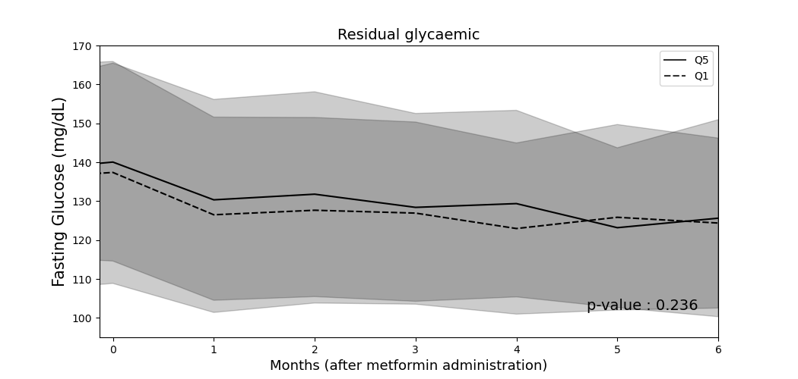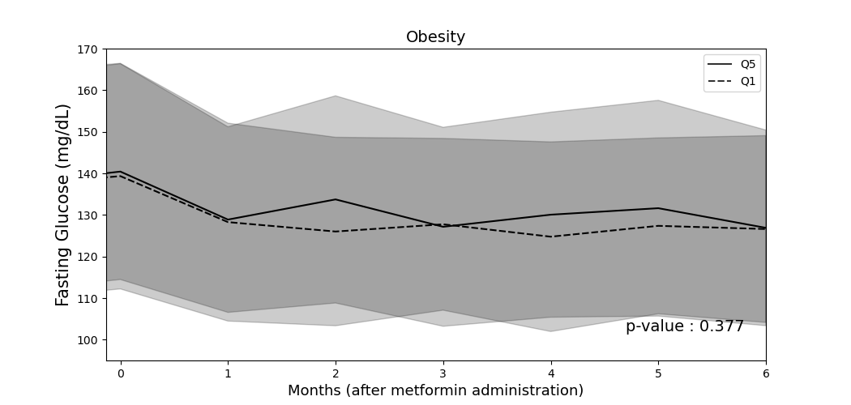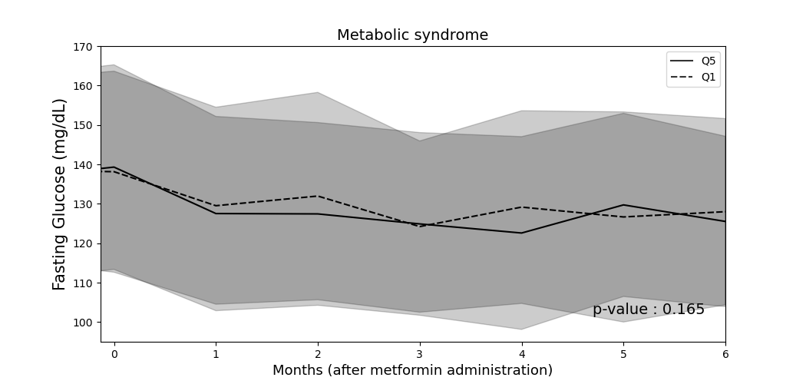
A
B
C

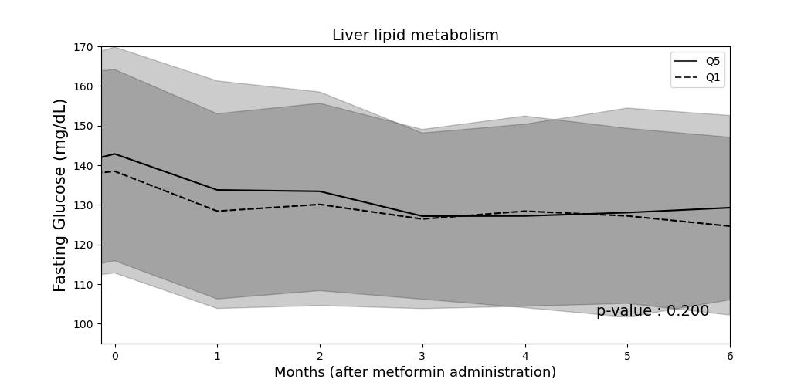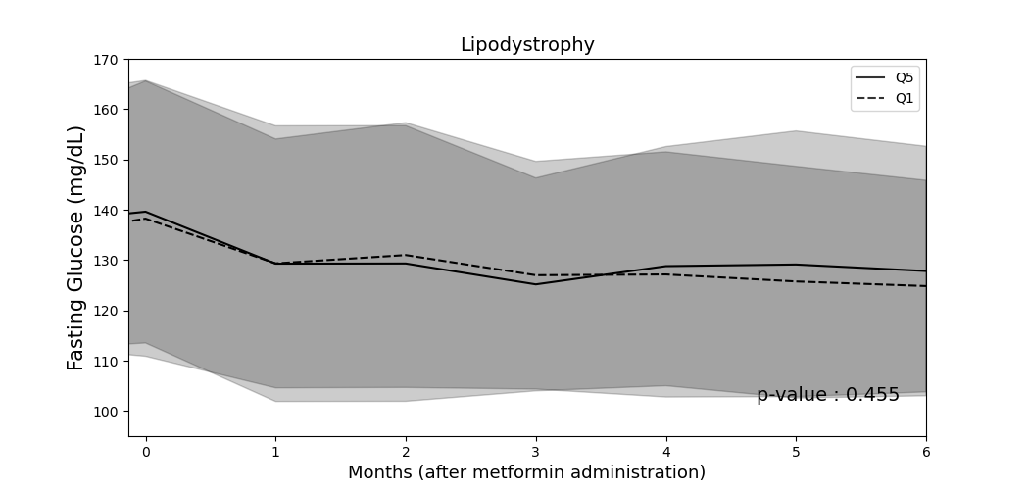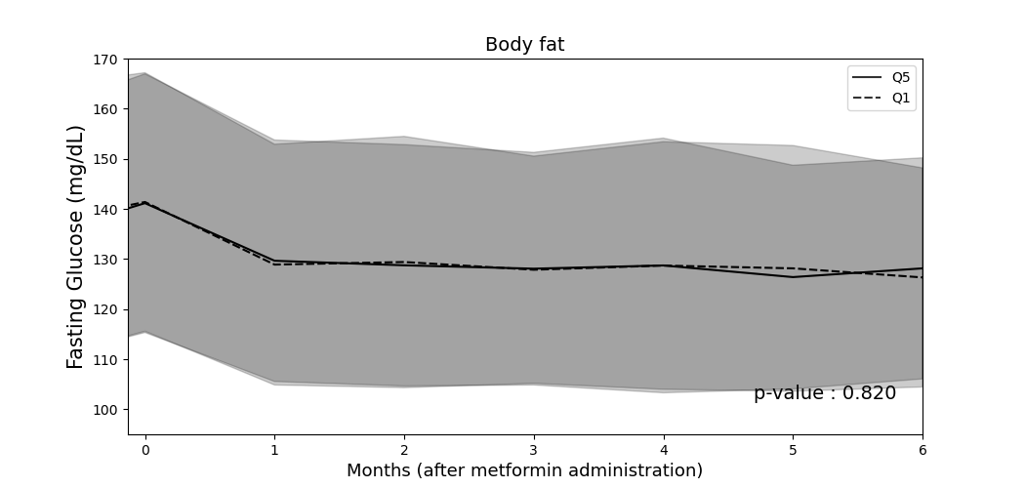
D
E
F

Fig. S2 Trends of FBG responses to metformin monotherapy of Q5 vs. Q1 in those two clusters not shown in Figure 2.

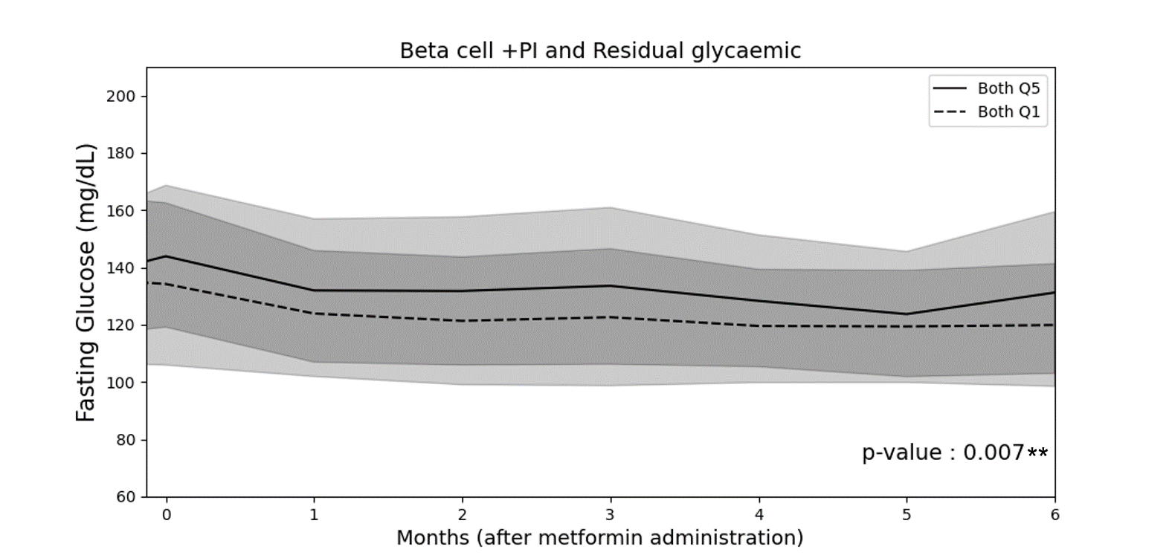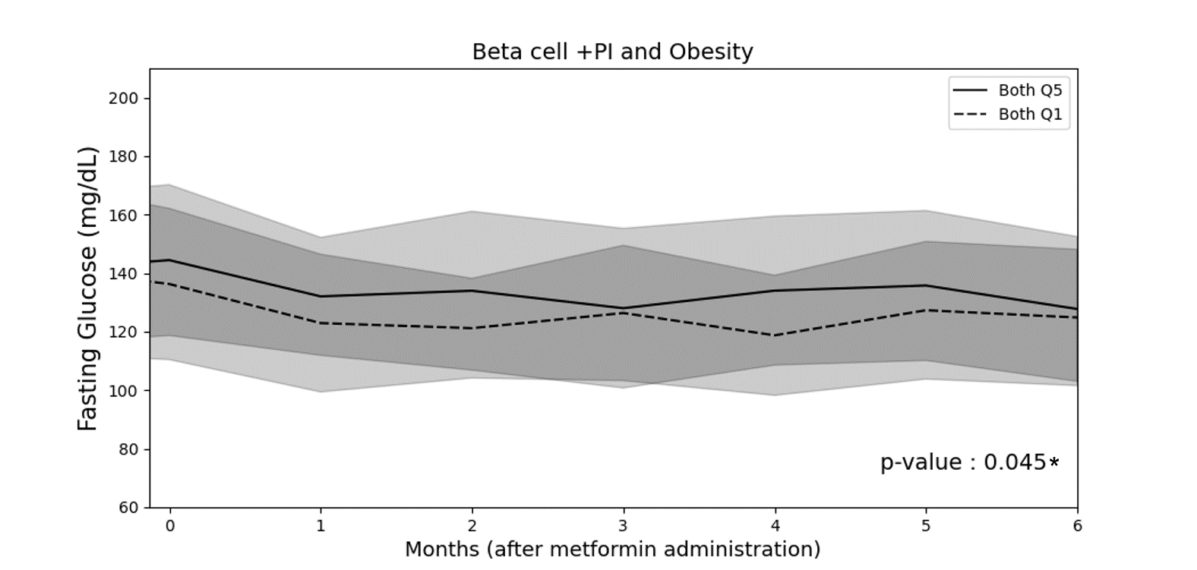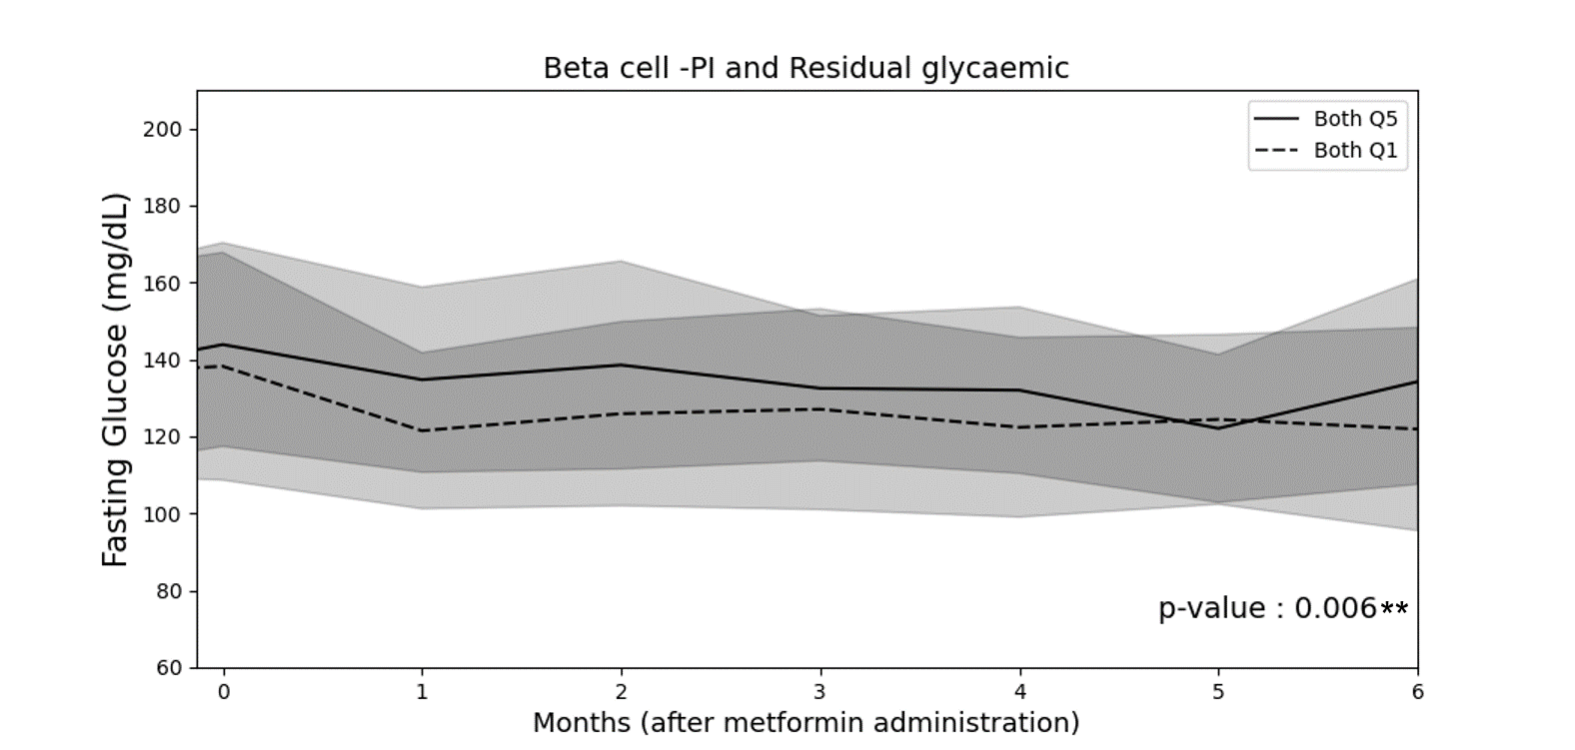
A
B
C
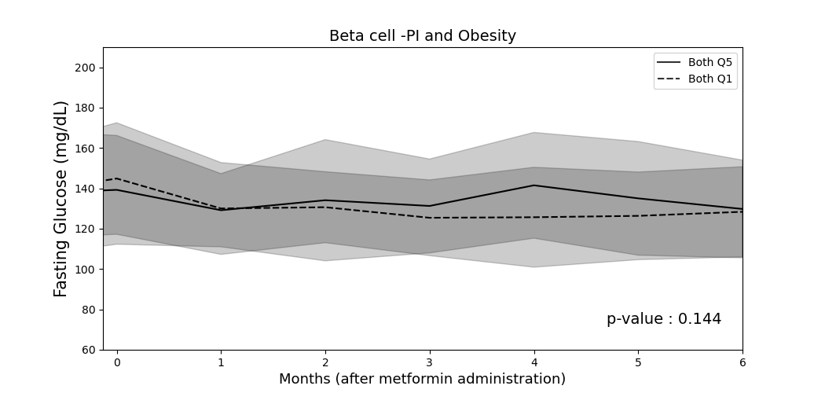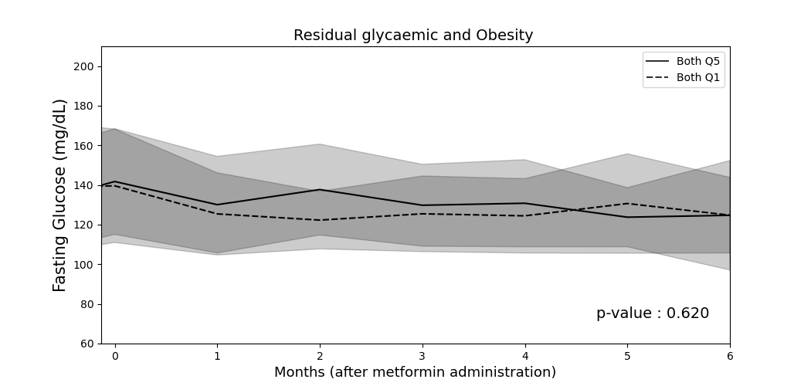
D
E

Fig. S3 Trends of HbA1c responses to metformin monotherapy of Q5 vs. Q1 in Beta cell -PI, residual glycaemic and combination of two clusters.

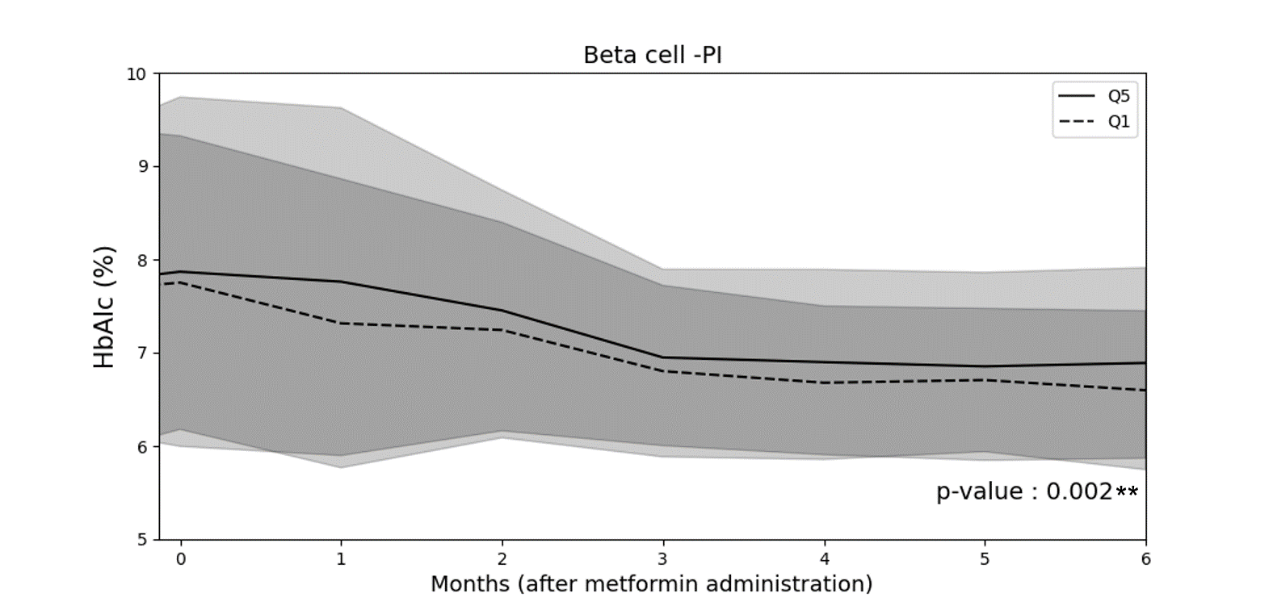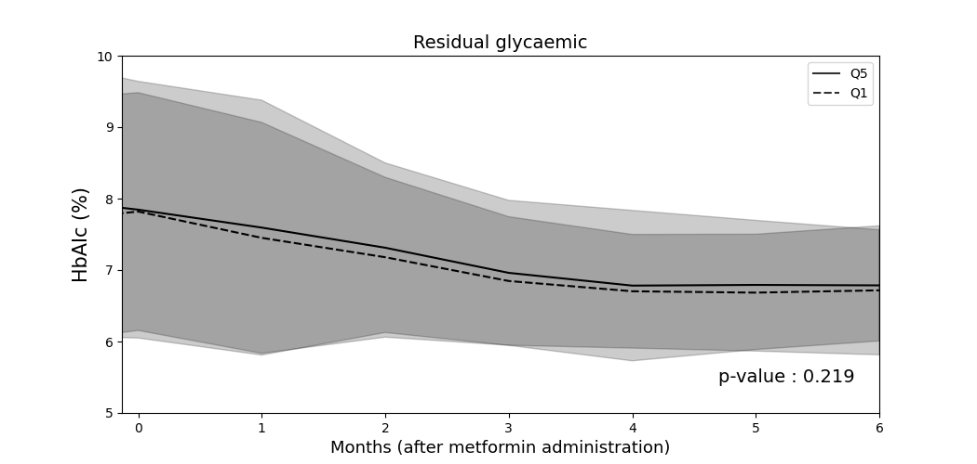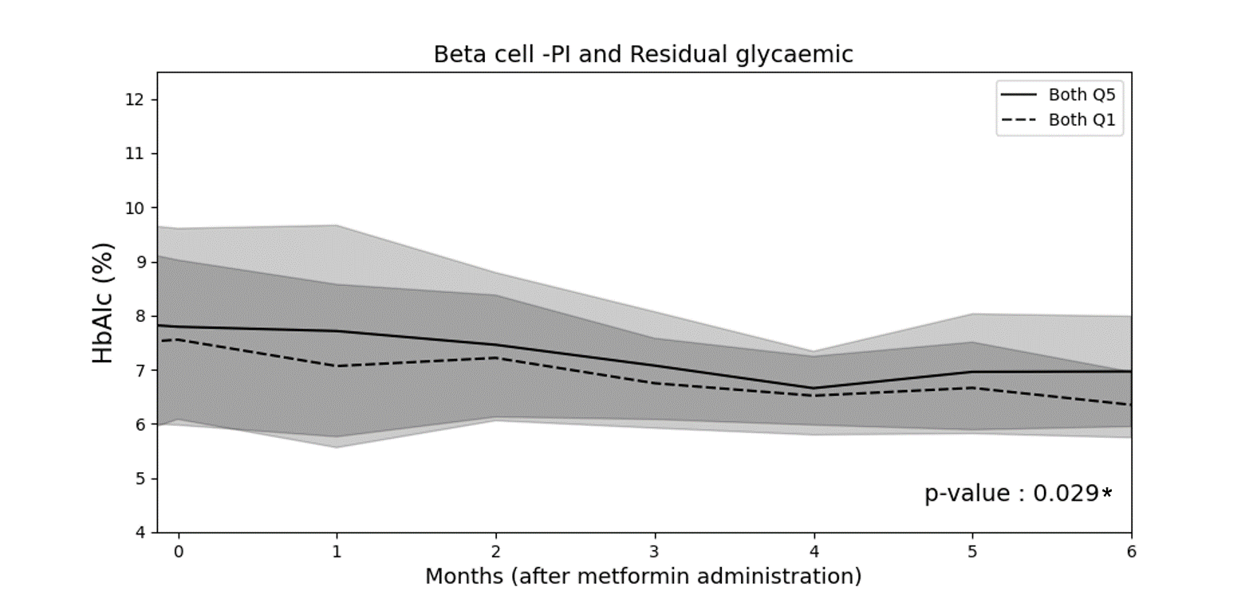
A.
B.
C.

Fig. S4 Trends of HbA1c responses to metformin monotherapy of Q5 vs. Q1 in each cluster not shown in Figure S3.

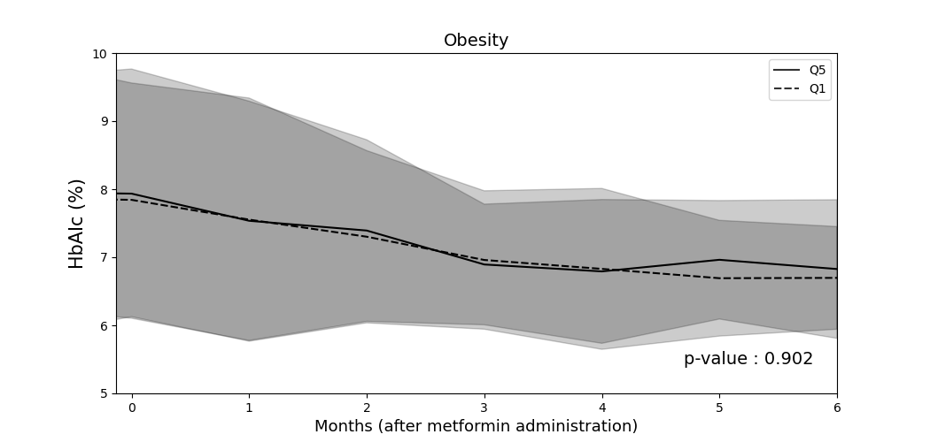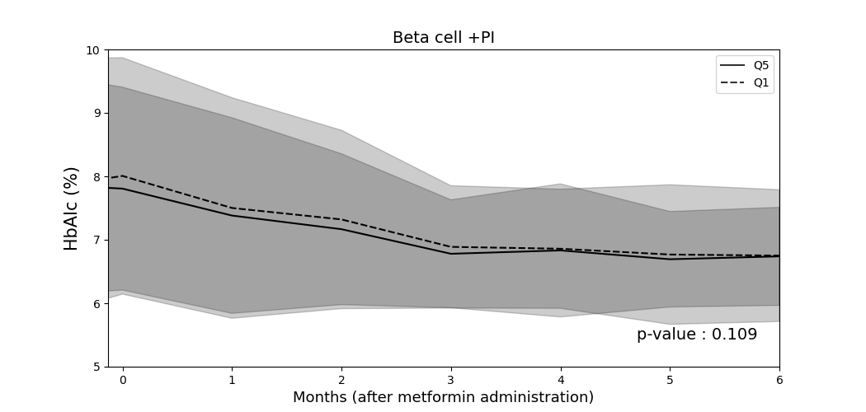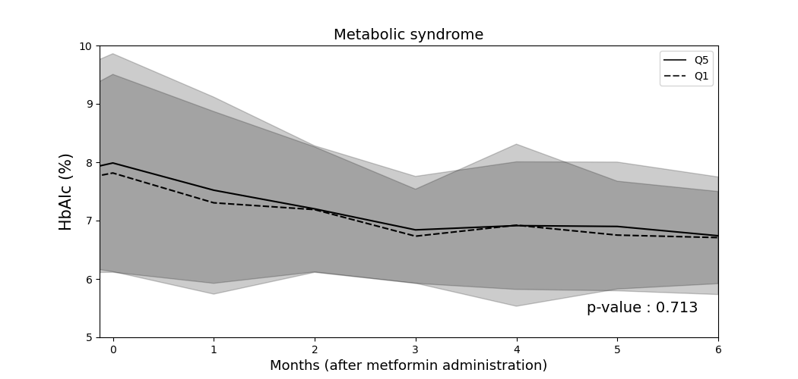
A
B
C
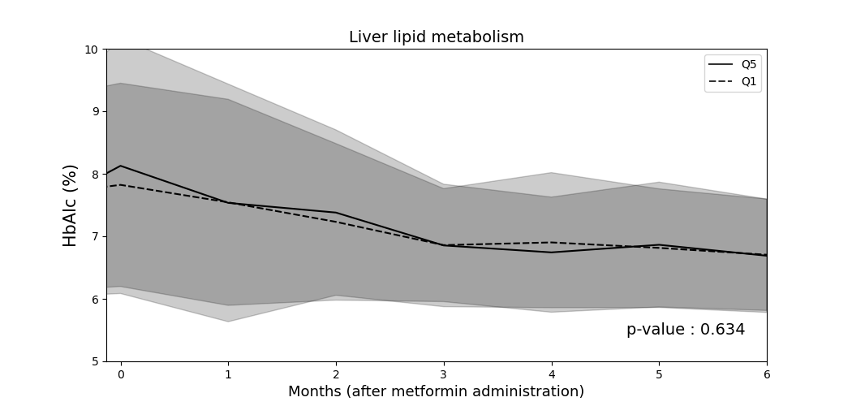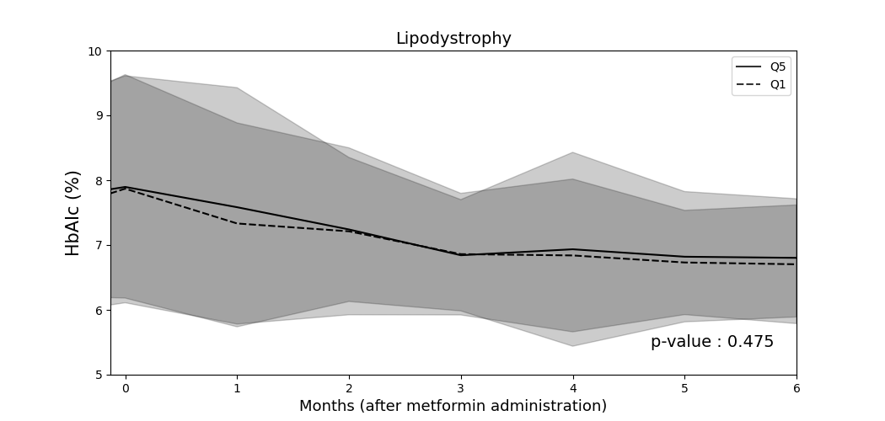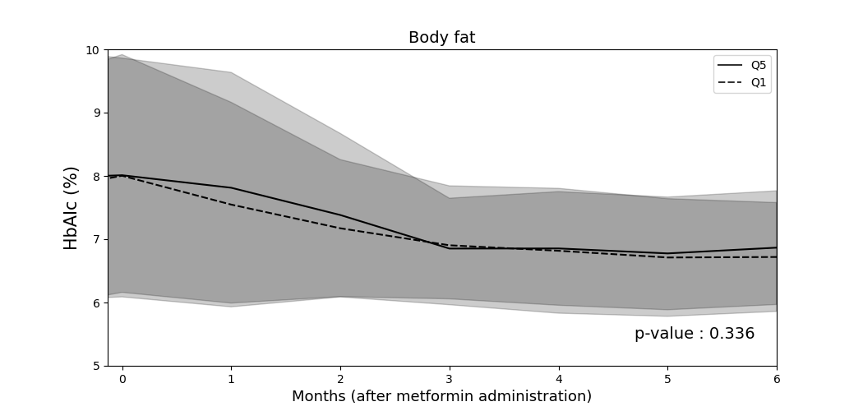
D
E
F

Fig. S5 Trends of HbA1c responses to metformin monotherapy of Q5 vs. Q1 in those two clusters not shown in Figure S3.

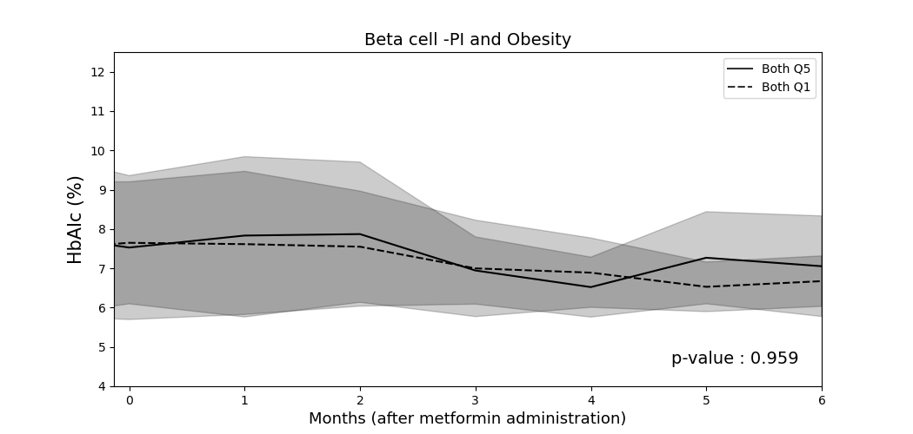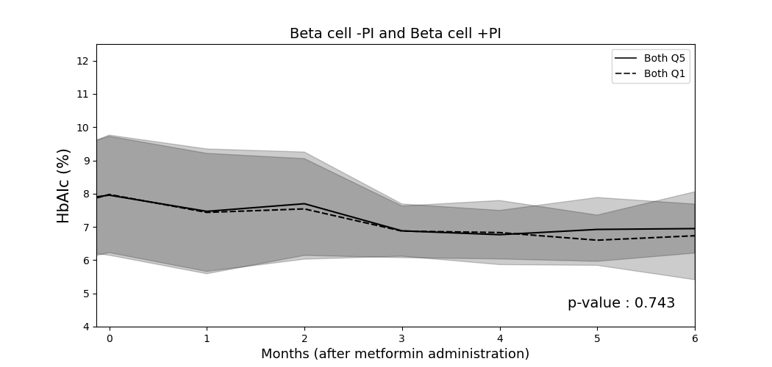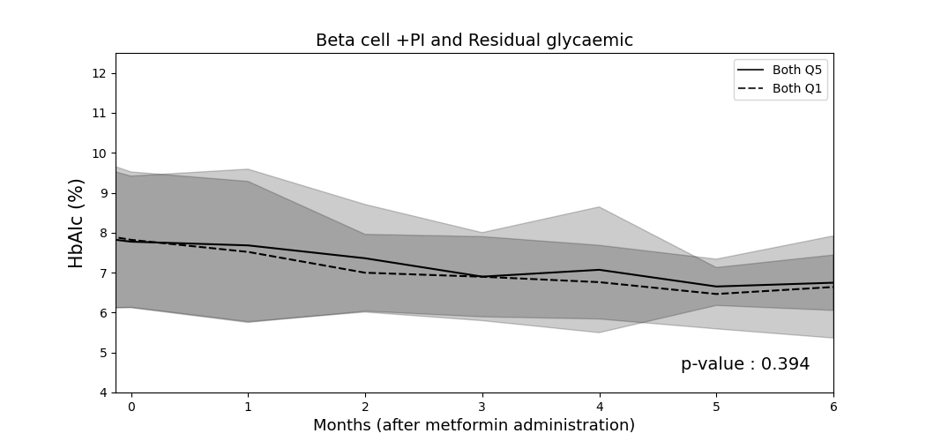
A
B
C
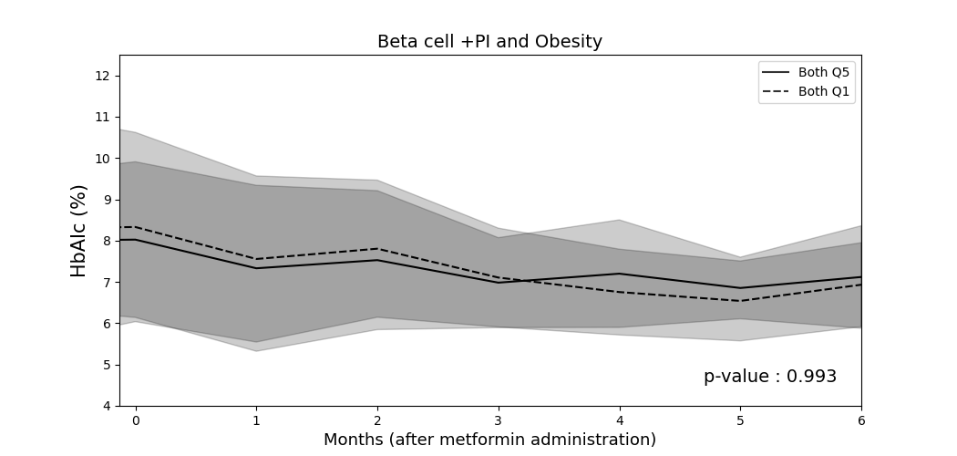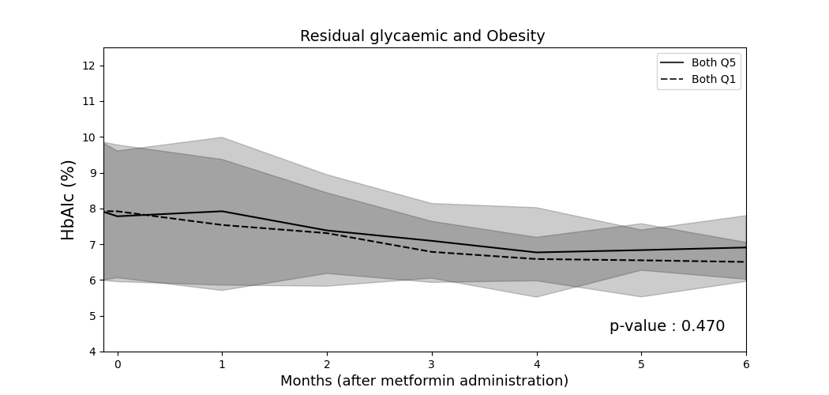
D
E

Fig. S6 Change of FBG/HbA1c responses across PRS spectrum during metformin monotherapy.
