R. Rittersberger et al., 2025, International Journal of Pharmaceutics
Inhalative Polyclonal Immunoglobulin G for the Prevention of Respiratory Infections: A comprehensive in vitro assessment
Supplementary Material and Methods
Determination of deposition volume in the ALICE Cloud system with extension plates
For the determination of the deposition volume of Panzyga® 2% with 200/ 400 µg/mL PS80, the ALICE Cloud system (Vitrocell, Waldkirch, Germany) was activated and pre-heated to 37 °C 0.5–1 h before use. Extension plates (Figure M1A) were equilibrated to 37 °C in an incubator prior to use. Each nebulizer was loaded with 1 mL Milli-Q (MQ) water and operated until complete aerosolization was achieved. Meshes and nebulizers were dried with a lint-free paper towel (Kimberly-Clark, Koblenz/ Rheinhafen, Germany) and care was taken to avoid contact with the central mesh region.
Panzyga® 2% with 200/ 400 µg/mL PS80 was spiked with 500 µg/mL FITC-dextran 4 kDa (Sigma Aldrich, Darmstadt, Germany). The mixture was vortexed briefly to ensure homogeneity.
Extension plates were prepared by pipetting 260 µL PBS pH 7.4 (Carl Roth, Karlsruhe, Germany) into each well. Transwells inserts from which the membrane had been removed were inserted into the extension plates. The plates were then transferred into the Cloud system and fitted with two cover rings to seal the well openings (Figure M1B).
The PARI eFlow® nebulizer was filled with 200 µL of FITC-spiked Panzyga® in different formulations and sealed tightly. It was carefully positioned on top of the Cloud system to ensure a stable and straight fit (Figure M1C/D). Nebulization was initiated by pressing the on/off button until an acoustic signal (beeping) was heard. After nebulization completion (indicated by a second acoustic signal), a 10 min aerosol sedimentation phase was allowed.
Following sedimentation, the system hood was removed and samples were collected from each well into a black flat-bottom 96-well plate (Greiner BioOne, Kremsmünster, Austria). The plate was sealed and protected from light until further analysis.
The collected samples were analyzed using a fluorescence-based quantification method. FITC-spiked Panzyga® 2% was first diluted 1:5 in PBS pH 7.4, resulting in a working concentration of 100 µg/mL FITC-dextran. A 11-step 1:2 serial dilution series was prepared in PBS pH 7.4. 100 µL of the standard curve and samples were applied to a black flat-bottom 96-well plate. Fluorescence was measured at 520 nm on a Tecan plate reader (Tecan, Männedorf, Switzerland). All samples were measured on the same day as deposition experiment.
After each experiment, the hood, extension plate, and cover rings were rinsed extensively under running tap water (VE) and dried with paper towels. The nebulizer was rinsed thoroughly with tap water, taking care to clean the mesh gently. The nebulizer was reassembled and operated with 2 mL MQ water to ensure residual removal, followed by another thorough rinse (mesh included). Finally, the heating block of the Cloud system was wiped with a wet paper towel.
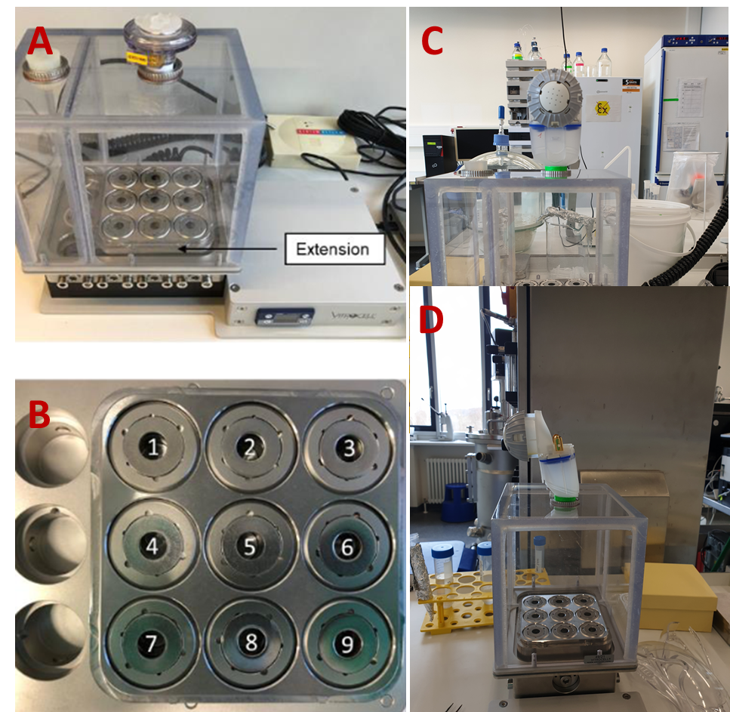
Supplementary Figure M1: Set-up of the ALICE Cloud system utilized for the transcytosis assay of Panzyga® 2 % with 200/ 400 µg/mL PS80. A) Self-made steel extension plate in the ALICE Cloud system. B) Extension plate with the 2 cover rings. The bigger/ outer one is used for inserting the membrane inserts, the smaller one prevents direct aerosol deposition into the basolateral acceptor medium. C) Set-up of the PARI eFlow® on the ALICE Cloud system, front view. D) Set-up of the PARI eFlow® on the ALICE Cloud system, side view.

Supplementary Data
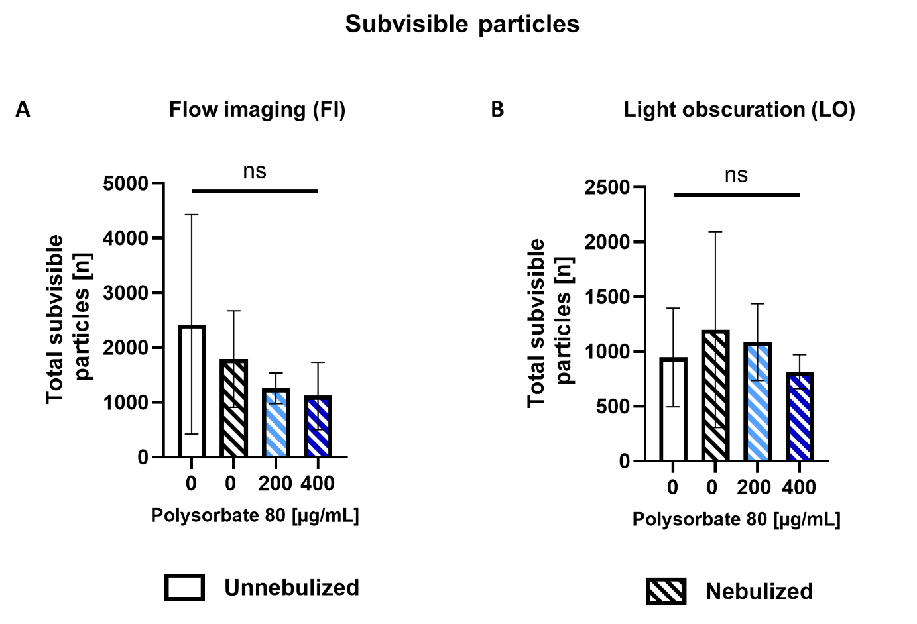
Supplementary Figure S1: Analysis of subvisible particle formation of nebulized IVIg 10% via A) flow imaging (FI) and B) light obscuration (LO). A) Total subvisible particle analysis via FI (n= 3). B) Total subvisible particle analysis via LO (n= 3). Values are shown as mean ± SD. Ordinary one-way ANOVA; P > 0.05, not significant (ns), not shown; P < 0.05, significant (*); P < 0.01, significant (**); P < 0.001, significant (***); P < 0.0001, significant (****). n = independent nebulizations.

Supplementary Table S2: PDI values of (nebulized) Panzyga® 10 % in different formulations from DLS – Comparison of PDI of undiluted (nebulized) IVIg containing 0; 200; or 400 µg/mL PS80; n = 3. n = independent nebulizations.
Formulation |  | PDI
Panzyga® 10 %, native | unnebulized | 0.25 ± 0.00
Panzyga® 10 %, native | nebulized | 0.28 ± 0.00
Panzyga ® 10 % + 200 µg/mL PS80 | nebulized | 0.26 ± 0.00
Panzyga ® 10 % + 400 µg/mL PS80 | nebulized | 0.26 ± 0.00

Supplementary Table S3: Detailed Alamar Blue cytotoxicity results of TPMC and RPMI 2650 - Comparison of a potential toxic effect of (nebulized) IVIg containing 0; 200; or 400 µg/mL PS80 on TMPC, RPMI 2650 cells, respectively. TMPC = Trachea mucosal primary cells; TMPC: n = 20, N = 2 - 4. RPMI2650: n = 15 - 25, N = 2 - 5. Viability presented in %, relative to medium control, mean ± SD. N = independent experiments, n = membrane inserts per sample.
Formulation |  | Viability [%, relative to medium control, mean ± SD) in TMPC | Viability [%, relative to medium control, mean ± SD) in RPMI 2650
Panzyga® 10 %,  native | unnebulized | 129.95 ± 20.25 | 101.35 ± 13.36
Panzyga ® 10 %  + 200 µg/mL PS80 | unnebulized | 102.43 ± 22.99 | 103.34 ± 13.38
Panzyga ® 10 %  + 200 µg/mL PS80 | nebulized | 106.56 ± 25.63 | 96.89 ± 6.16
Panzyga ® 10 %  + 400 µg/mL PS80 | unnebulized | 118.55 ± 8.54 | 91.87 ± 17.41
Panzyga ® 10 %  + 400 µg/mL PS80 | nebulized | 134.78 ± 20.22 | 98.34 ± 4.12

Supplementary Table S4: Detailed immunogenicity data of IVIg in different formulations before or after nebulization on dendritic DC2.4 cells. Cells were stimulated with IVIg with no PS80, or with addition of PS80 (200/ 400 µg/mL). Post stimulation, proinflammatory cytokine expression, Il6, Il1B and Tnf-α levels were measured after 6 h via quantitative RT – PCR and 2-ΔΔCt values were calculated. n = 2, N = 2. n = 2, N = 2. N = biological replicates and n = technical replicates. Values are shown as mean ± SD. Ordinary one-way ANOVA comparing samples to the nebulized, original formulation (without PS80) of Panzyga®; p > 0.05, not significant (ns), *p < 0.05; **p < 0.01; ***p < 0.001, ****p < 0.0001. Mean differences (mean diff) and 95 % confidence intervals (CI) included. The ANOVA yielded an overall significant effect (F(21, 22) = 26.09, p < 0.0001, η² = 0.9614).
Formulation |  | Il-1B  (fold change relative to formulation buffer = 1, mean ± SD) | Il-6  (fold change relative to formulation buffer = 1, mean ± SD) | TNF-α  (fold change relative to formulation buffer = 1, mean ± SD)
Panzyga® 10 %,  native | unnebulized | 3.77 ± 0.33  ****p ≤ 0.0001  Mean diff -7.56  95 % CI  -10.32 to -4.803 | 3.02 ± 0.22  **p ≤ 0.01  Mean diff -3.90  95 % CI  -6.659 to -1.142 | 1.19 ± 0.04  ns, p > 0.05  Mean diff -0.5370  95 % CI  -3.295 to 2.221
Panzyga® 10 %,  native | nebulized | 11.32 ± 1.97 | 6.92 ± 0.57 | 1.73 ± 0.05
Panzyga ® 10 %  + 200 µg/mL PS80 | unnebulized | 3.73 ± 0.90 | 3.46 ± 0.56 | 0.60 ± 0.20
Panzyga ® 10 %  + 200 µg/mL PS80 | nebulized | 3.40 ± 0.21  ****p ≤ 0.0001  Mean diff 7.934  95 % CI  5.176 to 10.69 | 2.31 ± 0.27  ***p ≤ 0.001  Mean diff 4.614  95 % CI  1.856 to 7.372 | 0.90 ± 0.05  ns, p > 0.05  Mean diff 0.8254  95 % CI  -1.933 to 3.584
Panzyga ® 10 %  + 400 µg/mL PS80 | unnebulized | 5.36 ± 1.65 | 4.46 ± 0.81 | 1.16 ± 0.10
Panzyga ® 10 %  + 400 µg/mL PS80 | nebulized | 4.04 ± 0.23  ****p ≤ 0.0001  Mean diff 7.292  95 % CI  4.534 to 10.05 | 3.03 ± 0.61  **p ≤ 0.01  Mean diff 3.895  95 % CI  1.137 to 6.653 | - ± 0.41  ns, p > 0.05  Mean diff 0.5424  95 % CI  -2.216 to 3.301
Untreated |  | 2.53 ± 0.48  ****p ≤ 0.0001  Mean diff 8.805  95 % CI  6.046 to 11.56 | 2.93 ± 0.56  ***p ≤ 0.001  Mean diff 3.993  95 % CI  1.235 to 6.751 | 0.68 ± 0.10  ns, p > 0.05  Mean diff 1.049  95 % CI  -1.709 to 3.807

Supplementary Figure S5: Trans-epithelial transport data of 0.37 mg/cm² IgG on Calu-3 - Transepithelial permeability of (nebulized, collected and pipetted) IVIg (100 mg/mL) containing 0; 200; or 400 µg/mL PS80 on Calu-3 over 48h n = 6, N = 3. N = biological replicates and n = technical replicates. Values are shown as mean ± SD. Value over bars is the mean value. One - way ANOVA; p > 0.05, not significant (ns), *p < 0.05; **p < 0.01; ***p < 0.001, ****p < 0.0001.

Supplementary Table S6: Protein antigens utilized in the xMAP® assay: Abbreviation, full name and function of the protein antigens utilized in the xMAP® beads assay
Abbreviation |  | Full name | Function | Reference
AdcaII | Adhesin competence protein A II |  | Acquisition of metal ions (Zn²⁺) | [1,2]
AliA | AmiA-like protein A |  | Acquisition of oligopeptides, Colonization | [1,3–6]
AliB | AmiA-like protein B |  | Acquisition of oligopeptides, Colonization | [1,3–5]
AliC | AmiA-like protein C |  | Colonization | [3–5,7]
AliD | AmiA-like protein D |  | Colonization | [3–5,7]
AmiA | Aminopterin resistance locus protein A |  | Acquisition of oligopeptides, Colonization | [1,3–5]
CbpC | Choline-binding protein C |  | Invasion, prevents autophagy | [5,8]
CbpE | Choline-binding protein E |  | Invasion | [9,10]
CbpL | Choline-binding protein L |  | Colonization, pulmonary and systemic infection; antiphagocytosis | [11,12]
DacB | L,D-carboxypeptidase/  muramoyl-tetrapeptide carboxypeptidase |  | Muramoyl-tetrapeptide carboxypeptidase;  Antibiotic resistance; adherence, colonization, pulmonary and systemic infection; antiphagocytosis | [1,13]
Enolase |  |  | Plasminogen binding | [14,15]
Etrx1 | Extracellular thioredoxin-like protein 1 |  | Thiol-disulfide oxidoreductase;  Extracellular oxidative stress resistance | [1,13,16]
Etrx2 | Extracellular thioredoxin-like protein 2 |  | Thiol-disulfide oxidoreductase;  Colonization, pulmonary and systemic infection; antiphagocytosis | [1,13,16]
GlpO | alpha-glycerophosphate oxidase |  | Colonization | [3,17]
GshT | Glutathione substrate-binding protein |  | Pulmonary infection,  Oxidative stress resistance | [5,18]
Hic2 | Factor H-binding inhibitor of complement |  | Inhibition of complement activation | [19,20]
LytA | Autolysine |  | Digestion the cell wall, release of Pneumolysin | [5,14]
LytB | N-acetylglucosaminidase |  | Cell division, colonization | [5,21]
LytC | Lysozyme/ Autolysine |  | Temperature-dependent autolysis | [5,22]
MalX | Maltodextrin-binding protein |  | Sugar acquisition, Pulmonary infection | [1,3,23]
MetQ | Methionine-binding lipoprotein Q |  | Pulmonary and (systemic) infection | [1,2]
MsrAB2 | Methionine sulfoxide reductase |  | Infection; antiphagocytosis, oxidative stress resistance | [13,16]
NanC | Neuraminidase C, cleavage of α2,3-linked sialic acid residues from glycoconjugates |  | Colonization and adherence | [14]
NgtS | N-glycan transport substrate-binding protein |  | Carbohydrate binding and processing | [3,24]
PavB | Pneumococcal adhesion and virulence factor B |  | Adherence to epithelial cells | [1,25]
PccL | Pneumococcal calycin fold containing lipoprotein |  | Colonization, invasion | [5,26]
PcpA | Pneumococcal choline-binding protein A |  | Colonization | [5,27,28]
PcsB | Pneumococcal cell wall separation protein |  | Peptidoglycan hydrolases, cell separation | [29,30]
PepO | Endopeptidase O |  | Plasminogen and fibronectin binding, complement control, adherence, invasion | [5,31]
PfbA | Plasmin- and fibronectin-binding protein A |  | Adherence and antiphagocytosis | [5,32]
PhpP | Pneumococcal Serin/Threonin phosphatase |  | Homeostasis, indirect influence on cell division and peptidoglycan synthesis | [5,33]
PhtD | Pneumococcal histidine triad D |  | Adherence | [5,34]
PiaA | Pneumococcal iron acquisition A |  | Iron acquisition, Pulmonary and systemic infection | [1,5,35]
PitB | Pilus-2 backbone protein |  |  | [5]
Pneumolysin | Thiol-activated toxin |  | Cytolytic toxin, activates complement system | [5,14,36]
PnrA | Pneumococcal nucleoside receptor A |  | Systemic infection | [1,2,23,37,38]
PpmA | Putative proteinase maturation protein A |  | Peptidyl-prolyl cis–trans isomerase; Colonization | [1]
PrtA2 | Cell wall-associated serine protease |  | Systemic infection | [5,39]
PsaA | Pneumococcal surface adhesin A |  | Acquisition of metal ions (Zn²⁺, Mn²⁺); Oxidative stress resistance; adherence, colonization; pulmonary and systemic infection | [1,2]
PspA | Pneumococcal surface protein A |  | Prevention of C3 binding to pneumococcal surface, binding of lactoferrin | [14,40]
PspC | Also known as CbpA  Choline-binding protein A |  | Invasion over epithelium | [14,41,42]
PstS | Phosphate-binding protein |  | Phosphate ABC transporter | [1,3]
RrgA | Pilus-1 tip protein |  | Adherence | [5,43–45]
RrgB | Pilus-1 backbone protein |  | Pilus formation | [5,44–46]
SatA | Sialic acid substrate-binding protein |  | Colonization | [3,47]
SlrA | Streptococcal lipoprotein rotamase A |  | Cyclophilin-type peptidyl-prolyl cis–trans isomerase;  Adherence, colonization; antiphagocytosis | [1]
SP_0060 |  |  | beta-galactosidase, sugar uptake? | [3,48]
SP_0107 |  |  | LysM domain-containing protein, Regulation of complement control? | [5,49]
SP_0191 | Hypothetical protein |  |  | [2,50]
S_0899 | Hypothetical protein |  |  | [2,50]
SP_1069 | Hypothetical protein |  |  | [5]
SP_1992 | Dimorphic invasion-involved protein A (DiiA) |  | Colonization, invasion | [5,51]
SP_2063 | Hypothetical protein |  |  | [5,52]
SP_2141 |  |  | exo-β-N-acetylhexosaminidase | [3,53]
TrxB | Thioredoxin reductase B |  | Oxidative stress resistance | [5,16]

Interestingly, the tested antigens showed highly variable binding responses, from ~10¹ to over ~10⁵. Among these, PhtD and PcsB exhibited the highest response values. PhtD is involved in zinc ion binding and complement factor inactivation and has been detected on the surface of S. pneumoniae strain N4 with specific antisera using flow cytometry [54]. It has shown promise as a vaccine candidate in clinical phase I studies and preclinical mouse and primate studies [54–56] and was found to be well-tolerated and immunogenic, when included in protein combination vaccines [57–60]. PcsB, a highly conserved peptidoglycan hydrolase involved in bacterial cell division, has shown high antibody titers in the sera of unvaccinated individuals, although these titers decrease with age [61]. However, immunogenic responses to PcsB vary, potentially due to formulation differences [61–64]. A combination vaccine including PcsB, StkP, and PsaA has completed phase I clinical trials, though results have yet to be published [65].

References
[1] S. Kohler, F. Voß, A. Gómez Mejia et al., “Pneumococcal lipoproteins involved in bacterial fitness, virulence, and immune evasion,” FEBS letters, vol. 590, no. 21, pp. 3820–3839, 2016.
[2] F. Voß, T. P. Kohler, T. Meyer et al., “Intranasal Vaccination With Lipoproteins Confers Protection Against Pneumococcal Colonisation,” Frontiers in immunology, vol. 9, p. 2405, 2018.
[3] S. W. J. He, F. Voß, M. A. Nicolaie et al., “Serological profiling of pneumococcal proteins reveals unique patterns of acquisition, maintenance and waning of antibodies throughout life,” The Journal of infectious diseases, 2024.
[4] M. Alcorlo, M. R. Abdullah, L. Steil et al., “Molecular and structural basis of oligopeptide recognition by the Ami transporter system in pneumococci,” PLoS pathogens, vol. 20, no. 6, e1011883, 2024.
[5] J. Seinen, R. Engelke, M. R. Abdullah et al., “Sputum Proteome Signatures of Mechanically Ventilated Intensive Care Unit Patients Distinguish Samples with or without Anti-pneumococcal Activity,” mSystems, vol. 6, no. 2, 2021.
[6] L. F. van Beek, K. Surmann, H. B. van Berg Saparoea et al., “Exploring metal availability in the natural niche of Streptococcus pneumoniae to discover potential vaccine antigens,” Virulence, vol. 11, no. 1, pp. 1310–1328, 2020.
[7] J. L. Bradshaw, H. R. Pipkins, L. E. Keller et al., “Mucosal Infections and Invasive Potential of Nonencapsulated Streptococcus pneumoniae Are Enhanced by Oligopeptide Binding Proteins AliC and AliD,” mBio, vol. 9, no. 1, 2018.
[8] S. Shizukuishi, M. Ogawa, A. Ryo et al., “Streptococcus pneumoniae promotes its own survival via choline-binding protein CbpC-mediated degradation of ATG14,” Autophagy, vol. 16, no. 8, pp. 1529–1531, 2020.
[9] C. Attali, C. Frolet, C. Durmort et al., “Streptococcus pneumoniae Choline-Binding Protein E Interaction with Plasminogen/Plasmin Stimulates Migration across the Extracellular Matrix,” Infection and Immunity, vol. 76, no. 2, pp. 466–476, 2008.
[10] L. Lagartera, A. González, M. Stelter et al., “Crystallization and preliminary X-ray diffraction studies of the pneumococcal teichoic acid phosphorylcholine esterase Pce,” Acta crystallographica. Section F, Structural biology and crystallization communications, vol. 61, Pt 2, pp. 221–224, 2005.
[11] J. Gutierrez-Fernandez, M. Saleh, M. Alcorlo et al., “Modular Architecture and Unique Teichoic Acid Recognition Features of Choline- Binding Protein L (CbpL) Contributing to Pneumococcal Pathogenesis,” 2016.
[12] H. Kazemian, D. Afshar, E. Garcia et al., “CbpM and CbpG of Streptococcus Pneumoniae Elicit a High Protection in Mice Challenged with a Serotype 19F Pneumococcus,” Iranian Journal of Allergy, Asthma and Immunology, 2019.
[13] M. R. Abdullah, J. Gutiérrez-Fernández, T. Pribyl et al., “Structure of the pneumococcal l,d-carboxypeptidase DacB and pathophysiological effects of disabled cell wall hydrolases DacA and DacB,” Molecular Microbiology, vol. 93, no. 6, pp. 1183–1206, 2014.
[14] A. Kadioglu, J. N. Weiser, J. C. Paton et al., “The role of Streptococcus pneumoniae virulence factors in host respiratory colonization and disease,” Nature reviews. Microbiology, vol. 6, no. 4, pp. 288–301, 2008.
[15] S. Bergmann, M. Rohde, G. S. Chhatwal et al., “alpha-Enolase of Streptococcus pneumoniae is a plasmin(ogen)-binding protein displayed on the bacterial cell surface,” Molecular Microbiology, vol. 40, no. 6, pp. 1273–1287, 2001.
[16] M. Saleh, S. G. Bartual, M. R. Abdullah et al., “Molecular architecture of Streptococcus pneumoniae surface thioredoxin-fold lipoproteins crucial for extracellular oxidative stress resistance and maintenance of virulence,” EMBO Molecular Medicine, vol. 5, no. 12, pp. 1852–1870, 2013.
[17] L. K. Mahdi, M. A. Higgins, C. J. Day et al., “The Pneumococcal Alpha-Glycerophosphate Oxidase Enhances Nasopharyngeal Colonization through Binding to Host Glycoconjugates,” EBioMedicine, vol. 18, pp. 236–243, 2017.
[18] A. J. Potter, C. Trappetti, and J. C. Paton, “Streptococcus pneumoniae uses glutathione to defend against oxidative stress and metal ion toxicity,” Journal of Bacteriology, vol. 194, no. 22, pp. 6248–6254, 2012.
[19] R. Janulczyk, F. Iannelli, A. G. Sjoholm et al., “Hic, a novel surface protein of Streptococcus pneumoniae that interferes with complement function,” The Journal of biological chemistry, vol. 275, no. 47, pp. 37257–37263, 2000.
[20] S. Kohler, T. Hallström, B. Singh et al., “Binding of vitronectin and Factor H to Hic contributes to immune evasion of Streptococcus pneumoniae serotype 3,” Thrombosis and haemostasis, vol. 113, no. 1, pp. 125–142, 2015.
[21] M. Domenech and E. García, “The N-Acetylglucosaminidase LytB of Streptococcus pneumoniae Is Involved in the Structure and Formation of Biofilms,” Applied and Environmental Microbiology, vol. 86, no. 10, 2020.
[22] M. Moscoso, E. López, E. García et al., “Implications of physiological studies based on genomic sequences: Streptococcus pneumoniae TIGR4 synthesizes a functional LytC lysozyme,” Journal of Bacteriology, vol. 187, no. 17, pp. 6238–6241, 2005.
[23] A. R. Narciso, F. Iovino, S. Thorsdottir et al., “Membrane particles evoke a serotype-independent cross-protection against pneumococcal infection that is dependent on the conserved lipoproteins MalX and PrsA,” Proceedings of the National Academy of Sciences of the United States of America, vol. 119, no. 23, e2122386119, 2022.
[24] J. K. Hobbs, B. Pluvinage, and A. B. Boraston, “Glycan-metabolizing enzymes in microbe-host interactions: the Streptococcus pneumoniae paradigm,” FEBS letters, vol. 592, no. 23, pp. 3865–3897, 2018.
[25] I. Jensch, G. Gámez, M. Rothe et al., “PavB is a surface-exposed adhesin of Streptococcus pneumoniae contributing to nasopharyngeal colonization and airways infections,” Molecular Microbiology, vol. 77, no. 1, pp. 22–43, 2010.
[26] M. R. Abdullah, Functional and structural characterization of DacB and PccL, lipoproteins contributing to pneumococcal pathogenesis, 2015.
[27] D. T. Glover, S. K. Hollingshead, and D. E. Briles, “Streptococcus pneumoniae surface protein PcpA elicits protection against lung infection and fatal sepsis,” Infection and Immunity, vol. 76, no. 6, pp. 2767–2776, 2008.
[28] M. Bologa, T. Kamtchoua, R. Hopfer et al., “Safety and immunogenicity of pneumococcal protein vaccine candidates: monovalent choline-binding protein A (PcpA) vaccine and bivalent PcpA-pneumococcal histidine triad protein D vaccine,” Vaccine, vol. 30, no. 52, pp. 7461–7468, 2012.
[29] S. G. Bartual, D. Straume, G. A. Stamsås et al., “Structural basis of PcsB-mediated cell separation in Streptococcus pneumoniae,” Nature Communications, vol. 5, no. 1, p. 3842, 2014.
[30] G. A. Stamsås, L. S. Håvarstein, and D. Straume, “CHiC, a new tandem affinity tag for the protein purification toolbox,” Journal of microbiological methods, vol. 92, no. 1, pp. 59–63, 2013.
[31] V. Agarwal, A. Kuchipudi, M. Fulde et al., Streptococcus pneumoniae endopeptidase O (PepO) is a multifunctional plasminogen-and fibronectin-binding protein, facilitating evasion of innate immunity and … // Streptococcus pneumoniae endopeptidase O (PepO) is a multifunctional plasminogen- and fibronectin-binding protein, facilitating evasion of innate immunity and invasion of host cells, 2013.
[32] M. Yamaguchi, Y. Terao, Y. Mori et al., “PfbA, a novel plasmin- and fibronectin-binding protein of Streptococcus pneumoniae, contributes to fibronectin-dependent adhesion and antiphagocytosis,” Journal of Biological Chemistry, vol. 283, no. 52, pp. 36272–36279, 2008.
[33] C. Hirschfeld, A. Gómez-Mejia, J. Bartel et al., “Proteomic Investigation Uncovers Potential Targets and Target Sites of Pneumococcal Serine-Threonine Kinase StkP and Phosphatase PhpP,” Frontiers in microbiology, vol. 10, p. 3101, 2019.
[34] A. Kallio, K. Sepponen, P. Hermand et al., “Role of Pht proteins in attachment of Streptococcus pneumoniae to respiratory epithelial cells,” Infection and Immunity, vol. 82, no. 4, pp. 1683–1691, 2014.
[35] M. Jomaa, S. Terry, C. Hale et al., “Immunization with the iron uptake ABC transporter proteins PiaA and PiuA prevents respiratory infection with Streptococcus pneumoniae,” Vaccine, vol. 24, no. 24, pp. 5133–5139, 2006.
[36] K. Jahn, S. Handtke, R. Palankar et al., “Pneumolysin induces platelet destruction, not platelet activation, which can be prevented by immunoglobulin preparations in vitro,” Blood advances, vol. 4, no. 24, pp. 6315–6326, 2020.
[37] M. R. Abdullah, M. T. Batuecas, F. Jennert et al., “Crystal Structure and Pathophysiological Role of the Pneumococcal Nucleoside-binding Protein PnrA,” Journal of molecular biology, vol. 433, no. 2, p. 166723, 2021.
[38] P. W. M. Hermans, P. V. Adrian, C. Albert et al., “The streptococcal lipoprotein rotamase A (SlrA) is a functional peptidyl-prolyl isomerase involved in pneumococcal colonization,” Journal of Biological Chemistry, vol. 281, no. 2, pp. 968–976, 2006.
[39] C.-F. Hsu, C.-H. Hsiao, S.-F. Tseng et al., “PrtA immunization fails to protect against pulmonary and invasive infection by Streptococcus pneumoniae,” Respiratory research, vol. 19, no. 1, p. 187, 2018.
[40] S. Hammerschmidt, G. Bethe, P. H. Remane et al., “Identification of pneumococcal surface protein A as a lactoferrin-binding protein of Streptococcus pneumoniae,” Infection and Immunity, vol. 67, no. 4, pp. 1683–1687, 1999.
[41] C. Elm, R. Braathen, S. Bergmann et al., “Ectodomains 3 and 4 of human polymeric Immunoglobulin receptor (hpIgR) mediate invasion of Streptococcus pneumoniae into the epithelium,” Journal of Biological Chemistry, vol. 279, no. 8, pp. 6296–6304, 2004.
[42] S. Hammerschmidt, M. P. Tillig, S. Wolff et al., “Species-specific binding of human secretory component to SpsA protein of Streptococcus pneumoniae via a hexapeptide motif,” Molecular Microbiology, vol. 36, no. 3, pp. 726–736, 2000.
[43] A. L. Nelson, J. Ries, F. Bagnoli et al., “RrgA is a pilus-associated adhesin in Streptococcus pneumoniae,” Molecular Microbiology, vol. 66, no. 2, pp. 329–340, 2007.
[44] C. Harfouche, S. Filippini, C. Gianfaldoni et al., “RrgB321, a fusion protein of the three variants of the pneumococcal pilus backbone RrgB, is protective in vivo and elicits opsonic antibodies,” Infection and Immunity, vol. 80, no. 1, pp. 451–460, 2012.
[45] M. Moschioni, G. de Angelis, C. Harfouche et al., “Immunization with the RrgB321 fusion protein protects mice against both high and low pilus-expressing Streptococcus pneumoniae populations,” Vaccine, vol. 30, no. 7, pp. 1349–1356, 2012.
[46] M. Hilleringmann, P. Ringler, S. A. Müller et al., “Molecular architecture of Streptococcus pneumoniae TIGR4 pili,” The EMBO journal, vol. 28, no. 24, pp. 3921–3930, 2009.
[47] C. Marion, A. M. Burnaugh, S. A. Woodiga et al., “Sialic acid transport contributes to pneumococcal colonization,” Infection and Immunity, vol. 79, no. 3, pp. 1262–1269, 2011.
[48] W. T. Hendriksen, N. Silva, H. J. Bootsma et al., “Regulation of gene expression in Streptococcus pneumoniae by response regulator 09 is strain dependent,” Journal of Bacteriology, vol. 189, no. 4, pp. 1382–1389, 2007.
[49] J. A. Majchrzykiewicz, O. P. Kuipers, and J. J. E. Bijlsma, “Generic and Specific Adaptive Responses of Streptococcus pneumoniae to Challenge with Three Distinct Antimicrobial Peptides, Bacitracin, LL-37, and Nisin,” Antimicrobial agents and chemotherapy, vol. 54, no. 1, pp. 440–451, 2010.
[50] J. M. Chan, E. Ramos-Sevillano, M. Betts et al., “Bacterial surface lipoproteins mediate epithelial microinvasion by Streptococcus pneumoniae,” Infection and Immunity, vol. 92, no. 5, e0044723, 2024.
[51] M. S. Escolano-Martínez, A. Domenech, J. Yuste et al., “DiiA is a novel dimorphic cell wall protein of Streptococcus pneumoniae involved in invasive disease,” The Journal of infection, vol. 73, no. 1, pp. 71–81, 2016.
[52] J. McCluskey, J. Hinds, S. Husain et al., “A two-component system that controls the expression of pneumococcal surface antigen A (PsaA) and regulates virulence and resistance to oxidative stress in Streptococcus pneumoniae,” Molecular Microbiology, vol. 51, no. 6, pp. 1661–1675, 2004.
[53] M. Robb, J. K. Hobbs, S. A. Woodiga et al., “Molecular Characterization of N-glycan Degradation and Transport in Streptococcus pneumoniae and Its Contribution to Virulence,” PLoS pathogens, vol. 13, no. 1, e1006090, 2017.
[54] J. E. Adamou, J. H. Heinrichs, A. L. Erwin et al., “Identification and characterization of a novel family of pneumococcal proteins that are protective against sepsis,” Infection and Immunity, vol. 69, no. 2, pp. 949–958, 2001.
[55] M. Seiberling, M. Bologa, R. Brookes et al., “Safety and immunogenicity of a pneumococcal histidine triad protein D vaccine candidate in adults,” Vaccine, vol. 30, no. 52, pp. 7455–7460, 2012.
[56] P. Denoël, M. T. Philipp, L. Doyle et al., “A protein-based pneumococcal vaccine protects rhesus macaques from pneumonia after experimental infection with Streptococcus pneumoniae,” Vaccine, vol. 29, no. 33, pp. 5495–5501, 2011.
[57] W. A. Brooks, L.-J. Chang, X. Sheng et al., “Safety and immunogenicity of a trivalent recombinant PcpA, PhtD, and PlyD1 pneumococcal protein vaccine in adults, toddlers, and infants: A phase I randomized controlled study,” Vaccine, vol. 33, no. 36, pp. 4610–4617, 2015.
[58] A. Odutola, M. O. Ota, E. O. Ogundare et al., “Reactogenicity, safety and immunogenicity of a protein-based pneumococcal vaccine in Gambian children aged 2-4 years: A phase II randomized study,” Human vaccines & immunotherapeutics, vol. 12, no. 2, pp. 393–402, 2016.
[59] G. L. Rodgers and K. P. Klugman, “The future of pneumococcal disease prevention,” Vaccine, 29 Suppl 3, C43-8, 2011.
[60] M. Masomian, Z. Ahmad, L. T. Gew et al., “Development of Next Generation Streptococcus pneumoniae Vaccines Conferring Broad Protection,” Vaccines, vol. 8, no. 1, 2020.
[61] P. Schmid, S. Selak, M. Keller et al., “Th17/Th1 biased immunity to the pneumococcal proteins PcsB, StkP and PsaA in adults of different age,” Vaccine, vol. 29, no. 23, pp. 3982–3989, 2011.
[62] C. Giefing, A. L. Meinke, M. Hanner et al., “Discovery of a novel class of highly conserved vaccine antigens using genomic scale antigenic fingerprinting of pneumococcus with human antibodies,” The Journal of experimental medicine, vol. 205, no. 1, pp. 117–131, 2008.
[63] R. J. Anderson, S. Guru, R. Weeratna et al., “In vivo screen of genetically conserved Streptococcus pneumoniae proteins for protective immunogenicity,” Vaccine, vol. 34, no. 50, pp. 6292–6300, 2016.
[64] S. Hill, C. Entwisle, Y. Pang et al., “Immunogenicity and mechanisms of action of PnuBioVax, a multi-antigen serotype-independent prophylactic vaccine against infection with Streptococcus pneumoniae,” Vaccine, vol. 36, no. 29, pp. 4255–4264, 2018.
[65] “ClinicalTrials.gov | Open-Label Study Assessing The Safety, Immunogenicity and Dose Response of IC47 |,” 2/6/2024, https://clinicaltrials.gov/study/NCT00873431?term=NCT00873431&rank=1&tab=results.

