Supplementary Figures

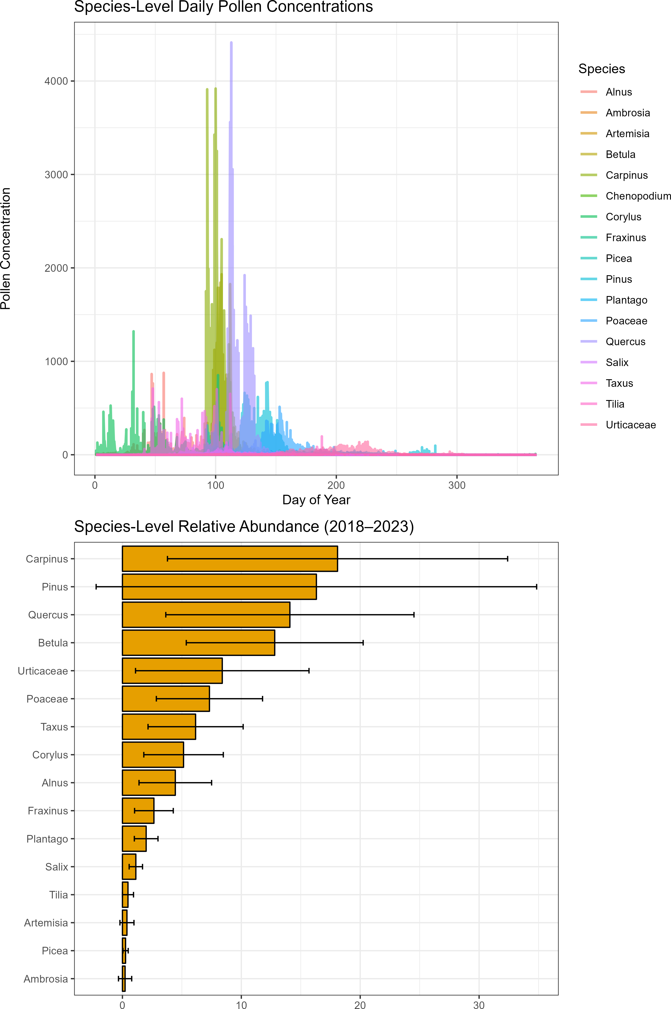
Figure S1: Temporal patterns of airborne pollen in Augsburg (2018-2023). The upper panel shows daily pollen concentrations for 16 taxa across the season measured by automatic pollen monitor BAA500, highlighting interspeciﬁc diﬀerences in ﬂowering timing and pollen release. The lower panel shows the relative abundance of each species, based on cumulative contribution to total pollen concentration over the period. Together, the plots illustrate phenological dynamics and dominant contributors to airborne pollen exposure in Augsburg.

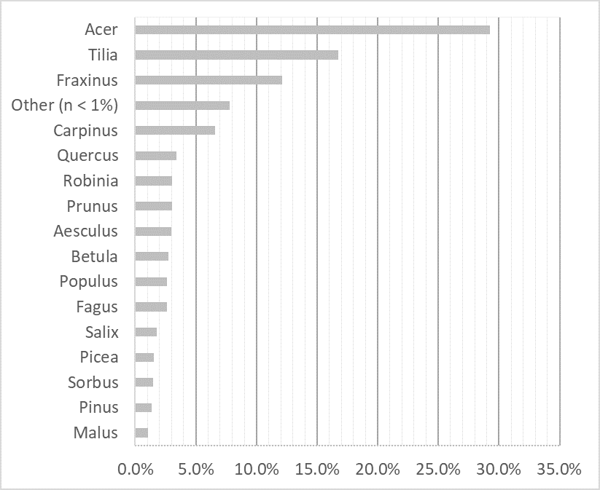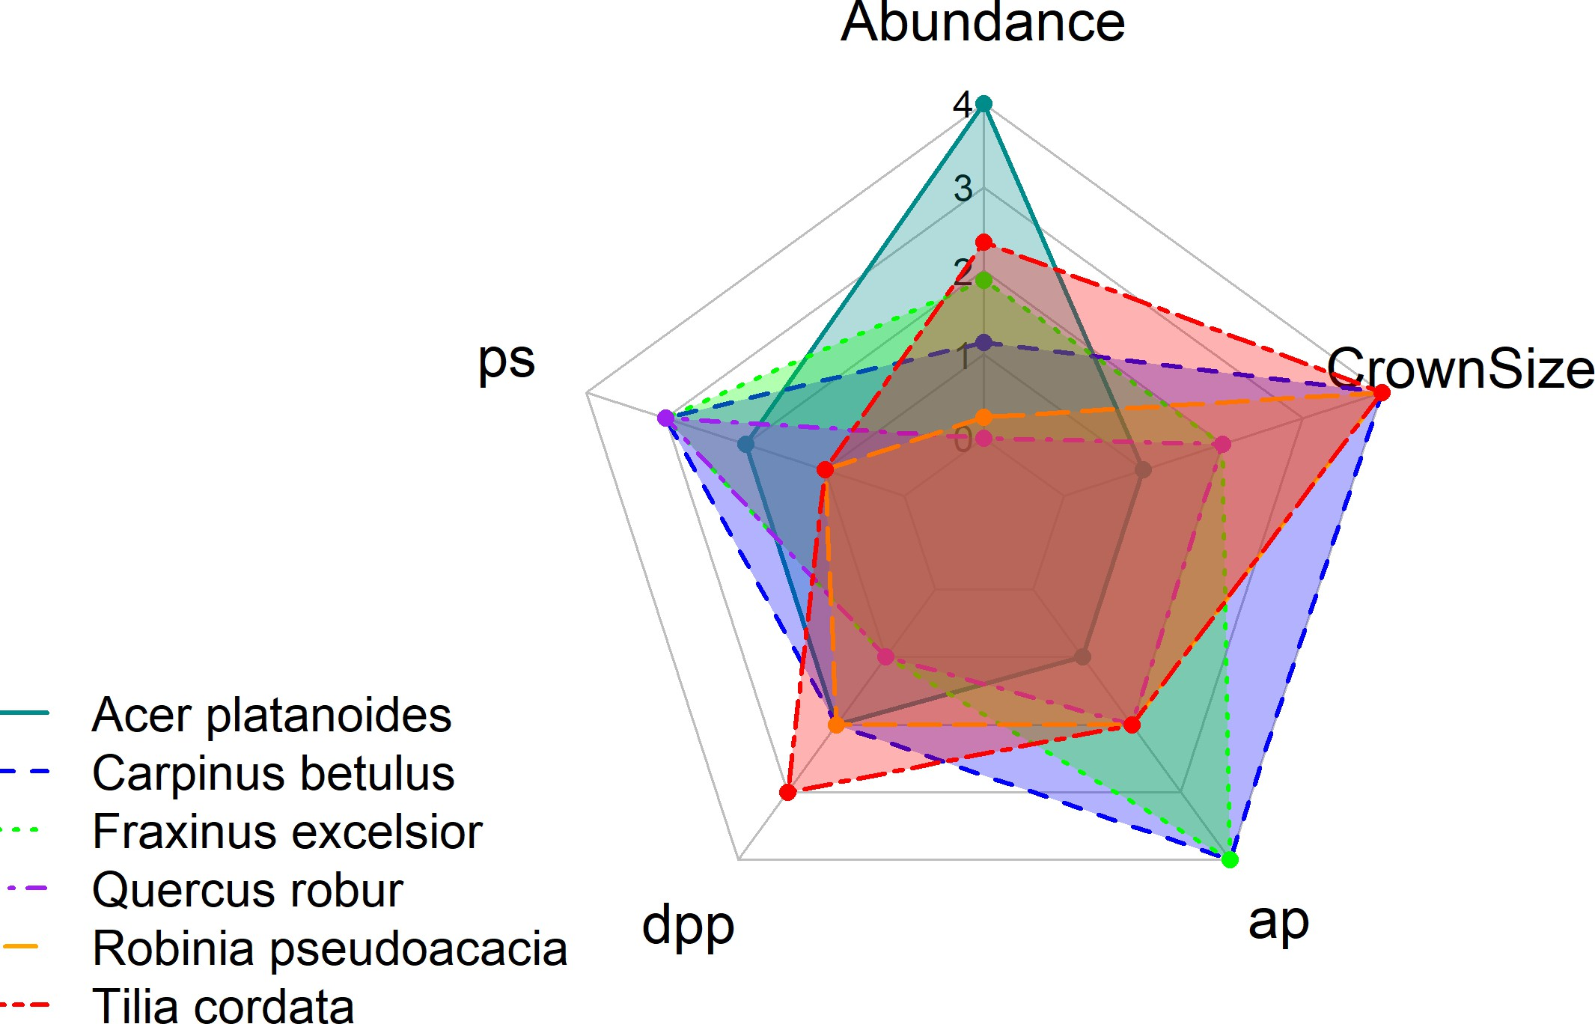
(a) Species composition in Augsburg landscape (b) Allergenicity-related parameter
Figure S2: Species abundance and allergenicity proﬁles in Augsburg (a) Bar chart illustrating the relative abundance of diﬀerent tree species (%) in Augsburg city area, highlighting the dominant species contributing to the overall urban forest structure. (b) Radar plot comparing allergenicity-related parameters for the most abundant tree species in the city landscape. Each axis represents a key factor inﬂuencing allergenicity, including intrinsic allergenic potential (𝑎𝑝), pollination duration (𝑑𝑝𝑝), pollination strategy (𝑝𝑠), abundance and crown size. All parameters are displayed on a uniﬁed 0-4 range scale, with the exception of 𝑑𝑝𝑝 and 𝑝𝑠, which retain their original 0-3 ranges.

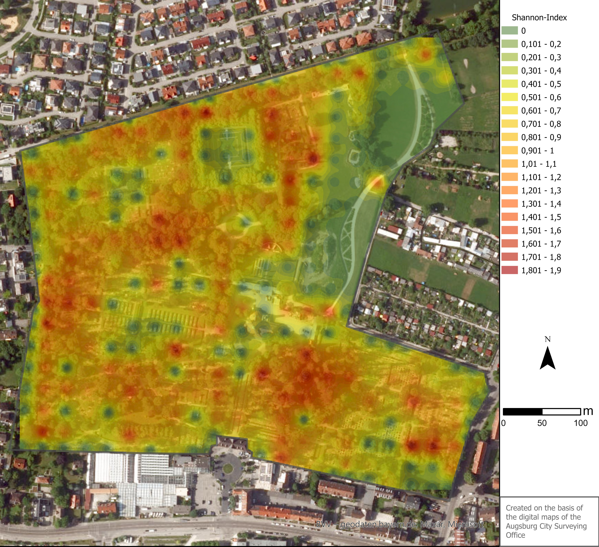

Figure S3: Shannon diversity mapping Tree species diversity (Shannon-index) calculated across a 25 m × 25 m spatial resolution in the urban park Westfriedhof, Augsburg.

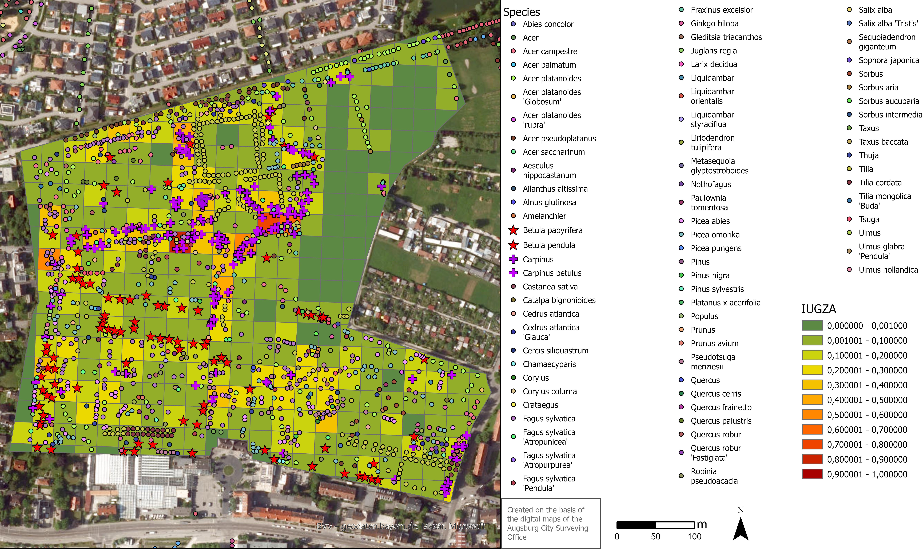

Figure S4: Spatial I_{UGZA} assessment with tree locations Spatial distribution of allergenicity index I_{UGZA} for a 25 m × 25 m
spatial resolution within the study area Westfriedhof and the location of the diﬀerent tree species.

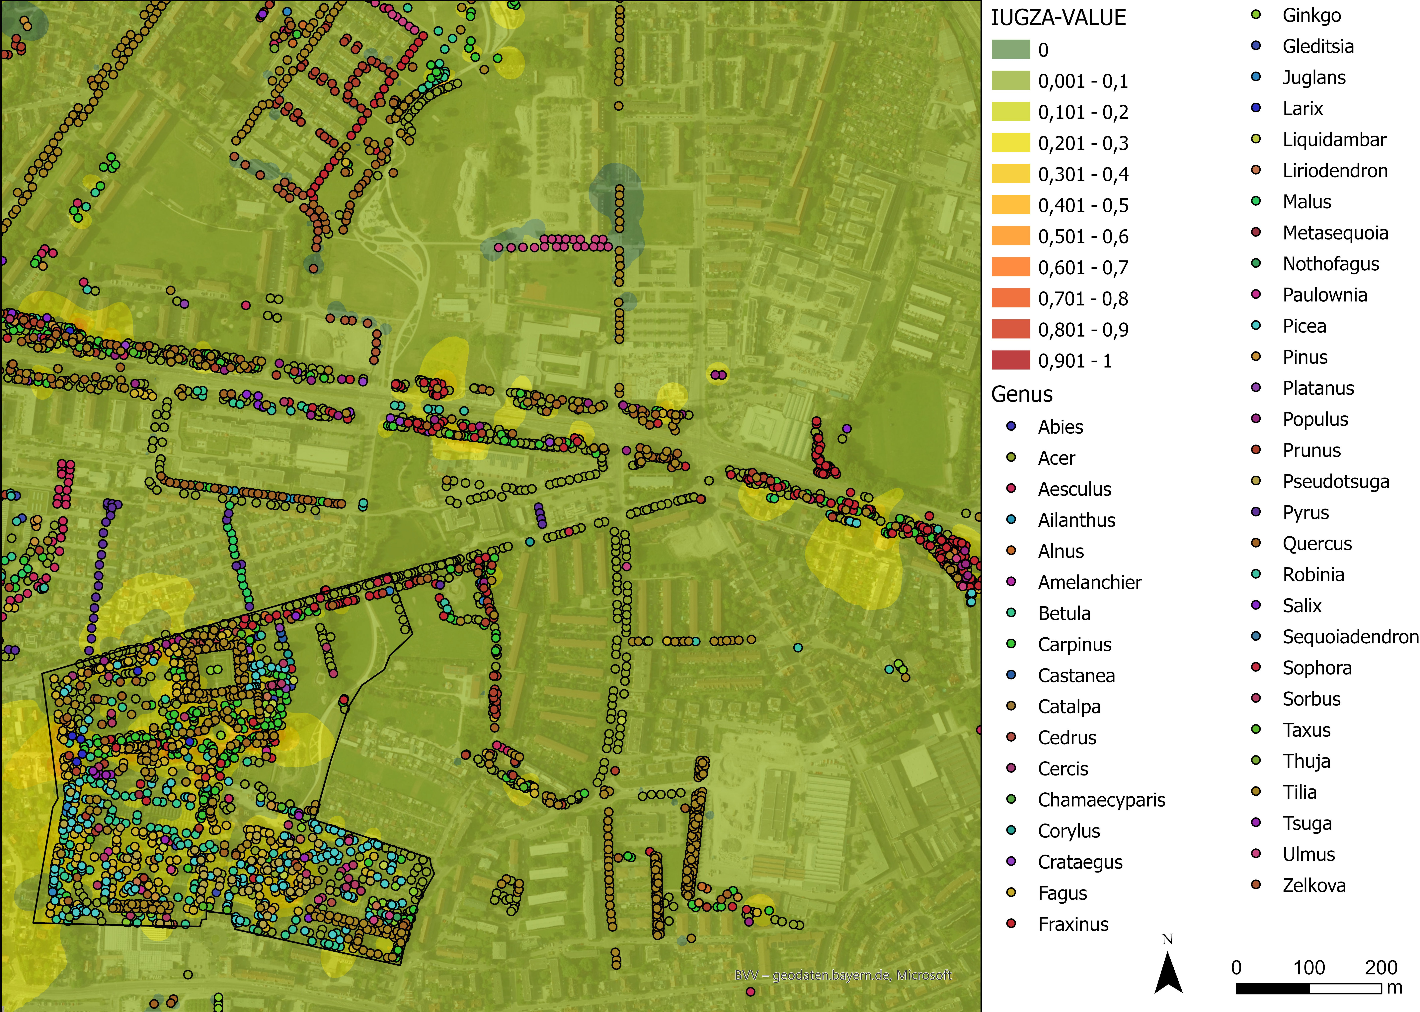

Figure S5: Annual I_{UGZA} distribution and tree locations in the residential area around Westfriedhof. Estimated allergenic potential in the residential area surrounding Westfriedhof (outlined in black), calculated using the I_{UGZA} on a 25 m × 25 m grid size. Interpolation was performed using the Inverse Distance Weighting (IDW) method to visualize annual allergenicity patterns. Tree locations and species distribution are also shown to contextualize local allergenic sources.

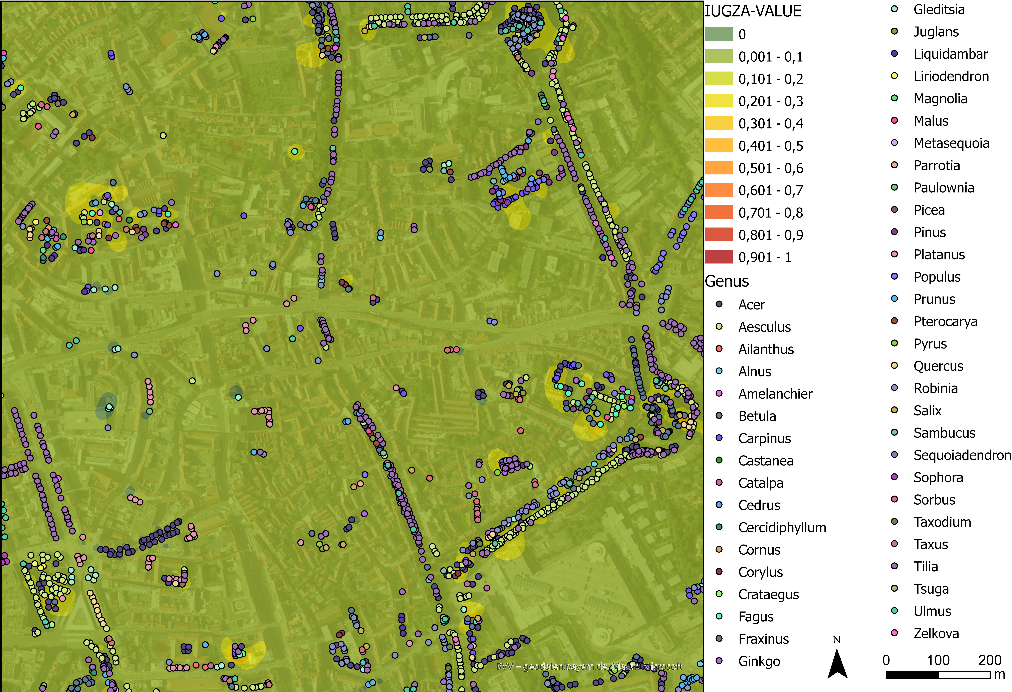

Figure S6: Annual I_{UGZA} distribution and tree locations in old town of Augsburg. Estimated allergenic potential in the old town of Augsburg, calculated using the I_{UGZA} on a 25 m × 25 m grid size. Interpolation was performed using the Inverse Distance Weighting (IDW) method to visualize annual allergenicity patterns. Tree locations and species distribution are also shown to contextualize local allergenic sources.

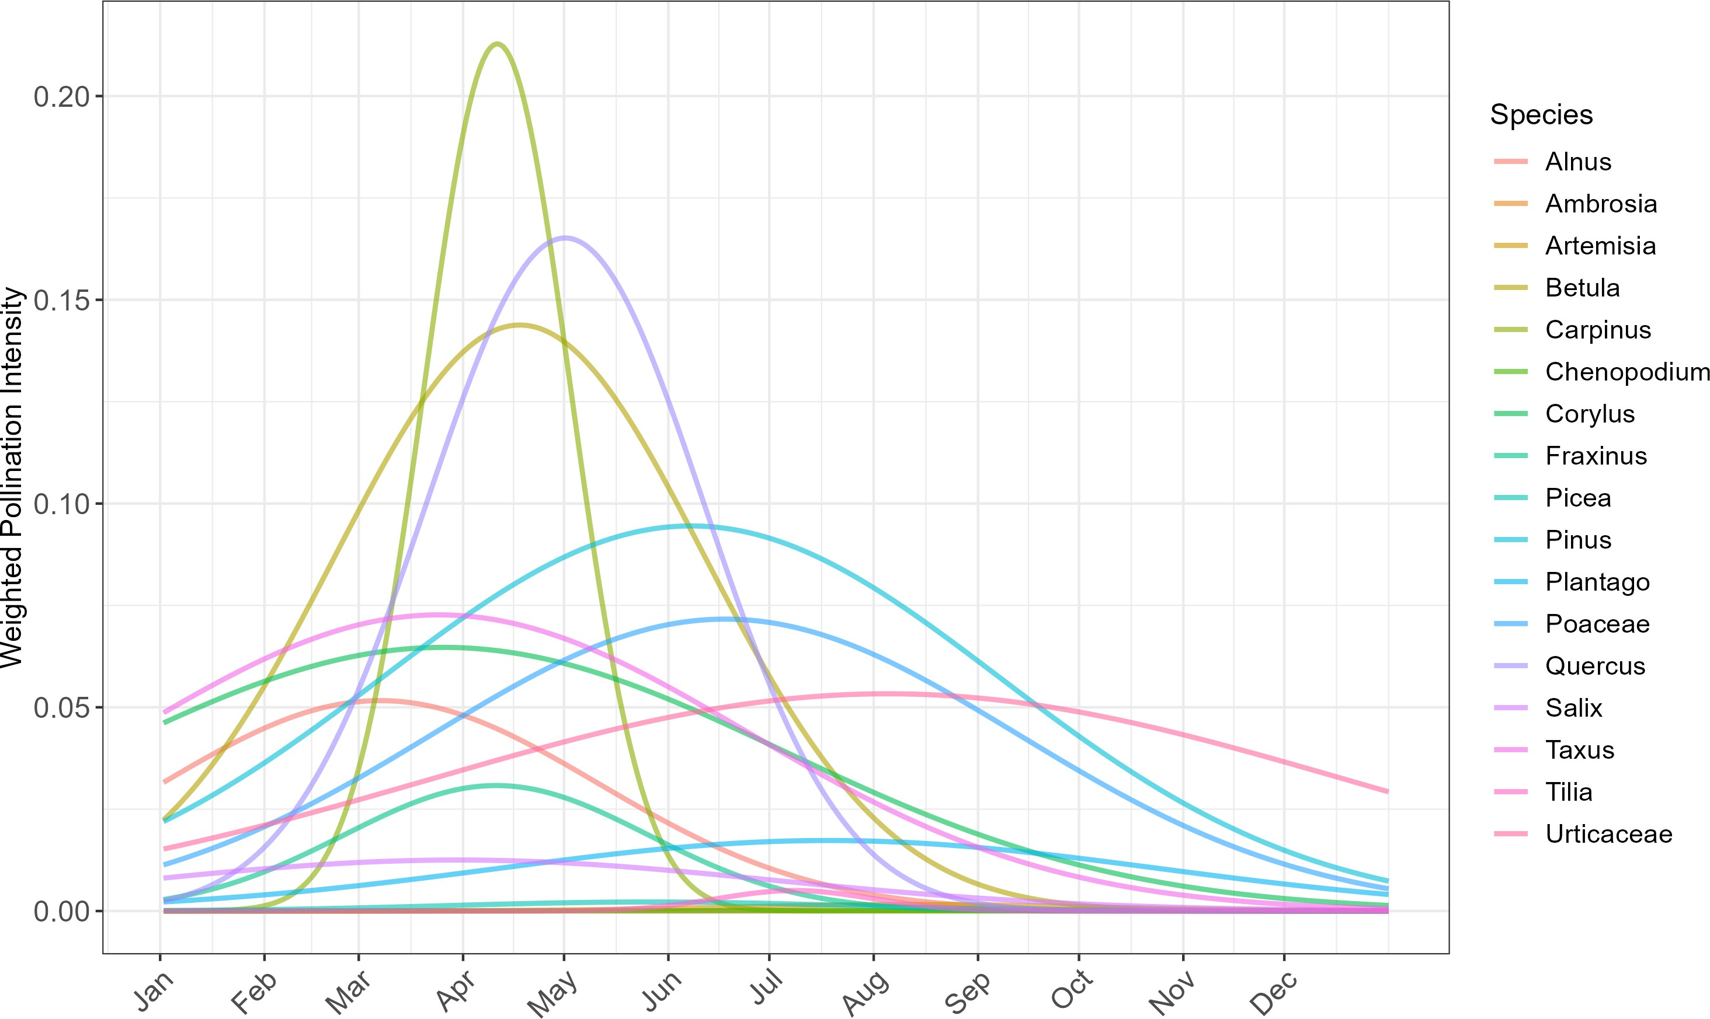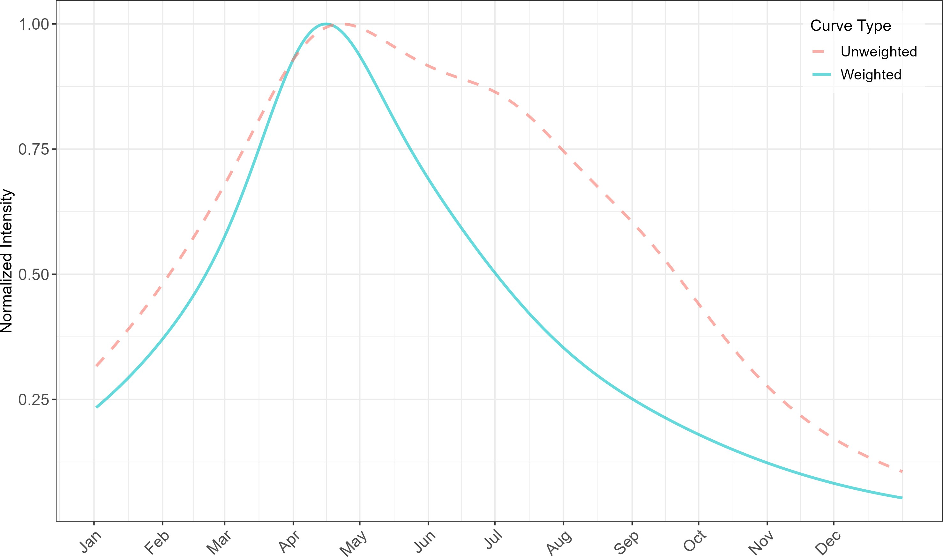
(a) Species-level weighted pollination curves (b) Weighted vs. unweighted pollination intensity
Figure S7: Species-level and aggregate pollination intensity curves (a) Species-speciﬁc weighted pollination intensity curves for 16 taxa in the study area. Curves are constructed using Gaussian distributions based on species-speciﬁc ﬂowering periods and weighted by their local abundance and structural crown size. These curves provide a detailed view of temporal pollen release patterns, highlighting diﬀerences in phenology and peak intensity across taxa. (b) Comparison between the total pollination intensity curve derived from unweighted (dashed red line) and abundance-weighted (solid blue line) species-speciﬁc PI values. The weighted curve reﬂects the combined inﬂuence of species-speciﬁc ﬂowering phenology and local tree abundance, oﬀering a more accurate temporal representation of allergenic potential in the study area.

Supplementary Tables

Table S1: Species-speciﬁc parameters. Overview of tree species included in the study with their allergen-related and morphological characteristics: ps indicates the pollen strategy, dpp the duration of pollen period, and ap the allergenicity potential. Crown size refers to the classiﬁcation of crown dimensions according to the methodology of [81]. Flowering time Augsburg shows the locally observed ﬂowering period in Augsburg according to the local pollen calendar. Taxa determined only at the genus level are highlighted in grey.

Genus/Species | ps | dpp | ap | Crown size | Flowering time Augsburg
Abies concolor | 3 | 1 | 1 | Type 4 | May
Acer campestre | 2 | 2 | 2 | Type 4 | End April – May
Acer palmatum | 2 | 2 | 2 | Type 4 | End April – May
Acer platanoides | 2 | 2 | 1 | Type 4 | April
Acer platanoides ‘Globosum’ | 2 | 2 | 1 | Type 4 | April
Acer platanoides ‘rubra’ | 2 | 2 | 1 | Type 4 | April
Acer pseudoplatanus | 2 | 2 | 1 | Type 4 | May
Acer saccharinum | 1 | 2 | 2 | Type 4 | March – April
Aesculus hippocastanum | 2 | 1 | 2 | Type 1 | End April – Early June
Ailanthus altissima | 2 | 1 | 3 | Type 1 | Mid June – Mid July
Alnus glutinosa | 3 | 2 | 4 | Type 2 | End January – Early March
Amelanchier | 1 | 2 | 0 |  | April – Early May
Betula papyrifera | 3 | 2 | 4 | Type 2 | Mid February – Mid May
Betula pendula | 3 | 2 | 4 | Type 2 | Mid February – Mid May
Carpinus | 3 | 2 | 4 | Type 1 | Mid March – Early May
Carpinus betulus | 3 | 2 | 4 | Type 1 | Mid March – Early May
Castanea sativa | 3 | 3 | 2 | Type 1 | June – Mid July
Catalpa bignonioides | 1 | 2 | 3 | Type 2 | Mid June – Early July
Cedrus atlantica | 1 | 2 | 1 | Type 2 | Mid September – Mid October
Cedrus atlantica ‘Glauca’ | 1 | 2 | 1 | Type 2 | Mid September – Mid October
Cercis siliquastrum | 1 | 3 | 2 | Type 2 | April – May
Chamaecyparis | 3 | 2 | 3 | Type 2 | March – Early April
Corylus | 3 | 3 | 4 | Type 2 | January – Early April
Corylus colurna | 3 | 3 | 4 | Type 2 | February – March
Crataegus | 1 | 2 | 1 | Type 2 | Mid May – Early June
Fagus sylvatica | 3 | 2 | 2 | Type 1 | Mid April – Mid May
Fagus sylvatica ‘Atropunicea’ | 3 | 2 | 2 | Type 1 | Mid April – Mid May
Fagus sylvatica ‘Pendula’ | 3 | 2 | 2 | Type 1 | Mid April – Mid May
Fraxinus excelsior | 3 | 1 | 4 | Type 2 | May
Ginkgo biloba | 3 | 1 | 2 | Type 2 | Mid April – Early May
Gleditsia triacanthos | 1 | 2 | 1 | Type 2 | Mid May – June
Juglans regia | 3 | 2 | 2 | Type 2 | End April – Early May
Larix decidua | 3 | 2 | 1 | Type 2 | March – May
Liquidambar | 1 | 2 | 1 | Type 2 | March – May
Liquidambar orientalis | 1 | 2 | 1 | Type 2 | End April – May
Liquidambar styraciﬂua | 2 | 2 | 2 | Type 2 | April – May
Liriodendron tulipifera | 1 | 2 | 1 | Type 2 | Mid May – June
Metasequoia glyptostroboides | 3 | 1 | 4 | Type 1 | May
Nothofagus | 3 | 2 | 0 |  | May
Paulownia tomentosa | 1 | 2 | 2 | Type 2 | Mid April – May
Picea abies | 3 | 3 | 2 | Type 4 | Mid April – Mid May
Picea omorika | 3 | 1 | 1 | Type 4 | Mid May – June
Picea pungens | 3 | 3 | 2 | Type 4 | May

Genus/Species | ps | dpp | ap | Crown size | Flowering time Augsburg
Pinus | 3 | 1 | 2 | Type 2 | Mid April – August
Pinus nigra | 3 | 1 | 2 | Type 2 | Mid April – August
Pinus sylvestris | 3 | 1 | 2 | Type 2 | Mid April – August
Platanus x acerifolia | 3 | 1 | 4 | Type 2 | Mid April – End April
Populus | 3 | 1 | 2 | Type 2 | March – April
Prunus | 1 | 2 | 1 | Type 2 | Mid April – Early May
Prunus avium | 1 | 2 | 1 | Type 2 | Mid April – Early May
Pseudotsuga menziesii | 3 | 2 | 1 | Type 3 | Mid April – May
Quercus | 3 | 1 | 2 | Type 3 | Mid April – May
Quercus cerris | 3 | 1 | 2 | Type 3 | May
Quercus frainetto | 3 | 1 | 2 | Type 3 | May
Quercus palustris | 3 | 1 | 2 | Type 3 | May
Quercus robur | 3 | 1 | 2 | Type 3 | Mid April – Early May
Quercus robur ‘Fastigiata’ | 3 | 1 | 2 | Type 3 | Mid April – Early May
Robinia pseudoacacia | 1 | 2 | 2 | Type 1 | End May – Mid June
Salix alba | 3 | 2 | 2 | Type 2 | April – May
Salix alba ‘Tristis’ | 3 | 2 | 2 | Type 2 | April – May
Sequoiadendron giganteum | 3 | 2 | 2 | Type 1 | March – April
Sophora japonica | 1 | 1 | 0 |  | End July – End August
Sorbus | 1 | 2 | 1 | Type 4 | Mid May – June
Sorbus aria | 1 | 1 | 1 | Type 4 | Mid May – June
Sorbus aucuparia | 1 | 2 | 1 | Type 4 | Mid May – June
Sorbus intermedia | 1 | 2 | 1 | Type 4 | Mid May – June
Taxus | 0 | 3 | 0 |  | March – April
Taxus baccata | 0 | 3 | 0 |  | March – April
Thuja | 3 | 2 | 2 | Type 2 | April – May
Tilia | 1 | 3 | 2 | Type 1 | Mid June – End July
Tilia cordata | 1 | 3 | 2 | Type 1 | Mid June – End July
Tilia mongolica ‘Buda’ | 1 | 3 | 2 | Type 2 | Mid June – End July
Tsuga | 2 | 1 | 1 | Type 2 | May
Ulmus | 3 | 1 | 2 | Type 1 | Early – Mid April
Ulmus glabra ‘Pendula’ | 3 | 1 | 2 | Type 1 | Early – Mid April
Ulmus hollandica | 3 | 1 | 2 | Type 1 | Early – Mid April

Table S2
Species-speciﬁc pollination curve parameters. Gaussian parameters used for species-speciﬁc pollination intensity curves (𝑃 𝐼𝑡), including peak ﬂowering day 𝜇 and temporal spread 𝜎. Maximum intensity 𝐴 is normalized to 1 for all taxa. Species weights, derived from their relative abundance in the study area, are also included and were used to scale each taxon’s contribution to the overall 𝑃 𝐼𝑡.

Species P  Alnus | eak Day (𝜇)  65 | Spread (𝜎)  64.8 | Weight  0.0516
Ambrosia | 245 | 31.7 | 0.0001
Artemisia | 224 | 54.3 | 0.0016
Betula | 107 | 54.8 | 0.1438
Carpinus | 100 | 21.7 | 0.2128
Chenopodium | 216 | 90.6 | 0.0001
Corylus | 84 | 101.1 | 0.0647
Fraxinus | 100 | 45.2 | 0.0308
Picea | 146 | 59.6 | 0.0022
Pinus | 158 | 91.7 | 0.0945
Plantago | 199 | 97.7 | 0.0173
Poaceae | 168 | 86.9 | 0.0716
Quercus | 120 | 41.2 | 0.1652
Salix | 88 | 93.5 | 0.0125
Taxus | 83 | 91.3 | 0.0727
Tilia | 188 | 23 | 0.0050
Urticaceae 216 135.9 0.0533

Comparison of model formulations for estimating meteorological sensitivity coeﬃcients used in the CIA adjustment. Performance metrics of diﬀerent statistical models tested for estimating the short-term inﬂuence of temperature and precipitation and the long-term inﬂuence of CO₂ on airborne pollen concentrations. The comparison includes three standard model evaluation metrics: R2 (CV) - Cross-validated coeﬃcient of determination, indicating how well the model predicts unseen data; Adjusted R2 - Adjusted for the number of predictors, providing a more conservative estimate of explained variance and AIC (Akaike Information Criterion) - A measure of model parsimony that penalizes overﬁtting; lower values indicate better model quality.

Model | R2 (CV) | Adj. R2 | AIC
Linear Regression (raw lags) | 0.02 | 0.021 | 6520
Log + Lags Only | 0.15 | 0.154 | 9934
Log + Lags + Interactions | 0.16 | 0.155 | 9932
OLS (Julian Spline) | 0.67 | 0.670 | 7785
Ridge Regression (with autoreg.) | 0.81 | — | —
GAM (Spline + Lags + AR) | 0.81 | — | —
Final OLS (Spline + AR) | 0.83 | 0.831 | 6250

Supplementary methods

S0.1. Climatic Impact Adjustment (CIA) - Model selection and comparison
We explored a range of statistical models to derive biologically meaningful and statistically robust coeﬃcients 𝛼 and 𝛽. These included standard OLS models, regularized regressions (Ridge, Lasso), Generalized Additive Models (GAMs), and models with interaction terms or mixed eﬀects. We also tested diﬀerent lag structures (lag 0-7 for temperature and lag 0-3 for precipitation) and assessed inclusion of phenological seasonality via cyclic spline terms. The performance of each model was evaluated and selected using adjusted 𝑅², AIC, and cross-validation where applicable (Table S3).
This modeling eﬀort highlighted the importance of including both temperature and precipitation as short-term meteorological drivers of pollen variability, while treating CO₂ as a long-term scaling factor. The ﬁnal model oﬀered a strong compromise between statistical performance (adjusted 𝑅² = 0.83) and ecological plausibility. The 2023 pollen season was used to illustrate the temporal resolution and application of CIA on daily IUGZA values.

S0.2. Regression model for CIA sensitivity coeﬃcients
To estimate the meteorological sensitivity coeﬃcients 𝛼 (temperature) and 𝛽 (precipitation) used in the Climatic Impact Adjustment (CIA) factor, we ﬁtted a multiple linear regression model (Ordinary Least Squares, OLS) using six years (2018-2023) of pollen concentration and meteorology daily data from Augsburg. The dependent variable was the log-transformed total daily pollen concentration (Equation 9):

$y_{t}= \log{(1+{Pollen}_{t})}$ (9)
Predictors included were:
∗
- 𝑇 𝑡 : standardized average temperature over lag 0 and lag 1,
- 𝑃 ∗: standardized precipitation at lag 0,
𝑡

∗
- 𝑦
𝑡−1
: standardized log pollen at lag 1 (autoregressive term),

- (Julian Day𝑡): seasonal eﬀect modeled as a cyclic cubic spline with 6 degrees of freedom.
All variables were standardized to zero mean and unit variance before ﬁtting. The full model (Equation 10) is expressed as:

$y_{t}= α×{\overline{T}}_{t}^{*}+β×P_{t}^{*}+γ×y_{t-1}^{*}+f(Julian {Day}_{t})+ε_{t}$ (10)

The autoregressive and seasonal components improved model ﬁt (adjusted 𝑅² = 0.83).

Final coeﬃcients used in the CIA equation. Estimated sensitivity coeﬃcients 𝛼 and 𝛽 were derived from a multiple linear regression model using six years of daily pollen, temperature, and precipitation data.

Variable | Symbol | Estimate | Description
Avg. Temperature (lag 0–1) | 𝛼 | 0.56 | Temperature sensitivity
Precipitation (lag 0) | 𝛽 | 0.14 | Precipitation sensitivity

S0.3. Final CIA equation and estimated sensitivity coeﬃcients
The ﬁnal formulation is given by Equation 11. This index-modifying multiplier incorporates standardized meteorological sensitivity to temperature and precipitation (𝛼, 𝛽), according to the previous details, as well as a scaling factor for rising atmospheric CO₂, accounting for short and long-term climatic inﬂuences on airborne pollen emissions.

${CIA}_{t}=\left\lceil 1+α×{\overline{T}}_{t}^{*}+β×P_{t}^{*}\right\rceil ×{CO}_{2}-factor$ (11)

where the CO₂ adjustment is modeled as a long-term fertilization eﬀect (Equation 12):

${CO}_{2}-factor=1+0.05×\left(\frac{\overline{{CO}_{2}}-400}{100}\right)$ (12)

Here, CO₂ is the mean atmospheric CO₂ (ppm) in the historical dataset. CIA values were clipped to the biologically plausible range [0.5, 2.0] and applied to adjust the daily IUGZA index, as described in the main manuscript.
The ﬁnal 𝛼 and 𝛽 estimates (Table S4) were then used in the CIA calculation (Equation 11) and applied to adjust
the daily IUGZA index.

