Supplemental Information

An optoacoustic black carbon sensor for ship emission monitoring
Linda Haedrich^{a, b}, Nikolaos Kousias^{c}, Ioannis Raptis^{c}, Delin Li^{a, b}, Uli Stahl^{a, b}, Leonidas Ntziachristos^{c}, Vasilis Ntziachristos^{a, b, d}
ªChair of Biological Imaging, Central Institute for Translational Cancer Research (TranslaTUM), School of Medicine and Health & School of Computation, Information and Technology, Technical University of Munich, Munich, Germany;
^{b}Institute of Biological and Medical Imaging, Bioengineering Center, Helmholtz Zentrum München, Neuherberg, Germany;
^{c}Mechanical Engineering Department, Aristotle University of Thessaloniki, P.O. Box 458, GR 54124 Thessaloniki, Greece;
^{d}Munich Institute of Biomedical Engineering (MIBE), Technical University of Munich, Garching b. München, Germany

CONTACT Vasilis Ntziachristos, bioimaging.translatum@tum.de, Chair of Biological Imaging, Central Institute for Translational Cancer Research (TranslaTUM), Technical University of Munich, Ismaninger Str. 22, 81675 Munich, Germany

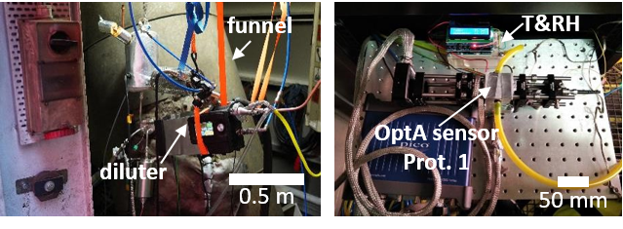
- Pictures of the sensor implemented on-board the Stena Germanica

Supplemental Figure 1: Pictures of the sampling set-up and the prototype optoacoustic sensor during the on-board campaign at the Stena Germanica. Left: The funnel of Main Engines 2 and an eDiluter Pro used for sample dilution, are shown. The eDiluter Pro is mounted next to the funnel and draws an exhaust sample through a hole in the funnel and a sampling probe. Right: The main body of the prototype optoacoustic sensor is mounted on an aluminium breadboard. Yellow Tygon tubes are connected to the sensor’s sample inlet and outlet. A temperature and humidity sensor is located in an airtight box, and measures the sample’s conditions after the optoacoustic sensor’s sample outlet.

- Temperature and humidity curves during shipboard measurements
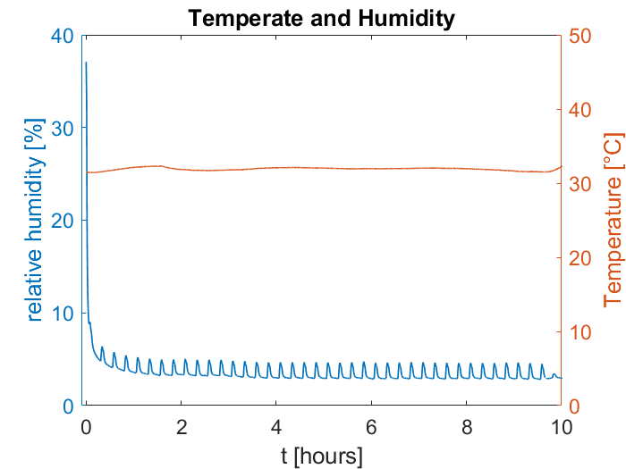
The OptA sensor prototype underestimates the signal in the beginning of the shipboard measurement (Figure 2a), which can be attributed to high humidity levels within the sensor due to high ambient humidity in the funnel room. Supplemental Figure 2 shows that operation of the sensor for ∼0.5 h decreases humidity to a stable value, which is the same time as when measured BC concentrations increases. Thus, connecting the sensor to the dilution system and allowing the dilution system to run for some time before initial measurements are taken will resolve this problem in the future.
Supplemental Figure 2: Time series of the Temperature and Relative Humidity (RH) measured during the shipboard BC measurements presented in main text Figure 3. The temperature of the sample is stable at approximately 32ºC, while the RH is between 4 and 8% for most of the measurement duration. Significantly higher RH is observed at the first few sampling cycles, roughly 30 minutes. The RH also follows the pattern of the dilution cycle, as the RH is very low during the flushing periods and increases slightly when the eDiluter draws sample from the exhaust funnel.

