Supporting information to the paper:
Exploring priority and year effects on plant diversity, productivity and vertical root distribution: first insights from a grassland field experiment

Table of contents:
Appendix S1. Timeline of the POEM experiment
Appendix S2. Composition of the seed mixtures used in the mixture plots of POEM2020 and POEM2021.
Appendix S3. Seed mass used in the monoculture plots of POEM2020 and POEM2021.
Appendix S4. Installation of minirhizotron tubes in POEM2021 plots.
Appendix S5. Video of the installation of root observation tubes (minirhizotrons) in POEM2021 plots.
Appendix S6. Relationship between shoot productivity measured in 2 quadrats and 4 quadrats (g/m²).
Appendix S7. Description of the training procedure to obtain a root segmentation model with RootPainter.
Appendix S8. Results of permutational multivariate analysis of variance (PERMANOVA) testing the effects of PFG order of arrival, year of initiation and sampling year on dissimilarities in plant species composition using species-specific biomass data.
Appendix S9. Results of permutational multivariate analysis of variance (PERMANOVA) testing the effects of PFG order of arrival, year of initiation and sampling year on dissimilarities in plant species composition using presence/absence data.
Appendix S10. Effects of year of initiation, sampling year and PFG order of arrival on the aboveground productivity of sown (A) and unsown (B) species.
Appendix S11. Effects of year of initiation, sampling year and PFG order of arrival on the aboveground productivity of sown forbs (A), grasses (B) and legumes (C).
Appendix S12. Results of a generalised linear mixed-effect model testing the effects of PFG order of arrival, year of initiation and sampling year on the effective number of species at q=0 (species richness).
Appendix S13. Results of a generalised linear mixed-effect model testing the effects of PFG order of arrival, year of initiation and sampling year on the effective number of species at q=1.
Appendix S14. Results of a generalised linear mixed-effect model testing the effects of PFG order of arrival, year of initiation and sampling year on the effective number of species at q=2.
Appendix S15. Results of a generalised linear mixed-effect model testing the effects of PFG order of arrival, year of initiation and sampling year on total shoot dry weight (g/m²).
Appendix S16. Temporal evolution of the average planar root surface density (pRSD) measured in POEM2021 plots for each PFG order of arrival scenario using minirhizotrons.
Appendix S17. Predictions from a first generalised additive model of the planar root surface density (pRSD) as a function of time since the start of the experiment (0-800 days) and soil depth (1.4-49.5 cm).

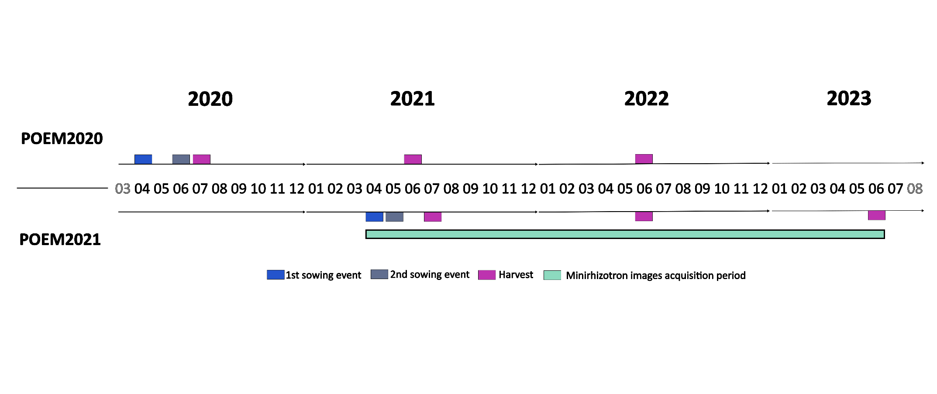
Appendix S1. Experimental timeline. This timeline includes activities carried out in POEM2020 and POEM2021 during the first three growing seasons.

Appendix S2. Composition of the seed mixtures used in the mixture plots of POEM2020 and POEM2021. For each species, the target number of individuals in a plot was calculated considering (1) the plot surface area (9 m²), (2) the desired plant density (1000 plants/m²), (3) the fact that PFGs should be equally represented in the seed mixture, and (4) the fact that species within each PFG should be equally represented in the seed mixture. ‘Seeds per plot’ is the total number of seeds needed to reach the target number of individuals of a species in a plot. ‘Seed mass per plot’ is the corresponding seed mass value. TSW, thousand seed weight (g); FG, functional group (F for forbs, G for grasses, L for legumes); GR, germination rate [0,1].

Species | FG | Target number of ind per plot | POEM2020 |  |  |  | POEM2021
Species | FG | Target number of ind per plot | TSW (g) | GR | Seeds per plot | Seed mass per plot (g) | TSW (g) | GR | Seeds per plot | Seed mass per plot (g)
Lotus  corniculatus | L | 750 | 1.25 | 0.71 | 1050 | 1.31 | 1.36 | 0.76 | 987 | 1.34
Trifolium  arvense | L | 750 | 0.31 | 0.31 | 2386 | 0.74 | 0.43 | 0.51 | 1463 | 0.63
Trifolium  campestre | L | 750 | 0.49 | 0.31 | 2386 | 1.18 | 0.53 | 0.56 | 1339 | 0.71
Lathyrus  pratensis | L | 750 | 10.65 | 0.51 | 1458 | 15.54 | 9.40 | 0.68 | 1099 | 10.33
Anthoxanthum  odoratum | G | 750 | 0.51 | 0.40 | 1875 | 0.95 | 0.47 | 0.48 | 1579 | 0.74
Bromus  hordeaceus | G | 750 | 2.55 | 0.74 | 1010 | 2.57 | 2.70 | 0.52 | 1442 | 3.89
Festuca  ovina | G | 750 | 0.28 | 0.31 | 2386 | 0.67 | 0.25 | 0.16 | 4688 | 1.18
Agrostis  capillaris | G | 750 | 0.07 | 0.86 | 875 | 0.06 | 0.09 | 0.28 | 2727 | 0.25
Silene  vulgaris | F | 500 | 0.59 | 0.77 | 648 | 0.38 | 0.55 | 0.88 | 568 | 0.31
Dianthus  deltoides | F | 500 | 0.16 | 0.89 | 565 | 0.09 | 0.18 | 0.92 | 543 | 0.10
Pilosella  officinarum | F | 500 | 0.19 | 0.76 | 658 | 0.12 | 0.19 | 0.92 | 543 | 0.10
Jasione  montana | F | 500 | 0.02 | 0.74 | 673 | 0.01 | 0.02 | 0.50 | 1000 | 0.02
Potentilla  argentea | F | 500 | 0.13 | 0.51 | 972 | 0.12 | 0.07 | 0.24 | 2083 | 0.16
Pimpinella  saxifraga | F | 500 | 0.73 | 0.13 | 3846 | 2.81 | 0.93 | 0.20 | 2500 | 2.32

Appendix S3. Seed mass used in the monoculture plots of POEM2020 and POEM2021. The target number of individuals in a plot was calculated considering (1) the plot surface area (4 m²) and (2) the desired plant density (1000 plants/m²). ‘Seeds per plot’ is the total number of seeds needed to reach the target number of individuals of a species in a plot. ‘Seed mass per plot’ is the corresponding seed mass value. TSW, thousand seed weight (g); FG, functional group (F for forbs, G for grasses, L for legumes); GR, germination rate [0,1].

Species | FG | Target number of ind per plot | POEM2020 |  |  |  | POEM2021
Species | FG | Target number of ind per plot | TSW (g) | GR | Seeds per plot | Seed mass per plot (g) | TSW (g) | GR | Seeds per plot | Seed mass per plot (g)
Lotus  corniculatus | L | 4000 | 1.25 | 0.71 | 5600 | 6.97 | 1.36 | 0.76 | 5263 | 7.16
Trifolium  arvense | L | 4000 | 0.31 | 0.31 | 12727 | 3.95 | 0.43 | 0.51 | 7805 | 3.35
Trifolium  campestre | L | 4000 | 0.49 | 0.31 | 12727 | 6.27 | 0.53 | 0.56 | 7143 | 3.78
Lathyrus  pratensis | L | 4000 | 10.65 | 0.51 | 7778 | 82.87 | 9.40 | 0.68 | 5861 | 55.09
Anthoxanthum  odoratum | G | 4000 | 0.51 | 0.40 | 10000 | 5.08 | 0.47 | 0.48 | 8421 | 3.97
Bromus  hordeaceus | G | 4000 | 2.55 | 0.74 | 5385 | 13.72 | 2.70 | 0.52 | 7692 | 20.75
Festuca  ovina | G | 4000 | 0.28 | 0.31 | 12727 | 3.58 | 0.25 | 0.16 | 25000 | 6.29
Agrostis  capillaris | G | 4000 | 0.07 | 0.86 | 4667 | 0.33 | 0.09 | 0.28 | 14545 | 1.34
Silene  vulgaris | F | 4000 | 0.59 | 0.77 | 5185 | 3.07 | 0.55 | 0.88 | 4545 | 2.48
Dianthus  deltoides | F | 4000 | 0.16 | 0.89 | 4516 | 0.72 | 0.18 | 0.92 | 4348 | 0.77
Pilosella  officinarum | F | 4000 | 0.19 | 0.76 | 5263 | 0.98 | 0.19 | 0.92 | 4348 | 0.81
Jasione  montana | F | 4000 | 0.02 | 0.74 | 5385 | 0.10 | 0.02 | 0.50 | 8000 | 0.18
Potentilla  argentea | F | 4000 | 0.13 | 0.51 | 7778 | 0.97 | 0.07 | 0.24 | 16667 | 1.24
Pimpinella  saxifraga | F | 4000 | 0.73 | 0.13 | 30769 | 22.46 | 0.93 | 0.20 | 20000 | 18.60

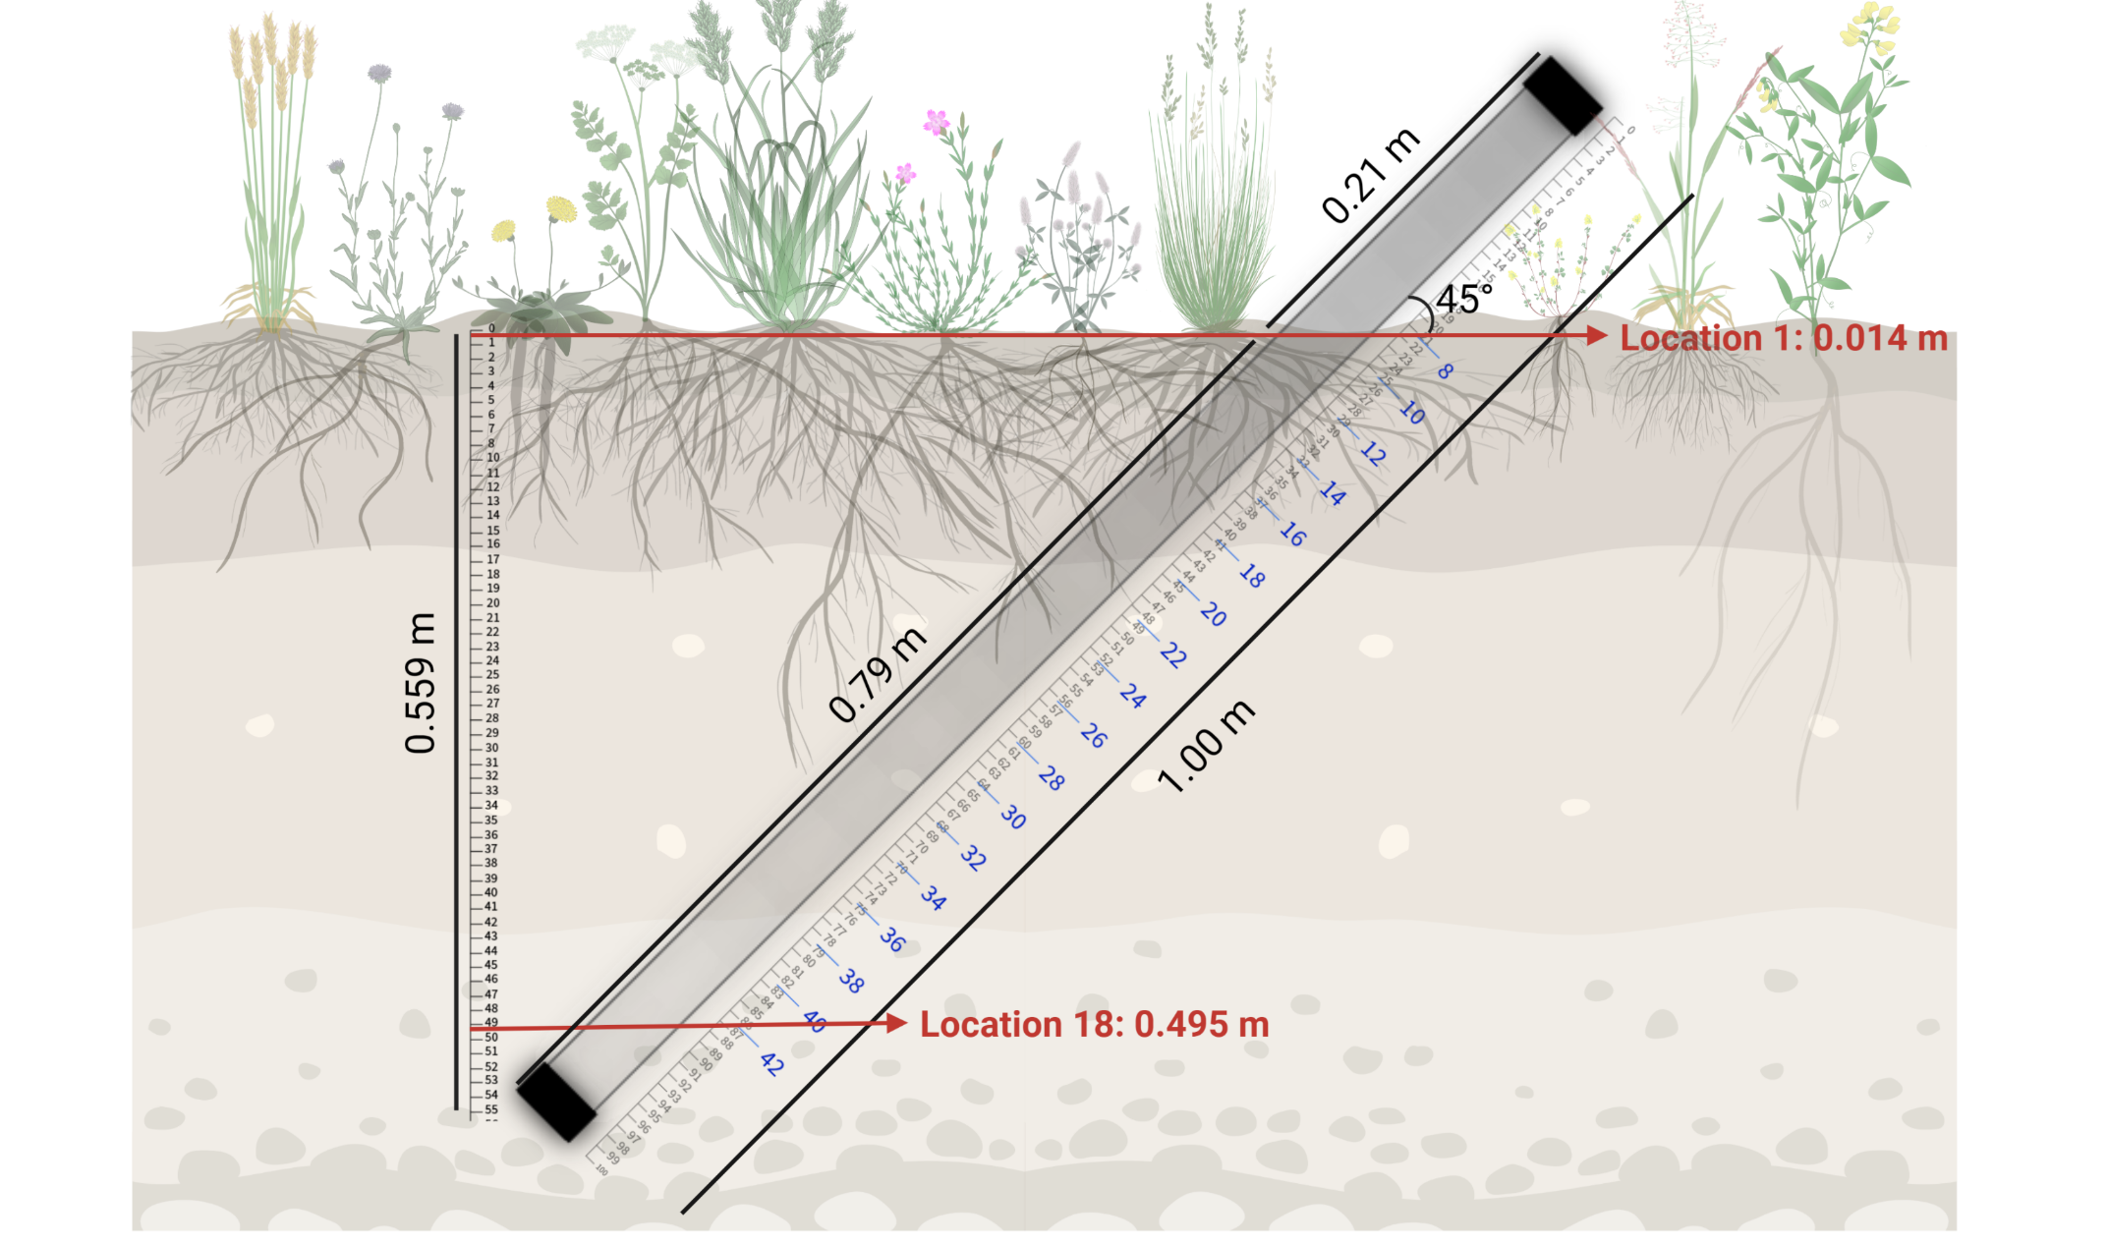
Appendix S4. Installation of minirhizotron tubes in POEM2021 plots. Minirhizotron tubes were installed at a 45° angle. A step-by-step description of the installation of minirhizotron tubes in POEM2021 is available in the video provided as supplementary material. Roots growing along a minirhizotron tube were regularly imaged at 18 equally spaced locations (in blue) along the tube. Using the setup shown in the figure, root images were collected between 1.4 cm depth and 49.5 cm depth.

Appendix S5. Video of the installation of root observation tubes (minirhizotrons) in POEM2021 plots. The video is available on Figshare: https://doi.org/10.6084/m9.figshare.24749409.v1

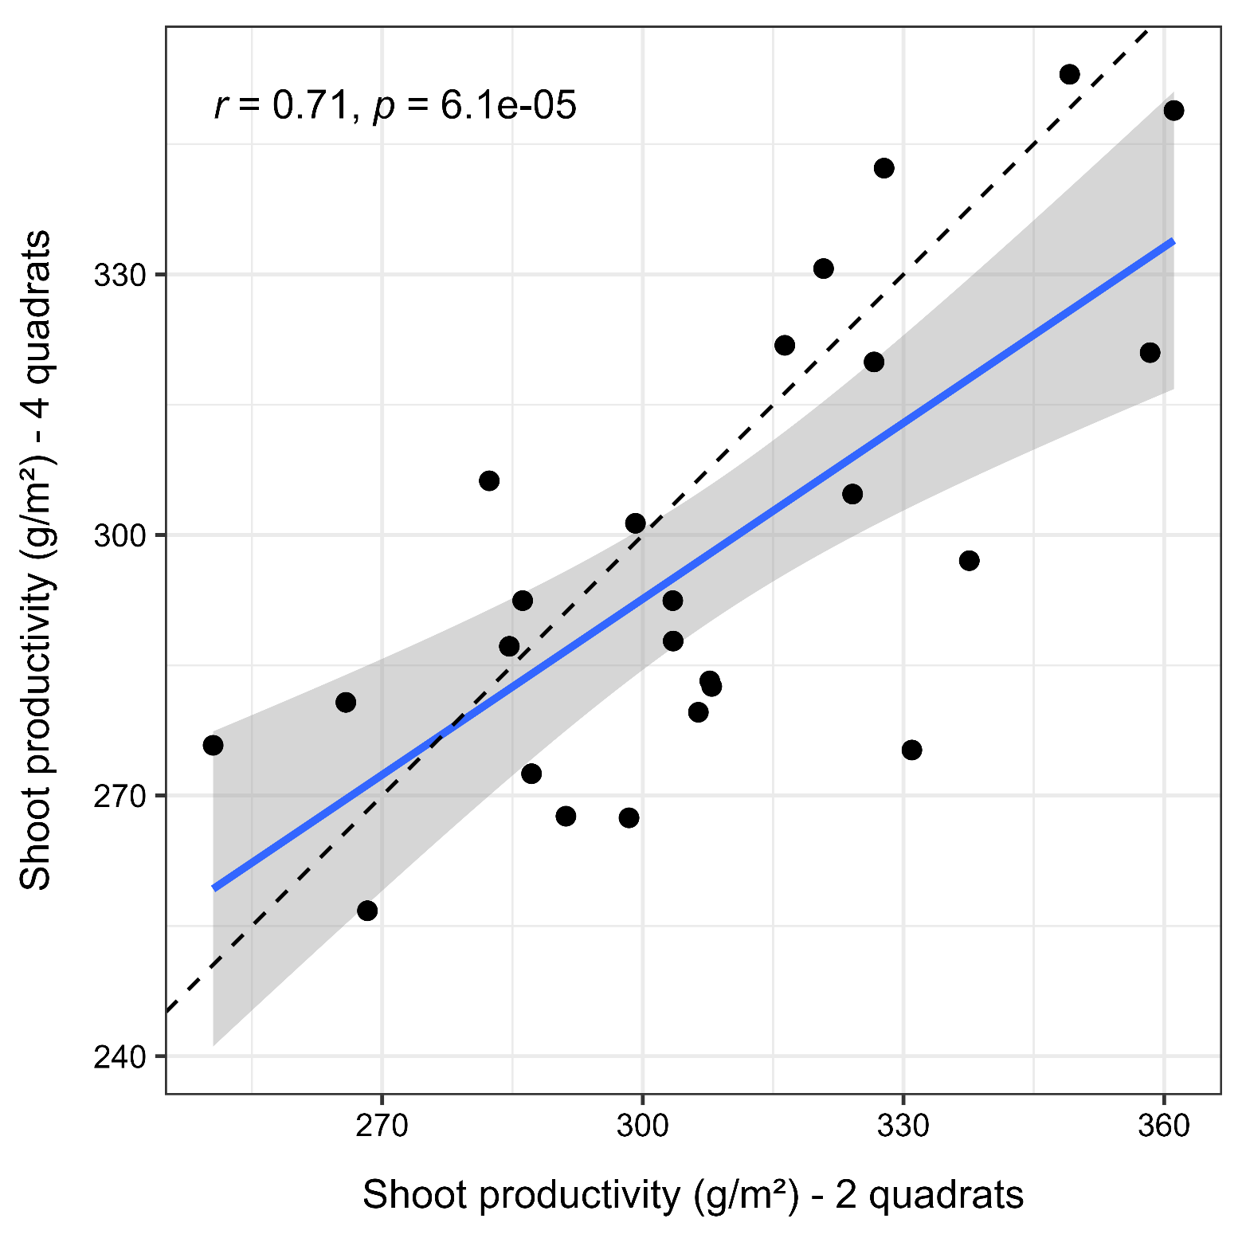
Appendix S6: Relationship between shoot productivity measured in 2 quadrats and 4 quadrats (g/m²). The blue line represents the linear regression, and the shaded area indicates the 95% confidence interval. The dashed line represents the 1:1 relationship for reference. This plot was created using shoot biomass data collected in 2020 in the first sub-experiment (POEM2020). At this specific harvest, biomass was harvested in four quadrats per plot. The total shoot dry weight (in g/m²) in two quadrats was obtained by summing the total shoot dry weight of two randomly selected quadrats in each plot.
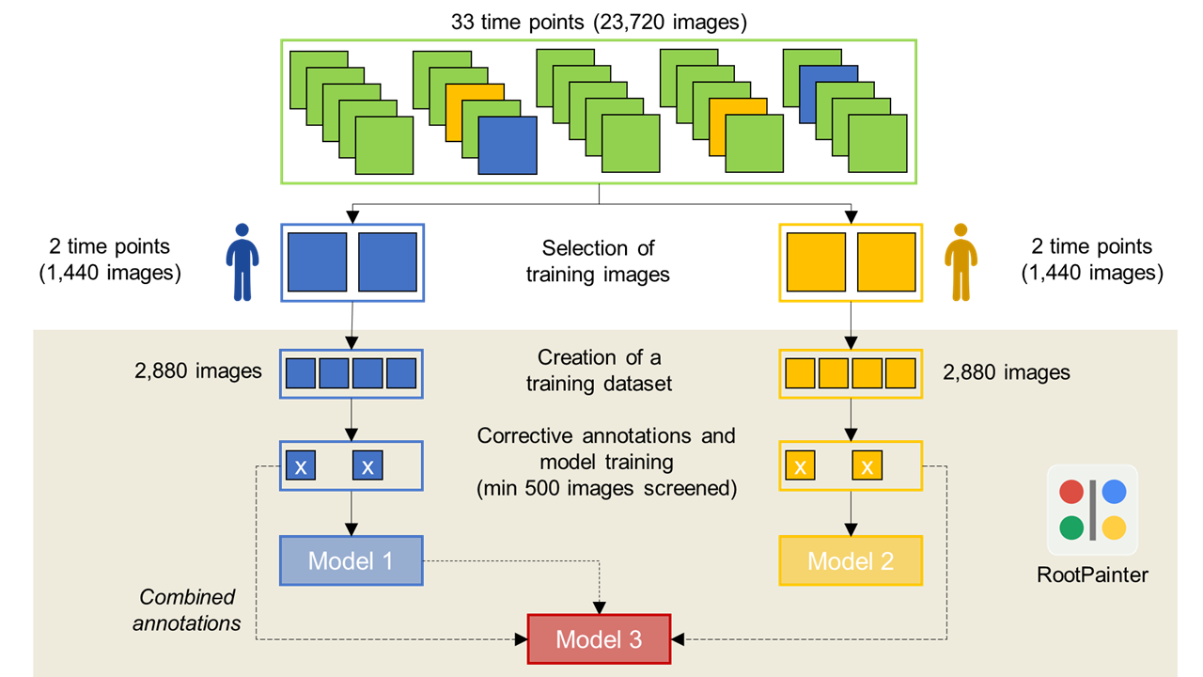
Appendix S7: Description of the training procedure to obtain a root segmentation model with RootPainter. Model 3 was used to segment all root images for this paper.

Appendix S8. Results of permutational multivariate analysis of variance (PERMANOVA) testing the effects of PFG order of arrival, year of initiation and sampling year on dissimilarities in plant species composition using species-specific biomass data. The Bray-Curtis dissimilarity index was used. Terms were added sequentially (first to last). Number of permutations: 1000. See also figure 2A.

 | Df | Sum of squares | R² | F | P-value
PFG order of arrival (a) | 4 | 3.46 | 0.077 | 7.94 | 0.000999
Sampling year (b) | 2 | 17.70 | 0.393 | 81.22 | 0.000999
Year of initiation (c) | 1 | 2.61 | 0.058 | 23.97 | 0.000999
a*b | 8 | 2.79 | 0.062 | 3.20 | 0.000999
a*c | 4 | 1.09 | 0.024 | 2.50 | 0.002997
b*c | 2 | 3.11 | 0.069 | 14.27 | 0.000999
a*b*c | 8 | 1.15 | 0.026 | 1.32 | 0.081918
Residual | 120 | 13.07 | 0.291
Total | 149 | 44.98 | 1.000

Appendix S9. Results of permutational multivariate analysis of variance (PERMANOVA) testing the effects of PFG order of arrival, year of initiation and sampling year on dissimilarities in plant species composition using presence/absence data. The Jaccard dissimilarity index was used. Terms were added sequentially (first to last). Number of permutations: 1000. See also figure 2B.

 | Df | Sum of squares | R² | F | P-value
PFG order of arrival (a) | 4 | 1.75 | 0.097 | 8.23 | 0.000999
Sampling year (b) | 2 | 6.76 | 0.373 | 63.50 | 0.000999
Year of initiation (c) | 1 | 1.48 | 0.081 | 27.72 | 0.000999
a*b | 8 | 1.03 | 0.057 | 2.42 | 0.000999
a*c | 4 | 0.52 | 0.029 | 2.47 | 0.000999
b*c | 1 | 1.12 | 0.062 | 21.03 | 0.000999
a*b*c | 4 | 0.12 | 0.007 | 0.59 | 0.966034
Residual | 100 | 5.32 | 0.294
Total | 124 | 18.11 | 1.000

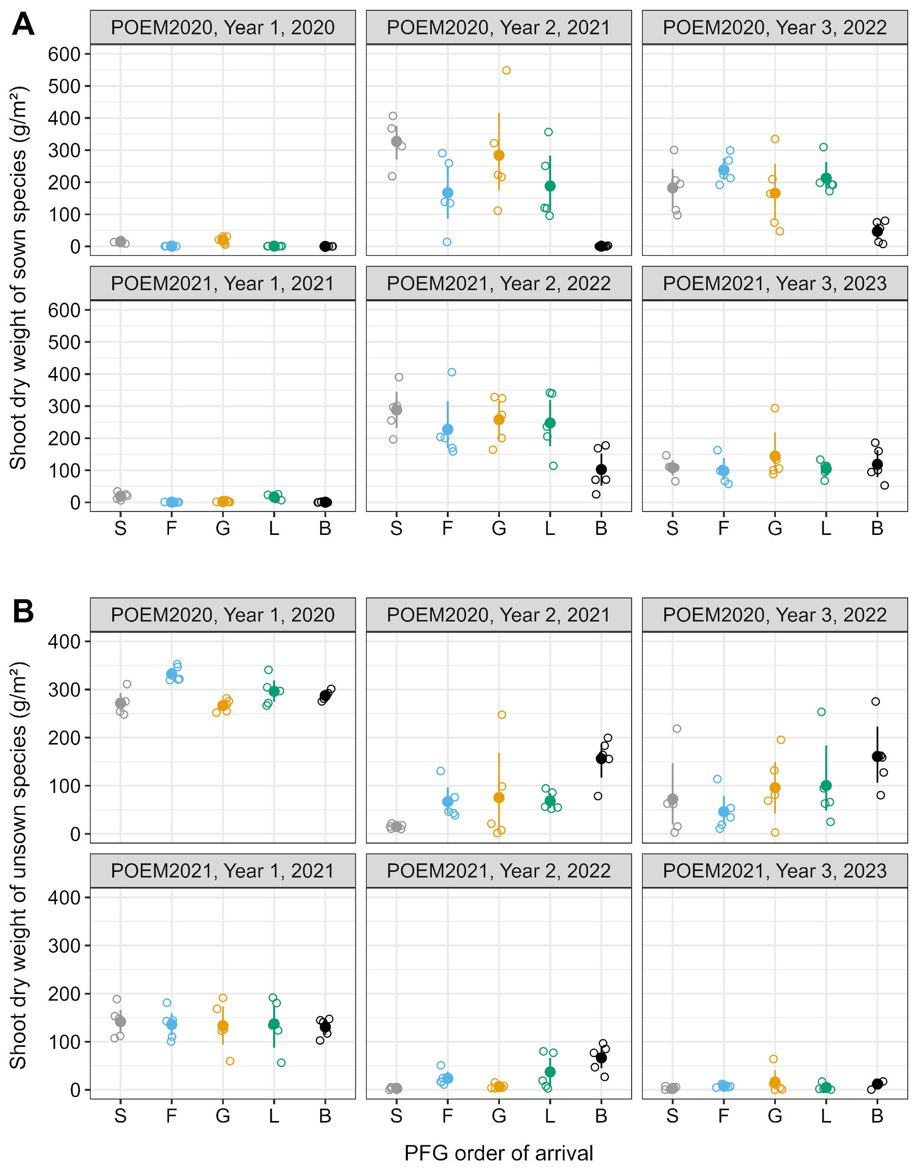
Appendix S10. Effects of year of initiation, sampling year and PFG order of arrival on the aboveground productivity of sown (A) and unsown (B) species. For each combination of year of initiation, PFG of arrival and sampling year, the mean value (closed dot) and 95% confidence interval computed using non-parametric bootstrap are shown (n=5). Open dots represent the observed shoot dry weight values, which are jittered horizontally to improve readability. S, synchronous sowing of forbs, grasses and legumes; F, forbs sown first; G, grasses sown first; L, legumes sown first; B free succession plots.
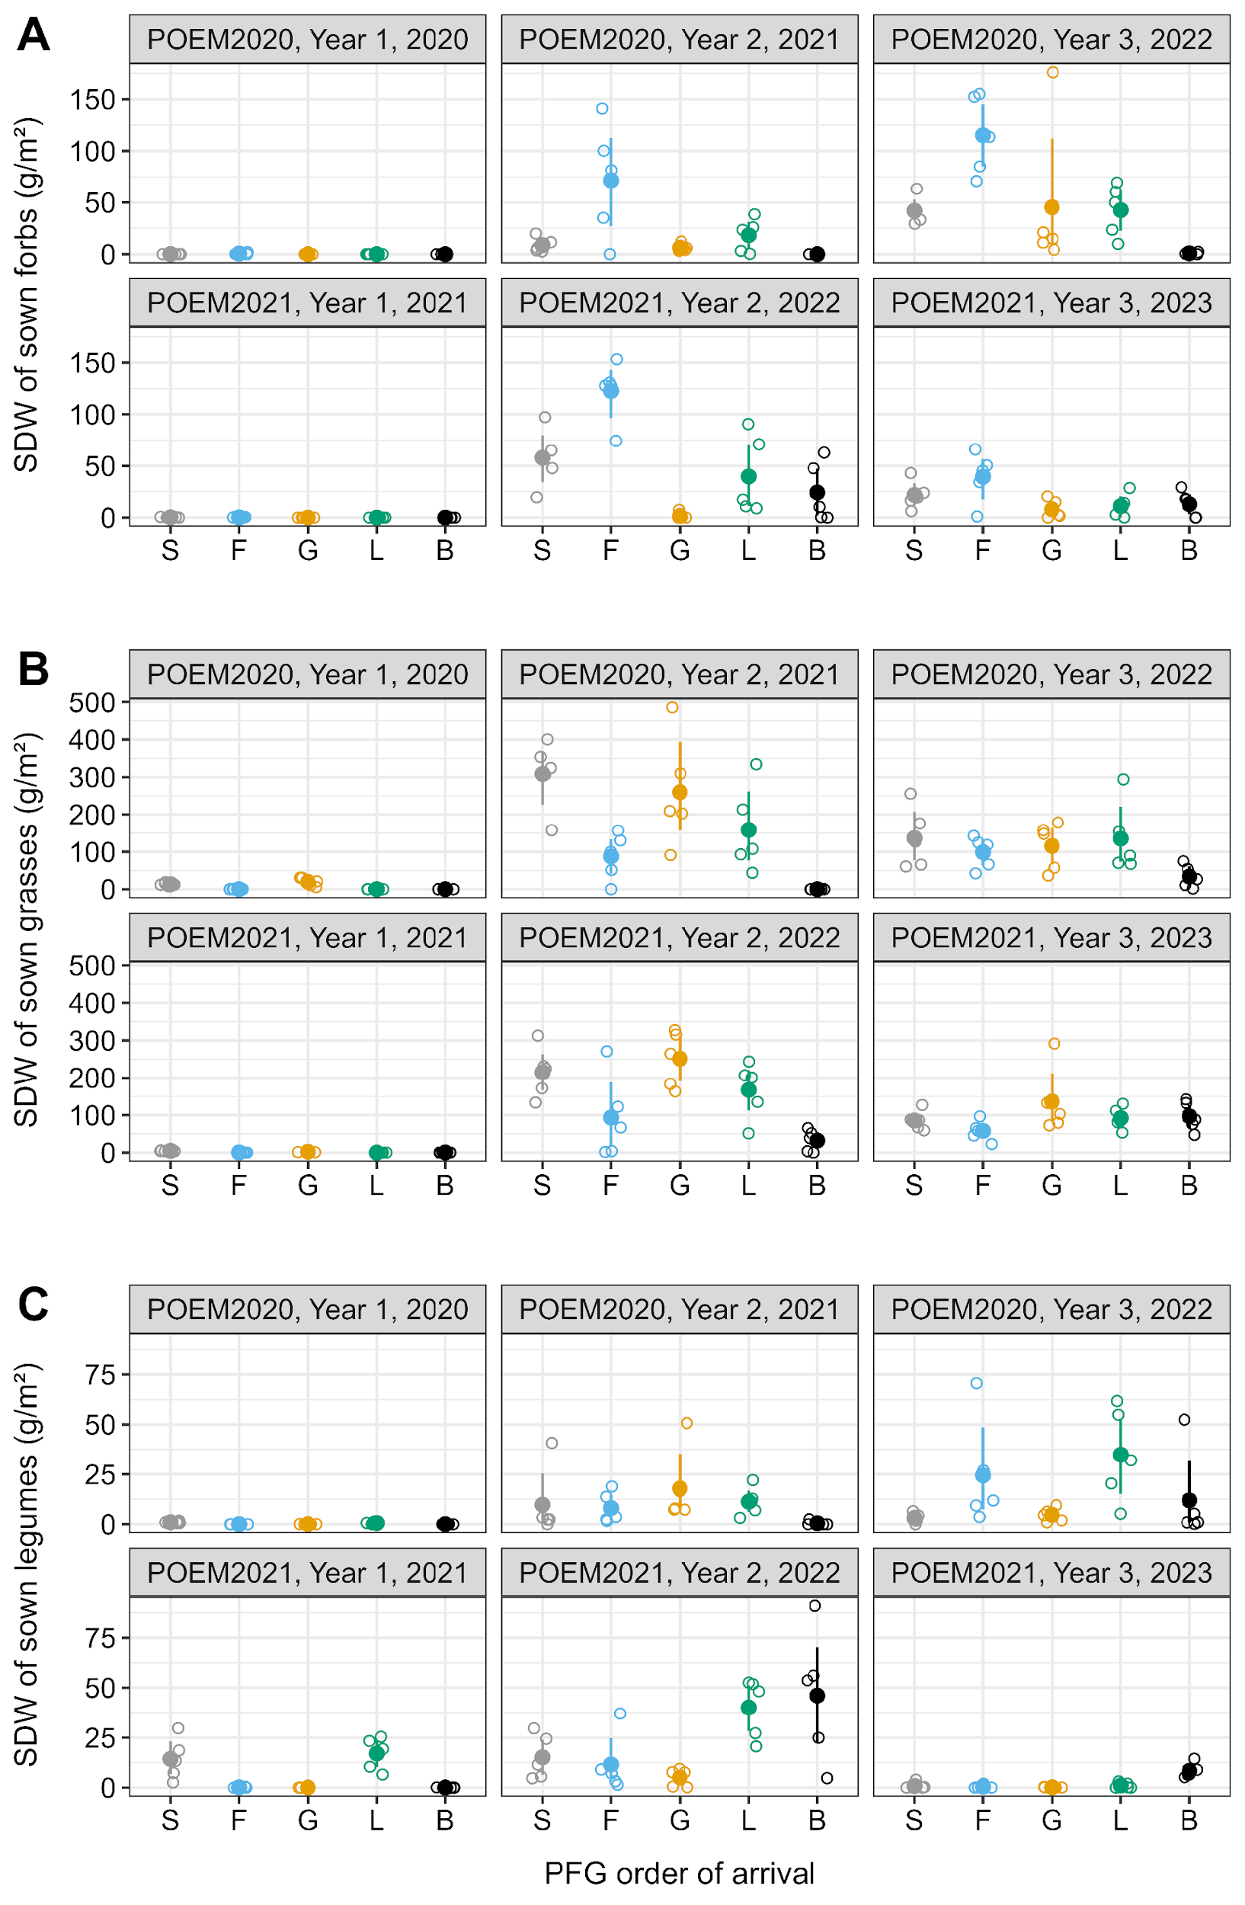
Appendix S11. Effects of year of initiation, sampling year and PFG order of arrival on the aboveground productivity of sown forbs (A), grasses (B) and legumes (C). For each combination of year of initiation, PFG of arrival and sampling year, the mean value (closed dot) and 95% confidence interval computed using non-parametric bootstrap are shown (n=5). Open dots represent the observed shoot dry weight values, which are jittered horizontally to improve readability. S, synchronous sowing of forbs, grasses and legumes; F, forbs sown first; G, grasses sown first; L, legumes sown first; B free succession plots.

Appendix S12. Results of a generalised linear mixed-effect model testing the effects of PFG order of arrival, year of initiation and sampling year on the effective number of species at q=0 (species richness). Plot ID was used as a random effect in the model. The model was fitted using a quasipoisson distribution and a log-link function. This analysis of deviance table (Type III tests) was produced using the Anova function in the car package (Fox and Weisberg, 2019). See also Figure 3.

 | Chisq | Df | P-value
(Intercept) | 1896.3 | 1 | < 2.2e-16
PFG order of arrival (a) | 31.03 | 4 | 3.0e-6
Sampling year (b) | 8.10 | 2 | 0.0174
Year of initiation (c) | 1.30 | 1 | 0.2547
a*b | 25.81 | 8 | 0.0011
a*c | 7.02 | 4 | 0.1347
b*c | 2.92 | 2 | 0.2328
a*b*c | 4.94 | 8 | 0.7637

Appendix S13. Results of a generalised linear mixed-effect model testing the effects of PFG order of arrival, year of initiation and sampling year on the effective number of species at q=1. Plot ID was used as a random effect in the model. The model was fitted using a Gamma distribution and a log-link function. This analysis of deviance table (Type III Wald chi square tests) was produced using the Anova function in the car package (Fox and Weisberg, 2019). See also Figure 3.

 | Chisq | Df | P-value
(Intercept) | 111.93 | 1 | < 2.2e-16
PFG order of arrival (a) | 3.93 | 4 | 0.4149
Sampling year (b) | 27.15 | 2 | 1.27e-06
Year of initiation (c) | 0.11 | 1 | 0.7370
a*b | 73.79 | 8 | 8.62e-13
a*c | 6.59 | 4 | 0.1591
b*c | 14.21 | 2 | 0.0008
a*b*c | 16.97 | 8 | 0.0304

Appendix S14. Results of a generalised linear mixed-effect model testing the effects of PFG order of arrival, year of initiation and sampling year on the effective number of species at q=2. Plot ID was used as a random effect in the model. The model was fitted using a Gamma distribution and a log-link function. This analysis of deviance table (Type III Wald chi square tests) was produced using the Anova function in the car package (Fox and Weisberg, 2019). See also Figure 3.

 | Chisq | Df | P-value
(Intercept) | 56.18 | 1 | 6.60e-14
PFG order of arrival (a) | 4.06 | 4 | 0.3979
Sampling year (b) | 23.68 | 2 | 7.21e-06
Year of initiation (c) | 0.83 | 1 | 0.3628
a*b | 61.76 | 8 | 2.10e-10
a*c | 4.81 | 4 | 0.3073
b*c | 15.74 | 2 | 0.0004
a*b*c | 15.33 | 8 | 0.0530

Appendix S15. Results of a generalised linear mixed-effect model testing the effects of PFG order of arrival, year of initiation and sampling year on total shoot dry weight (g/m²). Plot ID was used as a random effect in the model. The model was fitted using a Gamma distribution and a log-link function. This analysis of deviance table (Type III Wald chi square tests) was produced using the Anova function in the car package (Fox and Weisberg, 2019). See also Figure 4.

 | Chisq | Df | P-value
(Intercept) | 1963.29 | 1 | < 2.2e-16
PFG order of arrival (a) | 1.01 | 4 | 0.9077
Sampling year (b) | 3.58 | 2 | 0.1669
Year of initiation (c) | 9.97 | 1 | 0.0016
a*b | 24.85 | 8 | 0.0016
a*c | 1.96 | 4 | 0.7433
b*c | 9.04 | 2 | 0.0109
a*b*c | 16.90 | 8 | 0.0312

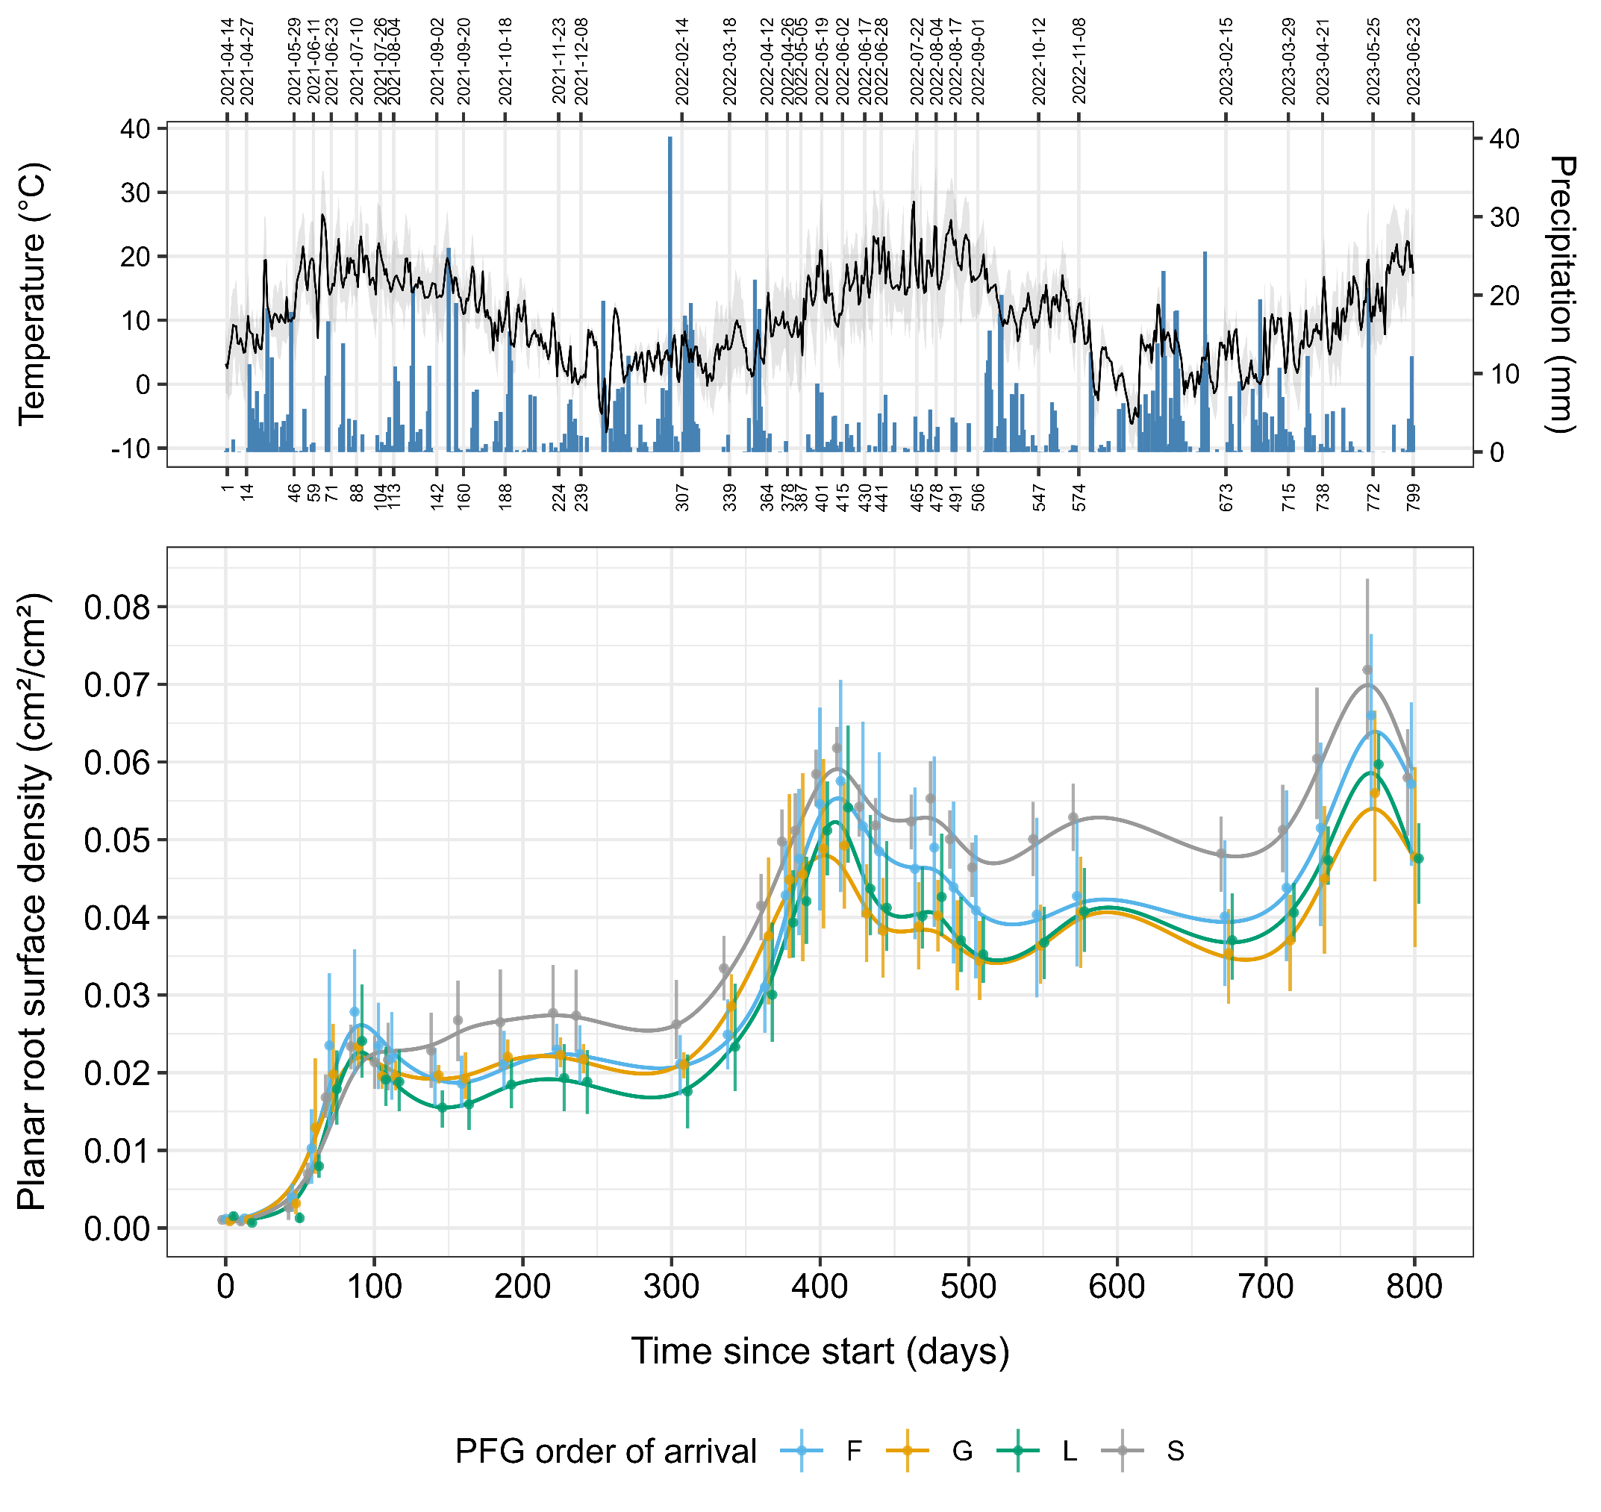
Appendix S16. Root productivity was weakly affected by PFG order of arrival. Panel A shows the evolution of maximum, mean and minimum air temperature (°C), as well as daily precipitation (mm), at our experimental site between April 2021 and June 2023. Panel B shows the temporal evolution of the average planar root surface density (pRSD) measured in POEM2021 plots for each PFG order of arrival scenario using minirhizotrons. Points and error bars indicate mean pRSD values and 95% confidence intervals (non-parametric bootstrap) measured at 33 time points spread over the first 800 days of POEM2021, respectively. Continuous lines are predictions from a generalised additive model. S, synchronous sowing of forbs, grasses and legumes; F, forbs sown first; G, grasses sown first; L, legumes sown first.

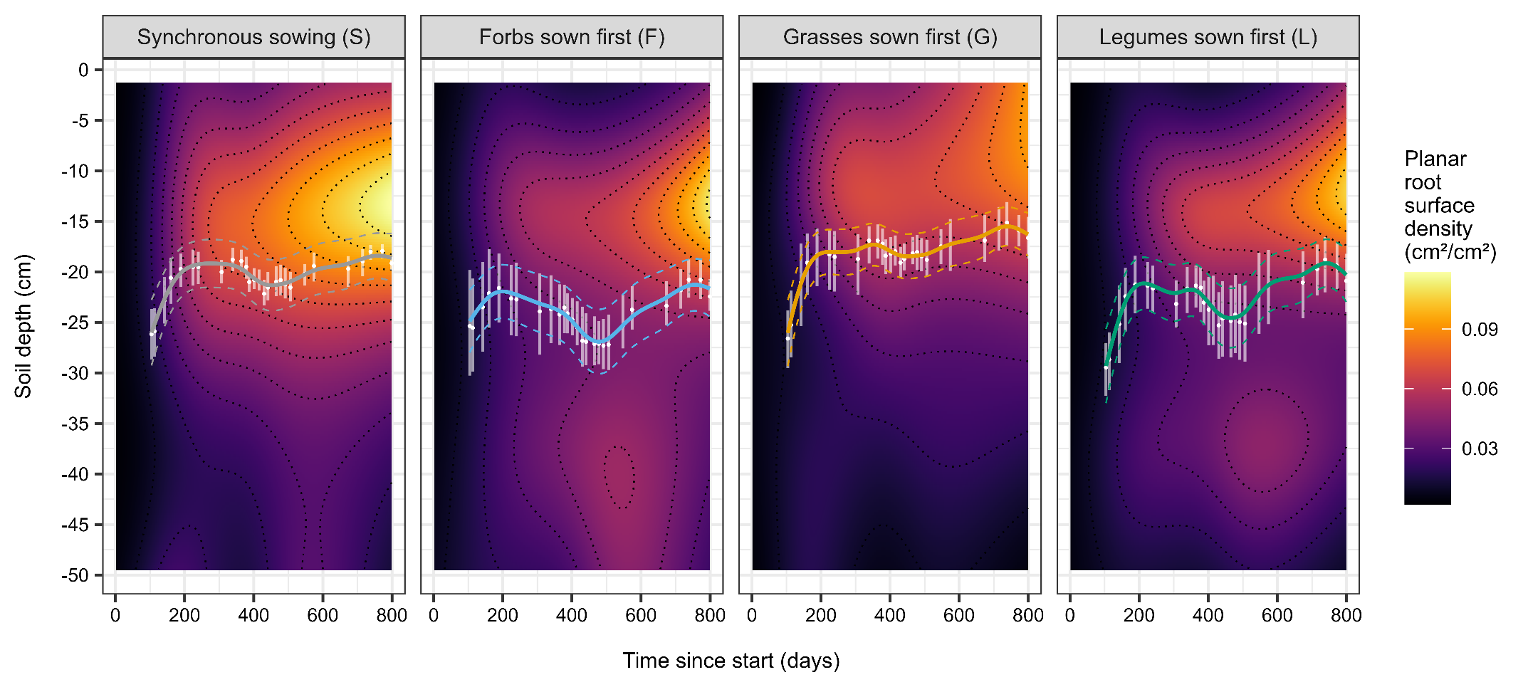
Appendix S17. Sowing forbs or legumes first led to deeper-rooted plant communities. The raster image in each panel shows predictions from a first generalised additive model of the planar root surface density (pRSD) as a function of time since the start of the experiment (0-800 days) and soil depth (1.4-49.5 cm). Results are plotted separately for each PFG order of arrival scenario. On top of each raster, white dots and error bars indicate the mean values and 95% confidence intervals (non-parametric bootstrap) of the mean rooting depth (MRD) estimated from planar root surface density data between days 100 and 800, respectively. Continuous lines are predicted MRD values from a second generalised additive model.

