Supporting Information

Amplification of light-ultrasound interaction in a pi-shifted fiber bragg grating for enhanced ultrasonic sensitivity

Tai-Anh La, Rami Shnaiderman and Vasilis Ntziachristos *

1. Comparison of state-of-the-art ultrasound detectors for optoacoustic sensing

Table S1 – Sensitivity and bandwidth of several piezoelectric transducers (PZTs) and optical-resonator-based detectors. DFBG – D-shaped Fiber Bragg grating, NEPD – overall noise equivalent pressure density.
Technology | Detector | Sensitive element | Detection area [mm²] | Bandwidth [MHz] | NEPD [mPa/√Hz]
Piezoelectric | Ferro Perm ¹ | Piezoceramic | 405 | 5 | 0.009
transducer | Olympus NDT ² | Piezoceramic | 30 | 50 | 0.2
(PZT) | SONAXIS ³ | LiNbO₃ | 7 | 50 | 0.4
 | Kibero ¹ | Piezoceramic | 3 | 200 | 2
 | Fabry-Perot ⁴ | Polymer resonator | 0.7x10⁻³ | 30 | 2.1
 | Microring ⁵ | Polymer resonator | 2.8x10⁻³ | 200 | 2.1
Microresonator- | Optomechanic ⁶ | Silicon membrane | 0.3x10⁻³ | 27 | 1.3
based detector | Optomechanic ⁷ | Silicon membrane | 4.8x10⁻² | 0.14 | 1.1
 | Bragg grating ⁸ | Silicon resonator | 1.5x10⁻⁵ | 200 | 2.2
 | DFBG (sensor herein) | Silica resonator | 4.9x10⁻³ | 100 | 0.42

2. Enhanced light-sound interaction in D-shaped fiber

Fig. S1 present the 2D simulation of the transmitted longitudinal ultrasonic pressure when the fiber is untouched (O-shaped, Fig. S1a) and side-polished (D-shaped, Fig. S1b). The incident ultrasound wave is a Dirac-delta pulse with flat wave-front. The incident wave once entering the O-shaped fiber is diverged. The curved sensing surface of the O-shaped fiber acts as an acoustic divergence lens, which bends the wave-front downward and reduces the pressure at the fiber core. On the other hand, the flat sensing surface of the D-shaped fiber preserves the flat wave-front, resulting in a two-fold improvement of pressure at the core proximity. In addition, two sharp edges are formed at the intersects between the polishing surface and the outer cladding, creating two diffracting edge. From these edges, diffractive edge waves travelling with longitudinal speed, shear speed and Rayleigh wave are generated ⁹, increasing the fraction of acoustic power that is converted into ultrasound wave propagating toward the core of the optical fiber. Harnessing such diffractive edge waves would further enhance the sensitivity.

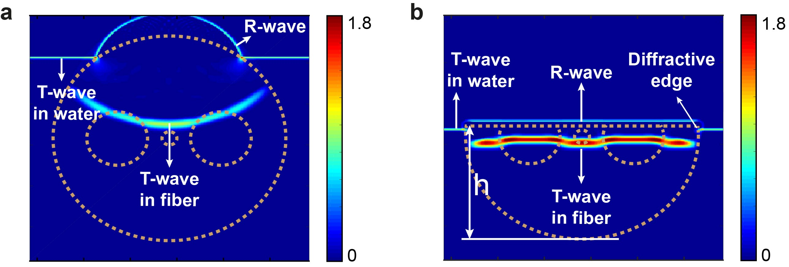
Figure S1 – 2D simulation of the transmitted longitudinal ultrasonic pressure (T-wave) near the fiber core of the O-shaped (a) and D-shaped (b) fibers.

3. Resonant behavior of the DFBG with varying h

Fig. S2 depicts the reflected spectrum of the D-shaped Fiber Bragg grating (DFBG) during the side-polishing process. The spectrum was obtained by sweeping the interrogation wavelength around the resonant frequency. At remained thickness (h) = 75 µm and h = 125 µm, the resonant notch was unaffected and the Q-factor remained the same. At h = 70 µm, the typical stop-band characteristic of the Fiber Bragg grating (FBG) was significantly perturbed and the width of the resonant notch was enlarged by more than two-fold due to strong interference from the high order modes originating from the polished region¹⁰. After partially removing the core region of the fiber (h = 65 µm), the optical loss became severe and light was not strongly confined inside the pi-shifted cavity, drastically reducing both the Q-factor and the visibility of the resonant notch.

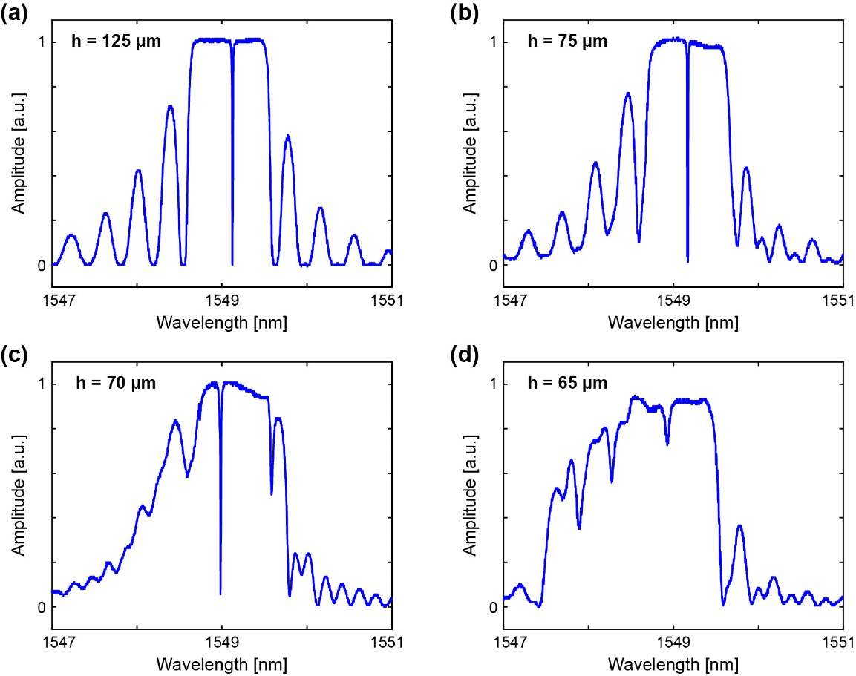
Figure S2 – Reflected spectra of the original pi-shifted Fiber Bragg grating (pFBG) (a) and the D-shaped Fiber Bragg grating (DFBG) during the side polishing process at different remained thicknesses (h): 75 µm (b), 70 µm (c) and 65 µm (d).

4. Focused Piezoelectric Transducers

Table S2 – Characteristics of the focused piezoelectric transducers (PZTs) used in this study for comparison with the D-shaped Fiber Bragg grating (DFBG)
Name | fPZT25 | fPZT50
Manufacturer | SONAXIS, France | SONAXIS, France
Model | CMF183 – PR 6V | HFM31 – PR 6V
Center frequency [MHz] | 25 | 50
Diameter [mm] | 6 | 4
Focal length [mm] | 6 | 4

5. Resolutions of the DFBG

Table S3 – Comparison of the spatial resolutions between the DFBG and ultrasound detectors of similar sensitivity (i.e. NEPD < 5 mPa/√Hz)
Sensors | Bandwidth  [MHz] | Detection aperture  [µm] | Axial resolution  [µm] | Lateral resolution  [µm]
Focused PZT ^{3,11} | 90~180 | Φ 10 ~ Φ 20 | 4~9 | 15~30
Fiber-based Fabry-Perot ⁴ | 28 | Φ 30 | 66 | 94
Embedded Bragg etalon ¹² | 160 | Φ 10 | 8.5 | 14
Polymer microring ¹³ | 170 | Φ 60 | - | -
Silicon microring ^{6,14} | 36 | Φ 20 | 38 | 59
Chalcogenide microring ¹⁵ | 220 | Φ 40 | 44 | 50
Silicon Bragg grating (TM mode) ⁸ | 200 | 200 x 0.5 | 6 | -
DFBG (sensor herein) | 100 | 490 x 10 | 6.5 | 580 x 50

The spatial resolutions of the DFBG were characterized by measuring the full-width half maximum (FWHM) of the point spread function (PSF) with respect to a point-like optoacoustic source ^{12,16}. Because the detection aperture of the DFBG has line shape, the PSFs along the transverse direction (X axis) and longitudinal direction (Y axis) with respect to the axial direction of the fiber were characterized separately (Fig. S3). The axial resolution was found to be 6.5 µm in both direction – which is justified by the solely dependence of the axial resolution on the sensor bandwidth. The lateral resolution was smeared by the line-shaped detection aperture to 580 x 50 µm. The lateral resolution can further be enhanced by increasing the grating strength to confine light in a smaller volume ¹⁷, or using focusing technique to create a virtual aperture ¹⁸.

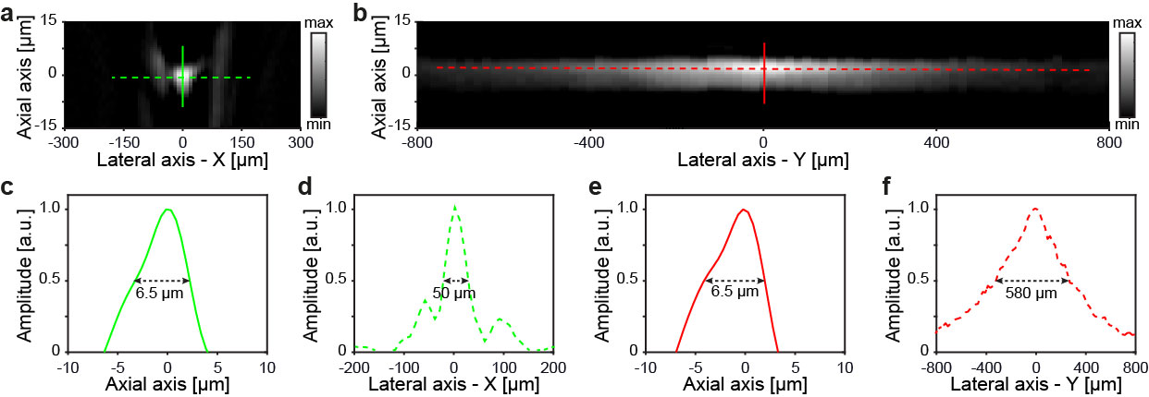
Figure S3 – Characterization of the point spread function (SPF) of the DFBG across the transverse (X) direction (a) and longitudinal (Y) direction (b) with respect to the axial axis of the fiber. The FWHM of the PSF are plotted in (c-f).

6. Sensitivity of the DFBG

The reference hydrophone has a sensitivity of 440 mV/MPa in the 10-30 MHz frequency range. The responses of the hydrophone and the three detectors were passed through a 10-30 MHz digital band pass filter. In the same frequency range, the sensitivities of the DFBG, fPZT25, and fPZT50 were calibrated to be 394 mV/kPa, 109 mV/kPa and 62 mV/kPa, respectively.
To account for differences in the peak frequency response of optoacoustic (OptA) detectors, we used the noise equivalent pressure (NEP) extrapolation method ¹⁹ to calculate the sensitivity of the detectors over a 20MHz bandwidth around each detector’s peak frequencies. The peak sensitivity of the DFBG was calculated to be 983 mV/kPa in the frequency range of 70-90 MHz. In contrast, the peak sensitivity of the fPZT25 was calculated to be 109 mV/kPa in the frequency range of 10-30 MHz and the peak sensitivity of the fPZT50 was calculated to be 119 mV/kPa in the frequency range of 34-54 MHz. Taking into account the root-mean-square value of noise in the corresponding bandwidths, the noise equivalent pressure densities (NEPD) of the DFBG, fPZT25 and fPZT50 were 0.42 mPa/√Hz, 0.35 mPa/√Hz and 0.40 mPa/√Hz, respectively. The NEPDs characterized for the two focused PZTs here are in good agreement to the NEPDs characterized using the pulse-echo method in previous studies ³.

7. Optoacoustic signals in the single microsphere sensing experiment

The signal recorded by the ultrasound detectors is a combination of signal propagating directly from the microsphere (the T-wave) and the signal being reflected at the interface between the adhesive layer and the cover slip (the R-wave) as illustrated in Fig. S4. The adhesive layer is made of acrylic, which has a speed of sound of approximately 2700 m/s. Because of the large acoustic impedance mismatch between acrylic and glass, the R-wave is almost as strong as the T-wave, resulting in strong destructive interference and significantly reducing the amplitude of the acoustic components with the half wavelength corresponding to the distance d between the microsphere and the glass-acrylic boundary. This causes a dip in the spectrum of the recorded signals at 45 MHz (Fig. 3f), which corresponds to d ≈ 30 µm. This estimated distance (d) is reasonably in agreement with the thickness of the original adhesive layer (D = 50 µm), given that the microsphere was gently pressed into the adhesive layer.

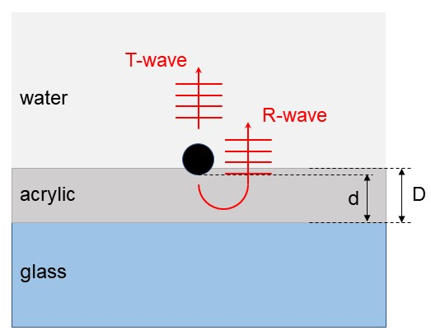
Figure S4 – Schematic showing the parameters that contribute to the detected signal in the single-particle sensing experiment: the T-wave (the optoacoustic wave that propagates directly to the ultrasound detector) and the R-wave (the optoacoustic wave being reflected at the acrylic-water interface before reaching the ultrasound detector). D is the thickness of the acrylic adhesive layer, while d is the actual distance between the microsphere and the surface of the cover slip.

8. Sensitivity enhancement for the DFBG

The NEPD of the DFBG is calculated as
$$NEPD= \frac{{noise}_{rms}}{S\sqrt{BW}}$$
where $S$ denotes the sensitivity [mV/Pa], ${noise}_{rms}$ is the root-mean-square of the system noise [mV] and $BW$ is the acoustic bandwidth. $S$ is directly proportional to the optical power of the interrogation laser ²⁰, so the NEPD could be further enhanced by using a tunable laser with higher output power.
The NEPD could also be significantly improved by reducing the noise of the read-out system. Current noise is dominated by the laser phase noise that was converted to intensity noise, as observed in other silica-based detectors ¹². Pulse interferometry has been demonstrated as a powerful method to reduce laser noise while also enabling parallelization of sensor array ²¹. Balance detection also offers valuable methods to reduce the laser noise but at the cost of constructing a reliable reference arm ^{22,23}. One readily available method that is compatible with our current interrogation system and require no additional modification of the read-out circuit is to balance the reflected and transmitted light existing at the two ports of the DFBG ²⁴. This method reduced the noise of the interrogation system by > 10 dB, and could potentially increase the NEPD of the DFBG to below 0.1 mPa/√Hz.

References

1 Winkler, A. M., Maslov, K. & Wang, L. V. Noise-equivalent sensitivity of photoacoustics. Journal of Biomedical Optics 18 (2013). https://doi.org:10.1117/1.Jbo.18.9.097003
2 Wissmeyer, G., Pleitez, M. A., Rosenthal, A. & Ntziachristos, V. Looking at sound: optoacoustics with all-optical ultrasound detection. Light: Science & Applications 7 (2018). https://doi.org:10.1038/s41377-018-0036-7
3 Schwarz, M. et al. Optoacoustic Dermoscopy of the Human Skin: Tuning Excitation Energy for Optimal Detection Bandwidth With Fast and Deep Imaging in vivo. IEEE Transactions on Medical Imaging 36, 1287-1296 (2017). https://doi.org:10.1109/tmi.2017.2664142
4 Guggenheim, J. A. et al. Ultrasensitive plano-concave optical microresonators for ultrasound sensing. Nature Photonics 11, 714-719 (2017). https://doi.org:10.1038/s41566-017-0027-x
5 Ling, T., Chen, S.-L. & Guo, L. J. High-sensitivity and wide-directivity ultrasound detection using high Q polymer microring resonators. Applied Physics Letters 98 (2011). https://doi.org:10.1063/1.3589971
6 Westerveld, W. J. et al. Sensitive, small, broadband and scalable optomechanical ultrasound sensor in silicon photonics. Nature Photonics 15, 341-345 (2021). https://doi.org:10.1038/s41566-021-00776-0
7 Leinders, S. M. et al. A sensitive optical micro-machined ultrasound sensor (OMUS) based on a silicon photonic ring resonator on an acoustical membrane. Scientific Reports 5 (2015). https://doi.org:10.1038/srep14328
8 Hazan, Y., Levi, A., Nagli, M. & Rosenthal, A. Silicon-photonics acoustic detector for optoacoustic micro-tomography. Nature Communications 13 (2022). https://doi.org:10.1038/s41467-022-29179-7
9 Weise, W., Wilkens, V. & Koch, C. Frequency response of fiber-optic multilayer hydrophones: experimental investigation and finite element simulation. IEEE Transactions on Ultrasonics, Ferroelectrics, and Frequency Control 49, 937-946 (2002). https://doi.org:10.1109/TUFFC.2002.1020164
10 Zhao, J. et al. Rough Side-Polished Fiber With Surface Scratches for Sensing Applications. IEEE Photonics Journal 7, 1-7 (2015). https://doi.org:10.1109/jphot.2015.2423288
11 Aguirre, J. et al. Precision assessment of label-free psoriasis biomarkers with ultra-broadband optoacoustic mesoscopy. Nature Biomedical Engineering 1 (2017). https://doi.org:10.1038/s41551-017-0068
12 La, T. A., Ülgen, O., Shnaiderman, R. & Ntziachristos, V. Bragg grating etalon-based optical fiber for ultrasound and optoacoustic detection. Nature Communications 15, 7521 (2024). https://doi.org:10.1038/s41467-024-51497-1
13 Li, H., Dong, B., Zhang, Z., Zhang, H. F. & Sun, C. A transparent broadband ultrasonic detector based on an optical micro-ring resonator for photoacoustic microscopy. Scientific Reports 4 (2014). https://doi.org:10.1038/srep04496
14 Cedric, P. et al. in Proc.SPIE. 1196017.
15 Pan, J. et al. Parallel interrogation of the chalcogenide-based micro-ring sensor array for photoacoustic tomography. Nat Commun 14, 3250 (2023). https://doi.org:10.1038/s41467-023-39075-3
16 Shnaiderman, R. et al. Silicon‐Photonics Point Sensor for High‐Resolution Optoacoustic Imaging. Advanced Optical Materials (2021). https://doi.org:10.1002/adom.202100256
17 Rosenthal, A., Razansky, D. & Ntziachristos, V. High-sensitivity compact ultrasonic detector based on a pi-phase-shifted fiber Bragg grating. Optics Letters 36, 1833-1835 (2011). https://doi.org:10.1364/OL.36.001833
18 Guan, B.-O., Jin, L., Ma, J., Liang, Y. & Bai, X. Flexible fiber-laser ultrasound sensor for multiscale photoacoustic imaging. Opto-Electronic Advances 4 (2021). https://doi.org:10.29026/oea.2021.200081
19 Shnaiderman, R., Wissmeyer, G., Ülgen, O., Mustafa, Q., Chmyrov, A. & Ntziachristos, V. A submicrometre silicon-on-insulator resonator for ultrasound detection. Nature 585, 372-378 (2020). https://doi.org:10.1038/s41586-020-2685-y
20 Paul C. Beard, F. P., and Tim N. Mills. Transduction Mechanisms of the Fabry-Perot Polymer Film Sensing Concept for Wideband Ultrasound Detection. IEEE Transactions on Ultrasonics, Ferroelectrics, and Frequency Control 46, 1575-1582 (1999).
21 Amir Rosenthal, D. R., and Vasilis Ntziachristos. Wideband optical sensing using pulse interferometry. Optics Express 20 (2012).
22 Riobó, L., Hazan, Y., Veiras, F., Garea, M., Sorichetti, P. & Rosenthal, A. Noise reduction in resonator-based ultrasound sensors by using a CW laser and phase detection. Optics Letters 44 (2019). https://doi.org:10.1364/ol.44.002677
23 Hu, L., Liu, G., Zhu, Y., Luo, X. & Han, M. Laser Frequency Noise Cancelation in a Phase-Shifted Fiber Bragg Grating Ultrasonic Sensor System Using a Reference Grating Channel. IEEE Photonics Journal 8, 1-8 (2016). https://doi.org:10.1109/jphot.2016.2527018
24 Qi Wu, Y. O. High-sensitivity ultrasonic phase-shifted fiber Bragg grating balanced sensing system. OPTICS EXPRESS 20, 28353-28362 (2012).

