Appendix
A- Ultra-high resolutions mass spectrometry
Fourier transform ion cyclotron resonance mass spectra (FT-ICR MS) of UPW and STW, with and without added MP and free chlorine, are shown in Figure A.1. These spectra serve as the basis for Figure 1, where MP-chlorinated by products were identified with high mass accuracy and specificity. The ultrahigh resolution and mass accuracy of FT-ICR MS are crucial for distinguishing closely related compounds, enabling the precise detection and identification of chlorinated transformation products in complex environmental matrices. Peak abundances of these chlorinated compounds were compared between UPW and STW to evaluate how matrix composition influences by-product formation under identical chlorination conditions (see Figure 1).

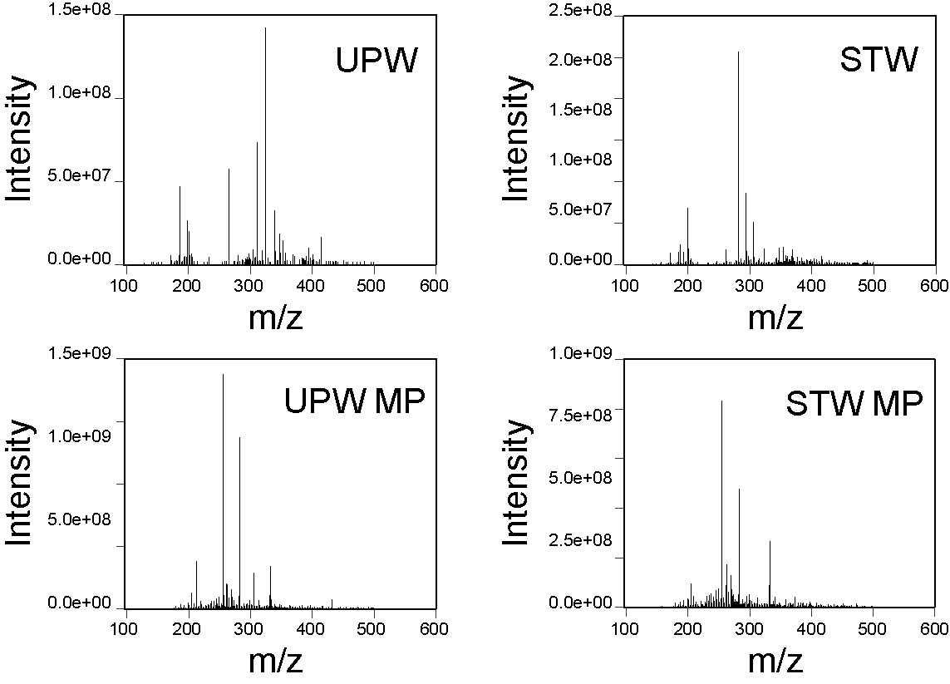
Figure A.1 – Mass spectra obtained by FT-ICR for UPW and STW samples, both with and without the addition of MP and free chlorine.

B – Quantification of MP-chlorinated by-products
To quantify the concentration of MP-chlorinated by products (3-Cl-MP, and 3,5-diCl-MP), a solution of STW with MP at 100 µg/L was reacted with 5 mg/L of free chlorine in STW for 30 min.The reaction was quenched using ascorbic acid (2.5 mg per mg of free chlorine). By-products were subsequently quantified through Liquid Chromatography with tandem mass spectrometry (LC-MS/MS) using a Shimadzu Nexera Ultra-High Performance Analytical Chromatography (UHPLC) system coupled to an LCMS-8040 triple quadrupole mass spectrometer (Shimadzu Corporation, Tokyo, Japan), after electrospray ionisation (ESI) under negative ionisation mode. The nebulising and drying gas flows were set at 2.8 and 14 dm³ min⁻¹, respectively. The heat block and desolvation line temperatures were 400 °C and 250 °C. Argon was used as the collision gas at 230 kPa. For quantification, the most abundant fragment (multiple reaction monitoring, MRM1) was used, whereas the identity confirmations was performed by analsying the second most abundant fragment (MRM2).
Table B.1 - Multiple reaction monitoring (MRM) parameters for tandem mass spectrometry analysis of target analytes, after ESI under negative mode (DP is the declustering potential; CE is the collision energy; CXP is the collision cell exit potential)
Analyte | Precursor ion (m/z) | Quantification (MRM1) |  |  |  | Confirmation (MRM2)
Analyte | Precursor ion (m/z) | Product ion | DP (V) | CE  (V) | CXP (V) | Product ion | DP  (V) | CE (V) | CXP (V)
MP | 151.25 | 92.00 | 11.0 | 21 | 15 | 136.05 | 30 | 17 | 28
3,5-diCl-MP | 219.10 | 159.95 | 16 | 21 | 15 | 131.90 | 25 | 30 | 26
3-Cl-MP | 185.20 | 125.95 | 21 | 25 | 12 | 170.00 | 14 | 18 | 17

Chromatographic separation was achieved in a Kinetex™ 1.7 µm F5 (pentafluorophenyl) 100 A (100 × 2.1 mm, i.d.) column acquired to Phenomenex, Inc. (California, USA), using a gradient mobile phase of ultrapure water and acetonitrile, at a flow rate of 0.20 mL min⁻¹. The gradient started with a linear increase from 30 % to 40 % of organic phase during the first 5 min run, which were kept for 1.5 min, followed by a rapid decrease from 40 % to 30 % of acetonitrile in 0.1 min and an equilibration period of 3.4 min, resulting in a total run of 10 min. The column oven temperature was kept at 30 °C, the autosampler at 15 °C and the injection volume was 10 µL.
Figure B.1 - Chromatogram of MP, 3,5-diCl-MP and 3-Cl-MP, showing both MRM parameters for each analyte.

Calibration curves for MP, 3-Cl-MP, and 3,5-diCl-MP under STW matrix with a free chlorine concentration of 5 mg/L for 30 min, were performed to quantify the concentration of 3-Cl-MP and 3,5-diCl-MP resulting from the reaction between MP at 0.1 mg/L with free chlorine at 5 mg/L for 30 min. The results indicate that when MP at 0.1 mg/L reacts with 5 mg/L of free chlorine for 30 min in STW, the formation of 3,5-diCl-MP occurs, with a concentration of 10 µg/L. This suggests that MP is partially converted into 3,5-diCl-MP within that time frame (30 min). As 3-Cl-MP was not detected, it appears that it may also be further transformed into 3,5-diCl-MP after 30 min of chlorination.

C – Biofilm structure of dual-species biofilms formed in PPL coupons and non-exposed and exposed to MP, 3-Cl-MP, and 3.5-diCl-MP
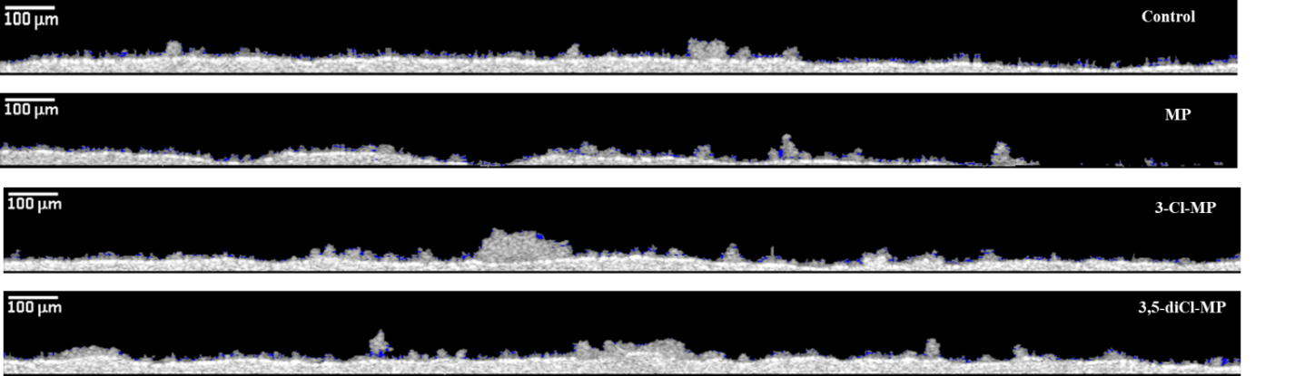
Figure C.1 – OCT images of the structure of dual-species biofilm formed on PPL coupons and non-exposed, MP-, 3-Cl-MP, and 3,5-diCl-MP-exposed for 7 days.

D – Biofilm structure of dual-species biofilms formed in PPL coupons and non-exposed and exposed to MP, 3-Cl-MP, and 3.5-diCl-MP, and treated with free chlorine at 5 mg/L
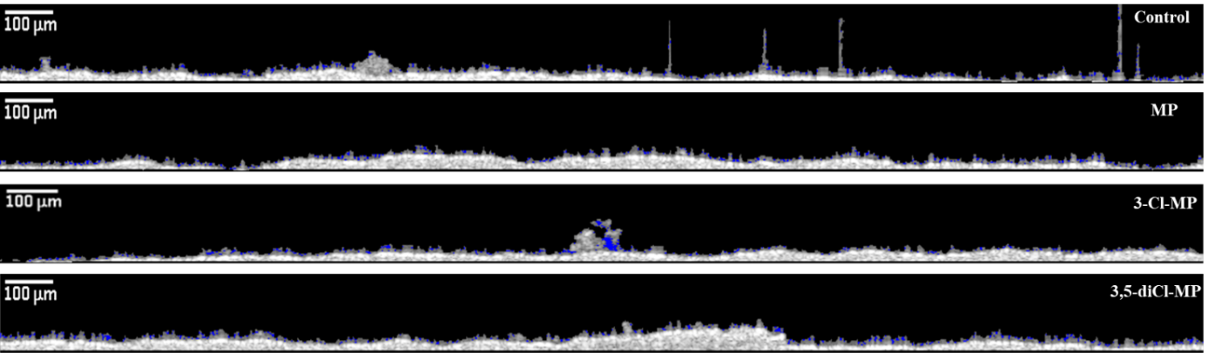
Figure D.1 - OCT images of the structure of chlorine treated dual-species biofilm formed on PPL coupons and non-exposed, MP-, 3-Cl-MP, and 3,5-diCl-MP-exposed for 7 days.

E – Bacterial cell replication
The effects on cell replication of MP and MP-chlorinated by-products exposure at 15 μg/L to both planktonic bacteria were based on the measurement of optical density at 610 nm over time. Each bacterial suspension (adjusted to 10⁸ CFU/mL in R2A) was placed in a sterile 96-well microtiter plate with the absence and presence of MP, 3-Cl-MP, and 3,5-diCl-MP at a final concentration of 15 µg/L. Fresh R2A medium growth was used as a negative control sample. The OD₆₁₀ was measured at a defined interval time (30 min) in a Fluostar Omega automated microplate reader (BMG Labtech, Madrid, Spain) for 24 h. Then, data was adjusted to the Gompertz model, described through Equation E.1.
$A \left(t\right)= A_{max}exp(-exp\left(\frac{μ_{m}exp1}{A_{max}}\left(λ-t\right)+1\right))$ (E.1)
Where, A (t) and A_{max} correspond to OD₆₁₀ at a defined time and after the maximum time (24 h) of exposure; $λ$ is the lag time length (h); µ_{m} is the maximum specific growth rate (h⁻¹); and t is the time (h).
The exposure to MP, 3-Cl-MP, and 3,5-diCl-MP caused a decrease in the A_{max} parameter of A. calcoaceticus, suggesting an interference on the bacterial cell growth (Figure E.1, Table E.1). However, the other kinetic parameters were not affected (Table E.1). S. maltophilia cell replication seemed to suffer some modification when exposed to MP and MP-chlorinated by-products (Figure E.2, Table E.2). An increase in the A_{max} was observed for 3,5-diCl-MP exposed S. maltophilia in comparison to non-exposed counterparts and all compounds seem to increase the lag phase of replication growth (Table E.2, P < 0.05).
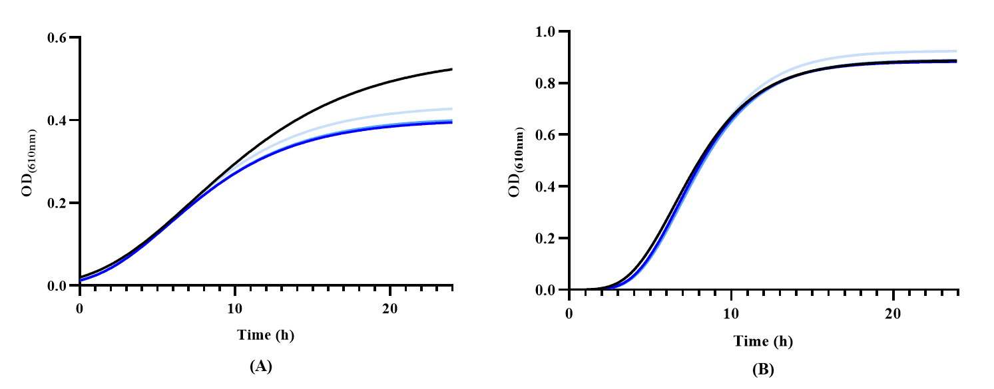
Figure E.1 - A. calcoaceticus (A) and S. maltophilia (B) growth curves (according to the Gompertz model of the experimental data) of non-exposed (control) (▬) and exposed to MP (▬), 3-Cl-MP (▬), and 3,5-diCl-MP (▬) cells for 24 h at 15 µg/L.

Table E.1 - Kinetic parameters obtained after application of the Gompertz model for both non-exposed and MP-, 3-Cl-MP-, 3,5-diCl-MP-exposed A. calcoaceticus cells. *- samples were statistically different from non-exposed counterparts (control) (t-test. P < 0.05).
Gompertz parameters | Control | MP (15 µg/L) | 3-Cl-MP (15 µg/L) | 3.5-diCl-MP  (15 µg/L)
A_{max} | 0.560 ± 0.007 | 0.400 ± 0.006* | 0.410 ± 0.006* | 0.440 ± 0.006*
µ_{m} (h⁻¹) | (3.00 ± 0.09) × 10⁻² | (3.00 ± 0.17) × 10⁻² | (3.00 ± 0.16) × 10⁻² | (3.00 ± 0.16) × 10⁻²
$λ$ (h) | 1.23 ± 0.20 | 1.13 ± 0.33 | 1.14 ± 0.31 | 1.24 ± 0.30
r² | 0.987 | 0.952 | 0.956 | 0.962

Table E.2 - Kinetic parameters obtained after application of the Gompertz model for both non-exposed and MP-, 3-Cl-MP-, 3,5-diCl-MP-exposed S. maltophilia cells. *- samples were statistically different from non-exposed counterparts (control) (t-test. P < 0.05).
Gompertz parameters | Control | MP (15 µg/L) | 3-Cl-MP (15 µg/L) | 3.5-diCl-MP  (15 µg/L)
A_{max} | 0.890 ± 0.009 | 0.880 ± 0.006 | 0.890 ± 0.008 | 0.930 ± 0.007*
µ_{m} (h⁻¹) | (1.20 ± 0.06) × 10⁻¹ | (1.20 ± 0.04) × 10⁻¹ | (1.20 ± 0.05 × 10⁻¹ | (1.20 ± 0.04) × 10⁻¹
$λ$ (h) | 3.70 ± 0.19 | 4.04 ± 0.12* | 4.13 ± 0.15* | 4.14 ± 0.13*
r² | 0.946 | 0.978 | 0.965 | 0.976

