Supplementary Material

Figure S1
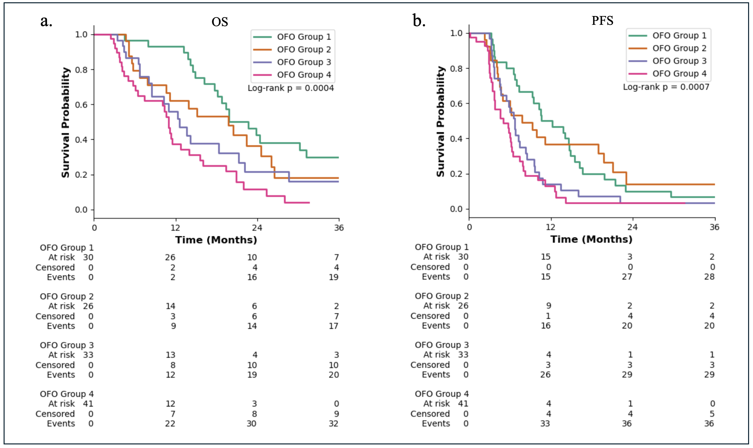
Figure S1. Kaplan-Meier survival plot of IDH-wildtype GBM. (a) OS by OFO group 1-4, demonstrating a stepwise decline in OS. (b) PFS by OFO group, similarly showing shorter PFS in higher OFO categories.
P-values, log-rank test.

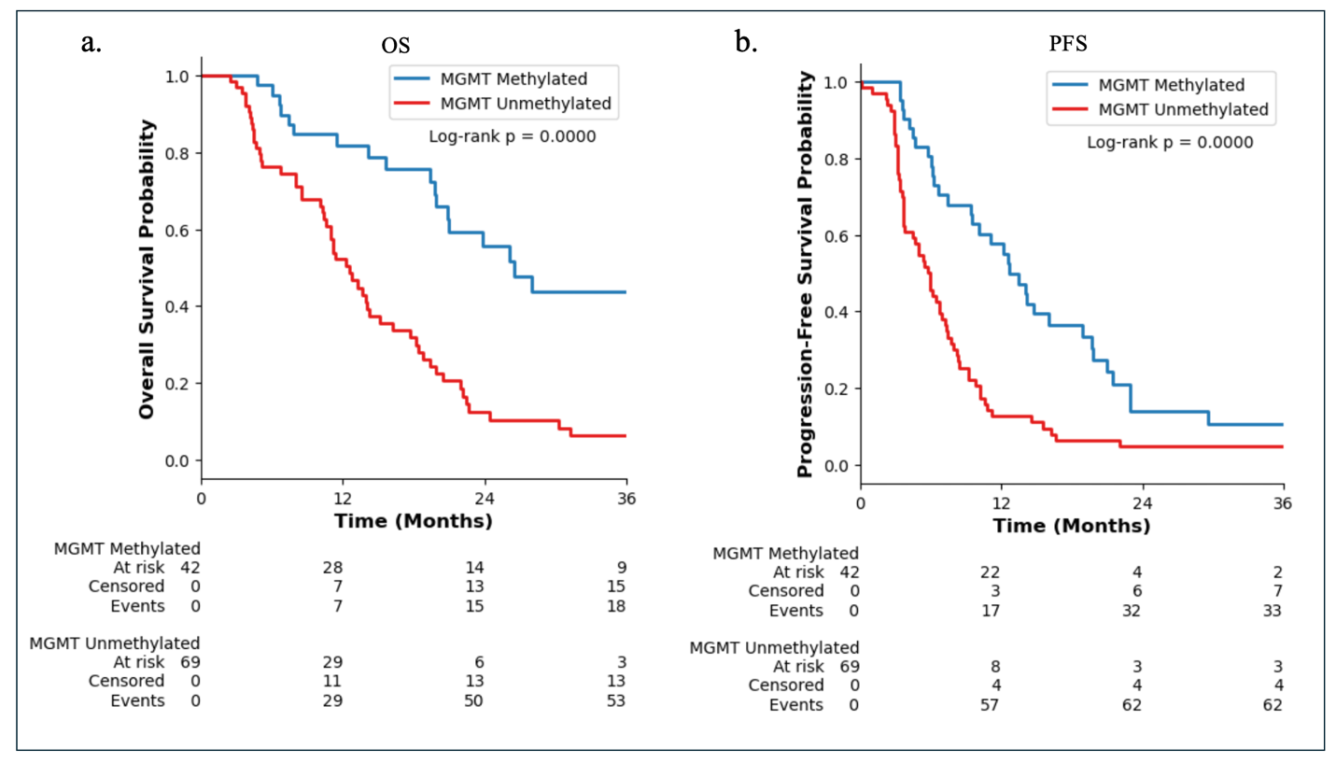
Figure S2
Figure S2. Kaplan-Meier survival plots of IDH-wildtype GBM. (a) OS stratified by MGMT status. (b) PFS stratified by MGMT status. P-values, log-rank test.

Figure S3
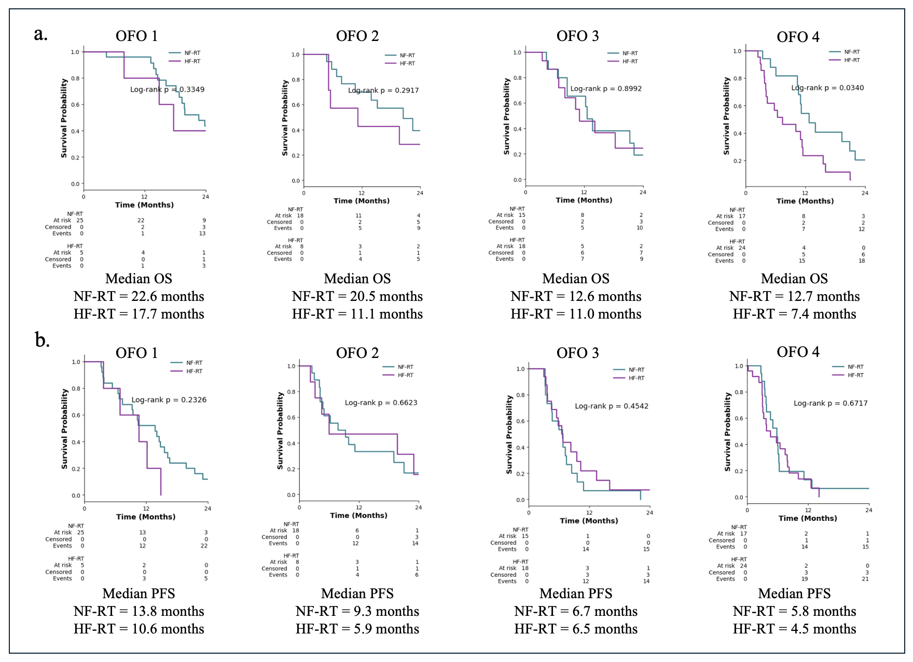
Figure 3. Kaplan-Meier survival plot of IDH-wildtype GBM. (a) OS by OFO group 1-4, demonstrating a stepwise decline in OS. (b) PFS by OFO group showing shorter PFS in higher OFO categories. P-values, log-rank test.

