Urbanization influences hemorrhagic fever with renal syndrome transmission: 34-year evidence from China's national surveillance

Junyu He^{1,2,#}, Yanding Wang^{3,4,#}, Xiaopeng Xu^{1,#}, George Christakos^{1,*}, Danjie Zhang^{5,6}, Yuanyong Xu^{5,6}, Qiulan Chen^{7,*}, WenyiZhang^{5, 6,*}

¹ Ocean College, Zhejiang University, Zhoushan, China
² Ocean Academy, Zhejiang University, Zhoushan, China
³Institute of Epidemiology, Helmholtz Zentrum München, German Research Center for Environmental Health (GmbH), IngolstädterLandstraße 1, 85764 Neuherberg, Germany
⁴Institute for Medical Information Processing, Biometry, and Epidemiology (IBE), Faculty of Medicine, LMU Munich, Pettenkofer School of Public Health, Munich, Germany
⁵Chinese PLA Center for Disease Control and Prevention, Beijing, China
⁶Department of Epidemiology, School of Public Health, China Medical University, Shenyang, China
⁷National Key Laboratory of Intelligent Tracking and Forecasting for Infectious Diseases, Chinese Center for Disease Control and Prevention, Beijing, China

* Correspondence: zwy0419@126.com; pierianspring@gmail.com; chenql@chinacdc.cn
# The authors contribute equally to the manuscript.

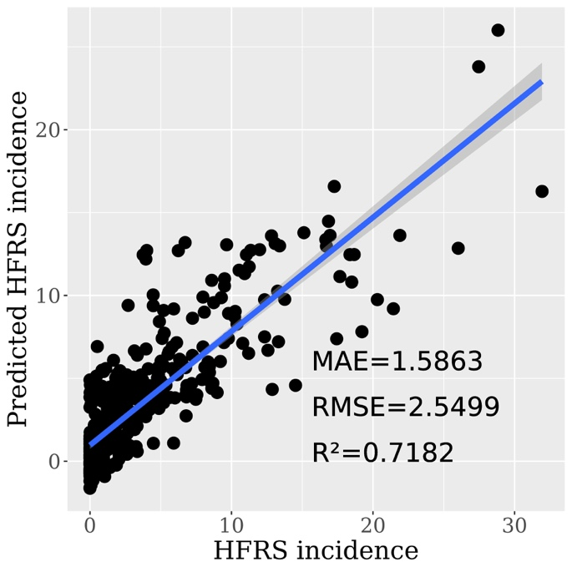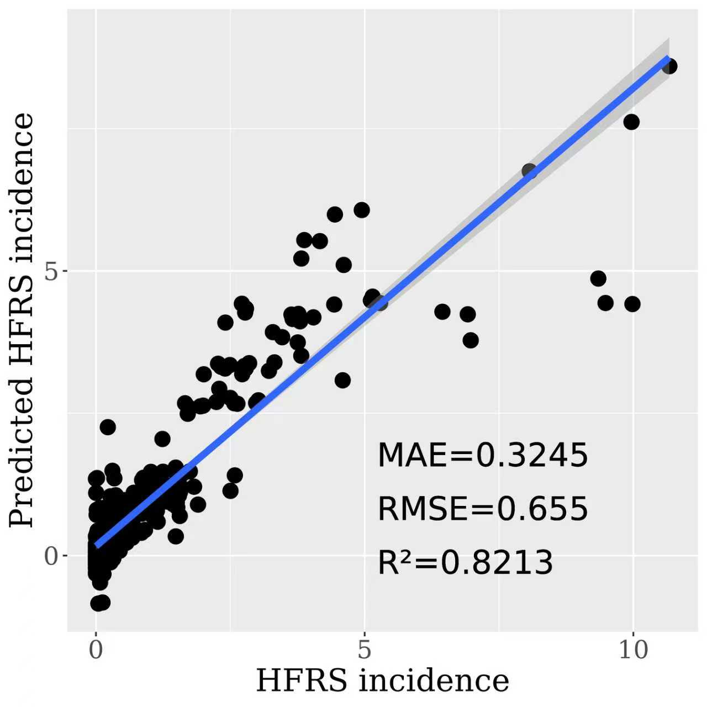
(a) (b)
Figure S1. The performance of linear mixed-effects model in predicting the HFRS incidence during the period (a) 1985-2004 and (b) 2005-2018

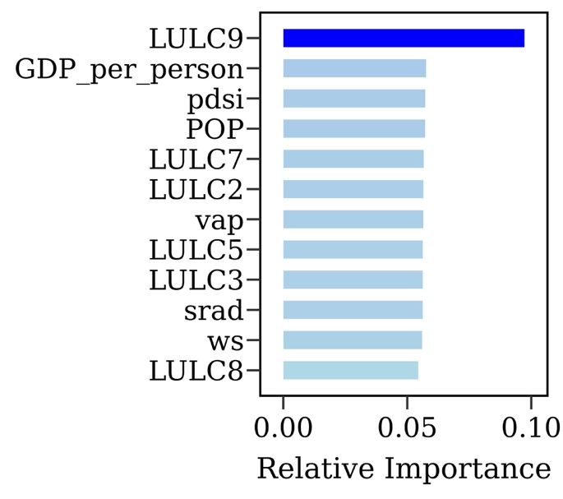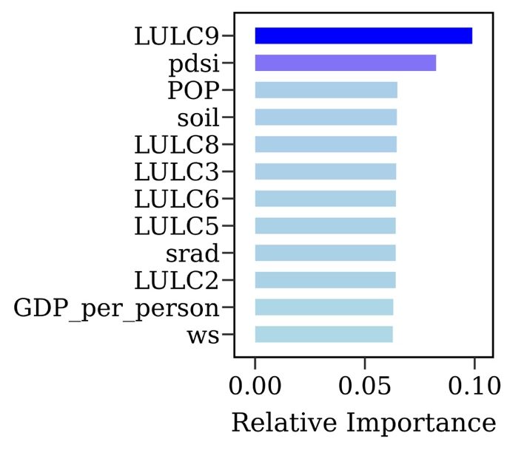
(a) (b)
Figure S2. The relative importance of the considered variables in linear mixed-effects model during the period (a) 1985-2004 and (b) 2005-2018. POP, SRAD, PDSI, VAP, WS, LULC2, LULC3, LULC5, LULC6, LULC7, LULC8, LULC9 represent population, near-surface downward shortwave radiation, the palmer drought severity index, water vapor partial pressure in air, wind speed, forest, shrub, water, snow/ice, barren, impervious surfaces and wetland, respectively.

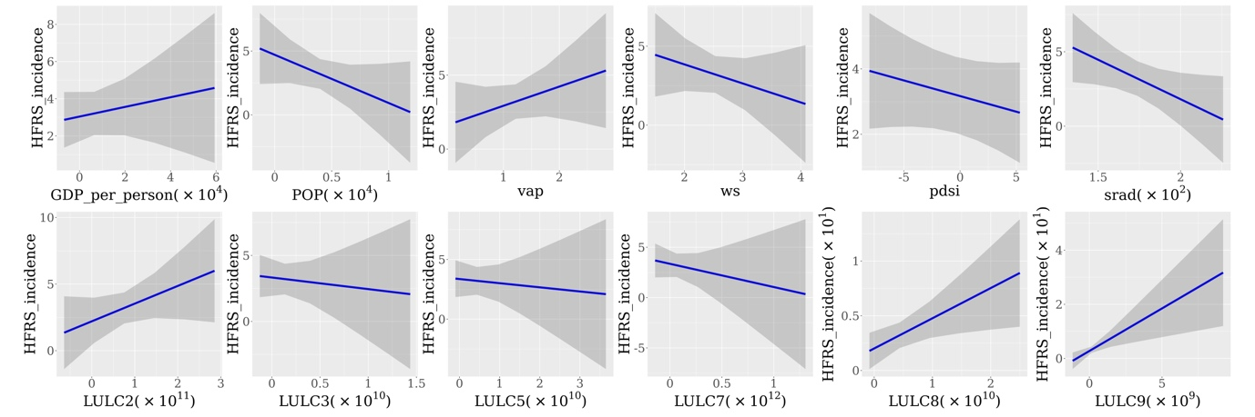
(a)
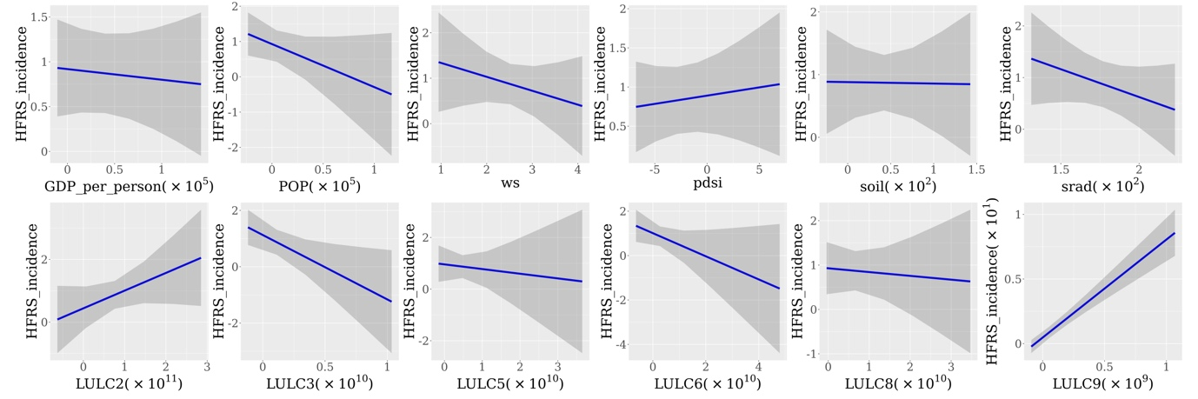
(b)
Figure S3. The partial dependence of the considered variables in linear mixed-effects model during the period (a) 1985-2004 and (b) 2005-2018. POP, SRAD, PDSI, VAP, WS, LULC2, LULC3, LULC5, LULC6, LULC7, LULC8, LULC9 represent population, near-surface downward shortwave radiation, the palmer drought severity index, water vapor partial pressure in air, wind speed, forest, shrub, water, snow/ice, barren, impervious surfaces and wetland, respectively.

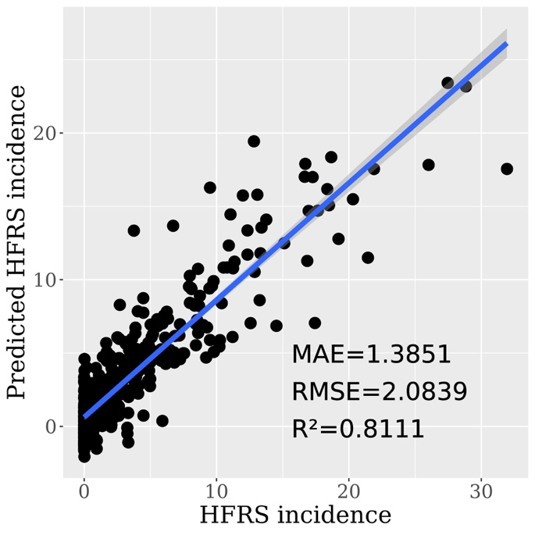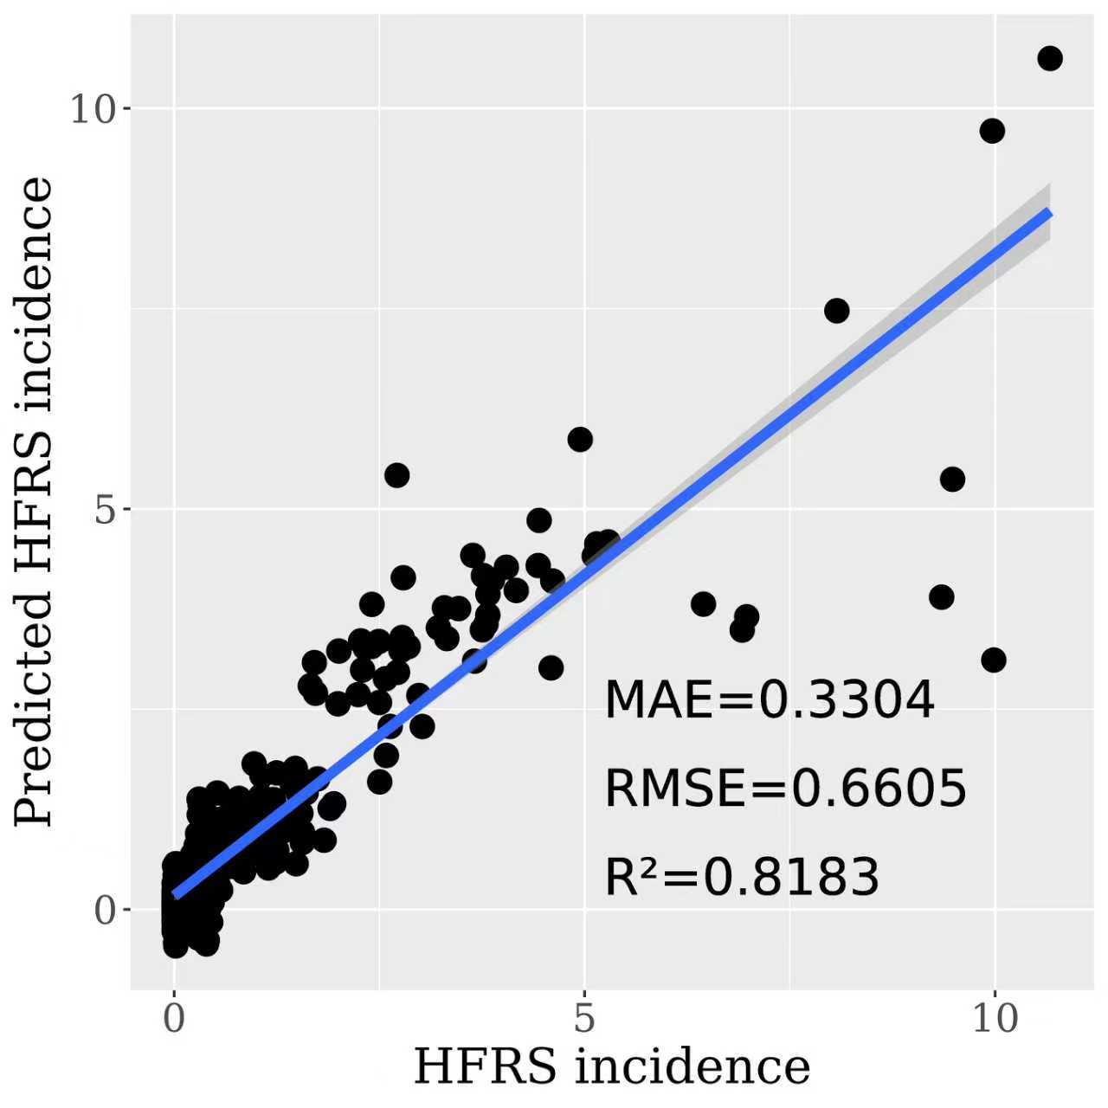
(a) (b)
Figure S4. The performance of generalized additive model in predicting the HFRS incidence during the period (a) 1985-2004 and (b) 2005-2018

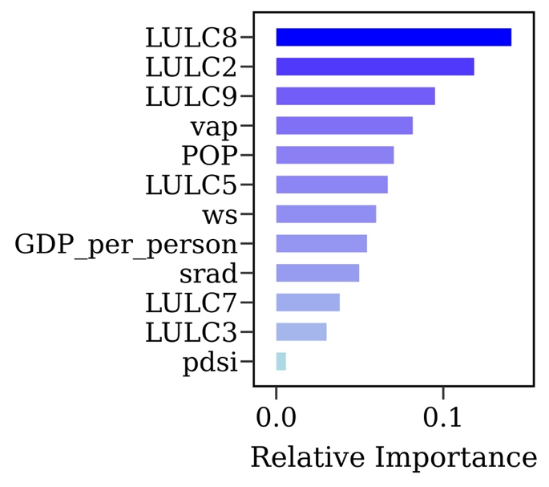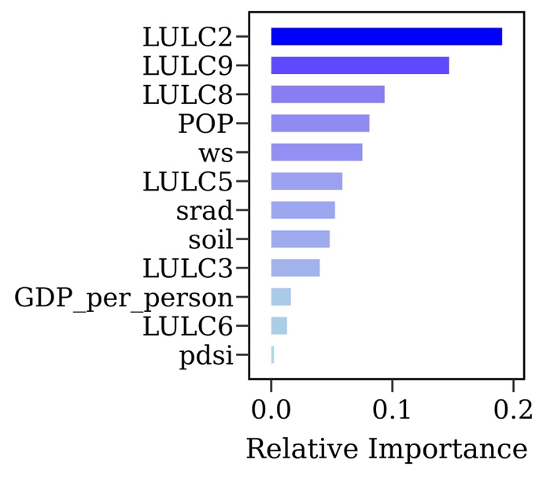
(a) (b)
Figure S5. The relative importance of the considered variables in generalized additive model during the period (a) 1985-2004 and (b) 2005-2018. POP, SRAD, PDSI, VAP, WS, LULC2, LULC3, LULC5, LULC6, LULC7, LULC8, LULC9 represent population, near-surface downward shortwave radiation, the palmer drought severity index, water vapor partial pressure in air, wind speed, forest, shrub, water, snow/ice, barren, impervious surfaces and wetland, respectively.

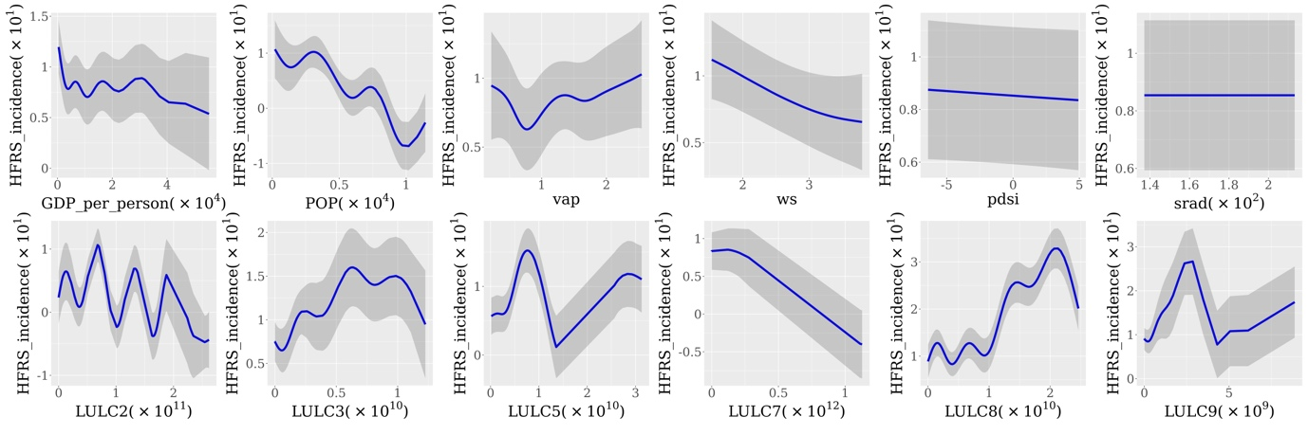
(a)
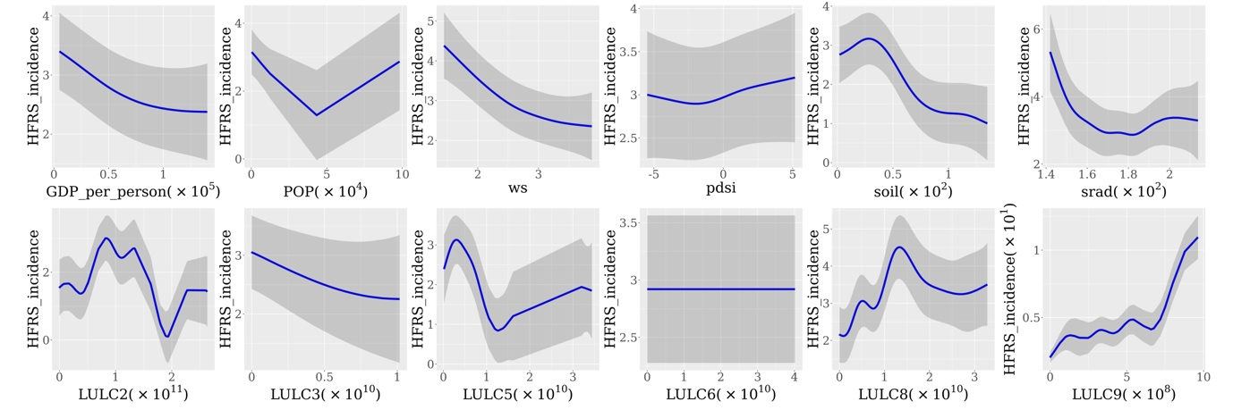
(b)
Figure S6. The partial dependence of the considered variables in generalized additive model during the period (a) 1985-2004 and (b) 2005-2018. POP, SRAD, PDSI, VAP, WS, LULC2, LULC3, LULC5, LULC6, LULC7, LULC8, LULC9 represent population, near-surface downward shortwave radiation, the palmer drought severity index, water vapor partial pressure in air, wind speed, forest, shrub, water, snow/ice, barren, impervious surfaces and wetland, respectively.

