List of Supplemental Materials
Supplemental Results. A set of the results using CFA for all 120 MSAs.

Supplemental Text. Descriptions and processing procedures of the area-level variables describing contexts for adaptive capacity.

Supplemental Figure 1. Factor loadings of the selected variables by CFA and PCA in the demographic and economic status, health, environment, and infrastructure contexts. Axis labels marked in yellow and gray colors indicate that the variables are only selected by CFA and PCA, respectively.

Supplemental Figure 2. Urban Heat Health Risk (UHHR) scores for the overall, and demographic and economic status (DES), health (HLT), environment (ENV), and infrastructure (INF) contexts by PCA approach. The scores are sorted by the overall scores by the CFA approach (CFA Overall).

Supplemental Figure 3. Part R-squared of demographic and economic status, health, environment, and infrastructure contexts by the principal component analysis (PCA) approach in the joint models explaining the associations with excess heat-related cardiovascular hospitalizations per 100,000 beneficiaries (xHEAT-CVD burden rates) for the historical period, and changes in future xHEAT-CVD burden rates under different scenarios.
Supplemental Table 1. Population, total area of land (Land Area) and water (Water Area) in square kilometer, population density, and percent urban area within the Metropolitan Statistical Area (MSA) classified as urban area based on the 2010 Census Urban and Rural Classification for the 80 selected MSAs in this study.
Supplemental Table 2. Mean, standard deviation (sd), and interquartile range (IQR) of the temperature above minimal hospitalization percentile at the ZCTA level within each MSA, and mean temperature above minimal hospitalization percentile at the MSA level (MSA_Mean) in the near-, mid-, and long-term using Community Earth System Model version 1 under Representative Concentration Pathway 4.5.
Supplemental Table 3. Initial input variables for creating Urban Heat Health Risk (UHHR) scores in the demographic and economic (DES), health (HLT), environment (ENV), and infrastructure (INF) contexts. Variables with a variable code are selected for creating UHHR scores, and variables without a variable code are removed during the variable evaluation process.
Supplemental Table 4. Part R-squared of demographic and economic status (DES), health (HLT), environment (ENV), and infrastructure (INF) contexts in the joint models explaining the associations with excess heat-related cardiovascular hospitalizations per 100,000 beneficiaries (xHEAT-CVD burden rates) for the historical period, and changes in future xHEAT-CVD burden rates under different scenarios.

Supplemental Table 5. Associations of overall Urban Heat Health Risk (UHHR) scores and joint associations of UHHR scores of the demographic and economic status (DES), health (HLT), environment (ENV), and infrastructure (INF) by principal component analysis (PCA) for historical period burden rates (2000 - 2017), change in future burden rates based on CESM-CCSM4 (CC4) under the paired scenarios of Representative Concentration Pathways (RCPs) and Shared Socioeconomic Pathways (SSPs) for moderate emission-middle of the road (rcp45-ssp2) and high emission-fossil fuel development (rcp85-ssp5) and GFDL-CM3 (GC3) under rcp85-ssp5 for near- (2025–2054), mid- (2045–2074), and long-term (2070–2099) given one unit increase in scores. Bold face indicates statistical significance level is < 0.05.

Supplemental Results.
While the primary results reported in the main text using MSAs with increased relative risks at the historical period (N=80) only, Supplemental Results section provides parallel results as reported as the main results in the main text using all 120 MSAs.

List of Tables and Figures in Supplemental Results:
Supplemental Results - Table 1. Data descriptions, years, sources, loadings from the confirmatory factor analysis for the selected variables in the demographic and economic (DES), health (HLT), environment (ENV), and infrastructure (INF) contexts used to describe adaptive capacity.
Supplemental Results - Table 2. Mean, standard deviation (sd), and range of: future temperature percentiles of the temperature at the minimum hospitalization percentile (92nd percentile) (pTile of T_{MHP}); number of days above T_{MHP} (Days ≥ T_{MHP}); growth rate of the population aged 65 and older (Population Growth); excess heat-related cardiovascular disease hospitalizations per 100,000 beneficiaries per year (xHEAT-CVD burden rate); and changes in xHEAT-CVD burden rate (folds) between the historical and future periods (Change in xHEAT-CVD rate). Results are shown for the 80 Metropolitan Statistical Areas included in analysis. The historical period refers to 2000–2017, and near-, mid-, and long-term refers to 2025–2054, 2045–2074, and 2070–2099, respectively.
Supplemental Results - Table 3. Associations of overall Urban Heat Health Risk (UHHR) scores and context-specific UHHR scores (demographic and economic status (DES), health (HLT), environment (ENV), and infrastructure (INF)) with the historical period (2000-2017) and change in future excess heat-related cardiovascular disease burden rates. The UHHR scores were generated using confirmatory factor analysis (CFA). Future burden rates are shown for three different scenarios for the near- (2025–2054), mid- (2045–2074), and long-term (2070–2099) and based on CESM-CCSM4 (CC4) under the paired scenarios of Representative Concentration Pathways (RCPs) and Shared Socioeconomic Pathways (SSPs) for moderate emission-middle of the road (rcp45-ssp2) and high emission-fossil fuel development (rcp85-ssp5) and GFDL-CM3 (GC3) under rcp85-ssp5. Results are shown), per unit increase in score. Bold face indicates statistical significance level is <0.05.

Supplemental Results - Figure 1. Urban Heat Health Risk (UHHR) scores, overall and for the demographic and economic status (DES), health (HLT), environment (ENV), and infrastructure (INF) contexts for each of the 80 MSAs for the historical period (2000–2017). Positive values (in warm colors) indicate lower adaptive capacity or increased vulnerability, while negative values (cooler colors) indicate higher adaptive capacity or decreased vulnerability. X-axis represents the UHHR scores, and y-axis represents the 120 MSAs.
Supplemental Results - Figure 2. Part R-squared of demographic and economic status, health, environment, and infrastructure contexts in the joint models explaining the associations with excess heat-related cardiovascular hospitalizations per 100,000 beneficiaries per year (xHEAT-CVD burden rates) for the historical period, and changes in future xHEAT-CVD burden rates under different scenarios and future periods.

Supplemental Results - Table 1.
Context | Description | Year(s) | Source(s)* | Loadings
DES | Median household income | 2015 - 2019 | ACS | -0.859
 | Percent population in management, business, science, and arts occupations | 2015 - 2019 | ACS | -0.799
 | Number of civic and social organizations per 1,000 people | 2003 - 2017 | CVI | -0.542
 | Percent household with limited English-speaking status | 2015 - 2019 | ACS | 0.098
 | Percent population aged 25 and above with an education attainment less than high school or equivalent | 2015 - 2019 | ACS | 0.547
 | Percent population without any health insurance | 2015 - 2019 | ACS | 0.562
 | Percent housing units that are mobile homes | 2015 - 2019 | ACS | 0.638
 | Percentage of gross household income spent on energy costs in summer (June to September) | 2018 | Shen et al. (2023) | 0.725
 | Percent families below 150% poverty level | 2015 - 2019 | ACS | 0.818
HLT | Mean prevalence proportion of chronic obstructive pulmonary disease | 2011 - 2019 | CMS | -0.578
 | Mean prevalence proportion of congestive heart failure | 2011 - 2019 | CMS | -0.380
 | Mean prevalence proportion of acute myocardial infarction | 2011 - 2019 | CMS | 0.222
 | Mean prevalence proportion of chronic kidney diseases | 2011 - 2019 | CMS | 0.313
 | Mean prevalence proportion of depression | 2011 - 2019 | CMS | 0.324
ENV | Mean canopy cover | 2019 | MRLC | -0.086
 | Annualized wildfire frequency | 2023 | NRI | -0.060
 | Ratio of canopy in urban versus rural areas | 2019 | MRLC, EnviroAtlas | -0.060
 | Annualized heat wave frequency | 1996 - 2019 | NRI | -0.019
 | Annualized drought frequency | 2023 | NRI | 0.151
 | Ratio of canopy and imperviousness | 2019 | MRLC | 0.175
INF | Percent household with broadband internet | 2015 - 2019 | ACS | -0.848
 | Averaged number of potential cooling places per sq. km | 2010 to 2019 | Census | -0.305
 | Percent household with 1 or more of the 4 housing unit problems | 2015 - 2019 | CHAS | -0.134
 | Percent population in Census tracts with a Walkability Score less than the national median score (32) | 2022 | CVI | 0.314
 | Distance to the nearest medical facility (hospitals, urgent cares) | 2024 | HIFLD, Tiger | 0.386
 | Percent population living within greater than 15 km away from a medical facility | 2024 | HIFLD, Tiger | 0.405
 | Percent population in Census tracts with a Public Transit Performance Score less than the national median score (3.2) | 2019 | CVI | 0.541
*ACS: U.S. Census American Community Survey 5-Year Estimate; Shen et al. (2023): dataset was obtained through personal communication; CVI: Climate Vulnerability Index; CMS: Center for Medicare and Medicaid Services; MRLC: Multi-Resolution Land Characteristics; EnviroAtlas: U.S. Environmental Protection Agency EnviroAtlas project; NRI: Federal Emergency Management Agency (FEMA) National Risk Index; HIFLD: Homeland Infrastructure Foundation-Level Data; Tiger: U.S. Census Bureau Topologically Integrated Geographic Encoding and Referencing system

Supplemental Results - Table 2.
 | pTile of T_{MHP} |  | Days ≥ T_{MHP} |  | Population Growth |  |  | xHEAT-CVD rate |  | Change in xHEAT-CVD rate
120 MSAs | Mean (sd) | Range | Mean (sd) | Range | Mean (sd) | Range | Mean (sd) |  | Range | Mean (sd) | Range
Historical period | 92.0 (0) | 92.0–92.0 | 29.0 (0) | 29.2 – 29.2 | - | - | 7.10 (21.78) |  | -55.10 - 78.72 | - | -
CC4-rcp45-ssp2
Near-term | 86.5 (5.4) | 70.1 - 98.7 | 51.1 (20.3) | 5.0 - 112.3 | 2.30 (0.67) | 1.10 - 5.10 | 43.08 (182.02) |  | -610.39 - 1182.91 | 1.65 (9.67) | -60.9 - 43.35
Mid-term | 84.1 (5.8) | 67.4 - 98.4 | 59.9 (21.9) | 6.2 - 121.5 | 3.10 (1.30) | 0.95 – 9.00 | 80.71 (338.68) |  | -1158.99 - 2172.26 | 3.81 (19.6) | -119.18 - 87.03
Long-term | 82.5 (6.6) | 64.8 - 97.9 | 65.5 (24.5) | 8.3 - 131.3 | 4.20 (2.30) | 0.87 – 14.00 | 138.02 (618.1) |  | -2073.21 - 4323.56 | 6.9 (35.48) | -207.85 - 180.64
CC4-rcp85-ssp5
Near-term | 84.2 (5.9) | 67.5 - 98.1 | 59.7 (22.3) | 7.4 - 121.6 | 2.50 (0.76) | 1.20 - 5.70 | 76.64 (283.25) |  | -789.26 - 1836.63 | 3.47 (17.88) | -120.1 - 89.89
Mid-term | 79.5 (6.7) | 61.0 - 95.9 | 76.3 (24.7) | 15.7 - 144.7 | 3.70 (1.70) | 1.10 – 11.00 | 211.12 (812.56) |  | -2146.54 - 5885.1 | 11.61 (48.81) | -260.34 - 307.87
Long-term | 73.8 (7.3) | 52.6 - 92.5 | 97.3 (27.0) | 28.5 - 175.5 | 5.6 0(3.10) | 1.10 – 19.00 | 625.71 (2487.63) |  | -6328.12 - 19950.31 | 38.68 (140.53) | -552.02 – 950.00
GC3-rcp85-ssp5
Near-term | 79.9 (6.9) | 60.4 - 98.1 | 75.2 (25.6) | 7.4 - 146.9 | 2.50 (0.76) | 1.20 - 5.70 | 137.18 (560.78) |  | -1155.77 - 4335.2 | 7.06 (28.90) | -140.74 - 170.09
Mid-term | 72.7 (7.5) | 52.2 - 95.6 | 101.3 (27.7) | 17.5 - 176.7 | 3.70 (1.70) | 1.10 – 11.00 | 502.24 (2018.31) |  | -3690.61 - 17284.31 | 29.62 (102.01) | -390.54 - 613.64
Long-term | 65.4 (8.1) | 41.5 - 88.6 | 127.7 (29.8) | 43.6 - 215.5 | 5.60 (3.10) | 1.10 – 19.00 | 1515.46 (6013.25) |  | -10750.76 - 52489.23 | 97.08 (318.3) | -1009.88 - 1961.99
CC4-rcp45-ssp2: Community Climate System Model (CESM-CCSM4) under RCP 4.5 adjusting for population growth for aged 65 and older under SSP2-4.5
CC4-rcp85-ssp5: Community Climate System Model (CESM-CCSM4) under RCP 8.5 adjusting for population growth for aged 65 and older under SSP5-8.5
GC3-rcp85-ssp5: Geophysical Fluid Dynamics Laboratory Coupled Model (GCM-CM3) under RCP 8.5 adjusting for population growth for aged 65 and older under SSP5-8.5
Supplemental Results - Table 3.
 | Overall | DES | HLT | ENV | INF
Historical period | 2.25 [-1.15, 5.66] | 4.16 [0.51, 7.81] | 5.97 [2.04, 9.91] | -1.72 [-5.72, 2.28] | -7.04 [-11.46, -2.62]
CC4-rcp45-ssp2 Near-term | 2.02 [0.57, 3.48] | 0.25 [-1.41, 1.91] | 0.93 [-0.87, 2.72] | 1.67 [-0.16, 3.49] | 1.89 [-0.12, 3.91]
Mid-term | 4.01 [0.91, 7.11] | 0.16 [-3.34, 3.66] | 2.06 [-1.72, 5.83] | 4.31 [0.47, 8.14] | 4.06 [-0.18, 8.30]
Long-term | 8.01 [2.17, 13.85] | 1.18 [-5.45, 7.81] | 3.18 [-3.98, 10.33] | 7.95 [0.68, 15.22] | 7.40 [-0.63, 15.44]
CC4-rcp85-ssp5 Near-term | 4.07 [1.37, 6.77] | 0.21 [-2.83, 3.25] | 1.84 [-1.44, 5.12] | 3.52 [0.19, 6.86] | 4.27 [0.59, 7.95]
Mid-term | 12.08 [3.19, 20.98] | 1.81 [-8.39, 12.02] | 3.62 [-7.39, 14.63] | 11.00 [-0.18, 22.18] | 11.33 [-1.04, 23.69]
Long-term | 33.70 [4.41, 62.99] | 7.24 [-26.62, 41.09] | 7.66 [-28.87, 44.18] | 33.58 [-3.52, 70.69] | 27.49 [-13.53, 68.50]
GC3-rcp85-ssp5 Near-term | 7.12 [1.69, 12.55] | 2.06 [-4.22, 8.34] | 2.23 [-4.55, 9.00] | 6.41 [-0.48, 13.29] | 4.78 [-2.83, 12.38]
Mid-term | 23.68 [2.44, 44.92] | 6.00 [-18.40, 30.40] | 7.68 [-18.65, 34.01] | 27.47 [0.73, 54.22] | 15.14 [-14.42, 44.71]
Long-term | 68.30 [-2.31, 138.90] | 14.11 [-66.62, 94.84] | 19.33 [-67.77, 106.44] | 96.51 [8.02, 185.00] | 45.13 [-52.69, 142.94]
CC4-rcp45-ssp2: Community Climate System Model (CESM-CCSM4) under RCP 4.5 adjusting for population growth for aged 65 and older under SSP2-4.5
CC4-rcp85-ssp5: Community Climate System Model (CESM-CCSM4) under RCP 8.5 adjusting for population growth for aged 65 and older under SSP5-8.5
GC3-rcp85-ssp5: Geophysical Fluid Dynamics Laboratory Coupled Model (GCM-CM3) under RCP 8.5 adjusting for population growth for aged 65 and older under SSP5-8.5

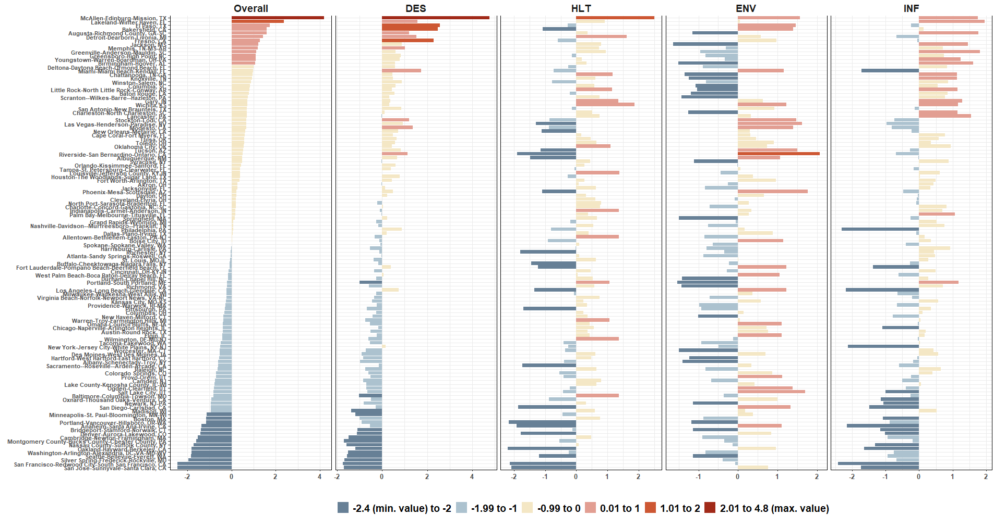
Supplemental Results - Supplemental Results - Figure 1.

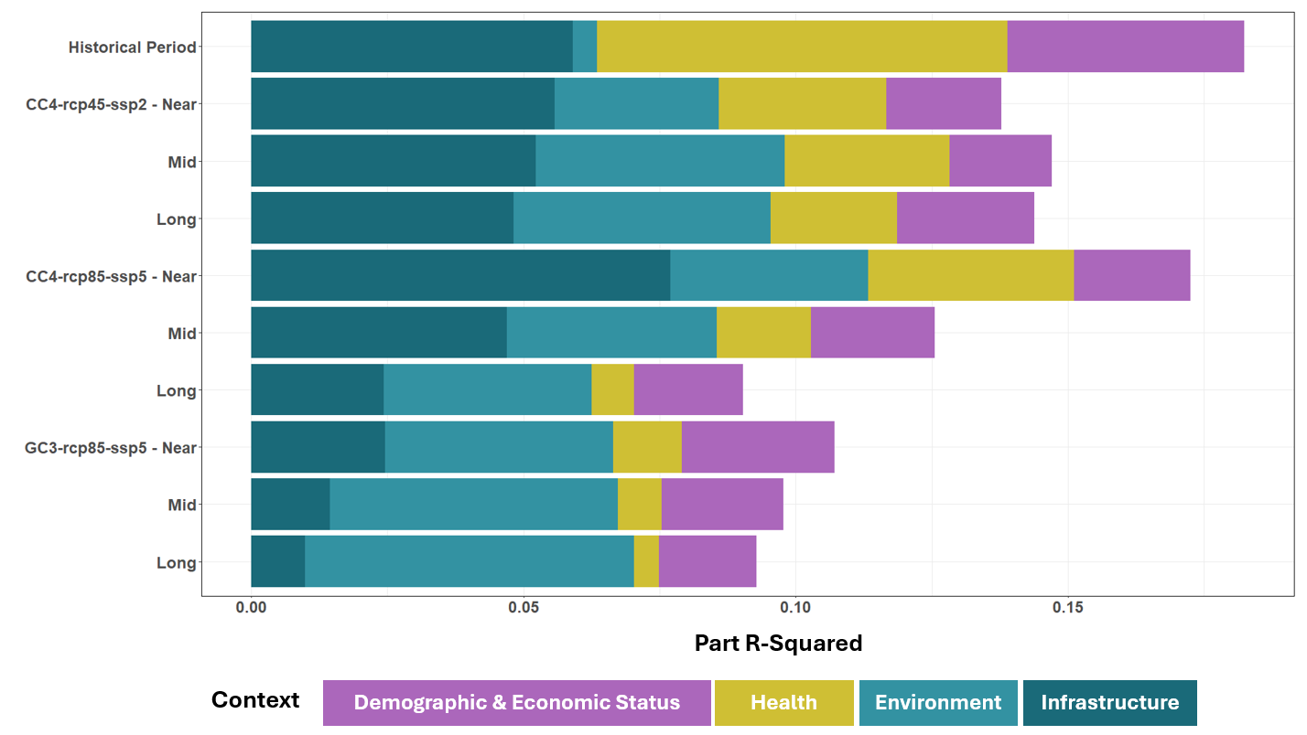
Supplemental Results - Supplemental Results - Figure 2.

Supplemental Text.
The final set of variables used to generate the UHHR scores in the DES and HLT contexts for the 80 MSAs were primarily the native values obtained from the data sources. DES variables included median household income; percent of population without a high school an education or equivalent; percent of population without health insurance coverage; percent of population with management, business, science, and arts occupations; and percent of housing units that are mobile homes from the U.S. Census American Community Survey 2015-2019, energy burden for June-September, 2018 (Shen et al., 2023), and number of civic and social organizations per 1,000 people from the Climate Vulnerability Index (Tee Lewis et al., 2023). For the HLT context, the selected variables were derived from the Medicare dataset used in this study, including prevalence of chronic kidney disease, acute myocardial infarction and depression in 2019, and changes in prevalence of congestive heart failure during 2011-2019.
Unlike the variables in the DES and HLT contexts, many of the variables in the ENV and INF contexts required additional geoprocessing to aggregate to the MSA level. The included variables for the ENV context were grouped into two categories: potential environmental resilience and historical natural hazards. For the potential environmental resilience, the selected variables were percent of tree canopy, ratio of tree canopy to imperviousness, and ratio of tree canopy in urban versus to tree canopy non-urban areas. These were derived using three datasets at 30-m resolution: 2019 USFS Percent Tree Canopy Cover (Coulston et al., 2012), 2019 National Land Cover Database (NLCD) Percent Imperviousness (Wickham et al., 2013), and 2020 Dasymetric Population (Baynes et al., 2022). Zonal statistics were applied to obtain the mean values of percent tree canopy and percent imperviousness. Ratio of tree canopy to imperviousness for each CBSA was derived by using percent tree canopy divided by percent imperviousness. Ratio of tree canopy in urban areas to non-urban areas was derived by first dichotomizing pixels as urban and non-urban masks in the 2020 Dasymetric Population layer using a threshold of 5 (representing a population density of around 5,600 people per square kilometer, which is the population density of the 50th-most populated city in the U.S.), then extracting tree canopy within the urban and non-urban masks to obtain each mean value, and lastly deriving the ratio using the mean tree canopy in the urban mask divided by the mean tree canopy in the non-urban mask for each MSA.
For the historical natural hazards in the ENV context, annualized frequency of drought and wildfire variables were obtained directly from the county-level National Risk Index (Zuzak et al., 2022) and area-weighted to aggregate to the MSA level. Estimates of particulate matter of 2.5 micrometers or less in diameter (PM_{2.5}) were obtained from satellite-derived measures developed by the Atmospheric Composition Analysis Group at Washington University in St. Louis, Missouri, USA (Shen et al., 2024). Mean values of PM_{2.5} for the summer months across 2000-2019 were calculated using zonal statistics.
For the INF context, variables were selected to represent accessibility to places for responding to extreme heat and active transportation. The variables that represent accessibility to places for responding to heat were the median distance to the closest medical facilities, percent population living >15 kilometers away from any medical facilities, and total number of potential cooling places per square kilometer. The first two variables were derived using the NEAR function (ESRI ArcGIS Pro 3.5.2 Near function) to calculate each pair of distances between the centroid of each census block group within each CBSA and the locations of hospitals and urgent care facilities, obtained from the Homeland Infrastructure Foundation-Level Data (HIFLD, 2024). Median distance to the closest hospital or urgent care facilities was then summarized for each MSA, and percent of population living >15 kilometers away from any medical facilities was calculated by the sum of the population in the census block groups who lived >15 kilometers away from any medical facilities in each MSA divided by the total population in the MSA. The total number of potential cooling places per square kilometer was derived by first gathering the total number of settlements in each MSA that are commonly used as cooling centers in response to extreme heat, identified using the North American Industry Classification System (NAICS) codes (Widerynski et al., 2017) from the Census County Business Patterns. A list of the NAICS codes used in this study is described in Supplemental Text – Table 1. This number was then divided by the total land area of the MSA.
The selected variables that represented active transportation were percent population with poor walkability and poor public transportation obtained from the census-tract level Climate Vulnerability Index (Tee Lewis et al., 2023). Poor walkability and public transportation were defined as census tracts with a walkability or public transportation score less than the median value of the walkability and public transportation scores across the nation, respectively. Percent of population with poor walkability and public transportation were calculated using the sum of the population in the census tracts with a value less than the national median value within each MSA divided by the total population in the MSA.

Supplemental Text – Table 1
NAICS | Description
519120 | Libraries and Archives
624210 | Community Food Services
624221 | Temporary Shelters
624229 | Other Community Housing Services
624230 | Emergency and Other Relief Services
624110 | Child and Youth Services
624120 | Services for the Elderly and Persons with Disabilities
624190 | Other Individual and Family Services
813110 | Religious Organizations
712110 | Museums
712120 | Historical Sites
712130 | Zoos and Botanical Gardens
712190 | Nature Parks and Other Similar Institutions
445110 | Supermarkets and Other Grocery (except Convenience) Stores
445120 | Convenience Stores
445210 | Meat Markets
445220 | Fish and Seafood Markets
445291 | Baked Goods Stores
445292 | Confectionery and Nut Stores
445299 | All Other Specialty Food Stores
445310 | Beer, Wine, and Liquor Stores
446110 | Pharmacies and Drug Stores
446120 | Cosmetics, Beauty Supplies, and Perfume Stores
446130 | Optical Goods Stores
446199 | All Other Health and Personal Care Stores
447110 | Gasoline Stations with Convenience Stores
447190 | Other Gasoline Stations
448110 | Men's Clothing Stores
448120 | Women's Clothing Stores
448130 | Children's and Infants' Clothing Stores
448140 | Family Clothing Stores
448150 | Clothing Accessories Stores
448190 | Other Clothing Stores
448210 | Shoe Stores
448310 | Jewelry Stores
448320 | Luggage and Leather Goods Stores
451110 | Sporting Goods Stores
451120 | Hobby, Toy, and Game Stores
451130 | Sewing, Needlework, and Piece Goods Stores
451140 | Musical Instrument and Supplies Stores
451211 | Book Stores
451212 | News Dealers and Newsstands
452210 | Department Stores
452311 | Warehouse Clubs and Supercenters
452319 | All Other General Merchandise Stores
453110 | Florists
453210 | Office Supplies and Stationery Stores
453220 | Gift, Novelty, and Souvenir Stores
453310 | Used Merchandise Stores
453910 | Pet and Pet Supplies Stores
453991 | Tobacco Stores
453998 | All Other Miscellaneous Store Retailers (except Tobacco Stores)
722410 | Drinking Places (Alcoholic Beverages)
722511 | Full-Service Restaurants
722513 | Limited-Service Restaurants
722514 | Cafeterias, Grill Buffets, and Buffets
722515 | Snack and Nonalcoholic Beverage Bars
812111 | Barber Shops
812112 | Beauty Salons
812113 | Nail Salons
711110 | Theater Companies and Dinner Theaters

References
Baynes, J., et al., 2022. Improving intelligent dasymetric mapping population density estimates at 30 m resolution for the conterminous united states by excluding uninhabited areas. Earth Syst. Sci. Data 14, 2833–2849
Coulston, J. W., et al., 2012. Modeling percent tree canopy cover: A pilot study. Photogrammetric Engineering and Remote Sensing. 78, 715-727.
ESRI ArcGIS Pro 3.5.2 Near function, https://pro.arcgis.com/en/pro-app/latest/tool-reference/analysis/near.htm
HIFLD, 2024. Homeland Infrastructure Foundation-Level Data available at https://hifld-geoplatform.hub.arcgis.com/pages/hifld-open. Accessed on 6 March 2024.
Tee Lewis, P. G., et al., 2023. Characterizing vulnerabilities to climate change across the United States. Environment International. 172, 107772.
Wickham, J. D., et al., 2013. Accuracy assessment of NLCD 2006 land cover and impervious surface. Remote Sensing of Environment. 130, 294-304.
Widerynski, S., et al., 2017. Use of cooling centers to prevent heat-related illness: Summary of evidence and strategies for implementation.
Zuzak, C., et al., 2022. The national risk index: Establishing a nationwide baseline for natural hazard risk in the US. Natural Hazards. 114, 2331-2355.

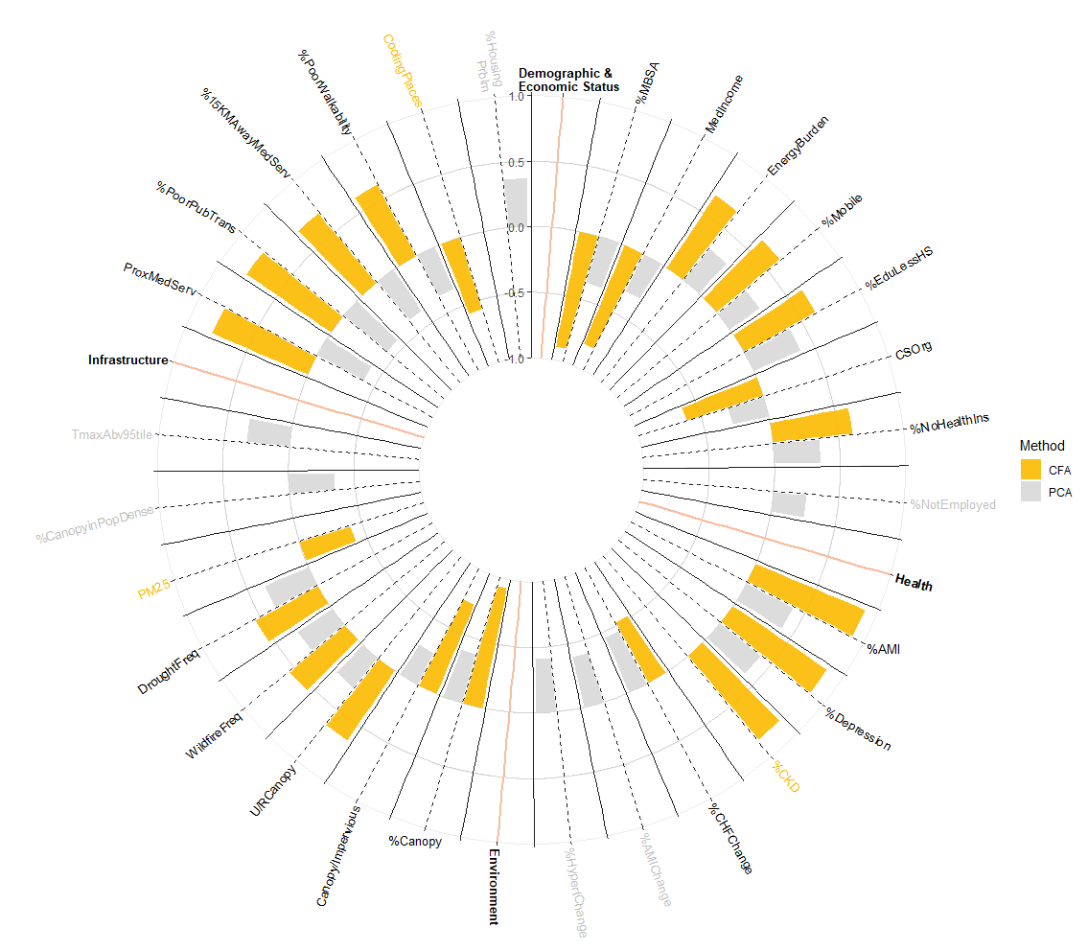
Supplemental Figure 1

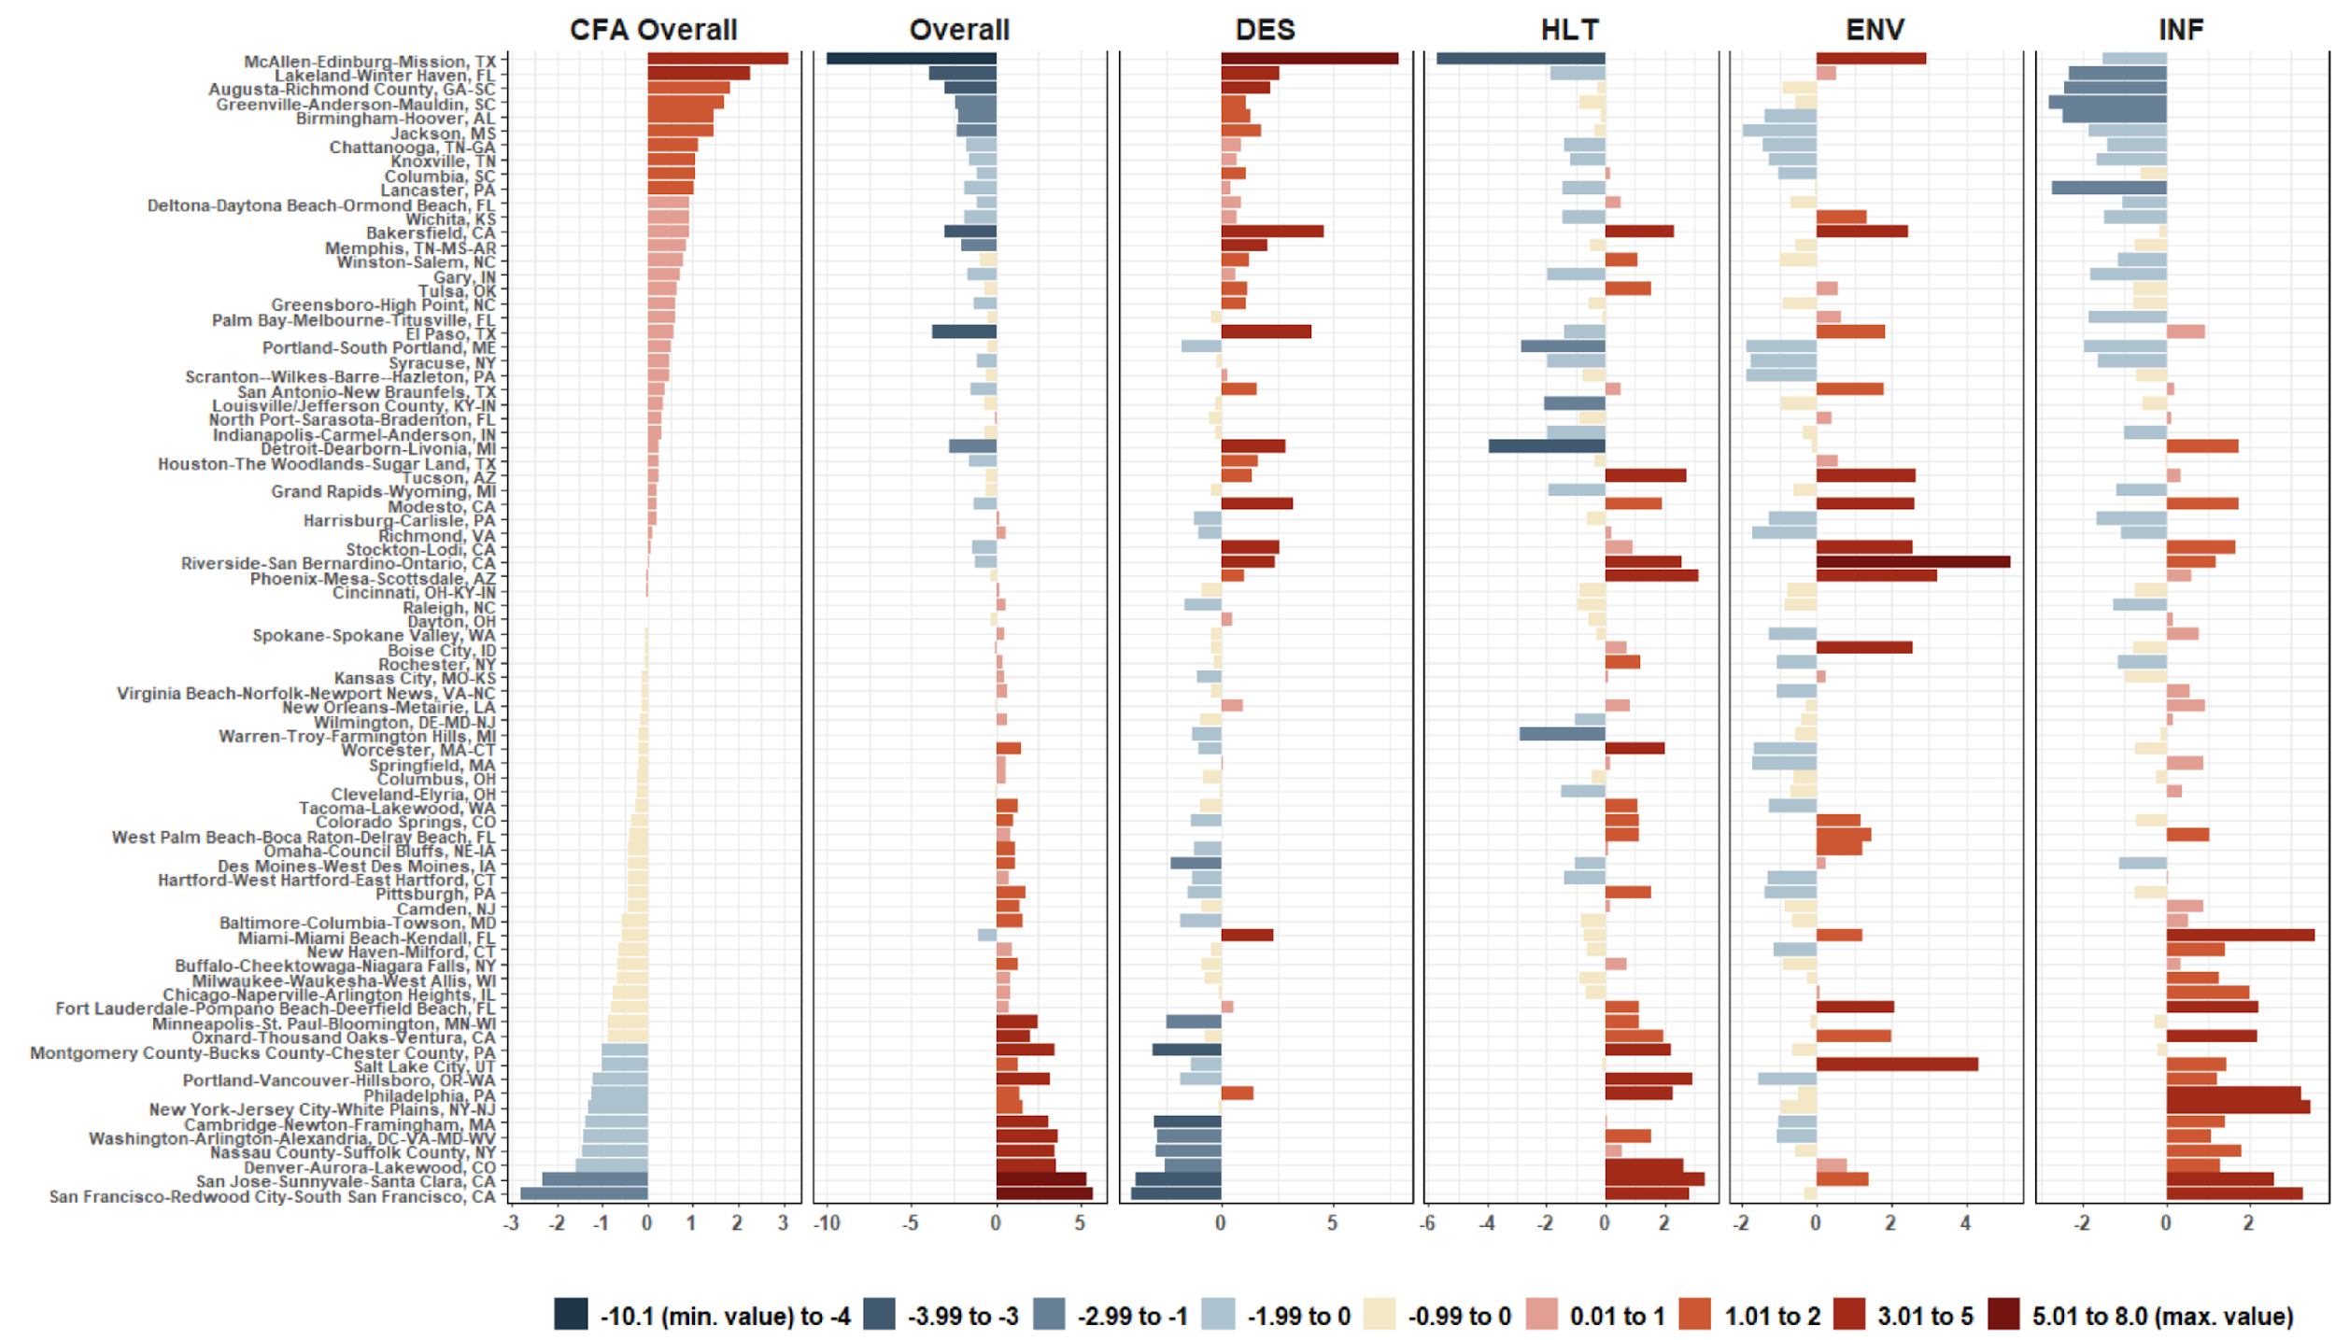
Supplemental Figure 2.

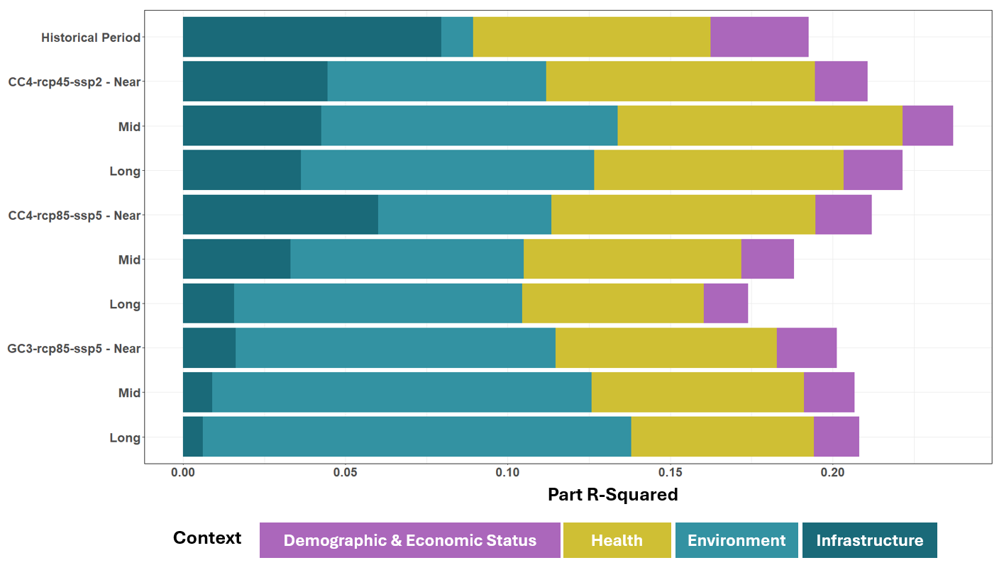
Supplemental Figure 3.

Supplemental Table 1. Population, total area of land (Land Area) and water (Water Area) in square kilometer, population density, and percent urban area within the Metropolitan Statistical Area (MSA) classified as urban area based on the 2010 Census Urban and Rural Classification for the 80 selected MSAs in this study.
MSA Name | Population | Land Area | Water Area | Population Density | Percent Urban Area
Augusta-Richmond County, GA-SC | 564,873 | 9,014.9 | 262.9 | 62.7 | 7.8%
Bakersfield, CA | 839,631 | 21,061.6 | 79.6 | 39.9 | 2.7%
Baltimore-Columbia-Towson, MD | 2,710,489 | 6,737.8 | 1,304.2 | 402.3 | 30.5%
Birmingham-Hoover, AL | 1,128,047 | 13,673.9 | 233.8 | 82.5 | 11.2%
Boise City, ID | 616,561 | 30,472.7 | 175.6 | 20.2 | 1.9%
Buffalo-Cheektowaga-Niagara Falls, NY | 1,135,509 | 4,053.5 | 2,075.8 | 280.1 | 18.1%
Cambridge-Newton-Framingham, MA | 2,246,244 | 3,393.9 | 945.7 | 661.9 | 57.8%
Camden, NJ | 1,250,679 | 3,475.4 | 110.0 | 359.9 | 39.6%
Chattanooga, TN-GA | 528,143 | 5,410.4 | 126.5 | 97.6 | 15.3%
Chicago-Naperville-Arlington Heights, IL | 7,262,718 | 8,938.8 | 1,897.9 | 812.5 | 42.4%
Cincinnati, OH-KY-IN | 2,114,580 | 10,796.8 | 184.5 | 195.8 | 21.7%
Cleveland-Elyria, OH | 2,077,240 | 5,173.0 | 5,133.7 | 401.6 | 20.9%
Colorado Springs, CO | 645,613 | 6,951.2 | 12.1 | 92.9 | 7.4%
Columbia, SC | 767,598 | 9,590.1 | 340.0 | 80.0 | 11.0%
Columbus, OH | 1,901,974 | 12,422.9 | 139.3 | 153.1 | 13.1%
Dayton, OH | 799,232 | 3,320.0 | 21.7 | 240.7 | 26.4%
Deltona-Daytona Beach-Ormond Beach, FL | 590,289 | 4,109.0 | 1,079.4 | 143.7 | 14.5%
Denver-Aurora-Lakewood, CO | 2,543,482 | 21,616.2 | 147.2 | 117.7 | 8.3%
Des Moines-West Des Moines, IA | 569,633 | 7,468.7 | 72.8 | 76.3 | 7.6%
Detroit-Dearborn-Livonia, MI | 1,820,584 | 1,585.3 | 156.9 | 1,148.4 | 82.2%
El Paso, TX | 804,123 | 14,461.7 | 8.1 | 55.6 | 4.2%
Fort Lauderdale-Pompano Beach-Deerfield Beach, FL | 1,748,066 | 3,133.3 | 292.9 | 557.9 | 30.7%
Gary, IN | 708,070 | 4,865.3 | 607.8 | 145.5 | 16.2%
Grand Rapids-Wyoming, MI | 988,938 | 6,912.4 | 2,932.7 | 143.1 | 10.6%
Greensboro-High Point, NC | 723,801 | 5,163.8 | 67.1 | 140.2 | 17.3%
Greenville-Anderson-Mauldin, SC | 824,112 | 7,020.8 | 200.5 | 117.4 | 17.5%
Harrisburg-Carlisle, PA | 549,475 | 4,200.8 | 109.0 | 130.8 | 14.1%
Hartford-West Hartford-East Hartford, CT | 1,212,381 | 3,922.8 | 238.6 | 309.1 | 41.5%
Houston-The Woodlands-Sugar Land, TX | 5,920,416 | 21,388.8 | 3,070.6 | 276.8 | 21.8%
Indianapolis-Carmel-Anderson, IN | 1,887,877 | 11,153.5 | 88.9 | 169.3 | 18.9%
Jackson, MS | 567,122 | 12,041.1 | 207.9 | 47.1 | 6.0%
Kansas City, MO-KS | 2,009,342 | 18,791.9 | 304.9 | 106.9 | 11.0%
Knoxville, TN | 8,37,571 | 9,066.3 | 386.6 | 92.4 | 13.3%
Lakeland-Winter Haven, FL | 602,095 | 4,656.4 | 550.9 | 129.3 | 18.0%
Lancaster, PA | 519,445 | 2,444.5 | 103.6 | 212.5 | 26.4%
Louisville/Jefferson County, KY-IN | 1,235,708 | 9,267.8 | 160.6 | 133.3 | 14.3%
McAllen-Edinburg-Mission, TX | 774,769 | 4,068.5 | 31.2 | 190.4 | 22.9%
Memphis, TN-MS-AR | 1,324,829 | 12,909.7 | 320.2 | 102.6 | 10.8%
Miami-Miami Beach-Kendall, FL | 2,496,435 | 4,915.1 | 1,381.7 | 507.9 | 18.6%
Milwaukee-Waukesha-West Allis, WI | 1,555,908 | 3,767.8 | 4,836.3 | 412.9 | 18.4%
Minneapolis-St. Paul-Bloomington, MN-WI | 3,348,859 | 19,779.8 | 1,250.1 | 169.3 | 16.0%
Modesto, CA | 514,453 | 3,871.6 | 51.4 | 132.9 | 7.9%
Montgomery County-Bucks County-Chester County, PA | 1,924,009 | 4,760.0 | 78.9 | 404.2 | 54.7%
Nassau County-Suffolk County, NY | 2,832,882 | 3,099.6 | 4,220.6 | 914.0 | 30.6%
New Haven-Milford, CT | 862,477 | 1,565.7 | 667.1 | 550.9 | 51.7%
New Orleans-Metairie, LA | 1,189,866 | 8,292.4 | 12,120.1 | 143.5 | 5.5%
New York-Jersey City-White Plains, NY-NJ | 13,866,159 | 9,294.6 | 2,143.1 | 1,491.8 | 49.4%
North Port-Sarasota-Bradenton, FL | 702,281 | 3,363.9 | 826.8 | 208.8 | 22.7%
Omaha-Council Bluffs, NE-IA | 865,350 | 11,265.5 | 149.0 | 76.8 | 6.6%
Oxnard-Thousand Oaks-Ventura, CA | 823,318 | 4,773.7 | 946.0 | 172.5 | 10.2%
Palm Bay-Melbourne-Titusville, FL | 543,376 | 2,630.6 | 1,402.0 | 206.6 | 20.3%
Philadelphia, PA | 2,084,985 | 823.5 | 39.8 | 2,531.9 | 93.6%
Phoenix-Mesa-Scottsdale, AZ | 4,192,887 | 37,725.1 | 85.1 | 111.1 | 9.0%
Pittsburgh, PA | 2,356,285 | 13,679.0 | 157.9 | 172.3 | 20.0%
Portland-South Portland, ME | 514,098 | 5,386.3 | 2,013.9 | 95.5 | 7.4%
Portland-Vancouver-Hillsboro, OR-WA | 2,226,009 | 17,310.8 | 356.4 | 128.6 | 8.9%
Raleigh, NC | 1,130,490 | 5,486.1 | 75.4 | 206.1 | 26.8%
Richmond, VA | 1,208,101 | 11,851.9 | 328.2 | 101.9 | 10.8%
Riverside-San Bernardino-Ontario, CA | 4,224,851 | 70,611.9 | 375.1 | 59.8 | 4.9%
Rochester, NY | 1,079,671 | 8,459.6 | 5,126.9 | 127.6 | 7.8%
Salt Lake City, UT | 1,087,873 | 19,900.5 | 1,061.4 | 54.7 | 3.7%
San Antonio-New Braunfels, TX | 2,142,508 | 18,939.7 | 150.8 | 113.1 | 9.0%
San Francisco-Redwood City-South San Francisco, CA | 1,523,686 | 1,282.8 | 1,236.9 | 1,187.8 | 19.5%
San Jose-Sunnyvale-Santa Clara, CA | 1,836,911 | 6,938.1 | 40.7 | 264.8 | 12.7%
Scranton--Wilkes-Barre--Hazleton, PA | 563,631 | 4,524.0 | 76.4 | 124.6 | 11.9%
Spokane-Spokane Valley, WA | 527,753 | 14,611.5 | 272.3 | 36.1 | 3.2%
Springfield, MA | 621,570 | 2,964.0 | 90.8 | 209.7 | 24.2%
Stockton-Lodi, CA | 685,306 | 3,603.5 | 91.1 | 190.2 | 11.1%
Syracuse, NY | 662,577 | 6,176.8 | 1,020.7 | 107.3 | 8.7%
Tacoma-Lakewood, WA | 795,225 | 4,324.0 | 354.7 | 183.9 | 19.5%
Tucson, AZ | 980,263 | 23,794.3 | 5.3 | 41.2 | 4.3%
Tulsa, OK | 937,478 | 16,237.2 | 494.3 | 57.7 | 6.2%
Virginia Beach-Norfolk-Newport News, VA-NC | 1,676,822 | 6,969.9 | 3,216.6 | 240.6 | 16.0%
Warren-Troy-Farmington Hills, MI | 2,475,666 | 8,485.6 | 742.2 | 291.8 | 29.4%
Washington-Arlington-Alexandria, DC-VA-MD-WV | 4,431,070 | 13,189.0 | 1,070.5 | 336.0 | 24.3%
West Palm Beach-Boca Raton-Delray Beach, FL | 1,320,134 | 5,101.7 | 1,070.3 | 258.8 | 19.9%
Wichita, KS | 630,919 | 12,982.1 | 92.1 | 48.6 | 5.0%
Wilmington, DE-MD-NJ | 705,670 | 2,860.5 | 465.4 | 246.7 | 23.0%
Winston-Salem, NC | 640,595 | 5,202.3 | 81.1 | 123.1 | 18.0%
Worcester, MA-CT | 916,980 | 5,241.3 | 199.3 | 174.9 | 22.5%

Supplemental Table 2.
 |  | Near Term (2025 – 2054) |  |  | Mid Term (2045 – 2074) |  |  | Long Term (2070 – 2099)
MSA Name | # ZCTA | MSA_Mean | Mean (sd) | IQR | MSA_Mean | Mean (sd) | IQR | MSA_Mean | Mean (sd) | IQR
Augusta-Richmond County, GA-SC | 45 | 29.3 | 29.4 (0.1) | 0.2 | 29.6 | 29.6 (0.1) | 0.2 | 29.7 | 29.8 (0.1) | 0.2
Bakersfield, CA | 52 | 30.3 | 30.7 (0.9) | 1.5 | 30.4 | 30.9 (1.0) | 1.7 | 30.5 | 30.9 (1.0) | 1.8
Baltimore-Columbia-Towson, MD | 163 | 27.8 | 28.0 (0.3) | 0.4 | 28.0 | 28.2 (0.3) | 0.4 | 28.2 | 28.4 (0.3) | 0.4
Birmingham-Hoover, AL | 133 | 28.6 | 28.7 (0.1) | 0.2 | 28.9 | 29.0 (0.1) | 0.2 | 29.2 | 29.3 (0.2) | 0.2
Boise City, ID | 40 | 26.5 | 27.3 (0.5) | 0.8 | 26.6 | 27.5 (0.6) | 0.8 | 26.6 | 27.5 (0.6) | 0.9
Buffalo-Cheektowaga-Niagara Falls, NY | 86 | 25.1 | 25.2 (0.4) | 0.4 | 25.3 | 25.4 (0.4) | 0.4 | 25.4 | 25.6 (0.4) | 0.5
Cambridge-Newton-Framingham, MA | 125 | 25.4 | 25.6 (0.1) | 0.1 | 25.7 | 25.8 (0.1) | 0.2 | 25.9 | 26.0 (0.1) | 0.2
Camden, NJ | 103 | 27.5 | 27.6 (0.2) | 0.3 | 27.7 | 27.8 (0.2) | 0.3 | 27.8 | 28.0 (0.2) | 0.3
Chattanooga, TN-GA | 54 | 27.7 | 28.0 (0.3) | 0.5 | 28.0 | 28.3 (0.3) | 0.5 | 28.3 | 28.6 (0.3) | 0.6
Chicago-Naperville-Arlington Heights, IL | 273 | 26.7 | 26.9 (0.3) | 0.4 | 27.1 | 27.3 (0.3) | 0.5 | 27.4 | 27.6 (0.3) | 0.5
Cincinnati, OH-KY-IN | 153 | 26.9 | 27.1 (0.2) | 0.4 | 27.3 | 27.5 (0.3) | 0.5 | 27.7 | 27.8 (0.3) | 0.5
Cleveland-Elyria, OH | 99 | 26.0 | 26.1 (0.1) | 0.2 | 26.3 | 26.4 (0.2) | 0.3 | 26.5 | 26.6 (0.2) | 0.4
Colorado Springs, CO | 47 | 23.5 | 23.8 (0.7) | 1.1 | 23.6 | 24.0 (0.9) | 1.3 | 23.7 | 24.0 (0.8) | 1.1
Columbia, SC | 51 | 29.7 | 29.8 (0.2) | 0.4 | 29.9 | 30.0 (0.3) | 0.4 | 30.0 | 30.2 (0.3) | 0.4
Columbus, OH | 133 | 26.4 | 26.5 (0.3) | 0.4 | 26.7 | 26.9 (0.3) | 0.5 | 27.0 | 27.1 (0.3) | 0.5
Dayton, OH | 64 | 26.8 | 26.9 (0.2) | 0.4 | 27.2 | 27.3 (0.3) | 0.4 | 27.5 | 27.6 (0.3) | 0.5
Deltona-Daytona Beach-Ormond Beach, FL | 30 | 29.1 | 29.1 (0.1) | 0.1 | 29.2 | 29.2 (0.1) | 0.1 | 29.4 | 29.4 (0.1) | 0.0
Denver-Aurora-Lakewood, CO | 131 | 23.0 | 24.3 (0.8) | 0.6 | 23.1 | 24.6 (0.9) | 0.7 | 23.2 | 24.6 (1.0) | 0.8
Des Moines-West Des Moines, IA | 79 | 27.2 | 27.3 (0.2) | 0.4 | 27.7 | 27.9 (0.3) | 0.4 | 28.1 | 28.3 (0.3) | 0.4
Detroit-Dearborn-Livonia, MI | 73 | 26.4 | 26.5 (0.1) | 0.1 | 26.7 | 26.8 (0.1) | 0.1 | 26.9 | 27.0 (0.1) | 0.2
El Paso, TX | 36 | 30.5 | 30.9 (0.2) | 0.2 | 30.7 | 31.2 (0.2) | 0.2 | 30.9 | 31.2 (0.2) | 0.1
Fort Lauderdale-Pompano Beach-Deerfield Beach, FL | 54 | 29.8 | 29.8 (0.1) | 0.1 | 29.9 | 29.9 (0.1) | 0.1 | 30.1 | 30.1 (0.1) | 0.1
Gary, IN | 54 | 26.7 | 26.9 (0.2) | 0.3 | 27.1 | 27.3 (0.2) | 0.3 | 27.3 | 27.5 (0.3) | 0.5
Grand Rapids-Wyoming, MI | 75 | 25.3 | 25.3 (0.2) | 0.3 | 25.7 | 25.7 (0.2) | 0.3 | 25.8 | 25.9 (0.3) | 0.4
Greensboro-High Point, NC | 43 | 28.0 | 28.0 (0.1) | 0.1 | 28.3 | 28.4 (0.1) | 0.1 | 28.5 | 28.6 (0.1) | 0.1
Greenville-Anderson-Mauldin, SC | 57 | 28.5 | 28.5 (0.2) | 0.2 | 28.8 | 28.8 (0.2) | 0.2 | 29.0 | 29.0 (0.2) | 0.2
Harrisburg-Carlisle, PA | 72 | 26.6 | 26.8 (0.3) | 0.5 | 27.0 | 27.1 (0.3) | 0.5 | 27.2 | 27.3 (0.3) | 0.6
Hartford-West Hartford-East Hartford, CT | 100 | 25.6 | 25.7 (0.2) | 0.5 | 25.9 | 26.0 (0.3) | 0.5 | 26.0 | 26.1 (0.3) | 0.6
Houston-The Woodlands-Sugar Land, TX | 240 | 30.1 | 30.2 (0.1) | 0.2 | 30.2 | 30.3 (0.2) | 0.2 | 30.4 | 30.4 (0.2) | 0.2
Indianapolis-Carmel-Anderson, IN | 133 | 26.7 | 26.8 (0.1) | 0.2 | 27.2 | 27.3 (0.2) | 0.2 | 27.5 | 27.6 (0.2) | 0.2
Jackson, MS | 50 | 28.9 | 29.0 (0.2) | 0.2 | 29.3 | 29.4 (0.2) | 0.3 | 29.6 | 29.7 (0.2) | 0.4
Kansas City, MO-KS | 215 | 29.0 | 29.2 (0.3) | 0.4 | 29.7 | 30.0 (0.4) | 0.4 | 30.2 | 30.4 (0.4) | 0.4
Knoxville, TN | 76 | 26.8 | 27.0 (0.3) | 0.5 | 27.2 | 27.4 (0.4) | 0.6 | 27.4 | 27.7 (0.5) | 0.7
Lakeland-Winter Haven, FL | 39 | 29.3 | 29.3 (0.1) | 0.1 | 29.4 | 29.5 (0.1) | 0.1 | 29.6 | 29.6 (0.1) | 0.1
Lancaster, PA | 63 | 26.8 | 26.9 (0.1) | 0.1 | 27.1 | 27.2 (0.1) | 0.2 | 27.3 | 27.4 (0.1) | 0.2
Louisville/Jefferson County, KY-IN | 109 | 27.9 | 28.1 (0.3) | 0.5 | 28.4 | 28.6 (0.3) | 0.5 | 28.7 | 28.9 (0.4) | 0.6
McAllen-Edinburg-Mission, TX | 29 | 31.5 | 31.5 (0.2) | 0.2 | 31.7 | 31.7 (0.3) | 0.2 | 31.8 | 31.8 (0.3) | 0.2
Memphis, TN-MS-AR | 87 | 29.4 | 29.6 (0.3) | 0.3 | 29.8 | 30.0 (0.3) | 0.3 | 30.2 | 30.4 (0.3) | 0.3
Miami-Miami Beach-Kendall, FL | 80 | 29.8 | 29.8 (0.1) | 0.1 | 29.9 | 29.9 (0.1) | 0.2 | 30.1 | 30.1 (0.1) | 0.1
Milwaukee-Waukesha-West Allis, WI | 88 | 25.4 | 25.6 (0.3) | 0.5 | 25.8 | 26.0 (0.3) | 0.5 | 26.0 | 26.3 (0.3) | 0.5
Minneapolis-St. Paul-Bloomington, MN-WI | 244 | 25.9 | 26.1 (0.2) | 0.3 | 26.3 | 26.5 (0.3) | 0.3 | 26.6 | 26.8 (0.3) | 0.4
Modesto, CA | 29 | 28.1 | 28.3 (0.2) | 0.1 | 28.2 | 28.4 (0.2) | 0.1 | 28.3 | 28.4 (0.2) | 0.1
Montgomery County-Bucks County-Chester County, PA | 143 | 26.9 | 27.1 (0.2) | 0.3 | 27.2 | 27.4 (0.2) | 0.3 | 27.4 | 27.5 (0.2) | 0.3
Nassau County-Suffolk County, NY | 177 | 26.3 | 26.4 (0.2) | 0.3 | 26.5 | 26.6 (0.3) | 0.4 | 26.6 | 26.7 (0.3) | 0.4
New Haven-Milford, CT | 41 | 25.6 | 25.6 (0.1) | 0.3 | 25.9 | 25.9 (0.1) | 0.2 | 26.0 | 26.1 (0.1) | 0.2
New Orleans-Metairie, LA | 96 | 29.5 | 29.6 (0.2) | 0.3 | 29.6 | 29.8 (0.2) | 0.3 | 29.8 | 30.0 (0.2) | 0.4
New York-Jersey City-White Plains, NY-NJ | 590 | 26.7 | 27.1 (0.4) | 0.6 | 27.0 | 27.4 (0.4) | 0.6 | 27.2 | 27.6 (0.4) | 0.7
North Port-Sarasota-Bradenton, FL | 46 | 29.2 | 29.3 (0.1) | 0.1 | 29.3 | 29.5 (0.1) | 0.1 | 29.5 | 29.6 (0.1) | 0.1
Omaha-Council Bluffs, NE-IA | 118 | 28.0 | 28.2 (0.2) | 0.3 | 28.7 | 28.8 (0.2) | 0.3 | 29.1 | 29.3 (0.2) | 0.2
Oxnard-Thousand Oaks-Ventura, CA | 27 | 23.7 | 24.0 (0.4) | 0.4 | 23.8 | 24.1 (0.5) | 0.6 | 23.7 | 24.1 (0.6) | 0.6
Palm Bay-Melbourne-Titusville, FL | 30 | 29.1 | 29.2 (0.0) | 0.1 | 29.3 | 29.3 (0.0) | 0.0 | 29.5 | 29.5 (0.1) | 0.1
Philadelphia, PA | 86 | 27.8 | 27.9 (0.2) | 0.3 | 28.0 | 28.1 (0.1) | 0.2 | 28.2 | 28.3 (0.1) | 0.3
Phoenix-Mesa-Scottsdale, AZ | 162 | 36.3 | 36.5 (0.2) | 0.2 | 36.4 | 36.6 (0.2) | 0.3 | 36.4 | 36.7 (0.3) | 0.3
Pittsburgh, PA | 368 | 25.5 | 25.7 (0.2) | 0.3 | 25.8 | 26.0 (0.3) | 0.4 | 26.0 | 26.2 (0.3) | 0.4
Portland-South Portland, ME | 91 | 23.6 | 23.7 (0.1) | 0.2 | 23.8 | 24.0 (0.1) | 0.2 | 23.9 | 24.0 (0.1) | 0.2
Portland-Vancouver-Hillsboro, OR-WA | 139 | 22.6 | 23.0 (0.3) | 0.5 | 22.8 | 23.3 (0.3) | 0.4 | 22.7 | 23.3 (0.3) | 0.5
Raleigh, NC | 52 | 28.6 | 28.7 (0.1) | 0.1 | 28.8 | 28.9 (0.1) | 0.1 | 29.0 | 29.1 (0.1) | 0.1
Richmond, VA | 93 | 28.3 | 28.4 (0.1) | 0.2 | 28.6 | 28.6 (0.1) | 0.2 | 28.8 | 28.8 (0.1) | 0.2
Riverside-San Bernardino-Ontario, CA | 158 | 31.3 | 30.7 (1.4) | 1.4 | 31.7 | 30.9 (1.5) | 1.5 | 31.8 | 31.0 (1.5) | 1.6
Rochester, NY | 110 | 25.2 | 25.3 (0.2) | 0.3 | 25.5 | 25.6 (0.2) | 0.3 | 25.7 | 25.8 (0.3) | 0.4
Salt Lake City, UT | 46 | 28.0 | 28.2 (0.7) | 0.9 | 28.2 | 28.4 (0.8) | 1.0 | 28.3 | 28.4 (0.7) | 0.9
San Antonio-New Braunfels, TX | 118 | 30.9 | 31.0 (0.2) | 0.2 | 31.0 | 31.2 (0.2) | 0.3 | 31.1 | 31.3 (0.2) | 0.2
San Francisco-Redwood City-South San Francisco, CA | 60 | 21.0 | 21.2 (0.2) | 0.2 | 21.1 | 21.2 (0.2) | 0.2 | 21.0 | 21.2 (0.2) | 0.2
San Jose-Sunnyvale-Santa Clara, CA | 70 | 23.5 | 23.5 (0.4) | 0.3 | 23.5 | 23.5 (0.4) | 0.3 | 23.5 | 23.5 (0.4) | 0.4
Scranton--Wilkes-Barre--Hazleton, PA | 76 | 24.9 | 25.1 (0.2) | 0.3 | 25.2 | 25.4 (0.3) | 0.3 | 25.4 | 25.6 (0.3) | 0.3
Spokane-Spokane Valley, WA | 63 | 24.0 | 24.6 (0.5) | 0.9 | 24.3 | 24.9 (0.6) | 0.9 | 24.3 | 24.9 (0.5) | 0.8
Springfield, MA | 71 | 25.2 | 25.3 (0.4) | 0.5 | 25.5 | 25.6 (0.4) | 0.5 | 25.7 | 25.8 (0.4) | 0.5
Stockton-Lodi, CA | 32 | 27.3 | 27.3 (0.2) | 0.3 | 27.4 | 27.4 (0.2) | 0.3 | 27.5 | 27.5 (0.2) | 0.3
Syracuse, NY | 100 | 24.7 | 24.8 (0.4) | 0.7 | 25.0 | 25.1 (0.4) | 0.7 | 25.1 | 25.2 (0.4) | 0.7
Tacoma-Lakewood, WA | 62 | 20.7 | 21.0 (0.1) | 0.2 | 21.0 | 21.2 (0.1) | 0.1 | 21.0 | 21.3 (0.1) | 0.1
Tucson, AZ | 47 | 33.2 | 33.2 (0.4) | 0.3 | 33.3 | 33.5 (0.4) | 0.4 | 33.5 | 33.6 (0.5) | 0.4
Tulsa, OK | 91 | 30.5 | 30.7 (0.2) | 0.2 | 31.1 | 31.2 (0.2) | 0.2 | 31.5 | 31.6 (0.2) | 0.3
Virginia Beach-Norfolk-Newport News, VA-NC | 116 | 28.5 | 28.7 (0.1) | 0.2 | 28.7 | 28.8 (0.2) | 0.3 | 28.8 | 28.9 (0.2) | 0.4
Warren-Troy-Farmington Hills, MI | 159 | 25.9 | 26.0 (0.1) | 0.2 | 26.1 | 26.3 (0.2) | 0.2 | 26.3 | 26.4 (0.2) | 0.2
Washington-Arlington-Alexandria, DC-VA-MD-WV | 295 | 27.7 | 27.9 (0.2) | 0.3 | 28.0 | 28.1 (0.2) | 0.3 | 28.2 | 28.4 (0.2) | 0.3
West Palm Beach-Boca Raton-Delray Beach, FL | 53 | 29.6 | 29.7 (0.1) | 0.1 | 29.6 | 29.7 (0.1) | 0.1 | 29.8 | 29.9 (0.1) | 0.1
Wichita, KS | 86 | 30.4 | 30.5 (0.3) | 0.2 | 31.0 | 31.1 (0.3) | 0.3 | 31.5 | 31.5 (0.3) | 0.3
Wilmington, DE-MD-NJ | 60 | 27.6 | 27.7 (0.1) | 0.1 | 27.9 | 27.9 (0.1) | 0.2 | 28.0 | 28.1 (0.1) | 0.2
Winston-Salem, NC | 38 | 27.6 | 27.6 (0.2) | 0.3 | 28.0 | 28.0 (0.2) | 0.3 | 28.2 | 28.2 (0.2) | 0.3
Worcester, MA-CT | 118 | 25.0 | 25.1 (0.2) | 0.4 | 25.3 | 25.5 (0.2) | 0.4 | 25.5 | 25.6 (0.2) | 0.4

Supplemental Table 3.
Context | Variable code | Description | Year(s) | Source(s)*
DES | %MBSA | Percent population in management, business, science, and arts occupations | 2015 - 2019 | ACS
 | MedIncome | Median household income | 2015 - 2019 | ACS
 | EnergyBurden | Percentage of gross household income spent on energy costs in summer (June to September) | 2018 | Shen et al. (2023)
 | %Mobile | Percent housing units that are mobile homes | 2015 - 2019 | ACS
 | %EduLessHS | Percent population aged 25 and above with an education attainment less than high school or equivalent | 2015 - 2019 | ACS
 | CSOrg | Number of civic and social organizations per 1,000 people | 2003 - 2017 | CVI
 | %NoHealthIns | Percent population without any health insurance | 2015 - 2019 | ACS
 |  | Economic growth | 2015 - 2019 | Bureau of Economic Analysis
 |  | Cost of living | 2024 | EPI
 |  | Percent households with an income less than cost of living | 2015 - 2019, 2024 | ACS & EPI
 |  | GINI Index | 2015 - 2019 | ACS
 |  | Percent families below 150% poverty level | 2015 - 2019 | ACS
 |  | Percent population age 65+ living alone | 2015 - 2019 | ACS
 |  | Percent civilian labor forces age 16+ | 2015 - 2019 | ACS
 |  | Percent household with limited English-speaking status | 2015 - 2019 | ACS
 |  | Percent group quarters populations | 2015 - 2019 | ACS
 |  | Median home value | 2015 - 2019 | ACS
 |  | Dissimilarity index | 2015 - 2019 | ACS†
 |  | Percent owner-occupied housing | 2015 - 2019 | ACS
 |  | Percent occupied housing without vehicles | 2015 - 2019 | ACS
HLT | %AMI | Mean prevalence proportion of acute myocardial infarction | 2019 | CMS
 | %Depression | Mean prevalence proportion of depression | 2019 | CMS
 | %CKD | Mean prevalence proportion of chronic kidney diseases | 2019 | CMS
 | %CHFChange | Mean prevalence proportion of congestive heart failure | 2019 | CMS
 |  | Mean prevalence proportion of diabetes | 2019 | CMS
 |  | Mean prevalence proportion of hypertension | 2019 | CMS
 |  | Mean prevalence proportion of chronic obstructive pulmonary disease | 2019 | CMS
 |  | Mean prevalence proportion of ischemic heart disease | 2019 | CMS
 |  | Change in prevalence proportion of acute myocardial infarction between 2011 and 2019 | 2011, 2019 | CMS
 |  | Change in prevalence proportion of depression between 2011 and 2019 | 2011, 2019 | CMS
 |  | Change in prevalence proportion of chronic kidney diseases between 2011 and 2019 | 2011, 2019 | CMS
 |  | Change in prevalence proportion of congestive heart failure between 2011 and 2019 | 2011, 2019 | CMS
 |  | Change in prevalence proportion of diabetes between 2011 and 2019 | 2011, 2019 | CMS
 |  | Change in prevalence proportion of hypertension between 2011 and 2019 | 2011, 2019 | CMS
 |  | Change in prevalence proportion of chronic obstructive pulmonary disease between 2011 and 2019 | 2011, 2019 | CMS
 |  | Change in prevalence proportion of ischemic heart disease between 2011 and 2019 | 2011, 2019 | CMS
 |  | Percent population age 65+ with disability | 2019 | ACS
ENV | %Canopy | Mean canopy cover | 2019 | MRLC
 | Canopy/Impervious | Ratio of canopy and imperviousness | 2019 | MRLC
 | U/RCanopy | Ratio of canopy in urban versus rural areas | 2019 | MRLC, EnviroAtlas
 | WildfireFreq | Annualized wildfire frequency | 2023 | NRI
 | DroughtFreq | Annualized drought frequency | 2023 | NRI
 | PM25 | PM_{2.5} in summer (June to September) | 2000 - 2019 | Atmospheric composition Analysis Group, Washington University in St. Louis
 |  | Expected annual loss score (18 hazards) | 2000 - 2021 | NRI
 |  | Annualized heat wave frequency | 1996 - 2019 | NRI
 |  | Annual average number of days maximum temperature above 95F | 1990 - 2019 | daymet
 |  | Annual average number of days minimum temperature above 68F | 1990 - 2019 | daymet
 |  | Annual average number of days maximum temperature above 95th percentile | 1990 - 2019 | daymet
 |  | Annual average number of heatwave events (>=3 consecutive days of maximum temperature above 90th percentile) | 1990 - 2019 | daymet
 |  | Mean NO2 | 2000 - 2016 | SEDAC
 |  | Mean O3 | 2000 - 2016 | SEDAC
INF | ProxMedServ | Distance to the nearest medical facility (hospitals, urgent cares) | 2024 | HIFLD, Tiger
 | %PoorPubTrans | Percent population in Census tracts with a Public Transit Performance Score less than the national median score (3.2) | 2019 | CVI
 | %15KMAwayMedServ | Percent population living within greater than 15 km away from a medical facility | 2024 | HIFLD, Tiger
 | %PoorWalkability | Percent population in Census tracts with a Walkability Score less than the national median score (32) | 2022 | CVI
 | CoolingPlaces | Averaged number of potential cooling places per sq. km | 2010 - 2019 | Census
 |  | Percent household with broadband internet | 2015 - 2019 | ACS
 |  | Percent household with 1 or more of the 4 housing unit problems | 2015 - 2019 | CHAS
 |  | Percent housing built before 1990 | 2015 - 2019 | ACS
 |  | Number of hospital beds per 10,000 people | 2016 | CVI
*ACS: U.S. Census American Community Survey 5-Year Estimate; Shen et al. (2023): dataset was obtained through personal communication; CVI: Climate Vulnerability Index; EPI: Economic Policy Institute, https://www.epi.org/resources/budget/; CMS: Center for Medicare and Medicaid Services; MRLC: Multi-Resolution Land Characteristics; EnviroAtlas: U.S. Environmental Protection Agency EnviroAtlas project; NRI: Federal Emergency Management Agency (FEMA) National Risk Index; HIFLD: Homeland Infrastructure Foundation-Level Data; SEDAC: NASA's Socioeconomic Data and Applications Center; Tiger: U.S. Census Bureau Topologically Integrated Geographic Encoding and Referencing system; CHAS: Comprehensive Housing Affordability Strategy.
†used as input to derive values based on methodology by Green, https://coascenters.howard.edu/dissimilarity-index-tutorial

Supplemental Table 4.
 | DES | HLT | ENV | INF
Historical period | 0.032 | 0.069 | 0.007 | 0.064
CC4-RCP45-SSP2
Near-term | 0.041 | 0.026 | 0.035 | 0.047
Mid-term | 0.036 | 0.025 | 0.050 | 0.043
Long-term | 0.042 | 0.019 | 0.052 | 0.040
CC4-RCP85-SSP5
Near-term | 0.046 | 0.033 | 0.039 | 0.063
Mid-term | 0.044 | 0.013 | 0.043 | 0.040
Long-term | 0.037 | 0.005 | 0.044 | 0.021
GC3-RCP85-SSP5
Near-term | 0.046 | 0.009 | 0.048 | 0.022
Mid-term | 0.038 | 0.005 | 0.060 | 0.014
Long-term | 0.033 | 0.003 | 0.068 | 0.010
CC4-rcp45-ssp2: Community Climate System Model (CESM-CCSM4) under RCP 4.5 adjusting for population growth for aged 65 and older under SSP2-4.5
CC4-rcp85-ssp5: Community Climate System Model (CESM-CCSM4) under RCP 8.5 adjusting for population growth for aged 65 and older under SSP5-8.5
GC3-rcp85-ssp5: Geophysical Fluid Dynamics Laboratory Coupled Model (GCM-CM3) under RCP 8.5 adjusting for population growth for aged 65 and older under SSP5-8.5
Supplemental Table 5.
 | Overall | DES | HLT | ENV | INF
Historical period | -0.95 [-2.53, 0.64] | 1.59 [-0.43, 3.61] | -2.97 [-5.28, -0.65] | -1.53 [-4.12, 1.06] | 4.13 [1.66, 6.59]
CC4-rcp45-ssp2 Near-term | -0.97 [-1.64, -0.29] | -0.27 [-1.16, 0.61] | -1.38 [-2.39, -0.36] | 1.70 [0.56, 2.84] | -1.00 [-2.08, 0.08]
Mid-term | -2.00 [-3.42, -0.57] | -0.87 [-2.71, 0.97] | -3.12 [-5.23, -1.01] | 4.17 [1.80, 6.53] | -2.13 [-4.38, 0.12]
Long-term | -3.85 [-6.55, -1.16] | -1.14 [-4.66, 2.38] | -5.47 [-9.51, -1.44] | 7.62 [3.10, 12.14] | -3.71 [-8.01, 0.59]
CC4-rcp85-ssp5 Near-term | -1.90 [-3.15, -0.66] | -0.37 [-2.02, 1.28] | -2.42 [-4.31, -0.53] | 2.87 [0.75, 4.99] | -2.17 [-4.18, -0.15]
Mid-term | -5.55 [-9.67, -1.42] | -1.39 [-6.86, 4.08] | -7.66 [-13.94, -1.39] | 10.36 [3.33, 17.38] | -5.35 [-12.03, 1.34]
Long-term | -15.34 [-28.94, -1.75] | -6.02 [-23.97, 11.93] | -24.49 [-45.06, -3.91] | 36.39 [13.34, 59.45] | -12.19 [-34.12, 9.74]
GC3-rcp5-ssp5 Near-term | -3.27 [-5.80, -0.75] | -0.90 [-4.20, 2.41] | -5.00 [-8.79, -1.21] | 7.09 [2.85, 11.34] | -2.21 [-6.25, 1.82]
Mid-term | -11.13 [-20.97, -1.29] | -5.17 [-17.90, 7.56] | -20.00 [-34.59, -5.41] | 29.70 [13.35, 46.05] | -6.17 [-21.73, 9.38]
Long-term | -32.29 [-64.99, 0.42] | -20.97 [-62.94, 21.00] | -63.81 [-111.92, -15.70] | 103.47 [49.57, 157.37] | -17.04 [-68.31, 34.24]
CC4-rcp45-ssp2: Community Climate System Model (CESM-CCSM4) under RCP 4.5 adjusting for population growth for aged 65 and older under SSP2-4.5
CC4-rcp85-ssp5: Community Climate System Model (CESM-CCSM4) under RCP 8.5 adjusting for population growth for aged 65 and older under SSP5-8.5
GC3-rcp85-ssp5: Geophysical Fluid Dynamics Laboratory Coupled Model (GCM-CM3) under RCP 8.5 adjusting for population growth for aged 65 and older under SSP5-8.5

