Longitudinal associations of long-term exposure to ambient air pollution, residential greenness, and air temperature with type 2 diabetes subphenotypes: results from the KORA cohort study
Supplementary Materials
Corresponding authors:
Annette Peters
Institute of Epidemiology, Helmholtz Zentrum München - German Research Center for Environmental Health
Ingolstädter Landstr. 1, 85764 Neuherberg, Germany
E-Mail: annette.peters@helmholtz-munich.de

Methods
Environmental exposure assessment
Air pollution
In brief, three biweekly measurements were obtained from a total of 20 measurement locations within the study region from March 2014 to April 2015, covering the warm, intermediate, and cold seasons. Although the air pollution assessments were performed later than the diabetes examinations, the misclassification risk should be low because spatial differences in air pollution are demonstrated to remain stable [1, 2]. Simultaneously, measurements were obtained at a reference site throughout the whole measurement period to adjust for temporal variation. For each monitoring site, the annual average concentrations were first calculated. Then, linear land-use regression models were fitted by regressing the measured annual average concentrations against geographic information system-based spatial predictors, including local land use, building density, population density, household density, topography, coordinates, and road network data. Finally, the residential annual exposure to air pollution from the built model was assigned to the home addresses of each study participant as the residential mean concentration. The performance of LUR models was evaluated by leave-one-out cross-validation (LOOCV), which indicated good model fits for all the air pollution concentrations. The adjusted model explained variance (R²) ranged from 0∙68 (PM_{coarse}) to 0∙94 (NO₂), and the adjusted LOOCV R²s were between 0∙55 (PM_{coarse}) and 0∙89 (NO₂). More information about this approach was given elsewhere [3]. For participants who moved during the study period, the updated residential addresses were used for exposure assignment; otherwise, the same exposure levels were assigned across different visits.
Residential greenness
The NDVI was calculated using cloud-free satellite images of Landsat 7 ETM with a spatial resolution of 30m ✕ 30m from the Global Visualisation Viewer from the U.S. Geological Survey (https://earthexplorer.usgs.gov/). NDVI data were only available for 2006, 2008, 2013, and 2015, while the KORA F4 was conducted from 2006 to 2008, and the KORA FF4 from 2013 to 2014. Therefore, we calculated and assigned the mean of the years 2006 and 2008 for F4 participants in 2007 and the mean of 2013 and 2015 for FF4 participants in 2014, respectively. The NDVI ranges from -1 to 1, with values close to 1 indicating highly vegetated areas and values close to 0 corresponding to barren areas of rock, sand, or snow. Negative NDVI values were set to missing as they represent mainly water and do not convey information on vegetation [4].
Air temperature
German-wide high-resolution (1 ✕ 1 km, daily) mean air temperature was derived from high-resolution spatiotemporal regression-based models, which comprised multiple data sources, including satellite-derived land surface temperature (LST) values, monitor-based air temperature observations and spatial predictors (elevation, vegetation, urban fabric, arable land, pastures, forests, and inland waters [5]. The models were trained in three stages to predict near-surface air temperature with complete temporal and spatial coverage from 2000 to 2020. In the first stage, for days and grid cells where both monitor-based air temperature and satellite-derived LST were available, a linear mixed-effects model with daily random intercepts and slopes for LST was built and adjusted for the aforementioned spatial predictors. In the second stage, air temperature for grids without monitor-based air temperature but with available LST was predicted using the model fitted in the first stage. In the third stage, for the remaining days and grid cells with neither LST data nor air temperature observations available, the second-stage air temperature predictions were regressed against thin-plate spline interpolated air temperature to achieve full air temperature coverage within the country. The model’s performance was evaluated through 10-fold cross-validation and external datasets: the internal validation indicated high accuracy (R² ≥0.96) and had low errors (Root Mean Square Error (RMSE): ≤ 1.41 ℃); and external validation confirmed the strong performance, particularly in the region of Augsburg where KORA study is conducted, against a dense and independent network of stations (R2 = 0.99, RMSE = 1.07 oC). For each participant, the residential address was linked to the nearest exposure grid centroids, utilizing pseudonymized participants' IDs and exposure grid IDs to ensure privacy and confidentiality.
Other variables
Smoking status was categorized into current smokers (comprising regular and occasional smokers), past smokers, and never smokers. Alcohol consumption was assessed by calculating alcohol intake in grams per day from beer, wine, or spirits. Participants were grouped into non (0 g/day), moderate (men > 0 and < 40 g/day, women > 0 and < 20 g/day;) and high (men ≥ 40 g/day, women ≥ 20 g/day) consumers. Anthropometric measurements (height, weight, and waist circumference) and blood pressure (BP) were conducted by trained investigators at the study center. Body mass index (BMI) was calculated as weight (in kilograms) divided by height (in meters squared). For BP, three measurements were collected from an automatic digital oscillometer (HEM 705CP-II Omron Corporation, Japan) at 3-minute intervals. Participants sat in a chair with their back supported for at least 5 minutes before the 1st measurement, with the right lower arm resting on the table at heart level. The mean of the 2nd and 3rd measurements of systolic BP was used for the present study. Serum total cholesterol and high-density lipoprotein (HDL were measured using the CHOL Flex and AHDL Flex (Dade Behring, Germany), respectively. The use of glucose-lowering medication was defined using Anatomical Therapeutic Chemical Classification System codes, based on participants’ original packaging of the pharmaceutical products taken during the last 7 days preceding the examination [6].HOMA2-IR and HOMA2-B were calculated with the HOMA calculator (University of Oxford, Oxford, UK) [7]. A higher HOMA2-IR indicates reduced insulin sensitivity, and a lower HOMA2-B indicates decreased fasting insulin secretion.
References
1. Eeftens, M., et al., Stability of measured and modelled spatial contrasts in NO(2) over time. Occupational and Environmental Medicine, 2011. 68(10): p. 765-770.
2. Wang, R.R., et al., Temporal stability of land use regression models for traffic-related air pollution. Atmospheric Environment, 2013. 64: p. 312-319.
3. Wolf, K., et al., Land use regression modeling of ultrafine particles, ozone, nitrogen oxides and markers of particulate matter pollution in Augsburg, Germany. The Science of the Total Environment, 2017. 579: p. 1531-1540.
4. Markevych, I., et al., A cross-sectional analysis of the effects of residential greenness on blood pressure in 10-year old children: results from the GINIplus and LISAplus studies. BMC Public Health, 2014. 14: p. 477.
5. Nikolaou, N., et al., High-resolution spatiotemporal modeling of daily near-surface air temperature in Germany over the period 2000-2020. Environmental Research, 2023. 219: p. 115062.
6. Laxy, M., et al., Quality of Diabetes Care in Germany Improved from 2000 to 2007 to 2014, but Improvements Diminished since 2007. Evidence from the Population-Based KORA Studies. PloS One, 2016. 11(10): p. e0164704.
7. Levy, J.C., D.R. Matthews, and M.P. Hermans, Correct homeostasis model assessment (HOMA) evaluation uses the computer program. Diabetes Care, 1998. 21(12): p. 2191-2192.

Results
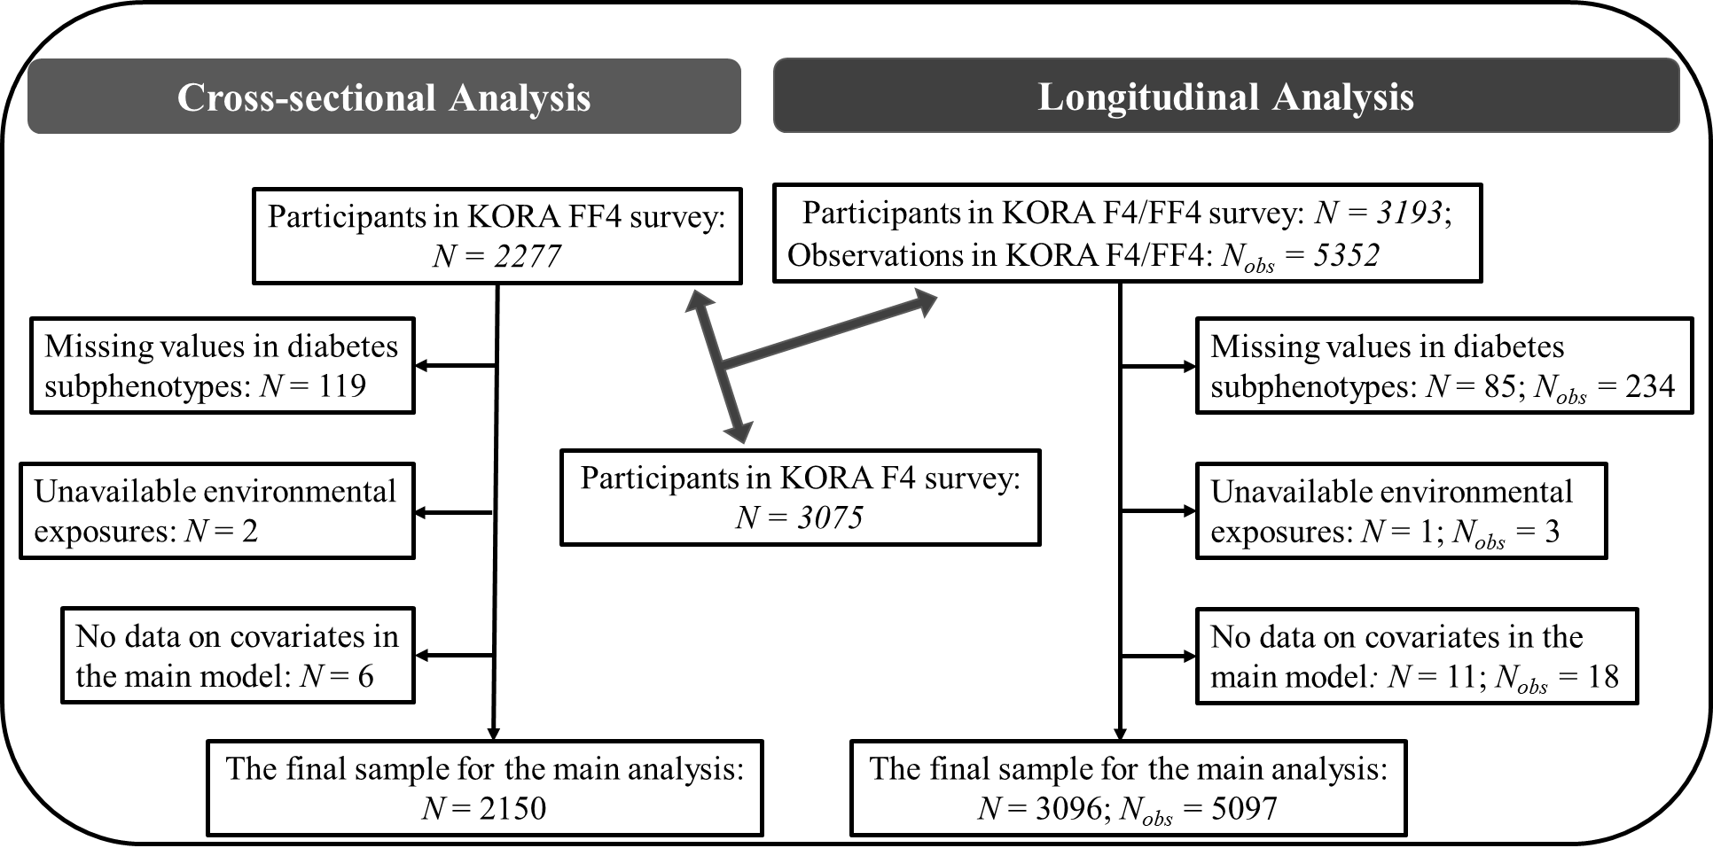
Figure S1. Flow chart
Abbreviation: KORA: Cooperative Health Research in the Region of Augsburg. F4: first follow-up examination of the KORA fourth cross-sectional health survey. FF4: second follow-up examination of the KORA fourth cross-sectional health survey. N, number of participants; N_{obs}: number of observations.
Table S1. Clustering center in KORA FF4.
Variables | Cluster A  (N = 28) | Cluster B  (N = 182) | Cluster C  (N = 91)
Age (years) | -1.28 | 0.32 | -0.24
BMI (kg/m2) | 1.06 | -0.43 | 0.53
HbA1c (mmol/mol) | 1.57 | -0.03 | -0.42
HOMA2-B | -0.57 | -0.43 | 1.04
HOMA2-IR | 0.37 | -0.53 | 0.94
hs-CRP (mg/L) | 2.02 | -0.29 | -0.04
Abbreviation: KORA: Cooperative Health Research in the Region of Augsburg. FF4: second follow-up examination of the KORA fourth cross-sectional health survey. BMI: body mass index. HbA1c: hemoglobin A1c. HOMA2-IR: homeostasis model assessment of insulin resistance. HOMA2-B: homeostasis model assessment of β-cell function. hs-CRP: high-sensitivity C-reactive protein. Cluster A, insulin-deficient diabetes. Cluster B, age-related diabetes. Cluster C, insulin-resistant diabetes.
Figure S2. Distributions of clustering variables in different diabetes subphenotypes across KORA F4 (2006-2008) and FF4 (2013-2014).
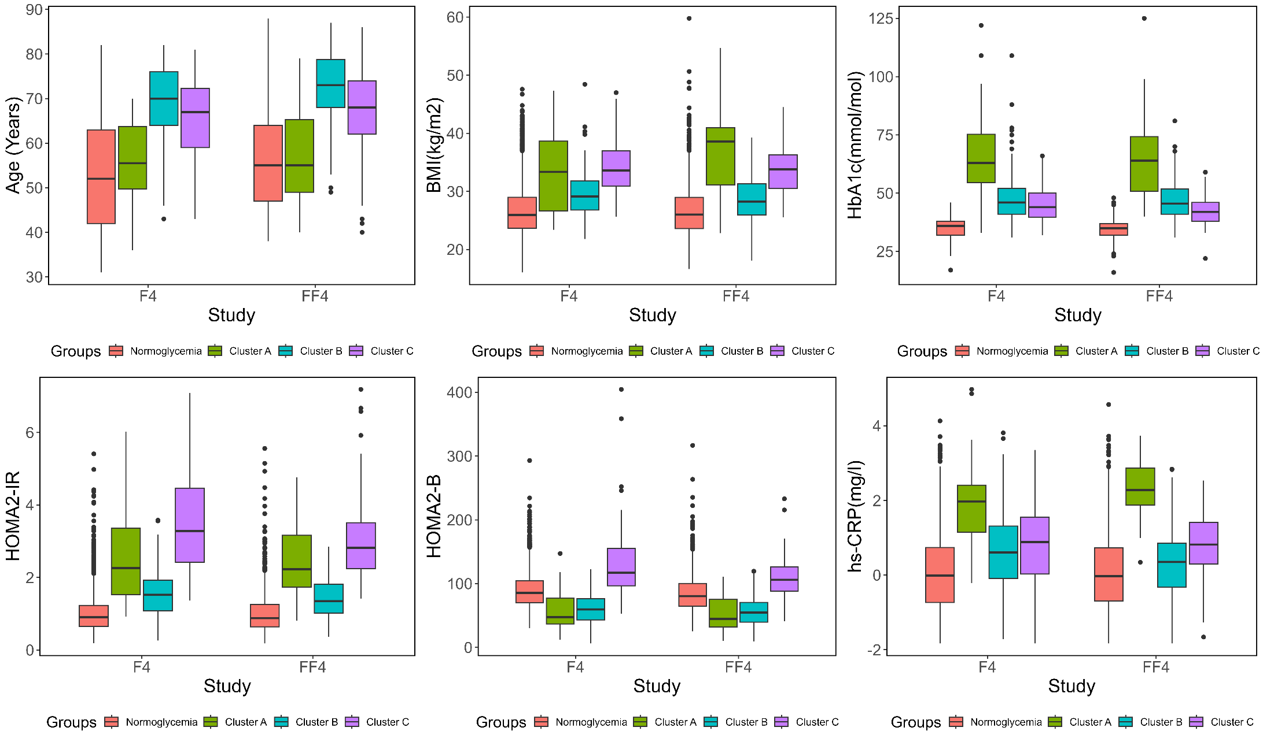
Abbreviation: KORA: Cooperative Health Research in the Region of Augsburg. F4: first follow-up examination of the KORA fourth cross-sectional health survey. FF4: second follow-up examination of the KORA fourth cross-sectional health survey. BMI: body mass index. HbA1c: hemoglobin A1c. HOMA2-IR: homeostasis model assessment of insulin resistance. HOMA2-B: homeostasis model assessment of β-cell function. hs-CRP: high-sensitivity C-reactive protein. Cluster A, insulin-deficient diabetes. Cluster B, age-related diabetes. Cluster C, insulin-resistant diabetes.
Figure S3. Participants’ migration between different diabetes subphenotype groups between KORA F4 (2006-2008) and FF4 (2013-2014).
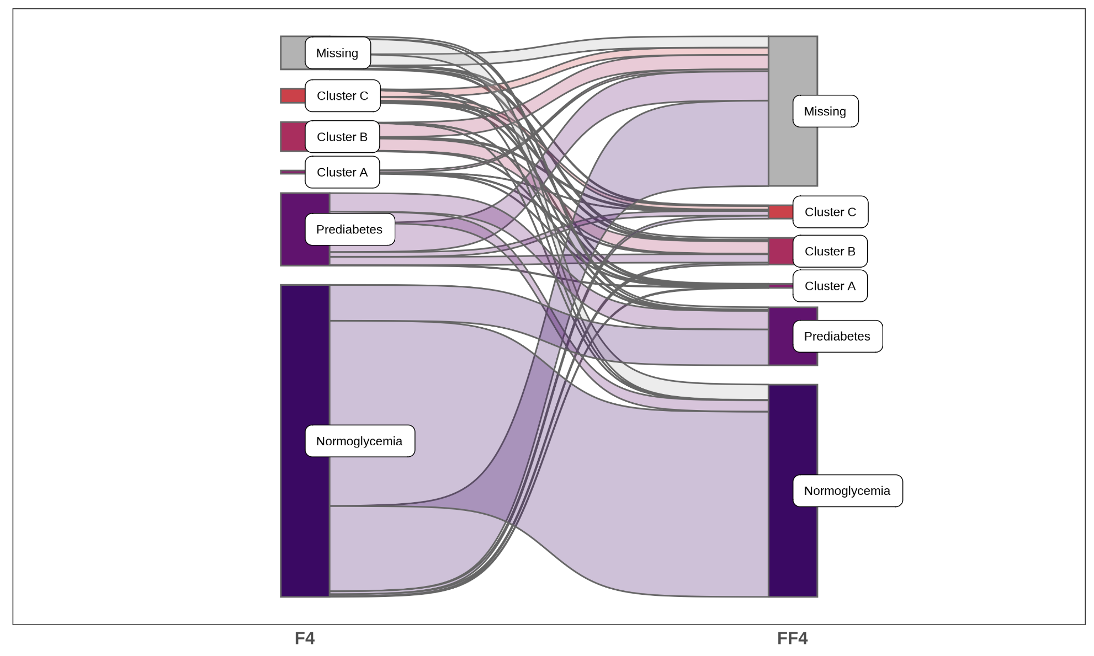
Abbreviation: KORA: Cooperative Health Research in the Region of Augsburg. F4: first follow-up examination of the KORA fourth cross-sectional health survey. FF4: second follow-up examination of the KORA fourth cross-sectional health survey. Cluster A, insulin-deficient diabetes. Cluster B, age-related diabetes. Cluster C, insulin-resistant diabetes.
Table S2. Number of participants’ migration between different diabetes subphenotype groups between KORA F4 and FF4.
F4 | FF4
F4 | Normoglycemia | Prediabetes | Cluster A | Cluster B | Cluster C | Missing | Total
Normoglycemia | 1267 | 245 | 5 | 13 | 20 | 584 | 2134
Prediabetes | 77 | 127 | 3 | 57 | 32 | 200 | 496
Cluster A | 0 | 0 | 3 | 4 | 1 | 14 | 22
Cluster B | 1 | 3 | 4 | 84 | 8 | 99 | 199
Cluster C | 1 | 6 | 6 | 10 | 24 | 49 | 96
Missing | 106 | 16 | 7 | 14 | 6 | 77 | 226
Total | 1452 | 397 | 28 | 182 | 91 | 1023 | 3173
Abbreviation: KORA: Cooperative Health Research in the Region of Augsburg. F4: first follow-up examination of the KORA fourth cross-sectional health survey. FF4: second follow-up examination of the KORA fourth cross-sectional health survey. Cluster A, insulin-deficient diabetes. Cluster B, age-related diabetes. Cluster C, insulin-resistant diabetes.
Table S3. Odds ratios (ORs) (together with 95% confidence intervals) of diabetes subphenotypes for an interquartile range (IQR) change of environmental exposures in the longitudinal analysis using data from F4 and FF4.
Exposures | Models | Cluster A | Cluster B | Cluster C
Air pollution
PM_{2.5} | Minimum | 0.68(0.47,0.99)* | 1.16(0.97,1.39) | 1.22(0.97,1.53)†
 | Main | 0.72(0.49,1.06)† | 1.19(0.99,1.43)† | 1.29(1.01,1.64)*
 | Extended | 0.73(0.49,1.07) | 1.17(0.97,1.40) | 1.25(0.97,1.60)†
PM_{2.5}abs | Minimum | 0.64(0.42,0.99)* | 1.07(0.88,1.29) | 1.24(0.98,1.56)†
 | Main | 0.69(0.44,1.08) | 1.12(0.93,1.36) | 1.30(1.01,1.67)*
 | Extended | 0.69(0.44,1.09) | 1.10(0.91,1.34) | 1.28(0.99,1.65)†
PM_{coarse} | Minimum | 0.83(0.57,1.22) | 1.01(0.85,1.20) | 1.08(0.87,1.34)
 | Main | 0.92(0.62,1.36) | 1.08(0.90,1.29) | 1.22(0.98,1.54)†
 | Extended | 0.93(0.63,1.39) | 1.06(0.89,1.27) | 1.21(0.96,1.52)
PM₁₀ | Minimum | 0.79(0.52,1.20) | 0.96(0.81,1.15) | 1.18(0.95,1.46)
 | Main | 0.84(0.55,1.29) | 1.00(0.84,1.20) | 1.25(0.99,1.58)†
 | Extended | 0.85(0.55,1.31) | 0.99(0.82,1.19) | 1.25(0.99,1.59)†
PNC | Minimum | 0.83(0.60,1.14) | 1.00(0.87,1.16) | 1.07(0.90,1.28)
 | Main | 0.85(0.61,1.19) | 1.03(0.89,1.20) | 1.13(0.94,1.37)
 | Extended | 0.88(0.63,1.23) | 1.02(0.88,1.19) | 1.14(0.94,1.38)
NO₂ | Minimum | 0.55(0.34,0.88)* | 1.01(0.83,1.24) | 1.12(0.88,1.43)
 | Main | 0.56(0.34,0.93)* | 1.06(0.87,1.30) | 1.18(0.91,1.54)
 | Extended | 0.56(0.34,0.94)* | 1.04(0.85,1.27) | 1.16(0.89,1.51)
NO_{x} | Minimum | 0.76(0.53,1.07) | 0.99(0.85,1.16) | 1.08(0.88,1.32)
 | Main | 0.78(0.54,1.12) | 1.02(0.87,1.20) | 1.15(0.92,1.42)
 | Extended | 0.79(0.55,1.15) | 1.01(0.86,1.19) | 1.13(0.91,1.41)
Temperature
T_{sd} | Minimum | 0.86(0.54,1.36) | 1.16(0.95,1.41) | 1.02(0.79,1.31)
 | Main | 1.00(0.61,1.63) | 1.22(0.99,1.49)† | 1.14(0.86,1.50)
 | Extended | 1.03(0.62,1.71) | 1.27(1.03,1.55)* | 1.25(0.94,1.66)
T_{m} | Minimum | 1.26(0.87,1.83) | 1.12(0.95,1.33) | 0.99(0.81,1.22)
 | Main | 1.38(0.93,2.06) | 1.13(0.95,1.34) | 1.04(0.83,1.30)
 | Extended | 1.41(0.94,2.12)† | 1.15(0.97,1.37) | 1.09(0.86,1.38)
NDVI
300 m | Minimum | 0.79(0.53,1.18) | 0.98(0.82,1.17) | 1.17(0.94,1.46)
 | Main | 0.84(0.56,1.26) | 1.02(0.85,1.22) | 1.22(0.97,1.55)†
 | Extended | 0.85(0.56,1.29) | 1.02(0.85,1.22) | 1.21(0.95,1.54)
500 m | Minimum | 0.64(0.41,1.00)† | 0.94(0.78,1.14) | 1.13(0.90,1.43)
 | Main | 0.67(0.42,1.05)† | 0.99(0.81,1.19) | 1.19(0.93,1.54)
 | Extended | 0.67(0.43,1.07)† | 0.98(0.81,1.19) | 1.17(0.90,1.51)
1000 m | Minimum | 0.54(0.34,0.86)* | 1.02(0.84,1.23) | 1.17(0.92,1.48)
 | Main | 0.55(0.34,0.90)* | 1.07(0.88,1.30) | 1.23(0.95,1.59)
 | Extended | 0.55(0.34,0.90)* | 1.06(0.87,1.29) | 1.20(0.92,1.55)
Note: We used normoglycemia as the reference group. The minimum model was adjusted for age, sex, and visits. The main model was adjusted for age, sex, visits, family status, education years, body mass index, smoking status, alcohol consumption, and physical activity. The extended model was adjusted for covariates in the main model, plus waist circumference, systolic blood pressure, high-density lipoproteins cholesterol, and triglycerides. Effects were estimated for an IQR decrease in mean temperature and greenness, and an IQR increase in air pollution and temperature deviation.
Abbreviation: PM: particulate matter. PM_{2.5}: PM with an aerodynamic diameter less than 2∙5 µm. PM_{2∙5}abs: PM_{2∙5} absorbance. PM_{coarse}: PM with an aerodynamic diameter of 2∙5–10 µm. PM₁₀: PM with an aerodynamic diameter less than 10 µm. PNC: particle number concentration. NO₂: nitrogen dioxide. NO_{x}: nitrogen oxides. T_{sd}: standard deviation of temperature. T_{m}: mean temperature. NDVI: normalized difference vegetation index. Cluster A, insulin-deficient diabetes. Cluster B, age-related diabetes. Cluster C, insulin-resistant diabetes.
† P < 0.1.* P < 0.05.** P < 0.001.
Figure S4. Odds ratios (ORs) of diabetes subphenotypes associated with an interquartile range (IQR) change in air pollution, temperature, and NDVI from single, two-, three-, and four-exposure models in longitudinal analysis.
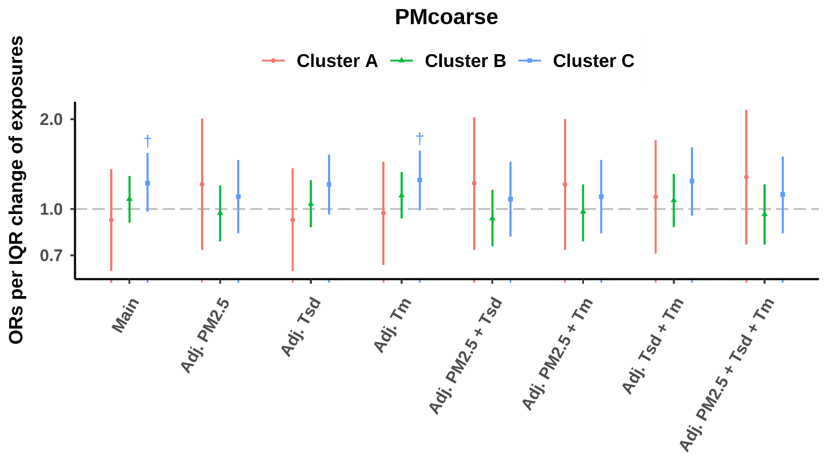

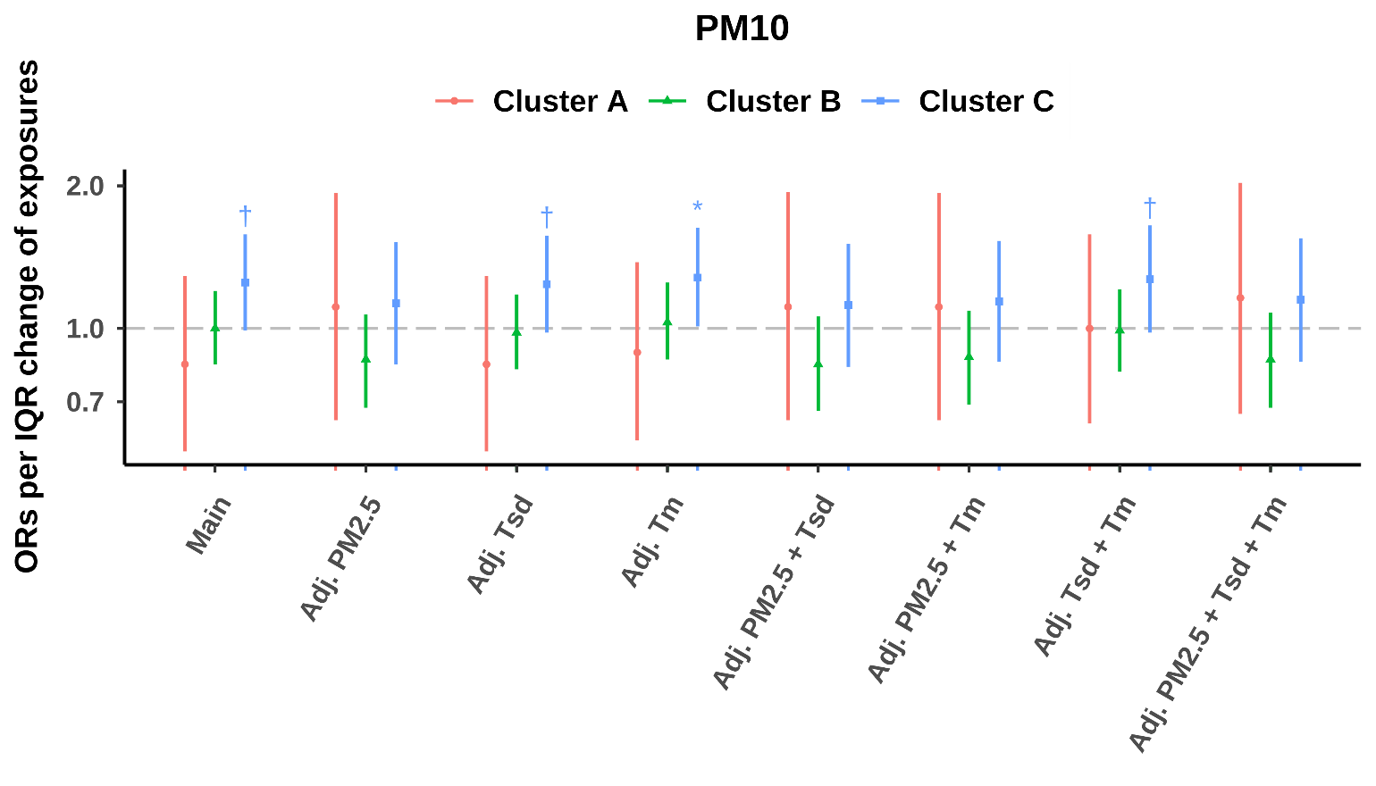
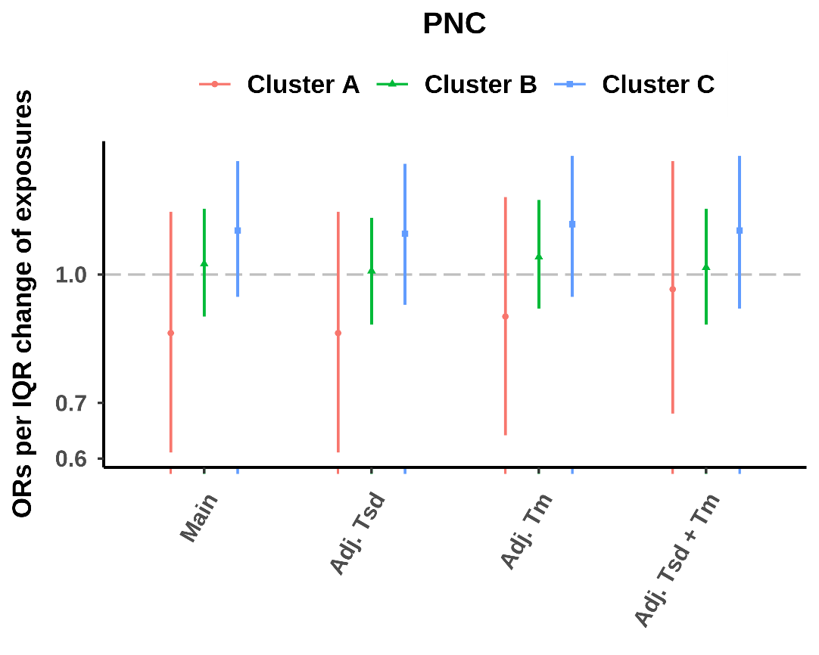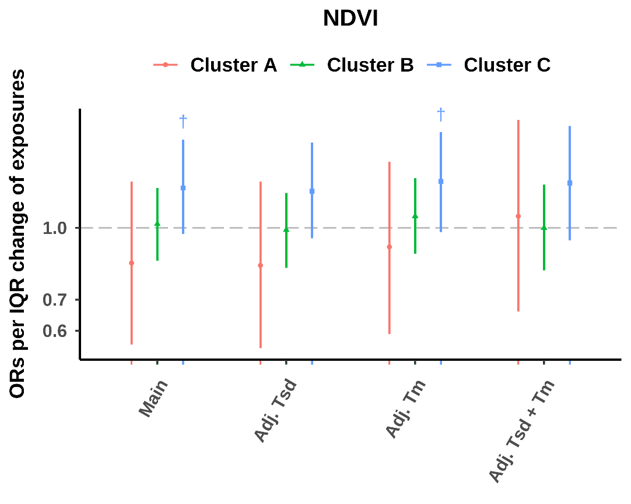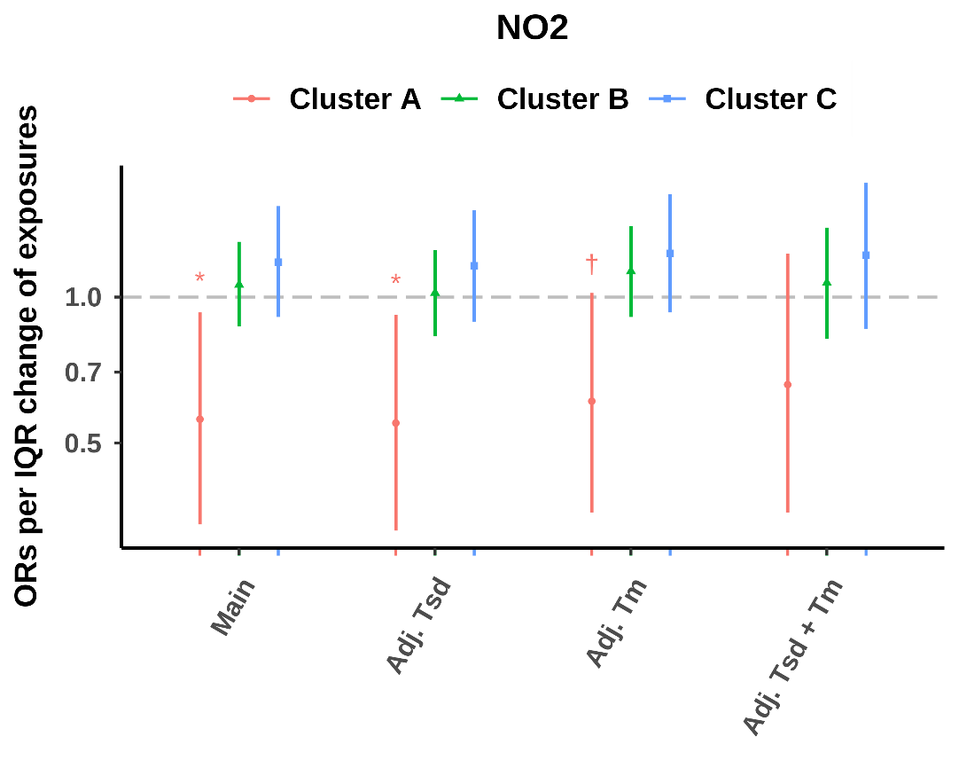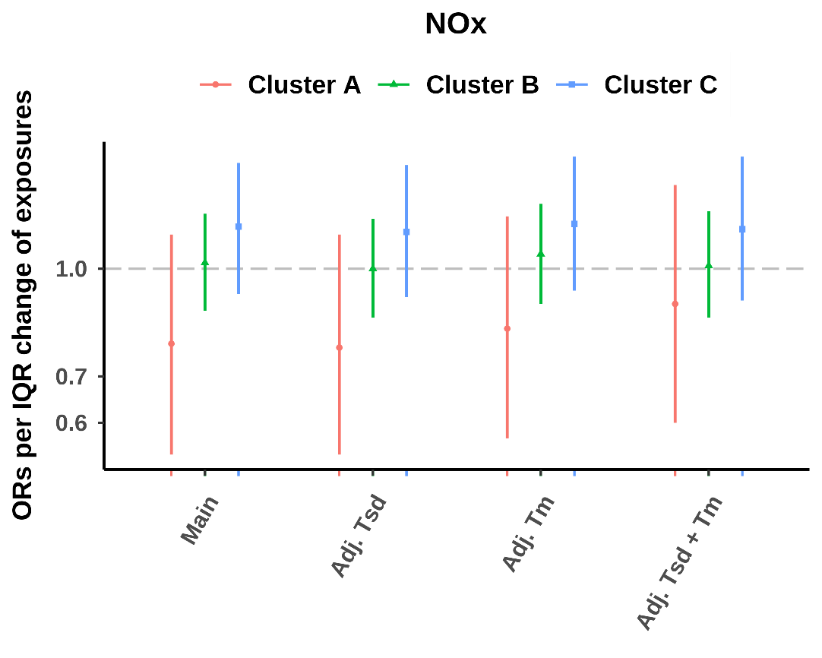
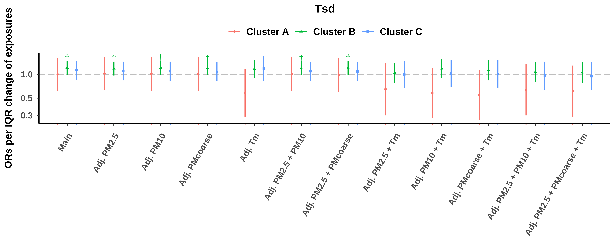
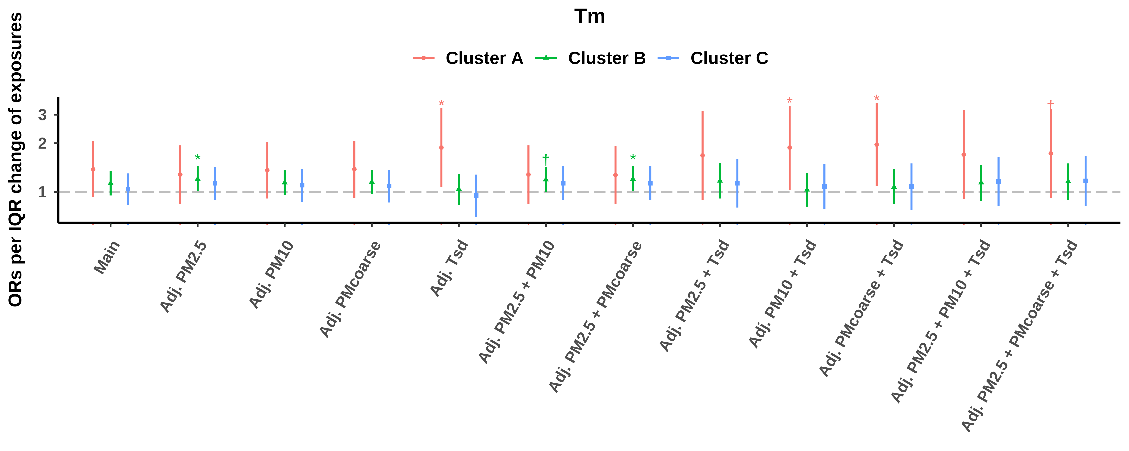
Note: Models were adjusted for age, sex, visits, family status, education years, body mass index, smoking status, alcohol consumption, and physical activity. Effects were estimated for an IQR decrease in mean temperature and NDVI in a 300 m buffer, and an IQR increase in air pollution and temperature deviation.
Abbreviation: PM: particulate matter. PM_{2.5}: PM with an aerodynamic diameter less than 2∙5 µm. PM_{2∙5}abs: PM_{2∙5} absorbance. PM_{coarse}: PM with an aerodynamic diameter of 2∙5–10 µm. PM₁₀: PM with an aerodynamic diameter less than 10 µm. PNC: particle number concentration. NO₂: nitrogen dioxide. NO_{x}: nitrogen oxides. T_{sd}: standard deviation of temperature. T_{m}: mean temperature. NDVI: normalized difference vegetation index. Cluster A, insulin-deficient diabetes. Cluster B, age-related diabetes. Cluster C, insulin-resistant diabetes.
† P < 0.1.* P < 0.05.** P< 0.001.
Table S4. Cumulative Risk Index of diabetes subphenotypes associated with air pollution, mean temperature, temperature deviation, and greenness from two-exposure models in the longitudinal analysis.
Model | Cluster A | Cluster B | Cluster C | AIC | BIC
PM_{2.5} + T_{sd} | 0.74(0.40,1.35) | 1.39(1.07,1.80) | 1.41(0.99,2.00) | 7531.0 | 8014.7
PM_{2.5} + T_{m} | 0.99(0.51,1.91) | 1.51(1.13,2.04) | 1.51(1.01,2.24) | 7531.5 | 8015.2
PM_{2.5} + NDVI | 0.76(0.50,1.15) | 1.12(0.92,1.37) | 1.30(1.00,1.69) | 7532.2 | 8015.8
PM_{2.5}abs + T_{sd} | 0.73(0.40,1.35) | 1.30(1.01,1.67) | 1.39(0.99,1.95) | 7532.9 | 8016.6
PM_{2.5}abs + NDVI | 0.72(0.45,1.13) | 1.09(0.89,1.33) | 1.31(1.01,1.69) | 7533.9 | 8017.6
PM_{2.5}abs + T_{m} | 0.95(0.48,1.90) | 1.39(1.03,1.88) | 1.52(1.02,2.26) | 7534.2 | 8017.9
T_{sd}+ T_{m} | 1.09(0.66,1.81) | 1.23(0.99,1.51) | 1.13(0.85,1.50) | 7534.9 | 8018.6
T_{sd}+ NDVI | 0.85(0.46,1.56) | 1.20(0.94,1.54) | 1.32(0.95,1.86) | 7536.3 | 8020.0
T_{sd}+ PM_{coarse} | 0.94(0.53,1.66) | 1.25(0.98,1.60) | 1.31(0.94,1.82) | 7537.9 | 8021.6
T_{sd}+ T_{m} | 1.09(0.66,1.81) | 1.23(0.99,1.51) | 1.13(0.85,1.50) | 7534.9 | 8018.6
T_{sd}+ PM₁₀ | 0.86(0.46,1.59) | 1.20(0.92,1.55) | 1.36(0.97,1.92) | 7536.1 | 8019.7
T_{sd}+ NDVI | 0.85(0.46,1.56) | 1.20(0.94,1.54) | 1.32(0.95,1.86) | 7536.3 | 8020.0
NO₂ + NDVI | 0.58(0.35,0.97) | 1.05(0.86,1.29) | 1.22(0.93,1.59) | 7533.1 | 8016.8
NO₂ + T_{sd} | 0.61(0.32,1.17) | 1.24(0.95,1.61) | 1.28(0.90,1.82) | 7533.3 | 8017.0
NO₂ + T_{m} | 0.74(0.34,1.58) | 1.32(0.96,1.83) | 1.36(0.88,2.09) | 7535.5 | 8019.2
Note: Models were adjusted for age, sex, visits, family status, education years, body mass index, smoking status, alcohol consumption, and physical activity. Effects were estimated for an IQR decrease in mean temperature and NDVI in a 300 m buffer, and an IQR increase in air pollution and temperature deviation.
Abbreviation: PM: particulate matter. PM_{2.5}: PM with an aerodynamic diameter less than 2∙5 µm. PM_{2∙5}abs: PM_{2∙5} absorbance. PM_{coarse}: PM with an aerodynamic diameter of 2∙5–10 µm. PM₁₀: PM with an aerodynamic diameter less than 10 µm. NO₂: nitrogen dioxide. T_{sd}: standard deviation of temperature. T_{m}: mean temperature. NDVI: normalized difference vegetation index. Cluster A, insulin-deficient diabetes. Cluster B, age-related diabetes. Cluster C, insulin-resistant diabetes. AIC: Akaike Information Criterion and BIC: Bayesian Information Criterion.
Table S5. Cumulative Risk Index of diabetes subphenotypes associated with air pollution, mean temperature, temperature deviation, and greenness from three-exposure models in the longitudinal analysis.
Model | Cluster A | Cluster B | Cluster C | AIC | BIC
PM_{2.5} + T_{sd} + NDVI | 0.76(0.41,1.41) | 1.33(1.02,1.73) | 1.42(0.99,2.03) | 7533.2 | 8043.0
PM_{2.5} + T_{sd} + T_{m} | 0.93(0.47,1.82) | 1.52(1.13,2.05) | 1.51(1.01,2.25) | 7533.9 | 8043.7
PM_{2.5}abs + T_{sd} + T_{m} | 0.94(0.47,1.87) | 1.39(1.03,1.88) | 1.52(1.02,2.26) | 7535.9 | 8045.8
PM_{2.5}abs + T_{sd} + NDVI | 0.76(0.41,1.41) | 1.26(0.97,1.63) | 1.39(0.98,1.97) | 7536.0 | 8045.8
T_{sd} + T_{m}+ PM_{coarse} | 1.19(0.64,2.21) | 1.30(0.99,1.71) | 1.36(0.94,1.95) | 7539.8 | 8049.6
T_{sd} + T_{m} + NDVI | 1.15(0.59,2.26) | 1.23(0.92,1.64) | 1.40(0.95,2.07) | 7539.9 | 8049.7
T_{sd} + T_{m} + PM₁₀ | 1.09(0.56,2.12) | 1.21(0.91,1.62) | 1.42(0.97,2.06) | 7539.1 | 8048.9
NO₂ + NDVI + T_{sd} | 0.63(0.33,1.21) | 1.22(0.94,1.59) | 1.32(0.92,1.87) | 7534.9 | 8044.7
NO₂ + NDVI + T_{m} | 0.78(0.36,1.67) | 1.31(0.94,1.82) | 1.41(0.91,2.19) | 7537.3 | 8047.1
Note: Models were adjusted for age, sex, visits, family status, education years, body mass index, smoking status, alcohol consumption, and physical activity. Effects were estimated for an IQR decrease in mean temperature and NDVI in a 300 m buffer, and an IQR increase in air pollution and temperature deviation.
Abbreviation: PM: particulate matter. PM_{2.5}: PM with an aerodynamic diameter less than 2∙5 µm. PM_{2∙5}abs: PM_{2∙5} absorbance. PM_{coarse}: PM with an aerodynamic diameter of 2∙5–10 µm. PM₁₀: PM with an aerodynamic diameter less than 10 µm. NO₂: nitrogen dioxide. T_{sd}: standard deviation of temperature. T_{m}: mean temperature. NDVI: normalized difference vegetation index. Cluster A, insulin-deficient diabetes. Cluster B, age-related diabetes. Cluster C, insulin-resistant diabetes. AIC: Akaike Information Criterion and BIC: Bayesian Information Criterion.
Table S6. Cumulative Risk Index of diabetes subphenotypes associated with air pollution, mean temperature, temperature deviation, and greenness from four-exposure models in the longitudinal analysis.
Model | Cluster A | Cluster B | Cluster C | AIC | BIC
PM_{2.5} + T_{sd} + NDVI + T_{m} | 1.03(0.51,2.06) | 1.41(1.03,1.93) | 1.55(1.02,2.36) | 7537.0 | 8073.0
PM_{2.5}abs + T_{sd} + T_{m} + NDVI | 1.02(0.50,2.07) | 1.33(0.98,1.82) | 1.54(1.01,2.33) | 7539.5 | 8075.5
T_{sd} + T_{m} + PM_{coarse} + NDVI | 1.17(0.59,2.32) | 1.26(0.94,1.70) | 1.44(0.97,2.14) | 7545.5 | 8081.5
T_{sd} + T_{m} + PM₁₀ + NDVI | 1.13(0.56,2.28) | 1.22(0.90,1.65) | 1.48(0.99,2.21) | 7546.4 | 8082.4
NO₂ + NDVI + T_{sd} + T_{m} | 0.79(0.36,1.70) | 1.29(0.93,1.79) | 1.42(0.91,2.20) | 7540.2 | 8076.2
Note: Models were adjusted for age, sex, visits, family status, education years, body mass index, smoking status, alcohol consumption, and physical activity. Effects were estimated for an IQR decrease in mean temperature and NDVI in a 300 m buffer, and an IQR increase in air pollution and temperature deviation.
Abbreviation: PM: particulate matter. PM_{2.5}: PM with an aerodynamic diameter less than 2∙5 µm. PM_{2∙5}abs: PM_{2∙5} absorbance. PM_{coarse}: PM with an aerodynamic diameter of 2∙5–10 µm. PM₁₀: PM with an aerodynamic diameter less than 10 µm. NO₂: nitrogen dioxide. T_{sd}: standard deviation of temperature. T_{m}: mean temperature. NDVI: normalized difference vegetation index. Cluster A, insulin-deficient diabetes. Cluster B, age-related diabetes. Cluster C, insulin-resistant diabetes. AIC: Akaike Information Criterion and BIC: Bayesian Information Criterion.
Figure S5. Odds ratios (ORs) of diabetes subphenotypes for an interquartile range (IQR) change of environmental exposures in the sensitivity analyses.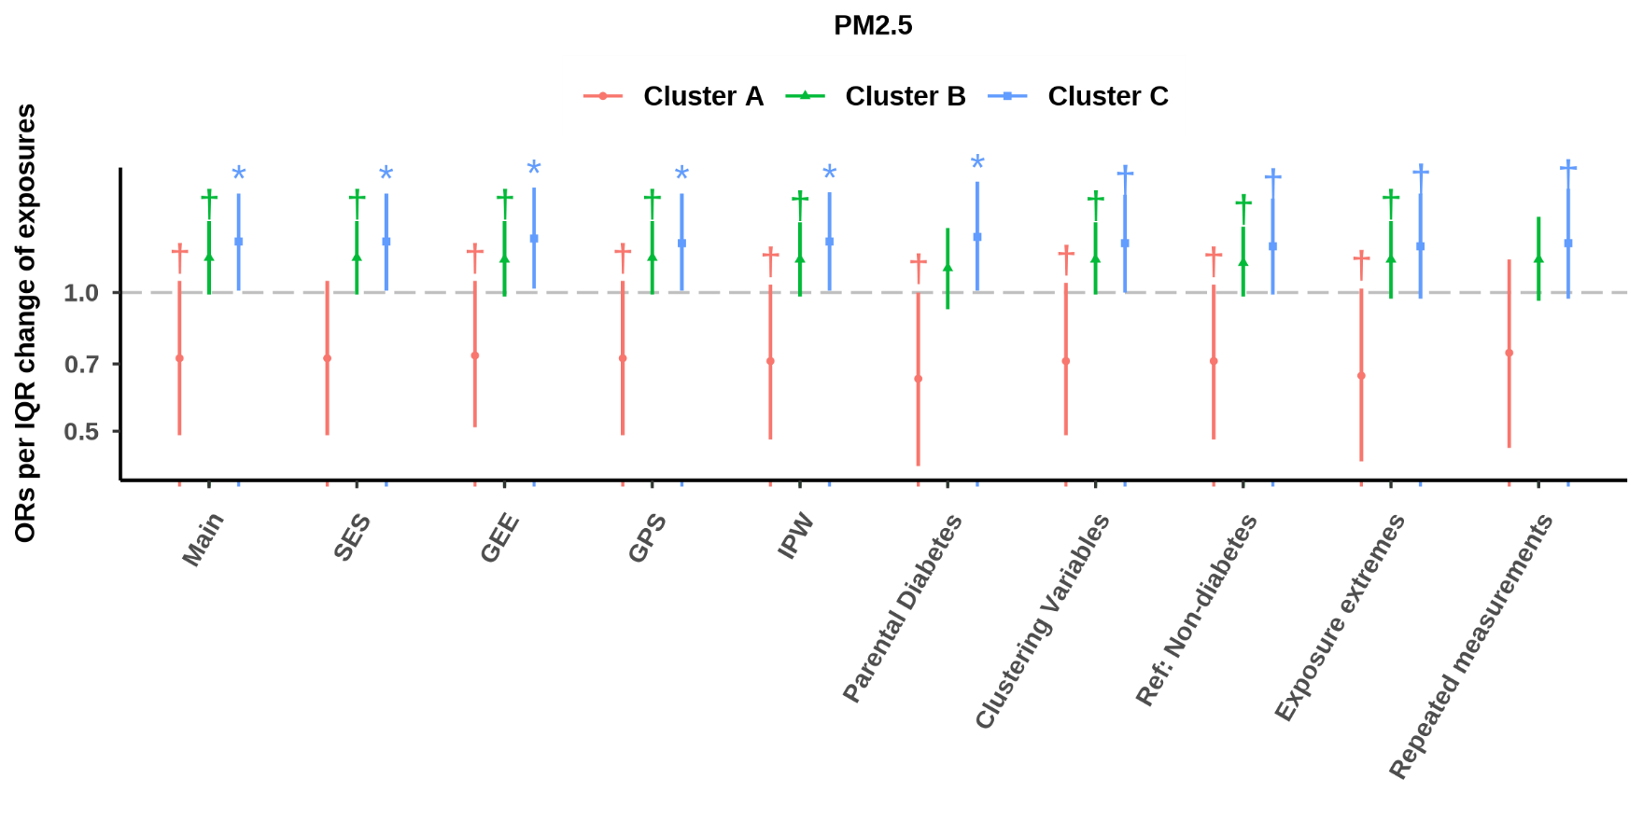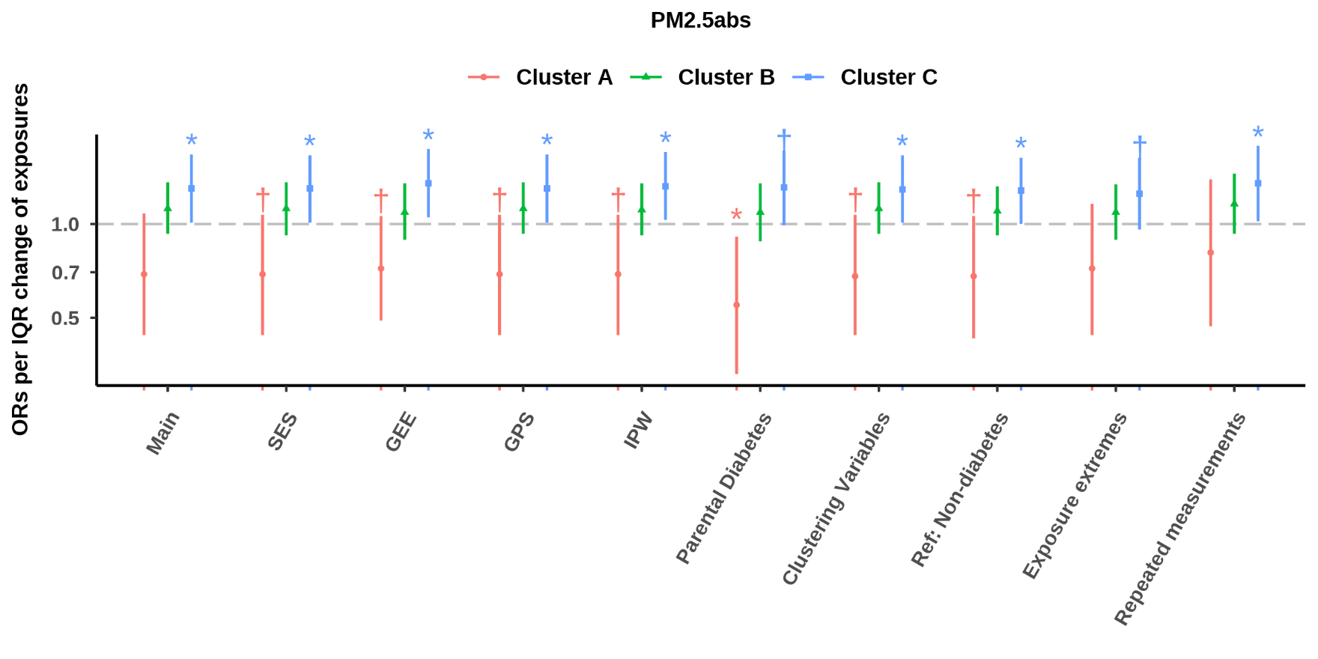

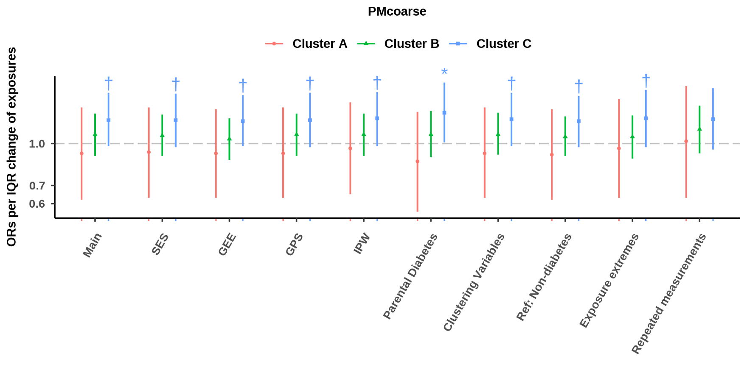
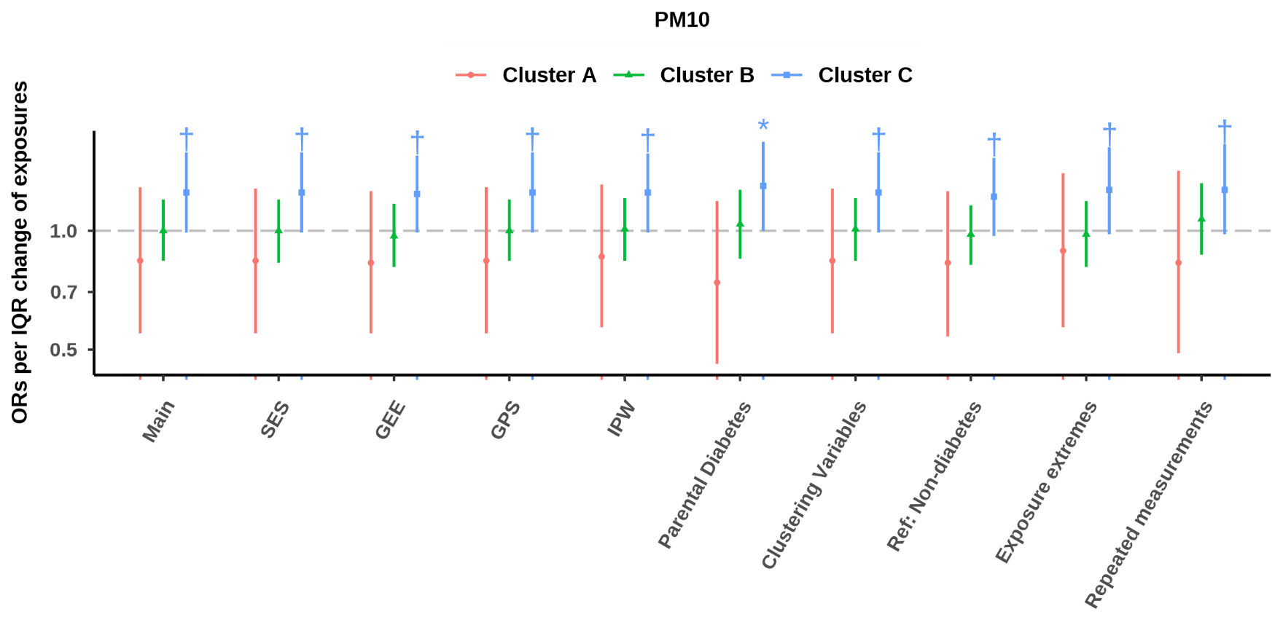
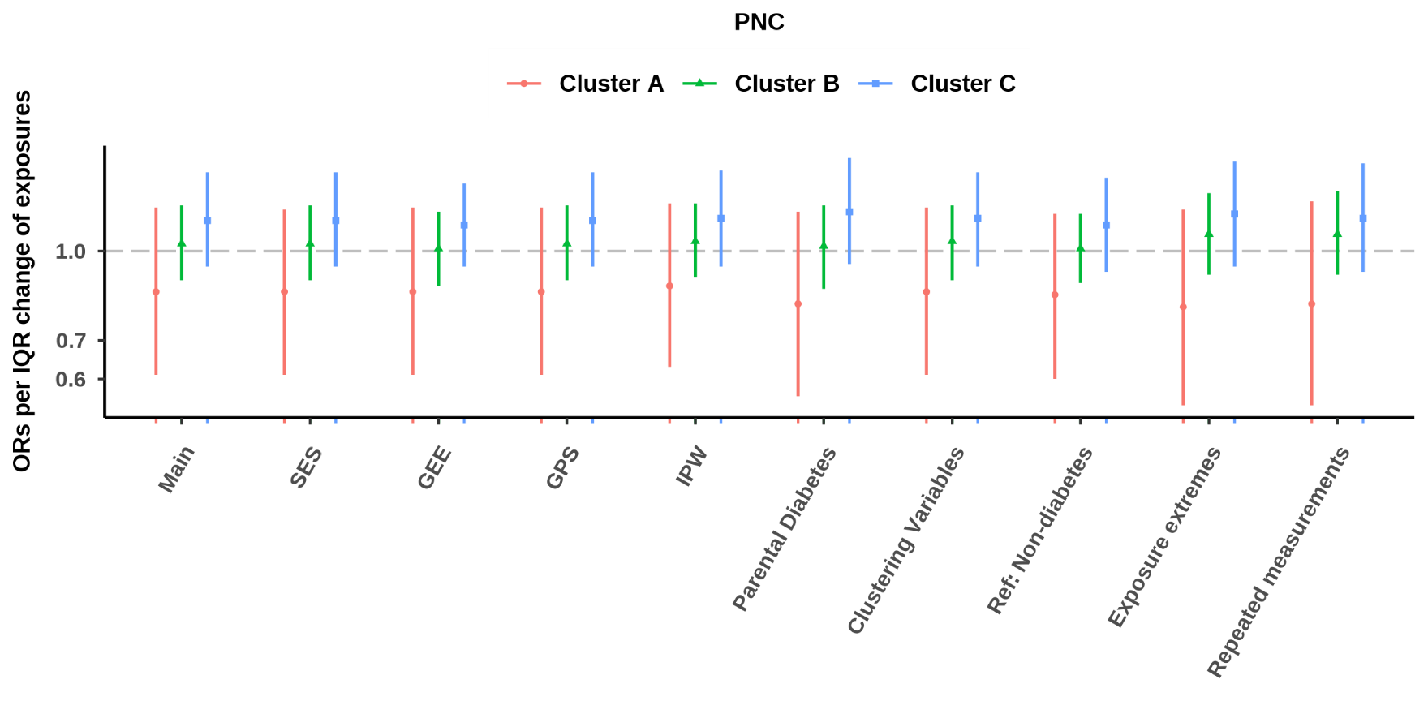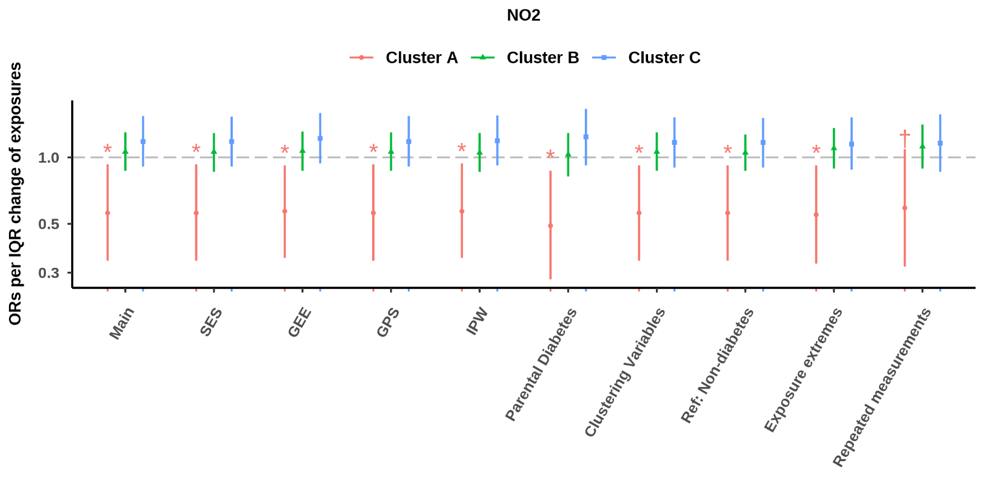
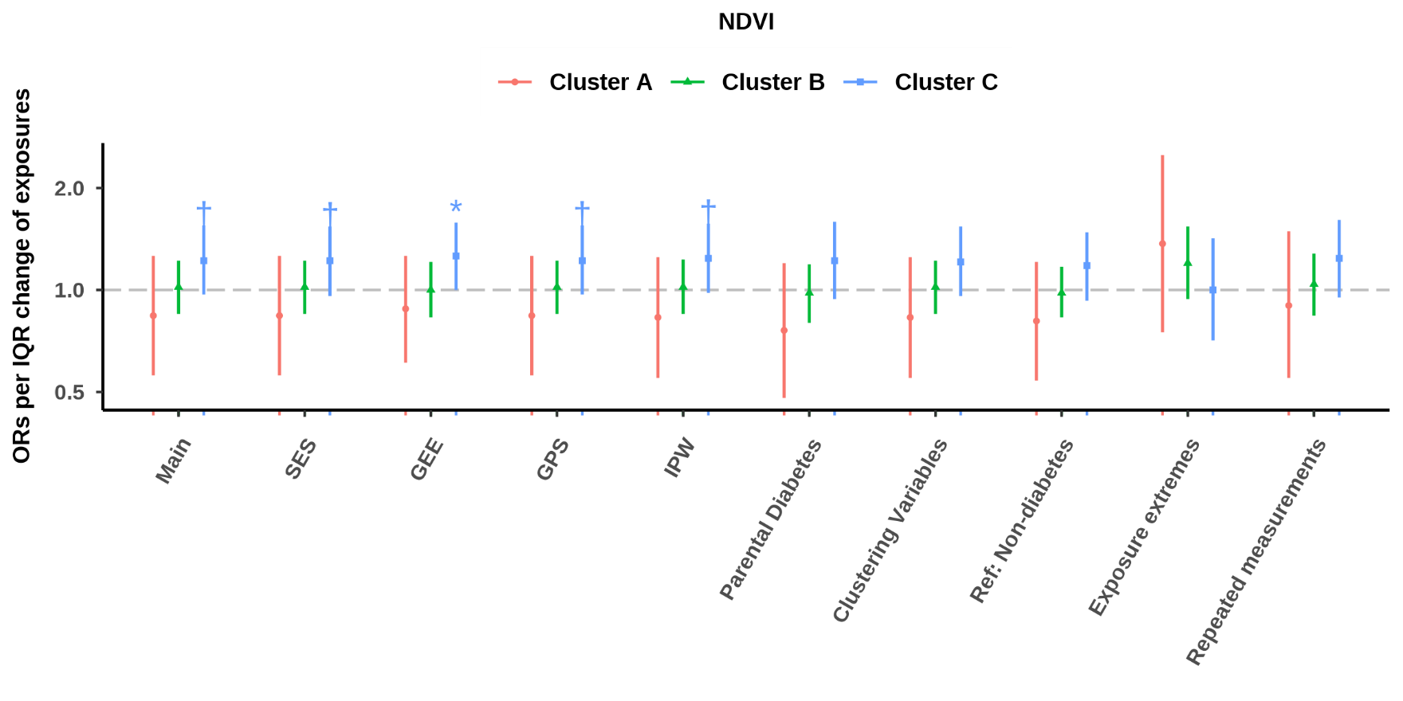
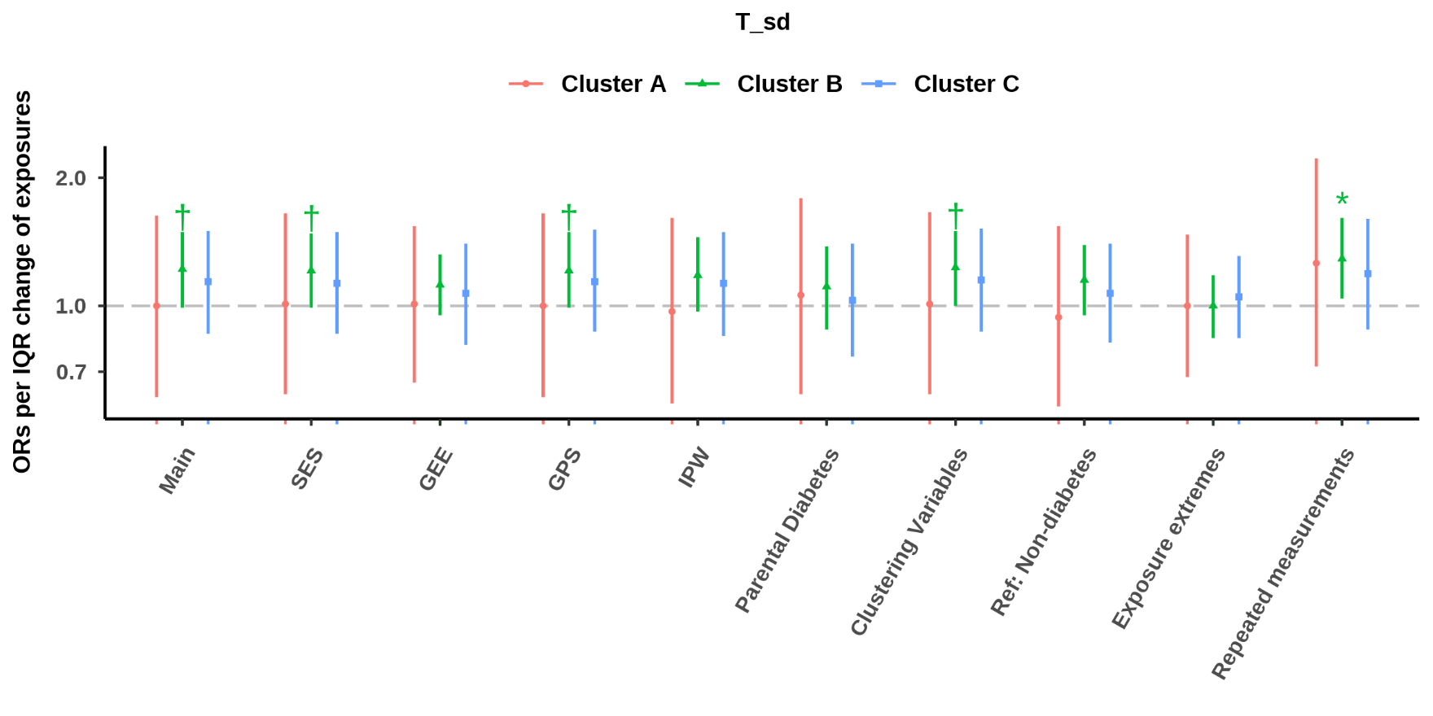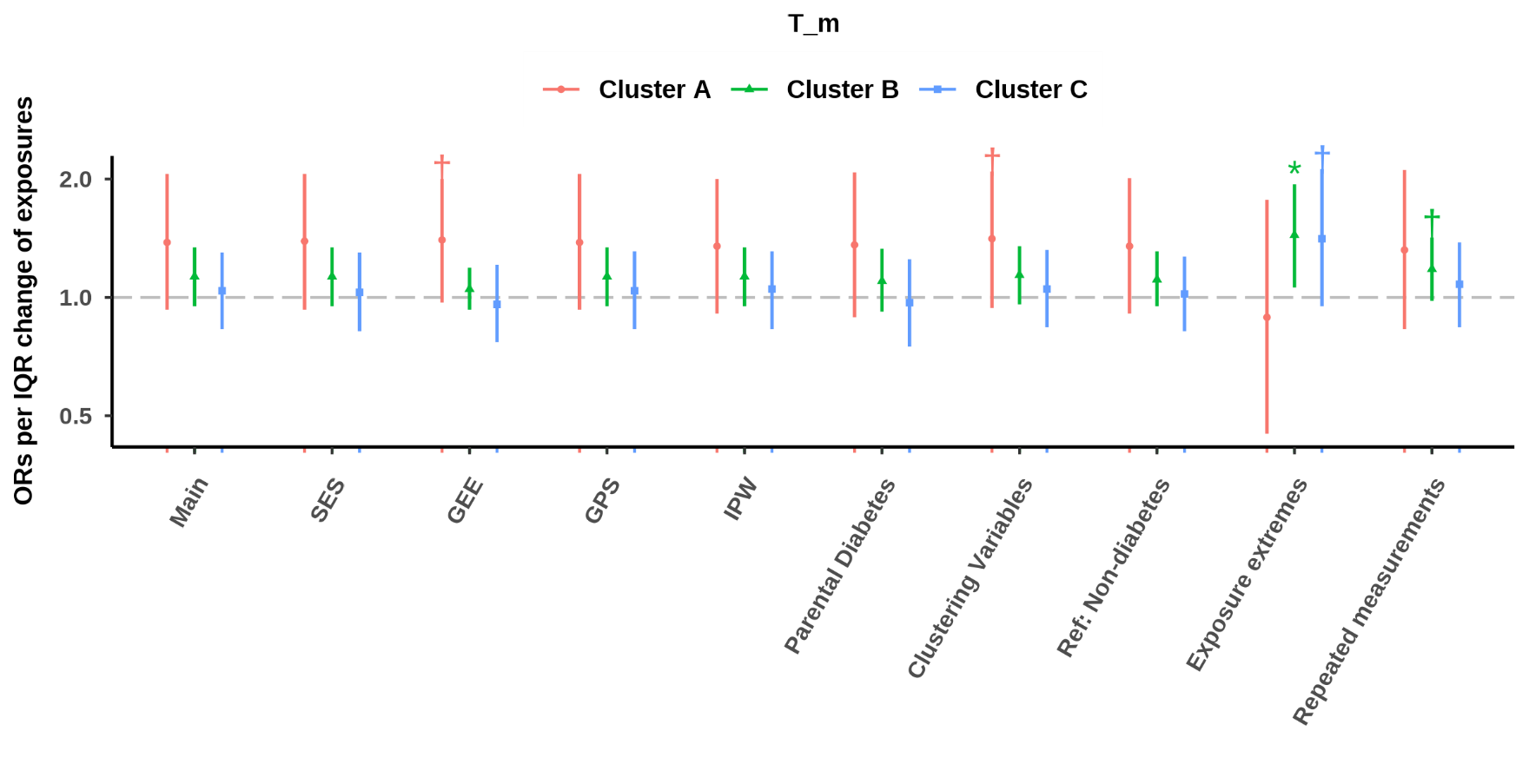

Effects were estimated for an IQR decrease in mean temperature and greenness, and an IQR increase in air pollution and temperature deviation.
Abbreviation: PM: particulate matter. PM_{2.5}: PM with an aerodynamic diameter less than 2∙5 µm. PM_{2∙5}abs: PM_{2∙5} absorbance. PM_{coarse}: PM with an aerodynamic diameter of 2∙5–10 µm. PM₁₀: PM with an aerodynamic diameter less than 10 µm. PNC: particle number concentration. NO₂: nitrogen dioxide. NO_{x}: nitrogen oxides. T_{sd}: standard deviation of temperature. T_{m}: mean temperature. NDVI: normalized difference vegetation index. Cluster A, insulin-deficient diabetes. Cluster B, age-related diabetes. Cluster C, insulin-resistant diabetes. SES: socioeconomic status. GEE: generalized estimating equations. GPS: generalized propensity score. IPW: inverse-probability weights.
† P < 0.1.* P < 0.05.** P < 0.001.

