Supplementary Material
Blood coagulation factors and risk of venous thromboembolism: a population-based study
Anna Erhard, Dennis Freuer, Annette Peters, Margit Heier, Christine Meisinger, Jakob Linseisen

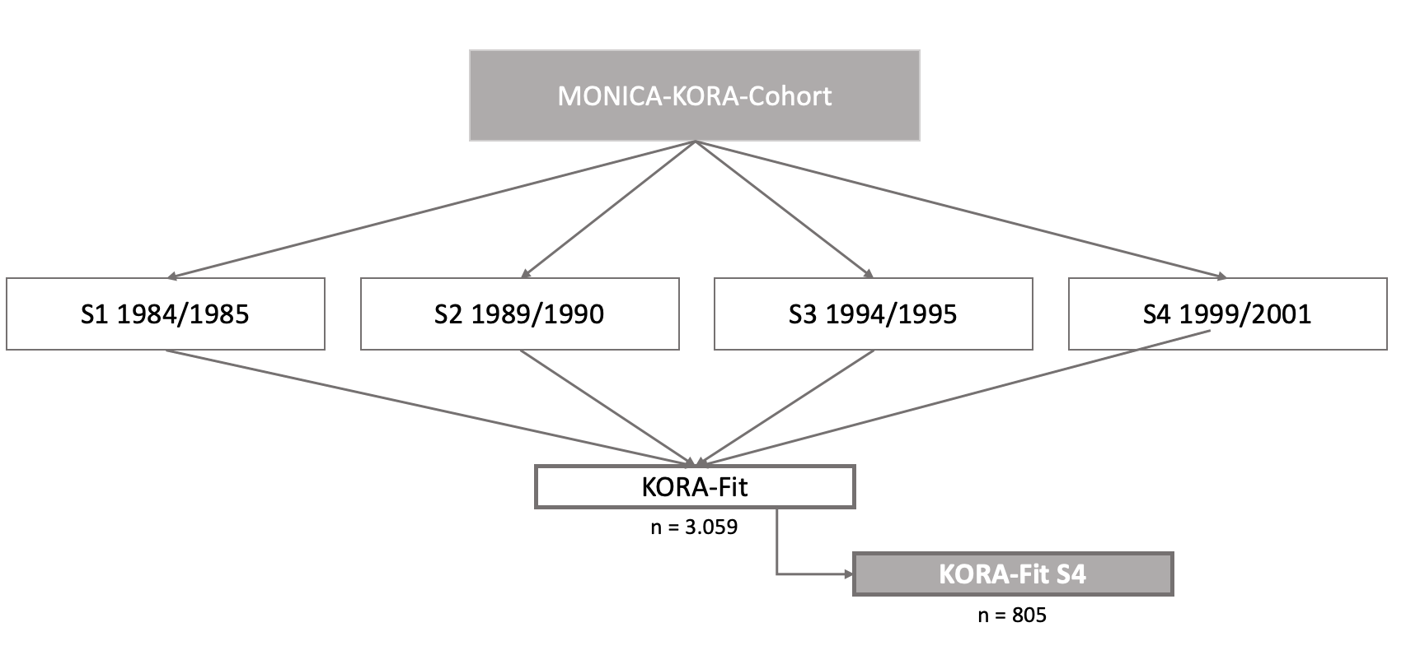

Figure S1: The four cross-sectional studies (S1-S4) forming the MONICA-KORA cohort study, and the KORA-Fit examination (2018-2019) inviting participants born between 1945 – 1964, also from the S4 sample (KORA-Fit S4).

Table S1: Methods used for the analysis of blood coagulation factors in citrate plasma samples of KORA-Fit S4 participants
Blood coagulation factor | Reference value | Measurement Technique | Assay or Reagents | Measuring device
Prothrombin time | 82 – 125 % | Photometric assay | Thromborel S Siemens Eschborn | BCS-XP, Siemens Eschborn
aPTTª | 26 – 36 sec. | Photometric assay | Pathromtin SL, CaCl2 solution, Actin FS, Siemens Eschborn | BCS-XP, Siemens Eschborn
Antithrombin | 83 – 118 % | Chromogenic assay | Innovance Antithrombin, SCS Cleaner, Siemens Eschborn | BCS-XP, Siemens Eschborn
Fibrinogen | 210 – 400 mg/dl | Photometric and turbidimetric assay | Multifibren U, Siemens Eschborn | BCS-XP, Siemens Eschborn
D-dimer | < 500 µg/L | Turbidimetric assay | Innovance D-Dimer Kit, Siemens Eschborn | BCS-XP, Siemens Eschborn
Protein C | 70 – 140 % | Photometric assay | Berichrom Protein C, Siemens Eschborn | BCS-XP, Siemens Eschborn
Protein S | women: 52 – 126 %  men: 73 – 130 % | Photometric assay | Hemoclot Protein S, OVB-Puffer, CaCl2, SCS-Cleaner | CaoChrom, Wien
Factor VIII | 70 – 150 % | Photometric assay | Factor VIII deficient plasma, Pathromtin SL, CaCl2, Siemens Eschborn | BCS-XP, Siemens Eschborn
ª activated partial thromboplastin time

Table S2: Calculated AICs regarding non-linear associations for the number of knots between three and five
Number of knots | AIC for aPTT | AIC for Protein C | AIC for Protein S
3 | 162.91 | 210.52 | 205.79
4 | 164.14 | 211.15 | 206.83
5 | 164.09 | 211.76 | 208.92

Table S3: P values representing results of testing the non-linearity using restricted cubic splines
 | aPTT | Prothrombin  time | Factor VIII | Antithrom-bin | Fibrino-gen | D-dimer | Protein C | Protein S
age | 0.505 | 0.577 | 0.972 | 0.968 | 0.581 | 0.999 | 0.953 | 0.880
BMI | 0.468 | 0.530 | 0.838 | 0.810 | 0.334 | 0.815 | 0.251 | 0.404
eGFR | 0.442 | 0.660 | 0.562 | 0.570 | 0.530 | 0.592 | 0.456 | 0.559
Exposure | 0.002 | 0.489 | 0.699 | 0.682 | 0.065 | 0.984 | 0.047 | 0.0003

