Biology and Fertility of Soils

Supplementary Material

Application of high carbon amendments stabilize soil microbial community composition and improves microbial recovery after late spring drought during winter wheat cultivation
Nora Bissinger^{1,2}, Hannah Anzenberger¹, Sabine von Tucher³, Rüdiger Reichel⁴, Nicolas Brüggemann⁴, Michael Schloter^{2,5}, Stefanie Schulz²

Supplementary Methods
Amplicon Sequencing and processing
The final reaction for the initial amplicon PCR contained 12.5 µL NEBNext® High-Fidelity PCR Master Mix (New England Biolabs, USA), 0.3 µL of each primer at 10 pmol µL⁻¹, 2.5 µL 0.3% BSA, 1 µL of 5 ng µL⁻¹ diluted DNA, and 8 µL of DEPC-treated water, in a final volume of 25 µL. PCR reactions were run on a PeqStar 96x PCR cycler (PeqLab Ltd, UK) using the following PCR-program: 60 s at 98°C, 23 cycles of 10 s at 98°C, 30 s at 55°C, 30 s at 72°C, and 5 min at 72°C. To test for contaminations, three blank extractions and three non-template controls were included and processed during library preparation. Specific length of the PCR product was verified via gel electrophoresis (1.5 % agarose gel). All PCR products were purified with MagSi-NGS Prep Plus magnetic beads (Steinbrenner Laborsysteme GmbH, Germany), beads:DNA ratio of 0.8:1. The DNA concentration was determined fluorometrically using the Quan-iT™ PicoGreen dsDNA Assay Kit. Subsequent, indices were added to the overhangs of the amplified fragments by an indexing PCR containing 1x NEBNext® High-Fidelity 2x PCR Master Mix (New England Biolabs, USA), 2.5 µL indexing primer 1, and 2 from Nextera XT Index Kit v2 (Illumina Inc, USA), and 10 ng of purified DNA in a total volume of 25 µL. PCR program indexing PCR was: 60 s at 98°C, 10 cycles of 10 s at 98°C, 30 s at 55°C, 30 s at 72°, and 5 min at 72°C. The indexed amplicons were purified with the magnetic beads (0.8:1 ratio). Quality assessment and final quantification of the indexed fragments was done via Fragment Analyzer CE System (Advanced Analytical Technologies, USA). The indexed amplicons were diluted to a final DNA concentration of 4nM, pooled equimolarly, and sequenced on Illumina MiSeq using the MiSeq Reagent v3 (600 Cycle) kit. 20% PhiX (5 pM) was loaded alongside the samples.

Supplementary tables
Table S1 Crop protection and fertilizer treatment on the Duernast field trial season 2022/2023
Product | Active Ingredient | Application quantity | Date
Round Up® Power Flex | Glyphosate | 3.5 l/ha | 23.08.2022
Round Up® Power Flex | Glyphosate | 3.5 l/ha | 28.10.2022
Atlantis® OD | Mesosulfuron, Iodosulfuron | 1.0 l/ha | 20.03.2023
Husar® OD | Iodosulfuron-methyl-natrium | 0.08 l/ha | 20.03.2023
CCC 720® | Chlormequatchlorid | 0.7 l/ha | 22.03.2023
Ascra® Xpro | Prothioconazol, Bixafen, Fluopyram | 1.5 l/ha | 04.05.2023
YaraLiva® TROPICOTE®  15.5% N, 26% CaO | 60 kg N/ha (55.7 kg NO₃⁻-N + 4.3 kg NH₄⁺-N/ha  72 kg Ca/ha | 387 kg/ha | 23.03.2023
YaraLiva® TROPICOTE®  15.5% N, 26% CaO | 60 kg N/ha (55.7 kg NO₃⁻-N + 4.3 kg NH₄⁺-N/ha  72 kg Ca/ha | 387 kg/ha | 08.05.2023
YaraLiva® TROPICOTE®  15.5% N, 26% CaO | 60 kg N/ha (55.7 kg NO₃⁻-N + 4.3 kg NH₄⁺-N/ha  72 kg Ca/ha | 387 kg/ha | 01.06.2023

Table S2 Thermal cycles, primers with reference and standard plasmid for 16S rRNA qPCR of Bacteria and Archaea
Gene | Thermal profile and cycles | Primer pair | Reference
16S rRNA  bacteria | (95°C-45s,58°C-45s,72°C-45s) x 40 | FP 16S (5´-GGTAGTCYAYGCMSTAAACG-3´)  RP 16S (5´- GACARCCATGCASCACCTG-3`) | Bach et al. 2002  Bach et al. 2001
16S rRNA  archaea | (95 °C–20 s/55 °C–60 s/72 °C–60 s) x 5  (95 °C–20s/50 °C–60 s/72 °C–60 s) x 40 | rSAf(i) (5´- CCTAYGGGGCGCAGCAG-3`)  958r (5´-YCCGGCGTTGAMTCCAATT-3´) | Nicol et al. 2003  Bano et al. 2004

Table S 3 Table displaying the read loss per processing step during the bioinformatic pipeline. Samples with blank in their name display extraction controls and with NTC PCR controls
samples | filter+trim reads.in | filter+trim reads.out | dadaF | dadaR | merged | seqtable | removeBimera
T1P10_S71_L001_R1_001.fastq.gz | 231599 | 181652 | 170467 | 175360 | 135413 | 135413 | 134378
T1P13_S74_L001_R1_001.fastq.gz | 159655 | 117530 | 108036 | 112064 | 83937 | 83937 | 83736
T1P14_S75_L001_R1_001.fastq.gz | 197649 | 154971 | 144972 | 148753 | 113097 | 113097 | 112382
T1P16_S77_L001_R1_001.fastq.gz | 247016 | 194067 | 182103 | 187339 | 145230 | 145230 | 144252
T1P21_S82_L001_R1_001.fastq.gz | 206457 | 158549 | 147509 | 152369 | 119915 | 119915 | 119261
T1P23_S84_L001_R1_001.fastq.gz | 179974 | 138886 | 128557 | 132815 | 99865 | 99865 | 99521
T1P24_S85_L001_R1_001.fastq.gz | 154769 | 121906 | 112261 | 116092 | 86995 | 86995 | 86572
T1P3_S64_L001_R1_001.fastq.gz | 193946 | 151963 | 141340 | 145989 | 111935 | 111935 | 111564
T1P5_S66_L001_R1_001.fastq.gz | 249922 | 191695 | 180338 | 185551 | 147696 | 147696 | 146481
T1P6_S67_L001_R1_001.fastq.gz | 281182 | 222228 | 209258 | 214591 | 167963 | 167963 | 167016
T1P7_S68_L001_R1_001.fastq.gz | 258961 | 199789 | 187248 | 192912 | 149863 | 149863 | 149085
T1P8_S69_L001_R1_001.fastq.gz | 314220 | 248497 | 234094 | 240470 | 188931 | 188931 | 187251
T2P10_S10_L001_R1_001.fastq.gz | 102207 | 43718 | 38244 | 38415 | 17882 | 17882 | 17882
T2P13_S13_L001_R1_001.fastq.gz | 199137 | 85620 | 77843 | 77512 | 36172 | 36172 | 36124
T2P14_S14_L001_R1_001.fastq.gz | 226666 | 95829 | 87518 | 84497 | 33619 | 33619 | 33598
T2P16_S16_L001_R1_001.fastq.gz | 208628 | 85652 | 77352 | 73780 | 25631 | 25631 | 25631
T2P21_S21_L001_R1_001.fastq.gz | 318583 | 172880 | 161636 | 165914 | 114724 | 114724 | 114138
T2P23_S23_L001_R1_001.fastq.gz | 176408 | 97949 | 89874 | 92893 | 58730 | 58730 | 58574
T2P24_S24_L001_R1_001.fastq.gz | 182359 | 102233 | 94225 | 97233 | 59489 | 59489 | 59346
T2P3_S3_L001_R1_001.fastq.gz | 290147 | 150322 | 139368 | 141643 | 82897 | 82897 | 82577
T2P5_S5_L001_R1_001.fastq.gz | 211121 | 98027 | 90147 | 91888 | 56001 | 56001 | 55893
T2P6_S6_L001_R1_001.fastq.gz | 260009 | 142856 | 132336 | 135152 | 78361 | 78361 | 78332
T2P7_S7_L001_R1_001.fastq.gz | 121376 | 60055 | 52942 | 54573 | 28990 | 28990 | 28990
T2P8_S8_L001_R1_001.fastq.gz | 305421 | 160766 | 149815 | 152301 | 90676 | 90676 | 90487
T3P10_S42_L001_R1_001.fastq.gz | 107062 | 59655 | 53245 | 55480 | 32671 | 32671 | 32612
T3P13_S45_L001_R1_001.fastq.gz | 255928 | 120514 | 111483 | 112217 | 56099 | 56099 | 55733
T3P14_S46_L001_R1_001.fastq.gz | 258451 | 136272 | 126518 | 130525 | 86667 | 86667 | 86270
T3P16_S48_L001_R1_001.fastq.gz | 173453 | 97610 | 89520 | 92747 | 56621 | 56621 | 56354
T3P21_S53_L001_R1_001.fastq.gz | 162357 | 54758 | 49304 | 40259 | 10782 | 10782 | 10782
T3P23_S55_L001_R1_001.fastq.gz | 183590 | 41368 | 36405 | 25010 | 5285 | 5285 | 5285
T3P24_S56_L001_R1_001.fastq.gz | 186773 | 68174 | 61951 | 55702 | 15841 | 15841 | 15841
T3P3_S35_L001_R1_001.fastq.gz | 251247 | 117300 | 107679 | 106435 | 45703 | 45703 | 45620
T3P5_S37_L001_R1_001.fastq.gz | 234502 | 99755 | 91900 | 89884 | 34752 | 34752 | 34644
T3P6_S38_L001_R1_001.fastq.gz | 216941 | 94278 | 86739 | 86698 | 39127 | 39127 | 39015
T3P7_S39_L001_R1_001.fastq.gz | 156520 | 73750 | 66153 | 66203 | 26999 | 26999 | 26999
T3P8_S40_L001_R1_001.fastq.gz | 170705 | 82286 | 75237 | 74837 | 30502 | 30502 | 30400
T4P10_S68_L001_R1_001.fastq.gz | 150965 | 81319 | 74019 | 76896 | 46992 | 46992 | 46930
T4P13_S71_L001_R1_001.fastq.gz | 170770 | 97442 | 89859 | 92530 | 56839 | 56839 | 56720
T4P14_S72_L001_R1_001.fastq.gz | 151836 | 82883 | 75820 | 78412 | 47296 | 47296 | 47166
T4P16_S74_L001_R1_001.fastq.gz | 169449 | 95287 | 88030 | 90960 | 56621 | 56621 | 56438
T4P8_S52_L001_R1_001.fastq.gz | 1449212 | 1184715 | 1132244 | 1156894 | 1001994 | 1001994 | 930856
T4P21_S79_L001_R1_001.fastq.gz | 257582 | 152383 | 142770 | 147075 | 100609 | 100609 | 99891
T4P23_S81_L001_R1_001.fastq.gz | 252646 | 137049 | 127754 | 132018 | 91725 | 91725 | 91439
T4P24_S82_L001_R1_001.fastq.gz | 216532 | 129375 | 119909 | 123972 | 83981 | 83981 | 83652
T4P5_S63_L001_R1_001.fastq.gz | 310879 | 54840 | 49439 | 34512 | 8144 | 8144 | 8144
T4P6_S64_L001_R1_001.fastq.gz | 279336 | 47183 | 42000 | 25683 | 5270 | 5270 | 5270
T4P3_W_S97_L001_R1_001.fastq.gz | 438884 | 324200 | 303676 | 312092 | 258707 | 258707 | 249078
T4P7_W_S98_L001_R1_001.fastq.gz | 450596 | 322132 | 301979 | 311326 | 256120 | 256120 | 245485
Ex3_S88_L001_R1_001.fastq.gz | 13977 | 10313 | 9364 | 9429 | 6423 | 6423 | 6423
PCRneg1_S89_L001_R1_001.fastq.gz | 1926 | 1202 | 1135 | 1079 | 963 | 963 | 963
PCRneg2_S90_L001_R1_001.fastq.gz | 4993 | 3665 | 3411 | 3378 | 2921 | 2921 | 2904
PCRneg3_S91_L001_R1_001.fastq.gz | 2289 | 1705 | 1630 | 1606 | 1417 | 1417 | 1401
Ex4_S25_L001_R1_001.fastq.gz | 12265 | 5802 | 5598 | 5520 | 4473 | 4473 | 4473
T4Ex1_S83_L001_R1_001.fastq.gz | 9253 | 3999 | 3384 | 2367 | 991 | 991 | 991
T4Ex2_S84_L001_R1_001.fastq.gz | 8577 | 3894 | 3232 | 2984 | 1498 | 1498 | 1498
PCRneg4_S26_L001_R1_001.fastq.gz | 1677 | 732 | 719 | 644 | 574 | 574 | 574
T4PCRneg1_S85_L001_R1_001.fastq.gz | 6739 | 3051 | 2503 | 1937 | 679 | 679 | 679
T4PCRneg2_S86_L001_R1_001.fastq.gz | 4884 | 2269 | 1768 | 1498 | 534 | 534 | 534

Table S 4 Plant yield (average value and standard error) and grain quality parameter
 | Grain_at_86%_dm  [dt ha⁻¹] | Straw yield  [dt dm ha⁻¹] | Thousand kernel weight [g] | Protein N [%dm] | Starch  [%dm]
Control  HCA | 77.3 (4.67)  75.9 (3.04) | 70.7 (14.42)  66.3 (9.53) | 38.4 (0.74)  39.5 (0.85) | 12.3 (0.32)  11.9 (0.42) | 69.3 (0.44)  69.7 (0.28)

Table S 5 Table displaying results of Welch Two Sample t-test for plant yield and grain quality parameters
Welch Two Sample t-test
Grain_at_86%_dm  Straw yield  Thousand kernel weight  Protein N  Starch | t-value | df | p-value
 | 0.63  0.61  -2.54  1.84  -1.64 | 8.59  8.67  9.84  9.31  8.48 | 0.54  0.55  0.03  0.09  0.14

Table S6 Average values and standard error of pH values
 | February | May | July | August
Control  HCA | 7.04 (0.17)  7.01 (0.12) | 6.50 (0.13)  6.42 (0.13) | 6.85 (0.11)  6.84 (0.14) | 6.86 (0.10)  6.78 (0.08)

Table S7 ANOVA table displaying the F and p values for the linear mixed effects models (lme). We used microbial carbon (C_{mic}), microbial nitrogen (N_{mic}), dissolved organic carbon (DOC), dissolved organic nitrogen (DON), ammonium (NH₄) and nitrate (NO₃) as response variables. The fitting order was response variable ~ treatment*sampling, random=~1|block
Linear mixed effect models
 | Cmic |  | Nmic |  | DOC |  | DON |  | NH₄ |  | NO₃
(intercept)  treatment  sampling  treatment: sampling | F-value | p-value | F-value | p-value | F-value | p-value | F-value | p-value | F-value | p-value | F-value | p-value
(intercept)  treatment  sampling  treatment: sampling | 16779.00  1.35  2.38  0.34 | <.0001  0.2524  0.0850  0.7907 | 1574.84  0.0006  2.608  0.75 | <.0001  0.9811  0.0660  0.5276 | 7605.72  1.28  9.04  1.93 | <.0001  0.2658  0.0002  0.1426 | 326.18  3.79  20.35  0.71 | <.0001  0.059  <.0001  0.5498 | 346.03  0.57  8.67  0.15 | <.0001  0.4545  0.0002  0.928 | 92.44  2.53  55.17  0.51 | <.0001  0.1196  <.0001  0.6759

Table S 8 Estimated marginal means (EMMs) for C_{mic,} N_{mic,} DOC, DON, NH₄ and NO₃ data generated using the emmeans package in R. The statistical model employed was as previously described. Post hoc comparisons were conducted using Tukey's method, using pairwise comparison between Control, respectively HCA samples at all four sampling time points
Post hoc analysis
 | C_{mic} | N_{mic} | DOC | DON | NH₄ | NO₃
Contrast  Feb Control vs May Control  Feb Control vs July Control  Feb Control vs Aug Control  May Control vs July Control  May Control vs Aug Control  July Control vs Aug Control  Feb HCA vs May HCA  Feb HCA vs July HCA  Feb HCA vs Aug HCA  May HCA vs July HCA  May HCA vs Aug HCA  July HCA vs Aug HCA | p-value  1.0000  1.0000  1.0000  1.0000  1.0000  1.0000  1.0000  1.0000  1.0000  1.0000  1.0000  1.0000 | p-value  1.0000  1.0000  1.0000  1.0000  1.0000  1.0000  1.0000  1.0000  1.0000  0.6812  1.0000  1.0000 | p-value  1.0000  0.6155  1.0000  1.0000  1.0000  1.0000  0.0098  0.0045  0.0039  1.0000  1.0000  1.0000 | p-value  1.000 0.0030  0.4451  <.0001  0.0046  1.000  1.000  0.1096  1.000  0.0035  0.3776  1.0000 | p-value  0.0906  0.3297  1.0000  1.0000  0.1294  0.4572  0.4820  1.0000  1.0000  1.0000  0.3692  1.0000 | p-value  0.1326  1.0000  1.0000  0.0004  0.0279  1.0000  0.0363  1.0000  1.0000  0.0051  1.0000  0.2218

Table S9 ANOVA table displaying the F and p values for the linear mixed effects models (lme). We used qPCR 16S rRNA bacteria data, qPCR 16S rRNA archaea data as well as Observed Species Richness as response variables. The fitting order was response variable ~ treatment*sampling, random=~1|block
Linear mixed effect models
 | qPCR 16S rRNA bacteria |  | qPCR 16S rRNA archaea
(intercept)  treatment  sampling  treatment: sampling | F-value | p-value | F-value | p-value
(intercept)  treatment  sampling  treatment: sampling | 537.08  4.05  7.91  1.04 | <.0001  0.0514  0.0003  0.385 | 71538.25  0.26  3.53  0.52 | <.0001  0.614  0.0240  0.669

Table S10 Estimated marginal means (EMMs) for qPCR 16S rRNA gene bacteria data, qPCR 16S RNA gene archaea data and Observed Species Richness values generated using the emmeans package in R. The statistical model employed was as previously described. Post hoc comparisons were conducted using Tukey's method, using pairwise comparison between Control, respectively HCA samples at all four sampling time points
Post hoc analysis
 | qPCR 16S rRNA gene bacteria | qPCR 16S rRNA gene archaea
Contrast  Feb Control vs May Control  Feb Control vs July Control  Feb Control vs Aug Control  May Control vs July Control  May Control vs Aug Control  July Control vs Aug Control  Feb HCA vs May HCA  Feb HCA vs July HCA  Feb HCA vs Aug HCA  May HCA vs July HCA  May HCA vs Aug HCA  July HCA vs Aug HCA | p-value  1.0000  1.0000  0.0314  1.0000  0.0031  0.3535  1.0000  1.0000  1.0000  1.0000  1.0000  1.0000 | p-value  1.0000  1.0000  1.0000  1.0000  0.529  1.0000  1.0000  1.0000  1.0000  1.0000  1.0000  1.0000

Table S 11 ANOVA table displaying the F and p values for the linear mixed effects models (lme). We used Observed Species Richness as response variables. The fitting order was response variable ~ treatment*sampling, random=~1|block
Linear mixed effect models
Observed Species Richness
 | F-value | p-value
(intercept)  treatment  sampling  treatment: sampling | 1874.29  0.40  6.70  0.04 | <.0001  0.529  0.0010  0.987

Table S 12 Estimated marginal means (EMMs) for Observed Species Richness values generated using the emmeans package in R. The statistical model employed was as previously described. Post hoc comparisons were conducted using Tukey's method, using pairwise comparison between Control, respectively HCA samples at all four sampling time points
Post hoc analysis
 | Richness
Contrast  Feb Control vs May Control  Feb Control vs July Control  Feb Control vs Aug Control  May Control vs July Control  May Control vs Aug Control  July Control vs Aug Control  Feb HCA vs May HCA  Feb HCA vs July HCA  Feb HCA vs Aug HCA  May HCA vs July HCA  May HCA vs Aug HCA  July HCA vs Aug HCA | p-value  0.9910  0.0827  1.0000  1.0000  1.0000  1.0000  1.0000  0.1232  1.0000  1.0000  1.0000  1.0000

Table S13 Results of pairwise adonis based on the result of PERMANOVA based on Bray-Curtis dissimilarity matrix.
contrast  Feb vs May  Feb vs July  Feb vs Aug  May vs July  May vs Aug  July vs Aug | Pairwise.adonis on PERMANOVA results
 | Df | SumOfSqs | F.Model | R² | p-value | p-value adjusted
 | 1  1  1  1  1  1 | 0.9982001  1.4439769  0.4338588  0.4217420  0.4351055  0.6573872 | 7.539761  9.179293  2.676513  2.094845  2.110992  2.847402 | 0.25501413  0.29440351  0.10846398  0.08694162  0.08755310  0.1145958 | 0.001  0.001  0.002  0.009  0.013  0.003 | 0.006  0.006  0.012  0.054  0.078  0.018

Supplementary figures
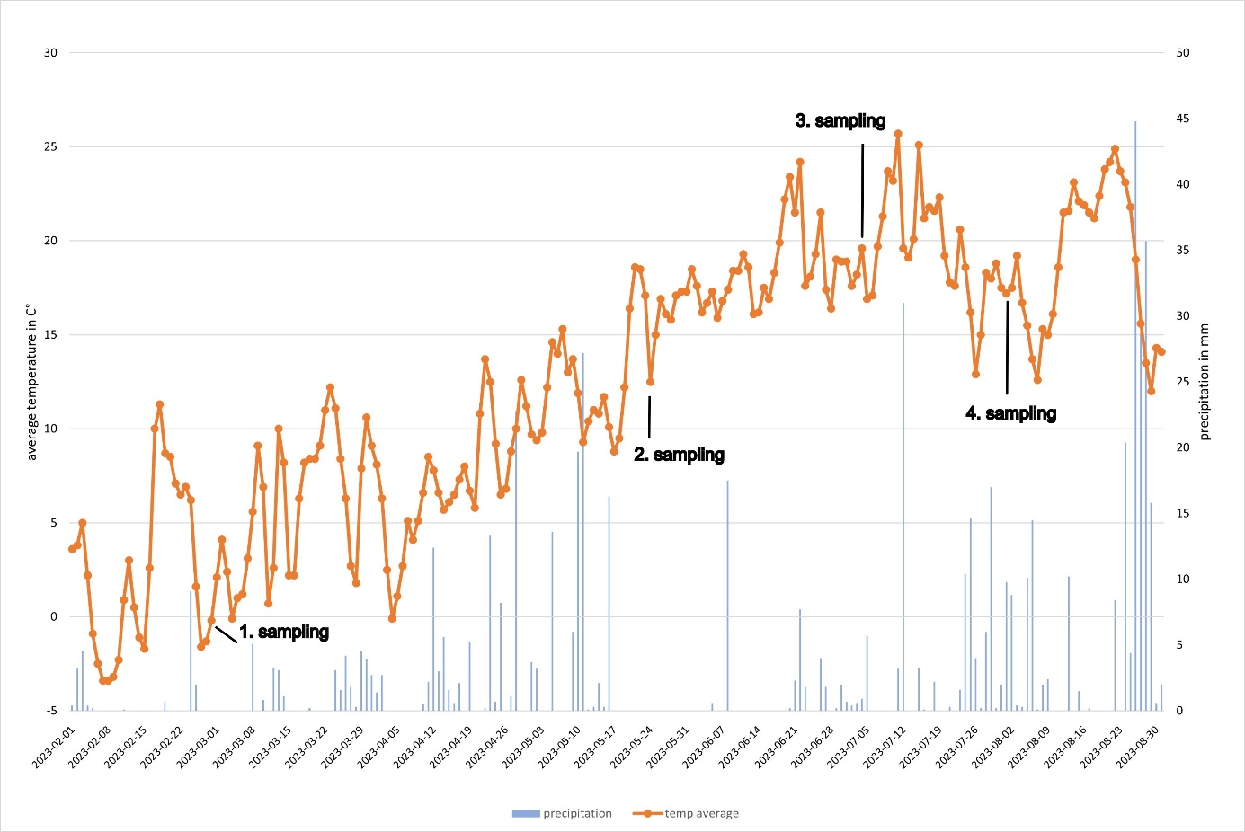
Fig. S 1 Average temperature and precipitation data metrological station Weihenstephan-Duernast from 01.02.2023 until 31.08.2023.

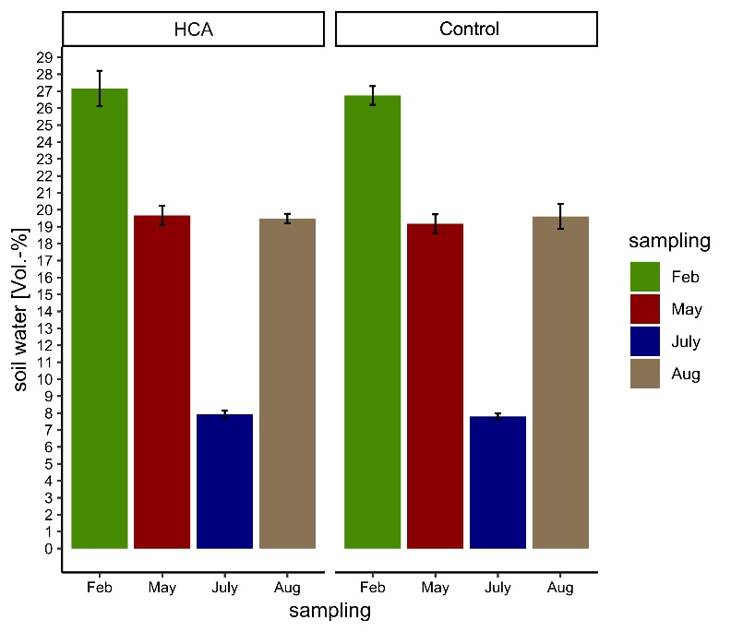
Fig. S 2 Moisture content topsoil from 0-10 cm over the period of the 1-year experimental field trial at Dürnast.
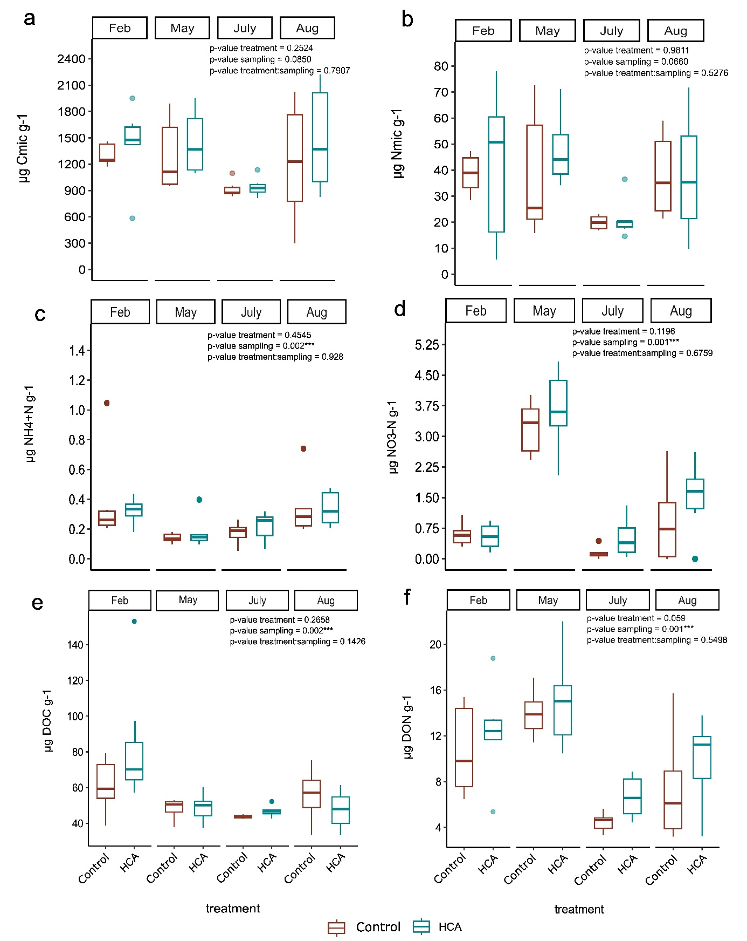
Fig. S 3 Boxplot showing the values of a C_{mic} [µg C_{mic} g⁻¹ dry soil] and b N_{mic} [µg N_{mic} g⁻¹ dry soil], values of c ammonium [µg NH₄⁺-N g⁻ ¹ dry soil] and d nitrate [µg NO₃⁻-N g⁻¹ dry soil] and e DOC [µg DOC g⁻¹ dry soil] and f DON [µg DON g⁻¹ dry soil]. Significantly differences between sampling time points and treatments are listed in table S8 with Post-hoc analysis.

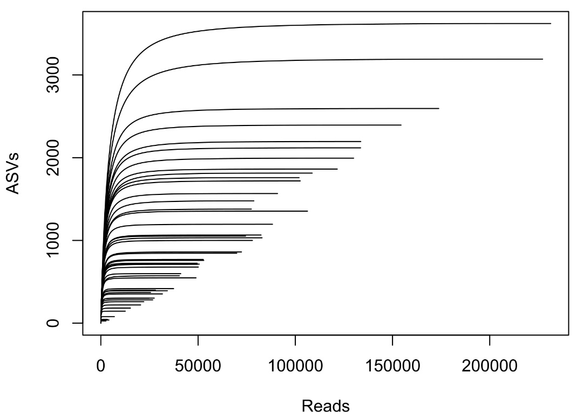
Fig. S 4 Rarefaction curve drawn using the ASV table prevenient from metabarcoding sequencing.

Supplementary references

Bach, H. J., Hartmann, A., Schloter, M., Munch, J. C. (2001). PCR primers and functional probes for amplification and detection of bacterial genes for extracellular peptidases in single strains and in soil. J Microbiol Methods, 44: 173-182. https://doi.org/https://doi.org/10.1016/S0167-7012(00)00239-6
Bano, N., Ruffin, S., Ransom, B., Hollibaugh, J. T. (2004). Phylogenetic Composition of Arctic Ocean Archaeal Assemblages and Comparison with Antarctic Assemblages. Appl Environ Microbiol, 70: 781-789. https://doi.org/doi:10.1128/AEM.70.2.781-789.2004
Nicol, G. W., Glover, L. A., Prosser, J. I. (2003). Molecular analysis of methanogenic archaeal communities in managed and natural upland pasture soils. Glob Chang Biol, 9: 1451-1457. https://doi.org/https://doi.org/10.1046/j.1365-2486.2003.00673.x

