Supplementary material to

Sex-specific individual and joint associations of multiple environmental exposures with diabetes and obesity in the population-based German National Cohort (NAKO)
Fiona Niedermayer ^{1, 2}*, Barbara Hoffmann ³, Boya Zhang ^{4, 5}, Jie Chen ^{4, 5}, Jaime E. Hart ^{4, 5}, Francine Laden ^{4, 5}, Gabriele Bolte ^{6, 7}, Tobia Lakes ^{8, 9}, Tamara Schikowski ^{10, 11}, Karin Halina Greiser ¹¹, Jeroen Staab ¹², Nikolaos Nikolaou ², Marco Dallavalle ², Matthias B. Schulze ^{13, 14}, Wolfgang Lieb ¹⁵, Cara Övermöhle ¹⁵, Thaddäus Tönnies ¹⁶, Verena Katzke ¹¹, Heiko Becher ¹⁷, Beate Fischer ¹⁸, Michael Leitzmann ¹⁸, Klaus Berger ¹⁹, Fatemeh Mayvaneh ¹⁹, Thomas Keil ^{20, 21, 22}, Lilian Krist ²⁰, Carolina J. Klett-Tammen ²³, Jana-Kristin Heise ²³, Tobias Pischon ^{24, 25, 26}, Ilais Moreno Velásquez ²⁴, Börge Schmidt ²⁷, Rajini Nagrani ²⁸, Stefan Rach ²⁸, Hermann Brenner ²⁹, Bernd Holleczek ³⁰, Volker Harth ³¹, Nadia Obi ³¹, Anna Köttgen ³², Rafael Mikolajczyk ³³, Claudia Meinke-Franze ³⁴, Wolfgang Hoffmann ³⁴, Alexandra Schneider ², Kathrin Wolf ², Annette Peters ^{1, 2, 35}

*Corresponding author:
Fiona Niedermayer
Ingolstädter Landstr. 1, 85764 Neuherberg, Germany
Email: fiona.niedermayer@helmholtz-munich.de
ORCID: 0000-0002-6798-2630

Number of supplementary tables: 14
Number of supplementary figures: 15
Number of supplementary methods: 1

Table S1. Characteristics of included and excluded participants of the German National Cohort (NAKO).
 |  | Included  (n = 174,955) |  | Excluded  (n = 29,728) | p-value
 | Sex, female n (%) |  | 88,245 (50.4) | 15,027 (50.5) | 0.731
Age (years), mean (SD) |  | 49.5 (12.8) |  | 51.9 (12.5) | <0.001
 | Diagnosis of diabetes, yes n (%) |  | 9,747 (5.6) | 2,548 (8.7) | <0.001
Age at diabetes diagnosis, mean (SD) |  | 47.6 (13.1) |  | 48.9 (12.3) | <0.001
 | Obesity (≥ 30 kg/m²) yes n (%) |  | 36,579 (20.9) | 7,441 (25.9) | <0.001
Body Mass Index (kg/m²), mean (SD) |  | 26.6 (5.0) |  | 27.3 (5.4) | <0.001
Waist circumference (cm), mean (SD) |  | 91.0 (14.31) |  | 93.1 (14.9) | <0.001
Physical activity (min/week), mean (SD) |  | 1,440 (1,583) |  | 1,028 (1,539) | <0.001
Alcohol consumption (g/day), mean (SD) |  | 10.6 (16.7) |  | 10.5 (17.5) | 0.608
Smoking behavior, n (%) |  |  |  |  | <0.001
 | Never-smoker |  | 81,151 (46.4) | 9,062 (39.5)
 | Ex-smoker |  | 56,988 (32.6) | 7,001 (30.5)
 | Current smoker |  | 36,816 (21.0) | 6,881 (30.0)
Education (ISCED 2011), n (%) |  |  |  |  | <0.001
 | Primary |  | 687 (0.4) | 868 (3.0)
 | Lower secondary |  | 3,527 (2.0) | 1,475 (5.0)
 | Upper secondary |  | 55,430 (31.7) | 10,852 (36.9)
 | Post-secondary non-tertiary |  | 15,700 (9.0) | 2,233 (7.6)
 | Bachelor’s |  | 55,324 (31.6) | 7,862 (26.7)
 | Master’s |  | 32,657 (18.7) | 4,658 (15.8)
 | Doctoral |  | 7,695 (4.4) | 1,038 (3.5)
 | Still in education or training |  | 3,935 (2.2) | 0 (0.0)
 | Income (Euros), mean (SD) |  | 3,721 (2,493) | 3,305 (2,518)
 | Partnership, n (%) |  |  |  | <0.001
 | Single |  | 32,807 (18.8) | 6,526 (22.1)
 | Living with partner |  | 124,039 (71.0) | 20,153 (68.3)
 | Partner but living separately |  | 17,894 (10.2) | 2,831 (9.6)
 | Unemployment rate at district level (%), mean (SD) |  | 8.62 (3.21) | 8.9 (3.0) | <0.001
 | Population density (n/m²), 1km buffer, mean (SD) |  | 4,652 (4,363) | 4,861 (4,524) | <0.001
 | Degree of urbanization at municipality level, n (%) |  |  |  | <0.001
 | Urban |  | 124,979 (71.4) | 21,627 (72.8)
 | Suburban |  | 27,923 (16.0) | 4,274 (14.4)
 | Rural |  | 22,045 (12.6) | 3,815 (12.8)
p-values are calculated by t-test for continuous variable and by chi-squared test for categorical variables
Abbreviations: ISCED = International Standard Classification of Education, N = number, SD = standard deviation
Table S2. Descriptive statistics of environmental exposures and population density and their Spearman correlation coefficients in the German National Cohort (NAKO, n = 174,955).
Exposure | Summary statistics |  |  | Correlations
Exposure | Mean (SD) | Median (IQR) | Min; Max | NO₂ | PM_{2.5} | PM_{2.5}abs | T_{mean} | L_{den} (100m) | NDVI
NO₂ [µg/m³] | 26.82 (8.11) | 26.81 (10.56) | 4.76; 76.92 | - | - | - | - | - | -
PM_{2.5} [µg/m³] | 17.27 (1.98) | 17.28 (2.92) | 9.32; 23.70 | 0.56 | - | - | - | - | -
PM_{2.5}abs [10⁻⁵m⁻¹] | 1.63 (0.38) | 1.63 (0.49) | 0.73; 4.05 | 0.84 | 0.65 | - | - | - | -
T_{mean} [°C] | 10.87 (0.83) | 10.93 (1.11) | 7.64; 13.05 | 0.65 | 0.48 | 0.54 | - | - | -
L_{den} (100m) [dB(A)] | 44.53 (6.03) | 40.67 (8.3) | 40.00; 72.45 | 0.61 | 0.35 | 0.56 | 0.40 | - | -
NDVI | 0.54 (0.10) | 0.55 (0.14) | 0.18; 0.83 | -0.54 | -0.39 | -0.59 | -0.42 | -0.34 | -
Population density [n/m²] | 4,652 (4,363) | 3,4450 (13,739) | 0; 22,178 | 0.72 | 0.48 | 0.71 | 0.58 | 0.42 | -0.64
Abbreviation: IQR = interquartile range; L_{den} = day–evening–night noise level, Min = minimum, Max = maximum, NDVI = normalized difference vegetation index, NO₂= nitrogen dioxide, PM_{2.5} = particulate matter < 2.5 µm; PM_{2.5}abs= PM_{2.5} absorbance, T_{mean} = mean air temperature.; SD = standard deviation.

Table S3. Associations of environmental exposures with diabetes and obesity for n = 86,710 men n = 88,245 women in the German National Cohort (NAKO) adding one confounder at the time to the logistic regression model.
Exposure | IQR | Adjustment | Diabetes |  | Obesity (BMI ≥ 30 kg/m²)
Exposure | IQR | Adjustment | Men | Women | Men | Women
Exposure | IQR | Adjustment | OR (95% CI) | OR (95% CI) | OR (95% CI) | OR (95% CI)
NO₂ [µg/m³] | 10.6 | Basic | 0.97 (0.93; 1.01) | 0.95 (0.91; 0.99) | 0.86 (0.84; 0.88) | 0.90 (0.88; 0.92)
NO₂ [µg/m³] | 10.6 | Basic + study center region | 1.05 (0.99; 1.11) | 1.01 (0.95; 1.08) | 0.90 (0.87; 0.93) | 0.96 (0.93; 0.99)
NO₂ [µg/m³] | 10.6 | Basic + education | 0.99 (0.96; 1.03) | 0.96 (0.92; 1.01) | 0.90 (0.88; 0.92) | 0.94 (0.92; 0.96)
NO₂ [µg/m³] | 10.6 | Basic + unemployment rate | 0.96 (0.93; 1.00) | 0.94 (0.91; 0.98) | 0.86 (0.84; 0.88) | 0.89 (0.87; 0.92)
NO₂ [µg/m³] | 10.6 | Basic + population density | 1.01 (0.97; 1.06) | 0.98 (0.93; 1.04) | 0.98 (0.95; 1.00) | 0.97 (0.94; 1.00)
NO₂ [µg/m³] | 10.6 | Full model | 1.10 (1.02; 1.19) | 1.04 (0.96; 1.13) | 1.05 (1.01; 1.10) | 1.05 (1.01; 1.10)
PM_{2.5} [µg/m³] | 2.9 | Basic | 1.04 (1.00; 1.09) | 1.05 (1.00; 1.10) | 0.90 (0.87; 0.92) | 0.92 (0.90; 0.94)
PM_{2.5} [µg/m³] | 2.9 | Basic + study center region | 1.12 (1.03; 1.21) | 1.11 (1.02; 1.21) | 0.98 (0.93; 1.02) | 1.05 (1.00; 1.11)
PM_{2.5} [µg/m³] | 2.9 | Basic + education | 1.07 (1.02; 1.12) | 1.08 (1.03; 1.13) | 0.93 (0.91; 0.95) | 0.97 (0.94; 0.99)
PM_{2.5} [µg/m³] | 2.9 | Basic + unemployment rate | 1.02 (0.97; 1.06) | 1.02 (0.97; 1.07) | 0.88 (0.86; 0.90) | 0.90 (0.88; 0.90)
PM_{2.5} [µg/m³] | 2.9 | Basic + population density | 1.10 (1.05; 1.16) | 1.11 (1.06; 1.17) | 1.00 (0.98; 1.03) | 0.99 (0.96; 1.02)
PM_{2.5} [µg/m³] | 2.9 | Full model | 1.12 (1.02; 1.22) | 1.11 (1.01; 1.22) | 1.07 (1.02; 1.13) | 1.10 (1.04; 1.16)
PM_{2.5}abs [10⁻⁵m⁻¹] | 0.5 | Basic | 0.98 (0.95; 1.02) | 0.97 (0.93; 1.01) | 0.85 (0.83; 0.87) | 0.88 (0.86; 0.90)
PM_{2.5}abs [10⁻⁵m⁻¹] | 0.5 | Basic + study center region | 1.03 (0.98; 1.09) | 0.99 (0.95; 1.07) | 0.89 (0.87; 0.92) | 0.93 (0.90; 0.96)
PM_{2.5}abs [10⁻⁵m⁻¹] | 0.5 | Basic + education | 1.01 (0.97; 1.05) | 0.99 (0.95; 1.03) | 0.89 (0.87; 0.91) | 0.92 (0.90; 0.94)
PM_{2.5}abs [10⁻⁵m⁻¹] | 0.5 | Basic + unemployment rate | 0.98 (0.95; 1.02) | 0.97 (0.93; 1.01) | 0.85 (0.83; 0.87) | 0.88 (0.86; 0.90)
PM_{2.5}abs [10⁻⁵m⁻¹] | 0.5 | Basic + population density | 1.04 (0.99; 1.09) | 1.02 (0.98; 1.08) | 0.96 (0.93; 0.98) | 0.94 (0.91; 0.96)
PM_{2.5}abs [10⁻⁵m⁻¹] | 0.5 | Full model | 1.08 (1.01; 1.15) | 1.03 (0.96; 1.11) | 1.01 (0.97; 1.05) | 0.98 (0.95; 1.02)
T_{mean} [°C] | 1.1 | Basic | 0.92 (0.88; 0.95) | 0.96 (0.92; 1.00) | 0.84 (0.82; 0.85) | 0.87 (0.85; 0.89)
T_{mean} [°C] | 1.1 | Basic + study center region | 0.96 (0.90; 1.02) | 1.06 (1.00; 1.14) | 0.89 (0.85; 0.92) | 0.94 (0.90; 0.97)
T_{mean} [°C] | 1.1 | Basic + education | 0.96 (0.92; 1.00) | 1.00 (0.96; 1.04) | 0.88 (0.86; 0.90) | 0.93 (0.91; 0.96)
T_{mean} [°C] | 1.1 | Basic + unemployment rate | 0.88 (0.84; 0.91) | 0.92 (0.88; 0.97) | 0.81 (0.79; 0.83) | 0.84 (0.82; 0.86)
T_{mean} [°C] | 1.1 | Basic + population density | 0.93 (0.89; 0.97) | 0.99 (0.95; 1.04) | 0.91 (0.89; 0.93) | 0.92 (0.89; 0.94)
T_{mean} [°C] | 1.1 | Full model | 0.96 (0.90; 1.04) | 1.10 (1.02; 1.19) | 0.98 (0.94; 1.02) | 1.00 (0.96; 1.04)
L_{den} (100m) [dB(A)] | 8.3 | Basic | 1.06 (1.02; 1.10) | 1.03 (0.98; 1.07) | 0.99 (0.97; 1.02) | 1.02 (1.00; 1.05)
L_{den} (100m) [dB(A)] | 8.3 | Basic + study center region | 1.09 (1.05; 1.14) | 1.06 (1.01; 1.11) | 1.05 (1.02; 1.07) | 1.08 (1.05; 1.10)
L_{den} (100m) [dB(A)] | 8.3 | Basic + education | 1.05 (1.01; 1.10) | 1.03 (0.99; 1.08) | 1.00 (0.98; 1.03) | 1.04 (1.01; 1.06)
L_{den} (100m) [dB(A)] | 8.3 | Basic + unemployment rate | 1.04 (1.00; 1.09) | 1.01 (0.97; 1.06) | 0.99 (0.97; 1.01) | 1.01 (0.99; 1.04)
L_{den} (100m) [dB(A)] | 8.3 | Basic + population density | 1.08 (1.04; 1.12) | 1.05 (1.00; 1.09) | 1.06 (1.03; 1.08) | 1.07 (1.04; 1.09)
L_{den} (100m) [dB(A)] | 8.3 | Full model | 1.08 (1.03; 1.13) | 1.05 (1.00; 1.10) | 1.07 (1.04; 1.09) | 1.08 (1.05; 1.11)
Legend: Basic model included age, physical activity, alcohol consumption, smoking behavior. Full model includes the basic model and additionally study center region, education, unemployment rate at district level and population density. ORs and confidence intervals are given as IQR increase in exposure derived from logistic regression models. Abbreviation: BMI = Body Mass Index, CI = confidence interval, IQR = interquartile range, L_{den} = day–evening–night noise level, NO₂= nitrogen dioxide, OR = odds ratio, PM_{2.5} = particulate matter < 2.5 µm, PM_{2.5}abs= PM_{2.5} absorbance, T_{mean} = mean air temperature.
Table S4. Associations of environmental exposures with BMI and waist circumference for n = 86,710 men n = 88,245 women in the German National Cohort (NAKO) adding one confounder at the time to the linear regression model.
Exposure | IQR | Adjustment | BMI |  | Waist circumference
Exposure | IQR | Adjustment | Men | Women | Men | Women
Exposure | IQR | Adjustment | ß (95% CI) | ß (95% CI) | ß (95% CI) | ß (95% CI)
NO₂ [µg/m³] | 10.6 | Basic | -0.38 (-0.42; -0.34) | -0.34 (-0.39; -0.30) | -0.73 (-0.83; -0.63) | -0.57 (-0.69; -0.46)
NO₂ [µg/m³] | 10.6 | Basic + study center region | -0.30 (-0.36; -0.25) | -0.18 (-0.24; -0.11) | -0.67 (-0.82; -0.52) | -0.35 (-0.51; -0.19)
NO₂ [µg/m³] | 10.6 | Basic + education | -0.26 (-0.30; -0.22) | -0.19 (-0.24; -0.15) | -0.43 (-0.53; -0.33) | -0.25 (-0.36; -0.14)
NO₂ [µg/m³] | 10.6 | Basic + unemployment rate | -0.39 (-0.42; -0.35) | -0.36 (-0.41; -0.31) | -0.78 (-0.88; -0.68) | -0.63 (-0.74; -0.52)
NO₂ [µg/m³] | 10.6 | Basic + population density | -0.08 (-0.13; -0.04) | -0.11 (-0.17; -0.05) | 0.01 (-0.12; 0.14) | -0.02 (-0.16; 0.12)
NO₂ [µg/m³] | 10.6 | Full model | 0.06 (-0.02; 0.13) | 0.13 (0.04; 0.22) | 0.24 (0.04; 0.44) | 0.25 (0.04; 0.47)
PM_{2.5} [µg/m³] | 2.9 | Basic | -0.32 (-0.36; -0.27) | -0.28 (-0.33; -0.23) | -0.61 (-0.72; -0.49) | -0.47 (-0.60; -0.35)
PM_{2.5} [µg/m³] | 2.9 | Basic + study center region | -0.15 (-0.23; -0.06) | 0.03 (-0.07; 0.13) | -0.23 (-0.45; 0.00) | 0.17 (-0.08; 0.41)
PM_{2.5} [µg/m³] | 2.9 | Basic + education | -0.23 (-0.27; -0.19) | -0.14 (-0.19; -0.09) | -0.39 (-0.50; -0.27) | -0.17 (-0.29; -0.05)
PM_{2.5} [µg/m³] | 2.9 | Basic + unemployment rate | -0.36 (-0.40; -0.31) | -0.35 (-0.40; -0.29) | -0.81 (-0.93; -0.69) | -0.69 (-0.82; -0.56)
PM_{2.5} [µg/m³] | 2.9 | Basic + population density | -0.04 (-0.09; 0.01) | -0.05 (-0.11; 0.00) | 0.04 (-0.10; 0.17) | 0.01 (-0.13; 0.15)
PM_{2.5} [µg/m³] | 2.9 | Full model | 0.11 (0.02; 0.20) | 0.18 (0.07; 0.29) | 0.40 (0.16; 0.64) | 0.48 (0.21; 0.74)
PM_{2.5}abs [10⁻⁵m⁻¹] | 0.5 | Basic | -0.42 (-0.46; -0.38) | -0.39 (-0.44; -0.35) | -1.03 (-1.13; -0.93) | -0.79 (-0.90; -0.68)
PM_{2.5}abs [10⁻⁵m⁻¹] | 0.5 | Basic + study center region | -0.31 (-0.36; -0.27) | -0.23 (-0.29; -0.17) | -0.72 (-0.85; -0.59) | -0.48 (-0.62; -0.34)
PM_{2.5}abs [10⁻⁵m⁻¹] | 0.5 | Basic + education | -0.31 (-0.35; -0.27) | -0.26 (-0.30; -0.21) | -0.76 (-0.86; -0.66) | -0.50 (-0.61; -0.39)
PM_{2.5}abs [10⁻⁵m⁻¹] | 0.5 | Basic + unemployment rate | -0.42 (-0.46; -0.38) | -0.40 (-0.44; -0.35) | -1.04 (-1.14; -0.94) | -0.81 (-0.92; -0.70)
PM_{2.5}abs [10⁻⁵m⁻¹] | 0.5 | Basic + population density | -0.15 (-0.20; -0.10) | -0.19 (-0.25; -0.13) | -0.49 (-0.62; -0.36) | -0.38 (-0.52; -0.23)
PM_{2.5}abs [10⁻⁵m⁻¹] | 0.5 | Full model | -0.02 (-0.09; 0.04) | -0.01 (-0.08; 0.07) | 0.01 (-0.16; 0.18) | -0.05 (-0.24; 0.14)
T_{mean} [°C] | 1.1 | Basic | -0.44 (-0.48; -0.41) | -0.44 (-0.49; -0.39) | -0.84 (-0.94; -0.73) | -0.94 (-1.05; -0.82)
T_{mean} [°C] | 1.1 | Basic + study center region | -0.31 (-0.37; -0.25) | -0.27 (-0.35; -0.20) | -0.84 (-1.00; -0.68) | -0.66 (-0.84; -0.48)
T_{mean} [°C] | 1.1 | Basic + education | -0.31 (-0.35; -0.27) | -0.23 (-0.28; -0.19) | -0.50 (-0.60; -0.39) | -0.50 (-0.62; -0.38)
T_{mean} [°C] | 1.1 | Basic + unemployment rate | -0.51 (-0.55; -0.47) | -0.53 (-0.58; -0.48) | -1.11(-1.22; -1.00) | -1.22 (-1.34; -1.11)
T_{mean} [°C] | 1.1 | Basic + population density | -0.23 (-0.28; -0.19) | -0.28 (-0.33; -0.22) | -0.32 (-0.43; -0.20) | -0.63 (-0.76; -0.50)
T_{mean} [°C] | 1.1 | Full model | -0.06 (-0.12; 0.01) | -0.07 (-0.15; 0.01) | -0.25 (-0.43; -0.07) | -0.28 (-0.48; -0.08)
L_{den} (100m) [dB(A)] | 8.3 | Basic | -0.07 (-0.11; -0.03) | 0.04 (-0.01; 0.09) | -0.06 (-0.16; 0.05) | 0.16 (0.04; 0.28)
L_{den} (100m) [dB(A)] | 8.3 | Basic + study center region | 0.05 (0.01; 0.09) | 0.19 (0.14; 0.24) | 0.14 (0.03; 0.26) | 0.41 (0.29; 0.53)
L_{den} (100m) [dB(A)] | 8.3 | Basic + education | -0.04 (-0.08; 0.00) | 0.09 (0.04; 0.14) | 0.02 (-0.09; 0.12) | 0.27 (0.15; 0.38)
L_{den} (100m) [dB(A)] | 8.3 | Basic + unemployment rate | -0.08 (-0.12; -0.04) | 0.01 (-0.03; 0.06) | -0.14 (-0.25; -0.03) | 0.07 (-0.04; 0.19)
L_{den} (100m) [dB(A)] | 8.3 | Basic + population density | 0.08 (0.04; 0.12) | 0.17 (0.12; 0.22) | 0.28 (0.17; 0.39) | 0.43 (0.31; 0.55)
L_{den} (100m) [dB(A)] | 8.3 | Full model | 0.11 (0.06; 0.15) | 0.22 (0.16; 0.27) | 0.26 (0.15; 0.38) | 0.46 (0.34; 0.59)
Legend: Basic model included age, physical activity, alcohol consumption, smoking behavior. Full model = basic model plus study center region, education, unemployment rate at district level and population density. Betas and confidence intervals are given as IQR increase in exposure derived from linear regression models. Abbreviation: BMI = Body Mass Index, CI = confidence Interval, IQR = interquartile range; L_{den} = day–evening–night noise level, NO₂= nitrogen dioxide, PM_{2.5} = particulate matter < 2.5 µm; PM_{2.5}abs= PM_{2.5} absorbance, T_{mean} = mean air temperature.

Exposure | IQR | Logistic regression |  | Linear regression
Exposure | IQR | Diabetes | Obesity | BMI (kg/m²) | Waist circumference
Exposure | IQR | OR (95% CI) | OR (95% CI) | ß (95% CI) | ß (95% CI)
NO₂ [µg/m³] | 10.6 | 1.07 (1.01; 1.13) | 1.05 (1.02; 1.08) | 0.09 (0.03; 0.14) | 0.23 (0.09; 0.38)
PM_{2.5} [µg/m³] | 2.9 | 1.11 (1.04; 1.19) | 1.08 (1.04; 1.12) | 0.15 (0.08; 0.22) | 0.43 (0.25; 0.61)
PM_{2.5}abs [10⁻⁵m⁻¹] | 0.5 | 1.05 (1.00; 1.10) | 1.00 (0.97; 1.02) | -0.02 (-0.07; 0.03) | -0.04 (-0.16; 0.09)
T_{mean} [°C] | 1.1 | 1.02 (0.97; 1.07) | 0.99 (0.96; 1.01) | -0.07 (-0.12; -0.02) | -0.28 (-0.41; -0.15)
L_{den} (100m) [dB(A)] | 8.3 | 1.07 (1.03; 1.10) | 1.07 (1.05; 1.09) | 0.16 (0.13; 0.19) | 0.36 (0.28; 0.45)
Table S5. Associations of environmental exposures with diabetes, obesity and obesity-related measures from single-exposure linear and logistic regression models in the total sample of the German National Cohort (NAKO) (n = 174,955).
Legend: All models were adjusted for age, sex, study center region, physical activity, alcohol consumption, smoking behavior, education, unemployment rate at district level and population density. ORs, betas and confidence intervals are given per IQR increase in exposure. Diabetes diagnosis was reported by n = 9,747 (5.6%), and n = 36,579 (20.9 %) were obese. Abbreviation: BMI = Body Mass Index, CI = confidence interval, IQR = interquartile range; L_{den} = day–evening–night noise level, NO₂= nitrogen dioxide, OR = odds ratio, PM_{2.5} = particulate matter with diameter < 2.5 µm; PM_{2.5}abs= PM_{2.5} absorbance, T_{mean} = annual mean temperature.

Table S6. Sensitivity analyses of joint associations of two different environmental exposure mixtures with diabetes and obesity-related measures derived from quantile g-computation models in the German National Cohort (n = 86,710 men; n = 88,245 women).
Outcome | Sex | Multi exposure set 1:  PM_{2.5}, L_{den}, NDVI_{inverse} | Multi exposure set 1: without NDVI (PM_{2.5}, L_{den}) | Multi exposure set 1: PM_{2.5}, L_{den}, ns(NDVI) | Multi exposure set 2:  All exposures | Multi exposure set 2: All exposures except NDVI | Multi exposure set 2:  All exposures with ns(NDVI)
Outcome | Sex | OR / ß (95%-CI) | OR / ß (95%-CI) | OR / ß (95%-CI) | OR / ß (95%-CI) | OR / ß (95%-CI) | OR / ß (95%-CI)
Diabetes | Men | 1.20 (1.09; 1.33) | 1.15 (1.05; 1.25) | 0.86 (0.74; 1.01) | 1.13 (1.02; 1.26) | 1.11 (1.00; 1.23) | 0.84 (0.72; 0.98)
Diabetes | Women | 1.13 (1.01; 1.27) | 1.13 (1.02; 1.25) | 0.96 (0.80; 1.15) | 1.20 (1.05; 1.36) | 1.20 (1.06; 1.36) | 1.10 (0.92; 1.07)
Obesity | Men | 1.09 (1.04; 1.15) | 1.10 (1.06; 1.15) | 0.97 (0.88; 1.07) | 1.07 (1.01; 1.14) | 1.07 (1.01; 1.14) | 0.99 (0.90; 1.08)
Obesity | Women | 1.14 (1.08; 1.20) | 1.13 (1.08; 1.19) | 0.98 (0.89; 1.09) | 1.13 (1.06; 1.20) | 1.12 (1.06; 1.19) | 0.98 (0.89; 1.09)
BMI | Men | 0.12 (0.03; 0.21) | 0.16 (0.08; 0.25) | -0.11 (-0.27; 0.04) | 0.08 (-0.03; 0.19) | 0.09 (-0.01; 0.20) | -0.09 (-0.25; 0.07)
BMI | Women | 0.33 (0.21; 0.44) | 0.29 (0.18; 0.40) | -0.17 (-0.40; 0.06) | 0.24 (0.11; 0.37) | 0.20 (0.07; 0.33) | -0.26 (-0.49; -0.03)
Waist circumference | Men | 0.40 (0.14; 0.65) | 0.52 (0.29; 0.75) | -0.02 (-0.44; 0.40) | 0.25 (-0.05; 0.54) | 0.28 (0.00; 0.57) | -0.07 (-0.50; 0.35)
Waist circumference | Women | 0.72 (0.46 0.99) | 0.70 (0.44; 0.96) | -0.27 (-0.82; 0.27) | 0.46 (0.18; 0.74) | 0.39 (0.11; 0.67) | -0.60 (-1.14; -0.06)
Legend: Multi exposure set 2 included NO₂, PM_{2.5}, PM_{2.5}abs, T_{mean}, L_{den} and NDVI_{inverse}. Betas and ORs are given as interquartile range increase per exposure as exposures were standardized by dividing the exposures by their IQR. To capture the non-linear association between NDVI and outcomes, we included NDVI with natural cubic splines. Models were further adjusted for age, study region, physical activity, alcohol consumption, smoking behavior, education, neighborhood unemployment rate at district level and population density. Abbreviation: BMI = Body Mass Index; CI = confidence interval, IQR = interquartile range, L_{den} = day–evening–night noise level, NDVI = normalized difference vegetation index, NO₂= nitrogen dioxide, OR = odds ratio, PM_{2.5} = particulate matter < 2.5 µm; PM_{2.5}abs= PM_{2.5} absorbance, T_{mean} = mean air temperature.

Table S7. Participants’ characteristics in the final analytical sample of the German National Cohort (NAKO), stratified by sex and degree of urbanization.
 |  |  |  | Men  (n = 86,710) |  |  |  | Women  (n = 88,245)
 |  | Urban  (n = 62,004) |  | Suburban  (n = 13,771) |  | Rural  (n = 10,933) |  | Urban  (n = 62,975) |  | Suburban  (n = 14,152) |  | Rural  (n = 11,112)
Age (years), mean (SD) |  | 49.3 (13.0) |  | 50.2 (12.6) |  | 50.3 (12.1) |  | 49.4 (12.9) |  | 49.9 (12.4) |  | 49.4 (12.1)
 | Diagnosis of diabetes, yes n (%) |  | 3,656 (5.9) |  | 913 (6.6) |  | 783 (7.2) |  | 3,050 (4.8) |  | 736 (5.2) |  | 609 (5.5)
Age at diabetes diagnosis, mean (SD) |  | 49.9 (12.3) |  | 49.9 (12.0) |  | 50.0 (10.9) |  | 45.0 (13.8) |  | 44.5 (13.9) |  | 44.9 (13.7)
 | Obesity (≥ 30 kg/m²) yes n (%) |  | 12,491 (20.1) |  | 3,461 (25.1) |  | 3,144 (28.8) |  | 11,701 (18.6) |  | 3,013 (21.3) |  | 2,769 (24.9)
Body Mass Index (kg/m²), mean (SD) |  | 26.9 (4.4) |  | 27.7 (4.4) |  | 28.2 (4.5) |  | 25.8 (5.4) |  | 26.4 (5.5) |  | 26.9 (5.7)
Waist circumference (cm), mean (SD) |  | 95.9 (12.9) |  | 97.4 (12.8) |  | 98.9 (12.8) |  | 85.2 (13.5) |  | 85.98 (13.4) |  | 87.44 (13.9)
Physical activity (min/week), mean (SD) |  | 1,373 (1,542) |  | 1,568 (1,703) |  | 1,862 (1,869) |  | 1,396 (1,513) |  | 1,450 (1,590) |  | 1,476 (1,652)
Quintiles of physical activity, n (%)
Q1 |  | 10,821 ( 17.5) |  | 2,696 ( 19.6) |  | 2,043 ( 18.7) |  | 9,751 ( 15.5) |  | 2,772 (19.6) |  | 2,596 (23.4)
Q2 |  | 13,778 ( 22.2) |  | 2,531 ( 18.4) |  | 1,606 ( 14.7) |  | 13,317 ( 21.1) |  | 2,710 (19.1) |  | 1,917 (17.3)
Q3 |  | 13,633 ( 22.0) |  | 2,503 ( 18.2) |  | 1,654 ( 15.1) |  | 14,347 ( 22.8) |  | 2,730 (19.3) |  | 1,849 (16.6)
Q4 |  | 12,546 ( 20.2) |  | 2,888 ( 21.0) |  | 2,385 ( 21.8) |  | 13,257 ( 21.1) |  | 2,803 (19.8) |  | 2,127 (19.1)
Q5 |  | 11,226 ( 18.1) |  | 3,153 ( 22.9) |  | 3,245 ( 29.7) |  | 12,303 ( 19.5) |  | 3,137 ( 22.2) |  | 2,623 ( 23.6)
Alcohol consumption (g/day), mean (SD) |  | 13.8 (19.3) |  | 14.6 (19.9) |  | 14.9 (19.3) |  | 7.5 (13.1) |  | 6.6 (11.5) |  | 6.1 (11.1)
Smoking behavior, n (%)
 | Never-smoker |  | 26,071 (42.0) |  | 5826 (42.3) |  | 4477 (40.9) |  | 31127 (49.4) |  | 7606 (53.7) |  | 6043 (54.4)
 | Ex-smoker |  | 21,585 (34.8) |  | 5053 (36.7) |  | 3909 (35.8) |  | 19408 (30.8) |  | 4126 (29.2) |  | 2903 (26.1)
 | Current smoker |  | 14,348 (23.1) |  | 2892 (21.0) |  | 2547 (23.3) |  | 12440 (19.8) |  | 2420 (17.1) |  | 2166 (19.5)
Education (ISCED 2011), n (%)
 | Primary |  | 281 (0.5) |  | 35 (0.3) |  | 22 (0.2) |  | 281 (0.4) |  | 46 (0.3) |  | 22 (0.2)
 | Lower secondary |  | 1,020 (1.6) |  | 169 (1.2) |  | 85 (0.8) |  | 1532 (2.4) |  | 412 (2.9) |  | 309 (2.8)
 | Upper secondary |  | 15,891 (25.6) |  | 4786 (34.8) |  | 4506 (41.2) |  | 18866 (30.0) |  | 6105 (43.1) |  | 5271 (47.4)
 | Post-secondary non-tertiary |  | 5,093 (8.2) |  | 836 (6.1) |  | 497 (4.5) |  | 7188 (11.4) |  | 1335 (9.4) |  | 751 (6.8)
 | Bachelor’s |  | 20,342 (32.8) |  | 5594 (40.6) |  | 4556 (41.7) |  | 17216 (27.3) |  | 4159 (29.4) |  | 3455 (31.1)
 | Master’s |  | 13,569 (21.9) |  | 1,742 (12.6) |  | 964 (8.8) |  | 13,672 (21.7) |  | 1,624 (11.5) |  | 1,085 (9.8)
 | Doctoral |  | 4,141 (6.7) |  | 399 (2.9) |  | 210 (1.9) |  | 2574 (4.1) |  | 258 (1.8) |  | 113 (1.0)
 | Still in education or training |  | 1,667 (2.7) |  | 210 (1.5) |  | 93 (0.9) |  | 1646 (2.6) |  | 213 (1.5) |  | 106 (1.0)
 | Income (Euros), mean (SD) |  | 4,002 (2,770) |  | 4,014 (2,450) |  | 3,778 (2,299) |  | 3,463 (2,364) |  | 3,542 (2,101) |  | 3,390 (1,951)
 | Partnership, n (%)
 | Single |  | 11,073 (17.9) |  | 1,703 (12.4) |  | 1,275 (11.7) |  | 15,158 (24.1) |  | 2,217 (15.7) |  | 1,380 (12.4)
 | Living with partner |  | 44,181 (71.4) |  | 11,021 (80.1) |  | 8,779 (80.3) |  | 40,451 (64.3) |  | 10,778 (76.2) |  | 8,823 (79.4)
 | Partner but living separately |  | 6,662 (10.8) |  | 1,040 (7.6) |  | 874 (8.0) |  | 7,266 (11.6) |  | 1,148 (8.1) |  | 903 (8.1)
 | Unemployment rate at district level (%), mean (SD) |  | 9.1 (2.5) |  | 6.8 (3.8) |  | 8.1 (4.7) |  | 9.1 (2.5) |  | 6.8 (3.8) |  | 8.1 (4.7)
 | Population density (n/m²), 1km buffer, mean (SD) |  | 6,020 (4,375) |  | 1,630 (1,255) |  | 513 (569) |  | 6,087 (4,395) |  | 1,649 (1,255) |  | 529 (582)

*Q1: ≤ 210 min/wk for men, ≤ 200 min/wk for women, Q2: > 210 - ≤ 540 min/wk for men, > 200 - ≤ 530 min/wk for women, Q3: > 540 - ≤ 1,130 min/wk for men, > 530 - ≤ 1,110 min/wk for women, Q4: > 1,130 - ≤ 2,490 min/wk for men, > 1,110 - ≤ 2,370 min/wk for women, Q5: > 2,490 – 6,720 min/wk for men, > 2,370 – 6,720 for women. Abbreviations: ISCED = International Standard Classification of Education, N = number, SD = standard deviation,

Table S8. Participants distributed across the 16 German National Cohort (NAKO) study center regions, total and stratified by sex.
 | Overall  (n = 174,955) | Men  (n = 86,710) | Women  (n = 88,245)
Study center region, n (%)
Augsburg | 18,607 (10.6) | 9,443 (10.9) | 9,164 (10.4)
Berlin | 27,555 (15.7) | 13,591 (15.7) | 13,964 (15.8)
Bremen | 9,066 (5.2) | 4,481 (5.2) | 4,585 (5.2)
Düsseldorf | 7,289 (4.2) | 3,555 (4.1) | 3,734 (4.2)
Essen | 9,381 (5.4) | 4,680 (5.4) | 4,701 (5.3)
Freiburg | 9,075 (5.2) | 4,563 (5.3) | 4,512 (5.1)
Halle | 9,042 (5.2) | 4,346 (5.0) | 4,696 (5.3)
Hamburg | 6,640 (3.8) | 3,263 (3.8) | 3,377 (3.8)
Hannover | 8,463 (4.8) | 4,139 (4.8) | 4,324 (4.9)
Kiel | 5,750 (3.3) | 2,790 (3.2) | 2,960 (3.4)
Leipzig | 10,099 (5.8) | 5,055 (5.8) | 5,044 (5.7)
Mannheim | 8,999 (5.1) | 4,462 (5.1) | 4,537 (5.1)
Münster | 8,858 (5.1) | 4,414 (5.1) | 4,444 (5.0)
Neubrandenburg | 18,022 (10.3) | 9,009 (10.4) | 9,013 (10.2)
Regensburg | 9,137 (5.2) | 4,579 (5.3) | 4,558 (5.2)
Saarbrücken | 8,972 (5.1) | 4,340 (5.0) | 4,632 (5.2)

Table S9. Sensitivity analysis: Associations of environmental exposures with diabetes and obesity adjusted for different confounder sets in the German National Cohort (NAKO).
Exposure | IQR | Adjustment* | Diabetes |  | Obesity (BMI ≥ 30 kg/m²)
Exposure | IQR | Adjustment* | Men | Women | Men | Women
Exposure | IQR | Adjustment* | OR (95% CI) | OR (95% CI) | OR (95% CI) | OR (95% CI)
NO₂ [µg/m³] | 10.6 | Main model + income & partnership | 1.07 (0.99; 1.16) | 1.03 (0.94; 1.12) | 1.04 (1.00; 1.09) | 1.01 (0.97; 1.06)
NO₂ [µg/m³] | 10.6 | Main model without physical activity | 1.10 (1.02; 1.18) | 1.04 (0.96; 1.13) | 1.05 (1.00; 1.09) | 1.05 (1.00; 1.09)
NO₂ [µg/m³] | 10.6 | Main model + BMI | 1.08 (1.00; 1.17) | 1.02 (0.94; 1.11) | - | -
PM_{2.5} [µg/m³] | 2.9 | Main model + income & partnership | 1.08 (0.98; 1.18) | 1.09 (0.99; 1.20) | 1.06 (1.01; 1.12) | 1.06 (1.00; 1.12)
PM_{2.5} [µg/m³] | 2.9 | Main model without physical activity | 1.11 (1.02; 1.22) | 1.11 (1.01; 1.22) | 1.07 (1.02; 1.13) | 1.09 (1.03; 1.15)
PM_{2.5} [µg/m³] | 2.9 | Main model + BMI | 1.10 (1.00; 1.21) | 1.08 (0.98; 1.20) | - | -
PM_{2.5}abs [10⁻⁵m⁻¹] | 0.5 | Main model + income & partnership | 1.06 (0.99; 1.13) | 1.02 (0.95; 1.10) | 1.01 (0.97; 1.05) | 0.95 (0.92; 0.99)
PM_{2.5}abs [10⁻⁵m⁻¹] | 0.5 | Main model without physical activity | 0.97 (0.91; 1.04) | 1.03 (0.96; 1.10) | 1.00 (0.97; 1.04) | 0.98 (0.94; 1.02)
PM_{2.5}abs [10⁻⁵m⁻¹] | 0.5 | Main model + BMI | 1.08 (1.01; 1.15) | 1.03 (0.96; 1.11) | - | -
T_{mean} [°C] | 1.1 | Main model + income & partnership | 0.97 (0.90; 1.04) | 1.11 (1.03; 1.20) | 0.98 (0.94; 1.02) | 1.00 (0.96; 1.04)
T_{mean} [°C] | 1.1 | Main model without physical activity | 0.97 (0.91; 1.04) | 1.10 (1.02; 1.18) | 0.98 (0.94; 1.01) | 0.98 (0.93; 1.02)
T_{mean} [°C] | 1.1 | Main model + BMI | 0.97 (0.91; 1.05) | 1.12 (1.03; 1.21) | - | -
L_{den} (100m) [dB(A)] | 8.3 | Main model + income & partnership | 1.06 (1.01; 1.10) | 1.03 (0.99; 1.09) | 1.06 (1.03; 1.09) | 1.06 (1.03; 1.09)
L_{den} (100m) [dB(A)] | 8.3 | Main model without physical activity | 1.08 (1.03; 1.13) | 1.05 (1.00; 1.09) | 1.06 (1.04; 1.09) | 1.08 (1.05; 1.11)
L_{den} (100m) [dB(A)] | 8.3 | Main model + BMI | 1.06 (1.02; 1.11) | 1.02 (0.97; 1.07) | - | -
Legend: Main model included age, study center region, physical activity, alcohol consumption, smoking behavior, education, unemployment rate at district level and population density. ORs and confidence intervals are given as IQR increase in exposure derived from logistic regression models. Partnership is categorized as: single, living with partner, partner but living separately.
* Main model with income & partnership: men: n = 82,119; women: n = 81,756; model without physical activity: men: n = 86,710; women: n = 88,245
Abbreviation: BMI = Body Mass Index, CI = confidence interval, IQR = interquartile range, L_{den} = day–evening–night noise level, NO₂= nitrogen dioxide, OR = odds ratio, PM_{2.5} = particulate matter < 2.5 µm, PM_{2.5}abs= PM_{2.5} absorbance, T_{mean} = mean air temperature.

Table S10. Sensitivity analysis: Associations of environmental exposures with BMI and waist circumference adjusted for different confounder sets in the German National Cohort (NAKO).
Exposure | IQR | Adjustment* | BMI |  | Waist circumference
Exposure | IQR | Adjustment* | Men | Women | Men | Women
Exposure | IQR | Adjustment* | ß (95% CI) | ß (95% CI) | ß (95% CI) | ß (95% CI)
NO₂ [µg/m³] | 10.6 | Main model + income & partnership | 0.05 (-0.02; 0.13) | 0.04 (-0.05; 0.14) | 0.20 (0.00; 0.40) | 0.06 (-0.17; 0.28)
NO₂ [µg/m³] | 10.6 | Main model without physical activity | 0.04 (-0.03; 0.11) | 0.11 (0.02; 0.20) | 0.20 (0.00; 0.40) | 0.21 (-0.01; 0.42)
PM_{2.5} [µg/m³] | 2.9 | Main model + income & partnership | 0.10 (0.01; 0.19) | 0.10 (-0.02; 0.21) | 0.35 (0.10; 0.61) | 0.29 (0.02; 0.56)
PM_{2.5} [µg/m³] | 2.9 | Main model without physical activity | 0.11 (0.02; 0.20) | 0.18 (0.07; 0.29) | 0.41 (0.16; 0.65) | 0.46 (0.20; 0.72)
PM_{2.5}abs [10⁻⁵m⁻¹] | 0.5 | Main model + income & partnership | -0.03 (-0.09; 0.04) | -0.06 (-0.14; 0.02) | -0.02 (-0.20; 0.16) | -0.18 (-0.38; 0.01)
PM_{2.5}abs [10⁻⁵m⁻¹] | 0.5 | Main model without physical activity | -0.04 (-0.10; 0.03) | -0.02 (-0.10; 0.06) | -0.03 (-0.20; 0.14) | -0.09 (-0.28; 0.10)
T_{mean} [°C] | 1.1 | Main model + income & partnership | -0.06 (-0.12; 0.01) | -0.06 (-0.14; 0.03) | -0.22 (-0.41; -0.04) | -0.22 (-0.43; -0.02)
T_{mean} [°C] | 1.1 | Main model without physical activity | -0.06 (-0.13; 0.00) | -0.08 (-0.16; 0.00) | -0.26 (-0.44; -0.08) | -0.30 (-0.50; -0.10)
L_{den} (100m) [dB(A)] | 8.3 | Main model + income & partnership | 0.10 (0.05; 0.14) | 0.19 (0.13; 0.24) | 0.23 (0.11; 0.35) | 0.38 (0.25; 0.51)
L_{den} (100m) [dB(A)] | 8.3 | Main model without physical activity | 0.10 (0.06; 0.15) | 0.21 (0.16; 0.26) | 0.26 (0.14; 0.37) | 0.45 (0.33; 0.58)
Legend: Main model included age, study center region, physical activity, alcohol consumption, smoking behavior, education, unemployment rate at district level and population density. Betas and confidence intervals are given as IQR increase in exposure derived from linear regression models. Partnership is categorized as: single, living with partner, partner but living separately.
* Main model + income & partnership: men: n = 82,119; women: n = 81,756 due to missings in income and partnership; Main model without physical activity: men: n = 86,710; women: n = 88,245
Abbreviation: BMI = Body Mass Index, CI = Confidence Interval, IQR = interquartile range; L_{den} = day–evening–night noise level, NO₂= nitrogen dioxide, PM_{2.5} = particulate matter < 2.5 µm; PM_{2.5}abs= PM_{2.5} absorbance, T_{mean} = mean air temperature.

Table S11. Sensitivity analysis: Associations of environmental exposures with obesity, BMI, and waist circumference in the German National Cohort (NAKO) after excluding prevalent diabetes and cancer cases (in total: n = 9,203).
Exposure | IQR | Obesity (BMI ≥ 30 kg/m²) |  | BMI |  | Waist circumference
Exposure | IQR | Men  (n = 81,671) | Women  (n = 84,081) | Men  (n = 81,671) | Women  (n = 84,081) | Men  (n = 81,671) | Women  (n = 84,081)
Exposure | IQR | OR (95% CI) | OR (95% CI) | ß (95% CI) | ß (95% CI) | ß (95% CI) | ß (95% CI)
NO₂ [µg/m³] | 10.6 | 1.05 (1.00; 1.09) | 1.05 (1.00; 1.10) | 0.03 (-0.04; 0.1) | 0.10 (0.01; 0.18) | 0.16 (-0.04; 0.35) | 0.20 (-0.01; 0.42)
PM_{2.5} [µg/m³] | 2.9 | 1.07 (1.02; 1.13) | 1.09 (1.03; 1.15) | 0.10 (0.02; 0.19) | 0.16 (0.05; 0.27) | 0.39 (0.15; 0.64) | 0.42 (0.16; 0.68)
PM_{2.5}abs [10⁻⁵m⁻¹] | 0.5 | 1.00 (0.96; 1.04) | 0.98 (0.94; 1.02) | -0.05 (-0.11; 0.01) | -0.02 (-0.10; 0.05) | -0.07 (-0.24; 0.10) | -0.06 (-0.25; 0.12)
T_{mean} [°C] | 1.1 | 0.98 (0.94; 1.02) | 1.00 (0.95; 1.04) | -0.06 (-0.12; 0.01) | -0.09 (-0.17; -0.01) | -0.22 (-0.39; -0.04) | -0.31 (-0.50; -0.11)
L_{den} (100m) [dB(A)] | 8.3 | 1.06 (1.03; 1.08) | 1.06 (1.03; 1.09) | 0.08 (0.04; 0.13) | 0.19 (0.14; 0.24) | 0.19 (0.08; 0.31) | 0.41 (0.29; 0.54)
Legend: All models were adjusted for age, study center regions, physical activity, alcohol consumption, smoking behavior, education, unemployment rate at district level and population density. ORs, betas and confidence intervals are given as IQR increase exposure derived from linear and logistic regression models.
Abbreviation: BMI = Body Mass Index, CI = Confidence Interval, IQR = interquartile range, L_{den} = day–evening–night noise level, NO₂= nitrogen dioxide, OR = Odds ratio, PM_{2.5} = particulate matter < 2.5 µm, PM_{2.5}abs= PM_{2.5} absorbance, T_{mean} = mean air temperature.

Table S12. Sensitivity analysis: Associations of environmental exposures with BMI and waist circumference from single-exposure logistic regression models in the German National Cohort (NAKO) using data of participants with at least 5- or 10-year living duration at the residential address.
Exposure | Subgroup | IQR | Self-reported diagnosis of diabetes |  | Obesity (BMI ≥ 30 kg/m²)
Exposure | Subgroup | IQR | Men | Women | Men | Women
Exposure | Subgroup | IQR | OR (95% CI) | OR (95% CI) | OR (95% CI) | OR (95% CI)
NO₂ [µg/m³] | Living duration > 5 years | 10.3 | 1.14 (1.05; 1.25) | 1.05 (0.95; 1.16) | 1.05 (1.00; 1.11) | 1.06 (1.00; 1.11)
NO₂ [µg/m³] | Living duration > 10 years | 10.2 | 1.13 (1.03; 1.24) | 1.07 (0.96; 1.2) | 1.05 (0.99; 1.12) | 1.04 (0.98; 1.11)
PM_{2.5} [µg/m³] | Living duration > 5 years | 2.9 | 1.13 (1.02; 1.26) | 1.09 (0.97; 1.23) | 1.08 (1.01; 1.14) | 1.06 (1.00; 1.14)
PM_{2.5} [µg/m³] | Living duration > 10 years | 2.9 | 1.12 (1.00; 1.25) | 1.09 (0.96; 1.24) | 1.08 (1.01; 1.15) | 1.05 (0.98; 1.13)
PM_{2.5}abs [10⁻⁵m⁻¹] | Living duration > 5 years | 0.5 | 1.13 (1.05; 1.22) | 1.08 (0.99; 1.17) | 1.02 (0.97; 1.07) | 1.00 (0.96; 1.05)
PM_{2.5}abs [10⁻⁵m⁻¹] | Living duration > 10 years | 0.5 | 1.13 (1.04; 1.22) | 1.11 (1.01; 1.21) | 1.04 (0.99; 1.09) | 0.99 (0.94; 1.04)
T_{mean} [°C] | Living duration > 5 years | 1.2 | 0.97 (0.90; 1.06) | 1.17 (1.06; 1.28) | 1.01 (0.97; 1.06) | 1.02 (0.97; 1.07)
T_{mean} [°C] | Living duration > 10 years | 1.1 | 0.95 (0.87; 1.05) | 1.20 (1.07; 1.34) | 1.02 (0.97; 1.08) | 1.01 (0.95; 1.08)
L_{den} (100m) [dB(A)] | Living duration > 5 years | 7.7 | 1.10 (1.05; 1.15) | 1.04 (0.99; 1.1) | 1.07 (1.04; 1.10) | 1.08 (1.05; 1.11)
L_{den} (100m) [dB(A)] | Living duration > 10 years | 7.2 | 1.09 (1.04; 1.14) | 1.01 (0.96; 1.07) | 1.06 (1.03; 1.09) | 1.06 (1.03; 1.10)
Legend: All models were adjusted for age, study center region, physical activity, alcohol consumption, smoking behavior, education, unemployment rate at district level and population density. ORs and confidence intervals are given as IQR increase in exposure derived from logistic regression models. Sample sizes: n = 42,698 men with living duration > 10 years, n = 58,252 men with living duration > 5 years, n = 42,965 women with living duration > 10 years, n = 58,241 women with living duration > 5 years
Abbreviation: CI = Confidence Interval, IQR = interquartile range, L_{den} = day–evening–night noise level, NO₂= nitrogen dioxide, OR = Odds ratio, PM_{2.5} = particulate matter < 2.5 µm, PM_{2.5}abs= PM_{2.5} absorbance, T_{mean} = mean air temperature.
Table S13. Sensitivity analysis: Associations of environmental exposures with BMI and waist circumference from single-exposure linear regression models in the German National Cohort (NAKO) using data of participants with at least 5- or 10-year living duration at the residential address.
Exposure | Subgroup | IQR | BMI |  | Waist circumference
Exposure | Subgroup | IQR | Men | Women | Men | Women
Exposure | Subgroup | IQR | ß (95% CI) | ß (95% CI) | ß (95% CI) | ß (95% CI)
NO₂ [µg/m³] | Living duration > 5 years | 10.3 | 0.06 (-0.03; 0.15) | 0.14 (0.03; 0.26) | 0.29 (0.05; 0.53) | 0.33 (0.07; 0.6)
NO₂ [µg/m³] | Living duration > 10 years | 10.2 | 0.10 (0.00; 0.21) | 0.12 (-0.01; 0.25) | 0.46 (0.17; 0.75) | 0.33 (0.01; 0.64)
PM_{2.5} [µg/m³] | Living duration > 5 years | 2.9 | 0.13 (0.02; 0.24) | 0.13 (0.00; 0.27) | 0.51 (0.21; 0.81) | 0.39 (0.06; 0.72)
PM_{2.5} [µg/m³] | Living duration > 10 years | 2.9 | 0.13 (0.01; 0.26) | 0.10 (-0.06; 0.25) | 0.53 (0.19; 0.87) | 0.32 (-0.05; 0.69)
PM_{2.5}abs [10⁻⁵m⁻¹] | Living duration > 5 years | 0.5 | -0.01 (-0.09; 0.07) | 0.02 (-0.07; 0.12) | 0.11 (-0.11; 0.32) | 0.05 (-0.18; 0.29)
PM_{2.5}abs [10⁻⁵m⁻¹] | Living duration > 10 years | 0.5 | 0.03 (-0.06; 0.12) | 0.00 (-0.12; 0.11) | 0.24 (-0.01; 0.49) | 0.04 (-0.23; 0.31)
T_{mean} [°C] | Living duration > 5 years | 1.2 | -0.03 (-0.11; 0.05) | -0.02 (-0.13; 0.08) | -0.10 (-0.33; 0.12) | -0.17 (-0.42; 0.08)
T_{mean} [°C] | Living duration > 10 years | 1.1 | 0.01 (-0.09; 0.11) | -0.01 (-0.14; 0.12) | 0.03 (-0.25; 0.31) | -0.07 (-0.37; 0.24)
L_{den} (100m) [dB(A)] | Living duration > 5 years | 7.7 | -0.02 (-0.09; 0.06) | 0.21 (0.15; 0.27) | 0.35 (0.21; 0.49) | 0.47 (0.32; 0.62)
L_{den} (100m) [dB(A)] | Living duration > 10 years | 7.2 | 0.12 (0.07; 0.18) | 0.19 (0.12; 0.26) | 0.34 (0.19; 0.49) | 0.41 (0.25; 0.57)
Legend: All models were adjusted for age, study center regions, physical activity, alcohol consumption, smoking behavior, education, unemployment rate at district level and population density. ORs, betas and confidence intervals are given as IQR increase exposure derived from linear and logistic regression models. Sample sizes: n = 42,698 men with living duration > 10 years, n = 58,252 men with living duration > 5 years, n = 42,965 women with living duration > 10 years, n = 58,241 women with living duration > 5 years
Abbreviation: BMI = Body Mass Index, CI = Confidence Interval, IQR = interquartile range, L_{den} = day–evening–night noise level, NO₂= nitrogen dioxide, OR = Odds ratio, PM_{2.5} = particulate matter < 2.5 µm, PM_{2.5}abs= PM_{2.5} absorbance, T_{mean} = mean air temperature.

Table S14. Sensitivity analysis: Associations of environmental exposures with diabetes by using different definitions in the German National Cohort (NAKO).
Exposure | IQR | Excluding gestational diabetes (n = 1,157) | Excluding Type 1 diabetes likely cases  (n = 1,139) * |  | Excluding those without anti-diabetic medication use (n = 3,265)
Exposure | IQR | Women (n = 87,019) | Men (n = 86,326) | Women (n = 87,490) | Men (n = 85,483) | Women (n = 86,207)
Exposure | IQR | OR (95% CI) | OR (95% CI) | OR (95% CI) | OR (95% CI) | OR (95% CI)
NO₂ [µg/m³] | 10.6 | 1.10 (1.00; 1.22) | 1.09 (1.01; 1.18) | 1.05 (0.96; 1.15) | 1.10 (1.01; 1.20) | 1.13 (1.01; 1.26)
PM_{2.5} [µg/m³] | 2.9 | 1.19 (1.06; 1.33) | 1.10 (1.00; 1.20) | 1.14 (1.03; 1.27) | 1.11 (1.00; 1.23) | 1.17 (1.03; 1.33)
PM_{2.5}abs [10⁻⁵m⁻¹] | 0.5 | 1.10 (1.01; 1.19) | 1.07 (1.00; 1.14) | 1.04 (0.96; 1.12) | 1.09 (1.01; 1.17) | 1.13 (1.02; 1.24)
T_{mean} [°C] | 1.1 | 1.08 (0.98; 1.18) | 0.97 (0.90; 1.04) | 1.11 (1.02; 1.20) | 0.96 (0.89; 1.04) | 1.04 (0.93; 1.15)
L_{den} (100m) [dB(A)] | 8.3 | 1.07 (1.02; 1.13) | 1.07 (1.03; 1.12) | 1.04 (0.99; 1.10) | 1.09 (1.04; 1.14) | 1.09 (1.03; 1.16)
Legend: All models were adjusted for age, study center region, physical activity, alcohol consumption, smoking behavior, education, unemployment rate at district level and population density. ORs and confidence intervals are given as IQR increase in exposure derived from logistic regression models.
*defined as diagnosis age ≤ 30 years
Abbreviation: CI = Confidence Interval, IQR = interquartile range, L_{den} = day–evening–night noise level, NO₂= nitrogen dioxide, OR = Odds ratio, PM_{2.5} = particulate matter < 2.5 µm, PM_{2.5}abs= PM_{2.5} absorbance, T_{mean} = mean air temperature.

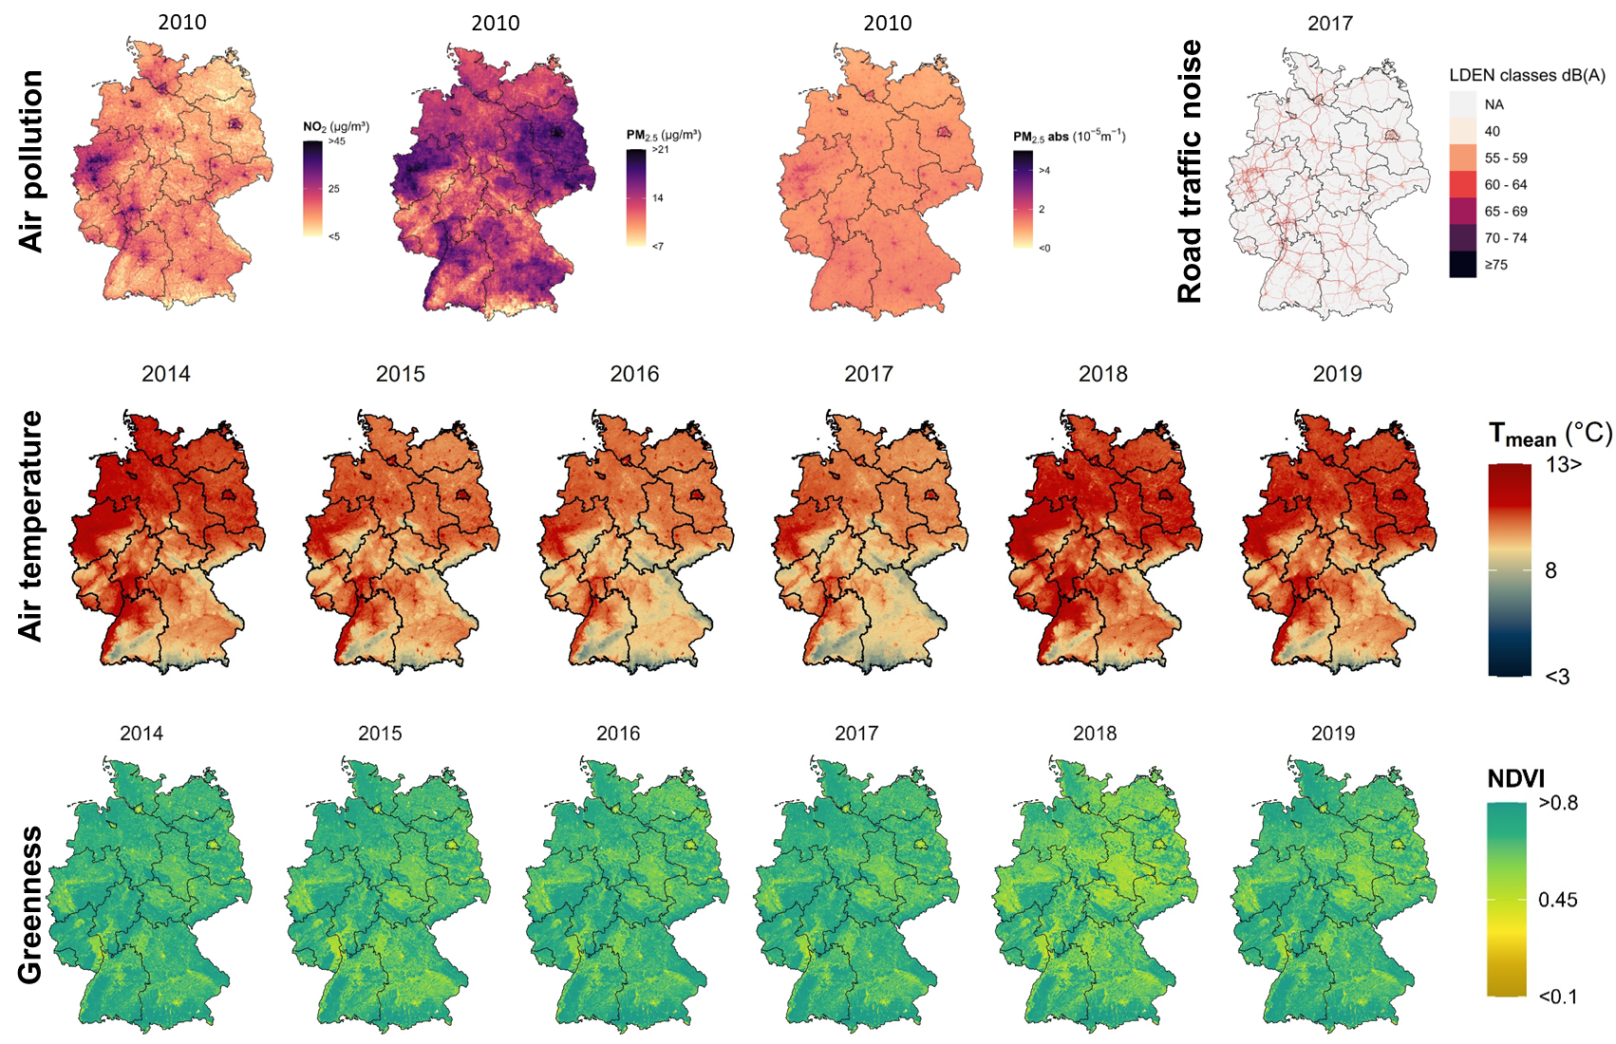
Figure S1. Maps Germany showing environmental exposures (air pollution, road traffic noise, air temperature and greenness) available in the German National Cohort (NAKO). Adapted from Wolf et al.¹. Abbreviations: L_{den} = day–evening–night noise level, NDVI = normalized difference vegetation index, NO₂= nitrogen dioxide, PM_{2.5} = particulate matter < 2.5 µm, PM_{2.5}abs= PM_{2.5} absorbance, T_{mean} = mean air temperature.
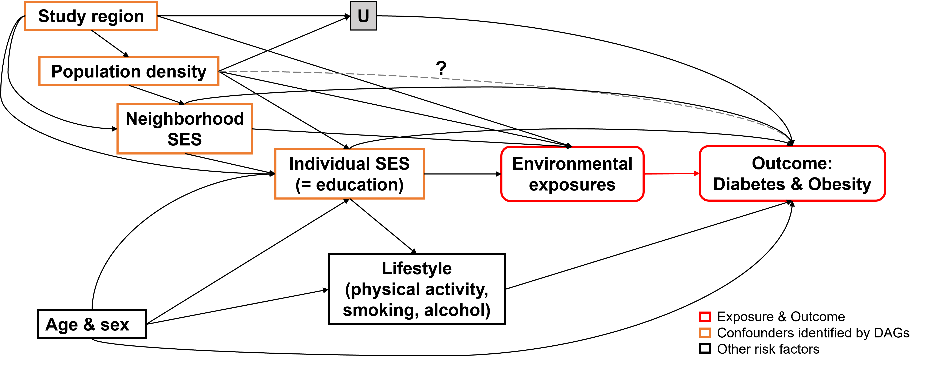

Figure S2. Directed acyclic graphs visualizing links between exposure, outcome, and covariates to identify potential confounders in the associations of environmental exposures with diabetes and obesity-related measures. Legend: U = unmeasured factors related to infrastructure/built environment or other residual confounding. Neighborhood SES is presented by unemployment rate at district level. Abbreviations: SES = socioeconomic status
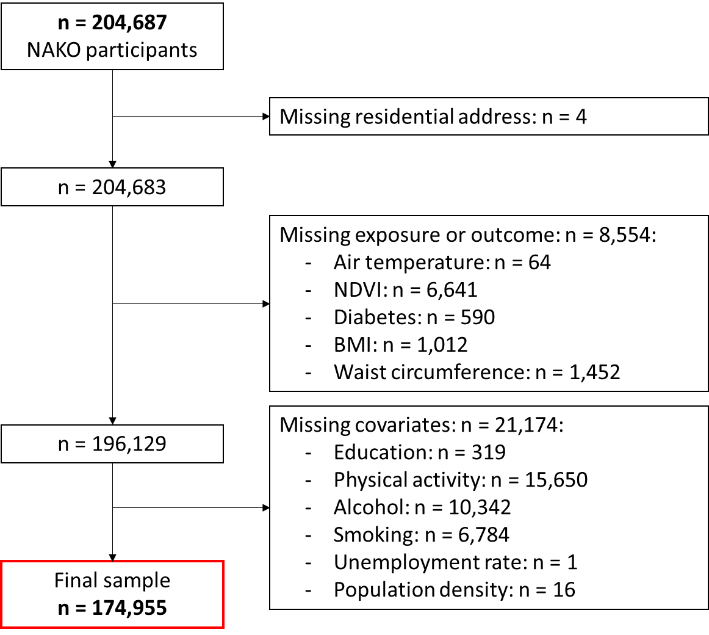
Figure S3. Flowchart presenting number of excluded participants from the German National Cohort (NAKO) and final analytical sample. Abbreviations: BMI = Body Mass Index, NDVI = Normalized difference vegetation index.

Figure S4. Exposure-response functions between environmental exposures and diabetes for n = 86,710 men in the German National Cohort (NAKO). Legend: Histograms present distribution of exposure (2nd y-axis on the right), vertical lines indicate percentiles of exposures (red: 10th and 90th percentile, yellow: 25th and 75th percentile; purple: 50th percentile). Models were fitted by restricted cubic splines for the exposure and were adjusted for age, study center region, lifestyle factors, education, unemployment rate at district level and population density.
Abbreviation: L_{den} = day–evening–night noise level, NDVI = normalized difference vegetation index, NO₂= nitrogen dioxide, log(OR) = log(odds ratio), PM_{2.5} = particulate matter < 2.5 µm, PM_{2.5}abs= PM_{2.5} absorbance, T_{mean} = mean air temperature.

Figure S5. Exposure-response functions between environmental exposures and diabetes for n = 88,245 women in the German National Cohort (NAKO). Legend: Histograms present distribution of exposure (2nd y-axis on the right), vertical lines indicate percentiles of exposures (red: 10th and 90th percentile, yellow: 25th and 75th percentile; purple: 50th percentile). Models were fitted by restricted cubic splines for the exposure and were adjusted for age, study center region, lifestyle factors, education, unemployment rate at district level and population density.
Abbreviation: L_{den} = day–evening–night noise level, NDVI = normalized difference vegetation index, NO₂= nitrogen dioxide, log(OR) = log(odds ratio), PM_{2.5} = particulate matter < 2.5 µm, PM_{2.5}abs= PM_{2.5} absorbance, T_{mean} = mean air temperature.

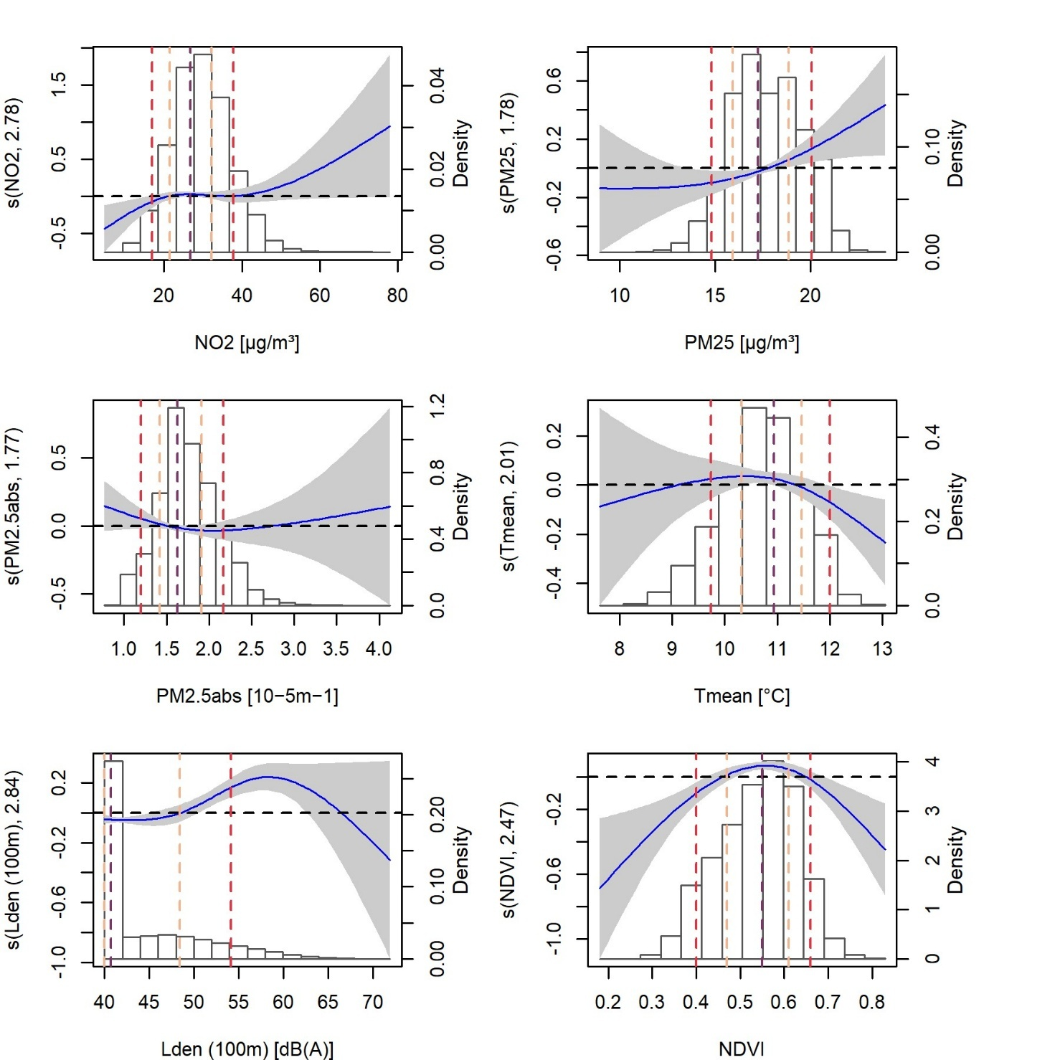
Figure S6. Exposure-response functions between environmental exposures and BMI for n = 86,710 men in the German National Cohort (NAKO). Legend: Histograms present distribution of exposure (2nd y-axis on the right), vertical lines indicate percentiles of exposures (red: 10th and 90th percentile, yellow: 25th and 75th percentile; purple: 50th percentile). Models were fitted by restricted cubic splines for the exposure and were adjusted for age, study center region, lifestyle factors, education, unemployment rate at district level and population density.
Abbreviation: BMI = Body Mass Index, L_{den} = day–evening–night noise level, NDVI = normalized difference vegetation index, NO₂= nitrogen dioxide, PM_{2.5} = particulate matter < 2.5 µm, PM_{2.5}abs= PM_{2.5} absorbance, T_{mean} = mean air temperature.

Figure S7. Exposure-response functions between environmental exposures and BMI for n = 88,245 women in the German National Cohort (NAKO). Legend: Histograms present distribution of exposure (2nd y-axis on the right), vertical lines indicate percentiles of exposures (red: 10th and 90th percentile, yellow: 25th and 75th percentile; purple: 50th percentile). Models were fitted by restricted cubic splines for the exposure and were adjusted for age, study center region, lifestyle factors, education, unemployment rate at district level and population density.
Abbreviation: BMI = Body Mass Index, L_{den} = day–evening–night noise level, NDVI = normalized difference vegetation index, NO₂= nitrogen dioxide, PM_{2.5} = particulate matter < 2.5 µm, PM_{2.5}abs= PM_{2.5} absorbance, T_{mean} = mean air temperature.

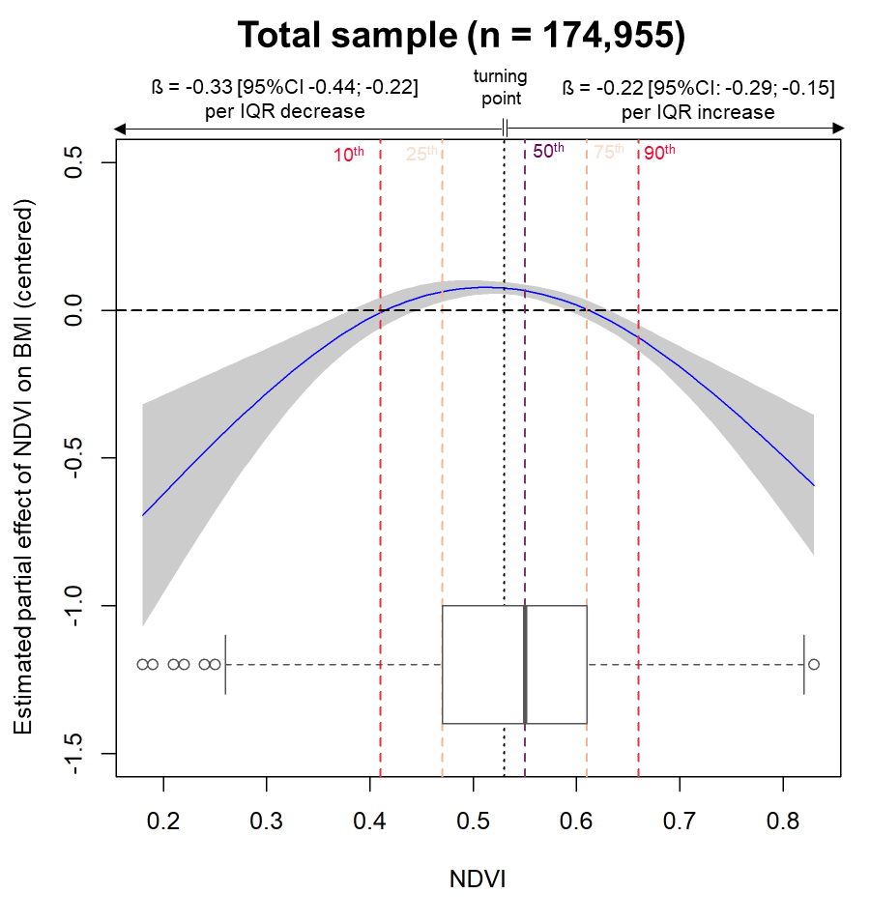
Figure S8. Non-linear exposure-response function between NDVI and BMI in the total analytical sample (n = 174,955) of the German National Cohort (NAKO). Legend: Boxplots present distribution of exposure, vertical lines indicate NDVI percentiles (red, yellow, purple) and turning point (black). Models were fitted by cubic splines for the exposure and were additionally adjusted for age, sex, study center region, lifestyle factors, education, unemployment rate at district level and population density. The betas and 95%-CI are given per IQR of 0.14 decrease in NDVI below the turning point (≤ 0.53) and per IQR of 0.14 increase in NDVI above the turning point (> 0.53) derived from piecewise linear regression models.
Abbreviations: BMI = Body Mass Index, CI = confidence interval, IQR = interquartile range, NDVI = Normalized difference vegetation index.

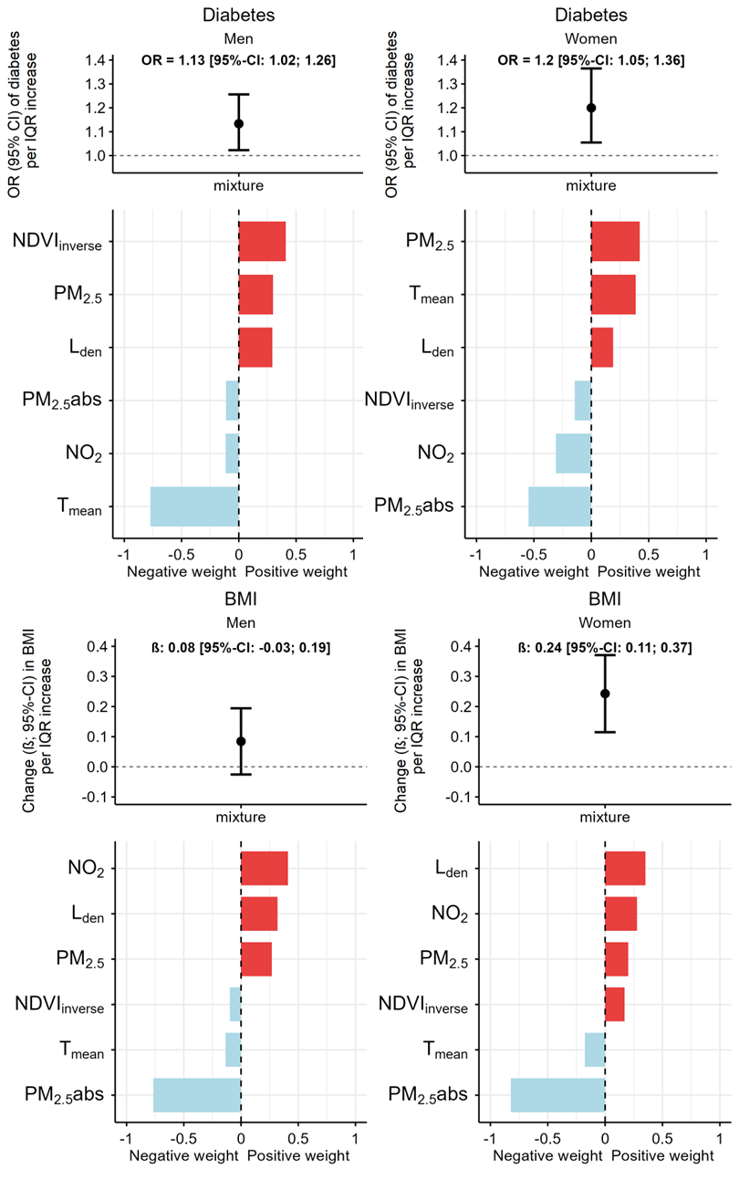
Figure S9. Joint associations of exposure to environmental mixture with diabetes and BMI for n = 86,710 men and n = 88,245 women from the German National Cohort (NAKO). Legend: Joint odds ratios and betas are given per interquartile range increase across all exposures derived from multi-exposure quantile g-computation models. We used the inverse of NDVI; and bars represent exposure weights, indicating the proportion of each exposure contributing to the overall positive and negative association. Models were additionally adjusted for age, study center region, lifestyle factors, education, unemployment rate at district level and population density. Abbreviations: BMI = Body Mass Index, CI = confidence interval, IQR = interquartile range, L_{den} = day–evening–night noise level, NDVI = normalized difference vegetation index, NO₂= nitrogen dioxide, OR = odds ratio, PM_{2.5} = particulate matter < 2.5 µm, PM_{2.5}abs= PM_{2.5} absorbance, T_{mean} = mean air temperature.

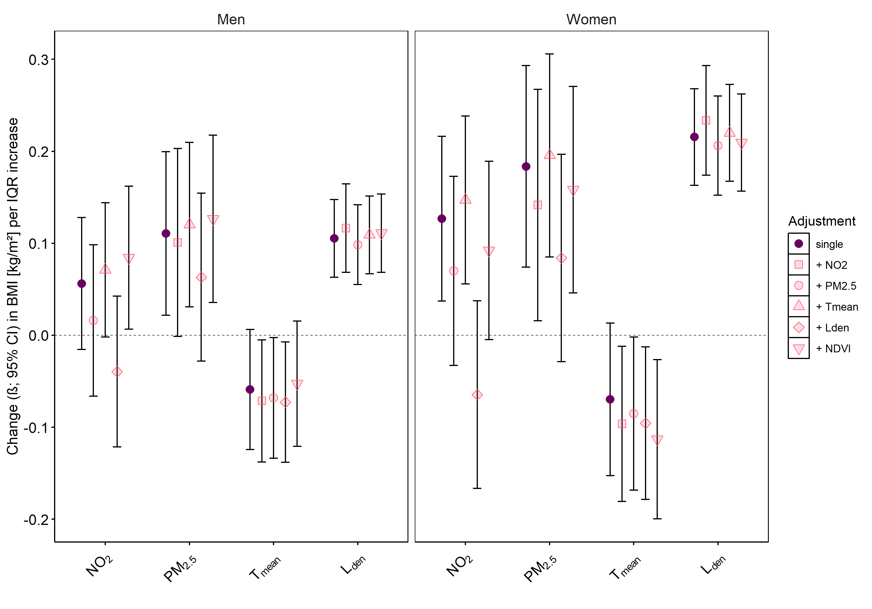
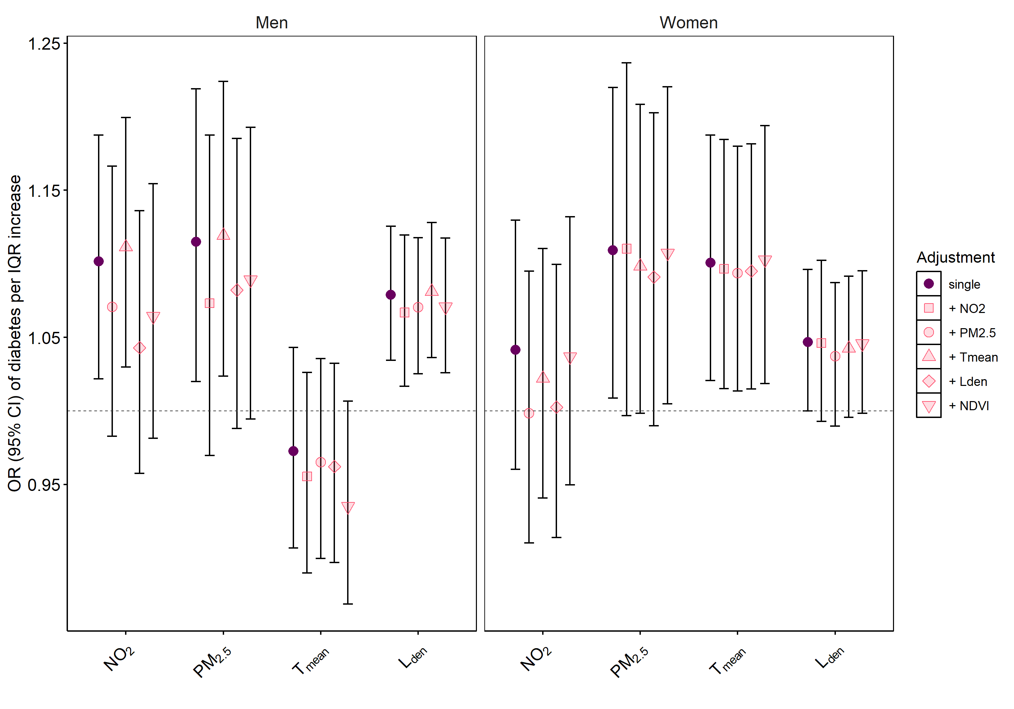
Figure S10. Comparison of single vs. two-exposure models to assess associations of environmental exposures with diabetes and BMI for men (n = 86,710) and women (n = 88,245) in the German National Cohort (NAKO). Legend: Linear and logistic regression models were performed and additionally adjusted for age, study center region, lifestyle factors, education, unemployment rate at district level and population density. Odds ratios and absolute changes are given per IQR increase in exposure. Abbreviations: BMI = Body Mass Index, CI = confidence interval, IQR = interquartile range, L_{den} = day–evening–night noise level, NDVI = normalized difference vegetation index, NO₂= nitrogen dioxide, OR = odds ratio, PM_{2.5} = particulate matter < 2.5 µm, PM_{2.5}abs= PM_{2.5} absorbance, T_{mean} = mean air temperature.
BMI
Diabetes

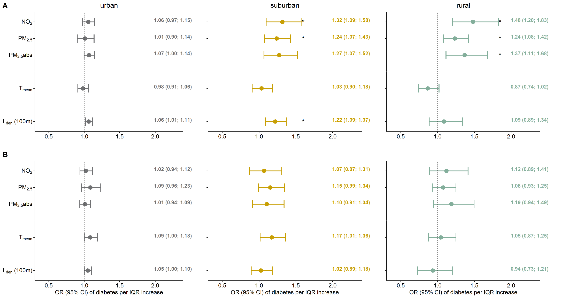
Figure S11. Urbanization-specific associations of environmental exposures with diabetes for men (A) and women (B) in the German National Cohort (NAKO). Legend: Odds ratios and 95%-CI were derived from logistic regression models including an interaction term between exposure and degree of urbanization from EUROSTAT. Star indicates p_{interaction} < 0.05. All models were additionally adjusted for age, study center region, lifestyle factors, education, unemployment rate at district level and population density. Urban: n = 62,004 men; n = 62,975 women, suburban: n = 13,771 men, n = 14,152 women, rural: n = 10,933 men, n = 11,112 women. Abbreviation: CI = confidence interval, IQR = interquartile range, L_{den} = day–evening–night noise level, NO₂= nitrogen dioxide, OR = odds ratio, PM_{2.5} = particulate matter < 2.5 µm, PM_{2.5}abs= PM_{2.5} absorbance, T_{mean} = mean air temperature.
Figure S12. Urbanization-specific exposure-response functions between NDVI and BMI for men (A) and women (B) in the German National Cohort (NAKO). Legend: Histograms present distribution of exposure (2nd y-axis on the right), vertical lines indicate percentiles of exposures (red: 10th and 90th percentile, yellow: 25th and 75th percentile; purple: 50th percentile). Models were fitted by cubic splines for the exposure and were additionally adjusted for age, study center region, lifestyle factors, education, unemployment rate at district level and population density. Urban: n = 62,004 men; n = 62,975 women, suburban: n = 13,771 men, n = 14,152 women, rural: n = 10,933 men, n = 11,112 women. Abbreviation: BMI = Body mass index, NDVI = normalized difference vegetation index.
B
A

Figure S13. Radar chart presenting standardized means of environmental exposures, population density, and BMI per study center region in the German National Cohort (NAKO). Legend: Grey areas indicate mean of the total NAKO sample (n = 174,955), red areas indicate mean of each study center regions. Abbreviations: BMI = Body Mass Index, L_{den} = day–evening–night noise level, NDVI = normalized difference vegetation index, NO₂= nitrogen dioxide, PM_{2.5} = particulate matter with diameter < 2.5 µm, PM_{2.5}abs= PM_{2.5} absorbance, T_{mean} = annual mean temperature.

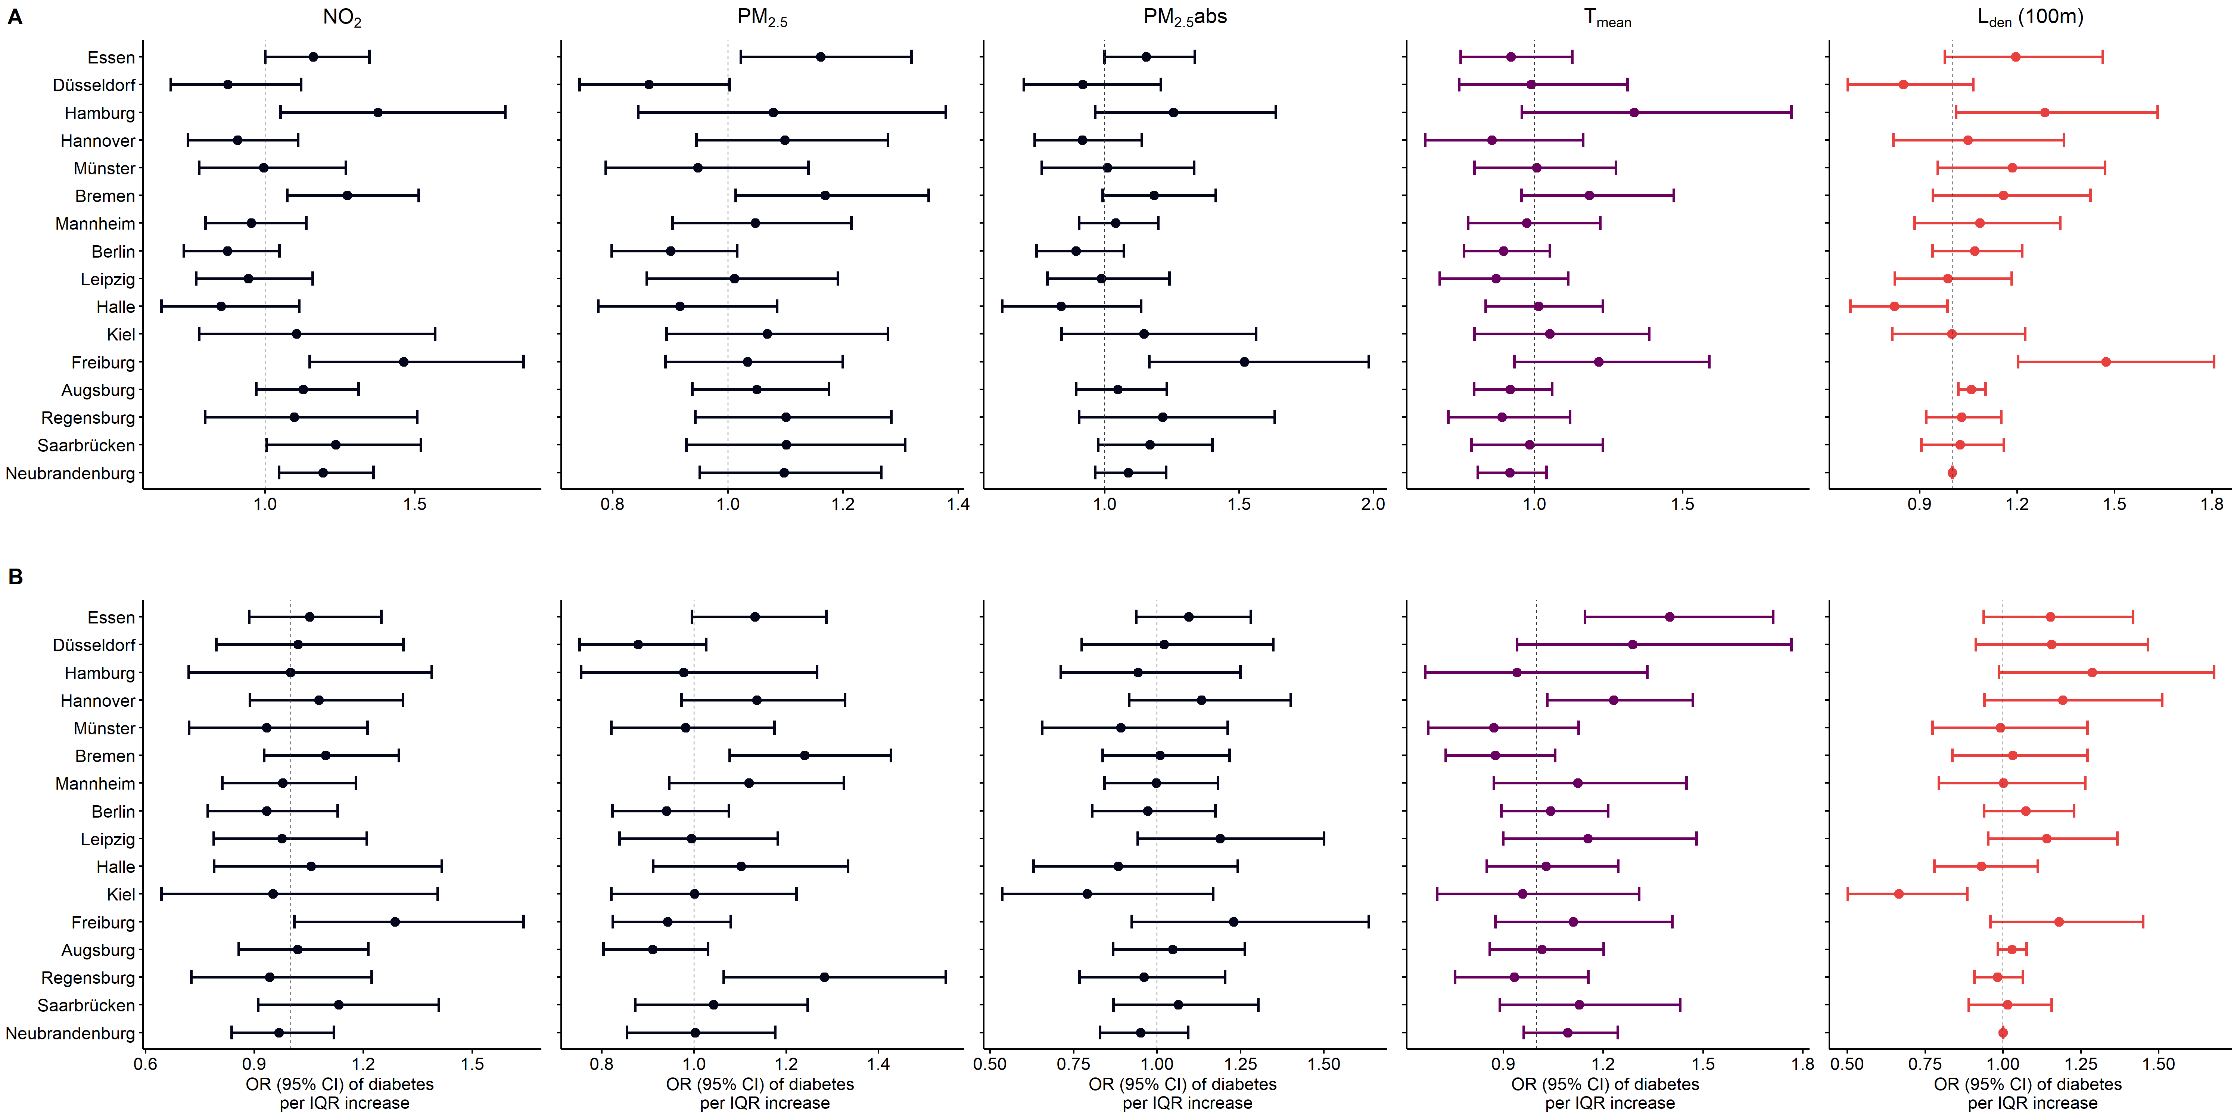
Figure S14. Study center region-specific associations between environmental exposures and diabetes for men (A) and women (B) in the German National Cohort (NAKO; n = 174,955). Legend: The order of study center regions is sorted by decreasing proportion of urban areas from top to bottom. ORs and 95%-CI are given per study center region specific IQR increase of exposure derived from logistic regression models and were additionally adjusted for age, lifestyle factors, education, unemployment rate at district level and population density. Abbreviations: CI = confidence interval, IQR = interquartile range, L_{den} = day–evening–night noise level, NO₂= nitrogen dioxide, OR = odds ratio, PM_{2.5} = particulate matter < 2.5 µm, PM_{2.5}abs= PM_{2.5} absorbance, T_{mean} = mean air temperature.
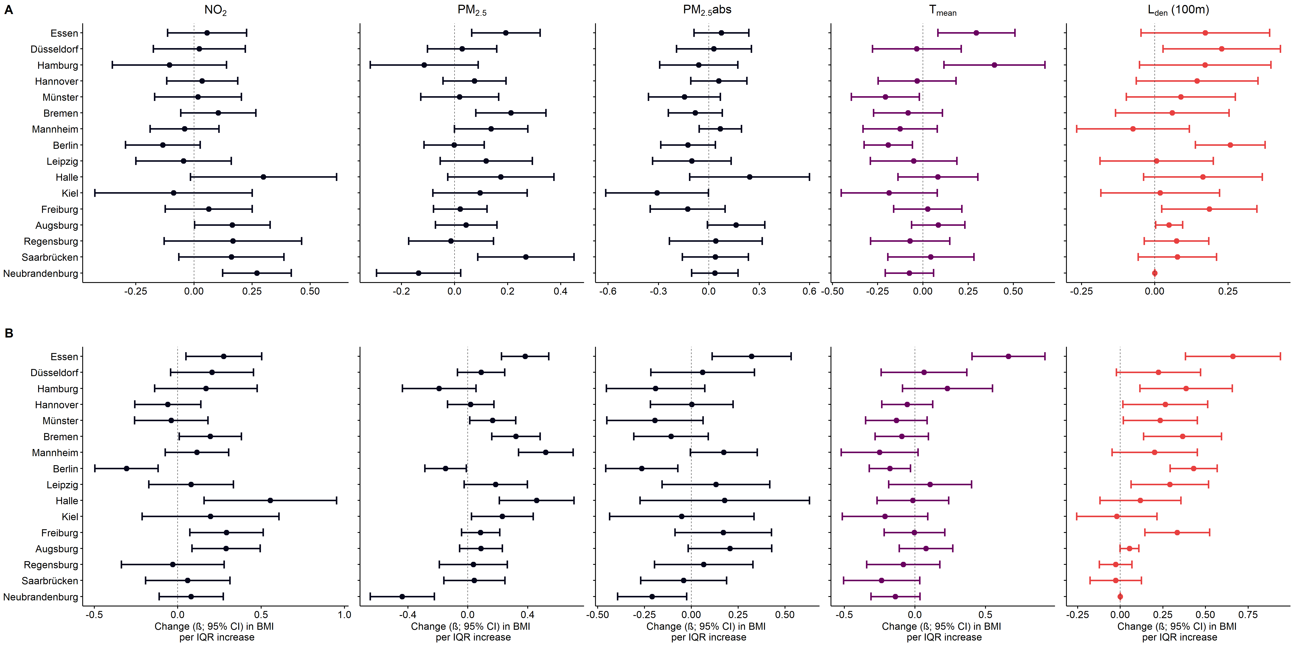
Figure S15. Study center region-specific associations between environmental exposures and BMI for men (A) and women (B) in the German National Cohort (NAKO). Legend: The order of study center regions is sorted by decreasing proportion of urban areas from top to bottom. Betas and 95%-CI are given per study center region specific IQR increase of exposure derived from linear regression models and were adjusted for age, lifestyle factors, education, unemployment rate at district level and population density. Abbreviations: BMI = Body Mass Index, CI = confidence interval, IQR = interquartile range, L_{den} = day–evening–night noise level, NO₂= nitrogen dioxide, OR = odds ratio, PM_{2.5} = particulate matter < 2.5 µm, PM_{2.5}abs= PM2.5 absorbance, T_{mean} = mean air temperature.
Supplementary Methods
Methods S1: Piecewise linear regression
We detected non-linear associations of NDVI with diabetes, obesity, BMI and waist circumference (Figure S4-S7). The exposure-response curve was inverted u-shaped with a turning point around the median and with two nearly linear associations above and below the turning point. To approximate the association per IQR increase and decrease in NDVI below and above the turning point, we implemented piecewise linear regression models using the segmented package in R.² From visual inspection of the exposure-response functions, we expected the turning point around the median of NDVI (0.55). To identify the exact turning point for men and women, we compared total and sex-stratified models with different turning points between 0.50 and 0.55 using R² and Akaike information criterion (AIC). The highest R² and lowest AIC were obtained using 0.53, 0.50, 0.53 as turning point for men, women, and the total sample, respectively.

References
1. Wolf K, Dallavalle M, Niedermayer F, Bolte G, Tobia Lakes TS, Greiser KH, et al. Environmental exposure assessment in the German National Cohort (NAKO). Environmental Research. 2025. https://doi.org/10.1016/j.envres.2025.121259.
2. Muggeo VM. Estimating regression models with unknown break-points. Stat Med. 2003;22(19):3055-71. https://doi.org/10.1002/sim.1545.

