Supporting Materials
Appendix S1

Supplementary methods relevant to the Enquiring About Tolerance (EAT) randomized clinical trial
Between November 2009 and July 2012, the EAT study recruited 1303 healthy, exclusively breast-fed three months old infants from across England and Wales, regardless of their atopic status or their family history of allergy or atopy. Infants were randomized to either the Standard Introduction Group (SIG) or the Early Introduction Group (EIG). Participants in the SIG continued exclusive breast-feeding until six months of age, thereafter parents could introduce allergenic foods according to their own preference. Participants randomized to the EIG were instructed to continue breast-feeding alongside the sequential introduction of the six most common allergenic foods (cows’ milk, peanut, hen’s egg, sesame, codfish in a randomized order, followed by wheat). Sensitization was evaluated by skin prick testing and specific IgE levels, and food allergies were diagnosed by double-blind oral food challenges. Monthly questionnaires concerning the infants’ general health, diet, home environment, and family history, as well as hygiene practices were completed from enrolment to 1 year of age, and three-monthly thereafter until age three.

Water hardness
Domestic water hardness levels (calcium carbonate concentrations) were obtained from local water supply companies according to each participants’ home postcode at recruitment. As per our previous analyses regarding the influence of water hardness on the incidence of AD in EAT infants, water hardness was dichotomized as “hard” or “soft” water based on the median value of CaCO₃ across the whole EAT cohort (≥257mg/L CaCO₃).¹

FLG genotyping
Infants’ were screened for the six most common filaggrin (FLG) mutations using TaqMan discrimination assays (mutations R501X, 2282del4, R2447X, E3247X; ABI 7900 HT; Applied Biosystems, Foster City, CA, U.S.A.) or by sizing fluorescent polymerase chain reaction products (mutations 3673delC and 3702delG; Applied Biosystems 3130 DNA sequencer) as previously described.²

Trans-epidermal water loss measurement
Trans-epidermal water loss (TEWL) provides an objective quantification of water passing across the stratum corneum into the environment, serving as an indicator of the integrity of the skin barrier. TEWL measurements were conducted at 3 months and 1 year on clinically unaffected skin on the volar forearm using an Aquaflux AF200 condenser chamber device (Biox, UK). Recordings were conducted in an environmentally-controlled clinical research facility (with ambient temperature 20±2 °C, relative humidity 32–50%). Recordings were not taken while infants were visibly distressed or crying. Parents were instructed not to apply any skin care products, moisturizers, or bath oils to their infant’s arms during the preceding 24 hours, as previously described.^{1,3} The mean of three TEWL measurements was calculated. As per our previous publications, infants were dichotomized as having impaired skin barrier (“raised TEWL”), if TEWL measurements were above the upper quartile of TEWL measurements in infants without visible AD at that age (median TEWL _{3 months} 12.4g m⁻² h⁻¹ (IQR 10.4-15.0), median TEWL _{1 year} 13.7g m⁻² h⁻¹ (IQR 11.4-16.1)).

Additional clinical meta-data for the EAT microbiome sub-study

Urban-rural categorization, based upon land-use surrounding the infant’s home
The CORINE Land Cover (CLC) database is a pan-European programme which assimilates national mapping initiatives and provides a standardized framework to categorize different land-use/land-cover classes. CLC operates a three-tier hierarchical structure to categorize land-use classes across European countries, with a spatial resolution of 100m. The five primary (level 1) land-use classifications are artificial surfaces, agricultural areas, wetlands, water bodies, and forests and natural areas. Our analysis was performed at the second hierarchal level which has fifteen classifications, including urban areas, agricultural lands (including different farming subtypes), forests, other natural environments, and bodies of water, thus providing a more granular description of land-use classes. The CORINE2012 raster map corresponded most closely with the birth year of EAT participants.
Latitude and longitude coordinates of each EAT participant’s home postcode (n=1303) were assigned to a spatial object, utilizing the WGS84 coordinate referencing system, and then transformed to align with the British National Grid (European Petroleum Survey Group (EPSG) projection 27700), using SpatialPointsDataFrame and spTransform functions (package rgdal, version 1.6-7). A circular area, or “buffer zone”, centered on each participants’ home postcode at enrolment was generated, using a 3km radius based on previous work.⁴ For each infant, the proportions of the fifteen land-use classes within the buffer zone were extracted from the CLC database. Land-use data were analyzed with principal component analysis (PCA) using function PCA (package: FactoMineR) and visualized using package factoextra (Figure S1A). Previous studies evaluating the relationship between land-use data and atopic conditions scaled the extracted land-use data to unit-variance prior to PCA,^{4,5} in contrast, we performed PCA without scaling. Our justification was two-fold. Firstly, extracted land-use data were compositional (the percentage of each land-use category within the buffer) and thus all measured on the same scale. Further, UK geography differs from Scandinavian countries where there are higher proportions of non-urban, non-farming land, for example lakes and forests. As the focus of our investigation was on urban and rural land-use classes, using non-scaled data emphasized the land-use types of interest to this study, whereas scaling would give equal weighting to rarer land-use types. The first PC corresponded to a gradient from very urban to very rural (agricultural) environments, an “urban-rural gradient”, and explained 66.0% of variance of the 3km land-use buffer zones. Using scaled data, only 19.1% of variance was explained by the first PC (not shown). Extremes values of the urban-rural gradient mapped closely to large urban centers and to rural areas of the UK (Figure S1B).
Infants were further dichotomized into urban and rural clusters with the R function HCPC (package: FactoMineR) (Figure S1C, S1D). Hierarchical clustering of principal components (HCPC) involves an iterative process of agglomerative clustering based within the principal components space and Euclidian distance. HCPC sequentially merges the most similar pair of observations (individuals) to form a cluster, followed by merging the next most similar pair of observations (individual + individual, or individual + cluster), either forming a new cluster (individual + individual) or enlarging the membership of the existing cluster (individual + cluster), and so forth. Clustering continues until all data are merged to a single cluster. The hierarchical nature of HCPC can be visualized using a dendrogram (Figure S1C). Two clusters were identified; cluster 1 (shown in black, designated the urban cluster) had 595 members that exhibited negative values on PC1, indicative of urban characteristics, while the 708 cluster 2 members (shown in green, rural cluster) had mostly positive values on PC1, signifying rural/agricultural characteristics (Figure S1D). Cluster 1 members had higher proportions of urban fabric land-use compared to the overall cohort (mean proportion of urban land-use cluster 1: 0.68 vs mean proportion of urban land-use overall cohort: 0.43). Cluster 2 was characterised by significantly lower proportions of urban fabric (mean proportion of urban land-use cluster 2: 0.22 vs mean overall cohort: 0.43), and significantly higher proportions of arable land (mean proportion in cluster 2: 0.31 vs mean overall cohort: 0.19), pastures (mean proportion in cluster 2: 0.26. vs mean overall cohort: 0.16), and forests (mean proportion in cluster 2: 0.06 vs mean overall cohort: 0.04).

Suplementary Figure S1 Objectively categorizing EAT participants’ homes as urban or rural, using the CORINE land cover (CLC) satellite imagery database. (A) Principal component biplot of land-use types within 3km buffer zones surrounding each infant’s home postcode at 3 months of age. Arrows relate to the five land-uses types contributing most to the first prinicipal component (Dim.1). Dim.1 explained 66.0% of the variance of land-use data, and reflects an urban-rural gradient, i.e. homes which are very urban to very rural (agircultural). Each individual (n=1303) is plotted as a point, coloured according to their position on Dim.1. (B) Map of England and Wales with infants’ home postcodes coloured according to their position on the urban-rural gradient, which demonstrates that extreme values of the urban-rural gradient map to large urban centres in England and Wales (black) and to rural areas (green). (C) Dendrogram of individuals according to hierarchical agglomerative clustering following principal component analysis (PCA), demonstrating separation into two clusters. (D) PCA plot demonstrating that cluster 1 (black) and cluster 2 (green) represent opposite ends of the urban-rural gradient. Elipses correspond to 95% of members.

Hygiene related questionnaire data
Parents completed questionnaires at 3 months regarding bathing practices (bathing frequency per week, use of bath products including soaps, shampoos and bubble bath) and how often they cleaned their infant’s hands and face per day. The use of baby wipes for cleaning their infant’s face and hands was also recorded.

Hygiene score
A simple hygiene score (Table S1) was calculated using the parent-reported hygiene/bathing data, adapted from the hygiene score proposed by the Avon Longitudinal Study of Parents and Children (ALSPAC) research team.⁶ ALSPAC researchers queried “How often in a normal day are hands cleaned before meals?” which was not asked in EAT. Quintiles of the hygiene scores were calculated, similarly to ALSPAC study team.

Table S1 Hygiene-related questions and responses
 | Responses and scores
 | 0 | 1 | 2 | 3 | 4
How often do you bathe your baby? |  | Once a week or less | 2-4 times a week | 5-6 times a week | Daily or more frequently
How often on a normal day are your baby's hands washed or wiped? | Not at all | 1-2 times | 3-4 times | ≥5 times
Do you normally use baby wipes/wet wipes for this? | No | Yes
How often on a normal day is your baby's face washed or wiped? | Not at all | 1-2 times | 3-4 times | ≥5 times
Do you normally use baby wipes/wet wipes for this? | No | Yes

Supplementary methods for the EAT skin microbiome study

Skin microbiome sub-study
During the course of the EAT clinical trial, additional funding was secured to sample and analyze the early life skin microbiome. Beginning from December 2011, skin swabs were collected from consecutive infants using a standardized protocol, at enrolment (3 months) and at the scheduled 1-year visits. A comparison of infants included in the microbiome sub-study and the overall cohort is presented in Table S2. Differences in rates of AD at enrolment and maternal atopy were not statistically significant, and family history of AD and atopy were otherwise equal. The microbiome sub-study cohort was more rural and had fewer older siblings.
Supplementary Table S2 Comparison of infants included in the Enquiring About Tolerance (EAT) microbiome study, to the remainder of the EAT cohort (those not included in this study). P-values calculated using Fisher's exact test.

 | EAT microbiome cohort (this study) | Remaining EAT cohort (not included) | P-value
 | n=148 | n=1155
Demographics and birth history
Sex (male) | 76 (51.4%) | 577 (50.0%) | 0.794
Ethnicity (White) | 128 (86.5%) | 976 (84.5%) | 0.627
Filaggrin gene status |  |  | 0.467
Wild type | 114 (77.0%) | 956 (82.8%)
Loss of function mutation | 12 ( 8.1%) | 124 (10.7%)
Missing | 22 (14.9%) | 75 ( 6.5%)
Caesarean delivery | 32 (21.6%) | 296 (25.6%) | 0.316
Personal and family history
Atopic dermatitis (AD) at enrolment (3-months) | 45 (30.4%) | 272 (23.5%) | 0.083
Missing | 0 ( 0.0%) | 1 ( 0.1%)
Maternal AD (%)* | 51 (34.5%) | 398 (34.5%) | 1
Missing | 0 ( 0.0%) | 2 ( 0.2%)
Maternal atopy (asthma, AD, hayfever, food allergy) (%)* | 87 (58.8%) | 771 (66.8%) | 0.053
Missing | 0 ( 0.0%) | 2 ( 0.2%)
Paternal AD (%)* | 34 (23.0%) | 226 (19.6%) | 0.327
Missing | 0 ( 0.0%) | 2 ( 0.2%)
Paternal atopy (asthma, AD, hayfever, food allergy) (%)* | 84 (56.8%) | 631 (54.6%) | 0.662
Missing | 0 ( 0.0%) | 2 ( 0.2%)
Older sibling(s) (%) | 78 (52.7%) | 734 (63.5%) | 0.012
Number of siblings |  |  | 0.003
None (%) | 70 (47.3%) | 422 (36.5%)
One (%) | 57 (38.5%) | 439 (38.0%)
Two or more (%) | 21 (14.2%) | 294 (25.5%)
Sibling(s) with AD (%)* | 40 (27.0%) | 356 (30.8%) | 0.393
Missing | 0 ( 0.0%) | 2 ( 0.2%)
Home environment
Urban-Rural classification (Urban) (%) | 54 (36.5%) | 541 (46.8%) | 0.018
Pets in the home (%) | 74 (50.0%) | 480 (41.6%) | 0.063
Missing | 0 ( 0.0%) | 2 ( 0.2%)
Cigarette smoke exposure (%) | 19 (12.8%) | 149 (12.9%) | 1
Missing | 0 ( 0.0%) | 2 ( 0.2%)
“Hard” domestic water [CaCO₃ concentration ≥257mg/L] (%) | 74 (50.0%) | 573 (49.6%) | 0.931
Systemic antibiotic use#
Antibiotics prior to enrolment | 18 (12.2%) | 149 (12.9%) | 0.896
Missing | 7 ( 4.7%) | 71 ( 6.1%)
Antibiotics in the 30 days preceding the 1-year visit | 27 (18.2%) | 129 (11.2%) | 0.048
Missing | 7 ( 4.7%) | 145 (12.6%)
Bathing and hygiene variables (3-month questionnaire)
Bathing frequency (%) |  |  | 0.012
Once per week or less | 19 (12.8%) | 176 (15.2%)
2-4 times per week | 79 (53.4%) | 447 (38.7%)
5-6 times per week | 11 ( 7.4%) | 124 (10.7%)
Daily or more than daily | 32 (21.6%) | 337 (29.2%)
Missing | 7 ( 4.7%) | 71 ( 6.1%)
Infrequent (weekly or less) bathing (%) | 19 (12.8%) | 176 (15.2%) | 0.463
Missing | 7 ( 4.7%) | 71 ( 6.1%)
Bath product use (soap, shampoo, bubble bath) (%) | 84 (56.8%) | 558 (48.3%) | 0.073
Missing | 7 ( 4.7%) | 71 ( 6.1%)
Frequency of hand washing/wiping (%) |  |  | 0.153
Not at all | 20 (13.5%) | 147 (12.7%)
1-2 times per day | 99 (66.9%) | 791 (68.5%)
3-4 times per day | 22 (14.9%) | 123 (10.6%)
≥ 5 times per day | 0 ( 0.0%) | 23 ( 2.0%)
Missing | 7 ( 4.7%) | 71 ( 6.1%)
Wet wipes used to clean hands (%) | 30 (20.3%) | 253 (21.9%) | 0.663
Missing | 27 (18.2%) | 218 (18.9%)
* Family history of AD and atopy were based on parent-reported questionnaires
# Systemic antibiotic use was based on parental recall, and did not specify the which antibiotic was used, the indication, nor the duration of treatment.

Skin microbiome sample collection
Skin swabs were collected first, prior to any other EAT procedures to minimize contamination. A sterile Isohelix buccal DNA collection swab was moistened with two drops of sterile saline (0.9% NaCl) and rubbed firmly in a circular manner across a 2x2cm area on the left forearm and placed directly into a collection container. The process was repeated on the left elbow. An environmental control swab was collected for each visit by holding a moistened swab in the air, and placing it directly into a collection container without touching anything else. A small pilot study involving both adults with AD, and unaffected adults, successfully demonstrated that our swabbing methodology was suitable for DNA extraction, amplification using V3-V4 primers and sequencing of skin bacterial communities.

Skin swab storage and high-throughput 16S amplicon sequencing
Once collected, skin swabs were stored at -80ºC, first at King’s College London and subsequently at a commercial life sciences facility (Cell Projects Ltd., UK). Samples were then transported to an external provider for DNA extraction and sequencing on dry-ice (Section of Microbiology, University of Copenhagen, Denmark). DNA was extracted from skin swabs using the PowerMag Soil DNA Isolation Kit optimized for epMotion (MO-BIO Laboratories, Inc, USA). DNA extraction was performed using the epMotion robotic platform model (Eppendorf, Hamburg, Germany), with modification from the manufacturer’s protocol, as described previously for another low biomass study involving the hypopharyngeal microbiome of infants.⁷ PCR amplification of the V3-V4 region of the bacterial 16S rRNA gene was performed with modified broad primers (Uni341F 5′-CCTAYGGGRBGCASCAG-3 and Uni806R 5′-GGACTACNNGGGTATCTAAT-3′). Illumina barcode indexing was added during a second PCR reaction. PCR products, after each cycle, were purified using a magnetic HighPrep PCR Clean-up system (MagBio Genomics Inc., USA). Eluted DNA concentrations were normalized using SequalPrep Normalization Plate Kit (Invitrogen, USA) and stored at -20ºC until sequencing. Samples were pooled and sequenced using MiSeq v3 (Illumina Inc, USA), on four runs (2 × 300bp paired-end reads). Sequencing was performed on four runs, and samples from the same individual were nested on sequencing runs. To avoid unbalanced nucleotide composition, sequencing runs were spiked-in with 30 µl 5% PHiX (Illumina Inc, USA).

Sequencing positive and negative control specimens
A number of controls were collected and sequenced alongside skin samples (Table S2). 1) A subset of the environmental control swabs (manually selected to be equally distributed amongst body sites and ages, and including both infants with AD and unaffected infants (n=34). 2) A positive control mock community HM-782D (BEI resources, USA). 3) DNA-extraction negative control consisting of phosphate buffered saline. 4) Molecular grade water (Sigma-Aldrich, Merck, Germany) run as samples from the point of the first PCR amplification. 5) Molecular grade water run as samples from the point of the second PCR amplification. Control samples were sequenced alongside the skin samples.

Table S3 Skin and control swabs during sample processing. Environmental (Env.) control were collected at time of skin sampling.
Extraction plate | Sequencing  run | EAT  samples | Env. control | DNA extraction | Mock community | PCR1  controls | PCR2  controls
All | All | 594 | 34 | 7 | 3 | 3 | 4
1  2  3 | Run1 | 66  61  46 | 4  8  2 | 0  1  1 | 1 | 1 | 1
3  4  5  6 | Run2 | 17  62  63  40 | 0  0  4  1 | 0  0  1  1 | 1 | 1 | 1
6  7  8  9 | Run3 | 21  64  61  32 | 0  3  4  2 | 0  0  1  1 | 1 | 1 | 1
9  10  O/0 | Run4 | 31  30  0 | 2  4  0 | 0  0  1 | 0 | 0 | 1

Data processing
Raw sequence reads were trimmed and filtered using DADA2.⁸ ASVs were re-annotated using the AnnotIEM tool^{9,10} which compares the sequence alignment against four databases (EzBioCloud, NCBI, RDP and Silva) and provides higher rates of species-level annotation than conventional methods which utilize a single referencing database. Samples with fewer than 2,000 reads were removed (n=6).

Contamination removal
Preliminary analysis suggested contamination of samples with non-skin derived bacterial DNA, linked to laboratory pipelines and reagents. PERmutational Multivariate ANalysis Of VAriance (PERMANOVA) demonstrated that sequencing run was a major determinant of the microbiome composition (data not shown). Furthermore, Acinetobacter was the dominant taxa in skin samples, the environmental control swabs, and DNA extraction negative controls, suggesting a degree of sample contamination (Figure S2).

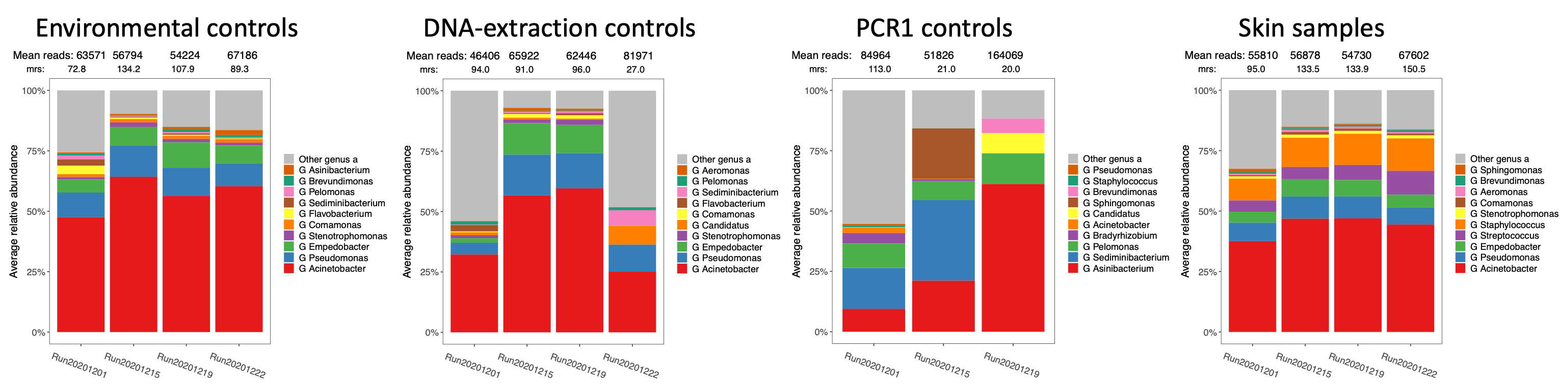
Figure S2 Stacked barcharts of relative abundance in negative controls, and in skin samples, prior to removal of contaminant ASVs. Environmental controls refers to control samples collected at the time of sample collection. Note: genera colours differ between plots.

In order to select the best method to identify and remove contaminating ASVs we compared a prevalence approach implemented by the R package decontam,¹¹ an abundance approach inspired by the tool MicrobIEM,¹² and feature-flagging based on partial least squares regression modelling (PLS) (data not shown). Ultimately, the abundance-based contamination removal approach was selected, and contaminant sequences were removed by creating a ratio of the abundance in samples compared to A) the environmental negative controls, B) DNA extraction controls and C) PCR1 controls. PCR2 controls had few reads, indicating low contamination during this processing step which likely represented DNA from samples contaminating the controls that should not be removed. The low number of reads also made them unsuitable for removing contamination, and thus PCR2 controls were not evaluated further.
Comparison of ASV abundance in PCR1 controls, relative to the abundance in skin samples, revealed a pattern where ASVs were convincingly more abundant in controls, or more abundant in skin samples (Figure S3) and thus a contamination abundance threshold of 5 was selected. This threshold meant that to not be labelled as contaminant, an ASV needed to be 5 times more abundant in a sample compared to the PCR1 negative controls. The separation was less clear comparing skin samples with either environmental negative controls or DNA-extraction controls (Figure S3). To inform the selection of a threshold to flag contaminants based upon these control samples, a series of PERMANOVA (PERmutational Multivariate ANalysis Of VAriance) was performed to evaluate the effects of various thresholds on the association between the microbiome community and the technical variable sequencing run, and the biological variables body site (“swab position”) and age (“sampling time”). For both the environmental negative controls and the DNA-extraction controls a contamination threshold of 2 was selected, which corresponded with a major decrease in R² for sequencing run (thereby reducing batch effect), but with a corresponding decrease in biological signals of body site and age (Figure S4). Critically, the selection of these thresholds was not selected to preferentially influence the association with clinical outcomes of interest, for example the presence of AD at 1 year (Figure S4). Contamination removal using these abundance thresholds retained a relatively high percentage of reads in skin samples (Figure S5) and removed almost all abundant genera in sampling/technical controls (Figure S6). Overall, the composition of the post-decontamination dataset reflected the expected members of a skin microbial community (Figure S5).

Figure S3 Contamination removal based on control sample abundance thresholds. For each ASV, the (square-root transformed) mean relative abundance in negative control samples was plotted against the mean relative abundance in the skin samples. Thresholds were selected to identify ASVs which were twice and five times more abundant in samples, compared to controls (dotted lines th=5 and th=2 respectively). Conversely, ASVs which were two or five times more abundant in controls fell below the thresholds th=0.5 and th=0.2 respectively. The plot comparing skin samples to PCR1 control samples demonstrated clear separation, and thus th=5 was selected. For the environemntal control swabs collected at the time of skin sample collection and the DNA-extraction controls the separation was more ambiguous, and thus the final threshold for contamination removal (th=2) was selected by evaluating the effect of removing contaminant ASVs at each threshold, as demonstrated in Figure S4. The Venn diagram depicts the number of ASVs flagged as contaminants. The majority of contaminants were identified by comparing samples to the environmental controls, however, using all available types of controls identified a more complete set of contaminants for removal.

Figure S4 Scatterplots of different contamination abundance thresholds. X-axes represent the logged ratio between abundance in environmental controls and samples, while the colours and shapes denote the ratio between abundance in extraction controls and samples, and the ratio between PCR1 controls and samples, respectively. The Y-axes correspond to the resulting R² from multiple PERMANOVAs. Each dot represents results of a PERMANOVA. Both the effect on technical and biological variables of interest were investigated. Body site refers to sampling (elbow vs forearm). Note: Y-axes intervals were selected based on the range of R² for the specific variable tested.

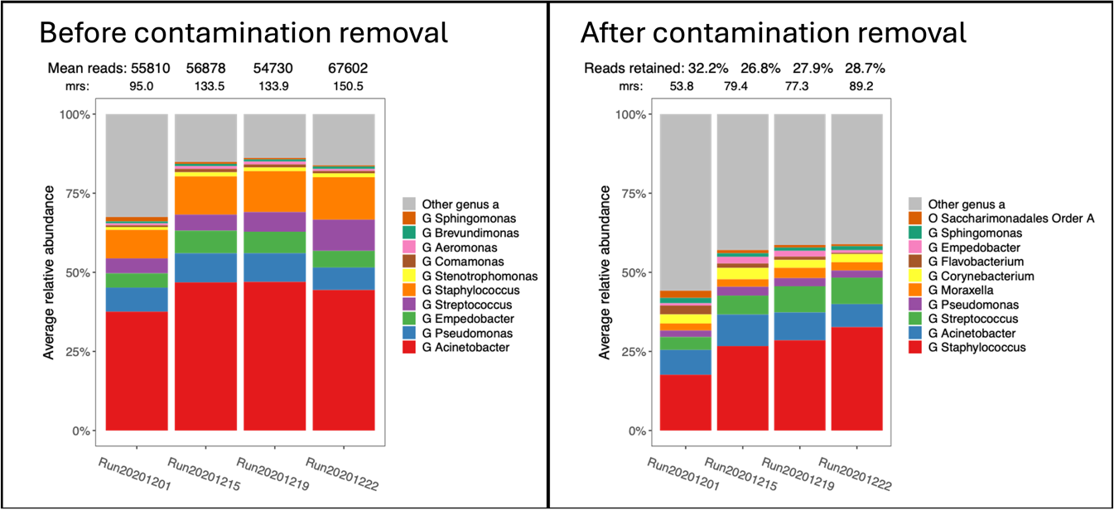
Figure S5 Stacked barplots of mean genus-level relative abundance before (left), and after contamination removal (right) using the defined abundance thresholds. Note: genera colours differ between plots.

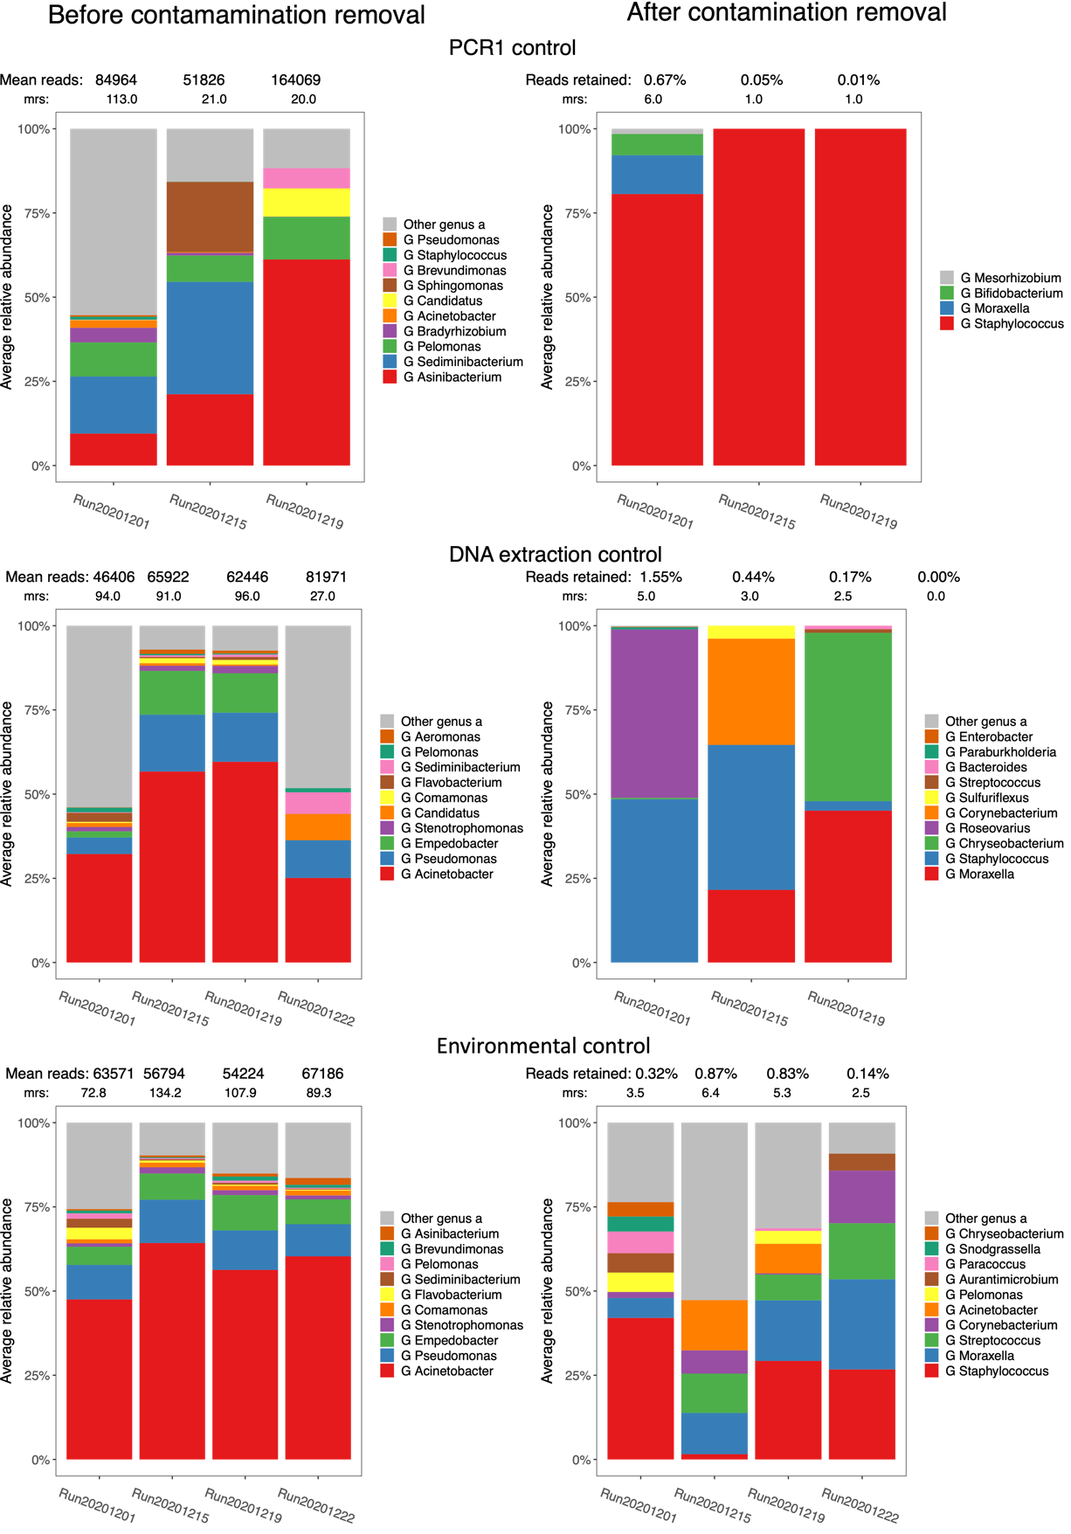
Figure S6 Stacked barplots of mean genus-level relative abundance before (left) and after contamination removal (right) using defined abundance thresholds. Note: genera colours differ between plots.

Statistical analysis
All analysis were performed using R version 4.3.1 (2023-06-16), with significant analytical processes performed using the following packages:
Data handling and standard statistics: dplyr, tidyr, tidyverse, stats, lme4, lmerTest, FactoMineR
Visualizations: ggplot2, rabuplot, cowplot, factoextra
Microbiome analysis and visualizations: phyloseq, speedyseq, vegan, AnnotIEM, BiodiversityR, decontam, MicrobIEM, copiome, DAtest, metagenomeSeq, metagMisc, microbiome, microViz.

Microbiome alpha diversity
Alpha diversity was evaluated using Shannon diversity index which incorporates both the richness, and evenness (how evenly the observed taxa are distributed). Shannon diversity was calculated on raw read counts, prior to any prevalence or abundance filtering. Shannon diversity was compared between samples or between groups of individuals with linear mixed-effects models (function lmer (R package lme4, lmerTest) to account for the longitudinal and paired nature of our samples. Individual were modelled as random-effects, while sequencing depth, natural logarithm-transformed sequencing depth and sequencing run were modelled as fixed-effects. Sequencing depth was log-transformed to account for a non-linear relationship with Shannon diversity. Post-hoc comparisons of Shannon diversity were performed using Wilcoxon signed-rank test adjusted for multiple comparisons using the Holm method.

Microbiome beta diversity
Beta diversity of the microbiome refers to the distance (or dissimilarity) between groups of individuals, or between groups of samples, and reflects the overall microbial community composition. Bray-Curtis dissimilarity was utilized throughout this manuscript, and is a beta-diversity metric which incorporates presence/absence and abundance of bacterial taxa. Bray-Curtis dissimilarity ranges between 0 and 1; if two samples share no taxa, their Bray-Curtis dissimilarity equals 1, and Bray-Curtis equals 0 if two samples share all taxa. Bray-Curtis dissimilarity was calculated at species-level, unless specified, when it was calculated at genus-level (Figure 1B). Prior to the calculation of Bray-Curtis dissimilarity, raw reads were Hellinger (square root)-transformed, and total-sum-scaled, producing the relative abundance table. Bray-Curtis dissimilarity matrix was then utilized for Permutational Multivariate ANalysis Of VAriance (PERMANOVA), using the adonis2 function (R package: vegan). Because body-site and age were identified as significant predictors of the microbiome composition, PERMANOVA was performed using a blocked design where data were permuted with matching age and body-site data only (the overall PERMANOVA results), before evaluating associations with each age and body-site specific group of samples, independently. In the PERMANOVAs, the effect of sequencing run and depth were accounted for by testing the marginal effect of each term.
Specifically in the AD-related analysis, due to fluctuations in disease activity, PERMANOVA testing was performed in a time-congruous manner, focusing on clinical outcomes and samples from the same time point, for example SCORAD at 3 months and the 3-month microbiome composition at the elbow and forearm. These analyses are denoted “Overall 3m” and “Overall 1y” and are presented alongside body-site specific PERMANOVA results (Figure 3, Tables S11 and S12). PERMANOVAs using Bray-Curtis dissimilarity were visualized using principal coordinate analysis (PCoA).

Additional microbiome analyses and visualisations
Relative abundances were compared and visualized with stacked bar charts and horizontal violin plots of individual genera as implemented in function rabuplot (package: rabuplot). P-values for comparisons of median abundance were calculated using Wilcoxon signed-rank test, and q-values (adjusted for multiple comparison using the Benjamini-Hochberg procedure) were calculated within package rabuplot.
Differential abundance of species was evaluated using da.ds2 (an implementation of DESeq2, package: DAtest).¹³ Following agglomeration at species level, counts were filtered to relative abundance of ≥0.01% and prevalence of ≥10% of samples to reduce noise from low abundance and rare species. Log-2-fold change and P-values were calculated for the abundance ratio for each species, between the groups being compared. P-values were adjusted with the Benjamini-Hochberg procedure, to reduce Type 1 errors. Differential abundance (volcano) plots were created, and species were labelled if their adjusted P-value was less than the Benjamini-Hochberg threshold.

Supplementary results figures
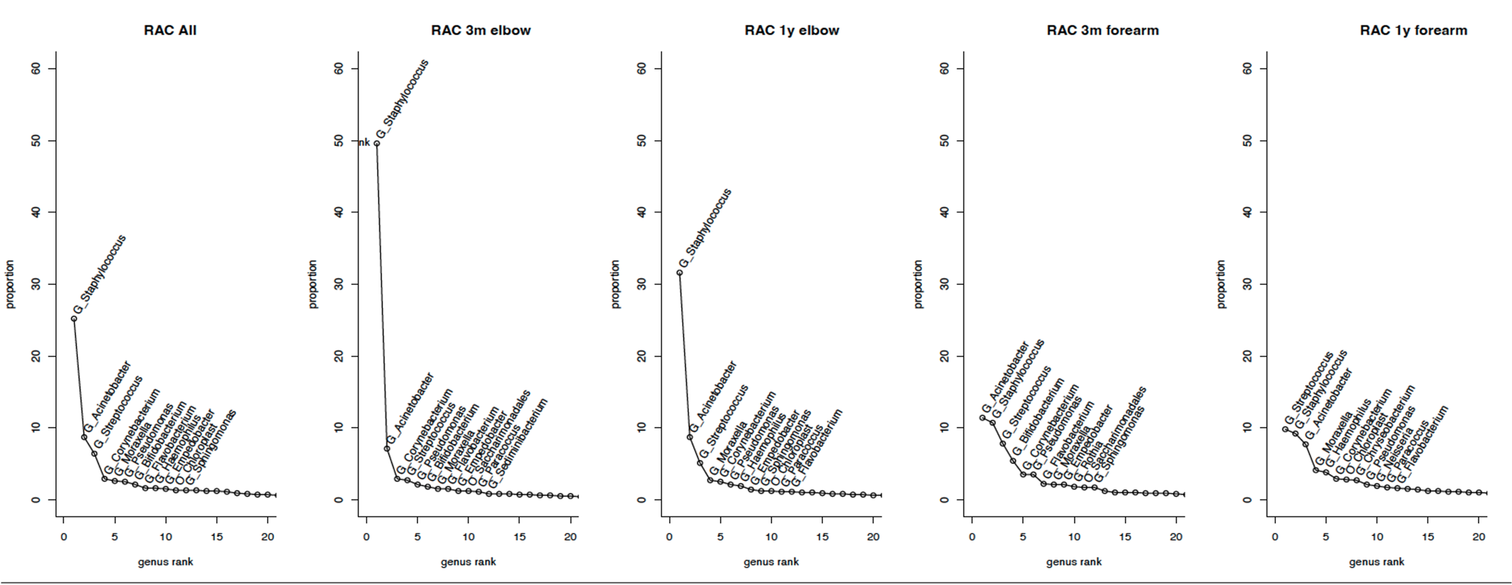Figure S7 Rank abundance curves (RAC), overall (A) and by each time-site combination (B-E), depicting the mean relative (total-sum scaled) abundance of each genus, ordered from most to least abundant. The 12 most abundant genera are labelled. Less steep slopes seen in forearm graphs (D & E) correspond to a more even community composition compared to antecubital fossa graphs. If an amplicon sequence variant was not annotated to genus level, the ASV was agglomerated to the highest taxonomic classification (G_ genus, O_ order)

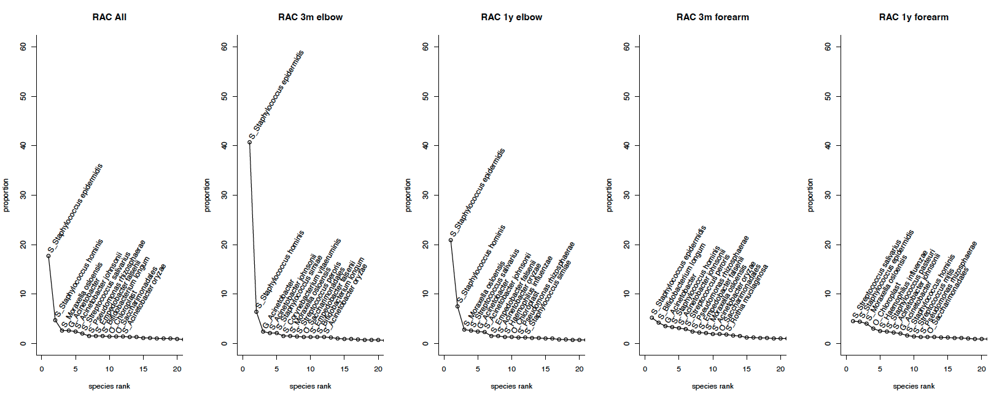
Figure S8 Rank abundance curves, overall (A) and by each time-site combination (B-E), depicting the mean relative (total-sum scaled) abundance of each species, ordered from most to least abundant.
The 12 most abundant species are labelled. Less steep slopes seen in forearm graphs (D & E) correspond to a more even community composition compared to antecubital fossa graphs. If an amplicon sequence variant was not annotated to species level, the ASV was agglomerated to the highest taxonomic classification (S_ species, G_ genus, O_ order)

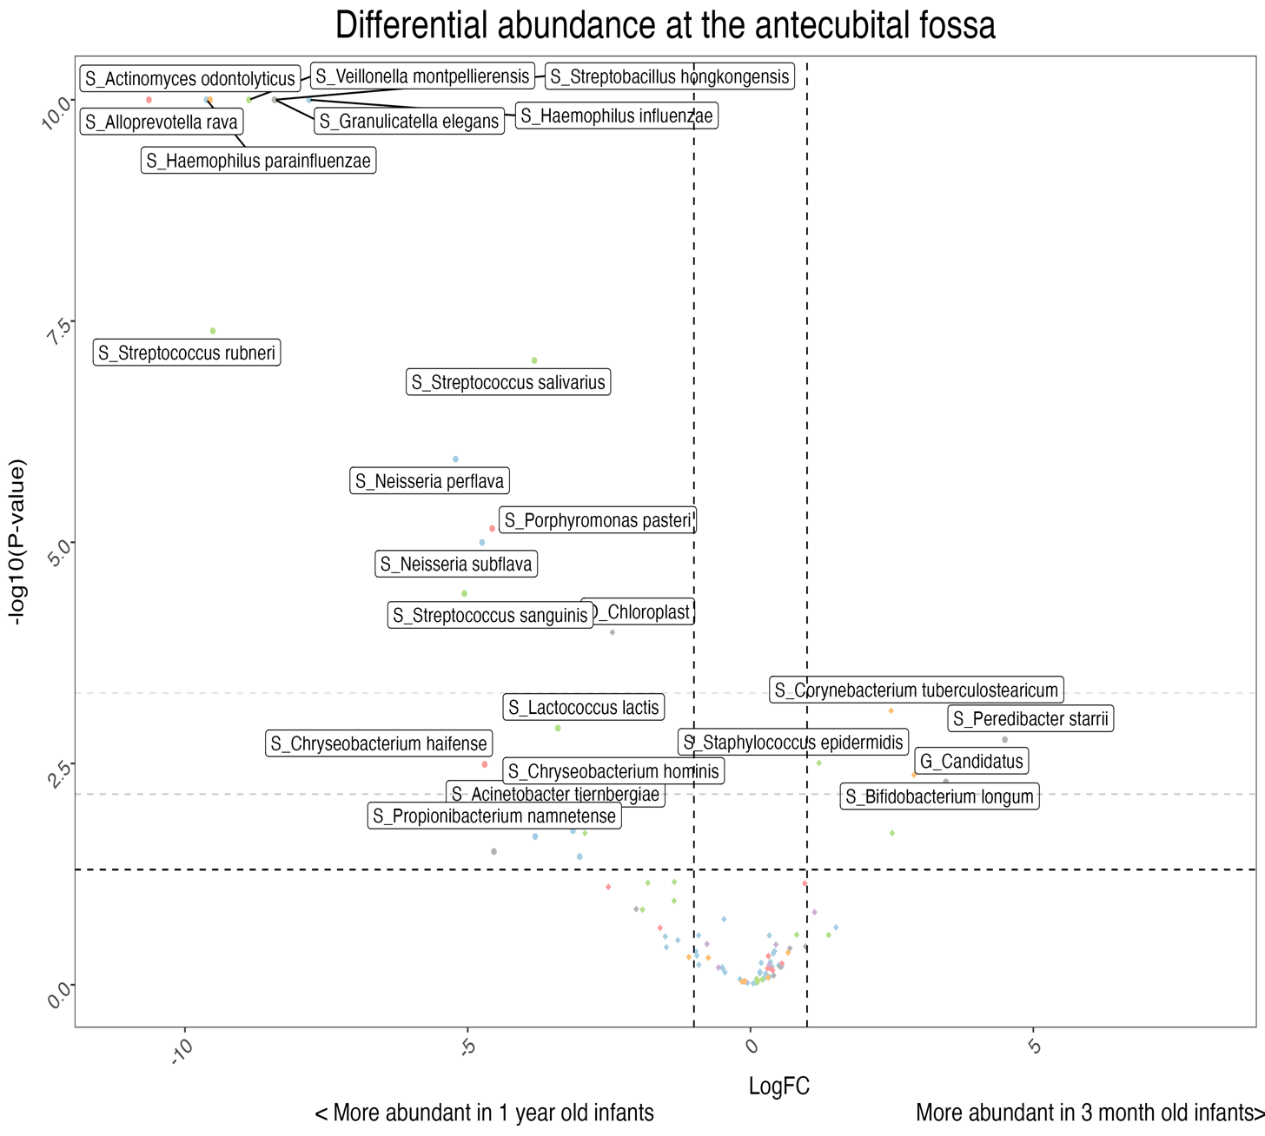
Figure S9 Volcano plot illustrating the differentially abundant species at the elbow in 3 months compared to 1 year old infants. ASVs were agglomerated at species level, and counts were filtered to relative abundance of ≥0.01% and prevalence of ≥10% of samples. Differential abundance metrics were calculated with the da.ds2 function (R package: DAtest). Log fold change (LogFC) was calculated for the abundance ratio in 3-month:1-year elbow samples and plotted on the x-axis. Species with LogFC>1 (to the right of the vertical dashed lines) were at least twice as abundant at 3 months, while those with LogFC<1 (to left of the vertical dashed lines) were at least twice as abundant at 1 year. The -log₁₀(P-value) was plotted on the y-axis. Horizontal dashed lines indicate significance thresholds (from inferior to superior); the conventional significance threshold (p≤0.05), the Benjamini-Hochberg (BH) or false discovery rate (fdr) threshold, and the Bonferroni threshold. Species with an fdr-adjusted p-value ≤ 0.05 were labelled in each plot.
Data points are colour-coded according to phylum; Proteobacteria (light blue), Bacteroidetes (pink), Actinobacteria (orange), Firmicutes (light green), Patescibacter (purple), and Other (grey). Taxa which were not annotated at species level are prefixed with “G_“ to indicate genus, “F_” family, “O_” order, “C_” class and “P_” phylum. To reduce overlap and enhance readability of species closer to the fdr-adjusted threshold, maximum -log10(P-values) were limited to 10, but raw differential abundance results are available in Table S7.

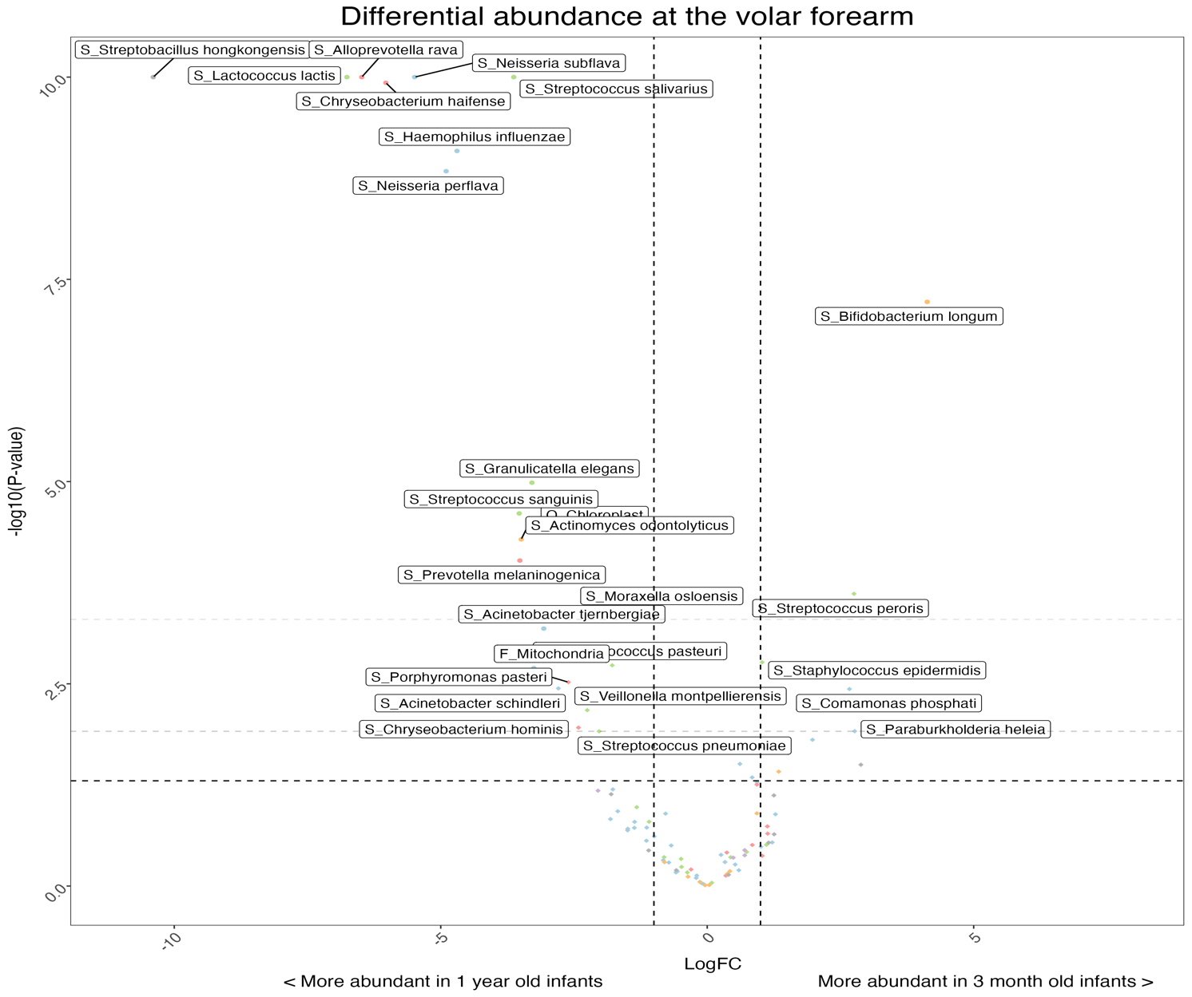
Figure S10 Volcano plot illustrating the differentially abundant species at the forearm in samples at 3 months compared to 1 year.
Methods as per Figure S9. Log fold change (LogFC) was calculated for the abundance ratio in 3-month-old:1 year old samples from the forearm, and plotted on the x-axis. Species with LogFC>1 (to the right of the vertical dashed lines) were at least twice as abundant at 3 months, while those with LogFC<1 (to left of the vertical dashed lines) were at least twice as abundant at 1 year. To reduce overlap and enhance readability of species closer to the fdr-adjusted threshold, maximum -log10(P-values) were limited to 10, but raw differential abundance results are available in Table S7.

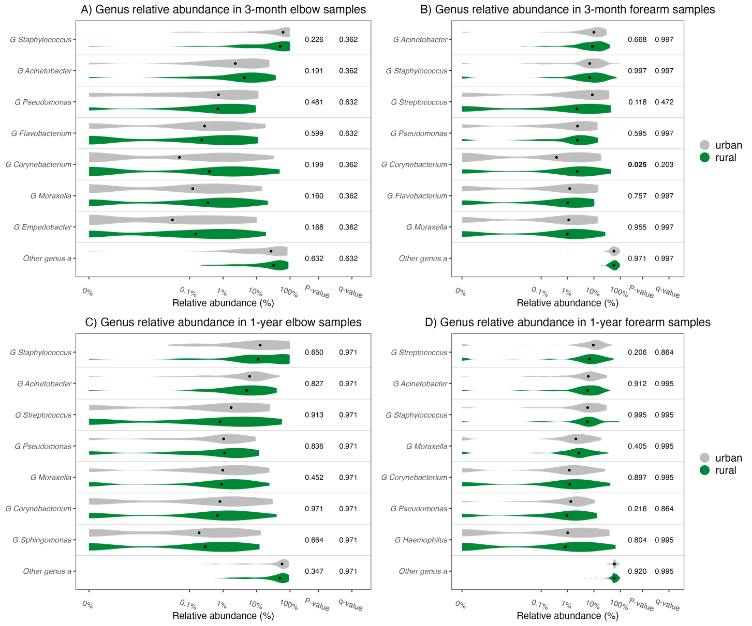
Figure S11 There are limited differences in the relative abundance between urban and rural infants. Violin plots comparing the distributions of genus relative abundance in infants residing in urban compared to rural areas, as defined by clustering of satellite-derived land-use data. The median relative abundance of the seven most abundant genera at each time-site sampling are represented by the black dot within each violin. P-values were generated using Wilcoxon signed-rank test and are presented with Benjamini-Hochberg adjusted q-values. A) Relative abundances at the elbow at 3 months, stratified by urban-rural classification. B) Relative abundances at the forearm at 3 months, stratified by urban-rural classification. C) Relative abundances at the elbow at 1 year, stratified by urban-rural classification. D) Relative abundances at the forearm at 1 year, stratified by urban-rural classification.

Figure S12 Volcano plots illustrating the differentially abundant species in urban compared to rural infants.
Infants were classified as urban or rural based upon hierarchical clustering of principal components of the CORINE land-use/land-cover (LULC) surrounding their home postcodes at 3 months. Each plot corresponds to a specific body site and time point: Panel A: samples from the elbow (antecubital fossa, ACF) at 3 months; Panel B: samples from the forearm (VF) at 3 months; Panel C: samples from the elbow at 1 year; Panel D: samples from the forearm at 1 year. Differential abundance metrics were calculated with the da.ds2 function (R package: DAtest) as before. LogFC was calculated for the abundance ratio in urban compared to rural infants and plotted on the x-axis. Species with LogFC>1 (to the right of the vertical dashed lines) were at least twice as abundant in urban infants, while species with LogFC<1 (to left of the vertical dashed lines) were at least twice as abundant in rural infants. The -log10(P-value) was plotted on the y-axis. Species with an fdr-adjusted p-value ≤ 0.05 were labelled in each plot. Data points were colour-coded according to phylum; Proteobacteria (light blue), Bacteroidetes (pink), Actinobacteria (orange), Firmicutes (light green), Patescibacter (purple), and Other (grey). To enhance readability in Panel B, maximum -log₁₀(P-values) were limited to 10, and maximum -LogFC values were limited to -10.

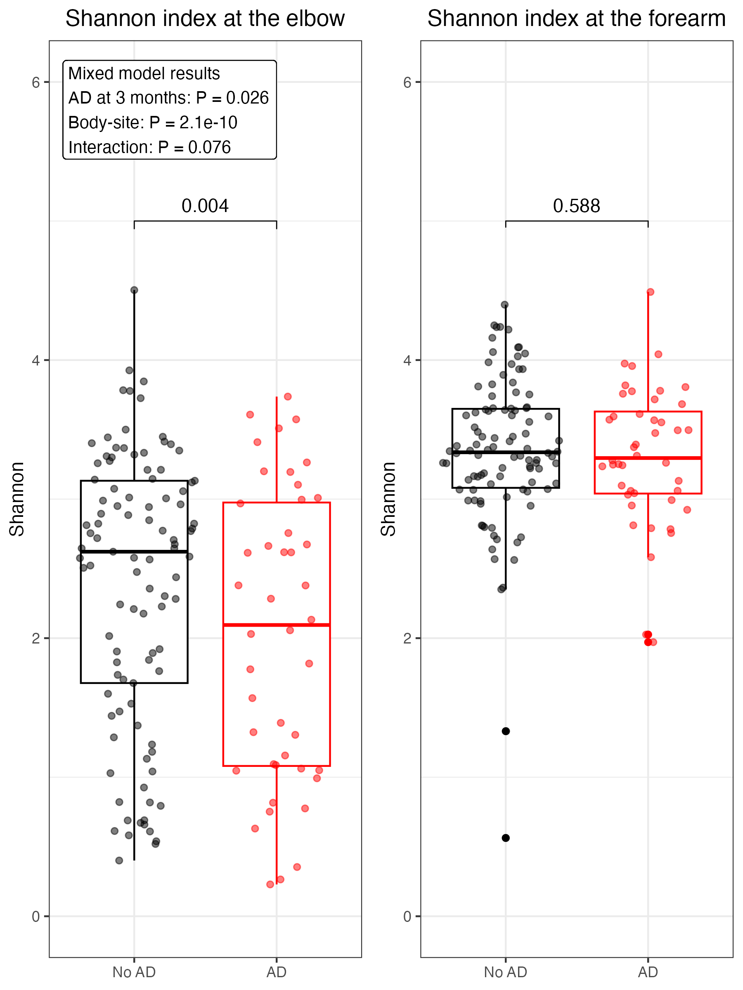
Figure S13 Boxplots depicting the relationship between the presence of atopic dermatitis (AD) at 3 months of age and the Shannon diversity index at 3 months of age.
The text box contains the results of a linear mixed-effects model which was created to evaluate the association between AD and Shannon diversity, accommodating paired samples from the elbow and the forearm. The mixed model was adjusted for sequencing run, sequencing depth, natural logarithm-transformed sequencing depth, as well as the interaction between AD and body-site, as fixed-effects, and the individual infants as random-effects. Brackets and associated P-values within the plots represent the comparisons of estimated marginal means, generated using function emmeans (R package: emmeans).

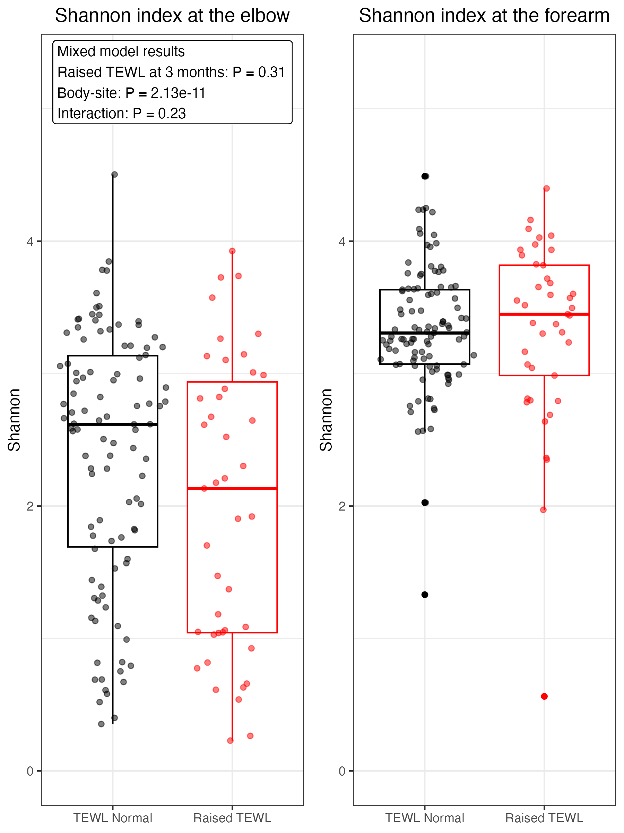
Figure S14 Boxplots depicting the relationship between raised Trans-Epidermal Water Loss (TEWL) at 3 months of age and the Shannon diversity index at 3 months of age.
The text box contains the results of a linear mixed-effects model which was created to evaluate the association between raised TEWL (TEWL greater than the upper quartile amongst infants without AD at 3-months) and Shannon diversity, accommodating paired samples from the elbow and the forearm. The mixed model was adjusted for sequencing run, sequencing depth, natural logarithm-transformed sequencing depth, as well as the interaction between TEWL and body-site, as fixed-effects, and the individual infants as random-effects. Post-hoc testing was not performed as there was no statistical significance with TEWL in the mixed model.

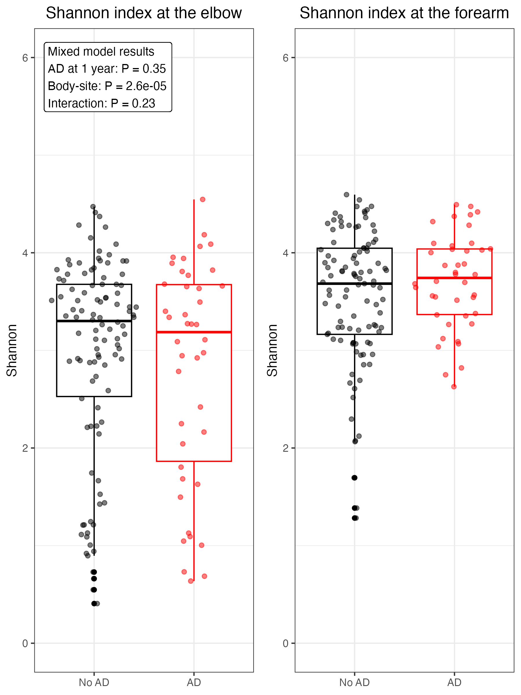
Figure S15 Boxplots depicting the relationship between the presence of atopic dermatitis (AD) at 1 year of age and Shannon diversity index at 1 year of age.
The text box contains the results of a linear mixed-effects model which was created to evaluate the association between AD and Shannon diversity, accommodating paired samples from the elbow and the forearm. The mixed model was adjusted for sequencing run, sequencing depth, natural logarithm-transformed sequencing depth, as well as the interaction between AD and body-site, as fixed-effects, and the individual infants as random-effects. Post-hoc comparisons of Shannon diversity were not performed, as was done in Figure S13, as the mixed model results demonstrated no statistically significant association between AD and Shannon diversity at 1 year of age.

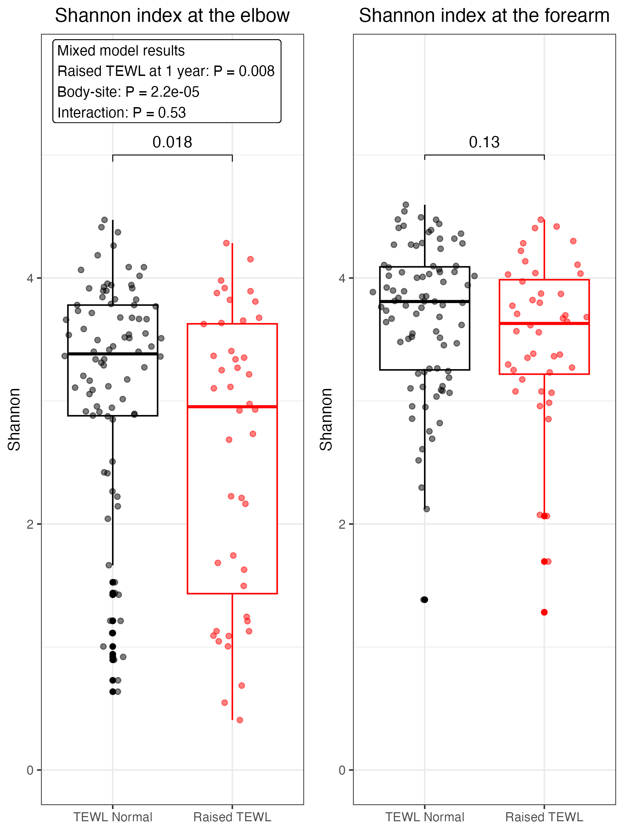
Figure S16 Boxplots depicting the relationship between the raised Trans-Epidermal Water Loss (TEWL) at 1 year of age and the Shannon diversity index at 1 year of age.
The text box contains the results of a linear mixed-effects model which was created to evaluate the association between raised TEWL (TEWL greater than the upper quartile amongst infants without AD at 1 year) and Shannon diversity, accommodating paired samples from the elbow and the forearm. The mixed model was adjusted for sequencing run, sequencing depth, natural logarithm-transformed sequencing depth, as well as the interaction between TEWL and body-site, as fixed-effects, and the individual infants as random-effects. Brackets and associated P-values within the plots represent the comparisons of estimated marginal means, generated using function emmeans (R package: emmeans).
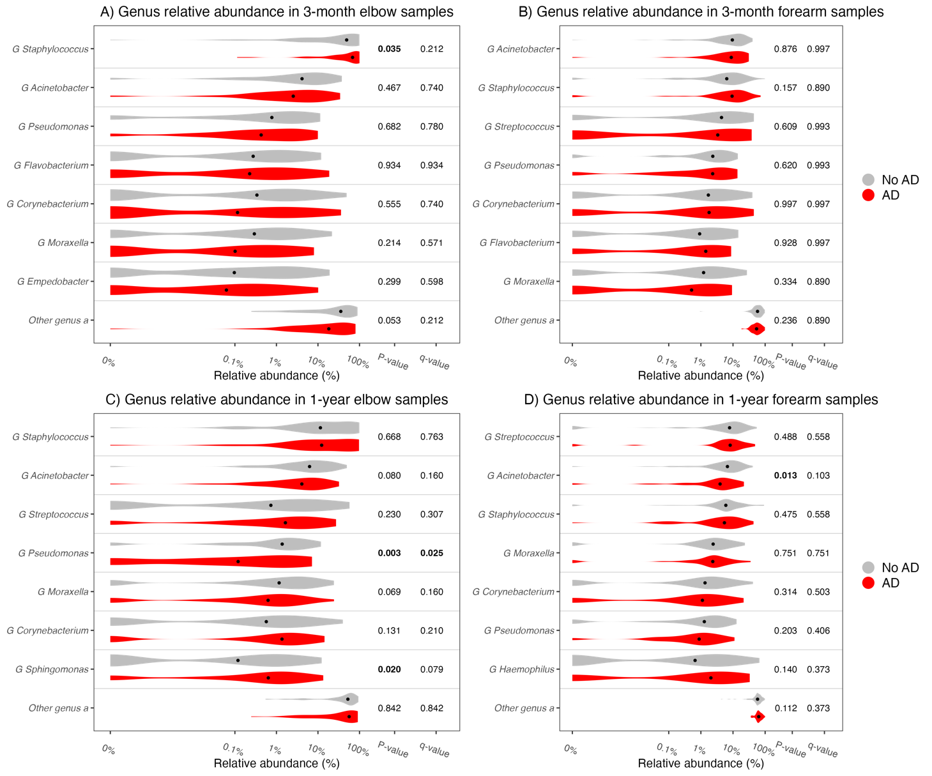
Figure S17 Violin plots comparing the distributions of genus relative abundance in infants with atopic dermatitis (AD) to those without AD.
AD was diagnosed at 3 months and at 1 year based on specialist skin examination. The median relative abundance of the seven most abundant genera at each time-site sampling are represented by the black dot within each violin. P-values were generated using Wilcoxon signed-rank test and are presented with Benjamini-Hochberg adjusted q-values. A) Relative abundances at the elbow at 3 months, stratified by the presence of AD at 3 months. B) Relative abundances at the forearm at 3 months, stratified by the presence of AD at 3 months. C) Relative abundances at the elbow at 1 year, stratified by the presence of AD at 1 year. D) Relative abundances at the forearm at 1 year, stratified by the presence of AD at 1 year.
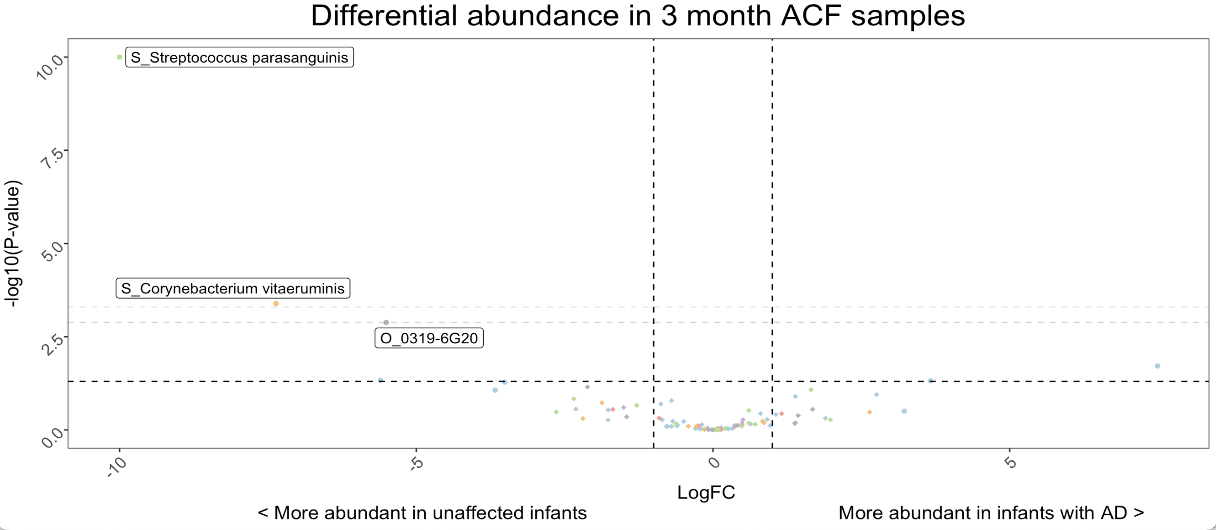
Figure S18 Volcano plot illustrating the differentially abundant species in samples from the elbow (ACF: antecubital fossa) at 3 months of age, comparing infants with atopic dermatitis (AD) at 3 months to those without AD at 3 months. ASVs were agglomerated at species level, and counts were filtered to relative abundance of ≥0.01% and prevalence of ≥10% of samples. Differential abundance metrics were calculated with the da.ds2 function (R package: DAtest). Log fold change (LogFC) was calculated for the abundance ratio in 3-month-old infants with AD compared to those without AD, and plotted on the x-axis. Species with LogFC>1 (to the right of the vertical dashed lines) were at least twice as abundant in those with AD, while those with LogFC<1 (to left of the vertical dashed lines) were at least twice as abundant in unaffected infants. The -log10(P-value) was plotted on the y-axis. Horizontal dashed lines indicate significance thresholds, from inferior to superior, the conventional significance threshold (p≤0.05), the Benjamini-Hochberg (BH) or false discovery rate (fdr) threshold, and the Bonferroni threshold. Species with an fdr-adjusted p-value ≤ 0.05 were labelled in each plot. If a taxon (for example, O_0319-6G20, a member of the Oligoflexia class) was not annotated at species level it was prefixed with “O_” to indicate order. Data points are colour-coded according to phylum; Proteobacteria (light blue), Bacteroidetes (pink), Actinobacteria (orange), Firmicutes (light green), Patescibacter (purple), and Other (grey). To facilitate plotting, maximum LogFC values were limited to -10, but raw differential abundance results are available in Table S13.

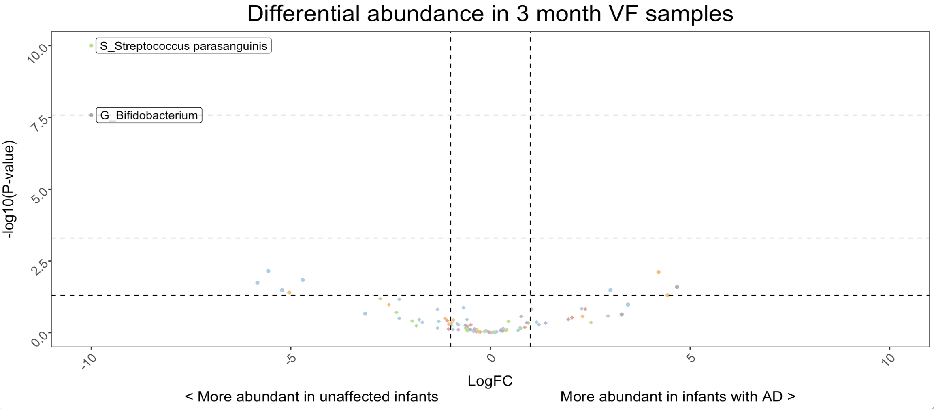
Figure S19 Volcano plot illustrating the differentially abundant species in samples from the forearm (VF: volar forearm) at 3 months of age, comparing infants with atopic dermatitis (AD) at 3 months to those without AD at 3 months, as per S18.
Log fold change (LogFC) was calculated for the abundance ratio in 3 month old infants with AD compared to those without AD, and plotted on the x-axis. Species with LogFC>1 (to the right of the vertical dashed lines) were at least twice as abundant in those with AD, while those with LogFC<1 (to left of the vertical dashed lines) were at least twice as abundant in unaffected infants. Species with an fdr-adjusted p-value ≤ 0.05 were labelled in each plot. The “G_” prefix indicates this taxon was annotated to genus-level. To facilitate plotting, maximum LogFC values were limited to -10, but raw differential abundance results are available in Table S13.
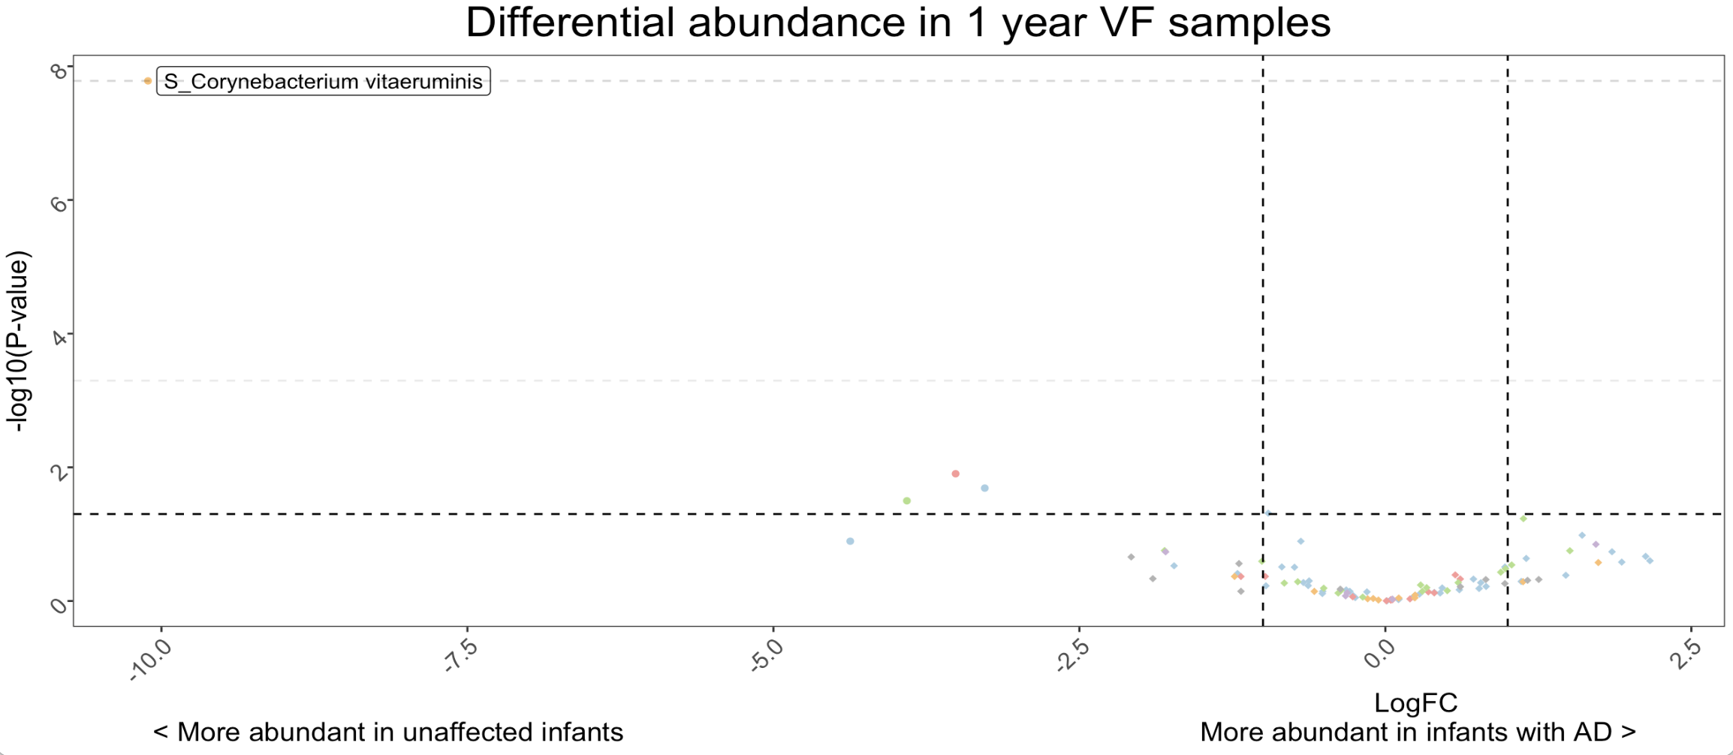
Figure S20 Volcano plot illustrating the differentially abundant species in samples from the forearm (VF: volar forearm) at 1 year of age, comparing infants with atopic dermatitis (AD) at 1 year to those without AD at 1 year, as per Figure S18. Log fold change (LogFC) was calculated for the abundance ratio in 1 year old infants with AD compared to those without AD, and plotted on the x-axis. Species with LogFC>1 (to the right of the vertical dashed lines) were at least twice as abundant in those with AD, while those with LogFC<1 (to left of the vertical dashed lines) were at least twice as abundant in unaffected infants. Species with an fdr-adjusted p-value ≤ 0.05 were labelled in each plot. To facilitate plotting, maximum LogFC values were limited to -10, but raw differential abundance results are available in Table S13.
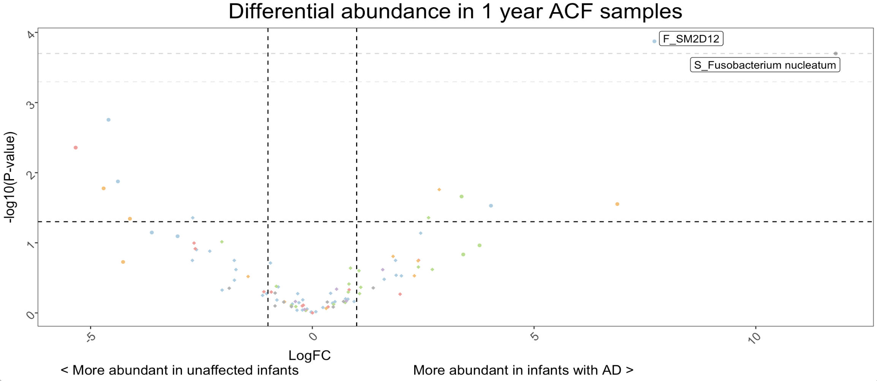
Figure S21 Volcano plot illustrating the differentially abundant species in samples from the elbow (ACF: antecubital fossa) at 1 year of age, comparing infants with atopic dermatitis (AD) at 1 year to those without AD at 1 year, as per Figure S18.
. Log fold change (LogFC) was calculated for the abundance ratio in 1 year old infants with AD compared to those without AD, and plotted on the x-axis. Species with LogFC>1 (to the right of the vertical dashed lines) were at least twice as abundant in those with AD, while those with LogFC<1 (to left of the vertical dashed lines) were at least twice as abundant in unaffected infants. Species with an fdr-adjusted p-value ≤ 0.05 were labelled in each plot. Raw differential abundance results are available in Table S13.

Supplementary results tables
Table S4 PERMANOVA results assessing the relationship between Bray-Curtis dissimilarity (genus-level) and sampling and technical variables, based on 999 permutations.
 | Degrees of freedom | Sum Of Sqs | R² | Pseudo-F statistic | P-value
Body site | 1 | 5.439 | 0.031 | 19.871 | ≤0.001
Infants’ age | 1 | 4.184 | 0.024 | 15.286 | ≤0.001
Sequencing run | 3 | 4.632 | 0.027 | 5.64 | ≤0.001
Sequencing depth | 1 | 0.723 | 0.004 | 2.642 | ≤0.001
Residual | 579 | 158.488 | 0.912 | NA | NA
Total | 585 | 173.81 | 1 | NA | NA
Permutation test for adonis2 under reduced model, marginal effects of terms and free (unconstrained) permutations (n=999). Sum Of Sqs: Sum of squares.

Table S5 The 20 most abundant taxa, agglomerated to genus-level, overall and according to each sampling time-site. Rank refers to the rank of abundance, Mean abundance is the mean number observed reads per sample, and mean relative abundance is the mean of the total-sum-scaled abundance of each genus per sample.
 | Overall |  |  | Elbow - 3 month |  |  | Elbow - 1 year |  |  | Forearm - 3 month |  |  | Forearm - 1 year
Taxa | Rank | Mean abundance | Mean relative abundance | Rank | Mean abundance | Mean relative abundance | Rank | Mean abundance | Mean relative abundance | Rank | Mean abundance | Mean relative abundance | Rank | Mean abundance | Mean relative abundance
Staphylococcus | 1 | 147.7 | 25.2 | 1 | 71.9 | 49.6 | 1 | 46.7 | 31.6 | 2 | 15.6 | 10.7 | 2 | 13.5 | 9.2
Acinetobacter | 2 | 51.2 | 8.7 | 2 | 10.4 | 7.1 | 2 | 12.8 | 8.7 | 1 | 16.7 | 11.4 | 3 | 11.4 | 7.7
Streptococcus | 3 | 37.2 | 6.4 | 4 | 3.9 | 2.7 | 3 | 7.6 | 5.1 | 3 | 11.4 | 7.8 | 1 | 14.5 | 9.8
Corynebacterium | 4 | 17.3 | 2.9 | 3 | 4.2 | 2.9 | 5 | 3.7 | 2.5 | 5 | 5.2 | 3.5 | 6 | 4.2 | 2.9
Moraxella | 5 | 15.3 | 2.6 | 7 | 2.2 | 1.5 | 4 | 4 | 2.7 | 8 | 3 | 2.1 | 4 | 6.1 | 4.1
Pseudomonas | 6 | 14.4 | 2.5 | 5 | 3.1 | 2.1 | 6 | 3.1 | 2.1 | 6 | 5.1 | 3.5 | 9 | 3.2 | 2.1
Bifidobacterium | 7 | 12.5 | 2.1 | 6 | 2.6 | 1.8 | 34 | 0.6 | 0.4 | 4 | 7.8 | 5.4 | 19 | 1.5 | 1
Flavobacterium | 8 | 9.4 | 1.6 | 8 | 2.2 | 1.5 | 12 | 1.6 | 1.1 | 7 | 3.2 | 2.2 | 12 | 2.4 | 1.6
Haemophilus | 9 | 9.3 | 1.6 | 137 | 0.1 | 0.1 | 7 | 2.8 | 1.9 | 22 | 0.9 | 0.6 | 5 | 5.5 | 3.8
Empedobacter | 10 | 8.7 | 1.5 | 9 | 1.8 | 1.2 | 8 | 2.1 | 1.4 | 9 | 3 | 2.1 | 16 | 1.8 | 1.2
Chloroplast (Order) | 11 | 7.8 | 1.3 | 31 | 0.4 | 0.3 | 10 | 1.8 | 1.2 | 14 | 1.5 | 1 | 7 | 4.2 | 2.8
Sphingomonas | 12 | 7.5 | 1.3 | 14 | 1.1 | 0.8 | 9 | 1.8 | 1.2 | 12 | 2.5 | 1.7 | 13 | 2.1 | 1.5
Saccharimonadales (Order) | 13 | 7.5 | 1.3 | 10 | 1.7 | 1.2 | 13 | 1.5 | 1 | 11 | 2.5 | 1.7 | 18 | 1.6 | 1.1
Paracoccus | 14 | 7.2 | 1.2 | 11 | 1.7 | 1.1 | 11 | 1.6 | 1.1 | 16 | 1.4 | 1 | 11 | 2.5 | 1.7
Chryseobacterium | 15 | 7.1 | 1.2 | 42 | 0.3 | 0.2 | 14 | 1.5 | 1 | 17 | 1.3 | 0.9 | 8 | 4 | 2.7
Rothia | 16 | 6.7 | 1.1 | 13 | 1.1 | 0.8 | 16 | 1.2 | 0.8 | 10 | 2.7 | 1.8 | 17 | 1.7 | 1.1
Veillonella | 17 | 5.3 | 0.9 | 30 | 0.4 | 0.3 | 20 | 1 | 0.6 | 13 | 1.8 | 1.2 | 14 | 2.1 | 1.4
Stenotrophomonas | 18 | 4.8 | 0.8 | 15 | 1 | 0.7 | 17 | 1.2 | 0.8 | 15 | 1.4 | 1 | 23 | 1.2 | 0.8
Neisseria | 19 | 4.2 | 0.7 | 327 | 0 | 0 | 15 | 1.3 | 0.9 | 102 | 0.2 | 0.1 | 10 | 2.7 | 1.9
Roseovarius | 20 | 4.2 | 0.7 | 26 | 0.5 | 0.3 | 18 | 1.1 | 0.7 | 19 | 1.3 | 0.9 | 21 | 1.4 | 0.9

Table S6 Genus abundance is influenced by body site and age (time) at sampling, as well as technical variables (sequencing run and sequencing depth). The associations between the relative abundance of selected genera and sampling and technical variables, were modelled under mixed effects. The seven most abundant genera are represented, and others are grouped together as "Other genera". Models are adjusted for sequencing run, sequencing depth and natural logarithm-transformed sequencing depth as fixed-effects (technical variables), and individuals as random-effects. Genus relative abundance was log10-transformed, following the addition of a pseudo-count of 0.01, to facilitate visualization of right-skewed data (Figure 1D). Log-transformed sequencing depth was included as a covariate in mixed models to address the non-linear relationship between sequencing depth and genus abundance.
Staphylococcus
 | Sum Sq | Mean Sq | Numerator DF | Denominator DF | F value | p-value
Time | 5.16896107 | 5.16896107 | 1 | 440.354835 | 27.1057622 | 2.96E-07
Body site | 14.7136795 | 14.7136795 | 1 | 450.766204 | 77.1577678 | 3.32E-17
Sequencing depth | 3.42763115 | 3.42763115 | 1 | 563.618368 | 17.9743189 | 2.62E-05
Log (Sequencing depth) | 1.24127104 | 1.24127104 | 1 | 572.035169 | 6.50916059 | 0.0109911
Sequencing run | 9.02751528 | 3.00917176 | 3 | 157.880417 | 15.7799397 | 5.04E-09
Time:Body site | 0.80250418 | 0.80250418 | 1 | 438.69078 | 4.20829008 | 0.04082013
Acinetobacter
 | Sum Sq | Mean Sq | Numerator DF | Denominator DF | F value | p-value
Time | 0.12004492 | 0.12004492 | 1 | 437.089596 | 1.05521632 | 0.3048769
Body site | 0.17057203 | 0.17057203 | 1 | 446.146945 | 1.49935868 | 0.22141623
Sequencing depth | 5.61796144 | 5.61796144 | 1 | 548.979603 | 49.3828856 | 6.27E-12
Log (Sequencing depth) | 8.78E-06 | 8.78E-06 | 1 | 560.45383 | 7.72E-05 | 0.99299349
Sequencing run | 0.01128482 | 0.00376161 | 3 | 156.130732 | 0.0330652 | 0.99189966
Time:Body site | 1.25462125 | 1.25462125 | 1 | 435.624087 | 11.0283451 | 0.00097282
Streptococcus
 | Sum Sq | Mean Sq | Numerator DF | Denominator DF | F value | p-value
Time | 5.80369424 | 5.80369424 | 1 | 441.56251 | 28.5563779 | 1.46E-07
Body site | 15.2924426 | 15.2924426 | 1 | 455.639408 | 75.2446205 | 7.39E-17
Sequencing depth | 5.50979073 | 5.50979073 | 1 | 575.863267 | 27.1102611 | 2.68E-07
Log (Sequencing depth) | 1.95777899 | 1.95777899 | 1 | 568.561576 | 9.63301551 | 0.00200611
Sequencing run | 5.17109504 | 1.72369835 | 3 | 155.669552 | 8.48124993 | 2.97E-05
Time:Body site | 3.03E-06 | 3.03E-06 | 1 | 439.477186 | 1.49E-05 | 0.9969221
Pseudomonas
 | Sum Sq | Mean Sq | Numerator DF | Denominator DF | F value | p-value
Time | 0.36982389 | 0.36982389 | 1 | 439.52353 | 4.06871737 | 0.0442919
Body site | 0.04093725 | 0.04093725 | 1 | 451.917179 | 0.4503822 | 0.50249637
Sequencing depth | 1.44175975 | 1.44175975 | 1 | 575.036032 | 15.8619091 | 7.69E-05
Log (Sequencing depth) | 0.17873554 | 0.17873554 | 1 | 576.918508 | 1.96640724 | 0.16136757
Sequencing run | 0.32933402 | 0.10977801 | 3 | 155.067866 | 1.20775239 | 0.30889027
Time:Body site | 0.22712549 | 0.22712549 | 1 | 437.606572 | 2.49878238 | 0.11465684
Corynebacterium
 | Sum Sq | Mean Sq | Numerator DF | Denominator DF | F value | p-value
Time | 0.01740305 | 0.01740305 | 1 | 438.815487 | 0.13404868 | 0.71444706
Body site | 1.40622952 | 1.40622952 | 1 | 450.883264 | 10.8316221 | 0.00107616
Sequencing depth | 0.47590389 | 0.47590389 | 1 | 573.515478 | 3.66569684 | 0.05604064
Log (Sequencing depth) | 1.05909363 | 1.05909363 | 1 | 576.952509 | 8.15777356 | 0.00444211
Sequencing run | 1.41414541 | 0.4713818 | 3 | 154.643231 | 3.630865 | 0.01436044
Time:Body site | 0.33310254 | 0.33310254 | 1 | 436.935448 | 2.56575532 | 0.10992307
Moraxella
 | Sum Sq | Mean Sq | Numerator DF | Denominator DF | F value | p-value
Time | 5.34112406 | 5.34112406 | 1 | 437.962558 | 60.5347055 | 5.24E-14
Body site | 0.6995549 | 0.6995549 | 1 | 449.304533 | 7.92854636 | 0.00508017
Sequencing depth | 0.2016955 | 0.2016955 | 1 | 569.162621 | 2.28595659 | 0.13110464
Log (Sequencing depth) | 1.18559969 | 1.18559969 | 1 | 575.453783 | 13.4372329 | 0.00026951
Sequencing run | 0.98780114 | 0.32926705 | 3 | 154.464096 | 3.73181439 | 0.01260579
Time:Body site | 0.44835276 | 0.44835276 | 1 | 436.171497 | 5.08149634 | 0.02467799
Flavobacterium
 | Sum Sq | Mean Sq | Numerator DF | Denominator DF | F value | p-value
Time | 0.28388617 | 0.28388617 | 1 | 438.648246 | 3.88840123 | 0.04924855
Body site | 0.34942051 | 0.34942051 | 1 | 450.276271 | 4.78602802 | 0.02920494
Sequencing depth | 0.26787854 | 0.26787854 | 1 | 571.193596 | 3.66914402 | 0.05592763
Log (Sequencing depth) | 0.14212186 | 0.14212186 | 1 | 576.334339 | 1.94664926 | 0.16348577
Sequencing run | 3.84985842 | 1.28328614 | 3 | 154.885848 | 17.5772263 | 7.15E-10
Time:Body site | 0.01575175 | 0.01575175 | 1 | 436.821786 | 0.21575241 | 0.64252702
Other genera
 | Sum Sq | Mean Sq | Numerator DF | Denominator DF | F value | p-value
Time | 2.34045734 | 2.34045734 | 1 | 438.292158 | 43.6334303 | 1.15E-10
Body site | 5.76332026 | 5.76332026 | 1 | 448.316498 | 107.446279 | 1.03E-22
Sequencing depth | 10.20312 | 10.20312 | 1 | 559.12865 | 190.218006 | 1.87E-37
Log (Sequencing depth) | 0.12574716 | 0.12574716 | 1 | 568.843935 | 2.34431965 | 0.12629635
Sequencing run | 3.42555551 | 1.14185184 | 3 | 156.181127 | 21.2876825 | 1.30E-11
Time:Body site | 0.11959744 | 0.11959744 | 1 | 436.681468 | 2.22966956 | 0.13610494
Sum Sq = Sum of squares. Mean Sq = Mean squares (Sum Sq / NumDF). Numerator DF = degrees of freedom (numerator). Denominator DF = degrees of freedom (denominator). F value = F-statistic.

Table S7 Differential abundance analysis at species level, comparing abundances between ages and across body sites. LogFC refers to the log base 2-transformed ratio of abundances of each taxon, first comparing the abundance in 3-month sample to 1-year samples at the elbow and at the forearm, then comparing the abundances between body sites, at each age. A negative logFC means, for example, that a species was more abundant at 1 year (Order 1y>3m). Benjamini-Hochberg adjusted P-values (P-Adj) ≤ 0.05 were deemed significant, and are in bold. Tables are ordered by increasing adjusted P-values.
Differential abundance at the elbow (3m vs 1y)
Phylum | Class | Genus | Species | Order | LogFC | P-value | P-Adj
P_Firmicutes | C_Bacilli | G_Granulicatella | S_Granulicatella elegans | 1y>3m | -8.406 | 1.57E-21 | 1.56E-19
P_Bacteroidetes | C_Bacteroidia | G_Alloprevotella | S_Alloprevotella rava | 1y>3m | -10.637 | 2.48E-19 | 1.23E-17
P_Proteobacteria | C_Gammaproteobacteria | G_Haemophilus | S_Haemophilus influenzae | 1y>3m | -7.804 | 1.05E-14 | 3.47E-13
P_Firmicutes | C_Negativicutes | G_Veillonella | S_Veillonella montpellierensis | 1y>3m | -8.866 | 5.97E-14 | 1.48E-12
P_Proteobacteria | C_Gammaproteobacteria | G_Haemophilus | S_Haemophilus parainfluenzae | 1y>3m | -9.617 | 2.99E-13 | 5.93E-12
P_Actinobacteria | C_Actinobacteria_c | G_Actinomyces | S_Actinomyces odontolyticus | 1y>3m | -9.557 | 8.30E-13 | 1.37E-11
P_Fusobacteria | C_Fusobacteria_c | G_Streptobacillus | S_Streptobacillus hongkongensis | 1y>3m | -8.417 | 1.06E-11 | 1.50E-10
P_Firmicutes | C_Bacilli | G_Streptococcus | S_Streptococcus rubneri | 1y>3m | -9.507 | 4.09E-08 | 5.06E-07
P_Firmicutes | C_Bacilli | G_Streptococcus | S_Streptococcus salivarius | 1y>3m | -3.822 | 8.83E-08 | 9.71E-07
P_Proteobacteria | C_Betaproteobacteria | G_Neisseria | S_Neisseria perflava | 1y>3m | -5.215 | 1.15E-06 | 1.14E-05
P_Bacteroidetes | C_Bacteroidia | G_Porphyromonas | S_Porphyromonas pasteri | 1y>3m | -4.567 | 7.00E-06 | 6.30E-05
P_Proteobacteria | C_Betaproteobacteria | G_Neisseria | S_Neisseria subflava | 1y>3m | -4.746 | 1.01E-05 | 8.29E-05
P_Firmicutes | C_Bacilli | G_Streptococcus | S_Streptococcus sanguinis | 1y>3m | -5.059 | 3.79E-05 | 2.88E-04
P_Cyanobacteria | C_Cyanobacteriia | G_ | O_Chloroplast | 1y>3m | -2.441 | 1.04E-04 | 0.001
P_Actinobacteria | C_Actinobacteria_c | G_Corynebacterium | S_Corynebacterium tuberculostearicum | 3m>1y | 2.485 | 0.001 | 0.005
P_Firmicutes | C_Bacilli | G_Lactococcus | S_Lactococcus lactis | 1y>3m | -3.406 | 0.001 | 0.008
P_Bdellovibrionota | C_Bdellovibrionia | G_Peredibacter | S_Peredibacter starrii | 3m>1y | 4.498 | 0.002 | 0.01
P_Bacteroidetes | C_Flavobacteria | G_Chryseobacterium | S_Chryseobacterium haifense | 1y>3m | -4.7 | 0.003 | 0.017
P_Firmicutes | C_Bacilli | G_Staphylococcus | S_Staphylococcus epidermidis | 3m>1y | 1.211 | 0.003 | 0.017
P_Actinobacteria | C_Actinobacteria_c | G_Bifidobacterium | S_Bifidobacterium longum | 3m>1y | 2.891 | 0.004 | 0.02
P_Proteobacteria | C_Gammaproteobacteria | G_Acinetobacter | S_Acinetobacter tjernbergiae | 1y>3m | -2.995 | 0.004 | 0.02
P_Iainarchaeota | C_Iainarchaeia | G_Candidatus | G_Candidatus | 3m>1y | 3.454 | 0.005 | 0.023
P_Bacteroidetes | C_Flavobacteria | G_Chryseobacterium | S_Chryseobacterium hominis | 1y>3m | -3.28 | 0.007 | 0.029
P_Actinobacteria | C_Actinobacteria_c | G_Propionibacterium | S_Propionibacterium namnetense | 1y>3m | -4.067 | 0.007 | 0.029
P_Firmicutes | C_Negativicutes | G_Veillonella | S_Veillonella tobetsuensis | 1y>3m | -2.732 | 0.015 | 0.058
P_Proteobacteria | C_Alphaproteobacteria | G_Brevundimonas | S_Brevundimonas vesicularis | 1y>3m | -3.14 | 0.018 | 0.068
P_Firmicutes | C_Bacilli | G_Streptococcus | S_Streptococcus parasanguinis | 1y>3m | -2.928 | 0.019 | 0.068
P_Firmicutes | C_Bacilli | G_Streptococcus | S_Streptococcus peroris | 3m>1y | 2.506 | 0.019 | 0.068
P_Proteobacteria | C_Gammaproteobacteria | G_Moraxella | S_Moraxella catarrhalis | 1y>3m | -3.808 | 0.021 | 0.072
P_Fusobacteria | C_Fusobacteria_c | G_Fusobacterium | S_Fusobacterium nucleatum | 1y>3m | -4.537 | 0.031 | 0.103
P_Proteobacteria | C_Alphaproteobacteria | G_ | F_Mitochondria | 1y>3m | -3.021 | 0.036 | 0.114
P_Firmicutes | C_Bacilli | G_Streptococcus | S_Streptococcus pneumoniae | 1y>3m | -1.815 | 0.071 | 0.208
P_Bacteroidetes | C_Flavobacteria | G_Flavobacterium | S_Flavobacterium succinicans | 3m>1y | 0.958 | 0.071 | 0.208
P_Firmicutes | C_Bacilli | G_Staphylococcus | S_Staphylococcus pasteuri | 1y>3m | -1.348 | 0.069 | 0.208
P_Bacteroidetes | C_Bacteroidia | G_Prevotella | S_Prevotella melaninogenica | 1y>3m | -2.514 | 0.078 | 0.221
P_Firmicutes | C_Bacilli | G_Staphylococcus | S_Staphylococcus petrasii | 1y>3m | -1.352 | 0.112 | 0.309
P_Firmicutes | C_Negativicutes | G_Veillonella | S_Veillonella dispar | 1y>3m | -1.911 | 0.142 | 0.369
P_Actinobacteriota | C_Actinobacteria | G_Bifidobacterium | G_Bifidobacterium | 1y>3m | -2.021 | 0.139 | 0.369
P_Patescibacteria | C_Parcubacteria | G_ | O_Candidatus Nomurabacteria | 3m>1y | 1.133 | 0.151 | 0.384
P_Proteobacteria | C_Gammaproteobacteria | G_Moraxella | S_Moraxella osloensis | 1y>3m | -0.47 | 0.181 | 0.449
P_Bacteroidetes | C_Sphingobacteriia | G_Asinibacterium | S_Asinibacterium lactis | 1y>3m | -1.598 | 0.227 | 0.536
P_Proteobacteria | C_Betaproteobacteria | G_Limnohabitans | S_Limnohabitans curvus | 3m>1y | 1.512 | 0.225 | 0.536
P_Firmicutes | C_Clostridia | G_Desulfosporosinus | S_Desulfosporosinus orientis | 3m>1y | 1.381 | 0.274 | 0.597
P_Firmicutes | C_Bacilli | G_Staphylococcus | S_Staphylococcus simiae | 3m>1y | 0.816 | 0.273 | 0.597
P_Proteobacteria | C_Gammaproteobacteria | G_Acinetobacter | G_Acinetobacter | 3m>1y | 0.333 | 0.277 | 0.597
P_Proteobacteria | C_Alphaproteobacteria | G_Roseovarius | S_Roseovarius tolerans | 1y>3m | -0.917 | 0.276 | 0.597
P_Proteobacteria | C_Gammaproteobacteria | G_Acinetobacter | S_Acinetobacter parvus | 1y>3m | -1.507 | 0.285 | 0.599
P_Proteobacteria | C_Alphaproteobacteria | G_Brevundimonas | G_Brevundimonas | 1y>3m | -1.285 | 0.314 | 0.647
P_Patescibacteria | C_Saccharimonadia | G_ | O_Saccharimonadales | 3m>1y | 0.449 | 0.351 | 0.695
P_Patescibacteria | C_Parcubacteria | G_ | O_Candidatus Kaiserbacteria | 1y>3m | -0.77 | 0.346 | 0.695
P_Bdellovibrionota | C_Oligoflexia | G_ | O_0319-6G20 | 3m>1y | 0.972 | 0.368 | 0.715
P_Proteobacteria | C_Gammaproteobacteria | G_Pseudomonas | S_Pseudomonas stutzeri | 1y>3m | -1.488 | 0.377 | 0.717
P_Bacteroidota | C_Bacteroidia | G_ | F_37-13 | 3m>1y | 0.695 | 0.387 | 0.723
P_Proteobacteria | C_Gammaproteobacteria | G_Acinetobacter | S_Acinetobacter vivianii | 3m>1y | 0.425 | 0.416 | 0.758
P_Proteobacteria | C_Alphaproteobacteria | G_Paracoccus | S_Paracoccus yeei | 1y>3m | -0.965 | 0.421 | 0.758
P_Actinobacteria | C_Actinobacteria_c | G_Rothia | S_Rothia mucilaginosa | 3m>1y | 0.666 | 0.431 | 0.763
P_Proteobacteria | C_Gammaproteobacteria | G_Acinetobacter | S_Acinetobacter proteolyticus | 3m>1y | 0.403 | 0.443 | 0.769
P_Bacteroidetes | C_Flavobacteria | G_Empedobacter | S_Empedobacter falsenii | 3m>1y | 0.315 | 0.473 | 0.785
P_Proteobacteria | C_Betaproteobacteria | G_Variovorax | S_Variovorax humicola | 1y>3m | -0.949 | 0.468 | 0.785
P_Proteobacteria | C_Gammaproteobacteria | G_Pseudomonas | S_Pseudomonas rhizosphaerae | 3m>1y | 0.318 | 0.476 | 0.785
P_Actinobacteria | C_Actinobacteria_c | G_Corynebacterium | S_Corynebacterium ureicelerivorans | 1y>3m | -1.089 | 0.486 | 0.788
P_Actinobacteria | C_Acidimicrobiia | G_Aquihabitans | S_Aquihabitans daechungensis | 1y>3m | -0.746 | 0.495 | 0.79
P_Proteobacteria | C_Betaproteobacteria | G_Comamonas | S_Comamonas phosphati | 3m>1y | 0.497 | 0.6 | 0.842
P_Patescibacteria | C_Microgenomatia | G_ | O_Candidatus Woesebacteria | 1y>3m | -0.568 | 0.639 | 0.842
P_Bacteroidetes | C_Flavobacteria | G_Fluviicola | S_Fluviicola taffensis | 3m>1y | 0.355 | 0.655 | 0.842
P_Proteobacteria | C_Alphaproteobacteria | G_Paracoccus | S_Paracoccus marcusii | 1y>3m | -0.495 | 0.654 | 0.842
P_Bacteroidetes | C_Cytophagia | G_Pseudarcicella | S_Pseudarcicella hirudinis | 3m>1y | 0.556 | 0.577 | 0.842
P_Proteobacteria | C_Gammaproteobacteria | G_Pseudomonas | S_Pseudomonas resinovorans | 3m>1y | 0.38 | 0.627 | 0.842
P_Proteobacteria | C_Alphaproteobacteria | G_ | O_Micavibrionales | 1y>3m | -0.913 | 0.595 | 0.842
P_Proteobacteria | C_Betaproteobacteria | G_Pelomonas | S_Pelomonas saccharophila | 3m>1y | 0.373 | 0.635 | 0.842
P_Patescibacteria | C_Parcubacteria | G_ | C_Parcubacteria | 3m>1y | 0.333 | 0.593 | 0.842
P_Bacteroidetes | C_Flavobacteria | G_Empedobacter | G_Empedobacter | 3m>1y | 0.303 | 0.654 | 0.842
P_Proteobacteria | C_Gammaproteobacteria | G_Acinetobacter | S_Acinetobacter johnsonii | 3m>1y | 0.189 | 0.564 | 0.842
P_Proteobacteria | C_Gammaproteobacteria | G_Stenotrophomonas | S_Stenotrophomonas maltophilia | 3m>1y | 0.352 | 0.552 | 0.842
P_Actinobacteriota | C_Actinobacteria | G_Aurantimicrobium | G_Aurantimicrobium | 3m>1y | 0.523 | 0.627 | 0.842
P_Proteobacteria | C_Gammaproteobacteria | G_Aquitalea | G_Aquitalea | 1y>3m | -0.501 | 0.636 | 0.842
P_Proteobacteria | C_Gammaproteobacteria | G_Aeromonas | S_Aeromonas veronii | 3m>1y | 0.551 | 0.624 | 0.842
P_Bacteroidetes | C_Flavobacteria | G_Flavobacterium | S_Flavobacterium terrigena | 3m>1y | 0.392 | 0.686 | 0.871
P_Proteobacteria | C_Gammaproteobacteria | G_Acinetobacter | S_Acinetobacter oryzae | 3m>1y | 0.167 | 0.713 | 0.893
P_Proteobacteria | C_Betaproteobacteria | G_Paraburkholderia | S_Paraburkholderia heleia | 1y>3m | -0.452 | 0.723 | 0.894
P_Proteobacteria | C_Gammaproteobacteria | G_Pseudomonas | G_Pseudomonas | 3m>1y | 0.166 | 0.744 | 0.905
P_Proteobacteria | C_Gammaproteobacteria | G_Pseudomonas | S_Pseudomonas putida | 3m>1y | 0.266 | 0.75 | 0.905
P_Cyanobacteria | C_Vampirivibrionia | G_Vampirovibrio | G_Vampirovibrio | 3m>1y | 0.409 | 0.786 | 0.937
P_Proteobacteria | C_Alphaproteobacteria | G_Sphingomonas | S_Sphingomonas paucimobilis | 3m>1y | 0.241 | 0.843 | 0.958
P_Firmicutes | C_Bacilli | G_Staphylococcus | S_Staphylococcus hominis | 3m>1y | 0.106 | 0.861 | 0.958
P_Proteobacteria | C_Gammaproteobacteria | G_Pseudomonas | S_Pseudomonas taiwanensis | 1y>3m | -0.188 | 0.865 | 0.958
P_Proteobacteria | C_Alphaproteobacteria | G_ | F_SM2D12 | 3m>1y | 0.333 | 0.816 | 0.958
P_Firmicutes | C_Bacilli | G_Streptococcus | S_Streptococcus mitis | 3m>1y | 0.204 | 0.871 | 0.958
P_Proteobacteria | C_Gammaproteobacteria | G_Acinetobacter | S_Acinetobacter junii | 3m>1y | 0.219 | 0.87 | 0.958
P_Actinobacteria | C_Actinobacteria_c | G_Corynebacterium | S_Corynebacterium vitaeruminis | 3m>1y | 0.309 | 0.826 | 0.958
P_Proteobacteria | C_Gammaproteobacteria | G_Cellvibrio | S_Cellvibrio ostraviensis | 3m>1y | 0.092 | 0.942 | 0.96
P_Bacteroidetes | C_Sphingobacteriia | G_Sediminibacterium | S_Sediminibacterium salmoneum | 1y>3m | -0.095 | 0.917 | 0.96
P_Proteobacteria | C_Gammaproteobacteria | G_Acinetobacter | S_Acinetobacter ursingii | 1y>3m | -0.12 | 0.916 | 0.96
P_Firmicutes | C_Bacilli | G_Streptococcus | S_Streptococcus cristatus | 3m>1y | 0.12 | 0.939 | 0.96
P_Proteobacteria | C_Gammaproteobacteria | G_Aeromonas | S_Aeromonas hydrophila | 1y>3m | -0.053 | 0.95 | 0.96
P_Actinobacteria | C_Acidimicrobiia | G_Aciditerrimonas | S_Aciditerrimonas ferrireducens | 3m>1y | 0.126 | 0.889 | 0.96
P_Actinobacteria | C_Actinobacteria_c | G_Salinibacterium | S_Salinibacterium xinjiangense | 1y>3m | -0.149 | 0.923 | 0.96
P_Actinobacteria | C_Actinobacteria_c | G_Rhodoluna | S_Rhodoluna limnophila | 1y>3m | -0.105 | 0.916 | 0.96
P_Proteobacteria | C_Gammaproteobacteria | G_Acinetobacter | S_Acinetobacter schindleri | 3m>1y | 0.05 | 0.966 | 0.966
Differential abundance at the forearm (3m vs 1y)
Phylum | Class | Genus | Species | Order | LogFC | P-value | P-Adj
P_Fusobacteria | C_Fusobacteria_c | G_Streptobacillus | S_Streptobacillus hongkongensis | 1y>3m | -10.394 | 1.34E-31 | 1.32E-29
P_Bacteroidetes | C_Bacteroidia | G_Alloprevotella | S_Alloprevotella rava | 1y>3m | -6.483 | 3.61E-21 | 1.79E-19
P_Firmicutes | C_Bacilli | G_Lactococcus | S_Lactococcus lactis | 1y>3m | -6.76 | 3.09E-15 | 1.02E-13
P_Firmicutes | C_Bacilli | G_Streptococcus | S_Streptococcus salivarius | 1y>3m | -3.631 | 7.57E-13 | 1.87E-11
P_Proteobacteria | C_Betaproteobacteria | G_Neisseria | S_Neisseria subflava | 1y>3m | -5.49 | 1.75E-12 | 3.46E-11
P_Bacteroidetes | C_Flavobacteria | G_Chryseobacterium | S_Chryseobacterium haifense | 1y>3m | -6.03 | 1.18E-10 | 1.94E-09
P_Proteobacteria | C_Gammaproteobacteria | G_Haemophilus | S_Haemophilus influenzae | 1y>3m | -4.695 | 8.18E-10 | 1.16E-08
P_Proteobacteria | C_Betaproteobacteria | G_Neisseria | S_Neisseria perflava | 1y>3m | -4.899 | 1.46E-09 | 1.80E-08
P_Actinobacteria | C_Actinobacteria_c | G_Bifidobacterium | S_Bifidobacterium longum | 3m>1y | 4.127 | 6.02E-08 | 6.62E-07
P_Firmicutes | C_Bacilli | G_Granulicatella | S_Granulicatella elegans | 1y>3m | -3.289 | 1.03E-05 | 1.02E-04
P_Firmicutes | C_Bacilli | G_Streptococcus | S_Streptococcus sanguinis | 1y>3m | -3.528 | 2.48E-05 | 2.23E-04
P_Cyanobacteria | C_Cyanobacteriia | G_ | O_Chloroplast | 1y>3m | -2.45 | 3.91E-05 | 3.23E-04
P_Actinobacteria | C_Actinobacteria_c | G_Actinomyces | S_Actinomyces odontolyticus | 1y>3m | -3.49 | 5.18E-05 | 3.94E-04
P_Bacteroidetes | C_Bacteroidia | G_Prevotella | S_Prevotella melaninogenica | 1y>3m | -3.516 | 9.47E-05 | 6.69E-04
P_Firmicutes | C_Bacilli | G_Streptococcus | S_Streptococcus peroris | 3m>1y | 2.754 | 2.44E-04 | 1.61E-03
P_Proteobacteria | C_Gammaproteobacteria | G_Moraxella | S_Moraxella osloensis | 1y>3m | -1.187 | 3.89E-04 | 2.41E-03
P_Proteobacteria | C_Gammaproteobacteria | G_Acinetobacter | S_Acinetobacter tjernbergiae | 1y>3m | -3.067 | 0.001 | 0.004
P_Firmicutes | C_Bacilli | G_Staphylococcus | S_Staphylococcus epidermidis | 3m>1y | 1.031 | 0.002 | 0.009
P_Firmicutes | C_Bacilli | G_Staphylococcus | S_Staphylococcus pasteuri | 1y>3m | -1.783 | 0.002 | 0.01
P_Proteobacteria | C_Alphaproteobacteria | G_ | F_Mitochondria | 1y>3m | -3.253 | 0.002 | 0.01
P_Bacteroidetes | C_Bacteroidia | G_Porphyromonas | S_Porphyromonas pasteri | 1y>3m | -2.604 | 0.003 | 0.014
P_Proteobacteria | C_Betaproteobacteria | G_Comamonas | S_Comamonas phosphati | 3m>1y | 2.668 | 0.004 | 0.016
P_Proteobacteria | C_Gammaproteobacteria | G_Acinetobacter | S_Acinetobacter schindleri | 1y>3m | -2.793 | 0.004 | 0.016
P_Firmicutes | C_Negativicutes | G_Veillonella | S_Veillonella montpellierensis | 1y>3m | -2.251 | 0.007 | 0.028
P_Bacteroidetes | C_Flavobacteria | G_Chryseobacterium | S_Chryseobacterium hominis | 1y>3m | -2.416 | 0.011 | 0.044
P_Proteobacteria | C_Betaproteobacteria | G_Paraburkholderia | S_Paraburkholderia heleia | 3m>1y | 2.767 | 0.012 | 0.045
P_Firmicutes | C_Bacilli | G_Streptococcus | S_Streptococcus pneumoniae | 1y>3m | -2.03 | 0.012 | 0.045
P_Proteobacteria | C_Gammaproteobacteria | G_Aeromonas | S_Aeromonas hydrophila | 3m>1y | 1.975 | 0.016 | 0.055
P_Patescibacteria | C_Saccharimonadia | G_ | O_Saccharimonadales | 3m>1y | 1.026 | 0.02 | 0.069
P_Proteobacteria | C_Gammaproteobacteria | G_Acinetobacter | S_Acinetobacter proteolyticus | 3m>1y | 1.302 | 0.021 | 0.071
P_Proteobacteria | C_Gammaproteobacteria | G_Acinetobacter | G_Acinetobacter | 3m>1y | 0.613 | 0.031 | 0.098
P_Cyanobacteria | C_Vampirivibrionia | G_Vampirovibrio | G_Vampirovibrio | 3m>1y | 2.883 | 0.032 | 0.098
P_Actinobacteria | C_Actinobacteria_c | G_Rothia | S_Rothia mucilaginosa | 3m>1y | 1.34 | 0.039 | 0.116
P_Proteobacteria | C_Gammaproteobacteria | G_Pseudomonas | S_Pseudomonas rhizosphaerae | 3m>1y | 0.843 | 0.045 | 0.132
P_Proteobacteria | C_Gammaproteobacteria | G_Acinetobacter | S_Acinetobacter oryzae | 3m>1y | 0.936 | 0.052 | 0.148
P_Bacteroidetes | C_Flavobacteria | G_Flavobacterium | S_Flavobacterium succinicans | 3m>1y | 0.932 | 0.056 | 0.153
P_Proteobacteria | C_Gammaproteobacteria | G_Moraxella | S_Moraxella catarrhalis | 1y>3m | -1.771 | 0.064 | 0.171
P_Patescibacteria | C_Microgenomatia | G_ | O_Candidatus Woesebacteria | 1y>3m | -2.049 | 0.066 | 0.172
P_Fusobacteria | C_Fusobacteria_c | G_Fusobacterium | S_Fusobacterium nucleatum | 1y>3m | -1.802 | 0.073 | 0.186
P_Bacteroidota | C_Bacteroidia | G_ | F_37-13 | 3m>1y | 1.251 | 0.076 | 0.187
P_Firmicutes | C_Bacilli | G_Streptococcus | S_Streptococcus parasanguinis | 1y>3m | -1.323 | 0.106 | 0.256
P_Proteobacteria | C_Alphaproteobacteria | G_Paracoccus | S_Paracoccus marcusii | 1y>3m | -1.678 | 0.119 | 0.28
P_Proteobacteria | C_Gammaproteobacteria | G_Pseudomonas | S_Pseudomonas resinovorans | 3m>1y | 1.28 | 0.13 | 0.285
P_Proteobacteria | C_Gammaproteobacteria | G_Pseudomonas | G_Pseudomonas | 1y>3m | -0.781 | 0.127 | 0.285
P_Actinobacteria | C_Actinobacteria_c | G_Corynebacterium | S_Corynebacterium tuberculostearicum | 3m>1y | 0.931 | 0.126 | 0.285
P_Proteobacteria | C_Betaproteobacteria | G_Variovorax | S_Variovorax humicola | 1y>3m | -1.816 | 0.149 | 0.32
P_Firmicutes | C_Negativicutes | G_Veillonella | S_Veillonella tobetsuensis | 1y>3m | -1.09 | 0.16 | 0.332
P_Proteobacteria | C_Gammaproteobacteria | G_Pseudomonas | S_Pseudomonas stutzeri | 1y>3m | -1.362 | 0.161 | 0.332
P_Bacteroidetes | C_Flavobacteria | G_Fluviicola | S_Fluviicola taffensis | 3m>1y | 1.128 | 0.183 | 0.369
P_Proteobacteria | C_Gammaproteobacteria | G_Acinetobacter | S_Acinetobacter parvus | 1y>3m | -1.367 | 0.191 | 0.37
P_Proteobacteria | C_Gammaproteobacteria | G_Haemophilus | S_Haemophilus parainfluenzae | 1y>3m | -1.135 | 0.189 | 0.37
P_Proteobacteria | C_Alphaproteobacteria | G_Brevundimonas | G_Brevundimonas | 1y>3m | -1.491 | 0.196 | 0.373
P_Proteobacteria | C_Alphaproteobacteria | G_Sphingomonas | S_Sphingomonas paucimobilis | 1y>3m | -1.493 | 0.205 | 0.383
P_Bacteroidetes | C_Sphingobacteriia | G_Sediminibacterium | S_Sediminibacterium salmoneum | 3m>1y | 1.134 | 0.225 | 0.412
P_Actinobacteriota | C_Actinobacteria | G_Aurantimicrobium | G_Aurantimicrobium | 3m>1y | 1.256 | 0.229 | 0.412
P_Proteobacteria | C_Gammaproteobacteria | G_Pseudomonas | S_Pseudomonas putida | 1y>3m | -0.995 | 0.243 | 0.43
P_Proteobacteria | C_Alphaproteobacteria | G_Paracoccus | S_Paracoccus yeei | 1y>3m | -1.14 | 0.275 | 0.478
P_Bdellovibrionota | C_Oligoflexia | G_ | O_0319-6G20 | 3m>1y | 1.151 | 0.291 | 0.488
P_Proteobacteria | C_Betaproteobacteria | G_Limnohabitans | S_Limnohabitans curvus | 3m>1y | 1.22 | 0.289 | 0.488
P_Firmicutes | C_Clostridia | G_Desulfosporosinus | S_Desulfosporosinus orientis | 3m>1y | 1.112 | 0.309 | 0.503
P_Bacteroidetes | C_Flavobacteria | G_Flavobacterium | S_Flavobacterium terrigena | 3m>1y | 0.846 | 0.31 | 0.503
P_Proteobacteria | C_Alphaproteobacteria | G_Roseovarius | S_Roseovarius tolerans | 1y>3m | -0.676 | 0.315 | 0.503
P_Proteobacteria | C_Gammaproteobacteria | G_Aquitalea | G_Aquitalea | 3m>1y | 1.009 | 0.326 | 0.512
P_Bdellovibrionota | C_Bdellovibrionia | G_Peredibacter | S_Peredibacter starrii | 1y>3m | -1.099 | 0.363 | 0.553
P_Patescibacteria | C_Parcubacteria | G_ | O_Candidatus Nomurabacteria | 3m>1y | 0.703 | 0.36 | 0.553
P_Firmicutes | C_Bacilli | G_Staphylococcus | S_Staphylococcus petrasii | 3m>1y | 0.739 | 0.378 | 0.568
P_Bacteroidetes | C_Flavobacteria | G_Empedobacter | S_Empedobacter falsenii | 3m>1y | 0.367 | 0.385 | 0.569
P_Bacteroidetes | C_Sphingobacteriia | G_Asinibacterium | S_Asinibacterium lactis | 3m>1y | 1.033 | 0.422 | 0.598
P_Patescibacteria | C_Parcubacteria | G_ | O_Candidatus Kaiserbacteria | 3m>1y | 0.704 | 0.417 | 0.598
P_Proteobacteria | C_Gammaproteobacteria | G_Acinetobacter | S_Acinetobacter johnsonii | 3m>1y | 0.26 | 0.411 | 0.598
P_Patescibacteria | C_Parcubacteria | G_ | C_Parcubacteria | 3m>1y | 0.489 | 0.446 | 0.604
P_Firmicutes | C_Bacilli | G_Staphylococcus | S_Staphylococcus hominis | 3m>1y | 0.44 | 0.441 | 0.604
P_Firmicutes | C_Bacilli | G_Streptococcus | S_Streptococcus rubneri | 1y>3m | -0.808 | 0.439 | 0.604
P_Firmicutes | C_Bacilli | G_Streptococcus | S_Streptococcus mitis | 1y>3m | -0.491 | 0.462 | 0.618
P_Proteobacteria | C_Gammaproteobacteria | G_Acinetobacter | S_Acinetobacter ursingii | 1y>3m | -0.825 | 0.479 | 0.632
P_Proteobacteria | C_Gammaproteobacteria | G_Acinetobacter | S_Acinetobacter vivianii | 3m>1y | 0.333 | 0.505 | 0.65
P_Proteobacteria | C_Gammaproteobacteria | G_Acinetobacter | S_Acinetobacter junii | 1y>3m | -0.72 | 0.512 | 0.65
P_Actinobacteria | C_Actinobacteria_c | G_Corynebacterium | S_Corynebacterium vitaeruminis | 1y>3m | -0.803 | 0.506 | 0.65
P_Proteobacteria | C_Gammaproteobacteria | G_Pseudomonas | S_Pseudomonas taiwanensis | 3m>1y | 0.525 | 0.542 | 0.679
P_Firmicutes | C_Bacilli | G_Staphylococcus | S_Staphylococcus simiae | 1y>3m | -0.482 | 0.579 | 0.717
P_Proteobacteria | C_Gammaproteobacteria | G_Cellvibrio | S_Cellvibrio ostraviensis | 3m>1y | 0.593 | 0.637 | 0.761
P_Actinobacteriota | C_Actinobacteria | G_Bifidobacterium | G_Bifidobacterium | 1y>3m | -0.579 | 0.638 | 0.761
P_Bacteroidetes | C_Flavobacteria | G_Empedobacter | G_Empedobacter | 1y>3m | -0.303 | 0.624 | 0.761
P_Actinobacteria | C_Actinobacteria_c | G_Corynebacterium | S_Corynebacterium ureicelerivorans | 3m>1y | 0.425 | 0.655 | 0.768
P_Proteobacteria | C_Alphaproteobacteria | G_ | F_SM2D12 | 1y>3m | -0.561 | 0.66 | 0.768
P_Firmicutes | C_Negativicutes | G_Veillonella | S_Veillonella dispar | 1y>3m | -0.373 | 0.678 | 0.772
P_Proteobacteria | C_Gammaproteobacteria | G_Aeromonas | S_Aeromonas veronii | 1y>3m | -0.588 | 0.677 | 0.772
P_Actinobacteria | C_Actinobacteria_c | G_Rhodoluna | S_Rhodoluna limnophila | 3m>1y | 0.378 | 0.706 | 0.794
P_Iainarchaeota | C_Iainarchaeia | G_Candidatus | G_Candidatus | 3m>1y | 0.4 | 0.726 | 0.807
P_Bacteroidetes | C_Cytophagia | G_Pseudarcicella | S_Pseudarcicella hirudinis | 3m>1y | 0.349 | 0.743 | 0.808
P_Proteobacteria | C_Gammaproteobacteria | G_Stenotrophomonas | S_Stenotrophomonas maltophilia | 1y>3m | -0.196 | 0.741 | 0.808
P_Actinobacteria | C_Actinobacteria_c | G_Salinibacterium | S_Salinibacterium xinjiangense | 1y>3m | -0.36 | 0.766 | 0.824
P_Proteobacteria | C_Betaproteobacteria | G_Pelomonas | S_Pelomonas saccharophila | 1y>3m | -0.207 | 0.793 | 0.845
P_Actinobacteria | C_Acidimicrobiia | G_Aciditerrimonas | S_Aciditerrimonas ferrireducens | 1y>3m | -0.14 | 0.888 | 0.935
P_Proteobacteria | C_Alphaproteobacteria | G_Brevundimonas | S_Brevundimonas vesicularis | 1y>3m | -0.11 | 0.915 | 0.944
P_Firmicutes | C_Bacilli | G_Streptococcus | S_Streptococcus cristatus | 3m>1y | 0.085 | 0.911 | 0.944
P_Proteobacteria | C_Alphaproteobacteria | G_ | O_Micavibrionales | 1y>3m | -0.071 | 0.946 | 0.966
P_Actinobacteria | C_Actinobacteria_c | G_Propionibacterium | S_Propionibacterium namnetense | 3m>1y | 0.039 | 0.97 | 0.975
P_Actinobacteria | C_Acidimicrobiia | G_Aquihabitans | S_Aquihabitans daechungensis | 1y>3m | -0.039 | 0.975 | 0.975
Differential abundance in 3m samples (elbow vs forearm)
Phylum | Class | Genus | Species | Order | LogFC | P-value | P-Adj
P_Firmicutes | C_Bacilli | G_Staphylococcus | S_Staphylococcus epidermidis | Elbow > Forearm | -5.942 | 3.62E-63 | 3.59E-61
P_Firmicutes | C_Bacilli | G_Staphylococcus | S_Staphylococcus simiae | Elbow > Forearm | -5.659 | 3.21E-14 | 1.59E-12
P_Actinobacteria | C_Actinobacteria_c | G_Corynebacterium | S_Corynebacterium tuberculostearicum | Elbow > Forearm | -3.014 | 6.74E-06 | 2.22E-04
P_Firmicutes | C_Bacilli | G_Staphylococcus | S_Staphylococcus hominis | Elbow > Forearm | -2.473 | 6.70E-05 | 0.002
P_Firmicutes | C_Bacilli | G_Granulicatella | S_Granulicatella elegans | Forearm > Elbow | 7.126 | 1.29E-04 | 0.003
P_Firmicutes | C_Bacilli | G_Streptococcus | S_Streptococcus parasanguinis | Forearm > Elbow | 4.467 | 3.71E-04 | 0.006
P_Actinobacteriota | C_Actinobacteria | G_Bifidobacterium | G_Bifidobacterium | Forearm > Elbow | 7.349 | 0.001 | 0.014
P_Firmicutes | C_Negativicutes | G_Veillonella | S_Veillonella dispar | Forearm > Elbow | 3.755 | 0.001 | 0.015
P_Firmicutes | C_Bacilli | G_Streptococcus | S_Streptococcus cristatus | Forearm > Elbow | 2.949 | 0.005 | 0.051
P_Proteobacteria | C_Gammaproteobacteria | G_Haemophilus | S_Haemophilus parainfluenzae | Forearm > Elbow | 4.72 | 0.005 | 0.051
P_Firmicutes | C_Bacilli | G_Streptococcus | S_Streptococcus rubneri | Forearm > Elbow | 4.486 | 0.009 | 0.082
P_Cyanobacteria | C_Cyanobacteriia | G_ | O_Chloroplast | Forearm > Elbow | 1.825 | 0.011 | 0.091
P_Actinobacteria | C_Actinobacteria_c | G_Propionibacterium | S_Propionibacterium namnetense | Forearm > Elbow | 3.412 | 0.012 | 0.093
P_Actinobacteria | C_Actinobacteria_c | G_Bifidobacterium | S_Bifidobacterium longum | Forearm > Elbow | 1.844 | 0.022 | 0.157
P_Firmicutes | C_Bacilli | G_Streptococcus | S_Streptococcus peroris | Forearm > Elbow | 1.833 | 0.035 | 0.188
P_Firmicutes | C_Bacilli | G_Streptococcus | S_Streptococcus mitis | Forearm > Elbow | 2.188 | 0.029 | 0.188
P_Actinobacteria | C_Actinobacteria_c | G_Corynebacterium | S_Corynebacterium ureicelerivorans | Forearm > Elbow | 2.52 | 0.035 | 0.188
P_Proteobacteria | C_Gammaproteobacteria | G_Acinetobacter | S_Acinetobacter parvus | Forearm > Elbow | 3.398 | 0.033 | 0.188
P_Firmicutes | C_Negativicutes | G_Veillonella | S_Veillonella tobetsuensis | Forearm > Elbow | 2.663 | 0.038 | 0.188
P_Proteobacteria | C_Gammaproteobacteria | G_Pseudomonas | G_Pseudomonas | Elbow > Forearm | -1.201 | 0.036 | 0.188
P_Proteobacteria | C_Alphaproteobacteria | G_ | O_Micavibrionales | Forearm > Elbow | 2.428 | 0.058 | 0.272
P_Proteobacteria | C_Gammaproteobacteria | G_Aeromonas | S_Aeromonas veronii | Elbow > Forearm | -2.416 | 0.065 | 0.279
P_Proteobacteria | C_Gammaproteobacteria | G_Moraxella | S_Moraxella catarrhalis | Forearm > Elbow | 3.318 | 0.063 | 0.279
P_Firmicutes | C_Bacilli | G_Streptococcus | S_Streptococcus salivarius | Forearm > Elbow | 1.445 | 0.113 | 0.468
P_Bacteroidota | C_Bacteroidia | G_ | F_37-13 | Forearm > Elbow | 1.203 | 0.121 | 0.468
P_Bdellovibrionota | C_Bdellovibrionia | G_Peredibacter | S_Peredibacter starrii | Elbow > Forearm | -2.314 | 0.123 | 0.468
P_Bacteroidetes | C_Flavobacteria | G_Chryseobacterium | S_Chryseobacterium hominis | Forearm > Elbow | 1.728 | 0.162 | 0.56
P_Proteobacteria | C_Betaproteobacteria | G_Limnohabitans | S_Limnohabitans curvus | Forearm > Elbow | 1.665 | 0.164 | 0.56
P_Proteobacteria | C_Alphaproteobacteria | G_Brevundimonas | S_Brevundimonas vesicularis | Forearm > Elbow | 1.749 | 0.163 | 0.56
P_Actinobacteria | C_Actinobacteria_c | G_Actinomyces | S_Actinomyces odontolyticus | Forearm > Elbow | 2.847 | 0.18 | 0.595
P_Proteobacteria | C_Betaproteobacteria | G_Pelomonas | S_Pelomonas saccharophila | Elbow > Forearm | -1.105 | 0.197 | 0.614
P_Cyanobacteria | C_Vampirivibrionia | G_Vampirovibrio | G_Vampirovibrio | Forearm > Elbow | 1.854 | 0.198 | 0.614
P_Actinobacteria | C_Actinobacteria_c | G_Rothia | S_Rothia mucilaginosa | Forearm > Elbow | 1.012 | 0.218 | 0.653
P_Proteobacteria | C_Gammaproteobacteria | G_Aquitalea | G_Aquitalea | Forearm > Elbow | 1.22 | 0.227 | 0.661
P_Proteobacteria | C_Gammaproteobacteria | G_Haemophilus | S_Haemophilus influenzae | Forearm > Elbow | 1.472 | 0.241 | 0.683
P_Bacteroidetes | C_Sphingobacteriia | G_Sediminibacterium | S_Sediminibacterium salmoneum | Elbow > Forearm | -1.149 | 0.255 | 0.702
P_Proteobacteria | C_Gammaproteobacteria | G_Acinetobacter | S_Acinetobacter proteolyticus | Forearm > Elbow | 0.601 | 0.271 | 0.722
P_Proteobacteria | C_Gammaproteobacteria | G_Acinetobacter | S_Acinetobacter ursingii | Elbow > Forearm | -1.282 | 0.277 | 0.722
P_Firmicutes | C_Bacilli | G_Staphylococcus | S_Staphylococcus pasteuri | Forearm > Elbow | 0.902 | 0.307 | 0.742
P_Proteobacteria | C_Gammaproteobacteria | G_Pseudomonas | S_Pseudomonas resinovorans | Elbow > Forearm | -0.799 | 0.306 | 0.742
P_Iainarchaeota | C_Iainarchaeia | G_Candidatus | G_Candidatus | Elbow > Forearm | -1.305 | 0.301 | 0.742
P_Bacteroidetes | C_Flavobacteria | G_Fluviicola | S_Fluviicola taffensis | Forearm > Elbow | 0.855 | 0.327 | 0.771
P_Proteobacteria | C_Gammaproteobacteria | G_Pseudomonas | S_Pseudomonas rhizosphaerae | Forearm > Elbow | 0.325 | 0.425 | 0.837
P_Bacteroidetes | C_Flavobacteria | G_Empedobacter | S_Empedobacter falsenii | Elbow > Forearm | -0.351 | 0.407 | 0.837
P_Proteobacteria | C_Gammaproteobacteria | G_Acinetobacter | S_Acinetobacter vivianii | Elbow > Forearm | -0.474 | 0.365 | 0.837
P_Proteobacteria | C_Alphaproteobacteria | G_Roseovarius | S_Roseovarius tolerans | Forearm > Elbow | 0.671 | 0.431 | 0.837
P_Proteobacteria | C_Gammaproteobacteria | G_Stenotrophomonas | S_Stenotrophomonas maltophilia | Elbow > Forearm | -0.463 | 0.425 | 0.837
P_Bdellovibrionota | C_Oligoflexia | G_ | O_0319-6G20 | Forearm > Elbow | 0.897 | 0.401 | 0.837
P_Firmicutes | C_Clostridia | G_Desulfosporosinus | S_Desulfosporosinus orientis | Elbow > Forearm | -0.896 | 0.42 | 0.837
P_Firmicutes | C_Bacilli | G_Streptococcus | S_Streptococcus sanguinis | Forearm > Elbow | 1.625 | 0.382 | 0.837
P_Proteobacteria | C_Betaproteobacteria | G_Variovorax | S_Variovorax humicola | Elbow > Forearm | -1.246 | 0.402 | 0.837
P_Actinobacteria | C_Acidimicrobiia | G_Aciditerrimonas | S_Aciditerrimonas ferrireducens | Elbow > Forearm | -0.739 | 0.457 | 0.871
P_Actinobacteria | C_Actinobacteria_c | G_Corynebacterium | S_Corynebacterium vitaeruminis | Elbow > Forearm | -0.922 | 0.501 | 0.904
P_Patescibacteria | C_Parcubacteria | G_ | C_Parcubacteria | Elbow > Forearm | -0.461 | 0.488 | 0.904
P_Proteobacteria | C_Alphaproteobacteria | G_ | F_Mitochondria | Forearm > Elbow | 1.317 | 0.502 | 0.904
P_Proteobacteria | C_Alphaproteobacteria | G_Paracoccus | S_Paracoccus yeei | Forearm > Elbow | 0.917 | 0.529 | 0.928
P_Proteobacteria | C_Betaproteobacteria | G_Neisseria | S_Neisseria subflava | Forearm > Elbow | 1.251 | 0.535 | 0.928
P_Patescibacteria | C_Saccharimonadia | G_ | O_Saccharimonadales | Forearm > Elbow | 0.282 | 0.546 | 0.933
P_Bacteroidetes | C_Flavobacteria | G_Flavobacterium | S_Flavobacterium terrigena | Forearm > Elbow | 0.467 | 0.576 | 0.941
P_Patescibacteria | C_Parcubacteria | G_ | O_Candidatus Nomurabacteria | Forearm > Elbow | 0.404 | 0.58 | 0.941
P_Bacteroidetes | C_Flavobacteria | G_Empedobacter | G_Empedobacter | Elbow > Forearm | -0.4 | 0.571 | 0.941
P_Proteobacteria | C_Gammaproteobacteria | G_Pseudomonas | S_Pseudomonas taiwanensis | Forearm > Elbow | 0.573 | 0.59 | 0.943
P_Proteobacteria | C_Gammaproteobacteria | G_Acinetobacter | G_Acinetobacter | Elbow > Forearm | -0.094 | 0.752 | 0.945
P_Proteobacteria | C_Gammaproteobacteria | G_Acinetobacter | S_Acinetobacter johnsonii | Elbow > Forearm | -0.089 | 0.786 | 0.945
P_Proteobacteria | C_Gammaproteobacteria | G_Acinetobacter | S_Acinetobacter oryzae | Elbow > Forearm | -0.11 | 0.818 | 0.945
P_Firmicutes | C_Bacilli | G_Staphylococcus | S_Staphylococcus petrasii | Elbow > Forearm | -0.267 | 0.752 | 0.945
P_Actinobacteriota | C_Actinobacteria | G_Aurantimicrobium | G_Aurantimicrobium | Elbow > Forearm | -0.263 | 0.791 | 0.945
P_Proteobacteria | C_Alphaproteobacteria | G_Paracoccus | S_Paracoccus marcusii | Elbow > Forearm | -0.601 | 0.656 | 0.945
P_Proteobacteria | C_Gammaproteobacteria | G_Aeromonas | S_Aeromonas hydrophila | Forearm > Elbow | 0.178 | 0.831 | 0.945
P_Proteobacteria | C_Betaproteobacteria | G_Comamonas | S_Comamonas phosphati | Forearm > Elbow | 0.398 | 0.65 | 0.945
P_Proteobacteria | C_Betaproteobacteria | G_Paraburkholderia | S_Paraburkholderia heleia | Elbow > Forearm | -0.316 | 0.804 | 0.945
P_Proteobacteria | C_Gammaproteobacteria | G_Cellvibrio | S_Cellvibrio ostraviensis | Forearm > Elbow | 0.367 | 0.777 | 0.945
P_Firmicutes | C_Bacilli | G_Streptococcus | S_Streptococcus pneumoniae | Forearm > Elbow | 0.499 | 0.651 | 0.945
P_Actinobacteria | C_Acidimicrobiia | G_Aquihabitans | S_Aquihabitans daechungensis | Forearm > Elbow | 0.37 | 0.78 | 0.945
P_Proteobacteria | C_Gammaproteobacteria | G_Pseudomonas | S_Pseudomonas putida | Elbow > Forearm | -0.235 | 0.796 | 0.945
P_Proteobacteria | C_Alphaproteobacteria | G_ | F_SM2D12 | Forearm > Elbow | 0.683 | 0.697 | 0.945
P_Bacteroidetes | C_Sphingobacteriia | G_Asinibacterium | S_Asinibacterium lactis | Forearm > Elbow | 0.501 | 0.753 | 0.945
P_Patescibacteria | C_Microgenomatia | G_ | O_Candidatus Woesebacteria | Elbow > Forearm | -0.799 | 0.604 | 0.945
P_Firmicutes | C_Negativicutes | G_Veillonella | S_Veillonella montpellierensis | Forearm > Elbow | 1.116 | 0.615 | 0.945
P_Proteobacteria | C_Gammaproteobacteria | G_Acinetobacter | S_Acinetobacter schindleri | Elbow > Forearm | -0.572 | 0.679 | 0.945
P_Fusobacteria | C_Fusobacteria_c | G_Fusobacterium | S_Fusobacterium nucleatum | Forearm > Elbow | 0.711 | 0.806 | 0.945
P_Proteobacteria | C_Alphaproteobacteria | G_Brevundimonas | G_Brevundimonas | Elbow > Forearm | -0.36 | 0.792 | 0.945
P_Bacteroidetes | C_Bacteroidia | G_Porphyromonas | S_Porphyromonas pasteri | Forearm > Elbow | 1.286 | 0.657 | 0.945
P_Firmicutes | C_Bacilli | G_Lactococcus | S_Lactococcus lactis | Forearm > Elbow | 0.413 | 0.825 | 0.945
P_Bacteroidetes | C_Bacteroidia | G_Prevotella | S_Prevotella melaninogenica | Forearm > Elbow | 0.896 | 0.757 | 0.945
P_Bacteroidetes | C_Flavobacteria | G_Chryseobacterium | S_Chryseobacterium haifense | Forearm > Elbow | 0.635 | 0.826 | 0.945
P_Bacteroidetes | C_Bacteroidia | G_Alloprevotella | S_Alloprevotella rava | Forearm > Elbow | 0.675 | 0.816 | 0.945
P_Proteobacteria | C_Gammaproteobacteria | G_Pseudomonas | S_Pseudomonas stutzeri | Forearm > Elbow | 0.291 | 0.846 | 0.952
P_Actinobacteria | C_Actinobacteria_c | G_Rhodoluna | S_Rhodoluna limnophila | Forearm > Elbow | 0.18 | 0.857 | 0.953
P_Patescibacteria | C_Parcubacteria | G_ | O_Candidatus Kaiserbacteria | Elbow > Forearm | -0.156 | 0.867 | 0.954
P_Proteobacteria | C_Gammaproteobacteria | G_Acinetobacter | S_Acinetobacter junii | Forearm > Elbow | 0.184 | 0.888 | 0.966
P_Actinobacteria | C_Actinobacteria_c | G_Salinibacterium | S_Salinibacterium xinjiangense | Elbow > Forearm | -0.149 | 0.909 | 0.968
P_Proteobacteria | C_Betaproteobacteria | G_Neisseria | S_Neisseria perflava | Forearm > Elbow | 0.351 | 0.903 | 0.968
P_Proteobacteria | C_Gammaproteobacteria | G_Moraxella | S_Moraxella osloensis | Elbow > Forearm | -0.024 | 0.95 | 0.98
P_Proteobacteria | C_Alphaproteobacteria | G_Sphingomonas | S_Sphingomonas paucimobilis | Elbow > Forearm | -0.113 | 0.941 | 0.98
P_Proteobacteria | C_Gammaproteobacteria | G_Acinetobacter | S_Acinetobacter tjernbergiae | Forearm > Elbow | 0.091 | 0.945 | 0.98
P_Bacteroidetes | C_Flavobacteria | G_Flavobacterium | S_Flavobacterium succinicans | Elbow > Forearm | -0.024 | 0.963 | 0.982
P_Bacteroidetes | C_Cytophagia | G_Pseudarcicella | S_Pseudarcicella hirudinis | Elbow > Forearm | -0.022 | 0.984 | 0.994
P_Fusobacteria | C_Fusobacteria_c | G_Streptobacillus | S_Streptobacillus hongkongensis | Elbow > Forearm | -0.001 | 1 | 1
Differential abundance in 1 y samples (elbow vs forearm)
Phylum | Class | Genus | Species | Order | LogFC | P-value | P-Adj
P_Firmicutes | C_Bacilli | G_Staphylococcus | S_Staphylococcus epidermidis | Elbow > Forearm | -4.656 | 3.91E-28 | 3.87E-26
P_Firmicutes | C_Bacilli | G_Staphylococcus | S_Staphylococcus simiae | Elbow > Forearm | -4.471 | 3.22E-08 | 1.60E-06
P_Firmicutes | C_Bacilli | G_Staphylococcus | S_Staphylococcus hominis | Elbow > Forearm | -3.01 | 3.61E-07 | 1.19E-05
P_Firmicutes | C_Bacilli | G_Streptococcus | S_Streptococcus mitis | Forearm > Elbow | 2.681 | 2.71E-04 | 0.007
P_Bdellovibrionota | C_Bdellovibrionia | G_Peredibacter | S_Peredibacter starrii | Forearm > Elbow | 4.45 | 4.04E-04 | 0.008
P_Proteobacteria | C_Gammaproteobacteria | G_Acinetobacter | S_Acinetobacter schindleri | Forearm > Elbow | 3.097 | 0.001 | 0.008
P_Firmicutes | C_Bacilli | G_Streptococcus | S_Streptococcus cristatus | Forearm > Elbow | 2.821 | 0.001 | 0.008
P_Proteobacteria | C_Alphaproteobacteria | G_Brevundimonas | G_Brevundimonas | Forearm > Elbow | 3.707 | 0.001 | 0.012
P_Firmicutes | C_Bacilli | G_Granulicatella | S_Granulicatella elegans | Forearm > Elbow | 1.741 | 0.004 | 0.046
P_Actinobacteriota | C_Actinobacteria | G_Bifidobacterium | G_Bifidobacterium | Forearm > Elbow | 2.7 | 0.01 | 0.074
P_Proteobacteria | C_Gammaproteobacteria | G_Moraxella | S_Moraxella catarrhalis | Forearm > Elbow | 2.565 | 0.009 | 0.074
P_Firmicutes | C_Bacilli | G_Streptococcus | S_Streptococcus peroris | Forearm > Elbow | 2.294 | 0.008 | 0.074
P_Firmicutes | C_Bacilli | G_Staphylococcus | S_Staphylococcus pasteuri | Forearm > Elbow | 1.324 | 0.009 | 0.074
P_Firmicutes | C_Bacilli | G_Staphylococcus | S_Staphylococcus petrasii | Elbow > Forearm | -2.141 | 0.011 | 0.079
P_Proteobacteria | C_Betaproteobacteria | G_Paraburkholderia | S_Paraburkholderia heleia | Elbow > Forearm | -2.646 | 0.019 | 0.124
P_Firmicutes | C_Bacilli | G_Streptococcus | S_Streptococcus salivarius | Forearm > Elbow | 1.092 | 0.021 | 0.127
P_Proteobacteria | C_Gammaproteobacteria | G_Moraxella | S_Moraxella osloensis | Forearm > Elbow | 0.626 | 0.036 | 0.183
P_Proteobacteria | C_Betaproteobacteria | G_Comamonas | S_Comamonas phosphati | Elbow > Forearm | -2.027 | 0.042 | 0.183
P_Firmicutes | C_Negativicutes | G_Veillonella | S_Veillonella montpellierensis | Forearm > Elbow | 1.433 | 0.046 | 0.183
P_Firmicutes | C_Bacilli | G_Lactococcus | S_Lactococcus lactis | Forearm > Elbow | 1.554 | 0.044 | 0.183
P_Proteobacteria | C_Gammaproteobacteria | G_Haemophilus | S_Haemophilus influenzae | Forearm > Elbow | 1.487 | 0.044 | 0.183
P_Actinobacteria | C_Actinobacteria_c | G_Corynebacterium | S_Corynebacterium ureicelerivorans | Forearm > Elbow | 2.257 | 0.038 | 0.183
P_Proteobacteria | C_Betaproteobacteria | G_Neisseria | S_Neisseria perflava | Forearm > Elbow | 1.487 | 0.034 | 0.183
P_Proteobacteria | C_Betaproteobacteria | G_Neisseria | S_Neisseria subflava | Forearm > Elbow | 1.533 | 0.032 | 0.183
P_Bacteroidetes | C_Flavobacteria | G_Chryseobacterium | S_Chryseobacterium haifense | Forearm > Elbow | 1.856 | 0.045 | 0.183
P_Firmicutes | C_Negativicutes | G_Veillonella | S_Veillonella dispar | Forearm > Elbow | 1.783 | 0.05 | 0.185
P_Proteobacteria | C_Gammaproteobacteria | G_Aeromonas | S_Aeromonas hydrophila | Elbow > Forearm | -1.534 | 0.051 | 0.185
P_Bacteroidetes | C_Bacteroidia | G_Alloprevotella | S_Alloprevotella rava | Forearm > Elbow | 1.298 | 0.052 | 0.185
P_Bacteroidetes | C_Bacteroidia | G_Prevotella | S_Prevotella melaninogenica | Forearm > Elbow | 1.588 | 0.058 | 0.197
P_Proteobacteria | C_Gammaproteobacteria | G_Acinetobacter | S_Acinetobacter oryzae | Elbow > Forearm | -0.846 | 0.064 | 0.21
P_Proteobacteria | C_Alphaproteobacteria | G_ | F_Mitochondria | Forearm > Elbow | 1.809 | 0.071 | 0.216
P_Fusobacteria | C_Fusobacteria_c | G_Streptobacillus | S_Streptobacillus hongkongensis | Forearm > Elbow | 1.535 | 0.072 | 0.216
P_Cyanobacteria | C_Cyanobacteriia | G_ | O_Chloroplast | Forearm > Elbow | 0.994 | 0.071 | 0.216
P_Bacteroidetes | C_Bacteroidia | G_Porphyromonas | S_Porphyromonas pasteri | Forearm > Elbow | 1.266 | 0.076 | 0.22
P_Iainarchaeota | C_Iainarchaeia | G_Candidatus | G_Candidatus | Forearm > Elbow | 2.016 | 0.079 | 0.224
P_Firmicutes | C_Bacilli | G_Streptococcus | S_Streptococcus rubneri | Forearm > Elbow | 1.782 | 0.084 | 0.23
P_Bacteroidetes | C_Flavobacteria | G_Chryseobacterium | S_Chryseobacterium hominis | Forearm > Elbow | 1.512 | 0.098 | 0.261
P_Proteobacteria | C_Gammaproteobacteria | G_Pseudomonas | S_Pseudomonas resinovorans | Elbow > Forearm | -1.29 | 0.129 | 0.337
P_Patescibacteria | C_Parcubacteria | G_ | O_Candidatus Kaiserbacteria | Elbow > Forearm | -1.055 | 0.166 | 0.406
P_Proteobacteria | C_Gammaproteobacteria | G_Acinetobacter | S_Acinetobacter parvus | Forearm > Elbow | 1.371 | 0.167 | 0.406
P_Proteobacteria | C_Gammaproteobacteria | G_Acinetobacter | G_Acinetobacter | Elbow > Forearm | -0.4 | 0.168 | 0.406
P_Proteobacteria | C_Gammaproteobacteria | G_Stenotrophomonas | S_Stenotrophomonas maltophilia | Forearm > Elbow | 0.819 | 0.186 | 0.438
P_Proteobacteria | C_Gammaproteobacteria | G_Acinetobacter | S_Acinetobacter tjernbergiae | Forearm > Elbow | 1.063 | 0.196 | 0.452
P_Firmicutes | C_Negativicutes | G_Veillonella | S_Veillonella tobetsuensis | Forearm > Elbow | 0.896 | 0.222 | 0.499
P_Firmicutes | C_Clostridia | G_Desulfosporosinus | S_Desulfosporosinus orientis | Elbow > Forearm | -1.577 | 0.232 | 0.505
P_Patescibacteria | C_Parcubacteria | G_ | O_ | Elbow > Forearm | -0.704 | 0.235 | 0.505
P_Proteobacteria | C_Alphaproteobacteria | G_Paracoccus | S_Paracoccus yeei | Forearm > Elbow | 1.102 | 0.248 | 0.522
P_Bacteroidetes | C_Sphingobacteriia | G_Sediminibacterium | S_Sediminibacterium salmoneum | Elbow > Forearm | -0.955 | 0.27 | 0.556
P_Bacteroidetes | C_Sphingobacteriia | G_Asinibacterium | S_Asinibacterium lactis | Elbow > Forearm | -1.191 | 0.309 | 0.617
P_Proteobacteria | C_Betaproteobacteria | G_Pelomonas | S_Pelomonas saccharophila | Elbow > Forearm | -0.727 | 0.318 | 0.617
P_Proteobacteria | C_Betaproteobacteria | G_Limnohabitans | S_Limnohabitans curvus | Forearm > Elbow | 1.197 | 0.318 | 0.617
P_Proteobacteria | C_Alphaproteobacteria | G_Sphingomonas | S_Sphingomonas paucimobilis | Forearm > Elbow | 1.009 | 0.33 | 0.618
P_Actinobacteriota | C_Actinobacteria | G_Aurantimicrobium | G_Aurantimicrobium | Elbow > Forearm | -1.109 | 0.331 | 0.618
P_Bacteroidetes | C_Flavobacteria | G_Empedobacter | S_Empedobacter falsenii | Elbow > Forearm | -0.409 | 0.35 | 0.641
P_Firmicutes | C_Bacilli | G_Streptococcus | S_Streptococcus sanguinis | Forearm > Elbow | 0.691 | 0.367 | 0.66
P_Fusobacteria | C_Fusobacteria_c | G_Fusobacterium | S_Fusobacterium nucleatum | Forearm > Elbow | 0.817 | 0.392 | 0.693
P_Firmicutes | C_Bacilli | G_Streptococcus | S_Streptococcus parasanguinis | Forearm > Elbow | 0.679 | 0.407 | 0.706
P_Firmicutes | C_Bacilli | G_Streptococcus | S_Streptococcus pneumoniae | Forearm > Elbow | 0.61 | 0.435 | 0.742
P_Actinobacteria | C_Actinobacteria_c | G_Bifidobacterium | S_Bifidobacterium longum | Forearm > Elbow | 0.721 | 0.459 | 0.753
P_Proteobacteria | C_Gammaproteobacteria | G_Haemophilus | S_Haemophilus parainfluenzae | Forearm > Elbow | 0.589 | 0.476 | 0.753
P_Proteobacteria | C_Alphaproteobacteria | G_ | F_SM2D12 | Forearm > Elbow | 0.841 | 0.476 | 0.753
P_Proteobacteria | C_Alphaproteobacteria | G_Roseovarius | S_Roseovarius tolerans | Forearm > Elbow | 0.483 | 0.475 | 0.753
P_Proteobacteria | C_Gammaproteobacteria | G_Acinetobacter | S_Acinetobacter junii | Forearm > Elbow | 0.768 | 0.479 | 0.753
P_Bdellovibrionota | C_Oligoflexia | G_ | O_0319-6G20 | Forearm > Elbow | 0.736 | 0.508 | 0.778
P_Proteobacteria | C_Gammaproteobacteria | G_Acinetobacter | S_Acinetobacter vivianii | Elbow > Forearm | -0.325 | 0.511 | 0.778
P_Patescibacteria | C_Microgenomatia | G_ | O_Candidatus Woesebacteria | Elbow > Forearm | -0.668 | 0.529 | 0.789
P_Proteobacteria | C_Alphaproteobacteria | G_Paracoccus | S_Paracoccus marcusii | Forearm > Elbow | 0.58 | 0.537 | 0.789
P_Proteobacteria | C_Alphaproteobacteria | G_Brevundimonas | S_Brevundimonas vesicularis | Elbow > Forearm | -0.628 | 0.55 | 0.789
P_Patescibacteria | C_Parcubacteria | G_ | O_Candidatus Nomurabacteria | Forearm > Elbow | 0.503 | 0.546 | 0.789
P_Actinobacteria | C_Actinobacteria_c | G_Actinomyces | S_Actinomyces odontolyticus | Forearm > Elbow | 0.457 | 0.573 | 0.81
P_Proteobacteria | C_Gammaproteobacteria | G_Aquitalea | G_Aquitalea | Elbow > Forearm | -0.582 | 0.581 | 0.81
P_Actinobacteria | C_Acidimicrobiia | G_Aciditerrimonas | S_Aciditerrimonas ferrireducens | Elbow > Forearm | -0.482 | 0.598 | 0.822
P_Proteobacteria | C_Gammaproteobacteria | G_Pseudomonas | S_Pseudomonas rhizosphaerae | Elbow > Forearm | -0.231 | 0.613 | 0.831
P_Patescibacteria | C_Saccharimonadia | G_ | O_Saccharimonadales | Elbow > Forearm | -0.192 | 0.67 | 0.838
P_Proteobacteria | C_Alphaproteobacteria | G_ | O_Micavibrionales | Forearm > Elbow | 0.531 | 0.654 | 0.838
P_Bacteroidota | C_Bacteroidia | G_ | F_37-13 | Forearm > Elbow | 0.335 | 0.643 | 0.838
P_Actinobacteria | C_Actinobacteria_c | G_Rothia | S_Rothia mucilaginosa | Forearm > Elbow | 0.295 | 0.653 | 0.838
P_Proteobacteria | C_Gammaproteobacteria | G_Acinetobacter | S_Acinetobacter johnsonii | Elbow > Forearm | -0.129 | 0.677 | 0.838
P_Proteobacteria | C_Gammaproteobacteria | G_Acinetobacter | S_Acinetobacter proteolyticus | Elbow > Forearm | -0.254 | 0.639 | 0.838
P_Actinobacteria | C_Actinobacteria_c | G_Rhodoluna | S_Rhodoluna limnophila | Elbow > Forearm | -0.418 | 0.675 | 0.838
P_Proteobacteria | C_Gammaproteobacteria | G_Acinetobacter | S_Acinetobacter ursingii | Elbow > Forearm | -0.408 | 0.707 | 0.864
P_Bacteroidetes | C_Flavobacteria | G_Empedobacter | G_Empedobacter | Forearm > Elbow | 0.218 | 0.729 | 0.88
P_Actinobacteria | C_Actinobacteria_c | G_Salinibacterium | S_Salinibacterium xinjiangense | Elbow > Forearm | -0.408 | 0.749 | 0.883
P_Proteobacteria | C_Gammaproteobacteria | G_Aeromonas | S_Aeromonas veronii | Forearm > Elbow | 0.416 | 0.741 | 0.883
P_Bacteroidetes | C_Flavobacteria | G_Fluviicola | S_Fluviicola taffensis | Elbow > Forearm | -0.218 | 0.781 | 0.899
P_Actinobacteria | C_Actinobacteria_c | G_Corynebacterium | S_Corynebacterium tuberculostearicum | Elbow > Forearm | -0.193 | 0.778 | 0.899
P_Proteobacteria | C_Gammaproteobacteria | G_Pseudomonas | S_Pseudomonas taiwanensis | Forearm > Elbow | 0.226 | 0.797 | 0.907
P_Bacteroidetes | C_Flavobacteria | G_Flavobacterium | S_Flavobacterium succinicans | Elbow > Forearm | -0.097 | 0.849 | 0.955
P_Proteobacteria | C_Gammaproteobacteria | G_Pseudomonas | G_Pseudomonas | Elbow > Forearm | -0.066 | 0.887 | 0.965
P_Cyanobacteria | C_Vampirivibrionia | G_Vampirovibrio | G_Vampirovibrio | Elbow > Forearm | -0.243 | 0.883 | 0.965
P_Bacteroidetes | C_Flavobacteria | G_Flavobacterium | S_Flavobacterium terrigena | Forearm > Elbow | 0.146 | 0.88 | 0.965
P_Bacteroidetes | C_Cytophagia | G_Pseudarcicella | S_Pseudarcicella hirudinis | Forearm > Elbow | 0.034 | 0.972 | 0.978
P_Proteobacteria | C_Gammaproteobacteria | G_Pseudomonas | S_Pseudomonas putida | Elbow > Forearm | -0.054 | 0.945 | 0.978
P_Proteobacteria | C_Gammaproteobacteria | G_Cellvibrio | S_Cellvibrio ostraviensis | Elbow > Forearm | -0.093 | 0.94 | 0.978
P_Proteobacteria | C_Gammaproteobacteria | G_Pseudomonas | S_Pseudomonas stutzeri | Forearm > Elbow | 0.036 | 0.972 | 0.978
P_Actinobacteria | C_Actinobacteria_c | G_Propionibacterium | S_Propionibacterium namnetense | Forearm > Elbow | 0.029 | 0.978 | 0.978
P_Proteobacteria | C_Betaproteobacteria | G_Variovorax | S_Variovorax humicola | Forearm > Elbow | 0.055 | 0.963 | 0.978
P_Actinobacteria | C_Acidimicrobiia | G_Aquihabitans | S_Aquihabitans daechungensis | Elbow > Forearm | -0.081 | 0.939 | 0.978
P_Actinobacteria | C_Actinobacteria_c | G_Corynebacterium | S_Corynebacterium vitaeruminis | Elbow > Forearm | -0.046 | 0.97 | 0.978

Table S8 PERmutational Multivariate ANalysis Of VAriance (PERMANOVA) results assessing the marginal effects of intrinsic and heritable factors on Bray-Curtis dissimilarity at species-level. PERMANOVA was performed with 999 permutations constrained by age and body site, (the overall PERMANOVA results, using all samples), and subsequently performed with specific age and body-site samples only (the age-site specific analyses). Data were Hellinger transformed and total-sum scaled (TSS) prior to PERMANOVA. Models were adjusted for sequencing run and sequencing depth.
Overall PERMAMOVA results
Variable | Degrees of freedom | Sum Of Sqs | R² |  | Pseudo-F statistic | P-value | Missing data (N)
Subject ID | 147 | 67.211 | 0.308 |  | 1.333 | ≤0.001 | 0
Sequencing run | 3 | 4.768 | 0.022 |  | 4.348 | ≤0.001 | 0
Sequencing depth | 1 | 1.48 | 0.007 |  | 4.048 | ≤0.001 | 0
Sex | 1 | 0.453 | 0.002 |  | 1.241 | 0.046 | 0
Ethnicity (White/non-white) | 1 | 0.526 | 0.002 |  | 1.441 | 0.009 | 0
FLG mutation carrier | 1 | 0.737 | 0.004 |  | 2.003 | ≤0.001 | 88
Delivery method | 1 | 0.329 | 0.002 |  | 0.901 | 0.61 | 0
Maternal atopy | 1 | 0.396 | 0.002 |  | 1.083 | 0.184 | 0
Maternal AD | 1 | 0.342 | 0.002 |  | 0.934 | 0.529 | 0
Paternal atopy | 1 | 0.462 | 0.002 |  | 1.264 | 0.037 | 0
Paternal AD | 1 | 0.482 | 0.002 |  | 1.319 | 0.03 | 0
Siblings with AD | 1 | 0.569 | 0.003 |  | 1.557 | 0.004 | 0
Elbow - 3 months
Variable | Degrees of freedom | Sum Of Sqs | R² | Pseudo-F statistic |  | P-value | Missing data (N)
Sex | 1 | 0.414 | 0.009 | 1.263 |  | 0.132 | 0
Ethnicity (White/non-white) | 1 | 0.309 | 0.006 | 0.941 |  | 0.528 | 0
FLG mutation carrier | 1 | 0.504 | 0.012 | 1.528 |  | 0.042 | 22
Delivery method | 1 | 0.285 | 0.006 | 0.867 |  | 0.651 | 0
Maternal atopy | 1 | 0.246 | 0.005 | 0.747 |  | 0.911 | 0
Maternal AD | 1 | 0.344 | 0.007 | 1.048 |  | 0.325 | 0
Paternal atopy | 1 | 0.292 | 0.006 | 0.888 |  | 0.646 | 0
Paternal AD | 1 | 0.278 | 0.006 | 0.847 |  | 0.738 | 0
Siblings with AD | 1 | 0.462 | 0.01 | 1.41 |  | 0.072 | 0
Elbow - 1 year
Variable | Degrees of freedom | Sum Of Sqs | R² | Pseudo-F statistic |  | P-value | Missing data (N)
Sex | 1 | 0.321 | 0.006 | 0.882 |  | 0.726 | 0
Ethnicity (White/non-white) | 1 | 0.54 | 0.01 | 1.491 |  | 0.018 | 0
FLG mutation carrier | 1 | 0.463 | 0.01 | 1.264 |  | 0.075 | 22
Delivery method | 1 | 0.276 | 0.005 | 0.758 |  | 0.94 | 0
Maternal atopy | 1 | 0.449 | 0.008 | 1.239 |  | 0.096 | 0
Maternal AD | 1 | 0.358 | 0.007 | 0.985 |  | 0.478 | 0
Paternal atopy | 1 | 0.334 | 0.006 | 0.92 |  | 0.605 | 0
Paternal AD | 1 | 0.431 | 0.008 | 1.189 |  | 0.145 | 0
Siblings with AD | 1 | 0.322 | 0.006 | 0.886 |  | 0.709 | 0
Forearm - 3 months
Variable | Degrees of freedom | Sum Of Sqs | R² | Pseudo-F statistic |  | P-value | Missing data (N)
Sex | 1 | 0.492 | 0.009 | 1.386 |  | 0.012 | 0
Ethnicity (White/non-white) | 1 | 0.374 | 0.007 | 1.053 |  | 0.312 | 0
FLG mutation carrier | 1 | 0.334 | 0.007 | 0.929 |  | 0.69 | 22
Delivery method | 1 | 0.308 | 0.006 | 0.865 |  | 0.842 | 0
Maternal atopy | 1 | 0.331 | 0.006 | 0.931 |  | 0.659 | 0
Maternal AD | 1 | 0.306 | 0.006 | 0.86 |  | 0.854 | 0
Paternal atopy | 1 | 0.319 | 0.006 | 0.895 |  | 0.762 | 0
Paternal AD | 1 | 0.372 | 0.007 | 1.045 |  | 0.356 | 0
Siblings with AD | 1 | 0.371 | 0.007 | 1.043 |  | 0.353 | 0
Forearm - 1 year
Variable | Degrees of freedom | Sum Of Sqs | R² | Pseudo-F statistic |  | P-value | Missing data (N)
Sex | 1 | 0.356 | 0.007 | 1.01 |  | 0.414 | 0
Ethnicity (White/non-white) | 1 | 0.369 | 0.007 | 1.046 |  | 0.329 | 0
FLG mutation carrier | 1 | 0.338 | 0.007 | 0.941 |  | 0.606 | 22
Delivery method | 1 | 0.295 | 0.006 | 0.836 |  | 0.903 | 0
Maternal atopy | 1 | 0.438 | 0.008 | 1.245 |  | 0.053 | 0
Maternal AD | 1 | 0.36 | 0.007 | 1.021 |  | 0.376 | 0
Paternal atopy | 1 | 0.377 | 0.007 | 1.068 |  | 0.272 | 0
Paternal AD | 1 | 0.453 | 0.009 | 1.288 |  | 0.049 | 0
Siblings with AD | 1 | 0.343 | 0.006 | 0.972 |  | 0.512 | 0

Table S9 PERmutational Multivariate ANalysis Of VAriance (PERMANOVA) results assessing the marginal effects of extrinsic and living environment-related factors on Bray-Curtis dissimilarity at species-level. PERMANOVA was performed with 999 permutations constrained by age and body site, (the overall PERMANOVA results, using all samples), and subsequently performed with specific age and body-site samples only (the age-site specific analyses). Data were Hellinger transformed and total-sum scaled (TSS) prior to PERMANOVA. Models were adjusted for sequencing run and sequencing depth.
Overall PERMANOVA results
Variable | Degrees of freedom | Sum Of Sqs | R² | Pseudo-F statistic | P-value | Missing data (N)
Urban vs rural home location | 1 | 0.552 | 0.003 | 1.513 | 0.005 | 0
Older siblings Y/N | 1 | 0.415 | 0.002 | 1.137 | 0.121 | 0
Number of older siblings - categorical | 2 | 0.853 | 0.004 | 1.167 | 0.041 | 0
Pets Y/N | 1 | 0.401 | 0.002 | 1.098 | 0.159 | 0
Cats Y/N | 1 | 0.356 | 0.002 | 0.974 | 0.408 | 0
Dogs Y/N | 1 | 0.378 | 0.002 | 1.034 | 0.247 | 0
Passive smoke exposure | 1 | 0.42 | 0.002 | 1.15 | 0.114 | 0
Antibiotic use before enrolment | 1 | 0.381 | 0.002 | 1.043 | 0.27 | 27
Elbow - 3 months
Variable | Degrees of freedom | Sum Of Sqs | R² | Pseudo-F statistic | P-value | Missing data (N)
Urban vs rural home location | 1 | 0.307 | 0.006 | 0.935 | 0.513 | 0
Older siblings Y/N | 1 | 0.345 | 0.007 | 1.053 | 0.334 | 0
Number of older siblings - categorical | 2 | 0.695 | 0.015 | 1.06 | 0.327 | 0
Pets Y/N | 1 | 0.249 | 0.005 | 0.759 | 0.884 | 0
Cats Y/N | 1 | 0.321 | 0.007 | 0.979 | 0.445 | 0
Dogs Y/N | 1 | 0.31 | 0.006 | 0.943 | 0.512 | 0
Passive smoke exposure | 1 | 0.225 | 0.005 | 0.685 | 0.964 | 0
Antibiotic use before enrolment | 1 | 0.346 | 0.008 | 1.056 | 0.332 | 6
Elbow - 1 year
Variable | Degrees of freedom | Sum Of Sqs | R² | Pseudo-F statistic | P-value | Missing data (N)
Urban vs rural home location | 1 | 0.729 | 0.013 | 2.021 | 0.001 | 0
Older siblings Y/N | 1 | 0.395 | 0.007 | 1.089 | 0.226 | 0
Number of older siblings - categorical | 2 | 0.724 | 0.013 | 0.997 | 0.411 | 0
Pets Y/N | 1 | 0.363 | 0.007 | 1 | 0.399 | 0
Cats Y/N | 1 | 0.297 | 0.005 | 0.817 | 0.85 | 0
Dogs Y/N | 1 | 0.318 | 0.006 | 0.874 | 0.734 | 0
Passive smoke exposure | 1 | 0.341 | 0.006 | 0.938 | 0.557 | 0
Antibiotic use before enrolment | 1 | 0.434 | 0.008 | 1.2 | 0.124 | 7
Antibiotic use in preceding month | 1 | 0.38 | 0.007 | 1.053 | 0.314 | 7
Forearm - 3 months
Variable | Degrees of freedom | Sum Of Sqs | R² | Pseudo-F statistic | P-value | Missing data (N)
Urban vs rural home location | 1 | 0.423 | 0.008 | 1.189 | 0.095 | 0
Older siblings Y/N | 1 | 0.316 | 0.006 | 0.889 | 0.76 | 0
Number of older siblings - categorical | 2 | 0.692 | 0.013 | 0.972 | 0.575 | 0
Pets Y/N | 1 | 0.393 | 0.007 | 1.106 | 0.214 | 0
Cats Y/N | 1 | 0.336 | 0.006 | 0.944 | 0.615 | 0
Dogs Y/N | 1 | 0.351 | 0.007 | 0.985 | 0.47 | 0
Passive smoke exposure | 1 | 0.384 | 0.007 | 1.081 | 0.263 | 0
Antibiotic use before enrolment | 1 | 0.4 | 0.008 | 1.121 | 0.19 | 7
Forearm - 1 year
Variable | Degrees of freedom | Sum Of Sqs | R² | Pseudo-F statistic | P-value | Missing data (N)
Urban vs rural home location | 1 | 0.289 | 0.005 | 0.82 | 0.914 | 0
Older siblings Y/N | 1 | 0.356 | 0.007 | 1.01 | 0.398 | 0
Number of older siblings - categorical | 2 | 0.789 | 0.015 | 1.121 | 0.127 | 0
Pets Y/N | 1 | 0.356 | 0.007 | 1.011 | 0.389 | 0
Cats Y/N | 1 | 0.34 | 0.006 | 0.964 | 0.513 | 0
Dogs Y/N | 1 | 0.311 | 0.006 | 0.882 | 0.77 | 0
Passive smoke exposure | 1 | 0.479 | 0.009 | 1.363 | 0.025 | 0
Antibiotic use before enrolment | 1 | 0.342 | 0.007 | 0.974 | 0.528 | 7
Antibiotic use in preceding month | 1 | 0.317 | 0.006 | 0.896 | 0.746 | 7

Table S10 PERmutational Multivariate ANalysis Of VAriance (PERMANOVA) results assessing the marginal effects of personal hygiene related factors on Bray-Curtis dissimilarity at species-level. PERMANOVA was performed with 999 permutations constrained by age and body site, (the overall PERMANOVA results, using all samples), and subsequently performed with specific age and body-site samples only (the age-site specific analyses). Data were Hellinger transformed and total-sum scaled (TSS) prior to PERMANOVA. Models were adjusted for sequencing run and sequencing depth.

Overall PERMANOVA results
Variable | Degrees of freedom | Sum Of Sqs | R² | Pseudo-F statistic | P-value | Missing data (N)
Hard vs soft domestic water | 1 | 0.415 | 0.002 | 1.135 | 0.142 | 0
Bathing frequency (3 months) | 3 | 1.174 | 0.006 | 1.071 | 0.109 | 27
Infrequent vs frequent bathing (3 months) | 1 | 0.454 | 0.002 | 1.242 | 0.05 | 27
Frequency of hand washing (3 months) | 2 | 0.963 | 0.005 | 1.319 | 0.005 | 27
Baby wipes - hands (3 months) | 1 | 0.584 | 0.003 | 1.614 | 0.005 | 105
Bath products (3 months) | 1 | 0.506 | 0.002 | 1.386 | 0.011 | 27
Hygiene score (3 months) | 1 | 0.459 | 0.003 | 1.27 | 0.039 | 117
Quintile of hygiene score (3 months) | 4 | 2.026 | 0.012 | 1.403 | 0.001 | 117
Binary quintile of hygiene score (3 months) | 1 | 0.457 | 0.003 | 1.262 | 0.042 | 117
Elbow - 3 months
Variable | Degrees of freedom | Sum Of Sqs | R² | Pseudo-F statistic | P-value | Missing data (N)
Hard vs soft domestic water | 1 | 0.299 | 0.006 | 0.91 | 0.588 | 0
Bathing frequency (3 months) | 3 | 0.793 | 0.017 | 0.802 | 0.95 | 6
Infrequent vs frequent bathing (3 months) | 1 | 0.251 | 0.005 | 0.764 | 0.866 | 6
Frequency of hand washing (3 months) | 2 | 0.777 | 0.017 | 1.186 | 0.127 | 6
Baby wipes - hands (3 months) | 1 | 0.425 | 0.011 | 1.333 | 0.096 | 25
Hygiene score (3 months) | 1 | 0.408 | 0.011 | 1.28 | 0.124 | 28
Quintile of hygiene score (3 months) | 4 | 1.578 | 0.042 | 1.245 | 0.043 | 28
Binary quintile of hygiene score (3 months) | 1 | 0.547 | 0.015 | 1.722 | 0.022 | 28
Bath products (3 months) | 1 | 0.398 | 0.009 | 1.214 | 0.14 | 6
Elbow - 1 year
Hard vs soft domestic water | 1 | 0.305 | 0.006 | 0.84 | 0.82 | 0
Bathing frequency (3 months) | 3 | 1.025 | 0.02 | 0.942 | 0.675 | 7
Infrequent vs frequent bathing (3 months) | 1 | 0.368 | 0.007 | 1.017 | 0.394 | 7
Frequency of hand washing (3 months) | 2 | 0.824 | 0.016 | 1.14 | 0.133 | 7
Baby wipes - hands (3 months) | 1 | 0.44 | 0.01 | 1.234 | 0.126 | 27
Hygiene score (3 months) | 1 | 0.306 | 0.007 | 0.855 | 0.766 | 30
Quintile of hygiene score (3 months) | 4 | 1.413 | 0.033 | 0.988 | 0.509 | 30
Binary quintile of hygiene score (3 months) | 1 | 0.3 | 0.007 | 0.839 | 0.813 | 30
Bath products (3 months) | 1 | 0.366 | 0.007 | 1.009 | 0.421 | 7
Forearm – 3 months
Hard vs soft domestic water | 1 | 0.381 | 0.007 | 1.071 | 0.253 | 0
Bathing frequency (3 months) | 3 | 1.085 | 0.022 | 1.013 | 0.402 | 7
Infrequent vs frequent bathing (3 months) | 1 | 0.381 | 0.008 | 1.067 | 0.272 | 7
Frequency of hand washing (3 months) | 2 | 0.743 | 0.015 | 1.041 | 0.335 | 7
Baby wipes - hands (3 months) | 1 | 0.323 | 0.008 | 0.914 | 0.707 | 27
Hygiene score (3 months) | 1 | 0.347 | 0.008 | 0.982 | 0.523 | 30
Quintile of hygiene score (3 months) | 4 | 1.411 | 0.034 | 0.999 | 0.496 | 30
Binary quintile of hygiene score (3 months) | 1 | 0.332 | 0.008 | 0.939 | 0.631 | 30
Bath products (3 months) | 1 | 0.387 | 0.008 | 1.083 | 0.269 | 7
Forearm – 1 year
Hard vs soft domestic water | 1 | 0.285 | 0.005 | 0.808 | 0.944 | 0
Bathing frequency (3 months) | 3 | 1.008 | 0.02 | 0.955 | 0.661 | 7
Infrequent vs frequent bathing (3 months) | 1 | 0.329 | 0.007 | 0.936 | 0.612 | 7
Frequency of hand washing (3 months) | 2 | 0.671 | 0.013 | 0.953 | 0.607 | 7
Baby wipes - hands (3 months) | 1 | 0.437 | 0.01 | 1.245 | 0.076 | 26
Hygiene score (3 months) | 1 | 0.421 | 0.01 | 1.2 | 0.107 | 29
Quintile of hygiene score (3 months) | 4 | 1.443 | 0.034 | 1.027 | 0.362 | 29
Binary quintile of hygiene score (3 months) | 1 | 0.39 | 0.009 | 1.11 | 0.2 | 29
Bath products (3 months) | 1 | 0.375 | 0.007 | 1.068 | 0.275 | 7

Table S11 Results of PERmutational Multivariate ANalysis Of VAriance (PERMANOVA) testing for associations between the skin microbiome and atopic dermatitis and related variables. PERMANOVA was performed using the Bray-Curtis dissimilarity index, assessing the marginal effect of each variable, with 999 permutations (constrained by age and body site), and adjusted for sequencing run and sequencing depth. Analyses are time-congruous, evaluating clinical data and microbiome samples from the same time-point. Data were Hellinger transformed and total-sum scaled (TSS) prior to PERMANOVA
Variable | Degrees of freedom | Sum Of Sqs | R² | Pseudo-F statistic | P-value | Missing data (N) | Samples included
Associations with 3-month microbiome samples (Overall 3m)
Atopic dermatitis (AD) (3m) | 1 | 0.474 | 0.005 | 1.34 | 0.027 | 0 | 3m elbow, 3m forearm
Raised TEWL (3m) | 1 | 0.634 | 0.006 | 1.796 | 0.004 | 0 | 3m elbow, 3m forearm
AD on the forearm(s) (3m) | 1 | 0.365 | 0.003 | 1.031 | 0.305 | 0 | 3m elbow, 3m forearm
AD at the elbow(s) (3m) | 1 | 0.518 | 0.005 | 1.466 | 0.008 | 0 | 3m elbow, 3m forearm
SCORAD ≥15 (3m) | 1 | 0.361 | 0.011 | 1.014 | 0.341 | 203 | 3m elbow, 3m forearm
Frequency of moisturizer use (3m) | 5 | 1.733 | 0.017 | 0.977 | 0.436 | 13 | 3m elbow, 3m forearm
Associations with 1-year microbiome samples (Overall 1y)
Atopic dermatitis (1y) | 1 | 0.634 | 0.006 | 1.752 | 0.001 | 0 | 1y elbow, 1y forearm
Raised TEWL (1y) | 1 | 0.679 | 0.007 | 1.888 | 0.001 | 32 | 1y elbow, 1y forearm
AD on the forearm(s) (1y) | 1 | 0.539 | 0.005 | 1.489 | 0.006 | 0 | 1y elbow, 1y forearm
AD at the elbow(s) (1y) | 1 | 0.472 | 0.004 | 1.303 | 0.041 | 0 | 1y elbow, 1y forearm
SCORAD ≥15 (1y) | 1 | 0.458 | 0.015 | 1.269 | 0.063 | 211 | 1y elbow, 1y forearm
Frequency of moisturizer use (1y) | 5 | 1.915 | 0.018 | 1.059 | 0.136 | 14 | 1y elbow, 1y forearm
Age of onset categorizes infants as early onset AD (present at 3 months), late-onset (present at 1 year or later) or unaffected (before 3 years of age). AD: Atopic Dermatitis, SCORAD: SCOring of Atopic Dermatitis index, TEWL: Trans-Epidermal Water Loss.

Table S12 Results of PERmutational Multivariate ANalysis Of VAriance (PERMANOVA) testing for associations between atopic dermatitis (AD) and related variables and the skin microbiome at each set of site- and age-specific skin samples. PERMANOVA was performed using the Bray-Curtis dissimilarity index, assessing the marginal effect of each variable, with 999 permutations. PERMANOVA were adjusted for sequencing run and sequencing depth. Data were Hellinger transformed and total-sum scaled (TSS) prior to PERMANOVA.
Variable | Degrees of freedom | Sum Of Sqs | R² | Pseudo-F statistic | P-value | Missing data (N) | Samples included
3-month elbow
Atopic Dermatitis (AD) (3m) | 1 | 0.409 | 0.009 | 1.248 | 0.123 | 0 | 3m elbow
AD (1y) | 1 | 0.428 | 0.009 | 1.307 | 0.1 | 0 | 3m elbow
AD (3y) | 1 | 0.358 | 0.008 | 1.097 | 0.267 | 5 | 3m elbow
AD (ever) | 1 | 0.364 | 0.008 | 1.116 | 0.27 | 2 | 3m elbow
AD on the forearm(s) (3m) | 1 | 0.273 | 0.006 | 0.832 | 0.732 | 0 | 3m elbow
AD at the elbow(s) (3m) | 1 | 0.552 | 0.012 | 1.689 | 0.017 | 0 | 3m elbow
AD on the forearm(s) (1y) | 1 | 0.352 | 0.007 | 1.073 | 0.291 | 0 | 3m elbow
AD at the elbow(s) (1y) | 1 | 0.284 | 0.006 | 0.864 | 0.649 | 0 | 3m elbow
AD - age of onset | 2 | 0.667 | 0.014 | 1.021 | 0.393 | 2 | 3m elbow
SCORAD ≥15 (3m) | 1 | 0.337 | 0.024 | 1.049 | 0.363 | 101 | 3m elbow
SCORAD ≥15 (1y) | 1 | 0.338 | 0.026 | 1.088 | 0.262 | 104 | 3m elbow
Raised TEWL (3m) | 1 | 0.428 | 0.009 | 1.307 | 0.106 | 0 | 3m elbow
Raised TEWL (1y) | 1 | 0.348 | 0.008 | 1.058 | 0.301 | 15 | 3m elbow
Frequency of moisturizer use (3m) | 5 | 1.56 | 0.034 | 0.948 | 0.668 | 6 | 3m elbow
1-year elbow
AD (3m) | 1 | 0.321 | 0.006 | 0.882 | 0.698 | 0 | 1y elbow
AD (1y) | 1 | 0.543 | 0.01 | 1.499 | 0.022 | 0 | 1y elbow
AD (3y) | 1 | 0.374 | 0.007 | 1.034 | 0.351 | 5 | 1y elbow
AD (ever) | 1 | 0.385 | 0.007 | 1.065 | 0.304 | 2 | 1y elbow
AD - age of onset | 2 | 0.809 | 0.015 | 1.12 | 0.191 | 2 | 1y elbow
AD on the forearm(s) (3m) | 1 | 0.303 | 0.006 | 0.834 | 0.839 | 0 | 1y elbow
AD at the elbow(s) (3m) | 1 | 0.405 | 0.007 | 1.117 | 0.234 | 0 | 1y elbow
AD on the forearm(s) (1y) | 1 | 0.467 | 0.009 | 1.289 | 0.085 | 0 | 1y elbow
AD at the elbow(s) (1y) | 1 | 0.428 | 0.008 | 1.181 | 0.148 | 0 | 1y elbow
SCORAD ≥15 (3m) | 1 | 0.332 | 0.02 | 0.904 | 0.677 | 103 | 1y elbow
SCORAD ≥15 (1y) | 1 | 0.519 | 0.034 | 1.446 | 0.038 | 106 | 1y elbow
Raised TEWL (3m) | 1 | 0.396 | 0.007 | 1.091 | 0.243 | 0 | 1y elbow
Raised TEWL (1y) | 1 | 0.624 | 0.013 | 1.742 | 0.004 | 16 | 1y elbow
Frequency of moisturizer use (3m) | 5 | 1.786 | 0.035 | 0.986 | 0.546 | 7 | 1y elbow
Frequency of moisturizer use (1y) | 5 | 1.724 | 0.034 | 0.954 | 0.669 | 7 | 1y elbow
3-month forearm
AD (3m) | 1 | 0.38 | 0.007 | 1.069 | 0.291 | 0 | 3m forearm
AD (1y) | 1 | 0.405 | 0.008 | 1.139 | 0.166 | 0 | 3m forearm
AD (3y) | 1 | 0.335 | 0.007 | 0.94 | 0.649 | 5 | 3m forearm
AD (ever) | 1 | 0.363 | 0.007 | 1.02 | 0.386 | 2 | 3m forearm
AD - age of onset | 2 | 0.706 | 0.014 | 0.991 | 0.475 | 2 | 3m forearm
AD on the forearm(s) (3m) | 1 | 0.338 | 0.006 | 0.95 | 0.572 | 0 | 3m forearm
AD at the elbow(s) (3m) | 1 | 0.336 | 0.006 | 0.943 | 0.621 | 0 | 3m forearm
AD on the forearm(s) (1y) | 1 | 0.512 | 0.01 | 1.442 | 0.017 | 0 | 3m forearm
AD at the elbow(s) (1y) | 1 | 0.386 | 0.007 | 1.085 | 0.255 | 0 | 3m forearm
SCORAD ≥15 (3m) | 1 | 0.303 | 0.019 | 0.83 | 0.882 | 102 | 3m forearm
SCORAD ≥15 (1y) | 1 | 0.316 | 0.021 | 0.866 | 0.798 | 105 | 3m forearm
Raised TEWL (3m) | 1 | 0.475 | 0.009 | 1.338 | 0.036 | 0 | 3m forearm
Raised TEWL (1y) | 1 | 0.377 | 0.008 | 1.068 | 0.293 | 16 | 3m forearm
Frequency of moisturizer use (3m) | 5 | 1.66 | 0.033 | 0.927 | 0.875 | 7 | 3m forearm
1-year forearm
AD (3m) | 1 | 0.385 | 0.007 | 1.093 | 0.194 | 0 | 1y forearm
AD (1y) | 1 | 0.386 | 0.007 | 1.094 | 0.224 | 0 | 1y forearm
AD (3y) | 1 | 0.328 | 0.006 | 0.927 | 0.638 | 5 | 1y forearm
Atopic dermatitis (ever) | 1 | 0.388 | 0.007 | 1.102 | 0.193 | 2 | 1y forearm
AD - age of onset | 2 | 0.776 | 0.015 | 1.103 | 0.157 | 2 | 1y forearm
AD on the forearm(s) (3m) | 1 | 0.406 | 0.008 | 1.154 | 0.165 | 0 | 1y forearm
AD at the elbow(s) (3m) | 1 | 0.293 | 0.006 | 0.829 | 0.888 | 0 | 1y forearm
AD on the forearm(s) (1y) | 1 | 0.359 | 0.007 | 1.017 | 0.389 | 0 | 1y forearm
AD at the elbow(s) (1y) | 1 | 0.284 | 0.005 | 0.805 | 0.934 | 0 | 1y forearm
SCORAD ≥15 (3m) | 1 | 0.466 | 0.029 | 1.283 | 0.056 | 103 | 1y forearm
SCORAD ≥15 (1y) | 1 | 0.333 | 0.022 | 0.937 | 0.61 | 105 | 1y forearm
Raised TEWL (3m) | 1 | 0.399 | 0.008 | 1.133 | 0.165 | 0 | 1y forearm
Raised TEWL (1y) | 1 | 0.4 | 0.009 | 1.137 | 0.149 | 16 | 1y forearm
Frequency of moisturizer use (3m) | 5 | 1.667 | 0.033 | 0.947 | 0.777 | 7 | 1y forearm
Frequency of moisturizer use (1y) | 5 | 1.632 | 0.032 | 0.921 | 0.876 | 7 | 1y forearm
Age of onset categorizes infants as early onset AD (present at 3 months), late-onset (present at 1 year or later) or unaffected (before 3 years of age). AD: Atopic Dermatitis, SCORAD: SCOring of Atopic Dermatitis index, TEWL: Trans-Epidermal Water Loss.

Table S13 Differential species abundance according to the presence of atopic dermatitis (AD). Time-site-specific samples were analyzed separately. LogFC (log fold change) refers to the log base 2-transformed ratio of abundances of each taxon, comparing the abundance in infants with AD to those without AD. Negative logFC means a species was more abundant in those without AD. Benjamini-Hochberg adjusted P-values (P-Adj) ≤ 0.05 were deemed significant, and are in bold. Tables are ordered by increasing adjusted P-values. Tables are ordered by increasing adjusted P-values. Samples with P-value of NA (not applicable) were removed by the da.DS2 algorithm due to significant outliers.
Differential abundance at the elbow at 3 months and AD at 3 months
Phylum_A | Class_A | Genus_A | Species_A | Order | logFC | P-value | P-Adj
P_Firmicutes | C_Bacilli | G_Streptococcus | S_Streptococcus parasanguinis | No AD > AD | -23.716 | 1.536E-22 | 1.536E-22
P_Actinobacteria | C_Actinobacteria_c | G_Corynebacterium | S_Corynebacterium vitaeruminis | No AD > AD | -7.363 | 4.08E-04 | 0.019
P_Bdellovibrionota | C_Oligoflexia | G_ | O_0319-6G20 | No AD > AD | -5.507 | 0.001 | 0.04
P_Proteobacteria | C_Gammaproteobacteria | G_Acinetobacter | S_Acinetobacter parvus | AD > No AD | 7.49 | 0.019 | 0.445
P_Proteobacteria | C_Alphaproteobacteria | G_Paracoccus | S_Paracoccus marcusii | AD > No AD | 3.665 | 0.048 | 0.69
P_Proteobacteria | C_Alphaproteobacteria | G_Paracoccus | S_Paracoccus yeei | No AD > AD | -5.604 | 0.047 | 0.69
P_Proteobacteria | C_Gammaproteobacteria | G_Aeromonas | S_Aeromonas veronii | No AD > AD | -3.509 | 0.052 | 0.69
P_Firmicutes | C_Bacilli | G_Staphylococcus | S_Staphylococcus hominis | AD > No AD | 1.652 | 0.084 | 0.788
P_Proteobacteria | C_Betaproteobacteria | G_Limnohabitans | S_Limnohabitans curvus | No AD > AD | -3.67 | 0.086 | 0.788
P_Cyanobacteria | C_Cyanobacteriia | G_ | O_Chloroplast | No AD > AD | -2.116 | 0.07 | 0.788
P_Proteobacteria | C_Gammaproteobacteria | G_Cellvibrio | S_Cellvibrio ostraviensis | AD > No AD | 2.756 | 0.113 | 0.944
P_Proteobacteria | C_Gammaproteobacteria | G_Pseudomonas | G_Pseudomonas | AD > No AD | 1.389 | 0.127 | 0.976
P_Proteobacteria | C_Gammaproteobacteria | G_Moraxella | S_Moraxella osloensis | No AD > AD | -0.093 | 0.878 | 1
P_Proteobacteria | C_Betaproteobacteria | G_Comamonas | S_Comamonas phosphati | AD > No AD | 0.636 | 0.693 | 1
P_Firmicutes | C_Bacilli | G_Streptococcus | S_Streptococcus sanguinis | AD > No AD | 1.978 | 0.538 | 1
P_Firmicutes | C_Clostridia | G_Desulfosporosinus | S_Desulfosporosinus orientis | AD > No AD | 0.713 | 0.709 | 1
P_Firmicutes | C_Negativicutes | G_Veillonella | S_Veillonella montpellierensis | AD > No AD | 0.05 | 0.988 | 1
P_Patescibacteria | C_Microgenomatia | G_ | O_Candidatus Woesebacteria | AD > No AD | 1.392 | 0.648 | 1
P_Bacteroidetes | C_Flavobacteria | G_Fluviicola | S_Fluviicola taffensis | No AD > AD | -0.907 | 0.481 | 1
P_Proteobacteria | C_Alphaproteobacteria | G_ | F_Mitochondria | AD > No AD | 0.326 | 0.919 | 1
P_Patescibacteria | C_Saccharimonadia | G_ | O_Saccharimonadales | AD > No AD | 0.505 | 0.532 | 1
P_Bdellovibrionota | C_Bdellovibrionia | G_Peredibacter | S_Peredibacter starrii | AD > No AD | 1.434 | 0.411 | 1
P_Bacteroidetes | C_Cytophagia | G_Pseudarcicella | S_Pseudarcicella hirudinis | AD > No AD | 0.493 | 0.757 | 1
P_Proteobacteria | C_Betaproteobacteria | G_Paraburkholderia | S_Paraburkholderia heleia | AD > No AD | 1.895 | 0.485 | 1
P_Proteobacteria | C_Gammaproteobacteria | G_Acinetobacter | S_Acinetobacter schindleri | No AD > AD | -1.768 | 0.544 | 1
P_Bacteroidetes | C_Sphingobacteriia | G_Asinibacterium | S_Asinibacterium lactis | AD > No AD | 0.116 | 0.961 | 1
P_Proteobacteria | C_Gammaproteobacteria | G_Pseudomonas | S_Pseudomonas resinovorans | AD > No AD | 1.06 | 0.389 | 1
P_Firmicutes | C_Bacilli | G_Staphylococcus | S_Staphylococcus simiae | No AD > AD | -1.286 | 0.22 | 1
P_Patescibacteria | C_Parcubacteria | G_ | O_Candidatus Kaiserbacteria | No AD > AD | -1.506 | 0.25 | 1
P_Iainarchaeota | C_Iainarchaeia | G_Candidatus | G_Candidatus | No AD > AD | -1.454 | 0.447 | 1
P_Bacteroidetes | C_Bacteroidia | G_Porphyromonas | S_Porphyromonas pasteri | AD > No AD | 0.134 | 0.967 | 1
P_Proteobacteria | C_Gammaproteobacteria | G_Pseudomonas | S_Pseudomonas putida | No AD > AD | -0.855 | 0.537 | 1
P_Bacteroidetes | C_Bacteroidia | G_Prevotella | S_Prevotella melaninogenica | NA | 0 | 1 | 1
P_Proteobacteria | C_Gammaproteobacteria | G_Acinetobacter | S_Acinetobacter tjernbergiae | No AD > AD | -0.025 | 0.991 | 1
P_Bacteroidetes | C_Sphingobacteriia | G_Sediminibacterium | S_Sediminibacterium salmoneum | No AD > AD | -1.689 | 0.282 | 1
P_Firmicutes | C_Bacilli | G_Streptococcus | S_Streptococcus pneumoniae | AD > No AD | 0.202 | 0.912 | 1
P_Proteobacteria | C_Alphaproteobacteria | G_Brevundimonas | G_Brevundimonas | No AD > AD | -0.698 | 0.808 | 1
P_Proteobacteria | C_Alphaproteobacteria | G_ | O_Micavibrionales | No AD > AD | -0.784 | 0.807 | 1
P_Firmicutes | C_Negativicutes | G_Veillonella | S_Veillonella dispar | No AD > AD | -2.642 | 0.333 | 1
P_Bacteroidota | C_Bacteroidia | G_ | F_37-13 | AD > No AD | 0.415 | 0.749 | 1
P_Proteobacteria | C_Betaproteobacteria | G_Pelomonas | S_Pelomonas saccharophila | No AD > AD | -0.677 | 0.585 | 1
P_Proteobacteria | C_Gammaproteobacteria | G_Pseudomonas | S_Pseudomonas stutzeri | AD > No AD | 3.223 | 0.315 | 1
P_Proteobacteria | C_Gammaproteobacteria | G_Acinetobacter | S_Acinetobacter ursingii | No AD > AD | -0.239 | 0.898 | 1
P_Proteobacteria | C_Alphaproteobacteria | G_Sphingomonas | S_Sphingomonas paucimobilis | AD > No AD | 0.24 | 0.924 | 1
P_Firmicutes | C_Bacilli | G_Streptococcus | S_Streptococcus salivarius | AD > No AD | 0.48 | 0.783 | 1
P_Proteobacteria | C_Gammaproteobacteria | G_Haemophilus | S_Haemophilus parainfluenzae | AD > No AD | 0.143 | 0.965 | 1
P_Patescibacteria | C_Parcubacteria | G_ | C_Parcubacteria | AD > No AD | 0.49 | 0.643 | 1
P_Proteobacteria | C_Gammaproteobacteria | G_Haemophilus | S_Haemophilus influenzae | AD > No AD | 0.963 | 0.764 | 1
P_Actinobacteria | C_Actinobacteria_c | G_Propionibacterium | S_Propionibacterium namnetense | No AD > AD | -0.149 | 0.963 | 1
P_Proteobacteria | C_Gammaproteobacteria | G_Acinetobacter | G_Acinetobacter | No AD > AD | -0.699 | 0.165 | 1
P_Proteobacteria | C_Alphaproteobacteria | G_Brevundimonas | S_Brevundimonas vesicularis | No AD > AD | -0.204 | 0.949 | 1
P_Bacteroidetes | C_Flavobacteria | G_Empedobacter | S_Empedobacter falsenii | AD > No AD | 0.086 | 0.901 | 1
P_Bacteroidetes | C_Flavobacteria | G_Empedobacter | G_Empedobacter | AD > No AD | 1.157 | 0.366 | 1
P_Proteobacteria | C_Gammaproteobacteria | G_Acinetobacter | S_Acinetobacter oryzae | AD > No AD | 0.135 | 0.87 | 1
P_Firmicutes | C_Bacilli | G_Streptococcus | S_Streptococcus cristatus | AD > No AD | 0.036 | 0.987 | 1
P_Actinobacteria | C_Actinobacteria_c | G_Corynebacterium | S_Corynebacterium ureicelerivorans | No AD > AD | -2.192 | 0.495 | 1
P_Cyanobacteria | C_Vampirivibrionia | G_Vampirovibrio | G_Vampirovibrio | AD > No AD | 1.377 | 0.668 | 1
P_Patescibacteria | C_Parcubacteria | G_ | O_Candidatus Nomurabacteria | AD > No AD | 0.368 | 0.761 | 1
P_Proteobacteria | C_Gammaproteobacteria | G_Aeromonas | S_Aeromonas hydrophila | AD > No AD | 0.914 | 0.524 | 1
P_Proteobacteria | C_Gammaproteobacteria | G_Moraxella | S_Moraxella catarrhalis | AD > No AD | 0.269 | 0.933 | 1
P_Proteobacteria | C_Betaproteobacteria | G_Neisseria | S_Neisseria perflava | AD > No AD | 0.05 | 0.988 | 1
P_Proteobacteria | C_Gammaproteobacteria | G_Pseudomonas | S_Pseudomonas taiwanensis | No AD > AD | -0.071 | 0.975 | 1
P_Actinobacteria | C_Actinobacteria_c | G_Rothia | S_Rothia mucilaginosa | No AD > AD | -1.871 | 0.187 | 1
P_Actinobacteria | C_Acidimicrobiia | G_Aciditerrimonas | S_Aciditerrimonas ferrireducens | AD > No AD | 0.836 | 0.586 | 1
P_Proteobacteria | C_Gammaproteobacteria | G_Acinetobacter | S_Acinetobacter johnsonii | No AD > AD | -0.188 | 0.723 | 1
P_Proteobacteria | C_Alphaproteobacteria | G_ | F_SM2D12 | No AD > AD | -0.764 | 0.805 | 1
P_Proteobacteria | C_Gammaproteobacteria | G_Stenotrophomonas | S_Stenotrophomonas maltophilia | No AD > AD | -0.493 | 0.593 | 1
P_Firmicutes | C_Bacilli | G_Streptococcus | S_Streptococcus peroris | No AD > AD | -0.621 | 0.691 | 1
P_Firmicutes | C_Bacilli | G_Streptococcus | S_Streptococcus mitis | No AD > AD | -0.082 | 0.98 | 1
P_Bacteroidetes | C_Flavobacteria | G_Flavobacterium | S_Flavobacterium terrigena | AD > No AD | 0.369 | 0.809 | 1
P_Fusobacteria | C_Fusobacteria_c | G_Streptobacillus | S_Streptobacillus hongkongensis | No AD > AD | -0.079 | 0.981 | 1
P_Actinobacteria | C_Actinobacteria_c | G_Salinibacterium | S_Salinibacterium xinjiangense | AD > No AD | 2.638 | 0.335 | 1
P_Bacteroidetes | C_Bacteroidia | G_Alloprevotella | S_Alloprevotella rava | AD > No AD | 0.08 | 0.98 | 1
P_Firmicutes | C_Bacilli | G_Staphylococcus | S_Staphylococcus petrasii | AD > No AD | 0.602 | 0.663 | 1
P_Proteobacteria | C_Gammaproteobacteria | G_Acinetobacter | S_Acinetobacter proteolyticus | AD > No AD | 0.055 | 0.949 | 1
P_Proteobacteria | C_Betaproteobacteria | G_Neisseria | S_Neisseria subflava | No AD > AD | -0.294 | 0.927 | 1
P_Proteobacteria | C_Betaproteobacteria | G_Variovorax | S_Variovorax humicola | No AD > AD | -0.607 | 0.78 | 1
P_Proteobacteria | C_Gammaproteobacteria | G_Acinetobacter | S_Acinetobacter vivianii | AD > No AD | 0.802 | 0.363 | 1
P_Firmicutes | C_Bacilli | G_Streptococcus | S_Streptococcus rubneri | AD > No AD | 0.096 | 0.976 | 1
P_Bacteroidetes | C_Flavobacteria | G_Flavobacterium | S_Flavobacterium succinicans | No AD > AD | -0.245 | 0.772 | 1
P_Actinobacteria | C_Actinobacteria_c | G_Rhodoluna | S_Rhodoluna limnophila | No AD > AD | -0.416 | 0.798 | 1
P_Actinobacteriota | C_Actinobacteria | G_Aurantimicrobium | G_Aurantimicrobium | AD > No AD | 1.678 | 0.281 | 1
P_Actinobacteria | C_Actinobacteria_c | G_Corynebacterium | S_Corynebacterium tuberculostearicum | No AD > AD | -0.278 | 0.799 | 1
P_Bacteroidetes | C_Flavobacteria | G_Chryseobacterium | S_Chryseobacterium haifense | No AD > AD | -0.142 | 0.965 | 1
P_Proteobacteria | C_Alphaproteobacteria | G_Roseovarius | S_Roseovarius tolerans | No AD > AD | -0.6 | 0.719 | 1
P_Proteobacteria | C_Gammaproteobacteria | G_Aquitalea | G_Aquitalea | No AD > AD | -1.767 | 0.292 | 1
P_Proteobacteria | C_Gammaproteobacteria | G_Pseudomonas | S_Pseudomonas rhizosphaerae | No AD > AD | -0.878 | 0.203 | 1
P_Proteobacteria | C_Gammaproteobacteria | G_Acinetobacter | S_Acinetobacter junii | No AD > AD | -2.31 | 0.278 | 1
P_Firmicutes | C_Bacilli | G_Staphylococcus | S_Staphylococcus epidermidis | AD > No AD | 0.604 | 0.299 | 1
P_Actinobacteria | C_Acidimicrobiia | G_Aquihabitans | S_Aquihabitans daechungensis | AD > No AD | 0.86 | 0.65 | 1
P_Fusobacteria | C_Fusobacteria_c | G_Fusobacterium | S_Fusobacterium nucleatum | No AD > AD | -0.007 | 0.998 | 1
P_Firmicutes | C_Bacilli | G_Staphylococcus | S_Staphylococcus pasteuri | No AD > AD | -2.346 | 0.148 | 1
P_Bacteroidetes | C_Flavobacteria | G_Chryseobacterium | S_Chryseobacterium hominis | No AD > AD | -2.382 | NA | NA
P_Firmicutes | C_Negativicutes | G_Veillonella | S_Veillonella tobetsuensis | AD > No AD | 1.28 | NA | NA
P_Actinobacteria | C_Actinobacteria_c | G_Bifidobacterium | S_Bifidobacterium longum | No AD > AD | -0.747 | NA | NA
P_Firmicutes | C_Bacilli | G_Lactococcus | S_Lactococcus lactis | AD > No AD | 1.234 | NA | NA
P_Actinobacteria | C_Actinobacteria_c | G_Actinomyces | S_Actinomyces odontolyticus | AD > No AD | 0.717 | NA | NA
P_Actinobacteriota | C_Actinobacteria | G_Bifidobacterium | G_Bifidobacterium | AD > No AD | 0.342 | NA | NA
P_Firmicutes | C_Bacilli | G_Granulicatella | S_Granulicatella elegans | AD > No AD | 0.466 | NA | NA
Differential abundance at the forearm at 3 months and AD at 3 months
Phylum_A | Class_A | Genus_A | Species_A | Order | logFC | P-value | P-Adj
P_Firmicutes | C_Bacilli | G_Streptococcus | S_Streptococcus parasanguinis | No AD > AD | -11.382 | 2.2474E-11 | 2.0226E-09
P_Actinobacteriota | C_Actinobacteria | G_Bifidobacterium | G_Bifidobacterium | No AD > AD | -13.197 | 2.6282E-08 | 1.1827E-06
P_Actinobacteria | C_Acidimicrobiia | G_Aciditerrimonas | S_Aciditerrimonas ferrireducens | AD > No AD | 4.208 | 0.008 | 0.172
P_Proteobacteria | C_Alphaproteobacteria | G_Paracoccus | S_Paracoccus yeei | No AD > AD | -5.565 | 0.007 | 0.172
P_Proteobacteria | C_Gammaproteobacteria | G_Acinetobacter | S_Acinetobacter tjernbergiae | No AD > AD | -4.702 | 0.014 | 0.259
P_Proteobacteria | C_Gammaproteobacteria | G_Cellvibrio | S_Cellvibrio ostraviensis | No AD > AD | -5.836 | 0.018 | 0.27
P_Cyanobacteria | C_Vampirivibrionia | G_Vampirovibrio | G_Vampirovibrio | AD > No AD | 4.674 | 0.025 | 0.326
P_Proteobacteria | C_Gammaproteobacteria | G_Pseudomonas | S_Pseudomonas putida | AD > No AD | 3.004 | 0.033 | 0.327
P_Proteobacteria | C_Gammaproteobacteria | G_Moraxella | S_Moraxella catarrhalis | No AD > AD | -5.217 | 0.033 | 0.327
P_Actinobacteria | C_Acidimicrobiia | G_Aquihabitans | S_Aquihabitans daechungensis | No AD > AD | -5.039 | 0.04 | 0.357
P_Actinobacteria | C_Actinobacteria_c | G_Corynebacterium | S_Corynebacterium vitaeruminis | AD > No AD | 4.434 | 0.049 | 0.403
P_Firmicutes | C_Bacilli | G_Staphylococcus | S_Staphylococcus simiae | No AD > AD | -2.76 | 0.065 | 0.479
P_Proteobacteria | C_Gammaproteobacteria | G_Aeromonas | S_Aeromonas hydrophila | No AD > AD | -2.282 | 0.069 | 0.479
P_Proteobacteria | C_Alphaproteobacteria | G_Brevundimonas | G_Brevundimonas | AD > No AD | 3.442 | 0.104 | 0.631
P_Actinobacteria | C_Actinobacteria_c | G_Rhodoluna | S_Rhodoluna limnophila | No AD > AD | -2.543 | 0.105 | 0.631
P_Bacteroidetes | C_Sphingobacteriia | G_Sediminibacterium | S_Sediminibacterium salmoneum | AD > No AD | 2.375 | 0.149 | 0.685
P_Proteobacteria | C_Gammaproteobacteria | G_Acinetobacter | G_Acinetobacter | No AD > AD | -0.675 | 0.132 | 0.685
P_Proteobacteria | C_Alphaproteobacteria | G_Brevundimonas | S_Brevundimonas vesicularis | AD > No AD | 2.284 | 0.144 | 0.685
P_Proteobacteria | C_Gammaproteobacteria | G_Acinetobacter | S_Acinetobacter oryzae | AD > No AD | 1.029 | 0.151 | 0.685
P_Proteobacteria | C_Gammaproteobacteria | G_Stenotrophomonas | S_Stenotrophomonas maltophilia | No AD > AD | -1.327 | 0.152 | 0.685
P_Firmicutes | C_Negativicutes | G_Veillonella | S_Veillonella tobetsuensis | No AD > AD | -2.353 | 0.196 | 0.84
P_Proteobacteria | C_Gammaproteobacteria | G_Haemophilus | S_Haemophilus parainfluenzae | No AD > AD | -3.137 | 0.216 | 0.883
P_Bdellovibrionota | C_Bdellovibrionia | G_Peredibacter | S_Peredibacter starrii | AD > No AD | 3.286 | 0.23 | 0.9
P_Bacteroidetes | C_Flavobacteria | G_Chryseobacterium | S_Chryseobacterium hominis | AD > No AD | 2.044 | 0.296 | 0.932
P_Firmicutes | C_Negativicutes | G_Veillonella | S_Veillonella montpellierensis | AD > No AD | 2.519 | 0.435 | 0.932
P_Patescibacteria | C_Saccharimonadia | G_ | O_Saccharimonadales | AD > No AD | 0.772 | 0.27 | 0.932
P_Actinobacteria | C_Actinobacteria_c | G_Bifidobacterium | S_Bifidobacterium longum | No AD > AD | -1.134 | 0.316 | 0.932
P_Patescibacteria | C_Parcubacteria | G_ | O_Candidatus Kaiserbacteria | AD > No AD | 1.382 | 0.452 | 0.932
P_Iainarchaeota | C_Iainarchaeia | G_Candidatus | G_Candidatus | AD > No AD | 1.951 | 0.339 | 0.932
P_Bacteroidota | C_Bacteroidia | G_ | F_37-13 | AD > No AD | 0.909 | 0.441 | 0.932
P_Proteobacteria | C_Betaproteobacteria | G_Pelomonas | S_Pelomonas saccharophila | No AD > AD | -1.297 | 0.398 | 0.932
P_Proteobacteria | C_Gammaproteobacteria | G_Pseudomonas | S_Pseudomonas stutzeri | No AD > AD | -1.784 | 0.347 | 0.932
P_Proteobacteria | C_Alphaproteobacteria | G_Sphingomonas | S_Sphingomonas paucimobilis | No AD > AD | -2.285 | 0.312 | 0.932
P_Proteobacteria | C_Gammaproteobacteria | G_Pseudomonas | S_Pseudomonas taiwanensis | AD > No AD | 1.153 | 0.424 | 0.932
P_Actinobacteria | C_Actinobacteria_c | G_Rothia | S_Rothia mucilaginosa | No AD > AD | -0.976 | 0.438 | 0.932
P_Firmicutes | C_Bacilli | G_Streptococcus | S_Streptococcus peroris | AD > No AD | 0.95 | 0.455 | 0.932
P_Bacteroidetes | C_Flavobacteria | G_Flavobacterium | S_Flavobacterium terrigena | No AD > AD | -1.081 | 0.374 | 0.932
P_Actinobacteria | C_Actinobacteria_c | G_Salinibacterium | S_Salinibacterium xinjiangense | AD > No AD | 2.308 | 0.271 | 0.932
P_Proteobacteria | C_Betaproteobacteria | G_Variovorax | S_Variovorax humicola | AD > No AD | 2.943 | 0.259 | 0.932
P_Firmicutes | C_Bacilli | G_Streptococcus | S_Streptococcus rubneri | No AD > AD | -1.961 | 0.385 | 0.932
P_Actinobacteria | C_Actinobacteria_c | G_Corynebacterium | S_Corynebacterium tuberculostearicum | No AD > AD | -0.928 | 0.355 | 0.932
P_Proteobacteria | C_Gammaproteobacteria | G_Pseudomonas | S_Pseudomonas rhizosphaerae | No AD > AD | -0.587 | 0.345 | 0.932
P_Proteobacteria | C_Gammaproteobacteria | G_Acinetobacter | S_Acinetobacter junii | No AD > AD | -1.705 | 0.43 | 0.932
P_Firmicutes | C_Bacilli | G_Staphylococcus | S_Staphylococcus epidermidis | AD > No AD | 0.449 | 0.4 | 0.932
P_Proteobacteria | C_Alphaproteobacteria | G_Roseovarius | S_Roseovarius tolerans | No AD > AD | -0.83 | 0.481 | 0.961
P_Proteobacteria | C_Betaproteobacteria | G_Paraburkholderia | S_Paraburkholderia heleia | AD > No AD | 1.211 | 0.518 | 0.962
P_Proteobacteria | C_Gammaproteobacteria | G_Pseudomonas | S_Pseudomonas resinovorans | No AD > AD | -0.805 | 0.524 | 0.962
P_Actinobacteria | C_Actinobacteria_c | G_Corynebacterium | S_Corynebacterium ureicelerivorans | No AD > AD | -1.041 | 0.499 | 0.962
P_Bacteroidetes | C_Flavobacteria | G_Flavobacterium | S_Flavobacterium succinicans | No AD > AD | -0.493 | 0.522 | 0.962
P_Proteobacteria | C_Alphaproteobacteria | G_ | O_Micavibrionales | No AD > AD | -0.98 | 0.552 | 0.974
P_Cyanobacteria | C_Cyanobacteriia | G_ | O_Chloroplast | No AD > AD | -0.629 | 0.551 | 0.974
P_Firmicutes | C_Bacilli | G_Streptococcus | S_Streptococcus sanguinis | No AD > AD | -1.856 | 0.565 | 0.978
P_Proteobacteria | C_Gammaproteobacteria | G_Moraxella | S_Moraxella osloensis | No AD > AD | -0.117 | 0.856 | 0.98
P_Proteobacteria | C_Betaproteobacteria | G_Comamonas | S_Comamonas phosphati | AD > No AD | 0.34 | 0.789 | 0.98
P_Firmicutes | C_Clostridia | G_Desulfosporosinus | S_Desulfosporosinus orientis | No AD > AD | -0.613 | 0.716 | 0.98
P_Patescibacteria | C_Microgenomatia | G_ | O_Candidatus Woesebacteria | No AD > AD | -0.804 | 0.782 | 0.98
P_Bacteroidetes | C_Flavobacteria | G_Fluviicola | S_Fluviicola taffensis | AD > No AD | 0.284 | 0.847 | 0.98
P_Proteobacteria | C_Alphaproteobacteria | G_Paracoccus | S_Paracoccus marcusii | No AD > AD | -1.325 | 0.681 | 0.98
P_Bacteroidetes | C_Cytophagia | G_Pseudarcicella | S_Pseudarcicella hirudinis | AD > No AD | 0.858 | 0.645 | 0.98
P_Proteobacteria | C_Gammaproteobacteria | G_Acinetobacter | S_Acinetobacter schindleri | AD > No AD | 0.692 | 0.819 | 0.98
P_Bdellovibrionota | C_Oligoflexia | G_ | O_0319-6G20 | AD > No AD | 0.295 | 0.86 | 0.98
P_Proteobacteria | C_Gammaproteobacteria | G_Pseudomonas | G_Pseudomonas | No AD > AD | -0.565 | 0.59 | 0.98
P_Bacteroidetes | C_Bacteroidia | G_Prevotella | S_Prevotella melaninogenica | No AD > AD | -1.05 | 0.745 | 0.98
P_Firmicutes | C_Bacilli | G_Lactococcus | S_Lactococcus lactis | No AD > AD | -0.581 | 0.857 | 0.98
P_Firmicutes | C_Bacilli | G_Streptococcus | S_Streptococcus pneumoniae | AD > No AD | 0.738 | 0.67 | 0.98
P_Proteobacteria | C_Gammaproteobacteria | G_Acinetobacter | S_Acinetobacter parvus | No AD > AD | -0.545 | 0.801 | 0.98
P_Proteobacteria | C_Gammaproteobacteria | G_Acinetobacter | S_Acinetobacter ursingii | No AD > AD | -0.429 | 0.824 | 0.98
P_Firmicutes | C_Bacilli | G_Streptococcus | S_Streptococcus salivarius | No AD > AD | -0.341 | 0.79 | 0.98
P_Patescibacteria | C_Parcubacteria | G_ | C_Parcubacteria | AD > No AD | 0.25 | 0.815 | 0.98
P_Actinobacteria | C_Actinobacteria_c | G_Propionibacterium | S_Propionibacterium namnetense | AD > No AD | 0.392 | 0.829 | 0.98
P_Bacteroidetes | C_Flavobacteria | G_Empedobacter | G_Empedobacter | No AD > AD | -0.607 | 0.644 | 0.98
P_Firmicutes | C_Bacilli | G_Streptococcus | S_Streptococcus cristatus | AD > No AD | 0.406 | 0.78 | 0.98
P_Proteobacteria | C_Betaproteobacteria | G_Limnohabitans | S_Limnohabitans curvus | AD > No AD | 0.765 | 0.692 | 0.98
P_Patescibacteria | C_Parcubacteria | G_ | O_Candidatus Nomurabacteria | No AD > AD | -0.399 | 0.727 | 0.98
P_Proteobacteria | C_Gammaproteobacteria | G_Acinetobacter | S_Acinetobacter johnsonii | No AD > AD | -0.094 | 0.859 | 0.98
P_Proteobacteria | C_Alphaproteobacteria | G_ | F_SM2D12 (O_Rickettsiales) | No AD > AD | -0.941 | 0.771 | 0.98
P_Proteobacteria | C_Gammaproteobacteria | G_Acinetobacter | S_Acinetobacter vivianii | AD > No AD | 0.316 | 0.694 | 0.98
P_Actinobacteriota | C_Actinobacteria | G_Aurantimicrobium | G_Aurantimicrobium | No AD > AD | -0.505 | 0.761 | 0.98
P_Firmicutes | C_Bacilli | G_Staphylococcus | S_Staphylococcus pasteuri | AD > No AD | 0.264 | 0.839 | 0.98
P_Proteobacteria | C_Alphaproteobacteria | G_ | F_Mitochondria | No AD > AD | -0.421 | 0.896 | 0.984
P_Actinobacteria | C_Actinobacteria_c | G_Actinomyces | S_Actinomyces odontolyticus | No AD > AD | -0.287 | 0.925 | 0.984
P_Bacteroidetes | C_Flavobacteria | G_Empedobacter | S_Empedobacter falsenii | No AD > AD | -0.038 | 0.954 | 0.984
P_Firmicutes | C_Bacilli | G_Streptococcus | S_Streptococcus mitis | No AD > AD | -0.153 | 0.905 | 0.984
P_Bacteroidetes | C_Bacteroidia | G_Alloprevotella | S_Alloprevotella rava | No AD > AD | -0.259 | 0.936 | 0.984
P_Firmicutes | C_Bacilli | G_Staphylococcus | S_Staphylococcus petrasii | AD > No AD | 0.091 | 0.946 | 0.984
P_Bacteroidetes | C_Flavobacteria | G_Chryseobacterium | S_Chryseobacterium haifense | No AD > AD | -0.355 | 0.912 | 0.984
P_Proteobacteria | C_Gammaproteobacteria | G_Aquitalea | G_Aquitalea | AD > No AD | 0.155 | 0.923 | 0.984
P_Proteobacteria | C_Gammaproteobacteria | G_Aeromonas | S_Aeromonas veronii | AD > No AD | 0.113 | 0.963 | 0.984
P_Proteobacteria | C_Betaproteobacteria | G_Neisseria | S_Neisseria perflava | AD > No AD | 0.04 | 0.99 | 0.99
P_Proteobacteria | C_Gammaproteobacteria | G_Acinetobacter | S_Acinetobacter proteolyticus | AD > No AD | 0.018 | 0.983 | 0.99
P_Bacteroidetes | C_Sphingobacteriia | G_Asinibacterium | S_Asinibacterium lactis | No AD > AD | -1.127 | NA | NA
P_Bacteroidetes | C_Bacteroidia | G_Porphyromonas | S_Porphyromonas pasteri | AD > No AD | 26.168 | NA | NA
P_Firmicutes | C_Negativicutes | G_Veillonella | S_Veillonella dispar | No AD > AD | -9.48 | NA | NA
P_Proteobacteria | C_Gammaproteobacteria | G_Haemophilus | S_Haemophilus influenzae | AD > No AD | 1.547 | NA | NA
P_Firmicutes | C_Bacilli | G_Staphylococcus | S_Staphylococcus hominis | AD > No AD | 1.285 | NA | NA
P_Fusobacteria | C_Fusobacteria_c | G_Streptobacillus | S_Streptobacillus hongkongensis | AD > No AD | 0.584 | NA | NA
P_Proteobacteria | C_Betaproteobacteria | G_Neisseria | S_Neisseria subflava | No AD > AD | -1.286 | NA | NA
P_Firmicutes | C_Bacilli | G_Granulicatella | S_Granulicatella elegans | AD > No AD | 8.39 | NA | NA
P_Fusobacteria | C_Fusobacteria_c | G_Fusobacterium | S_Fusobacterium nucleatum | No AD > AD | -0.531 | NA | NA
Differential abundance at the elbow at 1 year and AD at 1 year
Phylum_A | Class_A | Genus_A | Species_A | Order | logFC | P-value | P-Adj
P_Proteobacteria | C_Alphaproteobacteria | G_ | F_SM2D12 (O_Rickettsiales) | AD > No AD | 7.714 | 1.34E-04 | 0.01
P_Fusobacteria | C_Fusobacteria_c | G_Fusobacterium | S_Fusobacterium nucleatum | AD > No AD | 11.802 | 2.00E-04 | 0.01
P_Proteobacteria | C_Gammaproteobacteria | G_Acinetobacter | S_Acinetobacter tjernbergiae | No AD > AD | -4.596 | 0.002 | 0.058
P_Bacteroidetes | C_Sphingobacteriia | G_Asinibacterium | S_Asinibacterium lactis | No AD > AD | -5.336 | 0.004 | 0.109
P_Proteobacteria | C_Betaproteobacteria | G_Paraburkholderia | S_Paraburkholderia heleia | No AD > AD | -4.384 | 0.013 | 0.246
P_Actinobacteria | C_Actinobacteria_c | G_Bifidobacterium | S_Bifidobacterium longum | No AD > AD | -4.706 | 0.017 | 0.246
P_Actinobacteria | C_Actinobacteria_c | G_Corynebacterium | S_Corynebacterium tuberculostearicum | AD > No AD | 2.861 | 0.017 | 0.246
P_Firmicutes | C_Bacilli | G_Streptococcus | S_Streptococcus pneumoniae | AD > No AD | 3.366 | 0.022 | 0.271
P_Proteobacteria | C_Gammaproteobacteria | G_Haemophilus | S_Haemophilus parainfluenzae | AD > No AD | 4.028 | 0.03 | 0.293
P_Actinobacteria | C_Actinobacteria_c | G_Corynebacterium | S_Corynebacterium vitaeruminis | AD > No AD | 6.878 | 0.028 | 0.293
P_Firmicutes | C_Bacilli | G_Staphylococcus | S_Staphylococcus simiae | AD > No AD | 2.621 | 0.044 | 0.345
P_Proteobacteria | C_Gammaproteobacteria | G_Pseudomonas | S_Pseudomonas putida | No AD > AD | -2.697 | 0.044 | 0.345
P_Actinobacteria | C_Actinobacteria_c | G_Propionibacterium | S_Propionibacterium namnetense | No AD > AD | -4.113 | 0.045 | 0.345
P_Proteobacteria | C_Gammaproteobacteria | G_Haemophilus | S_Haemophilus influenzae | AD > No AD | 2.443 | 0.073 | 0.481
P_Proteobacteria | C_Gammaproteobacteria | G_Acinetobacter | S_Acinetobacter junii | No AD > AD | -3.619 | 0.071 | 0.481
P_Proteobacteria | C_Alphaproteobacteria | G_Brevundimonas | S_Brevundimonas vesicularis | No AD > AD | -3.038 | 0.081 | 0.499
P_Bacteroidetes | C_Cytophagia | G_Pseudarcicella | S_Pseudarcicella hirudinis | No AD > AD | -2.667 | 0.101 | 0.555
P_Firmicutes | C_Bacilli | G_Staphylococcus | S_Staphylococcus petrasii | No AD > AD | -2.04 | 0.097 | 0.555
P_Firmicutes | C_Bacilli | G_Streptococcus | S_Streptococcus rubneri | AD > No AD | 3.771 | 0.109 | 0.567
P_Bacteroidetes | C_Flavobacteria | G_Chryseobacterium | S_Chryseobacterium hominis | No AD > AD | -2.64 | 0.122 | 0.59
P_Proteobacteria | C_Gammaproteobacteria | G_Aquitalea | G_Aquitalea | No AD > AD | -2.613 | 0.125 | 0.59
P_Proteobacteria | C_Gammaproteobacteria | G_Pseudomonas | S_Pseudomonas taiwanensis | No AD > AD | -2.312 | 0.132 | 0.592
P_Firmicutes | C_Clostridia | G_Desulfosporosinus | S_Desulfosporosinus orientis | AD > No AD | 3.404 | 0.147 | 0.616
P_Bacteroidetes | C_Bacteroidia | G_Prevotella | S_Prevotella melaninogenica | AD > No AD | 2.396 | 0.178 | 0.616
P_Actinobacteria | C_Actinobacteria_c | G_Actinomyces | S_Actinomyces odontolyticus | AD > No AD | 2.384 | 0.181 | 0.616
P_Proteobacteria | C_Gammaproteobacteria | G_Aeromonas | S_Aeromonas hydrophila | No AD > AD | -1.76 | 0.178 | 0.616
P_Actinobacteria | C_Actinobacteria_c | G_Rothia | S_Rothia mucilaginosa | AD > No AD | 1.821 | 0.156 | 0.616
P_Proteobacteria | C_Betaproteobacteria | G_Neisseria | S_Neisseria subflava | AD > No AD | 1.876 | 0.178 | 0.616
P_Proteobacteria | C_Betaproteobacteria | G_Variovorax | S_Variovorax humicola | No AD > AD | -2.705 | 0.178 | 0.616
P_Actinobacteria | C_Actinobacteria_c | G_Salinibacterium | S_Salinibacterium xinjiangense | No AD > AD | -4.267 | 0.188 | 0.619
P_Proteobacteria | C_Gammaproteobacteria | G_Pseudomonas | S_Pseudomonas rhizosphaerae | No AD > AD | -0.944 | 0.194 | 0.62
P_Proteobacteria | C_Betaproteobacteria | G_Comamonas | S_Comamonas phosphati | No AD > AD | -1.722 | 0.241 | 0.665
P_Firmicutes | C_Negativicutes | G_Veillonella | S_Veillonella dispar | AD > No AD | 2.392 | 0.222 | 0.665
P_Firmicutes | C_Bacilli | G_Streptococcus | S_Streptococcus cristatus | AD > No AD | 2.706 | 0.24 | 0.665
P_Patescibacteria | C_Parcubacteria | G_ | O_Candidatus Nomurabacteria | AD > No AD | 1.587 | 0.242 | 0.665
P_Firmicutes | C_Bacilli | G_Staphylococcus | S_Staphylococcus epidermidis | AD > No AD | 0.861 | 0.23 | 0.665
P_Firmicutes | C_Bacilli | G_Streptococcus | S_Streptococcus salivarius | AD > No AD | 1.052 | 0.25 | 0.67
P_Proteobacteria | C_Gammaproteobacteria | G_Pseudomonas | S_Pseudomonas stutzeri | AD > No AD | 2.008 | 0.296 | 0.731
P_Actinobacteria | C_Actinobacteria_c | G_Corynebacterium | S_Corynebacterium ureicelerivorans | AD > No AD | 2.301 | 0.295 | 0.731
P_Actinobacteria | C_Acidimicrobiia | G_Aciditerrimonas | S_Aciditerrimonas ferrireducens | No AD > AD | -1.448 | 0.303 | 0.731
P_Proteobacteria | C_Gammaproteobacteria | G_Aeromonas | S_Aeromonas veronii | AD > No AD | 1.89 | 0.29 | 0.731
P_Proteobacteria | C_Alphaproteobacteria | G_Sphingomonas | S_Sphingomonas paucimobilis | AD > No AD | 1.621 | 0.332 | 0.781
P_Proteobacteria | C_Gammaproteobacteria | G_Acinetobacter | S_Acinetobacter parvus | No AD > AD | -1.757 | 0.341 | 0.786
P_Firmicutes | C_Bacilli | G_Staphylococcus | S_Staphylococcus pasteuri | AD > No AD | 0.826 | 0.387 | 0.871
P_Proteobacteria | C_Gammaproteobacteria | G_Moraxella | S_Moraxella osloensis | No AD > AD | -0.33 | 0.531 | 0.876
P_Proteobacteria | C_Alphaproteobacteria | G_Paracoccus | S_Paracoccus marcusii | No AD > AD | -1.03 | 0.532 | 0.876
P_Patescibacteria | C_Saccharimonadia | G_ | O_Saccharimonadales | AD > No AD | 0.547 | 0.458 | 0.876
P_Firmicutes | C_Bacilli | G_Lactococcus | S_Lactococcus lactis | AD > No AD | 1.092 | 0.431 | 0.876
P_Bacteroidetes | C_Sphingobacteriia | G_Sediminibacterium | S_Sediminibacterium salmoneum | No AD > AD | -0.925 | 0.503 | 0.876
P_Proteobacteria | C_Alphaproteobacteria | G_ | O_Micavibrionales | No AD > AD | -2.034 | 0.472 | 0.876
P_Bacteroidota | C_Bacteroidia | G_ | F_37-13 | No AD > AD | -0.838 | 0.52 | 0.876
P_Actinobacteriota | C_Actinobacteria | G_Bifidobacterium | G_Bifidobacterium | AD > No AD | 1.374 | 0.44 | 0.876
P_Bacteroidetes | C_Flavobacteria | G_Empedobacter | G_Empedobacter | AD > No AD | 0.83 | 0.468 | 0.876
P_Firmicutes | C_Bacilli | G_Staphylococcus | S_Staphylococcus hominis | No AD > AD | -0.812 | 0.417 | 0.876
P_Proteobacteria | C_Gammaproteobacteria | G_Acinetobacter | S_Acinetobacter oryzae | AD > No AD | 0.413 | 0.525 | 0.876
P_Cyanobacteria | C_Vampirivibrionia | G_Vampirovibrio | G_Vampirovibrio | No AD > AD | -1.874 | 0.445 | 0.876
P_Firmicutes | C_Bacilli | G_Streptococcus | S_Streptococcus parasanguinis | AD > No AD | 1.065 | 0.53 | 0.876
P_Proteobacteria | C_Gammaproteobacteria | G_Stenotrophomonas | S_Stenotrophomonas maltophilia | No AD > AD | -0.768 | 0.425 | 0.876
P_Bacteroidetes | C_Flavobacteria | G_Flavobacterium | S_Flavobacterium terrigena | No AD > AD | -1.092 | 0.499 | 0.876
P_Firmicutes | C_Bacilli | G_Granulicatella | S_Granulicatella elegans | AD > No AD | 0.81 | 0.505 | 0.876
P_Bacteroidetes | C_Flavobacteria | G_Chryseobacterium | S_Chryseobacterium haifense | AD > No AD | 1.979 | 0.54 | 0.876
P_Proteobacteria | C_Alphaproteobacteria | G_ | F_Mitochondria | No AD > AD | -1.121 | 0.563 | 0.898
P_Patescibacteria | C_Microgenomatia | G_ | O_Candidatus Woesebacteria | AD > No AD | 0.769 | 0.675 | 0.93
P_Proteobacteria | C_Gammaproteobacteria | G_Pseudomonas | S_Pseudomonas resinovorans | AD > No AD | 0.51 | 0.691 | 0.93
P_Bdellovibrionota | C_Oligoflexia | G_ | O_0319-6G20 | No AD > AD | -0.645 | 0.699 | 0.93
P_Proteobacteria | C_Alphaproteobacteria | G_Brevundimonas | G_Brevundimonas | AD > No AD | 0.803 | 0.635 | 0.93
P_Proteobacteria | C_Betaproteobacteria | G_Pelomonas | S_Pelomonas saccharophila | AD > No AD | 0.455 | 0.723 | 0.93
P_Proteobacteria | C_Gammaproteobacteria | G_Acinetobacter | S_Acinetobacter ursingii | No AD > AD | -0.799 | 0.654 | 0.93
P_Patescibacteria | C_Parcubacteria | G_ | C_Parcubacteria | No AD > AD | -0.382 | 0.687 | 0.93
P_Proteobacteria | C_Gammaproteobacteria | G_Acinetobacter | G_Acinetobacter | No AD > AD | -0.215 | 0.651 | 0.93
P_Proteobacteria | C_Gammaproteobacteria | G_Moraxella | S_Moraxella catarrhalis | AD > No AD | 0.942 | 0.688 | 0.93
P_Firmicutes | C_Bacilli | G_Streptococcus | S_Streptococcus peroris | AD > No AD | 0.742 | 0.71 | 0.93
P_Fusobacteria | C_Fusobacteria_c | G_Streptobacillus | S_Streptobacillus hongkongensis | AD > No AD | 0.704 | 0.687 | 0.93
P_Proteobacteria | C_Gammaproteobacteria | G_Acinetobacter | S_Acinetobacter proteolyticus | No AD > AD | -0.302 | 0.714 | 0.93
P_Cyanobacteria | C_Cyanobacteriia | G_ | O_Chloroplast | AD > No AD | 0.338 | 0.699 | 0.93
P_Actinobacteria | C_Actinobacteria_c | G_Rhodoluna | S_Rhodoluna limnophila | No AD > AD | -0.627 | 0.695 | 0.93
P_Proteobacteria | C_Alphaproteobacteria | G_Paracoccus | S_Paracoccus yeei | AD > No AD | 0.75 | 0.63 | 0.93
P_Firmicutes | C_Negativicutes | G_Veillonella | S_Veillonella montpellierensis | No AD > AD | -0.372 | 0.811 | 0.937
P_Bdellovibrionota | C_Bdellovibrionia | G_Peredibacter | S_Peredibacter starrii | No AD > AD | -0.841 | 0.795 | 0.937
P_Firmicutes | C_Negativicutes | G_Veillonella | S_Veillonella tobetsuensis | AD > No AD | 0.48 | 0.755 | 0.937
P_Iainarchaeota | C_Iainarchaeia | G_Candidatus | G_Candidatus | AD > No AD | 0.472 | 0.824 | 0.937
P_Bacteroidetes | C_Flavobacteria | G_Empedobacter | S_Empedobacter falsenii | No AD > AD | -0.203 | 0.776 | 0.937
P_Proteobacteria | C_Betaproteobacteria | G_Neisseria | S_Neisseria perflava | No AD > AD | -0.452 | 0.746 | 0.937
P_Firmicutes | C_Bacilli | G_Streptococcus | S_Streptococcus mitis | No AD > AD | -0.473 | 0.781 | 0.937
P_Bacteroidetes | C_Bacteroidia | G_Alloprevotella | S_Alloprevotella rava | AD > No AD | 0.356 | 0.82 | 0.937
P_Bacteroidetes | C_Flavobacteria | G_Flavobacterium | S_Flavobacterium succinicans | No AD > AD | -0.227 | 0.793 | 0.937
P_Actinobacteriota | C_Actinobacteria | G_Aurantimicrobium | G_Aurantimicrobium | No AD > AD | -0.471 | 0.814 | 0.937
P_Proteobacteria | C_Alphaproteobacteria | G_Roseovarius | S_Roseovarius tolerans | AD > No AD | 0.239 | 0.837 | 0.942
P_Actinobacteria | C_Acidimicrobiia | G_Aquihabitans | S_Aquihabitans daechungensis | AD > No AD | 0.313 | 0.861 | 0.958
P_Firmicutes | C_Bacilli | G_Streptococcus | S_Streptococcus sanguinis | No AD > AD | -0.153 | 0.921 | 0.96
P_Proteobacteria | C_Gammaproteobacteria | G_Pseudomonas | G_Pseudomonas | No AD > AD | -0.119 | 0.88 | 0.96
P_Patescibacteria | C_Parcubacteria | G_ | O_Candidatus Kaiserbacteria | No AD > AD | -0.176 | 0.894 | 0.96
P_Bacteroidetes | C_Bacteroidia | G_Porphyromonas | S_Porphyromonas pasteri | No AD > AD | -0.142 | 0.917 | 0.96
P_Proteobacteria | C_Gammaproteobacteria | G_Cellvibrio | S_Cellvibrio ostraviensis | No AD > AD | -0.346 | 0.915 | 0.96
P_Proteobacteria | C_Betaproteobacteria | G_Limnohabitans | S_Limnohabitans curvus | No AD > AD | -0.223 | 0.91 | 0.96
P_Proteobacteria | C_Gammaproteobacteria | G_Acinetobacter | S_Acinetobacter schindleri | AD > No AD | 0.08 | 0.961 | 0.983
P_Proteobacteria | C_Gammaproteobacteria | G_Acinetobacter | S_Acinetobacter johnsonii | No AD > AD | -0.017 | 0.973 | 0.983
P_Proteobacteria | C_Gammaproteobacteria | G_Acinetobacter | S_Acinetobacter vivianii | No AD > AD | -0.027 | 0.973 | 0.983
P_Bacteroidetes | C_Flavobacteria | G_Fluviicola | S_Fluviicola taffensis | AD > No AD | 0.003 | 0.998 | 0.998
Differential abundance at the forearm at 1 year and AD at 1 year
Phylum_A | Class_A | Genus_A | Species_A | Order | logFC | P-value | P-Adj
P_Actinobacteria | C_Actinobacteria_c | G_Corynebacterium | S_Corynebacterium vitaeruminis | No AD > AD | -10.11 | 1.6536E-08 | 1.6371E-06
P_Bacteroidetes | C_Sphingobacteriia | G_Sediminibacterium | S_Sediminibacterium salmoneum | No AD > AD | -3.511 | 0.012 | 0.617
P_Proteobacteria | C_Gammaproteobacteria | G_Acinetobacter | S_Acinetobacter schindleri | No AD > AD | -3.273 | 0.02 | 0.675
P_Firmicutes | C_Clostridia | G_Desulfosporosinus | S_Desulfosporosinus orientis | No AD > AD | -3.909 | 0.032 | 0.784
P_Proteobacteria | C_Gammaproteobacteria | G_Acinetobacter | S_Acinetobacter johnsonii | No AD > AD | -0.957 | 0.048 | 0.96
P_Firmicutes | C_Bacilli | G_Streptococcus | S_Streptococcus salivarius | AD > No AD | 1.128 | 0.059 | 0.966
P_Proteobacteria | C_Gammaproteobacteria | G_Moraxella | S_Moraxella osloensis | No AD > AD | -0.151 | 0.73 | 0.99
P_Proteobacteria | C_Betaproteobacteria | G_Comamonas | S_Comamonas phosphati | No AD > AD | -0.976 | 0.592 | 0.99
P_Bacteroidetes | C_Flavobacteria | G_Chryseobacterium | S_Chryseobacterium hominis | No AD > AD | -0.981 | 0.429 | 0.99
P_Firmicutes | C_Bacilli | G_Streptococcus | S_Streptococcus sanguinis | AD > No AD | 0.982 | 0.329 | 0.99
P_Firmicutes | C_Negativicutes | G_Veillonella | S_Veillonella montpellierensis | AD > No AD | 0.595 | 0.532 | 0.99
P_Bacteroidetes | C_Flavobacteria | G_Fluviicola | S_Fluviicola taffensis | AD > No AD | 0.399 | 0.756 | 0.99
P_Proteobacteria | C_Alphaproteobacteria | G_ | F_Mitochondria | AD > No AD | 0.448 | 0.76 | 0.99
P_Bdellovibrionota | C_Bdellovibrionia | G_Peredibacter | S_Peredibacter starrii | AD > No AD | 0.977 | 0.548 | 0.99
P_Firmicutes | C_Negativicutes | G_Veillonella | S_Veillonella tobetsuensis | AD > No AD | 1.032 | 0.289 | 0.99
P_Proteobacteria | C_Betaproteobacteria | G_Paraburkholderia | S_Paraburkholderia heleia | AD > No AD | 1.11 | 0.51 | 0.99
P_Proteobacteria | C_Gammaproteobacteria | G_Pseudomonas | S_Pseudomonas resinovorans | No AD > AD | -0.512 | 0.718 | 0.99
P_Bdellovibrionota | C_Oligoflexia | G_ | O_0319-6G20 | No AD > AD | -1.9 | 0.463 | 0.99
P_Proteobacteria | C_Gammaproteobacteria | G_Pseudomonas | G_Pseudomonas | No AD > AD | -0.32 | 0.684 | 0.99
P_Firmicutes | C_Bacilli | G_Staphylococcus | S_Staphylococcus simiae | AD > No AD | 0.506 | 0.701 | 0.99
P_Patescibacteria | C_Parcubacteria | G_ | O_Candidatus Kaiserbacteria | AD > No AD | 1.72 | 0.142 | 0.99
P_Iainarchaeota | C_Iainarchaeia | G_Candidatus | G_Candidatus | AD > No AD | 1.253 | 0.476 | 0.99
P_Firmicutes | C_Bacilli | G_Lactococcus | S_Lactococcus lactis | AD > No AD | 1.508 | 0.177 | 0.99
P_Proteobacteria | C_Gammaproteobacteria | G_Acinetobacter | S_Acinetobacter tjernbergiae | No AD > AD | -0.631 | 0.588 | 0.99
P_Firmicutes | C_Bacilli | G_Streptococcus | S_Streptococcus pneumoniae | No AD > AD | -0.716 | 0.515 | 0.99
P_Proteobacteria | C_Alphaproteobacteria | G_ | O_Micavibrionales | AD > No AD | 0.766 | 0.65 | 0.99
P_Firmicutes | C_Negativicutes | G_Veillonella | S_Veillonella dispar | No AD > AD | -0.385 | 0.76 | 0.99
P_Bacteroidota | C_Bacteroidia | G_ | F_37-13 | No AD > AD | -1.196 | 0.275 | 0.99
P_Proteobacteria | C_Betaproteobacteria | G_Pelomonas | S_Pelomonas saccharophila | No AD > AD | -0.67 | 0.529 | 0.99
P_Proteobacteria | C_Gammaproteobacteria | G_Acinetobacter | S_Acinetobacter parvus | No AD > AD | -1.208 | 0.388 | 0.99
P_Proteobacteria | C_Gammaproteobacteria | G_Pseudomonas | S_Pseudomonas stutzeri | AD > No AD | 0.604 | 0.679 | 0.99
P_Proteobacteria | C_Gammaproteobacteria | G_Acinetobacter | S_Acinetobacter ursingii | AD > No AD | 1.931 | 0.262 | 0.99
P_Proteobacteria | C_Alphaproteobacteria | G_Sphingomonas | S_Sphingomonas paucimobilis | AD > No AD | 1.474 | 0.412 | 0.99
P_Patescibacteria | C_Parcubacteria | G_ | C_Parcubacteria | No AD > AD | -0.312 | 0.755 | 0.99
P_Proteobacteria | C_Gammaproteobacteria | G_Haemophilus | S_Haemophilus influenzae | AD > No AD | 0.977 | 0.31 | 0.99
P_Actinobacteriota | C_Actinobacteria | G_Bifidobacterium | G_Bifidobacterium | AD > No AD | 1.162 | 0.491 | 0.99
P_Proteobacteria | C_Gammaproteobacteria | G_Acinetobacter | G_Acinetobacter | No AD > AD | -0.691 | 0.128 | 0.99
P_Proteobacteria | C_Alphaproteobacteria | G_Brevundimonas | S_Brevundimonas vesicularis | No AD > AD | -1.726 | 0.297 | 0.99
P_Bacteroidetes | C_Flavobacteria | G_Empedobacter | S_Empedobacter falsenii | AD > No AD | 0.571 | 0.407 | 0.99
P_Bacteroidetes | C_Flavobacteria | G_Empedobacter | G_Empedobacter | AD > No AD | 0.351 | 0.73 | 0.99
P_Firmicutes | C_Bacilli | G_Staphylococcus | S_Staphylococcus hominis | No AD > AD | -1.009 | 0.255 | 0.99
P_Proteobacteria | C_Gammaproteobacteria | G_Acinetobacter | S_Acinetobacter oryzae | No AD > AD | -0.846 | 0.309 | 0.99
P_Firmicutes | C_Bacilli | G_Streptococcus | S_Streptococcus cristatus | AD > No AD | 0.943 | 0.371 | 0.99
P_Actinobacteria | C_Actinobacteria_c | G_Corynebacterium | S_Corynebacterium ureicelerivorans | No AD > AD | -1.232 | 0.429 | 0.99
P_Cyanobacteria | C_Vampirivibrionia | G_Vampirovibrio | G_Vampirovibrio | No AD > AD | -1.18 | 0.716 | 0.99
P_Proteobacteria | C_Betaproteobacteria | G_Limnohabitans | S_Limnohabitans curvus | AD > No AD | 2.162 | 0.25 | 0.99
P_Patescibacteria | C_Parcubacteria | G_ | O_Candidatus Nomurabacteria | No AD > AD | -1.796 | 0.184 | 0.99
P_Proteobacteria | C_Gammaproteobacteria | G_Aeromonas | S_Aeromonas hydrophila | AD > No AD | 0.78 | 0.532 | 0.99
P_Proteobacteria | C_Gammaproteobacteria | G_Moraxella | S_Moraxella catarrhalis | AD > No AD | 0.4 | 0.744 | 0.99
P_Firmicutes | C_Bacilli | G_Streptococcus | S_Streptococcus parasanguinis | No AD > AD | -0.504 | 0.643 | 0.99
P_Proteobacteria | C_Betaproteobacteria | G_Neisseria | S_Neisseria perflava | AD > No AD | 0.464 | 0.637 | 0.99
P_Actinobacteria | C_Acidimicrobiia | G_Aciditerrimonas | S_Aciditerrimonas ferrireducens | AD > No AD | 1.74 | 0.266 | 0.99
P_Proteobacteria | C_Gammaproteobacteria | G_Stenotrophomonas | S_Stenotrophomonas maltophilia | AD > No AD | 1.151 | 0.231 | 0.99
P_Firmicutes | C_Bacilli | G_Streptococcus | S_Streptococcus mitis | No AD > AD | -0.363 | 0.696 | 0.99
P_Bacteroidetes | C_Flavobacteria | G_Flavobacterium | S_Flavobacterium terrigena | No AD > AD | -1.18 | 0.43 | 0.99
P_Fusobacteria | C_Fusobacteria_c | G_Streptobacillus | S_Streptobacillus hongkongensis | AD > No AD | 0.821 | 0.477 | 0.99
P_Bacteroidetes | C_Bacteroidia | G_Alloprevotella | S_Alloprevotella rava | AD > No AD | 0.612 | 0.468 | 0.99
P_Firmicutes | C_Bacilli | G_Staphylococcus | S_Staphylococcus petrasii | No AD > AD | -1.804 | 0.176 | 0.99
P_Proteobacteria | C_Gammaproteobacteria | G_Acinetobacter | S_Acinetobacter proteolyticus | No AD > AD | -0.623 | 0.5 | 0.99
P_Proteobacteria | C_Betaproteobacteria | G_Neisseria | S_Neisseria subflava | AD > No AD | 0.72 | 0.47 | 0.99
P_Firmicutes | C_Bacilli | G_Granulicatella | S_Granulicatella elegans | AD > No AD | 0.302 | 0.717 | 0.99
P_Cyanobacteria | C_Cyanobacteriia | G_ | O_Chloroplast | No AD > AD | -0.368 | 0.664 | 0.99
P_Proteobacteria | C_Gammaproteobacteria | G_Acinetobacter | S_Acinetobacter vivianii | No AD > AD | -0.29 | 0.717 | 0.99
P_Firmicutes | C_Bacilli | G_Streptococcus | S_Streptococcus rubneri | No AD > AD | -0.826 | 0.539 | 0.99
P_Actinobacteria | C_Actinobacteria_c | G_Rhodoluna | S_Rhodoluna limnophila | No AD > AD | -0.58 | 0.718 | 0.99
P_Actinobacteriota | C_Actinobacteria | G_Aurantimicrobium | G_Aurantimicrobium | No AD > AD | -2.077 | 0.219 | 0.99
P_Proteobacteria | C_Alphaproteobacteria | G_Roseovarius | S_Roseovarius tolerans | AD > No AD | 1.608 | 0.104 | 0.99
P_Proteobacteria | C_Gammaproteobacteria | G_Aquitalea | G_Aquitalea | AD > No AD | 2.127 | 0.215 | 0.99
P_Proteobacteria | C_Gammaproteobacteria | G_Pseudomonas | S_Pseudomonas rhizosphaerae | No AD > AD | -0.742 | 0.312 | 0.99
P_Proteobacteria | C_Gammaproteobacteria | G_Acinetobacter | S_Acinetobacter junii | AD > No AD | 0.823 | 0.606 | 0.99
P_Proteobacteria | C_Alphaproteobacteria | G_Paracoccus | S_Paracoccus yeei | AD > No AD | 1.852 | 0.183 | 0.99
P_Firmicutes | C_Bacilli | G_Staphylococcus | S_Staphylococcus epidermidis | AD > No AD | 0.288 | 0.576 | 0.99
P_Actinobacteria | C_Acidimicrobiia | G_Aquihabitans | S_Aquihabitans daechungensis | AD > No AD | 1.126 | 0.514 | 0.99
P_Fusobacteria | C_Fusobacteria_c | G_Fusobacterium | S_Fusobacterium nucleatum | AD > No AD | 0.613 | 0.612 | 0.99
P_Proteobacteria | C_Gammaproteobacteria | G_Aeromonas | S_Aeromonas veronii | No AD > AD | -4.372 | 0.127 | 0.99
P_Firmicutes | C_Bacilli | G_Staphylococcus | S_Staphylococcus pasteuri | AD > No AD | 0.337 | 0.631 | 0.99
P_Patescibacteria | C_Microgenomatia | G_ | O_Candidatus Woesebacteria | No AD > AD | -0.325 | 0.838 | 0.991
P_Proteobacteria | C_Alphaproteobacteria | G_Paracoccus | S_Paracoccus marcusii | AD > No AD | 0.112 | 0.934 | 0.991
P_Patescibacteria | C_Saccharimonadia | G_ | O_Saccharimonadales | AD > No AD | 0.058 | 0.935 | 0.991
P_Bacteroidetes | C_Cytophagia | G_Pseudarcicella | S_Pseudarcicella hirudinis | No AD > AD | -0.267 | 0.863 | 0.991
P_Bacteroidetes | C_Sphingobacteriia | G_Asinibacterium | S_Asinibacterium lactis | AD > No AD | 0.201 | 0.93 | 0.991
P_Actinobacteria | C_Actinobacteria_c | G_Bifidobacterium | S_Bifidobacterium longum | No AD > AD | -0.057 | 0.968 | 0.991
P_Proteobacteria | C_Gammaproteobacteria | G_Pseudomonas | S_Pseudomonas putida | No AD > AD | -0.263 | 0.831 | 0.991
P_Bacteroidetes | C_Bacteroidia | G_Prevotella | S_Prevotella melaninogenica | AD > No AD | 0.058 | 0.958 | 0.991
P_Proteobacteria | C_Gammaproteobacteria | G_Cellvibrio | S_Cellvibrio ostraviensis | No AD > AD | -0.515 | 0.773 | 0.991
P_Actinobacteria | C_Actinobacteria_c | G_Actinomyces | S_Actinomyces odontolyticus | AD > No AD | 0.243 | 0.815 | 0.991
P_Proteobacteria | C_Gammaproteobacteria | G_Haemophilus | S_Haemophilus parainfluenzae | AD > No AD | 0.279 | 0.788 | 0.991
P_Actinobacteria | C_Actinobacteria_c | G_Propionibacterium | S_Propionibacterium namnetense | No AD > AD | -0.145 | 0.927 | 0.991
P_Proteobacteria | C_Gammaproteobacteria | G_Pseudomonas | S_Pseudomonas taiwanensis | AD > No AD | 0.229 | 0.863 | 0.991
P_Actinobacteria | C_Actinobacteria_c | G_Rothia | S_Rothia mucilaginosa | AD > No AD | 0.109 | 0.901 | 0.991
P_Proteobacteria | C_Alphaproteobacteria | G_ | F_SM2D12 (O_Rickettsiales) | No AD > AD | -0.246 | 0.889 | 0.991
P_Firmicutes | C_Bacilli | G_Streptococcus | S_Streptococcus peroris | No AD > AD | -0.185 | 0.873 | 0.991
P_Actinobacteria | C_Actinobacteria_c | G_Salinibacterium | S_Salinibacterium xinjiangense | AD > No AD | 0.241 | 0.896 | 0.991
P_Proteobacteria | C_Betaproteobacteria | G_Variovorax | S_Variovorax humicola | AD > No AD | 0.107 | 0.952 | 0.991
P_Bacteroidetes | C_Flavobacteria | G_Flavobacterium | S_Flavobacterium succinicans | AD > No AD | 0.043 | 0.956 | 0.991
P_Actinobacteria | C_Actinobacteria_c | G_Corynebacterium | S_Corynebacterium tuberculostearicum | No AD > AD | -0.099 | 0.918 | 0.991
P_Bacteroidetes | C_Flavobacteria | G_Chryseobacterium | S_Chryseobacterium haifense | AD > No AD | 0.044 | 0.971 | 0.991
P_Bacteroidetes | C_Bacteroidia | G_Porphyromonas | S_Porphyromonas pasteri | AD > No AD | 0.008 | 0.994 | 0.994
P_Proteobacteria | C_Alphaproteobacteria | G_Brevundimonas | G_Brevundimonas | AD > No AD | 0.013 | 0.994 | 0.994

1. Jabbar-Lopez ZK, Craven J, Logan K, et al. Longitudinal analysis of the effect of water hardness on atopic eczema: evidence for gene-environment interaction. Br J Dermatol. 2020;183(2):285-293.
2. Flohr C, Perkin M, Logan K, et al. Atopic dermatitis and disease severity are the main risk factors for food sensitization in exclusively breastfed infants. J Invest Dermatol. 2014;134(2):345-350.
3. Perkin MR, Craven J, Logan K, et al. Association between domestic water hardness, chlorine, and atopic dermatitis risk in early life: A population-based cross-sectional study. J Allergy Clin Immunol. 2016;138(2):509-516.
4. Lehtimäki J, Thorsen J, Rasmussen MA, et al. Urbanized microbiota in infants, immune constitution, and later risk of atopic diseases. J Allergy Clin Immunol. 2021;148(1):234-243.
5. Lehtimäki J, Karkman A, Laatikainen T, et al. Patterns in the skin microbiota differ in children and teenagers between rural and urban environments. Sci Rep. 2017;7:45651.
6. Sherriff A, Golding J. Factors associated with different hygiene practices in the homes of 15 month old infants. Arch Dis Child. 2002;87(1):30-35.
7. Mortensen MS, Brejnrod AD, Roggenbuck M, et al. The developing hypopharyngeal microbiota in early life. Microbiome. 2016;4(1):70.
8. Callahan BJ, McMurdie PJ, Rosen MJ, Han AW, Johnson AJ, Holmes SP. DADA2: High-resolution sample inference from Illumina amplicon data. Nat Methods. 2016;13(7):581-583.
9. Rauer L, Reiger M, Bhattacharyya M, et al. Skin microbiome and its association with host cofactors in determining atopic dermatitis severity. Journal of the European Academy of Dermatology and Venereology. 2023;37(4):772-782.
10. Bhattacharyya M, Rauer L, Reiger M, et al. AnnotIEM: novel tool for microbiome species-level annotation of 16S gene based microbial sequencing. bioRxiv. 2024:2024.2010.2031.621263.
11. Davis NM, Proctor DM, Holmes SP, Relman DA, Callahan BJ. Simple statistical identification and removal of contaminant sequences in marker-gene and metagenomics data. Microbiome. 2018;6(1):226.
12. Hülpüsch C, Rauer L, Nussbaumer T, et al. Benchmarking MicrobIEM - a user-friendly tool for decontamination of microbiome sequencing data. BMC Biol. 2023;21(1):269.
13. Russel J, Thorsen J, Brejnrod AD, Bisgaard H, Sørensen SJ, Burmølle M. DAtest: a framework for choosing differential abundance or expression method. bioRxiv. 2018:241802.

