Fig 1
H
PRDM16
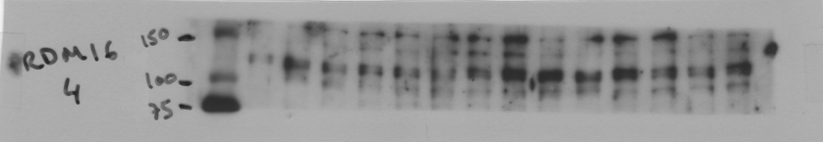
Vehicle LEAP2
CPT1alpha
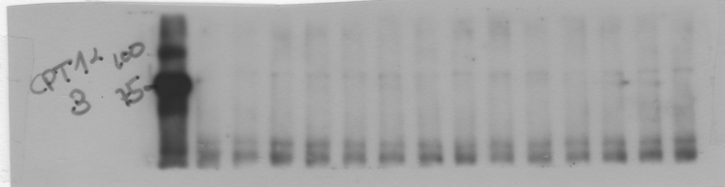
Vehicle LEAP2
PPARalpha
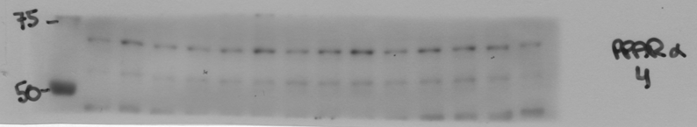 Vehicle LEAP2
GAPDH
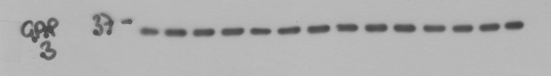 Vehicle LEAP2
GAPDH
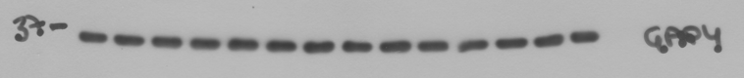
Vehicle LEAP2

I
BIP
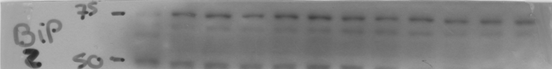
CTRL OA OA+LEAP2
pIRE1alpha
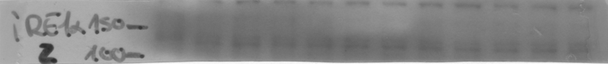
CTRL OA OA+LEAP2
CHOP
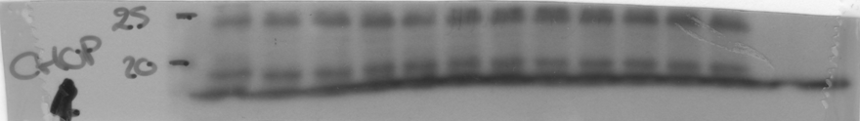
CTRL OA OA+LEAP2
GAPDH
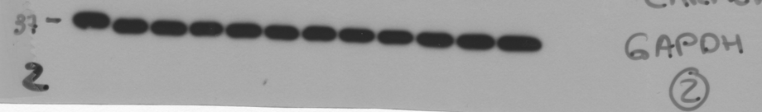 CTRL OA OA+LEAP2

Fig 3
G
PGC1a
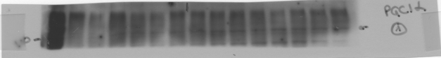
Vehicle LEAP2
PRDM16
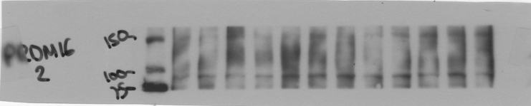
Vehicle LEAP2
PPARa
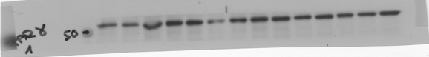
Vehicle LEAP2
CPT1a
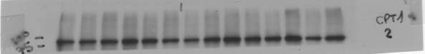
Vehicle LEAP2
GAPDH
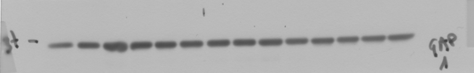
Vehicle LEAP2

I
BIP
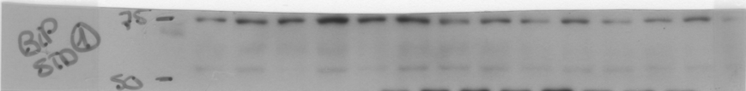
Vehicle LEAP2
pIRE1a
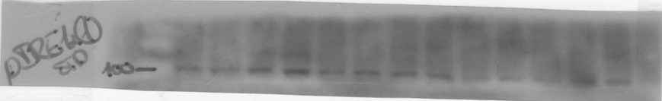
Vehicle LEAP2
CHOP
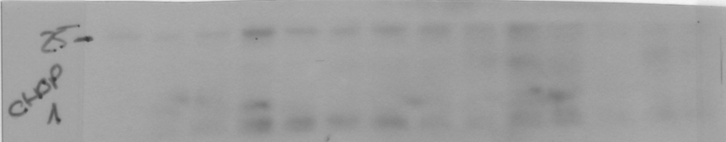 Vehicle LEAP2
GAPDH
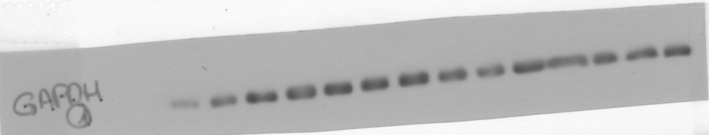
Vehicle LEAP2

Fig 4
F
PGC1a
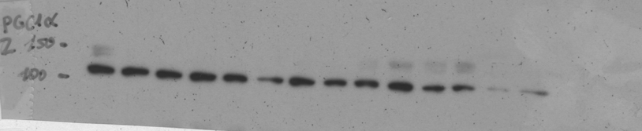
Vehicle LEAP2
PRDM16
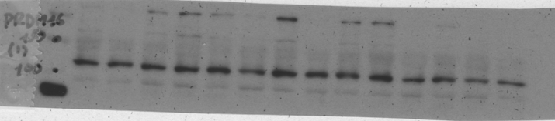 Vehicle LEAP2
PPARa
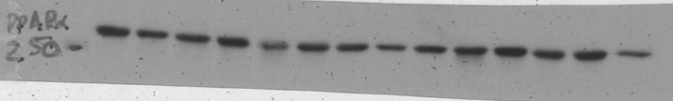 Vehicle LEAP2
CPT1a
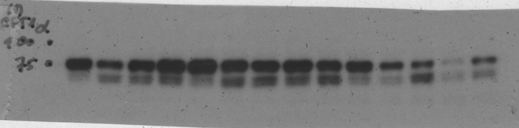 Vehicle LEAP2
GAPDH
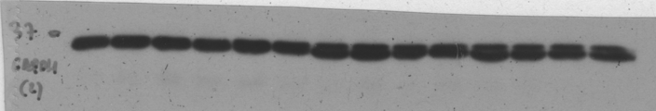 Vehicle LEAP2
H
BIP
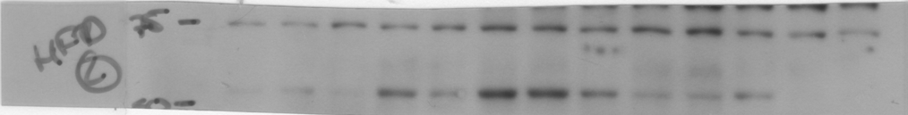
Vehicle LEAP2
pIRE1a
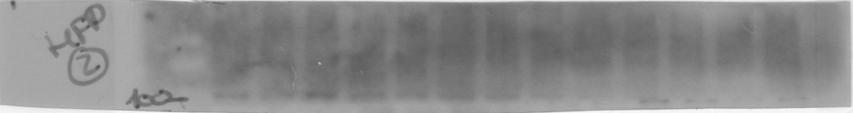 Vehicle LEAP2
CHOP
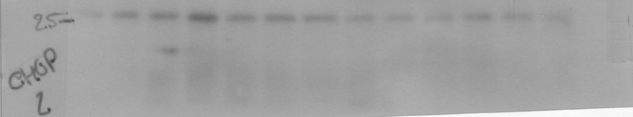 Vehicle LEAP2
GAPDH
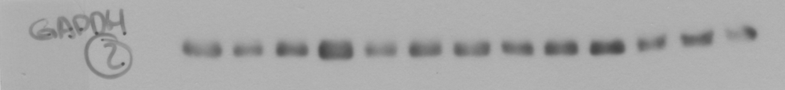 Vehicle LEAP2

