Supplementary material

Title: The joint impact of temperature, humidity, and air pollution on COVID-19 incidence: A multi-country time-series study in 439 cities

Authors:
Keita Wagatsuma^{a,b}, Denise Feurer^{c,d}, Wenhua Yu^{e,f}, Rongbin Xu^{e,f}, Tim Riffe^{g,h,i}, Maxi Stella Kniffka^{i,j}, Enrique Acosta^{i,k}, Ben Armstrong^{l}, Malcolm Mistry^{m,n}, Rachel Lowe^{o,p,q}, Dominic Royé^{r,s}, Masahiro Hashizume^{t,u}, Aurelio Tobias^{t,v}, Ana Maria Vicedo-Cabrera^{w,x}, Lina Madaniyazi^{t}, Chris Fook Sheng Ng^{u}, Carmen Íñiguez^{y}, Martina S. Ragettli^{z,aa}, Eric Lavigne^{ab,ac}, Patricia Matus Correa^{ad}, Nicolás Valdés Ortega^{ad}, Jan Kyselý ^{ae,af}, Aleš Urban^{ae,af}, Hans Orru^{ag}, Ene Indermitte^{ag}, Marek Maasikmets^{ah}, Susanne Breitner-Busch^{ai}, Alexandra Schneider^{ai}, Yasushi Honda^{aj,ak}, Barrak Alahmad^{al}, Antonella Zanobetti^{al}, Joel Schwartz^{al}, Gabriela Carrasco^{am}, Iulian Horia Holobâca^{an}, Ho Kim^{ao}, Whanhee Lee^{ap}, Michelle L. Bell^{aq}, Noah Scovronick^{ar}, Fiorella Acquaotta^{as}, Micheline de Sousa Zanotti Stagliorio Coelho^{at}, Magali Hurtado Diaz^{au}, Eunice Elizabeth Félix Arellano^{au}, Paola Michelozzi^{av}, Massimo Stafoggia^{av}, Francesca de’Donato^{av}, Shilpa Rao^{aw}, Xerxes Seposo^{ax}, Shilu Tong^{ay,az}, Jochem Klompmaker^{aaa}, Yuming Guo^{e,f}, Pierre Masselot^{m}, Antonio Gasparrini^{m}, Francesco Sera^{aab}

Affiliations:​
ª Division of International Health (Public Health), Graduate School of Medical and Dental Sciences, Niigata University, Niigata, Japan; ^{b} Institute for Research Administration, Niigata University, Niigata, Japan; ^{c} Unit of Biostatistics, Epidemiology and Public Health (UBEP), University of Padua, Padua, Italy; ^{d} Interdepartmental Research Center of Geomatics (CIRGEO), University of Padua, Padua, Italy; ^{e} Department of Epidemiology and Preventive Medicine, School of Public Health and Preventive Medicine, Monash University, Melbourne, Australia; ^{f} Climate, Air Quality Research Unit, School of Public Health and Preventive Medicine, Monash University, Melbourne, Australia; ^{g} Universidad del País Vasco (UPV/EHU), Leioa, Spain; ^{h} Ikerbasque (Basque Foundation for Science), Bilbao, Spain; ^{i} Max Planck Institute for Demographic Research, Rostock, Germany; ^{j} Universität Rostock, Germany; ^{k} Centre d’Estudis Demogràfics, Bellaterra, Spain; ^{l} Department of Public Health, Environments and Society, London School of Hygiene & Tropical Medicine, London, UK; ^{m} Environment & Health Modelling (EHM) Lab, Department of Public Health, Environments and Society, London School of Hygiene & Tropical Medicine, London, UK; ^{n} Department of Economics, Ca’ Foscari University of Venice, Venice, Italy; º Barcelona Supercomputing Center (BSC), Barcelona, Spain; ^{p} Catalan Institution for Research and Advanced Studies (ICREA), Barcelona, Spain; ^{q} Centre on Climate Change & Planetary Health and Centre for Mathematical Modelling of Infectious Diseases, London School of Hygiene & Tropical Medicine, London, UK; ^{r} CIBERESP, Madrid. Spain; ^{s} Biological Mision of Galicia (MBG), Spanish Council for Scientific Research (CSIC), Madrid, Spain; ^{t} School of Tropical Medicine and Global Health, Nagasaki University, Japan; ^{u} Department of Global Health Policy, Graduate School of Medicine, The University of Tokyo, Tokyo, Japan; ^{v} Institute of Environmental Assessment and Water Research (IDAEA), Spanish Council for Scientific Research (CSIC), Barcelona, Spain; ^{w} Institute of Social and Preventive Medicine, University of Bern, Bern, Switzerland; ^{x} Oeschger Center for Climate Change Research, University of Bern, Bern, Switzerland; ^{y} Department of Statistics and Computational Research. Universitat de València, València, Spain; ^{z} Swiss Tropical and Public Health Institute, Allschwil, Switzerland; ^{aa} University of Basel, Basel, Switzerland; ^{ab} School of Epidemiology and Public Health, Faculty of Medicine, University of Ottawa, Ottawa, Canada; ^{ac} Environmental Health Science and Research Bureau, Health Canada, Ottawa, Canada; ^{ad} Department of Public Health, Universidad de los Andes, Santiago, Chile; ^{ae} Institute of Atmospheric Physics of the Czech Academy of Sciences, Prague, Czech Republic; ^{af} Faculty of Environmental Sciences, Czech University of Life Sciences, Prague, Czech Republic; ^{ag} Institute of Family Medicine and Public Health, University of Tartu, Tartu, Estonia; ^{ah} Estonian Environmental Research Centre, Tallinn, Estonia; ^{ai} Institute of Epidemiology, Helmholtz Zentrum München–German Research Center for Environmental Health (GmbH), Neuherberg, Germany; ^{aj} Center for Climate Change Adaptation, National Institute for Environmental Studies, Tsukuba, Japan; ^{ak} Faculty of Health and Sport Sciences, University of Tsukuba, Tsukuba, Japan; ^{al} Department of Environmental Health, Harvard T.H. Chan School of Public Health, Harvard University, Boston, USA; ^{am} Institute of Tropical Medicine “Alexander von Humboldt,” Universidad Peruana Cayetano Heredia, Lima, Peru; ^{an} Faculty of Geography, Babes-Bolyai University, Cluj-Napoca, Romania; ^{ao} Department of Public Health Science, Graduate School of Public Health, & Institute of Health and Environment, Seoul National University, Seoul, Republic of Korea; ^{ap} School of Biomedical Convergence Engineering, Pusan National University; ^{aq} School of the Environment, Yale University, New Haven, CT, USA; ^{ar} Department of Environmental Health. Rollins School of Public Health, Emory University, Atlanta, USA; ^{as} Department of Earth Sciences, University of Torino, Italy; ^{at} Laboratory of Environmental and Experimental Pathology, University of São Paulo, Faculty of Medicine, Brazil; ^{au} Department of Environmental Health, National Institute of Public Health, Cuernavaca, Morelos, Mexico; ^{av} Department of Epidemiology, Lazio Regional Health Service, Rome, Italy; ^{aw} Norwegian Institute of Public Health, Oslo, Norway; ^{ax} Department of Hygiene, Graduate School of Medicine, Hokkaido University, Sapporo, Japan; ^{ay} National Institute of Environmental Health, China CDC, Beijing, China; ^{az} School of Public Health and Social Work, Queensland University of Technology, Brisbane, Australia; ^{aaa} National Institute for Public Health and the Environment (RIVM), Bilthoven, Netherlands; ^{aab} Department of Statistics, Computer Science and Applications “G. Parenti”, University of Florence, Florence, Italy

Corresponding author:
Keita Wagatsuma, PhD
Division of International Health (Public Health),
Graduate School of Medical and Dental Sciences, Niigata University
1-757 Asahimachi-dori, Chuo-ku, Niigata City, Niigata 951-8510, Japan
Tel: +81-25-227-2129; Fax: +81-25-227-0765
E-mail: waga@med.niigata-u.ac.jp
Table S1. Data sources.
Country | Sources
Alberta | https://www.alberta.ca/data/stats/covid-19-alberta-statistics-data.csv
British Columbia | http://www.bccdc.ca/Health-Info-Site/Documents/BCCDC_COVID19_Dashboard_Case_Details.csv
Manitoba | https://www.inspq.qc.ca/covid-19/donnees
Montreal | https://www.inspq.qc.ca/covid-19/donnees
Ontario | https://data.ontario.ca/dataset/f4112442-bdc8-45d2-be3c-12efae72fb27/resource/455fd63b-603d-4608-8216-7d8647f43350/download/conposcovidloc.csv
Saskatchewan | https://dashboard.saskatchewan.ca/health-wellness/covid-19/cases
Mexico | https://www.arcgis.com/sharing/rest/content/items/f10774f1c63e40168479a1feb6c7ca74/data
United States | https://data.cdc.gov/Case-Surveillance/COVID-19-Case-Surveillance-Restricted-Access-Detai/mbd7-r32t/about_data
Brazil | https://transparencia.registrocivil.org.br/painel-registral/especial-covid
Chile | https://raw.githubusercontent.com/MinCiencia/Datos- COVID19/master/output/producto1/Covid-19.csv
Peru | https://www.datosabiertos.gob.pe/dataset/casos-positivos-por-covid-19-ministerio-de-salud-minsa
Estonia | https://opendata.digilugu.ee/opendata_covid19_test_county_all.csv
Netherlands | https://opendata.arcgis.com/datasets/1365a2d9cb344b67999dd825c99cb1a5_0.csv
Norway | https://raw.githubusercontent.com/thohan88/covid19-nor-data/master/data/01_infected/msis/municipality.csv
United Kingdom | https://coronavirus.data.gov.uk/api/v2/data?areaType=ltla&metric=newCasesByPublishDate&format=csv
Czech Republic | https://onemocneni-aktualne.mzcr.cz/covid-19
Germany | https://www.arcgis.com/sharing/rest/content/items/f10774f1c63e40168479a1feb6c7ca74/data
Romania | https://raw.githubusercontent.com/denesdata/roem/master/data/time_series_ro_count ies_daily.csv
Switzerland | https://www.covid19.admin.ch/en/overview
Italy | https://github.com/pcm-dpc/COVID-19
Spain | https://cnecovid.isciii.es/covid19/resources/casos_hosp_uci_def_sexo_edad_provres.csv
South Africa | https://sacoronavirus.co.za/
Japan | https://www3.nhk.or.jp/n-data/opendata/coronavirus/nhk_news_covid19_prefectures_daily_data.csv
Kuwait | https://corona.e.gov.kw/en
Philippines | https://doh.gov.ph/
Singapore | https://www.moh.gov.sg/covid-19
Melbourn | https://www.health.gov.au/news/coronavirus-update-at-a-glance & https://www.covidlive.com.au/
Sydney | https://www.health.gov.au/news/coronavirus-update-at-a-glance & https://www.covidlive.com.au/
Malaysia | https://raw.githubusercontent.com/MoH-Malaysia/covid19-public/main/epidemic/cases_state.csv
South Korea | https://www.data.go.kr

Table S2. List of the 439 cities included in the studies, with observed COVID-19 cases, environmental exposures, governmental stringency index, and vaccination coverage.
Country | City name | COVID–19 cases | Daily mean humidex  Mean (range) [°C] | Daily mean PM₂.₅  Mean (range) [µg/m³] | Daily mean ultraviolet solar radiation  Mean (range) [J/m²] | Daily mean precipitation  Mean (range) [mm] | Daily mean OXCGRT SI  Mean (range) [%] | Daily mean vaccination coverage  Mean (range) [%]
Australia | Brisbane | 163,026 | 23.7 (9.2, 39.1) | 6.4 (2.4, 23.8) | 187.5 (14.2, 366.6) | 3.6 (0.0, 155.7) | 55.8 (11.1, 78.2) | 29.6 (0.0, 82.7)
Brazil | Belo Horizonte | 682,426 | 24.4 (11.0, 32.0) | 17.4 (4.9, 54.9) | 217.3 (28.2, 373.0) | 2.7 (0.0, 99.5) | 56.4 (23.9, 81.0) | 28.4 (0.0, 79.4)
Brazil | Belém | 132,832 | 37.3 (34.2, 39.5) | 11.9 (4.1, 22.6) | 209.5 (35.2, 292.7) | 7.1 (0.0, 189.8) | 56.4 (23.9, 81.0) | 28.5 (0.0, 79.4)
Brazil | Brasília | 5,686 | 24.8 (11.4, 30.7) | 17.7 (7.9, 67.4) | 228.2 (57.3, 364.4) | 2.8 (0.0, 51.7) | 55.2 (23.9, 81.0) | 30.3 (0.0, 79.4)
Brazil | Cuiabá | 155,273 | 20.3 (1.2, 31.0) | 17.9 (6.0, 39.7) | 177.1 (13.4, 377.8) | 3.6 (0.0, 73.9) | 56.4 (23.9, 81.0) | 28.6 (0.0, 79.4)
Brazil | Curitiba | 196,807 | 33.4 (14.0, 39.7) | 21.4 (3.1, 140.6) | 226.0 (37.2, 344.9) | 2.2 (0.0, 34.0) | 56.3 (23.9, 81.0) | 28.3 (0.0, 79.4)
Brazil | Fortaleza | 366,852 | 36.3 (32.4, 39.8) | 12.3 (5.0, 21.3) | 221.1 (29.5, 313.0) | 2.8 (0.0, 95.1) | 56.4 (23.9, 81.0) | 28.4 (0.0, 79.4)
Brazil | Goiânia | 27,784 | 26.9 (11.3, 33.0) | 17.4 (3.3, 59.1) | 227.3 (52.7, 356.8) | 2.7 (0.0, 94.7) | 56.2 (23.9, 81.0) | 28.8 (0.0, 79.4)
Brazil | João Pessoa | 173,482 | 35.2 (30.8, 40.1) | 10.7 (3.2, 17.3) | 223.6 (23.9, 309.2) | 3.2 (0.0, 108.8) | 56.4 (23.9, 81.0) | 28.5 (0.0, 79.4)
Brazil | Maceió | 125,213 | 34.2 (29.3, 39.3) | NA | 198.7 (7.8, 319.9) | 4.6 (0.0, 126.7) | 56.2 (11.1, 81.0) | 28.2 (0.0, 79.4)
Brazil | Manaus | 304,189 | 37.4 (31.7, 41.2) | 13.7 (3.6, 50.2) | 194.4 (42.8, 289.8) | 8.3 (0.0, 111.5) | 56.3 (23.9, 81.0) | 28.3 (0.0, 79.4)
Brazil | Natal | 140,244 | 35.3 (31.2, 39.5) | 11.4 (7.8, 21.2) | 217.1 (27.6, 308.9) | 3.6 (0.0, 85.7) | 56.3 (23.9, 81.0) | 28.3 (0.0, 79.4)
Brazil | Porto Alegre | 299,049 | 23.3 (4.8, 42.5) | 18.6 (3.5, 51.4) | 183.4 (9.7, 381.1) | 3.6 (0.0, 75.3) | 56.2 (11.1, 81.0) | 28.3 (0.0, 79.4)
Brazil | Recife | 265,263 | 34.7 (29.9, 39.4) | NA | 207.2 (27.6, 320.2) | 3.4 (0.0, 98.6) | 56.3 (23.9, 81.0) | 28.3 (0.0, 79.4)
Brazil | Salvador | 323,547 | 34.0 (27.8, 40.0) | 11.8 (7.5, 33.5) | 203.2 (25.3, 326.5) | 4.3 (0.0, 85.3) | 56.3 (23.9, 81.0) | 28.3 (0.0, 79.4)
Brazil | São Luís | 1,801 | 37.3 (34.2, 39.6) | NA | 209.1 (13.5, 298.4) | 6.3 (0.0, 125.6) | 55.8 (23.9, 81.0) | 29.5 (0.0, 79.4)
Brazil | São Paulo | 1,190,261 | 23.3 (5.1, 33.4) | 19.2 (5.0, 50.9) | 196.5 (24.9, 371.0) | 3.1 (0.0, 67.8) | 56.2 (11.1, 81.0) | 28.2 (0.0, 79.4)
Brazil | Teresina | 124,490 | 35.8 (29.9, 39.7) | 15.8 (8.4, 37.9) | 228.7 (36.9, 313.0) | 3.3 (0.0, 114.0) | 56.4 (23.9, 81.0) | 28.5 (0.0, 79.4)
Brazil | Vitória | 136,219 | 30.2 (19.1, 38.1) | 10.9 (3.4, 27.3) | 205.5 (27.5, 364.2) | 2.8 (0.0, 77.2) | 56.4 (23.9, 81.0) | 28.5 (0.0, 79.4)
Canada | Calgary Zone | 236,122 | 2.7 (–37.3, 29.8) | 8.2 (2.2, 73.7) | 174.2 (11.3, 365.6) | 1.6 (0.0, 53.1) | 61.0 (2.8, 76.4) | 34.5 (0.0, 81.9)
Canada | Edmonton Zone | 189,955 | 2.5 (–39.6, 31.6) | 8.6 (2.0, 119.9) | 165.8 (11.1, 356.9) | 1.6 (0.0, 36.9) | 61.0 (2.8, 76.4) | 34.5 (0.0, 81.9)
Canada | Vancouver Health Service Delivery Area | 48,299 | 10.2 (–16.6, 37.8) | 62.9 (37.6, 87.1) | 149.3 (2.6, 355.4) | 6.7 (0.0, 91.1) | 61.1 (2.8, 76.4) | 34.4 (0.0, 81.9)
Chile | Araucanía | 85,091 | 11.3 (–2.1, 27.2) | 51.5 (4.8, 242.6) | 173.7 (3.9, 397.9) | 3.4 (0.0, 59.9) | 62.0 (25.6, 90.3) | 42.3 (0.0, 90.0)
Chile | Región Metropolitana | 122,550 | 14.5 (–1.8, 27.2) | 43.8 (5.5, 147.8) | 233.8 (14.2, 413.0) | 1.3 (0.0, 38.6) | 62.0 (25.6, 90.3) | 42.3 (0.0, 90.0)
Chile | Valparaíso | 79,076 | 14.4 (6.5, 22.4) | 28.1 (10.4, 78.1) | 219.5 (19.8, 396.5) | 0.9 (0.0, 49.6) | 62.0 (25.6, 90.3) | 42.3 (0.0, 90.0)
Czech Republic | Prague | 528,084 | 10.5 (–17.3, 30.3) | 13.6 (1.8, 56.1) | 148.0 (6.7, 327.3) | 2.2 (0.0, 83.3) | 46.4 (11.1, 82.4) | 29.2 (0.0, 65.6)
Estonia | Tallinn | 283,494 | 7.2 (–21.7, 32.6) | 6.7 (2.3, 22.7) | 132.1 (1.9, 334.7) | 2.0 (0.0, 39.9) | 37.9 (0.0, 77.8) | 28.9 (0.0, 64.6)
Germany | Berlin | 1,138,948 | 11.2 (–15.2, 32.2) | 13.1 (3.8, 49.5) | 138.7 (4.0, 331.8) | 1.7 (0.0, 46.2) | 54.0 (14.8, 85.2) | 33.4 (0.0, 76.1)
Germany | Bremen | 203,198 | 11.4 (–12.5, 31.2) | 10.1 (2.5, 40.4) | 135.6 (2.5, 337.2) | 2.3 (0.0, 27.8) | 54.0 (14.8, 85.2) | 33.4 (0.0, 76.1)
Germany | Dortmund | 206,210 | 11.7 (–16.0, 32.2) | 10.9 (1.3, 44.5) | 139.3 (2.6, 333.8) | 2.6 (0.0, 56.8) | 54.0 (14.8, 85.2) | 33.4 (0.0, 76.1)
Germany | Dresden | 240,002 | 10.6 (–17.3, 31.1) | 11.3 (2.2, 54.9) | 142.8 (5.2, 333.2) | 2.1 (0.0, 36.5) | 54.0 (14.8, 85.2) | 33.4 (0.0, 76.1)
Germany | Duesseldorf | 225,171 | 12.4 (–12.4, 33.8) | 11.4 (2.3, 47.3) | 141.6 (3.2, 334.2) | 2.5 (0.0, 65.0) | 54.0 (14.8, 85.2) | 33.4 (0.0, 76.1)
Germany | Frankfurt | 286,710 | 11.9 (–11.9, 32.8) | 9.9 (1.8, 37.0) | 147.5 (4.3, 336.0) | 1.9 (0.0, 23.3) | 54.0 (14.8, 85.2) | 33.4 (0.0, 76.1)
Germany | Hamburg | 696,298 | 11.0 (–10.8, 31.7) | 10.4 (2.4, 44.0) | 135.4 (3.2, 331.9) | 2.1 (0.0, 22.6) | 54.0 (14.8, 85.2) | 33.4 (0.0, 76.1)
Germany | Koeln | 403,919 | 12.0 (–10.9, 33.3) | 10.4 (1.8, 38.0) | 143.1 (3.6, 335.5) | 2.5 (0.0, 91.2) | 54.0 (14.8, 85.2) | 33.4 (0.0, 76.1)
Germany | Leipzig | 238,362 | 11.2 (–16.9, 32.0) | 10.7 (2.3, 58.6) | 143.3 (4.7, 333.4) | 1.9 (0.0, 41.1) | 54.0 (14.8, 85.2) | 33.4 (0.0, 76.1)
Germany | Muenchen | 611,933 | 9.7 (–14.4, 29.5) | 10.2 (2.0, 34.1) | 156.8 (7.6, 339.4) | 3.1 (0.0, 49.2) | 54.0 (14.8, 85.2) | 33.4 (0.0, 76.1)
Germany | Stuttgart | 218,942 | 11.0 (–13.0, 30.9) | 9.9 (1.4, 36.5) | 154.7 (5.5, 339.5) | 2.3 (0.0, 34.9) | 54.0 (14.8, 85.2) | 33.4 (0.0, 76.1)
Italy | Ancona | 178,243 | 18.7 (–1.5, 39.4) | 6.0 (2.1, 21.6) | 194.8 (10.7, 338.1) | 1.6 (0.0, 36.4) | 60.2 (19.2, 93.5) | 35.5 (0.0, 81.2)
Italy | Bari | 444,613 | 20.5 (0.2, 38.8) | 6.7 (2.8, 31.8) | 203.8 (16.5, 343.6) | 1.5 (0.0, 36.4) | 60.2 (19.2, 93.5) | 35.5 (0.0, 81.2)
Italy | Bologna | 406,192 | 17.0 (–3.4, 38.3) | 13.0 (4.6, 35.6) | 185.4 (6.7, 335.1) | 1.7 (0.0, 33.5) | 60.2 (19.2, 93.5) | 35.5 (0.0, 81.2)
Italy | Brescia | 397,015 | 15.6 (–4.2, 36.2) | 16.1 (5.0, 59.9) | 175.0 (6.6, 332.0) | 2.9 (0.0, 52.4) | 60.2 (19.2, 93.5) | 35.5 (0.0, 81.2)
Italy | Brindisi | 131,183 | 20.9 (0.1, 40.4) | 6.6 (2.4, 45.5) | 207.7 (18.1, 344.3) | 1.5 (0.0, 30.3) | 60.2 (19.2, 93.5) | 35.5 (0.0, 81.2)
Italy | Cagliari | 123,977 | 21.4 (3.8, 40.1) | 12.8 (6.5, 33.1) | 213.3 (13.8, 341.7) | 1.2 (0.0, 31.0) | 60.2 (19.2, 93.5) | 35.5 (0.0, 81.2)
Italy | Catania | 329,682 | 22.8 (4.9, 40.7) | 17.6 (7.2, 43.5) | 209.6 (19.3, 342.3) | 1.5 (0.0, 69.0) | 60.2 (19.2, 93.5) | 35.5 (0.0, 81.2)
Italy | Firenze | 348,360 | 16.0 (–4.5, 36.1) | 11.0 (4.3, 28.9) | 184.7 (10.4, 341.3) | 2.3 (0.0, 32.4) | 60.2 (19.2, 93.5) | 35.5 (0.0, 81.2)
Italy | Frosinone | 160,230 | 17.4 (–3.9, 36.1) | 14.4 (6.1, 42.1) | 197.7 (9.3, 346.9) | 3.0 (0.0, 74.8) | 60.2 (19.2, 93.5) | 35.5 (0.0, 81.2)
Italy | Genova | 272,186 | 14.9 (–5.0, 34.4) | 12.8 (5.2, 46.2) | 167.3 (6.6, 344.3) | 3.1 (0.0, 84.0) | 60.2 (19.2, 93.5) | 35.5 (0.0, 81.2)
Italy | Latina | 208,804 | 20.0 (–0.2, 38.0) | 14.2 (5.4, 42.1) | 201.0 (14.4, 343.0) | 2.4 (0.0, 56.0) | 60.2 (19.2, 93.5) | 35.5 (0.0, 81.2)
Italy | Milano | 1,048,279 | 15.6 (–5.3, 37.4) | 17.7 (5.7, 54.0) | 176.5 (6.0, 343.6) | 3.0 (0.0, 73.3) | 60.2 (19.2, 93.5) | 35.5 (0.0, 81.2)
Italy | Napoli | 1,132,206 | 20.2 (–0.7, 37.9) | 16.8 (4.8, 109.4) | 191.5 (12.1, 339.9) | 3.0 (0.0, 66.8) | 60.2 (19.2, 93.5) | 35.5 (0.0, 81.2)
Italy | Padova | 409,301 | 16.7 (–3.8, 39.4) | 15.8 (5.2, 50.2) | 180.5 (6.0, 327.6) | 2.4 (0.0, 49.4) | 60.2 (19.2, 93.5) | 35.5 (0.0, 81.2)
Italy | Palermo | 366,635 | 21.1 (3.0, 39.5) | 7.1 (2.0, 76.9) | 215.7 (28.6, 341.1) | 1.7 (0.0, 38.5) | 60.2 (19.2, 93.5) | 35.5 (0.0, 81.2)
Italy | Pisa | 157,234 | 18.6 (–1.0, 37.8) | 11.4 (3.9, 33.0) | 191.9 (11.6, 336.9) | 2.7 (0.0, 62.3) | 60.2 (19.2, 93.5) | 35.5 (0.0, 81.2)
Italy | Rieti | 58,640 | 13.0 (–9.4, 30.7) | 14.0 (4.4, 52.1) | 192.6 (10.1, 342.4) | 2.5 (0.0, 46.4) | 60.2 (19.2, 93.5) | 35.5 (0.0, 81.2)
Italy | Roma | 1,472,759 | 19.3 (–1.5, 38.4) | 15.6 (6.8, 38.6) | 199.3 (15.2, 339.7) | 2.1 (0.0, 52.0) | 60.2 (19.2, 93.5) | 35.5 (0.0, 81.2)
Italy | Taranto | 191,409 | 21.2 (0.7, 39.7) | 14.8 (4.7, 50.1) | 207.8 (13.9, 343.1) | 1.3 (0.0, 31.9) | 60.2 (19.2, 93.5) | 35.5 (0.0, 81.2)
Italy | Torino | 744,879 | 14.2 (–7.4, 34.5) | 15.2 (3.8, 45.2) | 168.8 (5.3, 348.3) | 2.2 (0.0, 55.0) | 60.2 (19.2, 93.5) | 35.5 (0.0, 81.2)
Italy | Trieste | 97,766 | 13.9 (–8.0, 35.8) | 11.6 (3.6, 49.0) | 178.3 (6.3, 331.4) | 3.1 (0.0, 53.1) | 60.2 (19.2, 93.5) | 35.5 (0.0, 81.2)
Italy | Venezia | 354,634 | 17.5 (–3.1, 39.9) | 13.6 (5.3, 28.3) | 167.5 (5.4, 326.4) | 2.7 (0.0, 64.9) | 60.2 (19.2, 93.5) | 35.5 (0.0, 81.2)
Italy | Viterbo | 91,421 | 16.7 (–4.0, 34.9) | 13.8 (5.1, 37.6) | 198.1 (7.2, 340.8) | 2.3 (0.0, 41.1) | 60.2 (19.2, 93.5) | 35.5 (0.0, 81.2)
Japan | Aichi | 814,911 | 18.8 (–5.5, 41.6) | 16.6 (6.0, 63.0) | 175.7 (13.1, 340.5) | 5.2 (0.0, 89.1) | 43.4 (25.9, 55.1) | 33.0 (0.0, 82.8)
Japan | Chiba | 691,762 | 20.1 (–2.8, 44.0) | 18.5 (6.0, 64.7) | 167.5 (14.3, 334.8) | 5.1 (0.0, 97.0) | 43.4 (25.9, 55.1) | 33.0 (0.0, 82.8)
Japan | Fukuoka | 759,335 | 20.5 (–4.8, 41.6) | 19.7 (6.8, 93.6) | 172.5 (17.5, 333.8) | 5.3 (0.0, 184.8) | 43.4 (25.9, 55.1) | 33.0 (0.0, 82.8)
Japan | Hokkaido | 519,717 | 9.8 (–18.1, 38.2) | 12.2 (4.2, 56.0) | 168.0 (17.5, 338.0) | 3.3 (0.0, 74.5) | 43.4 (25.9, 55.1) | 33.0 (0.0, 82.8)
Japan | Hyogo | 663,400 | 19.2 (–5.0, 42.1) | 15.8 (4.4, 63.1) | 178.3 (13.5, 342.7) | 5.0 (0.0, 116.4) | 43.4 (25.9, 55.1) | 33.0 (0.0, 82.8)
Japan | Kanagawa | 1,158,655 | 19.2 (–2.8, 42.0) | 18.5 (6.5, 57.6) | 164.3 (14.5, 334.0) | 4.8 (0.0, 121.3) | 43.4 (25.9, 55.1) | 33.0 (0.0, 82.8)
Japan | Kyoto | 334,701 | 18.1 (–6.3, 41.4) | 17.0 (5.8, 65.7) | 171.1 (14.2, 341.1) | 5.0 (0.0, 99.9) | 43.4 (25.9, 55.1) | 33.0 (0.0, 82.8)
Japan | Osaka | 1,276,751 | 20.1 (–4.5, 43.7) | 16.5 (5.8, 53.4) | 175.6 (12.2, 344.7) | 4.8 (0.0, 113.5) | 43.4 (25.9, 55.1) | 33.0 (0.0, 82.8)
Japan | Saitama | 810,065 | 18.6 (–4.6, 43.6) | 19.0 (5.7, 62.1) | 161.3 (10.3, 334.5) | 4.2 (0.0, 78.1) | 43.4 (25.9, 55.1) | 33.0 (0.0, 82.8)
Japan | Tokyo | 2,233,215 | 19.2 (–3.7, 43.6) | 19.0 (6.5, 58.1) | 162.1 (11.9, 334.0) | 4.2 (0.0, 86.8) | 43.4 (25.9, 55.1) | 33.0 (0.0, 82.8)
Kuwait | Kuwait | 707,652 | 30.2 (4.7, 51.4) | 37.9 (14.8, 62.7) | 237.7 (27.2, 335.4) | 0.2 (0.0, 29.4) | 59.1 (11.1, 100.0) | 30.7 (0.0, 78.0)
Mexico | Area Metropolitana Monterrey | 343,565 | 26.1 (–1.7, 38.4) | 22.8 (4.4, 56.2) | 242.2 (35.4, 351.2) | 1.5 (0.0, 106.2) | 51.7 (2.8, 82.4) | 23.8 (0.0, 62.7)
Mexico | Zona Metropolitana Ciudad Juarez | 51,950 | 18.8 (–10.1, 34.4) | 13.5 (3.6, 42.0) | 266.7 (36.0, 384.5) | 0.4 (0.0, 26.6) | 51.9 (2.8, 82.4) | 23.9 (0.0, 62.7)
Mexico | Zona Metropolitana Guadalajara | 192,604 | 23.6 (12.1, 30.8) | 25.6 (6.0, 69.4) | 261.6 (41.9, 364.2) | 2.6 (0.0, 39.6) | 51.7 (2.8, 82.4) | 23.8 (0.0, 62.7)
Mexico | Zona Metropolitana Laguna | 58,859 | 19.5 (3.1, 27.5) | 22.9 (5.0, 74.1) | 275.3 (49.0, 366.5) | 0.8 (0.0, 55.5) | 51.7 (2.8, 82.4) | 23.8 (0.0, 62.7)
Mexico | Zona Metropolitana Leon | 135,955 | 20.3 (10.2, 26.8) | 19.4 (5.1, 45.9) | 265.0 (54.3, 365.4) | 1.8 (0.0, 28.7) | 51.7 (2.8, 82.4) | 23.8 (0.0, 62.7)
Mexico | Zona Metropolitana Puebla | 169,188 | 17.8 (10.2, 22.8) | 22.8 (5.0, 78.8) | 259.3 (73.0, 354.9) | 2.7 (0.0, 93.5) | 51.7 (2.8, 82.4) | 23.8 (0.0, 62.7)
Mexico | Zona Metropolitana Queretaro | 137,738 | 19.7 (9.3, 26.4) | 18.4 (5.3, 51.6) | 259.5 (56.4, 357.2) | 1.7 (0.0, 33.7) | 51.7 (2.8, 82.4) | 23.8 (0.0, 62.7)
Mexico | Zona Metropolitana San Luis | 138,137 | 18.6 (4.1, 26.6) | 17.3 (4.2, 64.0) | 260.2 (76.1, 368.6) | 1.5 (0.0, 38.2) | 51.7 (2.8, 82.4) | 23.8 (0.0, 62.7)
Mexico | Zona Metropolitana Tijuana | 68,463 | 19.0 (6.3, 33.0) | 15.4 (2.4, 68.4) | 248.6 (28.7, 371.2) | 0.8 (0.0, 38.2) | 51.7 (2.8, 82.4) | 23.8 (0.0, 62.7)
Mexico | Zona Metropolitana Valle de Mexico | 2,303,288 | 16.3 (7.0, 21.6) | 21.9 (4.7, 47.9) | 255.6 (55.5, 368.3) | 1.6 (0.0, 46.8) | 51.7 (2.8, 82.4) | 23.8 (0.0, 62.7)
Mexico | Zona Metropolitana Valled de Toluca | 68,906 | 13.1 (3.6, 17.4) | 26.2 (4.1, 129.4) | 248.9 (80.6, 357.7) | 3.7 (0.0, 33.2) | 51.7 (2.8, 82.4) | 23.8 (0.0, 62.7)
Netherland | Amsterdam | 391,300 | 12.2 (–10.5, 33.2) | 11.0 (2.9, 80.4) | 145.5 (3.9, 331.6) | 2.3 (0.0, 33.2) | 51.1 (15.7, 82.4) | 31.1 (0.0, 68.1)
Netherland | Den Haag | 214,041 | 12.4 (–9.4, 33.0) | 9.9 (2.9, 43.8) | 150.9 (4.3, 333.5) | 2.3 (0.0, 32.2) | 51.1 (15.7, 82.4) | 31.1 (0.0, 68.1)
Netherland | Eindhoven | 91,015 | 12.4 (–11.3, 33.6) | 11.7 (2.9, 48.5) | 142.1 (3.9, 332.7) | 2.3 (0.0, 38.3) | 51.1 (15.7, 82.4) | 31.1 (0.0, 68.1)
Netherland | Rotterdam | 283,047 | 12.3 (–11.3, 33.7) | 10.4 (2.5, 43.1) | 146.4 (3.9, 332.6) | 2.3 (0.0, 28.4) | 51.1 (15.7, 82.4) | 31.1 (0.0, 68.1)
Netherland | Utrecht | 154,481 | 12.1 (–12.5, 33.0) | 10.7 (2.9, 51.4) | 141.9 (3.5, 332.0) | 2.3 (0.0, 29.3) | 51.1 (15.7, 82.4) | 31.1 (0.0, 68.1)
Norway | Oslo | 197,392 | 6.9 (–20.5, 27.6) | 7.1 (2.1, 40.6) | 128.0 (1.0, 340.2) | 2.5 (0.0, 37.9) | 41.6 (11.1, 79.6) | 33.0 (0.0, 74.5)
Peru | Apurimac | 43,080 | 5.7 (1.6, 9.0) | 45.9 (7.5, 80.5) | 239.2 (102.3, 377.3) | 3.9 (0.0, 30.3) | 69.2 (13.9, 96.3) | 27.0 (0.0, 82.2)
Peru | Arequipa | 225,436 | 13.0 (6.6, 18.1) | 31.2 (4.5, 63.2) | 263.1 (98.1, 389.0) | 2.3 (0.0, 17.9) | 69.2 (13.9, 96.3) | 27.0 (0.0, 82.2)
Peru | Ayacucho | 52,052 | 10.9 (5.0, 14.1) | 35.3 (3.2, 84.9) | 235.0 (84.8, 366.4) | 3.0 (0.0, 24.0) | 69.2 (13.9, 96.3) | 27.0 (0.0, 82.2)
Peru | Cajamarca | 107,080 | 13.6 (9.0, 17.0) | 34.2 (3.5, 72.4) | 221.1 (76.1, 372.4) | 8.7 (0.0, 101.9) | 69.2 (13.9, 96.3) | 27.0 (0.0, 82.2)
Peru | Cusco | 130,752 | 6.5 (1.4, 9.9) | 46.6 (5.2, 91.4) | 218.9 (65.7, 359.1) | 3.1 (0.0, 31.7) | 69.2 (13.9, 96.3) | 27.0 (0.0, 82.2)
Peru | Huancavelica | 27,825 | 2.3 (–2.5, 5.5) | 48.1 (2.6, 85.0) | 243.0 (87.4, 377.1) | 4.3 (0.0, 25.1) | 69.2 (13.9, 96.3) | 27.0 (0.0, 82.2)
Peru | Huanuco | 56,252 | 16.0 (10.6, 19.0) | 50.3 (3.8, 123.1) | 213.0 (63.8, 321.7) | 4.2 (0.0, 30.1) | 69.2 (13.9, 96.3) | 27.0 (0.0, 82.2)
Peru | Ica | 99,226 | 24.5 (17.4, 32.2) | 24.3 (2.7, 47.9) | 262.1 (133.5, 355.5) | 0.2 (0.0, 11.2) | 69.2 (13.9, 96.3) | 27.0 (0.0, 82.2)
Peru | Junin | 139,756 | 2.0 (–3.1, 5.0) | 52.6 (11.1, 87.9) | 240.8 (133.5, 358.5) | 4.3 (0.0, 21.3) | 69.2 (13.9, 96.3) | 27.0 (0.0, 82.2)
Peru | La Libertad | 147,964 | 8.3 (4.6, 11.5) | 40.8 (4.6, 102.7) | 235.3 (101.1, 366.2) | 5.7 (0.0, 30.9) | 69.2 (13.9, 96.3) | 27.0 (0.0, 82.2)
Peru | Lambayeque | 103,718 | 26.2 (20.5, 35.0) | 14.5 (3.8, 27.2) | 244.6 (99.1, 323.5) | 0.5 (0.0, 18.6) | 69.2 (13.9, 96.3) | 27.0 (0.0, 82.2)
Peru | Lima | 1,706,110 | 22.6 (16.5, 30.8) | NA | 243.3 (141.6, 343.4) | 0.5 (0.0, 14.8) | 69.2 (13.9, 96.3) | 27.0 (0.0, 82.2)
Peru | Loreto | 61,538 | 36.1 (25.4, 40.3) | 20.4 (9.4, 39.0) | 186.9 (34.9, 295.6) | 8.3 (0.0, 85.2) | 69.2 (13.9, 96.3) | 27.0 (0.0, 82.2)
Peru | Piura | 139,494 | 28.3 (22.5, 36.5) | 18.2 (10.4, 31.3) | 251.9 (73.2, 332.3) | 0.6 (0.0, 42.8) | 69.2 (13.9, 96.3) | 27.0 (0.0, 82.2)
Peru | Puno | 64,188 | 6.4 (–0.7, 11.1) | 25.4 (11.8, 57.8) | 273.7 (105.4, 400.9) | 3.4 (0.0, 33.2) | 69.2 (13.9, 96.3) | 27.0 (0.0, 82.2)
Peru | San Martin | 66,242 | 31.4 (22.0, 35.4) | 29.7 (3.5, 55.8) | 204.6 (35.1, 310.4) | 6.1 (0.0, 70.7) | 69.2 (13.9, 96.3) | 27.0 (0.0, 82.2)
Peru | Tacna | 51,129 | 19.1 (12.3, 26.1) | 22.7 (12.2, 41.3) | 258.8 (120.8, 375.3) | 0.5 (0.0, 9.1) | 69.2 (13.9, 96.3) | 27.0 (0.0, 82.2)
Peru | Ucayali | 42,553 | 36.0 (22.7, 40.6) | 24.6 (3.4, 58.9) | 203.5 (34.8, 317.7) | 6.2 (0.0, 106.1) | 69.2 (13.9, 96.3) | 27.0 (0.0, 82.2)
Philippines | Cebu City | 58,134 | 36.5 (30.1, 39.5) | 8.9 (5.5, 22.1) | 202.8 (27.0, 317.2) | 8.7 (0.0, 117.7) | 67.4 (26.6, 100.0) | 18.0 (0.0, 62.2)
Philippines | Davao City | 141,328 | 36.8 (32.8, 39.8) | 7.6 (5.3, 20.9) | 195.5 (21.5, 314.7) | 5.6 (0.0, 108.2) | 67.2 (26.6, 100.0) | 17.9 (0.0, 62.2)
Philippines | Manila City | 73,836 | 37.9 (28.0, 42.5) | 19.3 (11.2, 46.9) | 203.9 (24.1, 304.0) | 5.9 (0.0, 186.7) | 67.3 (26.6, 100.0) | 18.1 (0.0, 62.2)
Philippines | Quezon City | 232,330 | 38.5 (28.6, 43.4) | 19.3 (11.3, 46.6) | 204.4 (23.1, 303.6) | 6.6 (0.0, 182.1) | 67.2 (26.6, 100.0) | 17.9 (0.0, 62.2)
Romania | Brasov | 109,879 | 8.3 (–17.8, 29.6) | 18.6 (5.6, 52.6) | 157.6 (11.9, 329.8) | 2.3 (0.0, 42.4) | 52.2 (11.1, 87.0) | 17.3 (0.0, 41.3)
Romania | Bucuresti | 565,570 | 13.6 (–11.8, 36.6) | 17.9 (5.6, 61.5) | 167.9 (5.5, 338.2) | 1.8 (0.0, 36.9) | 52.2 (11.1, 87.0) | 17.3 (0.0, 41.3)
Romania | Cluj | 166,565 | 8.9 (–14.6, 30.4) | 16.1 (5.2, 42.7) | 155.2 (5.0, 332.1) | 2.3 (0.0, 28.9) | 52.2 (11.1, 87.0) | 17.3 (0.0, 41.3)
Romania | Constanta | 117,217 | 14.7 (–9.4, 37.1) | 15.8 (7.5, 30.5) | 168.6 (8.8, 335.9) | 1.7 (0.0, 45.4) | 52.2 (11.1, 87.0) | 17.3 (0.0, 41.3)
Romania | Dolj | 74,686 | 13.5 (–10.3, 36.7) | 21.6 (7.1, 63.9) | 170.8 (6.8, 332.3) | 1.7 (0.0, 41.8) | 52.2 (11.1, 87.0) | 17.3 (0.0, 41.3)
Romania | Galati | 65,331 | 13.7 (–12.0, 36.9) | 16.0 (5.8, 57.7) | 164.3 (8.3, 330.7) | 1.3 (0.0, 22.5) | 52.2 (11.1, 87.0) | 17.3 (0.0, 41.3)
Romania | Iasi | 113,196 | 11.6 (–13.6, 35.5) | 14.8 (6.0, 51.9) | 154.7 (4.2, 337.2) | 1.5 (0.0, 25.4) | 52.2 (11.1, 87.0) | 17.3 (0.0, 41.3)
Romania | Timis | 154,915 | 13.3 (–10.3, 35.6) | 18.1 (6.0, 83.0) | 165.0 (6.4, 336.4) | 2.0 (0.0, 30.6) | 52.2 (11.1, 87.0) | 17.3 (0.0, 41.3)
Singapore | Singapore | 1,817,744 | 38.1 (33.5, 41.1) | NA | 190.2 (26.9, 296.1) | 7.4 (0.0, 90.8) | 49.4 (25.0, 82.4) | 40.0 (0.0, 90.2)
South Africa | City of Cape Town | 414,972 | 18.3 (7.7, 31.4) | 27.4 (8.0, 206.5) | 202.8 (19.0, 396.6) | 1.6 (0.0, 37.7) | 52.3 (11.1, 88.0) | 10.7 (0.0, 32.1)
Spain | A Coruna | 240,517 | 15.6 (3.2, 29.3) | 15.4 (4.2, 35.3) | 156.2 (8.9, 352.9) | 3.0 (0.0, 37.8) | 58.1 (35.4, 85.2) | 29.6 (0.0, 84.6)
Spain | Albacete | 84,330 | 14.6 (–8.6, 32.6) | 10.7 (4.1, 296.5) | 201.8 (22.8, 362.7) | 1.4 (0.0, 41.1) | 58.1 (35.4, 85.2) | 29.6 (0.0, 84.6)
Spain | Alicante | 417,410 | 20.3 (3.5, 38.4) | 8.5 (2.4, 37.0) | 192.9 (11.2, 349.5) | 1.2 (0.0, 58.7) | 58.1 (35.4, 85.2) | 29.6 (0.0, 84.6)
Spain | Almeria | 131,359 | 19.6 (4.3, 36.1) | 9.8 (3.0, 108.4) | 206.8 (22.6, 354.5) | 0.8 (0.0, 33.0) | 58.1 (35.4, 85.2) | 29.6 (0.0, 84.6)
Spain | Araba | 75,604 | 11.6 (–5.6, 30.0) | 9.4 (2.3, 43.1) | 159.8 (7.7, 353.0) | 2.5 (0.0, 35.0) | 58.1 (35.4, 85.2) | 29.6 (0.0, 84.6)
Spain | Asturias | 200,786 | 13.6 (–2.3, 30.3) | 11.2 (3.5, 64.5) | 165.5 (5.9, 352.4) | 3.6 (0.0, 55.5) | 58.1 (35.4, 85.2) | 29.6 (0.0, 84.6)
Spain | Badajoz | 163,336 | 18.5 (–0.4, 35.9) | 8.6 (3.3, 59.3) | 202.2 (15.0, 361.9) | 1.3 (0.0, 41.3) | 58.1 (35.4, 85.2) | 29.6 (0.0, 84.6)
Spain | Barcelona | 1,419,246 | 18.2 (1.4, 36.7) | 14.3 (4.8, 32.8) | 170.6 (16.9, 339.4) | 1.6 (0.0, 45.9) | 58.1 (35.4, 85.2) | 29.6 (0.0, 84.6)
Spain | Bizkaia | 272,017 | 15.2 (0.2, 31.9) | 9.6 (2.4, 40.7) | 156.6 (5.7, 348.3) | 3.6 (0.0, 46.9) | 58.1 (35.4, 85.2) | 29.6 (0.0, 84.6)
Spain | Burgos | 90,311 | 10.7 (–7.6, 29.7) | 7.0 (2.0, 132.8) | 176.9 (8.8, 357.9) | 1.9 (0.0, 49.5) | 58.1 (35.4, 85.2) | 29.6 (0.0, 84.6)
Spain | Cantabria | 112,444 | 15.9 (0.8, 33.4) | 13.8 (5.3, 33.0) | 150.4 (8.3, 350.5) | 3.3 (0.0, 42.1) | 58.1 (35.4, 85.2) | 29.6 (0.0, 84.6)
Spain | Castellana | 133,949 | 19.8 (3.4, 39.4) | 8.5 (1.6, 33.2) | 190.2 (26.1, 353.5) | 1.7 (0.0, 49.0) | 58.1 (35.4, 85.2) | 29.6 (0.0, 84.6)
Spain | Ceuta | 17,565 | 21.3 (7.6, 34.7) | 9.1 (3.4, 35.5) | 196.8 (14.0, 350.4) | 1.7 (0.0, 74.5) | 58.1 (35.4, 85.2) | 29.6 (0.0, 84.6)
Spain | Ciudad Real | 107,359 | 15.7 (–5.1, 33.4) | 11.2 (4.8, 78.2) | 204.9 (13.3, 367.8) | 1.2 (0.0, 36.0) | 58.1 (35.4, 85.2) | 29.6 (0.0, 84.6)
Spain | Cuenca | 48,026 | 11.3 (–8.5, 29.8) | 10.4 (4.4, 51.5) | 194.4 (6.9, 364.5) | 1.9 (0.0, 37.3) | 58.1 (35.4, 85.2) | 29.6 (0.0, 84.6)
Spain | Caceres | 85,083 | 17.4 (–0.8, 35.0) | 8.8 (3.3, 62.7) | 201.0 (12.6, 360.6) | 1.5 (0.0, 48.6) | 58.1 (35.4, 85.2) | 29.6 (0.0, 84.6)
Spain | Cadiz | 191,592 | 21.3 (4.7, 36.4) | 7.4 (3.3, 29.5) | 199.1 (5.5, 354.1) | 1.4 (0.0, 54.5) | 58.1 (35.4, 85.2) | 29.6 (0.0, 84.6)
Spain | Cordoba | 141,122 | 19.1 (0.2, 38.0) | 11.9 (3.7, 88.9) | 209.2 (15.9, 360.5) | 1.2 (0.0, 32.3) | 58.1 (35.4, 85.2) | 29.6 (0.0, 84.6)
Spain | Gipuzkoa | 210,761 | 15.1 (–0.9, 32.0) | 10.1 (3.4, 50.6) | 155.4 (6.5, 344.5) | 4.3 (0.0, 63.5) | 58.1 (35.4, 85.2) | 29.6 (0.0, 84.6)
Spain | Girona | 205,872 | 16.4 (–2.0, 37.2) | 10.9 (4.1, 29.5) | 169.0 (12.9, 337.2) | 2.5 (0.0, 64.3) | 58.1 (35.4, 85.2) | 29.6 (0.0, 84.6)
Spain | Granada | 173,395 | 16.1 (–1.6, 34.2) | 13.7 (4.0, 146.7) | 213.4 (25.2, 364.1) | 1.5 (0.0, 24.3) | 58.1 (35.4, 85.2) | 29.6 (0.0, 84.6)
Spain | Guadalajara | 62,109 | 13.3 (–5.5, 31.2) | 10.7 (4.1, 61.3) | 193.8 (13.7, 363.0) | 1.6 (0.0, 29.7) | 58.1 (35.4, 85.2) | 29.6 (0.0, 84.6)
Spain | Huelva | 83,710 | 21.1 (3.8, 37.8) | 9.1 (3.0, 71.2) | 214.8 (21.4, 357.8) | 1.2 (0.0, 49.8) | 58.1 (35.4, 85.2) | 29.6 (0.0, 84.6)
Spain | Huesca | 63,509 | 14.5 (–7.6, 34.0) | 9.0 (3.4, 35.8) | 190.9 (18.3, 358.3) | 1.8 (0.0, 37.4) | 58.1 (35.4, 85.2) | 29.6 (0.0, 84.6)
Spain | Illes Balears | 260,911 | 20.9 (5.4, 39.4) | 11.5 (4.9, 43.6) | 200.2 (21.9, 340.0) | 1.3 (0.0, 77.0) | 58.1 (35.4, 85.2) | 29.6 (0.0, 84.6)
Spain | Jaén | 113,496 | 17.2 (–1.3, 35.7) | 12.3 (4.6, 120.2) | 209.2 (12.8, 364.4) | 1.7 (0.0, 31.8) | 58.1 (35.4, 85.2) | 29.6 (0.0, 84.6)
Spain | La Rioja | 85,940 | 13.4 (–4.9, 32.9) | 8.6 (3.3, 33.4) | 168.7 (8.8, 355.3) | 1.8 (0.0, 33.3) | 58.1 (35.4, 85.2) | 29.6 (0.0, 84.6)
Spain | Las Palmas | 155,302 | 23.5 (14.3, 32.6) | 31.8 (7.7, 54.8) | 235.9 (61.1, 344.9) | 0.7 (0.0, 12.3) | 58.1 (35.4, 85.2) | 29.6 (0.0, 84.6)
Spain | LeÃ³n | 106,787 | 10.8 (–5.9, 28.4) | 8.5 (2.8, 75.9) | 176.9 (9.3, 354.3) | 1.7 (0.0, 50.2) | 58.1 (35.4, 85.2) | 29.6 (0.0, 84.6)
Spain | Lleida | 125,514 | 16.5 (–3.0, 36.7) | 11.0 (3.8, 31.3) | 191.2 (13.7, 355.5) | 1.2 (0.0, 35.5) | 58.1 (35.4, 85.2) | 29.6 (0.0, 84.6)
Spain | Lugo | 63,046 | 12.5 (–3.6, 28.6) | 10.3 (2.3, 40.8) | 161.7 (7.1, 352.3) | 2.8 (0.0, 29.1) | 58.1 (35.4, 85.2) | 29.6 (0.0, 84.6)
Spain | Madrid | 1,511,956 | 20.5 (5.2, 38.7) | 9.7 (2.8, 81.7) | 212.9 (23.1, 356.3) | 1.2 (0.0, 40.2) | 58.1 (35.4, 85.2) | 29.6 (0.0, 84.6)
Spain | Melilla | 19,676 | 21.4 (8.1, 36.9) | 12.9 (6.1, 75.2) | 204.3 (32.5, 346.6) | 1.0 (0.0, 28.5) | 58.1 (35.4, 85.2) | 29.6 (0.0, 84.6)
Spain | Murcia | 341,038 | 19.6 (1.4, 38.1) | 12.7 (3.6, 43.5) | 206.2 (14.9, 351.4) | 1.1 (0.0, 38.4) | 58.1 (35.4, 85.2) | 29.6 (0.0, 84.6)
Spain | MÃ¡laga | 273,407 | 14.3 (–4.9, 32.7) | 9.6 (2.0, 66.5) | 196.9 (15.7, 363.5) | 1.4 (0.0, 31.7) | 58.1 (35.4, 85.2) | 29.6 (0.0, 84.6)
Spain | Navarra | 200,908 | 12.1 (–6.9, 32.1) | 9.3 (3.3, 31.7) | 164.2 (9.1, 345.8) | 2.3 (0.0, 39.2) | 58.1 (35.4, 85.2) | 29.6 (0.0, 84.6)
Spain | Ourense | 70,099 | 14.1 (–3.4, 32.1) | 10.0 (2.1, 41.8) | 168.8 (7.7, 356.8) | 2.6 (0.0, 37.1) | 58.1 (35.4, 85.2) | 29.6 (0.0, 84.6)
Spain | Palencia | 50,285 | 11.8 (–5.2, 30.2) | 8.5 (3.4, 86.5) | 185.8 (10.2, 368.6) | 1.5 (0.0, 52.7) | 58.1 (35.4, 85.2) | 29.6 (0.0, 84.6)
Spain | Pontevedra | 213,386 | 15.4 (0.3, 30.3) | 10.6 (2.5, 34.9) | 175.0 (10.1, 354.9) | 3.9 (0.0, 47.3) | 58.1 (35.4, 85.2) | 29.6 (0.0, 84.6)
Spain | Salamanca | 81,407 | 12.6 (–5.2, 30.4) | 7.6 (1.7, 172.1) | 192.0 (7.8, 361.9) | 1.6 (0.0, 55.3) | 58.1 (35.4, 85.2) | 29.6 (0.0, 84.6)
Spain | Santa Cruz de Tenerife | 131,638 | 22.4 (12.3, 32.5) | 10.3 (2.5, 136.3) | 231.8 (34.1, 354.6) | 0.7 (0.0, 19.7) | 58.1 (35.4, 85.2) | 29.6 (0.0, 84.6)
Spain | Segovia | 38,683 | 11.4 (–7.8, 30.2) | 8.9 (3.4, 96.9) | 191.0 (14.3, 363.3) | 2.1 (0.0, 32.2) | 58.1 (35.4, 85.2) | 29.6 (0.0, 84.6)
Spain | Sevilla | 287,385 | 20.7 (2.5, 39.3) | 11.3 (3.4, 54.3) | 212.1 (14.3, 356.4) | 1.3 (0.0, 40.4) | 58.1 (35.4, 85.2) | 29.6 (0.0, 84.6)
Spain | Soria | 23,558 | 10.2 (–8.9, 30.3) | 9.8 (3.9, 43.4) | 183.4 (14.4, 364.0) | 1.9 (0.0, 34.9) | 58.1 (35.4, 85.2) | 29.6 (0.0, 84.6)
Spain | Tarragona | 215,374 | 18.4 (–0.1, 36.6) | 10.9 (3.4, 31.2) | 179.4 (21.7, 340.9) | 1.6 (0.0, 56.1) | 58.1 (35.4, 85.2) | 29.6 (0.0, 84.6)
Spain | Teruel | 38,897 | 11.0 (–9.0, 31.3) | 11.1 (4.0, 41.3) | 193.2 (15.5, 364.9) | 1.4 (0.0, 30.0) | 58.1 (35.4, 85.2) | 29.6 (0.0, 84.6)
Spain | Toledo | 164,900 | 15.8 (–5.0, 34.2) | 11.9 (3.9, 63.1) | 201.5 (15.0, 366.0) | 1.3 (0.0, 40.0) | 58.1 (35.4, 85.2) | 29.6 (0.0, 84.6)
Spain | Valencia | 677,761 | 20.1 (2.5, 38.4) | 9.9 (1.6, 44.6) | 193.7 (17.7, 350.4) | 1.8 (0.0, 66.4) | 58.1 (35.4, 85.2) | 29.6 (0.0, 84.6)
Spain | Valladolid | 146,478 | 12.4 (–5.1, 30.8) | 11.2 (3.8, 94.2) | 188.4 (12.7, 362.4) | 1.5 (0.0, 49.0) | 58.1 (35.4, 85.2) | 29.6 (0.0, 84.6)
Spain | Zamora | 41,473 | 13.0 (–4.5, 31.8) | 8.9 (3.7, 80.4) | 189.7 (7.9, 363.1) | 1.5 (0.0, 47.0) | 58.1 (35.4, 85.2) | 29.6 (0.0, 84.6)
Spain | Zaragoza | 245,803 | 16.0 (–3.6, 36.3) | 9.6 (3.1, 28.4) | 191.0 (10.8, 358.7) | 1.2 (0.0, 42.4) | 58.1 (35.4, 85.2) | 29.6 (0.0, 84.6)
Spain | Ãvila | 37,205 | 10.6 (–7.1, 28.8) | 9.5 (3.5, 102.1) | 194.7 (12.5, 363.0) | 1.7 (0.0, 44.2) | 58.1 (35.4, 85.2) | 29.6 (0.0, 84.6)
Switzerland | Basel–Stadt | 95,810 | 12.1 (–13.6, 33.2) | 10.5 (1.4, 35.5) | 161.2 (5.4, 345.1) | 2.6 (0.0, 41.2) | 42.0 (11.1, 73.2) | 31.2 (0.0, 68.7)
Switzerland | Bern | 450,146 | 9.1 (–11.5, 28.6) | 10.7 (2.3, 33.8) | 167.2 (4.2, 350.7) | 3.5 (0.0, 38.6) | 42.0 (11.1, 73.2) | 31.2 (0.0, 68.7)
Switzerland | Geneva | 225,675 | 11.4 (–8.3, 32.5) | 10.3 (2.0, 31.9) | 170.9 (4.4, 347.3) | 4.0 (0.0, 44.3) | 42.0 (11.1, 73.2) | 31.2 (0.0, 68.7)
Switzerland | Lucerne | 188,005 | 10.7 (–11.8, 31.4) | 10.3 (2.9, 33.9) | 163.8 (3.4, 352.2) | 4.4 (0.0, 54.0) | 42.0 (11.1, 73.2) | 31.2 (0.0, 68.7)
Switzerland | Sankt Gallen | 226,369 | 8.0 (–14.3, 27.3) | 10.2 (2.1, 35.2) | 161.4 (7.0, 345.0) | 4.5 (0.0, 49.8) | 42.0 (11.1, 73.2) | 31.2 (0.0, 68.7)
Switzerland | Ticino | 164,739 | 11.4 (–8.2, 31.6) | 13.1 (1.6, 57.1) | 167.6 (5.4, 345.3) | 4.0 (0.0, 80.6) | 42.0 (11.1, 73.2) | 31.2 (0.0, 68.7)
Switzerland | Vaud | 345,347 | 12.9 (–6.6, 34.7) | 10.6 (2.5, 34.9) | 168.0 (4.6, 344.7) | 3.5 (0.0, 37.1) | 42.0 (11.1, 73.2) | 31.2 (0.0, 68.7)
Switzerland | Zurich | 703,859 | 10.7 (–12.1, 31.3) | 10.4 (2.0, 59.5) | 163.9 (4.9, 342.4) | 3.1 (0.0, 53.3) | 42.0 (11.1, 73.2) | 31.2 (0.0, 68.7)
United Kingdom | Barnsley | 91,277 | 10.2 (–6.3, 28.2) | 9.8 (2.9, 59.2) | 121.7 (2.5, 340.1) | 2.5 (0.0, 22.6) | 53.5 (11.1, 88.0) | 34.6 (0.0, 74.3)
United Kingdom | Basildon | 69,075 | 12.0 (–5.6, 31.5) | 10.6 (2.9, 64.6) | 140.8 (5.0, 342.3) | 2.0 (0.0, 37.1) | 53.4 (11.1, 88.0) | 34.8 (0.0, 74.3)
United Kingdom | Basingstoke and Deane | 64,175 | 11.4 (–5.9, 31.6) | 9.7 (2.9, 36.4) | 134.5 (4.3, 342.9) | 2.1 (0.0, 48.3) | 53.4 (11.1, 88.0) | 34.8 (0.0, 74.3)
United Kingdom | Bedford | 68,305 | 11.3 (–6.6, 31.9) | 9.7 (3.8, 42.7) | 129.2 (4.4, 341.6) | 2.0 (0.0, 38.7) | 53.5 (11.1, 88.0) | 34.6 (0.0, 74.3)
United Kingdom | Birmingham | 346,741 | 10.4 (–5.9, 30.1) | 9.1 (2.4, 82.2) | 124.6 (3.5, 336.4) | 2.2 (0.0, 31.3) | 53.5 (11.1, 88.0) | 34.6 (0.0, 74.3)
United Kingdom | Blackburn with Darwen | 55,268 | 9.6 (–6.3, 28.6) | 9.0 (3.2, 43.3) | 124.2 (2.9, 341.7) | 3.7 (0.0, 35.7) | 53.5 (11.1, 88.0) | 34.6 (0.0, 74.3)
United Kingdom | Blackpool | 51,180 | 11.1 (–4.7, 27.9) | 47.5 (25.1, 66.4) | 130.4 (3.6, 338.0) | 4.0 (0.0, 34.5) | 53.5 (11.1, 88.0) | 34.6 (0.0, 74.3)
United Kingdom | Brighton and Hove | 103,151 | 12.2 (–4.7, 30.8) | 10.5 (2.5, 40.9) | 140.1 (4.5, 346.1) | 2.2 (0.0, 28.8) | 53.5 (11.1, 88.0) | 34.6 (0.0, 74.3)
United Kingdom | Bristol, City of | 178,999 | 11.5 (–5.0, 32.1) | 9.4 (2.9, 56.9) | 130.5 (4.1, 339.5) | 2.4 (0.0, 31.8) | 53.5 (11.1, 88.0) | 34.6 (0.0, 74.3)
United Kingdom | Burnley | 32,231 | 8.6 (–7.0, 27.6) | 8.9 (3.4, 40.6) | 118.7 (2.6, 342.1) | 3.6 (0.0, 38.3) | 53.4 (11.1, 88.0) | 34.8 (0.0, 74.3)
United Kingdom | Cambridge | 50,026 | 11.5 (–7.3, 31.8) | 10.2 (3.5, 41.1) | 130.0 (4.9, 341.7) | 2.1 (0.0, 30.4) | 53.4 (11.1, 88.0) | 34.8 (0.0, 74.3)
United Kingdom | Chelmsford | 65,790 | 11.6 (–5.9, 31.3) | 10.4 (3.4, 53.8) | 139.2 (5.1, 342.3) | 2.0 (0.0, 33.1) | 53.4 (11.1, 88.0) | 34.8 (0.0, 74.3)
United Kingdom | Cheltenham | 40,629 | 10.9 (–6.0, 31.0) | 9.1 (3.8, 39.7) | 127.9 (4.1, 338.6) | 2.2 (0.0, 36.7) | 53.4 (11.1, 88.0) | 34.8 (0.0, 74.3)
United Kingdom | Chesterfield | 36,304 | 10.0 (–6.6, 28.3) | 8.2 (1.9, 51.5) | 122.9 (3.0, 339.6) | 2.4 (0.0, 26.3) | 53.4 (11.1, 88.0) | 34.8 (0.0, 74.3)
United Kingdom | Colchester | 71,015 | 11.8 (–4.9, 30.6) | 9.9 (3.9, 44.8) | 139.4 (5.8, 341.0) | 2.0 (0.0, 26.4) | 53.4 (11.1, 88.0) | 34.8 (0.0, 74.3)
United Kingdom | Coventry | 115,920 | 10.8 (–5.9, 31.1) | 8.5 (2.3, 44.4) | 125.9 (3.5, 338.3) | 2.2 (0.0, 31.5) | 53.5 (11.1, 88.0) | 34.6 (0.0, 74.3)
United Kingdom | Crawley | 43,364 | 11.8 (–6.3, 32.0) | 10.1 (3.2, 39.1) | 141.7 (4.2, 346.7) | 2.1 (0.0, 33.1) | 53.3 (11.1, 88.0) | 34.8 (0.0, 74.3)
United Kingdom | Derby | 89,837 | 10.5 (–6.0, 29.5) | 8.8 (2.4, 43.6) | 124.3 (3.6, 338.6) | 2.2 (0.0, 25.7) | 53.5 (11.1, 88.0) | 34.6 (0.0, 74.3)
United Kingdom | Doncaster | 110,976 | 10.5 (–5.8, 28.2) | 9.6 (3.3, 50.2) | 125.3 (3.0, 340.2) | 2.2 (0.0, 20.7) | 53.5 (11.1, 88.0) | 34.6 (0.0, 74.3)
United Kingdom | Eastbourne | 35,440 | 12.8 (–3.8, 30.4) | 10.9 (4.6, 40.6) | 150.4 (4.6, 343.8) | 2.3 (0.0, 27.6) | 53.4 (11.1, 88.0) | 34.8 (0.0, 74.3)
United Kingdom | Exeter | 47,499 | 12.0 (–4.0, 30.4) | 8.9 (3.9, 38.9) | 138.7 (4.8, 348.0) | 2.3 (0.0, 34.5) | 53.4 (11.1, 88.0) | 34.8 (0.0, 74.3)
United Kingdom | Gloucester | 45,732 | 11.2 (–5.7, 31.5) | 9.3 (3.7, 41.3) | 127.8 (4.0, 338.5) | 2.2 (0.0, 35.6) | 53.4 (11.1, 88.0) | 34.8 (0.0, 74.3)
United Kingdom | Hastings | 32,438 | 12.3 (–5.3, 31.3) | 44.6 (26.1, 63.9) | 145.0 (4.7, 344.9) | 2.2 (0.0, 29.3) | 53.4 (11.1, 88.0) | 34.8 (0.0, 74.3)
United Kingdom | Ipswich | 49,622 | 11.6 (–5.2, 30.3) | 9.8 (4.0, 41.6) | 139.3 (5.7, 340.5) | 2.1 (0.0, 25.1) | 53.4 (11.1, 88.0) | 34.8 (0.0, 74.3)
United Kingdom | Kingston upon Hull, City of | 94,035 | 10.8 (–4.4, 28.2) | 9.5 (3.5, 45.8) | 132.3 (3.5, 340.4) | 2.2 (0.0, 23.3) | 53.5 (11.1, 88.0) | 34.6 (0.0, 74.3)
United Kingdom | Leicester | 118,526 | 10.7 (–6.0, 30.1) | 8.7 (2.5, 49.6) | 126.2 (4.4, 340.6) | 2.2 (0.0, 25.9) | 53.5 (11.1, 88.0) | 34.6 (0.0, 74.3)
United Kingdom | Lincoln | 35,564 | 10.9 (–5.1, 28.3) | 9.2 (3.5, 36.5) | 127.2 (3.6, 341.4) | 2.2 (0.0, 21.7) | 53.4 (11.1, 88.0) | 34.8 (0.0, 74.3)
United Kingdom | Liverpool | 179,760 | 11.0 (–5.2, 28.9) | 8.5 (2.8, 42.6) | 128.5 (3.6, 338.8) | 3.2 (0.0, 27.9) | 53.5 (11.1, 88.0) | 34.6 (0.0, 74.3)
United Kingdom | London | 3,003,884 | 11.8 (–7.1, 32.4) | 10.9 (3.2, 51.6) | 134.3 (3.7, 341.3) | 2.1 (0.0, 32.8) | 53.5 (11.1, 88.0) | 34.6 (0.0, 74.3)
United Kingdom | Luton | 75,529 | 11.0 (–7.0, 31.3) | 9.7 (3.8, 40.1) | 130.3 (4.0, 341.4) | 2.1 (0.0, 35.4) | 53.5 (11.1, 88.0) | 34.6 (0.0, 74.3)
United Kingdom | Maidstone | 61,447 | 11.8 (–7.9, 32.1) | 10.0 (3.4, 40.8) | 146.6 (4.7, 346.5) | 2.2 (0.0, 32.8) | 53.4 (11.1, 88.0) | 34.8 (0.0, 74.3)
United Kingdom | Manchester | 190,876 | 10.2 (–6.3, 29.8) | 9.2 (3.0, 42.7) | 120.0 (2.6, 339.4) | 3.1 (0.0, 34.5) | 53.5 (11.1, 88.0) | 34.6 (0.0, 74.3)
United Kingdom | Mansfield | 40,006 | 10.0 (–6.7, 28.2) | 8.6 (2.2, 46.6) | 123.7 (3.3, 340.0) | 2.2 (0.0, 23.3) | 53.4 (11.1, 88.0) | 34.8 (0.0, 74.3)
United Kingdom | Medway | 98,690 | 11.6 (–8.3, 32.0) | 10.1 (3.6, 40.3) | 144.1 (4.3, 346.0) | 2.2 (0.0, 34.5) | 53.5 (11.1, 88.0) | 34.6 (0.0, 74.3)
United Kingdom | Milton Keynes | 103,903 | 11.1 (–6.2, 31.6) | 9.5 (3.6, 40.1) | 129.4 (3.8, 341.0) | 2.1 (0.0, 43.7) | 53.5 (11.1, 88.0) | 34.6 (0.0, 74.3)
United Kingdom | Northampton | 82,109 | 10.8 (–6.2, 30.9) | 9.3 (3.6, 38.1) | 127.3 (4.2, 341.1) | 2.1 (0.0, 38.8) | 53.4 (11.1, 88.0) | 34.8 (0.0, 74.3)
United Kingdom | Norwich | 49,450 | 11.4 (–5.1, 29.8) | 9.4 (3.2, 48.1) | 142.3 (4.6, 341.1) | 2.1 (0.0, 34.8) | 53.4 (11.1, 88.0) | 34.8 (0.0, 74.3)
United Kingdom | Nottingham | 109,817 | 10.6 (–6.2, 28.9) | 9.0 (2.3, 42.4) | 124.8 (3.5, 340.2) | 2.1 (0.0, 21.9) | 53.5 (11.1, 88.0) | 34.6 (0.0, 74.3)
United Kingdom | Oxford | 57,100 | 11.3 (–5.8, 31.7) | 8.7 (2.4, 46.1) | 129.3 (3.5, 340.9) | 2.1 (0.0, 43.3) | 53.4 (11.1, 88.0) | 34.8 (0.0, 74.3)
United Kingdom | Peterborough | 77,455 | 11.4 (–6.1, 30.8) | 9.8 (4.1, 38.1) | 128.2 (4.3, 341.7) | 2.1 (0.0, 36.4) | 53.5 (11.1, 88.0) | 34.6 (0.0, 74.3)
United Kingdom | Plymouth | 98,031 | 12.3 (–2.5, 29.1) | 8.8 (2.6, 37.6) | 146.6 (6.8, 351.2) | 2.7 (0.0, 35.3) | 53.5 (11.1, 88.0) | 34.6 (0.0, 74.3)
United Kingdom | Preston | 51,944 | 10.4 (–5.7, 29.0) | 9.0 (3.0, 42.5) | 126.7 (3.2, 340.8) | 3.8 (0.0, 34.2) | 53.4 (11.1, 88.0) | 34.8 (0.0, 74.3)
United Kingdom | Reading | 61,370 | 11.4 (–5.9, 31.6) | 9.0 (2.0, 46.2) | 132.7 (3.7, 340.0) | 2.1 (0.0, 44.4) | 53.5 (11.1, 88.0) | 34.6 (0.0, 74.3)
United Kingdom | Sheffield | 196,594 | 9.9 (–6.6, 28.3) | 9.4 (2.5, 61.4) | 122.2 (2.6, 339.8) | 2.5 (0.0, 23.5) | 53.5 (11.1, 88.0) | 34.6 (0.0, 74.3)
United Kingdom | Slough | 53,010 | 11.7 (–5.9, 32.0) | 9.9 (3.0, 41.8) | 132.6 (3.5, 340.2) | 2.0 (0.0, 37.4) | 53.5 (11.1, 88.0) | 34.6 (0.0, 74.3)
United Kingdom | Southend–on–Sea | 64,824 | 12.4 (–5.5, 31.7) | 10.3 (3.0, 61.4) | 145.1 (5.0, 343.6) | 2.2 (0.0, 36.1) | 53.5 (11.1, 88.0) | 34.6 (0.0, 74.3)
United Kingdom | Stoke–on–Trent | 91,628 | 10.1 (–5.9, 29.5) | 8.8 (2.2, 42.8) | 123.2 (3.4, 338.5) | 2.5 (0.0, 32.0) | 53.5 (11.1, 88.0) | 34.6 (0.0, 74.3)
United Kingdom | Sunderland | 101,386 | 10.0 (–4.8, 26.0) | 7.8 (2.7, 35.9) | 126.3 (4.4, 340.7) | 2.1 (0.0, 45.0) | 53.5 (11.1, 88.0) | 34.6 (0.0, 74.3)
United Kingdom | Swindon | 79,338 | 11.2 (–5.7, 31.7) | 9.2 (3.4, 39.1) | 131.0 (4.6, 340.7) | 2.2 (0.0, 42.9) | 53.5 (11.1, 88.0) | 34.6 (0.0, 74.3)
United Kingdom | Thanet | 48,348 | 12.5 (–5.5, 30.4) | 46.2 (28.0, 65.6) | 144.0 (1.2, 345.0) | 2.0 (0.0, 31.7) | 53.4 (11.1, 88.0) | 34.8 (0.0, 74.3)
United Kingdom | Warrington | 81,024 | 10.5 (–5.5, 29.8) | 8.9 (2.6, 45.8) | 125.8 (3.2, 338.5) | 3.1 (0.0, 28.0) | 53.5 (11.1, 88.0) | 34.6 (0.0, 74.3)
United Kingdom | Wigan | 118,318 | 10.3 (–5.5, 29.5) | 9.0 (2.6, 44.8) | 126.0 (3.2, 338.6) | 3.1 (0.0, 30.2) | 53.5 (11.1, 88.0) | 34.6 (0.0, 74.3)
United Kingdom | Worcester | 35,939 | 11.2 (–5.6, 31.6) | 9.1 (3.6, 40.7) | 126.1 (4.0, 337.5) | 2.1 (0.0, 33.5) | 53.4 (11.1, 88.0) | 34.8 (0.0, 74.3)
United Kingdom | York | 71,295 | 10.0 (–5.5, 27.6) | 8.5 (2.0, 56.1) | 125.0 (3.4, 341.2) | 2.2 (0.0, 28.2) | 53.5 (11.1, 88.0) | 34.6 (0.0, 74.3)
United States | Akron | 113,629 | 11.4 (–19.9, 36.0) | 9.3 (1.5, 41.5) | 169.2 (8.6, 363.3) | 3.3 (0.0, 48.4) | 57.8 (20.4, 75.5) | 25.9 (0.0, 58.9)
United States | Albany | 62,397 | 10.6 (–20.0, 37.6) | 7.7 (1.9, 55.7) | 164.1 (8.6, 359.8) | 3.4 (0.0, 80.6) | 57.8 (20.4, 75.5) | 32.6 (0.0, 77.3)
United States | Albuquerque | 144,797 | 13.0 (–15.4, 31.0) | 10.1 (1.4, 64.8) | 249.6 (31.2, 382.7) | 0.6 (0.0, 26.0) | 57.8 (20.4, 75.5) | 31.6 (0.0, 71.5)
United States | Allentown | 85,397 | 12.3 (–16.1, 37.6) | 9.0 (1.8, 55.5) | 170.7 (9.0, 362.3) | 3.4 (0.0, 77.6) | 57.8 (20.4, 75.5) | 29.4 (0.0, 68.9)
United States | Anaheim | 509,228 | 19.7 (6.0, 36.8) | 12.4 (1.8, 59.8) | 238.4 (14.9, 370.4) | 0.8 (0.0, 37.6) | 57.8 (20.4, 75.5) | 30.2 (0.0, 72.5)
United States | Anchorage | 82,399 | 0.8 (–26.5, 24.4) | 6.0 (1.2, 33.4) | 115.3 (2.2, 323.6) | 2.7 (0.0, 53.9) | 57.8 (20.4, 75.5) | 26.8 (0.0, 62.6)
United States | Ann Arbor | 64,151 | 10.2 (–19.0, 36.4) | 9.2 (1.8, 46.8) | 171.9 (10.8, 362.8) | 2.5 (0.0, 44.5) | 57.8 (20.4, 75.5) | 26.8 (0.0, 60.4)
United States | Annandale | 150,764 | 15.8 (–9.4, 39.3) | 8.0 (1.3, 31.5) | 177.5 (11.5, 361.5) | 3.4 (0.0, 80.2) | 57.8 (20.4, 75.5) | 31.1 (0.0, 73.5)
United States | Atlanta | 454,956 | 19.5 (–5.5, 37.4) | 10.4 (3.3, 43.8) | 188.8 (9.2, 352.0) | 3.8 (0.0, 119.5) | 57.8 (20.4, 75.5) | 23.0 (0.0, 55.0)
United States | Atlantic City | 67,589 | 15.7 (–13.5, 40.1) | 7.4 (2.3, 39.4) | 181.9 (8.7, 355.8) | 3.4 (0.0, 60.6) | 57.8 (20.4, 75.5) | 32.7 (0.0, 76.0)
United States | Augusta | 62,860 | 21.8 (–3.9, 40.5) | 10.5 (2.9, 38.5) | 192.9 (10.4, 345.3) | 3.3 (0.0, 68.0) | 57.8 (20.4, 75.5) | 23.0 (0.0, 55.0)
United States | Austin | 97,175 | 24.6 (–16.1, 42.1) | 9.5 (3.3, 57.2) | 197.8 (10.4, 355.1) | 2.7 (0.0, 72.0) | 57.8 (20.4, 75.5) | 25.8 (0.0, 61.8)
United States | Aztec | 39,055 | 9.4 (–17.3, 29.5) | 7.1 (3.2, 33.5) | 247.8 (38.8, 382.7) | 0.7 (0.0, 15.1) | 57.8 (20.4, 75.5) | 31.6 (0.0, 71.5)
United States | Bakersfield | 238,710 | 19.4 (2.5, 38.4) | 17.6 (2.0, 138.8) | 244.9 (19.5, 368.9) | 0.6 (0.0, 30.5) | 57.8 (20.4, 75.5) | 30.2 (0.0, 72.5)
United States | Baltimore | 266,736 | 15.0 (–11.1, 39.9) | 7.7 (1.6, 28.9) | 173.8 (9.8, 358.6) | 3.6 (0.0, 73.7) | 58.2 (20.4, 75.5) | 32.0 (0.0, 75.9)
United States | Bangor | 27,862 | 7.7 (–24.1, 36.4) | 5.2 (1.1, 25.0) | 162.2 (5.8, 361.6) | 3.0 (0.0, 59.5) | 57.8 (20.4, 75.5) | 35.0 (0.0, 80.0)
United States | Barnstable | 43,729 | 12.5 (–11.6, 36.7) | 6.7 (3.1, 49.6) | 177.4 (7.5, 359.7) | 3.3 (0.0, 60.8) | 57.8 (20.4, 75.5) | 34.6 (0.0, 79.4)
United States | Bath | 22,457 | 21.0 (–5.1, 41.7) | 7.2 (2.5, 48.9) | 184.0 (9.6, 349.9) | 3.6 (0.0, 93.9) | 57.8 (20.4, 75.5) | 32.6 (0.0, 77.3)
United States | Baton Rouge | 96,378 | 25.4 (–6.0, 42.3) | 8.9 (2.6, 25.7) | 191.8 (21.1, 350.3) | 4.3 (0.0, 73.7) | 57.8 (20.4, 75.5) | 22.9 (0.0, 53.6)
United States | Beaver Dam | 20,517 | 8.6 (–27.5, 36.9) | 8.3 (1.6, 31.7) | 172.5 (12.0, 369.7) | 2.3 (0.0, 56.3) | 57.8 (20.4, 75.5) | 29.0 (0.0, 65.8)
United States | Birmingham | 235,866 | 20.5 (–7.2, 39.5) | 10.7 (3.5, 39.8) | 190.5 (16.6, 350.1) | 4.2 (0.0, 75.1) | 57.8 (20.4, 75.5) | 21.4 (0.0, 51.3)
United States | Boise City | 130,170 | 9.2 (–19.2, 32.8) | 10.1 (2.4, 76.3) | 208.4 (18.1, 372.1) | 1.1 (0.0, 29.8) | 57.8 (20.4, 75.5) | 22.4 (0.0, 55.5)
United States | Boston | 213,002 | 11.2 (–17.4, 38.3) | 7.3 (2.3, 50.8) | 167.3 (3.3, 364.2) | 3.0 (0.0, 57.2) | 57.8 (20.4, 75.5) | 34.6 (0.0, 79.4)
United States | Boulder | 65,106 | 4.4 (–25.9, 24.9) | 8.5 (1.9, 47.2) | 224.5 (38.6, 372.9) | 1.8 (0.0, 33.0) | 57.8 (20.4, 75.5) | 30.4 (0.0, 70.5)
United States | Brownsville | 34,960 | 31.4 (–2.3, 43.5) | 10.4 (3.2, 73.2) | 210.4 (19.2, 333.7) | 2.0 (0.0, 188.2) | 57.8 (20.4, 75.5) | 25.8 (0.0, 61.8)
United States | Buffalo | 229,696 | 10.3 (–17.7, 36.6) | 7.9 (2.1, 38.9) | 166.4 (6.1, 363.0) | 3.0 (0.0, 64.0) | 57.8 (20.4, 75.5) | 32.6 (0.0, 77.3)
United States | Burlington | 29,426 | 11.0 (–18.2, 38.1) | 7.0 (2.2, 52.4) | 167.1 (3.3, 364.3) | 3.0 (0.0, 56.3) | 57.8 (20.4, 75.5) | 35.8 (0.0, 81.5)
United States | Canton | 80,363 | 11.4 (–19.7, 35.8) | 9.4 (1.7, 42.2) | 168.7 (8.7, 363.5) | 3.2 (0.0, 45.4) | 57.8 (20.4, 75.5) | 25.9 (0.0, 58.9)
United States | Carlisle | 51,630 | 13.1 (–15.1, 37.7) | 9.5 (1.5, 41.2) | 171.4 (7.9, 361.9) | 3.1 (0.0, 115.3) | 57.8 (20.4, 75.5) | 29.4 (0.0, 68.9)
United States | Cedar Rapids | 31,663 | 11.7 (–29.1, 38.9) | 9.2 (1.7, 31.8) | 180.1 (7.0, 360.7) | 2.6 (0.0, 53.6) | 61.8 (20.4, 75.5) | 21.8 (0.0, 60.0)
United States | Charleston | 134,992 | 24.7 (–1.5, 42.5) | 7.6 (3.6, 22.7) | 200.7 (20.5, 346.1) | 3.6 (0.0, 67.1) | 57.8 (20.4, 75.5) | 24.2 (0.0, 57.3)
United States | Charlotte | 300,481 | 19.0 (–5.6, 38.0) | 9.1 (2.2, 37.9) | 188.1 (11.5, 359.1) | 3.5 (0.0, 93.1) | 57.8 (20.4, 75.5) | 25.7 (0.0, 61.7)
United States | Chattanooga | 101,251 | 18.6 (–6.5, 39.2) | 9.5 (1.4, 30.8) | 183.4 (10.8, 353.0) | 3.9 (0.0, 65.3) | 57.8 (20.4, 75.5) | 23.1 (0.0, 54.7)
United States | Chicago | 1,169,021 | 10.8 (–19.9, 37.6) | 9.6 (2.8, 32.8) | 178.0 (13.1, 365.5) | 3.1 (0.0, 80.2) | 57.8 (20.4, 75.5) | 28.7 (0.0, 69.3)
United States | Cincinnati | 216,029 | 14.2 (–15.1, 37.6) | 9.8 (2.0, 33.3) | 175.2 (7.5, 356.9) | 3.5 (0.0, 55.7) | 57.8 (20.4, 75.5) | 25.9 (0.0, 58.9)
United States | Cleveland | 241,770 | 11.9 (–15.4, 37.6) | 9.9 (1.7, 35.4) | 176.7 (10.3, 360.3) | 3.3 (0.0, 56.3) | 57.8 (20.4, 75.5) | 25.9 (0.0, 58.9)
United States | Colorado Springs | 184,693 | 6.4 (–24.1, 26.5) | 6.9 (1.9, 43.6) | 227.5 (49.8, 377.3) | 1.2 (0.0, 22.6) | 57.8 (20.4, 75.5) | 30.4 (0.0, 70.5)
United States | Columbia | 183,402 | 21.5 (–3.9, 40.6) | 8.8 (2.3, 27.0) | 190.6 (10.8, 347.0) | 3.3 (0.0, 53.0) | 57.8 (20.4, 75.5) | 24.2 (0.0, 57.3)
United States | Columbus | 296,588 | 12.8 (–16.8, 37.4) | 9.0 (2.2, 28.9) | 173.4 (9.4, 363.7) | 3.3 (0.0, 51.1) | 57.8 (20.4, 75.5) | 25.9 (0.0, 58.9)
United States | Corpus Christi | 19,940 | 29.5 (–6.7, 44.4) | 42.6 (9.0, 66.9) | 188.0 (14.6, 336.7) | 2.5 (0.0, 119.0) | 57.8 (20.4, 75.5) | 25.8 (0.0, 61.8)
United States | Dallas | 116,041 | 22.7 (–18.4, 42.8) | 9.5 (3.1, 42.6) | 197.6 (10.7, 353.8) | 2.9 (0.0, 78.7) | 57.8 (20.4, 75.5) | 25.8 (0.0, 61.8)
United States | Dayton | 158,941 | 13.0 (–16.6, 37.4) | 9.8 (1.7, 30.1) | 175.6 (9.1, 358.9) | 3.2 (0.0, 46.5) | 57.8 (20.4, 75.5) | 25.9 (0.0, 58.9)
United States | Daytona Beach | 75,940 | 28.9 (3.1, 41.5) | 8.4 (4.2, 20.6) | 187.7 (17.8, 340.4) | 3.4 (0.0, 68.6) | 57.8 (20.4, 75.5) | 28.5 (0.0, 67.2)
United States | Denver | 579,479 | 7.2 (–23.3, 27.8) | 9.4 (2.0, 55.5) | 221.7 (44.4, 369.7) | 1.3 (0.0, 36.8) | 57.8 (20.4, 75.5) | 30.4 (0.0, 70.5)
United States | Detroit | 274,878 | 11.0 (–17.9, 37.5) | 10.1 (1.9, 38.4) | 176.1 (11.2, 363.0) | 2.4 (0.0, 48.8) | 57.8 (20.4, 75.5) | 26.8 (0.0, 60.4)
United States | Dover | 44,171 | 16.0 (–12.6, 40.9) | 7.6 (2.1, 35.0) | 180.3 (7.8, 358.9) | 3.8 (0.0, 109.8) | 58.0 (26.5, 75.5) | 29.7 (0.0, 69.5)
United States | Durham | 76,451 | 18.8 (–7.2, 39.6) | 8.2 (1.8, 30.6) | 185.8 (8.1, 355.7) | 3.7 (0.0, 88.3) | 57.8 (20.4, 75.5) | 25.7 (0.0, 61.7)
United States | East St. Louis | 63,321 | 15.4 (–21.0, 40.1) | 10.4 (2.2, 37.4) | 181.1 (12.3, 357.6) | 3.4 (0.0, 55.6) | 57.8 (20.4, 75.5) | 28.7 (0.0, 69.3)
United States | El Paso | 65,177 | 17.3 (–10.1, 33.2) | 9.7 (3.6, 24.2) | 260.3 (35.0, 384.6) | 0.4 (0.0, 28.3) | 57.8 (20.4, 75.5) | 25.8 (0.0, 61.8)
United States | El centro | 59,091 | 23.5 (4.4, 44.9) | 13.5 (3.0, 54.6) | 259.2 (34.7, 375.9) | 0.2 (0.0, 15.7) | 57.8 (20.4, 75.5) | 30.2 (0.0, 72.5)
United States | Elizabeth | 127,058 | 13.4 (–15.7, 39.2) | 8.9 (2.0, 50.6) | 169.1 (8.8, 359.4) | 3.6 (0.0, 107.1) | 57.8 (20.4, 75.5) | 32.7 (0.0, 76.0)
United States | Elkhart | 55,375 | 11.0 (–21.3, 36.4) | 9.3 (2.1, 43.6) | 171.4 (10.3, 362.3) | 3.2 (0.0, 56.7) | 57.9 (20.4, 75.5) | 24.3 (0.0, 55.0)
United States | Erie | 59,691 | 10.6 (–16.1, 36.0) | 7.5 (1.7, 35.6) | 171.9 (7.2, 361.5) | 3.5 (0.0, 47.8) | 57.8 (20.4, 75.5) | 29.4 (0.0, 68.9)
United States | Essex | 214,578 | 13.0 (–15.8, 38.7) | 6.7 (2.9, 29.9) | 169.1 (8.7, 360.4) | 3.7 (0.0, 109.0) | 57.8 (20.4, 75.5) | 34.6 (0.0, 79.4)
United States | Eugene | 58,881 | 11.5 (–5.7, 34.3) | 10.0 (1.4, 413.0) | 172.9 (5.1, 362.6) | 3.5 (0.0, 61.5) | 57.8 (20.4, 75.5) | 30.5 (0.0, 69.9)
United States | Evansville | 58,098 | 16.3 (–15.3, 39.5) | 10.0 (2.4, 37.8) | 184.0 (10.0, 359.4) | 3.7 (0.0, 72.2) | 57.8 (20.4, 75.5) | 24.3 (0.0, 55.0)
United States | Everett | 145,984 | 10.3 (–11.1, 36.4) | 64.7 (34.8, 93.9) | 140.9 (4.4, 354.6) | 5.7 (0.0, 66.9) | 57.8 (20.4, 75.5) | 31.4 (0.0, 72.8)
United States | Fargo | 59,414 | 5.8 (–35.5, 39.2) | 8.0 (2.0, 113.1) | 174.9 (9.1, 359.9) | 1.8 (0.0, 41.8) | 57.8 (20.4, 75.5) | 24.1 (0.0, 55.8)
United States | Fayetteville | 93,415 | 20.4 (–5.1, 40.2) | 8.2 (2.1, 30.7) | 187.2 (7.7, 354.2) | 3.5 (0.0, 70.8) | 57.8 (20.4, 75.5) | 25.7 (0.0, 61.7)
United States | Flint | 72,184 | 9.8 (–19.2, 36.2) | 7.9 (2.1, 31.3) | 169.8 (11.0, 366.4) | 2.5 (0.0, 50.5) | 57.8 (20.4, 75.5) | 26.8 (0.0, 60.4)
United States | Fort Wayne | 106,153 | 11.6 (–21.8, 37.4) | 9.4 (3.0, 31.6) | 174.9 (9.4, 362.7) | 3.0 (0.0, 51.6) | 57.8 (20.4, 75.5) | 24.3 (0.0, 55.0)
United States | Fort Lauderdale | 473,525 | 32.7 (8.2, 41.7) | 8.7 (4.5, 27.5) | 202.4 (27.7, 334.5) | 4.0 (0.0, 78.7) | 57.8 (20.4, 75.5) | 28.5 (0.0, 67.2)
United States | Fort Myers | 111,967 | 31.0 (4.7, 41.3) | 7.8 (2.7, 25.2) | 212.4 (29.3, 341.2) | 3.5 (0.0, 96.9) | 57.8 (20.4, 75.5) | 28.5 (0.0, 67.2)
United States | Fort pierce | 56,602 | 31.1 (5.6, 41.4) | 29.1 (8.9, 53.9) | 188.1 (8.4, 335.7) | 3.8 (0.0, 60.1) | 57.8 (20.4, 75.5) | 28.5 (0.0, 67.2)
United States | Fort Worth | 28,527 | 22.4 (–19.2, 41.9) | 9.4 (1.9, 50.3) | 201.6 (11.2, 354.2) | 2.5 (0.0, 69.0) | 57.8 (20.4, 75.5) | 25.8 (0.0, 61.8)
United States | Fresno | 246,890 | 19.6 (3.5, 39.8) | 18.3 (1.8, 144.4) | 238.9 (11.4, 369.2) | 0.8 (0.0, 38.0) | 57.8 (20.4, 75.5) | 30.2 (0.0, 72.5)
United States | Gainesville | 53,062 | 27.0 (0.9, 40.6) | 8.1 (3.7, 40.8) | 195.0 (21.1, 345.4) | 3.2 (0.0, 41.5) | 57.8 (20.4, 75.5) | 28.5 (0.0, 67.2)
United States | Gary | 104,201 | 11.5 (–20.3, 37.4) | 9.1 (1.8, 49.7) | 178.6 (12.5, 365.8) | 3.3 (0.0, 80.4) | 57.9 (20.4, 75.5) | 24.3 (0.0, 55.0)
United States | Gettysburg | 25,111 | 14.1 (–14.3, 38.3) | 9.0 (2.8, 45.8) | 174.0 (9.4, 361.6) | 3.1 (0.0, 79.0) | 57.8 (20.4, 75.5) | 29.4 (0.0, 68.9)
United States | Grand Junction | 43,453 | 9.1 (–20.2, 31.1) | 6.9 (1.9, 52.3) | 233.7 (31.5, 384.8) | 0.9 (0.0, 22.1) | 57.8 (20.4, 75.5) | 30.4 (0.0, 70.5)
United States | Grand Rapids | 118,091 | 9.9 (–18.4, 36.8) | 9.3 (2.1, 34.5) | 172.8 (8.5, 367.4) | 2.7 (0.0, 54.9) | 57.8 (20.4, 75.5) | 26.8 (0.0, 60.4)
United States | Grand haven | 57,837 | 10.0 (–17.4, 36.9) | 7.8 (1.7, 27.4) | 176.6 (9.2, 365.0) | 2.6 (0.0, 54.1) | 57.9 (20.4, 75.5) | 26.7 (0.0, 60.4)
United States | Green bay | 56,008 | 8.1 (–26.3, 37.0) | 8.1 (1.7, 42.9) | 171.1 (13.7, 368.8) | 2.4 (0.0, 92.1) | 57.8 (20.4, 75.5) | 29.0 (0.0, 65.8)
United States | Greensboro | 139,060 | 17.4 (–7.9, 37.8) | 8.5 (1.2, 34.8) | 187.0 (9.1, 360.6) | 3.6 (0.0, 64.4) | 57.8 (20.4, 75.5) | 25.7 (0.0, 61.7)
United States | Greensburg | 80,986 | 11.8 (–21.1, 34.9) | 9.1 (2.3, 45.9) | 167.2 (8.7, 362.2) | 3.6 (0.0, 59.0) | 57.8 (20.4, 75.5) | 29.4 (0.0, 68.9)
United States | Greenville | 146,569 | 18.2 (–5.6, 37.3) | 8.8 (1.8, 28.5) | 189.2 (7.8, 352.4) | 3.9 (0.0, 141.9) | 57.8 (20.4, 75.5) | 24.2 (0.0, 57.3)
United States | Harrisburg | 58,544 | 13.1 (–15.0, 37.6) | 9.9 (2.0, 43.9) | 170.8 (7.8, 361.1) | 3.1 (0.0, 124.4) | 57.8 (20.4, 75.5) | 29.4 (0.0, 68.9)
United States | Hickory | 58,410 | 17.7 (–6.6, 37.8) | 8.8 (1.5, 31.2) | 188.3 (9.1, 361.9) | 3.6 (0.0, 94.6) | 57.8 (20.4, 75.5) | 25.7 (0.0, 61.7)
United States | Holland | 57,837 | 10.0 (–16.3, 36.4) | 8.1 (2.0, 25.9) | 175.7 (11.4, 366.4) | 2.8 (0.0, 61.4) | 57.9 (20.4, 75.5) | 26.7 (0.0, 60.4)
United States | Honolulu | 25,159 | 30.4 (22.4, 35.9) | 10.6 (10.6, 10.6) | 238.3 (37.6, 334.2) | 1.1 (0.0, 57.7) | 57.9 (20.4, 75.5) | 31.5 (0.0, 78.5)
United States | Houston | 191,370 | 26.7 (–13.2, 43.0) | 10.5 (3.6, 36.3) | 190.1 (19.4, 350.5) | 3.6 (0.0, 54.8) | 57.8 (20.4, 75.5) | 25.8 (0.0, 61.8)
United States | Indianapolis | 285,102 | 13.2 (–18.1, 37.5) | 10.4 (2.3, 34.5) | 176.4 (9.1, 361.2) | 3.1 (0.0, 51.2) | 57.8 (20.4, 75.5) | 24.3 (0.0, 55.0)
United States | Iowa City | 20,019 | 12.8 (–27.6, 39.1) | 9.4 (1.2, 31.1) | 181.8 (6.7, 360.1) | 2.7 (0.0, 61.9) | 62.1 (20.4, 75.5) | 20.9 (0.0, 59.2)
United States | Jacksonville | 146,160 | 27.1 (0.8, 41.6) | 9.4 (4.3, 40.8) | 195.5 (23.4, 344.6) | 3.4 (0.0, 59.8) | 57.8 (20.4, 75.5) | 28.5 (0.0, 67.2)
United States | Jersey City | 146,439 | 13.6 (–15.9, 39.4) | 5.2 (2.0, 49.6) | 170.4 (9.3, 358.5) | 3.5 (0.0, 92.2) | 57.8 (20.4, 75.5) | 32.7 (0.0, 76.0)
United States | Kalamazoo | 41,097 | 10.2 (–19.4, 36.1) | 9.2 (2.7, 28.9) | 171.6 (10.9, 364.4) | 2.9 (0.0, 43.9) | 57.8 (20.4, 75.5) | 26.8 (0.0, 60.4)
United States | Kansas City | 42,557 | 14.7 (–25.7, 40.3) | 9.1 (1.8, 46.1) | 184.8 (10.1, 354.9) | 2.9 (0.0, 66.5) | 57.8 (20.4, 75.5) | 26.3 (0.0, 61.8)
United States | Kenosha | 37,608 | 9.4 (–20.3, 35.8) | 9.1 (3.3, 25.9) | 172.9 (9.1, 365.8) | 2.5 (0.0, 77.1) | 57.8 (20.4, 75.5) | 29.0 (0.0, 65.8)
United States | Klamath Falls | 14,542 | 8.1 (–11.4, 30.3) | 15.5 (1.6, 243.4) | 211.5 (14.1, 377.3) | 1.2 (0.0, 33.6) | 57.8 (20.4, 75.5) | 30.5 (0.0, 69.9)
United States | Knoxville | 126,838 | 16.4 (–9.9, 36.5) | 8.9 (1.9, 38.7) | 183.8 (10.4, 354.2) | 3.8 (0.0, 70.3) | 57.8 (20.4, 75.5) | 23.1 (0.0, 54.7)
United States | La Porte | 26,561 | 11.3 (–19.6, 36.5) | 9.6 (2.4, 29.0) | 175.7 (12.3, 365.6) | 3.3 (0.0, 67.3) | 57.9 (20.4, 75.5) | 24.3 (0.0, 55.0)
United States | Lafayette | 59,696 | 26.0 (–7.0, 42.6) | 8.9 (3.3, 29.5) | 194.4 (17.8, 350.1) | 3.7 (0.0, 76.8) | 57.8 (20.4, 75.5) | 22.9 (0.0, 53.6)
United States | Lafayette (IN) | 50,077 | 12.6 (–20.0, 37.7) | 9.0 (2.1, 38.4) | 177.4 (11.0, 361.7) | 3.0 (0.0, 47.0) | 57.9 (20.4, 75.5) | 24.3 (0.0, 55.0)
United States | Lake Charles | 50,939 | 26.2 (–7.7, 43.0) | 9.3 (4.5, 38.3) | 197.0 (21.5, 349.7) | 4.3 (0.0, 113.8) | 57.8 (20.4, 75.5) | 22.9 (0.0, 53.6)
United States | Lakeland | 147,805 | 29.2 (2.6, 40.7) | 8.6 (3.8, 23.5) | 201.7 (26.5, 344.7) | 3.5 (0.0, 76.0) | 57.8 (20.4, 75.5) | 28.5 (0.0, 67.2)
United States | Lancaster | 122,851 | 13.8 (–14.0, 38.8) | 10.1 (1.9, 48.9) | 173.0 (9.8, 360.8) | 3.3 (0.0, 79.2) | 57.8 (20.4, 75.5) | 29.4 (0.0, 68.9)
United States | Lansing | 68,684 | 9.9 (–18.9, 36.1) | 8.8 (2.7, 28.5) | 170.5 (10.8, 365.8) | 2.6 (0.0, 51.0) | 57.8 (20.4, 75.5) | 26.8 (0.0, 60.4)
United States | Las Vegas | 491,815 | 18.1 (–3.5, 38.7) | 8.5 (1.8, 85.1) | 252.4 (27.6, 380.3) | 0.2 (0.0, 11.0) | 57.8 (20.4, 75.5) | 25.9 (0.0, 61.1)
United States | Layton | 99,568 | 7.6 (–15.8, 30.7) | 9.6 (1.2, 57.5) | 224.1 (21.0, 379.9) | 1.1 (0.0, 28.5) | 57.8 (20.4, 75.5) | 25.9 (0.0, 64.5)
United States | Little Rock | 98,849 | 20.0 (–19.7, 42.0) | 9.8 (2.0, 38.8) | 188.2 (11.6, 351.6) | 4.1 (0.0, 80.4) | 57.8 (20.4, 75.5) | 22.9 (0.0, 54.7)
United States | Logan | 36,325 | 11.4 (–16.0, 38.0) | 9.2 (1.6, 45.9) | 160.1 (3.4, 363.9) | 3.1 (0.0, 58.4) | 57.8 (20.4, 75.5) | 25.9 (0.0, 64.5)
United States | Los Angeles | 2,380,967 | 18.9 (4.8, 35.2) | 11.0 (3.0, 39.5) | 241.0 (12.8, 371.7) | 0.7 (0.0, 76.9) | 57.8 (20.4, 75.5) | 30.2 (0.0, 72.5)
United States | Louisville | 66,457 | 15.4 (–14.5, 38.5) | 10.1 (1.8, 34.7) | 177.1 (6.9, 355.6) | 3.7 (0.0, 57.8) | 58.1 (20.4, 75.5) | 25.4 (0.0, 57.5)
United States | Macon | 28,736 | 22.2 (–3.6, 40.4) | 9.5 (2.9, 29.9) | 194.0 (13.9, 345.0) | 3.1 (0.0, 84.3) | 57.8 (20.4, 75.5) | 23.0 (0.0, 55.0)
United States | Madison | 69,718 | 9.0 (–27.0, 37.1) | 10.4 (2.2, 37.4) | 173.0 (9.5, 365.1) | 2.4 (0.0, 41.5) | 57.8 (20.4, 75.5) | 28.7 (0.0, 69.3)
United States | Madison (WI) | 98,278 | 9.0 (–27.0, 37.1) | 8.8 (1.2, 33.5) | 173.0 (9.5, 365.1) | 2.4 (0.0, 41.5) | 57.8 (20.4, 75.5) | 29.0 (0.0, 65.8)
United States | Mcallen | 43,548 | 30.5 (–3.7, 43.2) | 11.7 (3.4, 62.1) | 218.2 (25.1, 334.9) | 1.8 (0.0, 199.3) | 57.8 (20.4, 75.5) | 25.8 (0.0, 61.8)
United States | Medford | 42,556 | 10.5 (–6.4, 34.5) | 13.3 (1.7, 384.2) | 201.8 (7.8, 371.5) | 2.1 (0.0, 35.5) | 57.8 (20.4, 75.5) | 30.5 (0.0, 69.9)
United States | Melbourne | 73,250 | 30.6 (5.1, 41.8) | 8.3 (3.9, 24.8) | 191.7 (25.0, 339.1) | 3.5 (0.0, 48.2) | 57.8 (20.4, 75.5) | 28.5 (0.0, 67.2)
United States | Melville | 371,012 | 13.6 (–14.4, 38.1) | 7.5 (2.0, 56.1) | 176.9 (8.9, 358.6) | 3.5 (0.0, 65.9) | 57.8 (20.4, 75.5) | 32.6 (0.0, 77.3)
United States | Memphis | 220,675 | 19.5 (–18.4, 41.2) | 9.2 (2.9, 33.2) | 189.1 (9.7, 355.1) | 4.0 (0.0, 59.0) | 57.8 (20.4, 75.5) | 23.1 (0.0, 54.7)
United States | Mercer | 23,370 | 10.7 (–20.3, 35.1) | 8.8 (2.5, 41.0) | 164.8 (6.8, 358.2) | 3.7 (0.0, 53.6) | 57.8 (20.4, 75.5) | 29.4 (0.0, 68.9)
United States | Miami | 924,526 | 33.1 (9.2, 41.6) | 8.9 (5.2, 24.7) | 209.2 (26.4, 330.3) | 3.8 (0.0, 74.2) | 57.8 (20.4, 75.5) | 28.5 (0.0, 67.2)
United States | Middlesex | 179,220 | 13.5 (–15.6, 39.1) | 8.8 (2.6, 49.9) | 169.9 (8.3, 361.8) | 3.6 (0.0, 119.4) | 57.8 (20.4, 75.5) | 32.7 (0.0, 76.0)
United States | Middletown | 89,696 | 11.4 (–18.2, 37.7) | 71.5 (18.9, 200.7) | 168.5 (8.9, 361.1) | 3.5 (0.0, 90.2) | 57.8 (20.4, 75.5) | 25.9 (0.0, 58.9)
United States | Milwaukee | 159,307 | 9.0 (–22.2, 35.6) | 9.4 (2.0, 35.4) | 173.1 (8.7, 368.0) | 2.4 (0.0, 82.2) | 57.8 (20.4, 75.5) | 29.0 (0.0, 65.8)
United States | Minneapolis | 388,967 | 7.7 (–30.9, 39.2) | 8.2 (0.9, 66.8) | 173.5 (8.9, 360.4) | 2.5 (0.0, 58.3) | 57.8 (20.4, 75.5) | 30.2 (0.0, 69.4)
United States | Mobile | 108,119 | 25.6 (–3.4, 42.7) | 8.8 (4.0, 19.2) | 185.8 (20.4, 346.0) | 4.8 (0.0, 141.6) | 57.8 (20.4, 75.5) | 21.4 (0.0, 51.3)
United States | Modesto | 136,456 | 18.4 (2.9, 38.5) | 15.1 (2.4, 119.7) | 235.3 (15.0, 368.7) | 0.8 (0.0, 51.9) | 57.8 (20.4, 75.5) | 30.2 (0.0, 72.5)
United States | Monroe | 47,436 | 23.0 (–14.4, 42.2) | 9.1 (3.0, 30.2) | 192.5 (15.1, 350.5) | 4.0 (0.0, 95.7) | 57.8 (20.4, 75.5) | 22.9 (0.0, 53.6)
United States | Montgomery | 51,329 | 22.7 (–4.0, 40.6) | 9.8 (3.5, 30.1) | 196.2 (16.8, 349.4) | 3.3 (0.0, 69.0) | 57.8 (20.4, 75.5) | 21.4 (0.0, 51.3)
United States | Muncie | 25,239 | 12.3 (–18.9, 37.2) | 9.4 (2.2, 31.0) | 176.9 (8.9, 359.7) | 3.0 (0.0, 63.7) | 57.9 (20.4, 75.5) | 24.3 (0.0, 55.0)
United States | Muskegon | 26,526 | 9.9 (–17.9, 36.8) | 8.0 (2.0, 26.2) | 176.4 (9.5, 365.3) | 2.6 (0.0, 52.7) | 57.9 (20.4, 75.5) | 26.7 (0.0, 60.4)
United States | Myrtle Beach | 94,394 | 23.3 (–2.0, 42.1) | 7.8 (3.9, 19.9) | 194.2 (14.3, 349.3) | 3.7 (0.0, 70.4) | 57.8 (20.4, 75.5) | 24.2 (0.0, 57.3)
United States | Nampa | 61,916 | 10.7 (–16.6, 33.8) | 10.1 (2.5, 77.4) | 207.6 (18.7, 371.9) | 0.8 (0.0, 17.9) | 57.8 (20.4, 75.5) | 22.4 (0.0, 55.5)
United States | Nashville | 186,571 | 17.9 (–12.9, 39.4) | 9.8 (1.5, 40.2) | 181.3 (9.2, 355.7) | 4.2 (0.0, 78.2) | 57.8 (20.4, 75.5) | 23.1 (0.0, 54.7)
United States | New Orleans | 180,368 | 27.1 (–3.5, 43.7) | 8.9 (2.2, 23.6) | 193.0 (18.7, 345.0) | 4.8 (0.0, 184.7) | 57.8 (20.4, 75.5) | 22.9 (0.0, 53.6)
United States | New York | 367,290 | 13.6 (–15.9, 39.4) | 7.9 (2.1, 54.6) | 170.4 (9.3, 358.5) | 3.5 (0.0, 92.2) | 57.8 (20.4, 75.5) | 32.6 (0.0, 77.3)
United States | New Haven | 96,050 | 12.7 (–14.3, 37.7) | 8.0 (2.0, 50.3) | 175.3 (6.7, 359.6) | 3.6 (0.0, 84.9) | 57.8 (20.4, 75.5) | 34.8 (0.0, 79.6)
United States | New London | 76,748 | 12.2 (–15.2, 36.8) | 6.8 (1.5, 34.4) | 176.7 (6.2, 359.5) | 3.4 (0.0, 69.3) | 57.9 (20.4, 75.5) | 34.8 (0.0, 79.6)
United States | Newark | 173,092 | 13.4 (–15.7, 39.2) | 8.9 (2.4, 49.5) | 169.1 (8.8, 359.4) | 3.6 (0.0, 107.1) | 57.8 (20.4, 75.5) | 32.7 (0.0, 76.0)
United States | Newburgh | 110,765 | 11.3 (–17.6, 37.4) | 7.7 (2.0, 50.1) | 168.0 (8.8, 358.5) | 3.4 (0.0, 87.2) | 57.8 (20.4, 75.5) | 32.6 (0.0, 77.3)
United States | Niles | 26,539 | 11.1 (–20.6, 36.8) | 9.3 (2.6, 27.7) | 172.8 (11.2, 363.0) | 3.3 (0.0, 64.5) | 57.8 (20.4, 75.5) | 26.8 (0.0, 60.4)
United States | Norfolk | 40,714 | 19.1 (–8.0, 41.0) | 7.5 (2.7, 29.4) | 186.1 (12.2, 345.8) | 3.4 (0.0, 77.9) | 57.9 (20.4, 75.5) | 31.0 (0.0, 73.5)
United States | Oakland | 238,482 | 15.0 (2.2, 31.8) | 9.7 (3.1, 74.5) | 225.6 (12.0, 367.7) | 0.7 (0.0, 47.4) | 57.8 (20.4, 75.5) | 30.2 (0.0, 72.5)
United States | Ocala | 56,152 | 27.6 (0.7, 40.9) | 8.7 (4.4, 25.2) | 198.6 (18.1, 346.4) | 3.2 (0.0, 53.5) | 57.8 (20.4, 75.5) | 28.5 (0.0, 67.2)
United States | Ogden | 70,499 | 7.5 (–17.0, 30.8) | 9.6 (1.4, 58.2) | 224.4 (23.0, 379.9) | 1.1 (0.0, 29.4) | 57.8 (20.4, 75.5) | 25.9 (0.0, 64.5)
United States | Oklahoma City | 176,109 | 18.4 (–25.5, 40.4) | 10.5 (2.3, 44.7) | 204.9 (12.8, 359.2) | 2.4 (0.0, 74.0) | 57.8 (20.4, 75.5) | 24.5 (0.0, 57.5)
United States | Omaha | 76,598 | 11.9 (–33.7, 39.5) | 8.0 (1.3, 45.8) | 190.7 (8.4, 357.2) | 2.3 (0.0, 48.5) | 57.8 (20.4, 75.5) | 27.9 (0.0, 63.7)
United States | Orlando | 295,158 | 29.1 (2.8, 41.2) | 7.9 (3.2, 21.6) | 195.4 (17.8, 343.8) | 3.6 (0.0, 49.4) | 57.8 (20.4, 75.5) | 28.5 (0.0, 67.2)
United States | Ottawa | 28,921 | 11.6 (–25.2, 38.3) | 9.6 (2.6, 37.1) | 176.0 (10.1, 363.7) | 3.0 (0.0, 94.6) | 57.8 (20.4, 75.5) | 28.7 (0.0, 69.3)
United States | Palm Beach | 303,838 | 31.7 (6.8, 41.2) | 7.4 (2.5, 28.2) | 198.1 (35.6, 336.6) | 4.2 (0.0, 54.5) | 57.8 (20.4, 75.5) | 28.5 (0.0, 67.2)
United States | Paterson | 127,900 | 12.7 (–15.9, 38.4) | 8.7 (2.6, 62.1) | 169.1 (8.2, 360.8) | 3.7 (0.0, 101.3) | 57.8 (20.4, 75.5) | 32.7 (0.0, 76.0)
United States | Pensacola | 52,467 | 26.2 (–0.9, 42.5) | 9.2 (4.1, 21.8) | 199.4 (25.3, 344.8) | 4.7 (0.0, 246.0) | 57.8 (20.4, 75.5) | 28.5 (0.0, 67.2)
United States | Philadelphia | 404,373 | 14.5 (–15.0, 39.9) | 9.1 (2.5, 39.4) | 171.6 (8.9, 359.6) | 3.4 (0.0, 59.4) | 57.8 (20.4, 75.5) | 29.4 (0.0, 68.9)
United States | Phoenix | 1,297,123 | 22.8 (2.5, 42.6) | 9.6 (1.9, 74.2) | 251.8 (25.8, 376.7) | 0.6 (0.0, 31.6) | 57.8 (20.4, 75.5) | 26.1 (0.0, 61.9)
United States | Pittsburgh | 260,662 | 12.3 (–19.4, 36.3) | 9.8 (2.3, 47.0) | 166.7 (8.6, 360.9) | 3.7 (0.0, 67.8) | 57.8 (20.4, 75.5) | 29.4 (0.0, 68.9)
United States | Plymouth | 125,530 | 10.3 (–18.6, 36.3) | 6.6 (2.9, 30.9) | 172.0 (10.6, 362.0) | 2.5 (0.0, 43.0) | 57.8 (20.4, 75.5) | 34.6 (0.0, 79.4)
United States | Port Arthur | 11,429 | 27.5 (–8.3, 43.2) | 9.0 (2.3, 43.9) | 199.0 (20.1, 348.1) | 4.1 (0.0, 93.7) | 57.8 (20.4, 75.5) | 25.8 (0.0, 61.8)
United States | Portage | 38,864 | 11.7 (–7.0, 37.4) | 8.3 (2.0, 385.4) | 161.4 (5.3, 360.2) | 3.5 (0.0, 51.3) | 57.8 (20.4, 75.5) | 24.3 (0.0, 55.0)
United States | Portland | 271,503 | 11.7 (–7.0, 37.4) | 8.3 (2.0, 385.4) | 161.4 (5.3, 360.2) | 3.5 (0.0, 51.3) | 57.8 (20.4, 75.5) | 30.5 (0.0, 69.9)
United States | Portland (ME) | 51,957 | 9.4 (–19.2, 35.7) | 6.1 (1.3, 30.4) | 160.8 (4.5, 361.1) | 3.3 (0.0, 75.6) | 57.8 (20.4, 75.5) | 35.0 (0.0, 80.0)
United States | Provo | 190,109 | 8.1 (–18.3, 30.3) | 8.1 (1.3, 46.6) | 229.5 (21.5, 384.6) | 0.9 (0.0, 19.7) | 57.8 (20.4, 75.5) | 25.9 (0.0, 64.5)
United States | Raleigh | 275,649 | 19.3 (–6.6, 39.9) | 8.2 (2.4, 29.8) | 186.0 (8.1, 354.0) | 3.6 (0.0, 88.9) | 57.8 (20.4, 75.5) | 25.7 (0.0, 61.7)
United States | Reading | 102,091 | 12.7 (–16.1, 38.2) | 9.2 (2.0, 45.3) | 170.9 (10.2, 361.6) | 3.4 (0.0, 102.5) | 57.8 (20.4, 75.5) | 29.4 (0.0, 68.9)
United States | Reno | 93,242 | 9.0 (–13.7, 29.3) | 11.8 (1.8, 203.3) | 238.3 (24.8, 385.1) | 1.0 (0.0, 64.4) | 57.8 (20.4, 75.5) | 25.9 (0.0, 61.1)
United States | Richmond | 170,057 | 17.6 (–7.2, 39.6) | 8.2 (1.6, 37.0) | 181.6 (11.0, 357.7) | 3.5 (0.0, 67.3) | 57.9 (20.4, 75.5) | 31.0 (0.0, 73.5)
United States | Riverside | 582,814 | 18.6 (2.1, 37.0) | 14.7 (2.2, 71.0) | 242.8 (15.5, 377.1) | 1.1 (0.0, 55.7) | 57.8 (20.4, 75.5) | 30.2 (0.0, 72.5)
United States | Rochester | 162,934 | 10.2 (–18.2, 35.8) | 7.2 (2.1, 38.1) | 163.8 (6.4, 364.5) | 3.0 (0.0, 72.8) | 57.8 (20.4, 75.5) | 32.6 (0.0, 77.3)
United States | Rockville | 110,955 | 14.9 (–11.5, 38.8) | 7.8 (1.5, 28.8) | 176.2 (11.0, 361.4) | 3.4 (0.0, 87.5) | 58.0 (20.4, 75.5) | 32.4 (0.0, 75.9)
United States | Sacramento | 276,030 | 17.5 (1.5, 38.6) | 12.1 (1.7, 145.3) | 228.6 (8.8, 367.5) | 1.1 (0.0, 88.7) | 57.8 (20.4, 75.5) | 30.2 (0.0, 72.5)
United States | Salt Lake City | 321,134 | 8.4 (–16.0, 30.8) | 9.0 (0.9, 48.8) | 224.4 (19.3, 380.8) | 1.2 (0.0, 25.3) | 57.8 (20.4, 75.5) | 25.9 (0.0, 64.5)
United States | San Jose | 295,357 | 16.1 (2.9, 38.0) | 11.5 (1.7, 128.2) | 230.1 (15.3, 367.7) | 1.0 (0.0, 65.9) | 57.8 (20.4, 75.5) | 30.2 (0.0, 72.5)
United States | San Antonio | 165,517 | 25.2 (–12.6, 42.0) | 10.3 (3.1, 61.9) | 201.2 (17.8, 346.8) | 2.4 (0.0, 78.0) | 57.8 (20.4, 75.5) | 25.8 (0.0, 61.8)
United States | San Diego | 691,419 | 19.1 (6.6, 34.2) | 10.3 (2.1, 44.1) | 241.6 (21.4, 372.3) | 0.7 (0.0, 36.7) | 57.8 (20.4, 75.5) | 30.2 (0.0, 72.5)
United States | San Francisco | 247,856 | 14.7 (3.6, 29.4) | 9.4 (3.0, 78.6) | 221.4 (10.8, 365.5) | 0.8 (0.0, 63.0) | 57.8 (20.4, 75.5) | 30.2 (0.0, 72.5)
United States | Santa Barbara | 82,087 | 17.2 (4.2, 34.3) | 8.9 (1.9, 50.3) | 237.4 (13.4, 371.6) | 0.7 (0.0, 52.5) | 57.8 (20.4, 75.5) | 30.2 (0.0, 72.5)
United States | Sarasota | 126,834 | 30.3 (4.6, 42.1) | 8.3 (4.1, 20.4) | 215.5 (32.5, 340.6) | 3.2 (0.0, 71.3) | 57.8 (20.4, 75.5) | 28.5 (0.0, 67.2)
United States | Scranton | 41,949 | 9.9 (–21.6, 35.6) | 7.6 (1.9, 53.3) | 167.8 (8.7, 361.5) | 3.2 (0.0, 90.5) | 57.8 (20.4, 75.5) | 29.4 (0.0, 68.9)
United States | Seattle | 344,432 | 11.3 (–10.4, 37.5) | 65.7 (36.9, 93.7) | 144.3 (4.7, 352.8) | 3.5 (0.0, 46.4) | 57.8 (20.4, 75.5) | 31.4 (0.0, 72.8)
United States | Sioux City | 21,322 | 12.2 (–32.5, 39.8) | 8.3 (1.9, 73.6) | 189.6 (9.5, 356.6) | 1.9 (0.0, 53.1) | 61.8 (20.4, 75.5) | 21.6 (0.0, 59.7)
United States | South bend | 72,046 | 11.1 (–20.8, 36.7) | 9.9 (2.5, 45.4) | 172.4 (11.2, 361.8) | 3.3 (0.0, 65.5) | 57.8 (20.4, 75.5) | 24.3 (0.0, 55.0)
United States | Spartanburg | 84,214 | 18.7 (–5.6, 37.8) | 8.8 (2.6, 26.6) | 188.9 (8.4, 355.2) | 3.5 (0.0, 115.2) | 57.9 (20.4, 75.5) | 24.1 (0.0, 57.2)
United States | Spokane | 118,931 | 8.5 (–21.8, 35.6) | 9.9 (1.8, 363.2) | 179.1 (8.4, 364.0) | 1.6 (0.0, 24.2) | 57.8 (20.4, 75.5) | 31.4 (0.0, 72.8)
United States | Springfield | 69,939 | 15.5 (–23.5, 38.2) | 8.3 (2.2, 31.5) | 184.4 (10.3, 352.8) | 3.8 (0.0, 72.2) | 58.2 (20.4, 75.5) | 23.8 (0.0, 56.2)
United States | Springfield (MA) | 136,635 | 10.7 (–18.5, 37.8) | 7.6 (2.2, 44.0) | 167.2 (5.2, 362.3) | 3.2 (0.0, 77.9) | 57.8 (20.4, 75.5) | 34.6 (0.0, 79.4)
United States | St. Charles | 89,595 | 15.1 (–21.8, 40.3) | 8.7 (1.5, 55.9) | 179.9 (12.8, 355.9) | 3.2 (0.0, 49.0) | 58.2 (20.4, 75.5) | 23.8 (0.0, 56.2)
United States | St. Louis | 254,138 | 15.3 (–21.0, 40.1) | 10.5 (2.2, 37.4) | 180.4 (12.3, 357.6) | 3.4 (0.0, 55.6) | 58.2 (20.4, 75.5) | 23.8 (0.0, 56.2)
United States | St. Petersburg | 137,608 | 30.1 (4.4, 42.0) | 8.3 (3.8, 21.2) | 206.4 (21.5, 341.7) | 3.3 (0.0, 67.9) | 57.8 (20.4, 75.5) | 28.5 (0.0, 67.2)
United States | Stamford | 141,397 | 12.6 (–15.7, 37.9) | 7.4 (1.8, 57.3) | 170.2 (8.6, 358.6) | 3.4 (0.0, 77.6) | 57.8 (20.4, 75.5) | 34.8 (0.0, 79.6)
United States | State College | 36,250 | 10.3 (–21.3, 34.7) | 8.4 (2.2, 42.7) | 167.7 (6.9, 365.0) | 3.0 (0.0, 102.5) | 57.8 (20.4, 75.5) | 29.4 (0.0, 68.9)
United States | Steubenville | 13,432 | 12.2 (–18.0, 36.3) | 9.8 (1.0, 58.8) | 168.3 (8.8, 362.8) | 3.4 (0.0, 50.6) | 58.0 (26.5, 75.5) | 26.1 (0.0, 58.9)
United States | Stockton | 160,296 | 17.1 (1.6, 36.4) | 13.7 (1.6, 132.2) | 233.8 (12.6, 369.0) | 0.9 (0.0, 58.6) | 57.8 (20.4, 75.5) | 30.2 (0.0, 72.5)
United States | Tacoma | 176,594 | 11.1 (–9.1, 36.9) | 8.1 (1.5, 182.2) | 147.7 (4.0, 353.6) | 3.6 (0.0, 53.0) | 57.8 (20.4, 75.5) | 31.4 (0.0, 72.8)
United States | Tallahassee | 51,066 | 25.5 (–0.6, 41.4) | 9.1 (3.9, 52.5) | 198.6 (12.0, 346.6) | 4.0 (0.0, 156.6) | 57.8 (20.4, 75.5) | 28.5 (0.0, 67.2)
United States | Tampa | 203,742 | 29.5 (3.3, 41.5) | 8.5 (3.0, 24.2) | 202.0 (18.3, 344.3) | 3.5 (0.0, 72.6) | 57.8 (20.4, 75.5) | 28.5 (0.0, 67.2)
United States | Terre Haute | 29,251 | 14.0 (–18.5, 38.6) | 9.4 (2.3, 37.9) | 178.9 (10.5, 359.2) | 3.2 (0.0, 45.8) | 58.0 (26.5, 75.5) | 24.4 (0.0, 55.0)
United States | Toledo | 135,380 | 11.6 (–20.5, 37.8) | 8.9 (1.6, 28.9) | 173.7 (9.4, 364.0) | 2.6 (0.0, 39.7) | 57.8 (20.4, 75.5) | 25.9 (0.0, 58.9)
United States | Toms River | 158,744 | 15.0 (–14.9, 40.1) | 7.7 (2.5, 43.9) | 175.0 (10.7, 356.5) | 3.7 (0.0, 140.9) | 57.8 (20.4, 75.5) | 32.7 (0.0, 76.0)
United States | Topeka | 48,742 | 14.9 (–26.1, 39.8) | 9.9 (2.6, 49.8) | 189.9 (11.1, 356.2) | 2.8 (0.0, 61.3) | 58.0 (26.5, 75.5) | 26.4 (0.0, 61.8)
United States | Trenton | 178,141 | 14.2 (–15.3, 39.7) | 8.9 (2.1, 51.1) | 171.3 (8.9, 360.3) | 3.5 (0.0, 63.5) | 57.8 (20.4, 75.5) | 32.7 (0.0, 76.0)
United States | Tucson | 255,537 | 21.5 (1.1, 40.5) | 8.2 (3.3, 18.5) | 256.1 (26.9, 384.0) | 0.6 (0.0, 21.3) | 57.8 (20.4, 75.5) | 26.1 (0.0, 61.9)
United States | Tulsa | 128,099 | 18.5 (–24.2, 40.7) | 9.9 (4.0, 34.7) | 193.1 (10.0, 352.7) | 3.5 (0.0, 70.2) | 57.8 (20.4, 75.5) | 24.5 (0.0, 57.5)
United States | Upper Marlboro | 125,294 | 16.3 (–9.2, 40.2) | 8.2 (1.8, 30.6) | 176.6 (9.6, 359.0) | 3.6 (0.0, 67.4) | 58.2 (20.4, 75.5) | 32.0 (0.0, 75.9)
United States | Vancouver | 85,354 | 11.8 (–6.8, 37.5) | 8.7 (1.8, 397.5) | 160.0 (5.4, 360.3) | 3.7 (0.0, 56.4) | 57.8 (20.4, 75.5) | 31.4 (0.0, 72.8)
United States | Ventura | 165,646 | 18.6 (5.8, 36.0) | 10.3 (2.6, 43.3) | 245.7 (14.9, 371.8) | 0.7 (0.0, 50.9) | 57.8 (20.4, 75.5) | 30.2 (0.0, 72.5)
United States | Visalia | 133,140 | 19.7 (2.5, 39.5) | 19.7 (2.5, 138.5) | 236.9 (16.2, 365.1) | 1.0 (0.0, 41.6) | 57.8 (20.4, 75.5) | 30.2 (0.0, 72.5)
United States | Washington | 52,725 | 12.3 (–17.4, 35.6) | 8.3 (1.7, 45.3) | 168.1 (8.5, 362.0) | 3.6 (0.0, 57.4) | 57.8 (20.4, 75.5) | 29.4 (0.0, 68.9)
United States | Wichita | 135,367 | 15.7 (–27.7, 39.8) | 9.4 (1.1, 50.9) | 201.5 (11.8, 360.5) | 2.4 (0.0, 45.2) | 57.8 (20.4, 75.5) | 26.3 (0.0, 61.8)
United States | Wilmington | 146,252 | 15.0 (–13.4, 40.5) | 8.0 (1.8, 44.9) | 174.1 (8.9, 359.6) | 3.5 (0.0, 64.8) | 57.8 (20.4, 75.5) | 29.5 (0.0, 69.5)
United States | Winston–Salem | 106,962 | 17.3 (–6.8, 37.6) | 8.7 (1.0, 35.1) | 187.0 (10.2, 361.1) | 3.6 (0.0, 64.1) | 57.8 (20.4, 75.5) | 25.7 (0.0, 61.7)
United States | Worcester | 207,254 | 9.9 (–19.8, 36.6) | 7.4 (3.0, 39.1) | 167.0 (4.1, 364.9) | 3.4 (0.0, 72.3) | 57.8 (20.4, 75.5) | 34.6 (0.0, 79.4)
United States | York | 118,841 | 13.7 (–14.1, 38.0) | 9.8 (2.4, 45.2) | 173.2 (9.8, 360.9) | 3.1 (0.0, 105.8) | 57.8 (20.4, 75.5) | 29.4 (0.0, 68.9)
United States | Youngstown | 44,574 | 11.2 (–19.8, 35.8) | 8.7 (2.0, 46.3) | 167.1 (8.1, 361.1) | 3.5 (0.0, 43.3) | 57.8 (20.4, 75.5) | 25.9 (0.0, 58.9)
Abbreviations: COVID-19, coronavirus disease 2019; PM₂.₅, fine particulate matter ≤ 2.5 μm; OXCGRT GSI, Oxford COVID-19 Government Response Tracker Government Stringency Index; NA, not available.

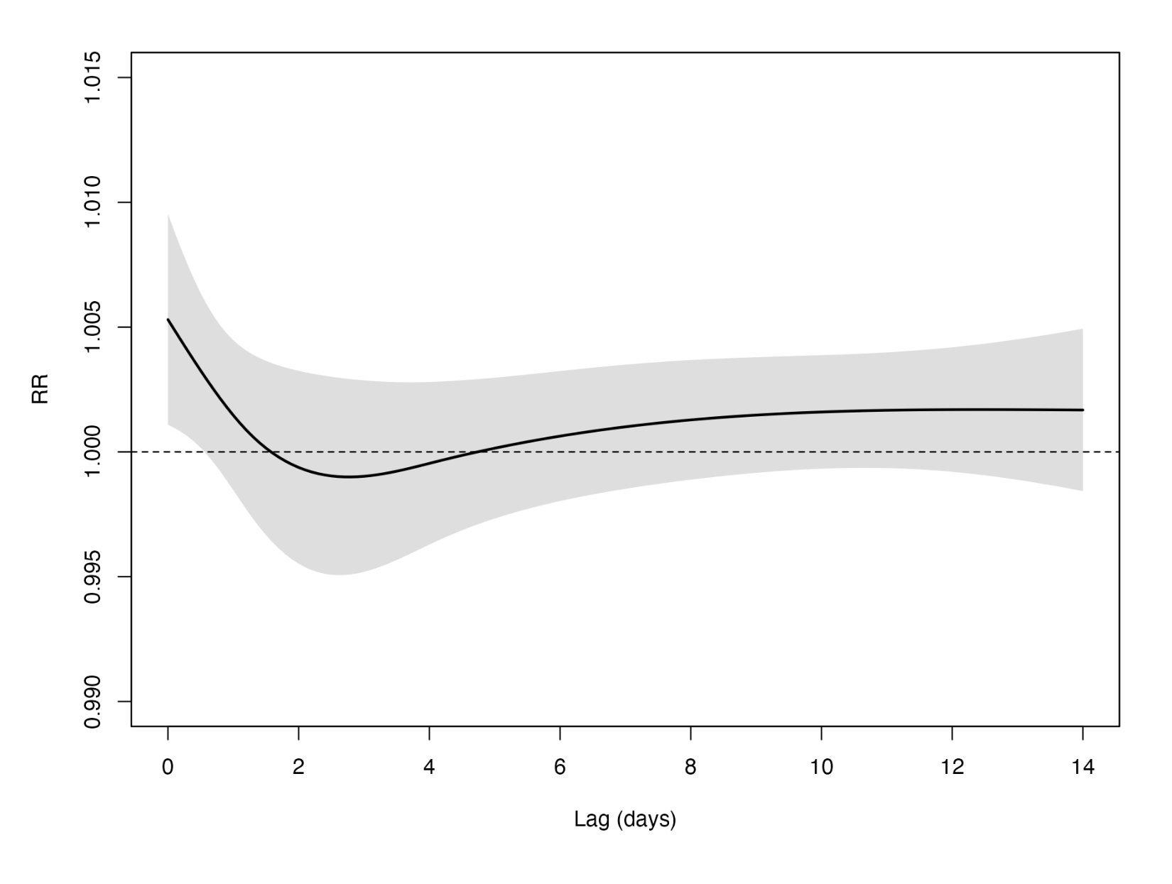
Fig. S1. Overall cumulative lag–response relationships between PM₂.₅ concentration and COVID-19 incidence for lags 0 to 14 days with 95% CIs. Notes: The lag–response association was modeled with a natural cubic spline with an intercept and two internal knots equally spaced in the log scale. Abbreviations: PM₂.₅, fine particulate matter ≤2.5 μm; COVID-19, coronavirus disease 2019; RR, relative risk; CI, confidence interval.

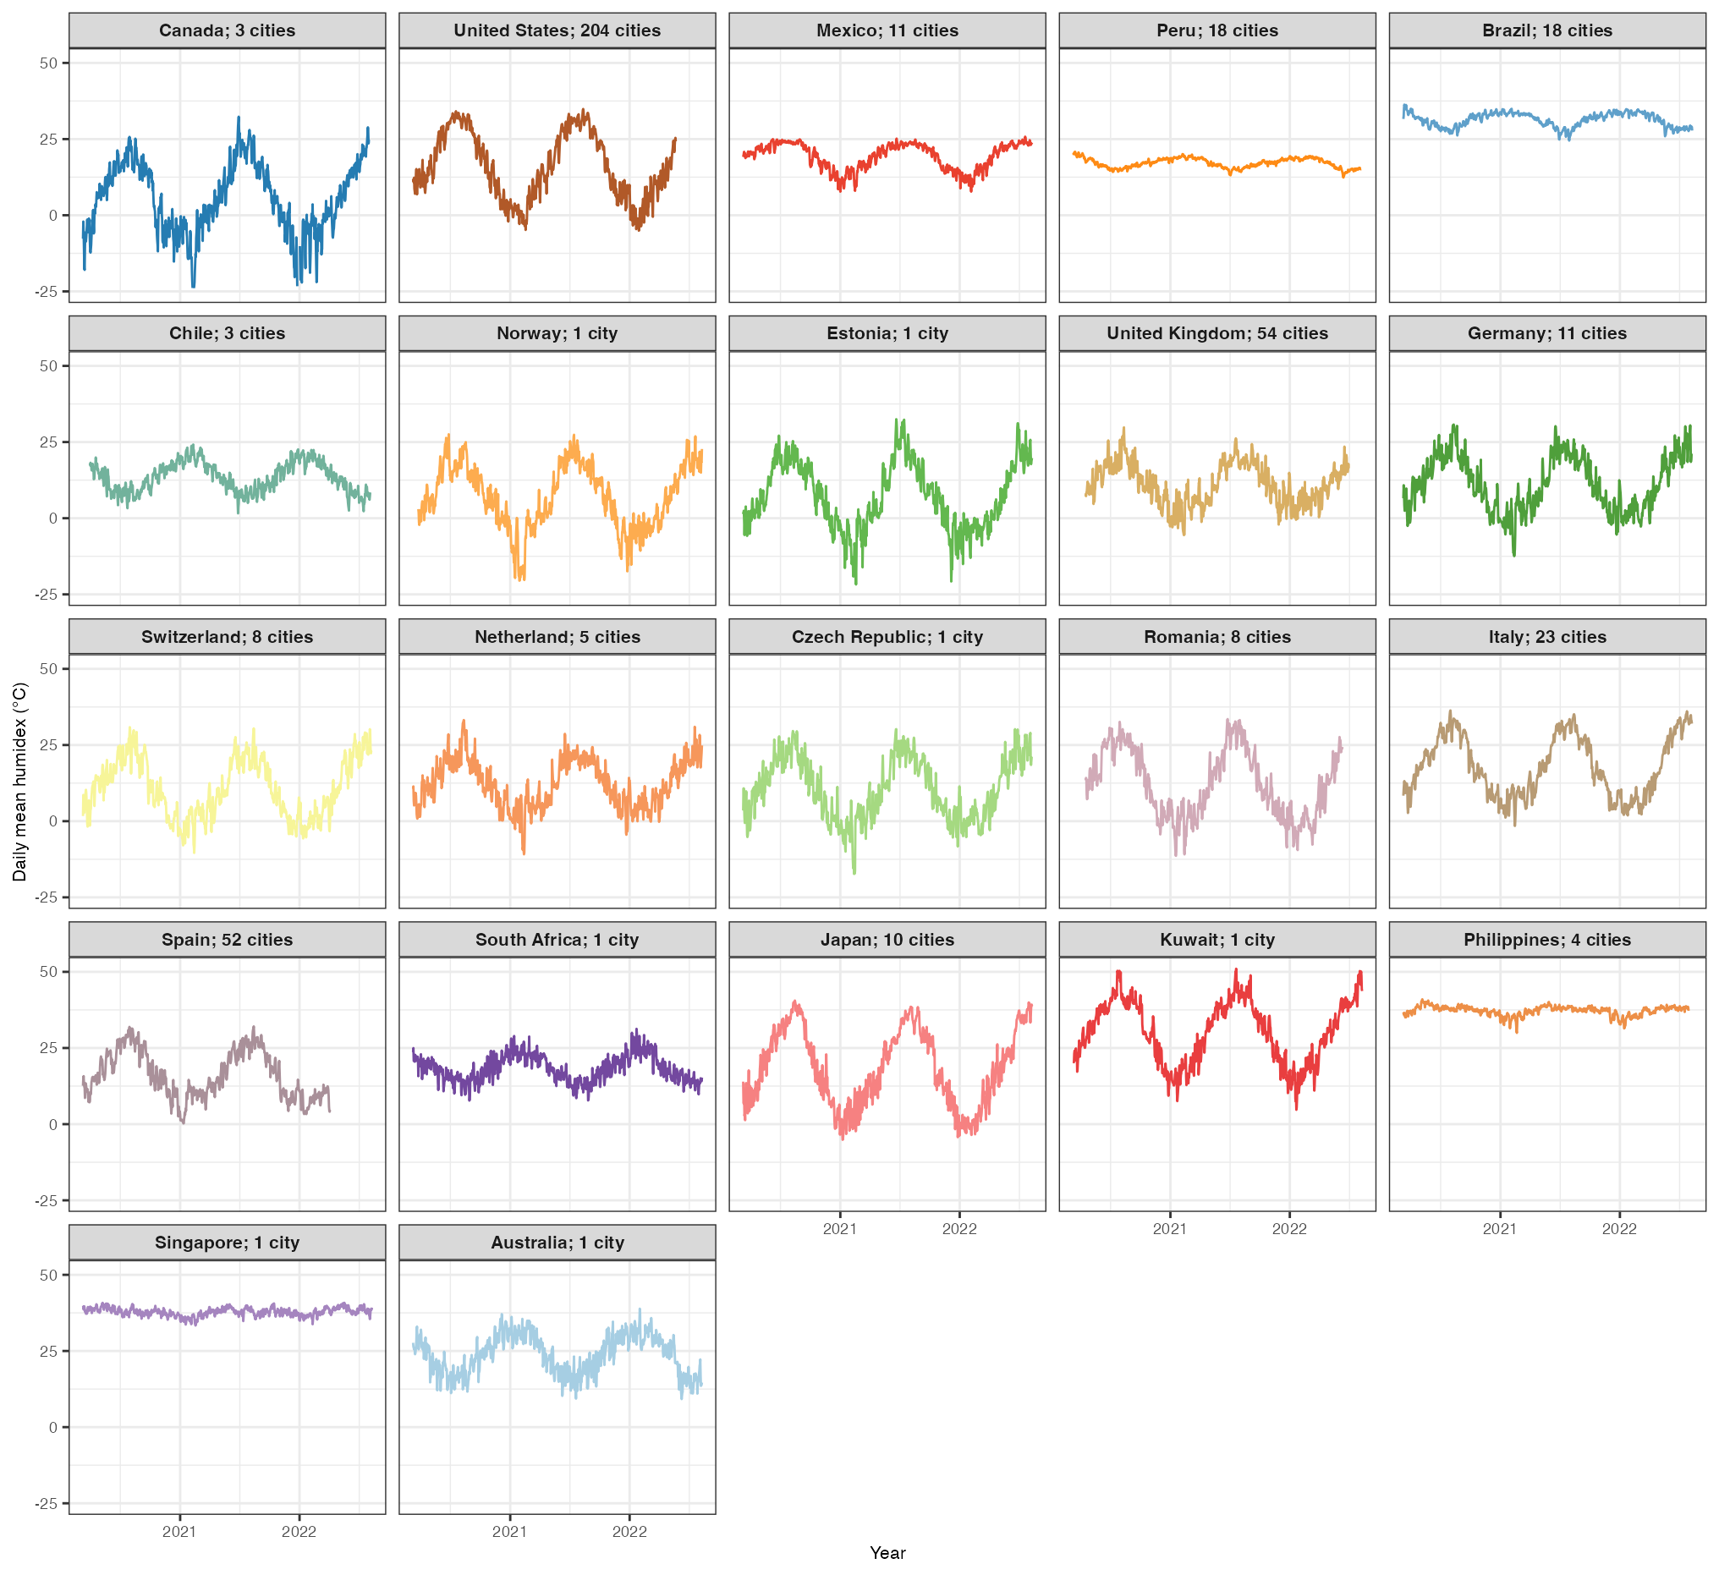
Fig. S2. Daily mean humidex (℃) time-series aggregated by country over the period.

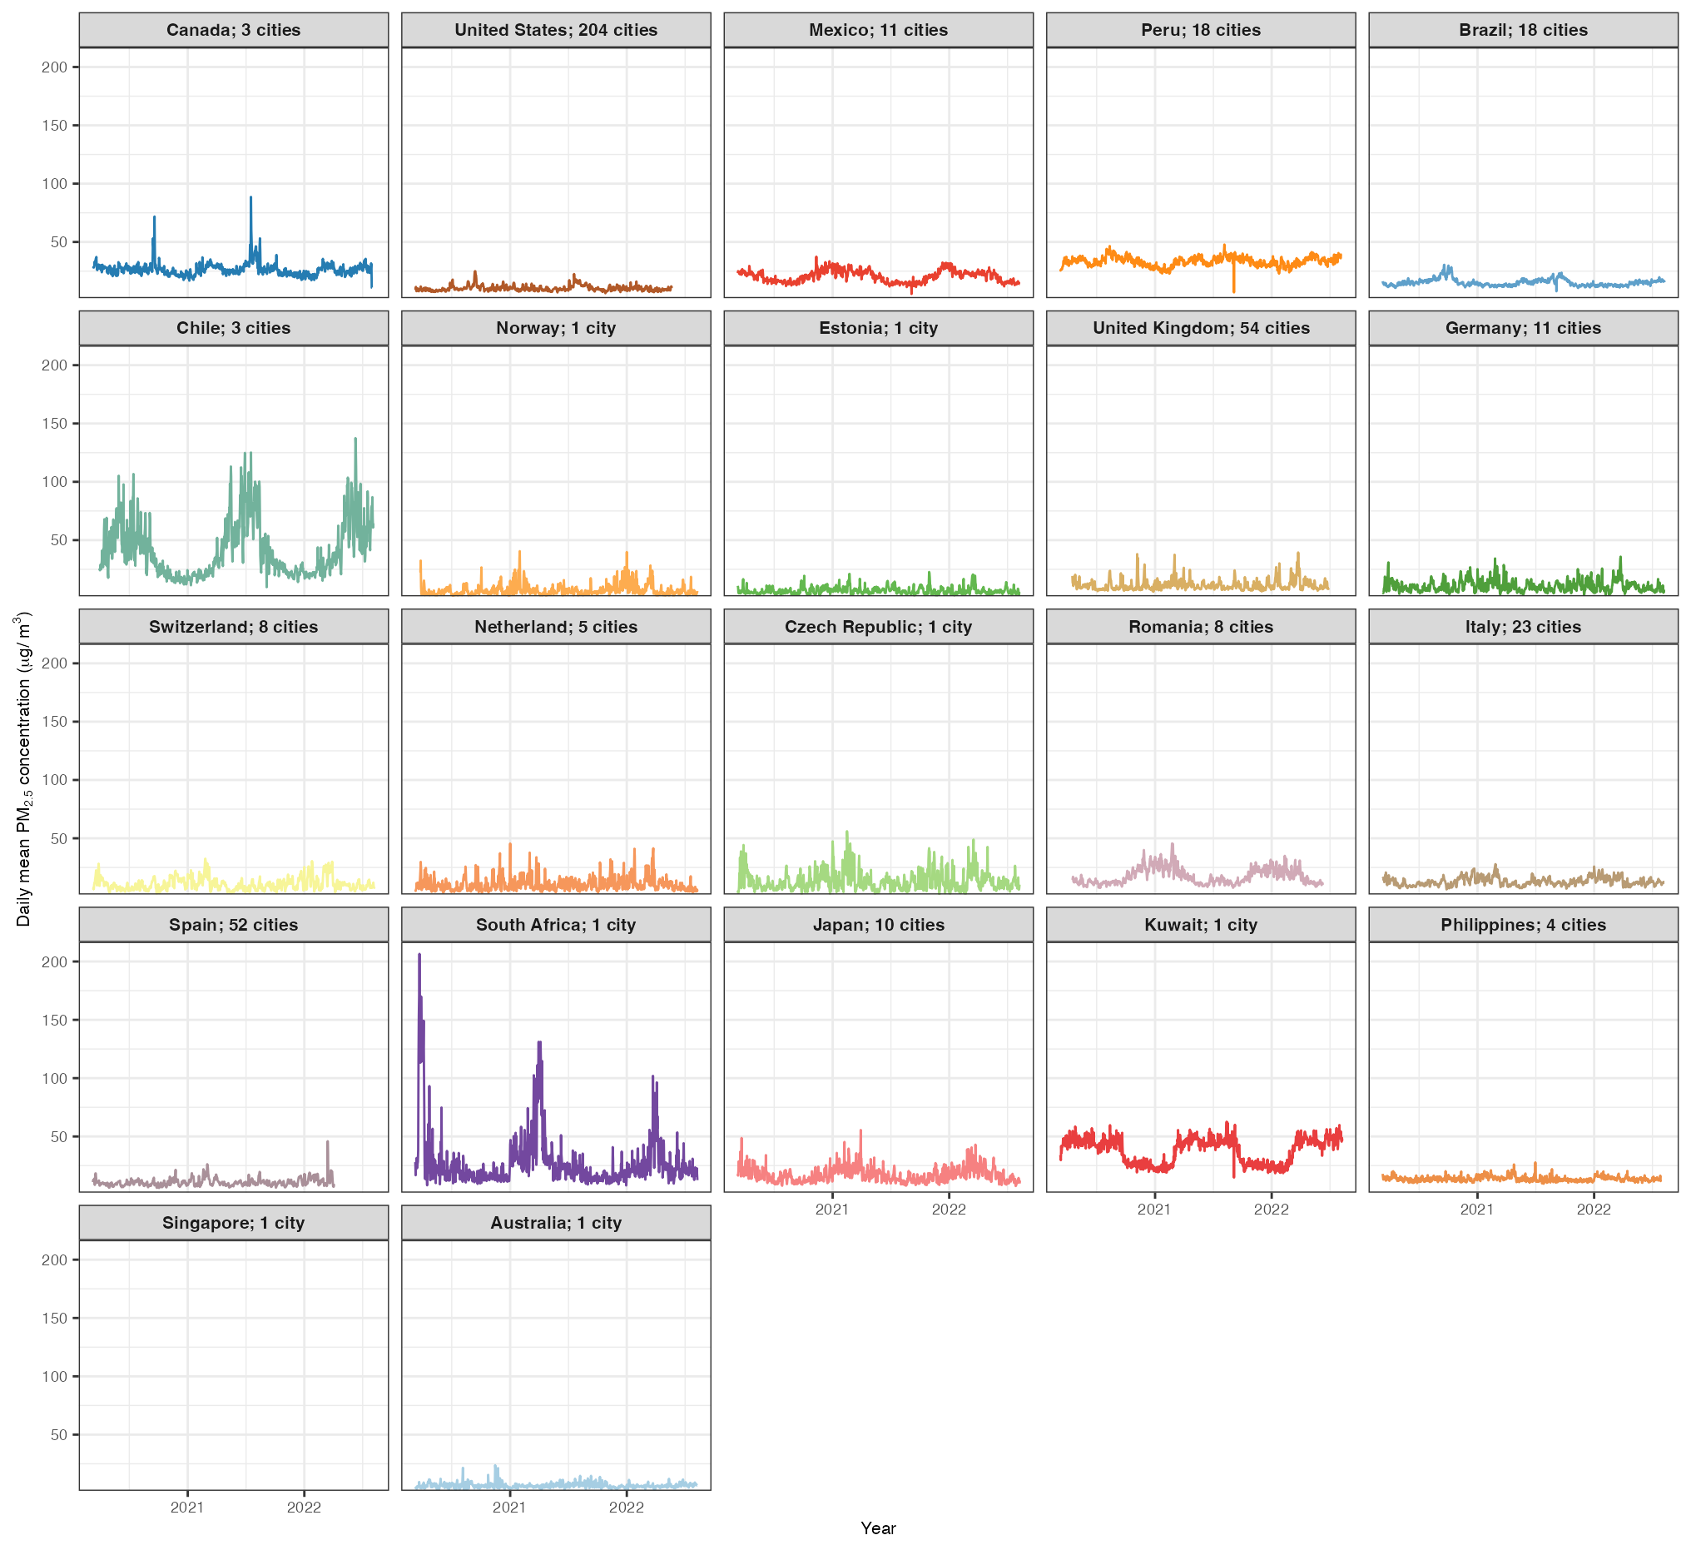
Fig. S3. Daily mean particulate matter with an aerodynamic diameter ≤2.5 µm (PM_{2.5}) concentration (μg/m³) time-series aggregated by country over the period.

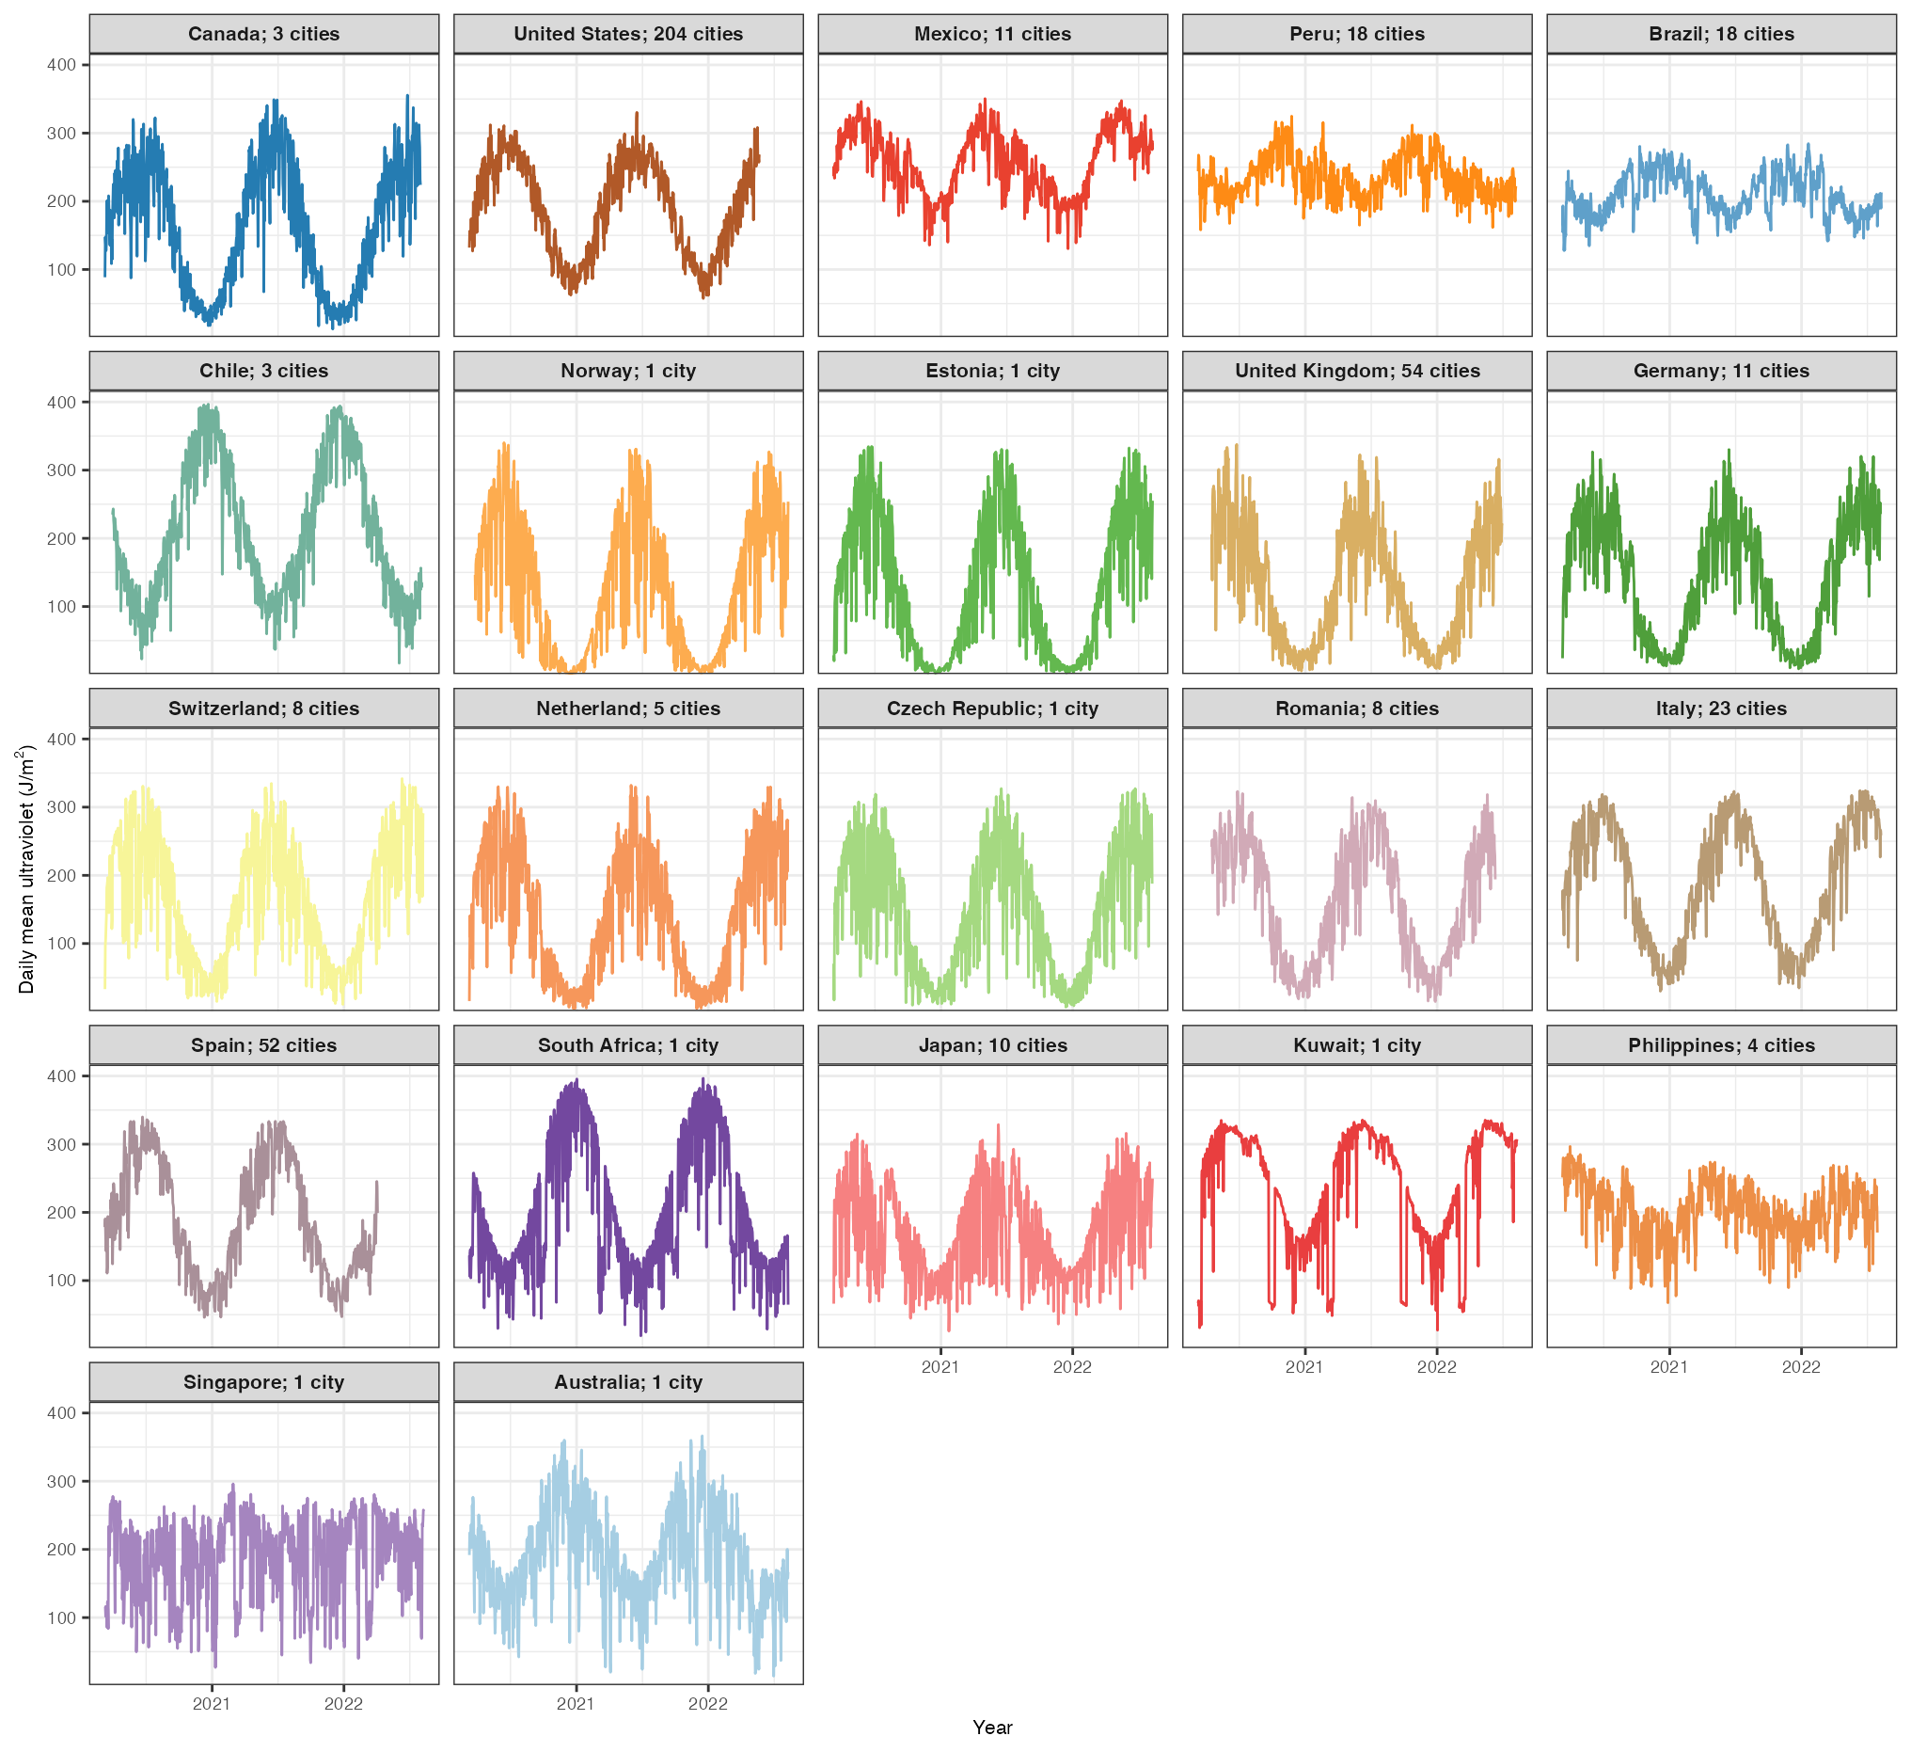
Fig. S4. Daily mean ultraviolet (J/m²) time-series aggregated by country over the period.

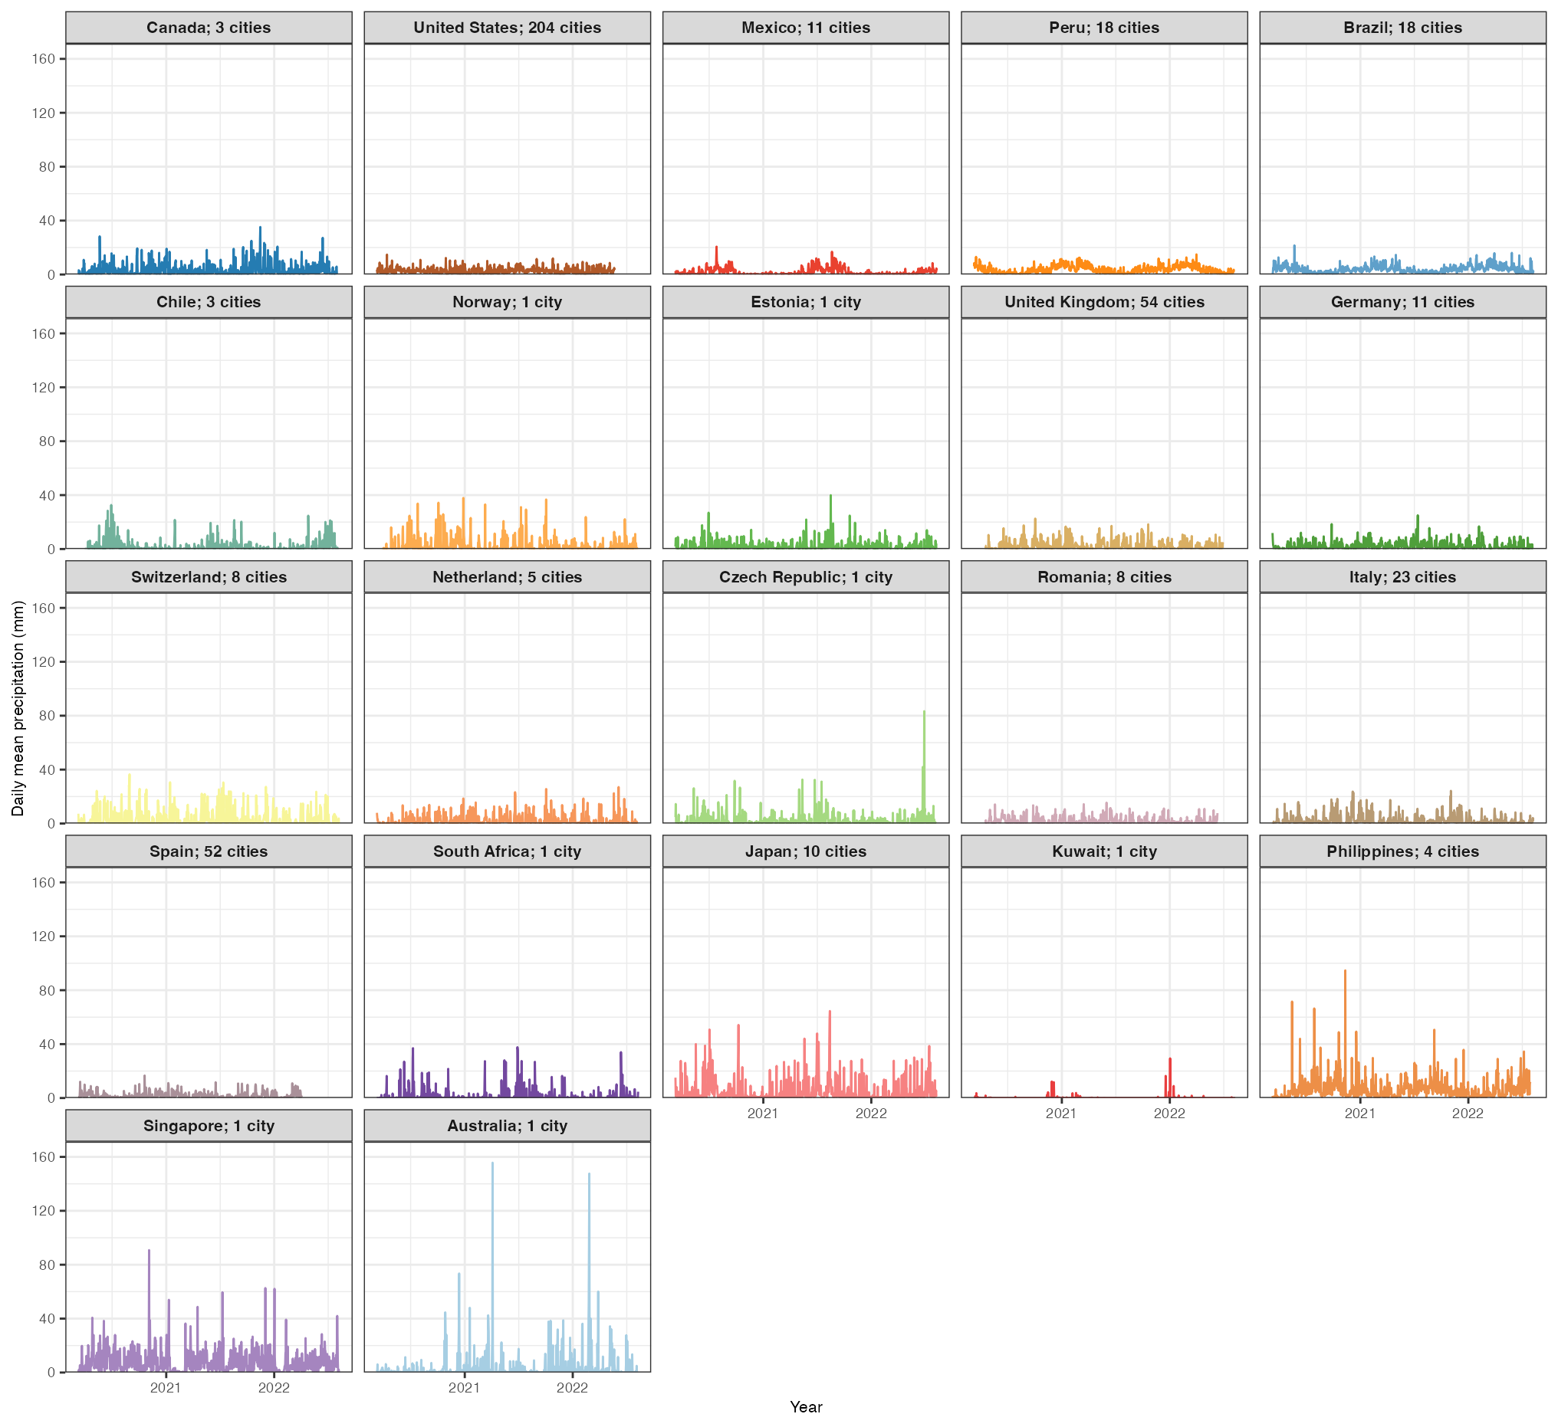
Fig. S5. Daily mean precipitation (mm) time-series aggregated by country over the period.

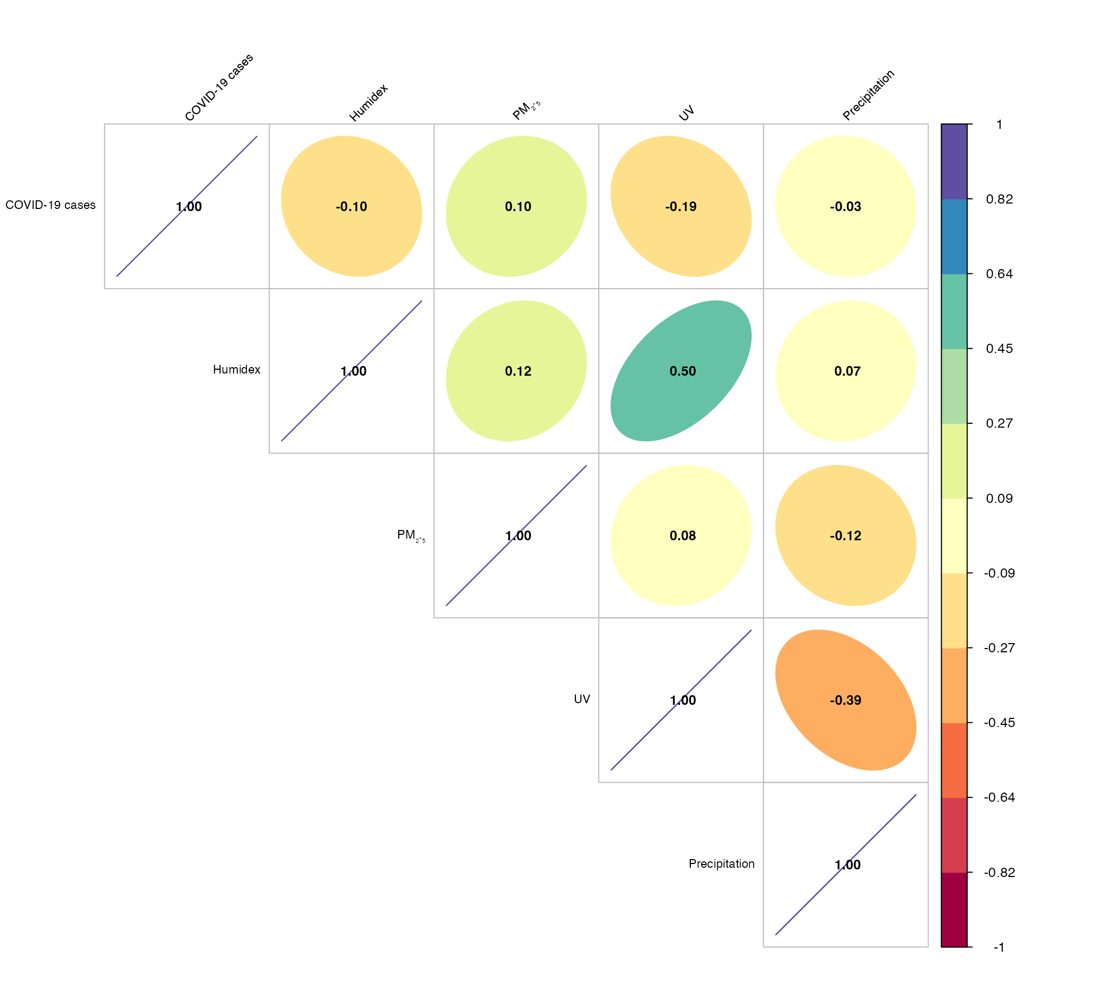
Fig. S6. Correlation matrix between COVID-19 incidence and environmental variables. Notes: Spearman’s rank–order correlation coefficients were used to assess the linear associations between COVID-19 cases, humidex (℃), PM_{2.5} concentration (μg/m³), UV (J/m²), and precipitation (mm). The legend on the right illustrates the strength of the correlation coefficient. Purple indicates stronger positive correlations, and dark red indicates stronger negative correlations. Abbreviations: COVID-19, coronavirus disease 2019; (%); PM₂.₅, fine particulate matter ≤2.5 μm; UV, ultraviolet.

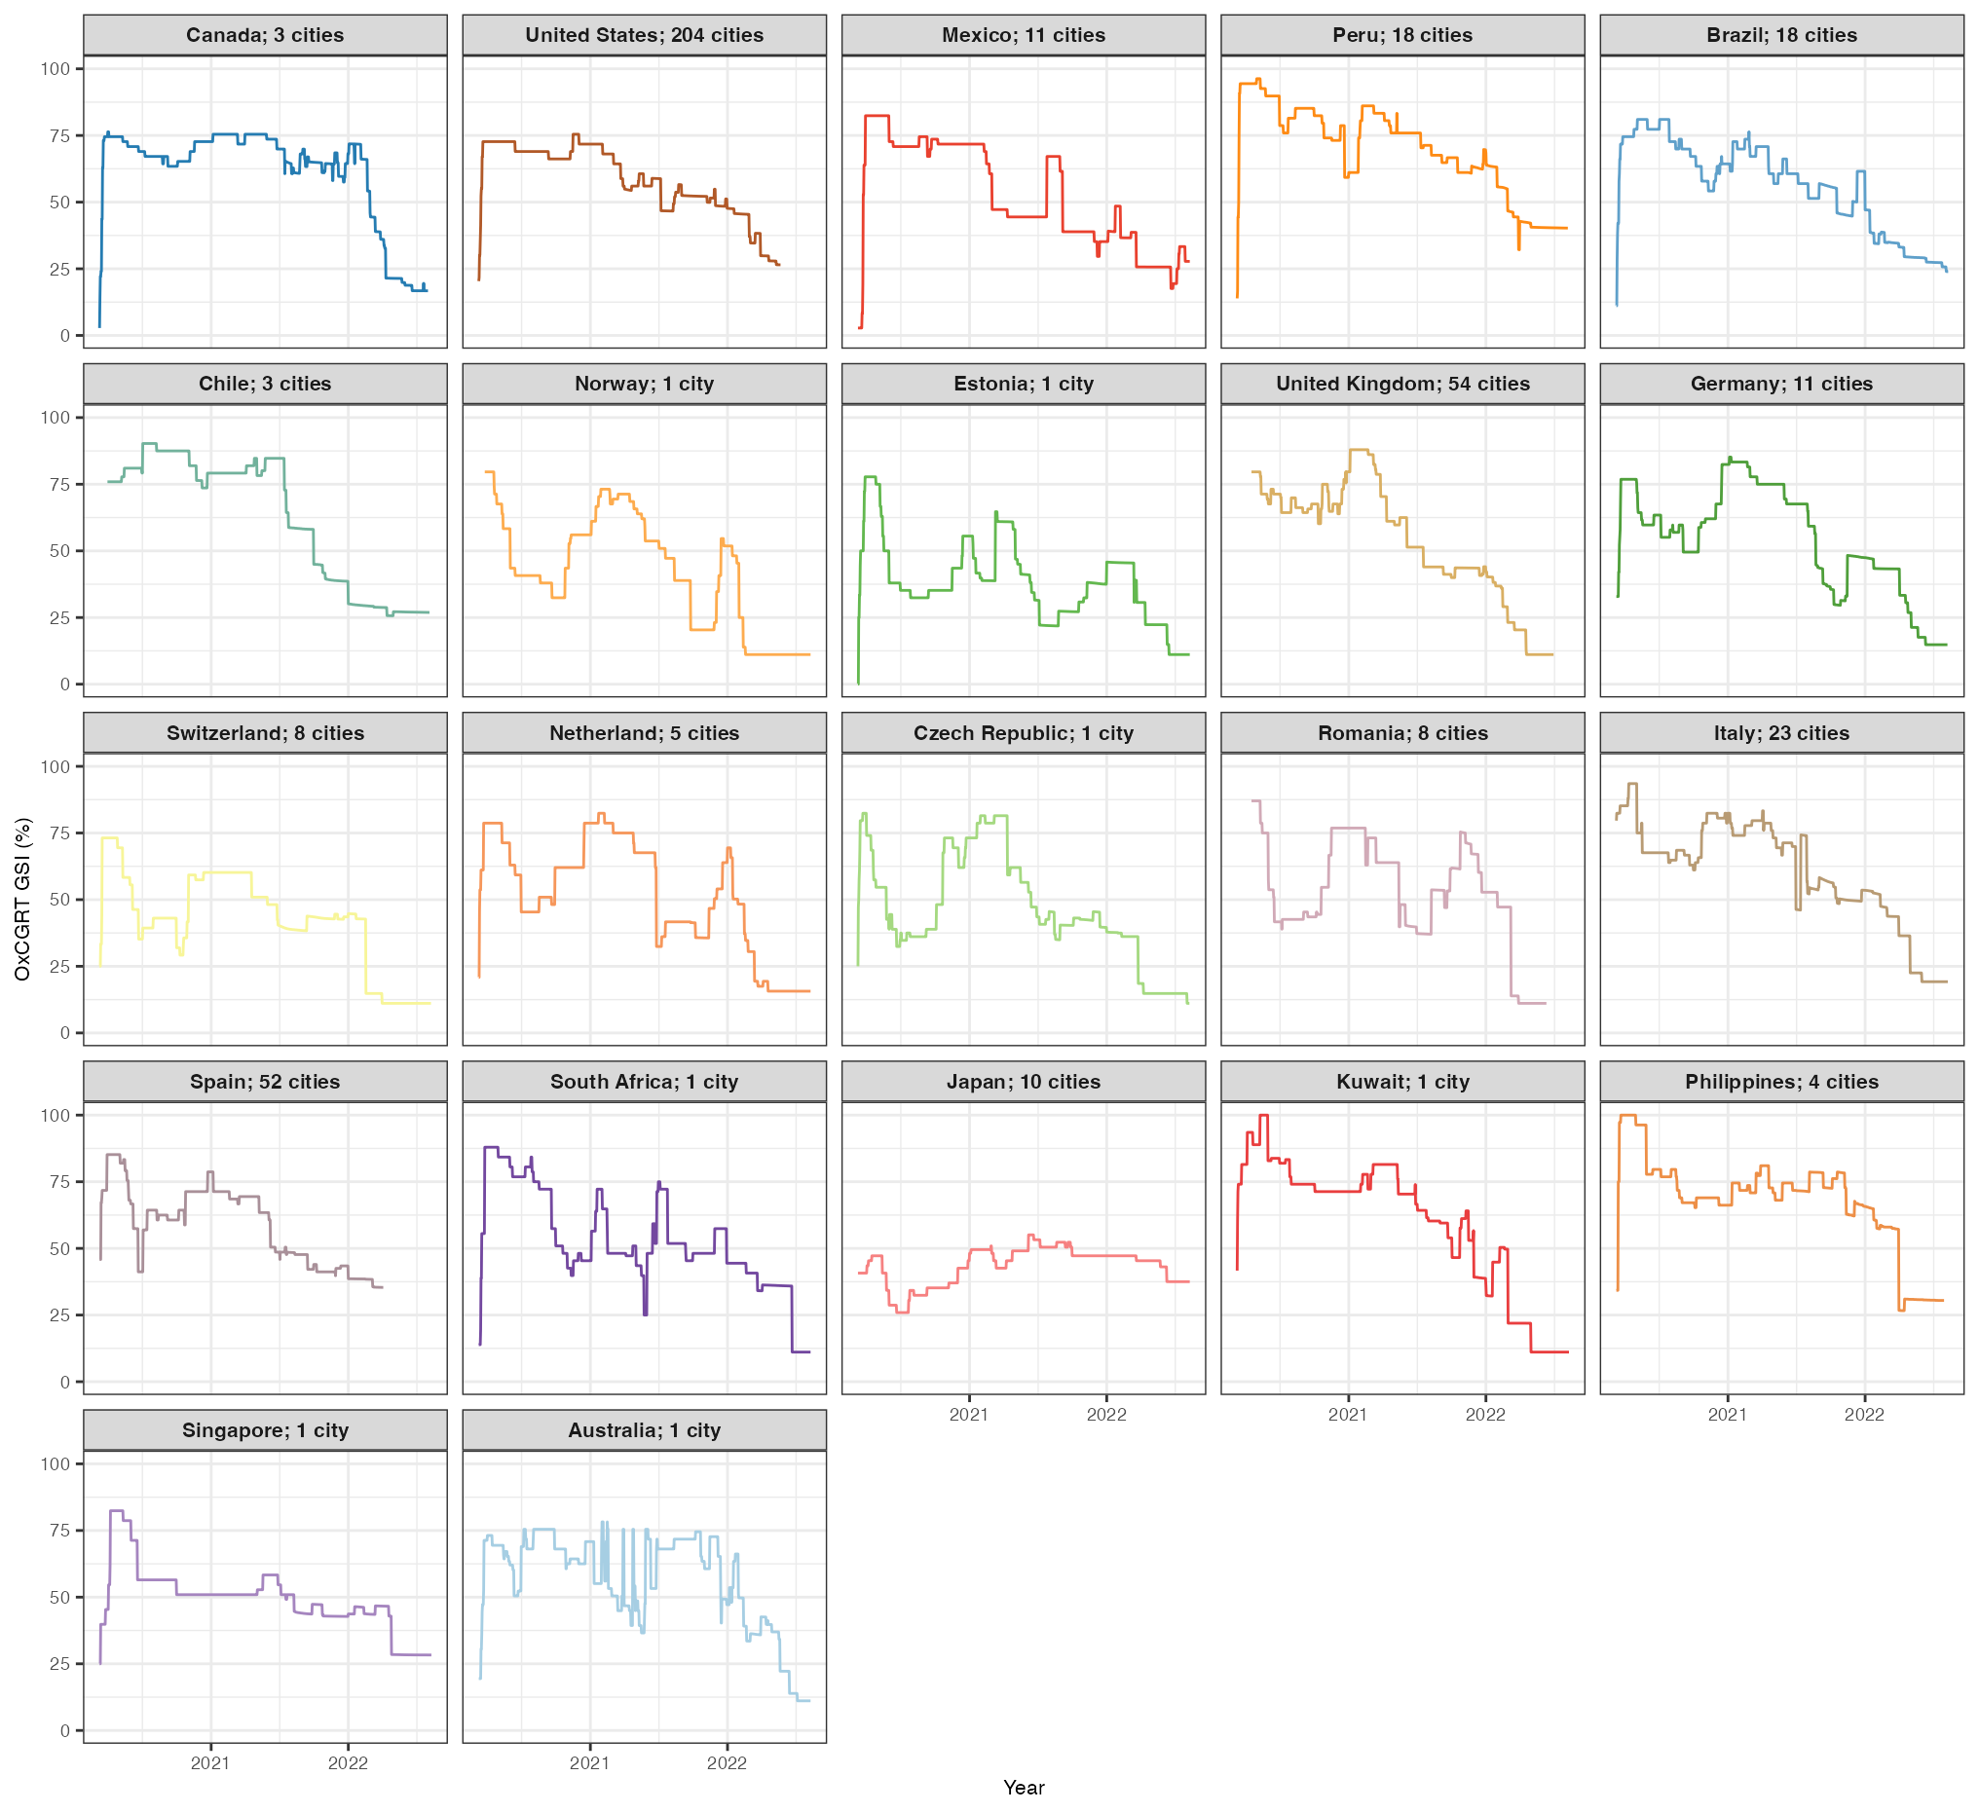
Fig. S7. Daily mean Oxford COVID–19 Government Response Tracker (OXCGRT) Governmental Stringency Index (GSI) (%) time-series aggregated by country over the period.

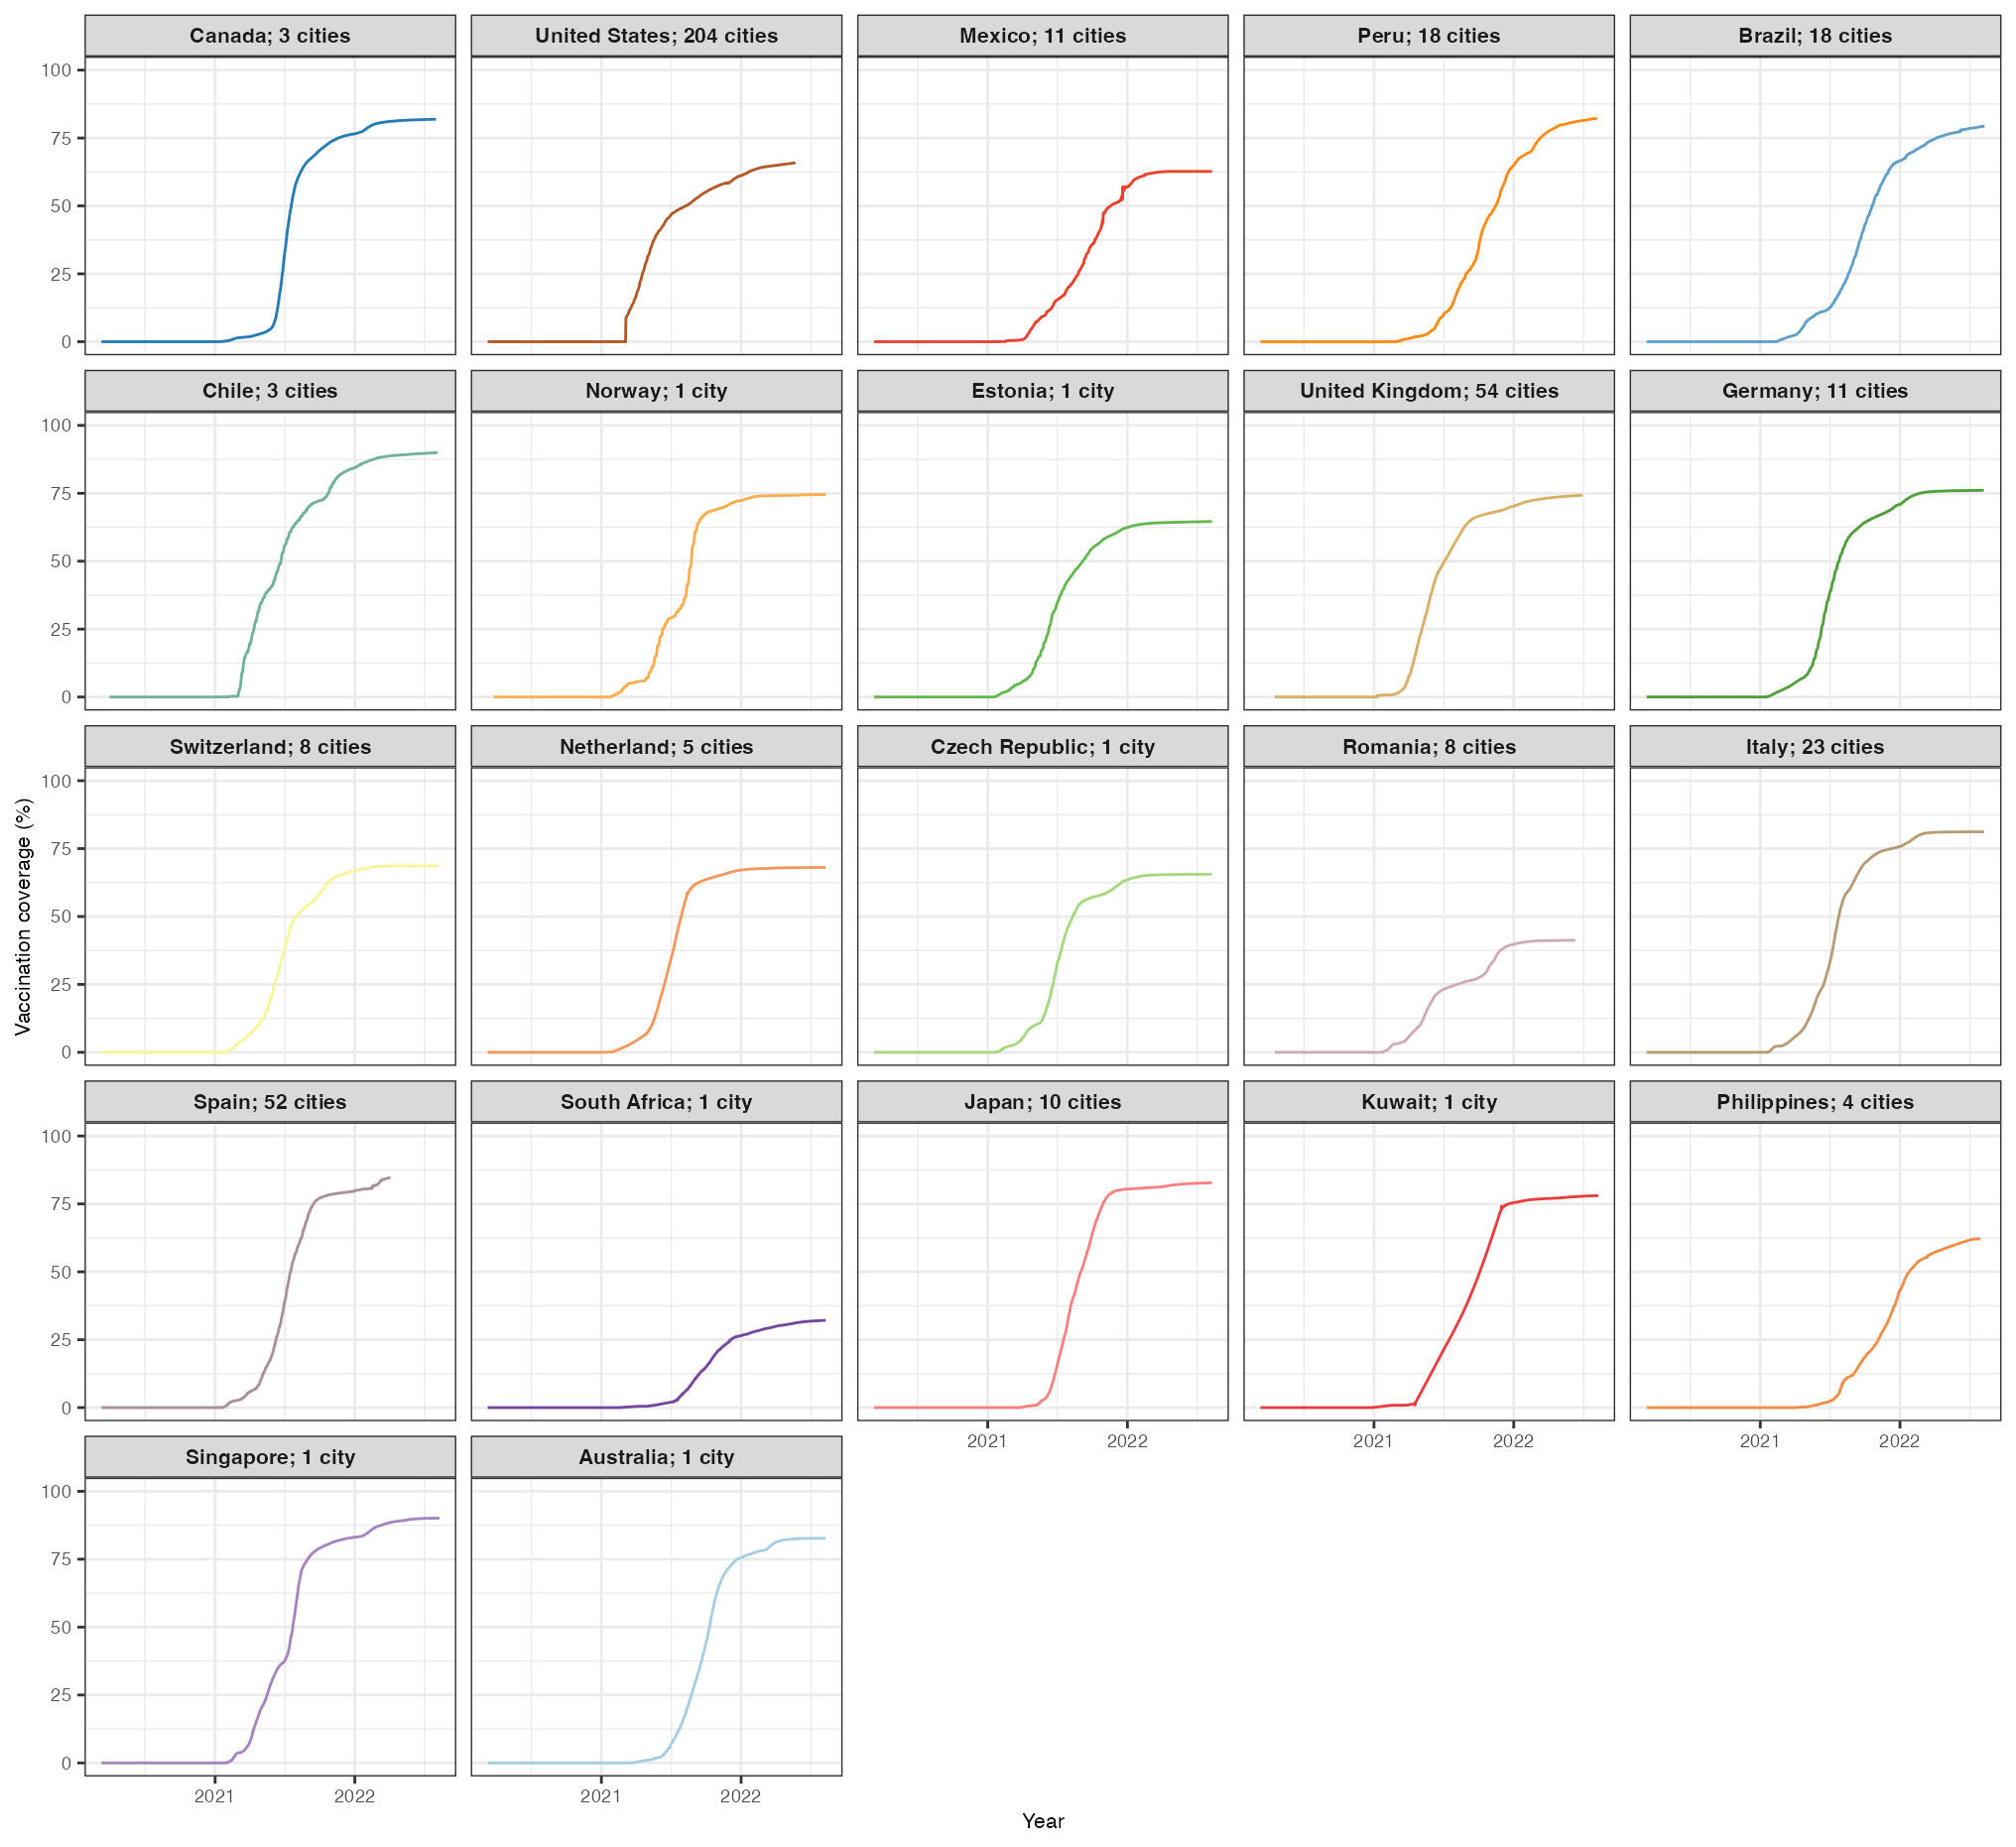
Fig. S8. Daily mean vaccination coverage (%) time-series aggregated by country over the period.

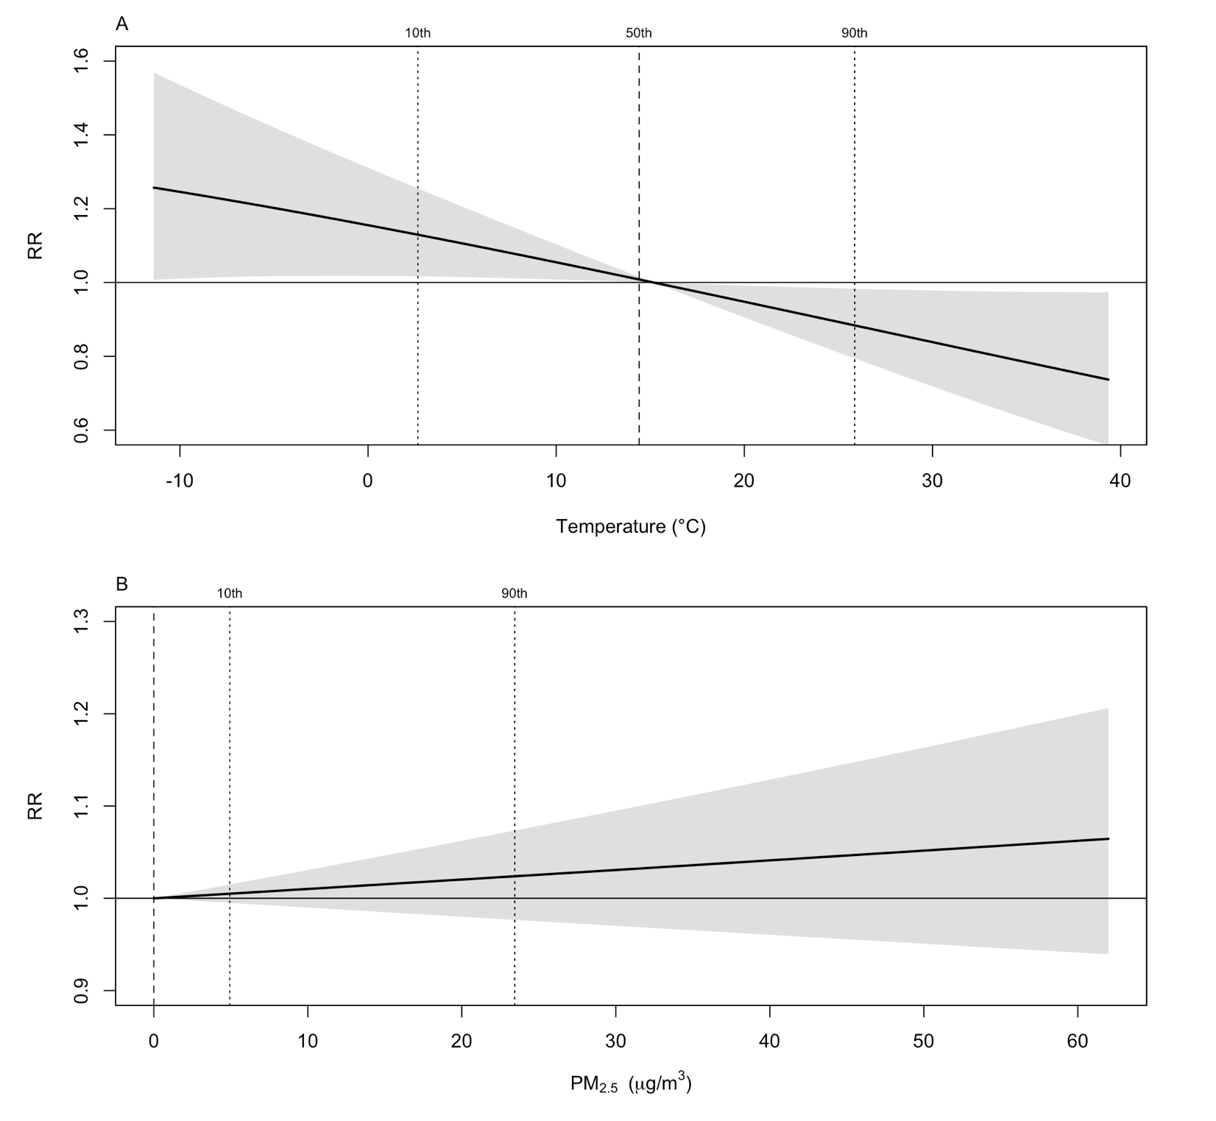
Fig. S9. Sensitivity analysis of the overall cumulative exposure–response relationships between humidex, PM₂.₅ concentration, and COVID-19 incidence when changing the max lag period. Notes: Lag period for humidex was reduced from 14 to 21 days (Panel A), and for PM₂.₅ from 2 to 7 days (Panel B). Abbreviations: PM₂.₅, fine particulate matter ≤2.5 μm; COVID-19, coronavirus disease 2019; RR, relative risk; CI, confidence interval.

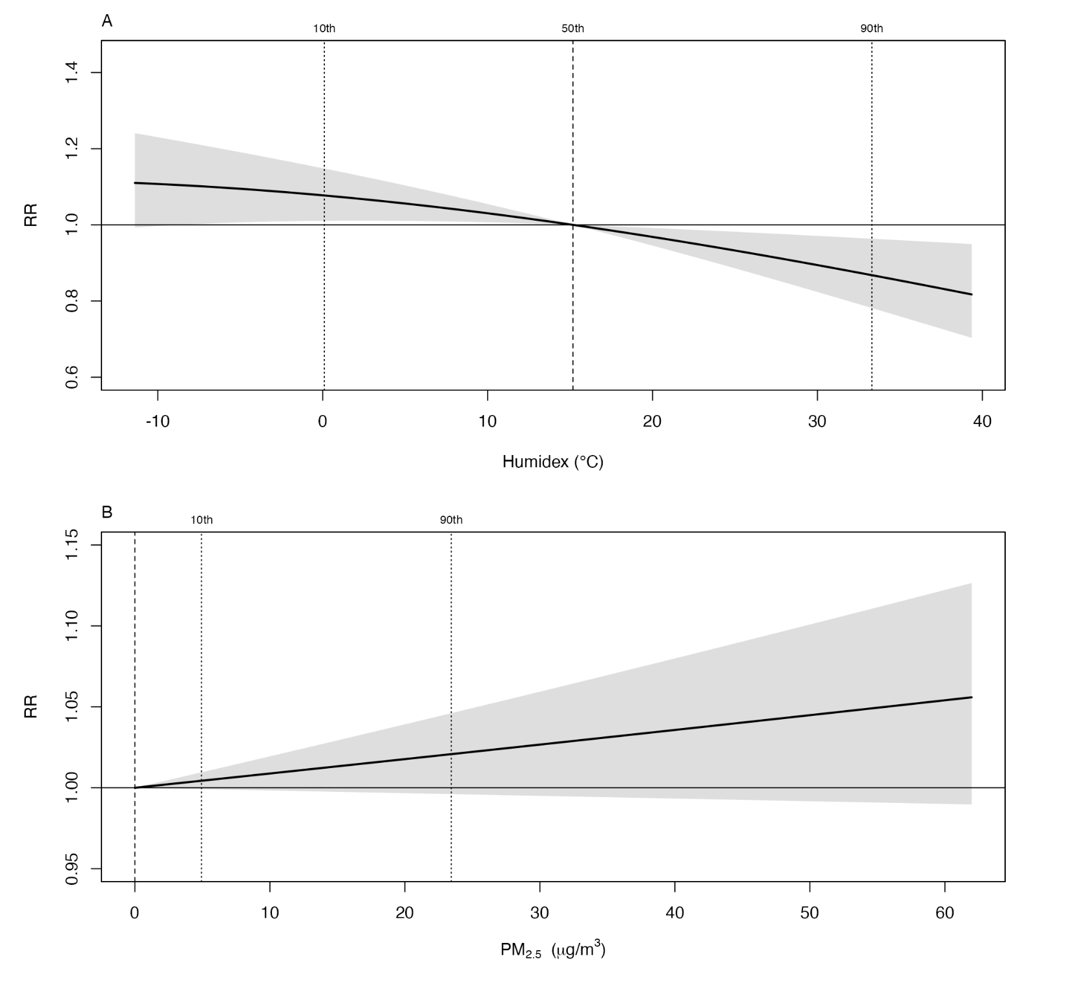
Fig. S10. Sensitivity analysis of the overall cumulative exposure–response relationships between humidex, PM₂.₅ concentration, and COVID-19 incidence when changing the degrees of freedom for time. Notes: Degrees of freedom for the natural cubic spline of calendar time was increased from 10 to 7 per year for humidex (Panel A) and PM_{2.5} concentration (Panel B). Abbreviations: PM₂.₅, fine particulate matter ≤2.5 μm; COVID-19, coronavirus disease 2019; RR, relative risk; CI, confidence interval.

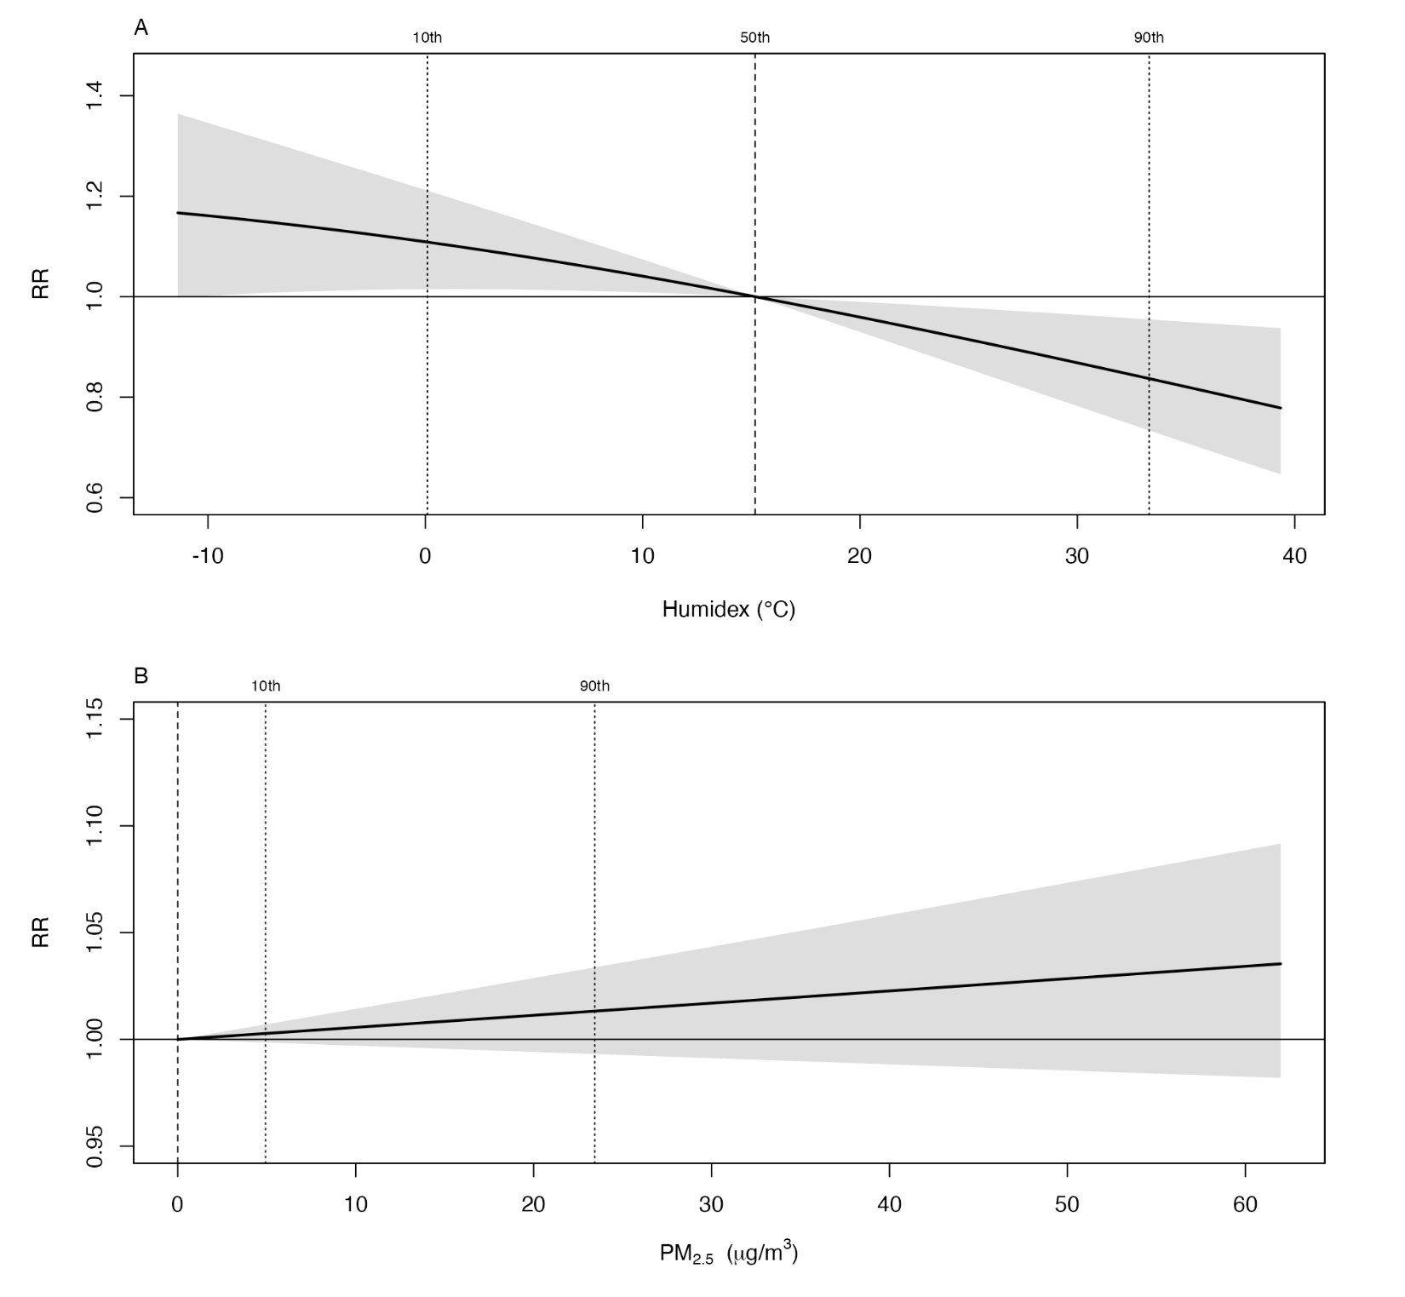
Fig. S11. Sensitivity analysis of the overall cumulative exposure–response relationships between humidex, PM₂.₅ concentration, and COVID-19 incidence when changing the confounder. Notes: Daily mean ultraviolet radiation and precipitation were additionally adjusted for using natural cubic splines with 3 degrees of freedom in the first-stage for humidex (Panel A) and PM_{2.5} concentration (Panel B). Abbreviations: PM₂.₅, fine particulate matter ≤2.5 μm; COVID-19, coronavirus disease 2019; RR, relative risk; CI, confidence interval.

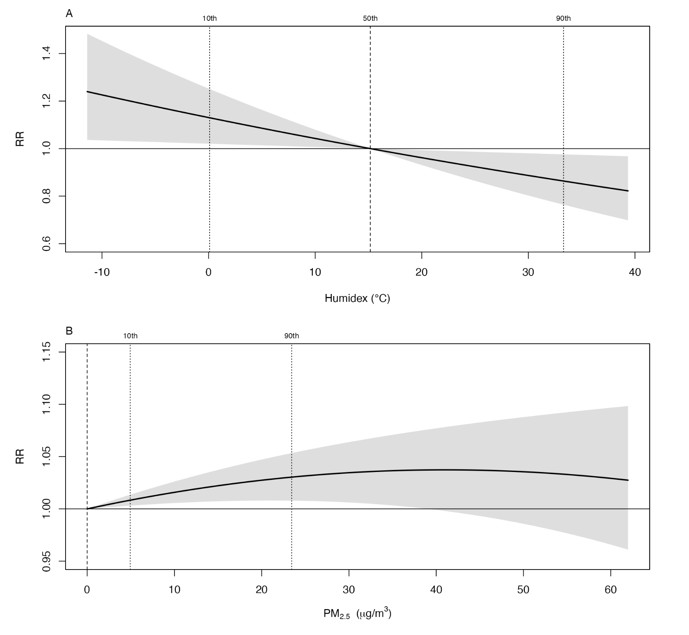
Fig. S12. Sensitivity analysis of the overall cumulative exposure–response relationships between humidex, PM₂.₅ concentration, and COVID-19 incidence when using a different functional form. Notes: In the first-stage analysis, we employed a linear functional form to characterize the exposure–response relationship for humidex (Panel A), whereas a second-degree polynomial function was used for PM₂.₅ concentration (Panel B). Abbreviations: PM₂.₅, fine particulate matter ≤2.5 μm; COVID-19, coronavirus disease 2019; RR, relative risk; CI, confidence interval.
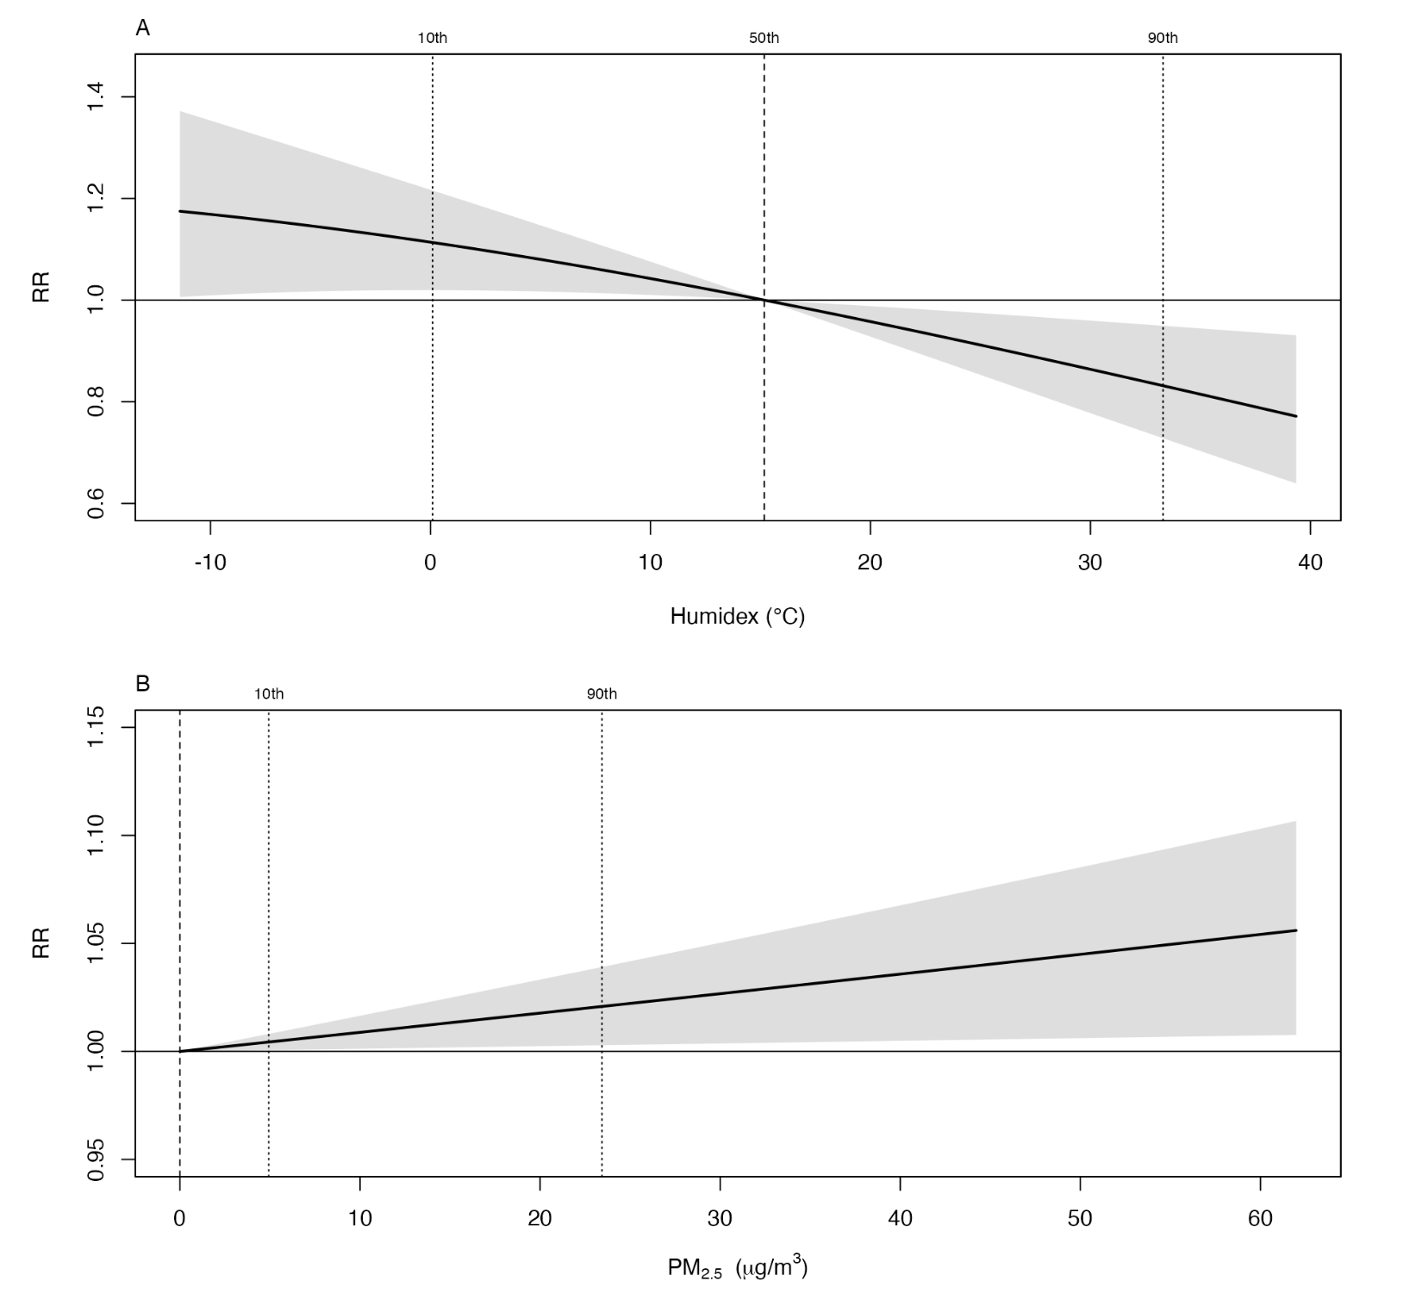Fig. S13. Sensitivity analysis of the overall cumulative exposure–response relationships for humidex and PM₂.₅ when fitted separate models. Notes: In this sensitivity analysis, we fitted separate models for a single exposure, i.e., humidex or PM₂.₅. Panel A shows the cumulative exposure–response curve for humidex, while Panel B displays the corresponding curve for PM₂.₅ concentration. Abbreviations: PM₂.₅, fine particulate matter ≤2.5 μm; COVID-19, coronavirus disease 2019; RR, relative risk; CI, confidence interval.

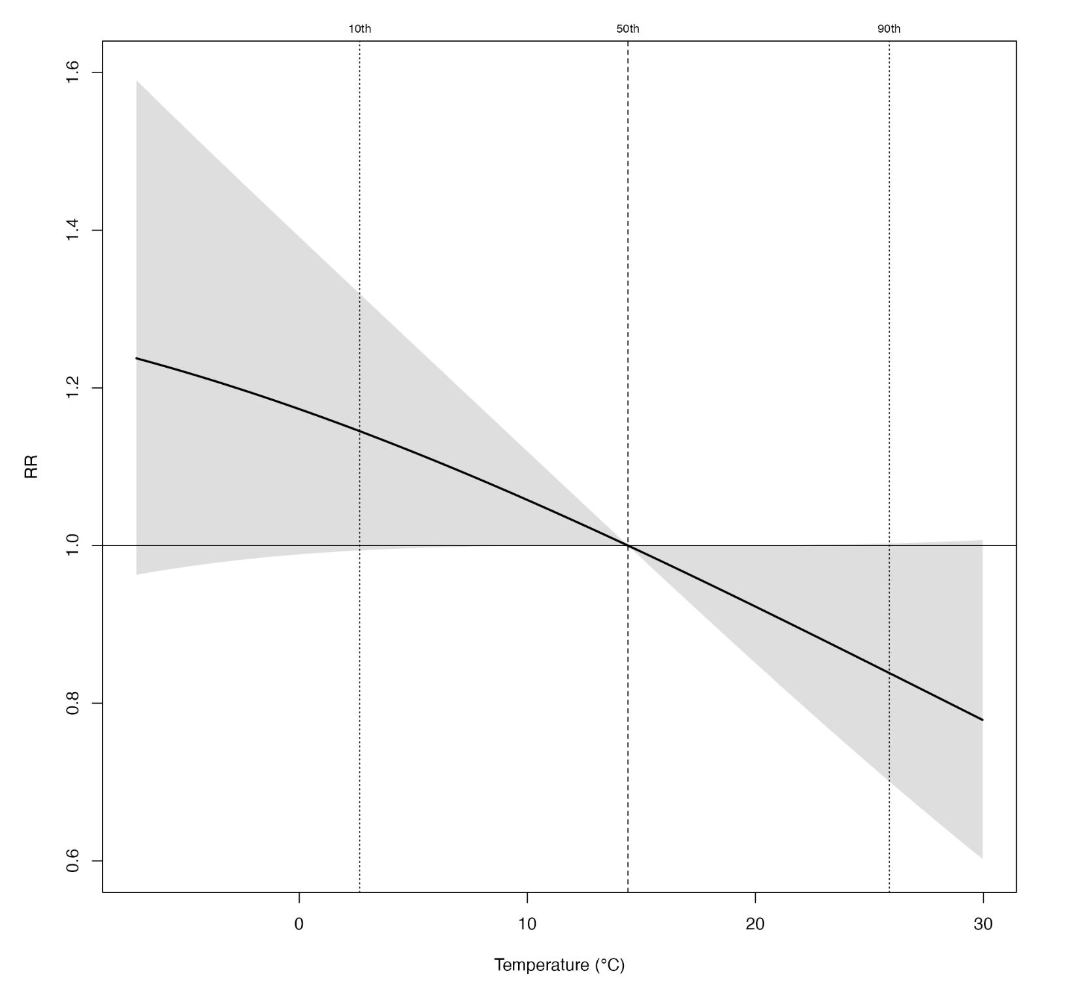
Fig. S14. Sensitivity analysis of the overall cumulative exposure–response relationships between ambient temperature and COVID-19 incidence. Notes: In this sensitivity analysis, we assessed the overall cumulative exposure–response curve for ambient temperature on COVID-19 incidence. Abbreviations: COVID-19, coronavirus disease 2019; RR, relative risk; CI, confidence interval.

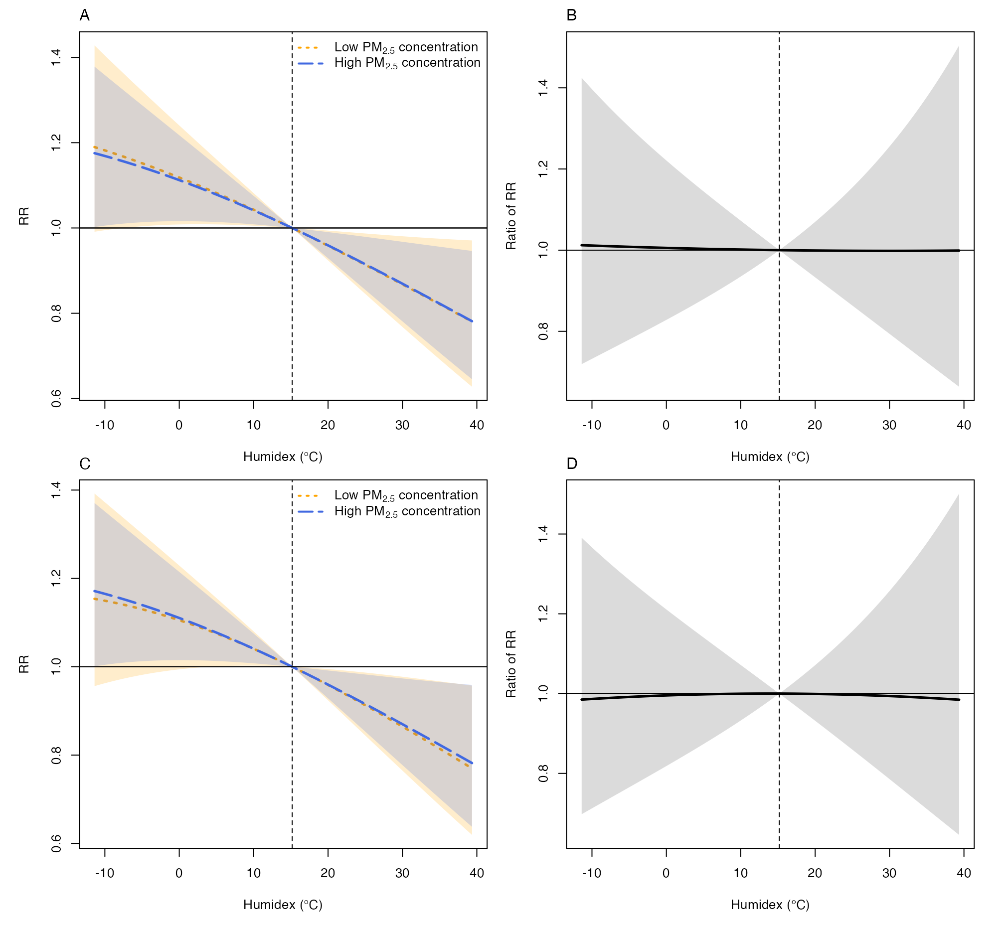
Fig. S15. Sensitivity analysis of the overall cumulative exposure–response relationship between humidex and COVID-19 incidence, stratified by PM₂.₅ concentrations at the moving average over lag days 0–1 and 0–3. Notes: Panel A presents the overall cumulative RRs for the association between humidex and COVID-19 incidence at low (10th percentile; solid light-orange lines) and high (90th percentile; dashed light-purple lines) levels of PM₂.₅ concentration on the lag days 0–1, with 95% CIs shown as shaded areas. Panel B shows the corresponding ratio of RRs comparing the humidex–COVID-19 associations at the 10th versus 90th percentiles of PM₂.₅ on the lag days 0–1. Panel C displays the overall cumulative RRs based on PM₂.₅ concentrations averaged over lag days 0–3. Panel D illustrates the corresponding ratio of RRs based on the 0–3 day moving average exposure. Abbreviations: PM₂.₅, fine particulate matter ≤2.5 μm; COVID-19, coronavirus disease 2019; RR, relative risk; CI, confidence interval.

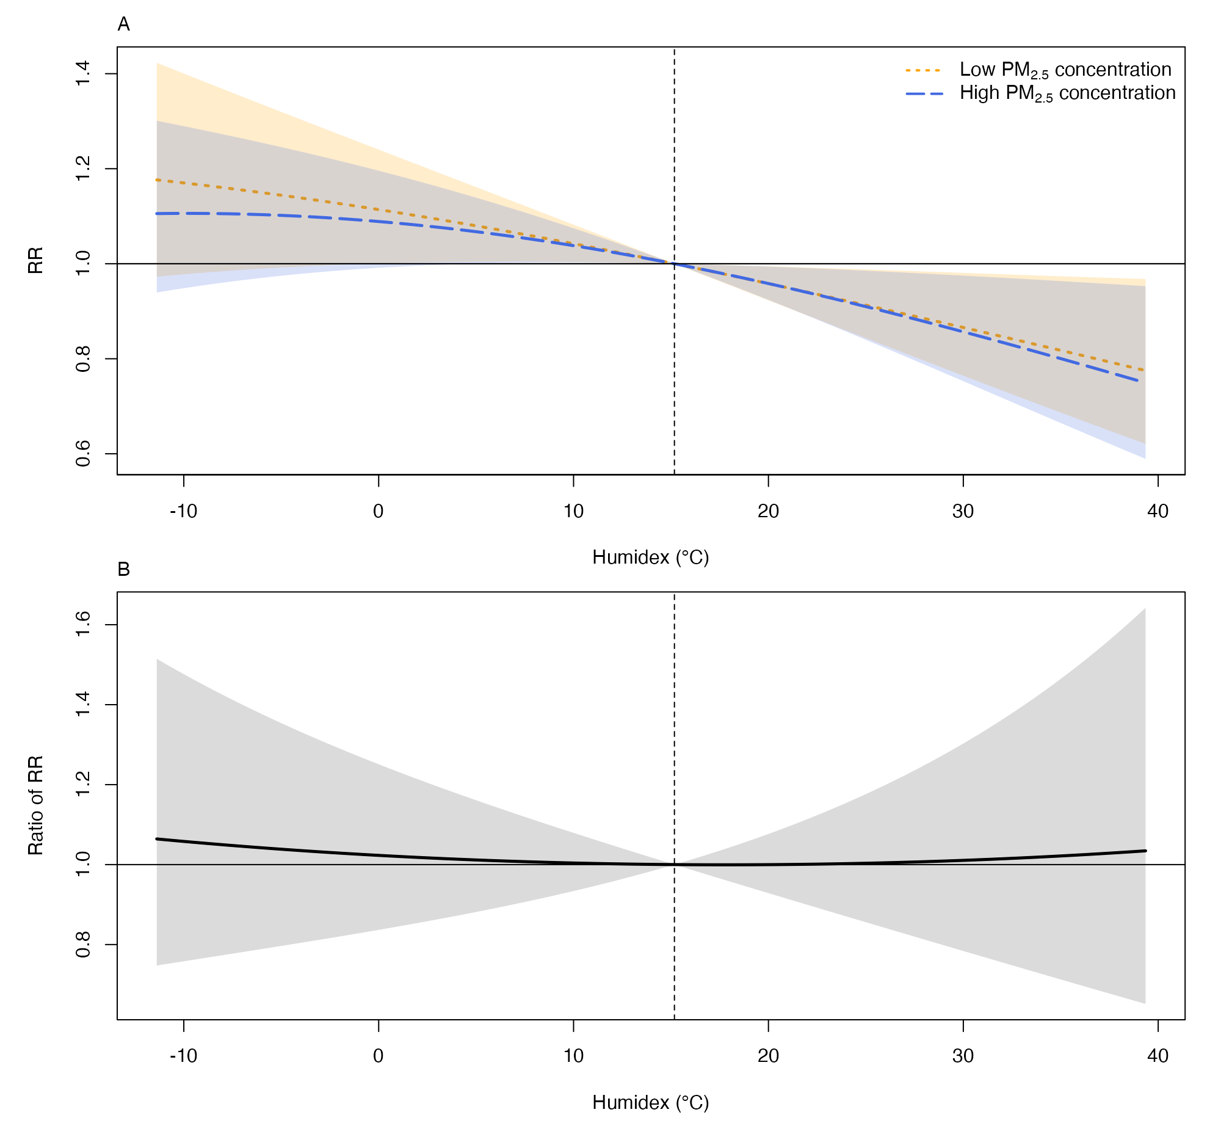
Fig. S16. Sensitivity analysis of the overall cumulative exposure–response relationship between humidex and COVID-19 incidence, using the 1st and 99th percentiles of PM₂.₅ concentrations to define low and high exposure levels. Notes: Panel A illustrates the overall cumulative RRs for the association between humidex and COVID-19 incidence at low (1st percentile; solid light-orange line) and high (99th percentile; dashed light-purple line) PM₂.₅ concentrations, with exposure averaged over lag days 0–2. Shaded areas represent 95% CIs. Panel B presents the corresponding ratio of RRs comparing the humidex–COVID-19 associations at the 1st and 99th percentiles of PM₂.₅, also based on exposure over lag days 0–2, with 95% CIs indicated by shaded regions. Abbreviations: PM₂.₅, fine particulate matter ≤2.5 μm; COVID-19, coronavirus disease 2019; RR, relative risk; CI, confidence interval.
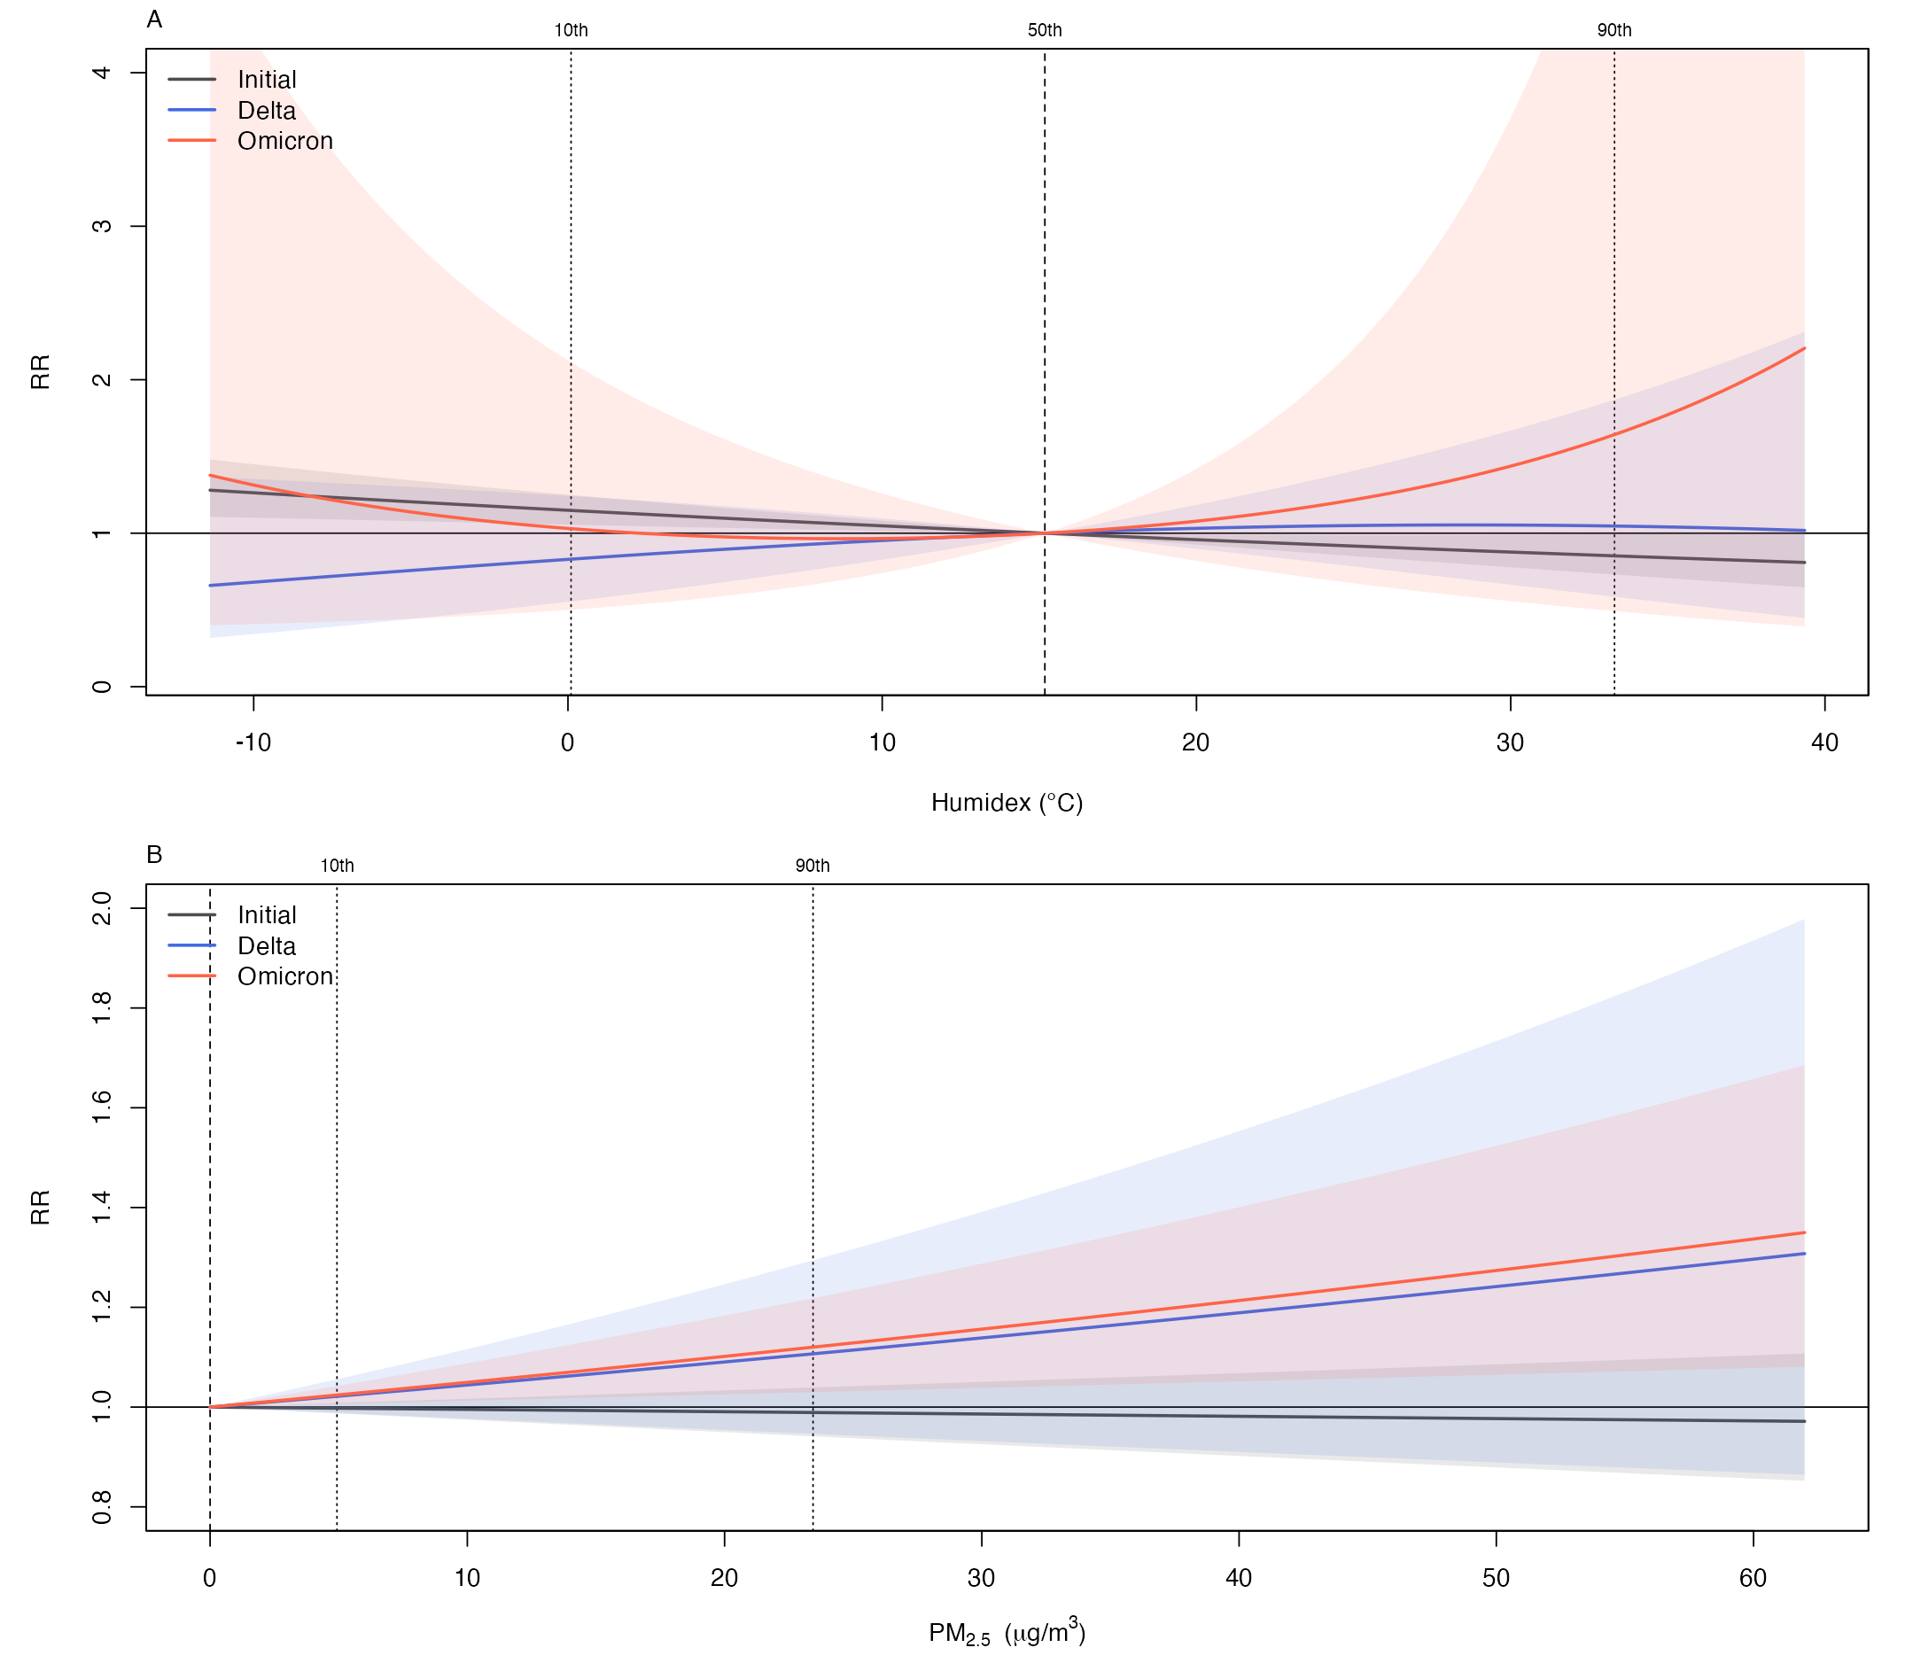
Fig. S17. Overall cumulative exposure–response relationships between humidex and PM₂.₅ concentration and COVID-19 incidence by dominant SARS-CoV-2 variant, with 95% CIs. Notes: Panel A illustrates the RRs for the overall cumulative association between humidex and COVID-19 incidence, stratified by periods dominated by the Initial, Delta, and Omicron variants; shaded areas indicate 95% CIs. Panel B presents the corresponding overall cumulative exposure–response relationship between PM₂.₅ concentration and COVID-19 incidence by dominant variant period, with 95% CIs likewise shown as shaded regions. Curves are centred at the median humidex and at 0 µg/m³ of the PM₂.₅ distribution, respectively. Abbreviations: PM₂.₅, fine particulate matter ≤2.5 µm; COVID-19, coronavirus disease 2019; RR, relative risk; CI, confidence interval.

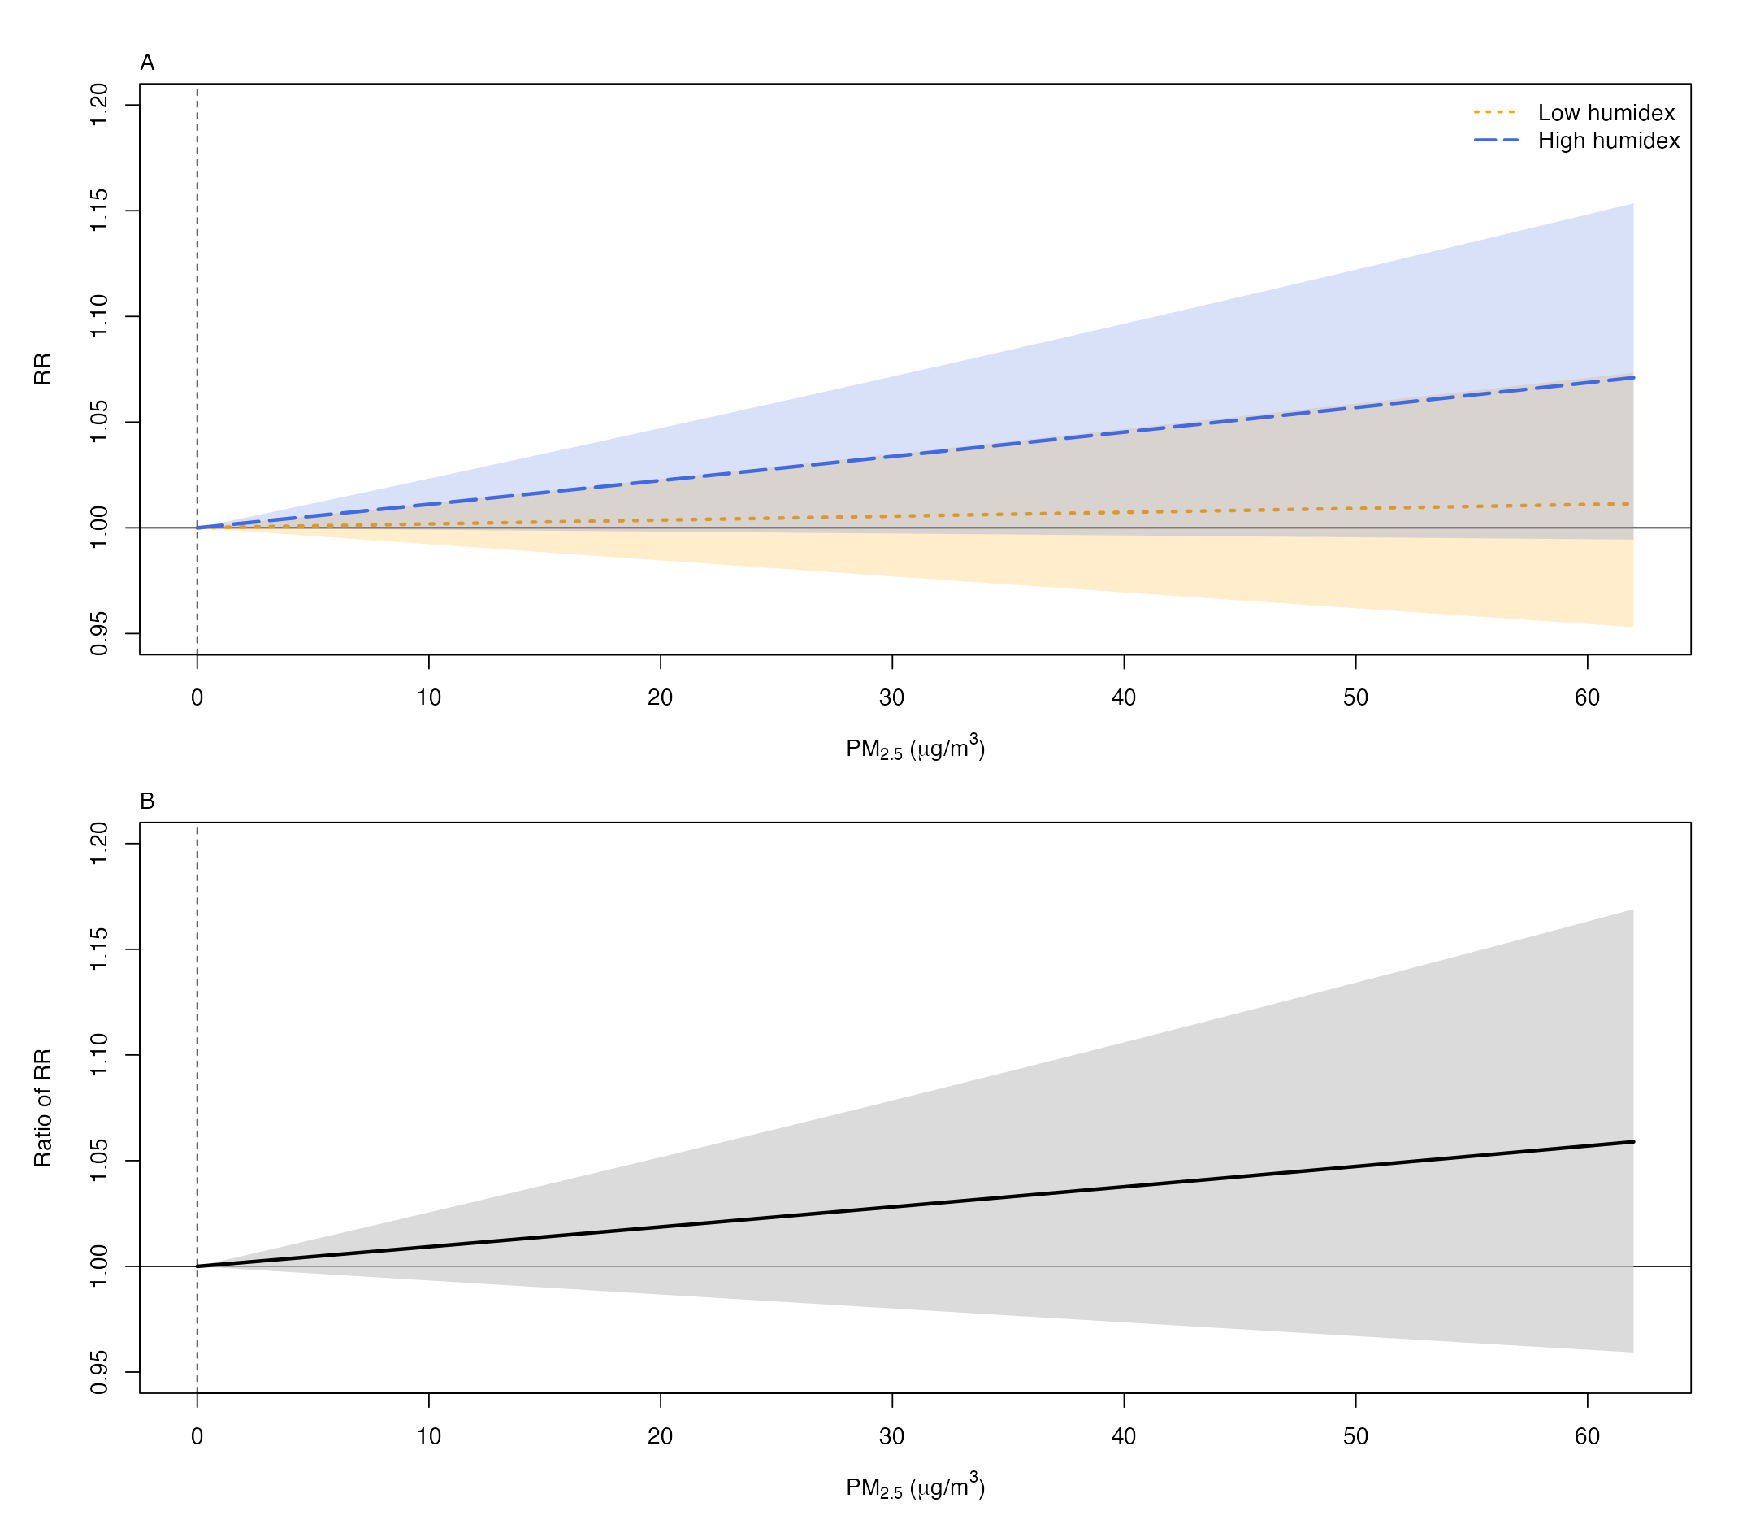
Fig. S18. Overall cumulative exposure–response relationships between PM₂.₅ concentration and COVID-19 incidence by humidex with 95% CIs. Notes: Panel A illustrates the RRs for the overall cumulative exposure–response relationship between PM₂.₅ concentration and COVID-19 incidence, estimated at low (10th percentile; solid light-orange lines) and high (90th percentile; dashed light-purple lines) humidex, with 95 % CIs depicted by shaded areas. Panel B presents the interaction between humidex and the overall cumulative PM₂.₅ concentration–COVID-19 association, expressed as the ratio of RRs at the 10th and 90th humidex, with corresponding 95 % CIs likewise shown as shaded regions. Vertical line marks the 0 μg/m³ of the PM₂.₅ distribution. Abbreviations: PM₂.₅, fine particulate matter ≤2.5 μm; COVID-19, coronavirus disease 2019; RR, relative risk; CI, confidence interval.

