Supplementary

Method

Soil organic matter characterization
Soil samples taken at a depth of 0-5 cm were dried at 40°C after sieving <2 mm. Coarse plant residues were collected separately using tweezers. After preparation of suspensions, the soil was dispersed using sonication at 450 J ml-1 to break down aggregate structures, following Just et al. (Just et al. 2021). The soil samples were then separated by sieving into a >20 µm coarse fraction containing particulate organic matter and a <20 µm fine fraction. The total C and N contents of the >20 µm and <20 µm fractions were determined by dry combustion at 1000°C using a Vario EL CN analyzer (Elementar). To determine the proportion of inorganic C in the bulk soil, the C was measured again after heating the samples in a muffle furnace at 550°C for 4 h to remove organic C.

Abundance of microbial functional groups in soil
Soil samples were taken at 0-5 cm, 5-15 cm, 15-25 cm, 25-35 cm, and 35-50 cm over three years (from March 2021 to March 2023). After soil sieving as described above, pooled soil samples from each depth were immediately stored on dry ice for DNA extractions as described by Andrade-Linares et al. (2021). Soil DNA concentrations were measured by fluorometry (Qubit 4, Invitrogen) using a Qubit dsDNA BR Assay kit (Invitrogen, USA). Negative controls were included using the same reagents in empty tubes, to check for contamination during the extraction. The extracted DNA was stored at −20 °C for further quantitative real-time polymerase-chain reaction (qPCR) assays. The abundance of fungi, bacteria, archaea and microbes catalyzing major steps of the N cycle were quantified by qPCR by using specific marker genes (Supplementary table 1). The optimal DNA dilution for qPCR was 1:64 and all genes were amplified using 1 × Power SYBR Green PCR Master Mix (Life Technologies Ltd, United Kingdom) to a final volume of 25 μl as described by Andradre-Linares et al. (2021). Details on the marker genes and qPCR conditions are described in Supplementary table 1. The targeted N cycling genes included: amoA for bacterial (AOB) and archaeal (AOA) ammonia oxidizers, nirS and nirK for nitrite reducers and nosZ (Clade I) for N₂O reducing a bacterium. Differences in log-transformed gene abundance and ratios were assessed using a Linear Mixed-Effects Model (LMM) with treatment, year, depth, and their interactions as fixed effects. Lysimeter was included as a random intercept, and a first-order autoregressive (AR (1)) correlation structure was applied to account for repeated measures over time using the nlme package version 3.1.162. Pairwise comparisons were performed post-hoc and adjusted for multiple comparisons using Tukey's method. All analyses were conducted in R version 4.3.1 (R core team, 2024).
Supplementary table 1.Thermal profiles and primers used for real-time PCR quantification of microbial genes in soil samples.
Goup | Target gene | Primer pair | Standard sources | Thermal profile | Cycles | Fragment (bp) | References
Bacteria | 16S-rRNA | FP 16S RP 16S | Pseudomonas putida | 95˚C-45s/58˚C-45s/72˚C-45s | 40 | 264 | Bach et al., 2002
Fungi | 18S, 5.8S and 28S rRNA | ITS1 | Trichoderma reesei | 94˚C-30s/50˚C-30s/72˚C-45s | 40 | 600 | White et al. 1990
Fungi | 18S, 5.8S and 28S rRNA | ITS4
Ammonia oxidizers | amoA (AOA) | amo19F CrenamoA 16r48x | Nitrosomonas europaea | 94˚C-45s/55˚C-45s/72˚C-45s | 40 | 624 | Leininger et al., 2006; Schauss et al., 2009
Ammonia oxidizers | amoA (AOB) | amoA1F amoA2R | Fosmid clone 54d9 | 94˚C-60s/58˚C-60s/72˚C-60s | 40 | 491 | Rotthauwe et al., 1997
Nitrite oxidizers | 16S-rRNA (NS) | Nspra-675f Nspra-746r | Nitrospira defluvii | 94˚C-30s/64˚C-30s/72˚C-60s | 40 | 93 | Graham et al., 2007
Nitrite oxidizers | nxrA (NB) | F1norA R2norA | Nitrobacter sp. | 94 C-30s/55˚C-30s/72˚C-30s | 40 | 322 | Poly et al., 2008; Wertz et al., 2008
Nitrite reducers | nirK | nirK876 nirK5R | Azospirillum irakense | 95˚C-15s/62-58˚C-30s/72˚C-30s | 5/40 | 164 | Braker et al., 1998; Henry et al., 2004
Nitrite reducers | nirS | cd3aF R3cd | Pseudomonas stutzeri | 94˚C-45s/57˚C-45s/72˚C-45s | 40 | 413 | Throbäck et al., 2004; Michotey et al., 2000
Nitrous oxide reducers | nosZ | nosZ2F nosZ2R | Pseudomonas stutzeri | 95˚C-15s/65-60˚C-30s/72˚C-30s 5 | 5/40 | 267 | Henry et al., 2006
N₂-fixing bacteria | nifH | nifH-f nifH-r | Azospirillum irakense | 95˚C-45s/55˚C-45s/72˚C-45s | 40 | 458 | Rösch et al., 2002

Result

Meteorological conditions - Air Temperature and Precipitation
Supplementary figure 1. Air temperature, and precipitation during the experiment at Fendt.
The average annual temperature in Fendt was 9.7°C, and an average annual precipitation of 1001.2 mm. The precipitation in 2022 is lower than 2021 as well as 2023 with only 855.5mm. The number of vegetation days in Fendt (average daily air temperature > 5 °C) was 239 days, with the majority of precipitation occurring between April and September (Supplementary figure 1).

Soil parameters
Supplementary table 3. Bulk total and organic carbon, inorganic carbon and N in 2022 which was collected in March 2023.
 | total C (g kg-1) | total N | IC | OC | TN | OC/ON
control | 61.8 ± 9.8 | 5.8 ± 1.0 | 1.3 ±1.0 | 60.5± 9.0 | 5.6 ± 0.8 | 10.9 ± 3.6
slurry separation | 65 ± 9 | 6.2 ± 1.0 | 1.0 ± 0.6 | 64 ± 8.5 | 6 ± 0.9 | 10.6 ± 2.9

Supplementary table 2. Size fractionation to approximate particulate and mineral-associated OM fractions (0-5 cm). Soil samples in 2021 which was collected in March 2022; Soil samples in 2022 which was collected in March 2023.
 | 2021 |  |  |  | 2022
 | C | N | C: N |  | C | N | C: N
control>20µm (38%) | 2.8±0.8 | 0.2±0.1 | 19.5±1.3a |  | 2.6±1.5 | 0.2±0.1 | 17.4±0.9a
slurry separation >20µm (37%) | 3.5±1.3 | 0.2±0.1 | 16.7±2.1b |  | 2.5±0.9 | 0.2±0.1 | 16.2±0.7b
control<20µm (62%) | 7.3±1.0 | 0.7±0.1 | 10.5±0.4 |  | 7.5±0.9 | 0.8±0.1 | 9.9±0.4
slurry separation <20µm (63%) | 7.8±0.5 | 0.8±0.1 | 10.3±0.3 |  | 7.8±0.5 | 0.8±0.1 | 9.7±0.2

Soil sampling was conducted in March 2022 and March 2023. The experimental results showed that there were no significant differences in SOC content, inorganic carbon content, TN content, and SOC ratio between the two treatments. The mass distribution of aggregates also exhibited the same pattern (Supplementary table 2,3). Additionally, in both sampling events, the SOC content, TN content, and SOC ratio in particulate and mineral-associated organic matter did not differ between the two treatments. This indicates that there were no significant differences in the initial soil conditions between the two treatments (Supplementary table 2).

Microbiology
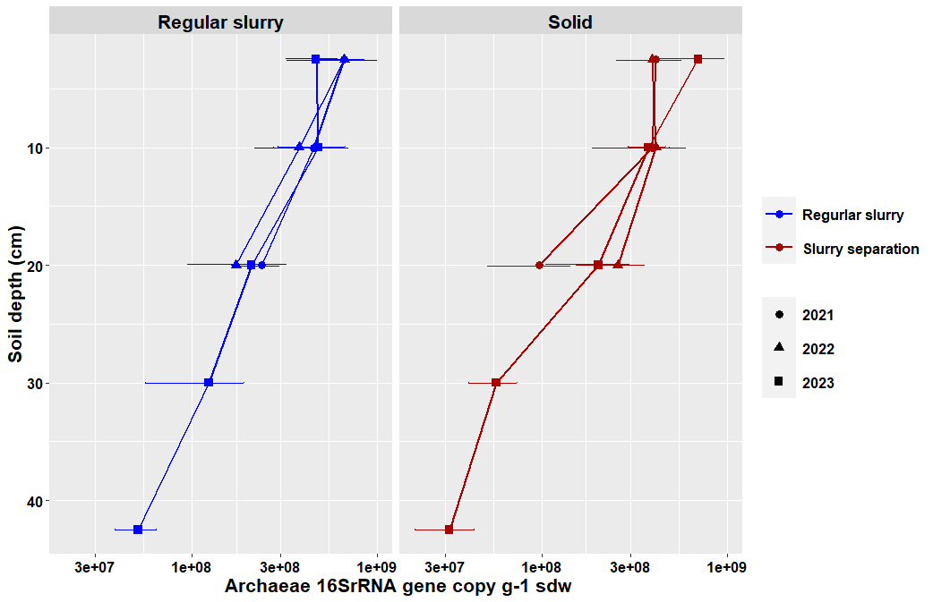
Supplementary figure 2.Vertical distribution of bacterial 16S rRNA gene abundance in soil under regular slurry and separated slurry treatments (2021–2023).
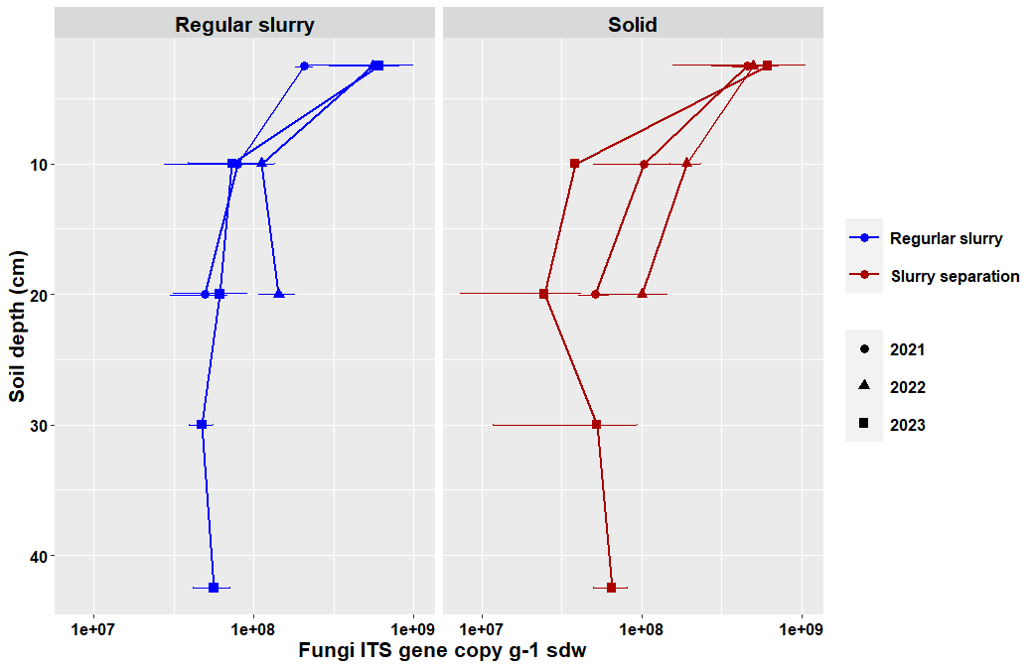
Supplementary figure 3. Vertical distribution of fungal ITS gene abundance in soil under regular slurry and separated slurry treatments (2021–2023).
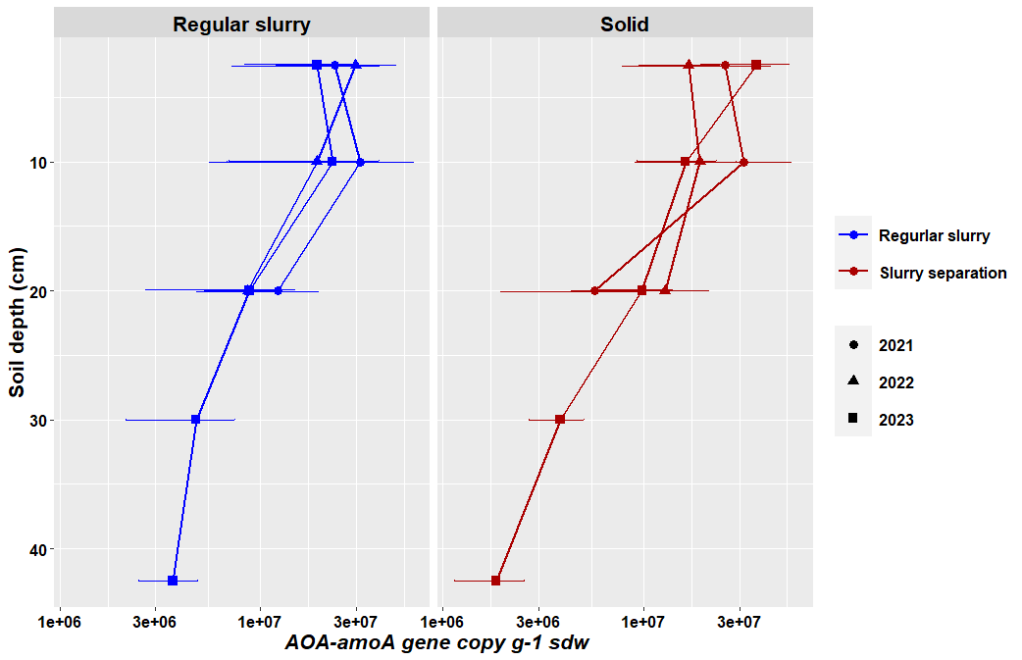
Supplementary figure 4.Vertical distribution of archaeal ammonia oxidizer (AOA-amoA) gene abundance in soil under regular slurry and separated slurry treatments (2021–2023).
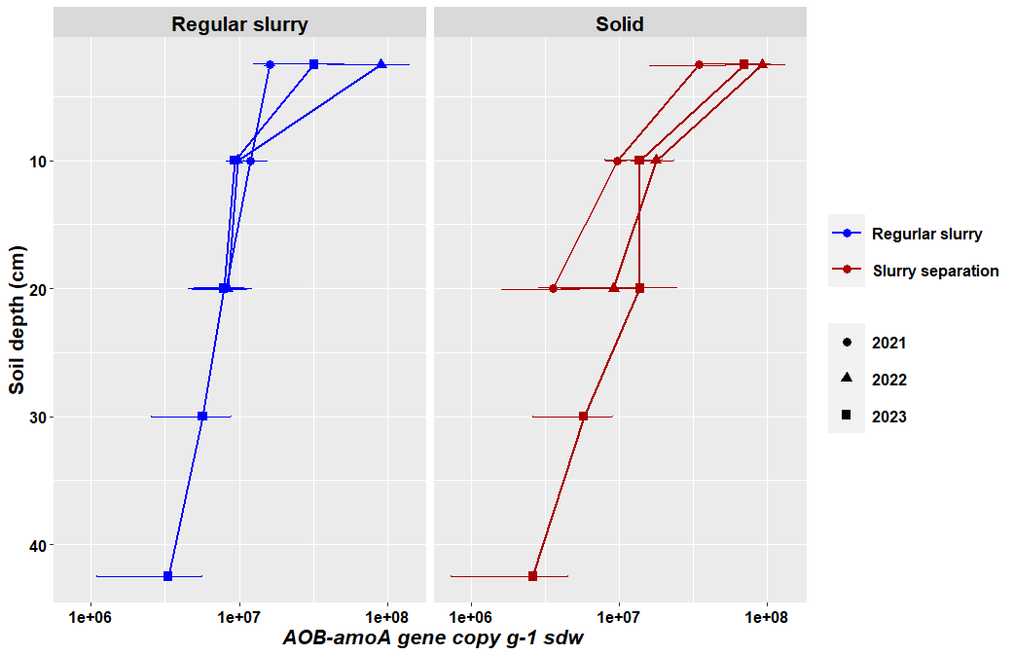
Supplementary figure 5.Vertical distribution of bacterial ammonia oxidizer (AOB-amoA) gene abundance in soil under regular slurry and separated slurry treatments (2021–2023).
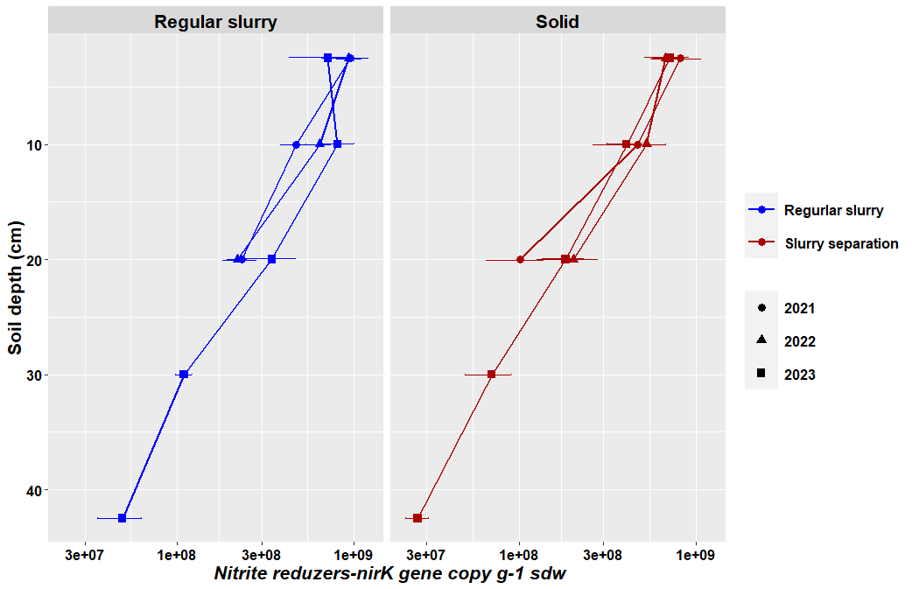
Supplementary figure 6.Vertical distribution of nirK gene abundance in soil under regular slurry and separated slurry treatments (2021–2023).
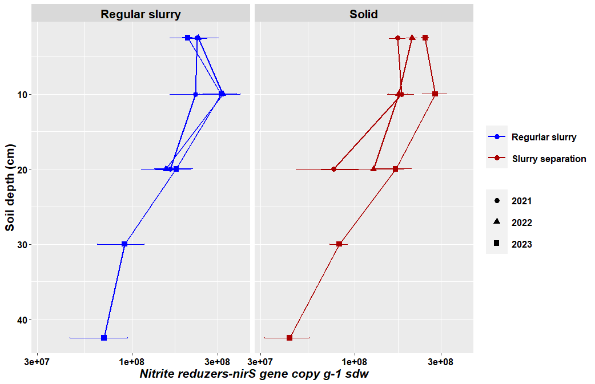
Supplementary figure 7.Vertical distribution of nirS gene abundance in soil under regular slurry and separated slurry treatments (2021–2023).
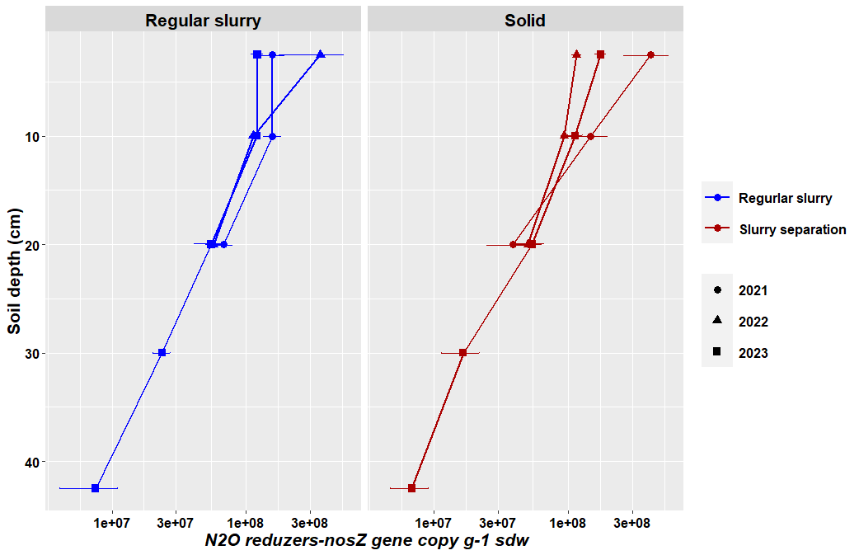
Supplementary figure 8.Vertical distribution of nosZ gene abundance in soil under regular slurry and separated slurry treatments (2021–2023).
We did not observe significant differences in the abundance of fungi, bacteria, archaea in response to the application of the different types of slurry in the topsoil at the different depths and sampling time points based on qPCR analysis of DNA extracted from the soil samples using universal ribosomal marker genes (Supplementary figure 1, 2). A further analysis of key functional microbial groups with selected primers for nitrifiers and denitrifiers, revealed no significant influence of type of slurry application on archaeal and bacterial ammonia oxidizers (AOA-amoA, AOB-amoA) across the years sampled (2021–2023). After two years of fertilization (year 2023), the AOA-amoA abundance ranged from 8.8 x 10⁶ gene copy per g⁻¹ of soil dry weight (sdw) (in 15 - 25 cm soil depth) to 3.6 x 107 gene copy per g⁻¹ of sdw (in 0 - 5 cm soil depth), while the AOB-amoA abundance ranged from 7.9 x 106 gene copy per g⁻¹ of sdw (in 15 - 25 cm soil depth) to 7.0 x 10⁷ gene copy per g⁻¹ of sdw (in 0 - 5 cm soil depth) (Supplementary figure 4). Also with regard to denitrification-related genes and their ratios, no significant differences were found (Supplementary figure 5-8). However, the separated slurry treatment tended to influence the abundance of denitrification-related genes across time. E.g., N₂O-reducing bacteria belonging to the Clade nosZ I exhibited increased abundance in the topsoil after two years under slurry separation treatment (from 1.1 to 1.7 x108 gene copy per g⁻¹ of sdw) compared to the regular slurry control in which this microbial abundance decreased after two years (from 3.6 to 1.2 x 108 gene copy per g⁻¹ of sdw). However, also these differences were not statistically significant (Supplementary figure 8).

Reference
Andrade-Linares, D.R., Zistl-Schlingmann, M., Foesel, B., Dannenmann, M., Schulz, S. and Schloter, M., 2021. Short term effects of climate change and intensification of management on the abundance of microbes driving nitrogen turnover in montane grassland soils. Science of The Total Environment, 780, p.146672. https://doi.org/10.1016/j.scitotenv.2021.146672.
Bach, H.J., Tomanova, J., Schloter, M. and Munch, J.C., 2002. Enumeration of total bacteria and bacteria with genes for proteolytic activity in pure cultures and in environmental samples by quantitative PCR mediated amplification. Journal of microbiological methods, 49(3), pp.235-245. https://doi.org/10.1016/S0167-7012(01)00370-0.
Braker, G., Schwarz, J. and Conrad, R., 2010. Influence of temperature on the composition and activity of denitrifying soil communities. FEMS Microbiology Ecology, 73(1), pp.134-148. https://doi.org/10.1111/j.1574-6941.2010.00884.x.
Graham, D.W., Knapp, C.W., Van Vleck, E.S., Bloor, K., Lane, T.B. and Graham, C.E., 2007. Experimental demonstration of chaotic instability in biological nitrification. The ISME journal, 1(5), pp.385-393. https://doi.org/10.1038/ismej.2007.45.
Henry, S., Bru, D., Stres, B., Hallet, S. and Philippot, L., 2006. Quantitative detection of the nosZ gene, encoding nitrous oxide reductase, and comparison of the abundances of 16S rRNA, narG, nirK, and nosZ genes in soils. Applied and environmental microbiology, 72(8), pp.5181-5189. https://doi.org/10.1128/AEM.00231-06.
Henry, S., Texier, S., Hallet, S., Bru, D., Dambreville, C., Chèneby, D., Bizouard, F., Germon, J.C. and Philippot, L., 2008. Disentangling the rhizosphere effect on nitrate reducers and denitrifiers: insight into the role of root exudates. Environmental Microbiology, 10(11), pp.3082-3092. https://doi.org/10.1111/j.1462-2920.2008.01599.x.
Just, C., Poeplau, C., Don, A., van Wesemael, B., Kögel-Knabner, I. and Wiesmeier, M., 2021. A simple approach to isolate slow and fast cycling organic carbon fractions in central European soils—Importance of dispersion method. Frontiers in Soil Science, 1, p.692583. https://doi.org/10.3389/fsoil.2021.692583.
Leininger, S., Urich, T., Schloter, M., Schwark, L., Qi, J., Nicol, G.W., Prosser, J.I., Schuster, S.C. and Schleper, C., 2006. Archaea predominate among ammonia-oxidizing prokaryotes in soils. Nature, 442(7104), pp.806-809. https://doi.org/10.1038/nature04983.
Michotey, V., Mejean, V. and Bonin, P., 2000. Comparison of methods for quantification of cytochrome cd 1-denitrifying bacteria in environmental marine samples. Applied and environmental microbiology, 66(4), pp.1564-1571. https://doi.org/10.1128/AEM.66.4.1564-1571.2000.
Poly, F., Wertz, S., Brothier, E. and Degrange, V., 2008. First exploration of Nitrobacter diversity in soils by a PCR cloning-sequencing approach targeting functional gene nxrA. FEMS microbiology ecology, 63(1), pp.132-140. https://doi.org/10.1111/j.1574-6941.2007.00404.x.
Rösch, C., Mergel, A. and Bothe, H., 2002. Biodiversity of denitrifying and dinitrogen-fixing bacteria in an acid forest soil. Applied and environmental microbiology, 68(8), pp.3818-3829. https://doi.org/10.1128/AEM.68.8.3818-3829.2002.
Rotthauwe, J.H., Witzel, K.P. and Liesack, W., 1997. The ammonia monooxygenase structural gene amoA as a functional marker: molecular fine-scale analysis of natural ammonia-oxidizing populations. Applied and environmental microbiology, 63(12), pp.4704-4712. https://doi.org/10.1128/aem.63.12.4704-4712.1997.
Schauss, K., Focks, A., Leininger, S., Kotzerke, A., Heuer, H., Thiele‐Bruhn, S., Sharma, S., Wilke, B.M., Matthies, M., Smalla, K. and Munch, J.C., 2009. Dynamics and functional relevance of ammonia‐oxidizing archaea in two agricultural soils. Environmental Microbiology, 11(2), pp.446-456. https://doi.org/10.1111/j.1462-2920.2008.01783.x.
Throbäck, I.N., Enwall, K., Jarvis, Å. and Hallin, S., 2004. Reassessing PCR primers targeting nirS, nirK and nosZ genes for community surveys of denitrifying bacteria with DGGE. FEMS microbiology ecology, 49(3), pp.401-417. https://doi.org/10.1016/j.femsec.2004.04.011.
Wertz, S., Leigh, A.K. and Grayston, S.J., 2012. Effects of long-term fertilization of forest soils on potential nitrification and on the abundance and community structure of ammonia oxidizers and nitrite oxidizers. FEMS Microbiology Ecology, 79(1), pp.142-154. https://doi.org/10.1111/j.1574-6941.2011.01204.x.
White, T.J., Bruns, T.D., Lee, S.B. and Taylor, J.W. (1990) Amplification and Direct Sequencing of Fungal Ribosomal RNA Genes for Phylogenetics. In: Innis, M.A., Gelfand, D.H., Sninsky, J.J. and White, T.J., Eds., PCR Protocols: A Guide to Methods and Applications, Academic Press, New York, 315-322. http://dx.doi.org/10.1016/B978-0-12-372180-8.50042-1

