Supplementary Material

Methods

S1.1. Maintenance of Animal Experiment
The experimental setup was maintained under standardized conditions (12:12 h light cycle, continuous freshwater influx at 2 l/min). All procedures were carried out by experienced personnel in compliance with existing regulations and approved in advance by the TUM Animal Welfare Office. Maintenance included the daily removal of fish feces and uneaten feed to avoid spoilage, as further detailed in Anonymous (2025) [38]. Water parameters were monitored continuously using a WTW Multi 3040 parameter device (dissolved oxygen: 8.76 ± 1.24 mg/L, temperature: 11.04 ± 0.18 °C, pH: 8.08 ± 0.12; see Supplementary Table S1). Ammonium-N (NH₄⁺-N) was measured daily with the Spectroquant Ammonium Reagent Test (0.41 ± 0.21 mg/L; Supelco, Sigma-Aldrich, USA).

S1.2. Amplicon Sequencing Library Preparation
PCR reaction included 12.5 µl NEBNext High-Fidelity PCR Master Mix (New England Biolabs,X), 0.5 µl of each primer (10 pmol/µl), 2.5 µl of 3 % BSA, 3 µl template DNA from mussel samples (diluted to 30 ng/µl) and 6 µl of nuclease-free water. Cycling conditions were: initial denaturation at 98 °C for 1 min; 30 cycles of 98 °C for 10 s, 55 °C for 30 s, and 72 °C for 30 s; followed by a final elongation at 72 °C for 5 min. Due to the low DNA concentration in water samples, 9 µl of undiluted DNA was directly used and subjected to 35 PCR cycles to ensure sufficient amplification. PCR products were purified using MagSi-NGSprep Plus magnetic beads (Steinbrenner Laborsysteme, Germany) with a bead-to-sample-ratio of 0.8:1. Purified samples were indexed using the Nextera XT Index Kit v2 with 8 cycles for mussel samples and 10 cycles for water samples with the following conditions: 30 s at 98 °C, 8 – 10 cycles of 10 s at 98 °C, 30 s at 55 °C, 30 s at 72 °C with a final 5 min elongation at 72 °C. Library quality and fragment size distribution was assessed with the DNF-471 Standard Sensitivity NGS Fragment Kit on a Fragment Analyzer (Agilent Technologies, USA).

S1.3. Statistical analyses and downstream processing
Differences in ASV Richness and Pielou Evenness were estimated with a linear model, ac-counting for sample type, treatment, time, and water parameters. Prior to statistical testing, data distribution was visually assessed using Q-Q plots, and variance homogeneity was tested with Levene test (car v3.1.3; [1]). Optimal model fit was determined beforehand based on the goodness-of-fit criteria using the stepAIC function of the package MASS [2]. To define the taxonomic overlap between water and mussel communities under control conditions, the number of shared genera was calculated across all sampling timepoints. To account for temporal variability between replicate groups, a prevalence threshold of 60 % was applied (MicEco package v0.9.19; [3]). The linear model used to detect differentially abundant ASVs in treated mussels included treatment, timepoint and their interaction to assess potential temporal dependencies in treatment responses as experimental variables. To reduce noise, a minimum prevalence threshold of 0.05 and minimum abundance threshold of 0.0001 were set. For phylogenetic reconstruction, sequences of Flavobacterium and Dechloromonas ASVs were aligned against full-length reference sequences from the SILVA LTP database using SINA [4]. Selected reference sequences were trimmed in silico to match the amplified region (515-806) using the corresponding primer sites. Alignments were refined using MUSCLE [5], and a maximum likelihood tree was inferred with IQ-TREE using the GTR-G substitution model, 1000 ultrafast bootstrap replicates and automatic thread optimization. Phylogenetic tree annotation was finalized with the ggtree package v3.10.1 [6].

S1.4. Florfenicol and Florfenicol amine quantification

The LC–MS/MS system (Waters, USA) included a 250 µL autosampler, binary and quaternary solvent delivery modules (BSM and QSM), a column switching manager for bidimensional operation, and a Xevo TQD Zspray triple quadrupole mass spectrometer with an electrospray ionization (ESI) source operating in both positive and negative ion modes. In the first chromatographic dimension (1D), an OASIS HLB column (30 mm × 2.1 mm; 20 µm) was employed for sample clean-up and pre-concentration. The second dimension (2D) used an Acquity™ UPLC BEH C18 analytical column (50 mm × 2.1 mm; 1.7 µm) for chromatographic separation and detection. Sample preparation involved the addition of 100 µL of FF-d₃ internal standard solution (200 ng mL⁻¹) to 900 µL of water sample, followed by vortexing for 30 seconds. The resulting mixture was filtered through a 0.22 µm PVDF syringe filter before analysis.

Supplementary Tables

Table S1: Mean concentrations of water parameters throughout the experimental period.
Treatment | diss. oxygen (mg/L) | pH | NH₄⁺-N (mg/L) | Temperature (°C)
Control | 9.40 ± 0.45 | 8.03 ± 0.16 | 0.24 ± 0.15 | 11.08 ± 0.44
FF | 8.86 ± 0.48 | 8.04 ± 0.14 | 0.30 ± 0.20 | 11.07 ± 0.44
Mixture | 9.33 ± 0.41 | 8.12 ± 0.14 | 0.33 ± 0.17 | 10.89 ± 0.47
PAA | 9.67 ± 0.29 | 8.19 ± 0.18 | 0.48 ± 0.23 | 10.66 ± 0.58
Mean (± SD) concentrations of dissolved oxygen (mg/L), pH, NH₄⁺-N (mg/L) and temperature (°C) in tank water recorded during the experiment. FF = Florfenicol, PAA = Peracetic Acid.

Table S2: Two-way ANOVA output of linear model on microbial ASV Richness and Evenness, showing F- and p-values for mussel samples only and the full model including water and mussel samples.
 | A. cygnea |  | Full
 | ASV Richness
 | F-Value | p-Value | F-value | p-value
Treatment | 0.161 | 0.9224 | 2.151 | 0.0967
Timepoint | 8.955 | 0.0001 | 8.718 | 0.0001
Treat:Time | 2.708 | 0.0043 | 2.314 | 0.0057
pH | 0.453 | 0.5039 | 7.740 | 0.0062
Temp | 0.755 | 0.3887 | 1.393 | 0.2399
NH₄⁺-N | 0.239 | 0.6271 | 1.062 | 0.3045
O₂ | 0.525 | 0.4718 | 9.430 | 0.0026
SampleType | - | - | 23.973 | 0.0001
 | Pielou Evenness
Treatment | 0.712 | 0.549 | 0.148 | 0.9309
Timepoint | 0.996 | 0.438 | 2.135 | 0.0532
Treat:Time | 0.912 | 0.552 | 1.514 | 0.1081
pH | 0.133 | 0.716 | 2.045 | 0.1549
Temp | 0.968 | 0.330 | 0.283 | 0.5956
NH₄⁺-N | 0.065 | 0.799 | 12.710 | 0.005
O₂ | 0.276 | 0.601 | 17.348 | 0.0001
SampleType | - | - | 834.864 | 0.0001

Table S3: Mass spectrometry parameters of the selective reaction monitoring mode.
Analyte | ESI | Precursor ion m/z | Product ion m/z | Transition | Cone voltage (V) | Collision energy (eV)
Florfenicol | - | 356 | 185 | Quantitation | 30 | 20
Florfenicol | - | 356 | 339 | Confirmation | 30 | 20
Florfenicol amine | + | 248 | 130 | Quantitation | 30 | 20
Florfenicol amine | + | 248 | 230 | Confirmation | 30 | 20
Florfenicol-d3 | - | 359 | 188 | Quantitation | 30 | 20
Florfenicol-d3 | - | 359 | 339 | Confirmation | 30 | 20

Table S4: LC-LC-MS/MS quantification of florfenicol and florfenicol amine in rearing water.
Treatment – Timepoint | Florfenicol (μg/L) | Florfenicol amine (μg/L)
Day 3 – FF | 3.0 | nd
Day 3 – Mixture | 2.7 | nd
Day 10 – FF | 1.1 | nd
Day 10 – Mixture | 1.9 | nd
Day 11 – FF | 0.7 | nd
Day 11 – Mixture | 1.5 | nd
Day 17 – FF | nd | nd
Day 17 - Mixture | nd | nd
nd = not detected, below quantification threshold of 0.5 µg/L.

Supplementary Figures

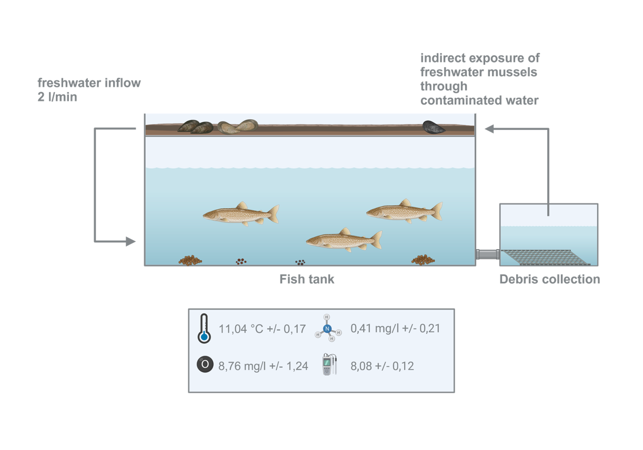
Figure S1:Graphical representation of experimental setup.
Figure S2: Rarefaction curves of mussel and water ASVs according to observed ASV richness.

Figure S3: Boxplots of a) ASV Richness and b) Pielou Evenness indices of mussel (pink) and water (blue) samples over the experimental period.

Figure S4: Venn diagram showing the overlap of shared genera aggregated over all sampling timepoints between mussel (pink) and water (blue) samples under baseline conditions. A prevalence threshold of 60 % was applied beforehand.
Figure S5: Treatment-induced changes of relative abundance of Aureispira ASVs aggregated on genus level over the experimental period.

Figure S6: Maximum-likelihood tree based on aligned 16S rRNA gene sequences, including all ASVs assigned to the three genera and a set of closely related reference genomes. Tips corresponding to reference sequences are labeled with strain names, while ASV tips are annotated with genus, species (where assignable), and ASV identifier. Categories indicate whether ASVs were shared between mussel and water microbiomes, unique to one habitat, or derived from reference genomes.

References
1. Fox J, Weisberg S. An R Companion to Applied Regression_, Third edition. Sage, Thousand Oaks CA. <https://socialsciences.mcmaster.ca/jfox/Books/Companion/>. 2019. Available from: https://socialsciences.mcmaster.ca/jfox/Books/Companion/
2. Venables WN, Ripley BD. Modern Applied Statistics with S. Fourth Edition. Springer, New York. ISBN 0-387-95457-0. 2002.
3. Russel J. Russel88/MicEco: v0.9.15. Zenodo; 2021. Available from: https://doi.org/10.5281/zenodo.4733747
4. Pruesse E, Peplies J, Glöckner FO. SINA: Accurate high-throughput multiple sequence alignment of ribosomal RNA genes. Bioinformatics. 2012;28:1823–9.
5. Edgar RC. MUSCLE: multiple sequence alignment with high accuracy and high throughput. Nucleic Acids Res. 2004;32:1792–7.
6. Yu G, Smith DK, Zhu H, Guan Y, Lam TT-Y. ggtree: an r package for visualization and annotation of phylogenetic trees with their covariates and other associated data. Methods Ecol Evol. 2017;8:28–36.

