Supplementary Table 1. Calculation of Healthy Lifestyle Index (HLI).
Modifiable Lifestyle Factors | Lifestyle categories | Category definition | Points  (0=unhealthiest, 3=healthiest) | Dichotomised HLI for regression analysis (1=healthy, 0=unhealthy)
Body Mass Index (BMI) | Normal weight | <25 kg/m² (normal weight) | 3 | 1
Body Mass Index (BMI) | Overweight | 25-<30 kg/m² | 2 | 0
Body Mass Index (BMI) | Obesity (class 1) | 30-<35 kg/m² | 1 | 0
Body Mass Index (BMI) | Obesity (class 2 or higher) | ≥35 kg/m² | 0 | 0
Accelerometer-measured moderate-to-vigorous physical activity in min/day | High | 4th quartile (>88.9-317) | 3 | 1
 | Moderate | 3rd quartile (>65.5-88.9) | 2 | 1
 | Light | 2nd quartile (>45.4-65.5) | 1 | 0
 | Low | 1st quartile (≤45.5) | 0 | 0
Smoking Status |  | Never | 3 | 1
Smoking Status |  | Former | 2 | 0
Smoking Status |  | Current <15 cigarettes per day | 1 | 0
Smoking Status |  | Current ≥15 cigarettes per day | 0 | 0
Alcohol consumption (AUDIT-C-Score) | Low risk | 0-3 (men)  0-2 (women) | 3 | 1  (<4 (men); <3 (women))
Alcohol consumption (AUDIT-C-Score) | Moderate risk | 4-5 (men)  3-5 (women) | 2 | 0  (≥4 (men); ≥3 (woman))
Alcohol consumption (AUDIT-C-Score) | High risk | 6-7 | 1 | 0  (≥4 (men); ≥3 (woman))
Alcohol consumption (AUDIT-C-Score) | Severe risk | 8-12 | 0 | 0  (≥4 (men); ≥3 (woman))
Total Healthy Lifestyle Index |  |  | Max points: 12

Supplementary Table 2. Characteristics of the study sample stratified by neighborhood SES and the total sample (n=24,936) including also participants without accelerometry.
 |  |  | Neighborhood SES
 | N | Total | 1 (best) | 2 | 3 | 4 | 5 | 6 | 7 (worst)
 |  | 24,936 | 2,100 (8.4) | 4,977 (20.0) | 4,500 (18.0) | 5,514 (22.1) | 3,492 (14.0) | 2,278 (9.1) | 2,075 (8.3)
Number of prognosis areas |  | 53 | 8 | 8 | 7 | 7 | 8 | 8 | 7
 |  |  | N (%) or mean±SD
Sex | 24,936
Male |  | 12,282 (49.3) | 1,045 (49.8) | 2,331 (46.8) | 2,291 (50.9) | 2,601 (47.2) | 1,776 (50.9) | 1,180 (51.8) | 1,058 (51.0)
Female |  | 12,654 (50.7) | 1,055 (50.2) | 2,646 (53.2) | 2,209 (49.1) | 2,913 (52.8) | 1,716 (49.1) | 1,098 (48.2) | 1,017 (49.0)
Age | 24,936 | 49.8±12.9 | 50.7±12.3 | 51.4±12.4 | 48.8±12.5 | 50.4±12.9 | 48.9±12.9 | 49.2±13.8 | 48.4±13.7
Education (ISCED 97)¹ | 22,357
High |  | 14,601 (65.3) | 1,340 (70.0) | 3,165 (70.6) | 2,835 (70.4) | 3,152 (63.2) | 1,987 (64.0) | 1,110 (55.0) | 1,012 (55.6)
Middle |  | 7,236 (32.4) | 558 (29.2) | 1,269 (28.3) | 1,123 (27.9) | 1,714 (34.3) | 1,029 (33.2) | 827 (41.0) | 716 (39.4)
Low |  | 520 (2.3) | 16 (0,8) | 51 (1.1) | 68 (1.7) | 125 (2.5) | 88 (2.8) | 81 (4.0) | 91 (5.0)
Employment status | 24,704
Employed |  | 18,915 (76.6) | 1,618 (77.7) | 3,845 (77.8) | 3,617 (81.2) | 4,109 (75.1) | 2,677 (77.4) | 1,591 (70.5) | 1,458 (71.4)
Not employed |  | 978 (4.0) | 42 (2.0) | 150 (3.0) | 150 (3.4) | 213 (3.9) | 138 (4.0) | 149 (6.6) | 136 (6.7)
Economically inactive  (retired or other reasons) |  | 4,811 (19.5) | 422 (20.3) | 947 (19.2) | 687 (15.4) | 1,148 (21.0) | 642 (18.6) | 516 (22.9) | 449 (22.0)
Monthly net equivalent household income in €² | 23,304 | 2,287±1,491 | 2,701±1,607 | 2,543±1,647 | 2,487±1,666 | 2,165±1,266 | 2,193±1,427 | 1,935±1,286 | 1,704±1,070
Marital status | 24,851
Living with partner |  | 15,806 (63.6) | 1,562 (74.5) | 3,359 (67.7) | 2,848 (63.5) | 3,382 (61.5) | 2114 (60.8) | 1388 (61.1) | 1,153 (55.8)
Not living with partner |  | 2,965 (11.9) | 181 (8.6) | 517 (10.4) | 561 (12.5) | 676 (12.3) | 463 (13.3) | 291 (12.8) | 276 (13.3)
No partner |  | 6,080 (24.5) | 353 (16.8) | 1,087 (21.9) | 1,073 (23.9) | 1,437 (26.2) | 898 (25.8) | 593 (26.1) | 639 (30.9)
Turkish descent³ | 24,921 | 503 (2.0) | 25 (1.2) | 60 (1.2) | 62 (1.4) | 104 (1.9) | 65 (1.9) | 57 (2.5) | 130 (6.3)
Lifestyle factors
BMI⁴ | 24,179 | 25.9±4.8 | 25.6±4.5 | 25.8±4.7 | 25.5±4.5 | 26.0±4.9 | 25.7±4.7 | 26.7±5.3 | 26.6±5.5
Underweight |  | 352 (1.5) | 25 (1.2) | 73 (1.5) | 59 (1.3) | 79 (1.5) | 57 (1.7) | 31 (1.4) | 28 (1.4)
Normal weight |  | 11,373 (47.0) | 1,008 (49.4) | 2,273 (47.6) | 2,172 (49.5) | 2,492 (46.8) | 1,644 (48.3) | 903 (40.7) | 881 (43.6)
Overweight |  | 8,377 (34.6) | 717 (35.1) | 1,656 (34.7) | 1,530 (34.9) | 1,861 (34.9) | 1,166 (34.2) | 789 (35.6) | 658 (32.6)
Obesity |  | 4,077 (16.9) | 290 (14.2) | 777 (16.3) | 628 (14.3) | 895 (16.8) | 538 (15.8) | 495 (22.3) | 454 (22.5)
Physical activity (MVPA-minutes per day)⁵ | 11,922 | 69.8±34.2 | 68.5±34.2 | 70.5±33.7 | 70.9±32.7 | 69.7±34.6 | 70.5±34.5 | 67.3±35.2 | 68.0±35.7
Smoking status | 23,715
Never |  | 10,370 (43.7) | 1,014 (50.2) | 2,152 (45.6) | 1,932 (44.7) | 2,215 (43.1) | 1,350 (40.2) | 963 (44.1) | 744 (37.9)
Former |  | 7,847 (33.1) | 666 (33.0) | 1,649 (34.9) | 1,408 (32.6) | 1,758 (34.2) | 1,105 (32.9) | 646 (29.6) | 615 (31.3)
Current |  | 5,451 (23.0) | 336 (16.6) | 916 (19.4) | 977 (22.6) | 1,162 (22.6) | 898 (26.7) | 570 (26.1) | 592 (30.2)
Alcohol consumption (AUDIT-C Score)⁶ | 23,612
Risky alcohol consumption AUDIT-C Score ≥4 (men)/ ≥3 (women) |  | 8,781 (37.2) | 665 (33.0) | 1,789 (38.0) | 1,664 (38.6) | 1,851 (36.1) | 1,351 (40.4) | 739 (34.1) | 722 (37.1)
Subjective health status | 23,665
(Good, very good, excellent) vs. (fair, poor) |  | 15,031 (63.5) | 1,243 (61.5) | 2,970 (62.8) | 2,626 (60.7) | 3.294 (64.3) | 2,094 (62.5) | 1,474 (68.1) | 1,330 (68.3)
Life satisfaction  (0=worst, 10=best) | 23,670 | 7.6±1.9 | 7.9±1.7 | 7.7±1.8 | 7.6±1.9 | 7.5±2.0 | 7.6±1.9 | 7.6±2.0 | 7.5±2.0
¹ISCED97: International standard classification of education.(1); ²Net household income devided by corresponding household members; ³Turkish descent, if i) own Turkish background or ii) migration of at least one parent from Turkey to Germany after 1949 (Wiessner et al., 2020); 4 BMI: Body Mass index in kg/m²; underweight: <18.5kg/m², normal weight: 18.5-24.9 kg/m², overweight: 25.0-29.9 kg/m², obesity: >30.0 kg/m²); ⁵MVPA: moderate-to-vigorous physical activity; 6 AUDIT-C: The AUDIT Alcohol Consumption Questions (2).
1. United Nations Educational Scientific and Cultural Organization (UNESCO). International Standard Classification of Education ISCED. 1997. 1–49 p.
2. Bush K, Kivlahan DR, McDonell MB, Fihn SD, Bradley KA. The AUDIT Alcohol Consumption Questions (AUDIT-C). Arch Intern Med. 1998;158:1789–95.

Supplementary Table 3. Multivariable linear (outcome: Healthy Lifestyle Index HLI) and logistic (outcomes: normal weight, upper median of physical activity (PA), never smoking, no risky alcohol consumption vs respective counterparts) univariate and multivariable regression analyses; multivariable analyses: N=10,827; adjusted for sex, age, Turkish descent, and education.
 | Healthy Lifestyle Index |  | Normal weight |  | Upper median PA |  | Never smoking |  | No risky alcohol consumption
 | beta coefficient (univariate) (95% CI) | beta coefficient (adjusted) (95% CI) | Crude OR (95% CI) | Adjusted OR (95% CI) | Crude OR  (95% CI) | Adjusted OR  (95% CI) | Crude OR  (95% CI) | Adjusted OR  (95% CI) | Crude OR  (95% CI) | Adjusted OR  (95% CI)
Social index (per unit worsening) | -0.08  (-0.10; -0.06) | -0.08  (-0.10; -0.06) | 0.96  (0.94;0.98) | 0.95  (0.93;0.97) | 0.99  (0.97;1.01) | 0.98  (0.96; 1.01) | 0.95  (0.93; 0.97) | 0.96  (0.94; 0.98) | 1.01  (0.99; 1.03) | 1.0  (0.98; 1.03)
Sex Ref: Male | 0.32 (0.24;0.39) | 0.33  (0.25; 0.40) | 1.91  (1.78;2.06) | 2.04  (1.89;2.20) | 0.74  (0.69;0.79) | 0.72  (0.67; 0.78) | 1.18  (1.09;1.27) | 1.20  (1.11; 1.30) | 1.3  (1.2;1.4) | 1.31  (1.21; 1.41)
Age (per year increase ) | -0.04  (-0.04; -0.04) | -0.04  (-0.04; -0.04) | 0.68  (0.67; 0.68) | 0.96  (0.96;0.96) | 0.96  (0.96;0.97) | 0.96  (0.96; 0.96) | 0.98  (0.98;0.99) | 0.98  (0.98; 0.99) | 1.0  (1.00;1.01) | 1.00  (1.00; 1.01)
Turkish descent (Ref: no) | -0.53  (-0.89;-0.17) | -0.34  (-0.69; 0.01) | 0.36  (0.25;0.52) | 0.40  (0.25;0.55) | 0.57  (0.42;0.79) | 0.52  (0.38; 0.73) | 0.69  (0.48;0.97) | 0.23  (0.53; 1.15) | 3.55  (2.19;5.78) | 3.26  (2.00; 5.31)
Low education (Ref: high) | -1.25  (-1.53;-0.97) | -1.29  (-1.56; -1.01) | 0.40  (0.31;0.52) | 0.48  (0.36;0.64) | 0.48  (0.37;0.61) | 0.54  (0.42; 0.71) | 0.28  (0.2;0.39) | 0.22  (0.19; 0.41) | 1.87  (1.37;2.55) | 1.65  (1.20; 2.26)
Middle education (Ref: high) | -0.51  (-0.6;-0.43) | -0.51  (-0.59; -0.43) | 0.72  (0.66;0.77) | 0.71  (0.66;0.77) | 0.72  (0.67;0.78) | 0.75  (0.69; 0.81) | 0.6  (0.56;0.65) | 0.61  (0.56; 0.66) | 1.21  (1.11;1.32) | 1.19  (1.10; 1.30)

Supplementary Table 4. Multivariable linear (outcome: Healthy Lifestyle Index HLI) and logistic (outcomes: normal weight, upper median of physical activity (PA), never smoking, no risky alcohol consumption vs respective counterparts) regression analyses; multivariable analyses: N=10,827; adjusted for sex, age, Turkish descent, and education.
 | Healthy Lifestyle Index | Normal weight | Upper median PA | Never smoking | No risky alcohol consumption
 | Adjusted* beta coefficient (95% CI) | Adjusted* OR (95% CI) | Adjusted* OR  (95% CI) | Adjusted* OR  (95% CI) | Adjusted* OR  (95% CI)
Social index  Highest (1-4) | Ref. | Ref. | Ref. | Ref. | Ref.
Lowest (5-7) | -0.3 (-0.38;-0.22) | 0.86 (0.79;0.94) | 0.93 (0.85;1.01) | 0.88 (0.80;0.95) | 0.97 (0.89;1.06)
*adjusted for sex, age, education, and migrant background

Supplementary Table 5. Sex-stratified multivariable linear (outcome: Healthy Lifestyle Index HLI) and logistic (outcomes: normal weight, upper median of physical activity (PA), never smoking, no risky alcohol consumption vs respective counterparts) regression analyses; multivariable analyses: N=10,827; adjusted for sex, age, Turkish descent, and education.
 | Healthy Lifestyle Index |  | Normal weight |  | Upper median PA |  | Never smoking |  | No risky alcohol consumption
 | Men | Women | Men | Women | Men | Women | Men | Women | Men | Women
 | Adjusted* beta coefficient (95% CI) |  | Adjusted* OR (95% CI)
Social index  Highest (1-4) | Ref.
Lowest (5-7) | -0.28 (0.16;0.40) | -0.31 (0.20;0.42) | 0.99 (0.87;1.12) | 0.76  (0.67;0.85) | 0.95 (0.84;1.07) | 0.91 (0.81;1.02) | 0.93 (0.82;1.05) | 0.83 (0.74;0.94) | 0.90 (0.80;1.02) | 1.05 (0.93;1.19)
p(interaction) | 0.692 |  | 0.002 |  | 0.481 |  | 0.203 |  | 0.055
*adjusted for age, education, and migrant background

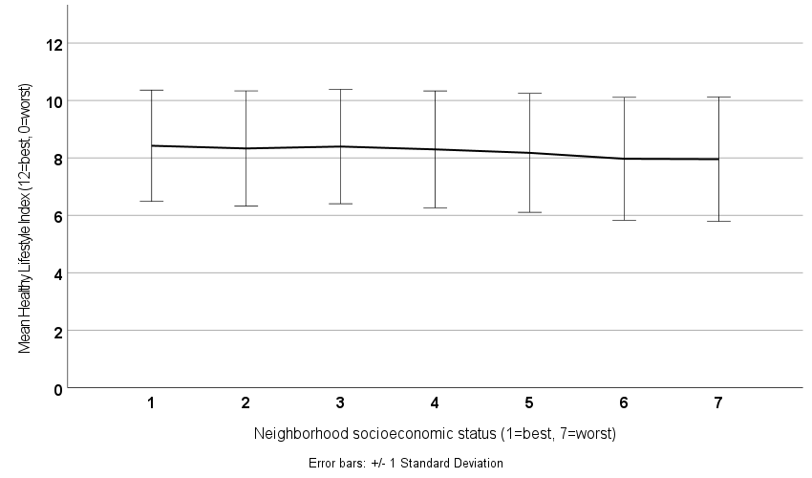

Supplementary Figure 1. Association of the Mean Healthy Lifestyle Index (± 1 standard deviation) with nSES.
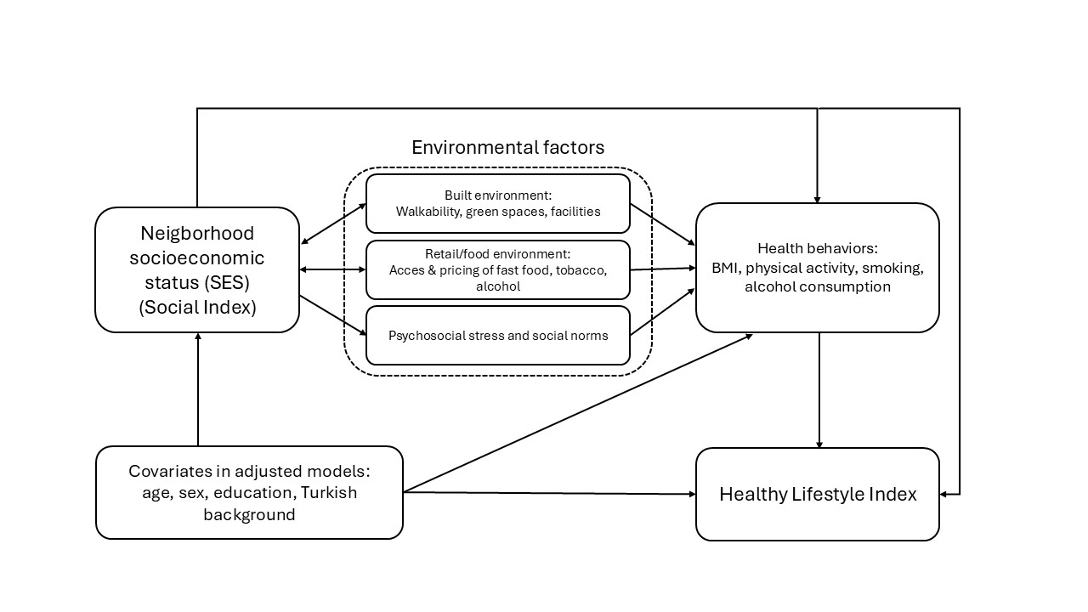
Supplementary Figure 2. Conceptual framework of nSES, covariates and potential environmental confounders/mediators with Healthy Lifestyle Index.

