SUPPLEMENTARY FIGURES:
Figure S1:
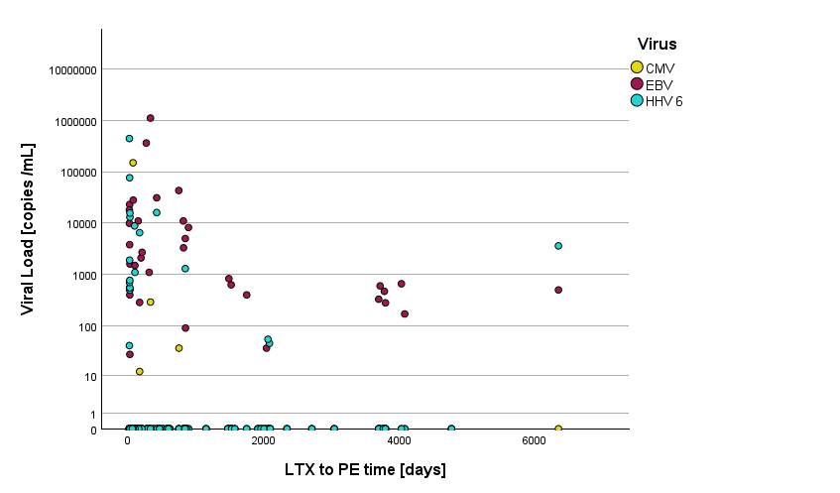
Figure S1: Pleural viral load of EBV, HHV6 and CMV in relation to time after transplantation.

SUPPLEMENTARY TABLES
Table S1:
Virus | Positive Samples (%) (n/N) | Median Viral Load of Positive Samples (copies/ml) [IQR]
EBV | 35% (35/99) | 1500 [435-10450]
HHV-6 | 19% (19/99) | 1300 [550-13000]
CMV | 4% (4/99) | 163 [18-111448]
HHV-7 | 1% (1/99) | 380 [-]
HSV-1 | 0% (0/99) | X
HSV-2 | 0% (0/99) | X

Table S1: Detected Herpesviruses in Pleural Effusion Samples.

Table S2:
Demographics | EBV Negative  n=64 | EBV Positive  n=35 | p-value
Immunosuppressive Regimen |  |  | 0,9740,724
Tacrolimus+ Steroids (n) | 86% (55/64) | 89% (31/35)
Tacrolimus+ Everolimus+ Steroids (n) | 6% (4/64) | 6% (2/35)
Tacrolimus+ Sirolimus+ Steroids (n) | 5% (3/64) | 3% (1/35)
Ciclosporin+ Steroids (n) | 3%(2/64) | 3% (1/35)
Renal Function at Baseline at the Time of Pleural Effusion* |  |  | 0,682
G1 (n) | 17% (10/64) | 17% (6/35)
G2 (n) | 14% (9/64) | 20% (7/35)
G3 (n) | 44% (28/64) | 20% (7/35)
G4 (n) | 16% (10/64) | 29% (10/35)
G5 (n) | 11% (7/64) | 14% (5/35)
Serum laboratory chemistry results
CRP (mg/dl) (median [IQR]) | 1,7 [0,7-6,3] | 3,5 [0,8-7,2] | 0,593
Creatinine (mg/dl) (median [IQR]) | 1,4 [1-2] | 1,8 [1,2-2,4] | 0,429
LDH (U/I) (median [IQR]) | 252 [222-304] | 267 [225-333] | 0,365
Protein (g/dl) (median [IQR]) | 5,8 [5,2-6,3] | 5,8 [5-6,6] | 0,684
Albumin (g/dl) (median [IQR]) | 3,5 [2,8-3,7] | 3,2 [2,8-3,7] | 0,085
Table S2: Supplementary characteristics of lung transplantation (LTX) patients by pleural effusion EBV (Epstein-Barr virus) status (EBV- vs. EBV+). All the analyses were performed using linear mixed-effects models (LMMs) to account for repeated measurements within patients. A p-value of <0.05 was considered statistically significant. *Renal function classified based on eGFR-value at the time of thoracentesis, in accordance with KDIGO guidelines.

Table S3:
Demographics | CMV Negative  (n=95) | CMV Positive  (n=4) | p-value
Immunosuppressive Regimen |  |  | 0,957
Tacrolimus+ Steroids (n) | 87% (83/95) | 75% (3/4)
Tacrolimus+ Everolimus+ Steroids (n) | 5% (5/95) | 25% (1/4)
Tacrolimus+ Sirolimus+ Steroids (n) | 4% (4/95) | 0
Ciclosporin+ Steroids (n) | 3% (3/95) | 0
Renal Function at Baseline at the Time of Pleural Effusion* |  |  | 0,372
G1 (n) | 17% (16/95) | 0
G2 (n) | 17% (16/95) | 0
G3 (n) | 35% (33/95) | 50% (2/4)
G4 (n) | 19% (18/95) | 50% (2/4)
G5 (n) | 13% (12/95 | 0
Serum laboratory chemistry results
CRP (mg/dl) (median [IQR]) | 2,3 [0,7-6,7] | 2,2 [2-2,2] | 0,628
Creatinine (mg/dl) (median [IQR]) | 1,5 [1,1-2,3] | 2,9 [1,4-2,9] | 0,611
LDH (U/I) (median [IQR]) | 255 [221-320] | 385 [294-385] | 0,061
Protein (g/dl) (median [IQR]) | 5,8 [5,2-6,4] | 5,2 [4,3-5,2] | 0,22
Albumin (g/dl) (median [IQR]) | 3,4 [3-3,9) | 3,1 [2,3-3,1] | 0,501

Table S3: Supplementary characteristics of lung transplantation (LTX) patients by pleural effusion CMV (Cytomegalovirus) status (CMV- vs. CMV+). All the analyses were performed using linear mixed-effects models (LMMs) to account for repeated measurements within patients. A p-value of <0.05 was considered statistically significant. *Renal function classified based on eGFR-value at the time of thoracentesis, in accordance with KDIGO guidelines.

Table S4:
Demographics | HHV-6 Negative  n=80 | HHV-6 Positive  n=19 | p-value
Immunosuppressive Regimen |  |  | 0,193
Tacrolimus+ Steroids (n) | 85% (68/80) | 95% (18/19)
Tacrolimus+ Everolimus+ Steroids (n) | 6% (5/80) | 5% (1/19)
Tacrolimus+ Sirolimus+ Steroids (n) | 5% (4/80) | 0
Ciclosporin+ Steroids (n) | 4% (3/80) | 0
Renal Function at Baseline at the Time of Pleural Effusion |  |  | 0,005
G1 (n) | 10% (8/80) | 42% (8/19)
G2 (n) | 16% (13/80) | 16% (3/19)
G3 (n) | 39% (31/80) | 21% (4/19)
G4 (n) | 21% (17/80) | 16% (3/19)
G5 (n) | 14% (11/80) | 5% (1/19)
Serum lab results
CRP (mg/dl) (median [IQR]) | 2,2 [0,7-6,2] | 3,7 [1,3-15,5] | 0,084
Creatinine (mg/dl) (median [IQR]) | 1,7 [1,2-2,4] | 1,2 [0,8-1,7] | 0,143
LDH (U/I) (median [IQR]) | 267 [25-331] | 249 [202-273] | 0,235
Protein (g/dl) (median [IQR]) | 5,9 [4,7-6,5] | 5,3 [4,4-6,1] | 0,027
Albumin (g/dl) (median [IQR]) | 3,5 [2,5-4] | 3,2 [2,4-3,5] | 0,099
Table S4: Supplementary characteristics of lung transplantation (LTX) patients by pleural effusion HHV-6 status (HHV-6- vs. HHV-6+). All the analyses were performed using linear mixed-effects models (LMMs) to account for repeated measurements within patients. A p-value of <0.05 was considered statistically significant. *Renal function classified based on eGFR-value at the time of thoracentesis, in accordance with KDIGO guidelines.

Table S5:
 | Unclear (n=43) | Post-operative (n=24) | Renal Failure (n=16) | Malign  (n=5) | Heart Failure (n=4) | Infection  (n=2) | Other  (n=5)
EBV  (n=35) | 37%  (16/43) | 33%  (8/24) | 44%  (7/16) | 40%  (2/5) | 25%  (1/4) | 0%  (0/2) | 20% (1/5)
HHV-6 (n=19) | 9%  (4/43) | 46%  (11/24) | 6%  (1/16) | 40%  (2/5) | 25%  (1/4) | 0%  (0/2) | 0%  (0/5)
CMV  (n=4) | 5%  (2/43) | 0%  (0/24) | 6%  (1/16) | 0%  (0/5) | 0%  (0/4) | 50% (1/2) | 0%  (0/5)
Table S5: Etiologies of EBV-, HHV6-, CMV-positive pleural effusions stratified by etiology.

SUPPLEMENTARY METHODS
Immunosuppressive Regimen
All LTX recipients received immunosuppressive treatment with a calcineurin inhibitor, typically tacrolimus) mycophenolate mofetil (MMF) and corticosteroids, optionally extended by a mTOR inihibitor. Calcineurin inhibitor trough levels were tapered during the first 4 years after transplantation, corticosteroid dosage was gradually reduced within the first 12 months after transplantation.
Thoracocentesis
Thoracenteses were performed according to internal standards. Briefly, a puncture site was identified using ultrasound, disinfected and anesthetized using 1% lidocaine solution. Subsequently, a soft thoracentesis pleural catheter was inserted and pleural fluid was directly removed by manual aspiration into 20-50ml syringes.
Categorization of etiology of pleural effusions
Malignant pleural effusion was defined as exudate with cytological detection of malignant cells or as a paramalignant effusion in the presence of thoracic malignancy or metastases without alternative cause. Post-operative pleural effusion was defined as an exudate occurring in close temporal association with thoracic surgery in the absence of another identifiable cause. Renal failure–related pleural effusion was defined as a transudate in patients with impaired renal function without alternative explanation. Heart failure–associated effusion was defined as transudate in the presence of elevated NT-proBNP levels and/or echocardiographic evidence of reduced cardiac function. Infectious pleural effusion was defined as exudate in the context of a pulmonary infection with no alternative explanation. Pleural effusions were classified as unclear when they did not meet the criteria for any of the above etiologies.

