Supplements
Derivation of the linear perturbation theory on equation 2.
Recall: $LRU=\frac{1}{1.21}\left(\frac{1}{1+\frac{g_{s}^{s}}{g_{i}^{s}}}\right)\left(\frac{1}{1-\frac{C_{i}^{c}}{C_{a}^{c}}}\right)$ (equation 3)
$dLRU ≈ \frac{∂LRU}{∂\left(\frac{g_{s}^{s}}{g_{i}^{s}}\right)}d(\frac{g_{s}^{s}}{g_{i}^{s}}) + \frac{∂LRU}{∂\left(\frac{C_{i}^{c}}{C_{a}^{c}}\right)}d(\frac{C_{i}^{c}}{C_{a}^{c}}) + {O(||∆||}^{2})$ with
$\frac{∂LRU}{∂(\frac{g_{s}^{s}}{g_{i}^{s}})} = -\frac{1}{1.21}\left(\frac{1}{(1+\frac{g_{s}^{s}}{g_{i}^{s}})^{2}}\right)\left(\frac{1}{1-\frac{C_{i}^{c}}{C_{a}^{c}}}\right)$ and $\frac{∂LRU}{∂(\frac{C_{i}^{c}}{C_{a}^{c}})} = \frac{1}{1.21}\left(\frac{1}{1+\frac{g_{s}^{s}}{g_{i}^{s}}}\right)\left(\frac{1}{(1-\frac{C_{i}^{c}}{C_{a}^{c}})^{2}}\right)$
$dLRU_gsgi_ratio= \frac{\frac{∂LRU}{∂\left(\frac{g_{s}^{s}}{g_{i}^{s}}\right)}d(\frac{g_{s}^{s}}{g_{i}^{s}})}{LRU}$ and $dLRU_CiCa_ratio= \frac{\frac{∂LRU}{∂\left(\frac{C_{i}^{c}}{C_{a}^{c}}\right)}d(\frac{C_{i}^{c}}{C_{a}^{c}})}{LRU}$∎
Equation S1. Linear perturbation theory on equation 2.

Figures
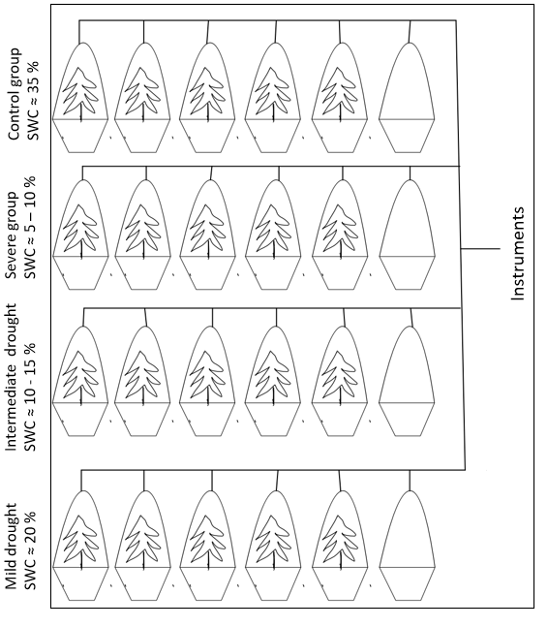
Figure S1. Schematic overview of the measurement setup.
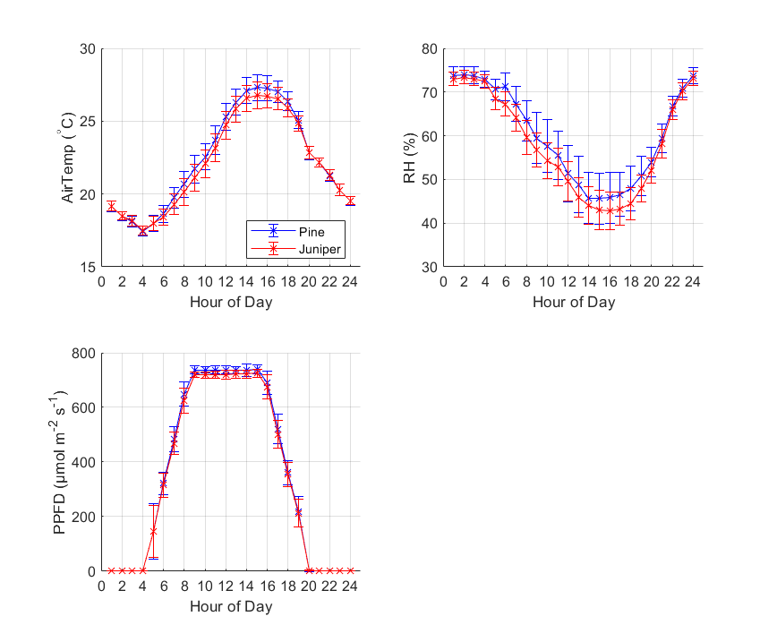
Figure S2. Temperature, relative humidity (RH) and photochemical photon flux density (PPFD) diurnal cycle in the climate chamber for pine (blue) and juniper (red).
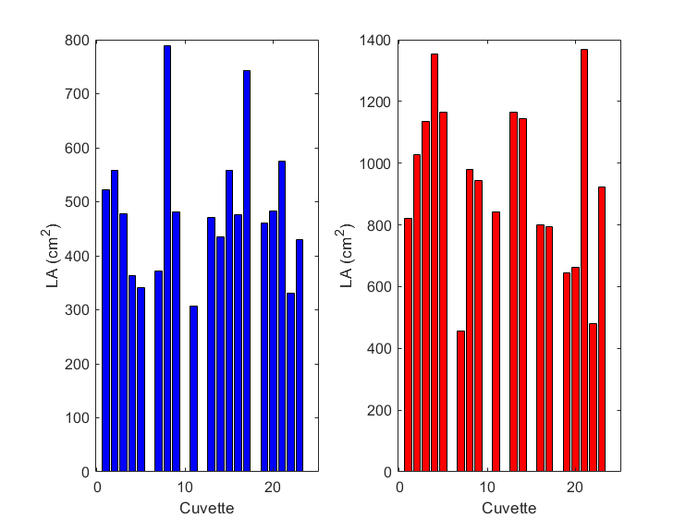
Figure S3. Leaf area (LA) in cm² per cuvette for pine (left) and juniper (right). Only soil cuvettes (nr 6, 12, 18, 24) have zero LA like cuvette 10 for both and 15 only for juniper which were excluded from the experiment.
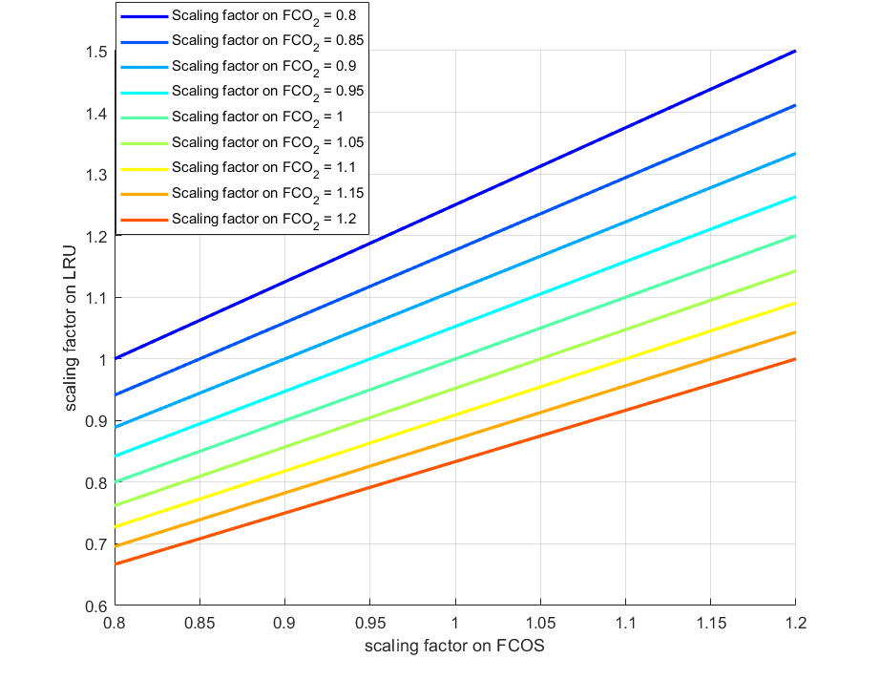
Figure S4. Sensitivity of the scaling factors on FCOS and FCO₂ reflected on the LRU. A range of 0 % - 20 % uncertainty on the fluxes is used.

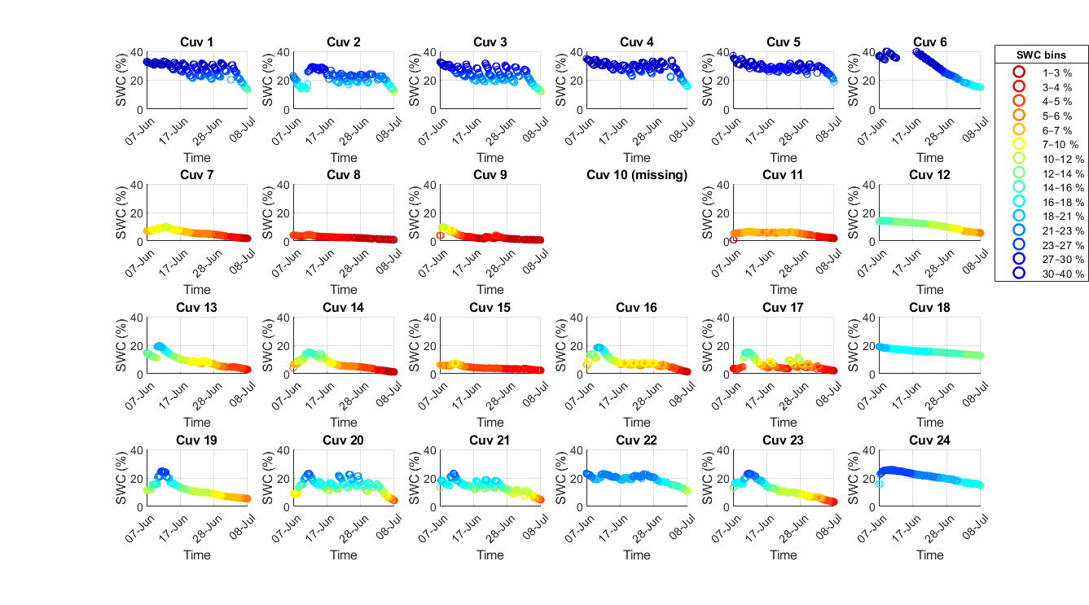
a
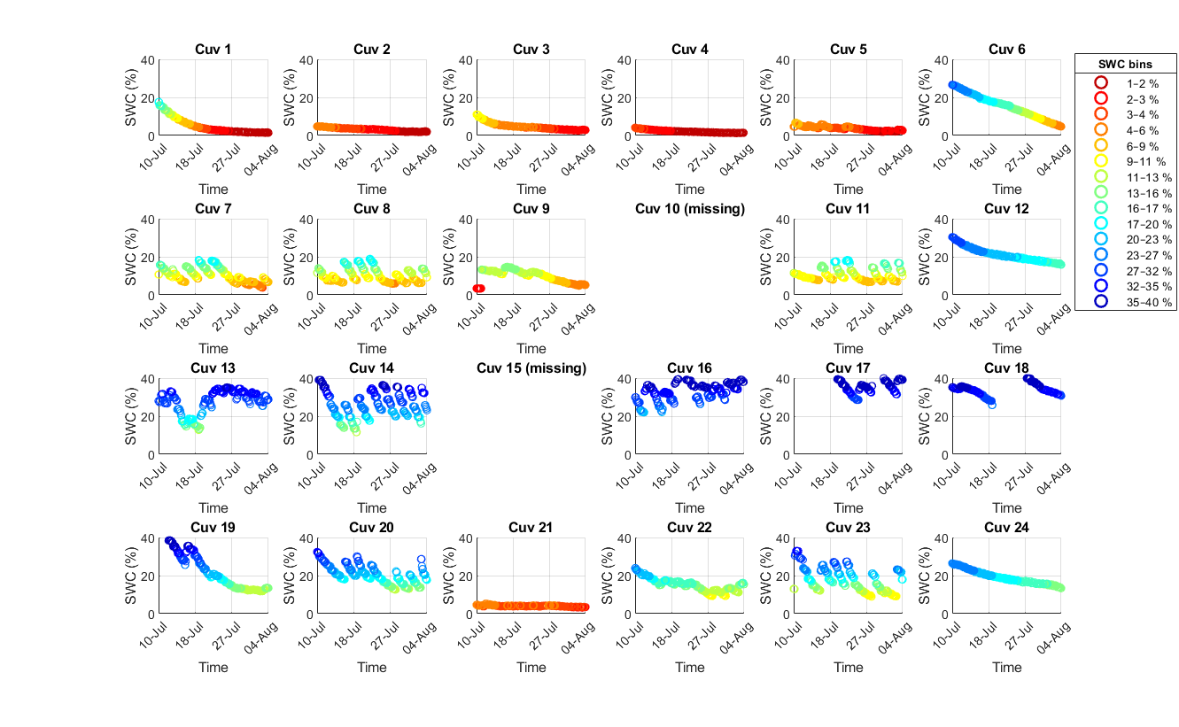
b
Figure S5. Soil water content (SWC) plotted against time, grouped into bins containing equal numbers of measurements. The SWC ranges for each bin are indicated in the legend. Panels (a) and (b) show pine and juniper, respectively, for each cuvette. Cuvettes 6, 12, 18 and 24 were only soil and cuvette 10 for both and 15 only for juniper were excluded from the experiment.
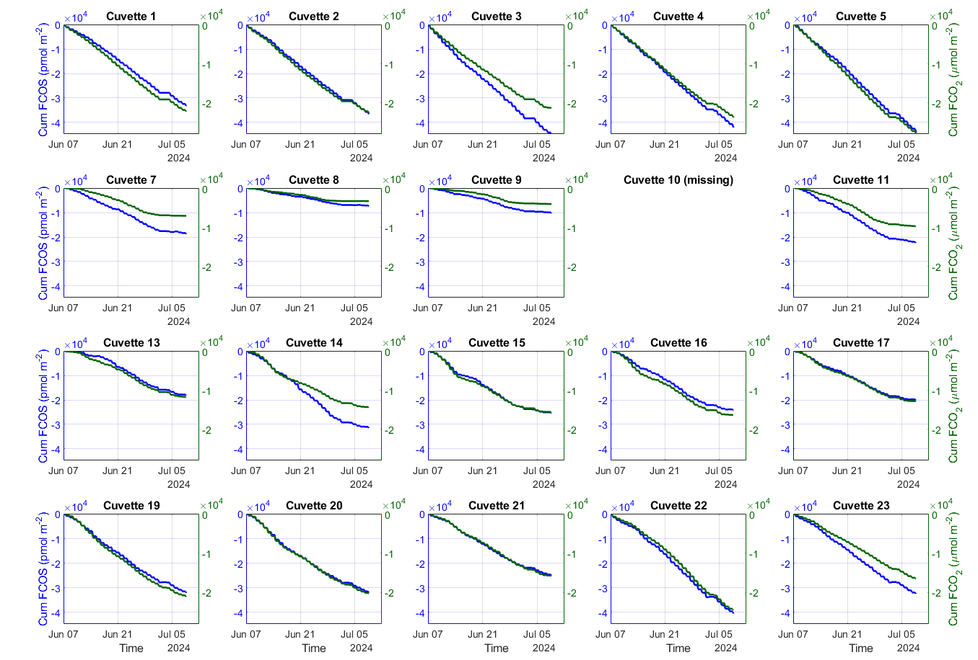
a
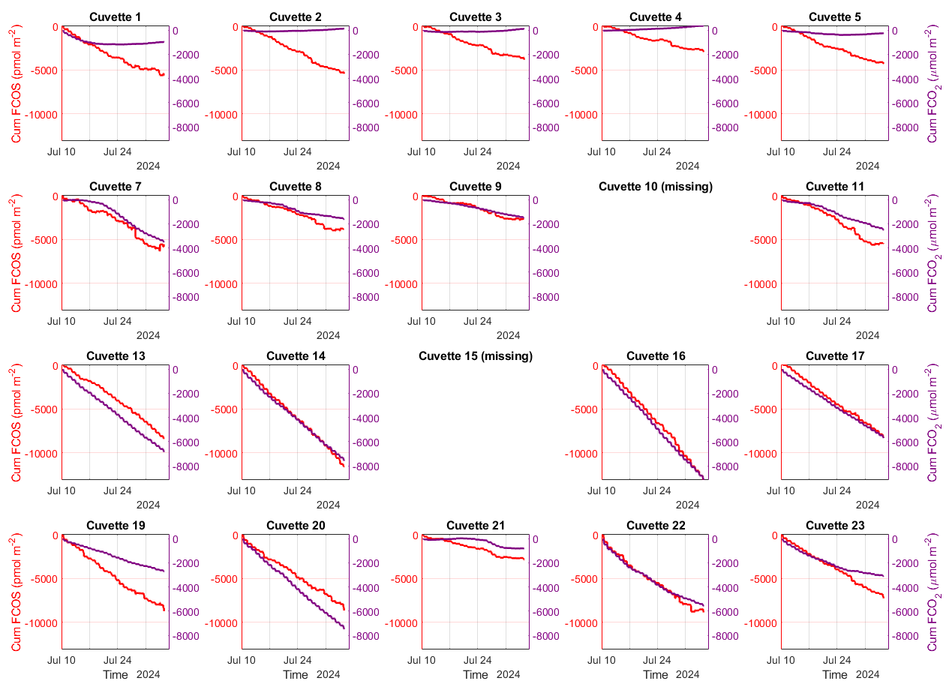
b
Figure S6. Cumulative day-time COS and CO₂ fluxes for pine and juniper over time for quantiles of soil water content (SWC) per plant cuvette. Cuvettes 10 and 15 for juniper were excluded from the experiment.

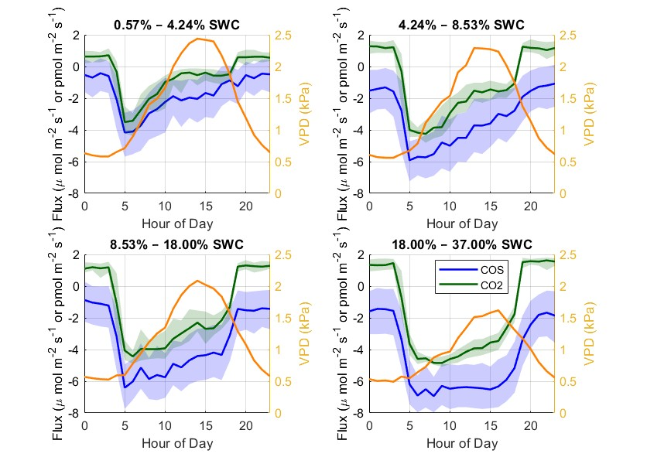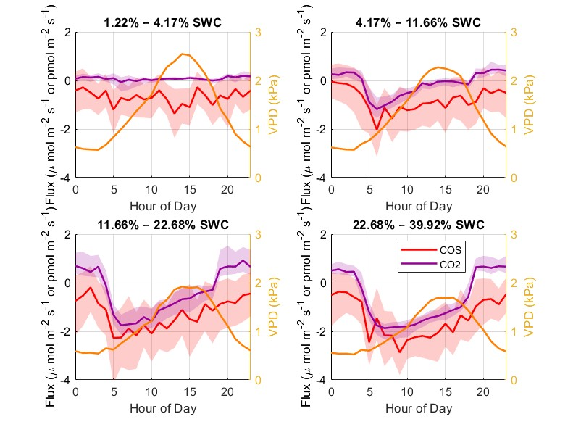
a
b
Figure S7. Median diurnal cycle of COS (blue, red) and CO₂ (green, purple) for pine in a and juniper in b fluxes with 25 % - 75 % percentile range (shadings) and vapor pressure deficit (VPD) (orange) on the y-axis. The four SWC bins were constructed by dividing the dataset into four groups with equal sample size after sorting by soil water content.
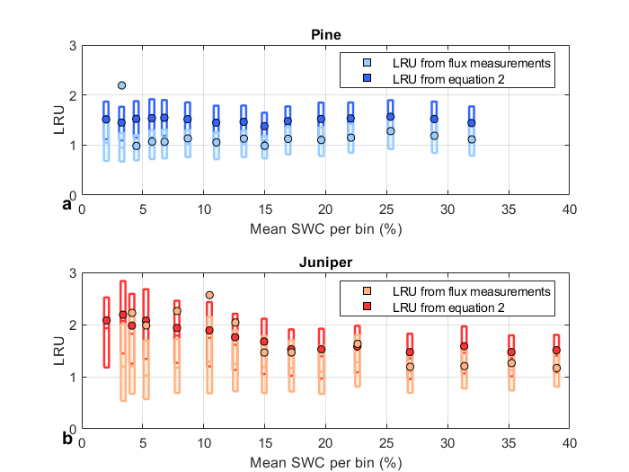
Figure S8. Leaf relative uptake (LRU) calculated based on measured COS and CO₂ fluxes (blue and red), and based on equation 2 (light blue and orange) for pine in a and juniper in b. The boxplots show the median with 25 % – 75 % percentile range, dots represent the mean. The mean difference between the two methods is 0.23 (17%) for pine and 0.18 (10%) for juniper. Only daytime (9:00 – 16:00 UTC) data was used.
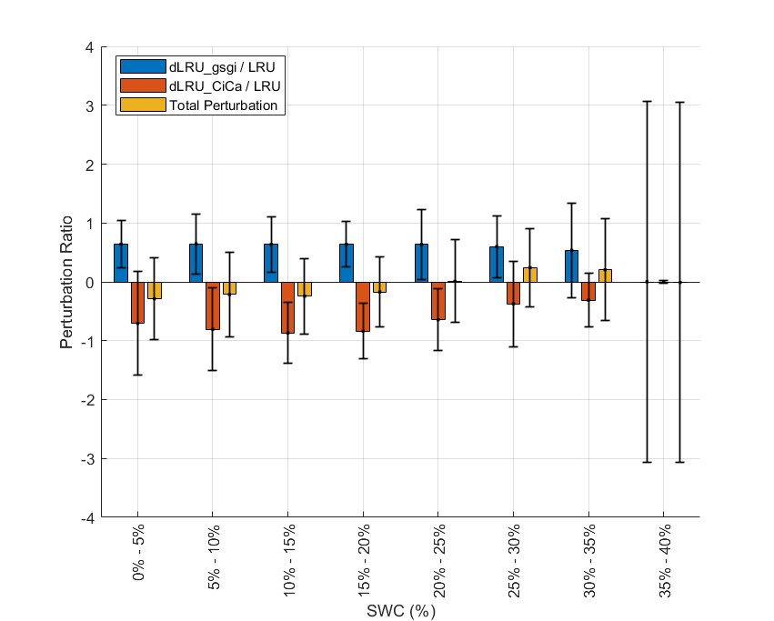
Figure S9. Linear perturbation analysis on pine (see equation S1). Variations in $\frac{g_{s}^{s}}{g_{i}^{s}}$ in blue, $\frac{C_{i}^{c}}{C_{a}^{c}}$ in red and the total perturbation on the leaf relative uptake (LRU) in orange. Medians (colored bar) with 25 % - 75 % percentile range (black whiskers) are showed. Only daytime (9:00 – 16:00 UTC) data was used.
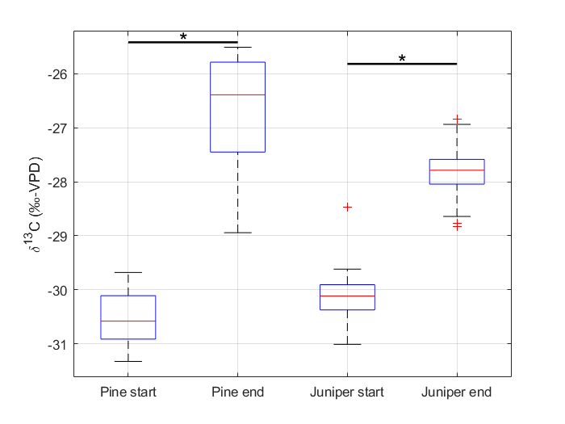
Figure S10. Boxplot of δ¹³C data for all pine and juniper sampled at the start and end of each experiment. Medians (red bar) with 25 % - 75 % percentile range (blue boxes) and upper and lower bounds (whiskers) with outliers are showed. Starts indicate significant (p < 0.001) difference between the pre and post samples.
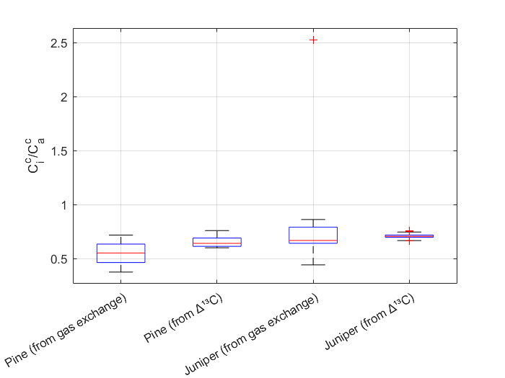
Figure S11. Boxplot of $\frac{C_{i}^{c}}{C_{a}^{c}}$ calculated using the gas exchange and δ¹³C data for pine and juniper. Medians (red bar) with 25 % - 75 % percentile range (blue boxes) and upper and lower bounds (whiskers) with outliers are showed. Only daytime (9:00 – 16:00 UTC) data was used for gas exchange values.

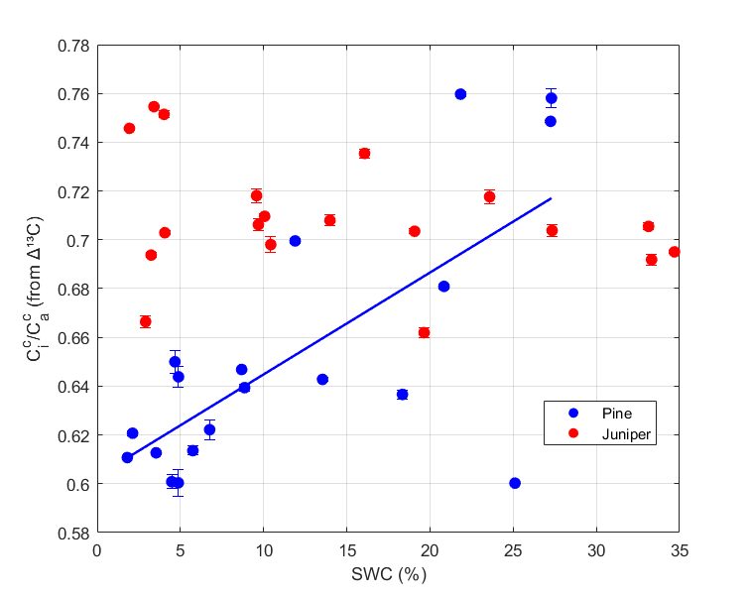
Figure S12. $\frac{C_{i}^{c}}{C_{a}^{c}}$ with standard deviation calculated with the mean δ¹³C data sampled at the end of the experiment against the SWC averaged over the last three weeks of the experiment for pine and juniper. In pine a significant increasing trend was found per increasing SWC unit (slope of 0.004 SWC % per $\frac{C_{i}^{c}}{C_{a}^{c}}$ and p-value of 0.0008).

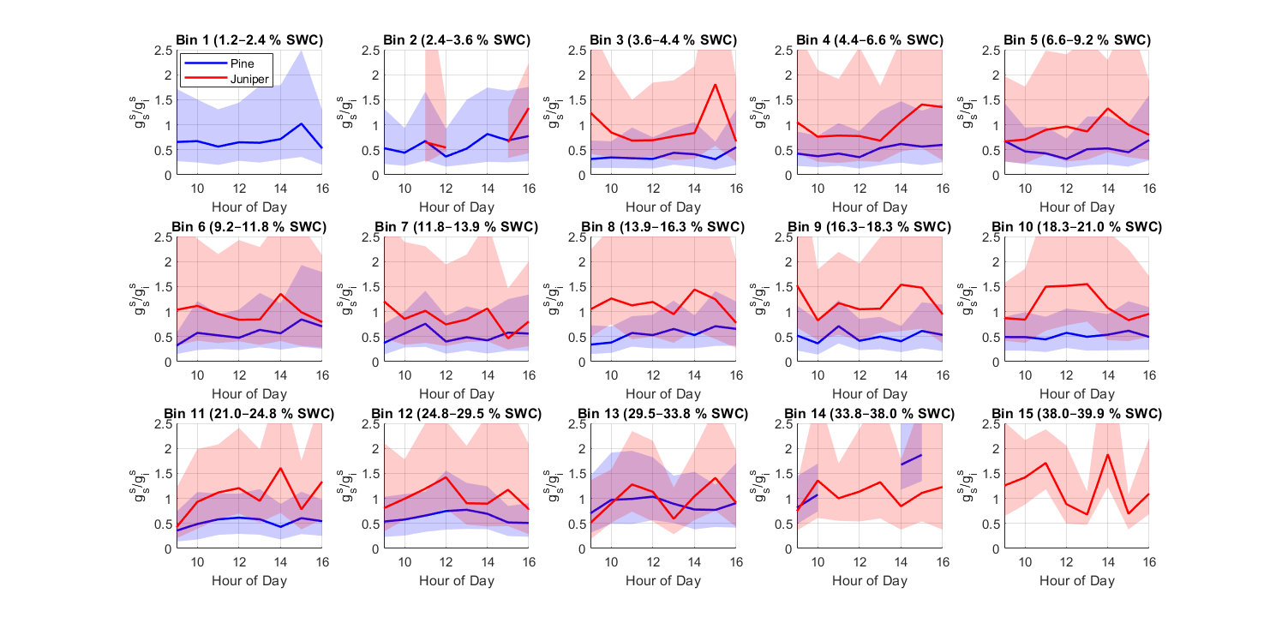
Figure S13. Median daytime (9:00 – 16:00 UTC) $\frac{g_{s}^{s}}{g_{i}^{s}}$ for pine (blue line) and juniper (red line) with 25 % -75 % percentile ranges (shadings) per bin of soil water content (SWC).

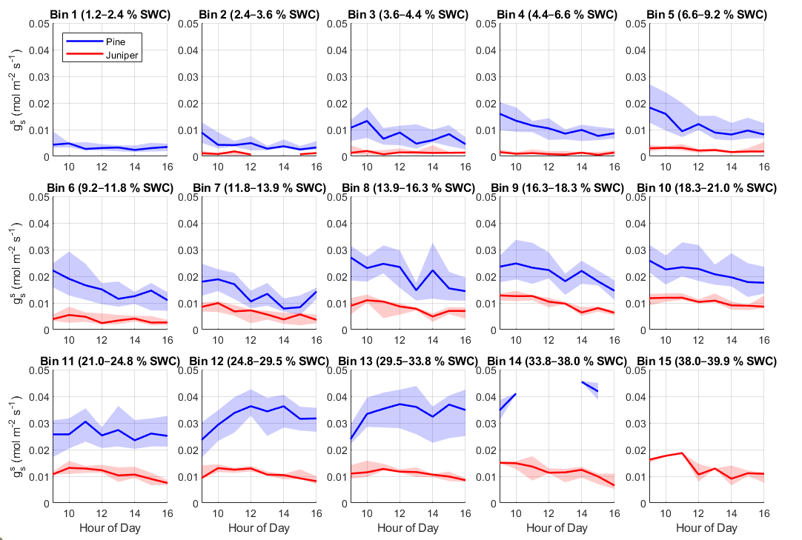
a
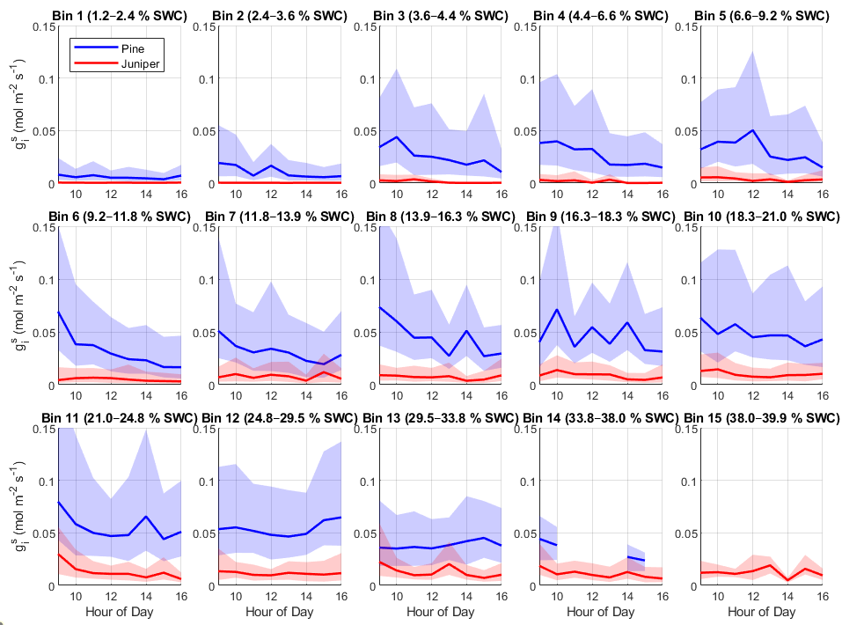
b
Figure S14. Daytime (9:00 – 16:00 UTC) median of stomatal conductance $g_{s}^{s}$ (mol/m2s) in a and internal conductance $g_{i}^{s}$ (molm⁻²s⁻¹) to COS in b for pine (blue line) and juniper (red line) with 25 % - 75 % percentile ranges (shadings) per bin of soil water content (SWC).
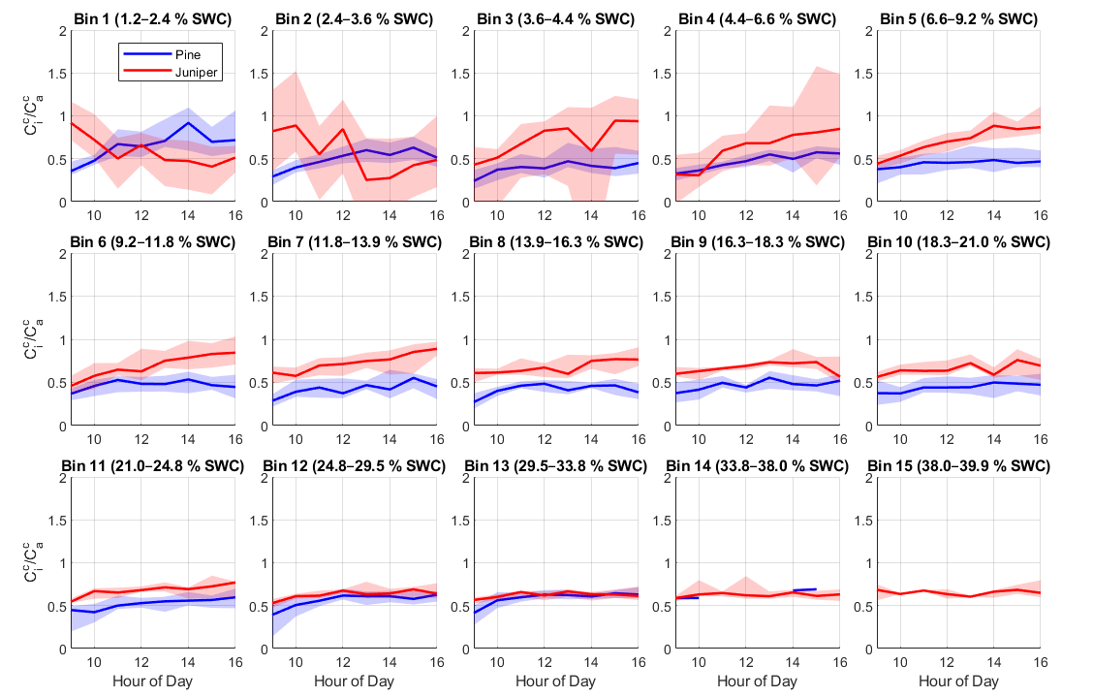
Figure S15. Daytime (9:00 – 16:00 UTC) median of $\frac{C_{i}^{c}}{C_{a}^{c}}$ for pine (blue line) and juniper (red line) with 25% - 75 % percentile ranges (shadings) per bin of soil water content (SWC).

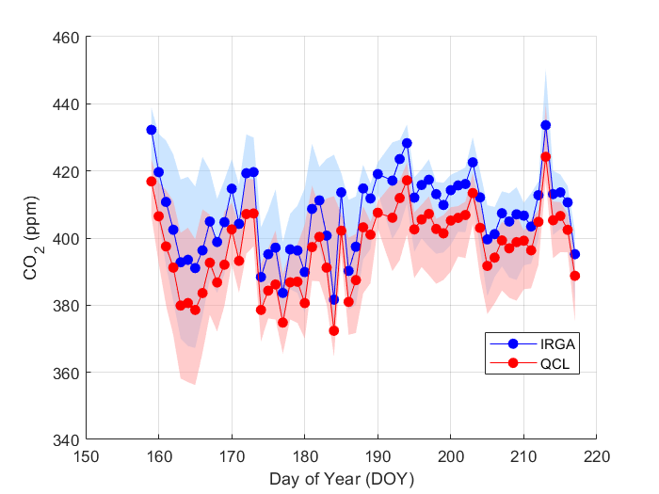
Figure S16. Median CO₂ concentrations during daytime (9:00 – 16:00 UTC) with 25 % – 75 % percentile. Blue data measured with the IRGA and red the data measured with the QCL.

