Supplementary Materials
Table S1. Infrared absorption bands and their corresponding band strength used to monitor the ice composition and its evolution during the deposition-irradiation process. Values extracted from Bouilloud et al. (2015). The following column density was calculated based on the infrared spectra of the SOMA-1 sample after 1 hour of deposition. Notes: ν: stretching.
Molecules | Mode | Wavenumber range (cm⁻¹) | Band Strength  A (cm.molecules⁻¹) | Calculated Column Density (molecules.cm⁻²)
H₂O | νOH | 3,612-3,003 | $$1.5×{10}^{-16}$$ | $$2.3×{10}^{17}$$
CH₃OH | νCO  νOH | 1,058-996  3,612-3,003 | $$1.07×{10}^{-17}$$  $$1.01×{10}^{-16}$$ | $$8.6×{10}^{16}$$
NH₃ | ν₂ umbrella  νNH | 1,230-1,058  3,612-3,003 | $$1.63×{10}^{-17}$$  $$2.3×{10}^{-17}$$ | $$2.0×{10}^{17}$$

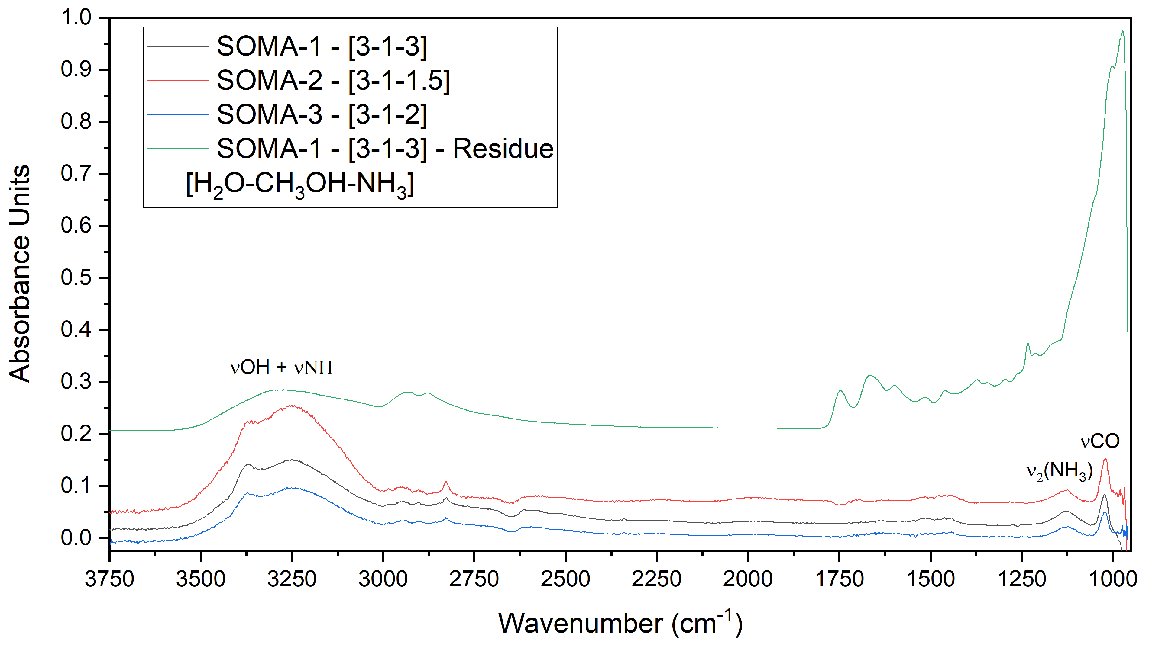
Figure S1. FT-IR spectra of the initial ice composition of SOMA-1, SOMA-2, and SOMA-3, composed of H₂O, CH₃OH, and NH₃, after 1 hour of deposition at 77 K on MgF₂ windows, together with the resulting organic residue obtained after warming the VUV-processed ice of the SOMA-1 sample. The relative proportions of each initial specie in samples are indicated in the legend as [H₂O-CH₃OH-NH₃].

Table S2. Lock-masses used for each ionisation mode, which were selected from the most intense peaks in the respective spectra. For example, C₇H₁₄N₄ corresponds to the HMT-CH₃ derivative already detected in such samples in previous analyses (Muñoz Caro et al., 2004; Garcia, 2023; Del Burgo Olivares et al., 2025). Common contaminants such as fatty acids C₁₆H₃₀O₂ and C₁₈H₃₄O₂, originating from solvents or extraction, and washing protocols, also produce intense signals in the spectra. C₁₂H₁₈F₁₂N₃O₆P₃ is a widely used internal calibrant provided by Bruker for APCI and APPI ionisation modes.
Ionisation mode | Sample | m/z | Attribution
ESI (+) | SOMA-1 | 155.129123  410.251029 | C₇H₁₄N₄  C₁₈H₃₁N₇O₄
 | SOMA-2 | 199.155338  227.150252  257.160817 | C₉H₁₈N₄O  C₁₀H₁₈N₄O₂  C₁₁H₂₀N₄O₃
 | SOMA-3 | 130.159026  155.129123 | C₈H₁₉N  C₇H₁₄N₄
ESI (-) | All three | 255.232954  283.264254 | C₁₆H₃₀O₂  C₁₈H₃₄O₂
APPI (+) | SOMA-1 | 199.155338  255.145167 | C₉H₁₈N₄O  C₁₁H₁₈N₄O₃
 | SOMA-2 | 622.028961 | C₁₂H₁₈F₁₂N₃O₆P₃
 | SOMA-3 | 129.091006 | C₇H₁₂O₂
APPI (-) | SOMA-1 | 255.232954 | C₁₆H₃₀O₂

Table S3. Analytical repeatability of the mass lists for each ionisation mode. Columns report the percentage of masses with coefficients of variation (CV) below 10%, 20%, and 30%, as well as the average CV for each mass list, highlighting the low analytical variability of replicate FT-ICR MS injections. CV was calculated using the intensity of each mass detected in the triplicates.
Ionisation mode | CV < 10% | CV < 20% | CV < 30% | Average CV (%)
ESI (+) | 74.1 | 93.9 | 97.6 | 8
ESI (-) | 78.3 | 98.4 | 99.9 | 7
APPI (+) | 77.8 | 94.9 | 99.1 | 7
APPI (-) | 63.3 | 92.1 | 98.9 | 9

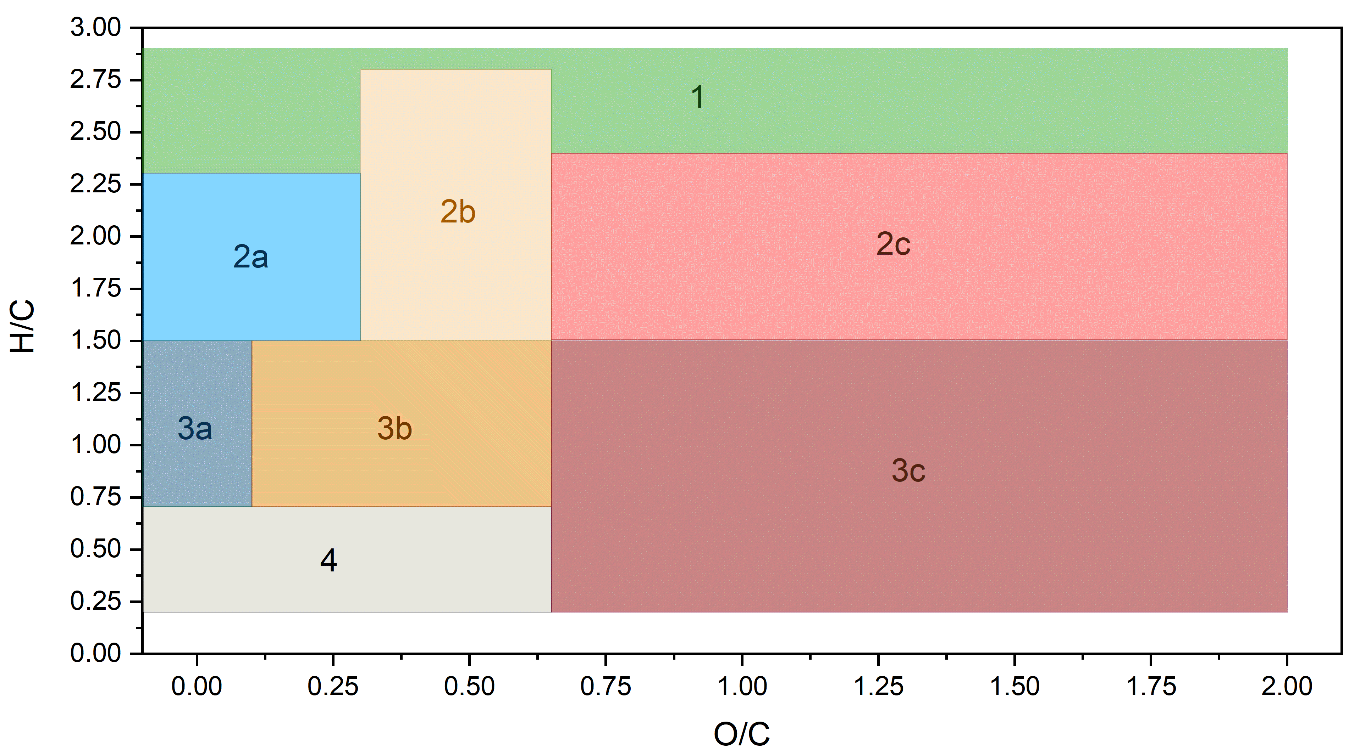
Figure S2. Van Krevelen partitions of FT-ICR MS data, originally defined from biochemical classes detected in natural organic matter, then adapted for astrophysical context in Danger et al. (2016). Category 1: Fully saturated structure -OR/-NR₁R₂, not included in categories 2a, 2b, and 2c (H/C ≥ 2.0; 0 ≤ O/C < 2). Category 2a: Alkyl chains with CO₂H/CONH₂ (1.5 ≤ H/C < 2.5; 0 ≤ O/C < 0.3). Category 2b: Alkyl chains (-CO₂R)n/(-CONR₁R₂)n/-NR₁R₂ (1.5 ≤ H/C < 2.8; 0.3 ≤ O/C < 0.65). Category 2c: Alkyl chains enriched in O (-CO₂R)n/-OR with low amount of N (1.5 ≤ H/C < 2.4; 0.65 ≤ O/C < 2). Category 3a: conjugated structures with possible phenyl groups enriched in N with few O functions (0.75 ≤ H/C < 1.5; 0 ≤ O/C < 0.1). Category 3b: conjugated structures with possible phenyl groups (-CO₂R)n/(-CONR₁R₂)n/-NR₁R₂ (0.75 ≤ H/C < 1.5; 0.1 ≤ O/C < 0.65). Category 3c: conjugated structures with possible phenyl groups, enriched in O with few N functions (0.75 ≤ H/C < 1.5; 0.65 ≤ O/C < 2). Category 4: Highly aromatic structures with O and N functions (0.2 ≤ H/C < 0.65; 0 ≤ O/C < 0.65).

S1. SOMA-1 Sample Supplementary Materials

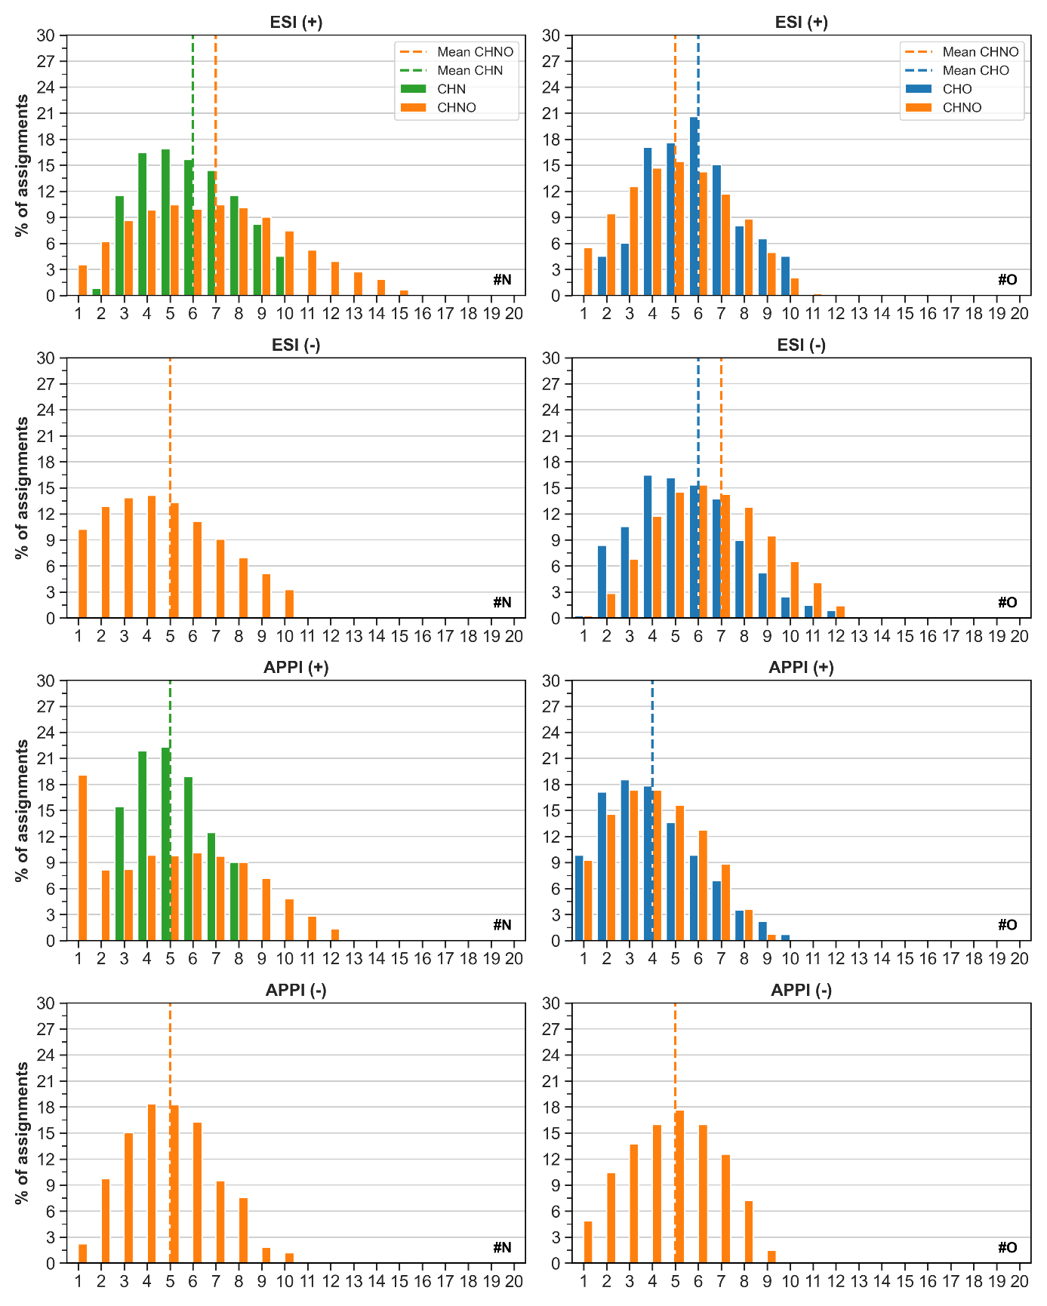
Figure S3. Distributions of N and O atoms in assignments obtained for the SOMA-1 sample, analysed by ESI (+), ESI (-), APPI (+), and APPI (-) FT-ICR MS.
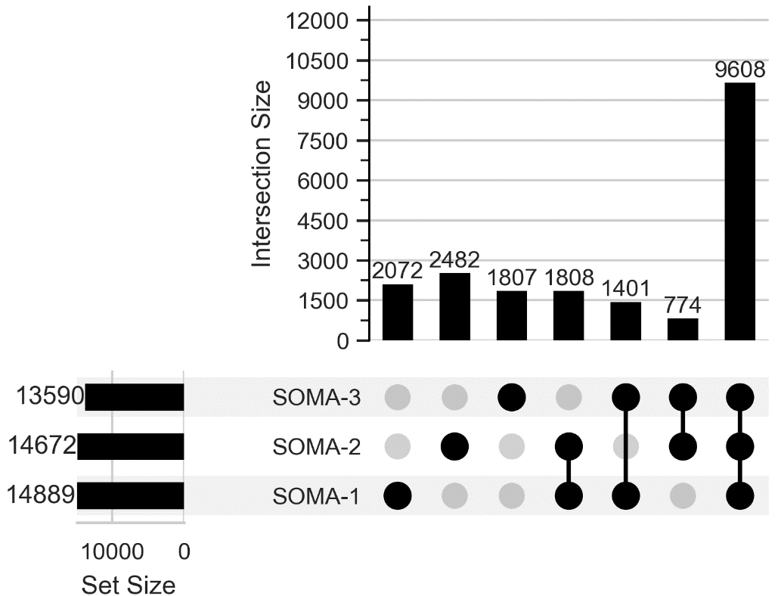
Figure S4. Number of unique molecular formulas assigned in the three sample SOMA-1, SOMA-2, and SOMA-3, achieved by ESI- and APPI-FT-ICR MS. The figure shows also the intersections between samples.

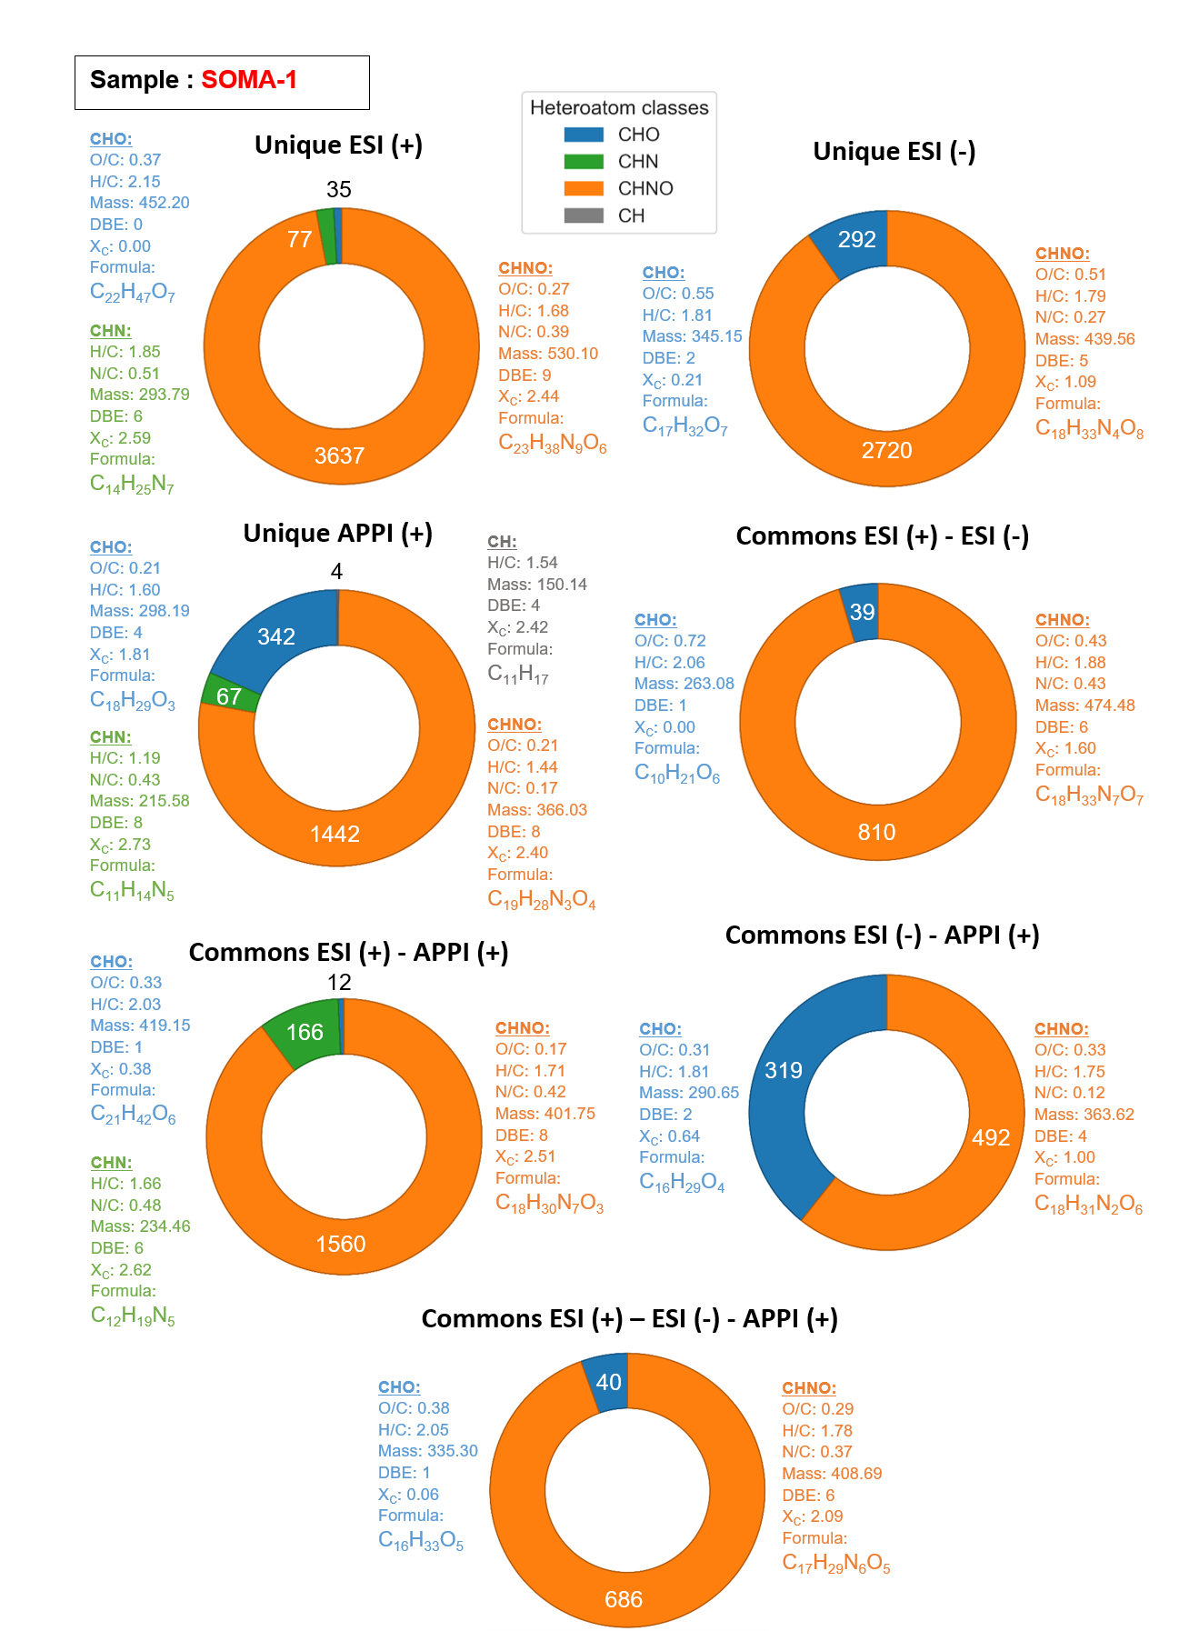
Figure S5. Subcategories data of Venn diagram achieved from data obtained using FT-ICR MS with ESI and APPI, in both positive- and negative-ion modes, from SOMA-1 organic residue made from VUV irradiated interstellar ice analogues (1/2).

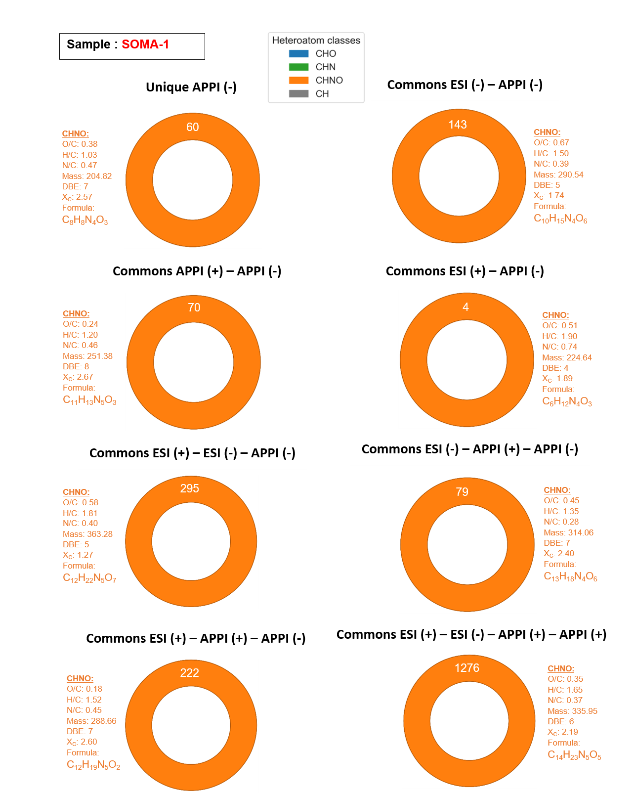
Figure S6. Subcategories data of Venn diagram achieved from data obtained using FT-ICR MS with ESI and APPI, in both positive- and negative-ion modes, from SOMA-1 organic residue made from VUV irradiated interstellar ice analogues (2/2).

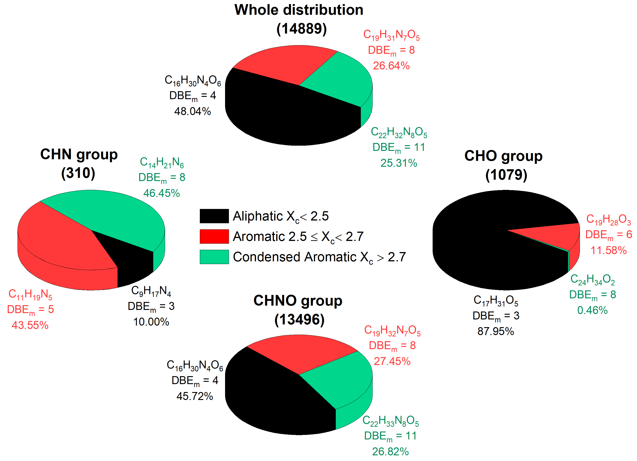
Figure S7. Unsaturation distribution of heteroatom assignments based on the aromaticity equivalent (X_{c}) for the whole distribution, CHNO, CHN, and CHO groups in SOMA-1. Data were obtained from each ionisation mode and duplicate attributions were removed. Figure adapted to Danger et al. (2016).

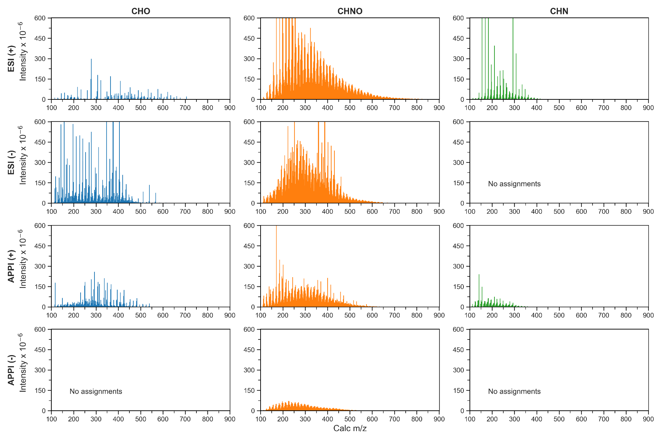
Figure S8. Mass spectra per heteroatom class of SOMA-1 sample, achieved by ESI (+), ESI (-), APPI (+), and APPI (-).

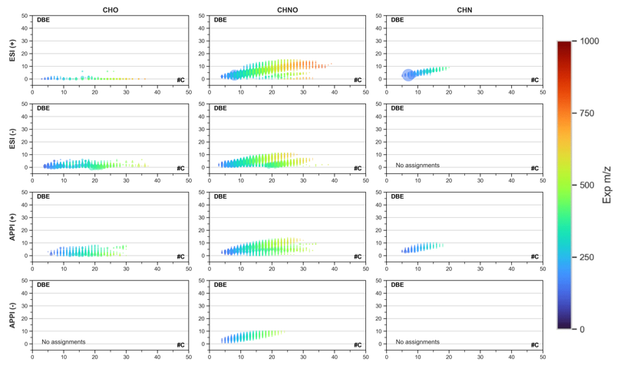
Figure S9. Double-Bond Equivalent (DBE) distributions in function of carbon number (#C) of the molecular formulas in SOMA-1, with multiple ionisation modes ESI (+), ESI (-), APPI (+), and APPI (-). The bubble size refers to the signal intensity and the colour to the experimental ion mass value from m/z 0 to 1,000.

S2. SOMA-2 Sample Supplementary Materials

Table S4. Description of the SOMA-2 extracted from H₂O-CH₃OH-NH₃ [3-1-1] analogue sample, analysed by ESI-FT-ICR MS, in both positive- and negative-mode, and APPI in positive-mode. Number of assignments for each class of molecules (CH, CHO, CHN, and CHNO), percentages of atomic ratios, as well as the average DBE, Xc, mass, and formula for each analytical condition are also displayed.
Heteroatom Class | ESI (-) | ESI (+) | APPI (+)
CH | - | - | -
CHO | 693 (9.8 %) | 18 (0.2 %) | 509 (9.8 %)
CHN | - | 298 (2.9 %) | 168 (3.2 %)
CHNO | 6,362 (90.2 %) | 9,826 (96.9 %) | 4,532 (87.0 %)
Total Assigned Features | 7,055 | 10,142 | 5,209
Average O/C | 0.46 | 0.26 | 0.27
Average H/C | 1.70 | 1.69 | 1.63
Average N/C | 0.25 | 0.36 | 0.23
Average DBE | 5 | 8 | 6
Average X_{c} | 1.39 | 2.34 | 1.92
Average mass | 395.28305 | 461.29109 | 356.80792
Average formula | C₁₇H₂₉N₄O₇ | C₂₀H₃₄N₇O₅ | C₁₇H₂₈N₄O₅

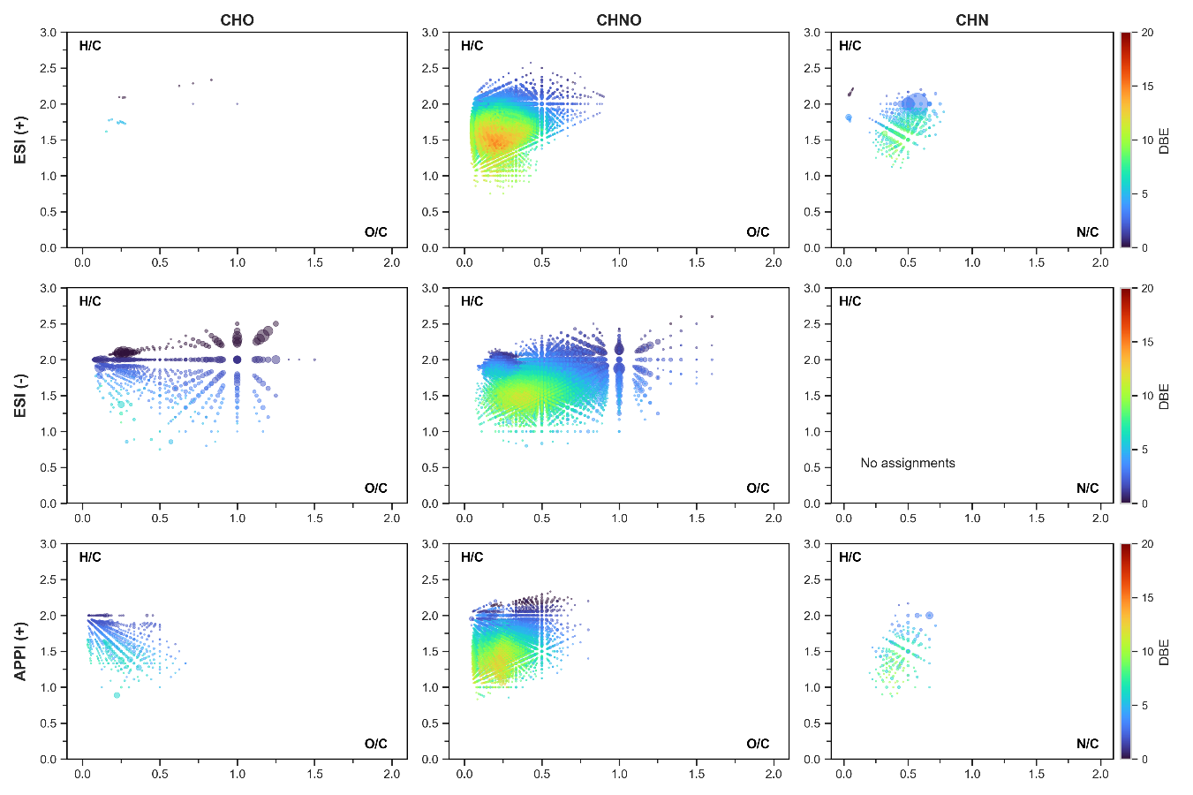
B.
A.
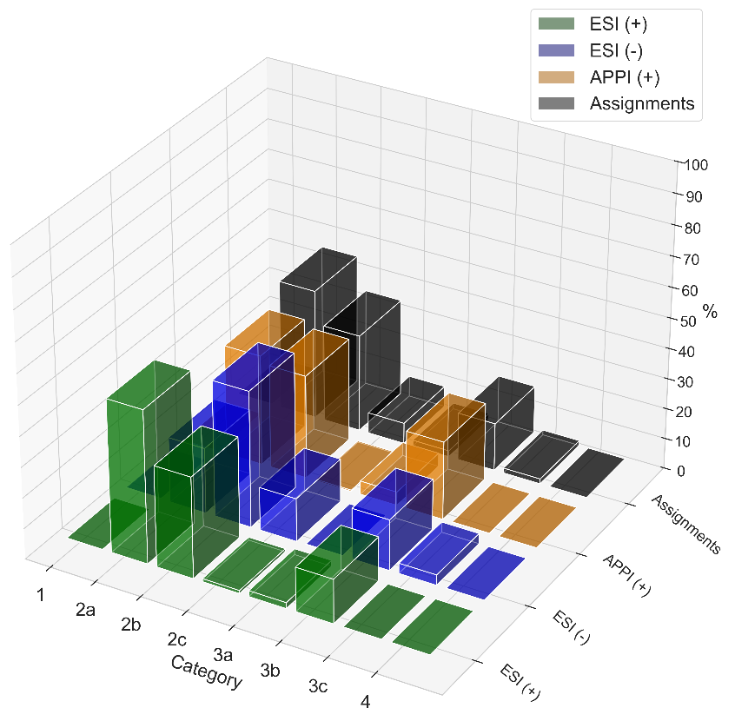
Figure S10. A) Van Krevelen diagrams of the different heteroatom classes identified in the SOMA-2, with multiple ionisation modes ESI (+), ESI (-), APPI (+), and APPI (-). The bubble size refers to the signal intensity and the colour to the DBE value from 0 to 20; B) Distribution of the van Krevelen categories for each ionisation mode used, as well as the total number of molecular formulas, referred as “Assignments”, based on Danger et al. (2016) partitions. Category 1: Fully saturated structures -OR/-NR₁R₂. Category 2a: Alkyl chains with CO₂H/CONH₂. Category 2b: Alkyl chains (-CO₂R)n/(-CONR₁R₂)n/-NR₁R₂. Category 2c: Alkyl chains enriched in O (-CO₂R)n/-OR with low amount of N. Category 3a: conjugated structures with possible phenyl groups enriched in N with few O functions. Category 3b: conjugated structures with possible phenyl groups (-CO₂R)n/(-CONR₁R₂)n/-NR₁R₂. Category 3c: conjugated structures with possible phenyl groups, enriched in O with few N functions. Category 4: Highly aromatic structures with O and N functions.
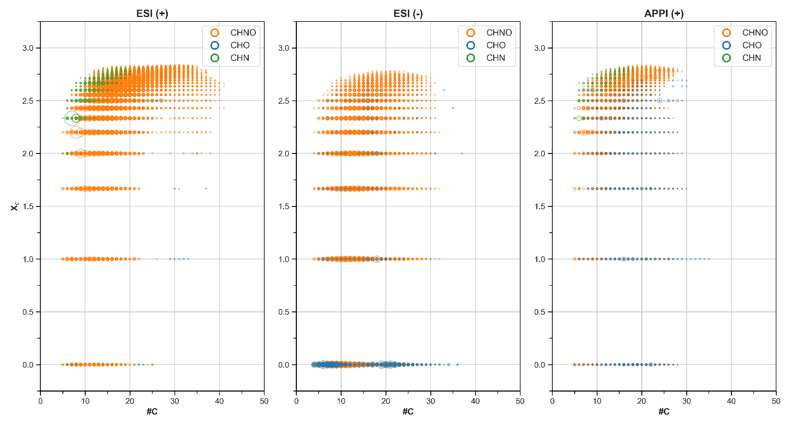
Figure S11. Aromaticity equivalent distributions of molecular formulas in the SOMA-2 sample, achieved by ESI (+), ESI (-), and APPI (+). The bubble size refers to the signal intensity. The colour refers to the heteroatom classes: Orange = CHNO; Blue = CHO; Green = CHN; Gray = CH. A X_{c} value of 2.5 would be analogue to a benzene-like structure.

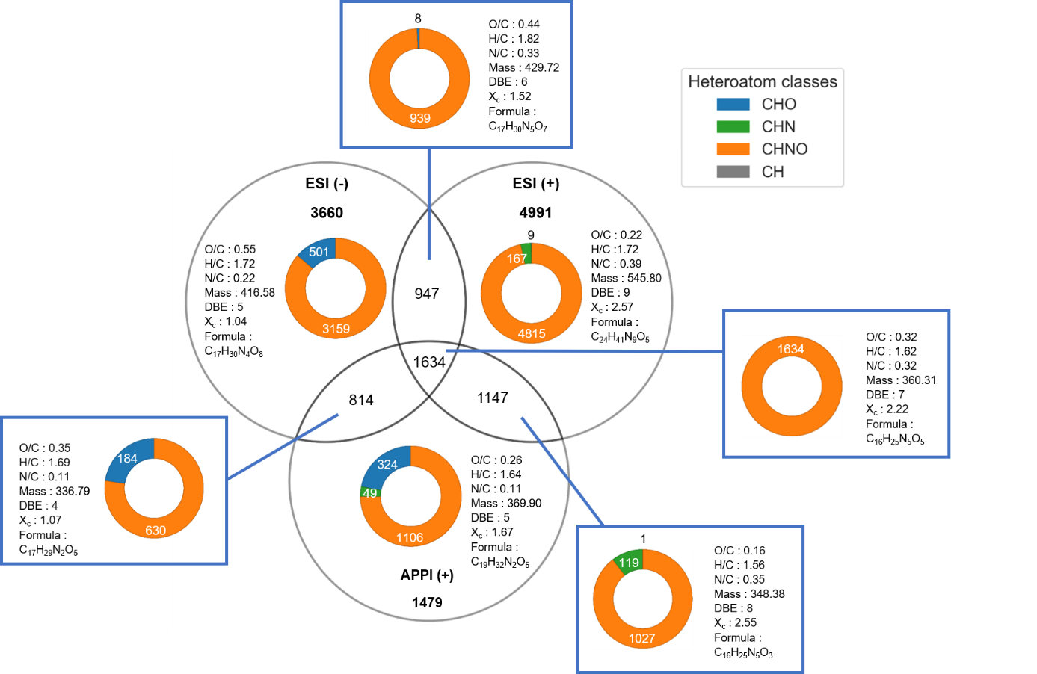
Figure S12. Venn diagram achieved from data obtained using FT-ICR MS with ESI in both positive- and negative-ion modes and APPI in positive-mode, from SOMA-2 organic residue made from VUV irradiated interstellar ice analogues. Each ellipse represent one analytical condition used in this study. The intersection between ellipses correspond to molecular formulas detected by two, or all three ionisation modes. For example, the central overlapping area represents 1,634 molecular formulas that were detected under all three analytical conditions, defining a shared population common to the three ionisation modes. Molecular formulas detected by multiple ionisation modes may correspond to several distinct isomers. The displayed values represent the averages of each distribution, considering all heteroatom classes. For the mean values of each subcategory, see Figure S17.
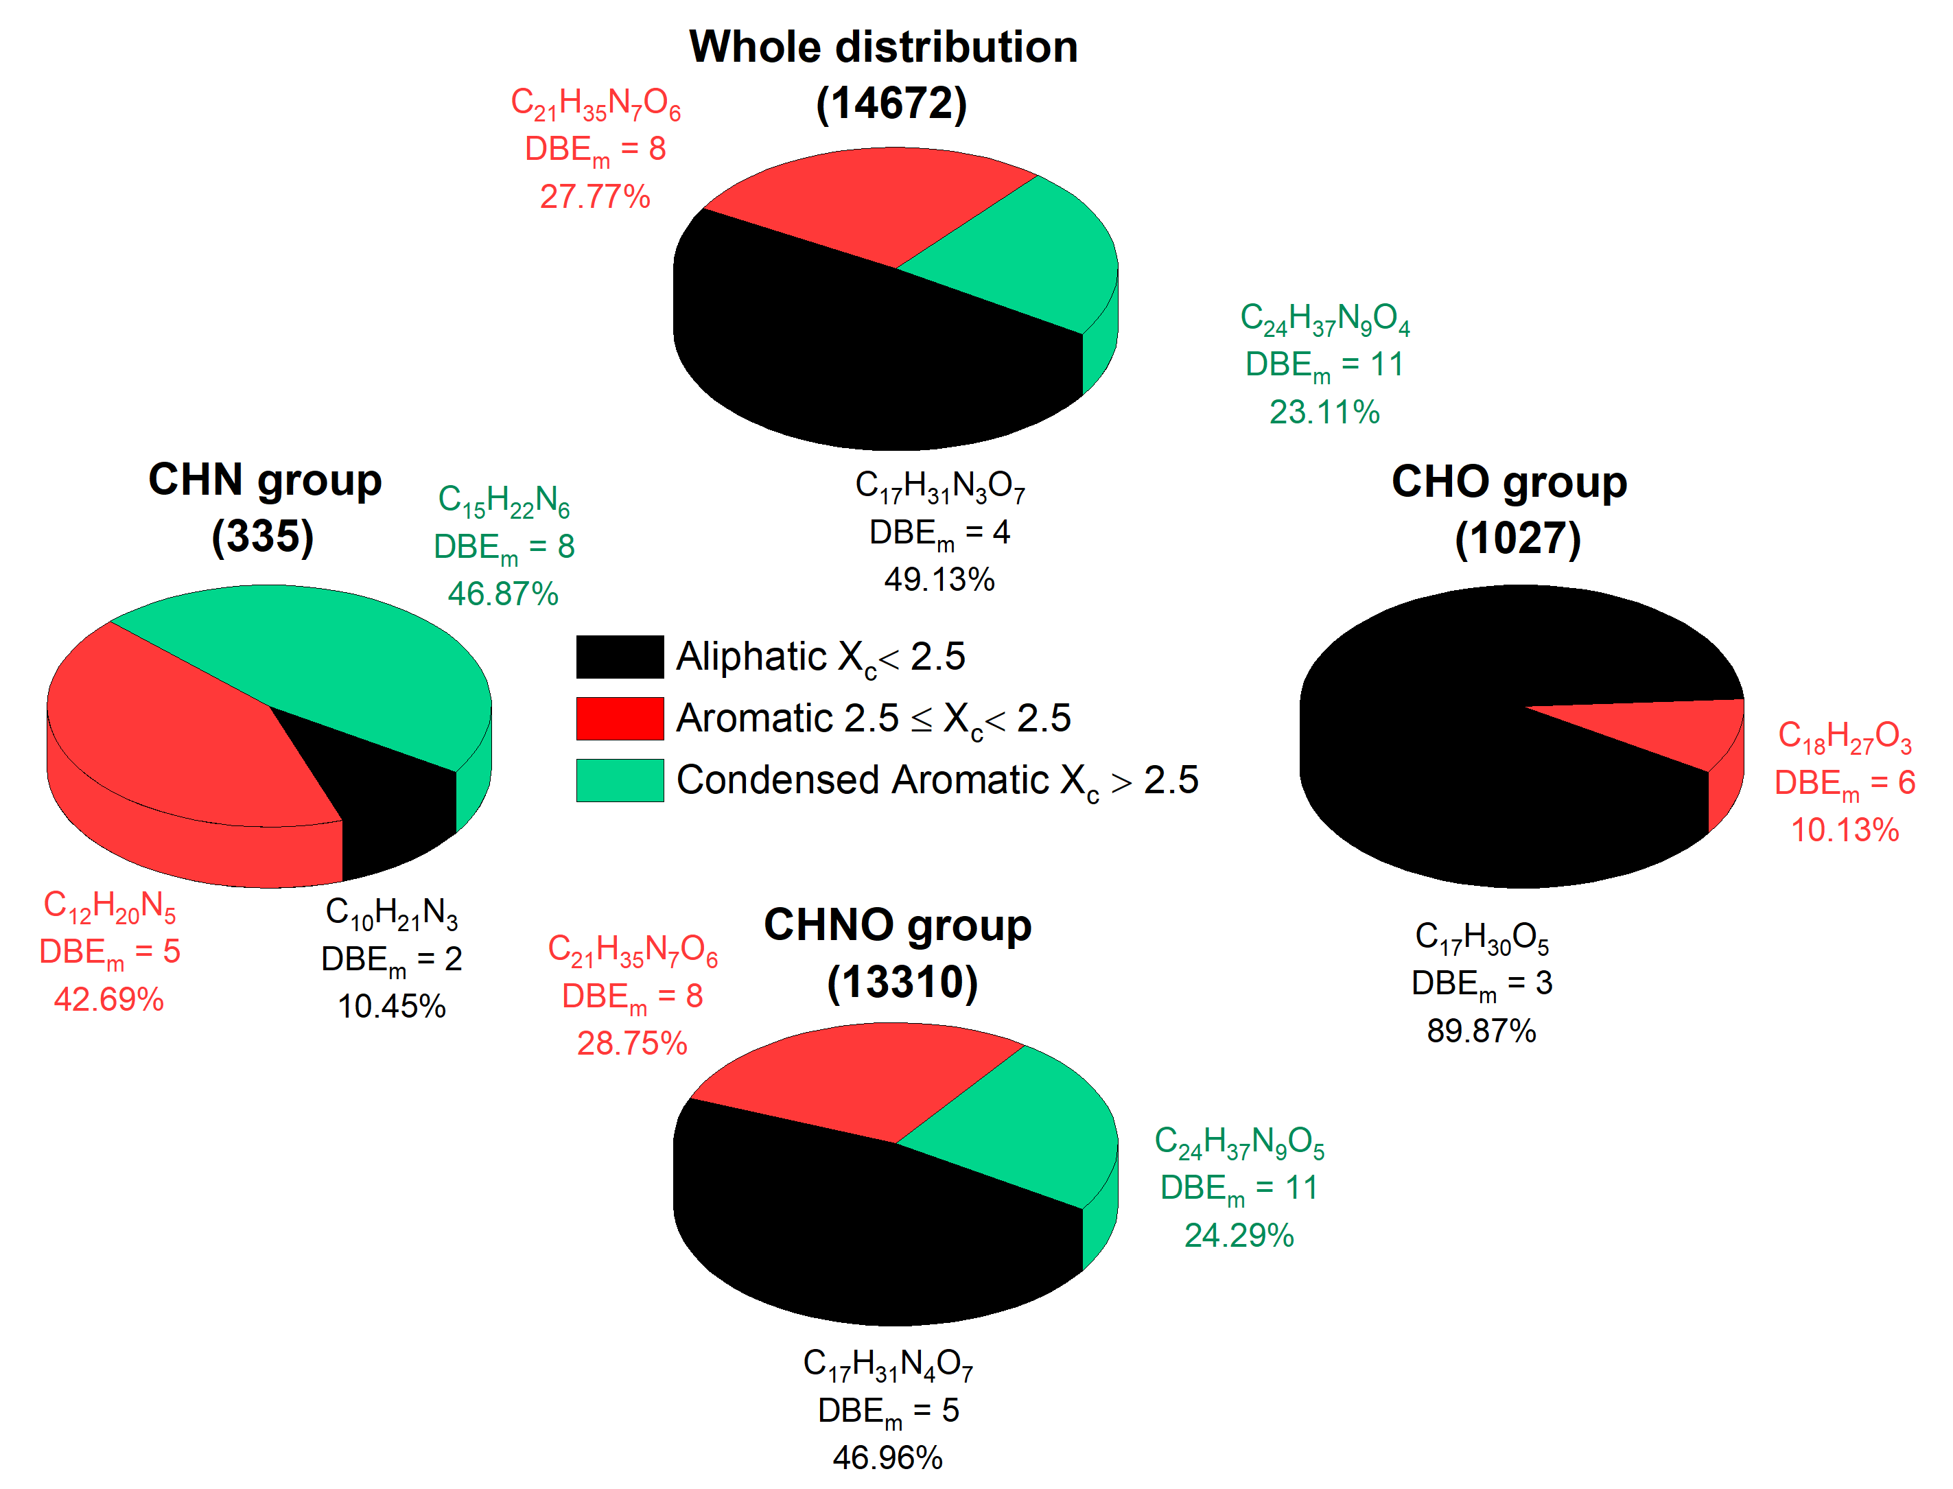
Figure S13. Unsaturation distribution of molecular assignments based on the aromaticity equivalent (X_{c}) for the whole distribution, CHNO, CHN, and CHO groups in SOMA-2. Data were obtained from each ionisation mode and duplicate attributions were removed. Figure adapted to Danger et al. (2016).

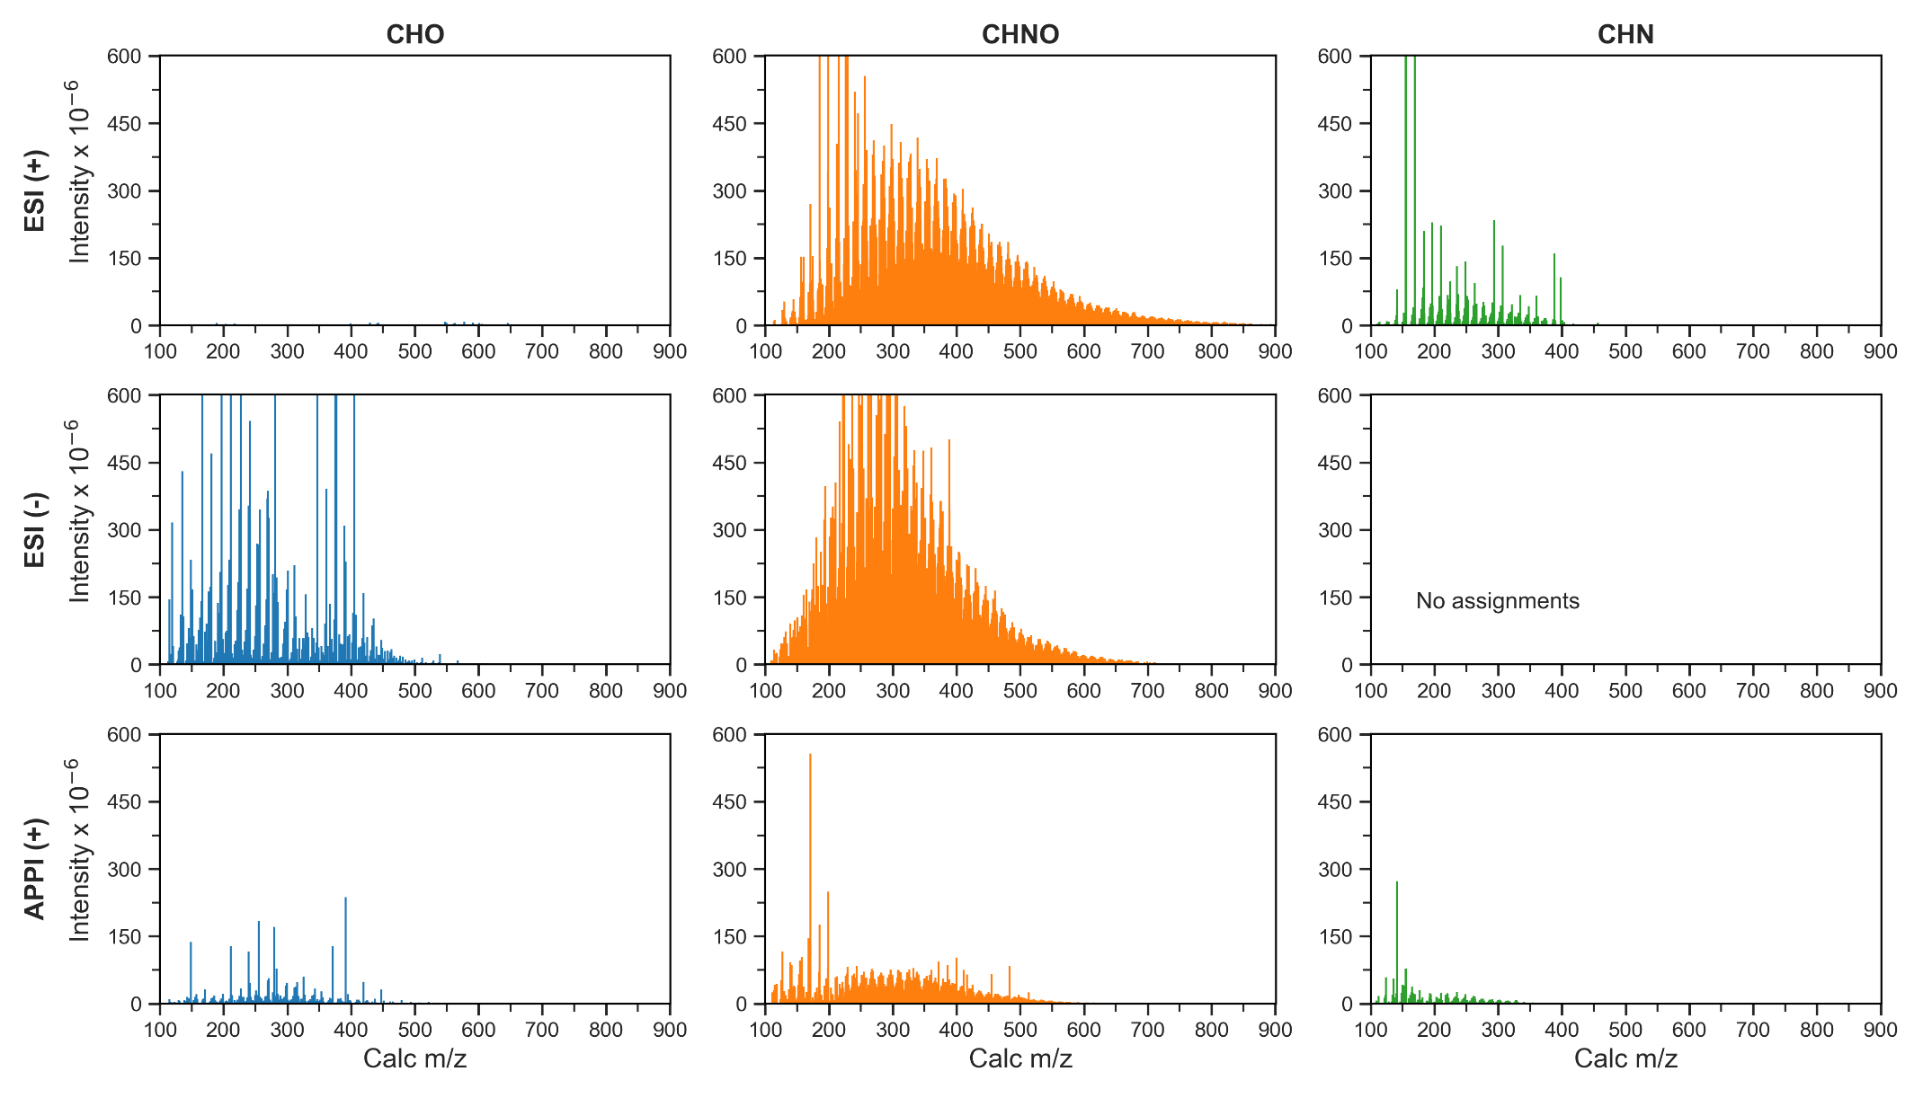
Figure S14. Mass spectra per molecular class of SOMA-2 sample, achieved by ESI (+), ESI (-), and APPI (+).
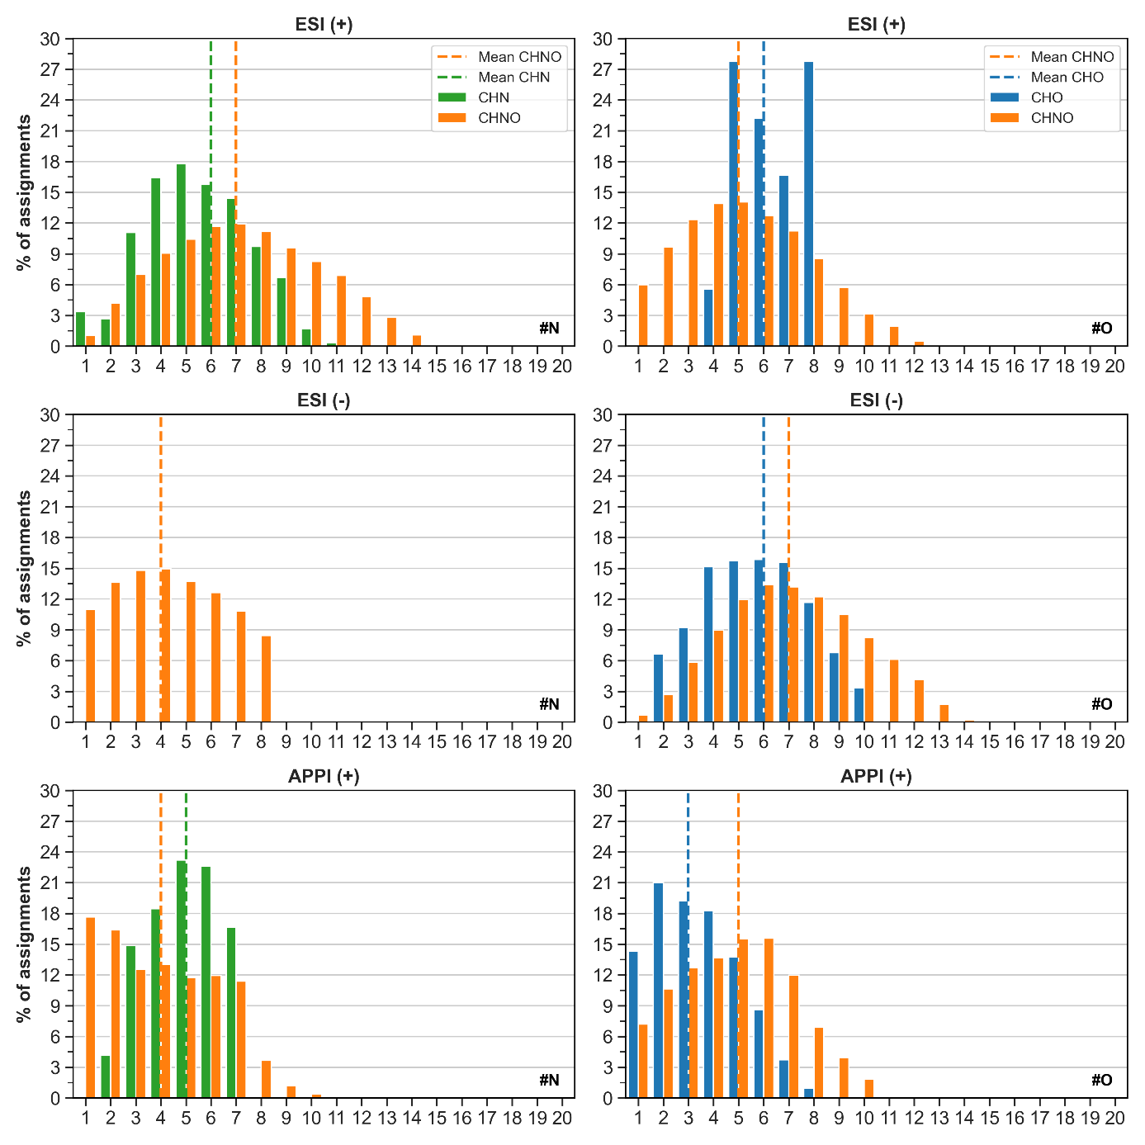
Figure S15. Distributions of N and O atoms in assignments obtained for the SOMA-2 sample, analysed by ESI (+), ESI (-), and APPI (+) FT-ICR MS.

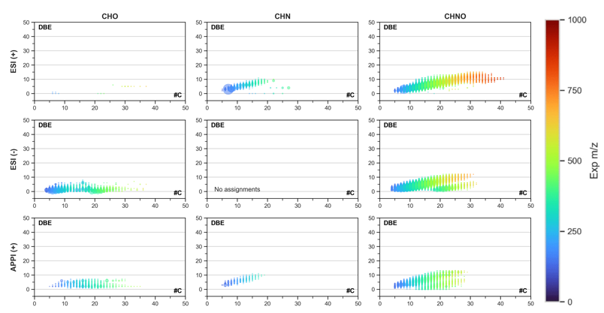
Figure S16. Double-Bond Equivalent (DBE) distributions in function of carbon number (#C) of the molecular formulas in SOMA-2, with multiple ionisation modes ESI (+), ESI (-), and APPI (+). The bubble size refers to the signal intensity and the colour to the experimental ion mass value from m/z 0 to 1,000.

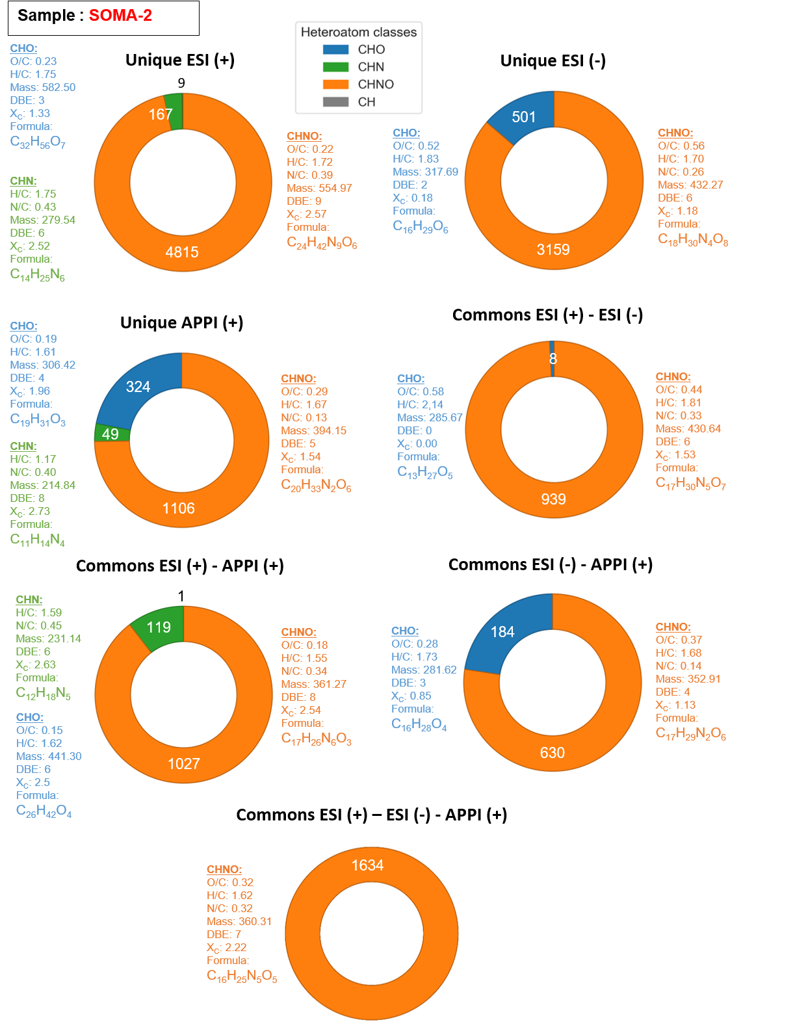
Figure S17. Subcategories data of Venn diagram achieved from data obtained using FT-ICR MS with ESI in both positive- and negative-ion modes, and APPI in positive-mode, from SOMA-2 organic residue made from VUV irradiated interstellar ice analogues.

S3. SOMA-3 Sample Supplementary Materials

Table S5. Description of the SOMA-3 extracted from H₂O-CH₃OH-NH₃ [3-1-2] analogue sample, analysed by ESI-FT-ICR MS, in both positive- and negative-mode, and APPI in positive-mode. Number of assignments for each class of molecules (CH, CHO, CHN, and CHNO), percentages of atomic ratios, as well as the average DBE, Xc, mass, and formula for each analytical condition are also displayed.
Heteroatom Class | ESI (-) | ESI (+) | APPI (+)
CH | - | - | 27 (0.4 %)
CHO | 955 (12.2 %) | 189 (2.2 %) | 140 (1.9 %)
CHN | - | 199 (2.3 %) | 319 (4.4 %)
CHNO | 6,892 (87.8 %) | 8,321 (95.5 %) | 6,740 (93.3 %)
Total Assigned Features | 7,847 | 8,709 | 7,226
Average O/C | 0.44 | 0.30 | 0.23
Average H/C | 1.73 | 1.75 | 1.62
Average N/C | 0.26 | 0.41 | 0.31
Average DBE | 5 | 6 | 7
Average X_{c} | 1.40 | 2.11 | 2.22
Average mass | 407.25812 | 399.06150 | 359.17408
Average formula | C₁₇H₃₁N₄O₇ | C₁₆H₂₈N₆O₅ | C₁₇H₂₇N₅O₄

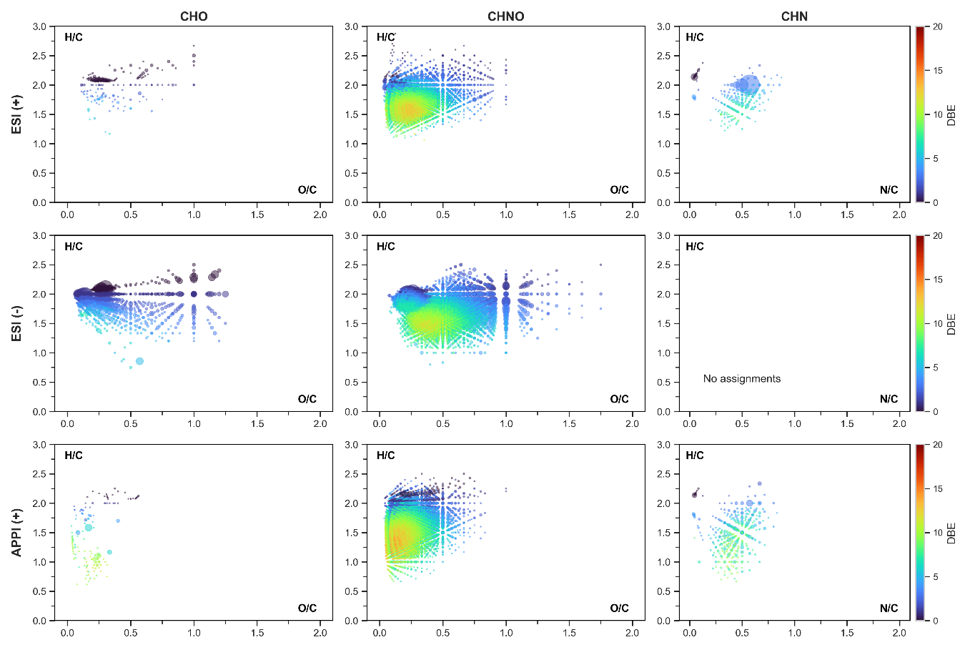
B.
A.
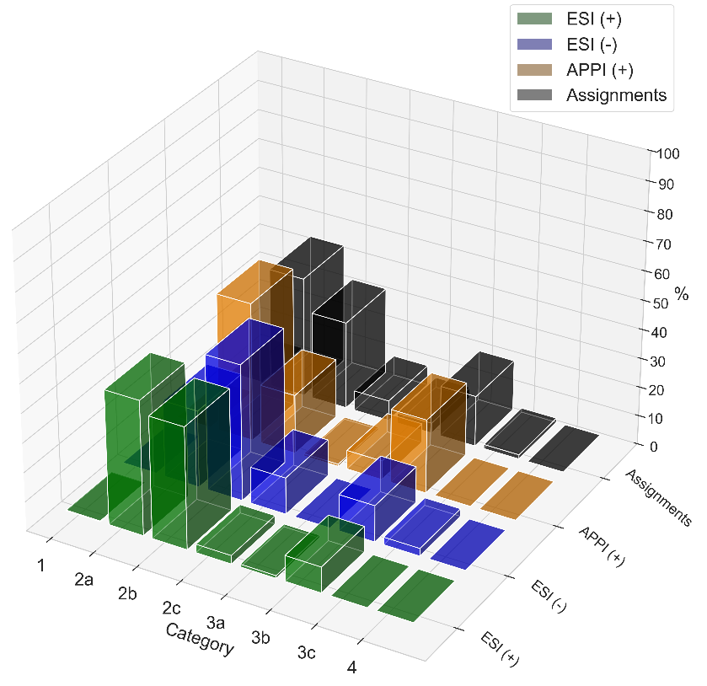
Figure S18. A) Van Krevelen diagrams of the different heteroatom classes identified in the SOMA-3, with multiple ionisation modes ESI (+), ESI (-), APPI (+), and APPI (-). The bubble size refers to the signal intensity and the colour to the DBE value from 0 to 20; B) Distribution of the van Krevelen categories for each ionisation mode used, as well as the total number of molecular formulas, referred as “Assignments”, based on Danger et al. (2016) partitions. Category 1: Fully saturated structures -OR/-NR₁R₂. Category 2a: Alkyl chains with CO₂H/CONH₂. Category 2b: Alkyl chains (-CO₂R)n/(-CONR₁R₂)n/-NR₁R₂. Category 2c: Alkyl chains enriched in O (-CO₂R)n/-OR with low amount of N. Category 3a: conjugated structures with possible phenyl groups enriched in N with few O functions. Category 3b: conjugated structures with possible phenyl groups (-CO₂R)n/(-CONR₁R₂)n/-NR₁R₂. Category 3c: conjugated structures with possible phenyl groups, enriched in O with few N functions. Category 4: Highly aromatic structures with O and N functions.
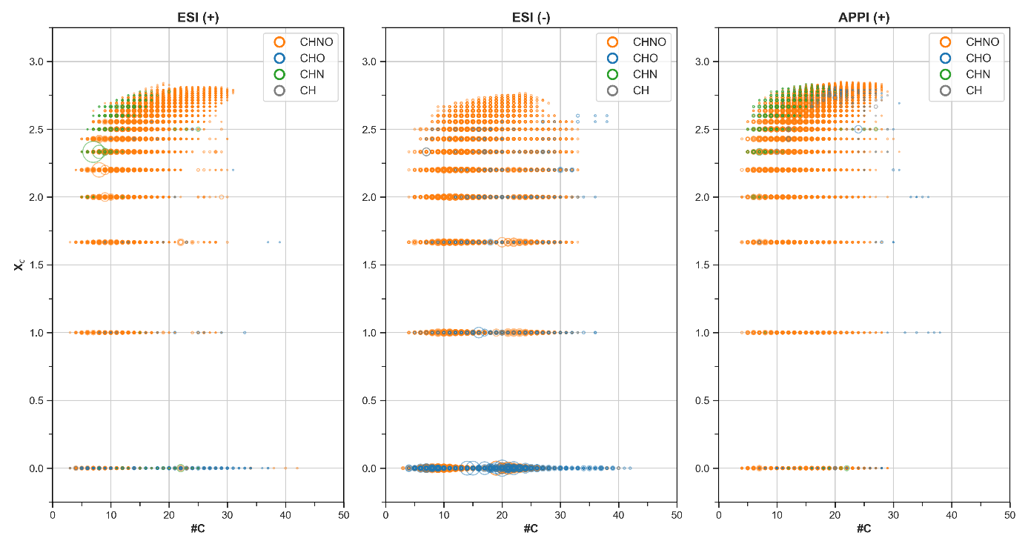
Figure S19. Aromaticity equivalent distributions of molecular formulas in the SOMA-3 sample, achieved by ESI (+), ESI (-), and APPI (+). The bubble size refers to the signal intensity. The colour refers to the heteroatom classes: Orange = CHNO; Blue = CHO; Green = CHN; Gray = CH. A Xc value of 2.5 would be analogue to a benzene-like structure.

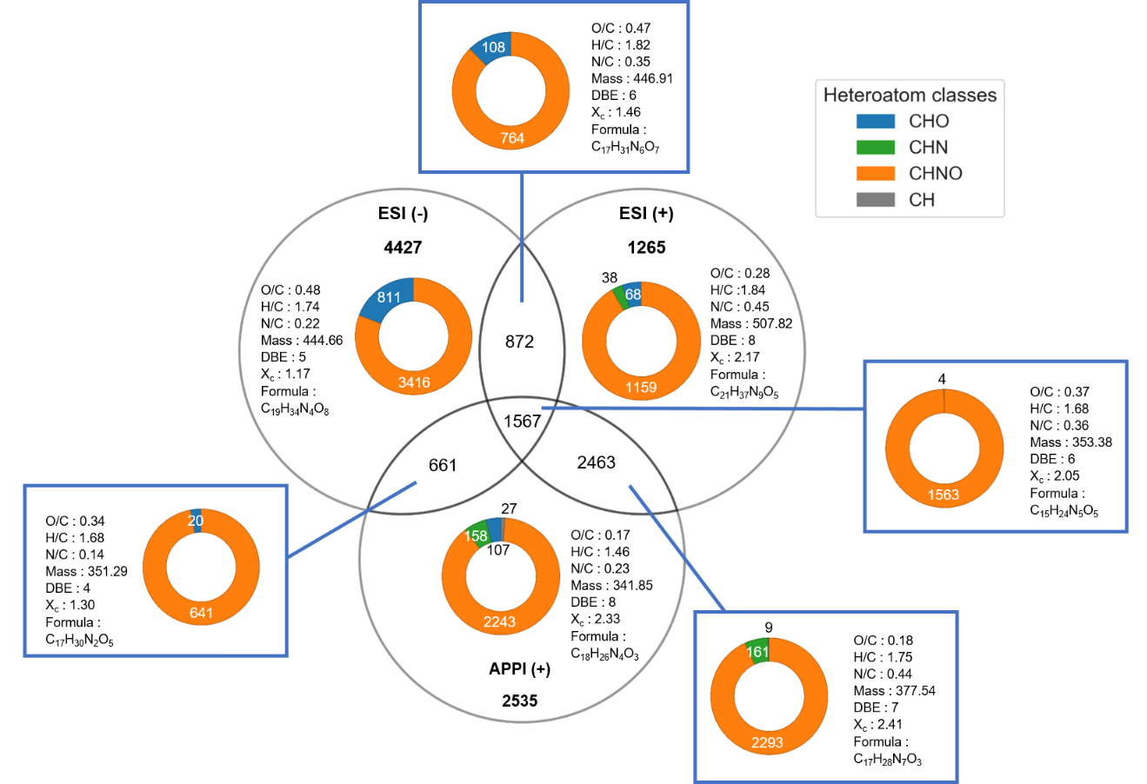
Figure S20. Venn diagram achieved from data obtained using FT-ICR MS with ESI, in both positive- and negative-ion modes, and APPI in positive-mode, from SOMA-3 organic residue made from VUV irradiated interstellar ice analogues. Each ellipse represents one analytical condition used in this study. The intersection between ellipses correspond to molecular formulas detected by two, or all three ionisation modes. For example, the central overlapping area represents 1,567 molecular formulas that were detected under all three analytical conditions, defining a shared population common to the three ionisation modes. Molecular formulas detected by multiple ionisation modes may correspond to several distinct isomers. The displayed values represent the averages of each distribution, considering all heteroatom classes. For the mean values of each subcategory, see Figure S25.
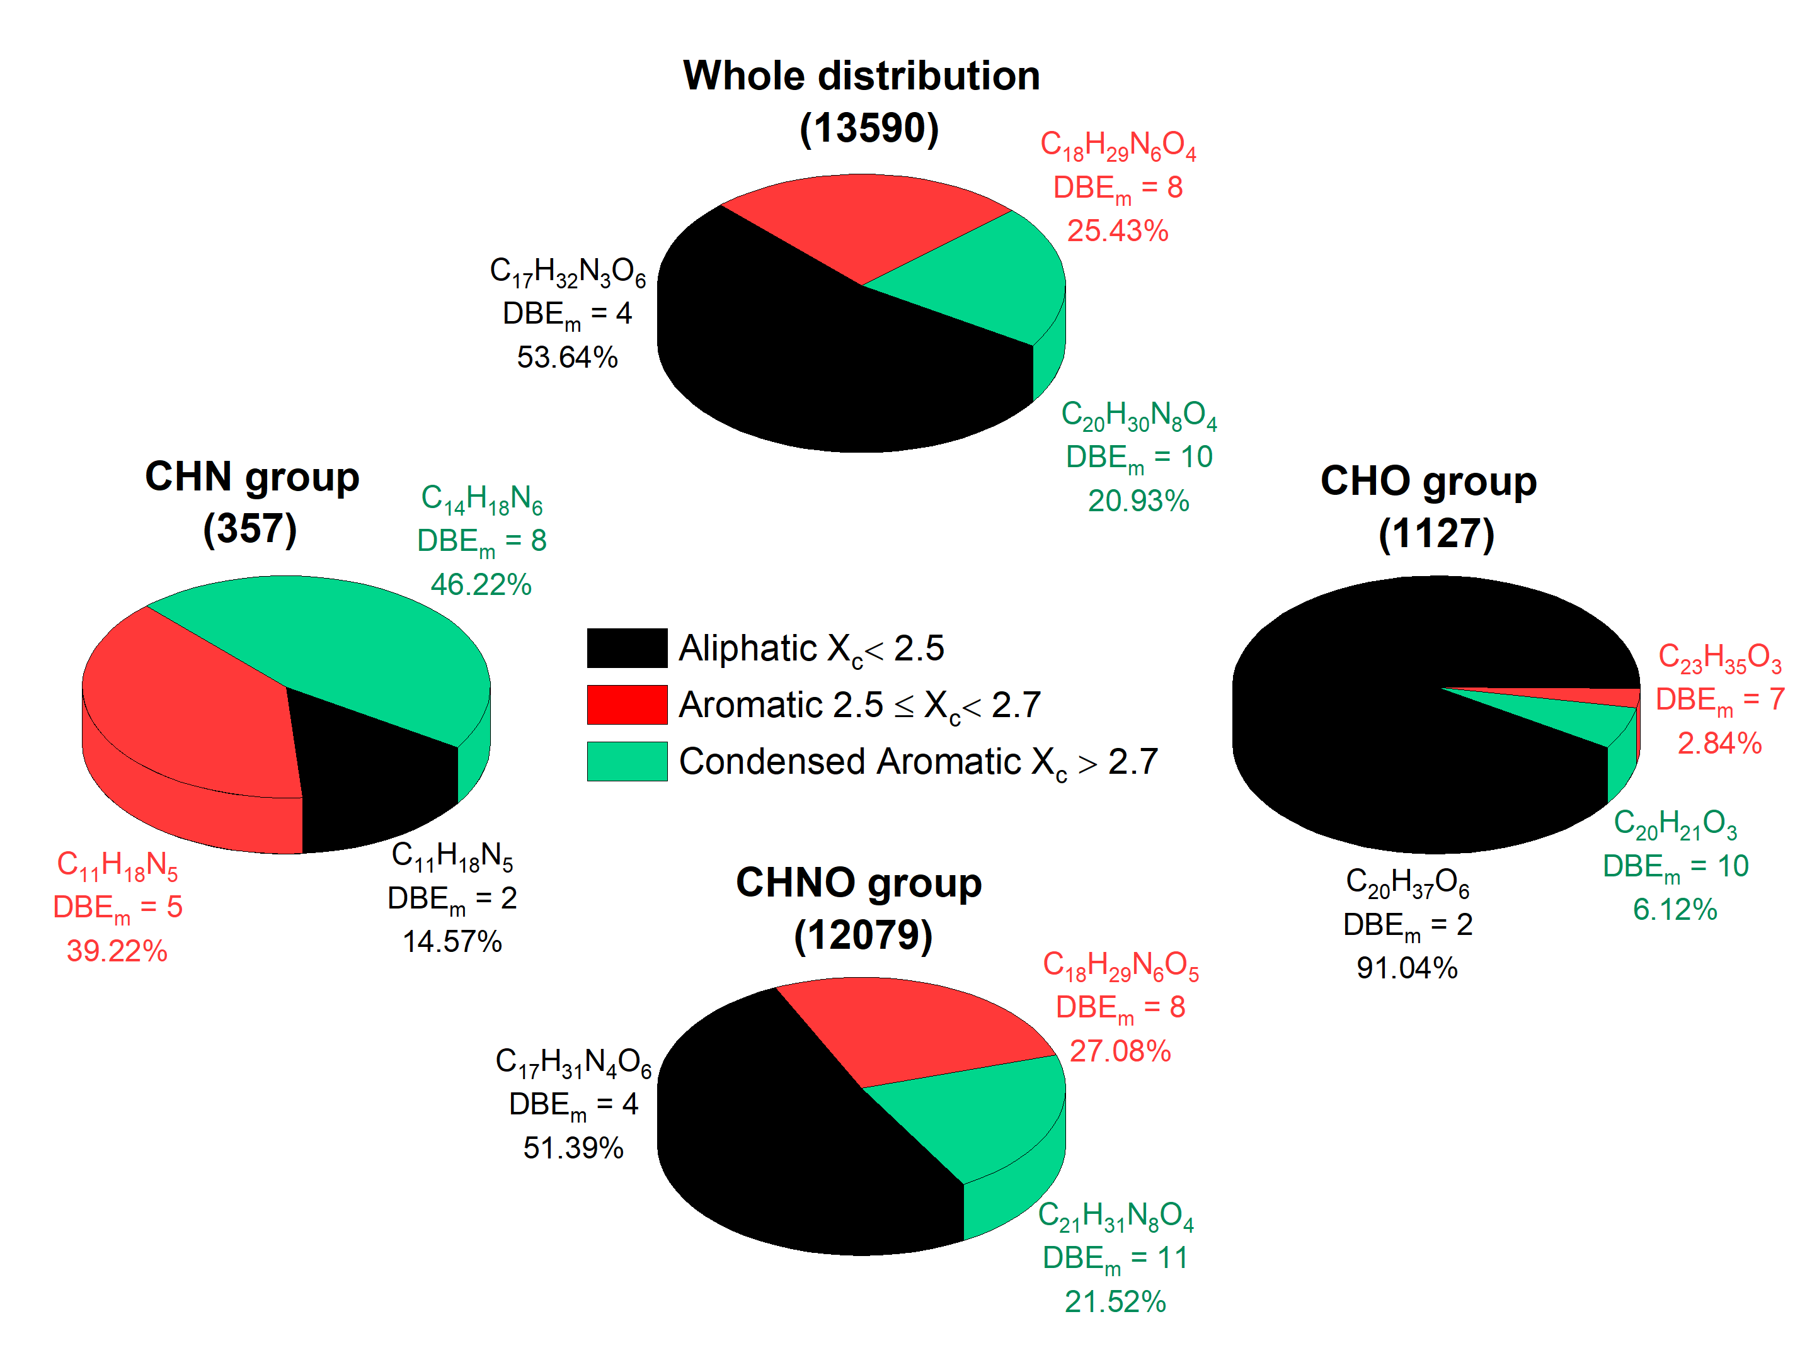
Figure S21. Unsaturation distribution of molecular assignments based on the aromaticity equivalent (X_{c}) for the whole distribution, CHNO, CHN, and CHO groups in SOMA-3. Data were obtained from each ionisation mode and duplicate attributions were removed. Figure adapted to Danger et al. (2016).

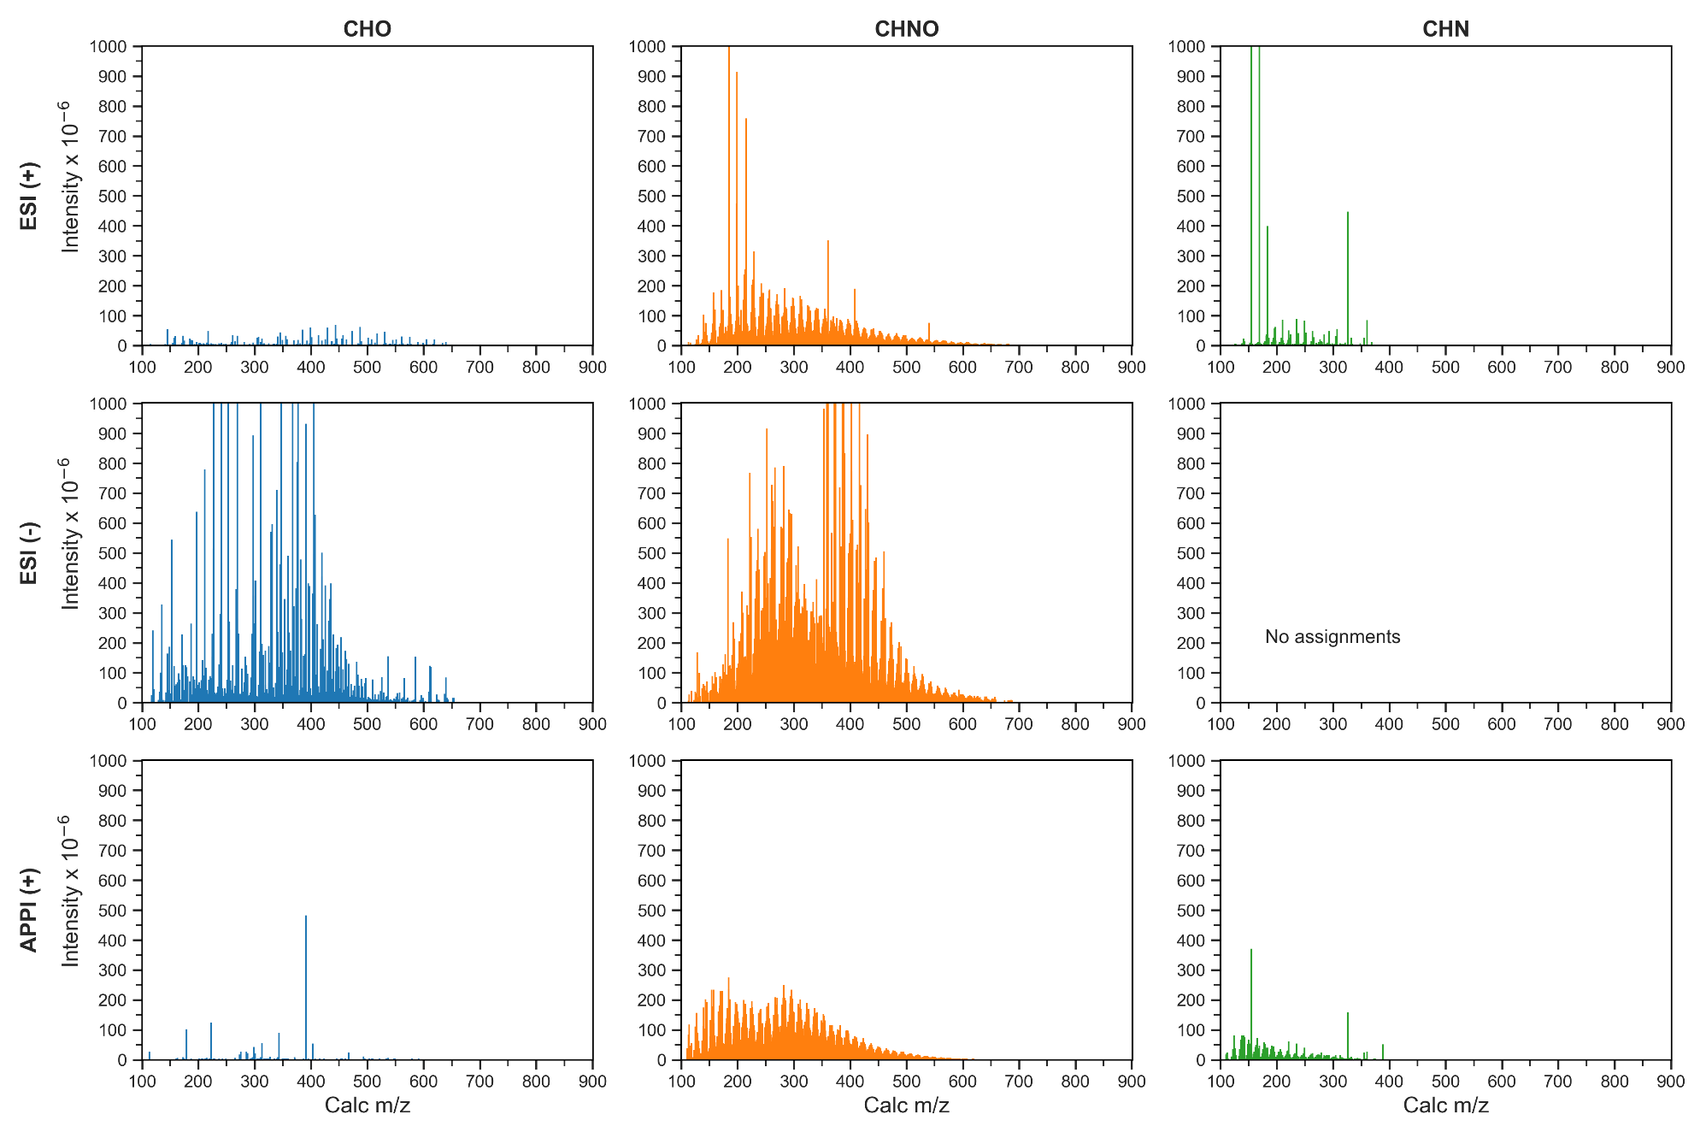
Figure S22. Mass spectra per heteroatom class of SOMA-3 sample, achieved by ESI (+), ESI (-), and APPI (+).

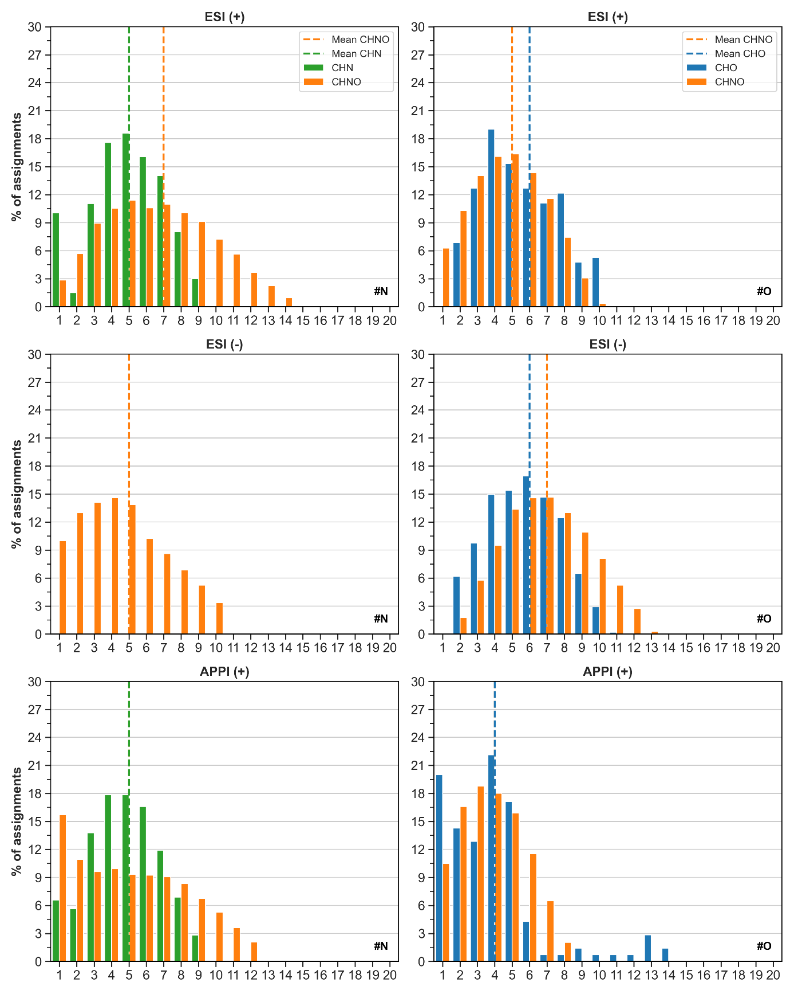Figure S23. Distributions of N and O atoms in assignments obtained for the SOMA-3 sample, analysed by ESI (+), ESI (-), and APPI (+) FT-ICR MS.

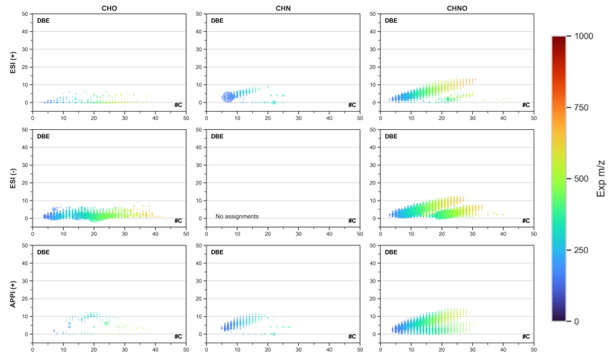
Figure S24. Double-Bond Equivalent (DBE) distributions in function of carbon number (#C) of the molecular formulas in SOMA-3, with multiple ionisation modes ESI (+), ESI (-), and APPI (+). The bubble size refers to the signal intensity and the colour to the experimental ion mass value from m/z 0 to 1,000.
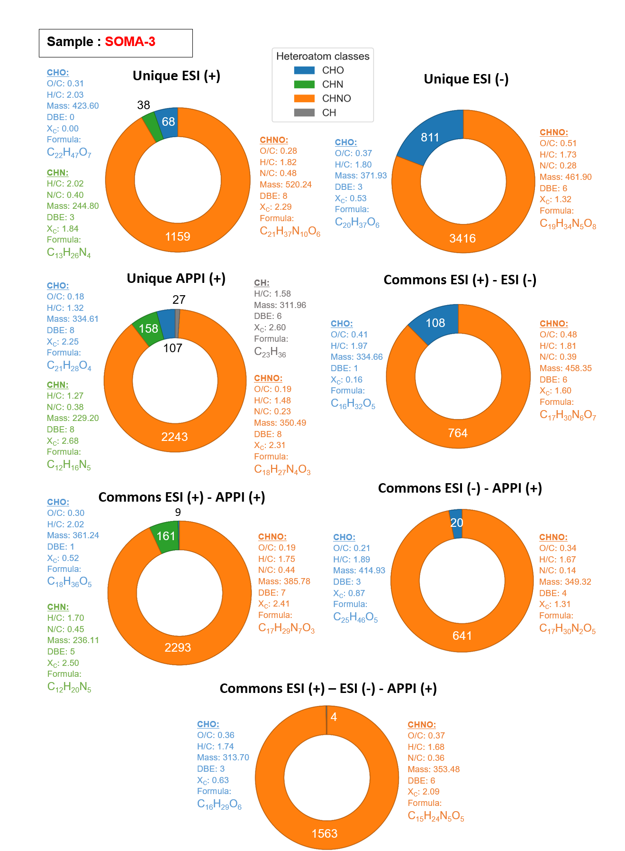
Figure S25. Subcategories data of Venn diagram achieved from data obtained using FT-ICR MS with ESI, in both positive- and negative-ion modes, and APPI in positive-mode, from SOMA-3 organic residue made from VUV irradiated interstellar ice analogues.

