Supplementary Material

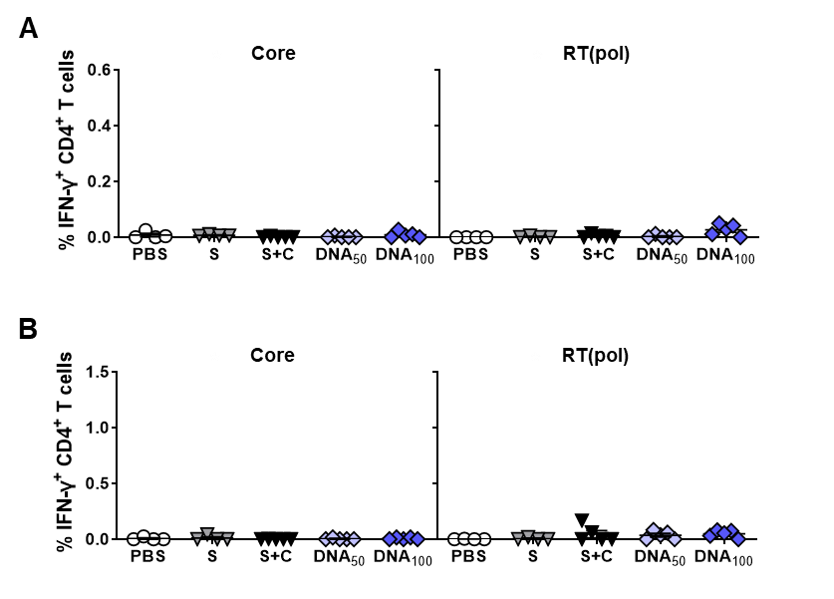
Supplementary Figure 1. Core- and RT(pol)-specific CD4⁺ T-cell responses induced by DNA prime – MVA boost immunization in HBV carrier mice. C57BL/6J mice (groups n ≥ 4) were infected with AAV-HBV and immunized as depicted in Figure 4A. End-point analyses were performed two weeks after MVA boost, at week 6. IFN-γ⁺ CD4⁺ T cells after ex vivo stimulation with overlapping HBV core- and RT(pol)-specific peptide pools isolated from (A) spleens and (B) livers of immunized mice. Mean ± SEM is shown.

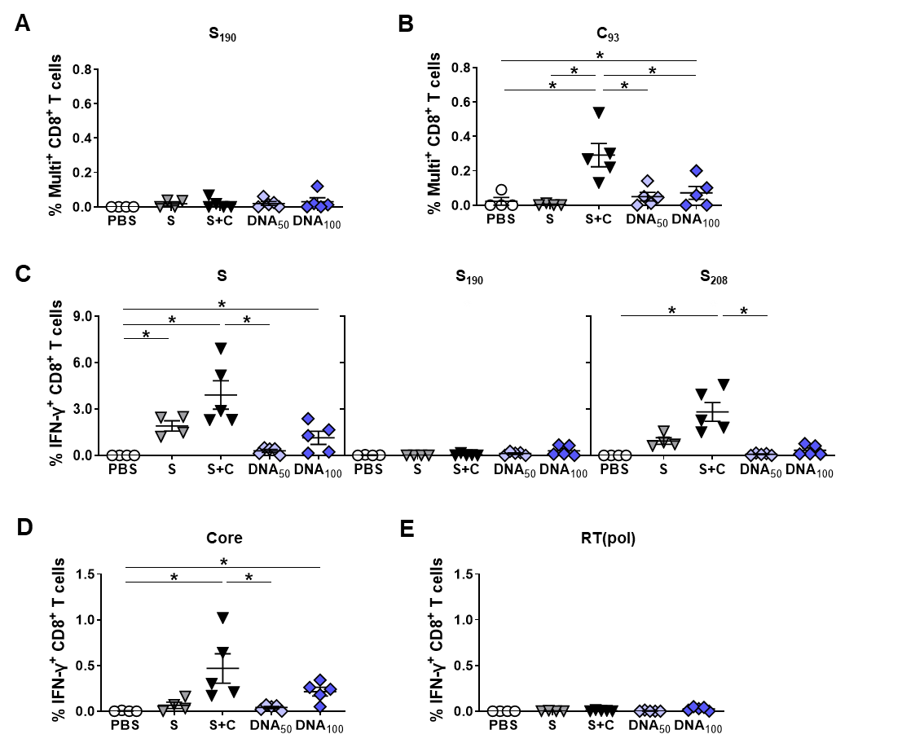
Supplementary Figure 2. Splenic HBV-specific effector T-cell responses induced by DNA prime – MVA boost immunization in HBV carrier mice. C57BL/6J mice (groups n ≥ 4) were infected with AAV-HBV and immunized as depicted in Figure 4A. End-point analyses were performed two weeks after MVA boost, at week 6. Frequencies of (A) S- and (B) Core-specific CD8⁺ T cells stained positive for S₁₉₀ or C₉₃ multimer in the spleen. (C) HBV S-specific IFN-γ responses of splenic CD8⁺ T cells determined by ICS after ex vivo stimulation with overlapping HBV S-specific peptide pool and single peptides S₁₉₀ and S₂₀₈. HBV (D) Core- and (E) RT(pol)-specific IFN-γ responses of splenic CD8⁺ T cells determined after ex vivo stimulation with overlapping HBV Core- and RT(pol)-specific peptide pools. (B-D) Mean ± SEM is shown. Statistical analysis using nonparametric One-Way ANOVA. p-values < 0.05 were considered statistically significant and marked with asterisks (*p<0.05).

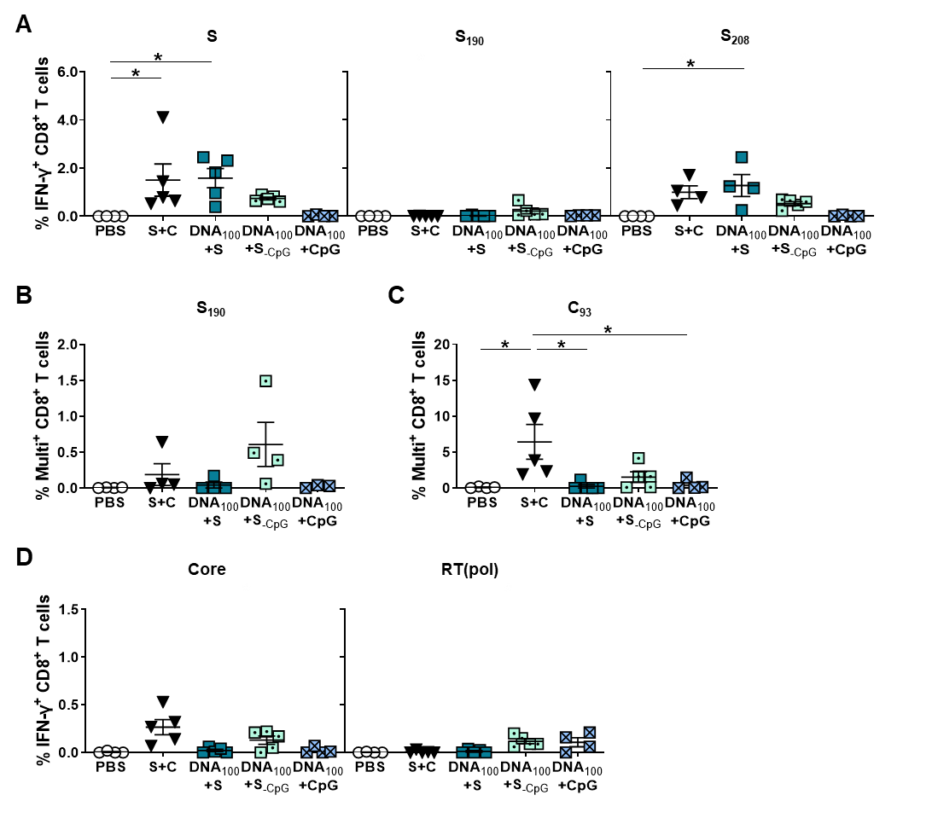
Supplementary Figure 3. CD8⁺ T-cell responses induced by simultaneous DNA/HBsAg prime – MVA boost immunization in HBV carrier mice. C57BL/6J mice (groups n ≥ 4) were infected with AAV-HBV and immunized as depicted in Figure 7A. End-point analyses were performed two weeks after MVA boost, at week 10. (A) S-specific IFN-γ responses of splenic CD8⁺ T cells determined by ICS after ex vivo stimulation with overlapping HBV S-specific peptide pool and single peptides S₁₉₀ and S₂₀₈. Frequencies of hepatic (B) S- and (C) Core-specific CD8⁺ T cells detected with S₁₉₀- or C₉₃-specific multimers. HBV (D) Core- and RT(pol)-specific IFNγ responses of splenic CD8⁺ T cells determined after ex vivo stimulation with overlapping Core- and RT(pol)-specific peptide pools. Mean ± SEM is shown. (A, C) Statistical analysis using nonparametric One-Way ANOVA. p-values < 0.05 were considered statistically significant and marked with asterisks (*p<0.05).

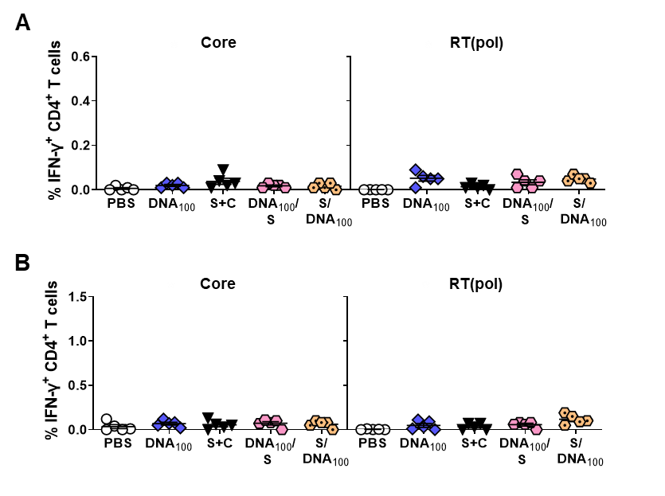
Supplementary Figure 4. Core- and RT-specific CD4⁺ T-cell responses induced by sequential DNA and HBsAg prime – MVA boost immunization in HBV-carrier mice. C57BL/6J mice (groups n = 5) were infected with AAV-HBV and immunized as depicted in Figure 9A. End-point analyses were performed two weeks after MVA boost, at week 10. (A-B) IFN-γ⁺ CD4⁺ T cells after ex vivo stimulation with overlapping HBV core- and RT(pol)-specific peptide pools isolated from (A) spleens and (B) livers of immunized mice. Mean ± SEM is shown.

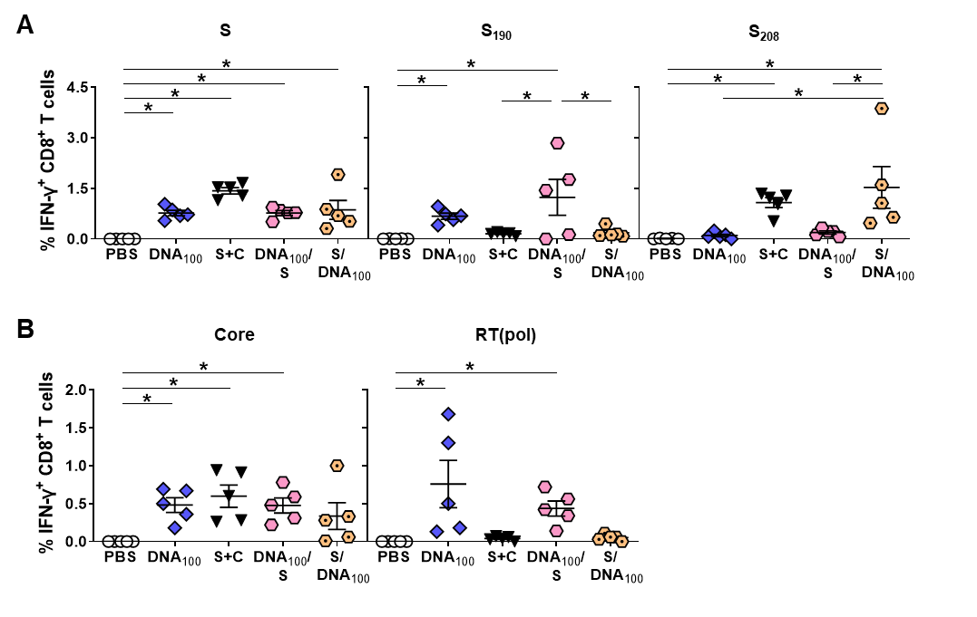
Supplementary Figure 5. Splenic HBV-specific CD8⁺ T-cell responses induced by sequential DNA and HBsAg prime – MVA boost immunization in AAV-HBV mice. C57BL/6J mice (groups n = 5) were infected with AAV-HBV and immunized as depicted in Figure 9A. End-point analyses were performed two weeks after MVA boost, at week 10. (A) S-specific IFN-γ responses of splenic CD8⁺ T cells determined by ICS after ex vivo stimulation with overlapping HBV S-specific peptide pool and single peptides S₁₉₀ and S₂₀₈. (B) Core- and RT(pol)-specific IFNγ responses of splenic CD8⁺ T cells determined after ex vivo stimulation with overlapping Core- and RT(pol)-specific peptide pools. Mean ± SEM is shown. Statistical analysis using nonparametric One-Way ANOVA. p-values < 0.05 were considered statistically significant and marked with asterisks (*p<0.05).

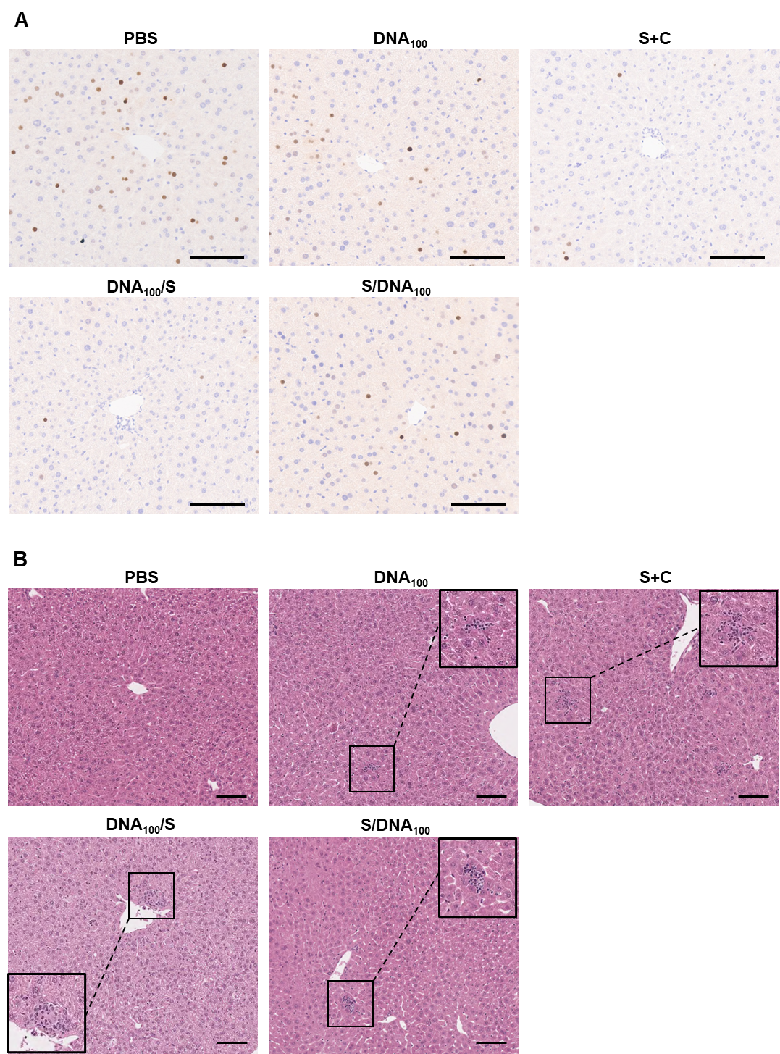
Supplementary Figure 6. Representative histology and immunohistochemistry of HBV carrier mice receiving sequential DNA and HBsAg prime – MVA boost immunization. C57BL/6J mice (groups n = 5) were infected with AAV-HBV and immunized as depicted in Figure 9A. End-point analyses were performed two weeks after MVA boost, at week 10. (A) Representative images of liver immunohistochemistry staining for HBcore protein (brown). Scale bars represent 100 μm. (B) Representative images of liver sections stained with H&E. Scale bars represent 100 μm, and inlets show magnification of the indicated areas.

